Example of a Site Plan

Site plans assist emergency services by providing information about the layout of the workplace and key locations such as chemical stores and vehicle entry points. Where a workplace requires a hazardous chemical manifest, a site plan must be kept with the manifest. An example of a site plan can be found in Figure 1.

The site plan must:

1. Be drawn to scale and show the direction of true north.
2. Include a legend that explains what any ID numbers and codes stand for.
3. Include a description of the activities carried out in adjoining sites or premises.
4. Show the location of hazardous chemicals stored in bulk and provide their identification details (for example, “DGT 3”).
5. Show the location of storage areas for packaged hazardous chemicals and IBCs and provide their identification details (for example, “PS3”).
6. Show the location where hazardous chemicals are manufactured or generated on site and provide their identification details (for example, “MA 2”).
7. Show the areas which have been designated for chemicals that are ‘in transit’ (for example, “ITA 1”).
8. Describe in words the location of the things referred to in items 4 to 7 above (for example, “the chemicals at DGT 3 are located in the southern corner of the premises and can be reached by entering the main gate and heading south past DGT 4”).
9. Show the location of the main entrance and other places of entry to and exit from the workplace.
10. Show any essential site services, including fire services and isolation points for fuel and power.
11. Show all drainage systems.
12. Show where the manifest is located.
13. Show and provide a description of adjoining workplaces, occupancies or sites (for example, “car repair shop” and “furniture factory”).
14. Show on site map the location of all other buildings, amenities, fences, car parks and storage areas.
15. Include the site name, address details, and the date the plan was prepared/revised.

Additional information that may assist emergency services should be included where available, such as:

1. Internal roadways for large sites.
2. Any surrounding or adjacent environmentally sensitive areas and watercourses.
3. Public street names adjacent to the premises and evacuation routes.
4. Site topography.

Figure 1: Example site plan

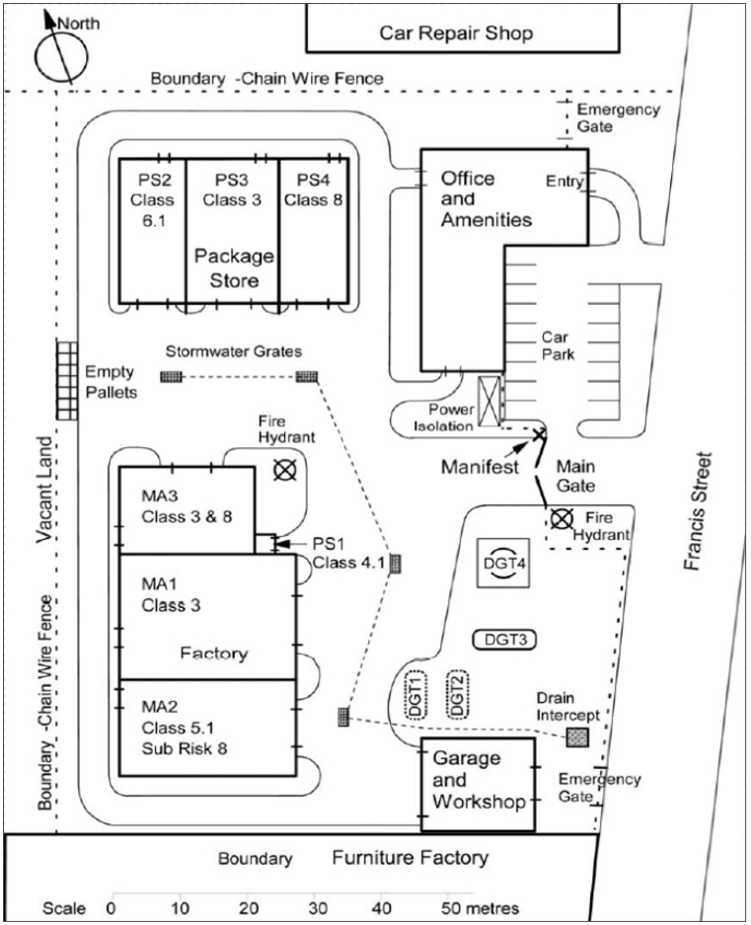

| XYZ CHEMICALS Pty Ltd  Lot 1234 Francis Street  Barton, ACT 2600  Date prepared: 1 Feb 2019  Plan no.: ABC001 | **Legend**  PS – Package stores  MA – Factory manufacturing areas  DGT – Storage tanks areas |
| --- | --- |