Storage of swimming pool chemicals
This information sheet provides advice about safely storing swimming pool chemicals. For more information refer to Safe Work Australia’s Managing risks of storing chemicals in the workplace or Workplace Health and Safety Queensland’s A Guide for Swimming Pool Retailers.

The risks of swimming pool chemicals
Swimming pool chemicals can be very dangerous when stored incorrectly. Two particular groups of swimming pools chemicals (oxidisers and corrosives) are highly reactive and need particular care.
Oxidisers intensify fires, and increase the risk of a fire or explosion occurring. They can also start a fire or release toxic gases if they come into contact with other chemicals, including moisture and water. Because of this, it is dangerous to keep oxidizers near other chemicals, heat sources or combustible materials (such as waste cardboard, oils and wood). Many oxidisers will also react dangerously with each other.
Common oxidisers include dry swimming pool chlorines (those supplied as powders, granules or tablets, e.g. calcium hypochlorite,and trichlorocyanuric acid) and swimming pool sanitisers (e.g. hydrogen peroxide).
Corrosives damage the skin and eyes on contact, and can burn the throat and respiratory tract if their fumes or vapours are inhaled. Corrosive swimming pool chemicals are either acids or bases (also called alkalis). Corrosive chemicals are usually incompatible with other chemicals and are often incompatible with each other, for example if swimming pool chlorine (a base) comes into contact with acid it releases poisonous chlorine gas.
Common acids include pH decreasers (e.g. hydrochloric acid and muriatic acid), while swimming pool chlorines (including liquid swimming pool chlorines, e.g. sodium hypochlorite or hypochlorite solution) are typically bases.
Common symbols used to warn users about oxidisers and corrosive chemicals are shown below. These are often included on the labels of swimming pool chemicals, however you should not rely on the presence of these symbols on product labels to determine if a product is hazardous. These symbols may not always be present, and you should always refer to the chemicals safety data sheet for complete information.
Incompatible chemicals can appear very similar when packaged. You should carefully inspect chemical packages and safety data sheets to ensure you are aware of your chemicals hazards and their recommended storage methods.
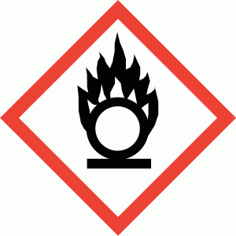 | 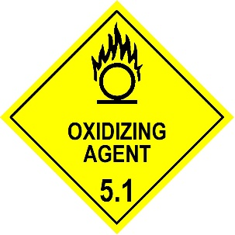 | 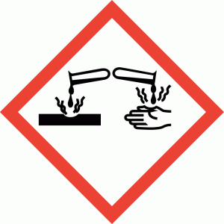 | 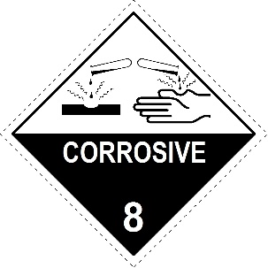
Common Oxidiser Symbols |  | Common Corrosive Symbols

It is important to recognise that a chemical can have more than one hazard. For example, dry pool chlorines are typically both oxidisers and bases. Some chemicals may present other hazards, such as causing skin irritation or allergic reactions. Complete information about a chemical’s hazards can be found in its safety data sheet.

General storage advice
Swimming pool chemicals should be stored in a cool, dry and well-ventilated space. Protection from the sun and moisture is also essential. Liquids should not be kept vertically above incompatible chemicals (i.e. do not put liquids on shelves above dry pool chlorine), as they may leak and cause a reaction.
The storage area should be kept clean, and combustible material must not be allowed to accumulate nearby. Dry pool chlorine stored outside should be kept in weatherproof packaging and protected from the weather, such as by waterproof sheeting.
Generally, swimming pool chemicals should not be stored with other hazardous chemicals.
You should consider how you will respond to any leaks or spills that occur in your storage area, and make sure you have suitable equipment to respond to any incidents, such as a spill kit. Similarly, when considering the first aid and fire-fighting requirements of your workplace, you should take into account the hazardous chemicals you store.

Separating incompatible chemicals
To ensure that hazardous chemicals do not react with one another, acids and bases should be separated from one another, while oxidisers should be separated from other hazardous chemicals, ignition sources and any flammable or combustible materials. If you are storing multiple oxidisers or multiple corrosive chemicals, you should check their safety data sheets for information about how they should be separated.
Steps should also be taken to stop waste chemicals from reacting with one another, as this may cause serious incidents. For example, when disposing of unwanted or left over chemicals, never combine incompatible chemicals in a bin, even in small amounts. Similarly, you should never reuse left over containers for hazardous chemicals; chemicals should only be stored and disposed of in their original containers.
If other hazardous chemicals are stored with pool chemicals, they should be separated in accordance with the advice in their safety data sheets and the guide Managing risks of storing chemicals in the workplace.
When storing up to 250 litres or kilograms of hazardous swimming pool chemicals, all incompatible chemicals should be kept a minimum of 3 metres apart or be separated by a solid, chemical-proof barrier (e.g. concrete). This includes separating oxidisers from flammable materials and ignition sources.
When storing more than 250 litres or kilograms of oxidising chemicals or 1000 litres or kilograms of corrosive chemicals, distances should be increased to 5 meters or a solid, chemical-proof barrier used.
A spill containment system (such as a bund) must be in place where there is a risk of hazardous chemicals spilling or leaking. Incompatible chemicals require separate spill containment systems and must not drain to a common point. Where liquid chemicals are stored in packages, the system should hold at least 25 per cent of the total volume of liquid stored. Where liquid chemicals are stored in a tank the system should be capable of holding the total volume of the tank.

Retail displays
If swimming pool chemicals are stored on display, the following additional precautions should be in place:
- No more than 100 litres or kilograms of oxidising chemicals should kept in a single display. Any additional chemicals should be in a dedicated storage area.
- Incompatible chemicals should be separated by at least three meters or by a chemical proof barrier (e.g. concrete). This includes separating fire risk chemicals (such as oxidisers and flammable liquids) from combustible materials such as paints and cardboard packaging.
- Chemicals should not be displayed in driveways or areas where vehicles may be active.
- Packages should not be opened on the premises.
- A fire extinguisher should be kept near the display area.
- Warning signs should be displayed, such as ‘DANGER – NO SMOKING’.
It may be convenient to use empty containers for display and store the hazardous chemicals in a separate area.

