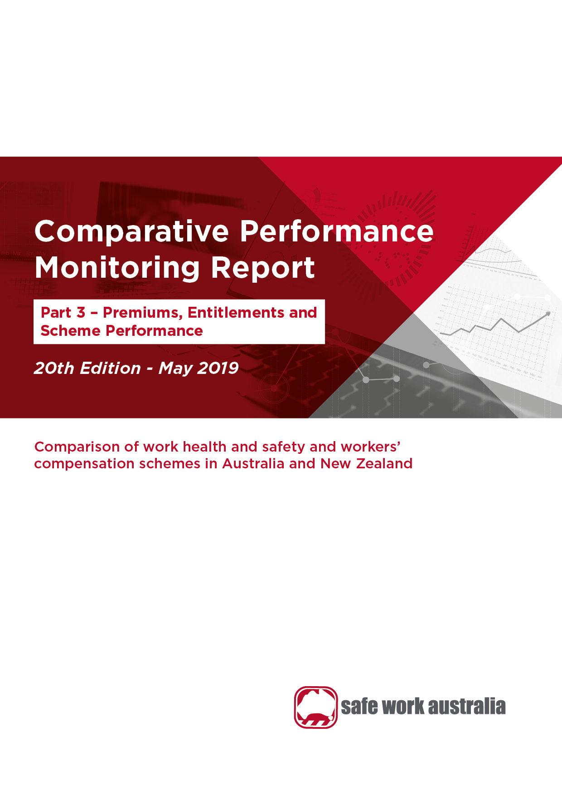

Disclaimer

Safe Work Australia provides the information in this publication to raise awareness of work health and safety. This information is general guidance only and does not replace any statutory requirement contained in any relevant state, territory or Commonwealth legislation. It is not a substitute for independent professional advice. Users should exercise their own skill and care to evaluate the accuracy, currency, completeness and relevance for their purposes of any information contained in the publication. Users should obtain appropriate advice relevant to their particular circumstances.

While Safe Work Australia makes every effort to ensure information is accurate and up-to-date, Safe Work Australia does not provide any warranty regarding the accuracy, currency or completeness of the information contained in this publication and will not be held liable for any loss, damage, cost or expense incurred or arising by reason of any person using or relying on the information in this publication.

This publication may incorporate views or information from third parties, which do not necessarily reflect the views of Safe Work Australia. The inclusion of such material does not indicate an endorsement of that material or a commitment to any particular course of action. The views in this publication should not be taken to represent the views of Safe Work Australia unless otherwise expressly stated.

**ISSN  2209-9182**



Creative Commons

With the exception of the Safe Work Australia logo, this report is licensed by Safe Work Australia under a Creative Commons 4.0 International Licence. To view a copy of this licence, visit

[https://creativecommons.org/licenses/by/4.0/](http://creativecommons.org/licenses/by/3.0/au/deed.enhttps://creativecommons.org/licenses/by/4.0/)

In essence, you are free to copy, communicate and adapt the work, as long as you attribute the work to Safe Work Australia and abide by the other licensing terms. The report should be attributed as the *Comparative Performance Monitoring Report 19th Edition Part 3 – Premium, entitlements and scheme performance.*

Enquiries regarding the licence and any use of the report are welcome at:

Copyright Officer  
Safe Work Australia   
GPO Box 641 Canberra ACT 2601

Email: [info@swa.gov.au](mailto:info@swa.gov.au)­­­

Important Notice

Safe Work Australia provides the information given in this document to improve public access to information about work health and safety information generally. The vision of Safe Work Australia is Australian workplaces free from injury and disease. Its mission is to lead and coordinate national efforts to prevent workplace death, injury and disease in Australia.

Contents

Foreword 4

1. Workers’ compensation premiums 8

1.1 Standardised average premium rates by jurisdiction 8

1.2 Standardised average premium rates by industry 9

2. Entitlements under workers’ compensation 21

2.1 Temporary impairment 21

2.2 Permanent impairment 23

2.3 Workplace fatality 24

3. Workers’ compensation scheme performance 26

3.1 Assets to liabilities ratio 26

3.2 Scheme expenditure 28

3.3 Current return to work 31

3.4 Disputation rate 32

3.5 Dispute resolution 34

4. Appendix 1 — Explanatory notes 36

4.1 Premium rates and entitlements 36

4.2 Return to work data 39

4.3 Assets to liabilities ratio (funding ratio) data 40

4.4 Scheme expenditure data 41

5. Appendix 2 — Key features of Australian workers’ compensation schemes 43

6. Appendix 3 – Jurisdictional contact information 46

Foreword

The Labour Ministers’ Council released the first Comparative Performance Monitoring (CPM) report in December 1998. The CPM project was transferred to Safe Work Australia when it was established in 2009. The CPM reports provide trend analysis on the work health and safety and workers’ compensation schemes operating in Australia and New Zealand. This is the 20th annual report of the CPM project.

The 20th CPM report has been split into three stand-alone parts:

[Part 1 – Work health and safety performance](https://www.safeworkaustralia.gov.au/doc/comparative-performance-monitoring-report-19th-edition-part-1) contains workers’ compensation statistics on jurisdictional performance between 2012–13 and 2016–17.

[Part 2 – Work health and safety compliance and enforcement activities](https://www.safeworkaustralia.gov.au/doc/comparative-performance-monitoring-report-19th-edition-part-2) contains information on compliance and enforcement activities of all jurisdictions during a five year period from 2012–13 to 2016–17.

Part 3 – Premium, entitlements and scheme performance (this report) contains information on premium rates, entitlements and scheme performance of all jurisdictions during a five year period between 2012–13 and 2016–17.

The CPM is complemented by the [*Australian Workers’ Compensation Statistics*](https://www.safeworkaustralia.gov.au/collection/australian-workers-compensation-statistics) report, which provides more detailed analysis of national workers’ compensation data using key variables such as occupation, industry, age and sex with supporting information on the circumstances surrounding work-related injury and disease occurrences. The [*Comparison of Workers’ Compensation Arrangements in Australia and New Zealand*](https://www.safeworkaustralia.gov.au/doc/comparison-workers-compensation-arrangements-australia-and-new-zealand-2016) provides more detailed information on each scheme including coverage, benefits, self-insurance, access to common law and dispute resolution. These publications can be found at the [Safe Work Australia](http://www.swa.gov.au/) website.

# Statement of purpose

The role of the CPM report is to facilitate improvement of work health and safety, workers’ compensation and related service outcomes in Australian and New Zealand schemes through an accessible report that:

1. monitors the comparative performance of jurisdictions over time, and
2. enables benchmarking across jurisdictions and the identification of best practice to support policy making.

# Data

The data used in this report were supplied by jurisdictions for the 2016–17 financial year plus updates back to 2012–13. Readers should be aware that the data presented here may differ from jurisdictional annual reports due to the use of different definitions and the application of adjustment factors to aid in the comparability of data. Explanatory commentary on the data items is contained within each chapter with additional information included in Appendix 1 – Explanatory Notes, at the end of this publication.

The data in this report were collected from:

* workers’ compensation schemes and work health and safety authorities as follows:
  + New South Wales — State Insurance Regulatory Authority; SafeWork NSW; icare; NSW Workers’ Compensation Commission.
  + Victoria — WorkSafe Victoria
  + Queensland — Office of Industrial Relations
  + Western Australia — WorkCover Western Australia
  + South Australia — Return to Work South Australia and SafeWork SA
  + Tasmania — WorkSafe Tasmania and WorkCover Tasmania
  + Northern Territory — NT WorkSafe, Department of Attorney-General and Justice
  + Australian Capital Territory — Access Canberra, Worksafe ACT within Chief Minister Treasury and Economic Development Directorate
  + Australian Government — Comcare
  + Seacare — Seacare Authority (Seafarers Safety, Rehabilitation and Compensation Authority), and
  + New Zealand — Accident Compensation Corporation and WorkSafe New Zealand
* the National Data Set for Compensation-based Statistics and the Work-related Traumatic Injury Fatalities data set compiled by Safe Work Australia. Further information on these data sets can be found on the [Safe Work Australia](https://www.safeworkaustralia.gov.au/statistics-and-research/statistics/statistics) website
* the Return to Work Survey that replaced the Return to Work Monitor previously published by the Heads of Workers’ Compensation Authorities. The full results of which can be accessed at [Safe Work Australia](https://www.safeworkaustralia.gov.au/subject-topics/return-work) website, and
* the Australian Bureau of Statistics (ABS) which provides estimates of the number of employees and hours worked based on the Labour Force Survey, the Survey of Employment and Earnings and data provided by Comcare. Further adjustments are performed using data from the Census, the Forms of Employment Survey and the Survey of Employment Arrangements, Retirement and Superannuation.

# Coordination

This report has been compiled and coordinated by Safe Work Australia with assistance from representatives of all work health and safety and workers’ compensation authorities in Australia and New Zealand. As agreed with Comcare in this report the name ‘Australian Government’ is used for indicators relating to the Australian Government jurisdiction in work health and safety and workers’ compensation matters, while ‘Comcare’ is used to describe Comcare – the entity for indicators relating to scheme performance.

Through a partnership of governments, employers and employees, Safe Work Australia leads the development of national policy to improve work health and safety and workers’ compensation arrangements across Australia.

Premium rates:
- The standardised average premium rate has decreased by 13% since 2012-13.
- Comcare had the lowest premium rate (1.03%).
- South Australia had the highest premium rate (1.93%).
- The agriculture, forestry and fishing industry had the highest premium rate (3.3% of payroll).
- The finance and insurance industry had the lowest premium rate (0.2% of payroll).

Scheme performance:
- Average funding ratio in Australia: 
136% - centrally funded schemes
116% - privately underwritten schemes
- The funding ratio for centrally funded schemes increased by 21% (since 2012-13).
- The funding ratio for privately underwritten schemes increased by 20% (since 2012-13).
- Queensland (201%) and Tasmania (141%) had the highest funding ratios.
- Australian schemes paid a total of $8.248 billion in workers’ compensation payments including:
51% direct to claimant
29% services to claimant
14% insurance operations
2% dispute resolution 
3% other administration
1% regulation.

Data note: All figures relate to 2016-17 unless otherwise specified.

Return to work: 
- ACT had the highest return to work rate (86%).
- Seacare had the lowest return to work rate (68%).
- 82% of injured workers in Australia returned to work.
- 80% of injured workers in New Zealand returned to work.

Workers' compensation disputation:
- 5% - the Australian disputation rate.
- The disputation rate in Australia has increased by 19% since 2012-13.
- 63% of disputes were resolved within three months. 

Data note: All figures relate to 2016-17 unless otherwise specified.

1. Workers’ compensation premiums

Workers’ compensation is a compulsory form of insurance for all employers in Australia. It provides protection to employees if they suffer a work-related injury or disease. Workers’ compensation premiums are paid by employers for this insurance, with the premium generally determined based on the amount of wages paid, as well as the industry and claim history of the employer.

The rates in this chapter are for policies that provided coverage during the financial years 2012–13 to   
2016–17. The premium rates reported are ‘earned premium’. Earned premium is defined as the amount allocated for cover in a financial year from premiums collected during the previous and current financial years, while written premium is defined as the amount of premium recorded for a policy at the time it is issued. The premiums reported are allocated for defined periods of risk, irrespective of when they were actually paid, enabling rates to be compared for each financial year. Goods and Services Tax charged on premiums is not included in the reported rates as most Australian employers recoup part or all of this tax through input tax credits.

Standardised average premium rates by jurisdiction

Readers should be aware that the historic standardised average premium rates reported here are slightly different to the rates published in previous CPM reports. This difference results from concording remuneration and premium figures provided by ANZSIC 06 back to ANZSIC 93 industry classification system.

Indicator 13 shows that the standardised Australian average premium rate was 1.33 per cent of payroll in 2016−17, a 1 per cent decrease from the previous financial year.

Indicator 13 – Standardised average premium rates (including insured and self-insured sectors) by jurisdiction

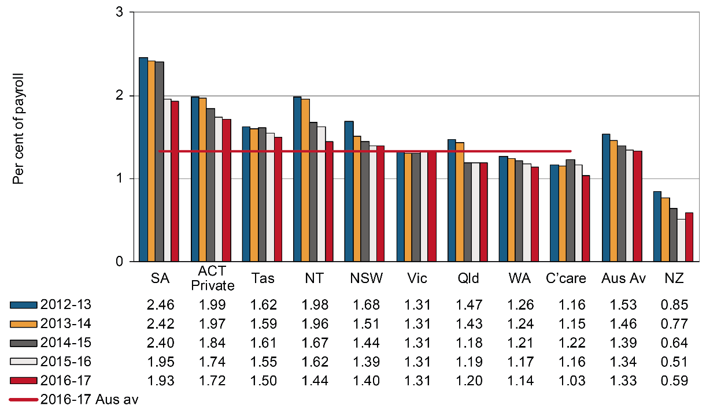

The South Australian scheme recorded the highest premium rate in 2016–17 (1.93 per cent of payroll). This was followed by the Australian Capital Territory (1.72 per cent of payroll), and Tasmania (1.50 per cent of payroll). The Northern Territory and the Australian Government recorded an 11 per cent decrease in their premium rate in 2016–17 compared with previous year.

The Australian Government recorded the lowest premium rate among all Australian jurisdictions at 1.03 per cent of payroll. The Western Australian scheme recorded the second lowest premium rate at 1.14 per cent of payroll in 2016–17, followed by Queensland at 1.20 per cent of payroll.

To be consistent with the Australian jurisdictions, the New Zealand premium information includes the levy on employers to fund the workers’ compensation portion of the ‘Residual Claims Account’. This account relates to workers’ compensation claims incurred prior to 1 July 1999 but excludes the liability for pre-1992 non-work injuries for earners. The New Zealand standardised average premium rate was 0.59 per cent of payroll, a 16 per cent increase from the previous financial year. This rate continues to be substantially lower than the rate recorded for Australia. One reason for the lower rate in New Zealand is that the New Zealand scheme does not provide coverage for the same range of mental health conditions as the Australian schemes.

It should be noted that these data will be different to premium rates published directly by the jurisdictions due to the adjustments made to the data to enable more accurate jurisdictional comparisons. The principal regulatory differences that affect comparability for which adjustments have been applied in this indicator are: the exclusion of provision for coverage of journey claims; the inclusion of self-insurers; the inclusion of superannuation as part of remuneration; and the standardisation of non-compensable excesses imposed by each scheme. The effect of each of these adjustments is shown in Appendix 1 – Table 3: Effect of adjustment factors on premium rates in 2016–17, in the Explanatory Notes. Information on published rates is outlined in the publication, *Comparison of Workers’ Compensation Arrangements in Australia and New Zealand* that can be found on the [Safe Work Australia](https://www.safeworkaustralia.gov.au/doc/comparison-workers-compensation-arrangements-australia-and-new-zealand-2018) website.

Standardised average premium rates by industry

Premium rates data are still shown using the 1993 version of the Industry Classification System as most jurisdictions are unable to supply premium data based on the 2006 Industry Classification System. Indicator 14 shows average premium rates by industry in Australia for the period from 2012–13 to   
2016–17. These data show that the Agriculture, forestry and fishing industry recorded the highest average premium rate at 3.33 per cent of payroll in 2016–17. The lowest premium rate was recorded by the Finance and insurance industry at 0.24 per cent of payroll.

Premium rates of 15 out of the 17 industries have decreased since 2012–13. The largest percentage decrease was recorded by the Finance and insurance industry (down 33 per cent), followed by Communication services (down 25 per cent), and Health and community services industry (down 17 per cent).

Indicator 14 – Australian average premium rates by industry

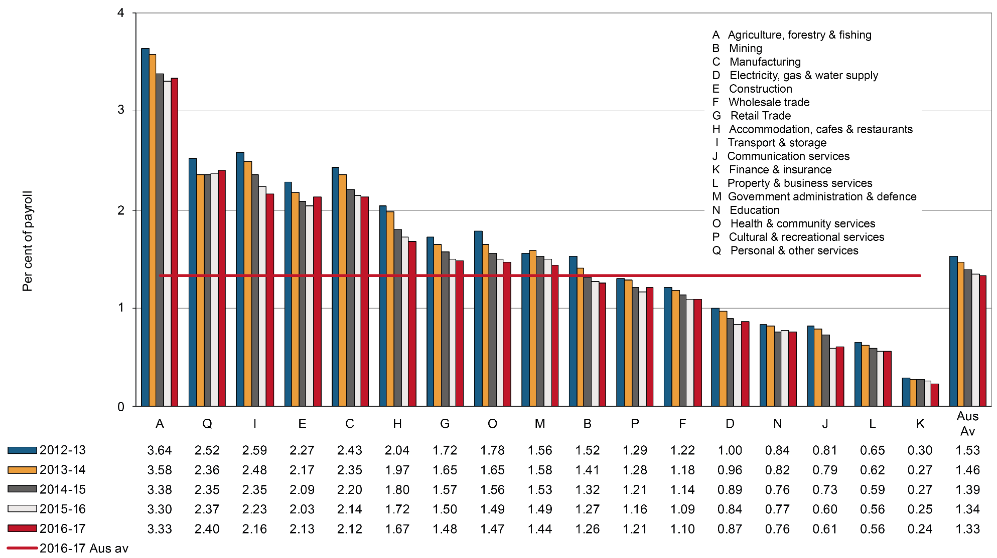

Standardised average premium rates by industry and jurisdiction

This section contains supplementary information to Indicator 14 – Australian average premium rates by industry. Presented below is a comparison of standardised average premium rates across the Australian jurisdictions for the 17 different industries. Premium rates data are still shown using the 1993 version of the Industry Classification System as most jurisdictions are unable to supply data based on the 2006 version of the Industry Classification System.

# Agriculture, forestry and fishing

Indicator 14a shows that in 2016–17 the standardised Australian average premium rate for Agriculture, forestry and fishing was 3.33 per cent of payroll. This rate was also the highest Australian average premium rate across all industries. Three out of eight Australian jurisdictions showed a decrease in premium rates in this industry in 2016−17 compared to the previous financial year, with the largest decrease observed in the Australian Capital Territory scheme (down 24 per cent). Victoria recorded the lowest premium rate for the industry in 2016‑17 (2.65 per cent of payroll), followed by Queensland (2.81 per cent). Four out of eight jurisdictions recorded an increase in premium rates in this industry in 2016−17 compared to the previous year, with the largest increase was in the Northern Territory (up 31 per cent).

The New Zealand premium rate for this industry (1.77 per cent of payroll) was much lower than the rate recorded for Australia (3.33 per cent of payroll) in 2016–17.

Indicator 14a – Standardised premium rates for Agriculture, forestry and fishing by jurisdiction

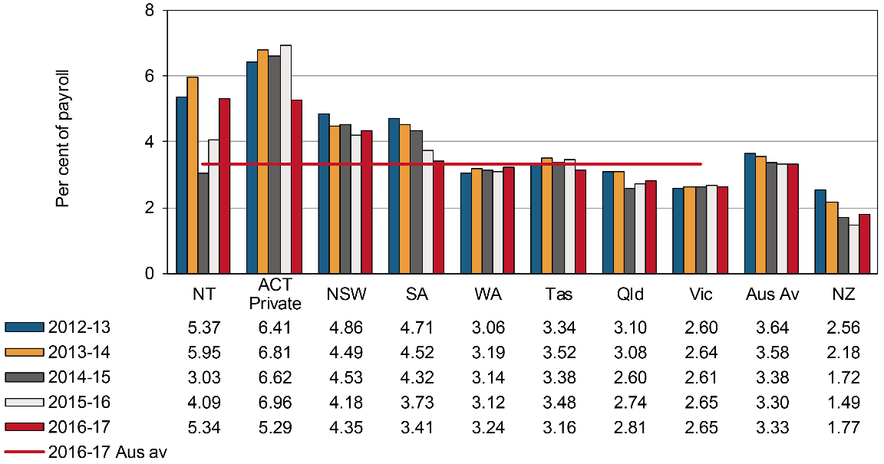

# Mining

Standardised average premium rates across jurisdictions for the Mining industry are shown in Indicator 14b. The Australian Capital Territory recorded the largest decrease in the premium rate (down 33 per cent) in 2016–17 compared to the previous year, followed by the Northern Territory (down 22 per cent) and Western Australia (down 3 per cent). The largest increase in premium rates in 2016–17 was observed in Tasmania (up 21 per cent), followed by New South Wales (up by 4 per cent). Western Australia had the lowest premium rate (0.67 per cent of payroll) for this industry in 2016–17.

The New Zealand premium rate for mining was 0.88 per cent of payroll in 2016–17, which is lower than the Australian average mining premium rate (1.26 per cent of payroll).

Indicator 14b – Standardised premium rates for Mining by jurisdiction

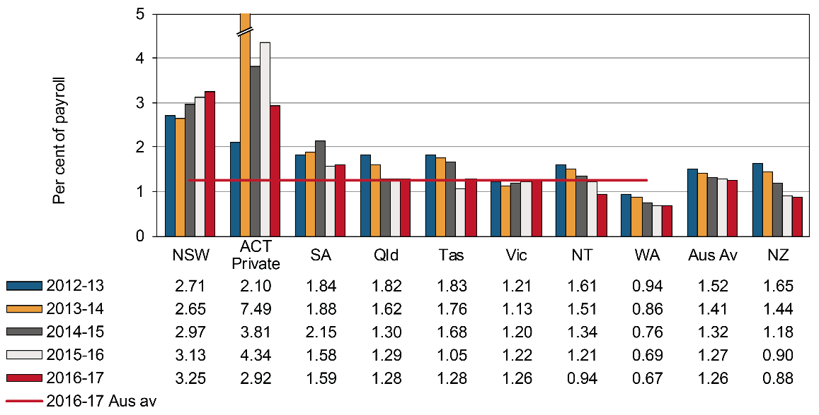

# Manufacturing

As shown in Indicator 14c, five out of nine jurisdictions showed a decrease in their premium rate in   
2016–17 compared to the previous year. The Australian Government had the largest decrease in its premium rate (down 65 per cent) in 2016–17 compared to 2015–16, followed by South Australia (down 11 per cent) and Tasmania (down 3 per cent). The largest increase in premium rate was recorded by the Australian Capital Territory (up 6 per cent), while remaining jurisdictions recorded premium rates similar to those recorded in the previous year. The Australian Government recorded the lowest premium rate (0.09 per cent of payroll) of all Australian jurisdictions.

The New Zealand standardised average premium rate in the Manufacturing industry was 0.61 per cent of payroll in 2016–17, a 15 per cent increase from the previous year.

Indicator 14c – Standardised premium rates for Manufacturing by jurisdiction

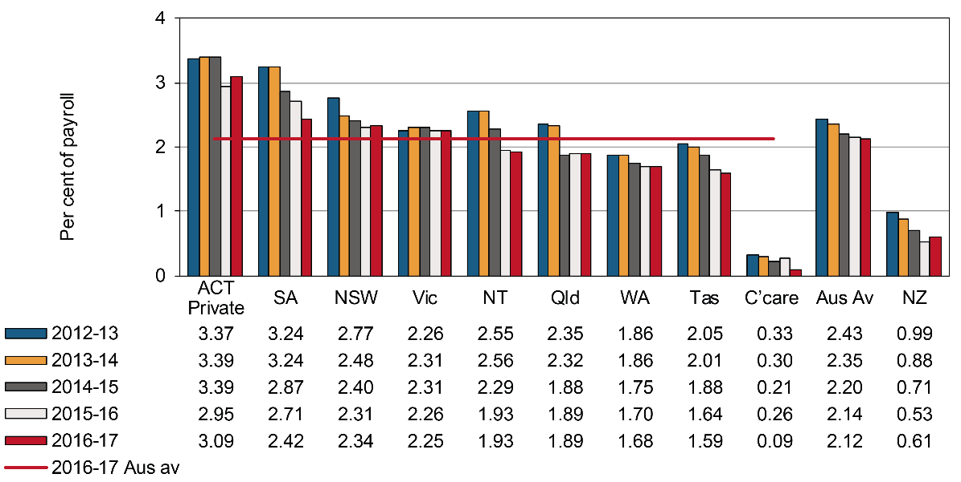

# Electricity, gas and water supply

Indicator 14d compares the premium rates across jurisdictions for the Electricity, gas and water supply industry. The Northern Territory (up 267 per cent), the Australian Capital Territory (up 47 per cent), Queensland (up 5 per cent) and Western Australia (up 3 per cent) were the only Australian jurisdictions to show increases in premium rates in 2016–17 compared to the previous year. The Australian Government recorded the largest fall (down 11 per cent), followed by Tasmania (down 3 per cent), Victoria (down 2 per cent) and New South Wales (down 1 per cent). The premium rate in South Australia was unchanged from the previous year.

New Zealand had a premium rate of 1.28 per cent of payroll in 2016–17, an increase of 7 per cent from the previous year.

Indicator 14d – Standardised premium rates for Electricity, gas and water supply by jurisdiction

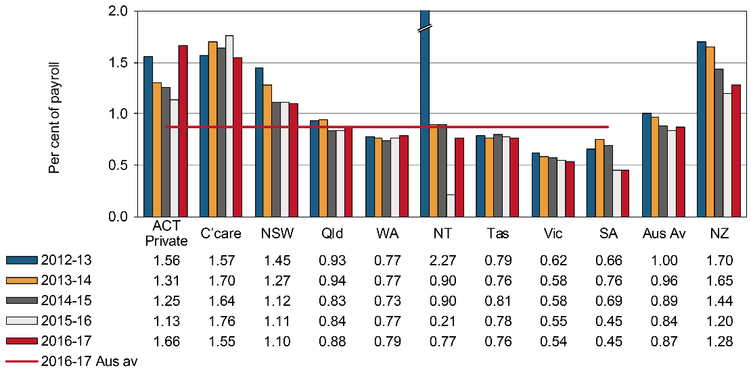

# Construction

Indicator 14e shows that in 2016–17 the Construction industry recorded an Australian average premium rate of 2.13 per cent of payroll, which was a 5 per cent increase compared to 2015–16. The Australian Government recorded the largest decrease (down 49 per cent) among Australian jurisdictions, followed by Tasmania (down 7 per cent), the Northern Territory (down 6 per cent) and the Australian Capital Territory (down 5 per cent). The Australian Government had the lowest premium rate (0.24 per cent of payroll) of all Australian jurisdictions in 2016–17.

New Zealand recorded an average premium rate of 1.37 per cent of payroll, up 12 per cent in 2016–17 compared to the previous year.

Indicator 14e – Standardised premium rates for Construction by jurisdiction

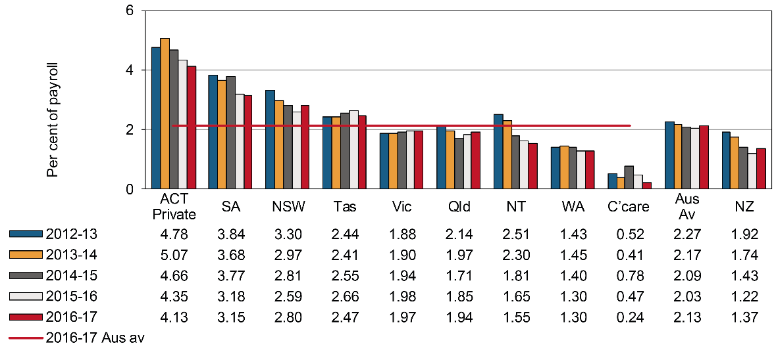

# Wholesale trade

Indicator 14f shows a slight increase in the Australian average premium rate in the Wholesale trade industry (up 1 per cent) in 2016–17 compared to the previous year. Three out of the eight Australian jurisdictions showed a reduction in their standardised average premium rates in 2016–17, with Tasmania showing the largest reduction (down 7 per cent). The Australian Capital Territory recorded the highest increase in its premium rate (up 8 per cent), followed by the Northern Territory (up 6 per cent). Queensland had the lowest premium rate of all Australian jurisdictions (0.95 per cent of payroll) in 2016–17.

New Zealand recorded a 12 per cent increase in the premium rate for this industry in 2016–17, up to 0.46 per cent of payroll.

Indicator 14f – Standardised premium rates for Wholesale trade by jurisdiction

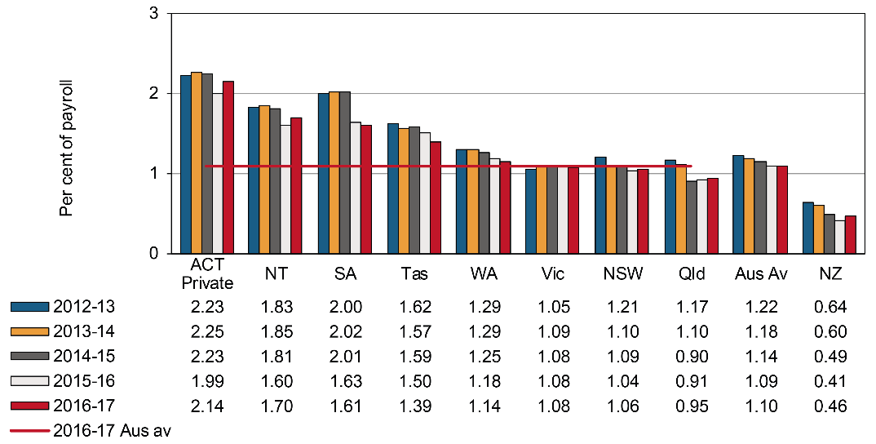

# Retail trade

Indicator 14g shows that in 2016–17 South Australia recorded the largest decrease in premium rate (down 10 per cent) in the Retail trade industry compared to the previous year, followed by the Northern Territory (down 5 per cent). Tasmania recorded a standardized premium rate of 1.09 per cent of payroll in 2016–17, the lowest among all Australian jurisdictions

In 2016–17, New Zealand had a premium rate of 0.52 per cent of payroll for the Retail industry, an increase of 16 per cent compared to 2015–16.

Indicator 14g – Standardised premium rates for Retail trade by jurisdiction

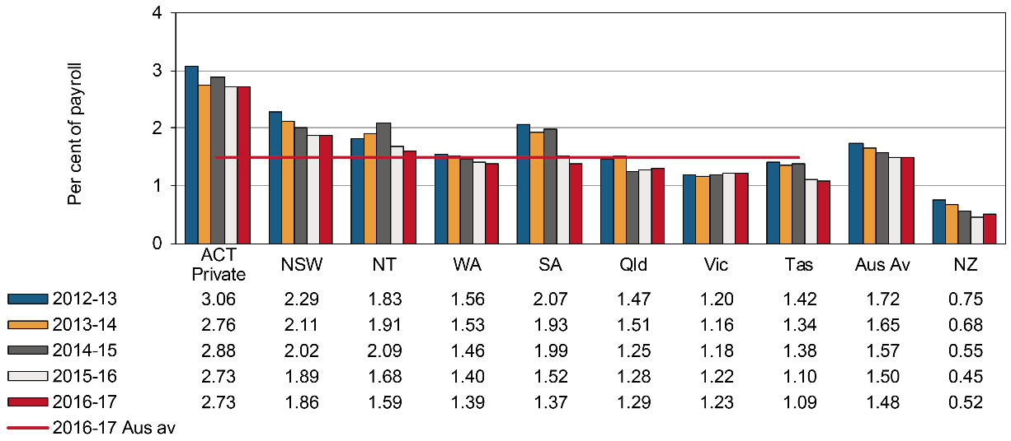

# Accommodation, cafes and restaurants

Indicator 14h shows that the Australian average premium rate for Accommodation, cafes and restaurants was 1.67 per cent of payroll in 2016–17, a 3 per cent reduction compared to the previous year.   
All jurisdictions, except the Australian Government (up 59 per cent) and the Northern Territory (up 5 per cent), recorded a fall in their premium rates in 2016–17 compared to 2015–16. Tasmania recorded the largest reduction (down 7 per cent), followed by New South Wales (down 4 per cent).

The New Zealand average premium rate was 0.65 per cent of payroll in 2016–17, up by 14 per cent compared to the previous year.

Indicator 14h – Standardised premium rates for Accommodation, cafes and restaurants by jurisdiction

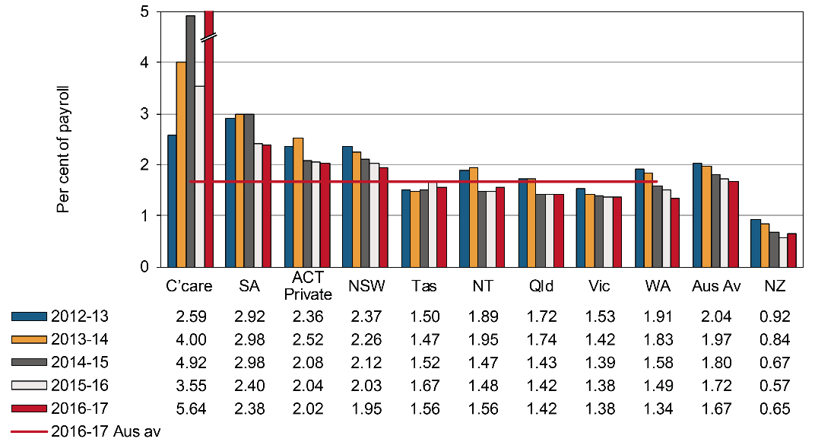

# Transport and storage

The standardised average premium rates for the Transport and storage industry are shown in Indicator 14i. The Australian Capital Territory had the highest premium rate (3.94 per cent of payroll) of all Australian jurisdictions, while the Australian Government recorded the lowest (1.41 per cent of payroll) in 2016–17. The Northern Territory showed the largest decrease (down 9 per cent) in its premium rate in 2016–17 compared to the previous year, followed by Tasmania (down 3 per cent) and Western Australia (down 2 per cent). The Australian Capital Territory recorded the highest increase in its premium rate (up 11 per cent) in 2016–17 compared to the previous year.

The New Zealand premium rate for Transport and storage (0.90 per cent of payroll) was less than half that of the Australian average for the industry (2.16 per cent of payroll) in 2016–17.

Indicator 14i – Standardised premium rates for Transport and storage by jurisdiction

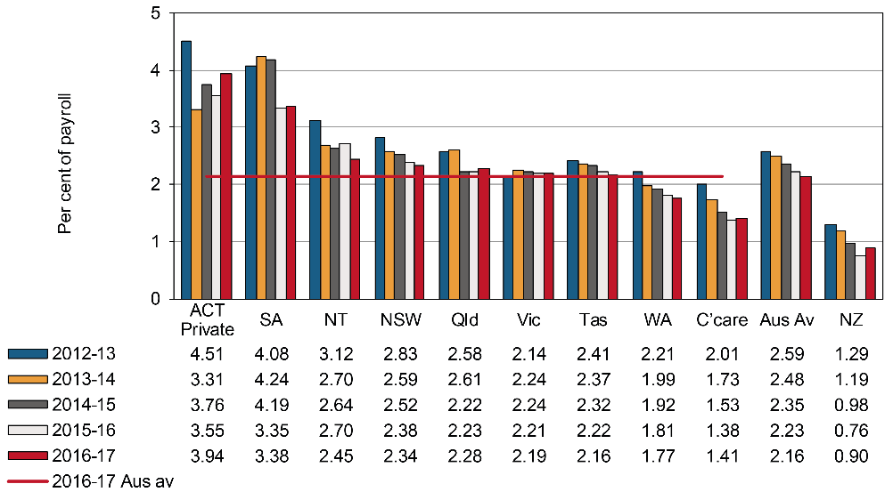

# Communication services

Indicator 14j shows that the Australian average premium rate for the Communication services industry was 0.61 per cent of payroll in 2016–17, a 2 per cent increase from the previous year. The Northern Territory recorded the largest decrease (down 13 per cent) in the premium rate in 2016–17 followed by the Australian Government (down 10 per cent). Victoria recorded the largest increase compared to the previous year, up by 24 per cent.

New Zealand’s premium rate was 0.58 per cent of payroll in 2016–17, increasing by 16 per cent since 2015–16.

Indicator 14j – Standardised premium rates for Communication services by jurisdiction

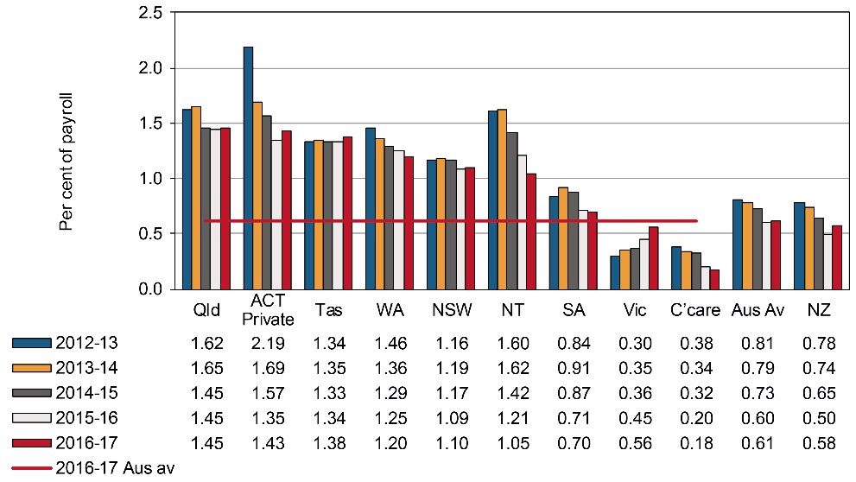

# Finance and insurance

Indicator 14k shows that in 2016–17, the Finance and insurance industry had an average premium rate of 0.24 per cent of payroll. Four jurisdictions recorded decreases in their premium rates compared to the previous year. The Australian Government recorded the largest decrease in the premium rates of this industry compared to the previous year (down 61 per cent), followed by the Northern Territory (down 21 per cent), and Tasmania (down 5 per cent). The Australian Capital Territory recorded a 34 per cent increase in the premium rates in 2016–17, followed by South Australia (up 25 per cent).

New Zealand reported a premium rate of 0.13 per cent of payroll for this industry, which is about half that of the Australian average (0.24 per cent of payroll).

Indicator 14k – Standardised premium rates for Finance and insurance by jurisdiction

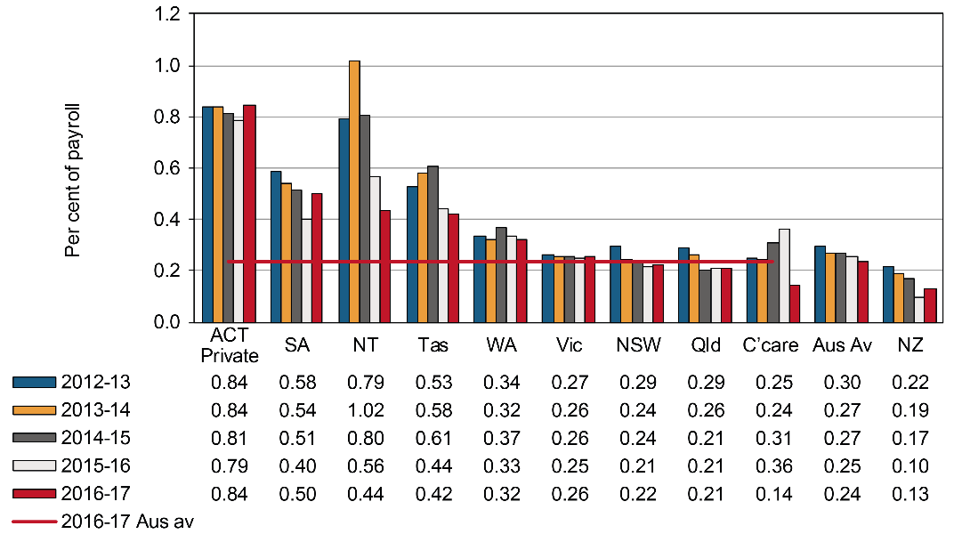

# Property and business services

As shown in Indicator 14l, six out of the nine Australian jurisdictions reported a reduction in their premium rates for the Property and business services industry in 2016–17 when compared to 2015–16. The Northern Territory showed the largest decrease over the last year in its premium rates (down 22 per cent), followed by the Australian Government and Western Australia (down 4 per cent each). South Australia recorded the highest premium rate (1.54 per cent of payroll), while New South Wales recorded the lowest (0.49 per cent of payroll).

New Zealand recorded a 23 per cent increase in its premium rate from 0.26 per cent of payroll in   
2015–16 to 0.32 per cent of payroll in 2016–17.

Indicator 14l – Standardised premium rates for Property and business services by jurisdiction

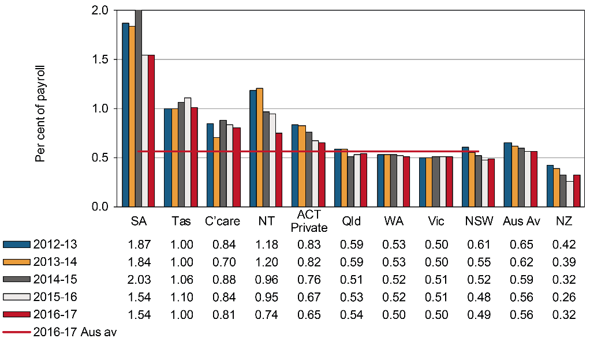

# Government administration and defence

Indicator 14m shows that while South Australia recorded the lowest premium rate in the Government administration and defence industry (1.09 per cent of payroll) in 2016–17, it also had the highest increase (up 56 per cent) from the previous year. The Northern Territory recorded the largest decrease (down 18 per cent) in its premium rate, followed by the Australian Government (down 9 per cent), and the Australian Capital Territory (down 13 per cent). The scheme covering the Australian Defence Force (ADF) personnel is excluded from this industry division as they are covered by the Military Rehabilitation and Compensation (MRC) Act administered by the Department of Veterans’ Affairs (DVA).

The New Zealand average premium rate was 0.20 per cent of payroll in 2016–17

Indicator 14m – Standardised premium rates for Government administration and defence by jurisdiction

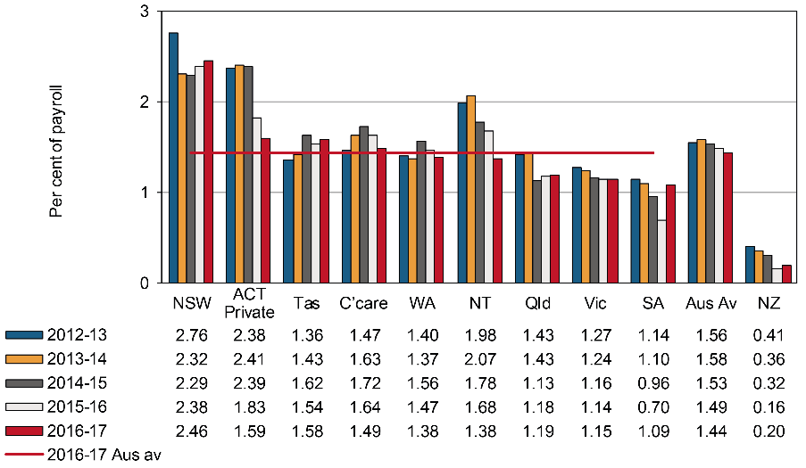

# Education

As shown in Indicator 14n, the Australian average premium rate for the Education industry fell by 1 per cent in 2016–17 compared to the previous year. The Northern Territory recorded the largest decrease (down 13 per cent), followed by the Australian Capital Territory (down 7 per cent). The Australian Government recorded the largest increase (up 23 per cent) in 2016–17, followed by South Australia (up 12 per cent). The premium rate for Queensland was the lowest (0.66 per cent of payroll) among Australian jurisdictions, closely followed by New South Wales (0.70 per cent of payroll).

New Zealand showed a 19 per cent increase, from 0.27 per cent of payroll in 2015–16 to 0.32 per cent of payroll in 2016–17.

Indicator 14n – Standardised premium rates for Education by jurisdiction

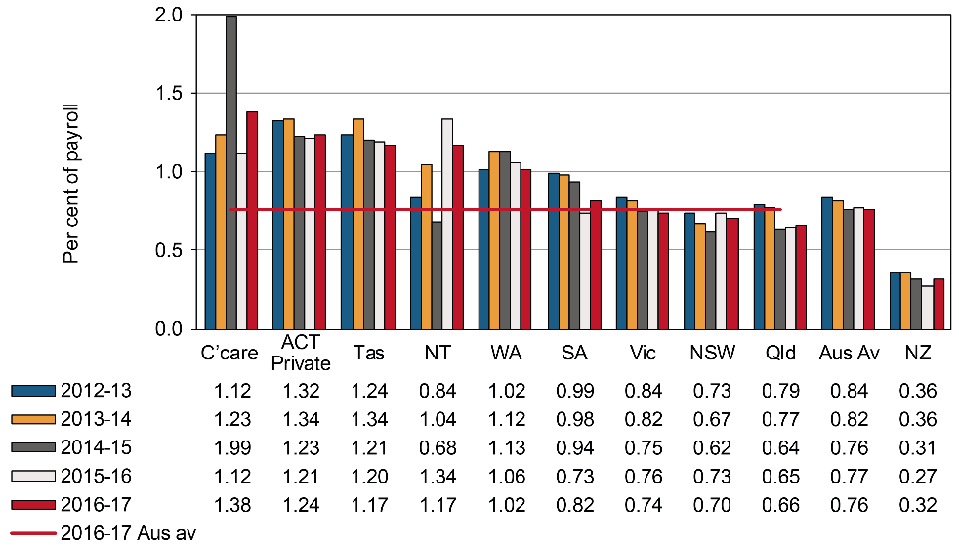

# Health and community services

Indicator 14o shows that the average Australian premium rate for the Health and community services industry has fallen by 1 per cent since 2015–16 to 1.47 per cent of payroll in 2016–17. The largest reduction in premium rate in 2016–17 compared to the previous year was seen in the Northern Territory (down 27 per cent). The Australian Government recorded a 16 per cent increase in its premium rate for this industry in 2016–17. Queensland had the lowest premium rate (0.93 per cent of payroll) in 2016–17 and the Australian Government had the highest (2.76 per cent of payroll).

New Zealand had an 18 per cent increase in the 2016–17 premium rates compared to 2015–16.

Indicator 14o – Standardised premium rates for Health and community services by jurisdiction

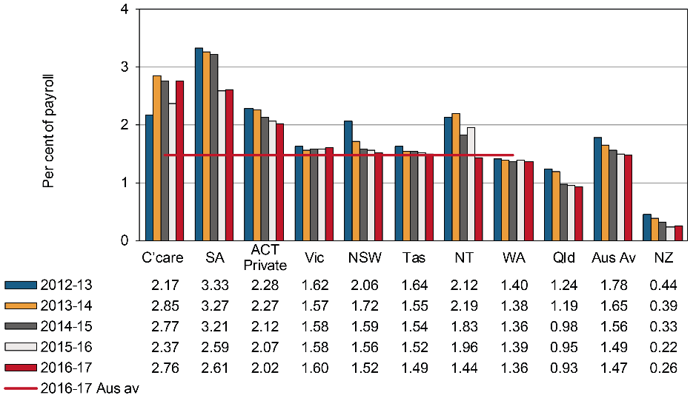

# Cultural and recreational services

Indicator 14p shows that in 2016–17, five out of nine Australian jurisdictions recorded an increase in their premium rates compared to the previous year. The Australian average premium rate for this industry was 1.21 per cent of payroll during the current year, which was a 4 per cent increase compared to 2015–16. The Northern Territory recorded the largest increase in its premium rates for this industry in 2016–17 compared to the previous year (up 63 per cent), followed by the Australian Capital Territory (up 27 per cent), then New South Wales (up 12 per cent).

New Zealand showed an increase in premium rate from 0.52 per cent of payroll in 2015–16 to 0.61 per cent of payroll in 2016–17 (an increase of 17 per cent).

Indicator 14p – Standardised premium rates for Cultural and recreational services by jurisdiction

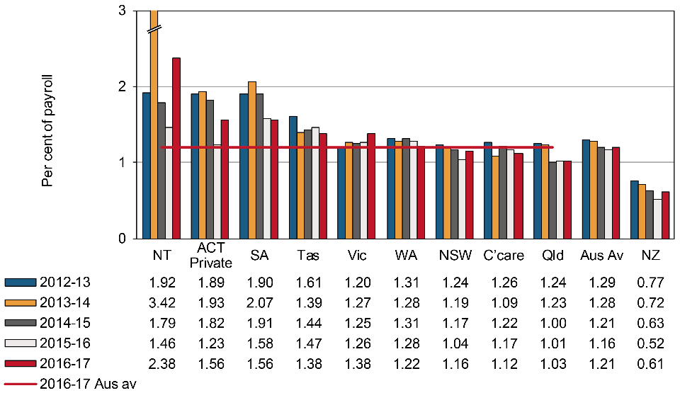

# Personal and other services

Indicator 14q shows that there was a 1 per cent increase in the Australian average premium rate in the Personal and other services industry in 2016–17 compared to the previous year. The Australian Capital Territory recorded the largest decrease in premium rate over the year (down 23 per cent), followed by Tasmania (down 11 per cent). The highest premium rate was recorded by the Australian Government (3.61 per cent of payroll) and the lowest by Queensland (0.95 per cent of payroll).

New Zealand recorded a premium rate of 0.87 per cent of payroll in 2016–17, 18 per cent higher than that in the previous year.

Indicator 14q – Standardised premium rates for Personal and other services by jurisdiction

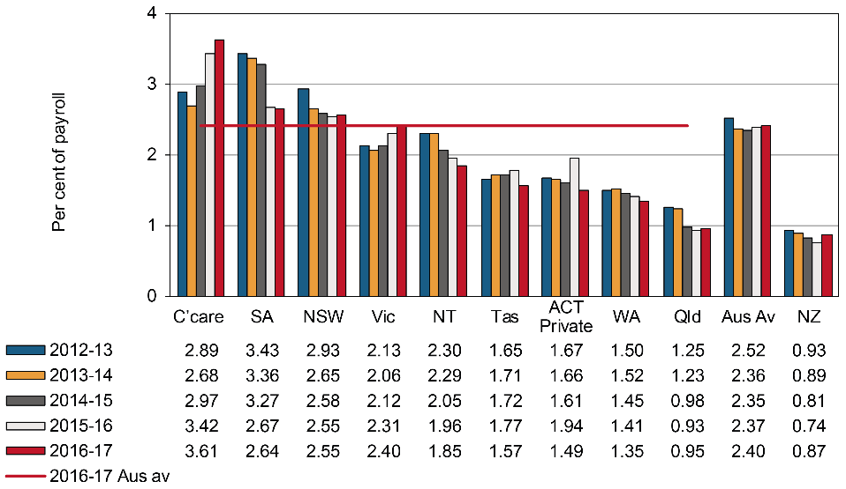

1. Entitlements under workers’ compensation

Entitlements are payable under workers’ compensation in the event an employee is injured or develops a work-related disease. Different entitlement levels across the jurisdictions can explain some of the differences in premium rates. Premium rates are set at a level to ensure sufficient funds are available to cover these entitlements.

The following examples have been included to provide indicative entitlements payable in each jurisdiction. A brief summary of how entitlements are calculated is contained in Appendix 2 – Table 2: Weekly entitlements under Australian workers’ compensation schemes for award wage earners as at   
1 January 2017. These entitlements are based on legislation current at 1 January 2017. More detailed information can be found in the *Comparison of Workers’ Compensation Arrangements in Australia and New Zealand* publication on the [Safe Work Australia](https://www.safeworkaustralia.gov.au/doc/comparison-workers-compensation-arrangements-australia-and-new-zealand-2018) website.

Data provided in other chapters of this report should also be considered when comparing entitlements provided under the various workers’ compensation schemes.

Temporary impairment

Impairment is assessed as temporary when a loss, loss of use, or derangement of any body part, organ system or organ function is not likely to continue indefinitely and the injured employee remains unable to work for a period of time then returns to previous duties on a full-time basis. This example details how jurisdictions compensate low, middle and high income[1] employees during selected periods of temporary impairment. Entitlements for an injured employee are shown in the following table using pre-injury earnings of $950 gross per week, $1,600 gross per week and $2,200 gross per week. These profiles have been chosen to highlight the statutory maximum entitlements payable, as well as jurisdictional differences in entitlements to workers employed on different income levels.

**Scenario**

The employee remains unable to work for a period of time before returning to their previous duties on a full-time basis. The employee has a dependant spouse and two children (aged 7 and 8). The employee injured their back and has lower back strain as a result.

Indicator 15 shows that for low income earners, Queensland and Western Australia provided full coverage (100 per cent) of pre-injury earnings for 104 weeks of impairment. After the 13th week of compensation, the Western Australian scheme does not compensate low income workers for overtime and bonuses and a 15 per cent reduction in weekly payments applies for higher income workers. The Tasmanian and Northern Territory schemes provided the second highest percentage (93 per cent) of pre‑injury earnings in compensation at 104 weeks of incapacity for low income earners, followed by South Australia (90 per cent) and Comcare (86 per cent). The Australian Capital Territory provided the lowest percentage of pre-injury earnings for 104 weeks of impairment (78 per cent) due in part to the step-down[2] in benefits to 65 per cent of pre-injury earnings after 26 weeks of compensation (see Appendix 2 – Table 2 for more details).

For middle income earners with 104 weeks of impairment, Tasmania provided the highest percentage of pre-injury earnings (93 per cent), followed by South Australia (90 per cent), Western Australia (87 per cent) and Comcare (86 per cent). The Australian Capital Territory provided the lowest percentage of pre-injury earnings for the full period of impairment (74 per cent).

In contrast to the low income scenario, where seven of the nine Australian jurisdictions provided full income protection for the first 26 weeks, only five jurisdictions provided full income protection for middle and high income earners for this period of incapacity.

New Zealand provided the same percentage (80 per cent) of pre-injury earnings regardless of income level or weeks of incapacity.

Indicator 15 – Average percentage of pre-injury earnings for selected periods of incapacity, as at 1 January 2017

| Level of pre-injury income | NSW | Vic | Qld | WA | SA | Tas | NT | ACT | Comcare | NZ |
| --- | --- | --- | --- | --- | --- | --- | --- | --- | --- | --- |
| 13 weeks of incapacity |  |  |  |  |  |  |  |  |  |  |
| Low income | 95 | 95 | 100 | 100 | 100 | 100 | 100 | 100 | 100 | 80 |
| Middle income | 95 | 95 | 85 | 100 | 100 | 100 | 100 | 100 | 100 | 80 |
| High income | (a)94 | 95 | 85 | 100 | 100 | 100 | 100 | 100 | 100 | 80 |
| 26 weeks of incapacity |  |  |  |  |  |  |  |  |  |  |
| Low income | 88 | 88 | 100 | 100 | 100 | 100 | 100 | 100 | 100 | 80 |
| Middle income | 88 | 88 | 85 | 93 | 100 | 100 | 100 | 100 | 100 | 80 |
| High income | (a)87 | 88 | 85 | 93 | 100 | 100 | 100 | 100 | 100 | 80 |
| 52 weeks of incapacity |  |  |  |  |  |  |  |  |  |  |
| Low income | 84 | 84 | 100 | 100 | 100 | 95 | 95 | 85 | 97 | 80 |
| Middle income | 84 | 84 | 80 | 89 | 100 | 95 | 88 | 83 | 97 | 80 |
| High income | (a)83 | 84 | 80 | 89 | 100 | 95 | 88 | 83 | 97 | 80 |
| 104 weeks of incapacity |  |  |  |  |  |  |  |  |  |  |
| Low income | 82 | 82 | 100 | 100 | 90 | 93 | 93 | 78 | 86 | 80 |
| Middle income | 82 | 82 | 78 | 87 | 90 | 93 | 81 | 74 | 86 | 80 |
| High income | (a)82 | 82 | (b)78 | (c)87 | 90 | 93 | 81 | (d)74 | 86 | 80 |

Maximum weekly payment is capped at $2,058.10 as at 1 January 2017. The level of pre-injury income for a high income earner will vary depending on the proportion of their pre-injury average weekly earnings to the maximum weekly payment.

In Queensland workers are paid a proportion of their normal weekly earnings (NWE) or a percentage of the original series amount of Queensland full time adult persons ordinary time earnings (QOTE) (i.e. 0 to 26 weeks – 85 per cent NWE or Award; 26 to 104 weeks – 75 per cent NWE or 70 per cent QOTE). The percentages are calculated on the higher amounts of the two possible payments.

In Western Australia there is a cap on weekly earnings set at twice the annual Average Weekly Earnings (WA) as published by the ABS each year. The weekly cap as at 1 January 2017 was $2,666.80 and applied to all income levels. The prescribed amount for weekly payments is $221,891.

1. In the Australian Capital Territory a statutory floor applies after 26 weeks of total incapacity in this example. Statutory floor means the national minimum wage set by Fair Work Australia under the Fair Work Act 2009 (Cwlth). National minimum wage as at 1 January 2017 is $672.70 ($17.70 per hour).

Permanent impairment

Impairment is assessed as permanent when it has reached maximal medical improvement. Maximal medical improvement is defined as a condition or state that is well stabilized and unlikely to change over the next year, with or without medical treatment. Over time, there may be some change; however, further recovery or deterioration is not anticipated.

This scenario shows the entitlements payable for a degree of permanent impairment caused by a workplace injury. Each jurisdiction has a predetermined statutory maximum lump sum payment for injuries causing permanent impairment. Maximum amounts are payable in cases of full permanent impairment. Appendix 2 – Table 3 lists entitlements under workers’ compensation schemes for each jurisdiction. The following scenario is indicative only for these types of payments.

**Scenario**

As a result of a workplace incident the employee was diagnosed with complete tetraplegia below the 6th cervical neurological segment. This resulted in paralysis of his hands, impaired upper body movement and paralysis of the trunk and lower limbs. He lost all lower body function and was wheelchair-bound. Impairment was total and permanent and there was no real prospect of returning to work.

The employee’s pre-injury earnings were $1,600 gross per week. The employee is 35 years of age and has a dependant spouse and two children aged 7 and 8. The younger child entered the workforce at 16 and the older child remained in full-time education until age 25. The employee contributed to a superannuation fund. There was no contributory negligence on his part; however there was negligence on the part of the employer.

Indicator 16 details the entitlements payable to the injured employee. The statutory component includes the weekly benefits payable for the remainder of the employee’s working life. Note that weekly payments in the New South Wales workers’ compensation scheme may be paid up to one year after retirement age (30 years in this instance assuming retirement age is 65) and all lump sum payments for permanent impairment. The common law component is an estimate of the additional payment available under a common law settlement, where applicable. All figures exclude medical and like services such as attendant care. Appendix 2 – Table 1: Key features of Australian workers’ compensation schemes as at 1 January 2017, identifies the jurisdictions that have access to common law. In the Australian Capital Territory common law awards regularly exceed the statutory entitlement for equivalent injuries, therefore the recovery provisions are always less than the common law payments. The Courts are able to consider permanent impairment and loss of earnings very broadly and without restriction, and frequently make awards on the basis of possible foregone career progression. The damage amounts can far exceed the limited and capped statutory entitlements.

In Western Australia, New South Wales, Queensland, Tasmania and the Australian Capital Territory there is no upper limit on damages that could be expected from a common law claim under this scenario. The Australian Capital Territory did not provide a figure for this scenario. Western Australia provided a figure of $3,998,480 which is based on the average of the five highest common law payments for claims finalised between 2012–13 and 2016–17. Queensland provided a figure of $1,451,690, which is based on an example similar to this scenario.

In Victoria the common law cap applicable at 1 January 2017 is $1,944,010 comprising of a maximum for pain and suffering cap of $589 650 and a pecuniary loss cap at $1,354 360. Statutory benefits received are deducted from common law damages awarded. After any common law settlement, medical and like expenses continue to be paid.

The South Australian scheme is limited to statutory compensation. In South Australia legislative changes that occurred in July 2015 resulted in a significant increase in the maximum lump sum amount payable to workers who suffer a permanent serious injury or illness. This amount was $493,393 in 2016−17. The South Australian system is weighted so that more compensation is paid to those with moderate to severe permanent injuries, rather than those with minor permanent injuries.

In the Comcare scheme, the maximum Lump sum payable is up to $183,035 plus up to $68,638 for non-economic loss. There is no cap on common law in the Australian government scheme.

The entitlements provided by the New Zealand scheme in this scenario are comparable to those provided by Australian jurisdictions. However, there is no access to common law under the New Zealand scheme.

Workplace fatality

This example examines the entitlements payable to dependants of an employee who died as a result of a work‑related injury. Entitlements to dependants are paid by way of a lump sum and/or weekly benefits, depending on the employee’s circumstances and scheme design.

Pecuniary entitlements may be affected by common law payments in jurisdictions where there is access to common law redress. South Australia and the Northern Territory have no access to common law, while the Australian Government has limited access to common law. In Victoria there may be access to an additional lump sum under the Wrongs Act 1958 (Wrongs Act)*,* which is the main legislation in Victoria that applies to common law claims for damages for personal injury in cases other than workplace injuries or transport accidents.

**Scenario**

The employee and family circumstances in this scenario are the same as in the previous example, but in this case the workplace incident resulted in death on 1 January 2016. The spouse did not re-enter the workforce or re-marry for 10 years.

Indicator 16 shows that total entitlements payable to dependants in the case of a fatality varied across jurisdictions. New South Wales provided the highest entitlement payable to dependants in Australia following a workplace incident resulting in a fatality at the amount of $922,492, followed by South Australia and Queensland at $867,794 and $835,366, respectively. The lowest entitlements for a fatality were provided in the Australian Capital Territory ($310,075) and Western Australia ($370,651). Appendix 2 – Table 3 provides more details on how these entitlements are calculated.

In Victoria, legislative changes that were enacted from April 2010 increased lump sum amounts payable from $273,970 to $503,000 backdated for all claims not determined from 10 December 2009. The lump sum amount increased to $831,970 in 2016–17.

In the Comcare scheme, benefits under the Safety, Rehabilitation and Compensation (SRC) Act were amended with lump sum payments (includes both death and permanent impairment payments) set at $724,907 in 2016–17.

In New Zealand, $771,975 is payable to dependants, which is higher than all but four Australian jurisdictions. The New Zealand scheme provides little in the way of lump sum amounts but provides high weekly benefits to the spouse and children while the children remain dependants.

Indicator 16 – Entitlements for permanent incapacity or fatality as at 1 January 2017

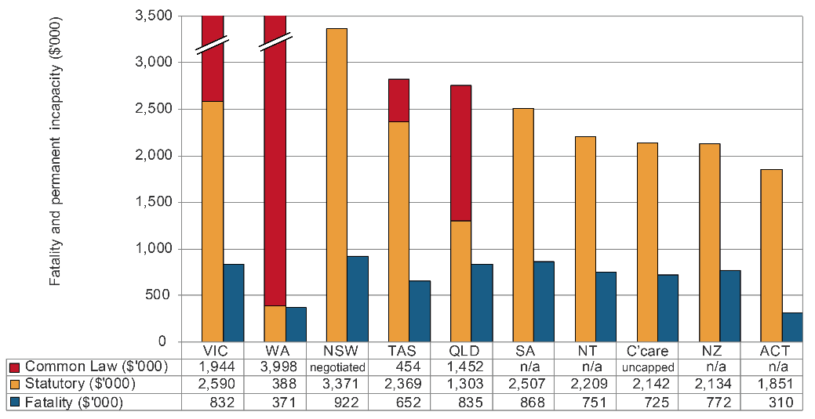

Notes:

New South Wales workers’ compensation arrangements allow workers with 15% or more WPI to sue for modified common law damages only - these are known as work injury damages. Workers are limited to recovering past and future economic loss only. There is no upper limit on compensation that can be paid for a work injury damages claim. The figure provided by NSW is based on the following assumptions: legislation as at 1 January 2017; the worker does not have access to other heads of damages (e.g. motor vehicle accident or civil liability claim); the worker has no residual earning capacity; assume a settlement date of 01 January 2017. When a worker successfully recovers damages, the worker is liable to repay out of those damages the amount of weekly compensation that a person has already been paid in respect of the injury.

In Queensland there is no upper limit on compensation that could be paid for a common law claim. The amount provided is based on an example. The common law additional amount excludes all statutory payments made and the estimated proportion of the lump sum payment attributed to medical and carer services (only one payment is made to the worker).

In the Australian Capital Territory, common law is uncapped so an amount is unable to be determined.

In Western Australia, a cap on common law benefits applies for injuries with more than 15 per cent to less than 25 per cent whole of person impairment (WPI). The cap amount is $465,974. However, in this example no common law cap would apply as the impairment would likely exceed the 25 per cent or more WPI threshold. The figure provided ($3,998,480 excluding medical and carer costs) is based on the average of the five highest common law payments for claims finalised between 2012–13 and 2016–17. It should be noted that weekly benefits and common law payments are not mutually exclusive. Common law payments are inclusive of weekly benefits, therefore, any statutory entitlements received would be deducted from the amount ordered at the common law claim. In Victoria the pain and suffering maximum is $577,050, less any sum received as a statutory lump sum. For pecuniary loss the maximum amount is $1,325,390 less any amount received in weekly benefits prior to settlement plus tax paid on the weekly benefits received.

1. Workers’ compensation scheme performance

There are significant differences in the funding arrangements for the various schemes around Australia. The schemes that are fully centrally funded (New South Wales, Victoria, Queensland, South Australia, the Australian Government and New Zealand) have both their work health and safety and workers’ compensation functions, and staffing and operational budgets funded by premiums. For those jurisdictions with privately underwritten schemes, funding for non-workers’ compensation functions comes directly from government appropriation. This difference in funding arrangements may have an impact on the data shown in this section.

Assets to liabilities ratio

This section reports the standardised ratio of assets to net outstanding claim liabilities (funding ratio) for each jurisdiction over the past five years. This indicator is a measure of the adequacy of the scheme to meet future claim payments. Ratios above 100 per cent indicate that the scheme has more than sufficient assets to meet its predicted future liabilities. Conversely, low ratios could be an indication of the need for a scheme to increase its premium rates to ensure that assets are available for future claim payments. Funding ratio trends should therefore be considered in conjunction with the premium rates reported elsewhere in this report.

Self-insurers are employers who are allowed by jurisdictions to self-insure for workers’ compensation where they manage and pay for their employees’ claims for work-related injuries, rather than paying premiums to insurers to take on these responsibilities. Self-insurers are excluded from the funding ratio measures as the workers’ compensation assets and liabilities are not quarantined from the rest of the self-insurer’s business. Self-insurers are regulated in each jurisdiction and are required to lodge financial guarantees with the regulatory authority to provide security for workers’ compensation entitlements. The level of guarantee varies between jurisdictions. A summary of the current requirements can be found in the *Comparison of Workers’ Compensation Arrangements in Australia and New Zealand* on the [Safe Work Australia](https://www.safeworkaustralia.gov.au/doc/comparison-workers-compensation-arrangements-australia-and-new-zealand-2016) website.

The data shown in this indicator may differ from jurisdictions’ annual reports due to the use of standard definitions of assets and liabilities. While a standard definition of the funding ratio of net outstanding claim liabilities has been adopted to improve comparability across jurisdictions, fundamental differences remain between centrally funded and privately underwritten schemes.

Insurers in privately underwritten schemes are governed by the Australian Prudential Regulatory Authority’s prudential regulatory requirements to make sure that enough funds are available to cover all liabilities. Including the measure for privately underwritten schemes alongside centrally funded schemes can be misleading because the funding ratio measure for privately underwritten schemes does not capture the true extent of the private schemes’ abilities to meet future claim payments. Therefore, the funding ratios of privately underwritten schemes are shown on a separate graph to those for the centrally funded schemes.

Indicator 17 shows that the average funding ratio for centrally funded schemes was 136 per cent in   
2016–17, a 2 per cent increase from the previous year. Except for New South Wales, all centrally funded schemes recorded an increase in funding ratios compared to the previous year. All centrally funded schemes have funding ratios above 100 per cent, indicating that assets are sufficient to meet future liabilities in these jurisdictions. The Australian Government funding ratio for 2016–17 increased by 21 per cent compared to the previous year. New South Wales recorded a seven per cent decrease in its funding ratio compared to the previous year.

In New Zealand, the funding ratio (189 per cent) increased by 4 per cent when compared to the previous years.

Indicator 17 – Standardised ratio of assets to net outstanding claim liabilities for centrally funded (CF) schemes

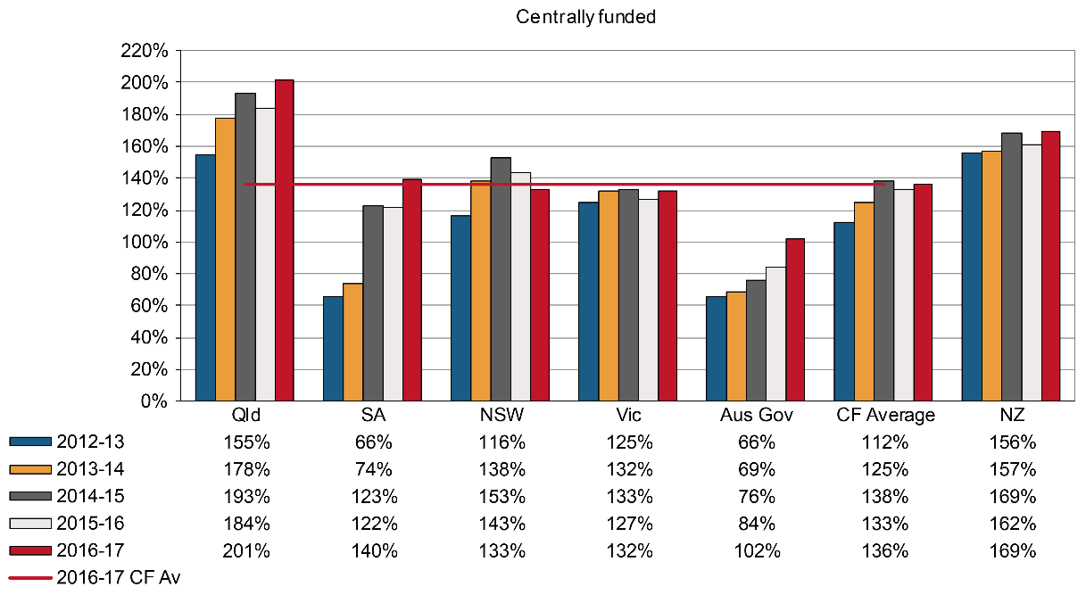

Indicator 18 shows that in 2016–17 the average funding ratio for privately underwritten schemes was 116 per cent, unchanged from the previous year. Tasmania recorded the only increase in funding ratio (up 4 per cent increase), while the Northern Territory recorded the largest decrease (down 6 per cent).

Seacare and the Australian Capital Territory schemes are privately underwritten, but no data are currently available for this Indicator.

Indicator 18 – Standardised ratio of assets to net outstanding claim liabilities for privately underwritten (PU) schemes

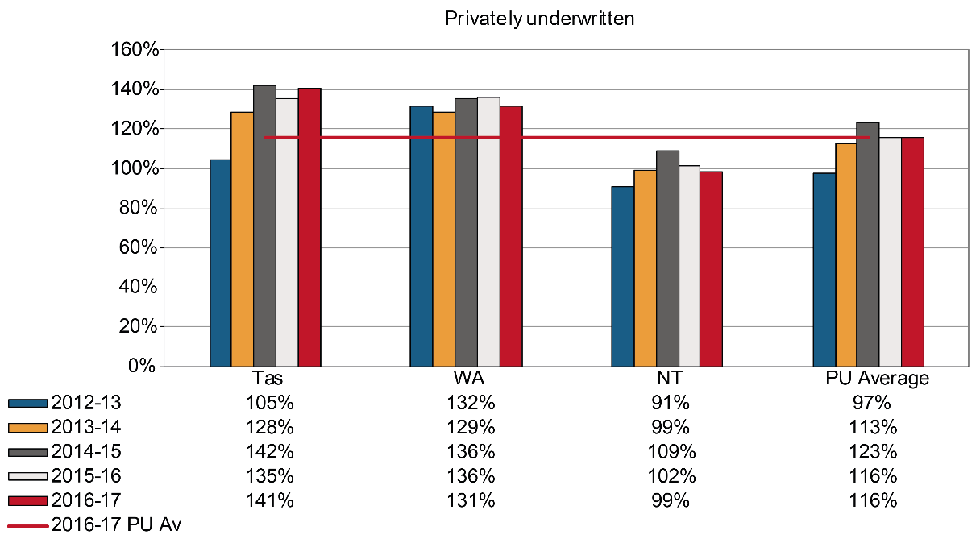

Scheme expenditure

Indicator 19 shows the amount and proportion of total scheme expenditure paid out to injured workers, plus administrative costs, for the periods 2012–13 and 2016–17. Since centrally funded and privately underwritten schemes have different financial structures, for this indicator the jurisdictions are shown in their respective funding arrangement group. While the standardisation methodology provides a comparable measure across the two groups, caution should still be exercised when making such comparisons.

Readers should be aware that an amendment has been made to two of the formulae underpinning this indicator to better align the distribution of the scheme expenditure with the scope definition. These adjustments have resulted in a slight increase in the proportion of payments as services to workers, while the proportion of costs to insurance operations decreased.

Total scheme expenditure across Australia increased by 3 per cent over the period from 2012–13 to 2016–‑17. All jurisdictions except New South Wales (down 4 per cent), Queensland (down 3 per cent), the Australian Government (down 13 per cent) and Seacare (down 29 per cent) recorded increases in their total expenditure during the same period. The largest percentage increase was recorded by Western Australia (up 15 per cent), followed by Victoria (up 13 per cent), the Northern Territory (up 11 per cent) and South Australia (up 6 per cent).

Payments direct to workers increased by 1 per cent over the five years and accounted for 51 per cent of total expenditure in 2016–17. Direct compensation is paid to injured employees either as weekly benefits, redemptions, common law settlements (excluding legal costs), and non-economic loss benefits. Three jurisdictions recorded increases in expenditure on payments direct to workers ranging from 20 per cent in Western Australia to 15 per cent in Victoria and Tasmania. The rest of the jurisdictions recorded slight decreases in payments direct to workers between 2012–13 and 2016−17.

Expenses paid to workers as other administration and services recorded the largest percentage increase in expenditure of all cost items (up 66 per cent) between 2012–13 and 2016–17.

Dispute resolution expenses recorded the second largest percentage increase in expenditure of all the cost items (up 62 per cent), with all jurisdictions recording increases except the Australian Government (down 13 per cent) and Seacare where no expenditure spent on dispute resolution in 2016−17 compared to 0.6 million dollars spent in 2012–13.

Costs associated with total expenses for insurance operations recorded decreases in most jurisdictions, ranging between 29 per cent for Seacare and 5 per cent in New South Wales. South Australia recorded a 59 per cent increase in total expenses for insurance operations, followed by the Northern Territory   
(31 per cent increase). Increases in expenditure on other administration were also seen in most of the jurisdictions.

Services to claimants’ expenses increased 6 per cent over the five years and accounted for 29 per cent of total expenses in 2016–17. Five out of nine jurisdictions recorded increases in the total expenses for services to claimants with the highest increase in the Northern Territory (up 36 per cent). Seacare recorded the largest decrease (down 27 per cent) in expenditure as services to claimants over the five year period. Costs associated with services to claimants include expenditures for medical and legal services plus expenditures for other services like funeral, interpreting and transport services.

New Zealand proportions have a different pattern to the Australian schemes with a lower proportion in direct to claimant expenditure and a higher proportion in services to claimant expenditure. This is due to the nature of the New Zealand scheme, where a greater proportion of workers’ medical costs are identified as work-related.

Indicator 19 – Scheme expenditure

|  |  |  |  |  |  |  |  |  |  |  |  |
| --- | --- | --- | --- | --- | --- | --- | --- | --- | --- | --- | --- |
| **Expenditure ($M)** | **Centrally funded** | | | | | **Privately underwritten** | | | | **Total** | |
| **Scheme costs** | **NSW** | **Vic** | **Qld** | **SA** | **Aus Gov** | **WA** | **Tas** | **NT** | **Seacare** | **Australia** | **NZ** |
| **2012–13** |  |  |  |  |  |  |  |  |  |  |  |
| Direct to claimant | 1,187.2 | 1,017.4 | 874.2 | 273.9 | 185.5 | 531.9 | 68.4 | 59.7 | 14.8 | 4,213.0 | 203.0 |
| Services to claimant | 819.5 | 560.8 | 268.5 | 164.9 | 94.3 | 278.9 | 42.9 | 28.9 | 3.0 | 2,261.6 | 154.5 |
| Insurance operations | 427.7 | 281.1 | 116.4 | 48.9 | 28.9 | 206.4 | 24.0 | 1.3 | 2.1 | 1,136.9 | 36.4 |
| Regulation | 39.9 | 53.8 | 9.1 | 8.7 | 1.7 | 4.8 | 1.8 | 0.0 | 0.0 | 119.2 | 20.3 |
| Dispute resolution | 30.3 | 31.3 | 13.1 | 6.2 | 4.0 | 4.0 | 1.1 | 0.5 | 0.6 | 91.0 | 0.0 |
| Other administration | 16.6 | 31.5 | 41.0 | 28.9 | 27.0 | 8.9 | 0.7 | 1.3 | 0.3 | 156.3 | 39.4 |
| **Total** | **2,521.1** | **1975.8** | **1322.3** | **531.5** | **341.4** | **1,034.5** | **138.9** | **91.7** | **20.9** | **7,978.2** | **453.5** |
| **2016–17** |  |  |  |  |  |  |  |  |  |  |  |
| Direct to claimant | 1,089.3 | 1,167.6 | 827.9 | 214.3 | 157.6 | 637.9 | 78.6 | 58.8 | 10.6 | 4,242.7 | 307.2 |
| Services to claimant | 807.2 | 666.2 | 294.9 | 149.5 | 86.7 | 307.5 | 44.2 | 39.4 | 2.2 | 2,398.0 | 216.2 |
| Insurance operations | 404.7 | 265.1 | 94.9 | 77.8 | 24.9 | 222.0 | 25.6 | 1.7 | 1.5 | 1,118.2 | 57.4 |
| Regulation | 13.5 | 41.7 | 11.1 | 6.1 | 2.4 | 4.6 | 2.3 | 0.0 | 0.0 | 81.5 | 26.4 |
| Dispute resolution | 81.5 | 35.7 | 13.7 | 6.2 | 3.5 | 4.9 | 1.1 | 0.6 | 0.0 | 147.3 | 0.0 |
| Other administration | 14.1 | 60.3 | 44.0 | 108.3 | 20.8 | 9.0 | 1.5 | 1.7 | 0.7 | 260.3 | 38.0 |
| **Total** | **2,410.3** | **2,236.6** | **1,286.5** | **562.2** | **295.9** | **1,185.9** | **153.4** | **102.2** | **14.9** | **8,247.8** | **645.1** |

Indicator 19 – Scheme expenditure (continued)

| **Percentage of total expenditure (%)** | **Centrally funded** | | | | | **Privately underwritten** | | | | **Total** | |
| --- | --- | --- | --- | --- | --- | --- | --- | --- | --- | --- | --- |
| **Scheme costs** | **NSW** | **Vic** | **Qld** | **SA** | **Aus Gov** | **WA** | **Tas** | **NT** | **Seacare** | **Australia** | **NZ** |
| **2012–13** |  |  |  |  |  |  |  |  |  |  |  |
| Direct to claimant | 47.1 | 51.5 | 66.1 | 51.5 | 54.3 | 51.4 | 49.3 | 65.1 | 70.7 | 52.8 | 44.8 |
| Services to claimant | 32.5 | 28.4 | 20.3 | 31.0 | 27.6 | 27.0 | 30.9 | 31.5 | 14.2 | 28.3 | 34.1 |
| Insurance operations | 17.0 | 14.2 | 8.8 | 9.2 | 8.5 | 20.0 | 17.3 | 1.4 | 10.3 | 14.3 | 8.0 |
| Regulation | 1.6 | 2.7 | 0.7 | 1.6 | 0.5 | 0.4 | 1.3 | 0.0 | 0.2 | 1.5 | 4.5 |
| Dispute resolution | 1.2 | 1.6 | 1.0 | 1.2 | 1.2 | 0.4 | 0.8 | 0.6 | 3.0 | 1.1 | 0.0 |
| Other administration | 0.7 | 1.6 | 3.1 | 5.4 | 7.9 | 0.9 | 0.5 | 1.4 | 1.6 | 2.0 | 8.7 |
| **Total** | **100.0** | **100.0** | **100.0** | **100.0** | **100.0** | **100.0** | **100.0** | **100.0** | **100.0** | **100.0** | **100.0** |
| **2016–17** |  |  |  |  |  |  |  |  |  |  |  |
| Direct to claimant | 45.2 | 52.2 | 64.3 | 38.1 | 53.3 | 53.8 | 51.2 | 57.5 | 71.2 | 51.4 | 47.6 |
| Services to claimant | 33.5 | 29.8 | 22.9 | 26.6 | 29.3 | 25.9 | 28.8 | 38.6 | 14.6 | 29.1 | 33.5 |
| Insurance operations | 16.8 | 11.9 | 7.4 | 13.8 | 8.4 | 18.7 | 16.7 | 1.7 | 9.8 | 13.6 | 8.9 |
| Regulation | 0.6 | 1.9 | 0.9 | 1.1 | 0.8 | 0.4 | 1.5 | 0.0 | 0.0 | 1.0 | 4.1 |
| Dispute resolution | 3.4 | 1.6 | 1.1 | 1.1 | 1.2 | 0.4 | 0.7 | 0.5 | 0.0 | 1.8 | 0.0 |
| Other administration | 0.6 | 2.7 | 3.4 | 19.3 | 7.0 | 0.8 | 1.0 | 1.7 | 4.4 | 3.2 | 5.9 |
| **Total** | **100.0** | **100.0** | **100.0** | **100.0** | **100.0** | **100.0** | **100.0** | **100.0** | **100.0** | **100.0** | **100.0** |

Administrative costs are affected by the type of scheme in operation. Indicator 20 shows the distribution of direct payments into weekly benefits and lump sums. The payment of long-term weekly benefits results in higher administration costs. This indicator shows that in 2016–17, all but two Australian schemes paid out more as weekly benefits than lump sum benefits. Queensland and Tasmania are the only jurisdictions which paid out more in lump sum payments than in weekly benefits.

Overall in Australia in 2016–17, a smaller proportion (down 11 per cent) of benefits were paid as a lump sum compared to the previous year, with six out of the nine jurisdictions recording decreases in the proportion paid as lump sums. The proportion of benefits paid as a lump sum by the New Zealand scheme decreased by 22 per cent compared to the previous year. However, the New Zealand scheme has little provision for lump sum payments.

Indicator 20 – Direct compensation payments by type and jurisdiction, 2016–17

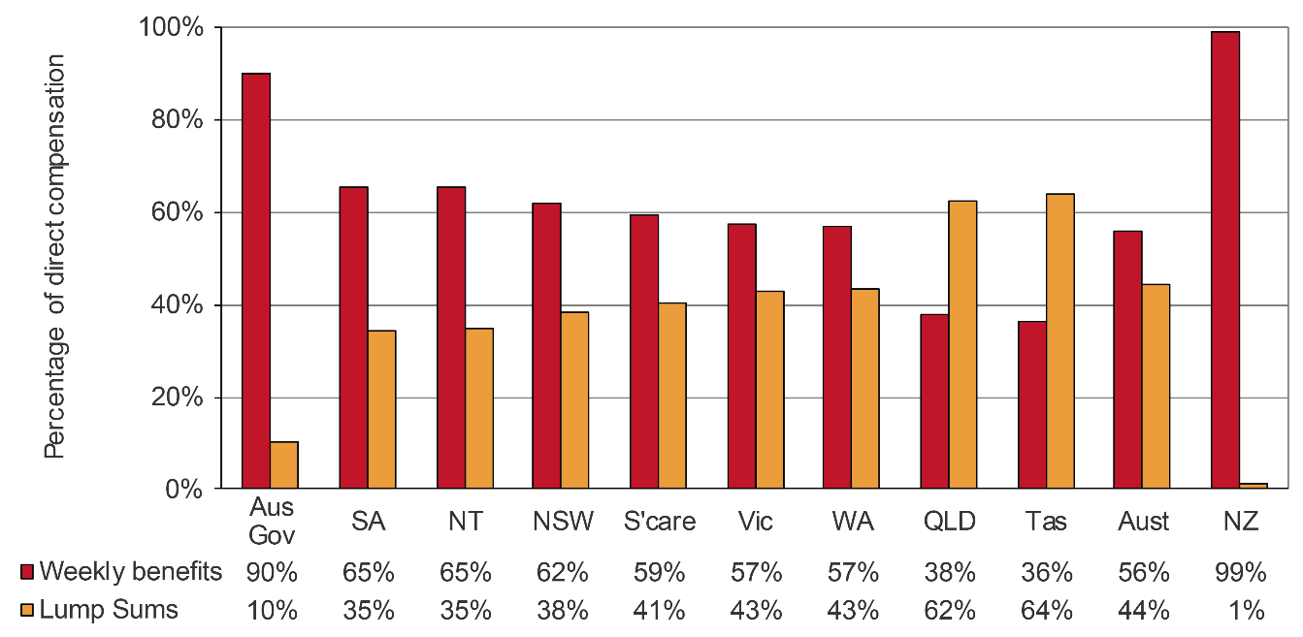

Current return to work

This section reports on the current return to work rates compiled from data published in the Return to Work Survey Report commissioned by Safe Work Australia.

The Return to Work Survey replaced the Return to Work Monitor that was produced by the Heads of Workers’ Compensation Authorities (HWCA). The current National Return to Work survey draws sample from the population of injured workers who:

* had at least one day away from work
* submitted a claim in the two years prior to the interview period
* had or did not have payment-related activity within 6 months prior to the sample being drawn
* worked in either premium paying (including own businesses) or self-insured organisations.

All Australian workers compensation authorities, except for South Australia, took part in the survey in 2018. The Australian Capital Territory participated for the first time in 2018.

The current return to work rate is based on Question C1 ‘Are you currently working in a paid job?’ and Question C7 ‘Can I just confirm, have you returned to work at any time since your workplace injury or illness?’ of the survey, with the rate referring to the proportion of injured workers who state ‘yes’ to both questions.

Current return to work rates reported here are for premium payers and self-insurers together, and are estimates based on a sample of the eligible population. Differences between and within jurisdictions should be interpreted with caution. More information on this aspect and the survey design can be found in Note 4 in Appendix 1.

Indicator 21 shows the current return to work rates by jurisdiction for the four surveys conducted in 2012, 2014, 2016 and 2018. Readers should note that this data represents a new series comprising both the balance and historic cohorts and should not be compared to results prior to 2012. In 2018, 82 per cent of Australian and 80 per cent of New Zealand injured workers from premium paying and self-insured organisations had returned to work and were working in a paid job at the time of the interview.

Indicator 21 – Current return to work rate for 2012, 2014, 2016 and 2018

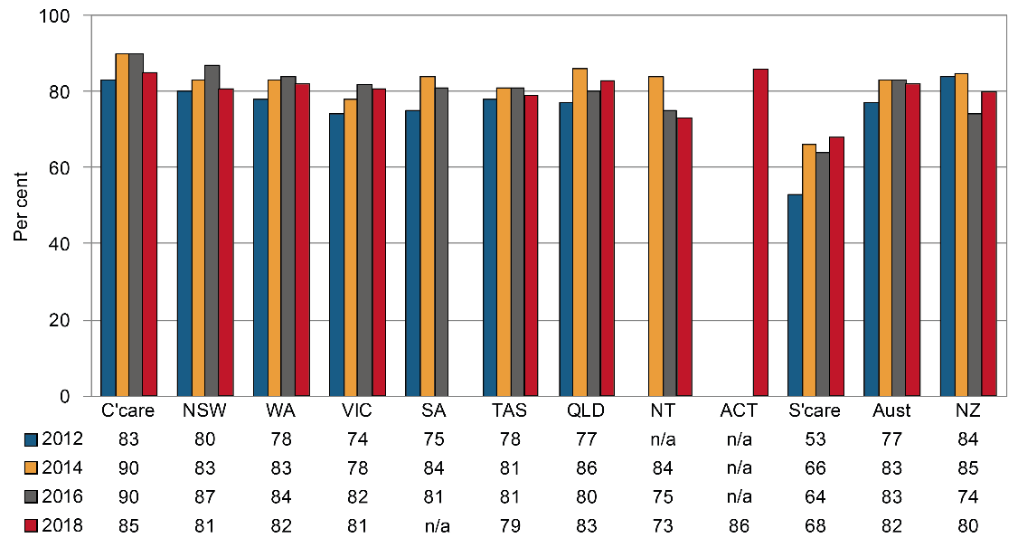

The current return to work rate in 2018 for Comcare (85 per cent), Queensland (83 per cent) and the Australian Capital Territory (86 per cent) was higher than the national rate. By contrast Victoria and New South Wales (81 per cent each), Tasmania (79 per cent), Seacare (68 per cent) and the Northern Territory (73 per cent), all recorded lower rates than the national average.

The current return to work rate increased for all jurisdictions who participated in the four biennial return to work surveys between 2012 and 2018. The rate fell in New Zealand during the same period.

The current return to work rate for Seacare is affected by legislation which requires a person to be certified medically fit to perform the normal on-board work tasks and duties of a seafarer.

Each jurisdiction faces varying challenges in their endeavors to improve return to work rates. Some drivers of return to work are defined by legislation and can only be influenced by the nature of the scheme design (whether it is short or long term in nature). For example, the benefit structure can influence return to work, as can the associated step down provisions and legislative differences regarding early claims reporting, employer obligations and common law arrangements.

Disputation rate

A dispute is an appeal to a formal mechanism, such as a review officer, conciliation or mediation service, against an insurer’s decision or decisions relating to compensation. Disputes exclude common law and also exclude redemptions and commutations unless processed as disputes through the jurisdiction’s dispute resolution system.

Indicator 22 shows the number of new disputes as a proportion of ‘active’ claims in the reference financial year. An active claim is described as any claim on which a payment of any type was made during the reference financial year (including claims with medical treatment costs only) regardless of when that claim was lodged.

The measure includes all disputes lodged for the year against any active claim that had any type of payment in the reference financial year. The comparison of disputation rates between jurisdictions must be treated with caution due to jurisdictional differences in scheme design, types of decisions that can be appealed, dispute resolution models and the cost of appeals.

Indicator 22 shows that while the Australian disputation rate (5.1 per cent of active claims) in 2016–17 has decreased by 19 per cent since 2012–13, the majority of Australian jurisdictions recorded increases in disputation rates during the five-year period. New South Wales recorded a substantial decrease (down 56 per cent) in its disputation rate since 2012–13, resulting in the 19 per cent decrease at the national level.

Indicator 22 – Proportion of claims with dispute

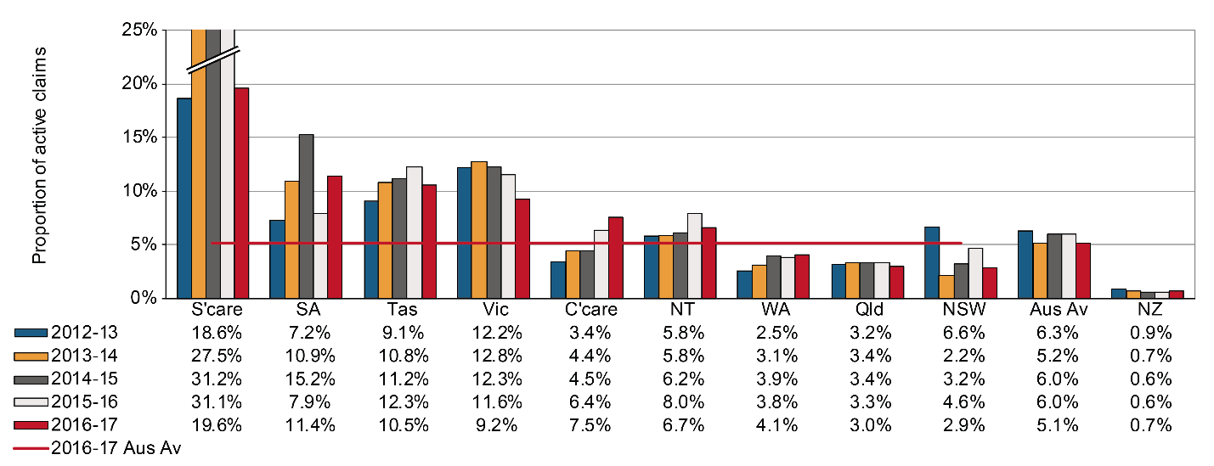

New South Wales recorded a substantial decrease (down 37 per cent) in its disputation rate in 2016–17 compared to the previous year. Dispute numbers (down 36 per cent from last year) were affected by the 2012 Workers’ Compensation System legislative amendments, which created two discrete dispute avenues for claimants. The new staged review model for work capacity decision (WCD) disputes enables a worker to seek an internal review by an insurer of the insurer’s WCD, potentially followed by a merit review by the State Insurance Regulatory Authority. Legal funding has been introduced for merit reviews. In addition, a worker may also then seek a procedural review by the Workers’ Compensation Independent Review Office, of the procedures used by the insurer in making the original WCD decision. The Workers’ Compensation Commission (WCC) retains jurisdiction over legally funded disputes involving claims liability, permanent impairment levels, and failure to commence provisional payments and approve medical procedures on time. In response to the legislative amendments in 2012, workers sought statutory reviews through the WCC in 2012–13 before the new WCD dispute process was introduced, causing a spike in the number of disputes lodged in that year.

South Australia showed a substantial increase (up 30 per cent) in the number of new disputes lodged in 2016-17 compared to 2015–16. The disputation rate for South Australia has recorded a 58 per cent increase during the five year period.

Western Australia recorded a disputation rate of 4.1 per cent in 2016–17. This represents an 8 per cent increase from 2015–16. Victoria recorded a 21 per cent increase in its disputation rate from the previous year. Comcare recorded a disputation rate of 7.5 per cent in 2016–17, a 17 per cent increase from the previous year.

New South Wales reported the lowest disputation rate of all the Australian jurisdictions at 2.9 per cent of active claims in 2016–17, followed by Queensland (3.0 per cent) and Western Australia (4.1 per cent). The disputation rate of Seacare in 2016–17 was the highest of all jurisdictions at 19.6 per cent of active claims, but this is substantially lower than the previous year (down by 37 per cent).

Recent increases in the Tasmanian disputation rate (up 15 per cent since 2012–13) can be partly attributed to provisions introduced into the Tasmanian legislation in 2010, including that all settlements occurring within two years of the date of the claim lodgment must be referred to the tribunal for approval and for all parties to notify the tribunal of a dispute in respect to injury management.

The New Zealand disputation rate is very low (0.7 per cent) because of the universal nature of its accident compensation scheme. Since people are covered whether the incident occurs at work, home, on the road, playing sport and whether they are employed, self-employed or a non-earner (child, pensioner, student, unemployed) there are very few disputes relating to cover.

Dispute resolution

The speed with which disputes are resolved depends on the systems and processes that are in place for each jurisdiction. Generally, the simpler the process, the faster the dispute is resolved. Where there is a lag in collection, exchange and lodgment of information by one or more parties, disputes are likely to be more adversarial and therefore more costly. A high percentage of disputes resolved in a longer time frame may also indicate that there are a high number of more complex disputes being dealt with within a jurisdiction, or that there are some mandatory medical or legal processes in place that inherently delay resolution.

Indicator 23 demonstrates that in the past five years in Australia there has been an increase (up 24 per cent) in the proportion of disputes resolved within one month.

The percentage of disputes resolved within three months increased by 25 per cent, and the percentage of disputes resolved within six months increased by 5 per cent, while the percentage of disputes resolved within nine months decreased by 1 per cent during this period.

In 2016–17, more than half the disputes (63 per cent) were resolved within three months of the date of lodgment on average in Australia. Queensland resolved the highest proportion of disputes within three months (81 per cent), followed by Western Australia (79 per cent), Tasmania (68 per cent) and Victoria (65 per cent).

Western Australia recorded decreases in the percentage of disputes resolved within one, three, six and nine months (down 12, 4, 5 and 3 per cent respectively).

With the exception of Seacare, Comcare disputes generally took more time to resolve than disputes in other jurisdictions. As Comcare disputes are referred to an external and independent body (Administrative Appeals Tribunal), it has minimal control over the associated time frames for dispute resolution. Disputes tend to be quite complex and require a long time to resolve. In line with this, Comcare recorded the second lowest proportion of disputes resolved for each of the four time periods in 2016–17. In addition, these proportions have improved over the four years to 2016–17 for one month and three month time periods.

While Seacare recorded a substantial increase in the proportion of disputes resolved within one month (up 147 per cent), it recorded decreases in the proportions of disputes resolved within three (down 4 per cent), six (down 8 per cent) and nine months (down 28 per cent). The time it takes to resolve applications in the seafarers’ jurisdiction is influenced by many factors, particularly the time needed by parties to obtain further evidence such as expert medical evidence as well as any delays associated with ensuring all related claims are before the Administrative Appeals Tribunal. The nature and complexity of the decisions under review will affect the time within which any agreed resolution can be reached or the applications can be progressed to hearing and determination. The number of applications made to the Administrative Appeals Tribunal is relatively small. Small changes in the number of cases finalised at particular times can result in relatively large percentage changes in the resolution rates within the specified time frames.

In 2016–17, Tasmania resolved 58 per cent of disputed claims within one month, which was substantially higher than any other jurisdiction. The proportion of disputes resolved within one month (58 per cent) and three months (68 per cent) in Tasmania were all higher than the Australian average for these two time periods. In 2016–17, Western Australia recorded dispute resolution rates higher than the Australian average in all four time periods.

In the New South Wales scheme, only 5 per cent of disputes were resolved within one month in 2016–17. However, increases were recorded in the New South Wales scheme for the long-term resolution rates within three, six and nine months (up 148 per cent, 28 per cent and 4 per cent respectively).

The resolution times for Victoria are affected by the compulsory conciliation process, which may or may not involve medical panel referral, and the fact that court litigation can only occur at the conclusion of the compulsory conciliation process. In 2016–17, Victoria recorded substantial increases in dispute resolution rates for one (up 57 per cent) and three months (up 11 per cent), but showed slight drop in these rates for 6 and 9 months (down 2 per cent each).

The proportion of disputes resolved in New Zealand is lower than the Australian average for the one and three month time periods but higher than the Australian average for the six and nine month time periods.

Indicator 23 – Percentage of disputes resolved within selected time periods (cumulative)

| **Jurisdiction\*\*** | **Within 1 month** | **Within 3 months** | **Within 6 months** | **Within 9 months** |
| --- | --- | --- | --- | --- |
| **2012–13** |  |  |  |  |
| New South Wales | 5.3 | 20.9 | 66.1 | 89.7 |
| Victoria | 9.5 | 59.0 | 84.2 | 92.7 |
| Queensland | 14.3 | 85.1 | 90.6 | 93.2 |
| Western Australia | 46.2 | 81.7 | 92.3 | 97.3 |
| Tasmania | 57.6 | 70.1 | 81.6 | 89.6 |
| Comcare | 3.8 | 13.7 | 29.6 | 47.7 |
| Seacare | 1.9 | 13.0 | 20.4 | 48.1 |
| **Australia** | **12.7** | **50.3** | **77.9** | **90.7** |
| New Zealand | 11.5 | 61.5 | 91.8 | 97.4 |
| **2016–17** |  |  |  |  |
| New South Wales | 4.5 | 51.9 | 84.7 | 92.9 |
| Victoria | 14.9 | 65.2 | 82.1 | 90.9 |
| Queensland | 9.2 | 81.2 | 95.6 | 97.2 |
| Western Australia | 40.6 | 78.5 | 87.6 | 94.5 |
| Tasmania | 57.7 | 67.5 | 78.4 | 85.8 |
| Comcare | 6.1 | 14.9 | 28.4 | 42.6 |
| Seacare | 4.7 | 12.5 | 18.8 | 34.4 |
| **Australia** | **15.8** | **63.1** | **81.8** | **89.6** |
| New Zealand | 13.7 | 54.8 | 89.9 | 96.4 |

** South Australia and the Northern Territory cannot supply data on the time required to resolve disputes.

1. Appendix 1 — Explanatory notes

Premium rates and entitlements

Issues affecting the comparability of premium rates across the schemes include:

* differences in benefits and coverage for certain types of injuries, in particular the coverage of the journey to and from work
* differences in claims management arrangements
* variations in the funding arrangements for delivery of work health and safety services, with some jurisdictions providing degrees of cross-subsidisation
* differences in the definitions of wages for premium setting purposes, including whether superannuation contribution is part of wages
* different scheme excess deductibles (note that wage under-declaration has not been accounted for as it is considered to have a similar prevalence in each jurisdiction)
* different levels of self-insurance
* different industry mixes
* differences in premium calculation methodology, and
* different actuarial assumptions used in the calculation of premium rates.

## Premiums in the self-insured sector

Most jurisdictions allow large employers to self-insure their workers’ compensation if they prove that they can manage the associated financial and other risks. Jurisdictions with a large proportion of employees under self-insurance arrangements include New South Wales, South Australia, Tasmania and the Australian Government. Significantly fewer self-insurers operate in Victoria, Queensland, Western Australia and the Australian Capital Territory Private Scheme. A number of methodologies are employed in this report to obtain an estimate of the amount of premium that self-insurers would pay.

## Employer excess factors

Some schemes have non-compensable excesses where the employer pays the first five or 10 days compensation and/or meets medical expenses to a maximum amount. To improve comparability of premium rates a common deductible for the first five days of compensation with no medical costs has been applied. The factors applied to the insured sector data in each jurisdiction are shown in Appendix 1 – Table 2. Adjustment factors have also been applied to the self-insured sector to make the data consistent with the common deductible of the first five days compensation with no medical costs.

## Journey factors

All jurisdictions except Victoria, Western Australia, Tasmania, the Australian Government and New Zealand provide some level of coverage for journey claims. Hence, an estimated amount equal to the cost of providing this coverage has been removed from the premium rates of the jurisdictions that provide this type of coverage. The factors applied are shown in Appendix 1 – Table 2. In New Zealand, journey claims are covered by a different scheme.

Appendix 1 – Table 2: Premium rate adjustment factors (per cent)

| **Jurisdiction** | **Employer excess factors** | | | **Journey** |
| --- | --- | --- | --- | --- |
| **Insured sector** | | **Self-insured** |
| **Time lost excess** | **Medical expenses** | **Time lost excess** |
| New South Wales | n/a | n/a | -1.5 | n/a |
| Victoria | 2.0 | 1.0 | -3.0 | n/a |
| Queensland | n/a | n/a | n/a | -6.5 |
| Western Australia | -1.9 | n/a | n/a | n/a |
| South Australia | 2.0 | n/a | -3.0 | n/a |
| Tasmania | n/a | 0.3 | -2.5 | n/a |
| Northern Territory | -2.5 | n/a | n/a | -3.0 |
| Australian Capital Territory Private | -1.8 | n/a | n/a | -7.5 |
| Comcare | -1.8 | n/a | -4.5 | n/a |
| Seacare | Excess adjustment factors reviewed annually | | | -6.0 |
| New Zealand | n/a | n/a | n/a | -7.5 |

## Seacare scheme

Seacare scheme policies often include large excesses, ranging from $5,000 to $100,000, representing approximately three weeks to more than 12 months compensation, with the majority of policies containing excesses in the $5,000 to $25,000 range. An adjustment factor has been developed to take into account the large and variable deductible.

## Effect of adjustment factors on premium rates

Appendix 1 – Table 3 presents average premium rates with various adjustments to assist comparability. Each column in this table represents progressively adjusted premium rates as follows:

Column 1 – These data are average premium rates for insured employers only, calculated using the definition of remuneration as used by that jurisdiction, i.e. superannuation included where applicable. GST was excluded in all cases. Rates are applicable to the employer and medical excesses that apply in each jurisdiction and should not be compared.

Column 2 – These rates are average premium rates for the insured sector adjusted to include superannuation in the definition of remuneration. Estimates of superannuation were applied to Western Australia, Tasmania and the Northern Territory. All other jurisdictions were able to provide appropriate data. Data for New Zealand were also adjusted to include superannuation.

Column 3 – These rates are the average premium rates for each jurisdiction including both the insured and self-insured sectors before any adjustment factors are applied.

Column 4 – These rates adjust the rates in column 3 to account for the different employer excesses that apply in each jurisdiction. The adjustment made to the data from the self-insured sector may be different to the adjustment applied to the premium paying sector due to the assumption that a nil employer excess applies to the self-insured sector.

Column 5 – These rates further adjust the rates in column 4 to remove a component comparable to the cost of providing workers’ compensation coverage for journeys to and from work. These adjustments apply to all jurisdictions except Victoria, Western Australia, Tasmania and New Zealand where the coverage for these types of claims is outside the workers’ compensation system.

Appendix 1 – Table 3: Effect of adjustment factors on premium rates in 2016–17

| **Jurisdiction** | **Average premium rates for premium paying sector** | | **Total(a) average premium rate** | **Total(a) average premium rate adjusted for employer excess** | **Total(a) average premium rate adjusted for employer excess and journey claims** |
| --- | --- | --- | --- | --- | --- |
|  | **Unadjusted** | **Adjusted to include superannuation** |
|  | **1** | **2** | **3** | **4** | **5** |
| NSW(b) | 1.27 | 1.27 | 1.40 | 1.40 | 1.40 |
| Vic | 1.33 | 1.33 | 1.28 | 1.31 | 1.31 |
| Qld(c) | 1.20 | 1.20 | 1.28 | 1.28 | 1.20 |
| WA | 1.27 | 1.16 | 1.17 | 1.14 | 1.14 |
| SA | 2.18 | 2.18 | 1.90 | 1.93 | 1.93 |
| Tas | 1.71 | 1.56 | 1.50 | 1.50 | 1.50 |
| NT | 1.69 | 1.54 | 1.53 | 1.49 | 1.44 |
| ACT Private | 1.87 | 1.87 | 1.89 | 1.85 | 1.72 |
| Comcare | 1.48 | 1.48 | 1.06 | 1.03 | 1.03 |
| Seacare(d) | unavailable | unavailable | unavailable | unavailable | unavailable |
| **Australia** | **1.32** | **1.32** | **1.34** | **1.35** | **1.33** |
| NZ | 0.82 | 0.75 | 0.64 | 0.64 | 0.59 |

(a) Total of adjusted premium for insured sector plus calculated premium for self-insured sector. (b) The NSW average premium rates also include the dust diseases levy which is not part of the New South Wales scheme but is payable by employers in that State. (c) Queensland includes stamp duty levied at a rate of 5 per cent of the premium including GST. (d) Note that there are no self-insurers in the Seacare scheme.

## Legislative changes to the NSW workers’ compensation system

The Workers Compensation System legislative amendments in 2012 not only introduced a new benefit structure but created a major cultural shift with the introduction of determining the ‘work capacity’ of the injured worker to return to work in suitable employment.

Changes to benefits and how they were calculated were introduced so those who had capacity to work were encouraged to return to work with benefits decreasing in percentages over the life of the claim (from 95 per cent of Pre-injury Average Weekly Earnings (PIAWE) initially to 80 per cent of PIAWE for a maximum of five years. For workers with a permanent impairment (PI) greater than 20 per cent, the five year cap on weekly payments does not apply. Medical expenses were limited to a 12-month period from when the worker ceased to be entitled to weekly benefits or from the date the claim was made (if the worker had not received any weekly benefits). For workers with a PI greater than 30 per cent, the entitlement to medical cover continues for life. There were also restrictions introduced for journey claims, heart attack/stroke claims, nervous shock and disease claims to better connect employment as a contributing factor to the injury.

Changes were also made to permanent impairment benefits, introducing a single ‘once-and-for-all’ assessment of PI, whereas previously top up payments were made as required if subsequent PI assessments deemed it necessary. Benefits for pain and suffering were removed from the scheme.

Further legislative amendments in 2015 extended medical expenses entitlements to:

* for workers assessed with 0–10 per cent PI, 2 years from when the worker ceased to be entitled to weekly benefits or from the date the claim was made (if the worker had not received any weekly benefits)
* for workers assessed with an 11–20 per cent PI, 5 years from when the worker ceased to be entitled to weekly benefits or from the date the claim was made (if the worker had not received any weekly benefits)
* for workers with a PI greater than 20 per cent, the entitlement to medical cover continues for life. In addition, the legislative amendments in 2015 provided that for those workers with highest needs (being those with PI over 30 per cent), weekly benefits were improved to better support those injured workers. The legislative amendments in 2015 also enabled injured workers to continue on weekly payments until the disputed work capacity assessment and/or decision had been resolved.

Return to work data

In 2012, a working group consisting of representatives of Australian and New Zealand workers’ compensation authorities, unions and employer groups developed a survey instrument and sampling methodology to measure return to work outcomes of injured workers receiving workers’ compensation. In June 2012, Safe Work Australia’s Strategic Issues Group for Workers’ Compensation (SIG-WC) agreed to the survey instrument and methodology and the Social Research Centre was contracted to undertake the survey.

Data for the 2018 Return to Work (RTW) indicator are drawn from the RTW – Full Summary Report. This measure is based on Question C1, ‘Are you currently working in a paid job?’ and Question C7, ‘Can I just confirm, have you returned to work at any time since your workplace injury or illness?’ It reports the proportion of injured workers who state ‘yes’ to both questions. The 2018 sample consisted of 4,602 injured workers who had made a workers’ compensation claim (Appendix 1 – Table 4). The Australian average for each year is calculated using the jurisdictions that participated in the survey for that year.

All Australia jurisdictions participated in the 2018 National Return to Work Survey except South Australia. New Zealand undertook a separate, but comparable, survey in 2018 and the findings of this will be reported separately by New Zealand.

For Australian jurisdictions, the sample was selected in two cohorts: Historic Return to Work (Historic) and Balance. The Historic Cohort refers to injured workers of premium paying organisations who had 10 or more days compensated, with claims ranging from 7 to 8 months of age in large jurisdictions and 7 to 9 months of age in smaller jurisdictions. Large jurisdictions were Queensland, New South Wales, Victoria, and Western Australia. Small jurisdictions were Comcare, Seacare, Tasmania, and the Northern Territory.

The Balance Cohort refers to injured workers of premium payers or self-insured organisations from a 2 year period (1 March 2016 to 31 January 2018) with at least one day compensated. The whole sample (Historic and Balance cohorts) was used in the CPM 20 – part 3 report for the Current Return to work rate by jurisdiction (Indicator 21).

The Full RTW Summary Reports since 2012 are available at the [Safe Work Australia](https://www.safeworkaustralia.gov.au/subject-topics/return-work) website.

Appendix 1 – Table 4: Return to Work Survey: Interviews by jurisdiction, 2018

| **Jurisdiction** | **Historic Cohort** | **Balance cohort** | | | **Total** |
| --- | --- | --- | --- | --- | --- |
| **(Premium payers only)** | **Premium payer** | **Self-insurer** | **Sub-total** |
| New South Wales | 419 | 255 | 191 | 446 | 865 |
| Victoria | 399 | 369 | 37 | 406 | 805 |
| Queensland | 439 | 339 | 31 | 370 | 809 |
| Australian Capital Territory | 39 | 96 | 15 | 111 | 150 |
| Western Australia | 373 | 125 | 15 | 140 | 513 |
| Tasmania | 123 | 332 | 27 | 359 | 482 |
| Comcare | 51 | 326 | 393 | 719 | 770 |
| Seacare | 7 | 51 | 0 | 51 | 58 |
| Northern Territory | 39 | 96 | 15 | 111 | 150 |
| **TOTAL of Australian Jurisdictions** | **1,889** | **1,989** | **724** | **2,713** | **4,602** |
| New Zealand (work-related injury only) | 360 | n/a | n/a | 212 | 572 |

## Interpretation of Seacare return to work results

Injured workers within the Seacare scheme face unique problems in attempting to return to work that need to be considered when interpreting Seacare data. To facilitate graduated return to work for an injured seafarer a supernumerary position on a ship needs to be found, but there are few supernumerary positions available. Also it can be difficult to include shore-based duties as part of a graduated return to work as many seafarers live in different locations to their employers’ offices.

Injured seafarers have to be passed as medically fit under fitness-for-duties regulations to resume full pre-injury duties. The injury time for seafarers may also be extended by the fact that ships are away from port for four to six weeks, meaning that injured workers may not be able to resume work immediately after they are deemed fit to do so. These factors can result in injured workers waiting additional time to return to work.

Assets to liabilities ratio (funding ratio) data

Different measures of assets to liabilities can arise from different economic and actuarial assumptions in valuing liabilities as well as differences in the definitions of:

* assets and net assets, and
* liabilities, such as allowance in some schemes for prudential margins, and allowance for different levels of claim handling expenses.

Different definitions of net assets have been addressed in this publication by applying a consistent definition. For centrally funded schemes, net assets are equal to the total current and non-current assets of the scheme minus the outstanding claim recoveries as at the end of the reference financial year. For privately underwritten schemes, assets are considered to be the insurers’ overall balance sheet claims provisions.

A consistent definition of net outstanding claim liabilities has also been adopted, but there are still some differences between jurisdictions in the measurement of net outstanding claim liabilities. These relate to the different assumptions for claim handling expenses by jurisdictions for which adjustments have not been applied.

Net outstanding claim liabilities for centrally funded schemes are equal to the total current and non-current liabilities of the scheme minus outstanding claim recoveries as at the end of the reference financial year. For privately underwritten schemes, liabilities are taken as the central estimate of outstanding claims for the scheme (excluding the self-insured sector) as at the end of the reference financial year.

For jurisdictions with a separate fund dedicated to workers’ compensation (centrally funded schemes), the assets set aside for future liabilities can be easily identified from their annual reports. Centrally funded schemes operate in Victoria, Queensland, South Australia, the Australian Government and New Zealand.

For jurisdictions where workers’ compensation is underwritten by insurance companies (privately underwritten schemes), assets are set aside to meet all insurance liabilities but the insurance companies do not identify reserves specifically for workers’ compensation liabilities. For these schemes net assets are considered to be the balance sheet provisions made by the insurers at the end of each financial year. Privately underwritten schemes operate in Western Australia, Tasmania, the Northern Territory, the Australian Capital Territory and Seacare.

The New South Wales scheme is a managed fund, combining some of the features of centrally funded schemes and privately underwritten schemes.

## Prudential margins

Many jurisdictions add prudential margins to their estimates of outstanding claims liabilities to increase the probability of maintaining sufficient assets to meet the liabilities estimate. This is done in recognition that there are inherent uncertainties in the actuarial assumptions underlying the value of outstanding liabilities. The addition of a prudential margin will lower the assets to liabilities ratio for that jurisdiction. As some jurisdictions do not have prudential margins, these margins have been removed from the estimates to enhance comparability. For jurisdictions that use prudential margins in determining their liabilities there will be a greater discrepancy between the ratios shown in this report and those shown in their annual reports. The margins that have been removed are:

* New South Wales — a risk margin of 12 per cent from 2012–13 and 2013–14, 15.6 per cent from 2014–15 and 2015–16 and 15.1 per cent from 2016–17.
* Victoria — a risk margin of 8.0 per cent for 2012–13, 2013–14, 2014–15, 2015–16 and 2016–17. The risk margin for the Insurers’ Guarantee Fund and the Uninsured Employers and Indemnity Funds is 40 per cent for the period 2012–13 to 2016–17.
* Queensland — a prudential margin of 10.1 per cent from 2012–13 and 9.7 per cent from 2013–14 and 2014–15 and 9.8% for 2015-16 and 2016-17.
* South Australia — a prudential margin of 5.5 per cent from 2012–13 and 2013–14, and 6.3 per cent from 2014–15 and 6.4 from 2015–16 and 12.4 per cent from 2016-17.
* Northern Territory — a prudential margin of 15 per cent for all years.

Scheme expenditure data

The data items for this measure are as follows:

* **Direct to worker costs** are compensation paid to injured employees either as weekly benefits, redemptions, lump sums, common law settlements (excluding legal costs) and non-economic loss benefits.
* **Services to worker costs** include medical treatment, rehabilitation, legal costs, return to work assistance, transportation, employee advisory services and interpreter costs that are used to assist employees recover from their injury and return to work.
* **Insurance operations costs** encompass claims management, premiums/ levy management, fees paid to agents, medical reports, licensed-insurer expenses, registration of employers, collection of premiums and other costs associated with the claims management and premium collection functions of the scheme.
* **Dispute resolution costs** include all activities associated with the finalising of disputes other than the direct costs associated with a claim, such as legal representation costs, which are included as claim payments. Dispute resolution costs also include costs associated with departments of justice/courts, conciliation, medical panels and workers’ compensation tribunals/courts.
* **Other administration costs** include expenditure associated with corporate administration, but exclude corporate administration costs allocated to work health and safety. Costs encompass executive management, board/management committee, corporate planning and reporting, finance, human resources and personnel, administration, audit costs, corporate legal costs, bank charges and IT costs (including depreciation).
* **Regulation costs** include license and performance management, compliance activity, fraud investigations, litigation and prosecution, return to work and compensation, advertising, IT costs, injury management and return to work research, actuarial services and administration and overseeing of self-insurers and exempt employers.

1. Appendix 2 — Key features of Australian workers’ compensation schemes

Appendix 2 — Table 1: Key features of Australian workers’ compensation schemes as at 1 January 2017

| **Jurisdiction** | **NSW** | **Vic** | **Qld** | **WA** | **SA** | **Tas** | **NT** | **ACT** | **Comcare** |
| --- | --- | --- | --- | --- | --- | --- | --- | --- | --- |
| **Fund type** | Managed fund | Central fund | Central fund | Private insurers | Central fund | Private insurers | Private insurers | Private insurers | Central fund |
| Cover for journey claims | No(a) | No(b) | Yes | No | No(c) | No | No unless a police officer(d) | Yes | No(e) |
| Common law available | Yes(f) | Yes – limited | Yes | Yes | No | Yes | No | Yes | Yes –limited |
| Redemptions/settlements available | Yes(g) | Yes – limited | Yes | Yes | Yes(h) | Yes | Yes | Yes | Yes – limited |
| Number of employees (i) | 3,482,439 | 2,879,730 | 2,182,516 | 1,211,769 | 752,046 | 218,994 | 140,423 | 143,406 | 407,111 |
| Number of self-insurers | 57(j) | 38 | 28 | 25 | 72 plus crown | 10(k) | 4 | 7 | 34(l) |
| Standardised average premium rate (per cent) | 1.40 | 1.31 | 1.20 | 1.14 | 1.93 | 1.50 | 1.44 | 1.72 | 1.03 |
| Funding ratio (per cent) | 133 | 132 | 201 | 131 | 140 | 141 | 99 | n/a | 102 |
| Disputation rate (per cent) | 2.9 | 9.2 | 3.0 | 4.1 | 11.4 | 10.5 | 6.7 | n/a | 7.5 |
| Current return to work rate (per cent) | 81 | 81 | 83 | 82 | NA | 79 | 73 | 86 | 85 |

1. Limited coverage continues for police officers, firefighters, paramedics, bushfire fighters, emergency services volunteers, and workers injured while working in or around coal mines. For all other workers injured on or after 19 June 2012 there must be a real and substantial connection between employments and the accident or incident out of which the personal injury arose.
2. Journey claims as a result of a transport accident are covered by the TAC in Victoria for injuries sustained to/from work. Journey injuries sustained in the course of work are compensable under the Workplace Injury Rehabilitation and Compensation Act 2013.
3. Journey claims are only covered in SA in limited circumstances – the journey must have been undertaken while carrying out work duties. Commutes between home and work are only compensable where there is a ‘real and substantial connection’ with employment.
4. Journey claims are not covered if the incident involves a motor vehicle. These are covered by the Motor Accidents (Compensation) Amendment Act 2007.
5. As of 13 April 2007, the SRC Act was amended to remove coverage for non-work related journeys and recess breaks; however on 7 December 2011 section 6 of the SRC Act was amended to reinstate ordinary recess claims.
6. To access common law, workers must reach a threshold of 15 per cent permanent impairment.
7. Commutations are subject to pre-conditions as per section 87EA of the Workers Compensation Act
8. A worker is only eligible if: (i) they have returned to work but are entitled to ≤ $30 pw, (ii) they are 55 years and have no current work capacity, or (iii) the Tribunal orders a redemption due to exceptional circumstances. Redemption can only be reached by agreement between the worker and WorkCover SA or self-insured employer.
9. Number of employees is supplied by the ABS using Labour Force Survey data as a base, with a number of adjustments applied to account for differences in coverage for some jurisdictions.
10. NSW licences 57 employers as self-insurers. NSW also licences 6 general insurers to provide insurance within specialised industries and an additional 193 government agencies deemed self-insurers covered by the Treasury Managed Fund which is centrally administered by the NSW Self-Insurance Corporation.
11. Not including the Tasmanian State Service.
12. As at 30 June 2017.

Appendix 2 – Table 2: Weekly entitlements under Australian workers’ compensation schemes for award wage earners as at 1 January 2017(a)

| **Jurisdiction** | **NSW** | **Vic** | **Qld** | **WA** | **SA** | **Tas** | **NT** | **ACT** | **Comcare** |
| --- | --- | --- | --- | --- | --- | --- | --- | --- | --- |
| **Entitlements expressed as a percentage of pre-injury earnings for award wage earners** | | | | | | | | | |
| **0–13 weeks (total incapacity)** | 95 per cent (excl O/T)(b) | 95 per cent | 85 per cent of NWE(c) (or 100 per cent under industrial agreement) (greater of) | 100 per cent | 100 per cent | 100 per cent | 100 per cent | 100 per cent | 100 per cent |
| **14–26 weeks (total incapacity)** | 80 per cent (excl O/T) | 80 per cent | 85 per cent of NWE(c) (or 100 per cent under industrial agreement) (greater of) | 100 per cent | 100 per cent | 100 per cent | 100 per cent | 100 per cent | 100 per cent |
| **27–52 weeks (total incapacity)** | 80 per cent (excl O/T) | 80 per cent | 75 per cent NWE or 70 per cent QOTE(c) | 100 per cent | 100 per cent | 90 per cent or 95 per cent(d) | 75–90 per cent | 65 per cent or Stat Floor | 27–45 wks 100 per cent  46–52 wks 75 per cent(e) |
| **53–104 weeks (total incapacity)** | 80 per cent (excl O/T) and shift allowance | 80 per cent (excl O/T) | 75 per cent NWE or 70 per cent QOTE(c) | 100 per cent | 80 per cent | 53–78 weeks 90 per cent or 95 per cent(d), 79–104 weeks 80 per cent or 85 per cent(d) | 75–90 per cent | 65 per cent or Stat Floor | 75 per cent(e) |
| **104+ weeks (total incapacity)** | 80 per cent - (excl O/T; cease at five years unless >20 per cent permanent impairment | 80 per cent (excl O/T, subject to work capacity test after 130 weeks) | 75 per cent NWE if >15 per cent impairment, otherwise an amount equal to the single pension rate(c). | 100 per cent | 80 per cent (ongoing entitlement if the worker is taken to be seriously injured on account of an assessment of whole person impairment arising from their work injury of 30 per cent or more) | 80 per cent or 85 per cent(d)(f) | 75–90 per cent but limited to 260 weeks unless more than 15 per cent PI | 65 per cent or Stat Floor | 75 per cent(e) |

1. Entitlement benefits in Victoria, WA, TAS, NT, ACT, and NZ do not include superannuation contributions. Compensation in the form of a superannuation contribution is payable in VIC after 52 weeks of weekly payments.
2. Maximum weekly payment is capped at $2058.10. O/T means ‘overtime’.
3. NWE – normal weekly earnings, QOTE – Original series amount of Queensland full-time adult persons Ordinary Time Earnings.
4. If there is medical evidence that the worker is unable to perform the worker’s usual duties with the employer; and there is medical evidence that the worker is able to return to perform suitable alternative duties with the employer and the employer does not enable the worker to undertake suitable alternative duties as part of the worker’s employment by the employer.
5. If the incapacitated employee is retired and receives an employer funded superannuation benefit, the SRC Scheme will pay a maximum of 70 per cent of NWE per week taking into account the weekly superannuation benefit or weekly equivalent of any lump sum amount received and the compensation amount.
6. But not exceeding: (i) 9 years from the date of the initial incapacity, if the worker’s permanent impairment (if any), at a percentage of the whole person, is less than 15 per cent or is not assessed; or (ii) 12 years from the date of the initial incapacity, if the worker’s permanent impairment, assessed at a percentage of the whole person, is 15 per cent or more but less than 20 per cent; or (iii) 20 years from the date of the initial incapacity, if the worker’s permanent impairment, assessed at a percentage of the whole person, is between 20 per cent and 30 per cent; or (iv) the period extending from the date of the initial incapacity to the day on which the entitlement of the worker ceases in accordance with Section 87 of the Workers Rehabilitation and Compensation Act 1988, if the worker’s permanent impairment, assessed at a percentage of the whole person, is 30 per cent or more.

Appendix 2 – Table 3: Other entitlements under Australian workers’ compensation schemes for award wage earners as at 1 January 2017

| **Jurisdiction** | **NSW** | **Vic** | **Qld** | **WA** | **SA** | **Tas** | **NT** | **ACT** | **Comcare** |
| --- | --- | --- | --- | --- | --- | --- | --- | --- | --- |
| **Lump sums– maximum** | >75 per cent permanent impairment: $584,580 (plus additional 5 per cent for back impairment) (a) | $589,650 | Max $314,920 permanent impairment + up to $314,920 additional lump sum if 30 per cent or more DPI + up to $356,745 for gratuitous care if 15 per cent or more DPI and a moderate to total level of dependency on day to day care for the fundamental activities of daily living | $221,891 + $166,418 in special circumstances (b) | $493,393 – lump sum for non-economic loss/ $361,476 for economic loss | $355,169 permanent impairment >70 per cent | $326,498 permanent impairment | $213,745 cpi indexed | Up to $183,034.84 permanent impairment + up to $68,638.10 non-economic loss |
| **Limits– medical and hospital** | $50,000 or greater amount fixed by the Authority and published in the Gazette or directed by Workers’ Compensation Commission(c) | 52 weeks from cessation of weekly payments (d) | Medical - no limit.  Hospital - 4 days (>4 days if reasonable) | $66,3567 + $50,000 in special circumstances | Not limited in time for workers taken to be seriously injured. Non-seriously injured workers' entitlement ceases after the worker has not had an entitlement to income support for a continuous period of 12 months or, if the worker has not had an entitlement to income support, after a period of 12 months. | No limits but entitlements cease one year following the cessation of weekly benefits, or if not entitled to weekly benefits, one year following the date the claim is made | No limit | No limit | No limit |
| **Death benefits (all jurisdictions pay funeral expenses to differing amounts)** | $765,650 + $137.10pw for each dependant child | $589,650 (shared) + pre-injury earnings-related pensions to a maximum of $2,150 pw for dependant partner/s and children | $589,875 for total dependency + dependants under 16 or students (under 21, receiving full time education) $145.70 pw paid quarterly. If totally dependant spouse the following additional sums - $15,770 for spouse + if dependants under 16 or students an additional $31,520 for each member other than spouse + while dependants under 6, to the spouse $116.60 per week paid quarterly. If there a no dependants (spouse, issue, next of kin) to the estate $58,990. If death of worker under 21, to the parent/s $35,450. | $304,185 + $58.10 pw for each dependant child + max of $66,567 for medical expenses | $493,393 + 50 per cent of deceased worker's NWE to totally dependant spouse + 25 per cent of worker's NWE to totally dependant orphaned child + 12.5 per cent of worker's NWE to totally dependant non-orphaned child. | $355,169 +100 per cent weekly payment 0-26 weeks, 90 per cent weekly payment 27-78 weeks, 80 per cent weekly payment 79-104 weeks + $128.37 pw for each dependant child | $571,371 plus $156.97 pw for each dependant child to max of 10 children | $213,745 + $71.25 pw for each dependant child (CPI indexed as of 1st Jan, 2017. Funeral benefits $5,620) | $528,43370 lump sum + up to $11,654.06 funeral + up to $145.32 pw for each dependant child |
|  |

1. PI amounts increased as part of the legislative amendments in 2015 reforms. For injuries on or after 5 August 2015, the maximum amount payable (for PI 75% and above) is $584,580. The amounts are subject to indexation - this is the amount applicable from 1 July 2017. Workers exempt from the June 2012 legislative changes to the NSW workers’ compensation system may also be entitled to pain and suffering lump sum compensation (max $50,000).
2. Lump sum shared under statutory formulae between spouse and children. Pension payable to partner for 3 years and to children until age of 16 (or 21 in full-time study).
3. For workers with a PI between 11% and 20%, the period extends up to five years, and for workers with a PI >20% entitlement to medical treatment and services for life. Some entitlements continue for life, including: provision of crutches, artificial members, eyes or teeth and other artificial aids or spectacles, including hearing aids and hearing aid batteries, home or vehicle modifications for life. Secondary surgery is also available for eligible workers.
4. Except for workers who receive pecuniary loss damages, receive a statutory voluntary settlement or meet statutory requirements for ongoing entitlement.
5. Appendix 3 – Jurisdictional contact information

| Jurisdiction | Organisation | Contact details |
| --- | --- | --- |
| New South Wales | State Insurance Regulatory Authority  SafeWork NSW  NSW Workers Compensation Commission  Icare NSW | [www.sira.nsw.gov.au](http://www.sira.nsw.gov.au/)  [contact@sira.nsw.gov.au](mailto:contact@sira.nsw.gov.au)  13 10 50  contact@safework.nsw.gov.au  [www.safework.nsw.gov.au](http://www.safework.nsw.gov.au/)  1300 368 040  [registry@wcc.nsw.gov.au](mailto:registry@wcc.nsw.gov.au)  [www.wcc.nsw.gov.au](http://www.wcc.nsw.gov.au)  [www.icare.nsw.gov.au](http://www.icare.nsw.gov.au/) |
| Victoria | WorkSafe Victoria | Advisory Service 1800 136 089  [info@worksafe.vic.gov.au](mailto:info@worksafe.vic.gov.au)  [www.worksafe.vic.gov.au](http://www.worksafe.vic.gov.au/) |
| Queensland | Office of Industrial Relations | Infoline 1300 362 128  [www.worksafe.qld.gov.au](https://www.worksafe.qld.gov.au/) |
| Western Australia | WorkCover WA  Department of Mines, Industry Regulation and Safety– WorkSafe | (08) 9388 5555  [www.workcover.wa.gov.au](http://www.workcover.wa.gov.au/)  1300 307 877  [www.dmirs.wa.gov.au](http://www.dmirs.wa.gov.au/) |
| South Australia | ReturnToWorkSA  SafeWork SA | 13 18 55  [www.rtwsa.com](http://www.rtwsa.com/)  1300 365 255  [www.safework.sa.gov.au](http://www.safework.sa.gov.au/) |
| Tasmania | WorkSafe Tasmania | 1300 366 322 (inside Tas)  (03) 6166 4600 (outside Tas)  [wstinfo@justice.tas.gov.au](mailto:wstinfo@justice.tas.gov.au)  [www.workcover.tas.gov.au](http://www.workcover.tas.gov.au/)  [www.worksafe.tas.gov.au](http://www.worksafe.tas.gov.au/) |
| Northern Territory | NT WorkSafe | 1800 019 115  [ntworksafe@nt.gov.au](mailto:ntworksafe@nt.gov.au)  [www.worksafe.nt.gov.au](http://www.worksafe.nt.gov.au/Pages/default.aspx) |
| Australian Capital Territory | Access Canberra WorkSafe ACT within Chief Minister Treasury and Economic Development Directorate | (02) 6207 3000  [www.worksafe.act.gov.au](http://www.worksafe.act.gov.au/health_safety) |
| Seacare | Seacare Authority | (02) 6275 0070  [seacare@comcare.gov.au](mailto:seacare@comcare.gov.au)  [www.seacare.gov.au](http://www.seacare.gov.au/) |
| Australian Government | Comcare | 1300 366 979  [www.comcare.gov.au](http://www.comcare.gov.au/) |
| New Zealand | Accident Compensation Corporation | 64 7 848 7400  [www.acc.co.nz](http://www.acc.co.nz/) |

1. Low ($950 pw), medium ($1,600 pw) and high ($2,200 pw) incomes are indicative amounts selected to show differences in entitlements for injured employees between jurisdictions based on income during selected periods of temporary impairment.
2. Step-down denotes the proportionate reduction in the entitlements paid to an injured worker to the increase in time lost (in weeks) from work.