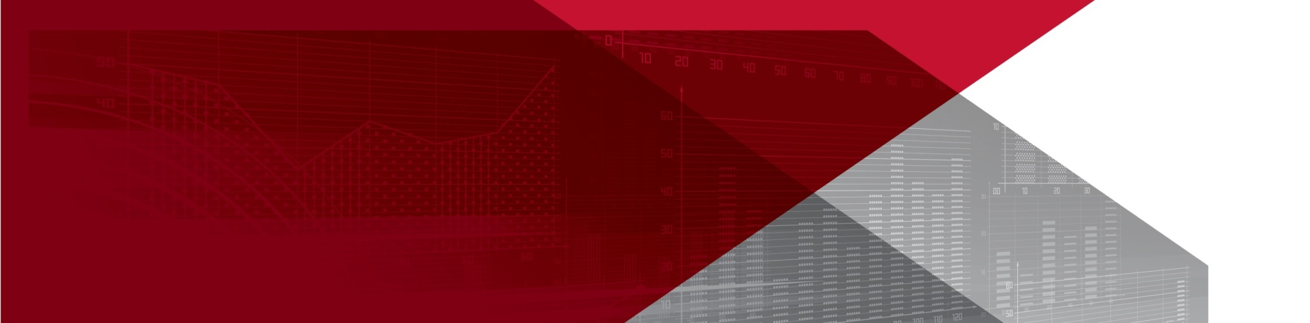**Priority industry snapshot:**

**Public administration**

**& safety**

**June 2018**

The public administration and safety industry is identified as a national priority to reduce the number and rate of work-related injuries and diseases in the *Australian Work Health and Safety Strategy 2012-2022.* The industry accounts for 6 per cent of total employment in Australia and includes three sub-industries: public administration; defence; and public order, safety and regulatory services.

This is an overview of the industry and its work health and safety (WHS) performance, identifying key WHS issues and segments of the industry where performance may be lagging.

# Key points

* Worker fatalities are relatively low with 7 fatalities per year.
* Serious claims rates are slightly higher than the average rate with 7.1 serious claims per million hours worked, but has declined by 33 per cent since 2010-11.
* Workers aged 35-54 years account for the majority of worker fatalities and have the highest serious claim frequency rates.
* The public order, safety and regulatory services sub-sector accounts for over 50 per cent of serious claims and 46 per cent of worker fatalities.
* Protective security workers account for 29 per cent of worker fatalities and 46 per cent of serious claims.
* Vehicle incidents account for 46 per cent of worker fatalities.
* Falls on the same level and muscular stress while handling objects both account for 14 per cent of serious claims.

# The evidence[1]

## Industry profile[2]

The public administration and safety industry accounted for 6 per cent of total employment in November 2017, with employment growing by 7 per cent over the five years to November 2017 (slightly lower than overall employment growth of 8 per cent). Employment in the industry is projected to increase by a further 9 per cent over the next five years.

The industry is comprised of a slightly older demographic, with just over a quarter of workers aged under 35 years, compared with almost 40 per cent across all industries. The industry has a higher proportion of full-time workers (83 per cent compared to the all industry average of 69 per cent), and a much lower proportion of casual employees (11 per cent, compared to the all industry average of 25 per cent).

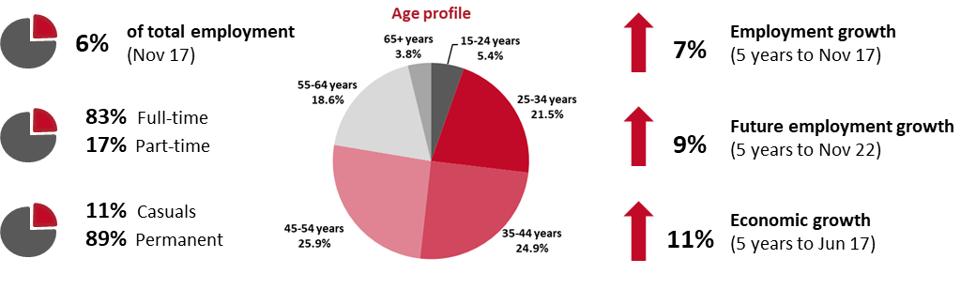

## Why is the public administration and safety industry a priority?

On average, the public administration and safety industry accounted for 8 per cent of serious workers’ compensation claims over the four years between 2012–13 and 2015–16. As a result, this industry was ranked sixth highest in the number of serious claims during this period and seventh highest in the frequency rate of serious claims. The public administration and safety industry ranked seventh in the number of fatalities and eleventh for the fatality rate, during the four‑year period.

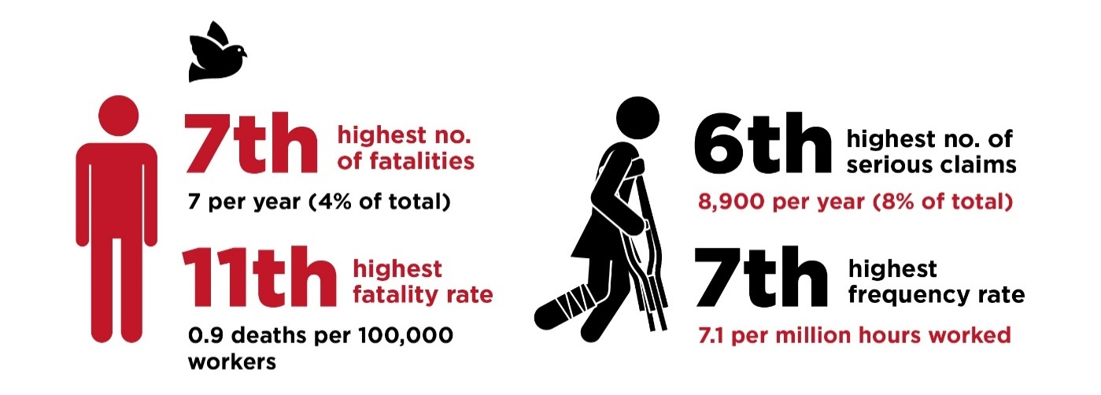

## WHS performance of the industry

Both the number and frequency rate of serious claims in the public administration and safety industry have been trending down in recent years. The number of serious claims in the industry has decreased by 28 per cent and the frequency rate of serious claims has fallen by 33 per cent since 2010-11.

Following a period of year-on-year volatility, both the number of fatalities and the fatality rate in the industry have started to trend down since 2013.

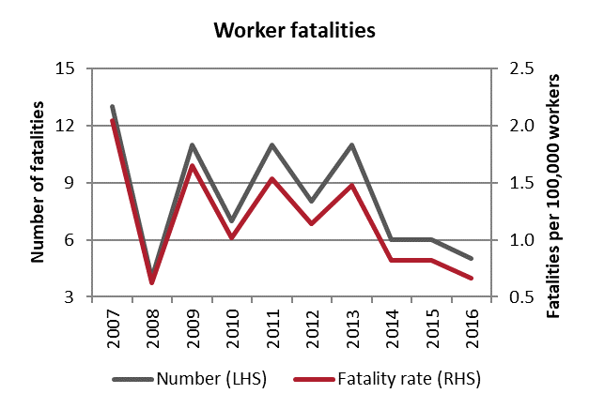 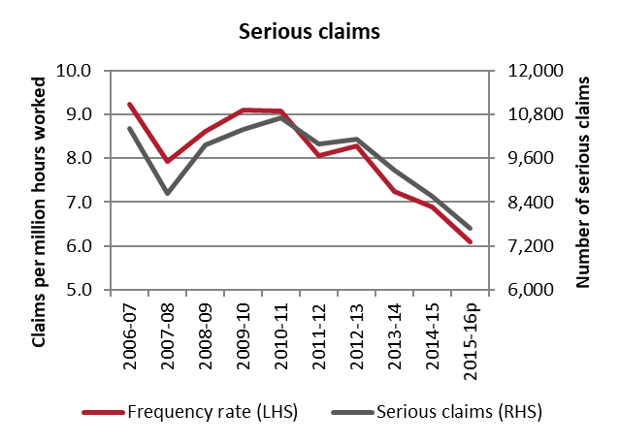

## Demographics

From 2013-2016, the majority of worker fatalities in the public administration and safety industry were workers aged 35-54 which account for half (50 per cent) of the 28 workers killed in the industry. Workers in these middle age groups also recorded the highest rate of serious claims from 2012-13 to 2015-16. Workers aged 45-54 recorded the highest rate (8.2 serious claims per million hours worked), followed closely by workers aged 35-44 (7.8 serious claims per million hours worked).

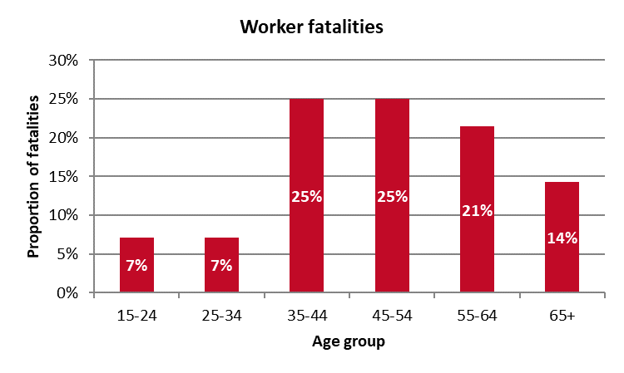 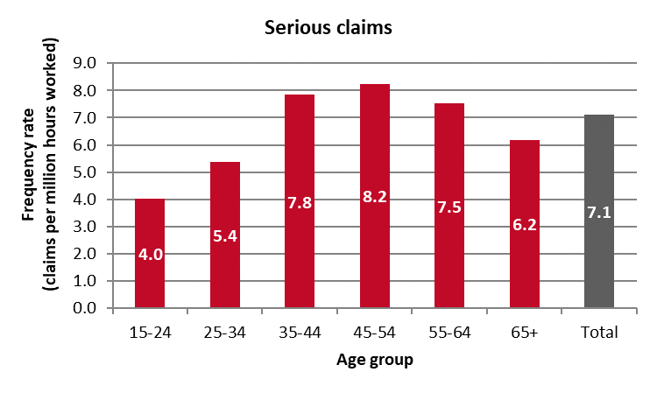

## Key areas of the industry

### Sub-industries

While the public order, safety and regulatory services sub-industry make up about a quarter of the industry’s workforce, it accounts for the majority of serious claims (55.5 per cent), and just under half (46 per cent) of worker fatalities. Not surprisingly, accounting for the size of the workforce, the public order, safety and regulatory services sub-industry also has by far the highest serious claim frequency rate (17.0 serious claims per million hours worked) and the highest fatality rate (1.6 fatalities per 100,000 workers).

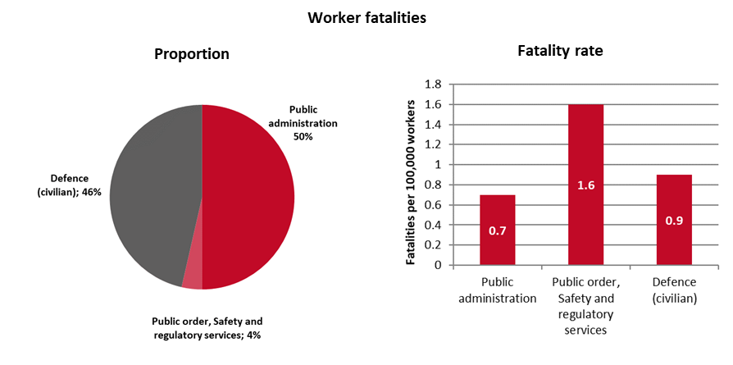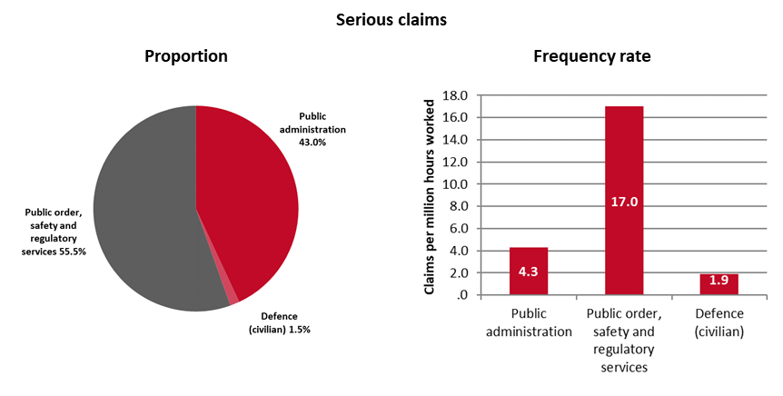

### Occupations

Within the public administration and safety industry, protective service workers accounted for the highest proportion of worker fatalities (29 per cent or 8 fatalities over the four-year period), followed by legal, social and welfare professionals (11 per cent or 3 fatalities), and design, engineering, science and transport professionals (11 per cent or 3 fatalities).

Protective service workers also accounted for the highest proportion of serious claims (46 per cent or an average of 4,080 claims per year), followed by other clerical and administrative workers (9 per cent or an average of 770 claims per year), and other labourers (8 per cent or an average of 700 claims per year).

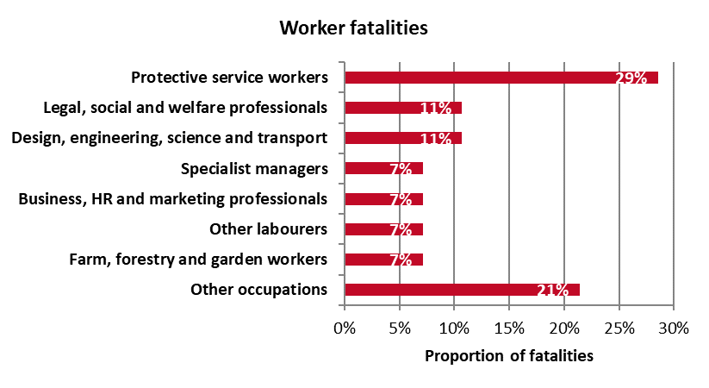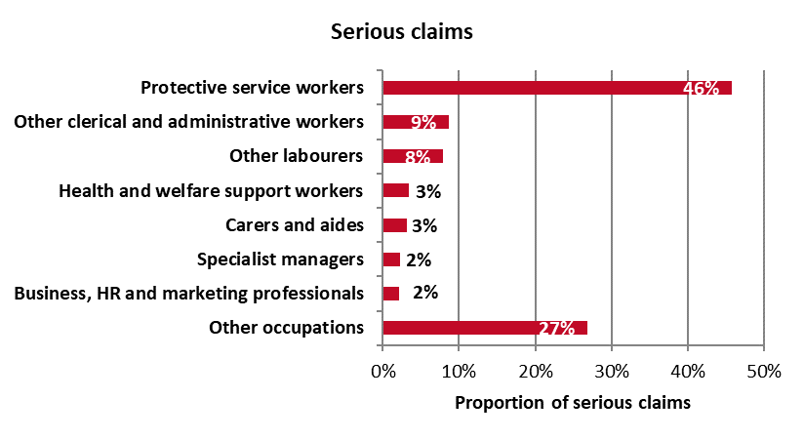

## Key WHS issues in the industry

Vehicle incidents accounted for the largest proportion of fatalities (46 per cent) within the public administration and safety industry, followed by being hit by moving objects (18 per cent), and being hit by falling objects (11 per cent). With regard to serious claims, the main cause of injuries was falls on the same level (14 per cent), followed by muscular stress while handling objects (14 per cent), and muscular stress while lifting, carrying or putting down objects (9 per cent).

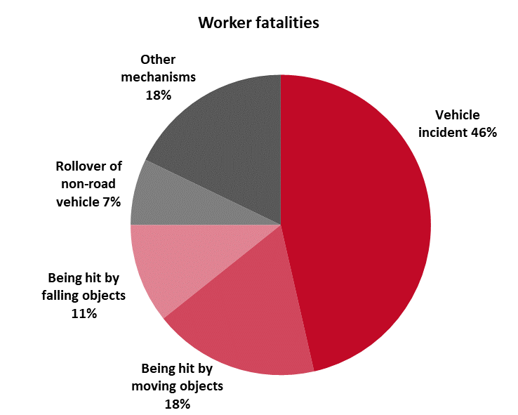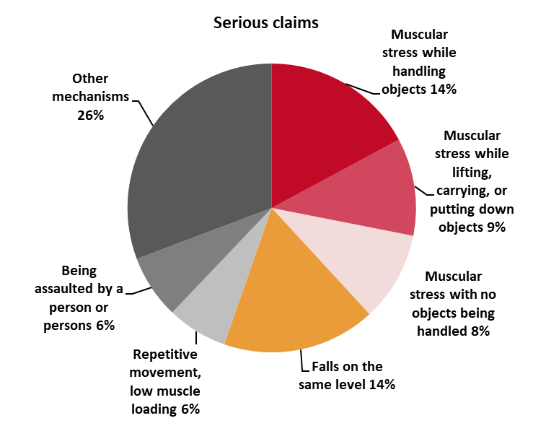

At the sub-industry level, vehicle incidents were the main cause of fatalities in all three sub-industries. For serious claims, falls on the same level was the main cause of injury for public administration and defence sub-industries, while muscular stress while handling objects was the main cause for the public order, safety and regulatory services sub-industry.

| **Main causes of fatalities** | **Main causes of serious claims** |
| --- | --- |
| **Public administration**   * Vehicle incident – 50% * Being hit by moving objects – 21% | **Public administration**   * Falls on the same level – 16% * Muscular stress while handling objects – 13% |
| **Defence**   * Vehicle incident – 100% | **Defence**   * Falls on the same level – 17% * Repetitive movement, low muscle loading – 16% |
| **Public order, safety and regulatory services**   * Vehicle incident – 38% * Being hit by falling objects – 15% * Being hit by moving objects – 15% | **Public order, safety and regulatory services**   * Muscular stress while handling objects – 15% * Falls on the same level – 13% |

1. Unless otherwise specified, the data contained in this report is sourced from Safe Work Australia’s National Data Set for Compensation-based Statistics and Work-related Traumatic Injury Fatalities data set. Fatalities data relate to the period 2013 to 2016, while serious claim data related to 2012-13 to 2015-16.
2. The data in this section is sourced from the Australian Bureau of Statistics and the Department of Employment’s *Employment Outlook to May 2022.*