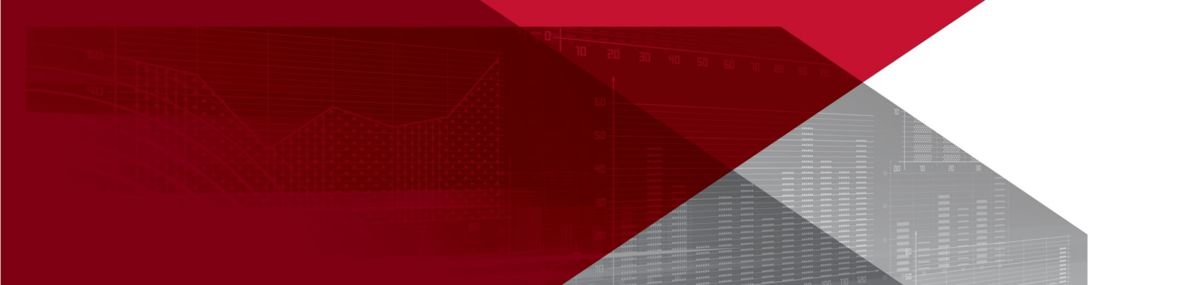**Priority industry snapshot:**

**Manufacturing**

**June 2018**

The manufacturing industry is identified as a national priority to reduce the number and rates of fatalities and serious claims in the *Australian Work Health and Safety Strategy 2012-2022*. The industry accounts for 7 per cent of total employment and includes 15 broad sub-industries: food product manufacturing; beverage and tobacco, product manufacturing; textile, leather, clothing and footwear manufacturing; wood product manufacturing; pulp, paper and converted paper product manufacturing; printing (including the reproduction of recorded media); petroleum and coal product manufacturing; basic chemical and chemical product manufacturing; polymer product and rubber product manufacturing; non-metallic mineral product manufacturing; primary metal and metal product manufacturing; fabricated metal product manufacturing; transport equipment manufacturing; machinery and equipment manufacturing; and furniture and other manufacturing.

This is an overview of the industry and its work health and safety (WHS) performance, highlighting key WHS issues and segments of the industry where performance may be lagging.

# Key points

* Worker fatalities are slightly below the overall average with 1.4 fatalities per 100,000 workers.
* The industry has the second highest serious claim frequency rate with 8.9 serious claims per million hours worked. However, the rate has decreased by 38 per cent over the past decade.
* The fabricated metal product sub-industry recorded the highest frequency rate with 24.0 serious claims per million hours worked.
* The metallic mineral product manufacturing sub-industry had the highest fatality rate with 7.4 fatalities per 100,000 workers.
* Vehicle incidents and being hit by falling objects were the main causes of fatalities (18 per cent of fatalities each), and Muscular stress while lifting, carrying or putting down objects was the main cause of injuries (19 per cent of serious claims).

# The evidence[1]

## Industry profile[2]

While the manufacturing industry accounted for 7 per cent of total employment in November 2017, employment in the industry has been falling, down by 8 per cent over the five years to November 2017, and is projected to fall by a further 4 per cent over the next five years. The falling employment growth is in line with falling economic growth in the industry – down by 10 per cent over the five years to June 2017. A continued structural decline in employment and the closure of major car manufacturers is highly likely to contribute to further falls in the future.

The age distribution of workers in the industry is broadly in line with the distribution in all industries, with just over two-thirds (69 per cent) aged 25-54. The industry has a higher proportion of full-time workers (85 per cent compared to the all industry average of 69 per cent), and a lower proportion of casual employees (20 per cent compared to the all industry average of 25 per cent).

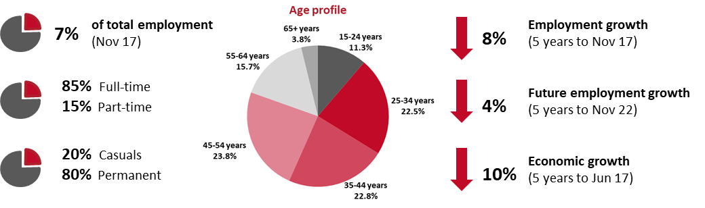

## Why is the manufacturing industry a priority?

The nature of the work in the manufacturing industry means it is a relatively high risk industry and this   
is reflected in the comparatively high level of fatalities and serious workers’ compensation claims (accounting for 7 per cent of fatalities and 13 per cent of serious claims). Over the last four years, on average, the fatality rate was the eighth highest and the serious claim frequency rate was the second highest. In terms of numbers, due to the larger size of the industry, the manufacturing industry ranks fourth for the number of fatalities and second for the number of serious claims.

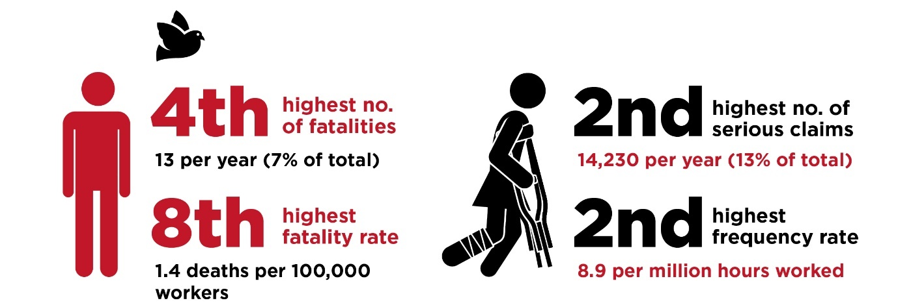

## WHS performance of the industry

While the number of fatalities and serious claims in the manufacturing industry remain comparatively high, there have been substantial improvements over the last 10 years. While the fatality rate has remained relatively stable for much of the last five years, it has fallen substantially from 2.9 fatalities per 100,000 workers in 2008 to 0.7 in 2016.

In relation to serious claims, the number of claims have been decreasing for the last 10 years, and despite a shrinking workforce, the frequency rate has also been trending down, falling from 13.5 serious claims per million hours worked in 2006-07 to 8.4 in 2015-16.

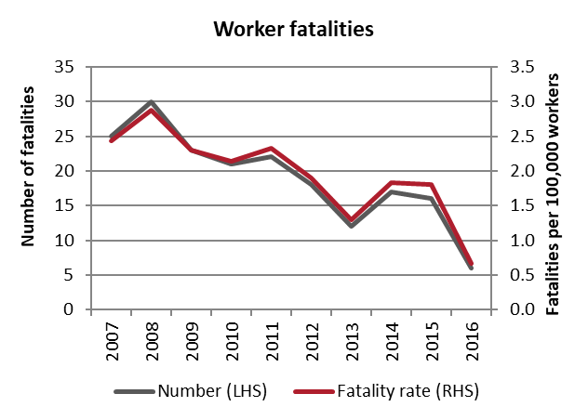 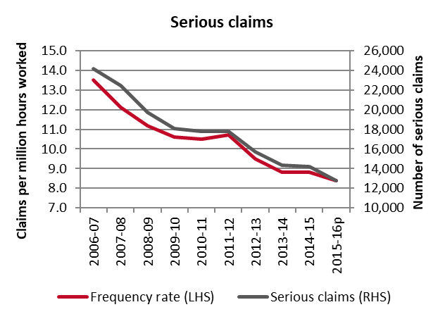

## Demographics

Workers aged 35-44 years accounted for the majority of worker fatalities in the manufacturing industry (27 per cent), followed by those aged 55-64 years (25 per cent) from 2013-2016.

The youngest workers in the industry were the most likely to make a compensation claim for a serious injury or illness. Workers aged under 25 years had the highest frequency rate (10.7 serious claims per million hours worked) in the period from 2012-13 to 2015-16. This was followed by older workers aged 55-64 which had a frequency rate of 9.4 serious claims per million hours worked.

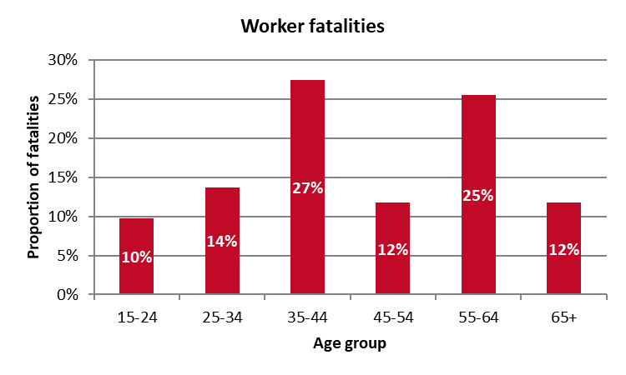 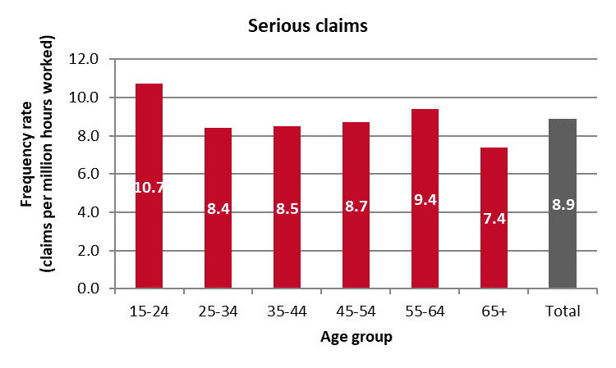

## Key areas of the industry

### Sub-industries

The food product manufacturing sub-industry accounted for the highest proportion of serious claims (26.3 per cent) between 2012-13 and 2015-16, followed by fabricated metal product manufacturing (16.6 per cent) and machinery and equipment manufacturing (11.2 per cent). In relation to worker fatalities, non-metallic mineral product manufacturing accounted for the highest proportion of fatalities (20 per cent), followed by fabricated metal product manufacturing (16 per cent), machinery and equipment manufacturing (12 per cent) and food product manufacturing (12 per cent).

Accounting for the size of the workforce, the fabricated metal product manufacturing sub-industry recorded the highest serious claim frequency rate (24.0 serious claims per million hours worked), followed by wood product manufacturing (16.3 serious claims per million hours worked). By contrast, the non-metallic mineral product manufacturing sub-industry recorded the highest fatality rate (7.4 fatalities per 100,000 workers), followed by petroleum and coal product manufacturing (6.4 fatalities per 100,000 workers).

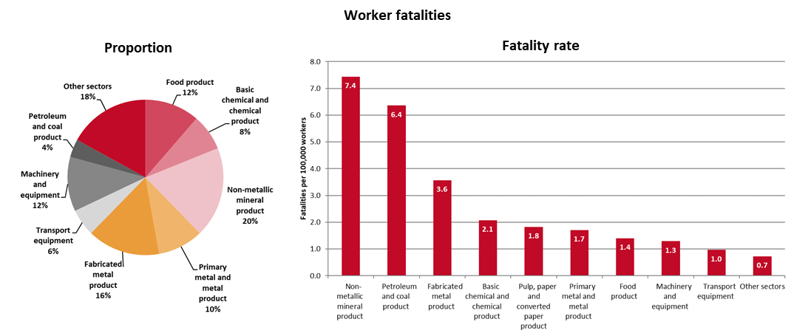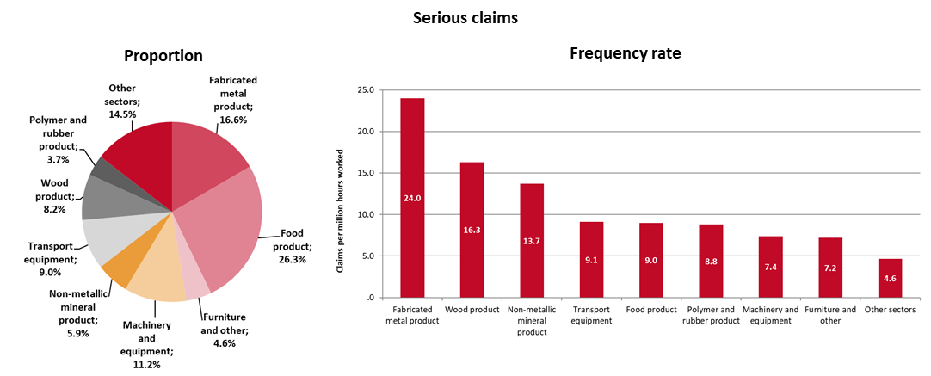

### Occupations

Truck drivers accounted for the highest proportion of worker fatalities (22 per cent or 11 fatalities over four years) within the manufacturing industry, followed by mobile plant operators (10 per cent or 5 fatalities).

Miscellaneous labourers accounted for the highest proportion of serious claims (11 per cent or an average of 1,620 claims per year), followed by food process workers (11 per cent or an average of 1,530 claims per year) and miscellaneous factory process workers (11 per cent or an average of 1,510 claims per year).

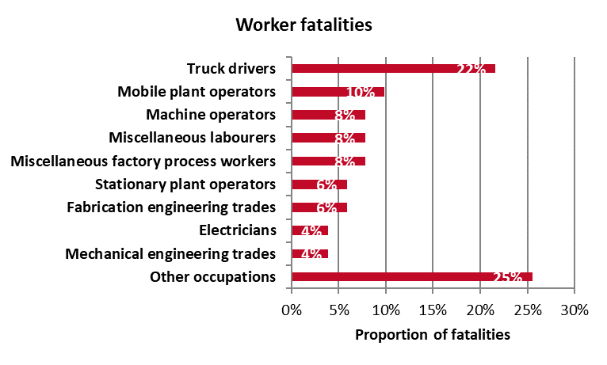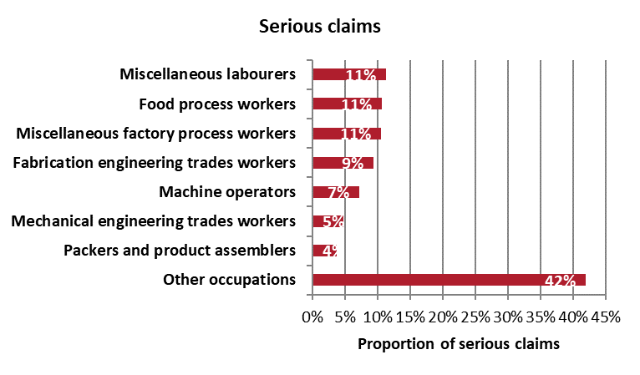

## Key WHS issues in the industry

Vehicle incidents and being hit by falling objects accounted for the largest proportion of fatalities (18 per cent each) within the manufacturing industry, followed by falls from a height (16 per cent) and being hit by moving objects (16 per cent). For serious claims, the main cause of injuries was muscular stress while lifting, carrying or putting down objects (19 per cent of claims), followed by muscular stress while handling objects (17 per cent) and falls on the same level (10 per cent).

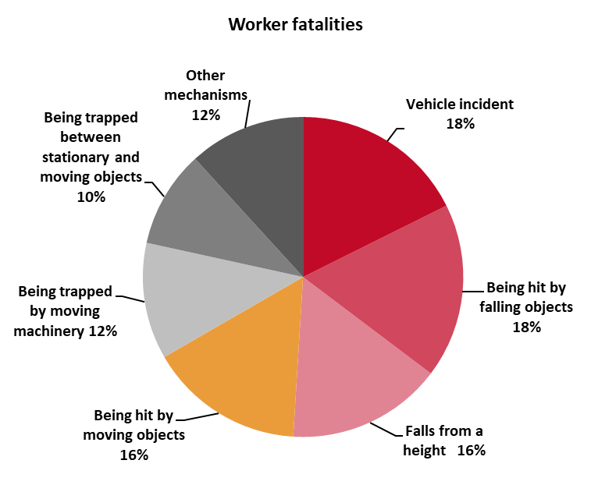 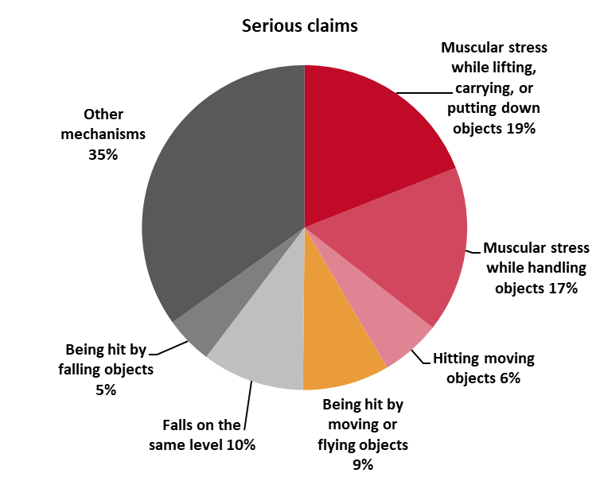

At the sub-industry level, the main causes of injuries were broadly the same across all the sub-industries with the most serious claims, however, there were some differences with respect to fatalities, as shown in the table below.

| **Main causes of fatalities**  **[Note: only sub-industries with most fatalities included]** | **Main causes of injuries**  **[Note: only sub-industries with most claims included]** |
| --- | --- |
| **Food product manufacturing**   * Vehicle incident – 50% * Being trapped between stationary and moving objects – 33% * Being trapped by moving machinery – 17% | **Food product manufacturing**   * Muscular stress while handling objects – 19% * Muscular stress while lifting, carrying or putting down objects – 18% * Falls on the same level – 11% |
| **Fabricated metal product manufacturing**   * Being hit by falling objects – 25% * Falls from a height – 25% | **Fabricated metal product manufacturing**   * Muscular stress while lifting, carrying or putting down objects – 20% * Muscular stress while handling objects – 13% * Being hit by moving or flying objects – 11% |
| **Machinery and equipment manufacturing**   * Being trapped by moving machinery – 50% | **Machinery and equipment manufacturing**   * Muscular stress while lifting, carrying or putting down objects – 18% * Muscular stress while handling objects – 16% * Falls on the same level – 10% |
| **Non-metallic mineral product manufacturing**   * Being hit by moving objects – 30% * Being hit by falling objects –30% * Vehicle incident – 20% | **Transport equipment manufacturing**   * Muscular stress while handling objects – 18% * Muscular stress while lifting, carrying or putting down objects – 16% * Being hit by moving or flying objects – 9% |
| **Primary metal & metal product manufacturing**   * Falls from a height – 40% | **Non-metallic mineral product manufacturing**   * Muscular stress while lifting, carrying, or putting down objects – 18% * Muscular stress while handling objects – 14% * Falls on the same level – 13% |

1. Unless otherwise specified, the data contained in this report is sourced from Safe Work Australia’s National Data Set for Compensation-based Statistics and Work-related Traumatic Injury Fatalities data set. Fatalities data relate to the period 2013 to 2016, while serious claim data related to 2012-13 to 2015-16.
2. The data in this section is sourced from the Australian Bureau of Statistics and the Department of Employment’s *Employment Outlook to May 2022.*