**Priority industry snapshot:**

**Health care and social assistance**

**June 2018**

The health care and social assistance industry is identified as a national priority to reduce the number and rate of work-related injuries and diseases in the *Australian Work Health and Safety Strategy 2012‑2022*. The industry is the largest employing industry in Australia, accounting for 13 per cent of total employment, and includes four broad sub-industries: hospitals; medical and other health care services; residential care services; and social assistance services.

This is an overview of the industry and its work health and safety (WHS) performance, highlighting key WHS issues and segments of the industry where performance may be lagging.

# Key points

* Worker fatalities are relatively low with 3 fatalities per year.
* The industry accounts for the highest proportion of workers’ compensation claims, with 17,795 claims per year.
* The frequency rate for serious claims has decreased by 29 per cent over the last decade.
* Older workers account for the majority of worker fatalities and recorded the highest serious claim frequency rates.
* The hospitals, and residential care services sub-sectors account for the majority of serious claims and recorded the highest frequency rates.
* Carers and aides account for 31 per cent of serious claims, followed by health professionals who account for 19 per cent.
* The highest proportion of serious claims in the industry are due to:
  + muscular stress while handling objects (25 per cent)
  + falls on the same level (15 per cent), and
  + muscular stress while lifting, carrying or putting down objects (15 per cent).

# The evidence[1]

## Industry profile[2]

The health care and social assistance industry is the largest employing industry in Australia, accounting for 13 per cent of total employment in November 2017. The industry has also recorded the highest employment growth over the five years to November 2017, increasing by 22 per cent (compared with overall employment growth of 8 per cent) and is expected to grow by 16 per cent over the next five years. This strong future employment growth will be driven by the full implementation of the National Disability Insurance Scheme (NDIS), ongoing ageing of the population and increasing demand for childcare and home based care services.

The age distribution of workers is broadly in line with the all industry distribution, with just over two-thirds (68 per cent) aged 25-54. The industry has a higher proportion of part-time workers (43 per cent compared to the all industry average of 31 per cent), but a lower proportion of casual employees (19 per cent compared to the all industry average of 25 per cent).

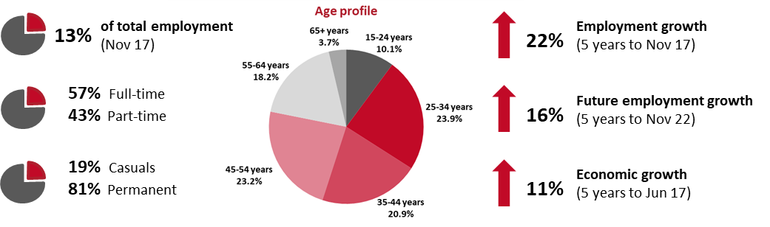

## Why is the health care and social assistance industry a priority?

On average, the health care and social assistance industry accounted for 16 per cent of serious workers’ compensation claims over the four years between 2012–13 and 2015–16. As a result, this industry was ranked the highest in terms of the number of serious claims and fourth highest in the frequency rate of serious claims. Although being the largest industry, the health care and social services industry ranked thirteenth and fifteenth in the number of fatalities and the fatality rate, respectively, during the four-year period. The key issue in this industry that requires attention is the high rate of injuries.

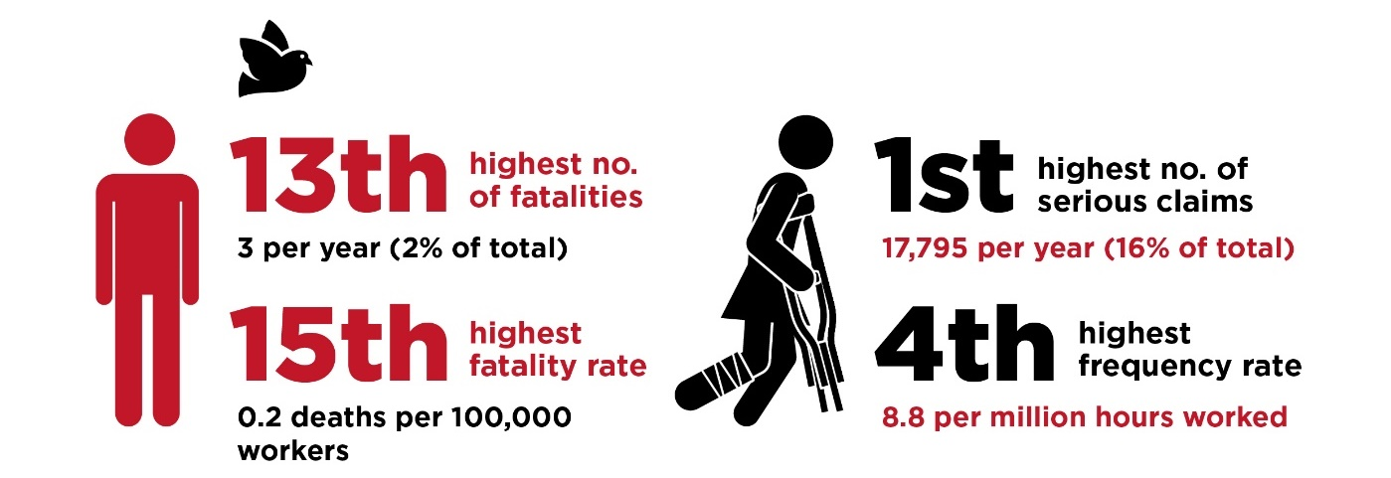

## WHS performance of the industry

While the health care and social assistance industry has the highest number of serious claims, the number of claims has been falling steadily since the peak in 2011-12, despite a substantial increase in the workforce over the same period. As a result, the frequency rate of serious claims has fallen significantly over the last decade, down 29 per cent since 2006-07.

Despite some year-on-year volatility due to the low number of fatalities in this industry, the fatality rate remained relatively stable over the last five years at or around 0.2 fatalities per 100,000 workers.

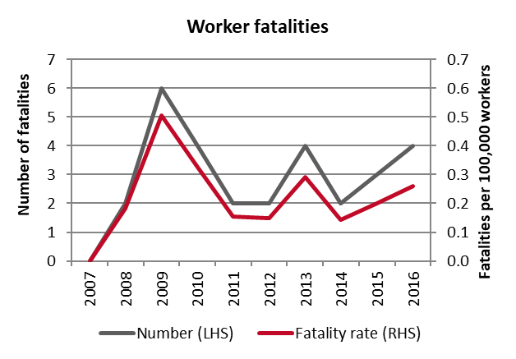 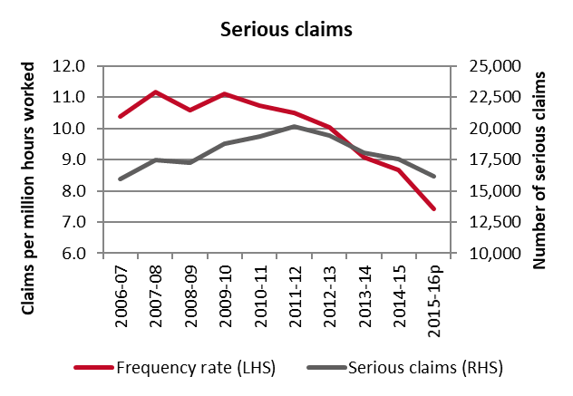

## Demographics

Older workers accounted for the majority of worker fatalities in the health care and social assistance industry, with more than three quarters (77 per cent) of the 13 workers killed in the industry aged 45 and over from 2013-2016.

In relation to serious workers’ compensation claims, older workers in the industry were also more likely to have a serious injury or illness. Workers aged 55-64 years had the highest frequency rate (11.6 serious claims per million hours worked) in the period from 2012-13 to 2015-16, followed closely by workers aged 45-54 years (11.2 serious claims per million hours worked).

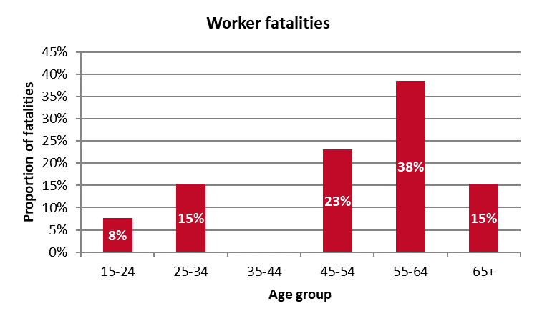 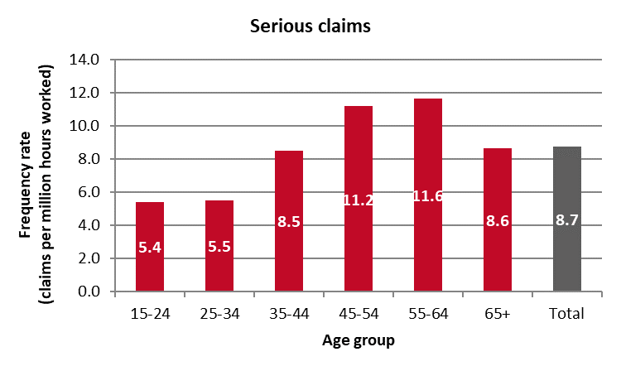

## Key areas of the industry

### Sub-industries

The hospital services sub-industry accounted for the highest proportion of serious claims (37 per cent), followed by the residential care services sub‑industry (33 per cent) over the last four years.

The medical and other health care services sub-industry accounted for the highest proportion of fatalities (38 per cent), noting however, the low numbers of fatalities overall in the broader industry. While residential care services had the highest fatality rate, it was still relatively low when compared to all industries.

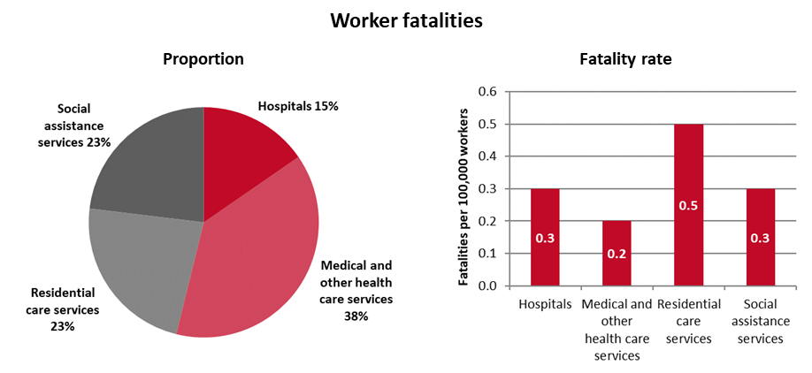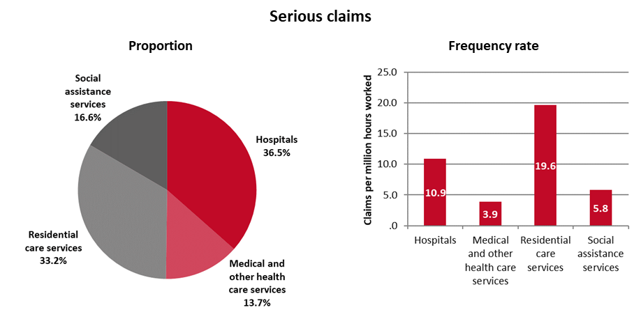

### Occupations

Carers and aides accounted for the highest proportion of serious claims (33 per cent or an average of 5,895 claims per year), followed by health professionals (19 per cent or an average of 3,410 claims per year), and health and welfare support workers (17 per cent or an average of 2,985 claims per year).

In relation to worker fatalities, noting the relatively low number of fatalities in this industry, health and welfare support workers accounted for the highest proportion of fatalities (31 per cent or 4 fatalities over the four-year period), followed by health professionals (23 per cent or 3 fatalities), road and rail drivers (15 per cent or 2 fatalities), and carers and aides (15 per cent or 2 fatalities).

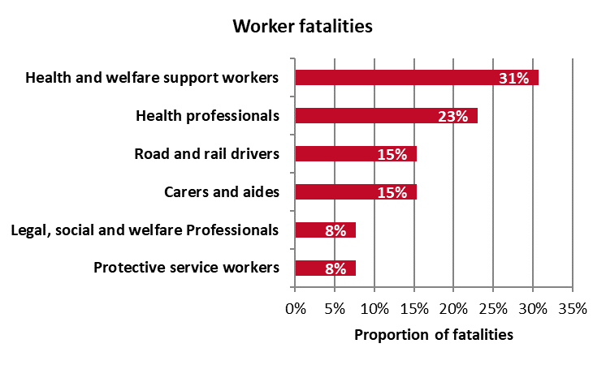 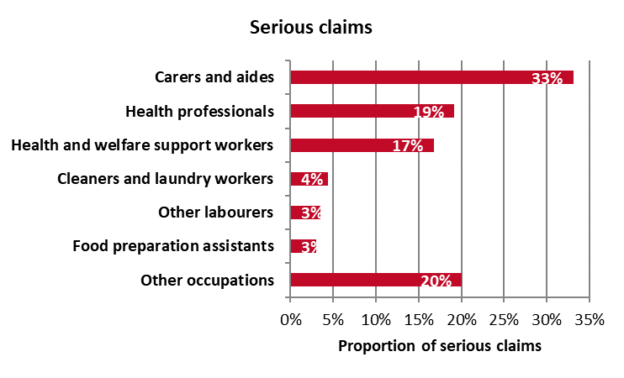

## Key WHS issues in the industry

Vehicle incidents accounted for the largest proportion of fatalities (69 per cent) within the health care and social assistance industry, while muscular stress while handling objects accounted for the largest proportion of injuries (25 per cent).

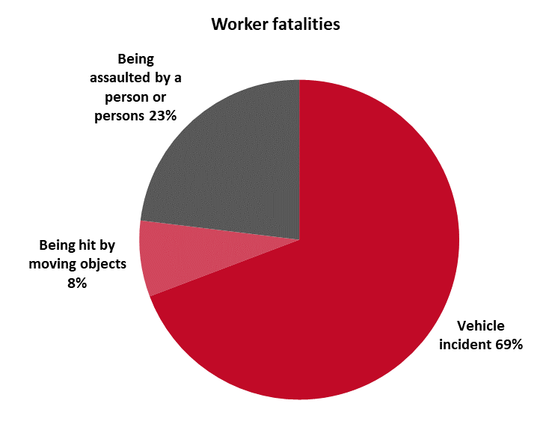 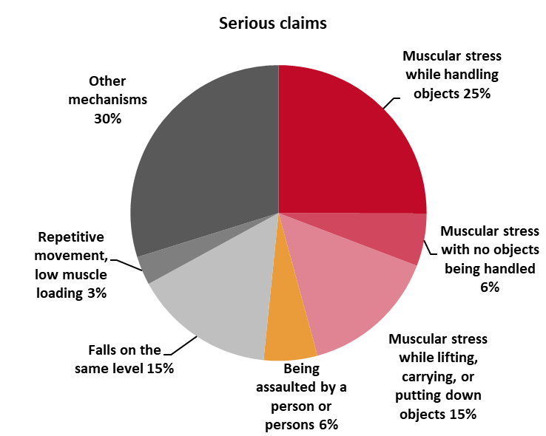

Vehicle incidents were also the main cause of fatalities in all four sub-industries, while being assaulted by a person or persons was the second most common cause of fatalities in three out of four sub-industries. However, there were some differences with respect to serious claims. Muscular stress while handling objects was the main cause of serious claims in both the hospitals and residential care services sub‑industries, whereas, it was the second most common cause in both medical and other health care services and social assistance services sub-industries.

| **Main causes of fatalities** | **Main causes of serious claims** |
| --- | --- |
| **Hospitals**   * Vehicle incident – 50% * Being assaulted by person or persons – 50% | **Hospitals**   * Muscular stress while handling objects – 28% * Muscular stress while lifting, carrying, or putting down objects – 15% * Falls on the same level – 14% |
| **Medical and other health care services**   * Vehicle incident – 80% * Being assaulted by person or persons – 20% | **Medical and other health care services**   * Muscular stress while lifting, carrying, or putting down objects – 25% * Muscular stress while handling objects – 17% * Fall on the same level – 12% |
| **Residential care services**   * Vehicle incident – 67% * Being hit by moving objects – 33% | **Residential care services**   * Muscular stress while handling objects – 30% * Falls on the same level – 16% * Muscular stress while lifting, carrying, or putting down objects – 11% |
| **Social assistance services**   * Vehicle incident – 67% * Being assaulted by person or persons – 33% | **Social assistance services**   * Falls on the same level – 20% * Muscular stress while handling objects – 16% * Muscular stress while lifting, carrying, or putting down objects – 14% |

1. Unless otherwise specified, the data contained in this report is sourced from Safe Work Australia’s National Data Set for Compensation-based Statistics and Work-related Traumatic Injury Fatalities data set. Fatalities data relate to the period 2013 to 2016, while serious claim data related to 2012-13 to 2015-16.
2. The data in this section is sourced from the Australian Bureau of Statistics and the Department of Employment’s *Employment Outlook to May 2022.*