**Priority industry snapshot:**

**Construction**

**June 2018**

The construction industry is identified as a national priority to reduce the number and rate of fatalities and serious claims in the *Australian Work Health and Safety Strategy 2012-2022*. The industry accounts for 9 per cent of total employment and includes three sub‑industries: building construction (including both residential and non-residential); construction services (including site preparation, installation services, completions services); and heavy and civil engineering construction.

This is an overview of the industry and its work health and safety (WHS) performance, identifying key WHS issues and segments of the industry where performance may be lagging.

# Key points

* Worker fatalities are relatively high with 3.0 fatalities per 100,000 workers.
* Serious claims are high with 8.1 serious claims per million hours worked.
* The frequency rate of serious claims has decreased by 20 per cent over the last decade.
* Workers aged 45-54 account for the highest proportion of worker fatalities and serious claims, followed by workers aged under 25 years.
* The construction services sub-sector accounted for 63.7 per cent of serious claims and 62 per cent of worker fatalities.
* For occupations, construction and mining labourers accounted for the highest proportion of worker fatalities and serious claims.
* Falls from a height accounted for the largest proportion of fatalities (30 per cent), while muscular stress from lifting, carrying or putting down objects accounted for the highest proportion of serious claims (16 per cent).

# The evidence[1]

## Industry profile[2]

The construction industry accounted for 9 per cent of total employment in November 2017, with employment growing strongly by 18 per cent over the five years to November 2017 (more than double the rate of overall employment growth at 8 per cent). Employment in the industry is projected to continue to grow at a higher rate than the average over the next five years, increasing by 11 per cent. This growth will be driven by expected strong infrastructure investment and non-residential building activity, along with continuing high levels of residential construction (albeit more in line with population growth).

The industry is comprised of a slightly younger demographic, with 44 per cent of workers aged under 35 years old, compared with 39 per cent across all industries. While the industry has a much higher proportion of full-time workers (85 per cent compared to the all industry average of 69 per cent), the proportion of casual employees is broadly in line with the overall average (26 per cent compared to the all industry average of 25 per cent).

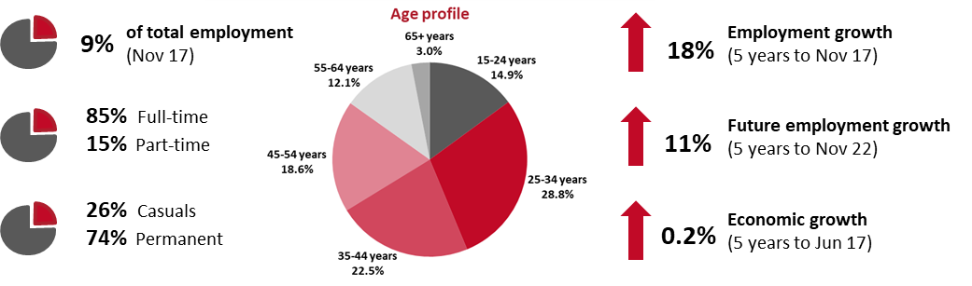

## Why is the construction industry a priority?

The nature of work in the construction industry means it is a relatively high risk industry and is reflected in both the comparatively high level of fatalities and serious workers’ compensation claims (accounting for 16 per cent of fatalities and 11 per cent of serious claims). Over the last five years, on average, the fatality rate was the sixth highest and the serious claim frequency rate was the fifth highest. In terms of numbers, due to the larger size of the industry, the construction industry ranks third for both the number of fatalities and serious claims over the last five years.

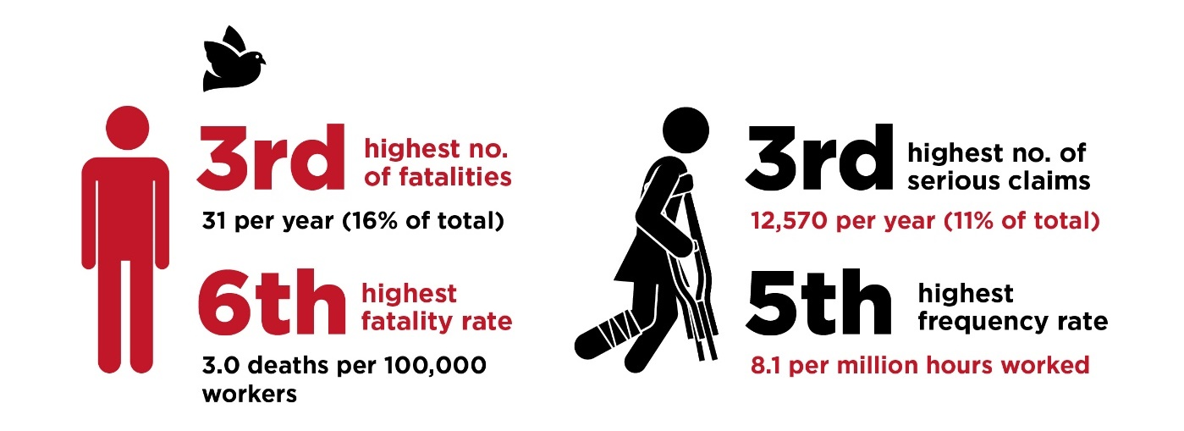

## WHS performance of the industry

While the number of fatalities and serious claims in the construction industry remain comparatively high, there have been substantial improvements over the last 10 years. While the fatality rate has remained relatively stable for much of the last five years, it has fallen substantially from 4.8 fatalities per 100,000 workers in 2007 to 3.3 in 2016.

In relation to serious claims, while the number of claims has been relatively stable for most of the last 10 years, due to the growing workforce, the frequency rate has been trending down, falling from 10.1 serious claims per million hours worked in 2006-07 to 8.0 in 2015-16.

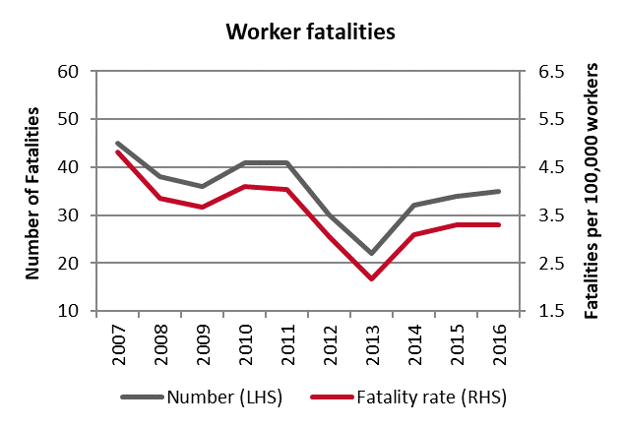 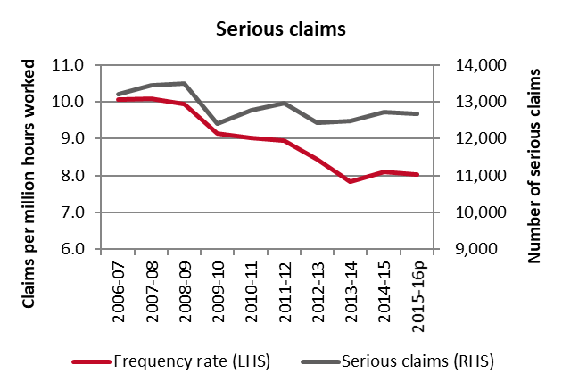

## Demographics

From 2013-2016, worker fatalities in the construction industry were relatively spread out across the age groups, with workers aged 55-64 years accounting for 22 per cent of the 123 workers killed in the industry, followed by those aged 25-34 years (21 per cent) and 45-54 years (20 per cent).

The serious claim frequency rate was also relatively similar across age groups, with workers aged 55-64 recording the highest rate (9.9 serious claims per million hours worked) in the period from 2012-13 to 2015-16, followed by workers aged 15-24 years (8.5 serious claims per million hours worked).

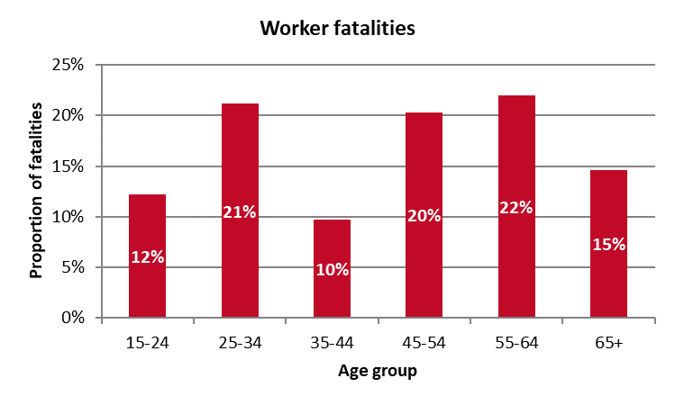 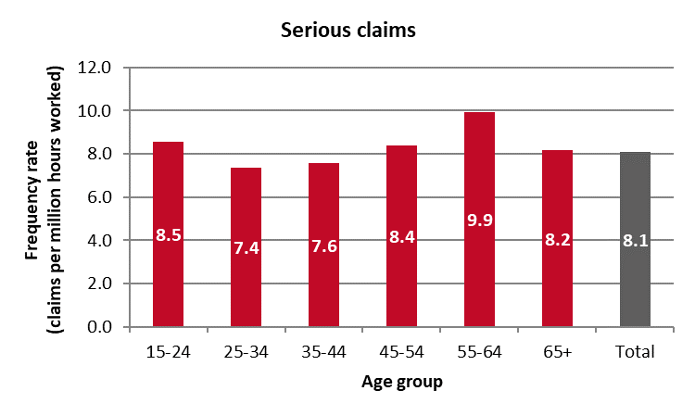

## Key areas of the industry

### Sub-industries

The construction services sub-industry accounts for the majority of workers in the construction industry, which is reflected in both the number of fatalities and serious claims. Over the four years from 2013 to 2016 this sub-industry accounted for just under two-thirds of fatalities (62 per cent) and serious claims (63.7 per cent). Within the construction services sub-industry, site preparation services, electrical services and concreting services were particular areas that saw fatalities and injuries.

Accounting for the size of the workforce, the heavy and civil engineering construction sub-industry recorded both the highest fatality rate (5.7 fatalities per 100,000 workers) and serious claim frequency rate (13.4 claims per million hours worked).

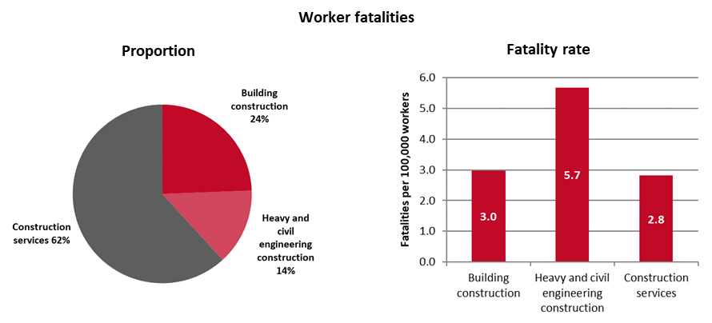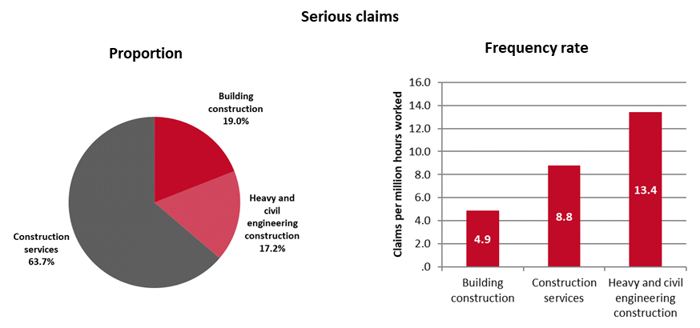

### Occupations

Construction and mining labourers accounted for the highest proportion of worker fatalities (22 per cent or 27 fatalities over the four-year period), followed by electricians (11 per cent or 14 fatalities), bricklayers, carpenters and joiners (8 per cent or 10 fatalities) and mobile plant operators (8 per cent or 10 fatalities).

In relation to serious claims, construction and mining labourers also accounted for the highest proportion of serious claims (17 per cent or an average of 2,195 claims per year), followed by bricklayers, carpenters and joiners (14 per cent or an average of 1,790 claims per year), and miscellaneous labourers (14 per cent or an average of 1,765 claims per year).

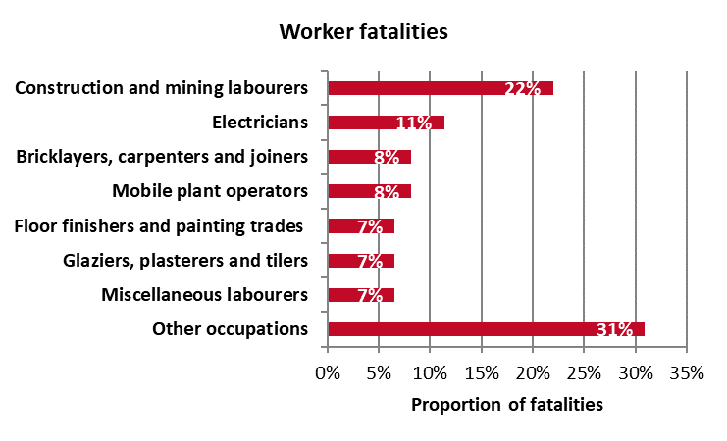 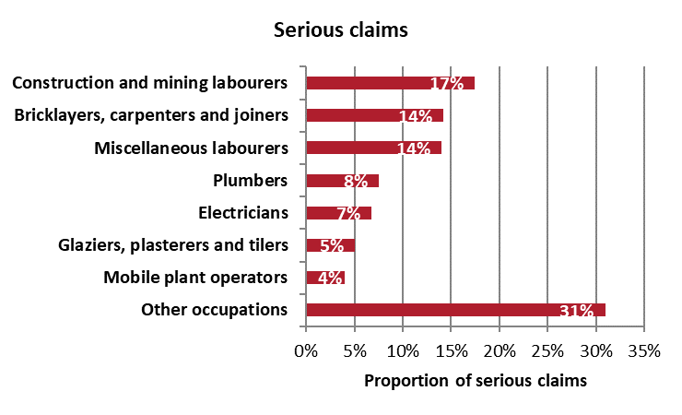

## Key WHS issues in the industry

Falls from a height accounted for the largest proportion of fatalities (30 per cent) within the construction industry, followed by being hit by falling objects (15 per cent), and vehicle incidents (15 per cent). With regard to serious claims, the main cause of injuries was muscular stress from lifting, carrying or putting down objects (16 per cent of claims), followed by muscular stress while handling objects (14 per cent), and falls on the same level (13 per cent).

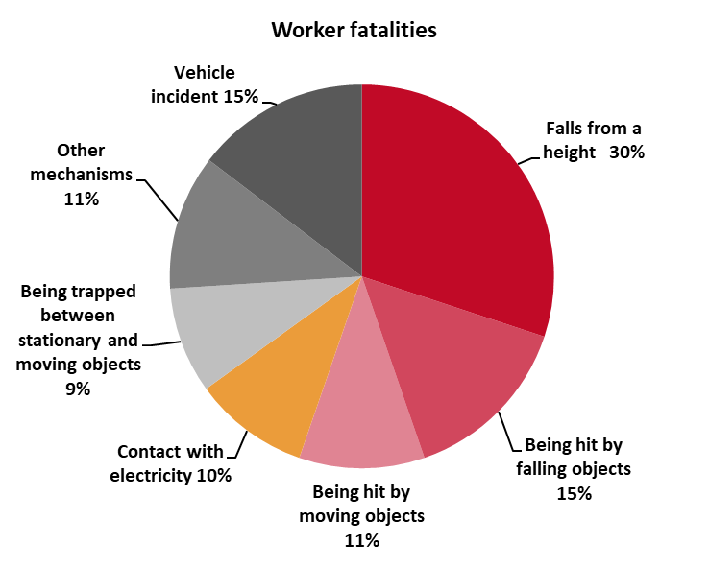 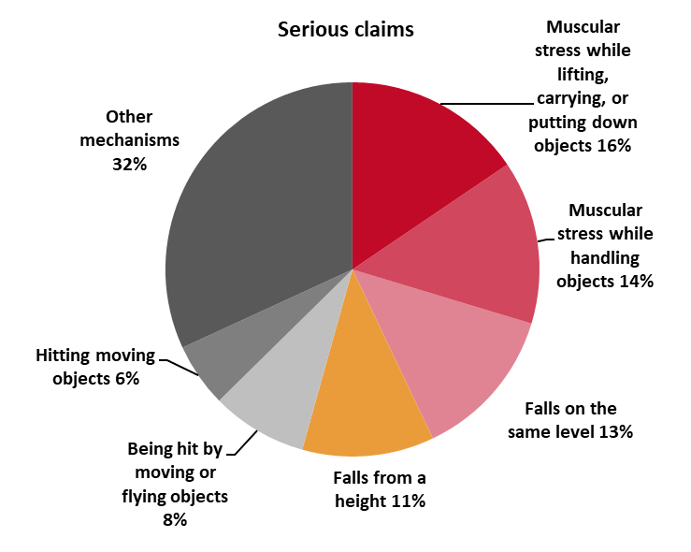

At the sub-industry level, falls from a height and muscular stress while lifting, carrying or putting down objects was the main cause of fatalities and injuries respectively in both building construction and construction services. By contrast, in the heavy and civil engineering construction sub-industry, being hit by moving objects was the main cause of fatalities and muscular stress while handling objects was the main cause of injuries.

| **Main causes of fatalities** | **Main causes of injuries** |
| --- | --- |
| **Building construction**   * Falls from a height – 37% * Being hit by falling objects – 27% * Vehicle incident – 10% * Being hit by moving objects – 10% | **Building construction**   * Muscular stress while lifting, carrying or putting down objects – 16% * Falls on the same level – 13% * Fall from a height – 12% |
| **Construction services**   * Falls from a height – 33% * Vehicle incident – 14% * Being hit by falling objects – 12% * Contact with electricity – 12% | **Construction services**   * Muscular stress while lifting, carrying or putting down objects – 16% * Muscular stress while handling objects – 14% * Falls on the same level – 13% |
| **Heavy and civil engineering construction**   * Being hit by moving objects – 35% * Vehicle incident – 24% * Being trapped between stationary and moving objects – 12% | **Heavy and civil engineering construction**   * Muscular stress while handling objects – 18% * Falls on the same level – 15% * Muscular stress while lifting, carrying or putting down objects – 14% |

1. Unless otherwise specified, the data contained in this report is sourced from Safe Work Australia’s National Data Set for Compensation-based Statistics and Work-related Traumatic Injury Fatalities data set. Fatalities data relate to the period 2013 to 2016, while serious claim data related to 2012-13 to 2015-16.
2. The data in this section is sourced from the Australian Bureau of Statistics and the Department of Employment’s *Employment Outlook to May 2022.*