**Priority industry snapshot:**

**Accommodation &**

**food services**

**June 2018**

The accommodation and food services industry is identified as a national priority to reduce work-related injuries and illnesses in the *Australian Work Health and Safety Strategy 2012-2022*. The industry includes two sub-industries: accommodation; and food and beverage services and accounts for 7 per cent of total employment.

This is an overview of the industry and its work health and safety (WHS) performance, highlighting key WHS issues and segments of the industry where performance may be lagging.

# Key points

* Worker fatalities are relatively low, with 3 fatalities per year.
* Serious claims are slightly higher than average with 6.4 claims per million hours worked.
* The frequency rate of serious claims has decreased by 25 per cent over the last decade.
* Despite the younger demographic of the accommodation and food services industry, workers aged 45-54 years account for the highest proportion of worker fatalities. Workers aged 55-64 years recorded the highest serious claim frequency rates.
* The food and beverage sub-industry accounts for the majority of serious claims and fatalities, however, the accommodation sub-industry recorded the highest frequency and fatality rate.
* Hospitality workers account for 22 per cent of serious claims, the highest percentage in the industry. This was followed by food trades workers who account for 20 per cent.
* Hospitality, retail and service managers account for 36 per cent of fatalities.
* Explosions account for the highest proportion of fatalities in the industry.
* The highest proportion of serious claims in the industry are due to:
  + falls on the same level (19 per cent)
  + muscular stress while lifting, carrying or putting down objects (14 per cent)
  + muscular stress which handling objects (11 per cent).

# The evidence[1]

## Industry profile[2]

The accommodation and food services industry accounted for 7 per cent of total employment in November 2017, with employment growing by 13 per cent over the five years to November 2017 (much higher than the overall employment growth of 8 per cent). Employment in the industry is projected to continue to grow at a higher rate than the average over the next five years, increasing by 11 per cent.

The industry has the youngest age demographic of all industries with 44 per cent of workers aged under 25 years old. The industry has the highest proportion of part-time workers (59 per cent compared to the all industry average of 31 per cent), and the highest proportion of casual employees (63 per cent compared to the all industry average of 25 per cent).

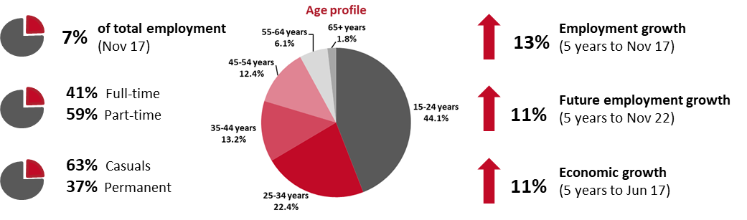

## Why is the industry a priority?

While the industry is a priority under the Strategy, the fatality rate is significantly lower than the all industry average, and serious claims are only slightly above the all industry average serious claim frequency rate of 6.2 claims per million hours worked. This is reflected by the industry recording the thirteenth highest fatality rate and the ninth highest frequency rate of serious claims. As shown later in the overview, however, the serious claim frequency rate is considerably higher in the accommodation segment of the industry.

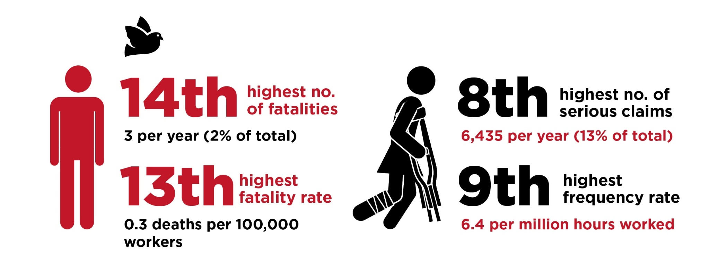

## WHS performance of the industry

Both the number and frequency rate of serious claims in the accommodation and food services industry have generally been trending down over the last decade. Since 2006-07, the number of serious claims in the industry has decreased by 12 per cent, while the frequency rate has fallen by 25 per cent.

Apart from a couple of years where there were a handful of additional fatalities, both the number and rate of worker fatalities in the industry has remained relatively stable over the last decade.

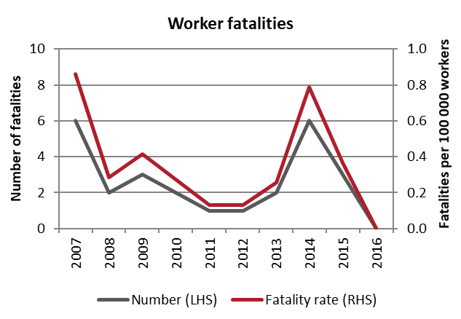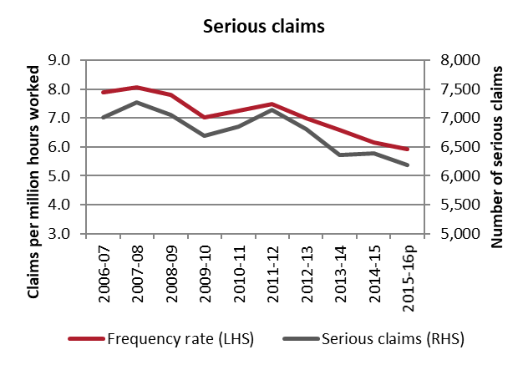

## Demographics

Noting the very low number of fatalities, over the period from 2013-2016, workers aged 45-54 accounted for the highest proportion of worker fatalities (36 per cent) in the accommodation and food services industry.

In relation to serious workers’ compensation claims, older workers in the industry were more likely to have a serious injury or illness. Workers aged between 55 and 64 years had the highest frequency rate (8.8 serious claims per million hours worked) in the period from 2012-13 to 2015-16, followed closely by workers aged 45 to 54 years (8.2 serious claims per million hours worked).

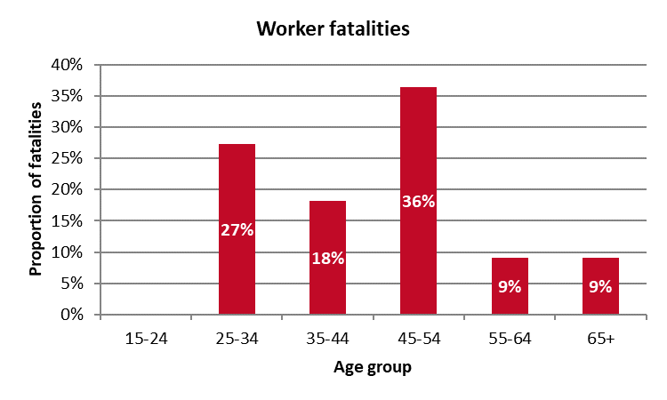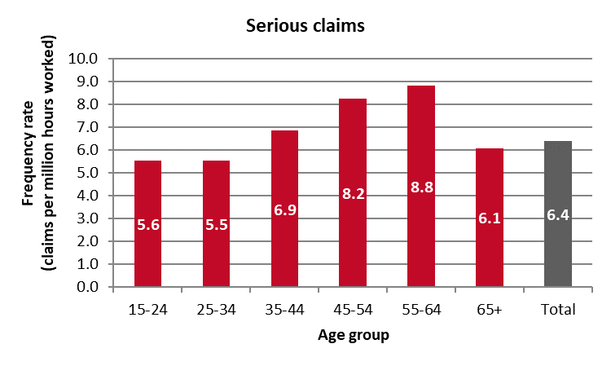

## Key areas of the industry

### Sub-industries

Accounting for the majority of workers in the accommodation and food services industry, the food and beverage services sub-industry accounted for just under two-thirds (64 per cent) of fatalities and just over three quarters (77 per cent) of serious claims.

When the much smaller size of the workforce is considered, the accommodation sub-industry recorded both the highest serious claim frequency rate (9.0 claims per million hours worked) and the highest fatality rate (0.9 fatalities per 100,000 workers).

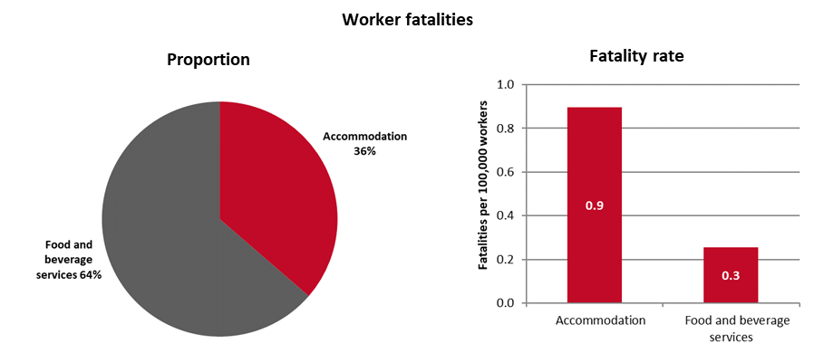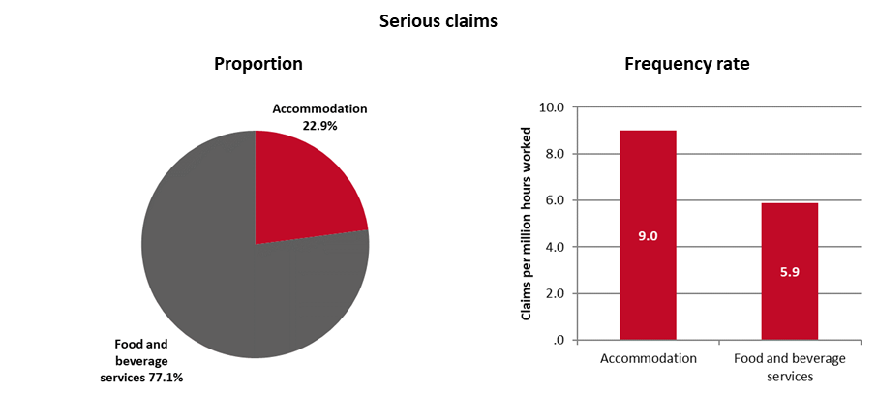

### Occupations

Within the accommodation and food services industry, hospitality workers accounted for the highest proportion of serious claims (22 per cent or an average of 1,385 claims per year), followed by food trades workers (20 per cent or an average of 1,305 claims per year), and food preparation assistants (15 per cent or an average of 965 claims per year).

In relation to worker fatalities, noting the low number of fatalities in this industry, hospitality, retail and service managers accounted for the highest proportion of fatalities (36 per cent or 4 fatalities over the four-year period), followed by other labourers (27 per cent or 3 fatalities), and hospitality workers (18 per cent or 2 fatalities).

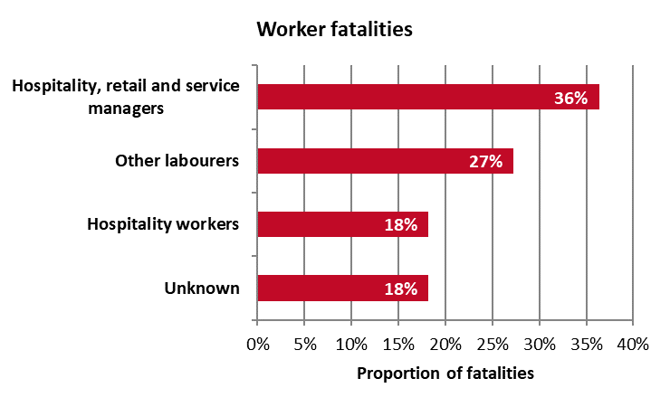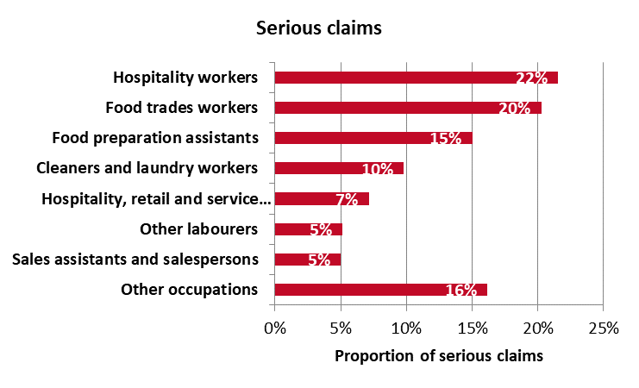

## Key WHS issues in the industry

The main causes of fatalities within the industry are explosions, accounting for 27 per cent of fatalities, followed by being assaulted by a person or persons (18 per cent), being hit by moving objects (18 per cent), and falls from a height (18 per cent).

The leading cause of serious injuries are falls on the same level (19 per cent of claims), followed by muscular stress while lifting, carrying or putting down objects (14 per cent), and muscular stress while handling objects (11 per cent).

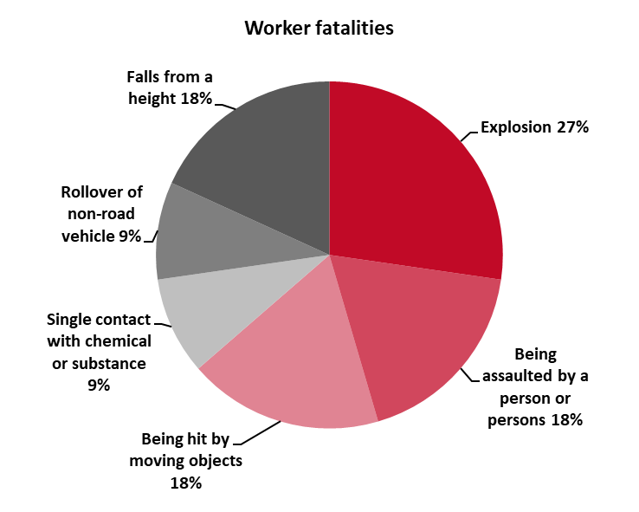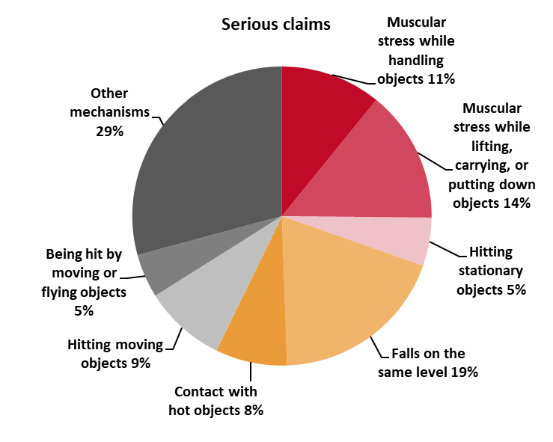

At the sub-industry level, the main causes of injuries were similar across the board, however, there were some differences with respect to fatalities. Explosions and being assaulted by a person or persons were the main causes of fatalities in the food and beverage services sub-industry, whereas falls from a height, being hit by moving objects, rollover of a non-road vehicle and contact with a chemical or substance each accounted for 1 fatality in the accommodation sub-industry.

| **Main causes of fatalities** | **Main causes of injuries** |
| --- | --- |
| **Accommodation** | |
| Falls from a height – 25%  Being hit by moving objects – 25%  Rollover of non-road vehicle – 25%  Contact with chemical or substance – 25% | Falls on the same level – 18%  Muscular stress while handling objects – 17%  Muscular stress while lifting, carrying or putting down objects – 16% |
| **Food and beverage service** | |
| Explosion – 43%  Being assaulted by person(s) – 29%  Being hit by moving objects – 14%  Falls from a height – 14% | Falls on the same level – 19%  Muscular stress while lifting, carrying or putting down objects – 14%  Hitting stationary objects – 10%  Contact with hot objects – 9% |

1. Unless otherwise specified, the data contained in this report is sourced from Safe Work Australia’s National Data Set for Compensation-based Statistics and Work-related Traumatic Injury Fatalities data set. Fatalities data relate to the period 2013 to 2016, while serious claim data related to 2012-13 to 2015-16.
2. The data in this section is sourced from the Australian Bureau of Statistics and the Department of Employment’s *Employment Outlook to May 2022.*