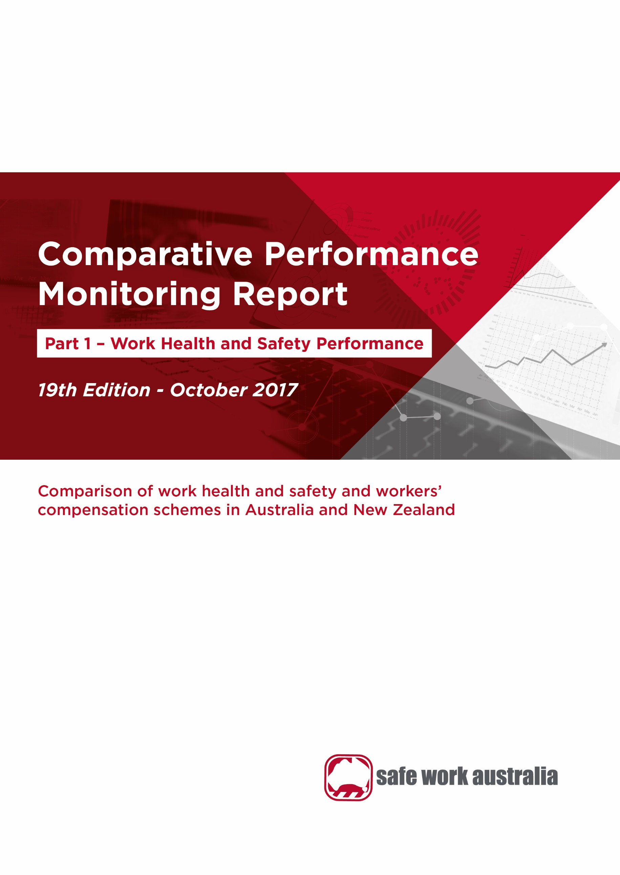

Disclaimer

Safe Work Australia provides the information in this publication to raise awareness of work health and safety. This information is general guidance only and does not replace any statutory requirement contained in any relevant state, territory or Commonwealth legislation. It is not a substitute for independent professional advice. Users should exercise their own skill and care to evaluate the accuracy, currency, completeness and relevance for their purposes of any information contained in the publication. Users should obtain appropriate advice relevant to their particular circumstances.

While Safe Work Australia makes every effort to ensure information is accurate and up-to-date, Safe Work Australia does not provide any warranty regarding the accuracy, currency or completeness of the information contained in this publication and will not be held liable for any loss, damage, cost or expense incurred or arising by reason of any person using or relying on the information in this publication.

This publication may incorporate views or information from third parties, which do not necessarily reflect the views of Safe Work Australia. The inclusion of such material does not indicate an endorsement of that material or a commitment to any particular course of action. The views in this publication should not be taken to represent the views of Safe Work Australia unless otherwise expressly stated.

ISBN 978-1-76051-171-5 (PDF)

ISBN 978-1-76051-172-2 (DOCX)



Creative Commons

With the exception of the Safe Work Australia logo, this report is licensed by Safe Work Australia under a Creative Commons 3.0 Australia Licence. To view a copy of this licence, visit

<http://creativecommons.org/licenses/by/3.0/au/deed.en>

In essence, you are free to copy, communicate and adapt the work, as long as you attribute the work to Safe Work Australia and abide by the other licensing terms. The report should be attributed as the Comparative Performance Monitoring Report 19th Edition Part 1 – Work Health and Safety Performance.

Enquiries regarding the licence and any use of the report are welcome at:

Copyright Officer  
Safe Work Australia   
GPO Box 641 Canberra ACT 2601

Email: [info@swa.gov.au](mailto:info@swa.gov.au)

Important Notice

Safe Work Australia provides the information given in this document to improve public access to information about work health and safety information generally. The vision of Safe Work Australia is Australian workplaces free from injury and disease. Its mission is to lead and coordinate national efforts to prevent workplace death, injury and disease in Australia.

Contents

Foreword 4

1. Serious claims 8

1.1 Incidence rate 8

1.2 Frequency rate 9

1.3 Long term incidence and frequency rates 9

1.4 Self-insured serious claims 11

2. Duration of absence 12

3. Work-related fatalities 13

3.1 Work-related traumatic injury fatalities 13

3.2 Work-related disease fatalities 14

4. Claims by size of business (in the private sector) 15

5. Claims by mechanism of incident 17

5.1 Claims by mechanism of incident and jurisdiction 18

6. Claims by industry 23

6.1 Claims by industry and jurisdiction 25

Appendix 1 — Explanatory notes 35

Appendix 2 – Jurisdictional contact information 39

Foreword

The Labour Ministers’ Council released the first Comparative Performance Monitoring (CPM) report in December 1998. The CPM project was transferred to Safe Work Australia when it was established in 2009. The CPM reports provide trend analysis on the work health and safety and workers’ compensation schemes operating in Australia and New Zealand. This is the 19th annual report of the CPM project.

The CPM is complemented by the [*Australian Workers’ Compensation Statistics*](https://www.safeworkaustralia.gov.au/collection/australian-workers-compensation-statistics) report, which provides more detailed analysis of national workers’ compensation data using key variables such as occupation, industry, age and sex with supporting information on the circumstances surrounding work-related injury and disease occurrences. The CPM is also complemented by the [*Comparison of Workers’ Compensation Arrangements in Australia and New Zealand*](https://www.safeworkaustralia.gov.au/doc/comparison-workers-compensation-arrangements-australia-and-new-zealand-2016), which discusses the way that each scheme deals with key aspects such as coverage, benefits, self-insurance, common law and dispute resolution. The publications can be found at the Safe Work Australia website.

# Statement of purpose

The role of the CPM report is to facilitate improvement of work health and safety, workers’ compensation and related service outcomes in Australian and New Zealand schemes through an accessible report that:

1. monitors the comparative performance of jurisdictions over time, and
2. enables benchmarking across jurisdictions and the identification of best practice to support policy making.

# Data

The data used in this report were supplied by jurisdictions for the 2015–16 financial year plus updates back to 2010–11. Readers should be aware that the data presented here may differ from jurisdictional annual reports due to the use of different definitions and the application of adjustment factors to aid in the comparability of data. Explanatory commentary on the data items is contained within each chapter with additional information included in Appendix 1 – Explanatory Notes, at the end of this publication.

The data in this report were collected from:

* workers’ compensation schemes and work health and safety authorities as follows:
  + New South Wales — State Insurance Regulatory Authority and SafeWork NSW
  + Victoria — WorkSafe Victoria
  + Queensland — Workplace Health and Safety Queensland, Office of Industrial Relations – Queensland Treasury, Queensland Workers’ Compensation Regulator and WorkCover Queensland
  + Western Australia — Department of Mines, Industry Regulation and Safety – WorkSafe
  + South Australia — Return to Work South Australia and SafeWork SA
  + Tasmania — WorkSafe Tasmania and WorkCover Tasmania
  + Northern Territory — NT WorkSafe, Department of Attorney-General and Justice
  + Australian Capital Territory — Access Canberra, Worksafe ACT within Chief Minister Treasury and Economic Development Directorate
  + Australian Government — Comcare
  + Seacare — Seacare Authority (Seafarers Safety, Rehabilitation and Compensation Authority), and
  + New Zealand — Accident Compensation Corporation and WorkSafe New Zealand
* the National Data Set for Compensation-based Statistics and the Work-related Traumatic Injury Fatalities data set compiled by Safe Work Australia. Further information on these data sets can be found on the [Safe Work Australia](https://www.safeworkaustralia.gov.au/statistics-and-research/statistics/statistics) website
* the Return to Work Survey that replaced the Return to Work Monitor previously published by the Heads of Workers’ Compensation Authorities. The full results of which can be accessed at [Safe Work Australia](https://www.safeworkaustralia.gov.au/subject-topics/return-work) website, and
* the Australian Bureau of Statistics (ABS) which provides estimates of the number of employees and hours worked based on the Labour Force Survey, the Survey of Employment and Earnings and data provided by Comcare. Further adjustments are performed using data from the Census, the Forms of Employment Survey and the Survey of Employment Arrangements, Retirement and Superannuation.

# Coordination

This report has been compiled and coordinated by Safe Work Australia with assistance from representatives of all work health and safety and workers’ compensation authorities in Australia and New Zealand. As agreed with Comcare in this report the name ‘Australian Government’ is used for indicators relating to the Australian Government jurisdiction in work health and safety and workers’ compensation matters, while ‘Comcare’ is used to describe Comcare – the entity for indicators relating to scheme performance.

Through a partnership of governments, employers and employees, Safe Work Australia leads the development of national policy to improve work health and safety and workers’ compensation arrangements across Australia.

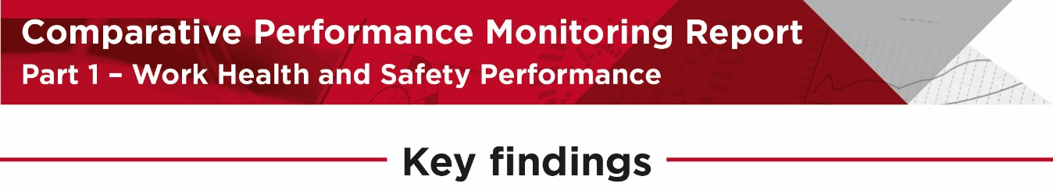

Comparing claims performance in Australia and New Zealand.
Australia: serious claim incidence rate has decreased by 19% between 2011-12 and 2014-15 and the incidence rate was 9.3 serious claims per 1,000 employees in 2015-16.
New Zealand: serious claim incidence rate has increased by 16% between 2011-12 and 2014-15 and the incidence rate was 11.3 serious claims per 1,000 employees in 2015-16.

Showing the words Australian long term claims 12 weeks or more compensation. Incidence rate of long term claims has decreased by 20% between 2011-12 and 2014-15.
The incidence rate was 2.8 long term serious claims per 1,000 employees 2015-16.

Showing claims with more than 52 weeks of compensation in 2013-14 with 10% of serious claims in Australia and 4% of serious claims in New Zealand. 
Claims with less than 6 weeks of compensation in 2013-14 with 52% of serious claims in Australia and 66% of serious claims in New Zealand. 




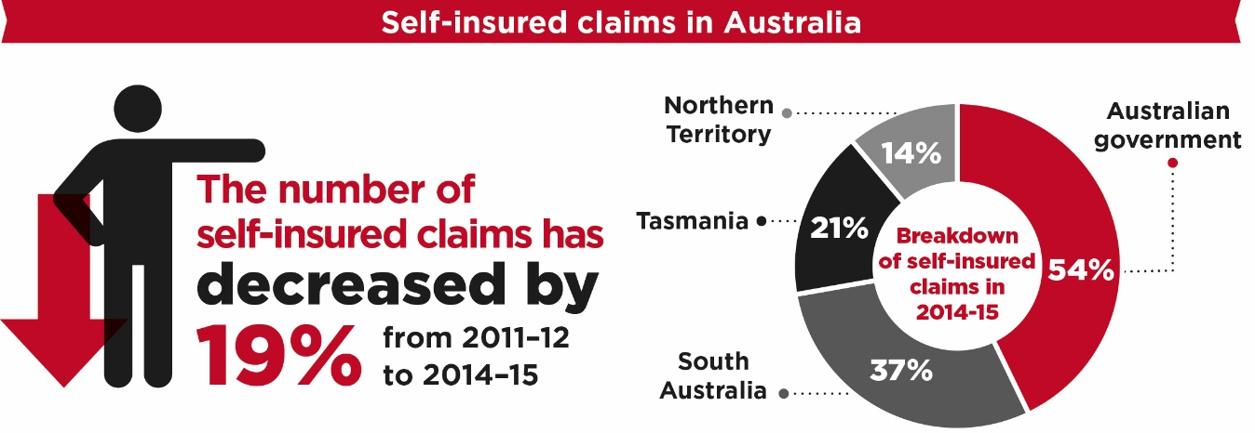

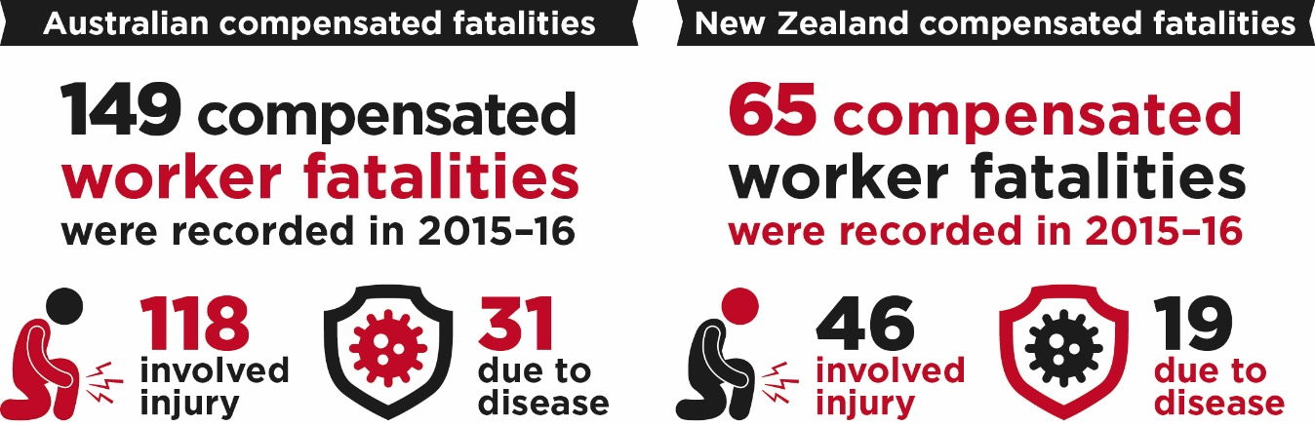

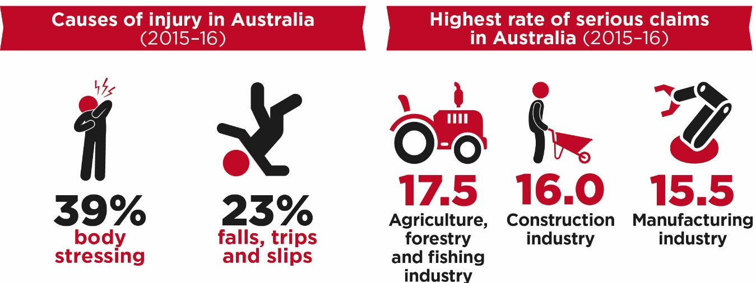

1. Serious claims

The data used in this section are accepted serious workers’ compensation claims lodged in each financial year plus fatalities information from additional sources. Serious claims refer to claims relating to incapacity that result in a total absence from work of one working week or more. Workers’ compensation data are currently the most comprehensive source of information for measuring work health and safety performance. While there are some limitations, most notably that the data reflect the injury experience of employees only and under-report the incidence of disease, workers’ compensation data still provide a good indication of work health and safety trends. The estimates of the number of employees and hours worked (supplied by the ABS) have been recently revised back to 2012–13. This change means that incidence and frequency rates published in this report will differ to those previously published.

Incidence rate

Indicator 1 shows that the Australian incidence rate for serious claims has steadily declined over the past four years, decreasing 19 per cent from 12.3 to 10.0 claims per 1,000 employees between 2011–12 and 2014–15. Preliminary data for 2015–16 show an incidence rate of 9.3 claims per 1,000 employees; however this is expected to rise when updated data are available.

Indicator – Incidence rates of serious injury and disease claims by jurisdiction

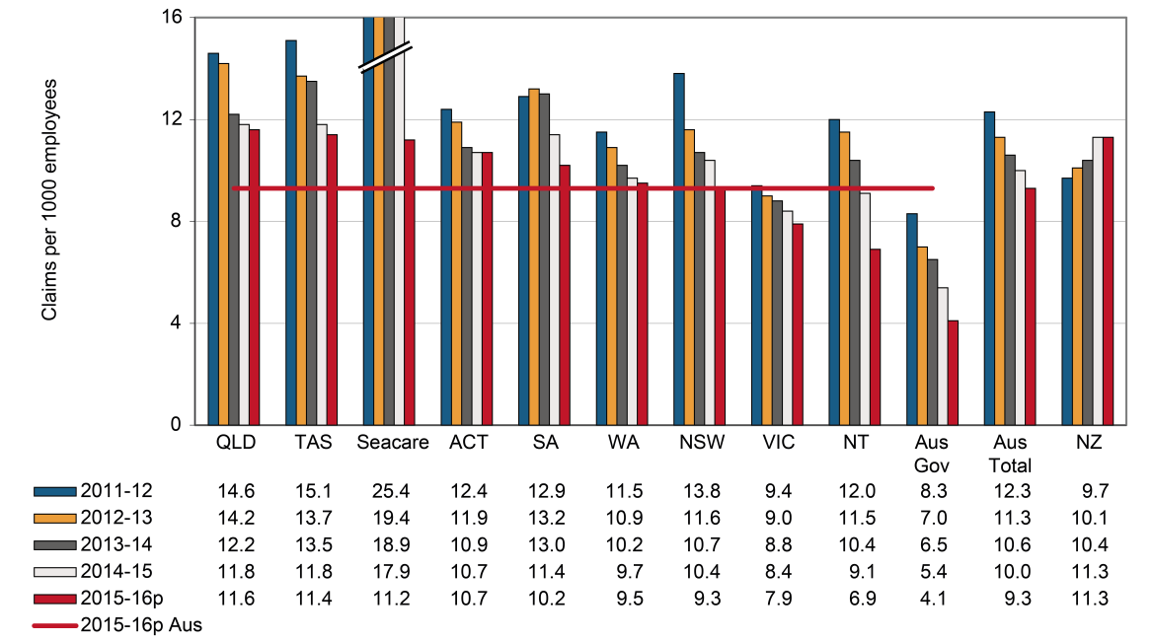

Between 2011–12 and 2014–15 all Australian jurisdictions recorded falls in the incidence rate of serious claims. The Australian Government recorded the largest decrease (down 35 per cent), followed by Seacare (down 30 per cent), New South Wales (down 25 per cent), the Northern Territory (down 24 per cent), and Tasmania (down 22 per cent). Preliminary data show that Queensland recorded the highest incidence rate of serious claims in 2015–16 with 11.6 claims per 1,000 employees, while the Australian Government recorded the lowest rate with 4.1 claims per employees, followed by the Northern Territory (6.9 claims per 1,000 employees).

Over the period from 2011–12 to 2014–15, New Zealand recorded a 16 per cent increase in the incidence rate of serious claims, increasing from 9.7 to 11.3 claims per 1,000 employees. Preliminary data for 2015–16 show the New Zealand incidence rate has remained unchanged at 11.3 serious claims per 1,000 employees.

Frequency rate

Indicator 2 shows that the Australian frequency rate of serious claims decreased 18 per cent from 7.3 claims per million hours worked in 2011–12 to 6.0 in 2014–15. Preliminary data show that the Australian frequency rate of serious claims has decreased slightly to 5.6 claims per million hours worked in 2015–16. Although the frequency rate data show a similar level of improvement to incidence rates across jurisdictions, there are differences in the ranking of jurisdictions. Tasmania recorded the highest frequency rate at 7.5 claims per one million hours worked in 2015–16, compared to the second highest incidence rate. Seacare only had the ninth highest frequency rate (compared to the third highest incidence rate) due to the 24-hour basis on which its frequency rates are calculated. Refer to Note 1 in Appendix 1 - Explanatory notes for further information.

Indicator – Frequency rates of serious injury claims by jurisdiction

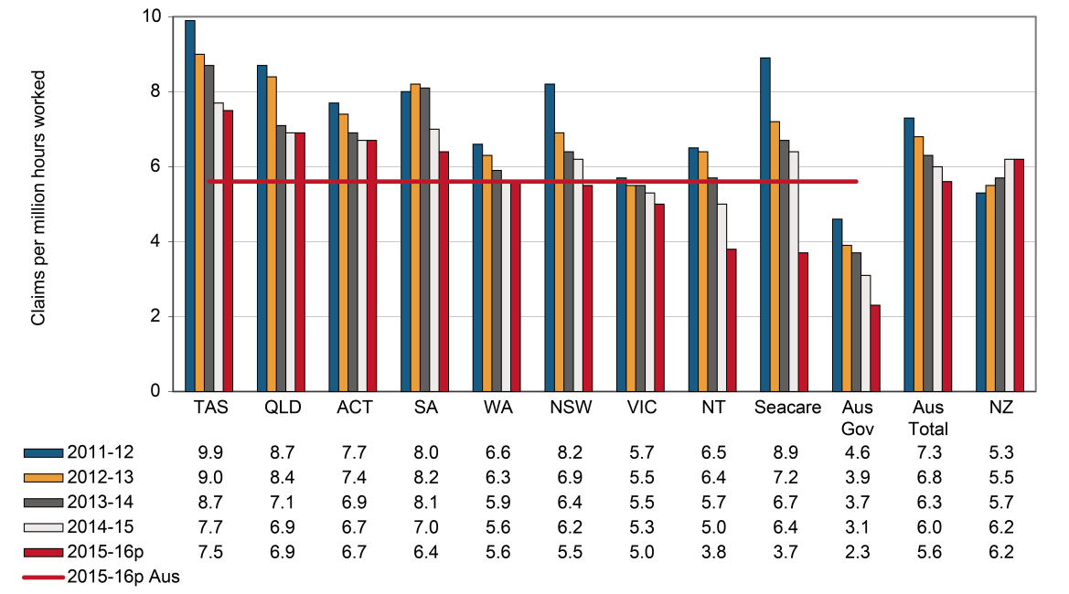

Long term incidence and frequency rates

Indicator 3 shows that the incidence rate of long term injury and disease claims in Australia decreased by 20 per cent between 2011–12 and 2014–15. While the preliminary 2015–16 results show a 13 per cent decrease in the incidence rate compared to the previous year, these data should be treated with caution due to less time lost from work associated with these claims compared to claims from the previous years as some of them will not yet been finalised. On average, 32 per cent of serious claims resulted in 12 or more weeks of compensation over the five year period.

All Australian jurisdictions recorded a decrease in incidence rates of long term claims over the period from 2011–12 to 2014–15. Australian Government had the highest decrease in incidence rate (down 39 per cent) over the period, followed by the Northern Territory (down 37 per cent), New South Wales (down 34 per cent) and Seacare (down 24 per cent). New Zealand recorded a 28 per cent increase over this period, however, its rate remains lower than that of Australia.

Indicator – Incidence rates of long term (12 weeks or more compensation) injury and disease claims by jurisdiction

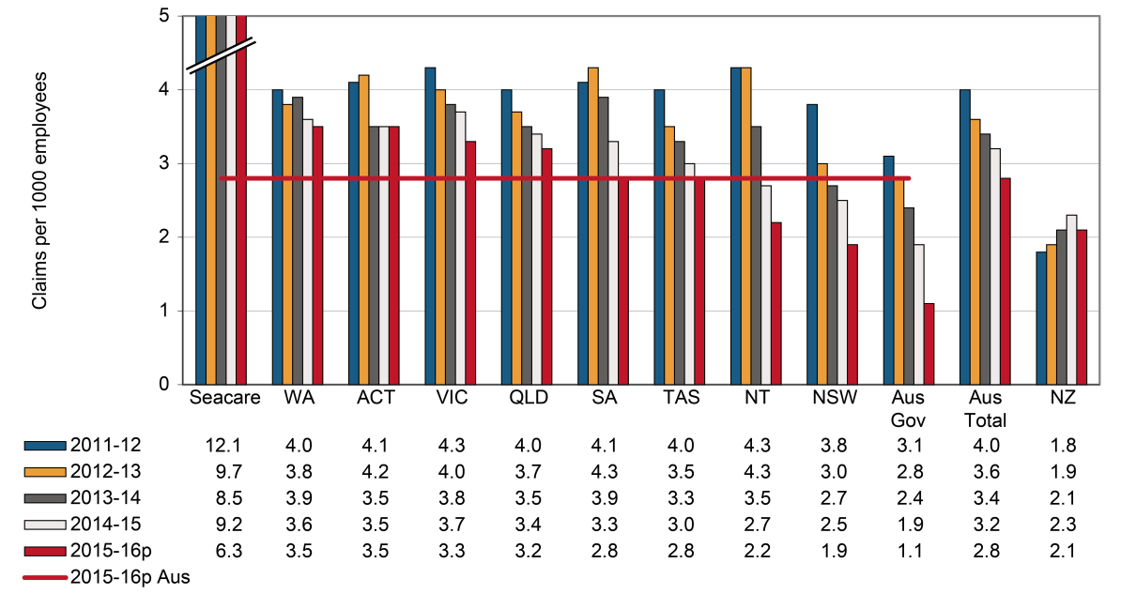

The frequency rates of long term claims (Indicator 4) decreased across all Australian jurisdictions during the comparative period. The Australian frequency rate of long-term serious claims decreased by 21 per cent from 2.4 claims per million hours worked in 2011–12 to 1.9 in 2014–15. Preliminary data for 2015–16 shows the Australian frequency rate of long-term serious claims was 1.7 claims per million hours worked.

Indicator – Frequency rates of long term (12 weeks or more compensation) injury and disease claims by jurisdiction

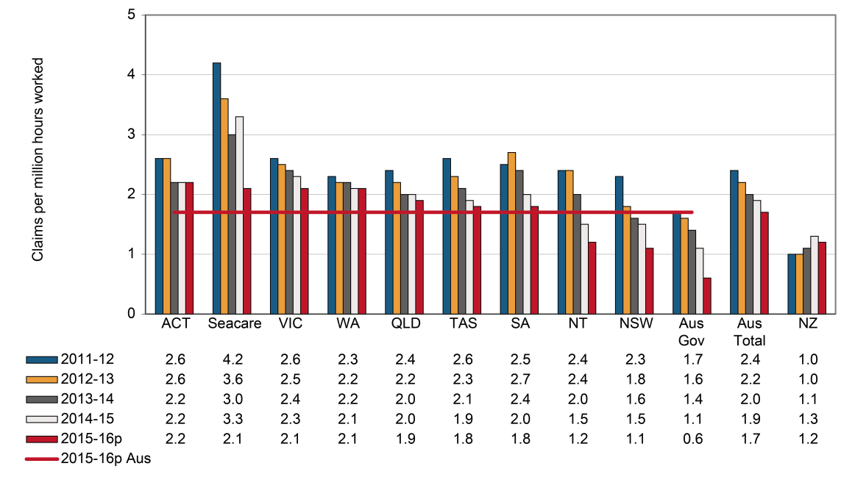

Self-insured serious claims

Indicator 5 shows that the number of self-insured serious claims in Australia decreased by 19 per cent during the period from 2011–12 to 2014–15. The preliminary data for Australia in 2015‑16 shows a further 11 per cent decrease from the previous year. The Northern Territory recorded the highest decrease in the number of self-insured serious claims (down 33 per cent) over the period from 2011–12 to 2014–15, followed by the Australian Government (down 31 per cent), New South Wales (down 30 per cent) and Victoria (down 29 per cent). South Australia was the only jurisdiction to show an increase in the number of self-insured serious claims (up 3 per cent) during the same period.

The number of self-insured serious claims in New Zealand showed a 24 per cent increase between 2011–12 and 2014–15. Preliminary data show a decrease of 4 per cent in the number of self-insured claims over the year to 2015–16.

The proportion of self-insured claims in Australia did not show any substantive change during the comparative period. The Australian Government (54 per cent) had the highest percentage of self‑insured claims in 2014–15, followed by South Australia (37 per cent), Tasmania (21 per cent), and the Northern Territory (14 per cent). By contrast, the Australian Capital Territory had the lowest percentage of self-insured claims (2 per cent). Preliminary data for 2015–16 showed a similar trend, with the highest and lowest percentages reported in the Australian Government and the Australian Capital Territory, respectively.

In New Zealand, 25 per cent of serious claims in 2014–15 were recorded by self-insurers, which is more than twice the Australian proportion for the same financial year.

For more information on self-insurers’ arrangements in Australia and New Zealand refer to Chapter six of the Comparison of Workers’ Compensation Arrangements publication on [Safe Work Australia](https://www.safeworkaustralia.gov.au/workers-compensation/comparing-australias-workers-compensation-schemes) website.

Indicator a – Self-insured claims: number of serious claims by jurisdiction

|  | SA | NSW | Vic | Qld | WA | Aus Gov | Tas | NT | ACT | Australian total | NZ |
| --- | --- | --- | --- | --- | --- | --- | --- | --- | --- | --- | --- |
| 2011–12 | 2,995 | 4,031 | 2,706 | 2,142 | 1,012 | 1,625 | 640 | 250 | 30 | 15,431 | 4,615 |
| 2012–13 | 3,137 | 3,003 | 2,246 | 1,983 | 1,014 | 1,324 | 616 | 260 | 23 | 13,606 | 5,240 |
| 2013–14 | 3,202 | 2,859 | 2,079 | 1,833 | 975 | 1,264 | 561 | 245 | 29 | 13,047 | 5,203 |
| 2014–15 | 3,072 | 2,833 | 1,925 | 1,808 | 976 | 1,126 | 541 | 167 | 30 | 12,478 | 5,740 |
| 2015–16p | 2,534 | 2,381 | 1,829 | 1,704 | 944 | 923 | 564 | 144 | 28 | 11,051 | 5,524 |

Indicator 5b – Self-insured claims: proportion of serious claims by jurisdiction

|  | SA | NSW | Vic | Qld | WA | Aus Gov | Tas | NT | ACT | Australian total | NZ |
| --- | --- | --- | --- | --- | --- | --- | --- | --- | --- | --- | --- |
| 2011–12 | 32 | 9 | 11 | 8 | 8 | 53 | 20 | 18 | 2 | 12 | 25 |
| 2012–13 | 32 | 8 | 10 | 7 | 8 | 48 | 21 | 19 | 1 | 11 | 27 |
| 2013–14 | 34 | 8 | 9 | 7 | 8 | 51 | 20 | 18 | 2 | 11 | 25 |
| 2014–15 | 37 | 8 | 9 | 7 | 8 | 54 | 21 | 14 | 2 | 11 | 25 |
| 2015–16p | 34 | 7 | 8 | 7 | 8 | 57 | 22 | 16 | 2 | 11 | 23 |

1. Duration of absence

The duration of absence associated with claims provides an indication of the severity of injuries occurring in Australia. Indicator 6 shows the variation across the jurisdictions in the percentage of claims involving selected periods of compensation. These data are based on claims lodged in 2013–14, which is the most recent year that reliable data are available for this indicator.

Indicator 6 shows that 52 per cent of claims in Australia resulted in less than six weeks of compensation. The jurisdictional rates were broadly similar except for Seacare where only 25 per cent of claims were resolved in this time. Seacare (25 per cent), Victoria (40 per cent), the Australian Government (45 per cent), Western Australia (46 per cent) and the Northern Territory (50 per cent) all recorded lower percentages than the national figure. Injured workers in the Seacare scheme face unique issues in return to work that need to be considered when interpreting the Seacare results for this indicator. Refer to Note 4 in Appendix 1 (Explanatory notes) for further information.

Victoria had the highest percentage of claims that continued past 52 weeks of compensation (18 per cent of claims), followed by Western Australia (13 per cent), the Australian Government (11 per cent) and South Australia (10 per cent). Queensland and Tasmania had the lowest percentage (6 per cent) of claims continuing past 52 weeks of compensation.

The New Zealand scheme finalised a higher proportion of claims within six weeks (66 per cent), which is 27 per cent higher than the Australian average (52 per cent of claims).

Indicator – Serious claims: Percentage involving selected periods of compensation, 2013–14

| Jurisdiction | less than 6 weeks | 6 weeks or more | 12 weeks or more | 26 weeks or more | 52 weeks or more |
| --- | --- | --- | --- | --- | --- |
| New South Wales | 58 | 42 | 26 | 13 | 7 |
| Victoria | 40 | 60 | 44 | 29 | 18 |
| Queensland | 54 | 46 | 29 | 14 | 6 |
| South Australia | 56 | 44 | 30 | 17 | 10 |
| Western Australia | 46 | 54 | 38 | 24 | 13 |
| Tasmania | 58 | 42 | 24 | 12 | 6 |
| Northern Territory | 50 | 50 | 34 | 18 | 9 |
| Australian Capital Territory | 53 | 47 | 32 | 17 | 9 |
| Australian Government | 45 | 55 | 38 | 21 | 11 |
| Seacare | 25 | 75 | 45 | 21 | 8 |
| Australian average | **52** | **48** | **32** | **18** | **10** |
| New Zealand | 66 | 34 | 20 | 9 | 4 |

1. Work-related fatalities

Work-related traumatic injury fatalities

The data presented in this section are sourced from the Work-related Traumatic Injury Fatality (TIF) data collection. The TIF collection provides the most accurate information on work-related injury fatalities, as the data are sourced from workers’ compensation data, fatality notifications to the various work health and safety authorities and information in the National Coronial Information System (NCIS). Only around 60 per cent of work-related fatalities recorded in the TIF collection are typically compensated. This is in part due to self-employed workers not being covered by workers’ compensation schemes. Many self-employed workers work in high risk sectors such as agriculture, transport and construction. Further information about the TIF collection and a detailed analysis of the data can be found on the [Safe Work Australia](https://www.safeworkaustralia.gov.au/collection/work-related-traumatic-injury-fatalities) website.

Information presented below in Indicator 7 does not include fatal work-related incidents occurring on a public road. This is because some fatalities, particularly those related to traffic incidents, may be missed due to the way these deaths are identified. The information in the NCIS relies heavily on information collected from reports which may not include sufficient information to identify whether or not the deceased was working at the time of the incident. The compensated injury fatalities in the TIF collection are based on date of death and not date of lodgement as in the case of compensated fatalities involving occupational diseases (Indicator 8).

Indicator 7 shows that between 2011–12 and 2015–16 there was a 10 per cent decrease in the number of workers killed as a result of incidents not on a public road. Over the five years, on average, New South Wales has recorded the highest number of fatalities per year (43 fatalities), followed by Queensland (37 fatalities) and Victoria (28 fatalities).

It should be noted that traumatic injury fatality data can be volatile year-on-year. In particular, multiple death events can impact the data, despite efforts of jurisdictions in reducing or eliminating work-related traumatic injury fatalities.

There were 65 compensated fatalities (includes incidents on a public road) in New Zealand in 2015–16. New Zealand recorded a 2 per cent increase in the number of compensated fatalities from 84 in 2011–12 to 86 in 2014–15.

Indicator a – Traumatic injury fatalities: number of incidents not on a public road, by state of death

|  | 2011–12 | 2012–13 | 2013–14 | 2014–15 | 2015–16 | 5 year average |
| --- | --- | --- | --- | --- | --- | --- |
| New South Wales | 48 | 50 | 36 | 42 | 41 | **43** |
| Queensland | 45 | 39 | 36 | 30 | 34 | **37** |
| Victoria | 27 | 25 | 28 | 26 | 32 | **28** |
| Western Australia | 19 | 18 | 20 | 19 | 23 | **20** |
| South Australia | 12 | 11 | 8 | 10 | 9 | **10** |
| Tasmania | 5 | 4 | 6 | 7 | 5 | **5** |
| Northern Territory | 5 | 1 | 5 | 1 | 2 | **3** |
| Australian Capital Territory | 2 | 1 | 1 | u/a | u/a | **1** |
| Australian total | **163** | **149** | **140** | **135** | **146** | **147** |

Indicator 7b – Traumatic injury fatalities: incidence rate per 100,000 workers for incidents not on a public road, by state of death

|  | 2011–12 | 2012–13 | 2013–14 | 2014–15 | 2015–16 | 5 year average |
| --- | --- | --- | --- | --- | --- | --- |
| New South Wales | 1.4 | 1.4 | 1.0 | 1.2 | 1.1 | **1.2** |
| Queensland | 2.0 | 1.7 | 1.6 | 1.3 | 1.4 | **1.6** |
| Victoria | 1.0 | 0.9 | 1.0 | 0.9 | 1.1 | **1.0** |
| Western Australia | 1.5 | 1.4 | 1.5 | 1.4 | 1.7 | **1.5** |
| South Australia | 1.5 | 1.4 | 1.0 | 1.2 | 1.1 | **1.2** |
| Tasmania | 2.1 | 1.7 | 2.6 | 2.9 | 2.1 | **2.3** |
| Northern Territory | 4.1 | 0.8 | 3.8 | 0.8 | 1.5 | **2.2** |
| Australian Capital Territory | 1.0 | 0.5 | 0.5 | u/a | u/a | **0.6** |
| Australian total | **1.4** | **1.3** | **1.2** | **1.2** | **1.2** | **1.3** |

Work-related disease fatalities

Workers’ compensation data contain some information on disease-related fatalities but are known to understate the number of fatalities from work-related causes. It can be difficult to associate a disease that becomes evident later in life after exposure to a chemical or substance that occurred many years earlier while at work. Some occupational diseases such as asbestosis and mesothelioma are compensated through separate mechanisms while many other diseases go unreported and/or uncompensated.

Indicator 8 shows that in 2015–16 there were 31 accepted workers’ compensation claims for a work-related fatality involving an occupational disease in Australia. This number is expected to rise as more claims lodged in 2015–16 are accepted. There was a substantial decrease (down 44 per cent) in the number of fatalities related to occupational diseases in Australia from 2011–12 to 2014–15.

Fatalities are recorded in the National Dataset for Compensation-based Statistics against the date of lodgement of the claim, not the date of death. Data revisions from previous years could occur where a claim is lodged in one year but not accepted until after the data are collected for that year or for an injury or disease in one year where the employee dies from that injury or disease in a subsequent year. This is particularly the case with disease-related fatalities where considerable time could elapse between date of diagnosis leading to a claim being lodged and the date of death.

Safe Work Australia reports on mesothelioma using data from the National Cancer Statistics Clearing House. Mesothelioma in Australia: Incidence (1982 to 2013) and Mortality (1997 to 2012), is the most recent publication which is available at the [Safe Work Australia](https://www.safeworkaustralia.gov.au/doc/mesothelioma-australia-incidence-1982-2013-and-mortality-1997-2012) website. The Australian Mesothelioma Registry also reports annually on mesothelioma incidence which is also available on its [website](https://www.mesothelioma-australia.com/home/).

Indicator – Compensated fatalities involving occupational diseases by jurisdiction

| Jurisdiction | 2011–12 | 2012–13 | 2013–14 | 2014–15 | 2015–16p | 5 year average |
| --- | --- | --- | --- | --- | --- | --- |
| New South Wales | 12 | 7 | 7 | 9 | 7 | **8** |
| Victoria | 15 | 11 | 11 | 9 | 9 | **11** |
| Queensland# | 26 | 17 | 14 | 16 | 2 | **15** |
| Western Australia | 6 | 5 | 6 | 1 | 3 | **4** |
| South Australia | 0 | 1 | 0 | 0 | 0 | **0** |
| Tasmania | 0 | 0 | 0 | 0 | 0 | **0** |
| Northern Territory | 0 | 0 | 0 | 0 | 0 | **0** |
| Australian Capital Territory | 0 | 0 | 0 | 0 | 0 | **0** |
| Australian Government | 23 | 21 | 21 | 11 | 10 | **17** |
| Seacare | 0 | 0 | 0 | 0 | 0 | **0** |
| Australian total | **82** | **62** | **59** | **46** | **31** | **56** |
| New Zealand | 36 | 45 | 30 | 39 | 19 | **34** |

# The majority of compensated fatalities for occupational diseases in Queensland and the Australian Government are due to mesothelioma or asbestosis. Queensland compensates more of these fatalities through its scheme than is the case in other jurisdictions where compensation is more often sought through separate mechanisms including common law.

1. Claims by size of business (in the private sector)

Indicator 9 compares the incidence of serious workers’ compensation claims by size of business in 2010–11 and 2014–15. Eight Australian jurisdictions collect compensation data by size of business. Seacare has been excluded as 2015–16 data were unavailable for comparison.

There are differences in the methodologies used by schemes to collect this information and therefore caution should be exercised when making jurisdictional comparisons. This indicator reports on the private sector only and excludes those industry sectors that are wholly or substantially public sector industries (i.e. Public administration and safety, Health care and social assistance, Education and training and Financial and insurance services).

In 2015–16, Australian businesses with 200 or more employees recorded the lowest incidence rate of serious claims (6.8 claims per 1,000 employees). With the exception of the Northern Territory, all other jurisdictions recorded the highest incidence rate in businesses with 20−199 employees in 2015–16. Overall, the incidence rate of serious claims in businesses with 1–19 employees, 20–199 employees and 200 or more employees fell by 22 per cent, 19 per cent and 26 per cent, respectively, between 2011–12 and 2015–16.

Indicator – Size of business: incidence rates (claims per 1,000 employees) of serious claims by jurisdiction (private sector only)*

|  | 1–19 employees | 20–199 employees | 200 or more employees | All employees |
| --- | --- | --- | --- | --- |
| 2011–12 |  |  |  |  |
| New South Wales | 11.1 | 12.3 | 7.4 | 10.2 |
| Victoria | 5.9 | 13.1 | 10.9 | 9.6 |
| Western Australia | 10.3 | 19.3 | 8.9 | 12.3 |
| South Australia | 10.5 | 14.5 | 10.2 | 11.4 |
| Tasmania | 9.8 | 23.0 | 15.3 | 15.2 |
| Northern Territory | 21.6 | 16.2 | 1.8 | 13.5 |
| Australian Capital Territory | 7.9 | 19.7 | 10.3 | 11.8 |
| Australia** | **9.3** | **13.9** | **9.2** | **10.5** |
| 2015–16p |  |  |  |  |
| New South Wales | 8.1 | 9.0 | 4.4 | 7.1 |
| Victoria | 5.2 | 12.5 | 8.1 | 8.1 |
| Western Australia | 8.0 | 15.5 | 10.4 | 10.7 |
| South Australia | 9.1 | 11.2 | 8.0 | 9.2 |
| Tasmania | 6.9 | 15.9 | 10.7 | 10.4 |
| Northern Territory | 12.6 | 9.9 | 2.3 | 8.4 |
| Australian Capital Territory | 7.9 | 18.2 | 8.4 | 10.7 |
| Australia** | **7.3** | **11.3** | **6.8** | **8.2** |

* This indicator shows patterns at two points in time. Selecting different points may show a different pattern.

** Excluding Queensland and Seacare.

1. Claims by mechanism of incident

Claim patterns can be analysed using the Type of Occurrence Classification System (TOOCS), which contains a series of codes providing information on the cause of the incident and the type of injury or disease sustained. Coding for the mechanism of incident is intended to identify the overall action, exposure or event that best describes the circumstances that resulted in the most serious injury or disease. More information on TOOCS can be found on the [Safe Work Australia](https://www.safeworkaustralia.gov.au/doc/type-occurrence-classification-system-3rd-edition-revision-1) website.

Indicator 10 shows the proportion of serious claims by the mechanism of incident over the past five years. Body stressing accounted for 39 per cent of the 104 770 serious claims in 2015–16. Claims due to Mental stress accounted for 6 per cent of claims, while claims due to Falls, slips and trips of a person accounted for 23 per cent.

Claims arising due to Falls, slips and trips of a person showed the highest reduction in claims (down 16 per cent) between the period 2011–12 to 2014–15, followed by Vehicle incidents (down 8 per cent).

Indicator – Proportion of serious claims by mechanism of incident

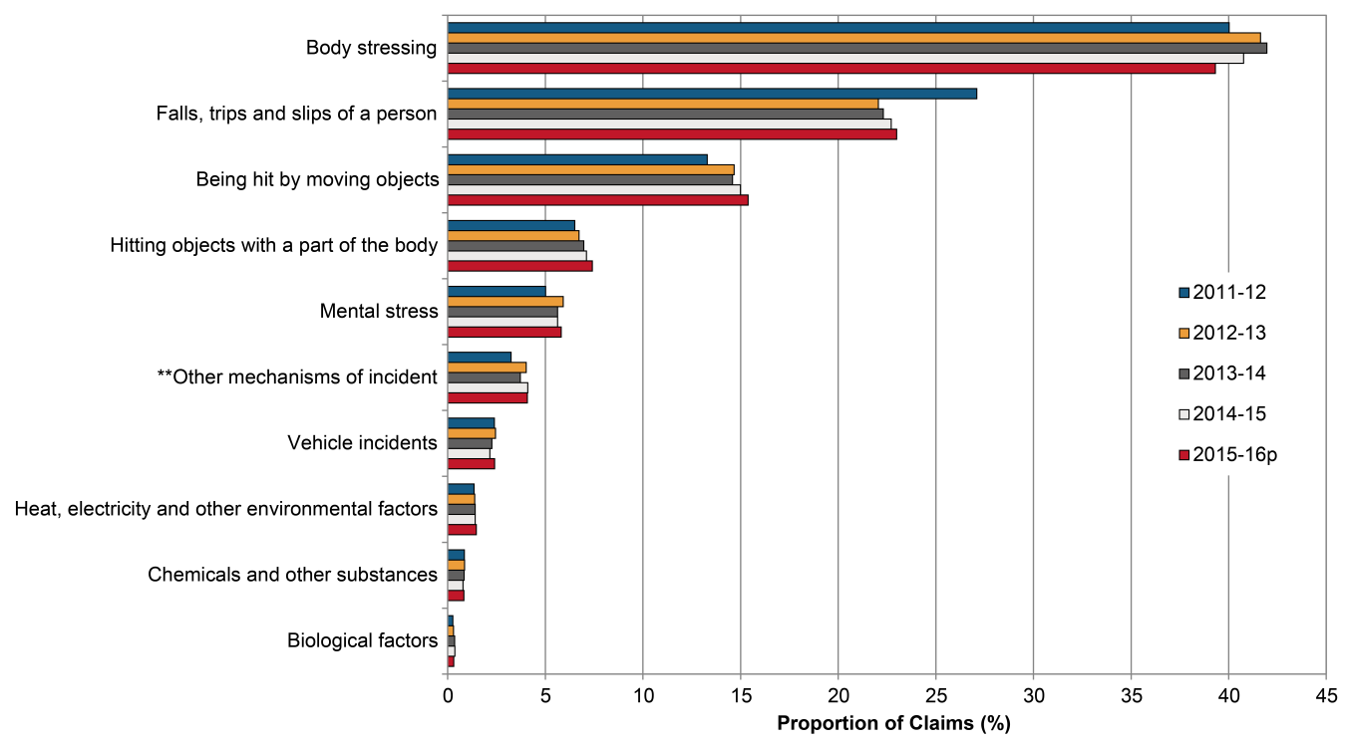

** Other mechanisms of incident include Sound and pressure, Other multiple mechanisms of incident, Roll over, Slide or cave-in and Unspecified mechanisms of incident.

Claims by mechanism of incident and jurisdiction

Presented below is a comparison of the proportion of claims across the Australian jurisdictions for the eight different groups of mechanisms of incident. Due to the differences in the total number of serious claims across jurisdictions, proportions are a better measure for direct comparison between jurisdictions. Hence, the data reported here are comparisons of the proportion of claims for each mechanism of incident across different jurisdictions. The industry and occupation composition of each jurisdiction, however, can have an influence on the proportion of claims due to different mechanisms and therefore may explain some of the differences between jurisdictions.

# Body stressing

Body stressing was the leading mechanism of incident for serious claims between 2011–12 and 2014–15 accounting for 41 per cent of the 110 280 serious claims in 2014–15.

Indicator 10a shows that in 2014–15 South Australia had the highest proportion of claims (45.4 per cent) involving Body stressing, followed by the Australian Government (44.7 per cent), Victoria (43.2 per cent) and Seacare (43.1 per cent), all of which were greater than the Australian average (40.8 per cent of claims). The Northern Territory had the lowest proportion of claims (27.1 per cent) involving Body stressing in 2014–15.

Indicator 10 – Proportion of serious claims involving body stressing by jurisdiction

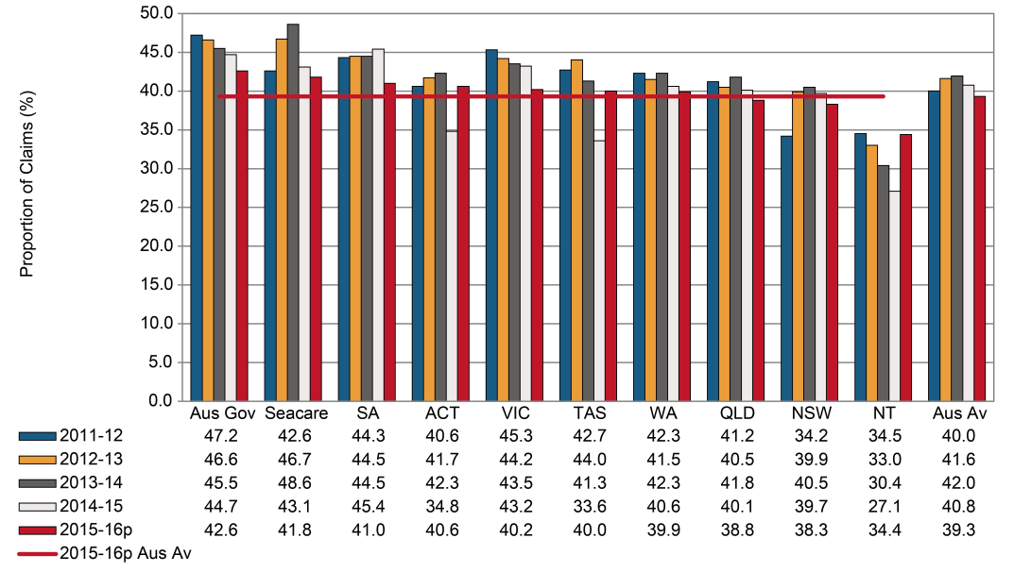

# Falls, trips and slips of a person

Indicator 10b shows the proportion of claims involving Falls, trips and slips of a person across the jurisdictions. Falls, trips and slips of a person accounted for 23 per cent of serious claims in Australia in 2014–15.

This mechanism of incident was the second leading cause for serious claims among employees across jurisdictions. Seacare recorded the highest proportion of claims (34.1 per cent) in 2014–15 for this mechanism, while the Australian Government recorded the lowest proportion of claims (20.5 per cent), followed by Tasmania (20.7 per cent) and South Australia (20.8 per cent).

Indicator 10 – Proportion of serious claims involving falls, trips and slips of a person by jurisdiction

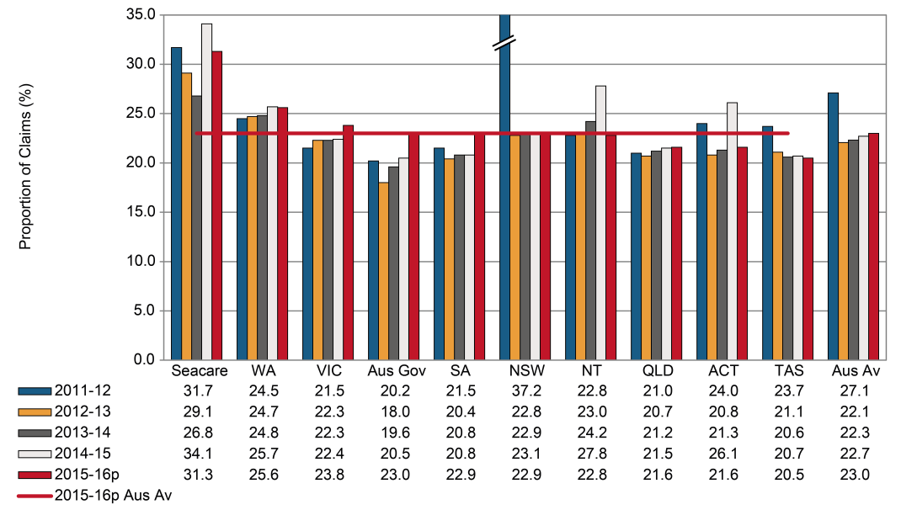

# Being hit by moving objects

The Northern Territory had the highest proportion of serious claims (21.9 per cent) in 2014–15 arising from Being hit by moving objects followed by Western Australia (18.3 per cent), Tasmania and Victoria (16.2 per cent each). The Australian Government had the lowest proportion of serious claims involving this mechanism of incident (6.4 per cent) during the same financial year.

The Australian average for the proportion of claims involving Being hit by moving objects has increased from 13.3 per cent in 2011–12 to 15.0 per cent in 2014–15.

Indicator 10 – Proportion of serious claims involving being hit by moving objects by jurisdiction

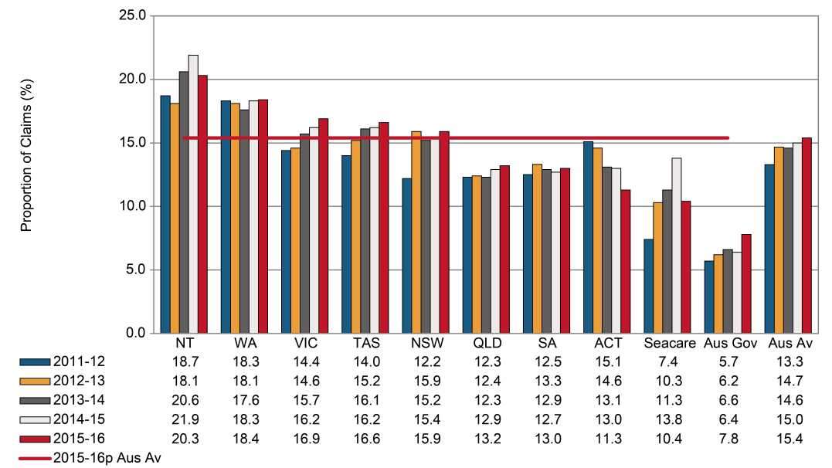

# Hitting objects with a part of the body

This mechanism of incident includes where the motion of a person results in hitting (including bumping, cutting, striking, grasping etc.) a stationary and moving objects (including machines, vehicles, equipment, tools etc.). Indicator 10d shows that New South Wales recorded the highest proportion of serious claims (9.0 per cent) in 2014–15, up from 6.5 per cent in 2011–12. The Australian Government recorded the lowest proportion of claims (3.2 per cent) followed by Seacare (3.3 per cent) in 2014–15. The Australian average has been increasing steadily since 2011–12, with 7.1 per cent of claims associated with this mechanism recorded in 2014–15.

Indicator 10 – Proportion of serious claims involving hitting objects with a part of the body by jurisdiction

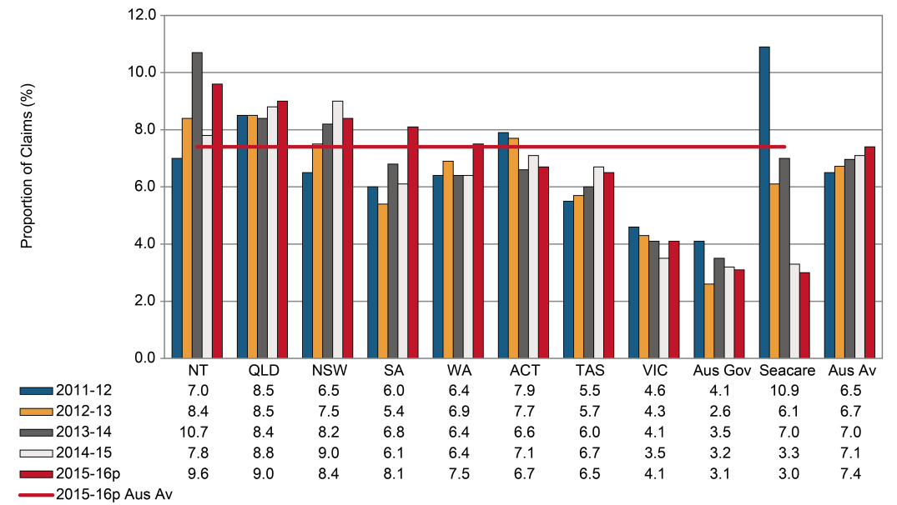

# Mental stress

The proportion of serious claims due to Mental stress in Australia increased from 5.0 per cent in 2011–12 to 5.6 per cent in 2014–15. The Australian Government had the highest proportion of Mental stress claims during 2014–15 (13.5 per cent), which is more than twice the Australian average. Seacare showed the lowest proportion of Mental stress claims during the same year (0.8 per cent of claims).

Indicator 10 – Proportion of serious claims involving mental stress by jurisdiction

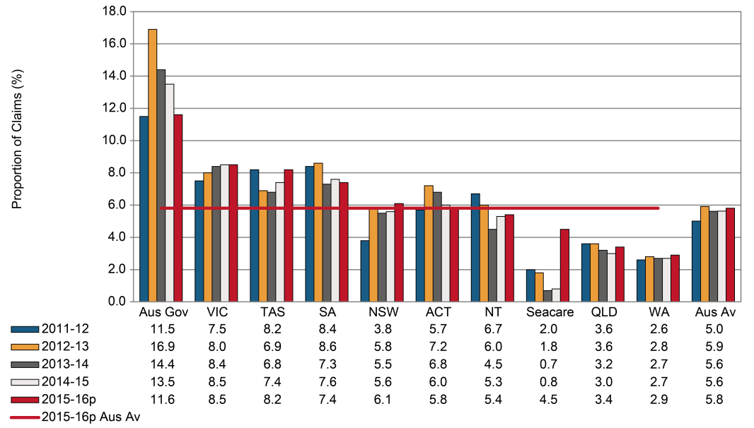

# Other mechanisms

Indicator 10f shows the proportions of serious claims involving Other mechanisms of incident. This category includes Biological factors, Chemicals and other substances, Sound and pressure, Other multiple mechanisms of incidents, Roll over, slide or cave-in and Unspecified mechanisms of incidents.

Tasmania (12.8 per cent) had the highest proportion of claims for this mechanism group during 2014–15 due to the substantial increase in the number of claims coded under unspecified mechanisms of incident and, therefore this data should be treated with caution. This was followed by Queensland (10.2 per cent), and the Australian Capital Territory (8.8 per cent). Western Australia recorded 2.1 per cent of serious claims due to this mechanism, which is the lowest proportion of all the jurisdictions in 2014–15. The Australian average was 5.3 per cent of claims in 2014–15.

Indicator 10 – Proportion of serious claims involving other mechanisms by jurisdiction

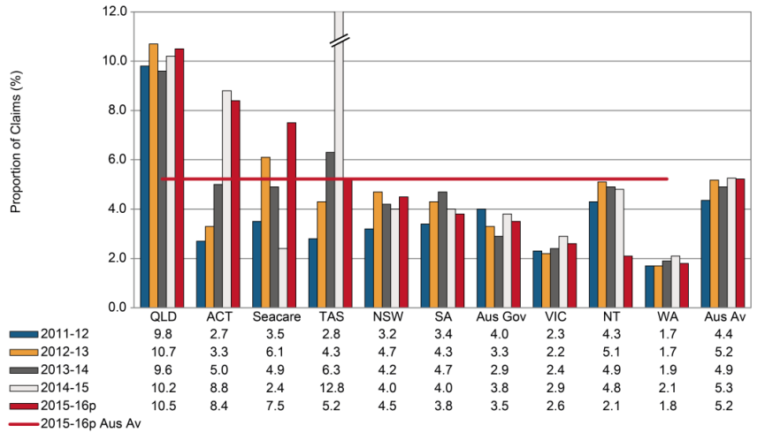

# Vehicle incidents

In 2014–15, 2.2 per cent of all serious claims across Australian jurisdictions were due to Vehicle incidents as shown in Indicator 10g. Serious claims due to vehicle incidents cover all claims lodged and accepted for compensation where vehicles were involved in the incident resulting in injuries.

The Australian Government showed the highest proportion of serious claims due to this mechanism (7.3 per cent) during 2014–15, which was more than three times the Australian average (2.2 per cent). This may in part be explained by the composition of this jurisdiction leading to lower proportions of claims due to other mechanisms. Tasmania had the lowest proportion of claims (1.4 per cent), followed by New South Wales (1.6 per cent). Seacare has not reported any Vehicle incident related claims since 2011–12.

Indicator 10 – Proportion of serious claims involving vehicle incidents by jurisdiction

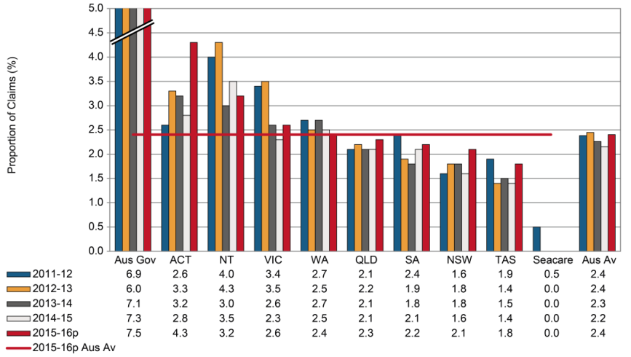

# Heat, electricity and other environmental factors

Of all the mechanisms of incident, claims associated with Heat, electricity and other environmental factors accounted for the lowest proportion (1.4 per cent) of serious claims in 2014–15. Indicator 10h shows that the proportion of claims has been stable since 2011–12 at 1.4 per cent.

Seacare (2.4 per cent) had the highest proportion of claims due to this mechanism of incident, followed by the Northern Territory (1.8 per cent). The lowest proportion of claims were reported by the Australian Government (0.6 per cent), Victoria (1.0 per cent) and Tasmania (1.2 per cent).

Indicator 10 – Proportion of serious claims involving heat, electricity and other environmental factors by jurisdiction

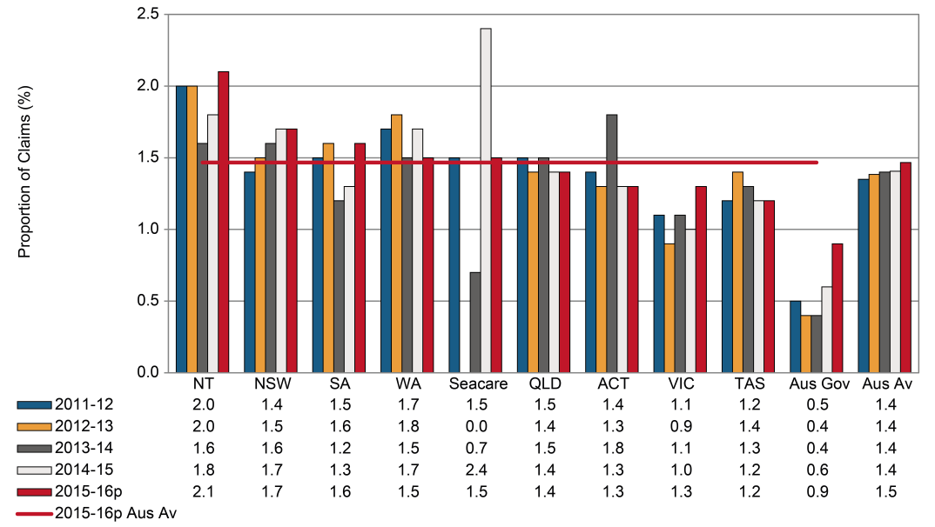

1. Claims by industry

Indicator 11 shows the incidence rates of serious claims in Australia by industry using the Australian and New Zealand Standard Industrial Classification 2006 system. Preliminary data show that in 2015–16, the Agriculture, forestry and fishing industry recorded the highest incidence rate with 17.5 serious claims per 1,000 employees, followed by the Construction (16.0), Manufacturing (15.5) and Transport, postal and warehousing (14.4) industries. Under the *Australian Work Health and Safety Strategy 2012–2022* these industries together with Accommodation and food services, Public administration and safety and Health care and social assistance have been identified as national priorities for prevention activities.

Decreases in the incidence rate of serious claims between 2011–12 and 2014–15 were recorded for all industries, with the most notable reductions seen in Administrative and support services (down 33 per cent), Transport, postal and warehousing (down 29 per cent), Other services (down 28 per cent) and Professional, scientific and technical services (down 25 per cent). More detailed information on claims by industry can be found in the Australian Workers’ Compensation Statistics report, published on the [Safe Work Australia](https://www.safeworkaustralia.gov.au/collection/australian-workers-compensation-statistics) website.

Indicator – Incidence rates of serious* claims by industry

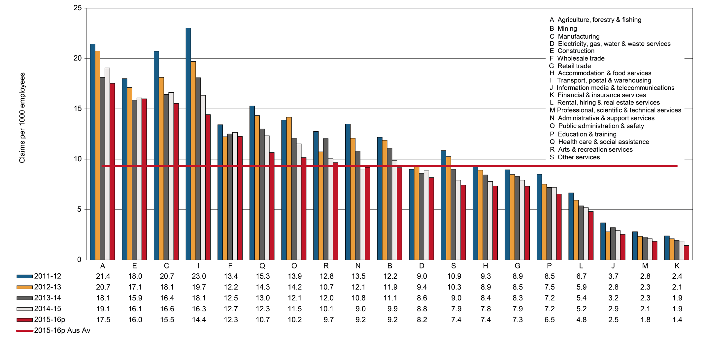

* Includes all accepted workers’ compensation claims for an incapacity that results in a total absence from work of one working week or more excluding fatalities and journey claims.

Claims by industry and jurisdiction

This section contains supplementary information to Indicator 11. Presented below is a comparison of the incidence rates of serious claims across the Australian jurisdictions for the 19 industry divisions.

Incidence rates in some industries at the jurisdictional level can be volatile and should be treated with caution. As the number of employees used in calculating incidence rates are estimated from survey samples, readers should be aware that the smaller the sample size the higher the values of relative standard errors in estimating number of employees.

# Agriculture, forestry and fishing

Indicator 11a shows the incidence rates of serious claims for the Agriculture, forestry and fishing industry, which had the highest Australian average (19.1 claims per 1,000 employees) of all industries during 2014–15.

The incidence rates for the Australian Capital Territory were not reported due to the relative standard error of the number of employees being greater than 50 per cent. In addition, the incidence rates for the Northern Territory should be interpreted with caution due to the high variability of the data.

Of the other jurisdictions, Western Australia recorded the highest incidence rate of serious claims in the Agriculture, forestry and fishing industry (30.4 claims per 1,000 employees) in 2014–15, followed by Queensland (22.8), New South Wales (21.5) and Tasmania (20.7). The lowest incidence rate was recorded in Victoria (10.8 claims per 1,000 employees).

Indicator 11 – Incidence rates of serious claims for agriculture, forestry and fishing by jurisdiction

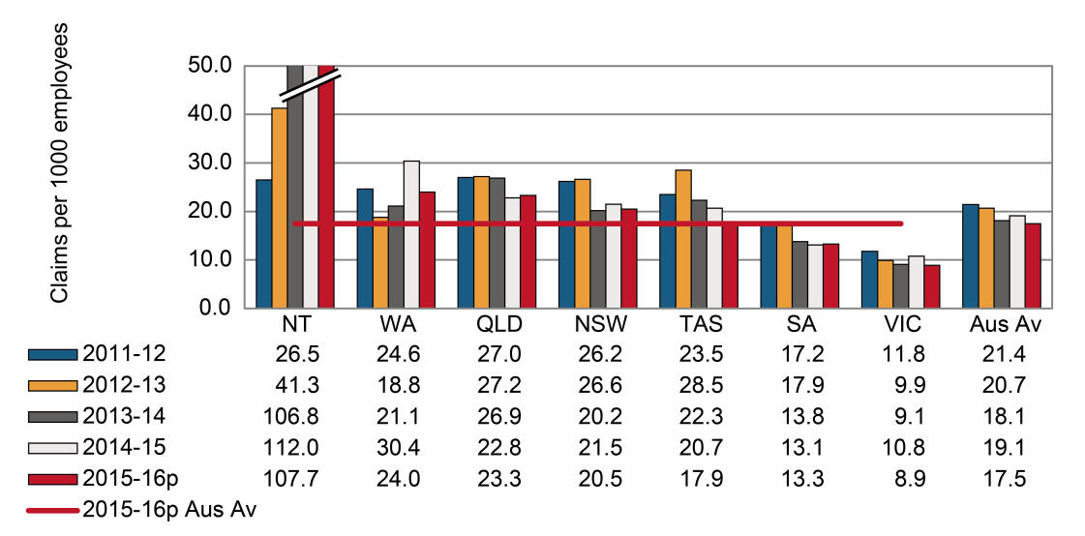

# Mining

In 2014–15 the Australian average incidence rate of serious claims in the Mining industry was 9.9 claims per 1,000 employees. With the exception of Victoria (up 9 per cent), all jurisdictions recorded a decrease in their incidence rates between 2011–12 and 2014–15. Queensland recorded the largest decrease in incidence rate (down 41 per cent), followed by the Northern Territory (down 39 per cent), and New South Wales (down 10 per cent). The incidence rates of the Australian Capital Territory were not reported due to a higher variability (greater than 50 per cent) in the relative standard error values of the number of employees.

Indicator 11 – Incidence rates of serious claims for mining by jurisdiction

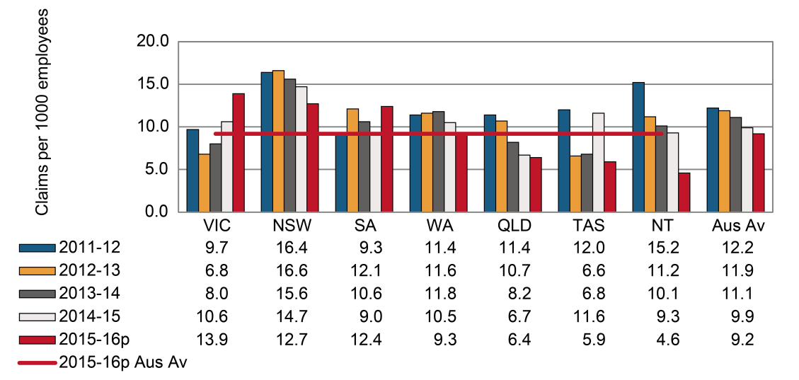

# Manufacturing

Indicator 11c shows that between 2011–12 and 2014–15 majority of jurisdictions recorded a decrease in incidence rates in the Manufacturing industry, with Tasmania recording the largest decrease (down 53 per cent). By contrast, the Australian Capital Territory, the Northern Territory and the Australian Government recorded increases in incidence rates during the same period

The Australian average incidence rate in 2014–15 was 16.6 claims per 1,000 employees, a 20 per cent decrease from 2011–12 rate. The incidence rates of the Australian Capital Territory should be interpreted with caution as the relative standard error of the number of employees was between 25 and 50 per cent.

Indicator 11 – Incidence rates of serious claims for manufacturing by jurisdiction

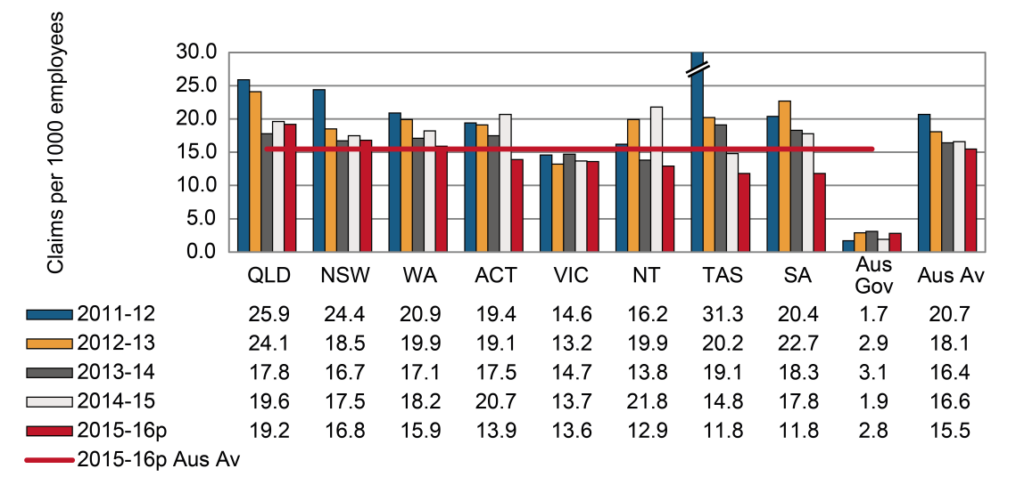

# Electricity, gas, water and waste services

Three out of the nine jurisdictions recorded decreases in the incidence rate in the Electricity, gas, water and waste services industry between 2011–12 and 2014–15, with increases in all other jurisdictions. The Australian average incidence rates of serious claims in this industry recorded a 2 per cent decrease in 2014–15 compared to 2011–12. The incidence rates of the Australian Capital Territory should be interpreted with caution as the relative standard error of the number of employees was between 25 and 50 per cent.

Indicator 11 – Incidence rates of serious claims for electricity, gas, water and waste services by jurisdiction

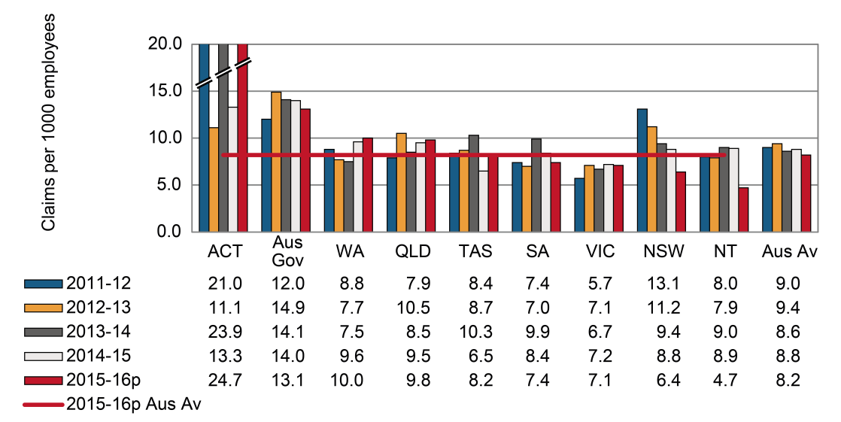

# Construction

Indicator 11e shows that the Australian average incidence rate for the Construction industry decreased by 11 per cent between 2011–12 and 2014–15. The Australian Government recorded the largest decrease (down 36 per cent), followed by Tasmania (down 20 per cent), Western Australia (down 19 per cent), Queensland (down 16 per cent) and the Australian Capital Territory (down 16 per cent). Victoria showed an increase (up 5 per cent) in incidence rates between 2011‑12 and 2014–15. The Australian Government, the Northern Territory, Victoria and New South Wales all recorded incidence rates less than the national rate (16.1 serious claims per 1,000 employees) in 2014–15.

Indicator 11 – Incidence rates of serious claims for construction by jurisdiction

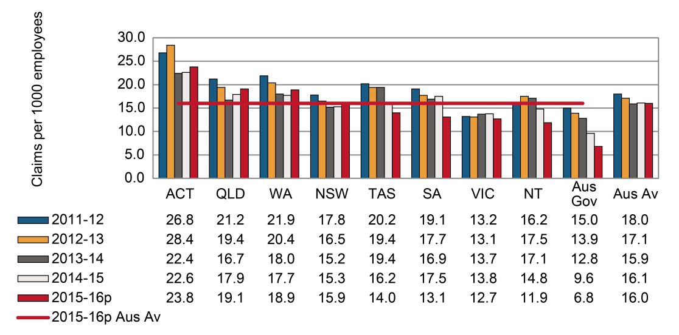

# Wholesale trade

Between 2011–12 and 2014–15 the Australian average incidence rate for the Wholesale trade industry fell by 5 per cent from 13.4 claims per 1,000 employees to 12.7. The Northern Territory showed the largest decrease in serious claims (down 36 per cent) between 2011–12 and 2014–15, followed by Tasmania (down 22 per cent).

South Australia had the highest incidence rate of claims in 2014–15 (19.4 claims per 1,000 employees) followed by Queensland (16.4 claims per 1,000 employees). The lowest incidence rate was recorded by Tasmania (8.7 claims per 1,000 employees). The incidence rates of the Australian Capital Territory should be interpreted with caution as the relative standard error of the number of employees was between 25 and 50 per cent.

Indicator 11 – Incidence rates of serious claims for wholesale trade by jurisdiction

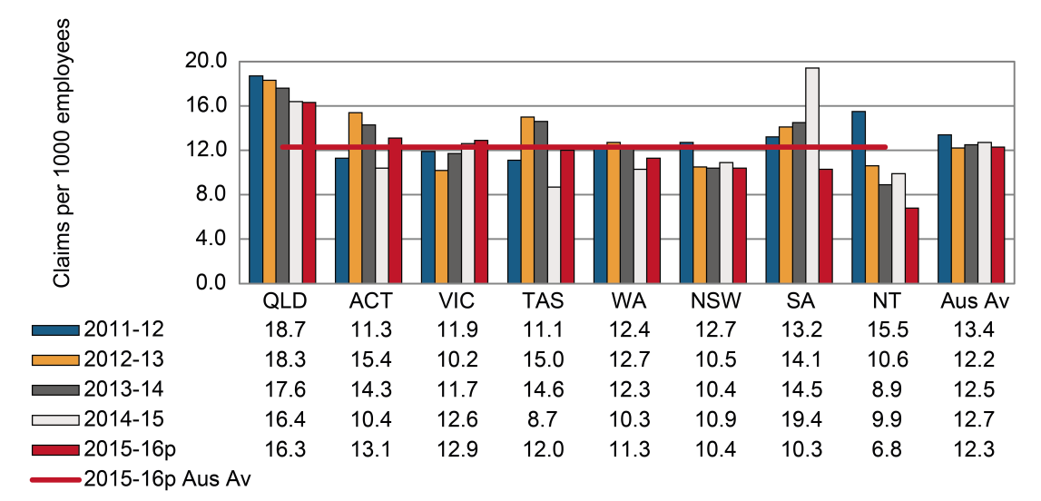

# Retail trade

Indicator 11g shows that the Australian average incidence rate of serious claims in the Retail trade industry decreased by 11 per cent between 2011–12 and 2014–15. With the exception of Victoria all other jurisdictions recorded decreases in their incidence rates over the same period. The Australian Capital Territory, New South Wales and the Northern Territory recorded a substantial decrease (down 23 per cent each), followed by Tasmania (down 16 per cent) and Queensland (down 15 per cent) between 2011–12 and 2014–15.

Indicator 11 – Incidence rates of serious claims for retail trade by jurisdiction

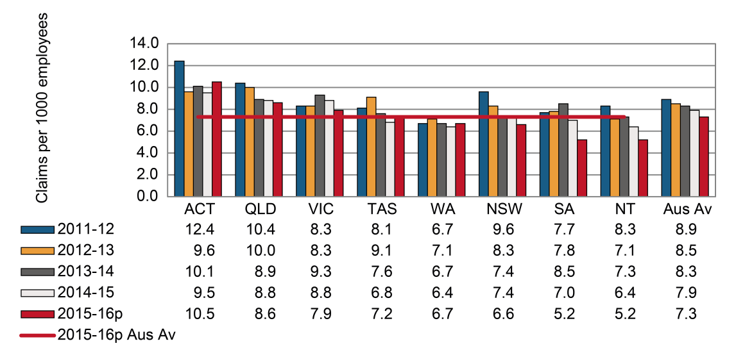

# Accommodation and food services

Indicator 11h shows that the Australian average incidence rate for the Accommodation and food services industry was 7.8 serious claims per 1,000 employees in 2014–15, down 16 per cent since 2011–12. With the exception of the Australian Capital Territory (up 12 per cent), all other jurisdictions reported a decrease in their incidence rates between 2011–12 and 2014-15. The Australian Government did not have any reportable claims after 2013–14.

Indicator 11 – Incidence rates of serious claims for accommodation and food services by jurisdiction

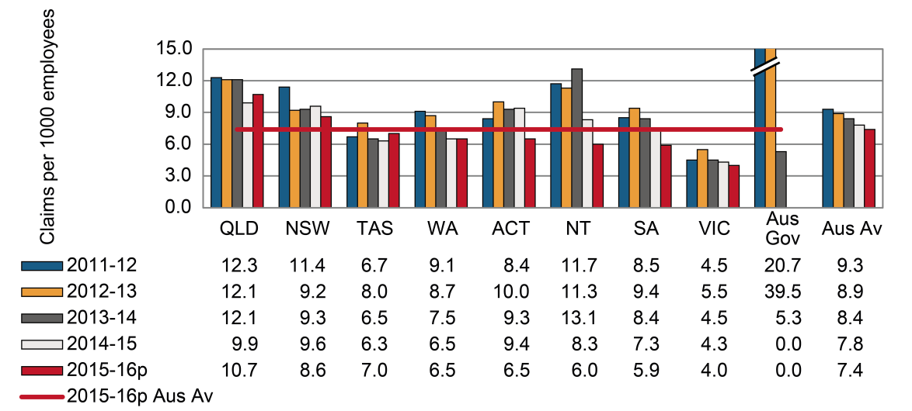

# Transport, postal and warehousing

Indicator 11i shows that the Australian average incidence rate for this industry was 16.3 serious claims per 1,000 employees in 2014–15, down by 29 per cent since 2011–12. All jurisdictions have recorded a decrease in their incidence rates during this period, ranging between 16 per cent in the Northern Territory and 44 per cent each in Tasmania and the Australian Capital Territory. The incidence rates for Seacare were not reported due to higher variability (greater than 50 per cent) in the relative standard error values of the number of employees. The incidence rates of the Australian Capital Territory should be interpreted with caution as the relative standard error of the number of employees was between 25 and 50 per cent.

Indicator 11 – Incidence rates of serious claims for transport, postal and warehousing by jurisdiction

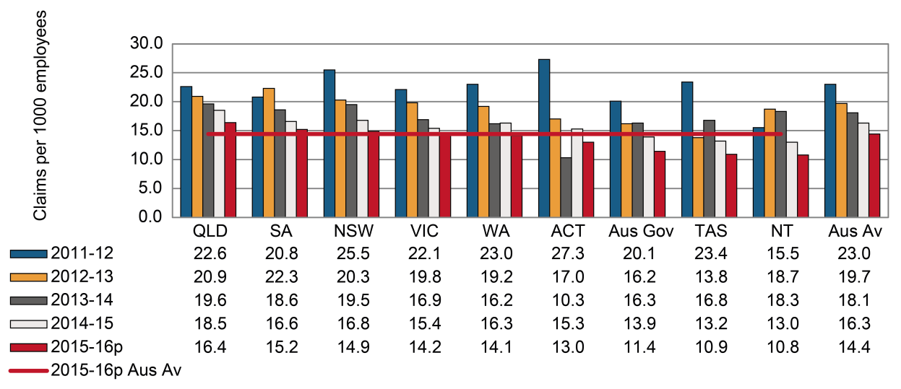

# Information, media and telecommunications

Indicator 11j shows the incidence rates of serious claims for the Information, media and telecommunications industry. The Australian average rate for 2014–15 was 2.9 claims per 1,000 employees, down by 22 per cent since 2011–12. The incidence rates of the Australian Capital Territory and the Northern Territory should be interpreted with caution as the relative standard error of the number of employees were between 25 and 50 per cent. Of the other jurisdictions, the Australian Government recorded the largest decrease (down 32 per cent) between 2011–12 and 2014–15 followed by New South Wales (down 29 per cent), Tasmania (down 20 per cent) and Victoria (down 15 per cent). Western Australia and South Australia recorded increases in incidence rates during this period.

Indicator 11 – Incidence rates of serious claims for information, media and telecommunications by jurisdiction

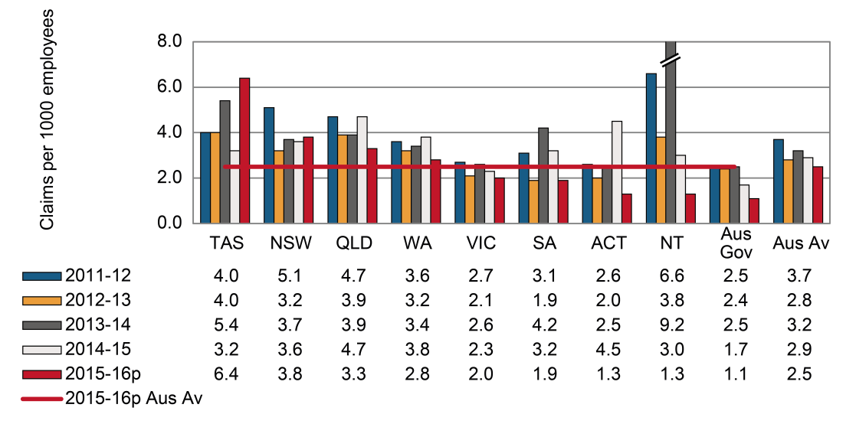

# Financial and insurance services

The Australian average incidence rate for the Financial and insurance services industry in 2014–15 was 1.9 claims per 1,000 employees, the lowest average incidence rate of serious claims among all industries. Indicator 22k shows a substantial decrease in the incidence rate of New South Wales (down 41 per cent) in 2014–15 compared to 2011–12, followed by Western Australia (down 30 per cent) and the Australian Government (down 25 per cent). The incidence rates of the Australian Capital Territory should be interpreted with caution as the relative standard error of the number of employees was between 25 and 50 per cent.

Indicator 11 – Incidence rates of serious claims for financial and insurance services by jurisdiction

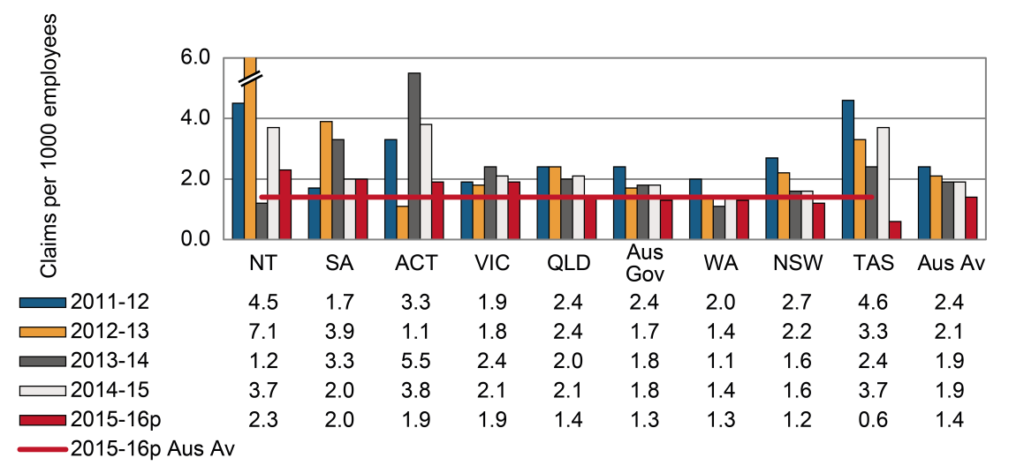

# Rental, hiring and real estate services

Indicator 11l shows that the Australian average incidence rate for the Rental, hiring and real estate services industry was 5.2 claims per 1,000 employees in 2014–15. Queensland showed the largest decrease in serious claims (down 36 per cent) between 2011–12 and 2014–15, followed closely by the Northern Territory (down 35 per cent) and Western Australia (down 33 per cent). The incidence rates of the Australian Capital Territory should be interpreted with caution as the relative standard error of the number of employees was between 25 and 50 per cent.

Indicator 11 – Incidence rates of serious claims for rental, hiring and real estate services by jurisdiction

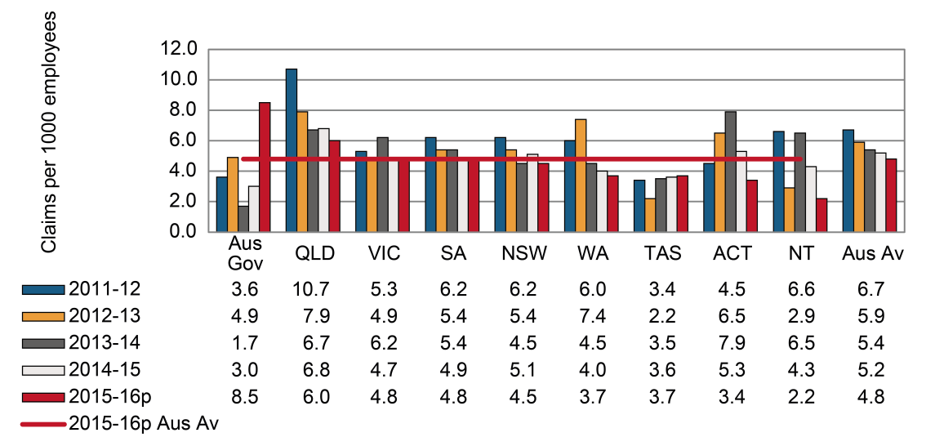

# Professional, scientific and technical services

All jurisdictions recorded decreases in their incidence rates for the Professional, scientific and technical services industry between 2011–12 and 2014–15, with the highest decrease recorded by the Northern Territory (down 54 per cent). Professional, scientific and technical services had the second lowest incidence rate overall in 2014–15 (2.1 claims per 1,000 employees) when compared to all other industries.

The relative standard error values for employee numbers in the Australian Capital Territory were greater than 50 per cent, hence the incidence rates for this industry are not reported here.

Indicator 11 – Incidence rates of serious claims for professional, scientific and technical services by jurisdiction

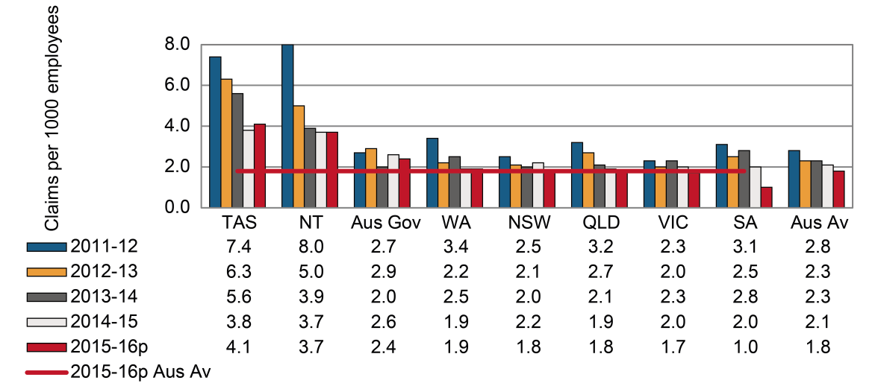

# Administrative and support services

The Australian average incidence rate in the Administrative and support services industry was 9.0 serious claims per 1,000 employees in 2014–15. Western Australia (5.5 claims per 1,000 employees) had the lowest incidence rate in 2014–15. New South Wales recorded the largest decrease (down 36 per cent) in the incidence rate between 2011–12 and 2014–15. Readers should be aware that the Australian Government has not reported any claims for this industry since 2011−12. The incidence rates of the Australian Capital Territory should be interpreted with caution as the relative standard error of the number of employees was between 25 and 50 per cent.

Indicator 11 – Incidence rates of serious claims for administrative and support services by jurisdiction

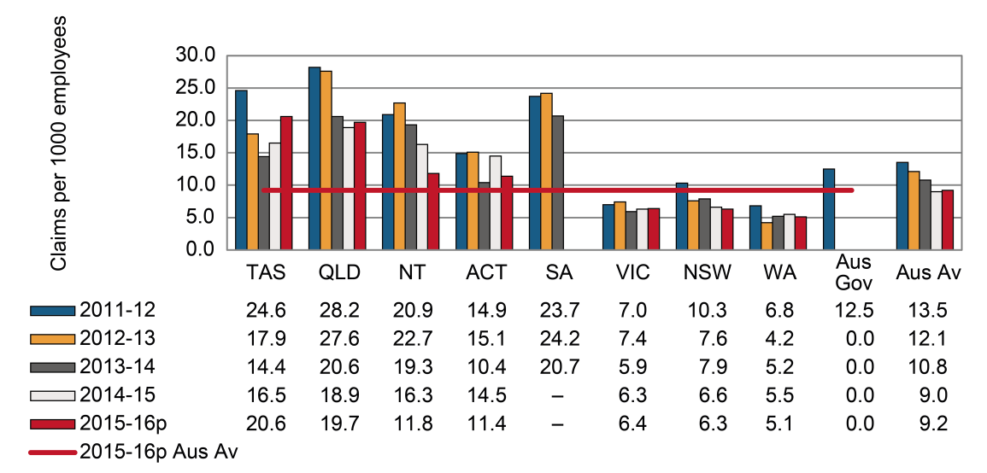

# Public administration and safety

Indicator 11o shows that the Australian average incidence rate of serious claims in the Public administration and safety industry was 11.5 claims per 1,000 employees in 2014–15, down from 13.9 claims per 1,000 employees in 2011–12. All jurisdictions except South Australia (up 23 per cent) showed a decrease in the incidence rate of claims between 2011–12 and 2014–15. The incidence rates of the Australian Capital Territory should be interpreted with caution as the relative standard error of the number of employees were between 25 and 50 per cent. Of all other jurisdictions, the Northern Territory recorded the largest decrease in incidence rate between 2011‑12 and 2014–15 (down 53 per cent).

Indicator 11 – Incidence rates of serious claims for public administration and safety by jurisdiction

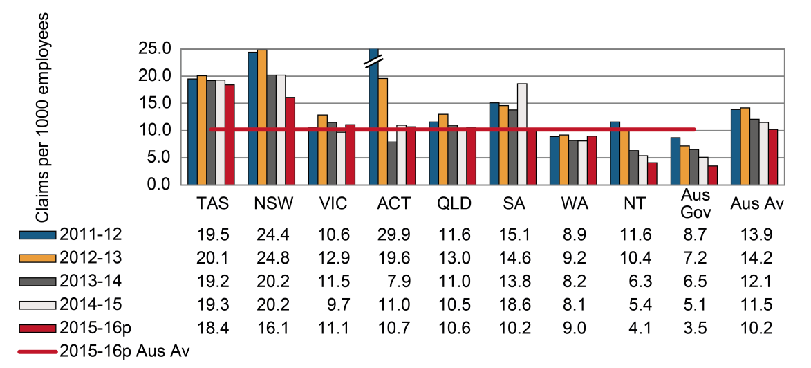

# Education and training

Indicator 11p shows that the Australian average incidence rate for the Education and training industry was 7.2 serious claims per 1,000 employees in 2014–15; a 15 per cent decrease since 2011–12. With the exception of three, all jurisdictions recorded a decrease in their incidence rates between 2011–12 and 2014–15. The Australian Government recorded the largest decrease (down 47 per cent), followed by New South Wales (down 33 per cent) and the Northern Territory (down 22 per cent). The incidence rates of the Australian Capital Territory should be interpreted with caution as the relative standard error of the number of employees were between 25 and 50 per cent.

Indicator 11 – Incidence rates of serious claims for education and training by jurisdiction

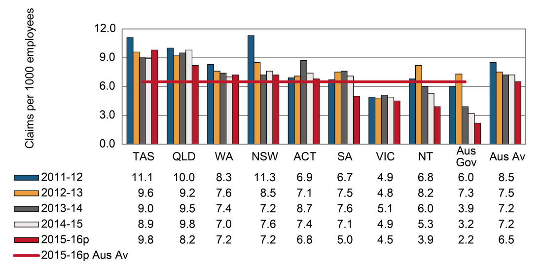

# Healthcare and social assistance

The Australian average incidence rate of serious claims in the Healthcare and social assistance industry in 2014–15 was 12.3 claims per 1,000 employees, which was 20 per cent lower than in 2011–12. All jurisdictions recorded decreases in their incidence rates for the industry between 2011–12 and 2014–15, with the highest decrease recorded in the Australian Government (down 43 per cent).

Indicator 11 – Incidence rates of serious claims for healthcare and social assistance by jurisdiction

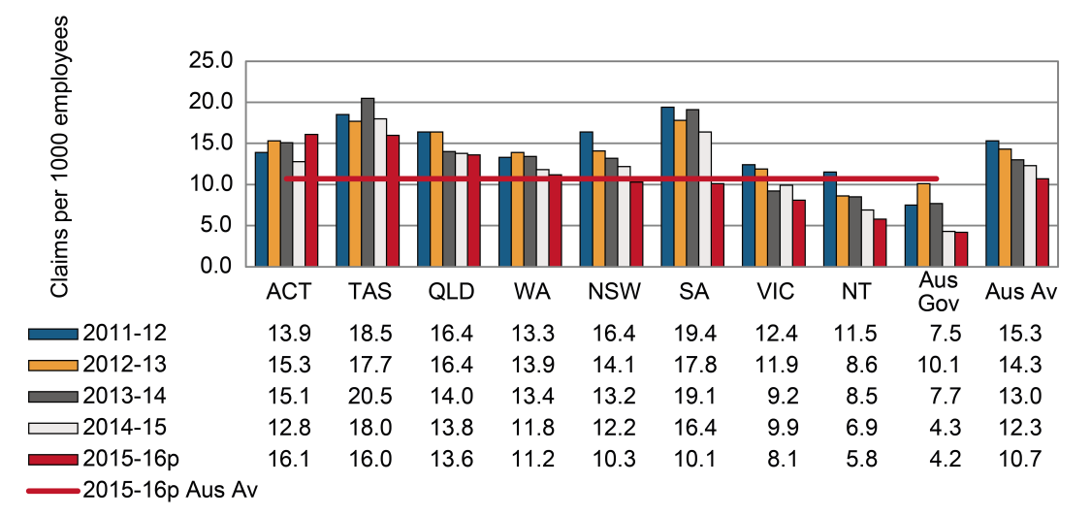

# Arts and recreation services

The Australian average incidence rate for the Arts and recreation services industry fell by 21 per cent from 12.8 claims per 1,000 employees in 2011–12 to 10.1 claims per 1,000 employees in 2014–15. Two out of the nine jurisdictions recorded increases in their incidence rates, while the rest showed a drop in their rates over the same period. Victoria recorded the largest decrease (down 39 per cent), followed by Western Australia (down 36 per cent) and the Northern Territory (down 31 per cent). In contrast, South Australia and the Australian Capital Territory recorded increases over the same period (up 16 per cent and 14 per cent respectively). The incidence rates of the Australian Capital Territory should be interpreted with caution as the relative standard error of the number of employees were between 25 and 50 per cent.

Indicator 11 – Incidence rates of serious claims for arts and recreation services by jurisdiction

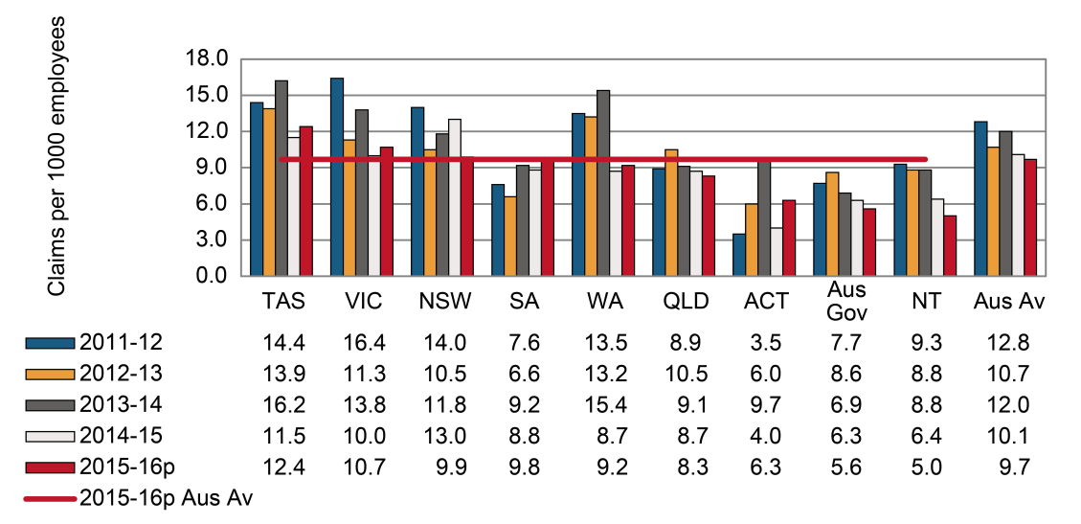

# Other services

Indicator 11s shows that the Australian average incidence rate of serious claims in the Other services industry decreased by 28 per cent between 2011–12 and 2014–15. Tasmania recorded the largest decrease (down 53 per cent), followed by the Northern Territory (down 46 per cent), New South Wales (down 42 per cent) and Queensland (down 27 per cent). The incidence rates of the Australian Capital Territory should be interpreted with caution as the relative standard error of the number of employees were between 25 and 50 per cent. The Australian Government data are not reported here due to the high relative standard error (greater than 50 per cent) in the employee numbers, rendering the data unreliable.

Indicator 11 – Incidence rates of serious claims for other services by jurisdiction

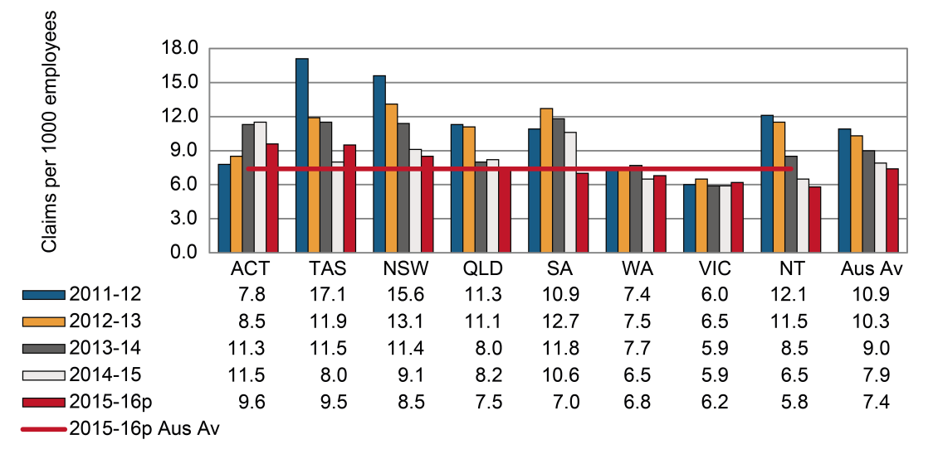

Appendix 1 — Explanatory notes

Workers’ compensation claims data

## Scope

The data presented in this report are extracted from the National Data Set for Compensation-based Statistics (NDS), which is compiled annually from claims made under state, territory and Australian Government workers’ compensation Acts. The New Zealand Accident Compensation Corporation (ACC) also collects data in accordance with the NDS.

Definition of a serious claim: Under the definition, a serious claim is a workers’ compensation claim for an incapacity that results in a total absence from work of one working week or more. Claims excluded from this definition include those arising from a work-related fatality or a journey to or from work or during a recess period. One working week is defined as lost when the number of hours lost is greater than or equal to the number of hours usually worked per week.

The data in this report do not cover all cases of occupational injury and diseases as workers’ compensation generally covers employees only. Therefore many contractors and self-employed workers are not represented by these data. The exclusion of self-employed persons is likely to result in an underestimate of the number of cases in industries where self-employed persons are common, such as Agriculture, forestry and fishing, Construction and Transport, postal and warehousing – Road transport, Administrative and support services and Arts and recreation services. However, the incidence and frequency rates shown in this report for all industries can be considered to be reliable, as the denominators used in the calculation of the rates have been adjusted to exclude self-employed persons.

In addition, the following have been excluded from the data in this report:

* occupational injuries and diseases resulting in absences from work of less than one working week
* military personnel within the Defence force
* cases not claimed as workers’ compensation or not acknowledged as being work-related, and
* claims for compensation to the Dust Diseases Authority of New South Wales.

Australian Government employees working in each jurisdiction have been included in Australian Government figures rather than state or territory results. Australian Capital Territory Public Service employees are covered by the Comcare scheme but operate under the work health and safety provisions of the Australian Capital Territory. These employees and their claims have been combined with Australian Capital Territory Private sector employees for reporting outcomes in Chapter 1 of this report.

Reporting on fatalities: Similar to the previous edition, this edition sources information from the traumatic injury fatalities (TIF) collection. The TIF collection provides the most accurate information on work-related injury fatalities since the data is sourced from workers’ compensation data, fatality notifications to the various work health and safety authorities and information in the National Coronial Information System (NCIS). Only around 60 per cent of work-related fatalities recorded in the TIF collection are typically compensated. This is in part due to self-employed workers not being covered by workers’ compensation schemes. Many self-employed workers work in high risk sectors such as agriculture, transport and construction. Further information about the TIF collection and a detailed analysis of the data can be found in the *Work-Related Traumatic Injury Fatalities* report published on the [Safe Work Australia](https://www.safeworkaustralia.gov.au/collection/work-related-traumatic-injury-fatalities) website.

There is no change to the source of information on disease-related fatalities in this edition of the CPM. This information is only available through the NDS.

The following table (Appendix 1 – Table 1) shows the preliminary number of serious claims, an estimate of the number of employees in each jurisdiction, and an estimate of the number of hours worked in each jurisdiction in 2015–16. Please note that the number of serious claims shown for Victoria includes adjustment factors that are explained later in this section. The figures for employee and hours worked in Appendix 1 – Table 1 are those that have been used to calculate the incidence and frequency rates in this report. Please note that the number of claims shown will increase when updated information is provided by the jurisdictions for next year’s report.

Appendix 1 – Table : Summary of key jurisdictional data, 2015–16

| Jurisdiction | Serious claims | Per cent of claims | Employees | Per cent of employees | Hours worked | Per cent of hours worked |
| --- | --- | --- | --- | --- | --- | --- |
| New South Wales | 31,850 | 30.4 | 3,438,040 | 30.6 | 5,751,537,220 | 31.0 |
| Victoria | 21,630 | 20.6 | 2,724,800 | 24.3 | 4,330,499,740 | 23.3 |
| Queensland | 25,130 | 24.0 | 2,170,470 | 19.3 | 3,661,022,050 | 19.7 |
| Western Australia | 11,960 | 11.4 | 1,257,110 | 11.2 | 2,116,882,150 | 11.4 |
| South Australia | 7,460 | 7.1 | 733,470 | 6.5 | 1,161,173,590 | 6.3 |
| Tasmania | 2,510 | 2.4 | 219,430 | 2.0 | 333,729,590 | 1.8 |
| Northern Territory | 900 | 0.9 | 130,300 | 1.2 | 238,872,160 | 1.3 |
| Australian Capital Territory | 1,660 | 1.6 | 155,150 | 1.4 | 246,624,470 | 1.3 |
| Australian Government | 1,610 | 1.5 | 394,280 | 3.5 | 691,112,470 | 3.7 |
| Seacare | 70 | 0.1 | 5,990 | 0.1 | 17,924,030 | 0.1 |
| Australian total | 104,770 | 100.0 | 11,229,040 | 100.0 | 18,549,377,470 | 100.0 |

Time series and adjustment of scheme data

The estimates of the number of employees and their hours worked for Australia are supplied by the Australian Bureau of Statistics and these denominator data are based on the Labour Force Survey, the Survey of Employment and Earnings and data provided by Comcare. Further adjustments are performed using data from the Census, the Forms of Employment Survey and the Survey of Employment Arrangements, Retirement and Superannuation. These data are matched to the scope of the claims data but may not be exact, particularly in the smaller jurisdictions, due to the number of employees being derived from a survey of the population rather than a census.

The labour force estimates were recently benchmarked against the 2011 Census and 20 years recasting is currently underway. As a result, the ABS revised and supplied Safe Work Australia with estimates for the number of employees and hours worked back to 2007–08. This change and the recent change in the definition of serious claims means that the incidence and frequency rates published in this report will differ to those previously published. The New Zealand employment data used has been sourced from the New Zealand census information.

Incidence and frequency rates, especially for the most recent years, are expected to rise as the number of accepted claims increases as a result of further data development. This may involve additional claims being accepted or shorter-term claims with temporary incapacity incurring additional time lost and subsequently matching the definition of a serious claim: one that involves one or more working weeks of time lost.

Claims data shown in this report for 2015–16 are preliminary unless otherwise stated. Therefore these data are likely to be understated and a comparison of 2015–16 data with those of previous years should be undertaken with caution.

In analysing trends over time, consideration needs to be given to any changes to jurisdiction-specific legislation and administrative processes during the period concerned, further details of which should be sought from the jurisdictions. Any commentary relating to these comparisons should be interpreted carefully, where provided.

Frequency rates for the Seacare scheme have been calculated using a 24-hour basis. This is in recognition of the 24-hour risk of exposure to workplace hazards due to the nature of employment in the maritime industry. This definition is consistent with data published by the Seacare Authority.

Due to difficulties obtaining time lost in hours for the Northern Territory, data have been estimated using the definition of a working week of five working days. To enable comparison of the data reported for the Northern Territory and data reported for all other jurisdictions, the data for the Northern Territory has been increased by a factor of 1.3 per cent.

Definition of injury and disease

Occupational injuries are defined as all employment-related injuries that are the result of a single traumatic event, occurring while a person is on duty or during a recess period at the workplace, and where there was a short or non-existent latency period. This includes injuries that are the result of a single exposure to an agent(s) causing an acute toxic effect.

Occupational diseases are defined as all employment-related diseases that result from repeated or long-term exposure to an agent(s) or event(s), or that are the result of a single event resulting in a disease (for example, the development of hepatitis following a single exposure to the infection).

In this report, the injuries data also include claims for musculoskeletal disorders (MSD). This change was necessitated by the introduction of a new coding system in Victoria in 2002–03 that resulted in a large number of claims previously coded as sprains and strains (injuries) being coded as diseases of the musculoskeletal system and connective tissue. This more accurately reflects the repetitive and long term muscle stress that results in these conditions. To minimise the effect of this coding change on time series consistency, musculoskeletal disorders have been combined with the data on injuries for all years and all jurisdictions in this report. A similar change in coding practices across all other jurisdictions has been occurring progressively from 2005–06 as the 3rd edition of the Type of Occurrence Classification Scheme (TOOCS) is introduced in each jurisdiction.

Adjustment of Victorian and South Australian data

Only claims involving one or more weeks of compensation have been used for analysis in Part 1 to enable greater comparability in the jurisdictional data. This accounts for the different employer excesses that exist in various schemes. Under the Victorian and South Australian workers’ compensation schemes the employer is generally liable for the first 10 days of lost wages by the injured worker. In addition to this, Victorian employers pay the first $692 of medical services (for the year 2016/2017 – indexed annually) unless the employer has elected the Excess Buyout option. Please refer to WorkSafe Victoria’s website for more information on the Excess Buyout option.

As employers do not always provide WorkSafe Victoria and Return to Work South Australia with information on claims lasting fewer than 10 days, an adjustment factor needs to be applied in order to compare Victorian and South Australian claims data with other jurisdictions. To calculate the Victorian and South Australian under 10 day excess impact, the percentage of claims between one and two weeks duration for Victoria and South Australia were compared with the percentage of one to two weeks claims for other Australian jurisdictions. From this comparison, the number of Victorian and South Australian claims between one and two weeks were increased by a factor so that the percentage of such claims was similar to the Australian average. The analysis was undertaken at the industry division level to allow for a greater degree of homogeneity in respect of claim duration in Victoria. The application of the factors has increased the claims supplied by WorkSafe Victoria by 14 per cent (from 19 290 to 21 965) and for South Australia by 19 per cent (from 6654 to 7950).

Size of business

The number of employees in each of the three business size groups has been provided by the ABS. Estimates of employment figures by ‘Small: less than 20 employees’, ‘Medium: 20–199 employees’ and ‘Large: 200 employees or more’ business size groups published in the 2012–13 ‘Australian Industry’ publication (ABS cat. No. 8155.0) are used. These estimates are produced annually using a combination of data directly collected from the annual Economic Activity Survey (EAS) conducted by the ABS and Business Activity Statement (BAS) data provided by businesses to the Australian Taxation Office (ATO). As figures in this publication are for ‘Employment’, the ABS Labour Force data were also used in order to be able to exclude self-employed persons from the ‘Australian Industry’ figures.

The scope and coverage of these estimates are for the private sector only, which consists of all business entities in the Australian economy except for entities classified as general Government. Data on the number of claims are collected in each jurisdiction by a variety of methods, some via the claim form and others by imputing estimates from the data supplied by employers.

Appendix 2 – Jurisdictional contact information

Appendix 2 – Table : Jurisdictional contact information

| Jurisdiction | Organisation | Contact details |
| --- | --- | --- |
| New South Wales | State Insurance Regulatory Authority  SafeWork NSW  Customer Service Centre | [www.sira.nsw.gov.au](http://www.sira.nsw.gov.au/)  [www.safework.nsw.gov.au](http://www.safework.nsw.gov.au/)  13 10 50 |
| Victoria | WorkSafe Victoria | Advisory Service 1800 136 089  [info@worksafe.vic.gov.au](mailto:info@worksafe.vic.gov.au)  [www.worksafe.vic.gov.au](http://www.worksafe.vic.gov.au/) |
| Queensland | Workplace Health and Safety Queensland – Office of Industrial Relations – Queensland Treasury | Infoline 1300 362 128  [www.worksafe.qld.gov.au](https://www.worksafe.qld.gov.au/) |
| Western Australia | WorkCover WA  Department of Mines, Industry Regulation and Safety– WorkSafe | (08) 9388 5555  [www.workcover.wa.gov.au](http://www.workcover.wa.gov.au/)  1300 307 877  [www.dmirs.wa.gov.au](http://www.dmirs.wa.gov.au/) |
| South Australia | Return to WorkSA  SafeWork SA | 13 18 55  [www.rtwsa.com](http://www.rtwsa.com/)  1300 365 255  [www.safework.sa.gov.au](http://www.safework.sa.gov.au/) |
| Tasmania | WorkSafe Tasmania | Helpline  1300 366 322 (inside Tas)  (03) 6166 4600 (outside Tas)  [wstinfo@justice.tas.gov.au](mailto:wstinfo@justice.tas.gov.au)  [www.workcover.tas.gov.au](http://www.workcover.tas.gov.au/)  [www.worksafe.tas.gov.au](http://www.worksafe.tas.gov.au/) |
| Northern Territory | NT WorkSafe | 1800 019 115  [ntworksafe@nt.gov.au](mailto:ntworksafe@nt.gov.au)  [www.worksafe.nt.gov.au](http://www.worksafe.nt.gov.au/Pages/default.aspx) |
| Australian Capital Territory | Access Canberra WorkSafe ACT within Chief Minister Treasury and Economic Development Directorate | (02) 6207 3000  [www.worksafe.act.gov.au](http://www.worksafe.act.gov.au/health_safety) |
| Seafarers | Seacare Authority | (02) 6275 0070  [seacare@comcare.gov.au](mailto:seacare@comcare.gov.au)  [www.seacare.gov.au](http://www.seacare.gov.au/) |
| Australian Government | Comcare | 1300 366 979  [www.comcare.gov.au](http://www.comcare.gov.au/) |
| New Zealand | Accident Compensation Corporation | 64 7 848 7400  [www.acc.co.nz](http://www.acc.co.nz/) |