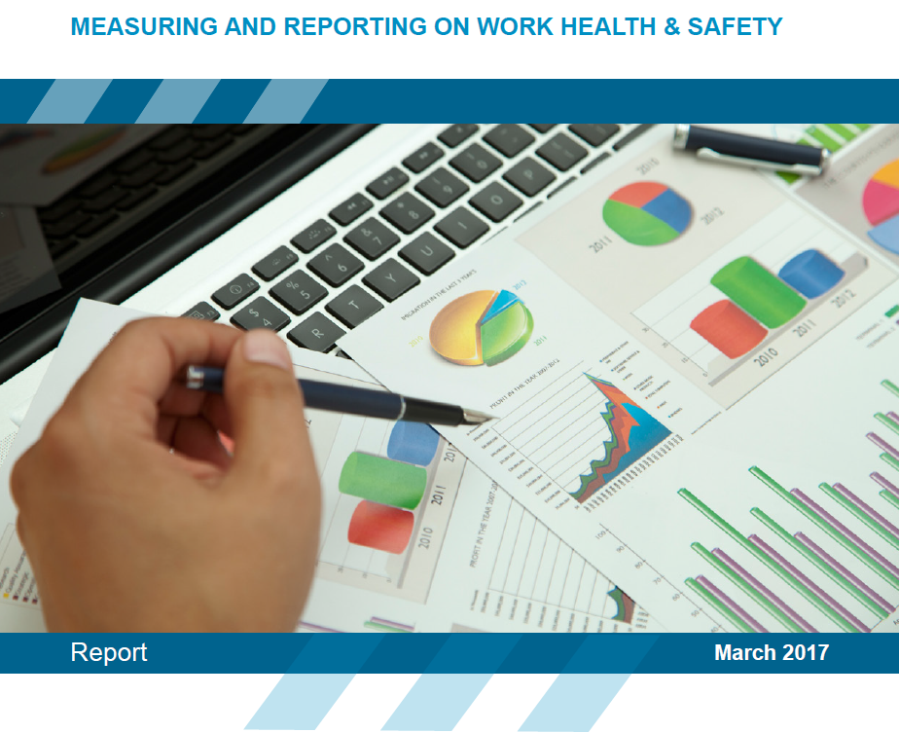

# ACKNOWLEDGEMENTS

**AUTHORS**

**Dr Sharron O’Neill** (CPA) is currently a Senior Lecturer in the School of Business, at the University of NSW (Canberra). At the time of writing, Dr O’Neill was Senior Research Fellow at the International Governance and Performance (IGAP) research centre at Macquarie University. She is a member of CPA Australia, the Australian Institute of Company Directors, the Safety Institute of Australia and the National Safety Council of Australia.

**Ms Karen Wolfe** (CFSIA) is a past Chair of the Safety Institute of Australia (SIA), NSW branch, a member of the Executive for the SIA College of Fellows, and Executive Officer to the CEO at the Australian Nuclear Science & Technology Organisation (ANSTO).

**RESEARCH ASSISTANCE**

The authors wish to acknowledge and thank Dr Karina Luzia for providing research assistance and project administrative support.

**PROJECT PARTNERS**

The authors would also like to acknowledge the following organisations for providing financial support for this project.

* Macquarie University
* Safe Work Australia
* Safety Institute of Australia
* **Chartered Accountants Australia** and New Zealand
* Australian Nuclear Science and Technology Organisation

We also wish to acknowledge the many organisations and individuals who provided technical support and advice over the life of the project.

**DISCLAIMER**

**The information provided in this document can only assist you in the most general way. This document does not replace any statutory requirements under any relevant Commonwealth, state and territory legislation. Safe Work Australia is not liable for any loss resulting from any action taken or reliance made by you on the information or material contained on this document. Before relying on the material, users should carefully make their own assessment as to its accuracy, currency, completeness and relevance for their purposes, and should obtain any appropriate professional advice relevant to their particular circumstances. The views in this report should not be taken to represent the views of Safe Work Australia unless otherwise expressly stated.**

**RESEARCH SPONSORED BY**

This project was collaboratively funded by Safe Work Australia, Chartered Accountants ANZ, the Safety Institute of Australia and the Macquarie University *Enterprise Partnership Grant* scheme.

 

Macquaire Univeristy logo 

**CREATIVE COMMONS**



With the exception of the Safe Work Australia logo, this report is licensed by Safe Work Australia under a Creative Commons 3.0 Australia Licence. To view a copy of this licence visit <http://creativecommons.org/licenses/by/3.0/au/deed.en>.

In essence you are free to copy, communicate and adapt the work as long as you attribute the work to the authors listed above, and abide by the other licensing terms.

Enquiries regarding the licence and any use of the report are welcome at:

Copyright Officer

Safe Work Australia

GPO Box 641 Canberra ACT 2601

Email: [copyrightrequests@swa.gov.au](mailto:copyrightrequests@swa.gov.au)

**SUGGESTED CITATION**

O’Neill, S & Wolfe, K, Measuring and reporting on work health & safety, Canberra, Safe Work Australia, 2017

ISBN 978-1-76028-909-6 [PDF]

ISBN 978-1-76028-910-2 [DOCX]

# FOREWORD

This report is intended primarily for business leaders and work health and safety (WHS)[1] managers of medium to large organisations. It examines the **performance information which officers may find useful** to assist them in exercising due diligence in discharging their duties under the model Work Health and Safety Act (model WHS Act). It also provides guidance on the type of information investors and other stakeholders are seeking in company annual reports.

The development of this report included a review of the academic and professional literature, interviews with key stakeholders, and workshops involving participants drawn from a cross section of industries across Australia. Initiated by the Institute of Chartered Accountants Australia and New Zealand, and supported by Safe Work Australia[2] and the Safety Institute of Australia, this project benefited from both accounting and WHS expertise and advice. WHS practitioners and people with experience preparing company reports attended workshops in major cities and rural/regional areas around Australia to provide feedback on the draft report. A virtual seminar and online surveys gathered further feedback which fed into refining the final report.

The resulting report sets out the information that WHS and accounting professionals saw as necessary for the two professions to be able to share information. It will support the consultative process required to identify useful WHS measures to help industry improve its WHS performance. It will also help businesses to provide informative and useful external reports which meet both corporate social responsibility and external benchmarking objectives. Ultimately this report highlights external and internal indicators to improve organisational level WHS reporting and to help officers discharge their WHS duties under the model WHS Act with due diligence. Officers should however ensure that they are familiar with the WHS laws that apply in their jurisdiction.

The report is further underpinned by a series of four research papers published on the Safe Work Australia website on [The Role of Accounting in Work Health and Safety Governance](http://www.safeworkaustralia.gov.au/sites/swa/about/publications/pages/issues-measurement-reporting-whs-performance-review). These papers include matters related to issues in the measurement and reporting of WHS performance, the assurance and verification of WHS information, the business case for safe, healthy and productive work, and performance measurement, incentives and organisational culture.

# EXECUTIVE SUMMARY

WHS reporting, like any other business intelligence, needs to provide management with relevant, robust and timely information that can inform the decisions that influence ongoing business performance. Poor WHS outcomes can have a detrimental impact on the lives and livelihoods of individuals and their families, on the financial, interpersonal and reputational health of a business and, potentially, on the wider community. The standard of due diligence required of an officer in the discharge of their WHS duty, together with WHS performance provide a baseline of mandatory requirements that include clear accountabilities and consequences for the actions of those in positions of control.

This paper explores processes for gathering and communicating the WHS performance information that guides the WHS decisions of an organisation’s officers. Officers are in a unique position to influence WHS performance through the direct allocation of human and financial resources to WHS systems, programs and initiatives and through their indirect impact on WHS from a myriad of other routine and extraordinary executive and business decisions.

The model WHS Act requires officers of a person conducting a business or undertaking (PCBU) to exercise due diligence to ensure that the business or undertaking complies with its health and safety duties.

Due diligence enables business decisions that will ensure WHS considerations are integrated seamlessly into the organisation’s business model. This requires an understanding of WHS performance data; what it looks like; where it comes from and, importantly, how WHS key performance indicators (KPIs) should be calculated and interpreted. The latter is essential to draw valid conclusions about WHS performance and to act on that performance information in an appropriate and meaningful way.

The WHS KPIs that support officers' due diligence fall into three categories. First, information about how up-to-date an organisation’s WHS 'risk picture' is, involving officers constantly refreshing their knowledge of general WHS concepts and practices and their understanding of the WHS risk associated with the business enterprise and its operations. Second, data relating to WHS performance: understanding processes of hazard identification, prioritisation and risk control, and the outputs of the WHS performance management system. Third, information relating to oversight and assurance: the verification of legal compliance and of the implementation and effectiveness of managerial and resource allocation processes needed to eliminate or minimise risk. This reveals whether an organisation is driven by a focus on minimum compliance or achieving best practice.

This report provides a framework for identifying the ‘right’ questions about WHS knowledge, controls, performance and assurance; for helping identify and interpret the appropriate WHS KPIs to inform those deliberations; for designing useful WHS reports; and for considering WHS performance data in a way that can add value to business decisions. In doing so, the multidimensional nature of WHS performance is illustrated and the clear pitfalls of relying on one-dimensional injury data, such as lost-time injury frequency rates (LTIFR), as an overarching measure of “success” are explored. In contrast, what is needed is a multi-dimensional framework for identifying critical risks and monitoring measures of implementation (lead KPIs) and effectiveness (lag KPIs) of relevant control measures. To that end, examples of lead and lag WHS KPIs are identified and described. This is not to suggest that every KPI suggested in this report should be adopted by all organisations. Rather, it argues that only a limited range of KPIs are sufficiently generic to be able to be benchmarked across organisations. Instead, each organisation needs to identify and use the lead and lag KPIs that can best inform the particular challenges and issues it faces. The majority of WHS KPIs will therefore be tailored to an organisation’s particular context and decision-needs.

Ultimately, managerial choices regarding the attributes and activities to be monitored, measured and managed will be shaped by the maturity of organisation’s WHS culture and leadership. This brings the need for effective officer due diligence full circle and reinforces the critical importance of providing officers with high quality, valid and timely WHS performance data.

Finally, this report addresses the need for WHS KPIs to inform the decisions of a range of internal and external stakeholders. It recognises that boards, management, shareholders, corporate and strategic partners, employees, non-government organisations, academics and the broader community make different decisions, and therefore have different WHS information needs. WHS reporting therefore needs to be mindful of the intended users and provide transparent and accessible reports that meet the needs of the intended report users.

# CONTENTS

ACKNOWLEDGEMENTS 2

FOREWORD 4

EXECUTIVE SUMMARY 5

CONTENTS 7

1. SETTING THE SCENE 9

1.1 The role(s) of officers: Directors versus managers 9

1.2 Officers’ (WHS) due diligence 10

1.3 Awareness of organisational culture 11

Safety culture 11

1.4 Identifying organisational maturity 12

1.5 Summary 14

Structure of this report 14

2. UNDERSTANDING WHS POSITION: THE WHS ‘RISK PICTURE’ 15

2.1 General knowledge of WHS matters 15

2.2 Understanding the organisation’s WHS 'risk picture’ 22

Identifying potential WHS hazards 22

Consolidating the WHS risk picture 28

Prioritising WHS concerns 29

Using risk matrices or ‘heat maps’ 29

2.3 Summary – Evaluating WHS position 31

3. UNDERSTANDING WHS PERFORMANCE 33

3.1 Health and safety performance 33

Direct evaluation of WHS management systems 34

Indirect evaluation of WHS management systems 35

Resourcing WHS management systems 36

3.2 Injury and illness performance 37

3.3 Summary – Evaluating WHS performance 40

4. ASSURANCE OF WHS SYSTEMS 41

4.1 What does ‘assurance’ mean? 42

4.2 Assurance of WHS systems, processes and performance 42

WHS inspections and reviews 44

4.3 Summary – Seeking assurance of WHS 45

4.4 Recommended further reading 46

5. DESIGNING WHS REPORTS 47

5.1 Criteria for choosing report content 47

5.2 Different users, different information needs 47

5.3 Reporting inside the organisation 48

5.4 Reporting outside the organisation 52

Reporting to investors, creditors, customers and other stakeholders 52

5.5 Summary 53

6. CONCLUSIONS 55

Recommended further reading 56

7. APPENDICES 57

**Appendix 1** Research method 57

Stage 1 57

Stage 2 57

**Appendix 2** Definition of an officer 58

**Appendix 3** Officers’ due diligence 59

**Appendix 4** A closer look at lost time injury data 60

**Appendix 5** Suggested KPIs 63

**Appendix 6** Sample report to the Board of Directors 68

Category 1: Risk picture 68

Category 2: WHS compliance 69

Category 3: WHS verification 69

**Appendix 7** Acronyms 70

**Appendix 8** Summarising WHS indicators by target audience 71

**Appendix 9** Measurement protocols 72

Outcome indicators – illness and injury 72

Outcome indicators – work disruption 74

**Appendix 10** Injury and illness Classifications 76

1. REFERENCES 77

# SETTING THE SCENE

Whether an organisation is public sector, private enterprise or not-for-profit, effective WHS management can contribute to business success. WHS risk is similar in many ways to any other business risk and there is a strong business case for managing WHS appropriately. Poor WHS decisions can have a detrimental impact on the lives of individuals and their families, on the financial, interpersonal and reputational health of a business and, potentially, on the wider community. Conversely, effective WHS management contributes to lower preventable costs and business risk, higher productivity and profitability and greater organisational success.

Because WHS matters are so deeply intermeshed with, and influenced by, financial and organisational objectives and processes, WHS considerations must be integrated into the organisation’s business model and thinking. WHS reporting, like any other business intelligence, provides relevant, robust and timely information to inform the decisions that influence business performance. It is important to understand the WHS data that supports that process; where it comes from, what it looks like and, importantly, how meaningful WHS KPIs should be calculated (see Appendix 9 – Measurement protocols) and interpreted. This knowledge enables officers to draw valid conclusions about WHS and to act appropriately on that information.

This report is written primarily for those business leaders and senior decision-makers who are officers[3] of a PCBU under the *Corporations Act 2001* (Cth) (Corporations Act). Much of the content will be familiar to WHS professionals, encouraging a shared dialogue across the business. This emphasises the interconnectedness of WHS with financial and organisational objectives and promotes improved integration of WHS concerns into strategic and business decisions.

## The role(s) of officers: Directors versus managers

The ‘officers’ of a PCBU are those people whose decisions affect the whole or a substantial part of the business and typically have significant control and oversight over the various systems and resources that directly and indirectly influence WHS. While ‘officers’ include both company directors and some senior managers, there is an **important distinction** between the role and purpose of a board and that of the senior management team (Figure 1).

Figure 1: The role(s) of KPIs

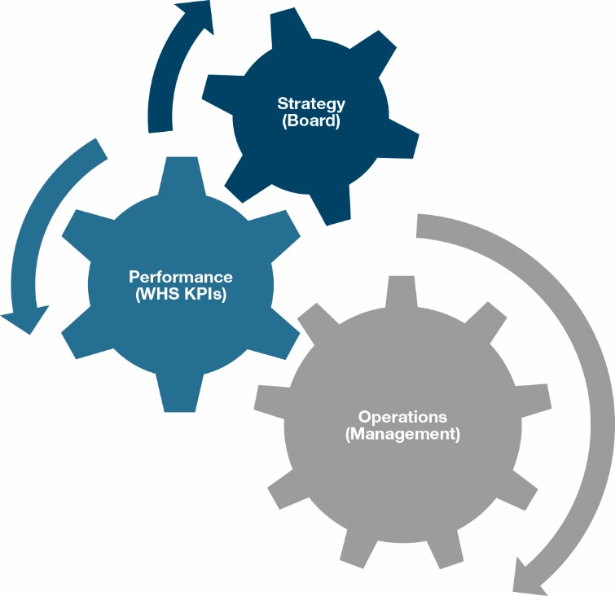

* The **board’s** role is to *provide* *strategic direction* to the business and to *oversee* the management of business risks (including those related to WHS). Boards do not manage risk directly, but they must: understand the purpose, the operations and the risks of a business; ensure adequate resources and personnel are made available to managers; develop suitable internal controls for the organisation; and actively seek assurance that risk is being managed appropriately.
* **Management’s** role is to *manage the day-to-day business operations and performance of the organisation*. This includes identifying and managing the range of business risks (including those related to WHS), monitoring financial and non-financial performance, and selecting and communicating to the board relevant and material[4] information about organisational risk, position and performance.[5]

Although boards and management differ in their focus and decisions, all officers influence WHS both directly (through decisions about WHS strategy, systems, programs, initiatives and resourcing) and indirectly (as both routine and extraordinary business decisions impact organisational culture and WHS outcomes). Decisions that produce safe, healthy and productive work therefore require an understanding of financial, operational and WHS matters and an appreciation of the relationships between them.

## Officers’ (WHS) due diligence

Exercising due diligence in decision-making is an essential element of good business practice. It is also a requirement that officers must observe under both the Corporations Actand under s 27 of the model WHS Act (see Appendix 3 - Officers’ due diligence). The standard of due diligence required by an officer to discharge his or her WHS duty represents the mandatory baseline of standards, accountabilities and consequences for the actions of those persons in positions of control of work.

The steps identified in s 27(5) of the model WHS Act, which sets out the meaning of ‘due diligence’ in the WHS context,provide a useful framework for identifying, organising and reporting the WHS information needed to protect the health and safety of workers and other persons, and support business decisions. They require officers to take reasonable steps to acquire and keep up-to-date knowledge of WHS matters and ensuring that the PCBU has, and implements, processes for complying with its WHS duties (see Figure 2).

**Figure 2: Informing WHS due diligence**

What an individual officer or an organisation must do to meet due diligence duties under the WHS Act.

This includes the duty of an officer to take reasonable steps to acquire and keep up-to-date knowledge of work health and safety matters; and to gain an understanding of the nature of the operations of the business or undertaking of the person conducting the business or undertaking and generally of the hazards and risks associated with those operations; and to ensure that the person conducting the business or undertaking has available for use, and uses, appropriate resources and processes to eliminate or minimise risks to health and safety from work carried out as part of the conduct of the business or undertaking; and to ensure that the person conducting the business or undertaking has appropriate processes for receiving and considering information regarding incidents, hazards and risks and responding in a timely way to that information; and
to ensure that the person conducting the business or undertaking has, and implements, processes for complying with any duty or obligation of the person conducting the business or undertaking under this Act; and to verify the provision and use of the resources and processes referred to above.


Just as financial reporting provides essential information about financial performance (i.e. ‘profit and loss’ over a period) and financial position (i.e. ‘balance sheet’ at a point in time), WHS reporting should provide officers and the PCBU with essential information about WHS performance (i.e. actions and outcomes over a period) and WHS position (i.e. health and safety at a given point in time). These can be summarised as follows:

Table 1: Reporting on WHS

|  | STATEMENT OF POSITION (‘Where are we at?’) | STATEMENT OF PERFORMANCE (‘What have we done?’) |
| --- | --- | --- |
| Financial perspective | Assets, liabilities and shareholders’ equity at a specified point in time | Concerned with **activity** (earning revenues and incurring expenses)  Concerned with **outcomes** (the resulting profit or loss) |
| WHS perspective | Hazards, controls and residual risk at a specified point in time | Concerned with **activity** (identifying and controlling hazardous exposures)  Concerned with **outcomes** (the resulting physical, psychosocial and financial impact of injury & illness) |

## Awareness of organisational culture

Organisational culture reflects those underlying values, assumptions and beliefs that are collectively embraced and embedded in a group (e.g. organisation, executive team, business unit, site or workgroup) and expressed in shared patterns of behaviour, choices and actions.[6]

The ‘tone at the top’ of an organisation is critical because workers’ perception of the organisation is based on their personal experiences of the policies, procedures, practices and routines they are subject to and the kinds of behaviours and events they observe occurring and being rewarded or supported.[7] Collectively, individuals’ perceptions are called the organisation’s climate. Relatively cost-effective techniques such as surveys, interviews and focus groups can evaluate the organisational climate as at a specific point in time. Monitoring change over time through periodic surveys can provide important feedback to business leaders on the perceived quality of WHS leadership and its success in policy and strategy implementation.

### Safety culture

While there are important differences between climate and culture, organisational climate indirectly shapes an organisation’s culture over time[8]. More recently, the term ‘safety culture’ was coined to draw attention to one perspective on an organisation’s culture, that is, the shared and deeply-held beliefs and behaviours people have regarding where and how WHS 'fits' for their business.[9] This includes what is meant or understood by WHS; the extent to which WHS is integrated into the organisation’s overall business strategy and operation; how WHS is prioritised *vis à vis* other business objectives; and how the WHS management system should and does operate. However, ‘safety culture’ must always be understood as an integral part of the business activity.

## Identifying organisational maturity

One of the most important concepts for officers who seek to exercise due diligence over WHS relates to the 'maturity' of the organisation’s ‘safety’ culture. This includes the extent to which management and the workforce understand WHS, recognise the multi-causal[10] nature of occupational injury and illness, and are committed to ensuring WHS by seamlessly integrating safe and healthy work principles and practices into all facets of the business.

The more mature the organisation’s approach to WHS, the more likely management are to understand their WHS risk profile and to set appropriate expectations in regard to manager and employee involvement in, and responses to, WHS priorities and initiatives. Efforts to describe maturity states include five-level maturity models offered by Hudson (2001): pathological, reactive, calculative, proactiveandgenerative; and Fleming (2001): emerging, managing, involving, co-operatingandcontinuously improving.[11]

These build on Westrum’s (1993) three-level maturity model: pathological, bureaucratic and generative, offered to help organisations plot their journey from a less mature to a more mature safety culture. Others, such as the International Council on Mining and Metals (2012) model also advocate a static three-step model of maturity: compliance*,* improvement and learning.

This report adopts a similar three-step approach which broadly maps to the above maturity models:

**Traffic light - red** **Immature:** Reactive, pathological, resistant, reactive, compliance, emerging.

**Traffic light - amber** **Developing:** Informing, calculative, managing, developing awareness, toward improvement.

**Traffic light - green** **Maturing:** Proactive, generative, learning, cooperating, continuously improving (avoiding complacency).

Reason (1997) suggests a mature culture is an informed culture, characterised by four essential attributes: a reporting culture (transparent); a just culture (fair); a flexible culture (empowered); a learning culture (continuously improving).[12]

Figure 3: The WHS cycle

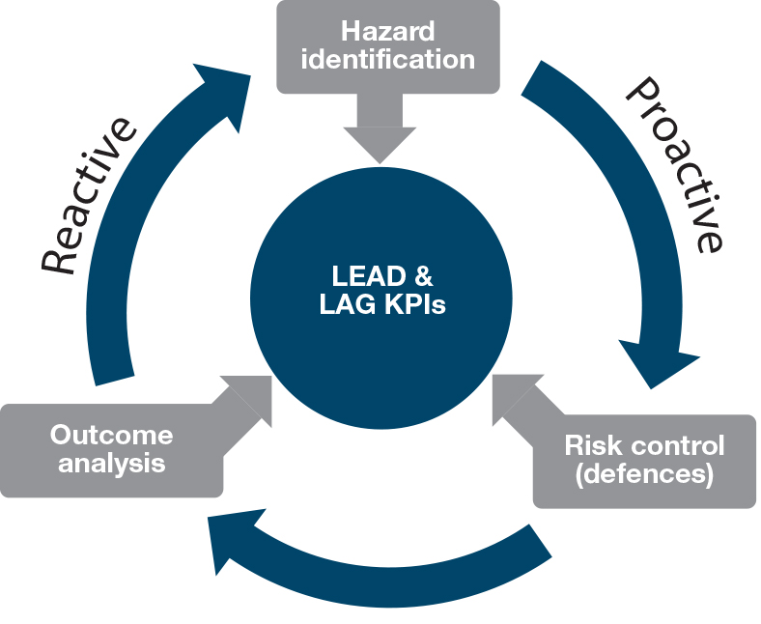

Organisations with mature WHS cultures adopt a proactive approach to their system of WHS management (or WHS cycle), which means they seek to identify and manage hazards that pose a risk to health and safety before they lead to injury or illness (Figure 3). Informed cultures capture a range of WHS performance information to support those decisions.

In contrast, a business with an immature culture tends to identify risks reactively; only after injury and illness has occurred. The KPIs available in immature organisations tend to focus on injury outcomes, primarily lost time injury (LTI) events (the limitations of which are outlined in Appendix 4 - A closer look at lost time injury data).

The maturity of an organisation’s culture is reflected in the sophistication of the performance data it monitors and makes available to inform the due diligence decisions of officers (and other stakeholders).

The WHS measures that inform the due diligence efforts of officers include a range of 'lead' and 'lag' KPIs. Lead and lag KPIs may be identified for each of the major control processes in the WHS cycle (see Figure 3). Importantly, lead indicators of each control reflect the inputs dedicated to that process. Lead KPIs, therefore, are useful indicators of aspects of the **implementation** of the control process. Similarly, lag indicators reflect the outputs or outcomes of a process and, as such, provide useful information about the effectiveness of a control. Figure 4 provides examples of lead and lag KPIs for various WHS controls (or WHS 'defences').

Figure 4: Evaluating the implementation and effectiveness of WHS controls (Adapted from: O’Neill, Wolfe and Holley 2014)

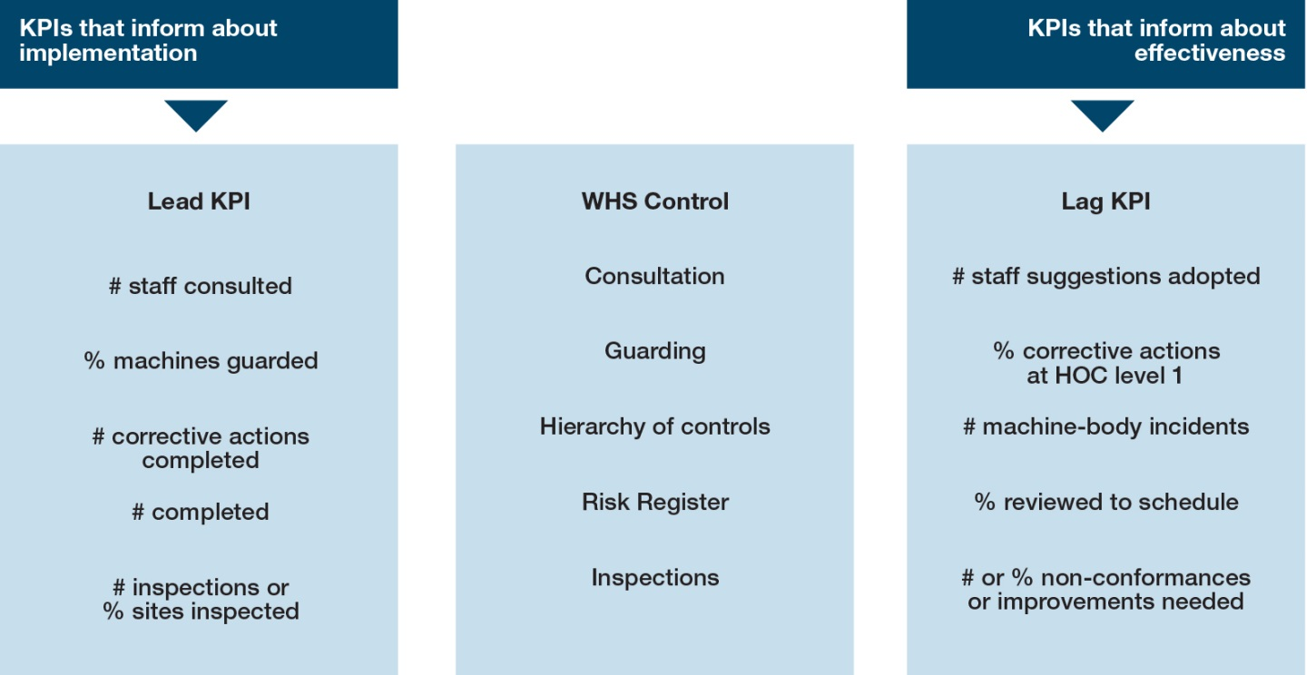

Importantly, there are different audiences who seek to exercise (WHS) due diligence by obtaining relevant performance information. These groups differ in their responsibilities and objectives, make different types of decisions and therefore have different WHS information needs. Broadly summarised, the primary groups are:

**Management** – responsible for the day to day management of all aspects of organisational performance. They need performance information primarily to inform **operational** decisions.

**Board of Directors** – provide strategic direction for the organisation and ensure oversight of material risk. They need information primarily to seek **assurance** and inform **strategic** decisions.

**Corporate partners** – such as investors, prime contractors, financiers, suppliers, customers, other workers. They need information primarily to inform **financial** and **supply chain** decisions.

**Other stakeholders** – such as media, government, unions, neighbours, community groups, researchers, etc. They need information primarily to inform **regulatory**, **economic** and **societal** decisions.

This report focuses primarily on the information useful to directors and external stakeholders, rather than the more detailed and context-specific data required by line managers, supervisors and workers to inform day-to-day production and performance decisions.

## Summary

WHS and broader business activity are inextricably intertwined because officers’ routine business decisions have direct and indirect impact on both organisational WHS culture and WHS outcomes. The officers’ duty in the model WHS Act, which must be discharged with due diligence, aims to ensure that these decisions are appropriately informed by mandating that officers possess current knowledge of WHS matters (both in principle and as it applies to the business in practice), employ appropriate and robust processes for information gathering and resource allocation, and implement and verify effective management controls and assurance mechanisms.

This section has outlined various key WHS concepts for officers and briefly explained the role of officers in shaping an organisation’s culture. In turn, the maturity of the organisational culture shapes the extent to which relevant and robust WHS performance information is available to officers to permit them to discharge their WHS duty with due diligence.

Throughout this report various KPIs are mapped against the three maturity levels identified above, with a more detailed summary provided in Appendix 4 - A closer look at lost time injury data. Together this provides a useful framework for understanding an organisation’s WHS governance structures and practices. Note, however, that there are an infinite number of WHS inputs, processes, attributes and outcomes that **could** be measured, but managers must devote resources to measuring and monitoring those KPIs that **add value** to the decisions made within and about the organisation. Consequently, we would not expect organisations to adopt every measure proposed in this report, but rather to review the suggestions and consider which individual measures are likely to provide useful data for supporting WHS due diligence in their organisation.

### Structure of this report

The remainder of this report examines the governance information that enables officers to exercise due diligence over WHS in their business or undertaking. The main body of the report aligns with the non-exhaustive concepts identified in s 27 of the model WHS Act to demonstrate what reasonable steps an officer may take to discharge their WHS duty with ‘due diligence’:

Part 2: **Knowledge**: Ensuring officers have adequate knowledge and an appropriate decision framework to understand the WHS implications of their business decisions (see model WHS Act s 27(5)(a) and (b)).

Part 3: **Management**: Understanding the performance metrics that help inform strategic and operational decisions about WHS risk management systems (see model WHS Act s 27(5)(c) and (d)).

Part 4: **Verification**: Differentiating the assurance mechanisms that help verify the implementation and effectiveness of systems and processes for WHS risk management (see model WHS Act s 27(5)(e) and (f)).

Part 5: **Reporting**: Understanding key considerations in the design of high quality WHS reports and communications.

# UNDERSTANDING WHS POSITION: THE WHS ‘RISK PICTURE’

As WHS legislation based on the model WHS Act began to be introduced across most Australian jurisdictions[13], many organisations responded by seeking to ensure their officers understood their legal due diligence obligations and exposure by providing training for officers about both the officers’ duty set out in s 27 of the model WHS Act and the penalties under law for breaching that WHS duty.

Far less focus appears to have been dedicated to ensuring officers were adequately trained in the subject matter needed to comply with their WHS duties, particularly relating to s 27(5)(a) and (b) of the model WHS Act which require officers to take reasonable steps to acquire and keep up to date knowledge of WHS matters, and to gain an understanding of the nature of the business and the hazards and risks association with its operations.

Each business has its own unique WHS risk profile, whether it is a small or large business, in a high risk industry or in a seemingly benign work environment. Understanding the WHS 'risk picture' of a business requires a general appreciation of important WHS concepts and systems, and an understanding of the work workers do and the critical hazards to which they, and the business, are exposed. This knowledge forms a conceptual foundation for:

* understanding the potential WHS implications of business decisions and activities, and
* considering, implementing and evaluating the controls needed to ensure WHS in the organisation.

## General knowledge of WHS matters

The model WHS Act requires officers to demonstrate that they have taken reasonable steps to acquire and maintain up-to-date knowledge of WHS matters. This knowledge includes elements of both professional (basic WHS terminology, principles and best practice) and legal requirements (awareness of applicable WHS laws and regulations). Interpretive guidance from Safe Work Australia stresses that duty holders must comply with control measures set out in the model WHS Act and model WHS Regulations. Furthermore, while businesses are not obliged to comply with codes of practice, they are admissible in WHS proceedings before a court and PCBUs are expected to identify them and implement those which apply, unless there is a better way to control the risk.[14]

The need to understand WHS concepts stems from the inextricably interwoven relationship between WHS and other aspects of business activity. Many routine business decisions have unintended, and often unrecognised, WHS consequences, so understanding WHS enables officers to appreciate how their individual decisions and actions can, positively or negatively, consciously or unconsciously, influence risk factors that drive WHS performance.[15] Knowledge of WHS matters, therefore, provides an essential foundation for corporate governance and sound business decisions.

Key concepts are particularly important to ensure officers recognise the various sources of potential hazards, **prioritise** options for risk mitigation appropriately, and appreciate the role of hierarchy of control principles in selecting the most appropriate and cost-effective hazard elimination or risk minimisation solution.

Key concepts of the WHS cycle include hazard identification, risk management and outcome analysis as outlined in detail below:

* The **WHS cycle** (see Figure 5)

Figure 5: The WHS cycle

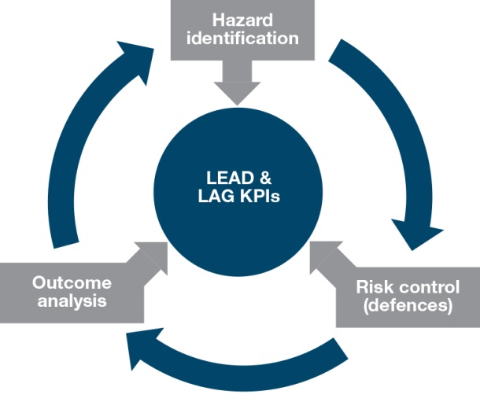

**1. Hazard identification:** the processes by which threats to health and safety of workers, community and supply chain are identified, evaluated and prioritised.

* A **hazard** is a particular **object, activity** or **situation** that, by definition, poses a risk of harm to a person, property or environment. Some hazards occur across a range of organisational settings (e.g. trip hazards), while others tend to be context specific (e.g. rain on slippery work surfaces), or industry specific (e.g. rock falls, or a cigarette lighter in a highly flammable work environment).
* Effective engagement and **consultation** with workers[16] and worker representatives is essential to ensure that strategic, risk management and performance decisions made by officers are based on a realistic understanding of the work they do (i.e. work *as done*), rather than relying on assumptions as to the way tasks are, or should be, performed (i.e. work *as imagined*).[17]
* Another important aspect of consultation is ensuring the **quality of performance data and advice** by obtaining data from **suitably knowledgeable and qualified persons.** Each officer’s need for raw WHS data versus more detailed analysis (and/or recommendations) depends on their level of WHS knowledge. Each has a legally enforceable obligation to exercise WHS due diligence, so those with less WHS knowledge must seek out people with sufficient expertise to provide the robust information, insights and analysis needed to inform their assessment of risk management and performance.
* Hazards often result from **multi-causal factors** and may originate inside or outside the business. Sources include **technical**, **human** and **organisational** factors, each of which may be an essential or contributing factor in a damaging occurrence.[18] Recognising hazards requires holistic attention to all three sources and the interdependencies that exist between them (see Table 2).

Table 2: Business factors that impact the WHS risk profile

| ORGANISATIONAL | TECHNOLOGICAL | HUMAN |
| --- | --- | --- |
| Situational factors | Process – plant/system | Staffing levels |
| Resource allocation | Maintenance | Training, skills, competence |
| Contractors | Operating limits and conditions | Organisational culture |
| Supply chain | Emergency arrangements | Performance incentives |
| Infrastructure procurement | Inputs – hazardous substances | Mental & physical wellbeing |
| Organisational change | High risk activities (regulated) | Communications/consultation |

Figure 6: Latent hazards

Picture of a person carrying a pile of boxes. Next to the picture there is text which states broken pavement, wet floors or an untidy work area are examples of latent hazards that may lead to a trip / slip and fall injury. 
The risk these hazards pose is significantly increased by the presence of additional hazards that attract attention away from, or obscure view of, the floor ahead (e.g. rushing, loud noises, texting, or carrying bulky items). 

* The presence of a hazard will not necessarily translate to an immediate injury or illness. Instead, many hazards are dormant, or **‘latent’**, having a theoretical (potential) risk of harm. An incident occurs when a set of active and latent hazards align. An incident is an unplanned event that may, or may not, result in an injury, illness, property and/or environmental damage (see examples in Figure 6).
* Substantial knowledge about the **cause and effect relationships** between various WHS hazards and work injuries or illnesses means those injuries are reasonably **foreseeable**. Importantly, there is a robust, inverse relationship between management efforts to identify and control WHS risk and the frequency and severity of work-related injury and illness*.*[19]
* **The limitations of risk ‘assessment’:** The temptation to assign numerical ratings to the risk posed by WHS hazards is pervasive. While some attempt to assess and prioritise risks is necessary, the use of quantitative risk assessments and (some) risk matrices often implies greater accuracy than can be warranted, and thus they can be misleading or counterproductive. This is because numerical assessments of both the likelihood and consequence of injury or illness are made with limited scientific evidence, are highly subjective and are prone to errors of personal bias and heuristics.[20] In particular, studies of catastrophic injury have repeatedly confirmed the risk was known but inadequately controlled, because the likelihood was vastly under-estimated.

**2. Risk management:** refers to the efforts made to address threats to the health and safety of workers (employed by the business or along the supply chain), and community (e.g. bystanders). These risk management efforts are referred to here as WHS ‘controls’.

* **WHS controls** cover three broad types of WHS hazards: **technical, cultural** and **governance** issues(see Figure 7). These form interconnected pillars to underpin the effective management of WHS by ensuring:
* Sound WHS hazard identification and risk management conducted by management in consultation with workers.
* Strong leadership with a robust safety culture.
* Effective mechanisms of WHS oversight and control.

Figure 7: WHS risk management controls

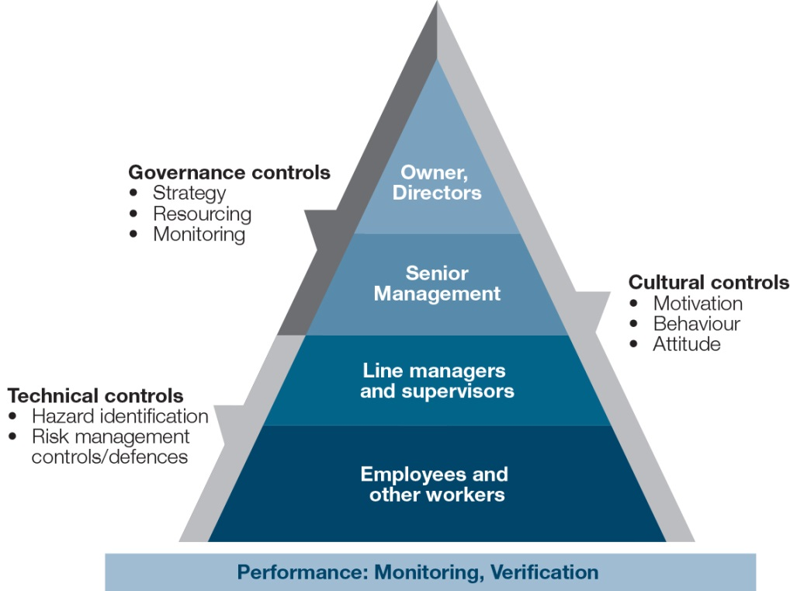

* **The hierarchy of controls** (HOC) (see Figure 8) is a framework for injury prevention. It ranks the possible controls for a hazard or risk from most to least effective. The HOC recommends to:
* Eliminate (remove) the hazards that cause illness or injury.
* Where eliminating a hazard is simply not reasonably practicable:
* Take actions to minimise, as much as possible, the potential for harm to anyone; and
* Monitor and address any residual risk of harm.

Note: the higher up the HOC, the greater the effectiveness and reliability of the strategy for minimising harm.

It is also crucial to consider the extent to which introducing a level 2 or 3 control potentially introduces a new, or different, hazard that will also need to be evaluated and controlled.[21]

Figure 8: Hierarchy of controls  
(Source: Safe Work Australia 2011, p13)

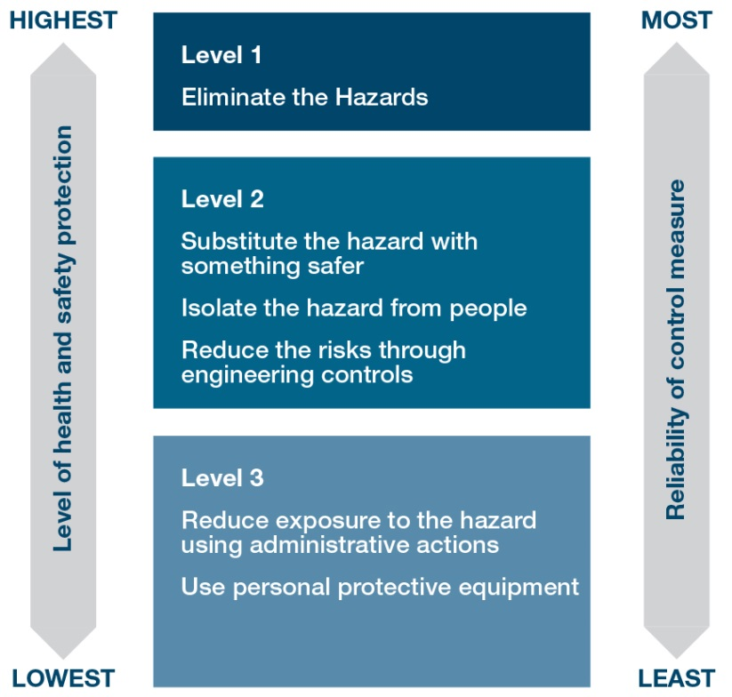

**3. Outcome analysis:** refers to analysing how successfully the business has performed with respect to various components of WHS performance outcomes including:

* safety performance (risk elimination/minimisation)
* injury performance (injury prevention), and
* financial performance (cost effectiveness).

Note: a more detailed look at performance outcomes is provided in section 3 of this report.

Each PCBU will have records, in one form or another, relating to the ways in which officers are informed about WHS matters. This may include training records, board attendance records etc. While it is possible to count or track KPIs for every activity, it is important to consider: **Would all this data add value, or just add noise? Identifying those KPIs that have the potential to guide improvement in performance** **ensures data collected and reported serves a purpose;** that it adds value by shedding light on important issues and informing important decisions. If not, then collecting, monitoring and reporting on it is likely to be a waste of time.

The more mature an organisation’s WHS culture, the more likely the business is to: carefully select KPIs that provide clear signals to action; track the KPIs routinely; and report regularly on the results to management; and report to officers only when the KPI data is relevant and material to the governance, risk management and resourcing decisions that officers need to make. Together this ensures that, while resources for monitoring performance are limited, there is adequate data to ensure key WHS risks are identified and prioritised for action, and officers obtain assurance that controls are resourced, implemented and effective.

Asking the right questions is important because the questions which management ask guide the choice of management controls, and then the availability of performance measures. The following provides examples of lead and lag KPIs that may be used to monitor the management and governance of officers’ knowledge of WHS matters and WHS business risk profile.

Table 3: Identifying controls for ensuring WHS knowledge

| Step 1: Asking pertinent questions to… Step 2: identify relevant controls |
| --- |
| * (Management question) How do we help officers improve their knowledge of WHS matters/WHS position? |
| * + Control: provide information via inductions, board briefings and training sessions   + Control: provide access to up-to-date risk register   + Control: provide subscriptions to high-quality legal/professional/industry alert services |
| * (Management question) How do we verify officers' knowledge of WHS matters is adequate? |
| * + Control: observe engagement at inductions, briefings and training sessions   + Control: assess knowledge, e.g. survey, performance review or evaluate contributions to risk assessments and WHS performance reviews etc |
| * (Governance question) What processes and systems ensure knowledge of WHS matters is adequate? |
| * + Control: record attendance at inductions, briefings and training sessions   + Control: ensure briefing/training are provided by persons with appropriate expertise   + Control: ensure the risk register is up-to date (e.g. review schedule with accountability assigned) |

Table 4 illustrates how important questions for management that guide the selection of WHS controls and, in turn, the selection of lead and lag KPIs, are used to inform managerial decisions (to improve WHS performance) and governance decisions (to improve the reliability of WHS systems).

Table 4: Developing KPIs for evaluating WHS knowledge

| **Developing KPIs for WHS AWARENESS – understanding the WHS risk picture** | | | |
| --- | --- | --- | --- |
| **CULTURE:** | **IMMATURE** | **DEVELOPING** | **MATURING** |
|  | Not used | Attempt to quantify risk – often fail to recognise limitations of bias, imperfect knowledge | Identify critical risks and use matrix to assign accountability rather than risk assessment |
| Evaluating the implementation of individual management controls (Lead KPIs) | | | |
| CONTROL: INDUCTIONS   * Have officers completed an induction (that includes WHS)? | – | # or % of officers inducted | # or % of officer inductions overdue (with timeframe) |
| * Are trained and competent people delivering the inductions? | – | – | % of inductions delivered by people with appropriate OHS qualifications and experience |
| Evaluating the effectiveness of individual management controls (Lag KPIs) | | | |
| * Was induction/training successful? Are inducted workers competent? | – | # or % of officers completing induction | % of officers meeting induction course requirements/assessment  # subsequent risk awareness failures (i.e. poor risk assessment) |

## Understanding the organisation’s WHS 'risk picture’

**Figure 9: Understanding the risk picture**

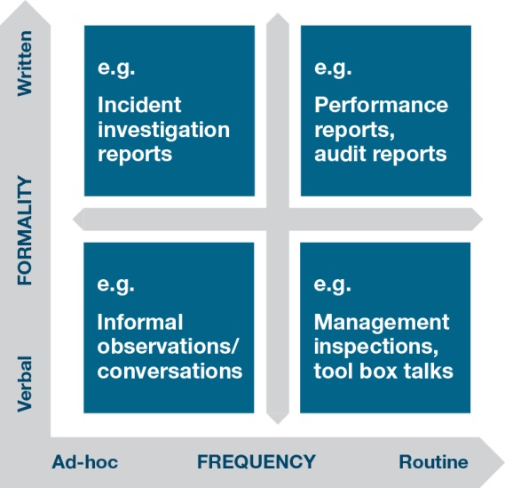

Unlike the general information described earlier as ‘WHS matters’, a WHS risk profile is **uniquely specific** to each business because organisational contexts and vulnerabilities differ. It is defined by the critical hazards that expose workers, and the business, to harm. Identifying these critical hazards is the starting point for considering, selecting, implementing and evaluating appropriate WHS risk-management controls.

Officers gather performance data through various communication processes, from the formal to informal and ad-hoc to routine (see Figure 9). Performance information may be qualitative (e.g. descriptive accounts, stories or discussion) or quantitative (e.g. numerical accounts like financial costs and KPIs).

Simply **copying** another business’s or industry leader’sreport style or content may allow benchmarking of performance externally, but can be incredibly **counter-productive** if one organisation’s risk profile, operating environment or business strategy differs from the other. Their KPIs may not capture the aspects of the business that need to be monitored, or may focus attention on inappropriate WHS priorities.

Measuring the wrong things is ultimately a waste of time and resources. KPIs need to add value to the decisions made in each business.

### Identifying potential WHS hazards

A growing global body of evidence is contributing to an increasingly sophisticated understanding of cause and effect relationships between specific WHS hazards and work-related injury and illness. Some have been long known (such as the potential WHS consequences of falls from heights or chemical exposure), while others have emerged more recently with advances in technology or understanding (such as hazards relating to mental illness, repetitive strain injury, some cancers, or the role of organisational factors in exacerbating human and technical hazards). The ready availability of knowledge about these factors means the associated injuries are reasonably foreseeable.

**Issues to consider when identifying potential WHS risks include:**

* Source of risks (work-related hazards)
* Type of organisation, product and/or service and the nature of the work undertaken (what injures people)
* The market the organisation operates in (including supply chain considerations)
* Potential organisational vulnerabilities (structural, managerial, operational and cultural)
* Confirmation of the conclusions:
* Has the event (or a similar event) occurred previously – here or elsewhere?
* Has it occurred in a similar situation?
* Does the cause-effect relationship make such an event appear probable?

Once potential sources of WHS hazards are identified, a WHS risk profile is developed by considering:

* nature and level of threats faced
* potential consequence of these adverse events
* likelihood* of the adverse events occurring
* effectiveness of the preventative controls that are in place.

*\*As noted above, statistical data/evidence may or may not be readily available to provide this confirmation and some estimates of consequence and likelihood may be unreliable.*

The following sections suggest sources that help identify potential WHS hazards and risks. They may also provide suggestions for useful performance data that may be developed to demonstrate due diligence. Again, this is not to suggest that every item below warrants measurement, but rather that there are a range of potential data sets from which relevant measures might be developed.

1. **Identifying WHS hazards proactively (Figure 10)**

Figure 10: Identifying hazards proactively

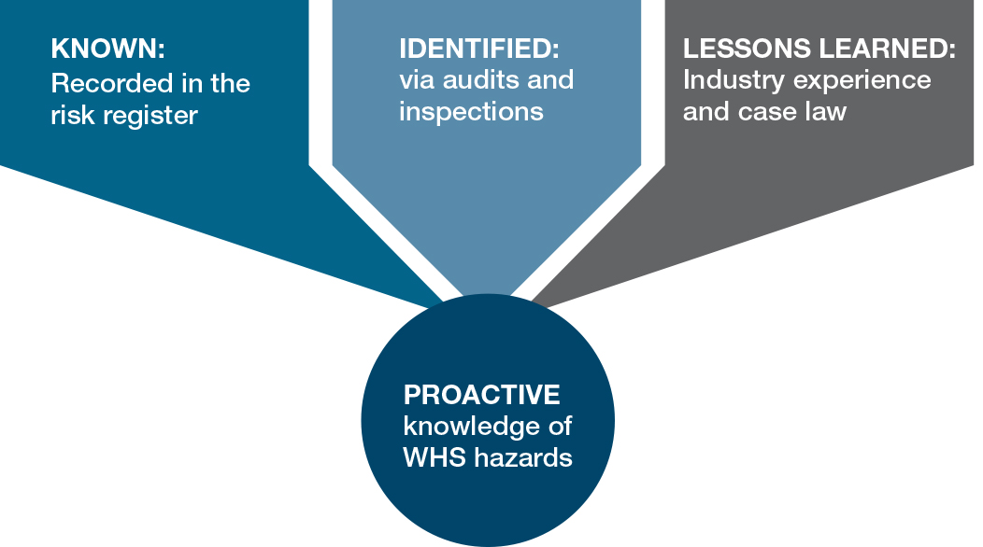

* **Insights from the risk register**

Information about **risks a business already knows about** should be available in the organisation’s risk register. This will include hazards ranging from those exposing workers to minor cuts and bruises through to those events, such as catastrophic equipment failure, with the potential to result in death, disabling injury and business failure.

* **Insights from inspections and audits**

Inspections or audits[22] conducted by trained, competent and independent professional provide an important review mechanism. There are two types of review:

* + **Compliance** *audits/inspections* provide valuable feedback on the extent to which WHS management systems and activities are legally compliant, conform to planned arrangements, and are operating as intended.[23] (It should be noted however that compliance with the Australian Standard 4801.2001 does not guarantee that WHS risks are being controlled *so far as is reasonably practicable*.

For example, this includes providing assurance as to whether or not:

* notifiable incidents are reported
* workers have been consulted
* notices issued under the WHS Act are complied with
* workers have been provided WHS training and instruction
* health and safety representatives (HSRs) have received their training entitlements.
  + **Performance** *audits/inspections* also provide timely feedback as to whether existing WHS systems and processes are effective and suitable to achieve the organisation’s policy and objectives, identifying potential weaknesses and suggesting improvements as appropriate.

Information obtained from performance audits, inspections and management ‘walk-arounds’ are an important source of information about new hazards and risks, and about management controls that require attention or review.

* **Insights from industry, professional and legal sources**

Information about potential hazards and risk may also be obtained from various external sources including peer organisations and industry bodies, professional associations and networks, regulators and advisory bodies, external auditors, legal firms and the media – including from regulations, codes of practice, or government guidance information. It may be gathered through digital communications, presentations by appropriately experienced guest speakers, subscriptions to legal or professional update services, and membership of and engagement with relevant professional organisations. It is the responsibility of those within the business or undertaking to critically evaluate the applicability of external information to their organisation and act on it as appropriate.

1. **Identifying WHS hazards reactively (Figure 11)**

Officers may learn about hazards ‘the hard way’; only after a costly injury or illness has occurred. Understanding the drivers and consequences of these incidents may be helped by lead and lag KPIs relating to incident investigations, sick leave, absenteeism and return to work, recruitment and retention, lost productivity, workers compensation, legal action, lost customers or lost contracts.

Figure 11: Identifying hazards reactively

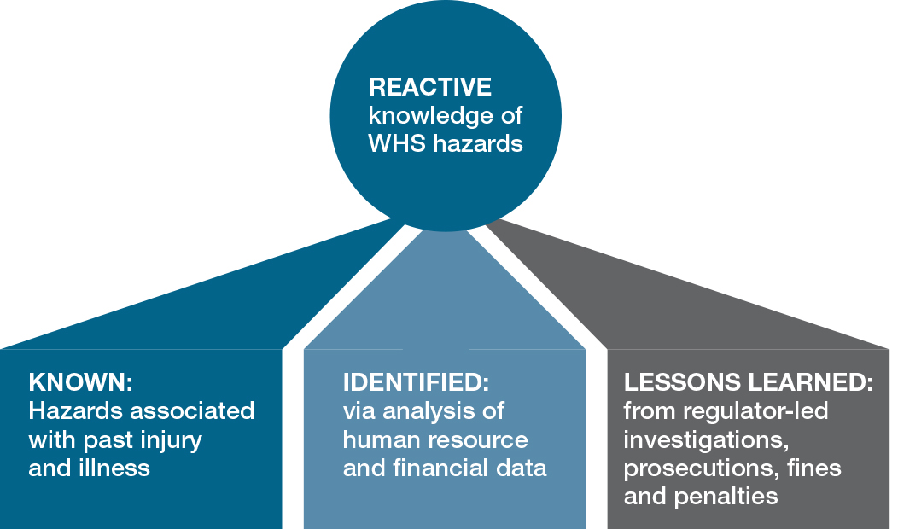

* **Insights from past injury and illness**

Analysing injury and illness incident reports can be an important source of information on uncontrolled risks. In particular, KPIs which identify the body part that was injured or the nature of illness or disease can alert management to areas of risk exposure in the workplace.

Relevant questions about injury and illness seek to **understand the damage sustained** by workers at work. Examining injuries and illnesses provides clues to both the consequences of WHS system ‘failures’ and the different types of risks that were uncontrolled at the time the incident occurred. These different perspectives offer useful insights into the scope, scale, drivers and consequences of Class 1 and Class 2 damage.[24]

1. **How many workers (and bystanders) have been damaged as a result of work-related injury or illness? and What type of damage have they suffered?**

To answer these questions, the raw number of injuries and illnesses is more informative than aggregated percentages. Data may be reported in tables or, as is often presented in annual reports and management reports, as a graphic. Figure 12[25], which reveals the number of individuals injured for the month, (month to date or MTD) with comparative year to date (YTD) and bodily location data, is an example of this type of graphic.

Figure 12: Body location of damage over time

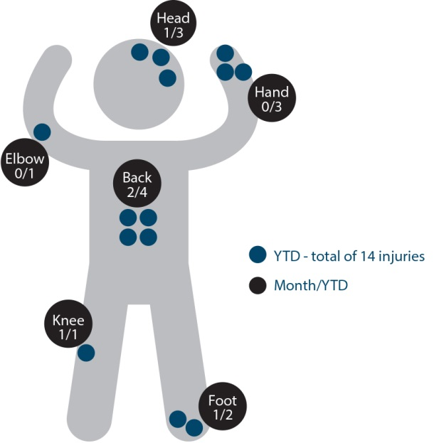

More sophisticated analyses identify not only the **frequency** with which an injury or illness occurs, but also provide a general indication of the **severity of damage** arising from those work-related injuries and illnesses (see, for example, Figure 13). This additional severity information alerts officers to potentially significant issues and helps ensure WHS controls are prioritised appropriately.

Figure 13: Body location of damage with severity

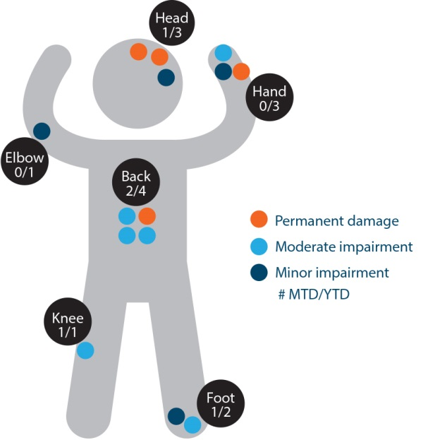

Reporting the **type of injury**[26] (i.e. identifying the medical condition arising from the injury or illness) can provide further insight into the types of hazards or gaps in WHS risk controls (see Figure 14).

Figure 14: Type of damage

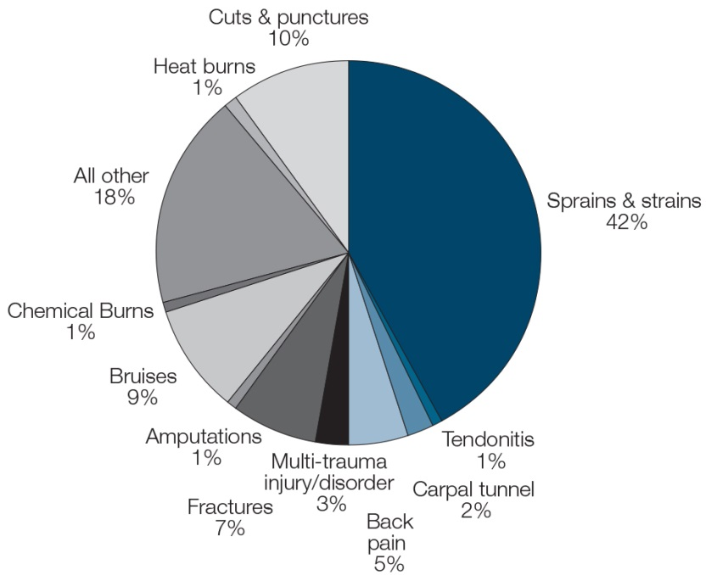

1. **How are injuries or illnesses occurring?**

Data relating to the immediate mechanism(s) of injury provides important clues to managers and boards about gaps in WHS controls and can indicate where further investigation, resources or controls may be needed.

Figure 15 provides an example of a graphic that illustrates reporting of injuries for the year, by the mechanism of injury.

Figure 15: Mechanism of injury  
Adapted from City and Ryde (2014) annual report, p72

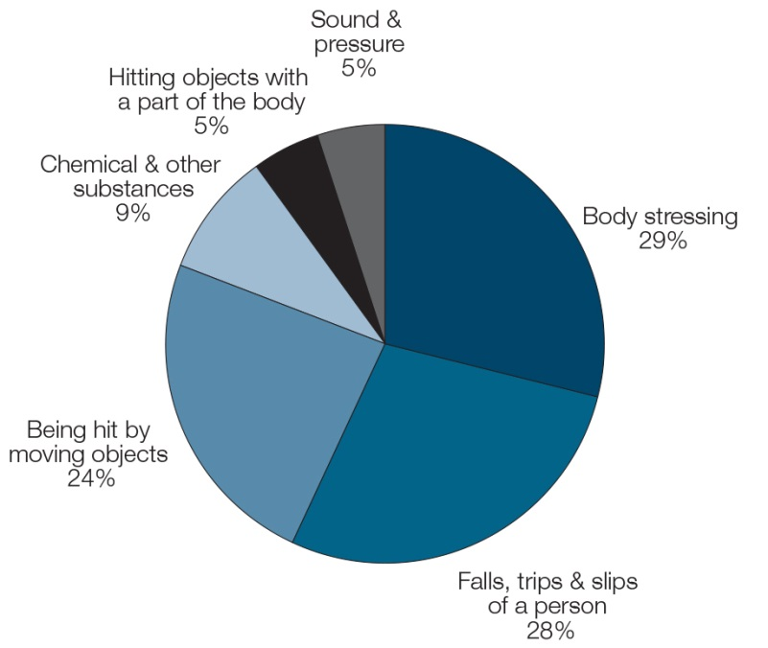

1. **Why are injuries or illnesses occurring?**

This is a different question yet again. It requires attention beyond the most obvious mechanism of injury, to identify the various ‘essential and contributing factors’[27] (typically a combination of multiple organisational, technical and human factors) that created the circumstances in which the injury/illness was able to occur.

* **Insights from human resource and financial information**

Further insights into potentially uncontrolled WHS risks may also be gleaned from patterns or unexpected changes in data relating to sick leave and absenteeism, annual leave, staff turnover and use of casual staff.

Similarly, insights into potentially uncontrolled WHS hazards may also be gleaned from actual-to-budget variances, or unexpected spikes in costs relating to unplanned maintenance, rework (e.g. due to inferior materials or inadequate processes), lost productivity, unplanned leave, expenditure on workers’ compensation or employee recruitment and retention.

* **Insights from regulatory investigations**

Hazards may be identified as a result of the findings of regulatory investigations into incidents. Outcomes could include forced implementation of conditions contained in improvement notices, enforceable undertakings and court ordered penalties.

### Consolidating the WHS risk picture

Consolidating a broad range of WHS risk information into a risk picture requires attention, first and foremost, to the potential damage to workers from injury and illness. This includes damage from exposure to hazards associated with low-risk, high-frequency events, such as minor cuts or trips, through to those associated with high-risk, low-frequency events, such as catastrophic equipment or process failure that result in death or disabling injury.

Once these are identified, **crucial interactions between WHS risk and broader business risks** within the business or undertaking and along the supply chain also need to be considered. These include financial and operational risks relating to:

* legal compliance
* loss of competent personnel and corporate memory
* public and environmental health and safety
* asset protection (e.g. from fire or damage)
* quality and safety of products or services
* Information Technology (IT) and Intellectual Property (IP) security (anti-fraud, anti-terrorism)
* reputational damage and its effect on factors including:
  + cost of capital
  + share price
  + consumer demand
  + transport and procurement
  + recruitment and retention
  + public sentiment
  + business continuity
* business failure.

### Prioritising WHS concerns

The relationship between WHS risk and broader elements of business risk reinforces the need to consider WHS risks within a broader business context. Importantly, higher-consequence outcomes (those that are more damaging to workers) tend to be associated with greater financial, operational and reputational business risk. This reinforces the need to address those hazards that have a potential to cause fatalities, disability or moderate-to-severe incapacity.

Moreover, an appropriate focus on high-consequence damage requires officers to explicitly consider both ‘people safety’ hazards and ‘process safety’ hazards. It has become increasingly clear that a singular focus on aggregated indicators of people safety, such as traditional injury measures, does not provide business surety as to the complete WHS risk profile. There is a critical need “for alternative indicators of safety which have a real bearing on how well major hazards are being managed”.[28]This is often referred to as process safety.

Process safety applies to businesses requiring a high level of assurance that systems and procedures associated with plant and equipment continue to operate as intended. The emphasis placed on attending to the prevention of high consequence damage in the model WHS Act is therefore consistent with an organisation’s broader financial risk-management objectives.

### Using risk matrices or ‘heat maps’

As noted above, reliably estimating the likelihood and consequence of injury associated with a particular hazard can be difficult in the absence of adequate empirical evidence. It is made more challenging due to the low frequency of fatal and disabling injury, and **poor access to past detailed injury data** at an organisational level. However, many serious and catastrophic events have resulted from risk which had been previously known and readily understood but was not adequately controlled, because the likelihood of injury had been seriously underestimated. This illustrates why risk assessment and the design of risk control measures **must** give particularly careful attention to hazards with the potential to cause life-altering harm or damage, **even where the likelihood of failure appears to be low**. It also shows why a traditional approach to constructing WHS risk matrices can be misleading and counterproductive.

Part of the problem stems from inadequate weight (and therefore priority) given to catastrophic and major risk in traditional business risk matrices (see Table 5).

Table 5: Traditional business risk matrix

|  |  | **CONSEQUENCE (Needs to be the dominant factor)** | | | | |
| --- | --- | --- | --- | --- | --- | --- |
|  |  | **Negligible** | **Minor** | **Moderate** | **Severe** | **Catastrophic** |
| **Likelihood** | **Very likely** | moderate | moderate | high | critical | critical |
| **Likely** | low | moderate | moderate | high | critical |
| **Possible** | low | moderate | moderate | moderate | high |
| **Unlikely** | very low | low | moderate | moderate | moderate |
| **Very unlikely** | very low | very low | low | low | moderate |

Given each catastrophic, major or moderate injury/illness not only reflects a failure to ensure WHS but also results in significant human, social and financial consequences, the need to direct attention to the prevention of Class 1 injury/illness (fatal and permanently disabling) is particularly critical. Alternative methods of risk rating to guide officers’ due diligence are required. One method (see Table 6) does not address the limitations of likelihood estimates, but seeks to clarify and reweight the risk matrix to direct attention to potential harm.

Table 6: WHS risk matrix – potential harm

|  |  | **Class 3 – Negligible** | **Class 2 – Moderate** | **Class 1 Severe** | **Class 1 Catastrophic** |
| --- | --- | --- | --- | --- | --- |
| **Likelihood** | **Very likely** | low | critical | critical | critical |
| **Likely** | low | critical | critical | critical |
| **Possible** | low | high | critical | critical |

A more meaningful rating approach (see Table 7), clarifies and reweights the risk matrix by considering the quality of risk controls and directing attention to residual risk. This begins to address the limitations of likelihood estimations by instead aligning the potential consequence to the adequacy of controls in place (see Table 7). The effectiveness of each control is rated as follows:

1. **Controls are in place.** The controls are currently working and are effective, i.e. the hazard or risk has been eliminated or residual risk is insignificant.
2. **Controls are in place to the full extent reasonably practicable**. There is some remaining risk because the controls are not ideal, but either there is simply no better control currently available or a better alternative would require investment grossly disproportionate to the risk. Ongoing monitoring of this risk is needed.
3. **Satisfactory controls are currently in place and appear to be working adequately at this time.** However, more effective controls are known, are available and could be implemented.
4. **Controls currently in place are inadequate**. There are known problems or limitations with existing controls and further action to eliminate or minimise the risk is needed.
5. **The risk is essentially uncontrolled**. Controls either have not been implemented, or they are grossly inadequate. Urgent action is required.

Table 7: WHS risk matrix – risk control ratings

|  |  | | | **CONSEQUENCE** | | | | | |
| --- | --- | --- | --- | --- | --- | --- | --- | --- | --- |
|  | | | **Class 3** | | **Class 2** | **Class 1** | | **Catastrophic** |
| 1. **Risk eliminated or insignificant** | | Cost effectiveness | very low | | very low | | | very low | very low |
| 1. **Controls are in place, to the full extent reasonably practicable** | | low | | low | | | moderate (5) | moderate  (5) |
| 1. **Satisfactory – controls seem adequate, but better controls are available** | | low | | **high** (10) | | | critical (20) | critical (20) |
| 1. **Existing controls are inadequate** | | moderate  (1) | | critical (50) | | | critical (100) | critical (100) |
| 1. **Risk is uncontrolled** | | moderate  (1) | | critical (50) | | | critical  (100) | critical (100) |

## Summary – Evaluating WHS position

The overriding duty of a PCBU is to **ensure** the health and safety of workers and others in the business (see s 19(2) of the model WHS Act). The ultimate question is therefore:

**Are workers at risk of harm (injury or illness) as a result of the work they do?**

An organisation’s WHS position reflects the quality of WHS risk management. It conveys information about the potential technical, human and organisational drivers of injury and illness, at a stated point in time. Understanding the risk picture therefore requires three steps as illustrated below in Figure 16.

Figure 16: Understanding the WHS position

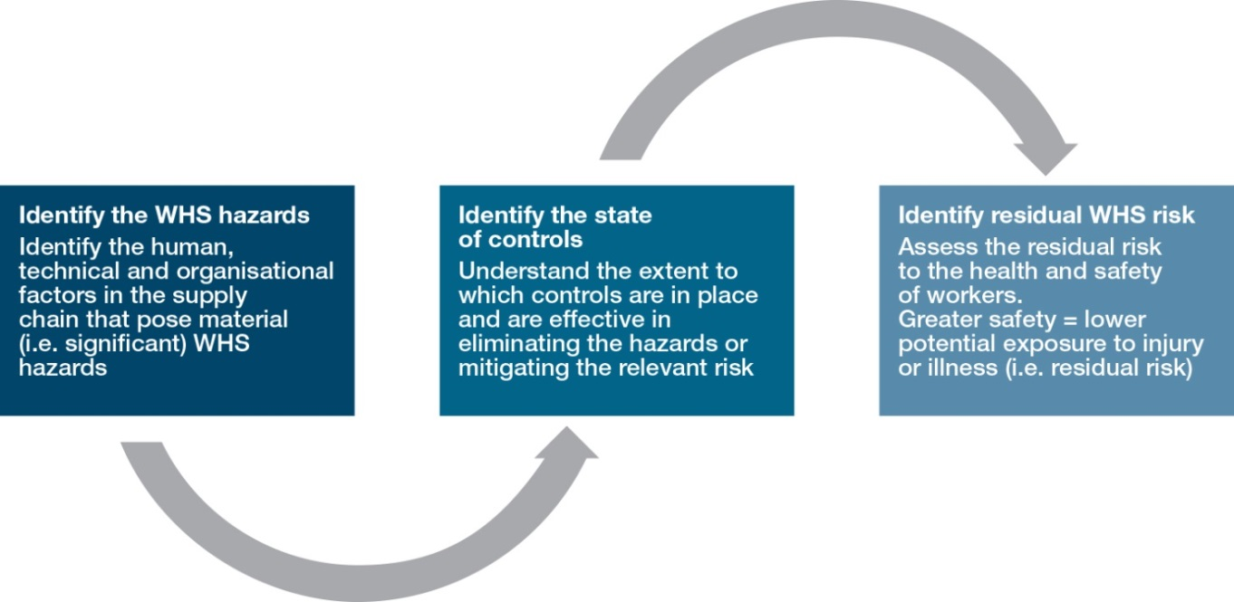

Table 8 provides examples of KPIs that may be used to help monitor the evaluation of risk identification and control to inform managerial decisions (to improve WHS performance) and governance decisions (to improve the reliability of WHS systems).

Table 8: Example – KPIs relating to risk picture

| **Developing KPIs for PERFORMANCE MANAGEMENT – understanding WHS risk position** | | | | | |
| --- | --- | --- | --- | --- | --- |
| Relevant questions about risk identification and control | | | | | |
| * Are all material (critical) risks identified and recorded? * Are controls in place and residual risks understood? | | | | | |
| **CULTURE:** | **IMMATURE** | | **DEVELOPING** | | **MATURING** |
| Evaluating implementation (Lead KPIs) | | | | | |
| * Is a risk register complete? | | - | # hazards listed on the register  % machines guarded etc | % of risk register reviewed/ updated to schedule | |
| * Are trained and competent people completing risk assessments? | | - | % of hazards assigned to officers for oversight | % of risks reviewed by people with OHS qualifications  # major risk assessments involving the CFO? HSE? | |
| Evaluating effectiveness (Lag KPIs) | | | | | |
| * Are risks appropriately identified? | | - | # new non-conformances detected in audits | # hazards/risks identified in investigations that were not on the hazard register | |
| * Are hazard elimination/ reduction controls effective? | | - | % of corrective actions completed | # control failures  % of residual risks mapped by priority | |

# UNDERSTANDING WHS PERFORMANCE

Examining WHS performance could involve a focus on performance in terms of processes, or in terms of outcomes. WHS processes, such as information gathering, management controls and assurance, are already addressed in other sections of this report, so this section examines WHS performance outcomes and the performance data that inform officers’ due diligence about the extent to which the business or undertaking’s WHS risk management system (and in particular the WHS management controls) are achieving their objectives. As cited on page 18, performance covers:

* **‘safety’ performance** (risk elimination/minimisation activity)
* **‘injury’** **performance** (injury and illness prevention outcomes)

## Health and safety performance

The overarching objective of **ensuring health and safety at work** means that two key considerations distinguish WHS risk management from strategies employed to manage other forms of business. Specifically:

* **Limited choice in WHS risk control strategy**: The model WHS Act requires a PCBU to eliminate, so far as is reasonably practicable[29] risks to the health and safety, or if the risk cannot be eliminated, to minimise it. Risk reduction may be pursued as an alternative strategy only where elimination is not reasonably practicable. Workers’ compensation insurance can be an important governance issue. However, a WHS duty cannot be transferred to another person – a business cannot ‘outsource’ WHS risks by relying on workers’ compensation (see Table 9). The delicacy of this balancing act is clearly defined by Tooma.[30]
* **Role of cost/benefit analysis**: WHS cost/benefit analyses are both challenging and biased because the financial costs of injury prevention are easily captured in accounting systems while failure costs and the benefits of success are often externalised and difficult to quantify. Accordingly, reasonable practicability provisions in the model WHS Act (see above) emphasise that cost considerations are not to be the primary determinant of WHS risk management. Note however, while cost/benefit considerations are inappropriate for guiding the choice of WHS risk strategy, they remain relevant for informing choices as to the control options that exist within a given risk management (RM) strategy, such as for evaluating the available options for eliminating a risk, or all the options for minimising the risk.

Table 9: Risk management strategies

| **RM STRATEGY** | **BUSINESS CONTEXT** | **WHS CONTEXT** |
| --- | --- | --- |
| Risk Avoidance ✓ | Business decision to avoid a risk by discontinuing the activity that produces the risk. | **Eliminate** the WHS risk, so far as is reasonably practicable. |
| Risk Minimisation ✓ | Risk management activity or programs designed to protect assets from loss or wastage and/or minimise the impact of losses. | If elimination is not reasonably practicable, the risk must not only minimised, it must be **minimised as far as is reasonably practicable**. |
| Risk Transfer  🗶 | Contractual assignment of the consequences (potential losses) to a third party. E.g. cost shifting through insurance, or outsourcing the task and thus the risk to external contractors. | WHS duties arising from a risk **cannot** be transferred. |
| Risk Retention  🗶 | Business decision to simply accept the risk, and to fully finance any consequences from within the business. No action is taken to address the risk. | Failure to eliminate/minimise a WHS risk constitutes a **failure to comply** with the model WHS Act. |
| Cost/benefit override  🗶 | Cost benefit analyses play an important role in determining whether to avoid, reduce, transfer, or take no action and retain a business risk. If the cost exceeds the benefit of a projected strategy then an alternate strategy is employed. | Reasonable practicability guidance states cost considerations **are not** to be the primary determinant of WHS risk management. |

### Direct evaluation of WHS management systems

The model WHS Act places an obligation on the PCBU to ensure health and safety by eliminating or minimising WHS risks, so far as is reasonably practicable. Evaluating health and safety performance therefore involves an assessment of the extent to which management controls have been implemented, and are effective, in eliminating, or minimising, critical health and safety risks across the organisation. Importantly, unless a health or safety risk has been eliminated, there is nearly always some **residual risk that needs evaluating and monitoring** after reasonable efforts to minimise the risk of injury or illness have been implemented.[31]

Various KPIs may be used to evaluate WHS controls and their success in eliminating or minimising risks to health and safety. In particular, page 12 of this paper illustrates how lead KPIs provide performance information on WHS inputs (effort) and are measures that can reflect the implementation of WHS controls. It also illustrates how lag KPIs relating to outputs and outcomes are used to report on the effectiveness of WHS processes and systems (see Figure 17). Together, lead and lag WHS KPIs inform decisions, from operating choices at the shop floor through to the allocation of resources and analyses of performance at the highest levels of management.

Figure 17: Examples of lead and lag KPIs for WHS

Controls which could be used include: 
Lead - # investigations, % major equipment assets  covered by maintenance schedule
Lag - % of actins implemented, % assets with maintenance overdue

Because WHS controls (defences) are specific to particular hazards and operations, potentially resulting in unlimited examples, this paper does not attempt to propose an exhaustive list of lead and lag KPIs. Nevertheless, a small number of examples are provided in Table 8 on page 31, and in the summaries at the end of sections 2, 3 and 4 to illustrate the key concepts.

### Indirect evaluation of WHS management systems

Organisational climate measures are an indirect performance measure that can give added insights into the cultural aspects of WHS, as well as individual perceptions of the environment that produces WHS performance. For example, validated safety climate survey results provide point-in-time feedback on perceptions of WHS leadership and management systems. Similarly, organisations may be interested in repackaging some of the data they already receive to understand the extent to which their organisation fosters a WHS culture that values reporting, justice, learning and flexibility. For examples, see Figure 18.

Figure 18: Examples of lead and lag KPIs for WHS culture

KPIs for reporting, just, learning and flexible cultures. 
Reporting: incentives for reporting, and processes to capture all events. 
Just: no blame reporting, essential factors identified, consequences for breaking rules clearly articulated and transparent. 
Learning : use of information gathered in investigation, occurrence of repeat injuries, and sources of information and advice.
Flexible: is training risk-based or rules-based? When is it acceptable to break the rules, and how is that followed up?

### Resourcing WHS management systems

The culture of an organisation is also reflected in the way resources are allocated to WHS efforts. Traditionally, financial discussions around WHS have focused on cost-benefit issues, despite the many limitations of applying the cost/benefit technique to WHS. These limitations are explored in some detail in the *Business Case for Safe, Healthy and Productive Work[32]*, and demonstrate fundamental flaws in cost-benefit analyses due to inadequate and inherently biased financial cost data, which tends to obscure the potential for improving productivity and operational decision-making.

Organisations with a mature WHS culture recognise these limitations and not only avoid engaging in artificial cost-benefit analyses, but adopt a more proactive approach to resourcing WHS. These include recognising the costs of proactive risk reduction as a business investment, and implementing financial management controls to ensure the relationships between WHS and resources are exploited appropriately. For example:

1. **Cost effectiveness of WHS interventions**

Although cost-benefit analyses are inappropriate foundations for hinging decisions on which risk-management strategy to adopt, **cost analyses** (as opposed to cost benefit) is an important tool for informing choices as to the most cost-effective option in a choice between equally effective risk control options. This could either be between two different methods, or two different providers, of **equally effective** isolation control options. Budgeted cost information is a leading KPI for WHS initiatives.

1. **Budget allocations, spending and variance analyses**

Cost control efforts must recognise the WHS implications of operating and financing decisions and vice versa. In particular, this means acknowledging the critical interdependencies between ‘safe and healthy work’ and the four Ps of planning, procurement, production and performance (which together encompass productivity). As a result, the management literature is peppered with evidence of corporate crises arising from inadequate management responses to health and safety risk; each of which showcase lingering reputational concerns in addition to significant failure costs that far outweighed the foregone cost of injury or illness prevention. The kinds of questions that not only need to be considered, but need to drive performance measurement are:

* Are resource-allocation processes sufficiently flexible to ensure WHS program aims can be met? Have sufficient financial and human resources been allocated to WHS? What mechanisms are in place to ensure opportunities to review funding allocations as and when needed, particularly if production, staffing, organisational structures or other circumstances change unexpectedly?
* Are expenditures on WHS investments considered a corporate cost, or a cost to an individual business unit? Similarly, are **routine** WHS expenditures considered as a corporate cost, or as a cost to an individual business unit? How does this influence willingness to make proactive investments in WHS? If the latter, what performance evaluation controls are in place to ensure business unit managers are not incentivised against proactive investments in WHS, or ensuring basic safe work methods are adequately resourced?

1. **Adequate consultation and risk assessment**

Risk controls for organisational change are particularly important to ensure the impact of change on other programs has been adequately considered and reviewed. This is particularly true when cost cutting is involved. It is not enough for officers to rely on low-level managers to ensure that cost cutting is not at the expense of safety. To ensure senior management have the confidence to say, “I am personally satisfied that the impact of cost cutting has not been at the expense of safety”[33], Hopkins (2000) advocates managers seek independent verification from a specialist third party who can provide assurance to management as to whether safety has been effected or is likely to be affected by cost cuts. This prompts the relevant question:

* Are appropriate processes of consultation and risk assessment mandated and verified to ensure WHS implications of organisational change are considered? These changes include mergers and acquisitions, restructuring, downsizing, cost cutting and contract (re)negotiations as well as organisational/infrastructure design, supply chain management and capital expenditure appraisal.

## Injury and illness performance

Analysing injury data provides important information for informing questions about WHS performance. The following sections examine KPIs relating to work-related injury and illness and explore which metrics are most useful for understanding different aspects of WHS performance. In particular, monitoring the profile of work-related injuries and illnesses is an important part of evaluating the success of an active injury prevention program or initiative. Organisations with an immature WHS culture tend to view injury as the primary means of identifying WHS risks rather than as a means of understanding risk control effectiveness.

Understanding progress in injury prevention requires an answer to the following questions:

* **Have any workers sustained injury or illness?**
* **If so, were workers killed? Permanently damaged? Temporarily incapacitated? Inconvenienced?**
* **If so, how many? How do these results compare to past experience?**

The injury classifications a business uses should help them examine each of these categories ensuring ‘time’ is time to recovery from injury or illness, not a return to work measure. Note that lost time injury rates do not help (for further explanation, see Appendix 4 - A closer look at lost time injury data). Figure 19 provides a meaningful framework for evaluating and reporting on performance. The traditional ‘safety triangle’ is turned upside down to better illustrate the **consequence** of injury rather than the **frequency** of injury. This correlates better with the impact of injury on both injured worker and employer.

Figure 19: Injury and Illness classifications

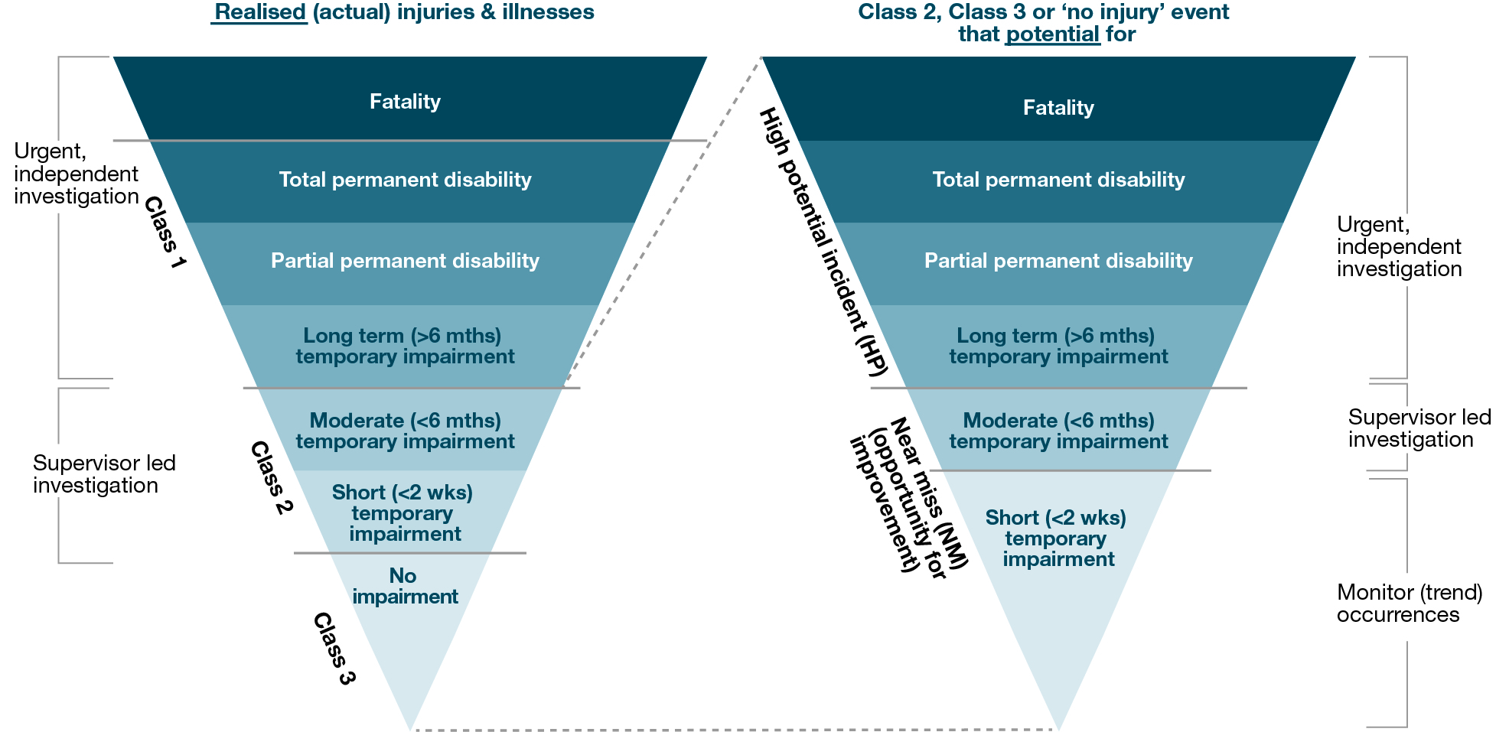

See Appendix 10 – Injury and illness classifications for a full page printable version of this figure.

As a general rule:

**Understanding frequency** (what was the total number of workers damaged as a result of work?)

The same result can be achieved by measuring the **number** of either:

* Total Recordable Injuries (TRI), or
* Total **Class 1** + **Class 2** injuries (preferred)

**Understanding severity** (how much damage has been sustained?)

Calculating the **number** of injuries that fall within each category inside the triangles above:

* Total fatal, permanent total disability (TPD), permanent partial disability (PPD), long term (LT), moderate (MT), short (ST), no impairment (NI)[34], or
* Total Class 1, Class 2, Class 3 injuries[35] (preferred)

When to report injuries as a number and when to report a rate?

Calculating and reporting the absolute raw number of injuries (e.g. TRI) is important because:

* Each injury represents a breach of the duty to ensure WHS.
* Total recordable injury, Class 1, Class 2 and Class 3 injury and illness, should each be presented as a whole number. The Class 1 KPI should be accompanied by a brief explanation if it reveals fatalities or permanent disabilities have occurred.
* Reporting injuries in raw numbers (e.g. total TRIs, Total Class 1 injuries) is important where injury numbers are likely to be too small for a frequency rate to provide statistically reliable or meaningful information. Reporting injuries in raw numbers is particularly important for Class 1 **injury and illness** to alert management to issues of significant risk or trends.
* Comparison of injury numbers to compensation claims data can highlight hidden injuries.

Converting **a number** of injuries (e.g. TRI) **to a frequency rate** (e.g. total Recordable Injury Frequency Rate (TRIFR)) is done only to enable comparisons of performance across organisations of significantly different size or comparisons across time where changes to key factors have occurred, such as significantly different employee numbers or hours worked. This is based on the premise that the differences in size are large enough to make the comparison of raw numbers meaningless. For example, comparing the prevalence of injuries sustained in a company with 70,000 employees to one with 3,000,000 employees. Tables 10 and 11 show possible KPIs for measuring and verifying the quality of injury reports.

Table 10: Developing KPIs for injury and illness performance

| **KPIs for INJURY AND ILLNESS PERFORMANCE** | | | |
| --- | --- | --- | --- |
| **CULTURE:** | **IMMATURE** | **DEVELOPING** | **MATURING** |
| Injury performance | Makes little if any attempt to monitor injury OR Responds to pressure for KPIs by reporting low quality KPIs of injury. | Attempts to understand number and profile of injury/illness but use KPIs that offer limited insight into severity. | Understands the profile of injury, illness and HPIs. Uses KPIs that monitor both frequency and severity of outcomes. |
| Specific management controls for injury prevention | | | |
| * E.g. Use incentive schemes to encourage injury & illness prevention | No | Links LTIFR or all injury rates to performance incentives (remuneration or reward). | Links only leading indicators and Class 1 outcomes to performance incentives and / or reward schemes. |
| Evaluating the effectiveness of injury prevention (Lag KPIs) | | | |
| * What damage to people has occurred as a result of the work our business we do? | LTI, LTIFR | # and % rates of: FAI, MTI, LTI and/or TRI  (Sometimes also includes the number of fatalities). | Number and frequency rates of: Class 1-fatal, Class 1-non-fatal, Class 2, Class 3 or similar. |
| Note: the inputs of injury prevention are the various lead and lag KPIs of risk management controls | | | |

Table 11: KPIs for verifying quality of the injury reporting system

| **KPIs for GOVERNANCE  Verifying the quality of the injury reporting system** | | | |
| --- | --- | --- | --- |
| * How do we know all injuries are reported? | Less is best | # new reports | # new reports, DART rate,  % Compensated to uncompensated injury |

## Summary – Evaluating WHS performance

**Measures of injury and illness** (hereafter, referred to as ‘injury’) are the most prevalent WHS KPI in company board reports and annual reports. Yet, they **do not measure the health and safety of the work environment, nor are they a reliable indicator of WHS performance**. Extraneous factors, including luck, could see injury rates fall even though significant latent hazards remain uncontrolled. Because injury rates measure injury occurrences, not health and safety, statements such as “Our LTIFR shows we significantly improved health and safety at work” reflect a poor understanding of the valid conclusions to be drawn from WHS data.

# ASSURANCE OF WHS SYSTEMS

The officer’s duty to exercise due diligence in ensuring compliance with WHS laws and to verify processes for informing, resourcing and discharging WHS risk control (see model WHS Act ss 27(5)(e) and (f)) demonstrates a need for officers to satisfy themselves that WHS risk management controls are properly implemented, resourced, evaluated and reviewed.

For example, an officer of a PCBU and the PCBU itself, should verify the PCBU’s compliance with the model WHS Act, including by ensuring that:

* notifiable incidents are reported
* workers have been consulted
* notices issued under the model WHS Act are complied with
* workers have been provided WHS training and instruction
* HSRs have received up to 5 days of training.

Verification processes occur at all levels of managerial oversight across an organisation. By taking a three-dimensional perspective on the WHS Cycle (Figure 20), inspired by the **three lines of defence model**[36], three unique perspectives on WHS governance and assurance become evident. Each level of management has different governance objectives and employs different KPIs to address their unique concerns and performance issues. Critical issues of governance and assurance filter up from one level to the next.

Figure 20: Three dimensional perspective on WHS cycle

| **Level** | **Oversight** | **Model** |
| --- | --- | --- |
| **3** | **Board level**  Monitoring the quality of WHS systems and corporate governance controls by boards, with oversight by auditors, regulators and external WHS accreditation bodies. KPIs evaluate processes for managerial and corporate oversight, i.e. the implementation and effectiveness of strategy, policies, systems and corporate governance controls. | **The WHS cycle of hazard identification, risk control (defences) and outcome analysis built around lead and lag KPIs is laid horizontally and layered to represent a three dimensional perspective.  At the bottom (Level1) the WHS cycle drives operational management oversight.  In the middle (Level 2) the WHS cycle drives corporate-level oversight.  At the top (Level 1) the WHS cycle drives Board oversight.  These represent three different levels of governance over WHS risk management activity.** |
| **2** | **Corporate**  Monitoring the success of WHS strategy and programs by corporate-level units including WHS, human resource, finance, etc. with oversight by the board. KPIs relate to audits, expenditure, staffing levels, culture, and WHS performance. |
| **1** | **Management**  Day-to-day monitoring by line managers and supervisors to improve WHS and business performance, with oversight by senior management. Relevant KPIs monitor production processes, routine WHS inspections, hazard identification and evaluation, implementation and effectiveness of individual WHS controls and incident analyses. |

Officers will seek assurance of the implementation and effectiveness of the internal (governance) controls they employ to manage organisational processes (WHS system-oriented controls such as reporting systems, or resource allocation controls). Officers will also seek assurance as to the implementation and effectiveness of risk-management controls implemented at lower levels in the organisation (those regarding KPIs discussed in sections 2 and 3).

Governance controls are controls over the operation of a system. Often referred to as the ‘paperwork’ of WHS, these controls aim not to monitor the improvement in safety, but to monitor the systems and processes that should result in safety improvement.

For example, these include controls and KPIs that seek to:

* verify compliance with legal requirements (WHS legislation) or with codes of practice and industry standards, organisational values, policies and practices[37]
* verify the effectiveness of processes that inform and resource WHS risk controls
* ensure changes to the business’ risk profile (e.g. arising from changes to equipment, raw materials, work processes or personnel) are identified, prioritised, resourced and addressed
* verify processes for review of risk controls affected by organisational changes (e.g. budget cutbacks).

## What does ‘assurance’ mean?

CPA Australia defines[38] assurance as:

“The term assurance refers to the expression of a conclusion that is intended to increase the confidence that users can place in a given subject matter or information. For example, a [financial] auditor’s report is a conclusion that increases the confidence that users can place in a company’s financial statements.”

## Assurance of WHS systems, processes and performance

Whilst processes of audit and assurance have long been associated with the financial accounting practice, the role of auditors, and internal auditors in particular, is increasingly applied to help provide assurance over an ever-broadening array of organisational risk-management activity. Assurance of WHS risk management is but one of these.

The purpose of an assurance engagement must be clear. The assuror may be engaged to verify compliance with a legal, professional or organisational policy requirement (known as a **‘compliance engagement’**), or to evaluate the effectiveness of an operation or risk management system and identify opportunities for improvements (known as a **‘performance engagement’** or **‘operational engagement’**).

Glendon[39] identifies six subjects for WHS assurance:

1. Plant technical assurance – review of all plant and processes conducted by specialists.
2. Assurance relating to specific topics – e.g. human factors or hazardous substances.
3. Site technical assurance – reviews all work of a specified type, is conducted at predetermined intervals and involves workers and specialists.
4. Compliance/verification assurance – tests compliance with legal obligations (compliance) and whether practices follow WHS Management Systems (WHSMS) policies and procedures (verification).
5. Validation assurance – focuses on WHSMS design (e.g. appropriate monitoring and systems are in place).
6. Management safety assurance – combination of validation and verification audits covering general safety matters, usually performed annually and conducted at both strategic and operational levels.

Assurance engagements differ in scope, objectives, criteria (methodology) and auditor independence, resulting in four discrete levels of assurance. As described in Table 12, the level of assurance depends on the training, independence and type of work performed by the assurance provider, and each level permits a different type, or strength, of assurance conclusion to be reached.

Table 12: Types of assurance[40]

| Type of assurance | Example | Nature of work performed | Example of conclusion |
| --- | --- | --- | --- |
| 1 Absolute assurance | Certification | Gathering and substantiation of **complete** or irrefutable evidence to support the conclusion. Not possible for WHS controls**\*** | “We **guarantee** the reported data is true and fair.”  (“stake my life on it”) |
| 2 Reasonable assurance | An **audit** of the system or report (may be an internal audit or external audit) | Gathering and substantiation **on a test basis** of detailed evidence to support the conclusion. Conducted against relevant audit standards or audit criteria by a competent and independent**^** person. | “We **believe** the WHS data presents a true and fair view of performance and is in accordance with relevant WHS standards and legislation.”  (“stake my bonus on it”) |
| 3 Limited assurance | A **review** or **inspection** of the WHS report or management controls | Observations, enquiries and analysis of target subject matter, or against criteria or checklists, by a trained person. | “We have **not become aware** of any reason to believe the data does **not** give a true and fair view of performance.” |
| 4 No assurance | Implementing WHS controls, or monitoring of WHS performance and preparation of WHS board reports. | | No conclusion provided. |

Note: * This is not possible for three reasons: it is impractical to test every control; the accuracy of judgements often cannot be determined exactly; and the result may be contingent on other factors.  
^ An independent auditor is free, both in mind and in appearance, from bias or external (including managerial) influence and is, therefore, able to independently form judgements and conclusions during the audit.

### WHS inspections and reviews

Mechanisms for seeking assurance include formal processes such as scheduled inspections and the use of checklists, through to informal activities such as management ‘walk-arounds’ and peer observations.

**Officer-led inspections**

The efforts of senior managers to personally conduct safety inspections and to consult directly with workers in the workplace are an important component of an officer’s verification toolkit. Processes need to be in place to verify that officers have the level and currency of WHS knowledge to successfully fulfil this role. Controls are also needed to verify the quality of the WHS information provided to the officers.

Leading safety experts, such as Andrew Hopkins and Michael Tooma, offer a number of suggestions for officers wishing to engage in WHS verification:

1. Be familiar with a safety critical procedure and question it with scepticism.
2. Be familiar with an accident or near miss and speak to the people concerned to identify whether investigations have been completed and corrective actions/recommendations implemented.
3. Review the hazard/risk register.
4. Conduct a workplace safety observation.
5. Meet with managers to identify challenges and resource needs.
6. Meet with workers and understand the work they do and risks they face.
7. Observe the work and discuss positive observations and suggested improvements.
8. Peer review – invite other officers to review the WHSMS or tour the site.

**‘Auditor’-led inspections and reviews**

Many internal WHS inspections and reviews are mistakenly referred to as ‘audits’, although in reality they are more accurately assurance reviews. The distinction is articulated in detail in the various assurance engagement standards[41] provided by the Australian Government’s Auditing and Assurance Standards Board*.* These standards relate to the conduct of the assurance process, rather than the subject matter for which assurance is sought.

Although inspections and reviews differ from audits in their scope, objectives, criteria (methodology) and auditor independence, they nevertheless provide a valuable role in monitoring compliance and seeking out opportunities for improvements to the WHS system.

**WHS audits**

Although WHS audits and reviews are not specifically mandated under the model WHS Act, properly conducted audits provide an important means of assurance over WHS systems. The AS/NZS 4801:2001 standard defines an audit as:

*A systematic examination against defined criteria to determine whether activities and related results conform to planned arrangements and whether these arrangements are implemented effectively and are suitable to achieve the organisation’s policy and objectives.*

Reference to criteria in this context does not mean checklists against which the subject matter is assessed. Audits may be described as ‘internal audits’ or ‘external audits’ depending on factors including the level of independence of the auditor and, importantly, the objective of the audit. For example:

*“Internal audit is an appraisal activity established within an entity and functions* ***under the direction of the company’s management and board****. It is a management tool and forms part of the company’s internal control structure… In general, the main focus of an internal audit is to* ***evaluate the adequacy and effectiveness of the company’s internal controls****.”[42]*

Internal audits are therefore designed to add value to the operation of a business or undertaking by “bringing a systematic, disciplined approach to evaluate and improve the effectiveness of risk management, control and governance processes”[43]. Curiously, an external audit firm may be engaged to provide internal audit services.

*“Conversely, an external audit is undertaken by an auditor who is* ***independent from the entity*** *and has been appointed to* ***express an opinion on…******specified accountability matter*** *[such as the financial statements or WHS]. External auditors act and report in accordance with their mandates, which may be dictated by legislation, regulation or established in a contract.”[44]*

## Summary – Seeking assurance of WHS

An absence of improvement in injury and illness outcomes, alone, is now widely understood to provide no reliable assurance as to the underlying quality of a WHS risk management system. Establishing and maintaining appropriate processes for actively seeking assurance is a critical component of WHS due diligence. In particular, assurance as to the business’s compliance with the model WHS laws, and verification of the processes and resourcing needed to ensure WHS, is mandated under the model WHS Act.

This section recognises two complementary sources of assurance information. First the day-to-day KPIs relating to governance controls captured and monitored by managers across the organisation. These include the many checklists, authorisations and ‘paper work’ controls that monitor the implementation and evaluation of policy elements of the WHS risk management system and the many compliance and performance reviews conducted within the organisation.

Within this suite of category 3 assurance mechanisms are important activities such as officer-led inspections and senior management reviews.

In addition, assurance is provided by formal programs of internal and external audit. Offering a higher level of rigour and independence, the audits gather detailed evidence and provide specific conclusions (audit opinions) in delivering assurance to management.

Clearly, mechanisms of assurance are an essential element of any WHS system. However, while they enhance the confidence in the robustness of a WHS management system, they cannot, in and of themselves, ensure safe and healthy work.

## Recommended further reading

Ghandar, A. and Purcell, J. (2010) *A Guide for Assurance on SME Sustainability Reports*, CPA Australia, Southbank.

Ghandar, A. (2014) *A Guide to understanding audit and assurance*, CPA Australia, Southbank.

Price Waterhouse Coopers (2010) *Implementing a Combined Assurance Approach in the Era of King III*, available from the [PWC website](https://www.pwc.co.za/en/assets/pdf/steeringpoint-kingiii-combined-assurance-11.pdf).

The Institute of Internal Auditors (2013) *The Three Lines of Defense in Effective Risk Management and Control,* IIA, Florida.

# DESIGNING WHS REPORTS

## Criteria for choosing report content

The most important considerations when selecting information to include in WHS reports are: the **relevance** for decision-making; data quality (**reliability** and **validity**); and **cost effectiveness**.

* **Relevant:** data is **useful** for informing decisions on issues that matter to the business or undertaking.
* It is material; of a size or importance that leaving it out makes a difference to the report user.
* It is attributable; allows managers to take action that can influence results.
* It is timely; relates to current performance.
* **Reliable:** data is **accurate** and **unambiguous**,free from error and free from bias. This means
* It can be measured consistently, making it comparable both over time and across organisations.
* It is clearly defined, easily understood and readily interpreted by users.
* **Valid:** data measures what it purports to measure. This means a measure has:
* Statistical validity; the data mathematically captures what the description says it captures.
* Face validity; is generally accepted as ‘fit for purpose’, i.e. seen as fair by staff and managers (or stakeholders).
* **Cost effective:** the cost of collecting the data does not outweigh the usefulness of that data.

Note: including information (data) that is immaterial in a report will actually *reduce* the report’s usefulness because the data does not add value, but instead adds noise and can obscure important messages.

Reporting relevant, reliable and valid information is assisted by the availability of generally accepted **measurement** and **reporting standards** or **protocols**.These help ensure data is easily understood by users and comparable across different times and contexts. Further information about recommended WHS performance measures and indicators is provided in sections 2, 3 and 4 of this report.

## Different users, different information needs

Report content is guided by the intended recipients’ needs. Users of WHS performance data include directors, executives, managers, investors, financial analysts, regulators, trade unions, academics, employees (current and future), NGOs and community groups.

Some data is relevant to the decisions of a broad range of user groups (e.g. injury outcomes). However, other WHS information is likely to be of interest to a limited subset of users. Report designers should:

* identify the target audience (who they will be reporting to),
* understand what decisions that audience needs/wants to make,
* consider what WHS information is likely to best inform those decisions.

Suggested indicators for each target audience are at Appendix 8 - Summarising WHS indicators by target audience.

**General versus special purpose disclosures**

Some stakeholders have the power to demand a tailored (**special purpose**) report or communication to meet their specific needs for WHS information (see Figure 21).

Less powerful stakeholders may also have a keen interest in a business’s WHS information, but no authority to demand a report that meets their specific need. Instead, they must rely on WHS information disclosed in **general purpose** reports, such as Annual Reports, sustainability reports, websites, or information provided by third parties. General purpose reports are designed to address the most common needs of a potentially diverse audience.

Figure 21: Examples of general and special purpose reports

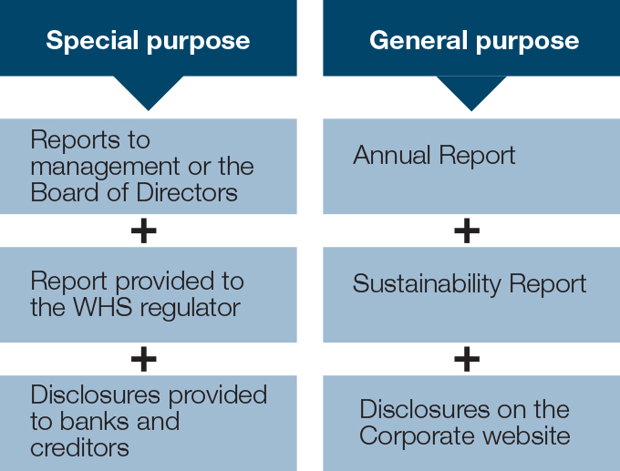

## Reporting inside the organisation

**Reporting to employees**

Communication of WHS information toemployeestypically aims to convey information about injury prevention efforts (e.g. injury updates) or about specific WHS risks, hazards or controls. These can take a number of forms. Time- or context-sensitive information can be disseminated through toolbox talks, emails, training sessions and staff meetings. Periodic WHS performance updates are also made available through newsletters, noticeboards and annual reports.

**Reporting to management**

Operational managers require timely data on WHS risk and performance, such as implementation and effectiveness of WHS controls and initiatives. These reports will be tailored to meet their information needs and requirements and may include a variety of KPIs from sections 2 and 3 above. They tend to address a broader range of performance issues than reports prepared for the board (see Figure 22).

For example:

Figure 22: Example of WHS report to management

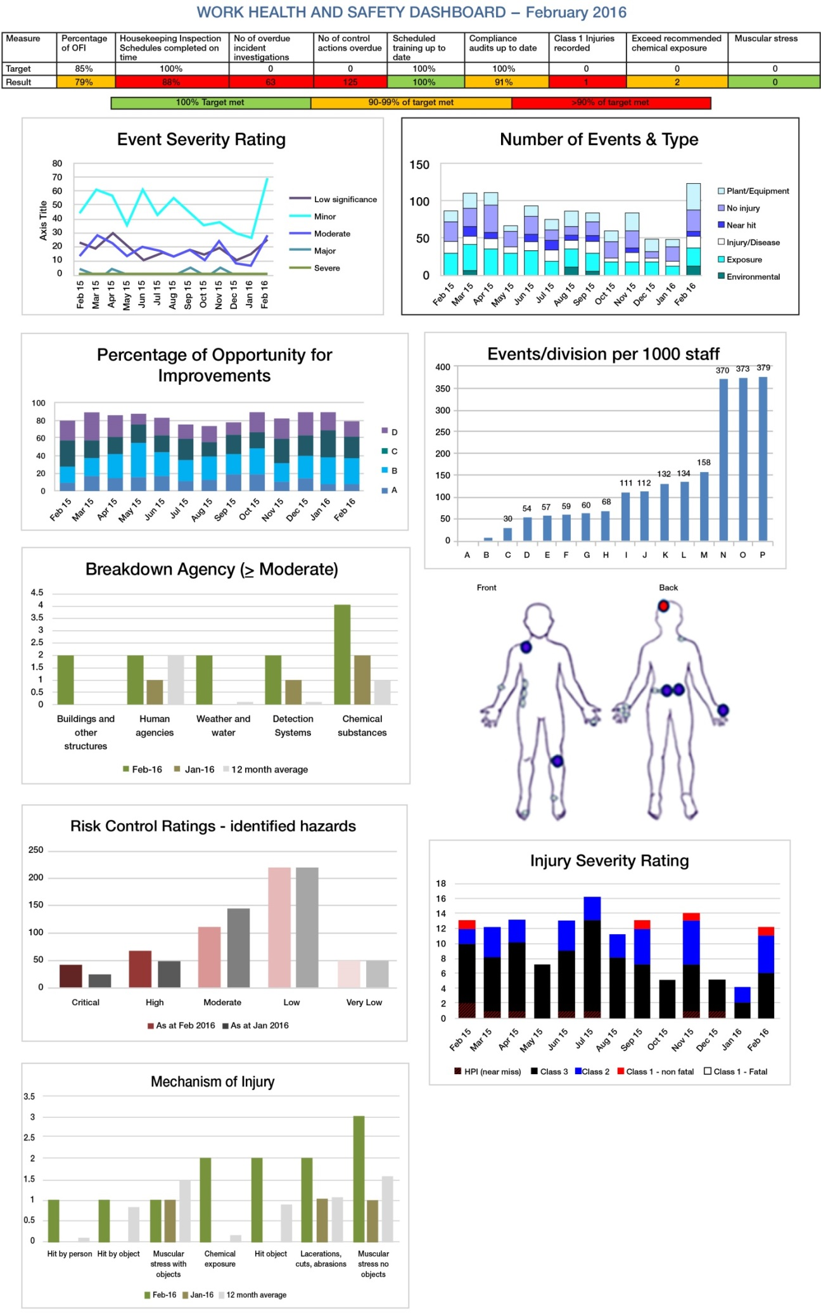

(Acknowledgement: adapted from dashboard provided by M Prior, Manager OHSS ANSTO.)

Supplementary information such as a list of critical hazards, descriptions of Class 1 incidents, or other summarised narratives could be provided on the reverse side of the dashboard report.

**Reporting to the board**

Information relevant and material for boards will inform strategic decisions, and/or WHS due diligence, by reporting on risk management and providing assurance as to the implementation and success of WHS strategy, WHS policy and internal controls. The officers’ duty set out in the model WHS Act (s 27) provides a useful framework for organising WHS information for board reports.

Guidance for preparing a WHS report to the board is provided on the next two pages, and an example offered in Appendix 6 – Sample report to the Board of Directors.

**WHS Report to the Board of Directors**

**Category 1: WHS risk picture**

This section aims to ensure Directors are apprised of **specific** and **significant changes** in: WHS regulation, technologies, practices (relevant **WHS matters**), and organisational hazards and risks (**organisational** **risk profile**).

* Indicators of change: where significant structural change, financial constraints, growth or downsizing is occurring, the likely impact on WHS should be highlighted/discussed. This may include discussion of a formal risk assessment, consultation plan, implementation plan.
* Relevant information may be sourced internally (e.g. via inspections, audits or incident analysis), or externally (e.g. from scanning legal, WHS and news sources). Information may be quantitative and/or qualitative.
* Note: The board’s focus is on **material** issues. Materiality is a key consideration in determining which issues are significant in terms of risk and/or cost should be reported to the board, and those that should instead be updated in the risk register (to which the board has access) and addressed by management.

At a minimum, this section of the board report should always include:

* **‘New top 3 (or 5)’** - To raise awareness and due consideration of emerging threats or examples of potentially significant regulatory/operational issues identified via **external** scanning. KPIs may be included for context.
* ‘**Our risk update**’ – To raise/maintain awareness of the organisation’s critical risks and highlight any significant changes in the organisation’s injury or risk profile. Keep explanations brief.

Board training issues may be flagged in this section, as and when necessary. For example, when a board member has not completed a WHS induction, or where identified and important training was scheduled but has not been delivered.

**Category 2: WHS position**

This section provides information about the state of ‘health and safety’ of the organisation at the end of the period. That is, the status of risks, controls and residual risk. Regarding the implementation and effectiveness of WHS policy and strategy, including those relating to the allocation of financial and human resources: This section should summarise the organisation’s success in meeting its obligations to ensure workers’ health and safety. Critical here are KPIs relating to critical controls that seek to eliminate or minimise WHS risk or reflect event reports (ERs) that remain unresolved at the end of the month (aged, if possible).

* **Indicators of critical defences:** lead and lag indicators of selected critical risk-control activities. It is important to focus primarily on significant changes and new risks, not to simply replicate every available measure from the WHS managers’ report in the board report. Where notable changes in risk or performance are rare, the board report might include a lead and lag indicator of a few different critical defences each month.

**Category 3: WHS performance**

This section should summarise the PCBU’s risk management efforts and the subsequent injury and illness outcomes. That is, its success in meeting its obligations to deliver the resources and processes needed to ensure workers’ health and safety.

* **Injury/illness:** the number of **actual injury cases**, by severity (not an aggregated injury rate) is appropriate. This allows officers to make informed assessments about different aspects of WHS impact, and reinforces that each and every recordable injury represents a failure to ensure WHS. Carefully prepared tables, bar charts or graphs can ensure injury data is both concise and useful (see section 2.2).
* **Risk elimination or minimisation efforts:** information about the actions taken to identify and eliminate hazards/minimise risk. May include KPIs/details relating to the implementation of WHS programs, initiatives, controls etc, climate survey results, incidents investigated and / or event reports (ERs) closed during the period. (For example, this could include a graph of ERs closed with categories reflecting the ‘hierarchy of control’ levels that applied to those solutions.)
* **Indicators of safety inspections:** include activity and outcome details for internal or external performance audits and inspections, E.g. KPIs relating to ‘opportunities for improvement’ identified or metrics such as average safety inspection conformance.
* **Financial indicators:** of the success or failure to ensure WHS compliance. This includes regulatory fines and penalties and updates on legal fees, workers’ compensation and (self-insurer) medical costs relating to Class 1 injury or illness. Other direct or indirect costs may be included if desired. Where trends in compensation costs are stable over time a short sentence may suffice. For example “compensation claims and costs are unchanged at 3 and $19,000/month.”

Note: KPIs such as LTIFR and total lost workdays may be included here, particularly if total days lost includes a range of non-productive time, e.g. days lost to injury or illness, absenteeism and sick leave, although it should be clear that these measure lost productivity not injury, nor safety (see Appendix 5 – Suggested KPIs).

**Category 4: WHS assurance**

This section provides assurance regarding the *systems* that seek to ensure WHS. KPIs relate to governance processes (rather than management processes):

* **Indicators of critical defences:** lead and lag indicators of selected critical risk-control activities. It is important to focus primarily on significant changes and new risks, not to simply replicate every available measure from the WHS managers’ report in the board report. Where notable changes in risk or performance are rare, the board report might include a lead and lag indicator of a few different critical defences each month.
* **Indicators of audits and assurance:** include activity and outcome details for internal or external compliance audits or external, for example KPIs relating to ‘opportunities for improvement’ identified or metrics such as average safety inspection conformance.

## Reporting outside the organisation

### Reporting to investors, creditors, customers and other stakeholders

Stakeholders predominantly interested in the short- or long-term financial health of an organisation, such as investors, may want information about the financial impact of WHS on the current or future bottom line. Alternatively, they may have a more holistic interest in the organisation’s performance (as in the case of ethical investors) and the extent to which a PCBU’s actions and performance align with its espoused commitments to environmental, social and financial governance. Investors, along with current employees, prospective employees and their advocates, also seek specific governance information on management’s commitment to WHS and evidence regarding the effectiveness of WHS management efforts. Other external stakeholders may focus more broadly on the various human and economic externalities that result from work-related injury and illness. Providing general information on WHS programs and management controls, and reporting the frequency and severity of injury and illness, goes some way to addressing the needs of each of these groups.

A suggested framework for reporting on WHS in Annual (or Sustainability) Reports:

**WHS Report for inclusion in Annual Reports and Sustainability Reports**

**1. Key statistics**

The WHS data included in Annual Reports should include, at a minimum, each item identified in Table 13. These can be concisely presented (as shown). Supplementary graphs and charts are also a useful means of conveying information, however if graphs/figures replace a table, **actual** performance must be clearly identifiable (i.e. use numerical labels).

Table 13: Occupational Injury / Illness Report

| **Occupational Injury/illness** | **Current year** | **Prior year** |
| --- | --- | --- |
| Fatalities  Non-fatal Class 1s | #  # | #  # |
| Class 2s (alternatively, TRIs) | # | # |
| - TRIFR | % | % |
| Class 3s (i.e. first aid) | # | # |
| **Internal investigations** (i.e. initiated internally) | | |
| Incident investigations | # | # |
| HOC rate or score **\*** | % | % |
| Indep. audit & (ASAC rate) | # (%) | # (%) |
| **External investigations** (i.e. by regulator/police) | | |
| Number | # | # |
| Fines & (relevant cases) | $ (#) | $ (#) |
| Costs |  |  |
| Compensated injury | $ | $ |
| Lost time: LWD & (LTIFR) | % (#) | % (#) |
| **\*** This reflects the number of actions implemented using controls at HOC level 1 (hazard elimination controls) versus HOC level 2 (risk minimising controls) versus HOC level 3 (risk reducing / administrative controls). It may be useful to present this information as a graphic rather than a rate or score. | | |

Reports may include additional performance data such as:

* WHS lead and lag KPIs relating to critical WHS risk controls
* 5-year average or industry average comparative data.

WHS data is typically provided in a ‘Health and safety’ section or ‘Social responsibility’ section of the report, although leading organisations have included selected key indicators, such as total class 1 injuries (C1), total recordable injury frequency rate (TRIFR) and hierarchy of control rate (HOC) in the ‘Highlights’ section at the front of the report.

**2: Descriptive information**

It is important to include brief explanatory information about WHS risk management and injury/illness outcomes in each Annual Report:

* + **Circumstances and consequences of each Class 1** injury or illness and a **statement about the action taken to prevent recurrence** are briefly outlined. Importantly, without that detail, statements such as: “the incidents have been thoroughly investigated and corrective actions to prevent recurrence have been implemented”are just **grossly inadequate motherhood statements**.

* + **Hazards/risks associated with the most** potentially **damaging** injuries or illnesses (able to cause death or permanent disability) and those associated with **the most frequently occurring injuries** are identified (typically top three of each). The former are typically low frequency. They may include psychosocial risks.
  + Comment on the programs and/or **processes used to manage the risks** identified above (i.e. the defences/controls in place) and **evidence as to their effectiveness** (e.g. including relevant lead and lag KPIs used to assess effectiveness).
  + A brief **overview of WHS governance arrangements**, such as outlining structures and mechanisms by which officers obtain assurance in relation to the implementation and effectiveness of WHS policies and controls. Where safety incentive schemes include WHS outcomes linked to individual or executive remuneration or to team-based performance evaluations, reports are encouraged to disclose key criteria and the actions taken to verify data and mitigate dysfunctional incentives.

## Summary

If WHS performance reports are to be useful and add value, they must be designed to concisely present the most relevant and material information to the intended report users. Some stakeholders, such as boards, banks, regulators and majority shareholders, may have sufficient power to obtain tailored WHS information from an organisation. Others rely on publicly available ‘general purpose’ reports such as Annual Reports, Sustainability Reports and corporate websites.

To identify the right KPIs to include in each report, preparers must understand the needs and priorities of its intended audience. Understanding how information will be used not only helps in designing WHS reports, but also helps identify and prioritise the WHS KPIs that should be measured and tracked; which is important given the limited resources typically available for monitoring performance.

* **KPIs for managers and boards:** Look at the organisation’s risk profile and find themost criticalhuman, technical and organisational challenges and vulnerabilities. Then select lead and lag indicators that allow effective monitoring of those issues.
* **KPIs for other stakeholders:** Understanding the objectives of relevant stakeholder groups and the decisions they want to make will help identify the information they most need. This may involve consultation. Note that some WHS performance data may address different needs of multiple stakeholder groups.

Table 14: Examples of the decision-relevance of various types of WHS KPIs

| Indicator of or insights into: | WHS risk management efforts | Impact of injury on the business | Level of damage to people | Economic and social impact | Making inter-organisational comparisons |
| --- | --- | --- | --- | --- | --- |
| Injury and illness data | | | | | |
| * Class 1, 2 and 3 injury and illness | ✓ | ✓ | ✓ | ✓ | ✓ |
| * TRIFR & C1 rate | ✓ | ✓ | ✓ | ✓ | ✓ |
| Productivity | | | | | |
| * lost work days | high freq.  low conseq. only | ✓ |  |  | ✓ |
| * lost time injury rate | ✓ |  |  | ✓ |
| WHS risk control | | | | | |
| * control implementation KPIs | ✓ | ✓ | ✓ | ✓ |  |
| * control effectiveness KPIs | ✓ | ✓ | ✓ | ✓ |  |
| * hazards associated with high consequence damage | ✓ |  | ✓ |  |  |
| * hazards associated with high frequency damage | ✓ |  | ✓ |  |  |
| Costs | | | | | |
| * workers’ compensation cost | ✓ | ✓ | ✓ | ✓ | ✓ |
| * fines and penalties | ✓ | ✓ | ✓ |  | ✓ |
| * investment | ✓ | ✓ | ✓ |  |  |
| * cost savings |  | ✓ |  |  |  |

# CONCLUSIONS

The standard of due diligence required of officers under the model WHS Act requires them to:

1. Understand the business or undertaking and its WHS risks, and
2. Ensure that the PCBU meets its WHS duties.

This report has highlighted the importance of access to relevant, robust and timely performance information for informing these decisions, and the need for officers, and other information users, to be able to interpret and apply that performance information in a valid and meaningful way. To that end, various WHS KPIs have been described and information provided on the context, circumstances and user groups in which (and for whom) they are most relevant.

While this report recommends a particular suite of KPIs for comparable, valid reporting on injury and illness outcomes, it emphasises the need to tailor KPIs for risk management decisions according to the business context and reinforces the limitations of simply copying KPIs used or reported by organisations that differ in size, operations, strategy, resources or performance. Measurement and reporting processes must be relevant and reliable to add value to decision-making. The question should not be “What measures do I report?” but “What information do my report users need? What decisions are they trying to make?”

Clearly, there is a plethora of potential KPIs that a PCBU could develop, or adopt, to inform WHS performance management. Reporting dilemmas, such as finding the balance between generic KPIs that can be benchmarked within and beyond the organisation, and more nuanced KPIs that are highly relevant to the business’ unique issues and risks are, to some extent at least, tempered by an appreciation of the distinction between KPIs for informing management decisions (which are more likely to be organisation-, and even work group-specific measures for improving performance) and KPIs for informing oversight and governance (which tend to relate to generic systems, and are more likely to translate across organisational boundaries).

In the end, the sophistication of the performance indicators available to inform officers’ due diligence will determine the strategies available to management and the level of control they ultimately have over an organisation’s WHS performance.

# Recommended further reading

**WHS legislation**

Dunn, C. (2012) *Annotated Australian Work Health and Safety Legislation*. CCH, Sydney.

Johnstone, R. and Tooma, M. (2012) *Work Health & Safety Regulation in Australia*, The Federation Press, Sydney

Sherriff, B and Tooma, M. (2010). *Understanding the Model Work Health and Safety Act*, CCH, Sydney.

Tooma. M. (2011). *Safety Security Health and Environment*, 2nd Ed., Federation Press.

**Due diligence obligations**

Tooma, M (2012) six part due diligence book series, published by CCH Australia.

**Identifying and managing WHS risk**

(2013) *Managing for Health and Safety*, HSE, England [UK Health and Safety Executive website](http://www.hse.gov.uk/managing/index.htm).

Dekker, S. (2007). *Just Culture: Balancing Safety and Accountability*. Surrey, England, Ashgate Publishing Ltd.

Dekker, S. (2011). *Drift into Failure: From Hunting Broken Components to Understanding Complex Systems*. Surrey, Ashgate.

Dunn, C. (2012) *Planning Work Health and Safety: An Introduction to Best Practice*. CCH, Sydney.

Dunn, C. and Chennell, S. (2012) *Australian Master Work Health and Safety Guide*. CCH, Sydney.

Hopkins, A. (2000). *Lessons from Longford: The Esso Gas Plant Explosion*. Sydney, CCH Australia Limited.

Hopkins, A. (2005). *Safety Culture and Risk: The Organisational Causes of Disasters*, CCH Australia.

Hopkins, A. (2007). *Lessons from Gretley: Mindful Leadership and the Law*. Sydney, CCH Australia Ltd.

Hopkins, A. (2008). *Failure to learn: the BP Texas City Refinery disaster*, CCH Australia.

Hopkins, A and Maslen, S (2015) *Risky Rewards: How Company Bonuses Affect Safety*, UK and USA, Ashgate Publishing Company.

Reason, J. (1997). *Managing the Risks of Organizational Accidents*. London, Ashgate Publishing Ltd.

Reason, J. (2008). *The Human Contribution: Unsafe Acts, Accidents and Heroic Recoveries*. Cornwall, Ashgate.

# APPENDICES

* 1. Research method

This report is the product of a two-stage research project. The first stage, *Developing WHS Guidelines*, was a pilot study that examined WHS reporting guidance and practice, identified measurement and reporting issues and produced a draft guide to WHS reporting. In stage two, *Testing and Evaluating the Draft WHS Indicators and Guidelines (‘the Guidelines’)*, industry feedback was sought on the content and presentation of the draft WHS Guidelines and the document revised accordingly. The resulting reportseeks to ensure WHS information communicated within and by organisations is relevant and reliable and that it can be interpreted by internal and external users in a meaningful and valid way.

### Stage 1

**Research method:** Stage 1 involved a comprehensive literature review of academic and grey literature on WHS reporting and WHS performance indicators. Information including the indicator name, calculation method and description of lead and lag performance indicators was recorded.

**Results:** Analysis revealed important variations in WHS reporting practice and in the reporting guidance provided by both Government and non-government organisations. These include inconsistencies in the formulae used to calculate various WHS KPIs and conflicts in their descriptions. Importantly, these variations were evident across countries, industries and organisations, revealing a clear lack of a systematic approach to evaluating and reporting on WHS position and performance. Drawing on the findings, the research team drafted a guide for evaluating and reporting on WHS within medium to large organisations.

### Stage 2

**Research method:** A series of face-to-face workshops and online surveys were then used to seek feedback on the document from industry, academics and regulators. Invitations to participate in the process were distributed electronically by email and on various accounting and safety professionals’ online forums.

A total 369 expressions of interest were received from potential research participants. Participants were emailed research project information and consent forms and were required to complete their registration by returning the signed forms and indicating a preference for a 2.5 hour face-to-face workshop from a list of ten workshops to be held in metropolitan locations across Australia and/or a one-hour webinar. All registered participants were provided with an electronic copy of the draft document prior to their nominated session.

Surveys on the perceived use and usefulness of the guide, and on the workshop and webinar training delivery methods, were collected from participants in two stages. One online survey was administered to each participant within a week of the workshop/webinar and another after three months. A total of 236 participants responded to the first survey and 115 of those responded to a follow-up survey. The surveys examined a range of issues including: the content of the guide, the content and delivery of the workshop and webinar, and whether and how they had applied the content of the guide in the workplace.

**Research sample:** Ten face-to-face workshops were held from 4 August to 9 September 2014. These were located in the following ten Australian cities – Hobart, Melbourne, Sydney, Brisbane, Townsville, Darwin, Albury-Wodonga, Canberra, Adelaide, and Perth. The target workshop sample size was 200 (20 per workshop). A total 191 people attended the workshops. In addition, a webinar was held on 11 September 2014 with 162 individuals participating. Of these, 61 actively engaged in the live chat facility.

**Results:** The guide was very enthusiastically received with 96% reporting the content was useful, 64% agreed or strongly agreed (26% neutral) that the guide helped improve their ability to communicate WHS information and 66% agreed or strongly agreed (23% neutral) that the session improved their understanding of WHS reporting. 96% indicated the content was relevant to their role at work and 91% indicated they were planning to apply the content to WHS reporting practices in their own workplace. After three months post-workshop/webinar, 51% of respondents had used the guide to explain WHS concepts to senior managers in their organisation; 55% had used the guide to discuss WHS reporting with others in their organisation; and 53% respondents had used the guide to reflect on and/or review the injury/illness frequency KPIs, and 58% to reflect on and/or review the leading WHS KPIs used in their organisation.

* 1. Definition of an officer

**The model Work Health and Safety Act (s 4)**

**Officer** means:

(a) an officer within the meaning of section 9 of the *Corporations Act 2001* of the Commonwealth (see below), other than a partner in a partnership; or

(b) an officer of the Crown within the meaning of section 247; or

(c) an officer of a public authority within the meaning of section 252, other than an elected member of a local authority acting in that capacity.

The definition of ‘officers’ inthe *Corporations Act 2001* is:

***Corporations Act 2001* (s 9)**

An officer of a corporation means:

(a) a director or secretary of the corporation; or

(b) a person:

(i) who makes, or participates in making, decisions that affect the whole, or a substantial part, of the business of the corporation; or

(ii) who has the capacity to affect significantly the corporation’s financial standing; or

(iii) in accordance with whose instructions or wishes the directors of the corporation are accustomed to act (excluding advice given by the person in the proper performance of functions attaching to the person’s professional capacity or their business relationship with the directors or the corporation); or

(c) a receiver, or receiver and manager, of the property of the corporation; or

(d) an administrator of the corporation; or

(e) an administrator of a deed of company arrangement executed by the corporation; or

(f) a liquidator of the corporation; or

(g) a trustee or other person administering a compromise or arrangement made between the corporation and someone else.

* 1. Officers’ due diligence

**The model Work Health and Safety Act (s 27(5))**

In this section, **due diligence**includes taking reasonable steps:

(a) to acquire and keep up-to-date knowledge of work health and safety matters; *and*

(b) to gain an understanding of the nature of the operations of the business or undertaking of the person conducting the business or undertaking and generally of the hazards and risks associated with those operations; *and*

(c) to ensure that the person conducting the business or undertaking has available for use, and uses, appropriate resources and processes to eliminate or minimise risks to health and safety from work carried out as part of the conduct of the business or undertaking; *and*

(d) to ensure that the person conducting the business or undertaking has appropriate processes for receiving and considering information regarding incidents, hazards and risks and responding in a timely way to that information; *and*

(e) to ensure that the person conducting the business or undertaking has, and implements, processes for complying with any duty or obligation of the person conducting the business or undertaking under this Act; *and*

(f) to verify the provision and use of the resources and processes referred to in paragraphs (c) to (e).

* 1. A closer look at lost time injury data

Often the first step in efforts to understand WHS is to identify whether injuries are occurring in an organisation and, if so, what impact they have[45]. This involves counting the number of injuries that have occurred over a specific period of time, typically a month and/or year. However, because injuries are not identical and the impact can vary from an uncompensated paper cut through to a compensated fatality, a single injury number or frequency rate is too aggregated to provide meaningful information to guide business decisions. Instead, injuries need to be classified into subsets to provide useful insights about the frequency of different types of injury and illness outcomes.

The use of numbers from lost time injury (LTI), medical treatment injury (MTI), and first aid injury (FAI) categories (see Figure 23) has become popular for examining injury/illness data because it separates out those events resulting in a lost capacity for work. Nevertheless, LTIs still combine all injuries involving lost work time, regardless of whether they resulted in fatality, permanent disability, long term incapacity or short term incapacity. Notably, the majority of LTIs have relatively short-term consequences (identified as ‘high frequency, low consequence’ injuries and illnesses).

Because LTIs also fail to address the problem of aggregating a wide range of injury severities, their use as an indicator of injury outcome (damage to workers) has come under increasing criticism[46] from WHS professionals, as well as corporate, investor and academic communities. Most importantly, because ‘low consequence’ injuries and illnesses occur far more frequently than ‘high consequence’ injuries, LTI data provides a general indicator of relatively minor events but no useful insight into the occurrence of more damaging injury and illness.

Figure 23: Historical injury categories

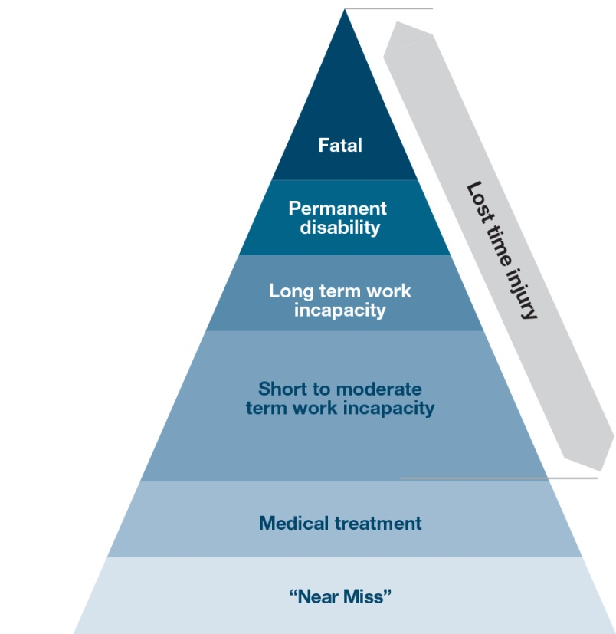

**LTIs reflect high-frequency, low-consequence injuries but provide little insight into disabling injury or illness.**

Alternative injury classification schemes have been proposed to make more meaningful distinctions between high, moderate and low severity (consequence) injury. Critically, these define severity in terms of impairment to the individual, rather than lost time, providing a much greater correlation with damage to both the worker and the business (damage in terms of both physical/psychological and financial damage).

This LTI problem was demonstrated in a study which examined a data set of >400,000 work-related injuries. Panel A (Figure 24) reflects trends over a 10-year period when those injuries are classified as either LTIs or Fatalities. Panel B repeats the exercise, only this time reclassifying the same injuries as either permanently disabling (Class 1) or temporarily incapacitating (Class 2).[47]

Figure 24: Identifying disabling injury

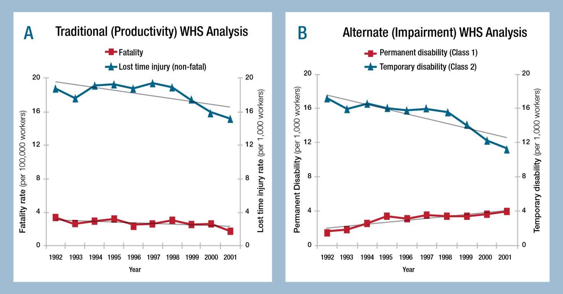

The results illustrate that a steadily decreasing trend in LTIs over time can hide a significant increase in the most damaging (and costly) group of non-fatal injury over the same period.

A board receiving only Panel A would be likely to draw very different conclusions as to the success of past WHS efforts and the appropriate focus of future WHS attention than those receiving only Panel B in their board report. Indeed, if a board was only given Panel A, directors may well ponder why compensation and related costs are increasing significantly while injury rates continue to decline.

So, are LTI, LTIFR and lost workday statistics useful KPIs?

The short answer is… yes, but not for making decisions about WHS.

The presence of LTIs confirm hazards were present and risks uncontrolled. However, an absence of LTIs or a reduction in LTIs does not necessarily mean risks are now controlled, or that WHS is improving.

Neither can LTIs inform about the human nor financial consequences arising from poor WHS (e.g. damage), as demonstrated above. Understanding injury performance, therefore, requires far greater and more robust attention to injury frequency and severity than LTI data is able to provide.

However, LTI data is useful for making decisions about the impact of poor WHS on productivity.

LTI KPIs are metrics that help understand lost productivity. They provide insight into the impact of poor WHS on business productivity. Because they don’t address all factors influencing lost productivity (e.g. absenteeism, presenteeism, sick leave, etc, a DART rate (days away, restricted or transferred) may be more useful.

For LTI data to contribute to a useful analysis, management reports need to provide context. This means citing both the LTI or LTIFR (an indicator of the number of disruptions) and a measure of total lost workdays (total time lost to the business). Reporting one without the other lacks context and so can be misleading.

* LTIs measure the number of times a business was disrupted (for at least 1 day) due to an employee’s work-related injury.
* Lost workdays measures the total disruption in terms of the number of full workdays lost to work-related injuries or illnesses.

Reporting only an LTIindicator should leave management asking, "Yes, but what impact did these LTIs have on productive capacity? How long were workers absent?"

Whereas, reporting only total lost workdays (LWDs) should leave management asking, "Yes, but did our lost workdays go down (up) because there were less (more) LTIs or because the LTIs that occurred were less (more) damaging?"

In summary:

* ‘Lost time’ KPIs are indicators of business disruption arising from inadequate injury prevention;   
  they are used to draw conclusions about the factors that contribute to lost productivity.
* But they do not measure injury and should not be used to draw conclusions about injury performance.  
  and they do not measure WHS and should not be used to draw conclusions about WHS performance.

Together, this illustrates why the inappropriate reporting of LTIFR has been a key criticism of past WHS reporting. All too often, it is incorrectly presented as evidence of the success of WHS even though it fails to measure WHS at all (does not assess either risks, or the effectiveness of controls). Nor does it even capture reliably the frequency or severity of work-related injury and illness[48].

* 1. Suggested KPIs

| WHS CONCERN | | DEFENCE / | | Culture | | | | SUGGESTED LEAD and LAG KPIs | | |
| --- | --- | --- | --- | --- | --- | --- | --- | --- | --- | --- |
| **CONTROL** | | **(2 = developing, 3 = maturing)** | | | | | | |
| Questions about awareness | | | | | | | | | | |
| Are managers adequately trained in WHS? | | WHS inductions | | 2 | | | | Lead | # or % of officers inducted | |
| Lag | # or % of officers inducted | |
| 3 | | | | Lead | # or % of officer inductions overdue (with time frame)  % of managers meeting course requirements | |
| Lag | % managers attending annual WHS refresher training | |
| Are officers and managers up to datein their WHS and organisational risk knowledge? | | External information sources  Internal information sources | | 2 | | | | Lead | # legal briefings and industry updates  % board reports containing WHS reports | |
| Lag | # officers / managers attending the briefings | |
| 3 | | | | Lead | % WHS inspections attended by officers  % who subscribe to update services | |
| Lag | % meetings at which updates are discussed  # officers satisfied with the quality/content of WHS reports received | |
| Who is accountable for WHS? | | Is accountability assigned for WHS assurance? for WHS reporting? | | 2 | | | | Lead | # officers who know who has accountability for WHS assurance  % officers that know who to ask for WHS data (e.g. HR, WHS, Finance) | |
| Lag | # issues brought to the board | |
| 3 | | | | Lead | % role descriptions with specific (not general) WHS accountabilities | |
| Lag | Sign off on WHS content in Annual Reports | |
| Questions about hazards and risk | | | | | | | | | | |
| Are officers aware of the organisation’s risk profile? | | Risk register and risk map | | 2 | | | | Lead | % of officers to review the risk register | |
| Lag | % risks assigned to officers for oversight | |
| 3 | | | | Lead | % of risk register reviewed against plan / schedule (eg. annual review)  % of risks from register mapped by priority | |
| Lag | # hazards / risks identified in event (incident) reports that were not on the risk register | |
| Are workers trained and competent in assessing risks to their health & safety? Are risk assessments reviewed by competent person(s)? | | Risk assessment training  Expertise acquired | | 2 | | | | Lead | # (or %) of workers who have completed risk assessment training | |
| Lag | % risk assessments undertaken by those trained people | |
| 3 | | | | Lead | % of risk assessments reviewed by people with WHS qualifications  # risk assessments involving the Chief Financial Officer | |
| Lag | # risk awareness failures (i.e. # of reports with poor risk assessment a causal factor, or recommend (re)training as a control). | |
| Are risks to health and safety assessed and documented? | |  | | 1 | | | |  | # of audit non-conformances | |
| 2 | | | | Lead | Clearly defined requirements for undertaking risk assessments | |
| Lag | % of risk assessments completed against plan | |
| 3 | | | | Lead | % of event reports with investigations outstanding/incomplete  % of supply chain risk assessments completed | |
| Lag | % risk assessments cited in business decisions | |
| Questions about resources and processes (controls) | | | | | | | | | | |
| What is our WHS capability?  training  quality of advice | | Targeted training (specific risks, competencies, or roles)  Informal training Provision of expert advice | | 2 | | | | Lead | | % toolbox talks completed  # completed HSR training  # subscriptions to WHS professional / advisory organisations  % completed statutory compliance training |
| Lag | | # incidents reported |
| 3 | | | | Lead | | # staff who are members of relevant professional body  # with WHS degree or masters + experience  % nominated staff completing training  % new staff completing inductions within 4 weeks |
| Lag | | % trained and competent |
| How are key risks managed? Are risks effectively managed? | |  | | 2 | | | | Lead | | # corrective actions identified |
| Lag | | # actions open (i.e. past due) |
| 3 | | | | Lead | | % corrective actions completed (for closed event reports) refer to actual programs and policies, not the policy manual |
| Lag | | % Corrective actions using level 1 Hierarchy of Control  % Corrective actions using level 2 Hierarchy of Control |
| Are WHS considerations integrated into organisational planning and resourcing decisions? | | Consultation  (re WHS risk) | | 2 | | | | Lead | | % procurement decisions made following a WHS risk assessment  % contracting decisions made following a WHS risk assessment  % decisions made in consultation with WHS expert |
| Lag | | # WHS incidents linked to:  - inappropriate plant/equip. purchases  - poor maintenance  - inadequate resources |
| 3 | | | | Lead | | % decisions made in consultation with WHS expert  - maintenance schedule ( or engineer)  - project management  - major staff planning / allocation  - capital expenditure appraisal decisions  % draft annual budget discussed with WHS expert  % of supply chain risk assessments completed |
| Lag | | # WHS incidents linked to:   * unsafe staffing levels, unsafe procurement, unsafe contracts * inappropriate plant / equip. purchases * poor project management, * poor maintenance * inadequate resources   % supply chain risk assessments cited in business decisions |
| What is the maturity profile of the organisation? | |  | | 2 | | | | Lead | | Develop an appropriate plan for improvement |
| Lag | | Current maturity level |
| 3 | | | | Lead | | Develop an appropriate plan for improvement benchmarked against best in class |
| Lag | | Current maturity level |
| Questions about monitoring | | | | | | | | | |
| Are hazards and risks identified? | | WHS inspections and audits Event (incident) reporting | | 2 | | Lead | | | # events reported,  # injuries and illnesses reported  # event investigations competed to schedule |
| Lag | | | % non-conformances detected,  # improvements identified in audit |
| 3 | | Lead | | | # event investigations competed to schedule  Average days to completion  % of audits conducted to schedule by appropriate people  #high potential incidents reported |
| Lag | | | % events arising from risks not on the risk register  % corrective actions completed to schedule  Effectiveness of corrective actions  # Class 1 versus Class 2 injuries & illnesses reported and analysed  # positive interaction deviations (PID)  % PID to total deviations |
| Are risk / hazard logs reviewed regularly? | | Risk register | | 2 | | Lead | | | Risk registers are complete |
| Lag | | | % Risk registers reviewed to schedule |
| 3 | | Lead | | | Risk registers are complete |
| Lag | | | % Risk registers reviewed to schedule |
| Are risks adequately controlled? | | Risk defences – various, as appropriate | | 2 | | Lead | | | Eg % guarding in place  % rosters complying with policy |
| Lag | | | # body-machine injuries |
| 3 | | Lead | | | Local teams identify process metrics relevant to work environment eg maintenance, pre-start checklist, operating limits/conditions, |
| Lag | | | # Class 1 injury & illness  # TRIs and  % TRIFR  # reports presented to executive (local teams select and report KPIs) |
| Are WHS inspections and audits conducted? | | Formal audits Inspections/observations | | 2 | | Lead | | | # inspections / observations completed |
| Lag | | | % non-conformances detected,  # linked to rewards |
| 3 | | Lead | | | % of audits conducted to schedule by appropriate people |
| Lag | | | # improvements identified in audit,  # linked to KPIs or sanctions |
| Are early intervention programs implemented and successful? | | Return to work program | | 2 | | Lead | | | # RTW programs in place |
| Lag | | | Average days to return |
| 3 | | Lead | | | Time to early intervention plan initiated |
| Lag | | | Days to RTW plan developed |
| Are incentives working as intended? | | Executive incentives  Employee incentives | | 2 | | Lead | | | % executives (or employees) on incentive plan linked to strategy |
| Lag | | | % of incentive paid  # Class 1 injury/illness |
| 3 | | Lead | | | % executives (or employees) on incentive plan linked to strategy |
| Lag | | | % incentive paid  # TRI |
| How is the safety climate? | | Safety climate survey | | 2 | | Not completed | | | |
| 3 | | Lead | | | % surveys completed |
| Lag | | | % analysis completed with action plans |
| How do we compare to other organisations? | |  | | 2 | | Lead | | | # organisations against which we benchmark |
| Lag | | | Benchmarking result |
| 3 | | Lead | | | # organisations benchmarked against who are best in class |
| Lag | | | Benchmarking result |
| Questions about compliance | | | | | | | | | | |
| Have we met the duty to ensure WHS? | | Regulatory requirements | | | | 2 | | Lead | | # Safe design, supply chain WHS improvement programs |
| Lag | | # incidents reported,  # regulatory investigations  # notices  # and $ of fines, penalties |
| 3 | | Lead | | # Programs introduced to meet best industry practice |
| Lag | | Severity profile of incidents |
| Do inspections and audits consider compliance with: WHS laws, regs. codes of practice?… with company policies and procedures? | | Compliance reviews, inspections and audits | | | | 2 | | Lead | | % audits against regulatory requirements |
| Lag | | # audits against requirements |
| 3 | | Lead | | # audits against company policies |
| Lag | | % Average safety audit compliance (re: legal compliance)  % Average safety audit compliance (re: policies) |
| Questions about verification | | | | | | | | | | |
| Are resources for WHS available and used? | | Finance approvals | | | | 2 | | Lead | | $ budgeted |
| Lag | | Variance analysis – budget to actual |
| 3 | | Lead | | $ budgeted for proactive WHS |
| Lag | | Variance analysis – budget to actual |
| Have approved WHS improvements been implemented? | | WHS improvement accountability assigned | | | | 2 | | Not reported | | |
| 3 | | Lead | | % approved programs/purchases completed to schedule |
| Lag | | % reporting back on effectiveness of new programs |
| Is the WHS Management System effective? | |  | | | | 3 | | Lead | | Does WHSMS meet AS4801 |
| Lag | | # events caused by WHSMS failures |
| Are WHS inspections and audits conducted as scheduled? | | WHS audit schedule | | | | 2 | | Lead | | # inspections completed |
| Lag | | # improvements identified during inspections |
| 3 | | Lead | | % of audits conducted to schedule by appropriately trained people |
| Lag | | % non-conformances detected (ASAC) |
| Are incidents / events / RTW data reliable (categorised and analysed appropriately)? | | Incident report audit | | | | 1 | | Lag | | LTIFR |
| 2 | | Lead | | % of event reports/investigations completed |
| Lag | | LTIFR, TRFIR |
| 3 | | Lead | | % of event reports/investigations completed |
| Lag | | Ratio of opportunities for improvement to total events  # identifying emerging issues/trends  % of reports/investigations audited  # requiring modifications/corrections |
| Are risk registers/hazard logs reviewed to schedule? | |  | | | | 2 | | Lead | | Risk registers are complete |
| Lag | | Risk registers are reviewed |
| 3 | | Lead | | Risk registers are updated regularly |
| Lag | | Registers are reviewed regularly |
| Are inspection results externally verified? | | External audit | | | | 2 | | Lead | | Not reported |
| Lag | | % non-conformances detected |
| 3 | | Lead | | # External audits of WHSMS  # External audits of incident reports |
| Lag | | # improvements identified |

* 1. Sample report to the Board of Directors

**WHS Report**

**To the Board of XX**

**As at 31 March, 2016**

### Category 1: Risk picture

1. External news:
   1. New **Code of Practice** approved in [insert name of State or Territory] on managing risks of plant
   2. Firm prosecuted for serious crush injury (similar machine as ours) on the basis of inadequate supervision of new (labour hire) employees. Also, another employer was fined for replacing an engineering control with an administrative control (removing a guard). Fines exceeded $380,000
   3. Suicide at (unrelated) Company [X] highlighted risks associated with bullying and harassment.
2. Our risk update
   1. Interactions with machinery are our most **serious** (high consequence) risk and injury rates relating to machinery have increased. Manual handling remains our most **frequent** risk.
   2. Sudden increase in hand injuries following introduction of new machine (3 injuries this month).
   3. Safety Climate survey revealed a potential issue relating to staffing levels and time pressure. This was confirmed by event investigations completed this month (see below). Workloads are being reviewed.

**Consultation:** re hand injuries – employees identified a blockage issue with the new machine. Manufacturer has been on site and will make modifications ASAP. Interlocks on guarding are in place and operating. Employees have been instructed that power to the machine is to be off to clear blockages when they occur. Impact on production output of approximately 3% is expected.

**Event reporting and investigations*:*** In total, 18events were reported for the month. Of these, only three resulted in injury. A further two events had unrealised potential to result in Class 1 injury. Full investigations into the five high potential incident (HPI) events were initiated with four of these now completed and closed. Significant progress was also made on closing the outstanding investigations, with 22 (73%) of the 30 outstanding EIs from last month now closed. Of the 26 EIs closed during the month, three required no further action while 23% were resolved using level 1 or 2 risk controls. The findings are summarised below.

| **EVENT REPORTS** | | | | | | **EVENT INVESTIGATIONS OUTSTANDING** | | |
| --- | --- | --- | --- | --- | --- | --- | --- | --- |
| **Realised risk** | | **Potential risk** | | **Hazards** | |
| Hand injuries | 3 | Fatality | 2 | Machinery design | 9 | Current | 1 | 11% |
|  |  | Hand/limb injuries | 3 | Time pressure | 12 | Overdue: |  |  |
|  |  | Psychosocial injury | 4 | Chemical handling equip | 1 | 1 month | 3 | 33% |
|  |  | Respiratory injury | 1 | Inadequate supervision | 2 | 2-3 months | 4 | 45% |
|  |  | Sprains & strains | 13 | Workplace layout | 2 | 4 months+ | 1 | 11% |
| Total | 3 | Total | 23 | Total | 26 | Total | 9 |  |

**Page 1/2**

### Category 2: WHS compliance

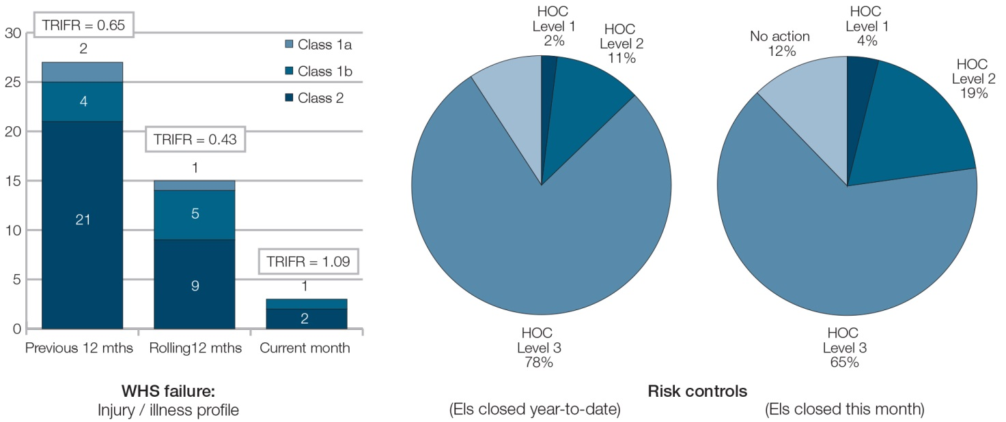

One Class 1b injury occurred in Business Unit [A]. The remaining 1b injuries occurred in Business Unit [C]. These injuries are associated with the new machine mentioned above.

Note: WorkCover investigation into the Class 1b hand injuries is continuing. Possible outcomes include prosecution or improvement notice. One worker has lost two fingers and had surgery to reattach his thumb. The other two workers had crush injuries to the tips of a finger. Compensation costs paid so far total $14,375. A further $21,000 in medical costs has been accrued.

### Category 3: WHS verification

Safety criteria are being integrated into individual performance reviews and into preparation and approval processes for all capital expenditure proposals.

Safety inspections conducted this month:

* Average Safety Inspection Conformance = 83%

(Inspections completed to schedule = 95% x inspection non-conformance rate = 13%)

* 5 potential safety improvements at hierarchy of control (HOC) Level 1 or 2 were identified during safety inspections (1 x HOC L1 and 4 x HOC L2). These improvements are currently being evaluated and costed.

Safety climate survey (taken in January) results identified an **18% fall in perceived quality of the safety climate** (mainly attributed to increased time pressure due to pre- and post- Christmas rush orders).

* Workload reviews for office staff commenced this month – now **43% complete**.

Selected issues and defences:

* 2 High Potential Incidents (HPI) occurred this month.
  + 1 **PSI** (process safety incident). Minor chemical [X] spill. No injuries or plant damage. The chemical handling process and equipment have been reviewed and revised.
  + 1 **NM** (near miss), a pallet fell from a turning forklift just missing a worker. This incident had the potential to cause long term or permanent injury. The forklift driver was inexperienced and has received additional training and will be supervised more closely.
* **68%** warehouse staff completed **manual handling training** this month.
* All floor supervisors are to undertake Labour Hire Worker Supervision training next month.

**Page 2/2**

* 1. Acronyms

| Term | Description |
| --- | --- |
| ALW | Average lost workdays |
| ASAC | Average safety audit conformance rate |
| ASIC | Australian Securities and Investment Commission |
| C1 | Class 1 severity injury or illness (fatality or permanently life-altering) |
| CFO | Chief financial officer |
| ASAC | Average safety audit conformance rate |
| DART | Days away, restricted or transferred |
| EI | Event investigation |
| FAI | First Aid Injury |
| HFLC | High frequency, low consequence (event) |
| HPI | High potential incident |
| HoC | Hierarchy of control |
| HSC | Health and safety committee |
| HSR | Health and safety representative |
| HR | Human resources |
| IA | Internal audit |
| KPI | Key performance indicator |
| LTI | Lost time injury |
| LTIFR | Lost time injury frequency rate |
| LWD | Lost work days |
| LFHC | Low frequency, high consequence (event) |
| MTI | Medically treated injury |
| NGO | Non-government organisation |
| NM | Near miss |
| PCBU | Person conducting a business or undertaking |
| PPD | Permanent partial disability |
| PSI | Process safety incident |
| RTW | Return to work |
| TIL | Long term temporary impairment |
| TPD | Permanent total disability |
| TRI | Total recordable injury |
| TRIFR | Total recordable injury and illness frequency rate |
| WHS | Work health and safety (also referred to as Occupational health and safety, OHS) |
| WHSMS | Work health and safety management system |

* 1. Summarising WHS indicators by target audience

| **WHS INDICATORS** | **INTERNAL REPORTS** | | **EXTERNAL REPORTS** | |
| --- | --- | --- | --- | --- |
| Boards | WHS | Investors | Community |
| **Financial indicators of WHS performance** | | | | |
| # workers’ compensation claims | ^ | 🗸 |  |  |
| $ workers’ compensation costs | 🗸 | 🗸 | 🗸 | ^ |
| $ fines and regulatory penalties | 🗸 | 🗸 | 🗸 | 🗸 |
| $ legal fees | ^ |  | ^ |  |
| $ lost revenues | ^ |  | ^ |  |
| $ reputational repair costs | ^ |  |  |  |
| $ contingent liabilities | ^ |  | 🗸 |  |
| $ WHS incentives paid | ^ | 🗸 | ^ | ^ |
| **Positive performance indicators** |  |  |  |  |
| ASAC rate | 🗸 | 🗸 | 🗸 | 🗸 |
| % actions at HOC level 1 or 2 | 🗸 | 🗸 | 🗸 | 🗸 |
| WHS maturity level | 🗸 | 🗸 |  |  |
| % risk assessments completed to plan | 🗸 | 🗸 | 🗸 | 🗸 |
| **Additional indicators as desired, e.g.** |  |  |  |  |
| # WHS improvement suggestions | ^ | 🗸 |  | ^ |
| # Officer WHS briefings & updates | ^ | 🗸 | ^ | ^ |
| % inductions completed in 1st 2 weeks | ^ | 🗸 |  |  |
| **Outcome indicators of injury/illness** | | | | |
| Fatality | 🗸 | 🗸 | 🗸 | 🗸 |
| Class 1a (injury & illness) | 🗸 | 🗸 | 🗸 | 🗸 |
| Class 1b+1c (injury & illness) | 🗸 | 🗸 |  | 🗸 |
| Total Class 1 |  | 🗸 |  |  |
| Class 2 (injury & illness) | 🗸 | 🗸 |  | 🗸 |
| Class 1+ 2 (or TRI) |  | 🗸 | 🗸 | 🗸 |
| TRIFR | 🗸 | 🗸 | 🗸 | 🗸 |
| Class 1 incident rate | 🗸 | 🗸 | 🗸 | 🗸 |
| **Outcome indicators of work disruption** | | | | |
| DART | 🗸 | 🗸 | 🗸 | 🗸 |
| LTIFR | ^ | 🗸 |  |  |
| LWD | 🗸 | 🗸 | 🗸 |  |
| ALW |  | 🗸 |  |  |
| Average days RTW | 🗸 | 🗸 | 🗸 | 🗸 |

**Legend**

🗸 Reported

^ Reported only where a significant change has occurred (positive or negative)

* 1. Measurement protocols

## Outcome indicators – illness and injury

| Indicator | Calculation | Rationale |
| --- | --- | --- |
| SEVERITY (CONSEQUENCE) FOCUS | | |
| Fatality | Total number of individuals who die as a result of work-related activity or exposure.  Components of employee, contractor and other (e.g. bystanders) fatalities may be shown separately and then in total. Similarly subtotals of those arising from injury versus illness may be shown where appropriate. | Reports on the lives lost as a result of a work-related activity or exposure. It therefore gives a measure of the severity of WHS control failures.  This measure also provides an indicator of the externalities that result from WHS failure (including the impact on the person’s family and community). |
| **CLASS 1 (life altering) outcomes** | | |
| 1a) Permanent total disability (PTD) | Total number of individuals who suffer a work-related injury or illness that results in their total and permanent incapacity (includes fatalities).  In addition, components of employee, contractor and other (e.g. bystanders) PTDs may be shown separately. | Reports on the lives permanently and totally altered as a result of a work-related activity or exposure. It gives a measure of the severity of WHS control failures. This measure is also an indicator of externalities associated with PTD outcomes (including the impact on the person’s family and community) and the substantial economic costs of medical and other services required to care for the now disabled person. |
| 1b) Permanent partial disability (PPD) | Total number of individuals who suffer a work-related injury or illness that results in a permanent incapacity, disability or disfigurement.  This include the loss of body parts (e.g. a limb, eye or thumb), bodily functions (e.g. hearing), motor skills or intellectual ability (e.g. as a result of head trauma), or significant scarring or disfigurement (e.g. burns). | Reports on the lives of individuals who, despite being permanently altered as a result of a work-related activity or exposure, are able to return to employment and retain a reasonable quality of life.  This measure is also an indicator of externalities associated with PPD outcomes. |
| 1c) Long-term temporary impairment (TIL) | Total number of individuals who suffer a work-related injury or illness that results in an extended temporary impairment exceeding 6 months to full recovery from injury/illness. | Reports on the lives of individuals who suffer a work-related injury or illness that impacts their life (and family) for a significant period. It is an indicator of consequences including externalities and lost productivity. |
| ***Total CLASS 1 outcomes*** | Sum total of the above 1a, 1b and 1c items | For the reasons outlined above, a number is far more appropriate than a frequency rate for these high consequence/low frequency outcomes. |
| **C1 RATE** | Number of Class 1 outcomes divided by the sum total of C1 plus C2 outcomes | This reflects the number of recordable injuries and illnesses that are life-altering. It is an indicator of an PCBU’s focus on injury prevention and their success in preventing high-severity (Class 1) outcomes. |
| **SEVERITY (CONSEQUENCE) FOCUS** | | |
| **CLASS 2 (non-life-altering) outcomes** | | |
| 2a) Medium-term temporary impairment (TIM) | The number and/or rate of persons who suffered, during a given period, a work-related injury or illness that results in a temporary impairment requiring more than two weeks but less than 6 months to full recovery. | TIS and TIM measures report on the number (or rate) of minor and moderately debilitating injuries and illnesses outcomes. These outcomes are likely to be associated with lost productivity, and, particularly for TIM, with added organisational expenses including replacement labour/recruitment costs.  Examining TIS as a rate of total Class 2 injuries also provides insight into return to work and injury management activities. |
| 2b) Short-term temporary impairment (TIS) | The number and/or rate of persons who suffered, during a given period, a work-related injury or illness that results in a temporary impairment requiring less than two weeks (or 10 consecutive days or shifts) to full recovery. |
| Total CLASS 2 outcomes | May be expressed as a sum total of those work-related injuries and illness that result in medium or short term impairment, or as a frequency rate of total Class 2 outcomes per 1,000,000 hours. | Class 2 outcomes report on the occurrence of high frequency/low(er) consequence injury and illness outcomes. |
| **CLASS 3 (minor) outcomes** | | |
| Total CLASS 3 outcomes  (No impairment injury or illness) | Number of injuries and illnesses that did not result in impairment (i.e. are more an inconvenience). First aid injuries will generally fall into this category. |  |
| **HIGH POTENTIAL INCIDENT** | | |
| Total HPI Outcomes | The number of ‘near miss’ (or ‘near hit’), Class 2 and Class 3 injuries or illnesses that had the potential to have resulted in a Class 1 injury or illness. | Identifying and analysing HPIs provide important learning opportunities for future injury prevention. This can uncover ‘what went wrong’ and, importantly, also discover ‘what went right’; that is, why the event did not result in damage despite a clear potential to do so. Was it quick thinking and appropriate action by staff, effective controls already in place, or was it just sheer luck that the outcome was not worse? |
| **FREQUENCY focus** | | |
| **TOTAL RECORDABLE INJURY (AND ILLNESS)** | | |
| Total recordable injury (TRI) | The total raw number of Fatalities, Lost Time Injuries and Medical Treated Injuries and Restricted Work Injuries. | (Note: Total TRIs should equal the total of Class 1 plus Class 2 outcomes). |
| Total Recordable Injury Frequency Rate (TRIFR) | A frequency rate calculated as TRI (above) per 1,000,000 hours worked  i.e. total TRIs x 1,000,000  total hours worked | The rate is calculated per 1,000,000 hours (rather than 200,000 hours):   * If using 200,000 hours as the denominator, this must be stated |

## Outcome indicators – work disruption

| Indicator | Calculation | Rationale |
| --- | --- | --- |
| **PRODUCTIVITY FOCUS** | | |
| Days away / restricted / transfer rate (DART) | Total number of incidents that resulted in:  - one or more days lost (see LTI below), or  - one or more days on restricted work duties, or  - that resulted in an employee being transferring to a different position or task in the business,  per 1,000,000 hours worked.  i.e. DART x 1,000,000 total number of hours worked | DART is a globally comparable measure that reflects those TRIs that affect the workplace.  Because it captures a broader range of workplace impact, the DART is less likely to motivate dysfunctional consequences (such as under-reporting and data manipulation) than alternatives such as LTIFR. |
| Lost time injury (LTI) | The sum total number of work-related fatality, injury or illness outcomes which have resulted in an individual being deemed fully unfit for work for a period of an entire work shift or more, at any time after the day or shift on which the injury or illness occurred, irrespective of whether a workers’ compensation claim has been lodged or not. | LTIs are a measure of the number of work-related injuries and illnesses that have resulted in one or more day’s work absence. LTIFR provides an indicator of injuries and illnesses causing work absence (per 100 employees).  While LTI and LTIFR are measures lost time occurrences they do not measure the extent of the time lost. LTIFR therefore needs to be presented with measures of LWD to provide the necessary context.  Further, some Class 1 outcomes, such as hearing loss, do not involve lost time. LTI measures therefore capture a subset of injuries only and so are not reliable measures of serious injury.  LTI data do not measure risk of injury or illness and so are therefore not measures of health and safety either. |
| Lost time injury frequency rate (LTIFR) | The number of LTIs per 1,000,000 hours worked.  i.e. total LTIs x 1,000,000  total hours worked |
| Total Lost Workdays (LWD) | The sum total number of workdays that each worker was absent due to work-related injury or illness.  Use a standard 230 days for each Class 1a outcome. | Note: include workdays that were recorded as annual, LSL or sick leave IF the worker would not have been able to work those days had the leave not been approved. Also, days lost in the current period as a result of an injury or illness that occurred in a prior period should be counted as an adjustment to the prior period result. |
| Average lost workdays (ALW) | Total LWDs divided by total LTIs | ALW provides an average duration rate of the LTIs occurring in a given period. However, it is not a reliable measure of severity because lost days only count days from the injury to the end of the target period. For example, different lost day totals will be counted for a 2a injury occurring at the beginning of the period to a similar injury occurring in the final week of the period. |

* 1. Injury and illness Classifications



# REFERENCES

American Industrial Hygiene Association (AIHA) Metrics Subcommittee (2001) *Industrial Hygiene Performance Metrics* AIHA.

Australian Safety and Compensation Council (ASCC) (2005) *Guidance on the Use of Positive Performance Indicators to Improve Workplace Health and Safety* ASCC: Canberra.

Australian Safety and Compensation Council (ASCC) (2005) *Guidance for Small Business on the Use of Positive Performance Indicators to Improve Workplace Health and Safety ASCC*: Canberra.

Blewett, V. (1994) Beyond Lost Time Injuries. *Positive Performance Indicators for OHS* Worksafe Australia Canberra.

Business Leaders Health & Safety Forum (BLF) (no date) *Industry Measurement and Benchmarking System Instruction Manual* BLF Wellington.

Center for Chemical Process Safety (CCPS) (2007) *Process safety leading and lagging metrics* *Initial release* CCPS – AICHE, New York. (December 20, 2007) http://www.aiche.org/ccps/

Chamber of Minerals & Energy, Western Australia (CMEWA), (2004) *Guide to Positive Performance Measurement in the Western Australian Minerals and Resources Industry* CMEWA Perth.

Chelius, J. R. (1991). *'Role of Workers' Compensation in Developing Safer Workplaces*.' *Monthly Labor Review* 114(9): 22.

Comcare (2010) *Better Practice Guide: OHS Reporting in Annual Reports* Australian Government Canberra.

Comcare (2004) *Positive performance indicators: measuring safety, rehabilitation and compensation performance* Australian Government Canberra.

Culvenor, J. (2015) ['Wire road barrier “ramps” need investigation'](https://safedesign.wordpress.com/2015/01/29/wire-road-barrier-ramps-needs-investigation-4-fatalities-in-one-crash/), [Accessed 15th Dec. 2015].

Dekker, S. (2006) ‘*Resilience engineering: chronicling the emergence of confused consensus'*, in Hollnagel, E., Woods, D.D. and Leveson, N. *Resilience Engineering: Concepts and Precepts*. Ashgate, USA.

Fleming, M. (2001) *Safety Culture Maturity Model*, Health and Safety Executive, UK Government.

Ghandar, A. (2014) *A Guide to understanding audit and assurance,* CPA Australia, Southbank. October.

Ghandar, A. and Purcell, J. (2010). *A Guide for Assurance on SME Sustainability Reports*, CPA Australia, Southbank.

Global Reporting Initiative (2006) *Sustainability reporting guidelines*, Amsterdam (www.gri.org).

Health & Safety Executive (HSE) (2013) *Managing for health and safety* 3rd edition HSE London.

Health & Safety Executive (HSE) (2009) *Leading indicators for assessing reduction in risk of long latency diseases* HSE London.

Health & Safety Executive (HSE) (2006*) Further development of health and safety performance management index For use by business, investors, employees, the regulator and other stakeholders* HSE London.

Health & Safety Executive (HSE) (2006) *Developing process safety indicators: a step-by-step guide for chemical and major hazard industries* HSE London.

Health & Safety Executive (HSE) (2005) *Further development of a corporate health and safety performance management index for use by business, investors, employees, the regulator and other stakeholders: validating the index* HSE London.

Health & Safety Executive (HSE) (2004) *The development of health and safety performance management index For use by business, investors, employees, the regulator and other stakeholders* HSE London.

Health & Safety Executive (HSE) (2003) *Factoring the human into safety: Translating research into practice: Benchmarking human and organisational factors in offshore safety* (Vol. 1 of 3) HSE London.

Health & Safety Executive (HSE) (2001) *A Guide to Measuring Health & Safety Performance* HSE London.

Health & Safety Executive (HSE) (2001) *Performance indicators for the assessment of emergency preparedness in major accident hazards* HSE London.

Health & Safety Executive (HSE) (2000) *Development of a Health and Safety Performance Measurement Tool* HSE London.

Health & Safety Executive (HSE) (1999) *Health & Safety Benchmarking: improving together* HSE London.

Health & Safety Executive (HSE) (no date) *Key Process Safety Performance Indicators: a short guide for Directors and CEOs* HSE London.

Health & Safety Laboratory (HSL) (2007) *Major Hazards Industry Performance Indicators Scoping Study* HSL Buxton.

Hopkins, A. (2000). *Lessons from Longford: The Esso Gas Plant Explosion*. Sydney, CCH Australia Limited.

Hopkins, A. (2005). *Safety Culture and Risk: The Organisational Causes of Disasters*, CCH Australia.

Hopkins, A. (2008). *Failure to learn: the BP Texas City Refinery disaster*, CCH Australia.

Hopkins, A and Maslen, S (2015) *Risky Rewards: How Company Bonuses Affect Safety*, UK and USA, Ashgate Publishing Company.

Hudson, P. (2001). *Safety Culture: The Ultimate Goal*. Flight Safety Australia, 29-31.

International Association of Oil & Gas Producers (OGP) (2011) *Safety Performance Indicators – 2010 data* OGP London.

International Council on Mining and Metals (ICMM) (2012) *Overview of leading indicators for occupational health and safety in mining*. ICMM London.

International Council on Mining and Metals (ICMM) (2012) *Step Change in Safety*, ICMM London.

ILO (2001) Report V(1): *Recording and notification of occupational accidents and diseases and ILO list of occupational diseases*, Fifth item on the agenda International Labour Conference 90th Session 2002.

Institute for Work & Health (IWH) (2011) *Benchmarking organizational leading indicators for the prevention and management of injuries and illnesses* IWH Toronto.

Institution for Occupational Safety & Health (IOSH) (2011) *Reporting Performance: Guidance on Including Health and Safety Performance in Annual Reports* London.

Janicak, C. (2010) *Safety Metrics: Tools and Techniques for Measuring Safety Performance*. Government Institutes Plymouth.

Kahneman, D. Slovic, P. and Tversky, A. (1982) *Judgement under uncertainty: Heuristics and Biases*, Cambridge University Press, New York.

Maclean, R. (2002) *The Sum of All Figures- Metrics that matter to top executives*, Environmental Protection, September 2002, Pages 12-14.

Martinov-Bennie, N., O’Neill, S. and Cheung, A. (2014). *Issues in the Assurance and Verification of WHS Information*. Safe Work Australia, January.

National Occupational Health & Safety Commission (NOHSC) (1999) *OHS Performance Measurement in the Construction Industry* Commonwealth of Australia Canberra.

National Occupational Health & Safety Commission (NOHSC) (1996) *Benchmarking Occupational Health and Safety* Commonwealth of Australia Canberra.

Organization for Economic Cooperation and Development (2003) *OECD guidance on safety performance indicators* Series on chemical accidents No. 11 OECD Paris.

O’Neill, S. (2014). *The Business Case for Safe, Healthy and Productive Work*. Safe Work Australia, November.

O’Neill, S., Flanagan, J. & Clarke, K. (2016) ‘*Safewash! Risk attenuation and the (mis)reporting of corporate safety performance to investors*’. *Safety Science* 83: 114-130.

O’Neill, S., Martinov-Bennie, N. & Cheung, A. (2013). *Issues in the Measurement and Reporting of Work Health and Safety Performance*. Safe Work Australia, December.

O’Neill, S., McDonald, G. and Deegan, C. (2015). ‘Lost in Translation: Institutionalised Logic and the Problematisation of Accounting for Injury’. *Accounting, Auditing and Accountability Journal*, 28(2): 180 -209.

O’Neill, S. Wolfe, K. and Holley, S. (2015). *Performance measurement, incentives and organisational culture*. Safe Work Australia, July.

Price Waterhouse Coopers (2010) *Implementing a Combined Assurance Approach in the Era of King III*, available from the [PWC website](https://www.pwc.co.za/en/assets/pdf/steeringpoint-kingiii-combined-assurance-11.pdf).

Prior, E. (2013). *Safety Spotlight: ASX1000 Companies and More*. Sydney, Citigroup Global Markets.

Prior, E. (2014). *Safety Spotlight: ASX1000 Companies and More*. Sydney, Citigroup Global Markets.

Safe Work Australia (2012) *Interpretive Guideline – Model Work Health and Safety Act: The meaning of reasonably practicable*, Australian Government, Canberra.

Safe Work Australia (2012) *Guide to the Model Work Health and Safety Act*, Australian Government, Canberra. http://www.safeworkaustralia.gov.au/sites/swa/about/publications/pages/guide-to-the-work-health-and-safety-act-

Safe Work Australia (2010) *Model Work Health and Safety Act*, Australian Government, Canberra. http://www.safeworkaustralia.gov.au/sites/swa/model-whs-laws/model-whs-act/pages/model-whs-act#h2-1

Standards Australia, (1990) *AS 1885: Workplace Injury and Disease Recording Standard* AS 1885.1-1990. WorkSafe Australia.

Step Change in Safety (no date) *Leading Performance Indicators: Guidance for Effective Use* Step Change in Safety Aberdeen.

The Institute of Internal Auditors (2013) *The Three Lines of Defence in Effective Risk Management and Control,* IIA, Florida.

University of Wollongong (2012) *OHS Performance Measurement and Reporting Guidelines*. University of Wollongong, Australia.

Worksafe Australia (1996) *Benchmarking Occupational Health And Safety* June 1996 Australian Government Publishing Service, Canberra.

Worksafe Australia (1994) *Positive performance indicators for OHS – Beyond lost time injuries*. Commonwealth of Australia Canberra.

1. For a list of all acronyms in this document see Appendix 7 - Acronyms.
2. Safe Work Australia is the national policy body responsible for the development of model WHS laws across Australia. The model WHS framework consists of the model WHS Act, the model WHS Regulations, model codes of practice and a National Compliance and Enforcement Policy. The Commonwealth, states and territories are responsible for regulating and enforcing the laws in their jurisdictions. All jurisdictions have implemented the model WHS laws except Victoria and Western Australia.
3. See Appendix 2 - Definition of officer (within the Australian context).
4. Information is material if it is likely to affect the outcome of the decisions the user will make.
5. It also includes information relevant to workers, investors, creditors, non-government organisations and other external stakeholders who seek to exercise WHS due diligence in regard to their own economic decisions.
6. O’Neill and Wolfe, 2015; Guldenmund, 2000; Schein, 1992.
7. Schneider et. al., 1996; Schneider et.al., 2013; Hopkins, 2002.
8. O’Neill and Wolfe, 2015.
9. Cooper, 2000 p.114.
10. See section 3.
11. Hudson, 2001. Fleming, 2001.

    12 Reason 1997, pp.195-196. For a TED Talk on building an informed culture to enhance productivity: [Link to a TED talk on building an informed culture](http://www.ted.com/talks/yves_morieux_as_work_gets_more_complex_6_rules_to_simplify).
12.
13. The model WHS Act was implemented in Commonwealth, NSW, ACT, NT, QLD jurisdictions in 2012 and TAS and SA in 2013.
14. See Interpretive Guideline - model WHS Act, the meaning of ‘reasonably practicable’, Safe Work Australia, 2012.
15. O’Neill and Wolfe, 2015.
16. Workers include both direct employees and workers across the supply chain (e.g. contractors).
17. Dekker 2006.
18. McDonald, 1985.
19. Chelius 1994, CCH 2003.
20. McDonald 2015, Kahneman, Slovic and Tversky, 1982.
21. See, for example Culvenor, 2015. ‘The Price of Work’ symposium, Federation University and https://safedesign.wordpress.com.
22. Inspections differ from audits in that, while they may employ checklists and trained ‘inspectors’, they tend to be less formal than audits and will not necessarily be conducted: by an independent person; against pre-determined criteria and standards; in accordance with professional audit standards of objectivity, materiality and scepticism (see section 4).
23. AS/NZS 4801.2001.
24. The classes of injury are defined by Geoff L. McDonald as:

    Class 1 injury permanently alters a person’s life, including disability or disfigurement (may or may not return to work).

    Class 2 is temporary incapacity with full recovery.

    Class 3, no impairment but temporary inconvenience, such as minor first aid.

    See McDonald 1985, 2016 and O’Neill, McDonald et al. 2015.
25. Figure 12 adapted from one provided by: K Warren, Head of HSE Southern Region, Laing O’Rourke (Note: Not Laing O’Rourke data).
26. http://www.iloencyclopaedia.org/images/stories/enlarged/Part13/POT_imgs/POT10F20.jpg
27. Examples of such analyses are provided by Hopkins 2008; 2005 and McDonald 2015.
28. Hopkins, A. 2000, p79.
29. Elimination as noted within the framework of reasonable practicability as outlined above.
30. Tooma (2012d).
31. SIA Body of Knowledge 2015.
32. O’Neill 2014.
33. Hopkins (2008) p82.
34. Note, NI refers to first aid injury where there is no temporary incapacity.
35. Class 1 injury permanently alters a person’s life, including disability or disfigurement (may or may not return to work). Class 2 is temporary incapacity with full recovery. Class 3, no impairment but temporary inconvenience, such as minor first aid.
36. The ‘3 lines of defence’ model distinguishes between three types of assurance processes: assurance of day-today operational activity by management, by corporate units within the organisation, and by external assurors.
37. See Australian Standard on Compliance (AS3806:2006) for example.
38. Ghandar 2014. p6.
39. Glendon 2006.
40. Adapted from CPA Australia 2014, pp6-7.
41. See: [Link to Australian Auditing and Assurance Standards Board](http://www.auasb.gov.au/) for standards on review and audit engagements.
42. Ghandar (2014), p13.
43. International Professional Practices Framework (IPPF), The Institute of Internal Auditors Research Foundation. Florida, USA, 2011.
44. Ghandar (2014), p13.
45. O’Neill, 2014.
46. For a more detailed review of the purpose and limitations of LTIs, see O’Neill, Wolfe and Holley, 2013.
47. O’Neill, McDonald and Deegan, 2015; O’Neill, Flanagan and Clarke, 2016.
48. LTI data can confirm in hindsight the presence of a risk, however the absence of an injury does not confirm the absence of uncontrolled risk. Further the measure does not provide information to management on where to address resources or provide assurance that appropriate controls are in place (see Safe Work Australia – Issues in the Measurement and Reporting of WHS Performance: A Review).