# psychosocial health and safety and bullying

# in australian workplaces

# Indicators from ACCEPTED WORKERS’ COMPENSATION CLAIMS

# ANNUAL STATEMENT, 3RD EDITION, 2016

## INTRODUCTION

This is the third annual national statement issued by Safe Work Australia to identify emerging trends in psychosocial health and safety and bullying in Australian workplaces. The information presented in this statement is based on data from accepted workers’ compensation claims involving mental stress. This mechanism category is assigned to claims when the work-related injury or disease results from the person experiencing mental stress or being exposed to mentally stressing situations.

The prevalence of this type of claim provides a limited indicator for the psychosocial health and safety status of Australian workplaces. The mental stress code includes a subcategory for work-related harassment and/or workplace bullying. This subcategory is assigned to claims when the employee was a victim of:

* repetitive assault and/or threatened assault by a work colleague or colleagues, or
* repetitive verbal harassment, threats, and abuse from a work colleague or colleagues.

This subcategory broadly aligns with the nationally accepted definition of workplace bullying of repeated and unreasonable behaviour directed towards a worker or a group of workers that creates a risk to health and safety (*Fair Work Act 2009*, s.789FD(1)). Excluded from the analysis as presented in this statement are claims due to sexual or racial harassment. Also excluded are assault cases where the physical injuries were more serious than the mental stress involved in the incident.

## MENTAL STRESS CLAIM TRENDS

Figure 1 shows that the frequency rate of mental stress claims has fallen between 2002-03 and 2014-15. While the rate for harassment and/or bullying claims has increased over that same period, it has started to trend down since the peak in 2010-11. This trend data is an approximate measure of the psychosocial health and safety status of Australian workplaces over time and should be interpreted with caution. External factors such as changes to jurisdictional legislation may have influenced the scope of claims involving mental stress over the reporting period.

**Figure 1: Mental stress and subcategory harassment and/or bullying: Frequency rates, 2002–03 to 2014–15p\***

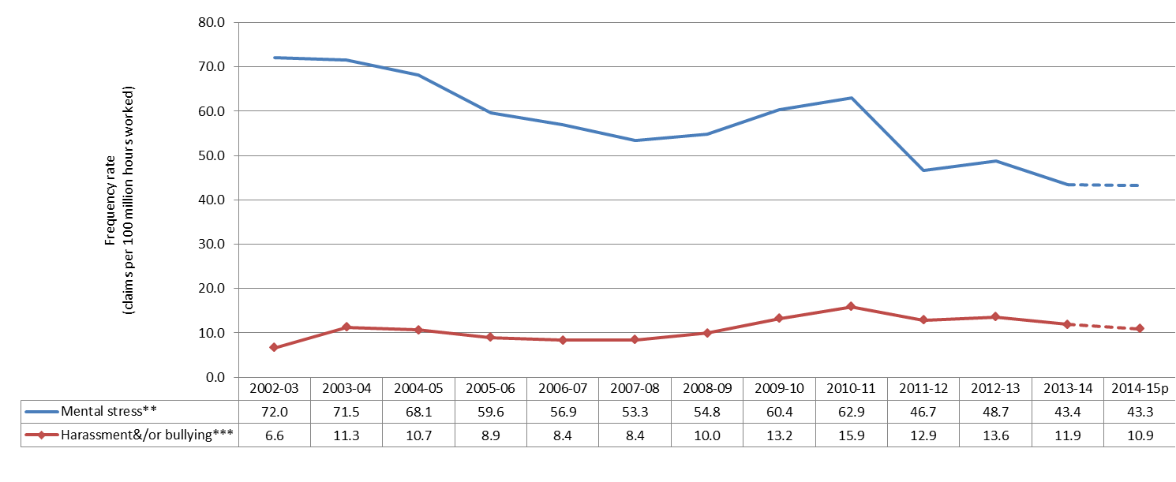

*2014-15 data are preliminary and subject to change.

** Mental stress data includes information from Victoria.

*** Harassment and/or bullying data excludes information from Victoria.

## MENTAL STRESS CATEGORY BREAKDOWN

Table 1 provides key statistics for claims involving mental stress as the main mechanism of injury or disease for 2013‑14 broken up by mechanism subcategory. It shows that, while mental stress claims only make up a small proportion of claims, the median time lost and median direct cost associated with mental stress claims are significantly higher compared to those observed for all workers’ compensation claims.

Table 1: Number, time lost, direct cost, frequency rate and incidence rate for mental stress claims, 2013-14*

| Sub-category of mental stress** | No. of claims | Median time lost (working weeks) | Median direct cost ($) | Frequency rate -  Claims per 100 million hours | Incidence rate -  Claims per 10 000 employees |
| --- | --- | --- | --- | --- | --- |
| Work pressure | 1 680 | 10.5 | 25 900 | 12.1 | 2.0 |
| Work related harassment and/or workplace bullying | 1 660 | 9.4 | 22 600 | 11.9 | 2.0 |
| Exposure to workplace or occupational violence | 890 | 4.0 | 7 800 | 6.4 | 1.1 |
| Exposure to a traumatic event | 730 | 4.4 | 9 600 | 5.2 | 0.9 |
| Other mental stress factors | 555 | 6.5 | 13 800 | 4.0 | 0.7 |
| Other harassment | 130 | 8.0 | 14 500 | 0.9 | 0.2 |
| Suicide or attempted suicide | 35 | 7.6 | 12 200 | 0.3 | 0.0 |
| **Total all mental stress\*\*** | **7 845** | **9.4** | **18 600** | **43.4** | **7.2** |
| **Total all accepted claims** | **244 295** | **0.7** | **2 400** | **1350.2** | **225.7** |

*Data are presented for 2013–14 rather than 2014–15p because the time lost from work and the direct cost associated with a compensation claim are generally not finalised until some time after the end of the financial year in which the claim was submitted. Note that workers’ compensation data reflect the year the claim was lodged, not the year in which the incident occurred. There may be a significant lag for mental stress claims.

**Mental stress subcategory data excludes information from Victoria. However the total mental stress data do include Victorian information and are therefore national figures.

## MENTAL STRESS CATEGORIES BY SEX

The frequency rate of workers’ compensation claims for harassment and/or bullying made by female employees was almost three times higher than the rate of these claims made by males. Similarly, the rate of claims made by females for exposure to workplace or occupational violence and work pressure were more than twice the rate of similar claims made by males.

Figure 2: Frequency rates by sex and mental stress subcategory, 2012–13 to 2014–15p combined

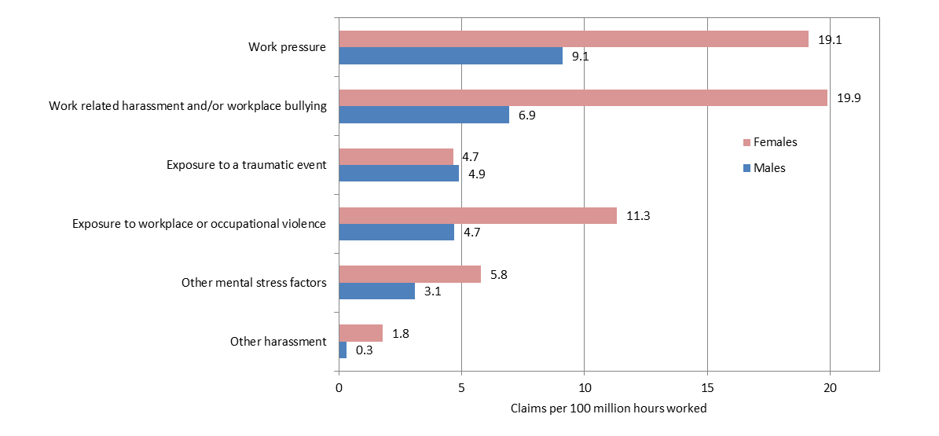

## HARASSMENT AND/OR BULLYING BY OCCUPATION AND INDUSTRY

Occupations with a high risk of exposure to work-related harassment and/or workplace bullying include Other miscellaneous and administrative workers; Other clerical and office support workers; and Prison officers.

Figure 3: Top 10 occupations for experiencing harassment and/or bullying, 2012–13 to 2014–15p combined

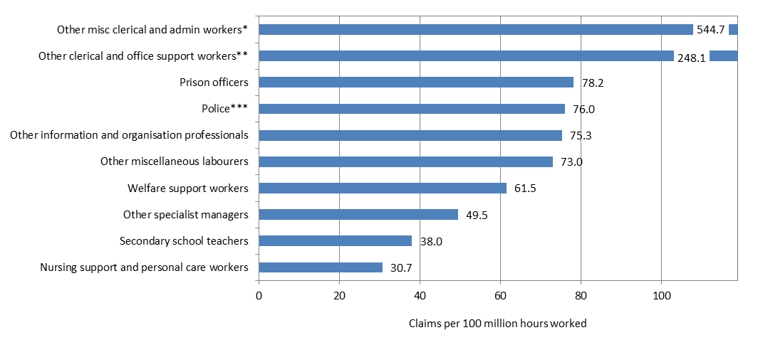

Note: Occupations are limited to those associated with more than 50 claims.  
*This group includes coding clerks, production assistants, proof readers, radio dispatchers and examination supervisors.

**This group includes classified advertising clerks, meter readers and parking inspectors.

***Excludes Western Australia.

Industries with high rates of claims involving work-related harassment and/or workplace bullying include Public order and safety services; Civic, professional and interest group services; and Local government administration.

Figure 4: Industries with high frequency rates of harassment and/or bullying, 2012–13 to 2014–15p combined

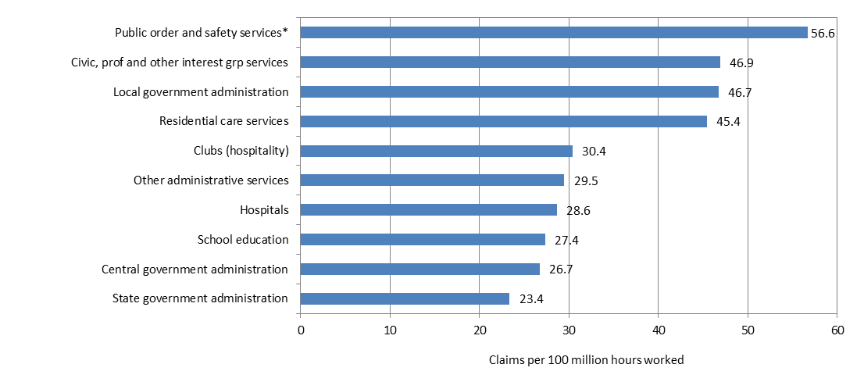

Note: Industries are limited to those associated with more than 50 claims.  
*Excludes Western Australia.

## RESEARCH

The *Bullying and Harassment in Australian Workplaces: Results from the Australian Workplace Barometer 2014-15* report shows that in 2014-15, using the national definition, 9.4 per cent of Australian workers participating in the survey reported they had been bullied at work in the previous six months. Using the international definition it was 9.7 per cent. The 2014-15 finding represents a 39 per cent increase in the prevalence of workplace bullying compared to that reported by participants in the 2009‑11 iteration of the Australian Workplace Barometer, when seven per cent reported they were bullied.

The Australian Bureau of Statistics *Work-related Injuries Survey 2013–14* showed that 60 per cent of employees eligible for workers’ compensation reported they experienced mental stress but did not apply for workers’ compensation (Australian Bureau of Statistics, 2014, Work Related Injuries, cat. no. 6324.0).

## OTHER INFORMATION

The House of Representatives Standing Committee on Education and Employment report *Workplace bullying: “We just want it to stop”,* tabled on 26 November 2012, contained 23 recommendations that focus on:

* defining what bullying is and is not
* promoting and strengthening existing legislative and regulatory frameworks
* improving workplace cultures
* enhancing tools for the prevention and early resolution of workplace bullying incidences, and
* providing an individual right of recourse.

Recommendation 18 of the report states “*The Committee recommends that Safe Work Australia issues an annual national statement which updates any emerging trends of its collated data from each of the state and territory regulators, and the Commonwealth, with respect to psychosocial health and safety generally and workplace bullying specifically.*” This statement is produced annually in response to this recommendation. For the full report go to [aph.gov.au](http://www.aph.gov.au/).

## THE FAIR WORK COMMISSION

From 1 January 2014, a worker (including an employee, contractor, apprentice or volunteer) who is covered by the *Fair Work Act 2009* and reasonably believes they have been bullied at work may apply to the Fair Work Commission for an order to stop the workplace bullying. More information is available at [www.fwc.gov.au](http://www.fwc.gov.au).

## OTHER RELATED SAFE WORK AUSTRALIA PUBLICATIONS

These and other reports are available at [safeworkaustralia.gov.au](http://www.safeworkaustralia.gov.au/sites/SWA)

* Guide for Preventing and Responding to Workplace Bullying, May 2016
* Dealing with Workplace Bullying - A Worker’s Guide, May 2016
* The Incidence of Accepted Workers’ Compensation Claims for Mental Stress in Australia, April 2013
* Work-related Mental Disorders profile, 2015

## DATA SOURCE AND EXPLANATORY NOTES

Data are sourced from the National Dataset for Compensation-based Statistics (NDS) and include all accepted workers’ compensation claims for temporary incapacity, permanent incapacity and fatalities made under state, territory and Commonwealth Government workers’ compensation Acts. Claims are coded according to the Type of Occurrence Classification System 3rd Ed. Revision 1 (TOOCS). Industry and occupation level data are presented using the Australian and New Zealand Standard Industrial Classification (ANZSIC) 2006 and Australian and New Zealand Standard Classification of Occupations (ANZSCO) 2006. Data presented for mental stress are national figures but data for subcategories of mental stress exclude Victoria because its data are not coded to that level of detail. Data for 2014-15 are preliminary (denoted by the letter ‘p’) and subject to future adjustment. Workers’ compensation statistics provide the only national administrative data indicators for psychosocial stressors in Australian workplaces. The hours worked data used to calculate frequency rates were provided by the Australian Bureau of Statistics in 2016.