VEHICLE LOADING CRANES  
INFORMATION SHEET

## Overview

This Information Sheet provides advice on managing risks associated with operating vehicle loading cranes in the workplace.

Further information on vehicle loading cranes is in the:

* [*General guide for cranes*](http://www.safeworkaustralia.gov.au/sites/swa/about/publications/pages/guidance-cranes)*,* and
* [Information Sheet: *High risk work licensing for vehicle loading cranes*](http://www.safeworkaustralia.gov.au/sites/swa/about/publications/pages/guidance-high-risk-work-licensing).

## What is a vehicle loading crane?

A vehicle loading crane is a crane mounted on a vehicle for the purpose of loading and unloading that vehicle (see Figure 1).

With the introduction of larger capacity vehicle loading cranes and proportional control (the ability to operate multiple crane functions simultaneously), they are also used for more traditional crane operations where the load is lifted:

* from the vehicle to an elevated area at a workplace, for example lifting packs of timber from the vehicle directly to a building floor
* both to and from locations remote from the vehicle on which the crane is mounted, and
* into place and held while it is connected to a structure e.g. installing a sign.

*Note*: While vehicle loading cranes can be used for the above operations the level of safety provided by the lifting set-up should not be less than when a mobile crane is used.

## Mounting a crane on a vehicle

Vehicle loading cranes should be mounted on vehicle types and models specified by the crane manufacturer. Installing a crane on an inappropriate vehicle could lead to structural failure of the crane or vehicle or make the vehicle and crane combination unstable.

The crane should be mounted in accordance with the crane manufacturer’s instructions, the relevant Australian Vehicle Standards Bulletin VSB6 or a competent person.

Welding the crane to the vehicle chassis is unacceptable as it can damage the chassis and lead to fatigue failure of the connection.

**Figure 1** Example of a vehicle loading crane

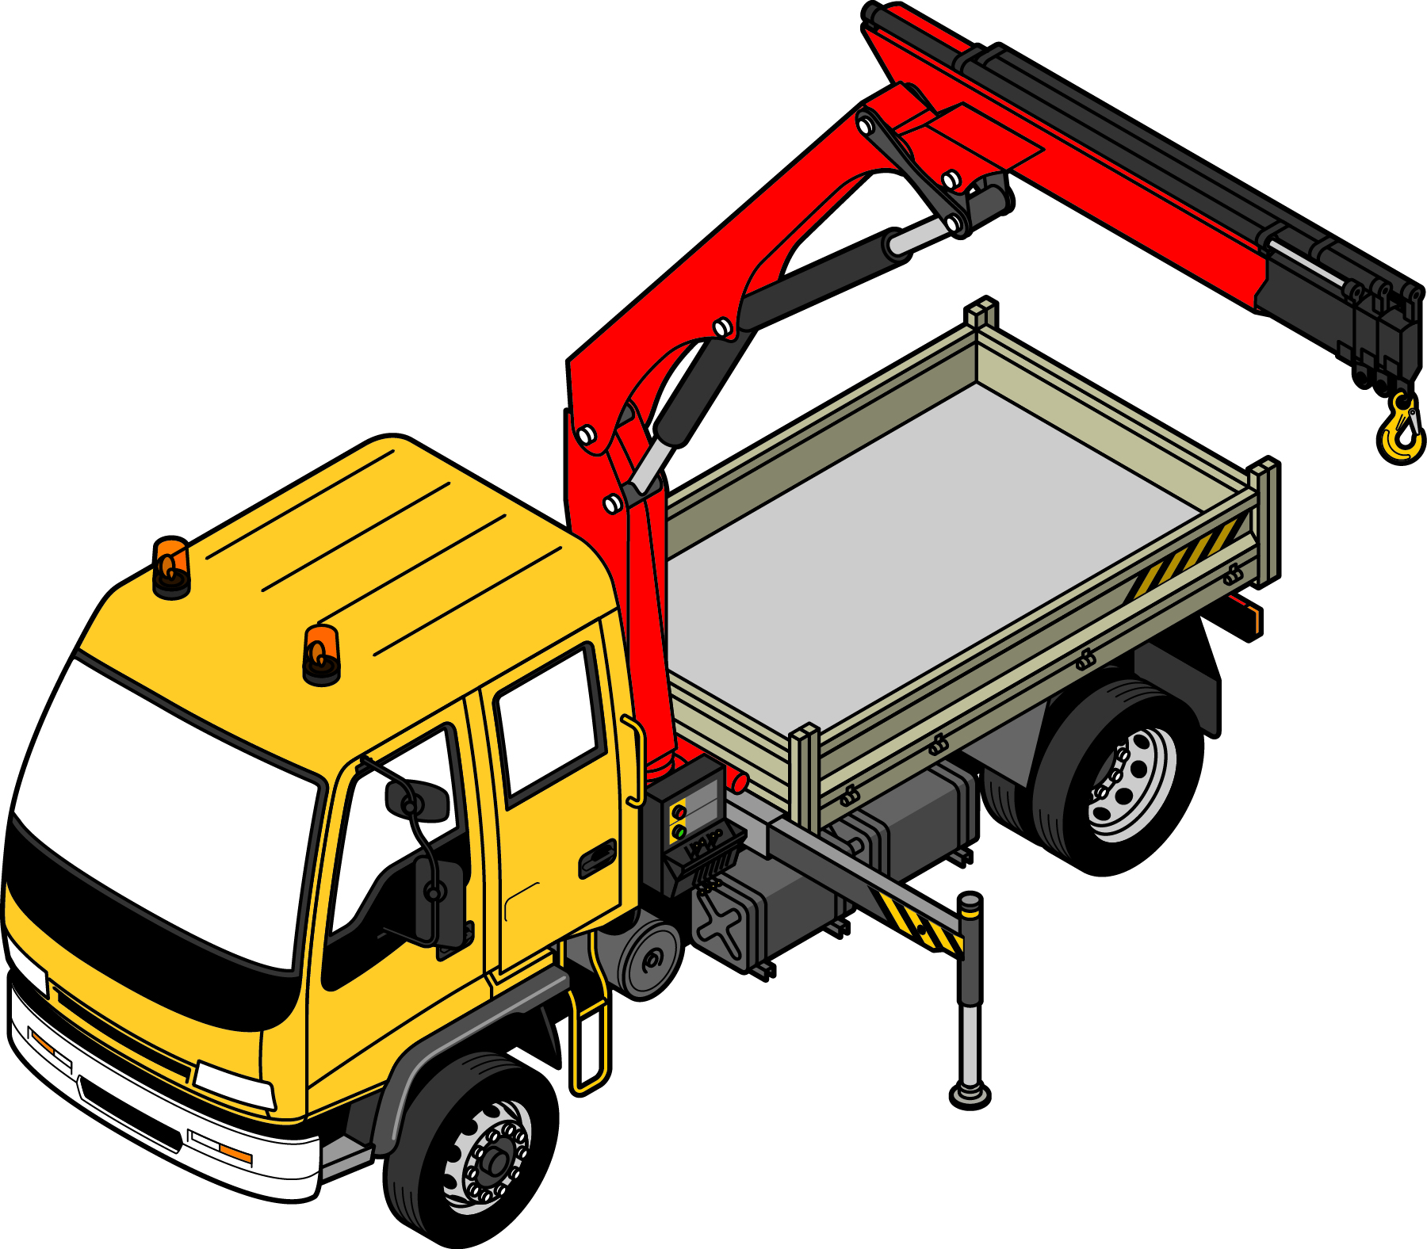

## Crane controls

Vehicle loading crane controls should be:

* self-centring, constant pressure controls—so operation of the crane stops when the operator releases the control, and
* permanently marked with clear, visible symbols.

Suitable risk control measures should prevent operators being crushed between the crane boom and the operator’s control panel. These may include:

* using remote controls
* relocating the controls on the vehicle
* installing slew limiters to prevent the boom contacting the operator
* installing physical barriers
* providing operator controls that can only be operated from a position where the boom or load cannot be lifted over the operator, and
* providing an emergency system to ensure the boom cannot drop under its own weight or the weight of a load.

An emergency stop device must be provided and should be located at every control station on the crane. Emergency stops should be easy to access, simple to use and capable of immediately shutting down crane movements. They should have to be manually reset after being activated.

## Load indicators

Vehicle loading cranes manufactured after 2003 should be fitted with a load indicator appropriate for the capacity of the crane. It should:

* warn the crane operator when the load exceeds 90 per cent of the rated capacity, and
* give a separate and different warning to the 90 per cent load warning to the crane operator and people near the crane if the rated capacity is exceeded.

Both warnings should be continuous.

## Inspections and maintenance

Regular crane inspections, maintenance and repairs are to be carried out in accordance with the instructions provided by the manufacturer or a competent person. Inspections must be completed at least annually.

## Documentation

Documentation that should be kept with the vehicle loading crane includes:

* crane operator manuals
* crane operator checklists or log books for completion as recommended by the manufacturer, and
* crane inspection, maintenance and service records that include information on when the next service is due.

## Operator competency and licensing

Vehicle loading crane operators must be trained and competent in operating the crane. Training should cover the controls, instruments, working load limits, load charts, safe working procedures for slinging and lifting and any operating limitations of each type of crane they operate.

A person must hold a high risk work (HRW) licence to operate a vehicle loading crane that has a capacity of 10 metre tonnes or more. This can be a:

* Vehicle Loading Crane HRW Licence, or
* one of the four slewing mobile crane HRW licences[1] .

A person with a vehicle loading crane HRW licence is able to sling the load as these competencies are included in their licence. However if the operator of the vehicle loading crane is operating the crane under a mobile crane HRW licence then they are unable to sling the load as these competencies are not included in the mobile crane HRW licence.

Where a vehicle loading crane is used for a purpose other than loading and unloading the vehicle on which it is mounted, a slewing mobile crane HRW licence may be required to operate the vehicle loading crane for that purpose.

A vehicle loading crane operator must hold the appropriate drivers licence for the vehicle loading crane’s class of road vehicle before driving it on a public road.

Further information on vehicle loading crane HRW licensing is in the [Information sheet: *High risk work licensing for vehicle loading cranes*](http://www.safeworkaustralia.gov.au/sites/swa/about/publications/pages/guidance-high-risk-work-licensing).

## Registration

Vehicle loading cranes with a rated capacity greater than 10 tonnes must be plant registered.

Vehicle loading cranes are normally a registered motor vehicle under state and territory road laws.

Further information on registration is in the [*General guide for cranes*](http://www.safeworkaustralia.gov.au/sites/swa/about/publications/pages/guidance-cranes).

## Operating a vehicle loading crane

To operate a vehicle loading crane safely the following risk control measures should be implemented.

### Vehicle loading crane set-up

* When selecting the set-up location for the vehicle loading crane a check should include that:
  + there are no underground services or recently backfilled excavations that may affect the stability of the crane
  + the crane can be set up level—the crane should only be operated when level, and
  + there is a safe distance between the boom over its full range of movement and overhead electric lines and other obstacles.
* If the crane is fitted with outriggers:
  + check ground surfaces are sufficiently stable and compacted to support the crane
  + the outriggers are fully extended, or extended according to the manufacturer’s instructions so that the crane interlock, where fitted, is disengaged, and
  + the outriggers are located on pads or other suitable support material.

### General operation

* The manufacturer’s instructions should always be followed when operating a vehicle loading crane.
* A vehicle loading crane should not be operated if it is malfunctioning. The issue should be immediately reported to the responsible person and the crane tagged out of use if appropriate.
* Unless specifically designed to do so vehicle loading cranes must not be used for:
  + lifting people, and
  + pick-and-carry operations.

### Moving loads

* The rated capacity of the vehicle loading crane should be known before starting work. Operating a vehicle loading crane outside its rated capacity can cause the vehicle to overturn.
* The manufacturer’s instructions should always be followed when deciding the method to lift the load, for example whether to unfold or fold the boom.
* Calculate the working radius and rated capacity for the load for all positions. If the rated capacity displayed on the load chart does not exceed the mass of the load for a particular working zone, lifting should not be attempted in that zone.
* The vehicle loading crane operator must be able to see the load at all times during the lift. If the load is out of the operator’s view the lifting process must be directed by a licensed dogger or rigger. Further information on dogging is in the [Information sheet: *High risk work licensing for dogging*](http://www.safeworkaustralia.gov.au/sites/swa/about/publications/pages/guidance-high-risk-work-licensing).
* Crane hooks with spring-loaded safety latches should be used and maintained in accordance with the manufacturer’s instructions.
* The vehicle loading crane should only be used with the load suspended vertically from the hook—the crane should not be used to drag the load over any surface.
* The boom should never be positioned directly above the operator control stations or above their head.

## Further information

Further information is in the following technical standards:

* AS 2550.1-2011: *Cranes, hoists and winches—Safe use Part 1: General requirements*, and
* AS 2550.11-2004: *Cranes, hoists and winches—Safe use Part 11: Vehicle-loading cranes.*

For further information see the Safe Work Australia website [www.swa.gov.au](http://www.swa.gov.au).

1. Slewing Mobile Crane - with a capacity up to 20 tonnes; Slewing Mobile Crane - capacity up to 60 tonnes; Slewing Mobile Crane - capacity up to 100 tonnes and Slewing Mobile Crane - capacity over 100 tonnes.