TREE AND VEGETATION MANAGEMENT NEAR OVERHEAD ELECTRIC LINES  
INFORMATION SHEET

## Overview

This Information Sheet provides advice for small businesses and workers on managing the risks associated with cutting, trimming or treating trees and other vegetation with chemicals or other processes near overhead electric lines and associated electrical equipment. For example:

* a person trimming a tree on private property
* a local government work crew—other than people authorised to clear vegetation around Electricity Supply Authority and private owner distribution electric lines and assets—clearing, planting or treating vegetation
* a building or road construction contractor clearing vegetation or tree trimming
* a contractor clearing vegetation or tree trimming, or
* a person picking fruit from trees.

Working near energised electric lines can create risks to workers and the public where:

* a person or something the person is holding or is in contact with could come closer than the relevant approach distances, and
* the risk of damage to overhead electric lines or associated electrical equipment may create extra risks to workers.

More information is in the [*General guide   
for working in the vicinity of overhead and underground electric lines*](http://www.safeworkaustralia.gov.au/sites/SWA/about/Publications/Documents/859/Overhead-Underground-Electric-Lines-General-Guide.docx) and associated material for:

* operating cranes and mobile plant
* scaffolding work
* agricultural work
* low voltage overhead electric lines near structures, and
* transporting high loads.

## What are the risks?

Contact with energised electric lines can cause death, electric shock or other injury to plant operators and workers. This can be caused directly or indirectly by electricity—a close approach to line conductors may allow a ‘flashover’ to occur. The risk of flashover increases as the line voltage increases.

Workers, plant, equipment or vegetation could contact energised overhead electric lines:

* during trimming operations
* due to unexpected worker movements   
  e.g. from a chainsaw kick back or slipping
* when relocating mobile plant like elevating work platforms
* due to windy conditions which blow vegetation against overhead electric lines   
  or make conductors sway
* when raising or lowering materials
* during electrical storms and wet weather, and
* due to unexpected electric line breakages causing them to fall to the ground, footpath or road.

## What do I need to do?

You must manage the risks associated with working near overhead electric lines and associated electrical equipment by:

* identifying potential hazards, assessing and controlling the risks
* consulting workers and asset owners e.g. the Electricity Supply Authority or the person with management or control of the electric line or premises, and
* deciding what work zones and approach distances are required for safe operations.

When assessing the risks consider:

* how close the vegetation is to the electric lines and whether it has attached itself to   
  the lines, poles, towers or stays
* the location, height, arrangement and visibility of overhead electric lines and supporting structures e.g. poles, towers   
  and stay wires
* the voltage of electric lines and exposed energised parts and whether they are insulated or bare
* possible sway or sag of the electric lines
* environmental conditions e.g. storm activity, wind strength and direction, heavy rain, hail and lightning
* site conditions e.g. terrain, ground surface and vehicular traffic
* the type of plant and machinery required –design envelope, stability, dimensions and operating characteristics, minimum clearance distances and manoeuvrability
* the type of work activities required and the frequency of work tasks
* qualifications, competency, skill and experience of people doing the work
* the setting up and packing up processes, and
* safe work practices and procedures e.g.   
  a safety observer and ‘permit to work.’

## Approach distances

Approach distances are one way of separating people from hazards. The approach distance   
for each work zone will vary depending on the voltage of the overhead electric line and the level of authorisation of each person doing the work. As the risk increases a greater approach distance is required. There are three work zones shown in Figure 1:

**Zone C** is a No Go Zone where Electricity Supply Authority approval is required. A ‘permit to work’ may be issued with specific conditions that must be met. If a SWMS is not required   
a written safe system of work based on a risk assessment is required. Clearing operations should stop where workers, trees or equipment are in danger of entering Zone C.

**Zone B** is for authorised persons who have been trained and assessed as competent to carry out tree and vegetation management   
work near energised overhead electric lines.   
A safety observer and a safe system of work should be used.

**Zone A** is for unauthorised persons who do not have sufficient training or experience to be able to avoid electrical dangers. Unauthorised persons should not climb a tree that is closer than 3 metres to energised overhead electric lines, or cut a branch that may come closer   
than 3 metres to energised overhead electric lines as a result of the work.

Work should not be done above overhead electric lines or where part of the tree or vegetation could fall or be carried closer   
than Zone A.

If there is a reasonable possibility of the work being done above overhead electric lines or coming closer than Zone A, the work should be done by authorised persons.

Approach distances and work zones in each state and territory vary for people, plant and vehicles depending on the voltage of the overhead electric line, whether the electric lines are insulated or bare and in some states with or without consultation with the person in control of the energised overhead electric line or exposed part.

More information on approach distances is in   
the [*General guide for working in the vicinity of overhead and underground electric lines*](http://www.safeworkaustralia.gov.au/sites/SWA/about/Publications/Documents/859/Overhead-Underground-Electric-Lines-General-Guide.docx) or by contacting your state or territory [Electricity Supply Authority](http://www.safeworkaustralia.gov.au/sites/SWA/about/Publications/Documents/859/Electricity-Supply-Authorities.docx) or [Electricity Regulator](http://www.safeworkaustralia.gov.au/sites/SWA/about/Publications/Documents/859/Electricity-Regulators.docx).

**Figure 1** Work zones for tree management   
in the vicinity of overhead electric lines

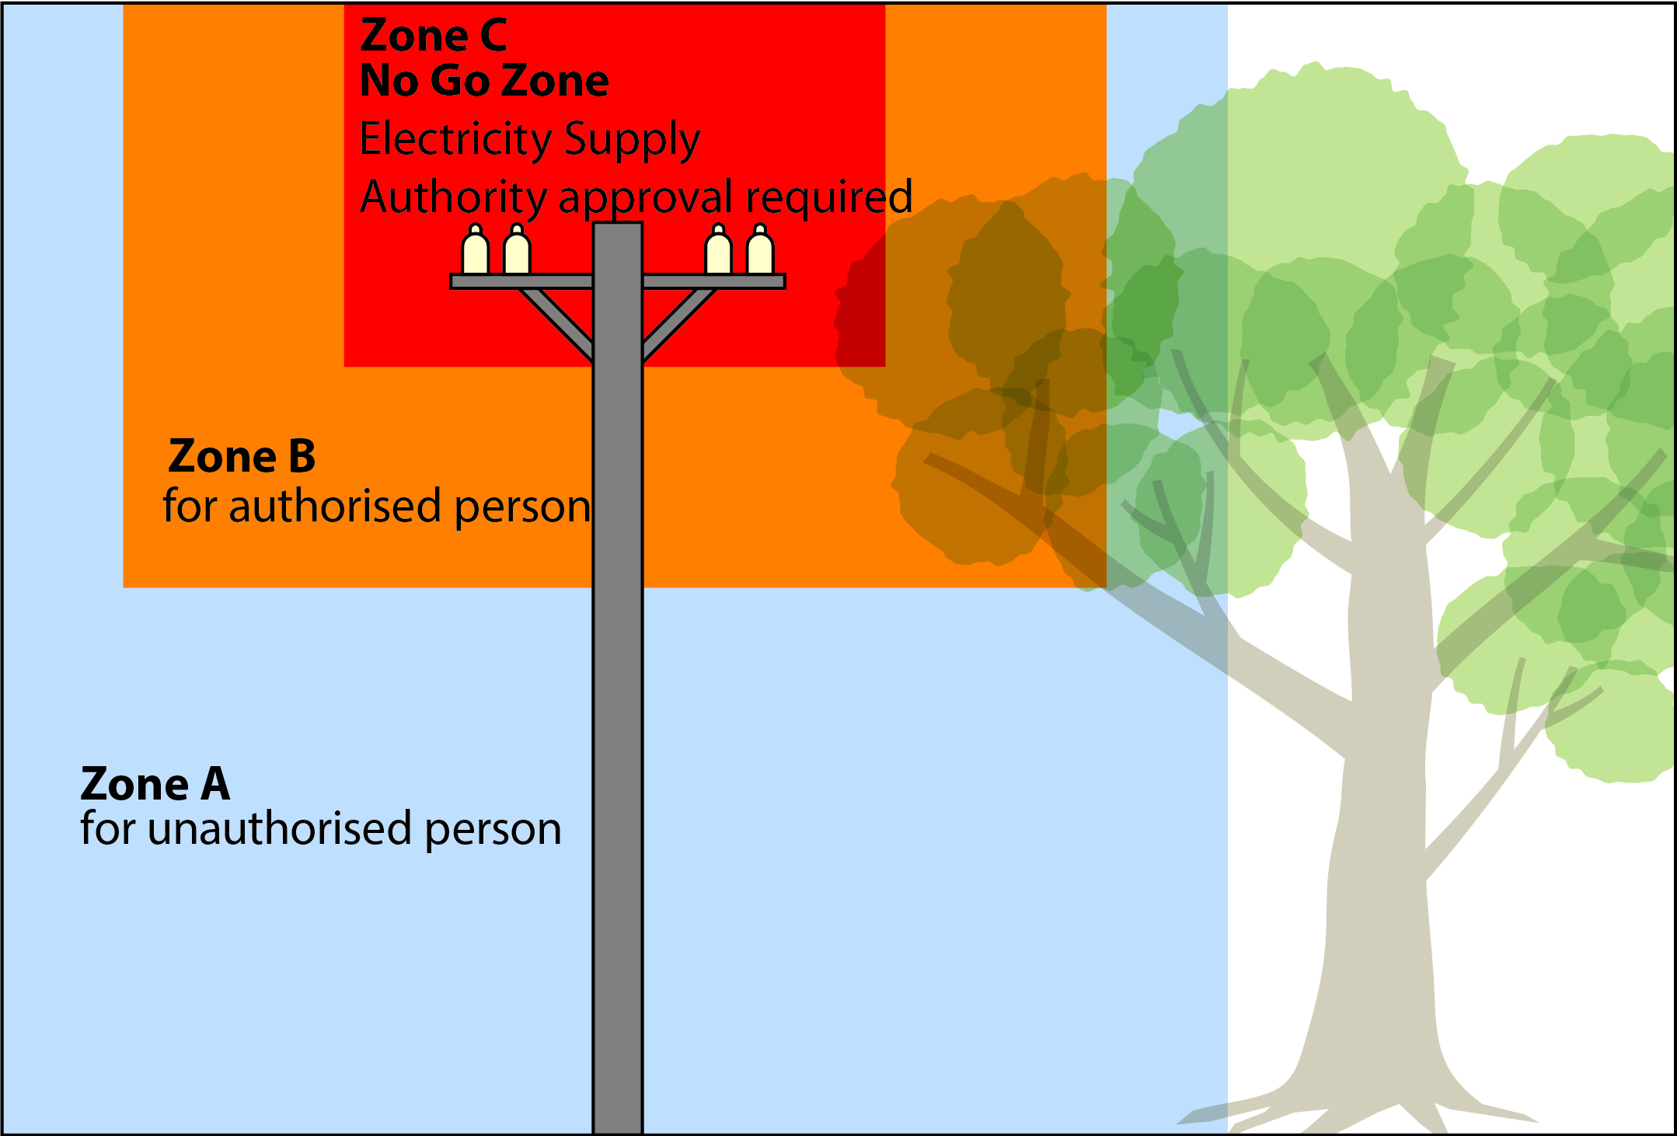

## How do I control the risks?

The best way to eliminate the hazard is by preventing people, plant, equipment and materials from coming close enough to energised overhead electric lines for direct contact or ‘flashover’ to occur. Consider:

* de-energising the electric line for the duration of the work, or
* re-routing the service line away from the work area.

De-energising or moving electric lines should   
be arranged with the Electricity Supply Authority as soon as possible.

Electric lines should always be treated as energised unless you have:

* an access authority confirming the electric lines have been de-energised, or
* another written document from the Electricity Supply Authority which allows people to work in the No Go Zone.

Where elimination is not reasonably practicable minimise the risks by:

* fitting plant with programmable zone limiting devices
* using alternative plant that cannot enter   
  an unsafe zone
* using ultrasonic measuring devices to measure the height of overhead lines
* using insulated fibreglass extension handles on loppers, instead of conductive aluminium extension handles, or
* limiting movement of plant with mechanical stops.

If a risk still remains use administrative controls like:

* making hazards more visible e.g. use warning signs or tiger tails, and
* managing and supervising the work to ensure approach distances are maintained including when operating plant like chainsaws.

Also consider the use of personal protective equipment (PPE) including:

* electrically tested insulated gloves, rubber soled boots and safety helmets
* rubber insulating mats or equipotential conductive mats for workers to stand on, and
* dry clothes especially in wet or humid conditions.

A combination of the above controls can   
be used if a single control is not enough   
to minimise the risks.

## Trees or branches contacting energised overhead electric lines

Trees that have grown into contact with energised overhead electric lines should not be cut by a person who is in an earthed situation, for example standing on the ground or working from within the tree. In this situation talk to your [Electricity Supply Authority](http://www.safeworkaustralia.gov.au/sites/SWA/about/Publications/Documents/859/Electricity-Supply-Authorities.docx) before starting work.

You should not touch any part of the branch or tree as the entire branch including the leaves may be energised. Never assume a tree branch can safely rest on or against overhead electric lines—they can conduct electricity even in dry conditions.

While it is not permitted to work on trees where part of them may fall onto overhead electric lines, it is important to know what action to take if this happens.

Contact with any part of the tree may result   
in electrocution and burns. If this occurs immediately contact the [Electricity Supply Authority](http://www.safeworkaustralia.gov.au/sites/SWA/about/Publications/Documents/859/Electricity-Supply-Authorities.docx) and keep all people clear of the area while waiting for help.

More information on emergency plans and rescue procedures is in the [*General guide   
for working in the vicinity of overhead and underground electric lines*](http://www.safeworkaustralia.gov.au/sites/SWA/about/Publications/Documents/859/Overhead-Underground-Electric-Lines-General-Guide.docx).

## Safety observer

A safety observer should be used whenever   
the work activity is done in Zone B or the work activity in Zone A can enter Zone B.

The safety observer should alert workers and crane or plant operators when approach distances are likely to be breached or other unsafe conditions arise.

A safety observer must be able to communicate effectively at all times with crane and mobile plant operators and warn them about an approach to Zone B.

Safety observers should monitor the work activity and have the authority to stop the   
work at any time.

## Safe work method statement (SWMS)

A SWMS is required for energised electrical work and high risk construction work carried   
out on or near energised electrical installations or services. A written SWMS should be based on a risk assessment. The SWMS and risk assessment should be available to workers   
on site for the duration of the work.

## Training and competence

Authorised persons who work closer than   
Zone B and safety observers who observe the work should have successfully completed a relevant training course provided by a registered training authority. They should be assessed as competent to carry out their work tasks in the vicinity of energised electric lines and exposed parts. Written certification should be verified.

Safety observers must be competent to implement control measures in an emergency and to rescue and resuscitate a worker if necessary. Authorised persons and safety observers must be re-assessed annually.

For further information see the [Safe Work Australia](http://www.swa.gov.au/) website (www.swa.gov.au).