**WORKPLACE TRAFFIC MANAGEMENT**

INFORMATION SHEET

Overview

This Information Sheet provides advice for small businesses and workers on managing traffic risks in the workplace.

More information is in the [*General guide for workplace traffic management*](http://www.safeworkaustralia.gov.au/sites/SWA/about/Publications/Documents/864/Traffic-Management-General-Guide.docx) and the specific guides for traffic management on [warehouses](http://www.safeworkaustralia.gov.au/sites/SWA/about/Publications/Documents/864/Traffic-Management-Guide-Warehousing.docx), [construction workplaces](http://www.safeworkaustralia.gov.au/sites/SWA/about/Publications/Documents/864/Traffic-Management-Guide-Construction-work.docx), [shopping centres](http://www.safeworkaustralia.gov.au/sites/SWA/about/Publications/Documents/864/Traffic-Management-Guide-Shopping-Centres.docx)   
and [events](http://www.safeworkaustralia.gov.au/sites/SWA/about/Publications/Documents/864/Traffic-Management-Guide-Events.docx).

What are the risks?

Where there are vehicles like cars, trucks or forklifts at your workplace there is a risk that they will collide with people.

People who work with or near vehicles are most at risk and customers and visitors to your workplace may also be at risk.

What do I need to do?

You must manage the risk of vehicles colliding with people at your workplace. There are a number of ways of doing this depending on the size of your workplace, the kinds of vehicles being used and how often vehicle and pedestrians interact.

You should start by identifying the hazards and the potential points of collision between people and vehicles. You can do this by considering the flows of traffic and people and by asking your workers and health and safety representatives about any problems they encounter at the workplace. You must then put in place control measures to eliminate or minimise the risks so far as is reasonably practicable. A number of control measures are generally needed to control the risks effectively.

Keeping people and vehicles apart

The best way to protect people is to keep them physically separated from vehicles. Think about how vehicles and pedestrians move around the area. Are they separated? Are there ways to stop them interacting?

Consider the layout of your workplace and see whether this can be achieved, for example by excluding people from vehicle operating areas.

This may not always be possible so minimise the risks in other ways, for example by:

* providing gates or temporary barriers   
  to separate vehicles from people
* scheduling work to avoid or reduce the need for pedestrians and vehicles to be in the same area
* creating exclusion zones like forklift-only areas in loading bays or pedestrian-only areas around tearooms, amenities and entrances
* locating delivery areas away from pedestrians or work activities
* clearly marking vehicle areas with signs   
  or reflective paint to warn pedestrians
* clearly marking pedestrian walkways   
  and crossings with paint or bollards
* using mirrors and vision panels in pedestrian doors entering vehicle areas
* using signs for speed limits, hazards like forklift operating areas and exclusion zones
* ensuring traffic areas are well lit, and
* ensuring workers wear high visibility clothing.

**Figure 1** Temporary physical barrier to keep people away from vehicles

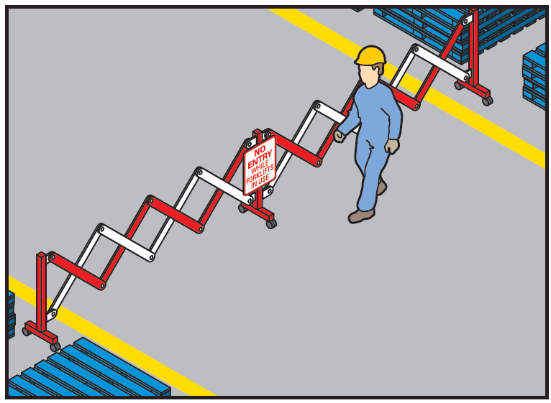

Vehicle movement

Where possible workers that are not needed for the activity should be excluded from vehicle areas.

Think about a vehicles visibility of pedestrians and whether devices are needed like external and side mirrors, reversing sensors, flashing lights or reversing alarms.

Reduce the speed of vehicles, for example using speed limiters on forklifts, implementing speed limits or speed humps on vehicle routes.

Reversing vehicles

Reversing vehicles are a significant hazard to pedestrians. If there is no alternative and vehicles need to reverse, think about:

* whether vehicles can be fitted with devices like reversing cameras, rotating lights or audible reversing alarms
* fixing mirrors at blind corners and other areas to aid visibility
* using a person to direct the reversing vehicle – this person should be in visual contact with the driver at all times and wear high visibility clothing
* keeping non-essential workers away from reversing areas, or
* ensuring reversing areas are well lit and clearly marked with signs or line markings.

Loading and unloading areas

You can manage loading and unloading safely by:

* designating pedestrian exclusion zones in loading and unloading areas which are clearly marked with signs, reflective paint, witches hats or physical barriers like chains or bollards
* designating a safety zone for the driver – they should be seen by the plant operator   
  at all times
* introducing clear and effective communication systems between the plant operator and the driver e.g. hand signals   
  or two-way radios, and
* providing ways to warn pedestrians and vehicle drivers that loading is in progress e.g. signage, cones, lights, alarms and horns.

**Figure 2** Examples of signs

The figure shows a PEDESTRIANS PROHIBITED sign.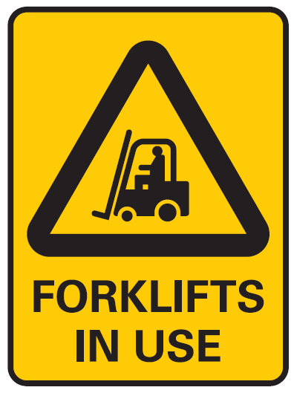

Parking

Parking areas may be needed for workers, visitors, large vehicles like trucks and other vehicles used in the workplace.

A good way to protect pedestrians is to:

* have parking areas away from busy work areas and traffic routes
* clearly mark and sign-post parking areas, or
* if possible, protect walkways leading to and from parking areas with physical barriers   
  like bollards.

The person operating the forklift should control the exclusion zone and clear operating procedures should be understood and implemented at all times.

**Figure 3** Walkway marked with lines and bollards

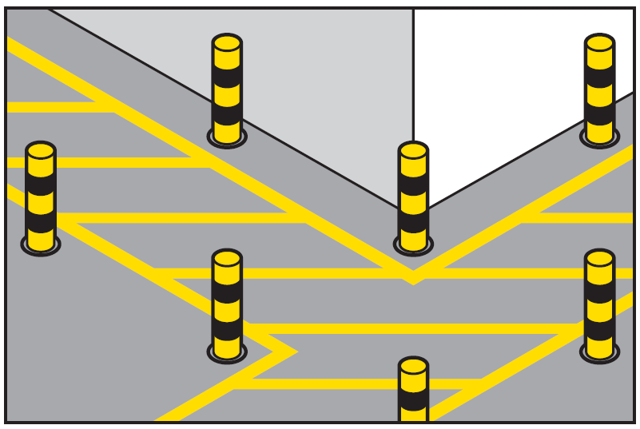

For further information see the [Safe Work Australia](http://www.swa.gov.au/) website (www.swa.gov.au).