# GENERAL GUIDE FOR WORKPLACE TRAFFIC MANAGEMENT

This General Guide provides information on how to manage traffic risks at a workplace. It is supported by specific guidance material on traffic management for [shopping centres](http://www.safeworkaustralia.gov.au/sites/SWA/about/Publications/Documents/864/Traffic-Management-Guide-Shopping-Centres.docx), [construction workplaces](http://www.safeworkaustralia.gov.au/sites/SWA/about/Publications/Documents/864/Traffic-Management-Guide-Construction-work.docx), [warehouses](http://www.safeworkaustralia.gov.au/sites/SWA/about/Publications/Documents/864/Traffic-Management-Guide-Warehousing.docx), [events](http://www.safeworkaustralia.gov.au/sites/SWA/about/Publications/Documents/864/Traffic-Management-Guide-Events.docx) and an [Information Sheet](http://www.safeworkaustralia.gov.au/sites/SWA/about/Publications/Documents/864/Traffic-Management-Information-Sheet.docx) for small business.

Who should use this Guide?

Traffic at a workplace includes:

* vehicles such as cars, trucks, vans and buses
* powered mobile plant such as forklifts, and
* cyclists.

This General Guide applies to all businesses or undertakings where there is a risk of traffic colliding with people in the workplace. However this does not apply to work which is carried out on or near a public road, for example constructing or repairing a road or working on a footpath or nature strip adjacent to a road.

If your work involves a public road you should contact your local road authority for the relevant traffic management requirements and guidelines.

For information about traffic management at mining workplaces, you should contact your local mining regulator.

Who has duties under the law?

Everyone in the workplace has a work health and safety duty. The main duties are set out in Table 1.

**Table 1** Duty holders and their obligations

| **Who** | **Duties** |
| --- | --- |
| **A person conducting a business or undertaking** | **A person conducting a business or undertaking** must ensure, so far as is reasonably practicable, that workers and other people are not exposed to health and safety risks arising from the business or undertaking.  A ‘person conducting a business or undertaking’ is a term that includes all types of working arrangements such as organisations, partnerships, sole traders or small business owners. For example a builder, a manufacturing business, a fast food franchisee and a self-employed person operating their own business are all persons conducting a business or undertaking.  **A person conducting a business or undertaking who has management or control of a workplace** must ensure, so far as is reasonably practicable, the workplace, the means of entering and exiting the workplace and anything arising from the workplace is without risks to health and safety.  **A person conducting a business or undertaking with management or control  of powered mobile plant at a workplace** must ensure it does not collide with pedestrians or other powered mobile plant. If there is a possibility of collision, the plant must have a warning device alerting persons who may be at risk from its movement. |
| **Designers, manufacturers, suppliers and importers** | **Designers, manufacturers, suppliers and importers** of plant or structures must ensure, so far as is reasonably practicable, the plant or structure is without risks to health and safety. For example, workplaces can be designed with vehicle and pedestrian routes that are separated. Mobile plant can be designed so the operator can see easily and the plant has speed limiters and warning devices. |
| **Officers** | **Officers,** such as company directors, have a duty to exercise due diligence to ensure the business or undertaking complies with the Work Health and Safety (WHS) Act and Regulations. This includes taking reasonable steps to ensure the business or undertaking has and uses appropriate resources and processes to eliminate or minimise risks from traffic at the workplace. |
| **Workers and others** | **Workers and other people at the workplace** must take reasonable care for their own health and safety, co-operate with reasonable policies, procedures and instructions and not adversely affect other people’s health and safety. |

How can traffic risks be managed?

Use the following steps to ensure, so far as is reasonably practicable, that workers and other people are not exposed to health and safety risks:

**1. Find out what could cause harm.** The following can help you identify potential hazards:

* Observe the workplace to identify areas where pedestrians and vehicles interact. Think about the floor plan of your workplace, if work is done close to public areas, when traffic volumes are higher, where potential blind spots are and other areas of poor visibility. Security footage may be useful if available.
* Ask your workers, pedestrians and visiting drivers about traffic management problems they encounter at your workplace.
* Review your incident and injury records including near misses.

A [checklist](http://www.safeworkaustralia.gov.au/sites/SWA/about/Publications/Documents/864/Traffic-Hazards-Checklist.docx) to help you identify traffic hazards is available on the Safe Work Australia website.

**2. Assess the risk**. In many cases the risks and related control measures will be well known. In other cases you may need to carry out a risk assessment to identify the likelihood of somebody being harmed by the hazard and how serious the harm could be. A risk assessment can help you determine what action you should take to control the risk and how urgently the action needs to be taken.

Most vehicle incidents at the workplace are from collisions between pedestrians and vehicles reversing, loading and unloading. People who work with or near vehicles are most at risk. Customers and visitors may also be at risk.

**3. Take action to control the risk.** The WHS laws require a business or undertaking do all that is reasonably practicable to eliminate or minimise risks.

The ways of controlling risks are ranked from the highest level of protection and reliability to the lowest. This ranking is known as the hierarchy of risk control. You must work through this hierarchy to manage risks.

The first thing to consider is whether hazards can be completely removed from the workplace. For example, risks can be eliminated by physically separating pedestrian routes from vehicle areas. This could be done by conducting activities at times when pedestrians are not present, using physical barriers or overhead walkways.

If it is not reasonably practicable to completely eliminate the risk then consider one or more of the following options in the order they appear below to minimise risks, so far as is reasonably practicable:

* substitute the hazard for something safer e.g. replace forklifts with other load shifting equipment like a walker stacker or pallet jacks
* isolate the hazard from people e.g. by creating a delivery area away from other pedestrians or work activities
* use engineering controls e.g. speed limiters on forklifts, presence sensing devices or interlocked gates.

If after implementing the above control measures a risk still remains, consider the following controls in the order below to minimise the remaining risk, so far as is reasonably practicable:

* use administrative controls e.g. warning signs or schedule delivery times to avoid or reduce the need for pedestrians and vehicles to interact
* use personal protective equipment (PPE) e.g. high visibility clothing.

A combination of the controls set out above may be used if a single control is not enough to minimise the risks.

You need to consider all possible control measures and make a decision about which are reasonably practicable for your workplace. Deciding what is reasonably practicable includes the availability and suitability of control measures, with a preference for using substitution, isolation or engineering controls to minimise risks before using administrative controls or PPE. Cost may also be relevant, but you can only consider this after all other factors have been taken into account.

**4. Check your control measures** regularly to ensure they are working as planned. Control measures need to be regularly reviewed to make sure they remain effective, taking into consideration any changes, the nature and duration of work and that the system is working as planned.

Further information on the risk management process is in the [Code of Practice*: How to manage work health and safety risks*](http://www.safeworkaustralia.gov.au/sites/swa/about/publications/pages/manage-whs-risks-cop)*.*

Who is involved?

You must consult your workers and their health and safety representatives (if any) when deciding how to manage the risks of traffic in the workplace, including when making changes. You should encourage reporting of safety problems.

If there is more than one business or undertaking involved at your workplace you must consult them to find out who is doing what and work together so risks are eliminated or minimised so far as is reasonably practicable.

This may involve discussing site-specific requirements including entering and exiting the site, vehicle parking, delivery areas and scheduling suitable times for loading and unloading.

Further information on consultation requirements is in the [Code of Practice*: Work health and safety consultation, co-operation and co-ordination*](http://www.safeworkaustralia.gov.au/sites/swa/about/publications/pages/consultation-cooperation-coordination-cop).

Traffic management plans

If you have a large workplace with a high volume of traffic a traffic management plan can help you communicate how you are managing traffic risks in your workplace.

A traffic management plan may include details of:

* the desired flow of pedestrian and vehicle movements
* the expected frequency of interaction of vehicles and pedestrians
* illustrations of the layout of barriers, walkways, signs and general arrangements to warn and guide traffic around, past, or through a work site or temporary hazard, and
* how short term, mobile work and complex traffic situations will be managed.

A traffic management plan could also set out:

* responsibilities of people managing traffic in the workplace
* responsibilities of people expected to interact with traffic in the workplace, and
* instructions or procedures for controlling traffic including in an emergency.

Workplaces with a high volume of traffic should establish a traffic management consultative committee made up of health and safety representatives,representatives from the operators of powered mobile plant, supervisors and from any other group sharing the traffic routes and working areas of the vehicles.

A traffic management plan should be regularly monitored and reviewed and importantly following an incident to ensure it is effective and takes into account changes at the workplace. In workplaces with a traffic management consultative committee, the committee should carry out the monitoring and review of the traffic management plan.

You should ensure workers are familiar with the traffic management plan and you should provide information, instruction and training on its use.

Information, training, instruction and supervision

Before mobile plant is used in your workplace you must provide anyone who will use it with the information, training, instruction or supervision necessary to protect them and others from the risks associated with traffic in a workplace.

Workers including contractors who are required to perform duties associated with traffic management at the workplace should be trained to perform those duties. Training should be provided to workers by a competent person.

Responsibilities for health and safety management must be clearly allocated. It is important each worker, contractor, subcontractor, visiting driver and other relevant people clearly understand their role in following safe work practices and taking reasonable care of themselves and others.

You should provide supervision to ensure safety procedures are being followed, particularly if you are relying on administrative control measures to minimise risks.

You must ensure so far as is reasonably practicable, everyone who has access to your workplace including visitors are provided with information necessary to protect them from risks to their health and safety, for example instructions on designated safe routes, parking areas, pedestrian exclusion zones and speed limits. This could be addressed through an induction process at your workplace.

Visitors should report to the reception area or site office and be given information on the safety procedures for the workplace before they are allowed into areas where vehicles and powered mobile plant are used.

You must ensure that any information, training and instruction provided, is presented so it is easily understood by workers. This may require providing information and training material in different languages.

# WAYS TO CONTROL TRAFFIC RISKS

Keeping people and vehicles apart

The best way to protect pedestrians is to make sure people and vehicles cannot interact. Where powered mobile plant is used at a workplace, you must ensure it does not collide with pedestrians or other powered mobile plant.

This can be achieved by not allowing vehicles in pedestrian spaces or not allowing pedestrians in vehicle operating areas, for example using overhead walkways (see Figure 1).

However this may not be reasonably practicable in all workplaces. If people and vehicles cannot be separated you should consider using:

* barriers or guardrails at building entrances and exits to stop pedestrians walking in front of vehicles (see Figure 2)
* high impact traffic control barriers (see Figure 3)
* temporary physical barriers (see Figure 4), or
* separate, clearly marked footpaths or walkways e.g. using lines painted on the ground or different coloured surfacing (see Figure 5).

Pedestrian routes and intersections should be clearly marked, unobstructed, well maintained and well lit.

More examples of how pedestrians and vehicles can be kept apart are in Appendix A.

**Figure 1** Overhead walkways

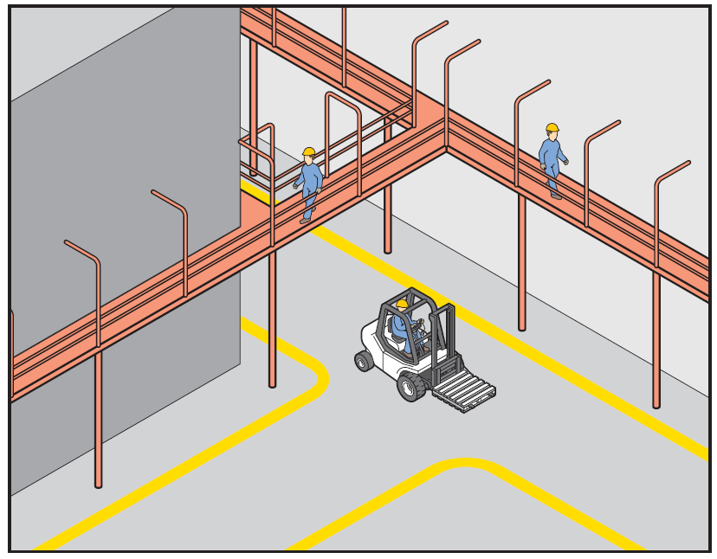

**Figure 2** Guardrail

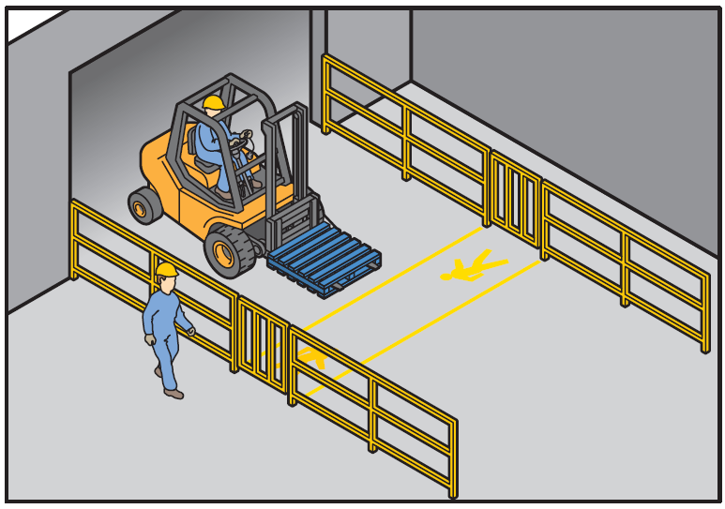

**Figure 3** High impact barrier

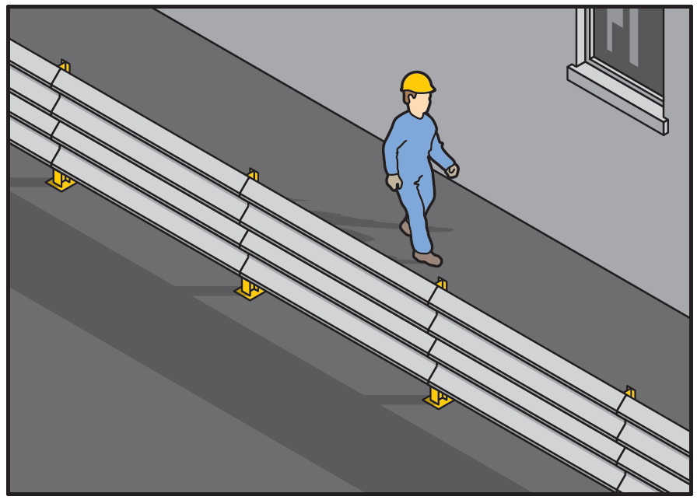

**Figure 4** Temporary physical barriers separating pedestrians from powered mobile plant

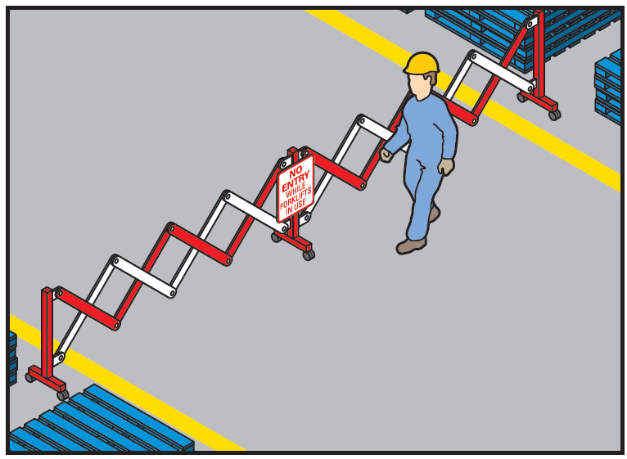

**Figure 5**Walkway marked with lines and bollards

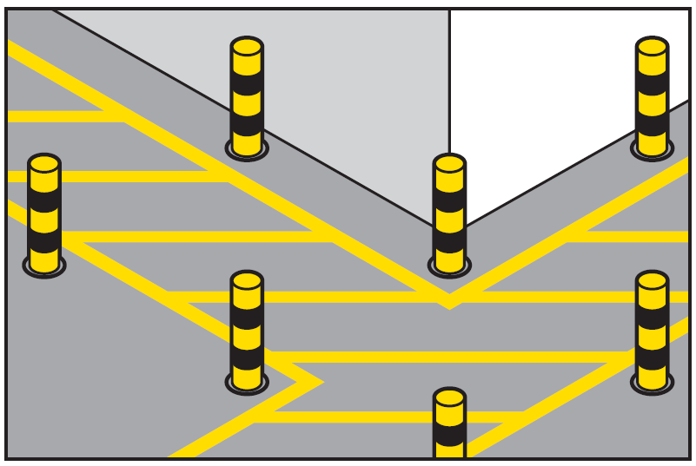

Vehicle routes

Vehicle routes at the workplace should have a firm and even surface, be wide and high enough for the largest vehicle using them and be well maintained and free from obstructions. They should be clearly sign-posted to indicate speed limits, traffic calming measures like speed humps and parking areas.

Reducing speed is very important where administrative control measures are the only reasonably practicable approach. Speed limits should be implemented and enforced and traffic calming devices like speed humps considered. Variations to speed limits should be clearly signposted.

More examples of how vehicle routes can be managed safely are in Appendix A.

Pedestrian crossings

If pedestrians have to cross vehicle routes in the workplace you can manage the risk in a number of ways, for example interlocked gates or gates with warning devices, physical barriers or rails, traffic light systems or having a competent worker direct traffic.

Pedestrian crossings should be clearly marked with ground markings, lights or signs. If the vehicle route to be crossed is a road or railway consider control measures that will work with those already established by the relevant authority, for example a local council or rail authority.

Both pedestrians and vehicles should have good visibility, for example pallet goods should not be stored in a way that would obscure vision.

Procedures indicating who has right of way at crossings should also be established.

Parking areas

Parking may be needed for workers, visitors, trucks and other vehicles used in the workplace. Consider setting out the workplace so parking areas:

* are located away from busy work areas and traffic routes
* have walkways leading to and from parking areas which are separated from vehicles or vehicle routes e.g. use physical controls like barriers or bollards to prevent vehicles from crossing into walking areas (see Figure 6), and
* are clearly marked and sign-posted, well lit and unobstructed.

More examples of how parking areas can be managed safely are in Appendix A.

**Figure 6** Pedestrian walkway in car park

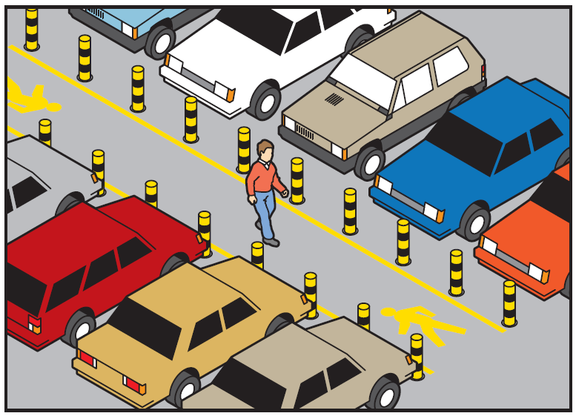

Reversing vehicles

If reasonably practicable eliminate the need for reversing by using drive-through loading and unloading systems, multi-directional mobile plant or rotating cabins. Where this is not possible consider:

* using devices like reversing sensors, reversing cameras, mirrors, rotating lights or audible reversing alarms
* using a person to direct the reversing vehicle if they cannot see clearly behind—this person should be in visible contact with the driver at all times and wear high-visibility clothing
* providing designated clearly marked, signposted and well lit reversing areas, and
* excluding non-essential workers from the area.

More examples of how the risks of reversing vehicles can be managed are in Appendix A.

Loading and unloading vehicles

Figure 7 provides examples of measures to manage loading and unloading activities safely.

It is important to make sure visitors including visiting drivers are aware of the workplace layout, the route they should take and safe working procedures for the workplace. Provide drivers with safe access to amenities away from loading areas or other vehicular traffic. To reduce driver fatigue a seat should be provided for long loading times.

If you have created zones to separate vehicles from people—called ‘exclusion zones’—the person operating the powered mobile plant such as forklifts should control the exclusion zone. Clear operating procedures should be understood and implemented at all times. Provide effective ways to warn of loading in progress to other plant operators, drivers and pedestrians. Warning devices can include signage, cones, lights, alarms and horns.

Ways to stop vehicles from moving during loading and unloading activities include using:

* vehicle or trailer restraints
* dock locks
* air brake isolation interlock devices
* traffic lights
* barriers or other ‘stop’ signals
* systems for controlling access to vehicle keys or the cabin, and
* safe systems of work which make sure the driver is aware of when it is safe to leave.

**Figure 7** Example of traffic control measures for truck loading and unloading

| Figure 7 shows examples of traffic control measures for truck loading and unloading including a designated pedestrian walkway protected by physical barriers; a pedestrian exclusion zone; a driver/pedestrian safety zone; a beam from a pedestrian-sensing device; barriers and bollards and warning lights activated by pedestrian sensors. | Clearly designated pedestrian walkway protected by physical barriers with staggered barriers to control approaching pedestrians.  Pedestrian exclusion zone has been established for a distance equal to the height of the load from the ground plus an additional allowance for the type of load.  Beam from pedestrian-sensing device.  Barriers, bollards, witches hats or paint marking the pedestrian exclusion zone.  Warning light activated by pedestrian sensors.  Establish a safety zone for the driver and other pedestrians. The driver should be in full view of the forklift operator. Stop the loading and unloading activities if the driver cannot be seen or needs to enter the exclusion zone. Alternatively, if it is safe to do so the system of work can provide for the driver to stay in the cabin during loading and unloading. Effective communication systems between the plant operator and the driver should be used such as a system of hand signals or two-way radios. |
| --- | --- |

Signs and road markings

Clear road markings like reflective paint and signs should be used to alert pedestrians and vehicle operators to traffic hazards in the workplace.

Signs should be provided to indicate exclusion and safety zones, parking areas, speed limits, vehicle crossings and hazards like blind corners, steep gradients and where forklifts are in use.

Signs and road markings should be regularly checked and maintained so they can be easily seen.

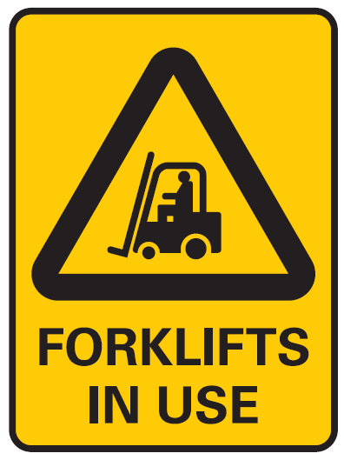The figure shows a PEDESTRIANS PROHIBITED sign.

Lighting

Traffic routes, manoeuvring areas and yards should be well lit with particular attention given to junctions, buildings, walkways and vehicles routes. Where possible they should be designed to avoid extreme light variation, for example drivers moving from bright into dull light or vice versa.

# APPENDIX A – TRAFFIC CONTROL MEASURES

The following information provides further examples of how traffic hazards and risks can be managed. Some examples may not be reasonably practicable to implement in your business or undertaking.

How can people and vehicles be kept apart?

* Use interlocking, chicaned or hinged gates that open towards the pedestrian—these methods create a stop or pause in the pedestrian’s movement before entering a vehicle area.
* Use boom gates and proximity devices which trigger boom gates.
* Provide separate entries and exits for pedestrians and vehicles.
* Create exclusion zones e.g. forklift-only areas in loading bays or pedestrian-only areas around tearooms, amenities and entrances.
* Schedule work to prevent mobile plant and pedestrians being in the same area at the same time.
* Have pedestrian routes which represent paths people would naturally follow to encourage pedestrians to stay on designated safe routes and avoid taking potentially hazardous shortcuts.
* Remove or identify blind corners using bollards.
* Use vision panels in pedestrian doors entering vehicle areas.
* Use staging areas to facilitate alternative load shifting equipment.

How can vehicle routes be managed safely?

* Provide vehicle routes that are:
  + one-way with enough passing space around stationary vehicles
  + wide and high enough for the largest vehicle using them including their load, taking into account turning circles, stopping distances and the need to reverse
  + flat or only have small slopes - steep gradients which cannot be avoided should be clearly signposted and guarded. Powered mobile plant like forklifts should operate on gradients only if the manufacturer specifies they are able to do so
  + avoid sharp or blind corners
  + well drained, maintained and lit, and
  + free from obstructions, grease, and surface damage.
* Manage queuing vehicles with enough space so queues do not impact on other traffic or block emergency exits. Workplaces with a large number of trucks should consider a queuing time slot system.
* Use a gatehouse to control traffic time slots.
* Provide separate areas for tarping, load restraint, load splitting, maintenance and clean down.
* Provide separate entry and exit points for large vehicles.

How can I keep people safe from powered mobile plant?

* Use signs to give advance warning to pedestrians and plant operators and to indicate who must give way.
* Isolate pallet racking aisles.
* Implement procedures setting out when and how mobile plant operators must give way to pedestrians.
* Implement systems of work to prevent forward carrying of loads if they obstruct the operator’s view.
* Minimise the number of mobile plant working at one time.
* Use speed-limiting devices and implementing speed limits.
* Use a combination of audio and visual warning devices like alarms, horns and flashing lights and ensure these are working when the plant is operating.
* Provide high-visibility or reflective clothing for workers and plant operators and high-visibility markings for mobile plant.

*Note:* Certain types of plant like forklifts and some types of cranes require the operator to have a high risk work license before they can operate plant. See Schedule 3 of the WHS Regulations for the classes of high risk work licenses and types of plant involved.

How can parking areas be managed safely?

* Set out parking areas so they are easy to drive in, out of and around in e.g. try to avoid the need for reversing and consider how large vehicles will be able to use the space safely.
* Use devices like speed humps to slow vehicles down.
* Prevent parked vehicles from rolling by parking them on level ground, preferably in a designated parking area with the brake firmly applied. Where this is not possible consider installing wheel humps in parking areas to prevent vehicles rolling away.
* Turn the wheels of the vehicle towards a safe stopping place like a curb or a wall so the vehicle or equipment does not accidently roll away.
* Chock the wheels of parked mobile plant.
* Avoid parking smaller vehicles behind large ones or in areas where the driver does not have clear visibility of the vehicle.

How can I keep people safe from reversing vehicles?

* Ensure reversing sensors, reversing cameras, rear vision mirrors, fixed safety mirrors and windscreens are kept clean and in working order.
* Use radios and other communication systems.
* Fix mirrors at blind corners e.g. convex mirrors.
* Fit refractive lenses on rear windows to help drivers see ‘blind spots’.
* Ensure visiting drivers are familiar with workplace routes and reversing areas.

What can I do to make sure vehicles are safe?

* Select vehicles and powered mobile plant which are suitable for the tasks.
* Ensure vehicles are fitted with seatbelts and parking brakes.
* Ensure vehicles are subject to a regular maintenance program.
* Report faults on all vehicles and powered mobile plant.
* Drivers should carry out basic safety checks before using vehicles.