TOWER AND MOBILE SCAFFOLDSINFORMATION SHEET

Overview

This Information Sheet provides advice for small businesses and workers on managing the risks associated with tower and mobile scaffolds and related scaffolding work.

For further information see the:

* [*General guide for scaffolds and scaffolding work*](http://www.safeworkaustralia.gov.au/sites/swa/about/publications/pages/guidance-scaffolding)
* [*Guide to scaffolds and scaffolding*](http://www.safeworkaustralia.gov.au/sites/swa/about/publications/pages/guidance-scaffolding)
* [*Guide to suspended (swing stage) scaffolds*](http://www.safeworkaustralia.gov.au/sites/swa/about/publications/pages/guidance-scaffolding)
* [*Guide to scaffold inspection and maintenance*](http://www.safeworkaustralia.gov.au/sites/swa/about/publications/pages/guidance-scaffolding)*,* and
* [Information Sheet*: Scaffolding work near overhead electric lines*](http://www.safeworkaustralia.gov.au/sites/swa/about/publications/pages/guidance-scaffolding)*.*

Tower and mobile scaffolds

A tower scaffold is an independent scaffold consisting of four vertical standards connected longitudinally and transversely or two frames in plan connected transversely to create a scaffold of one bay. It may also have an extra, short stabiliser bay or outriggers to increase stability.

A mobile scaffold is a tower scaffold mounted on wheels (see Figure 1).

**Figure 1** Mobile scaffold

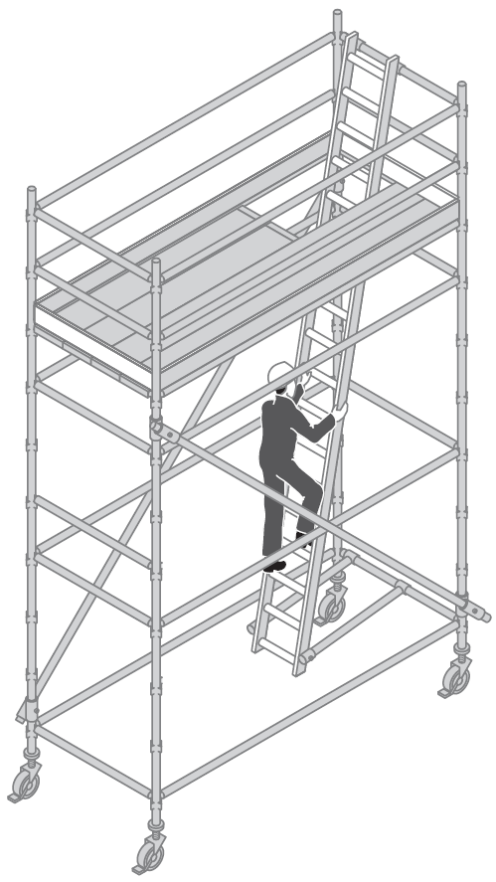

Manufacturers and suppliers must provide information about how to use and erect mobile scaffolds safely. If a scaffold is to be altered contact the manufacturer or supplier for guidance. Prefabricated mobile scaffolds should be erected in accordance with manufacturer’s specifications.

When do I need a high risk work licence?

A licensed scaffolder is required for the erection, alteration or dismantling of a tower or mobile scaffold where there is a risk that a person or object could fall more than 4 metres from the platform or the structure.

This means that if a scaffold that is less than   
4 metres in height is located adjacent to, for example an excavation, a licensed scaffolder may still be required (see Figure 2).

**Figure 2** Scaffold height, fall distance and licensing requirements

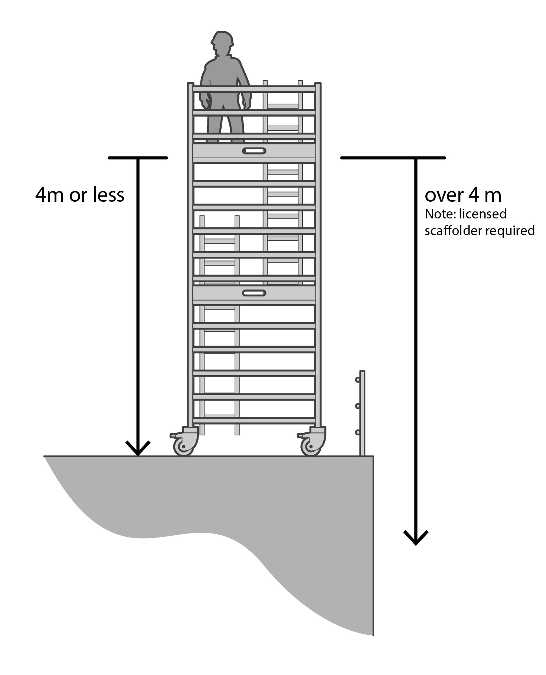

Often tower and mobile scaffolds will not require   
a licensed scaffolder to erect or dismantle them   
as there is no risk of a fall greater than 4 metres. However, the work should still be carried out by   
a competent person.

For further information on licensing requirements see the [*General guide for* s*caffolds and scaffolding work*](http://www.safeworkaustralia.gov.au/sites/swa/about/publications/pages/guidance-scaffolding)*.*

Control measures

The following control measures should be considered for tower and mobile scaffolds:

* Construct a tower scaffold with modular, frame or tube and coupler scaffolding.
* Locate a scaffold on firm level ground with the feet or wheels properly supported. Do not use loose bricks or building blocks to take the weight of the scaffold. Where adjustable wheels are used, the slope of the surface should not exceed 5 degrees.
* The height of the scaffold—from the bottom of the scaffold to the platform surface—should be no greater than the multiple of the minimum base dimension as specified in the manufacturer, supplier or designer information.
* Reduce the height to base ratios or provide extra support if the scaffold will be:
* sheeted or likely to be exposed to strong winds
* loaded with heavy equipment or materials
* used to hoist heavy materials or support rubbish chutes, and
* used for operations involving heavy   
  or awkward equipment e.g. grit blasting   
  or water-jetting.
* Use a secure internal ladder with a protected opening e.g. a hinged trap door for entry and exit to and from the scaffold.
* The internal ladder should be free of the supporting surface.
* Select the correct size and capacity wheels   
  to support the total mass of the dead and live loads of the scaffold.
* Use wheels that have the working load limit (WLL) clearly marked.
* Wheels should be locked before erection continues.
* Wheels with adjustable legs should be used and adjusted to keep the platform level when the supporting structure is at uneven or different heights.
* Include plan bracing at the base of mobile scaffolds to provide greater stability.
* Install guardrails, mid-rails and toeboards   
  on working platforms.
* Keep wheel brakes locked at all times unless moving the scaffold.

Work should not be done from tower or mobile scaffolds located on balconies or raised areas unless the scaffold is stable and secure or fixed to the structure to prevent movement.

Moving a scaffold

Before moving or relocating a scaffold check:

* there are no people or materials on the scaffold
* there are no overhead electric lines or other overhead obstructions in the line of travel
* the ground is firm, level and there are no obstructions—contact with a small obstruction can cause a mobile scaffold to overturn, and
* that electrical equipment and leads cannot become tangled with the scaffold.

Never move the scaffold in windy conditions.

Scaffolds with components that are not permanently fixed or which are not rated for   
lifting should only be moved in frames designed   
to lift individual components e.g. stillage’s.

If lifting a scaffold by crane, prepare a lifting plan outlining safe lifting points and how loose components like base jacks should be secured. Sling the scaffold at the point most likely to maintain stability and prevent dislodgment of scaffolding components.

The load should be slung by a licensed dogger   
or rigger and manoeuvred in a way that ensures the load remains stable.

A crane should not be used to lift aluminium mobile scaffolds because the scaffolding components may fail.

More information on scaffolds and scaffolding   
is in:

* AS 1576 (series): *Scaffolding*
* AS 1577: *Scaffold decking components*, and
* AS/NZS 4576: *Guidelines for scaffolding.*

For further information see the [Safe Work Australia](http://www.swa.gov.au/) website (www.swa.gov.au).