# GUIDE FOR SPLIT RIMS

## Purpose

This Guide provides information on how to manage the risks associated with split rims.

## What are split rims?

For the purpose of this Guide, split rims include a divided wheel, a multi-piece rim or a multi-piece wheel.

Split rims are used on a wide range of plant including forklifts, earthmoving machinery, trucks, buses, trailers, some older model four-wheel drives and wheelbarrows used across a range of industries including automotive, mining, construction, forestry, agriculture, and transport and storage. Further definitions can be found in the glossary.

## Who should use this Guide?

This Guide provides practical information for persons, including mobile tyre fitters, who carry out work activities where workers and others use or repair vehicles or machinery potentially fitted with split rims.

## Who has duties under the law?

Everyone in the workplace has a work health and safety duty. The main duties are set out in Table 1.

**Table 1** Duties related to split rims

| **Who** | **Duties** |
| --- | --- |
| **A person conducting a business or undertaking** | **A person conducting a business or undertaking** has the primary duty to ensure, so far as is reasonably practicable, workers and other people are not exposed to health and safety risks arising from the business or undertaking.  This duty requires the person to manage risks by eliminating health and safety risks so far as is reasonably practicable, and if it is not reasonably practicable to eliminate the risks, by minimising those risks so far as is reasonably practicable. It also includes ensuring so far as is reasonably practicable the provision and maintenance of a safe working environment. Further guidance is available in the [Code of Practice*: How to manage work health and safety risks*](http://www.safeworkaustralia.gov.au/sites/swa/about/publications/pages/manage-whs-risks-cop)*.* |
| **Officers** | **Officers,** such as company directors, have a duty to exercise due diligence to ensure the business or undertaking complies with the Work Health and Safety (WHS) Act and Regulations. This includes taking reasonable steps to ensure the business or undertaking has and uses appropriate resources and processes to eliminate or minimise risks from plant. |
| **Workers and others** | **Workers and other people at the workplace**, must take reasonable care for their own health and safety, co-operate with reasonable policies, procedures and instructions and not adversely affect other people’s health and safety. |

## The risk management process

### Identify hazards

There are numerous hazards associated with certain tyre-wheel assemblies, particularly divided wheels and multi-piece wheels. The main hazard is the uncontrolled releasing of compressed air from the tyre rim assembly and the compressed air propelling parts of the tyre, wheel or rim at significant speed.

Identifying hazards involves finding out what could go wrong and what could cause harm.

Some possible hazards when interacting with split rims are in Table 2. This list is not exhaustive and you should identify the specific hazards in each situation.

**Table 2** Examples of hazards when working with split rims

| **Split rim hazards** |
| --- |
| * Incorrectly fitted rim parts. * Damaged or mismatched rim parts. * Damaged wheels e.g. pitting by corrosion, wear, deformations and cracks. * Defects on new and used tyres. * Confusing wheel assembly bolts with securing bolts to attach wheel to vehicle. * Over inflation. * Pyrolysis (see the glossary). |

### Assess the risks

Every year people are killed or seriously injured when inflating a pneumatic tyre or removing a split rim-tyre assembly from a vehicle. Even an exploding wheel barrow split rim has been known to cause fatal injuries.

The hazards identified will have the potential to cause harm ranging from minor injuries to more serious injuries or death.

### Control the Risks

You must consult your workers and their health and safety representatives (if any) when deciding how to manage the risks in the workplace.

More than one duty holder can have the same duty. If there is more than one business or undertaking involved at your workplace you must consult them to share information, find out who is doing what and work together so risks are eliminated or minimised, so far as is reasonably practicable.

#### Hierarchy of controls

The model WHS laws require a business or undertaking do all that is reasonably practicable to eliminate or minimise risks. The ways of controlling risks are ranked from the highest level of protection and reliability to the lowest. This ranking is known as the hierarchy of controls. You must work through this hierarchy to manage risks.

**Table 3** Hierarchy of control and level of effectiveness

| **Control** | **Level of effectiveness** |
| --- | --- |
| Eliminating | Best. |
| Substituting | Effectiveness does not depend on human behaviour. |
| Isolating |
| Implementing engineering controls |
| Administrative controls | Effectiveness depends on human behaviour. |
| Using Personal Protective Equipment (PPE) | Does not control the risks directly. It controls the possible harm to a person. |

The first thing to consider is whether hazards can be removed from the workplace by eliminating the risk. If it is not reasonably practicable to completely eliminate the risk then consider substituting, isolating or implementing engineering controls. These three types of controls have the same ranking in the WHS legislation. Also, effectiveness of these controls does not depend on human behaviour.

*Example: Substituting with alternative single piece wheels that are suitable for the vehicle, e.g. their use would not introduce other unintended hazards.*

#### Administrative controls

Where the higher level controls do not completely eliminate the risk then administrative controls such as systems of work should be considered. The effectiveness of a system of work put in place to control the residual risks normally entails a procedure that depends on human behaviour, so will be considered as an administrative control.

The strength of a chain is the strength of the weakest link.

*Example: Providing an engineered protective cage for inflating the tyre. Unless the wheel is placed in the cage the risk is not controlled, so this is an administrative control, i.e. it depends on human behaviour.*

**Table 4** Examples of the application of the hierarchy of control for split rims

|  | **Approach** | **Examples** |
| --- | --- | --- |
| **Engineering controls** | **Substitution**  *swapping an object or situation with another, lower risk solution* | * Replacing split rims with a single piece wheel. |
| **Isolation**  *separating a person from a hazard* | * Providing a tyre inflation chamber where the inflation will not commence until the operator has left and the chamber door is shut and locked. |
| **Administrative controls** | **Administrative controls**  *processes and procedures that rely on human behaviour to be effective* | * Deflating tyres as the first step in inspection and removal from the vehicle. * Implementing procedures for safe tyre inflation when working on split rims, including;   + Using a tyre inflation cage or restraining device.   + Using a clip on valve and remote pressure gauge to enable a person to stand out of harms way during inflation. * Providing adequate supervision to ensure people follow the correct procedures. * Providing workers with relevant information, training and instruction. |
| **Personal protective  equipment**  *reduces exposure to the hazard but won’t prevent the likelihood of a risk occurring* | * Wearing eye protection. |

See the *Controlling risks associated with split rims* section in this document for further information on specific control measures for working with split rims.

### Review control measures

You should regularly check to make sure the control measures are working as planned. If problems are found, for example near misses, you should go back through the risk management steps, review the information and make further decisions about controls.

You should also review controls when there is a change at the workplace. Think about whether the changes will create a new risk that existing controls won’t manage. If so, identify a new or better control.

Sometimes when reviewing controls a new hazard or risk may be identified. Therefore you should reassess the new hazard and if necessary control the risk.

Further information about the risk management process can be found in the [Code of Practice: *How to manage work health and safety risks*](http://www.safeworkaustralia.gov.au/sites/swa/about/publications/pages/manage-whs-risks-cop).

## Controlling risks associated with split rims

Use the following steps to manage, so far as is reasonably practicable, that workers and other people are not exposed to health and safety risks from working with split rims.

The examples and procedure below provide practical illustration of risk management when working on split rim wheels. This list is not exhaustive and you should identify the specific management of each situation.

### Removing the tyre and wheel assembly from the vehicle

Manufacturers’ recommendations should be followed at each step including removing a wheel from the vehicle, inspecting the tyre, disassembly and assembly procedure including seating of parts and inflation.

Often the manufacturer of the wheel is unknown or their recommendations are unavailable and it is also sometimes not known whether the wheel is a split rim or a single piece wheel. The following procedure is recommended in the absence of manufacturer recommendations, unless the wheel is known to be a single piece wheel.

Before loosening the fasteners to remove a potential split rim wheel from a vehicle, deflate the tyre. Deflate both tyres when dealing with dual wheels, as the outer wheel may be holding a damaged inner wheel together.

Figure 1 shows a broken part of a multi-piece wheel that failed when the wheel nuts were loosened to access the parts behind the wheel. The grooves on the wheel were worn out and the wheel was corroded.

**Figure 1** Internal section, multi-piece wheel failure due to wear and corrosion

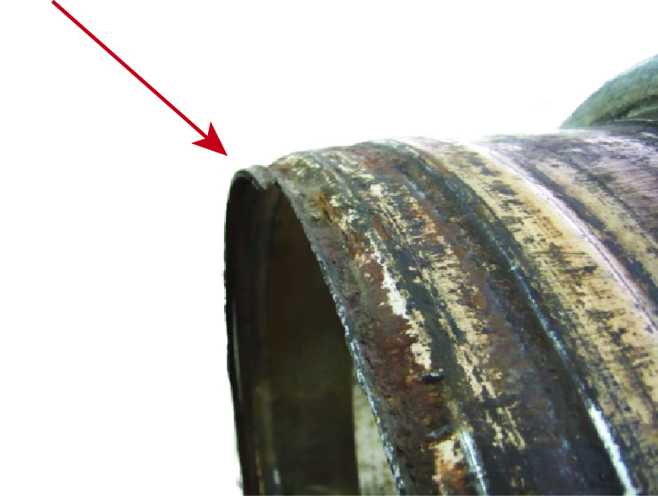

Figure 2 shows a wheel similar to Figure 1 with cracks and excessive corrosion which could not be observed while it is still fitted on the vehicle.

**Figure 2** Multi-piece wheel with cracks and corrosion not visible while fitted to the vehicle

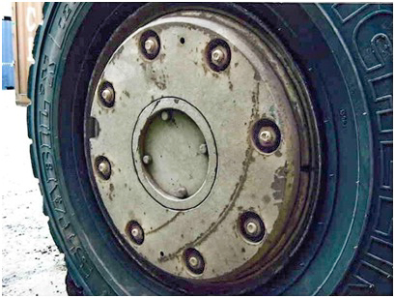

Sometimes the passage in the valve stem can remain blocked after the valve core has been removed. Clear these blockages with a flexible wire or similar device. Before undertaking such action, first put in place a safe system of work which may involve the use of PPE.

In rare instances where the tyre cannot be deflated through the valve system, the tyre may be driven over a specially designed spike to pierce the tyre. Manage any risks associated with this procedure by keeping people out of the danger zone in case the tyre explodes.

Divided wheels have two sets of fasteners, one set for bolting the two halves of the wheel together and the other to secure the wheel on to the hub. These two sets can be on the same pitch circle or on two different concentric circles. Nuts and bolts in early designs of wheels looked the same. Recent designs use bolts with two different types of bolt heads. The head of the bolts keeping the two halves together has a non-standard head requiring a special tool to undo them.

### Inspection and cleaning

* Workers undertaking inspection should be familiar with identifying defects and the acceptance criteria for usable components.
* All parts must be cleaned and inspected for pitting by excessive corrosion, wear, deformations and cracks before reuse. Power tools may be required to clean parts properly, and Non Destructive Testing (NDT) may be required to detect cracks in some components, see later dot point.
* Discard any fasteners that are corroded, stretched or have damaged threads and replace these with the fasteners of grade and dimensions recommended by the manufacturer.
* Tyres whether new or used, should be inspected for defects before fitting on the rim or wheel. Defects include:
  + perishing on tyres more than five years old
  + de-lamination inside or outside
  + wavy tyre walls, and
  + side wall damage which may lead to zipper failures.

*Note:* It may not be possible to identify all defects during inspection and care should be taken as described below, when inflating.

Defective tyres should be discarded.

* If a tyre has been subjected to overload or the pressure has dropped below 80 per cent, remove the tyre from the rim and inspect it before refitting and inflating it. Running with pressure below 80 per cent (or overloading) can contribute to fatigue failures, such as zipper failure. For dual-wheel assemblies, it is sometimes difficult to visually determine if the pressure of one tyre has dropped below 80 per cent of the recommended pressure—use a gauge to measure the pressure.
* NDT should be undertaken on rims larger than 600 mm (approximately 24 inches), based on manufacturers’ recommendations or the history of failures with a particular type of rim.

The frequency of NDT should depend on the time taken to develop cracks, the model of the vehicle, rim type and conditions under which the vehicle is used. For more information see AS 4457.1-2007: *Earth-moving machinery—Off-the-road wheels, rims and tyres—Maintenance and repair—Wheel assemblies and rim assemblies* and AS 4457.2-2008: *Earth-moving machinery—Off-the-road wheels, rims and tyres—Maintenance and repair—Tyres*, available from [saiglobal.com](http://infostore.saiglobal.com/store/).

* Discard or clearly label unusable parts so they cannot be unintentionally reused.

**Figure 3** The most critical information needed by the user is shown on the tyre

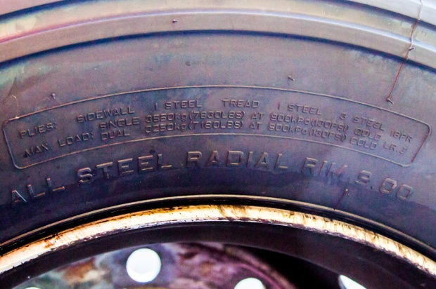

Figure 4 shows the four digit code for the week and year the tyre was manufactured. The tyre in the figure indicates that the tyre was manufactured in the 13th week of 2012.

**Figure 4** Four digit week and year manufacturing mark on tyre

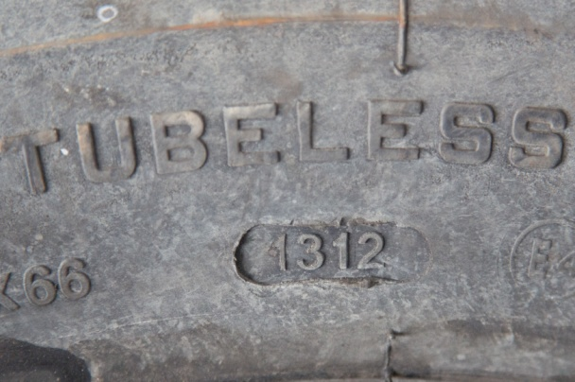

**Figure 5** Delamination of inside tyre

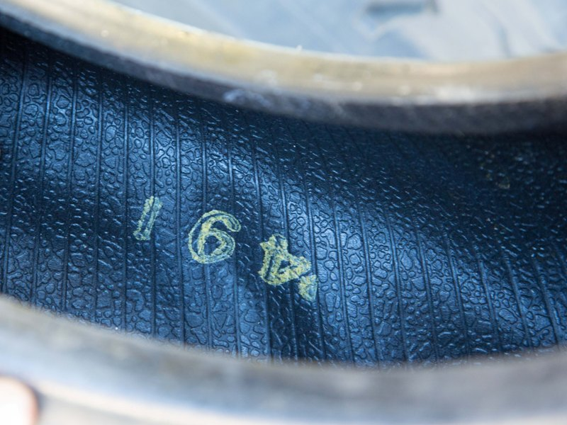

**Figure 6** Damaged side wall which can cause zipper failure

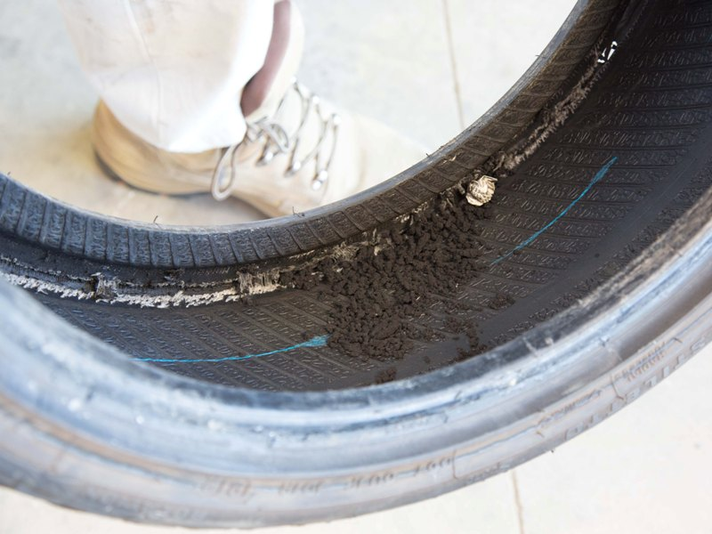

**Figure 7** Delaminated outside tyre

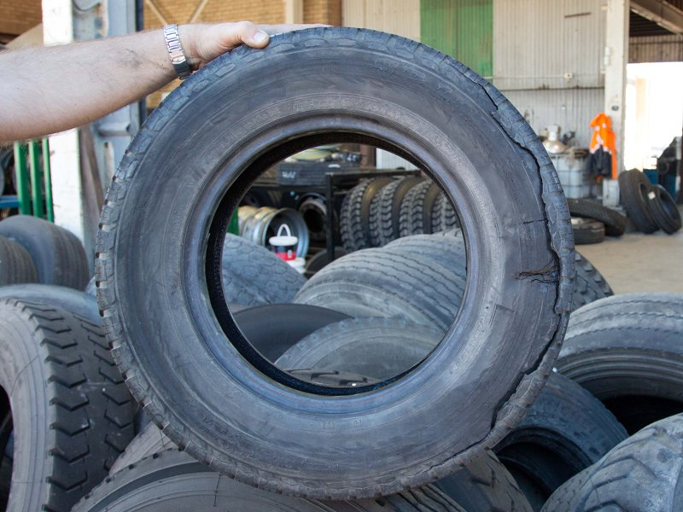

**Figure 8** The wall of the tyre is slightly distorted

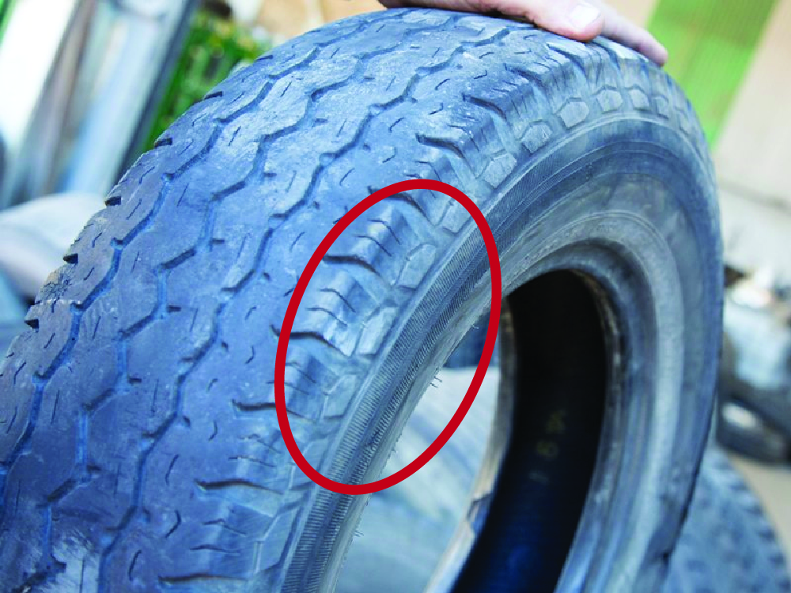

**Figure 9** Shows a rim that is pitted and not serviceable

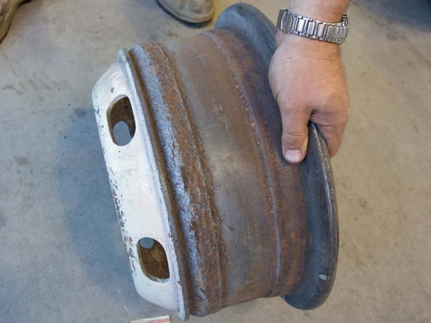

**Figure 10** Shows surface rust (not pitted) can be removed with a powered wire brush

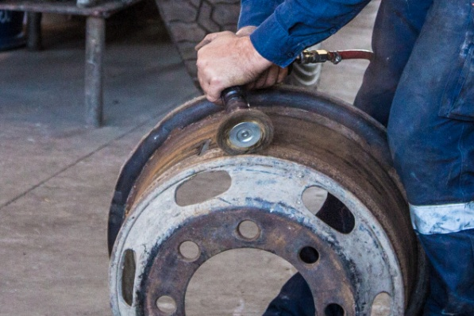

**Figure 11** Rejected rims are identified and isolated

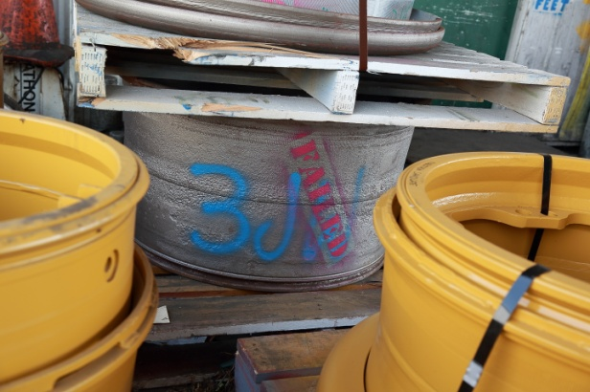

### Assembly

* Only use clean, serviceable and compatible parts. If any doubt, don’t use the components.
* Only use components recommended by the rim or wheel manufacturer.
* Only use lubricants suitable for assembling tyre, rim or wheel.
* Ensure the replacement fasteners are of the correct grade and dimensions.
* When securing the two halves of divided wheels ensure the torque is as per the manufacturer’s recommendations – over-tightening could lead to weakening or stripping the threads.
* Don’t use air pressure alone to seat parts of divided or multi-piece wheels.
* When seating, inflate tyre to a low pressure (generally about 30 kPa or 5 psi) and tap the lock-ring to seat it in the lock-ring groove. Don’t hit the wheel or rim components too hard to seat components. If difficulties arise, deflate the tyre and investigate the problem.

### Inflating tyres

* Don’t inflate tyres beyond the maximum cold pressure recommended by the manufacturer.
* Always keep away from the sidewall (i.e. the flat area on either side of the rolling direction of the tyre), even when the wheel is restrained. Use a long air hose so the tyre can be inflated without the need to be too close to the tyre. There should be at least 3 metres after the gauge and trigger used to control the inflation.
* Use a dump valve capable of rapidly deflating the tyre in the event of an emergency or as soon as you hear or see something unsafe or unusual.

**Figure 12** Location of dump valve for rapid emergency tyre deflation

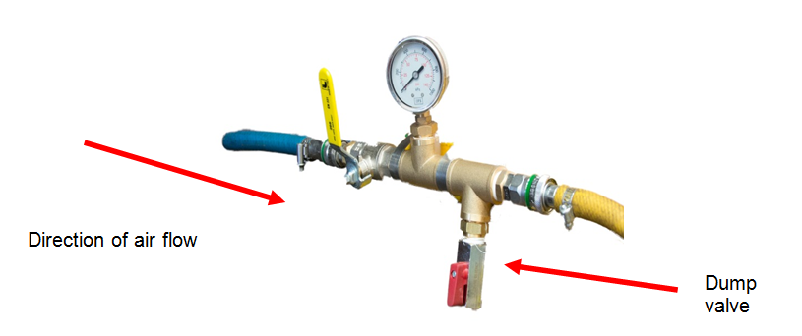

* Place the wheel in a cage before inflating. If a cage is not available use straps or other appropriate measures to control the risks. Straps may restrain flying parts but the whole assembly including the straps can fly apart if, for example a zipper failure occurs. Figure 13 shows the worker inflating the tyre stands outside of the projection area (indicated by the yellow lines).

**Figure 13** A tyre being inflated inside a cage

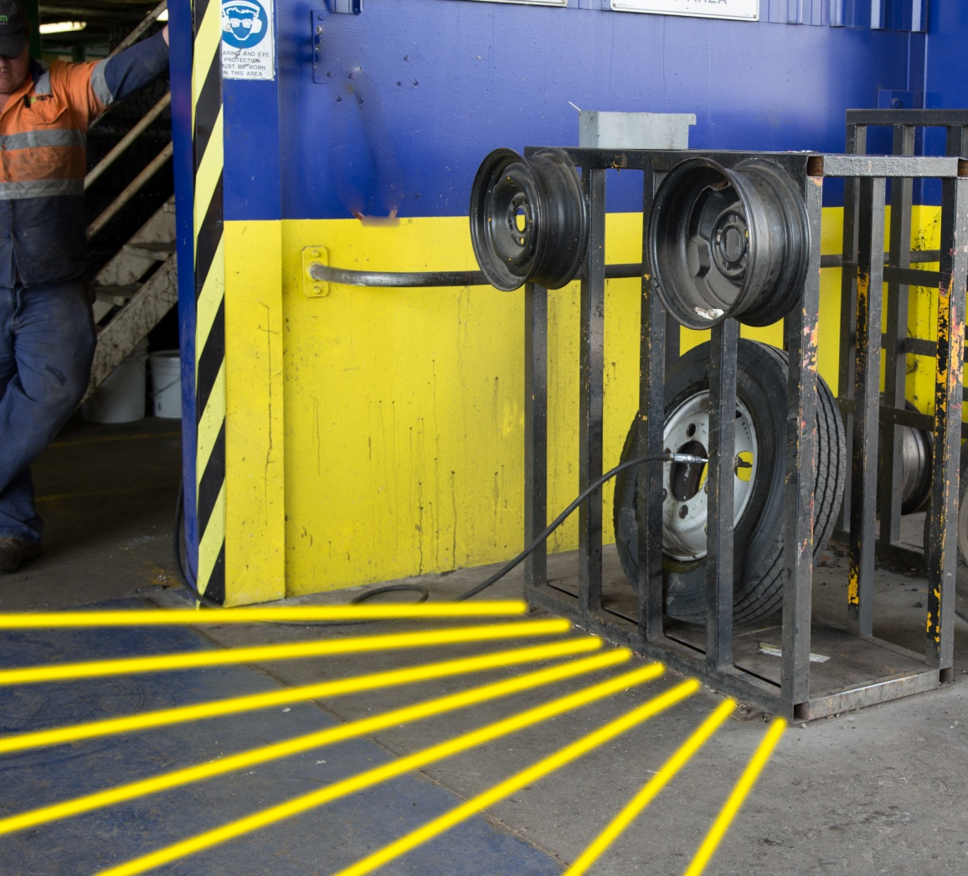

* Some divided wheels obtain full strength only when secured to the vehicle, so they should be inflated after fitting to the vehicle. Others need to be inflated to full pressure in an inflation cage or in another suitable restraining device. See the instruction manual to determine the type of wheel you are working with. If in doubt, inflate to about 30 kPa (5 psi), bolt the wheel to the hub of the vehicle and locate the vehicle in an appropriate area before inflating to full pressure, while standing outside of the projection area.
* Periodically check the functioning of the pressure regulators. Also, calibrate the pressure gauges.

**Figure 14** Tyre cage fitted to a vehicle used to change a split rim

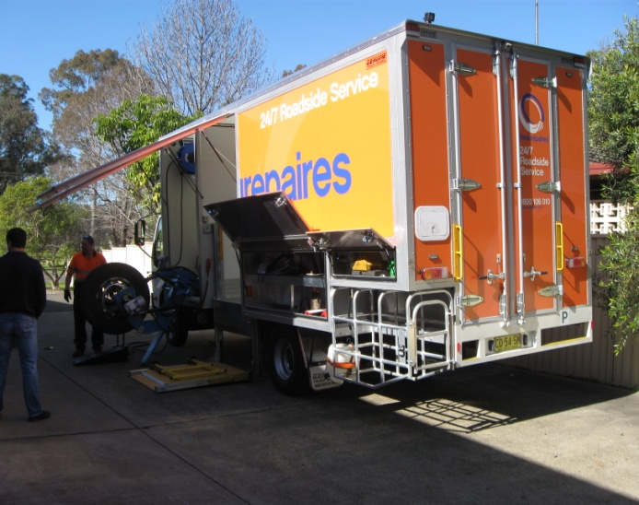 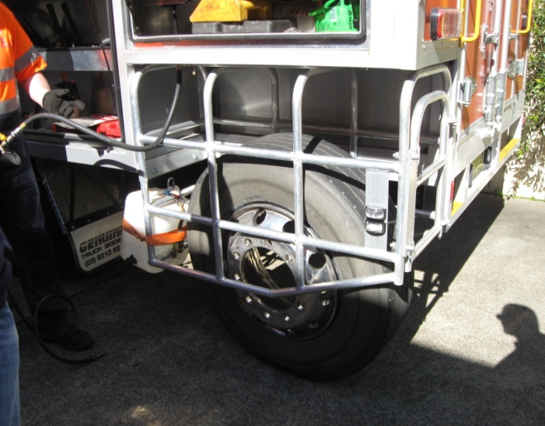

### Pyrolysis

When tyres are subject to excessive temperature, for example hit by lightning or power lines, or welding on wheel rims, a chemical process called pyrolysis occurs. This causes decomposition of the tyre material internally and builds up flammable gases and pressure within the tyre (without any noticeable signs). The tyre then explodes, sometimes up to three days after the build-up begins. If pyrolysis is suspected, deflate the tyre (if safe to do so) or park the vehicle in an isolation zone.

### Compressed air

Maintain the compressed air system in a safe working order. This should include appropriate inspections and maintenance of the compressor, air receiver, gauges, regulators and piping used at the workplace.

Further information is provided in the Information Sheet: *Compressed air and air receiver*.

## Information, training, instruction and supervision

As part of implementing control measures especially the administrative control including the use of PPE, workers must be provided with the information, training, instruction or supervision necessary to protect themselves and others.

Workers should be supervised by a competent person until they can competently undertake the work and should also be provided with regular refresher training as required. Adequate supervision must be provided to ensure the systems in place are followed.

## Glossary

For the purpose of the Guide, *split rim* includes a divided wheel, a multi-piece rim or a multi-piece wheel.   
The terminology used by the tyre industry and the general public are sometimes different. The glossary provides the terminology used by the industry.

*Centre plate* meansthe centre of the wheel, with a series of holes that fit the wheel to the axle hub using nuts or bolts. This is also known as the *nave plate.*

*Demountable rim* means a rim that fits directly onto a tapered hub, using cleats, nuts or bolts (fasteners) or, in some cases, a wedge band and fasteners.

*Divided wheel* means a wheel assembly made up of two halves of a wheel bolted together. Also known as a split rim - one type has two mirror image parts bolted together and other type has a wheel base and a bolt-on flange.

**Figure 15** Parts of a divided wheel

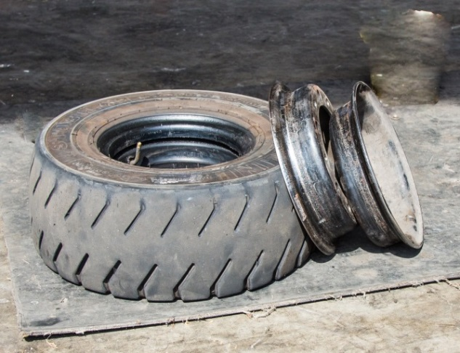

**Figure 16** Use of standard nuts (attaching wheel to hub) and ‘D’ section bolts (securing two parts of   
a divided wheel together)

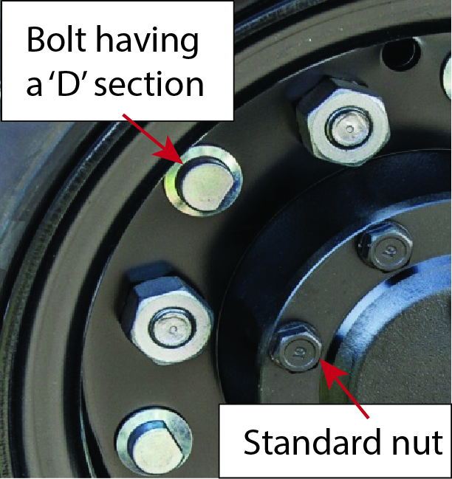

*Hub* means the assembly on the vehicle to which the wheel is fitted.

*Multi-piece wheel* means a wheel made up of two or more components (except divided wheels).

**Figure 17** Multi-piece rims that have more than two pieces

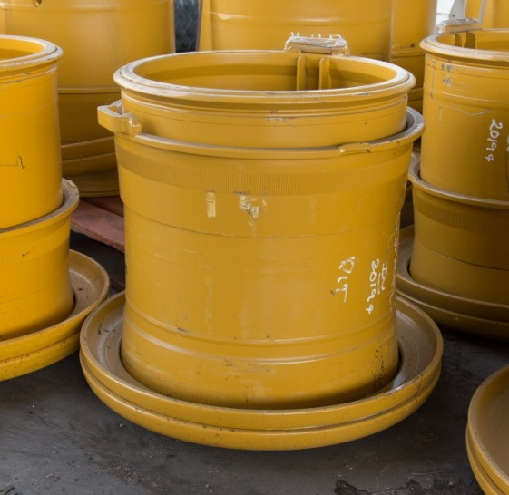 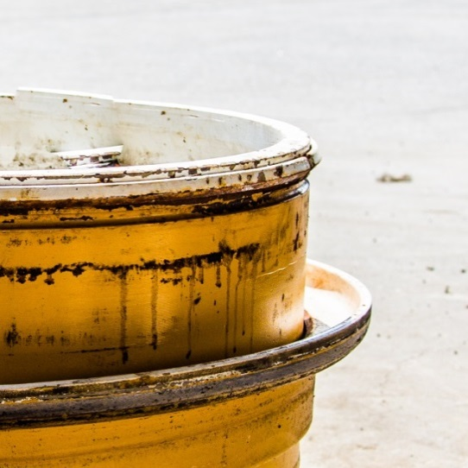

*Nave plate* means centre plate

*Pyrolysis* means decomposition of a substance by the action of heat, and in the case of a tyre, this refers to the decomposition of the tyre materials.

*Rim* means the outer circular part of a wheel or a rim where the tyre is fitted. Rims can be either single-piece or multi-piece. It is common for the terms wheels and rims to be used interchangeably by the general public.

*Rust band* means a rubber band that is placed between the tube and the rim to protect the tubes from rubbing on the rim and damaging it. This also protects the tube from rust that is formed when water enters into the rim of the wheel.

*Single piece wheel* means a wheel assembly that does not have components that can be dismantled. These are used in motor cars and many light trucks.

*Tyres* means a rubber covering that is usually reinforced, located on a rim that can be inflated to provide soft contact with the supporting surface.

*Note:* Pneumatic tyres are filled with air or gases such as nitrogen, solid (also known as resilient) and foam-filled tyres are used on vehicles that travel on smooth surfaces or slowly.

*Wheel* means an assembly made up of a rim and a centre plate. Components of some wheel assemblies can be dismantled. There are three major categories: single piece wheels, divided wheels (split rims) and multi-piece wheels.

*Note:* Wheels do not include tyres

*Zipper failure* means a circumferential fracture of the side wall of the tyre, generally caused by fatigue. Fatigue is usually caused by excessive flexing of the side walls when the pressure drops below 80 per cent of the recommended pressure or the tyre is overloaded.

## Further information

* [Video Safety Alert](http://www.youtube.com/watch?v=wnWwOVm488s): *Split rims and multi-piece wheels*
* [Fact Sheet: *Emergency plans*](http://www.safeworkaustralia.gov.au/sites/swa/about/publications/pages/emergency-plans-fact-sheet)
* [Code of Practice: *Managing the work environment and facilities*](http://www.safeworkaustralia.gov.au/sites/swa/about/publications/pages/environment-facilities-cop)
* [Code of Practice*: Work health and safety consultation, co-operation and co-ordination*](http://www.safeworkaustralia.gov.au/sites/swa/about/publications/pages/consultation-cooperation-coordination-cop).
* [Code of Practice: *Managing the risks of plant in the workplace*](http://www.safeworkaustralia.gov.au/sites/swa/about/publications/pages/managing-the-risks-of-plant-in-the-workplace)
* [Code of Practice*: How to manage work health and safety risks*](http://www.safeworkaustralia.gov.au/sites/swa/about/publications/pages/manage-whs-risks-cop)*.*
* [Information Sheet: *Compressed air and air receiver*](http://www.safeworkaustralia.gov.au/sites/swa/about/publications/pages/guidance-split-rims-and-compressed-air)