QUICK-HITCHES   
FOR EARTHMOVING MACHINERY  
INFORMATION SHEET

## Overview

This information sheet provides advice on managing the risks associated with using quick‑hitches on earthmoving machinery.

For further information see the [Information Sheet:   
*Using other powered mobile plant as a crane*](http://www.safeworkaustralia.gov.au/sites/swa/about/publications/pages/guidance-cranes)*.*

## Quick-hitches

A quick-hitch is a device that is fitted to an excavator or backhoe arm for the purpose of rapidly mounting or dismounting attachments. They are also known as ‘quick couplers’.

There are a number of different types of   
quick-hitches including half-hitch, mechanical, semi-automatic and automatic.

Quick hitches should have two mechanisms to engage the attachment—a primary retaining system and a backup safety system. Specifically:

* A retaining system is the primary retention system that locates the pins of the attachment in the corresponding location on the quick‑hitch or the host machine to retain the attachment.
* A safety system consists of a mechanical‑positive device that prevents the disengagement of the attachment if the primary system fails. Some safety systems not only prevent this disengagement but also prevent the attachment from swinging on one pin if the primary retention system fails.

In the event the primary retaining system fails, working forces should not act on a component of the hitch in a direction that could cause the safety device to disengage. A working force is the force acting on the attachment or the components of the hitch when using attachments as intended, or during foreseeable misuse.

Where a hitch can be engaged from the plant operating position it should be possible to verify correct engagement of the retaining system and the safety device from this position.

Hitches where it is not possible to verify the engagement of the safety device from the operating position are considered to be ‘semi‑automatic hitches’.

*Note:* Like semi-automatic hitches, half hitches and mechanical hitches also require the plant operator to get off their machine to walk up to the hitch and engage both the retaining system and the safety system. However, unlike semi‑automatic hitches there is an incentive to engage the safety system. This is because it is not possible to use the attachment unless someone has approached the hitch and engaged the primary retention system.

The excavator’s hydraulic and electrical system will need to be compatible with the control and actuation system for ‘semi-auto’ and ‘full-auto’ quick-hitches.

## Using quick-hitches

While a quick-hitch saves time and effort a number of fatalities have occurred in Australia   
as a result of attachments detaching from the hitch without warning and striking people.

Quick-hitches may be used many times a day while doing, for example construction or demolition. It is important that at each attachment change the quick-hitch is safely engaged to the attachment and the engagement is verified.

**Figure 1** A semi-automatic quick-hitch

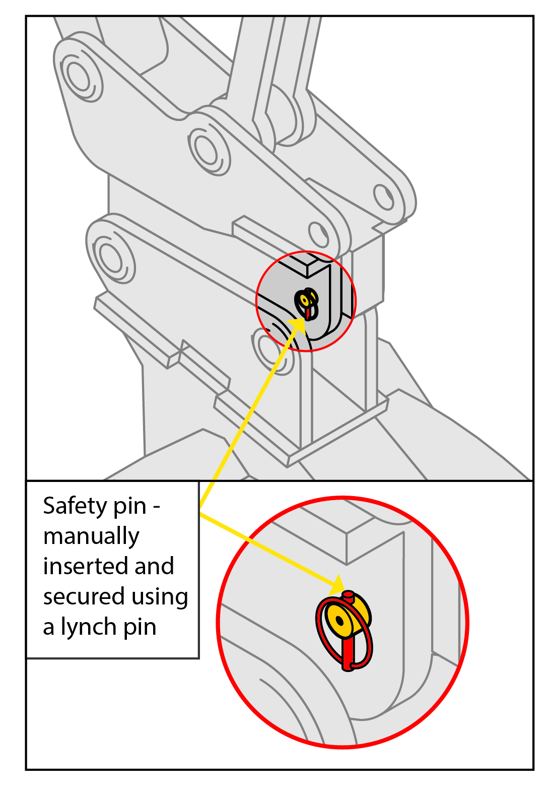

Lynch pins are typically used to secure the safety pin for half, mechanical and semi-automatic quick hitches (see Figure 1). The lynch pin and safety pin must be physically withdrawn and inserted by the operator each time they change an attachment, meaning they have to get off their machine to engage the back-up safety system correctly.

For example, when using a semi-automatic quick hitch the backup safety system must first be removed each time the attachment is to be changed then re-inserted after the new attachment has been engaged. As a result the safety device is sometimes not engaged due   
to the time and effort required.

Engaging the backup safety device can be considered an administrative control because   
it depends on human action.

Automatic quick-hitches are a preferred system   
as they include an engineering control, are reasonably practicable and the safety device can be engaged and verified from the plant operating position.

Where semi-automatic hitches are used they should be connected and used only after engaging the safety system in accordance with the manufacturer’s instructions. A safe system of work should be implemented including checking safety devices are engaged prior to use.

Other measures to prevent unintended detachment from quick-hitches include:

* checking attachments are compatible with the hitch
* checking hitches are compatible with the host machine
* checking the hydraulic system provides the correct pressure to retain attachments
* verifying correct engagement of the primary retention system
* verifying correct engagement of the safety system
* preventing unintended activation of the controls used to disengage the hitch, and
* performing inspection and maintenance of the hydraulic system, hitch and attachment, including checking for excessive wear on the corresponding parts.

Automatic quick-hitches should be inspected and maintained according to the manufacturer’s instructions to ensure safe operation of the automatic devices.

## Operator competency

Powered mobile plant operators must be trained and competent to operate the plant safely. If earthmoving machinery is used in multiple configurations, including through using a quick‑hitch, the plant operator may require more specific training for each of these tasks.

## Further information

Further information on quick-hitches is in   
AS 4772-2008: *Earthmoving machinery-Quickhitches for excavators and backhoe loaders.*

For further information see the Safe Work Australia website [www.swa.gov.au](http://www.safeworkaustralia.gov.au/sites/SWA).