GENERAL GUIDE FOR  
INDUSTRIAL LIFT TRUCKS

This General Guide provides information about managing health and safety risks for people who carry out activities involving industrial lift trucks. It is supported by an [Information Sheet](http://www.safeworkaustralia.gov.au/sites/SWA/about/Publications/Documents/863/Forklifts-Information-sheet.docx) for owners and operators of forklifts.

## What is an industrial lift truck?

**Industrial lift trucks** are powered mobile plant designed to move goods, materials or equipment.   
They are equipped with an elevating load carriage and for normal use, are equipped with a load-holding attachment. There are different types of powered industrial lift trucks including ride-on forklift trucks, pedestrian-operated trucks, straddle carriers and reach trucks.

Mobile cranes, earthmoving machinery and manually-powered lift trucks like pallet lifters are not industrial lift trucks. For the purposes of this Guide, reach stackers, multi-purpose tool carriers and telehandlers   
are not industrial lift trucks.

### What is a forklift truck?

A **forklift truck** is a powered industrial lift truck equipped with lifting media made up of a mast and elevating load carriage with a pair of fork arms or other arms that can be raised 900 mm or more off the ground.

A pedestrian-operated lift truck or a manually powered pallet truck is not a forklift truck.

Forklift trucks are the most commonly used industrial lift truck.

## Who should use this Guide?

You should use this Guide if you own, hire, lease, handle, store, transport, maintain or manage the use   
of an industrial lift truck in the workplace.

## Who has duties under the law?

Everyone in the workplace has a work health and safety duty. The main duties are set out in Table 1.

Table 1 Duty holders and their obligations

| **Who** | **Duties** |
| --- | --- |
| **A person conducting a business or undertaking** | **A person conducting a business or undertaking** must ensure, so far as is reasonably practicable, workers and other people are not exposed to health and safety risks arising from the business or undertaking.  A ‘person conducting a business or undertaking’ is a term that includes all types of working arrangements such as organisations, partnerships, sole traders or small business owners. For example a builder, a manufacturing business, a fast food franchisee and a self-employed person operating their own business are all persons conducting a business or undertaking.  **A person conducting a business or undertaking** must manage risks by eliminating health and safety risks, so far as is reasonably practicable and if it is not reasonably practicable to eliminate the risks, by minimising those risks, so far as is reasonably practicable. It also includes ensuring, so far as is reasonably practicable the:   * provision and maintenance of safe plant including industrial lift trucks, and * safe use, handling, storage and transport of plant.   The Work Health and Safety (WHS) Regulations include specific duties for a person conducting a business or undertaking with management or control of plant, powered mobile plant and plant that lifts or suspends loads.  If you own an industrial lift truck you are the person with management or control of that plant.  If you hire or lease an industrial lift truck, you have management or control of that plant for the period you have hired it. Both you and the person you have hired or leased it from will have duties to eliminate or minimise the risks associated with the plant, so far as is reasonably practicable. |
| **Designers, manufacturers, suppliers and importers** | **Designers, manufacturers, importers and suppliers of plant** must ensure, so far as is reasonably practicable, the plant they design, manufacture, import or supply is without risks to health and safety. This duty includes carrying out analysis, testing or an examination and providing specific information about the plant. Information must, so far as is reasonably practicable, be passed on from the designer through to the manufacturer and supplier to the end user.  Also see the [*Guide to the safe design of plant*](http://www.safeworkaustralia.gov.au/sites/SWA/about/Publications/Documents/858/Guide-Safe-Design-Plant.docx)*,* [*Guide for manufacturing safe plant*](http://www.safeworkaustralia.gov.au/sites/SWA/about/Publications/Documents/858/Guide-Manufacturing-Safe-Plant.docx) and [*Guide to importing and supplying safe plant*](http://www.safeworkaustralia.gov.au/sites/SWA/about/Publications/Documents/858/Guide-Importing-Supplying-Safe-Plant.docx). |
| **Officers** | **Officers**, such as company directors, have a duty to exercise due diligence to ensure the business or undertaking complies with the WHS Act and Regulations. This includes taking reasonable steps to ensure the business or undertaking has and uses appropriate resources and processes to eliminate or minimise risks from plant.  Also see [*Interpretive Guideline - model Work Health and Safety Act - the health and safety duty of an officer under section 27*](http://www.safeworkaustralia.gov.au/sites/swa/about/publications/pages/interpretive-guideline-section-27) |
| **Workers and others** | **Workers and other people at the workplace** must take reasonable care for their own health and safety, co-operate with reasonable policies, procedures and instructions and not adversely affect other people’s health and safety.  A person who operates a forklift truck must hold a high risk work forklift licence. No other industrial lift truck requires a high risk work licence to operate. |

## How can industrial lift truck risks be managed?

Use the following steps to ensure, so far as is reasonably practicable, that workers and other people are not exposed to health and safety risks:

**1. Find out what could cause harm.** The following can help you identify potential hazards:

* Observe the workplace to identify areas where industrial lift trucks operate and how they interact with other vehicles, pedestrians and fixed structures like storage racks.
* Visually inspect the industrial lift truck.
* Ask your workers, pedestrians and visiting delivery drivers about any problems they encounter at your workplace when interacting with industrial lift trucks–consider operation, inspection, maintenance, repair, transport and storage requirements.
* Review your incident and injury records including near misses.

**2. Assess the risk if necessary**. In many cases the risks and related control measures will be well known. In other cases you may need to carry out a risk assessment to identify the likelihood of somebody being harmed by the hazard and how serious the harm could be.

Most incidents involving industrial lift trucks are from:

* the industrial lift truck overturning or the operator being ejected
* collisions with pedestrians or other vehicles working in the same area
* loading and unloading e.g. loads falling on operators or workers, and
* mechanical failure of pressurised systems (e.g. hydraulic) that may release fluids that pose a risk.

People who work with or near industrial lift trucks are most at risk. Customers and visitors may also be at risk. A risk assessment can help you determine what action you should take to control the risk and how urgently the action needs to be taken.

**3. Take action to control the risk.** The WHS laws require a business or undertaking do all that is reasonably practicable to eliminate or minimise risks.

The ways of controlling risks are ranked from the highest level of protection and reliability to the lowest. This ranking is known as the hierarchy of risk control. You must work through this hierarchy to manage risks.

The first thing to consider is whether hazards can be completely removed from the workplace. For example, risks can be eliminated by changing the workplace so materials are delivered directly to the location where they are stored so there is no need to use an industrial lift truck.

If it is not reasonably practicable to completely eliminate the risk then consider one or more of the following options in the order they appear below to minimise risks, so far as is reasonably practicable:

* substituting the hazard for something safer e.g. use a manually-powered lift truck or pedestrian-operated lift truck instead of a ride-on forklift truck
* isolating the hazard from people e.g. by installing physical barriers that separate people from operating industrial lift trucks
* using engineering controls e.g. using a falling object protective structure (FOPS) or a roll over protective structure (ROPS), or a combination of both.

If after implementing the above control measures a risk still remains, consider the following controls in the order below to minimise the remaining risk, so far as is reasonably practicable:

* using administrative controls e.g. schedule delivery times to avoid or reduce the need for pedestrians and vehicles to interact, or
* using personal protective equipment (PPE) e.g. high visibility clothing and eye protection.

A combination of the controls set out above may be used if a single control is not enough to minimise the risks.

You need to consider all possible control measures and make a decision about which are reasonably practicable for your workplace. Deciding what is reasonably practicable includes the availability and suitability of control measures, with a preference for using substitution, isolation or engineering controls to minimise risks before using administrative controls or PPE. Cost may also be relevant, but you can only consider this after all other factors have been taken into account.

**4. Check your control measures** regularly to ensure they are working as planned. Control measures need to be regularly reviewed to make sure they remain effective, taking into consideration any changes, the nature and duration of work and that the system is working as planned.

Further information on the risk management process is in the [Code of Practice*: How to manage work health and safety risks*](http://www.safeworkaustralia.gov.au/sites/swa/about/publications/pages/manage-whs-risks-cop)*.*

More information on managing the risks of plant is in the [Code of Practice: *Managing risks of plant in the workplace*](http://www.safeworkaustralia.gov.au/sites/swa/about/publications/pages/managing-the-risks-of-plant-in-the-workplace).

## Who is involved?

You must consult your workers and their health and safety representatives (if any) when deciding how to manage the risks of using an industrial lift truck in the workplace.

If there is more than one business or undertaking involved at your workplace you must consult them to find out who is doing what and work together so risks are eliminated or minimised, so far as is reasonably practicable.

This may involve discussing site-specific requirements including the type of industrial lift truck to use, operator training and traffic management e.g. vehicle and pedestrian routes, delivery areas and loading and unloading arrangements.

Further information on consultation requirements is in the [Code of Practice*: Work health and safety consultation, co-operation and co-ordination*](http://www.safeworkaustralia.gov.au/sites/swa/about/publications/pages/consultation-cooperation-coordination-cop).

# USING INDUSTRIAL LIFT TRUCKS

When using industrial lift trucks in the workplace you should:

* ensure the industrial lift truck is suitable for the work to be done and is in a safe condition
* check if work areas are designed, established and maintained for safe operation
* complete pre-start safety checks, and
* prepare and follow safe work procedures for operation, shut down and maintenance.

## Information, training, instruction and supervision

A person conducting a business or undertaking must ensure people who operate industrial lift trucks:

* hold a valid high risk work licence for the type of industrial lift truck they are operating
* are trained to operate the type(s) of industrial lift truck(s) and attachments they are using, and
* are provided with information, training and instruction on the hazards, risks and control measures relevant to the workplace.

Operators should have easy access to the manufacturer’s instructions to operate industrial lift trucks safely. Specific training on how to operate industrial lift trucks should be provided by a competent person. The training should cover:

* information on the industrial lift trucks used including:
  + position, function and operating sequence of controls and instruments including seat adjustment controls
  + relevant design features and centre of gravity
  + attachments and components that can be used
  + how to estimate the load centre and mass of the item to be lifted
  + capacity, stability and limitations
* safety features e.g. guarding, emergency stop controls and warning devices
* safe work practices that apply to relevant work areas including the safety of pedestrians
* operating conditions including traffic rules, rights of way and clearances from overhead electric lines
* procedures for reporting faults, unsafe practices, damage, incidents or near misses
* inspection, maintenance and repair responsibilities, and
* emergency procedures.

Management systems should be in place to ensure:

* only those workers who hold a relevant high risk work licence and have received the required training and instruction carry out the work
* work is supervised so safe work procedures are followed, and
* trainee operators are supervised by a competent person.

## Choosing an industrial lift truck

Before you choose an industrial lift truck you should discuss your workplace needs with suppliers and identify industrial lift trucks that are most suited to the workplace and the work it will be used for. For example, a pedestrian operated industrial lift truck may be more suitable to minimise traffic movement risks in a small, busy workplace than a ride-on industrial lift truck.

A second-hand industrial lift truck is more likely to have out-dated or missing safety features. Suppliers of a second-hand lift truck must do what is reasonably practicable to supply equipment that is safe to use at work.

Some of the things to look for when choosing an industrial lift truck are:

* operator protective devices e.g. ROPS and FOPS
* integrated guarding e.g. for engine and battery compartments
* safe entry and exit e.g. enough steps and handholds
* low noise and vibration e.g. through a sprung and adjustable seat
* a fork load back-rest high enough to prevent the load or part of the load falling back onto the operator
* good visibility e.g. adjustable rear vision mirrors of enough size
* operator activated warning device (e.g. a horn)
* flow restrictors or similar, fitted to hydraulic lines to prevent free fall in the event of hydraulic hose failure e.g. when lifting people in a work box
* emission control systems or forklifts that do not produce emissions e.g. if the industrial lift truck will be working in a poorly ventilated area e.g. cold stores, and
* flame and static proofing e.g. if the industrial lift truck will be working in or near areas containing flammable or combustible atmospheres or materials.

Further information on powered mobile plant requirements is in the [Code of Practice: *Managing the risks of plant at the workplace*](http://www.safeworkaustralia.gov.au/sites/swa/about/publications/pages/managing-the-risks-of-plant-in-the-workplace).

## Operator controls

Badly designed or maintained operator controls can make an industrial lift truck unsafe and it may operate unpredictably. Operator controls must be:

* identified on the lift truck to indicate their nature, function and direction of operation
* located so they are readily and conveniently operated by each person using the industrial lift truck
* located or guarded to stop unintentional activation, and
* able to be locked into the “off” position to allow the disconnection of all motive power.

## Traffic management

Industrial lift trucks must not collide with pedestrians or other powered mobile plant. If there is a possibility of an industrial lift truck colliding with pedestrians or other vehicles you:

* must ensure the industrial lift truck has a warning device that will warn people of the movement of the industrial lift truck e.g. a horn or reversing alarms
* should set-up the workplace so industrial lift trucks, pedestrians and other vehicles are separated and their paths do not cross
* should provide dedicated loading and unloading areas.

Work areas should be designed and maintained so industrial lift trucks can be operated safely. Some of the control measures to consider and how they can be used are listed in Table 2.

**Table 2** Types of control measures and how they can be used

| **Control Measures** | **Examples of how to use control measures** |
| --- | --- |
| **Barricades** | Separating pedestrian and traffic areas with physical barriers can prevent pedestrians entering areas where industrial lift trucks are working. |
| **Bollards or guard rails** | These can be installed inside and outside on both sides of doorways used by industrial lift trucks to minimise the risk of collision with the doorway, pedestrians, other vehicles or immovable objects. Bollards and guard rails should be clearly identified e.g. painted with black and yellow diagonal stripes. |
| **Doors** | Doors made of transparent material can assist visibility and minimise, so far as is reasonably practicable, the risk of collision. |
| **Speed limits and speed humps** | Apply work area speed limits and install speed limiting devices in ride-on industrial lift trucks to control speed. Speed humps are unsuitable for controlling the speed of industrial lift trucks. Where they are installed to control other vehicles, provision should be made for industrial lift trucks to by-pass the speed humps. |
| **Satisfactory lighting** | This must be provided, so far as is reasonably practicable including in work areas where industrial lift trucks operate. The area immediately inside a building where industrial lift trucks enter should be well lit to avoid vision problems when passing from bright sunlight into a poorly lit area. Travelling in and out of covered areas creates a risk to operators who wear photo-chromatic glasses. These glasses darken as light intensity increases. |
| **Satisfactory ventilation** | This must be provided, so far as is reasonably practicable including in work areas where industrial lift trucks powered by Liquefied Petroleum Gas (LPG), petrol and diesel fuel are used so as to minimise the concentration of exhaust gas contaminants. Battery powered industrial lift trucks should be used in poorly ventilated or enclosed areas.  If it is necessary to use a combustion engine powered industrial lift truck in a poorly ventilated area like a shipping container or cool store it is preferable to use a diesel powered unit. This is because diesel engines produce less carbon monoxide than petrol or LPG powered units, noting diesel produces a visibly dirtier exhaust. Regular engine tuning and air monitoring should be carried out to minimise the exhaust of carbon monoxide and diesel particulates. Where reasonably practicable, avoid using powered mobile plant within an enclosed area.  If an industrial lift truck has to operate in a potentially flammable gas or combustible dust atmosphere, it should meet the relevant standard including the requirements for use in hazardous areas. |
| **Ramps** | These should be secure, robust, provided with edge protection, not exceed the manufacturer’s specific gradient for operating the industrial lift truck and be installed at points where an industrial lift truck needs to be driven from one level  to another. |
| **Loading docks** | Satisfactory edge protection or a system of work to minimise the risk of industrial lift trucks falling or being driven over the edge of a loading dock should be provided. The system could include clearly defined operating areas by line marking at least 2 metres from an exposed edge with the area between the line and the edge declared an industrial lift truck exclusion zone. |

For more information see the [*General guide for workplace traffic management*](http://www.safeworkaustralia.gov.au/sites/SWA/about/Publications/Documents/864/Traffic-Management-General-Guide.docx).

## Pre-start safety check

A pre-start safety check should be completed every time an operator uses a different industrial lift truck and at the beginning of each shift.

The pre-start safety check should include:

* reading the load rating plates to ensure the industrial lift truck and attachments are right for the task
* inspecting lift and tilt systems including attachments e.g. clamps, hydraulic lines for oil leaks, chains, cables and whether limiters are operating properly and safely
* checking steering, brakes including park brakes, operating controls and lights are operational
* inspecting each tyre for wear, damage and inflation for pneumatic types
* checking guarding is in place and functional e.g. around the battery compartment or fuel lines
* checking that warning devices are operational
* inspecting fork arms and attachments for deformation, damage or wear
* checking liquid levels e.g. hydraulic oil, brake fluid and water
* inspecting gas cylinders where necessary and their securing system, and
* testing seat belts to make sure they work reliably.

## Operating an industrial lift truck

A person who operates a forklift truck must hold a high risk work forklift licence. No other industrial lift truck requires a high risk work licence to operate.

For high risk work licensing purposes:

* a forklift truck does not include a pedestrian-operated truck or a pallet truck, and
* an order-picking forklift truck is where the operator’s controls are incorporated with the lifting media and elevate with the lifting media.

A tractor fitted with ‘lifting media made up of a mast and elevating load carriage to which is attached a pair of fork arms or other arms’ is a forklift truck for high risk work licensing purposes and a licence is required (see Figure 1). A licence is not required to operate a tractor with front end loader style lifting arms (see Figure 2).

**Figure 1** Tractor with mast and lifting arms is classified as a forklift truck

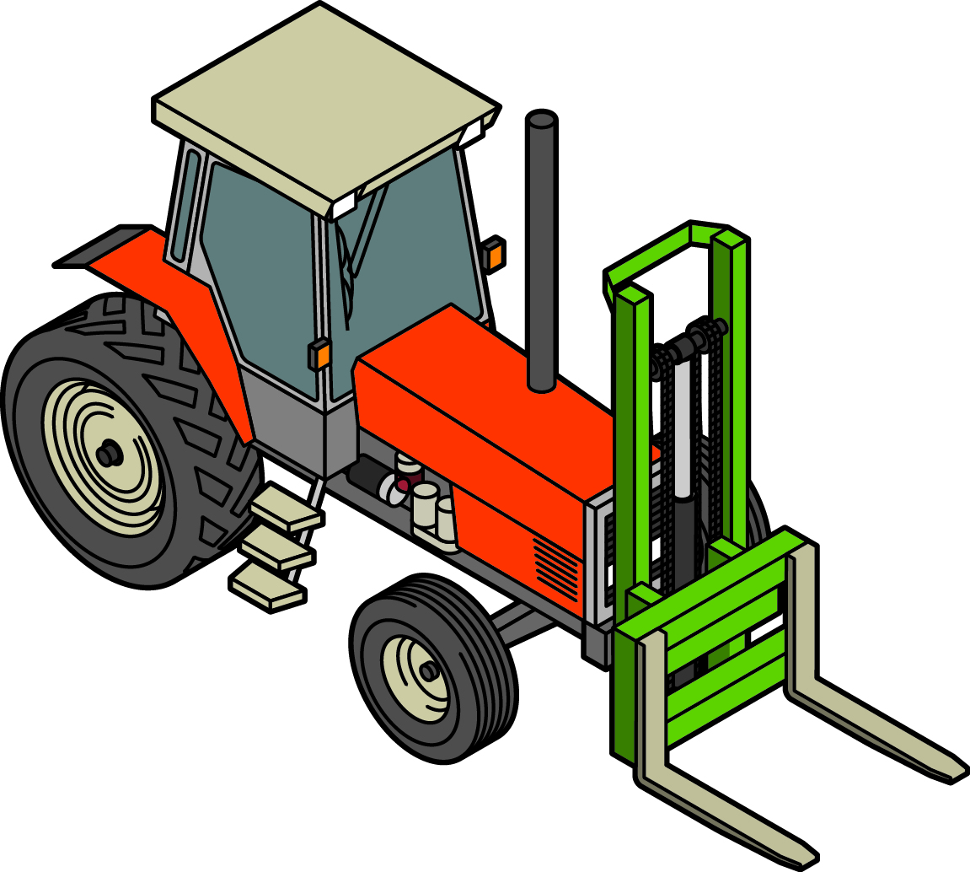

**Figure 2** Tractor with front end loader style lifting arms is not a forklift truck

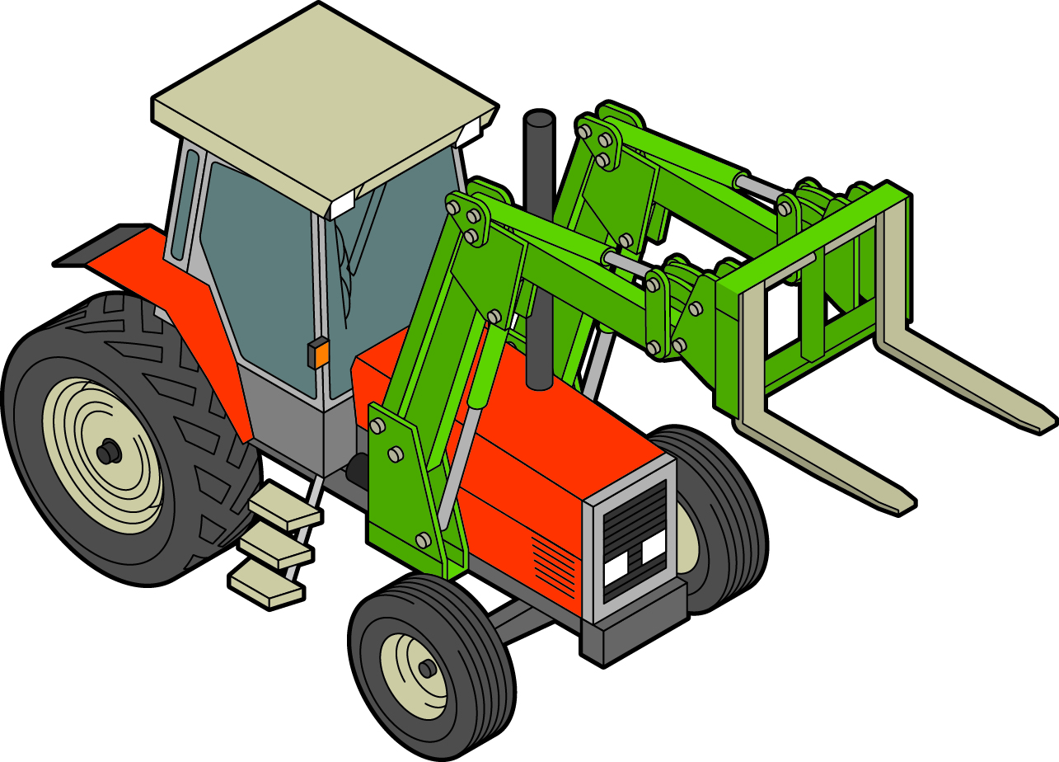

Training for a high risk work licence must be completed as part of a course delivered by a Registered Training Organisation (RTO). A person training to operate a forklift can operate a forklift truck at their workplace if they are:

* enrolled with an RTO to train as a forklift truck operator, and
* directly supervised while operating the forklift truck by a person who has both the relevant licence to perform the high risk work and suitable workplace experience.

Examples of when a high risk work licence is required to operate common types of forklift trucks are listed in Table 2.

Table 2 High risk work licences

| **Type of forklift truck** | **Operator licence required** |
| --- | --- |
| Counterbalanced forklift truck | Yes |
| Side-loading forklift truck | Yes |
| Container forklift truck | Yes |
| Reach forklift truck | Yes |
| Order-picking forklift truck | Yes |
| Rider seated powered high-lift pallet truck | Yes |
| Rider seated powered low-lift pallet truck | No |
| Powered pedestrian-operated lift truck | No |
| Straddle carrier | No |

Before operating an industrial lift truck you must ensure it is equipped with lifting attachments that are right for the load to be lifted or moved by the truck.

You must ensure the industrial lift truck is not used to carry a passenger unless:

* the truck is designed to carry a seated passenger
* the passenger seat is fitted with suitable seat restraints, and
* the passenger seat is protected by the operator protective device fitted to the industrial lift truck.

You must take all reasonable steps to ensure a passenger is seated in the passenger seat provided.

Where seat restraints are provided they should be used unless a risk assessment indicates it is not safe to do so and alternate risk controls are implemented. Pedestrian-operated industrial lift trucks do not need seat restraints.

Industrial lift trucks should be operated according to the manufacturer’s instructions and within the manufacturer’s design parameters. For example it is not safe to use an industrial lift truck in an area with a potentially explosive atmosphere unless it has been specifically designed or modified for such use.

Operators should have easy access to the manufacturer’s instructions and be trained so they can operate an industrial lift truck safely including:

* the position, function and operating sequence of controls and instruments including seat adjustment controls
* the specific design features including the capacity, stability and limitations like the centre of gravity and how to estimate the load centre and mass of the item to be lifted
* attachments and components that can be used
* safety features e.g. guarding, emergency stop controls and warning devices
* operating conditions including traffic rules, rights of way and clearances from overhead power or electricity lines
* safe work practices that apply to the work areas including the safety of pedestrians
* procedures for reporting faults, unsafe practices, damage, incidents or near misses
* inspection, maintenance and repair responsibilities, and
* emergency procedures.

Where reasonably practicable, you should not drive in reverse unless the industrial lift truck has controls that can be turned 180 degrees or dual controls. Long periods of driving in reverse can cause neck problems for operators. At all times you should have clear vision, free of obstacles.

## Loads

You must use an industrial lift truck that is designed to lift or suspend the load to be lifted. The lifting attachments must be suitable for the load and within the safe working limits of the industrial lift truck.

When suspending or lifting a load you must ensure, so far as reasonably practicable, that it is:

* not lifted over a person unless the industrial lift truck is specifically designed for that purpose
* lifted in a way where you are in control during the activity, and
* not lifted at the same time by more than one industrial lift truck unless the method of lifting ensures that the load placed on each item of plant does not go beyond the design capacity of the industrial lift truck.

The weight, shape, size and composition of a load can change the way it can be lifted safely. Every industrial lift truck should have a manufacturer’s data plate and load chart attached in clear view. These two items may be combined on one plate.

The data plate should clearly show the:

* make, model number and serial number
* mast tilt (degrees), forward and rear
* maximum lift height (metres)
* tyre pressures (Kpa), if pneumatic, and
* gross vehicle mass (kgs) and steer axle load (kgs) - unloaded with mast vertical - or drive axle loads (kgs).

The load chart should clearly show the rated load capacity (kgs) at certain load centre distance (mm) and at maximum lift height (metres) with mast vertical. It is critical to limit the load to the rated load capacity of the industrial lift truck or attachment as shown on the load chart.

If the rated load capacity is changed as a result of changes to the industrial lift truck or its attachments, the load chart should be revised before use. Each attachment should have its own load chart to help the operator.

Operators should be able to calculate whether loads of varying shapes and masses can be safely lifted by the industrial lift trucks to ensure they do not exceed the capacity of the machine.

Loads should be firmly placed against the carriage or back-rest with the mast tilted back enough to stop the load slipping, falling or rolling off the fork arms. Loads that have the ability to slip, fall or roll off the fork arms or pallet should be restrained with straps or similar.

Loads should always be carried as near to the ground as reasonably practicable. Operators should not drive an industrial lift truck with a raised load.

When handling a suspended load the operator should:

* secure the load across both fork arms for balance, using an attachment designed to be used on the industrial lift truck
* not go over the de-rated capacity of the industrial lift truck or the rated capacity of the attachment
* only lift the load vertically (straight up) with no dragging or off-vertical lifts
* move slowly and cautiously when the load is raised, and
* travel with the load as low as reasonably practicable.

If bulk bags like flexible intermediate bulk containers or similar loads are suspended from the forks of an industrial lift truck, the lifting capacity should be reduced by a safety factor of at least 20 percent to allow for the dynamic forces introduced as a result of sudden stops, starts or turns causing the load to swing.

## Instability

A common risk is for an industrial lift truck to tip over by rolling or overturning sideways, or by pitching forward when the back wheels lift off the ground. A loss of stability creates a risk of serious injury or harm to the operator and pedestrians.

Industrial lift trucks can tip over if the operator:

* drives with a raised load with the fork arms too high
* turns too fast
* carries a load facing down a slope or an unevenly balanced load
* speeds up too quickly in reverse
* brakes too quickly, especially on a loaded industrial lift truck
* brakes or speeds up while cornering or driving down a slope
* collides with another vehicle
* drives across slopes or uneven ground
* strikes low doors or overhead structures, or
* uses it to tow, push or pull something when it is not designed for this.

Rapid tail swing can cause an industrial lift truck to tip over. The speed of rear end swing will be up to three times that of the industrial lift truck’s forward speed. To avoid rapid tail swing, operators should reduce speed when turning. They should be aware the tail swing causes exaggerated movement of the tail and fork tips.

The centre of gravity (CG) in Figure 3 must remain within this triangle of stability (A-B-C). If the centre   
of gravity falls outside the triangle, the forklift will tip over. This explains why a forklift without a load can easily tip over with a simple sharp turn, even on a level surface.

**Figure 3** Triangle of stability

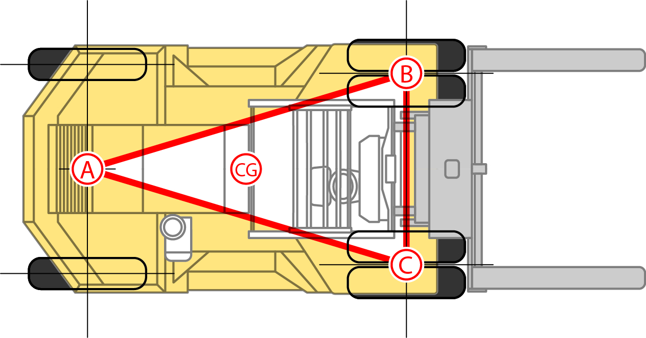

To avoid overturning, operators should:

* centre loads—this means having their centre of gravity on the industrial lift truck’s longitudinal centre line
* for loads with one end heavier than the other e.g. connecting rods for large engines, the heavy end should be nearer the centre line than the light end; or if multiple uneven units are to be carried on a pallet they should be located so every second unit is reversed—this means the first unit should have the heavy end to the right, the second unit should have the heavy end to the left and so on
* correctly secure the load on the pallet
* carry loads as close as reasonably practicable, to the ground or other supporting surfaces
* make sure tyres, where applicable, are correctly inflated as under inflated tyres can reduce stability
* do not travel across a slope greater than that recommended by the manufacturer, and
* slow down when driving across a sloping, uneven or wet surface.

## Work platforms and boxes

Some industrial lift trucks are designed to lift people. For example, an ‘order-picking industrial lift truck’ has an elevating platform that allows the operator to load shelves as well as control platform height and steer the industrial lift truck. If you use a separate work platform or box fitted to an industrial lift truck to lift people then you must ensure people in a work box:

* are securely attached
* stay largely within the workbox
* wear a safety harness if there is a risk of falling from a height, and
* can safely exit from the workbox and the industrial lift truck in the event of a failure in its normal operation.

Forklift trucks may be used to provide a safe work platform (see Figures 4 and 5). Work platforms and boxes should only be used to raise people performing occasional tasks and must be securely attached to the industrial lift truck. The industrial lift truck operator should perform an initial trial lift without a person in the work box to check the work box has a clear path and will not make contact with overhead power lines or other overhead obstructions.

**Figure 4** An example of an engineer-designed work box correctly positioned on the fork arms, with a safety harness and lanyard

**Figure 5** It is not safe to use a forklift as a work platform or to gain extra height by standing on the fork arms or a pallet

Figure 4 shows a person in a safety harness securely attached by a lanyard to an engineer-designed work box correctly positioned on the forklift tynes. This provides a safe work platform.

Figure 5 shows a person standing on a pallet on the forklift tynes to gain extra height. This is an unsafe work platform.

The following risk control measures should be put in place when using work platforms or boxes:

* Industrial lift trucks are equipped with flow restrictors or similar i.e. the valves in the hydraulic lines   
  to prevent free fall in the event of a hose failure.
* Work boxes should only be attached to a compliant industrial lift truck with a load capacity data plate that says which attachments may be used.
* The industrial lift truck is to be stabilised at all times while lifting people and preferably only used on   
  a hard, even and level surface.
* Before work starts make sure the parking brake is set, the vehicle drive controls are in neutral, the mast is vertical and hydraulic controls are off except lift and lower.
* Workers are trained to use work boxes safely including emergency procedures so occupants can be rescued if an incident or breakdown happens.
* Workers stand on the floor of the work box, not on a ladder or other object.
* Where possible, work boxes are not used to transport people.
* The operator of the industrial lift truck stays at the controls at all times.
* The work box safety gate is self-locking and kept shut when in the raised position.

Work box fall arrest anchorage points should meet the requirements of the work box manufacturer’s instructions or those of a competent person. Each fall arrest anchorage point should be located so a lanyard can be attached to it before the person using the lanyard moves into a position where they could fall. Installed anchorage points should be tested and approved by a competent person before they are used as a visual inspection may not reveal poor installation.

## Lifting Attachments

You must ensure that the industrial lift truck is equipped with lifting attachments that are right for the load to be lifted or moved by the truck. The attachment should be securely connected to the industrial lift truck prior to operation to prevent it separating from the lifting media.

Many specialised attachments are available for industrial lift trucks including slippers, bin lifters, carpet spikes, jibs, spreaders and drum handlers (see Figure 6 and Figure 7).

**Figure 6** Drum handler **Figure 7** Jib attachment

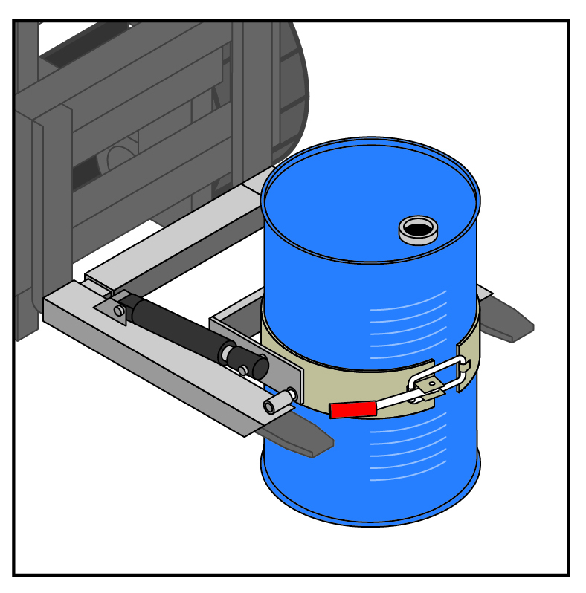 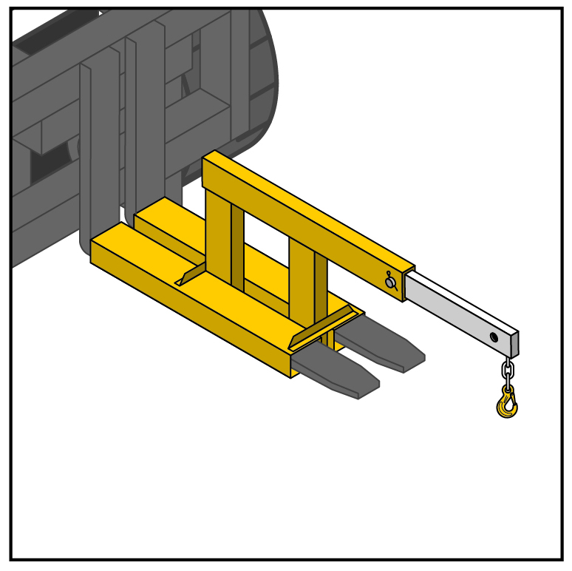

When choosing an attachment, check with the manufacturer or supplier of the industrial lift truck whether it can be used safely. If you fabricate an attachment, it must be designed by a competent person, for example an engineer, for the industrial lift truck it is to be used with. Specific training and supervision in the use of an attachment should be provided as necessary.

When an attachment is fitted to an industrial lift truck the centre of gravity can change, making it necessary to de-rate the lift truck capacity and restrict some operating controls. The load rating for the combination of the industrial lift truck and the attachment depends on the rating of the attachment and capacity of the lift truck. This means the load chart should name the attachment and show the corresponding capacity of the lift truck when using the attachment. The load chart can show ratings for using more than one attachment. Attachments like jibs have more than one lifting point and the load chart should show the lifting capacity for each point.

If an attachment is fitted to an industrial lift truck, ensure you have access to information on the de-rated capacity of the industrial lift truck. By using the industrial lift truck load chart and the information with the attachment, often found on the attachment’s load rating plate, the de-rated capacity of the industrial lift truck can be calculated.

Holes should not be drilled or cut through attachments or lifting media, for example fork arms, as this can weaken and destroy the integrity of the attachment. Changes should not be carried out unless they have been specified by a competent person, for example a mechanical engineer.

## Lifting a load using more than one industrial lift truck

No load should be lifted at the same time by more than one industrial lift truck unless the method of lifting ensures the load placed on each item will not go over the design capacity of the industrial lift truck.

Using two industrial lift trucks at the same time to handle a common load is dangerous and needs extra controls put into place. It is only allowed when it is not reasonably practicable to lift the load with a single lift truck and there is no other reasonably practicable safer option.

Where two industrial lift trucks are used at the same time to handle a common load, each lift truck should be operated by an experienced operator. The whole operation should be co-ordinated by an experienced third person who is competent to supervise the lift.

The multi-vehicle lift should be planned and discussed between both operators and the co-ordinator, before lifting starts. The methods of signalling and other communication between those involved should also be agreed and used. Radio communication is not enough unless it is kept free from interference from other radio systems and allows clear communication at all times.

You should check that the:

* industrial lift trucks used are identical or are selected relevant to the sharing of the load to be lifted
* load applied to each lift truck does not go over 75 percent of the load capacity of the industrial lift truck, and
* the distance a load is carried is the minimum necessary to load, unload or place the load.

## Ramps and loading docks

Before using an industrial lift truck on a slope, for example when driving it onto another vehicle, the operator should:

* check the brakes on the trailer or rail wagon being unloaded are set and the wheels chocked
* check a disconnected trailer is able to carry the combined weight of the industrial lift truck and the load along its whole length
* inspect the trailer or rail wagon floor for defects and judge whether the floor will support the mass   
  of the industrial lift truck and its load
* place the load on the uphill side when travelling up or down a slope
* ensure the mast is tilted back enough so the load being carried does not slide or roll off and in the process possibly overturn the industrial lift truck
* check the ramps are wide enough and maintained in a safe condition, and
* when travelling up or down a slope without a load make sure the forks are on the downhill side   
  e.g. reverse up and drive down.

Raised edges or buffers should be fitted on loading docks and ramps where there is a risk a wheel may be driven over an edge.

## Working near electrical lines

You must ensure, so far as is reasonably practicable, that no person or industrial lift truck at the workplace comes within an unsafe distance of an overhead or underground electric line.

If this is not reasonably practicable then you must carry out a risk assessment and implement control measures to manage the risks. The control measures must be consistent with any requirements of the electrical supply authority.

Electric lines pose significant risks including electrocution, arcing, explosion or fire causing burns, unpredictable cable whiplash and other things being electrified like signs, poles, trees or branches. Contact with energised overhead or underground electric lines can be fatal, whether they are carrying   
a voltage as high as 400 000 V or as low as 230 V. It is not necessary to touch an overhead electric line to be electrocuted. A ‘flashover’ or ‘arc’ can electrocute anyone close to a line conductor.

Most risks can be controlled by taking note of safe working distances for people and industrial lift trucks working near electric lines. Safe working distances will depend on the type of work being carried out and the voltage of the electric lines. You should contact the electricity supply authority to find out the type   
of control measures needed. This may include isolating the electric line for the duration of the work.

Contact with energised overhead electric lines may have an impact on mechanical aspects of the industrial lift truck, for example tyres, hydraulic and electrical systems. The industrial lift truck should   
be placed out-of-service straight away until it has been inspected by a competent person and is deemed safe to resume normal operation.

Further information about electrical safety is in the [*General guide for* *working in the vicinity of overhead and underground electric lines*](http://www.safeworkaustralia.gov.au/sites/SWA/about/Publications/Documents/859/Overhead-Underground-Electric-Lines-General-Guide.docx)and from the Electricity Regulator.

## Fuel handling and storage

Liquid fuel should be handled and stored in accordance with the relevant standard for the handling   
and storage of flammable and combustible liquids.

LPG should be handled and stored in accordance with the relevant standards. Industrial lift trucks powered by an LPG engine should be refuelled, parked and stored in well-ventilated areas a safe distance from combustible material, heat sources, ignition sources or open pits, unless the pits are   
well ventilated.

Only people who have received proper training should remove empty LPG cylinders from industrial lift trucks and install full LPG cylinders. Cylinders should be placed so the safety relief valve is facing in   
a direction (usually upwards) which would allow the release of vapour only if the relief valve operates.

The LPG cylinder valve should be turned off when the industrial lift truck is not in use.

## Battery charging and changing

The charging and changing of batteries at battery charging installations should be done according to the manufacturer’s instructions. Only people who have received proper training should be allowed to charge and change batteries on industrial lift trucks. Where PPE like face shields, aprons and rubber gloves are provided the worker must, so far as the worker is reasonably able, use or wear the equipment in line with information, training or reasonable instruction given.

The industrial lift truck should be parked in a safe position and the parking brake applied before battery charging begins. Operators should check the vent caps in the batteries are functioning correctly and stay in place during charging to prevent electrolyte spraying.

The cover over the battery should be held open while the battery is on charge to allow any generated gases to escape. Potentially explosive hydrogen gas is generated during the charging process.

People involved in a battery charging operation should consider the following safety precautions:

* No smoking.
* No open flames.
* Do not use mobile phones or other electronic devices.
* Do not use metal objects that might strike a spark near battery cells.
* Use the right tools for the task.
* Wear eye protection and other PPE as required.
* Remove rings and bracelets.

In areas where batteries are charged or changed, it is important there are washing facilities including   
eye washing and cleaning-up facilities for removing acid spills. If acid is spilt a ‘spill kit’ should be on hand to remove the hazard. If workers are splashed with battery acid they should quickly remove contaminated clothing and flush skin with large quantities of water.

Fire extinguishers should be available in the charging area.

The area should be ventilated so gases generated during battery charging are dispersed to prevent   
an explosive mixture developing.

## Parking and shut down

You must ensure, so far as is reasonably practicable, an industrial lift truck that is not in use is left in   
a state that does not create a risk to the health or safety of any person.

When parking an industrial lift truck the operator should:

* park on level ground with the load removed
* park in a way that does not block the flow of other traffic
* apply the park brake
* fully lower the fork arms and tilt them slightly forward so the tips of the fork arms touch the ground
* leave the drive controls in neutral, and
* shut off the fuel line e.g. LPG or power and lock the start control in the ‘off’ position.

When an industrial lift truck is left unattended, the ignition key should be removed or the start control locked off to stop unauthorised people from using it.

## Out-of-service procedures

If an industrial lift truck is found to be unsafe for normal use, out-of-service procedures should be followed. These include:

* the operator reporting the matter to an appropriate person straight after an unserviceable condition is identified.
* identifying and isolating the industrial lift truck as being out-of-service, and
* making sure an out-of-service industrial lift truck is not operated until it is made safe by a competent person and the out-of-service identification is removed.

Where an industrial lift truck is damaged, a competent person should inspect and assess:

* the nature and cause of the damage
* whether the industrial lift truck can be safely used in its damaged condition—if not follow the out-of-service procedures, and
* whether or not the industrial lift truck can be repaired and if so, what repairs must be done to make it safe to operate.

A copy of this assessment should be included in the inspection and maintenance records.

## Maintenance, inspection and repair

A preventative maintenance, inspection and testing program for industrial lift trucks helps ensure an industrial lift truck is safe to use. Where maintenance, inspection and testing is required it must be carried out by a competent person. For example, a licensed gas fitter for repairing or replacing a gas fitting on an LPG powered industrial lift truck.

Industrial lift trucks should be serviced and maintained regularly or at least once every 12 months.

A maintenance, inspection and testing program should be based on the manufacturer’s instructions or,   
if it is not reasonably practicable to meet the manufacturer’s instructions, then in line with the instructions of a competent person.

The maintenance, inspection and testing program should include:

* the manufacturer’s instructions and technical standards
* instructions developed by a competent person
* how often it should be inspected and maintained
* procedures to be followed when carrying out inspections and maintenance, and
* procedures for reporting and investigating dangerous happenings or variations from normal operation that have happened since the last inspection and maintenance.

When carrying out maintenance, inspection and repair, energy sources likely to cause a risk of injury should be removed or isolated. This includes stored energy, for example from hydraulic components under pressure or potential energy from a raised forklift carriage that can move under gravity.

Industrial lift trucks should be regularly cleaned to allow the detection of loose, worn or defective parts and to prevent defects that might lead to oil or fuel leaks and fires.

## Maintenance and inspection records

Records of maintenance, inspections, alterations or tests carried out on each industrial lift truck should be kept at or near the workplace for as long as it is in the workplace.

Records should include:

* information identifying the industrial lift truck
* the date the industrial lift truck was inspected, serviced and repaired
* where an hour meter is fitted, operating hours readings
* a detailed report of repair work carried out
* the name, qualifications and competency of the person who carried out the work, and
* details of changes made.

## Changing or altering an industrial lift truck

If you intend to use an industrial lift truck in a different way or for a purpose for which it was not designed, you must check for any new hazards and the risks should be assessed by a competent person.

If you change an industrial lift truck or its attachments in a way which affects how it operates or performs you should seek advice from the original designer, manufacturer and supplier before making the change.

Changes involving drilling holes or welding may destroy the integrity of the structure. Changes must not be carried out unless they have been specified by a competent person, for example a mechanical engineer.