**HAND–ARM VIBRATION**

INFORMATION SHEET

Overview

This Information Sheet provides advice on how to manage the risk of hand-arm vibration (HAV) in the workplace.

Workers using hand-held power tools may be exposed to harmful levels of HAV.

By minimising vibration exposure you can reduce the risk of musculoskeletal disorders.

What is hand–arm vibration?

HAV is vibration transmitted to the hand and arm when using hand-held power tools, and hand-guided machinery like powered lawn-mowers and while holding materials being processed by machines. HAV is commonly experienced by people who use jack-hammers, chainsaws, grinders, drills, riveters and impact wrenches.

What are the health effects of exposure to hand-arm vibration?

Exposure to HAV can result in health effects to the hand and arm including:

* disrupted circulation
* damage to nerves resulting in tingling and numbness in the hand
* damage to tendons, muscles, bones and joints, and
* specific disorders e.g. carpal tunnel syndrome and vibration white finger.

Together these effects are known as Hand-Arm Vibration Syndrome (HAVS).

Workers exposed to vibration while carrying out manual tasks may also notice pain in their hands and arms and reduced muscle strength.

Workers exposed for long periods and over a number of years may notice whitening of the fingers which is usually triggered by cold temperatures. This is from the temporary closing down of blood circulation to fingers.

There is evidence that workers who are exposed to both HAV and noise at the same time are more likely to suffer hearing loss than workers exposed to the same level of noise alone. Exposure to both vibration and noise is understood to also increase musculoskeletal problems.

Factors influencing the effects of exposure to hand-arm vibration

Exposure to HAV can be increased by:

*Tool characteristics:*

* higher vibration emission
* poor tool maintenance
* little or no handle insulation
* heavy tools, and
* larger surface area of hand in contact with tool.

*Work organisation:*

* long exposure during each work shift and over a number of years
* short and few rest periods
* cold temperatures
* harder material being contacted, and
* bad postures and working overhead.

*Individual worker characteristics:*

* gripping the handle more tightly than needed
* low operator skill e.g. poor technique
* lifestyle factors e.g. smoking, and
* medical history e.g. disease or prior injury   
  to fingers, hands or wrists.

Workers who report tingling and numbness   
in the hands after using vibrating tools may indicate a problem and controls should be put   
in place.

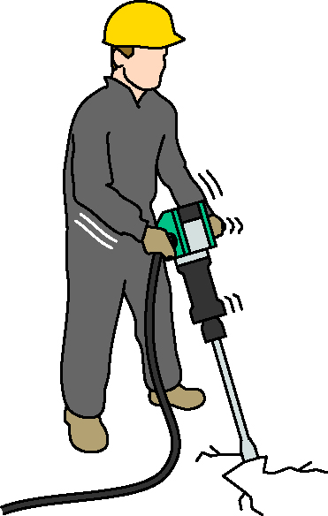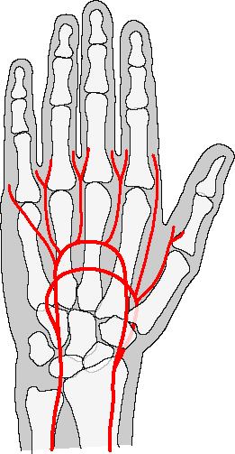

Eliminating and minimising vibration exposure

Eliminating or minimising exposure to HAV usually involves isolating or cushioning methods.

Workers must be consulted where reasonably practicable, when deciding how to manage the risks of exposure to HAV in the workplace including selecting and trialling new powered hand-tools.

Minimising HAV exposure usually requires a combination of control measures. Examples of control measures, in order of the highest level of protection and reliability to the lowest, include:

* substituting alternative methods or processes to eliminate the need to use vibrating hand-held tools
* purchasing or selecting tools with low vibration emission levels
* modifying existing tools to either minimise the vibration or prevent the vibration from moving into the handle of the tool
* directing cold air away from the worker’s hand
* maintaining equipment regularly, and
* altering work practices and the way work is organised to minimise exposure time.

Control measures should be supported by providing information, instruction or training on:

* good work practices and tool maintenance
* the effects of individual factors e.g. smoking and some medications may impact on circulation and vibration white finger, and
* recognising and reporting symptoms of HAVS.

Gloves should not be relied on to protect workers from vibration. They only provide protection from cold temperatures, water, cuts and abrasions. The use of thick gloves may make HAV exposure worse if a worker applies too much grip force to the tool.

Choosing the right tool

Similar tools can produce different amounts of vibration. Some tools are designed to produce lower levels of vibration or are manufactured to higher standards. You should consider which hand-held power   
tool is best for the work being done. An underpowered or blunt tool may take longer   
to do the job which will increase the time the worker is exposed. An overpowered or oversized tool may produce more vibration   
than necessary.

To make an informed choice you should get as much information as possible about the vibration emission of the tool. This is usually available from the tool manufacturer, importer or supplier.

Try to find data which is measured while doing the same task as you intend to use it for. This will give you a better idea of the levels likely to be found when the task is done in your workplace.

Do you need to measure vibration?

Measurement of HAV exposure may be needed if:

* there is not enough information on the vibration emission of the tool
* the vibration levels are likely to be high, and
* the tool is used for long periods of time.

More information

[*Guide to managing risks of exposure to hand-arm vibration in workplaces*](http://www.safeworkaustralia.gov.au/sites/swa/about/publications/pages/vibration.aspx)

[*Guide to measuring and assessing workplace exposure to hand-arm vibration*](http://www.safeworkaustralia.gov.au/sites/swa/about/publications/pages/vibration.aspx)

[*Guide to managing risks of exposure to whole-body vibration in workplaces*](http://www.safeworkaustralia.gov.au/sites/swa/about/publications/pages/vibration.aspx)

[*Guide to measuring and assessing workplace exposure to whole-body vibration*](http://www.safeworkaustralia.gov.au/sites/swa/about/publications/pages/vibration.aspx)*, and*

[Information sheet: *Whole–body vibration*](http://www.safeworkaustralia.gov.au/sites/swa/about/publications/pages/vibration.aspx)

For more information see the [Safe Work Australia](http://www.swa.gov.au/) website(www.swa.gov.au).