GUIDE FOR TRANSPORTING HIGH LOADS **NEAR** OVERHEAD ELECTRIC LINES

This Guide provides information on the responsibilities of transport operators, their workers and others when transporting high loads. Contact with energised overhead electric lines by high loads   
can cause death, electric shock or other injury to anyone involved in these activities.

Apart from electrical risks, there may be other obstacles or risks associated with this work, for example clearance from trees and traffic lights that are not covered. This Guide also does not cover permits and other requirements for the transport of over dimension loads from other authorities like a local council, rail or transport authorities.

This Guide is part of a series of material and should be read and used together with the [*General guide for* w*orking in the vicinity of overhead and underground electric lines*](http://www.safeworkaustralia.gov.au/sites/SWA/about/Publications/Documents/859/Overhead-Underground-Electric-Lines-General-Guide.docx)which provides information on planning and preparation, managing electrical risks, work zones and approach distances for overhead electric lines and specific guidance material for:

* [operating cranes and mobile plant](http://www.safeworkaustralia.gov.au/sites/SWA/about/Publications/Documents/859/Guide-Operating-Cranes-Mobile-Plant-OHEL.docx)
* [tree and vegetation management](http://www.safeworkaustralia.gov.au/sites/SWA/about/Publications/Documents/859/Tree-Vegetation-Management-OHEL-Information-Sheet.docx)
* [scaffolding work](http://www.safeworkaustralia.gov.au/sites/SWA/about/Publications/Documents/859/Scaffolding-Near-OHEL-Information-Sheet.docx)
* [agricultural work](http://www.safeworkaustralia.gov.au/sites/SWA/about/Publications/Documents/859/Agricultural-work-near-OHEL-Information-Sheet.docx), and
* [working near low voltage overhead electric lines near structures](http://www.safeworkaustralia.gov.au/sites/SWA/about/Publications/Documents/859/Guide-Low-Voltage-Overhead-Electric-Lines-Near-Structures.docx).

## What do I need to do?

If you are transporting high loads near overhead electric lines you need to understand:

* the different high load categories and the transport requirements associated with these categories
* notification form requirements
* who has responsibilities for transporting high loads
* specific jurisdictional requirements for transporting high loads, and
* specific terms used for transporting high loads.

### Transport requirements for high load categories

Electricity Supply Authorities have specific requirements that must be met before high loads can   
be moved with a vehicle near their overhead electric lines.

The transport requirements of high loads depend on the height of the load above the roads.   
There are four categories of high load, three of which have special requirements. The categories   
and their requirements are in Table 1.

**Table 1** Categories and requirements for high loads being transported

| **Category number** | **Maximum transport height of load above road** | **Transport requirements** |
| --- | --- | --- |
| **1** | Up to 4.6 metres | * Transport can be carried out without notification. |
| **2** | Over 4.6 metres,  but not exceeding 5.0 metres | * Notification to the Electricity Supply Authority is required. * The route should be assessed by a qualified person taking into account the Electricity Supply Authority’s advice about the network including information in the notification and safety advice. * Generally no escorting will be required, depending on the outcome of scoping and assessment. |
| **3** | Over 5.0 metres,  but not exceeding 5.5 metres | * Notification to the Electricity Supply Authority is required. * The route should be assessed by a qualified person taking into account the Electricity Supply Authority’s safety advice. * An escort may be required in accordance with the Electricity Supply Authority’s requirements or depending on outcome of scoping and assessment. |
| **4** | Exceeding 5.5 metres | * Notification to the Electricity Supply Authority is required. * The route should be assessed by a qualified person taking into account the Electricity Supply Authority’s advice about the network and all safety precautions advised by the network. * An escort is required. |

### Notification form requirements

Notification on transporting a high load form is available directly from the [Electricity Supply Authority](http://www.safeworkaustralia.gov.au/sites/SWA/about/Publications/Documents/859/Electricity-Supply-Authorities.docx) and their website. A notification form is required for categories 2, 3 and 4 and should include:

* Dimensions of the load. The maximum travel height of the load includes the height of the object and the vehicle used for transportation. If unable to predetermine the exact measurement, the maximum possible height should be used for scoping or assessing purposes.
* Route specification.
* Time or times during which transport is required to take place.
* Details of the service provider responsible for facilitating the transport of the high load and providing safety precautions.

*Note*: As circumstances may change between the date of assessment and the date of transporting the load, the road transport operator should contact the [Electricity Supply Authority](http://www.safeworkaustralia.gov.au/sites/SWA/about/Publications/Documents/859/Electricity-Supply-Authorities.docx) to confirm details within 24 hours of transporting the load.

### Responsibilities for transporting high loads

**Table 2** Responsibilities for transporting high loads

| **Responsible agent** | **Responsibilities for transporting high loads** |
| --- | --- |
| **Electricity Supply Authority** | * provide relevant electricity network information to transport operators and escort service providers * explain precautions for scoping or assessing high loads and escorting high loads, which address the electricity risks of these activities, and * provide written authorisation. |
| **Escort service provider** | * understand the no go zone concepts and their application * ensure only people with relevant training are engaged to perform relevant activities associated with escorting the high load * inform the Electricity Supply Authority if load and route do not conform to the notification details * decide on the strategy and plan of action in consultation with the Electricity Supply Authority * use only specialised equipment, especially where the equipment may and can come into contact with exposed energised parts * notify the Electricity Supply Authority of operational electrical safety problems identified like damage to network assets, and * direct road transport operators to ensure electrical safety is maintained. |
| **Road transport operator** | * notify the Electricity Supply Authority of the intention to move a high load in the vicinity of network assets * provide accurate information about high loads to the Electricity Supply Authority * comply with precautions required by the Electricity Supply Authority * comply with directions of escort provider, and * contact the Electricity Supply Authority about operational matters affecting electricity safety e.g. if the high load transport encountered electric lines lower than the minimum clearance required, where an escort service provider is not required. |
| **Scoping service provider or network assessor** | * provide accurate information about the network where the high load is to be transported. |

*Note*: The categories and requirements for transporting high loads are based on Queensland requirements. For specific requirements in other jurisdictions contact the relevant Transport or Traffic Authority listed below and your state or territory [Electricity Supply Authority](http://www.safeworkaustralia.gov.au/sites/SWA/about/Publications/Documents/859/Electricity-Supply-Authorities.docx).

### Specific requirements for transporting high loads

All state and territory jurisdictions have special requirements for transporting high loads above 4.3 or 4.6 metres on public roads. They require a gazette notice and permit for oversized or over-mass vehicles before transportation. For example, the New South Wales Roads and Maritime Services (RMS) requires a Load Carrying Permit for oversized or over-mass vehicles over 4.6 metres in height. If vehicles exceed 5.0 metres in laden height they must be accompanied by an Over Height Clearance Authority letter from each Electricity Supply Authority affected on the route to be travelled before the RMS will issue a Load Carrying Permit. Where a pilot or escort operation is necessary two-way communication between the escorted vehicle and the pilot and escort vehicles is required. Permit and operating conditions may include use of warning devices including signs, flashing lights and flags; speed restrictions; and time and route restrictions for specific travel zones.

Written approval from other authorities may also be required and may include:

* Rail or Tram Authority if travelling across rail or tram lines with overhead electric lines
* Electricity Supply Authority if travelling under or near high voltage electric lines
* Telecommunication Authority if travelling under communication cables, and
* Police Services if a police permit or police escort is required.

For more information contact your state or territory National Permit Office.

| **Jurisdiction** | **Unit Name** | **Contact** |
| --- | --- | --- |
| Australian Capital Territory | Roads ACT, Heavy Vehicle Permits Office | Ph: (02) 6207 6565  Fax: (02) 6207 6872  Web: <http://www.tams.act.gov.au> |
| New South Wales | Roads and Maritime Services, Special Permits Unit | Ph: 1300 656 371  Fax: 1300 361 570  Web: <http://www.rta.nsw.gov.au> |
| Northern Territory | Department of Lands and Planning, Motor Vehicle Registry, Permits Section | Ph: (08) 8999 3148  Fax: (08) 8941 0260  Web: <http://www.mvr.nt.gov.au> |
| Queensland | Department of Transport and Main Roads, Queensland Transport, Vehicle Engineering & Access Unit | Ph: (07) 3253 4452  Fax: (07) 3253 4607  Web: <http://www.tmr.qld.gov.au> |
| South Australia | Dept. for Transport, Energy & Infrastructure, Vehicle Permits Section | Ph: 1300 882 249  Fax: (08) 8348 9551  Web: <http://www.transport.sa.gov.au> |
| Tasmania | Dept. of Infrastructure, Energy & Resources, Land Transport Safety Division, Permits Officer | Ph: (03) 6233 5214  Fax: (03) 6233 5210  Web: <http://www.transport.tas.gov.au> |
| Victoria | Vic Roads Permit Group | Ph: (03) 9881 8852 or 13 11 17  Fax: (03) 9881 8854  Web: <http://www.vicroads.vic.gov.au> |
| Western Australia | Main Roads, Heavy Vehicle Operations | Ph: (08) 9311 8450  Fax: (08) 9311 8455  Web: <http://www.mainroads.wa.gov.au> |

## Meaning of specific terms used for transporting high loads

**Assessing –** checking the suitability of and the requirements necessary for safe transport of a proposed high load by reference to the Electricity Supply Authority’s records. If this is not possible, scoping should be undertaken.

**Escorting –** facilitating safe passage of a high load through an Electricity Supply Authority’s network including activities necessary to achieve safety.

**Escort service provider –** a person conducting a business or undertaking who provides services to escort a vehicle in accordance with the Electricity Supply Authority’s electrical safety precautions.

**Notification –** a road transport operator’s advice to the Electricity Supply Authority of the intended route and the specification of a high load.

**Road transport operator –** a person conducting a business or undertakingwhotransports a load more than 4.6 metres high.

**Scoping –** checking the suitability of and the requirements necessary for, safe transport of a proposed high load by physically checking the intended route. Allowances should be made for changes in the road profile like dips and the distance between front and rear wheel axles. Figure 1showsan example of a problem caused by changes to the road profile. Scoping may not be required where the suitability for transporting a high load over a particular route can be determined by assessment.

**Scoping service provider –** anElectricity Supply Authority or a person conducting a business or undertaking who carries out scoping or assessing in accordance with an Electricity Supply Authority’s high load safety precautions.

**Qualified person –** aperson who has successfully completed a high load transportation scoping course or its equivalent provided or authorised by an Electricity Supply Authority. The evaluation of the person’s qualification will be made by the relevant Electricity Supply Authority.

**Figure 1** The road profile can affect the clearance height of over dimension loads

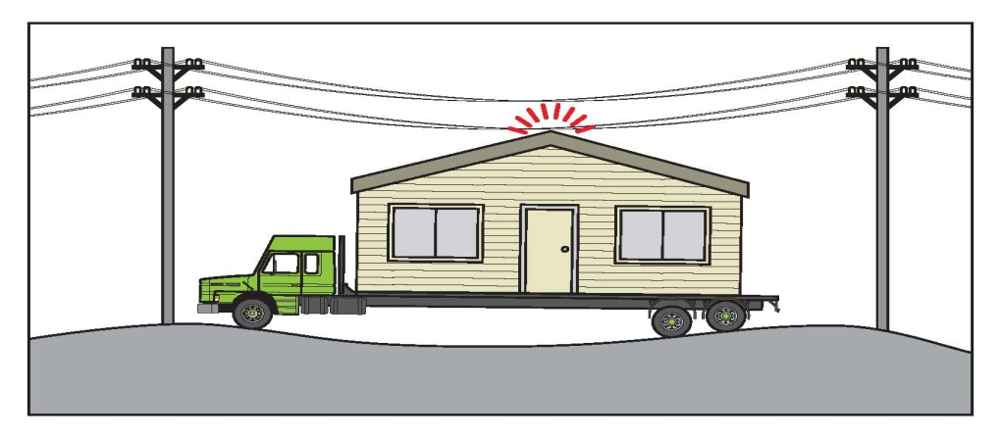

## Further information

Codes of practice, guidance material and other resources are available on the [Safe Work Australia](http://www.swa.gov.au/) website (www.swa.gov.au).