GUIDE TO MOBILE CRANES

This Guide provides information on mobile cranes and supports the [*General guide for cranes*](http://www.safeworkaustralia.gov.au/sites/swa/about/publications/pages/guidance-cranes).

This Guide also forms part of a series of guides and information sheets for cranes that includes information on:

* tower cranes
* inspecting and maintaining cranes
* bridge and gantry cranes
* vehicle loading cranes
* vessel-mounted cranes
* crane-lifted workboxes
* using other powered mobile plant as a crane, and
* quick-hitches for earth moving machinery.

**Note:** vehicle loading cranes are technically mobile cranes for the purposes of design registration but are not covered in this Guide.

## What are mobile cranes?

Amobile crane is a crane capable of travelling over a supporting surface without the need for fixed runways and relying only on gravity for stability.

They include three general types of mobile crane operating in Australia:

* hydraulic boom cranes
* lattice boom cranes including crawler cranes, and
* non-slewing (pick-and-carry) cranes.

Aslewing mobile crane is a mobile crane incorporating a boom or jib that can be slewed, but does not include earth moving equipment such as a front‑end loader, backhoe, or excavator configured for crane operation.

A non-slewing mobile crane - also known as a pick up and carry crane - is a mobile crane incorporating a boom or jib that cannot be slewed and includes:

* an articulated mobile crane, or
* a locomotive crane.

A vehicle tow truck is not considered to be a non-slewing mobile crane.

A mobile crane can be set up in a range of locations and environmental conditions. Some mobile cranes, for example a non-slewing mobile crane can also carry a load while moving (known as mobiling).

## High risk work licensing

A person who operates a mobile crane (other than non-slewing mobile cranes with a capacity of less than 3 tonnes) must hold the relevant high risk work licence to operate the crane. More information on high risk work licensing requirements is in the [*General guide for cranes*](http://www.safeworkaustralia.gov.au/sites/swa/about/publications/pages/guidance-cranes).

## Crane stability

Failure to maintain crane stability is one of the key factors associated with serious crane incidents. The main factors that affect crane stability include:

* operating the crane near its maximum rated capacity
* ground conditions and the means of supporting the crane’s outrigger pads, tyres or tracks
* the slope of the ground—both side slope and slope in direction of crane travel (this particularly applies to non-slewing mobile cranes), and
* wind conditions—this will vary depending on the size and shape of the suspended load and crane boom.

### Counterweights

The crane counterweight is critical in ensuring crane stability. A counterweight that is too light for a load and boom configuration will cause the crane to overturn in the direction of the suspended load.

A crane can also overturn backwards due to the effect of the counterweight in situations when:

* the counterweight is too heavy for the boom configuration
* the crane is travelling up a slope with the boom luffed up
* inadequate timbers are placed under the outrigger pads below the counterweight when the crane is positioned on soft ground, and
* outriggers are not extended or lowered into position.

On smaller mobile cranes the counterweight is generally fixed and cannot be easily removed. Counterweights can be designed to be removed for road travel or when lighter loads are lifted. In this case it is important to attach the correct type and number of counterweights to the crane for the particular lift to be carried out.

The crane manufacturer’s instructions specify how to secure the counterweights. Where counterweights are removable, each counterweight should be clearly identified with the crane manufacturer’s name or trademark and the mass of the counterweight.

Where the crane is fitted with a rated capacity limiter, the data input into the computer must be correct for the counterweight and boom configuration on the crane and related to that shown on the relevant load chart.

### Crane instrumentation including indicators

Safety instrumentation and electronic load monitoring equipment fitted to mobile cranes include:

#### Rated capacity limiters

Rated capacity limiters should be provided on mobile cranes manufactured since 2002 with a rated capacity of more than 3 tonnes. The limiter should prevent exceeding the rated capacity of the crane, within the tolerance of 100 to 110 per cent in order to prevent lifting and radius increases.

It is important that mobile cranes are operated within their rated design capacity.

#### Working radius indicators

A radius indicator displays the radius of the suspended load generally measured from the centre of the slew ring. A radius indicator should be fitted on all mobile cranes that were originally designed with this feature. The indicator should be displayed in metres and be accurate to +10 per cent and ‑3 per cent of the actual radius.

#### Load indicators

Load indicators should be fitted to mobile cranes with a maximum rated capacity of more than 3 tonnes. Load indicators measure and display the mass of the load being lifted. This indicator assists the crane operator to stay within the load chart and rated capacity of the crane. The load indicator should be capable of displaying the mass of the suspended load at all times.

#### Load charts

Load charts, also called rated capacity charts, identify what the crane is able to lift safely. The load chart should be available in the crane cabin for the crane operator to verify the crane is not being overloaded.

On some mobile cranes there may be more than one load chart for different boom and counterweight configurations. The load charts may be complex and include many conditions that should be complied with to ensure the crane can safely lift a load.

#### Stability function of load charts

When the load being lifted by the crane causes the crane to become unstable and overturn this condition is called tipping. The maximum load that the crane can lift before tipping occurs is calculated by applying a stability factor to work out when tipping may occur. The stability factor should be recorded on the crane load charts.

The stability factor of mobile cranes allows for variables including:

* dynamic factors caused by the crane motion and the load e.g. for boom movement, application of brakes, swaying of the load, and
* wind effects on the load and boom.

The stability factor typically used is:

* 75.0 per cent of tipping when the crane is operating on rubber or outriggers, and
* 66.6 per cent of tipping when the crane is operating in mobiling mode.

It is however also possible for a crane to overturn with smaller loads when operating in windy conditions, on sloping ground or if the crane is not operated smoothly.

### Wind conditions

Strong winds impose extra loads on a crane and may affect the crane’s stability. To ensure the stability of a mobile crane in windy conditions the following factors should be considered:

* The crane manufacturer’s instructions and load charts should state the maximum wind speed the crane can safely operate.
* Although a crane manufacturer may specify a maximum wind speed, a lower maximum wind speed may need to be applied, for example where the load and boom have large surface areas.
* Where the crane is lifting close to its rated capacity, wind speed is a critical factor as the safety margin is lower and wind can more easily impact on the crane’s stability.
* Nearby thunderstorm activity may cause sudden very high speed wind conditions called microbursts which can lead to unexpected changes in the wind load on the crane and make the load and crane unstable.
* Where the lift is a non-standard lift, with a suspended load or large surface area to be carried out in windy conditions, a competent person should provide written advice on safe lifting conditions. For example, a lower maximum wind speed than that identified by the manufacturer may be applied.
* Check that wind gauges (anemometers) are operating. Wind gauges should be mounted at the boom tip where the highest wind loading will occur. Where wind gauges are attached to the crane they should be mounted in accordance with the manufacturer’s instructions.

### Ground factors

Ground conditions can vary dramatically from one workplace to another and even within one workplace. Failure to address poor ground conditions to ensure crane stability may cause the crane to overturn resulting in serious injury to the crane operator and other people near the crane.

Factors affecting ground support of cranes include:

* surface water, water mixed with soil e.g. mud and underground water like springs or streams
* the type of ground e.g. clay, sand, rock or a mixture of these
* backfilled ground from a previous excavation or trench
* covered underground cavities or penetrations which still exist
* continued operation of the crane in one location, and
* the location of pressurised underground services e.g. a shallow fire hydrant main which may burst if an outrigger is located directly above it.

Decisions on the suitability of the ground conditions can only be made on the basis of visual inspection. Where it is difficult to work out if the ground conditions are suitable, documented information on the ground bearing pressure should be obtained from a geo-technical engineer. Rock usually provides the most stable supporting surface for a mobile crane. Although rock may be present on the surface it may not extend far below the surface. One way to establish how far rock may extend below the surface is to examine nearby excavations or trenches at the workplace. Rock that extends far below the surface provides an indication of the ground’s integrity. Extra risks created when outriggers are positioned close to an excavation must be managed.

Whether the ground has a ‘crust’ on its surface should be checked. The surface of this type of ground is usually firmer than the ground underneath. The firm surface may give the impression that the ground is more stable than it actually is. If the ground is punctured by an outrigger or the end of a crawler track, the softer ground will be exposed which may cause the crane to overturn.

Where a mobile crane is continuously operated in one location the ground underneath the outriggers will compact. The ground should be checked to ensure the crane has not compacted it to the extent that the crane is more likely to overturn.

### Sloping ground

Crane roll over can occur when a mobile crane travels along a side slope. Working on a slope has the effect of either increasing or decreasing the working radius of the crane, which may in turn affect the stability of the crane and cause the crane to overturn either forward, backwards or sideways.

Most manufacturers of mobile cranes with mobiling capability specify the cranes should only be operated on firm level ground. Working or travelling on sloping or uneven ground should be avoided where possible. If working on slopes is unavoidable the crane should be used within the manufacturer’s specified capacity for operating on the relevant degree of slope. Travel on a slope should be up or down the slope not across the slope.

Where the centre of gravity of the mobile crane is high above the ground, a minimal ground slope can be a major factor in causing the crane to overturn. This particularly applies when:

* the boom has a high luff angle
* the boom is telescoped out
* the centre of gravity of the suspended load is high, and
* there is articulation of an articulated crane.

A side slope of only 2 or 3 degrees can have a drastic effect on the stability of the crane. Soft ground, pneumatic tyres and suspension movement will also tend to increase the side angle of the crane and increase the risk of overturning.

Where fitted, the side slope inclinometer is to be used as a guide only as it is only accurate when the crane’s articulation is straight ahead with no load.

Manufacturers and suppliers should provide clear documented information on the maximum side slope a crane can safely travel over while mobiling.

### Crane proximity to excavations and trenches

When cranes are set up close to excavations or trenches there may be an increased risk of the sides of the excavation or trench wall collapsing causing the crane to overturn. This risk increases with softer ground and the presence of groundwater. The risk of collapse is greater for vertical cuts in the excavation wall compared to walls that have been battered back at an angle. The presence of ‘slippery back’ where there is a naturally occurring slip plane, for example a fracture in the ground, can also increase the risk of excavation or trench collapse.

The following principles should be applied when setting up mobile cranes near excavations:

* Where the ground is compact and not crumbling, the distance of any part of the crane outrigger support dunnage from the excavation should be at least equal to the depth of the excavation (general 1:1 rule).
* Where the ground is loose or backfilled i.e. crumbling, the distance of any part of the crane outrigger support dunnage from the excavation should be determined by a competent person e.g. a geotechnical engineer.

### Outriggers and stabilisers

Stabilisers and outriggers have many configurations depending on the type of crane. They are used to minimise the risk of rollover when the centre of gravity of the combined load and vehicle is outside the support base of the vehicle. Outriggers lift the vehicle's wheels off the ground while stabilisers are mainly used on vehicle loading cranes and do not lift the vehicles wheels off the ground.

Using outriggers on mobile cranes helps to provide greater stability to the crane when lifting loads. Irrespective of the ground conditions, timbers or other means of distributing the load should be placed under the outriggers except where engineering indicates a direct outrigger pad application.

Outriggers should be set according to the manufacturer’s instructions for the specific type of mobile crane and can be used to level the crane. Outriggers should be marked for the operator to see partial or full extension positions.

Only cranes that have the manufacturer’s approval and suitable overload interlocks should be used to lift with partially extended outriggers. If a lift is to be carried out with partially extended outriggers the correct outrigger configuration shown in the relevant load chart should be used.

The maximum pressure applied by a crane is a function of the crane mass, crane configuration—that is boom length and centre of gravity—and the mass of load on the hook. The ground bearing capacity should be greater than the maximum pressure applied by the crane to the ground to ensure the required crane support is provided. Before a lift is conducted appropriate ground bearing capacity must be checked and the use of control measures like outrigger pads considered.

Crane manufacturers should provide information on the maximum load and pressure applied by the outriggers to the ground for the different boom configurations supplied with the crane. This information should be in the crane operation manual kept in the operator’s cabin.

#### Timbers, pads and bog mats

A variety of materials can be used to distribute the mass of the mobile crane and the suspended load to the ground. Lengths of timber with rectangular cross sections (see Figure 1) are the most common form of outrigger pad. However plastic and metal pads are also provided for some cranes (see Figure 2).

**Figure 1** Typical timber outrigger pad

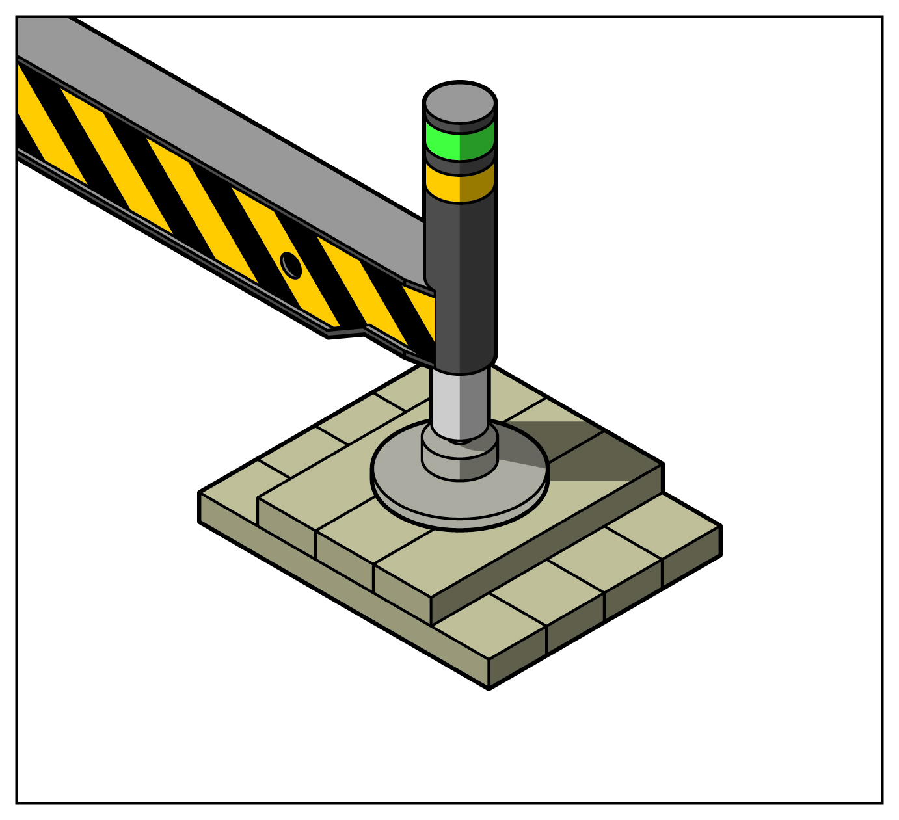

**Figure 2** Metal plate outrigger pads

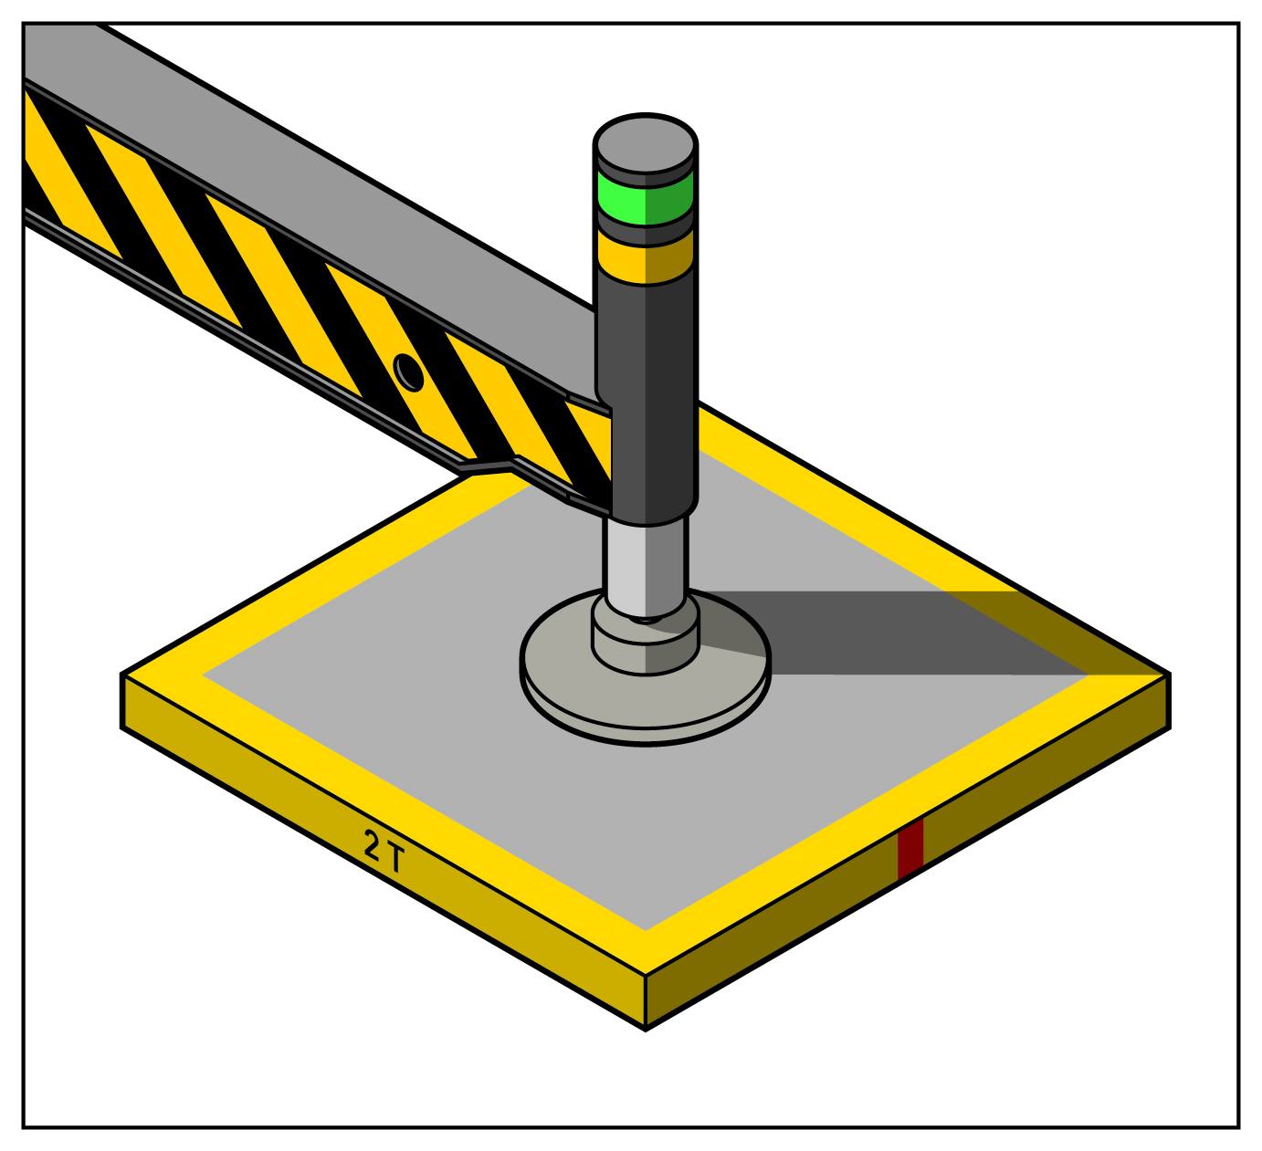

Plastic or timber bog mats are sometimes used under mobile cranes where the ground bearing capacity is low or ground protection is needed. These may also be used under the tracks of crawler cranes or where larger lifts are carried out.

Crawler cranes will generally apply considerably less point load to the ground than a crane on outriggers. This is because of the large area of tracks in contact with the ground compared with the smaller contact area of the outriggers on cranes of similar capacity. For heavy lifts and where the ground has poor bearing capacity, bog mats or other supporting materials may be needed.

Timbers, pads and bog mats should be of materials and dimensions specified by the crane manufacturer. If the manufacturer has not provided this information a competent person should specify the minimum size of the material to be used.

The following principles should be applied to timbers, pads, steel plates and bog mats used as outrigger pads:

* Timbers should be sufficient size for the load and ground pressure.
* Timbers should be laid together so the width of the timber pad is wider than the outrigger foot with no gaps between timbers.
* The dimensions of steel plates and bog mats should be determined by a competent person based on the type of mobile crane.

#### Calculating pressure applied by outriggers

Different ground types will have different ground bearing capacities. Where the ground consists of a combination of ground types, the poorer ground type should be used for determining the maximum ground pressure that can be applied to the ground when the crane is set up on outriggers. A number of crane manufacturers provide information on the maximum ground pressure applied when the crane is at maximum capacity and operating in the stability range of the load chart. Table 1 shows the typical maximum permissible ground pressure according to the ground type.

**Table 1** Typical maximum permissible ground pressure for different ground types

|  |  |
| --- | --- |
| **Ground type** | **Maximum permissible ground pressure (PMAX) (tonnes per m2)** |
| Hard rock | 200 |
| Shale rock and sandstone | 80 |
| Compacted gravel—with up to 20% sand | 40 |
| Asphalt | 20 |
| Compacted sand | 20 |
| Stiff clay (dry) | 20 |
| Soft clay (dry) | 10 |
| Loose sand | 10 |
| Wet clay | Less than 10 |

The greatest force applied by any outrigger to the ground will be at the point of tipping just as the crane is about to overturn and when the crane boom is located directly above an outrigger foot.

## Road travel

The crane manufacturer’s instructions should be followed when preparing a mobile crane for road travel to reduce the risk of injury to the crane operator and other people including pedestrians and other drivers.

Control measures for road travel include:

* checking tyre pressure
* securing outriggers—both hydraulic and manual—with a locking device and stowing them in a travelling position to ensure there is no lateral movement
* storing loose components in storage areas
* disengaging drives to hydraulic pumps, booms and outriggers and putting the controls in the off position, and
* restraining the boom and hook to ensure there is no unintended movement of the boom or hook.

## Crane Operations

Each of the mobile crane types have specific operational requirements that should be considered. Examples for each crane type are:

### Crawler cranes

The ground pressure applied by crawler cranes is different to that applied by a crane on outriggers. It is sometimes assumed the ground pressure will be the same at any place where the track is in contact with the ground. In practice this is rarely the case.

When the crawler crane is being used with a suspended load the ground pressure will be greater under the boom of the crane. If there is no load suspended on the crane the ground pressure will be greater under the counterweight.

The distribution of ground pressure applied by a crawler crane will vary according to the working radius, load mass, counterweight mass and slew.

### Lattice boom cranes

On lattice boom cranes the top of the extended boom should not be lowered to a point below the horizontal line that passes through its base pivot pin. If the boom tips below this plane the angle of pull of the boom luffing ropes could cause the boom to buckle before the boom begins to lift.

Lattice boom cranes should be operated according to the manufacturer’s instructions. Generally they should not be moved uphill with an unloaded boom in the near vertical position. They should not be operated with the boom at an angle less than what is shown on the load chart, or hard against the boom backstop to avoid serious damage to the structural components of the boom—the boom backstop is an emergency safeguard only and should not be regarded as an operational stop.

### Hydraulic boom mobile cranes

When operating the boom on hydraulic cranes make sure the boom sections are extended or retracted according to the manufacturer’s recommendations. Boom sections have failed by being extended contrary to manufacturer recommendations.

The crane should not be operated with the boom at an angle less than what is shown in the load chart.

### Non-slewing mobile cranes

When mobiling a load the rated load capacity of the crane should be checked to ensure the crane is not overloaded. If necessary the crane should be de-rated in accordance with the manufacturer’s instructions or those of a competent person.

The dogger should remain in sight of the crane operator. The dogger should not walk in the path of the crane or between the crane and the load.

When travelling and manoeuvring with a load, the crane operator should:

* plan the travel pathway
* inspect ground conditions and the intended pathway to identify any problem areas, for example wet ground, pot holes and undulations to be corrected or avoided before moving the load
* operate the crane according to the manufacturer’s instructions
* operate at a speed that is suitable for the dogger, ground conditions and the load – generally a comfortable walking pace
* consider the effect of wind loading, especially on loads with a large surface area
* carry the load at minimum boom length and as close to the ground as is possible
* carry load uphill of the crane i.e. drive in reverse down a slope to keep the load close to the crane
* engage axle locks, where fitted, as specified in the manufacturer’s instructions, and
* turn with a long radius, to reduce the articulation of the crane – articulation reduces the rated capacity of the crane.

## Inspection and maintenance

Inspecting and testing for cranes must include the:

* major inspection
* regular inspection and testing required for plant, and
* inspection and testing for plant item re-registration.

For further information see the [*Guide to inspecting and maintaining cranes*](http://www.safeworkaustralia.gov.au/sites/swa/about/publications/pages/guidance-cranes).

## Further information

The following technical standards provide further information on mobile cranes:

* AS 2550.1-2011: *Cranes, hoists and winches—Safe use Part 1: General requirements*, and
* AS 2550.5-2002: *Cranes, hoists and winches—Safe use Part 5: Mobile cranes.*

For further information see the Safe Work Australia website [www.swa.gov.au](http://www.safeworkaustralia.gov.au/sites/swa/pages/default).