GUIDE TO SUSPENDED   
(SWING STAGE) SCAFFOLDS

This Guide provides information on the potential hazards for suspended (swing stage) scaffolds   
and provides practical examples of ways you can control the risks associated with them.

It is part of a series of guidance material and should be read and used together with the [*General guide for* *Scaffolds and scaffolding work*](http://www.safeworkaustralia.gov.au/sites/SWA/about/Publications/Documents/865/Scaffolds-Scaffolding-Work-General-Guide.docx) which includes information on risk management as well   
as advice on planning, erecting, altering, dismantling and working with scaffolds and the following material:

* [*Guide to scaffolds and scaffolding*](http://www.safeworkaustralia.gov.au/sites/SWA/about/Publications/Documents/865/Guide-scaffolds-scaffolding.docx)
* [*Guide to scaffold inspection and maintenance*](http://www.safeworkaustralia.gov.au/sites/SWA/about/Publications/Documents/865/Guide-scaffold-inspection-maintenance.docx), and
* [*Information Sheet: Tower and mobile scaffolds*](http://www.safeworkaustralia.gov.au/sites/SWA/about/Publications/Documents/865/Tower-Mobile-Scaffolds-Information-Sheet.docx)*.*

Further information for scaffolding work near overhead electric lines is also available in the[Information Sheet: *Scaffolding work near overhead electric lines*](http://www.safeworkaustralia.gov.au/sites/SWA/about/Publications/Documents/859/Scaffolding-Near-OHEL-Information-Sheet.docx).

## Suspended scaffolds

A suspended scaffold incorporates a suspended platform capable of being raised or lowered when   
in use. Other terms often used are ‘suspended cradle’ and ‘swing-stage’ scaffold. They are typically prefabricated modular units (see Figure 1) or permanently fabricated units although they can be assembled from scaffolding.

**Figure 1** Suspended (swing-stage) scaffold – cradle (suspended) end

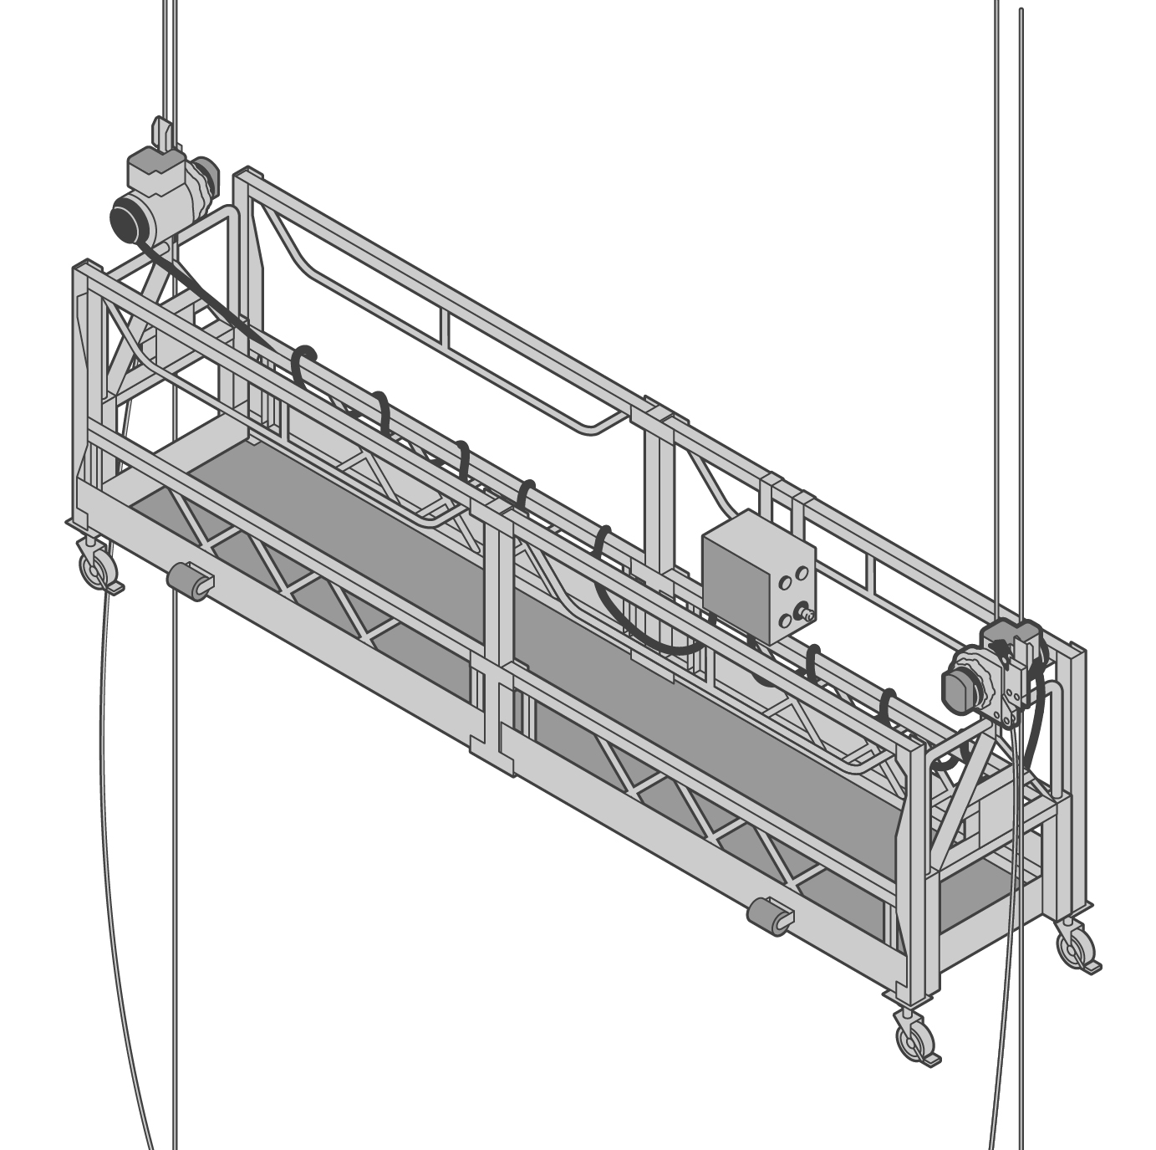

A suspended scaffold must be designed by a competent person and must be erected by a person holding an advanced scaffolding or advanced rigging high risk work licence. Operators do not require a licence but must be competent.

Designer or manufacturer instructions should be followed when installing, erecting and operating   
a suspended scaffold.

Risk control measures that should be implemented for a suspended scaffold include:

* providing safe entry to and exit from the cradle
* consulting with and providing specific training and instruction for workers on the correct procedures for using and working on suspended scaffolds including instructions on safety features like:
  + the emergency stop, load limiting device and rope lock device
  + rescue or emergency evacuation devices or equipment
  + raising and lowering operations particularly in the event of an emergency e.g. a power failure
* developing and implementing a rescue and retrieval procedure before starting work including all necessary equipment, and
* inspecting components for damage, wear and cracks before use and at pre-determined intervals. Non-destructive testing for cracks in high stress areas e.g. dye penetration testing may be needed to identify cracks not easily visible.

Example checklists for suspended (swing-stage) scaffolds are provided at Appendix A.

### Design

The suspension rig should be designed and documented by a competent person, for example   
a person who holds a tertiary qualification in a relevant engineering discipline.

Every area of design for a suspended scaffold system should receive a formal sign-off from a competent person. The formal sign-off for the suspended scaffold system should include the needle suspension system, cradle and hoist. Different parties may certify different components.

### Installation design

The scaffold configuration should be suitable for where the equipment is to be located and how it is intended to be used. The scaffold designer should consider the following to manage risks:

* The building or structure to which the suspended scaffold is to be mounted should be capable of supporting the scaffold and the intended loads including dead, live and environmental loads. The supporting structure should be assessed by an engineer and a statement of assessment provided.
* A detailed design plan should be prepared for erecting each suspended scaffold taking into account the design specifications of the scaffold, the limitations of the support structure and maximum operational wind speed or lateral forces it may be exposed to during erection or operation.
* Where structural alterations to the suspended scaffold are made, the changes should be recorded on an amended design plan. The designer or another competent person should review and approve the changes before the scaffold is used for the first time.
* Damage can be caused to the cradle or hoisting systems if certain activities e.g. welding, water or pressure blasting or demolition activities are carried out without protective measures being in place.
* To operate correctly, enough power should be available for electrically powered hoists— ensure the voltage drop is considered.
* Lateral restraints may be provided to prevent instability of the platform e.g. resulting from the work procedures or wind and may include:
  + lanyards
  + tensioned wire ropes
  + removable ties
  + fan units, and
  + suction units.

*Note:* Every restraint is to be removed when no longer required.

### Supply

Suppliers should get and keep written confirmation of the following:

* The suspended scaffold system has been designed in accordance with AS/NZS 1576.1: *Scaffolding – General requirements* and AS 1576.4: *Scaffolding - Suspended scaffolding*.
* Couplers supplied for use with suspended scaffold have been designed, tested and marked   
  in accordance with AS 1576.2: *Scaffolding – Couplers and accessories*.
* Scaffold hoists have been designed, manufactured and tested in accordance with AS 1418.2: *Cranes (including hoists and winches) – Serial hoists and winches*.

The supplier of the suspended scaffold must provide written operating and safe use instructions   
and warning tags to users of the equipment. Daily safety checklists may also be provided.

Suppliers should check that:

* The design of the powered scaffolding hoists being supplied is a twin rope type—a hoist with separate hoist rope and backup rope. Alternatively, a second hoist rope with secondary protective device should be used.
* Scaffold hoists and secondary protective devices have legible data plates bearing the following information:
  + type model identification
  + serial number
  + details of steel wire rope used including nominal size, grade i.e. quality, construction and maximum length where applicable
  + rated capacity hoisting
  + name or identification mark of the manufacturer of the hoist
  + reeving requirements where applicable, and
  + power supply requirements where applicable.
* If the cradle is fitted with a power outlet e.g. for hand tools, it should have a residual current device (RCD) on the cradle with a legible data label bearing the following information:
  + rating load in amps
  + residual tripping current—not more than 30 mA, and
  + power supply in volts.
* Hoist controls are labelled and unless the function is obvious, the operational functions displayed. Switches should be of the spring loaded ‘deadman’ or ‘hold to run’ type that returns to safe operation. Labels should include:
  + operation instructions
  + emergency stop switch, and
  + up and down control.
* The control box is compatible with how the specific type and model of hoist operates. If multiple hoists are used, each hoist should have the same operating specifications.
* Where a common control box is used for multiple hoists, it should be compatible with the hoists being used and be removable, unless an alternative method is used to isolate power to the cradle for safety and security when the suspended scaffold is not in service.
* Each scaffold hoist’s secondary protective device and load-limiting device is inspected and subjected to an operational test in accordance with AS/NZS 4576: *Guidelines for scaffolding* before each site delivery.
* Inspection and testing information is provided.
* An electrically powered scaffold hoist is fitted with a load-limiting device that will prevent the hoist from lifting more than 125 percent of its rated load.
* A secondary protective device, often incorporated into the hoist, is capable of stopping the cradle from falling if the hoist fails.
* Between each hiring of scaffold equipment, scaffolding components are inspected and maintained, so far as is reasonably practicable.

### Set-up

Before being set up, a competent person must inspect and verify the structural adequacy of the suspension system and the cradle. The manufacturer of the cradle and hoist should provide the structural verification and information on the maximum working load limit (WLL).

Scaffolders and operators should consider the areas around the suspended scaffold during design, erection and operation. The following particular areas of concern should be considered and addressed before work to erect or operate the scaffold starts:

* Where the scaffold is erected adjacent to or over public spaces or adjoining property specific controls like hoardings, catch platforms or barricades should be provided.
* Where the possibility exists for other workers to enter the area below the suspended scaffold specific controls should be provided e.g. catch platforms, barricades or signs.
* Overhead electric lines are a significant hazard and no part of the suspended scaffold including suspension and secondary ropes should be closer than 4 metres to an overhead electric line. When operating above electric lines and access to the cradle is provided above the power line this may be achieved by coiling the tail ropes to keep them above the power lines. Where operating from the ground, anchoring the ropes at ground level can prevent them from moving closer to the power lines.
* Every electric line should be considered energised unless there is written confirmation from the Electricity Supply Authority that the electric lines have been de-energised for the duration of the work. Further information on erecting a scaffold near overhead electric lines is in the [Information Sheet: *Scaffolding* *work near overhead electric lines*](http://www.safeworkaustralia.gov.au/sites/SWA/about/Publications/Documents/859/Scaffolding-Near-OHEL-Information-Sheet.docx).
* Protective measures should be provided to control the movement of vehicles near scaffolds and their trailing ropes and power cables.
* Where cranes operate near a suspended scaffold, there is a risk of the load snagging the scaffold or endangering people on the platform. Specific site procedures should be developed to minimise the risk.
* Where corrosive substances are to be used on the scaffold or in its vicinity, it may be necessary to develop specific procedures to minimise the risk of damage to critical scaffolding components.
* The dangers presented by hazardous areas should be assessed before selecting equipment e.g. electric hoists should not be used where dust can form an explosive atmosphere.

### Loading

The WLL should be clearly marked on the cradle of the suspended scaffold. The WLL of a cradle will depend on factors, for example its length, type of construction and material type. Materials loaded into the cradle should be evenly distributed and not be concentrated in one area.

To prevent overloading, swing-stage operators should verify the mass of the load to be carried by the cradle including people.

*Note:* On many long swing stages, the load capacity will be severely reduced and only minimal tools and equipment may be able to be carried.

### Load-limiting devices

Powered scaffold hoists should have a device to limit the lifting capacity of the hoist to a maximum of 1.25 times the rating of the hoist. Whatever the hoist stall capacity is, the suspension system and the cradle should be designed to withstand the stalling load applied by every scaffold hoist in use. This feature is designed to prevent failure in the event of the cradle snagging on an obstruction.

### Installing

Suspended scaffolds must be installed by a person holding an advanced rigging or advanced scaffolding high risk work licence and a competent person (which may be the installer) must verify the swing-stage scaffold system has been installed safely.

After moving and reinstalling a swing-stage scaffold system on a project, the reinstallation must be reinspected and verified by a competent person. If the reinstallation is different to what was originally verified, other than a smaller outboard, smaller cradle or larger inboard, a competent person must review the design and approve the new installation before use.

### Electrical installation

Enough electricity is essential to be able to operate the suspended scaffold hoists safely. The principal, electrical and scaffolding contractors should co-ordinate the planning of the electrical installation to ensure the correct voltage levels are provided. This may include locating the power-board close to the scaffold, dedicated power circuits, larger sub-mains and alternative methods of positioning the power-board.

The main power supply should be in a locked area to avoid unauthorised or unintentional interference.

Electrical installation design should consider:

* To limit voltage drop the suspended flexible cord should:
  + not be of excessive length, or
  + if extra length is required, have larger size conductors to compensate.
* The electricity supply for the suspended scaffold should be close to the scaffold to limit the length of the flexible cord needed to descend to the platform—this will assist in limiting voltage drop.
* The construction power-board should be designed so the removal of the suspension flexible cord from the socket-outlet requires a person to complete a deliberate act.
* The suspended flexible cord should be supported in a way that protects the cable from mechanical damage and prevents the cable from bending at a radius less than the manufacturer’s minimum. If the manufacturer’s information is not available, AS/NZS 3000:2007: *Electrical installations* gives the minimum internal radius as six times the cable diameter.
* Suspended flexible cords should be the heavy-duty double insulated type and be able to support its own weight over the length of the drop. Electrical cable should be fitted with thimble and eye for suspension to stop damage to the cable.
* The flexible cord should be supported in such a way to prevent the cradle from fouling or causing mechanical damage to the cable. The cable should be installed so it is not pulled across the structure of the cradle.
* The flexible cord should be long enough to allow the cradle to descend to the ground or a lower structure for exit in an emergency.
* When in use the control box should preferably be attached to the guardrail of the cradle on the side away from the working face.
* The electrical cables installed in the cradle should not be excessive in length, to prevent mechanical damage occurring to the cables and to limit voltage drop.
* Electrical cables from the control box to the hoists should be enclosed for protection from mechanical damage and securely attached to the cradle. Extra mechanical protection may be required and is dependent on the work carried out e.g. demolition, grinding or abrasive blasting.
* There should be a system that allows the suspended scaffold to be effectively isolated from the electricity supply when not in use to prevent unauthorised operation—this may be located within   
  a locked power-board or by using a readily removable control panel on the cradle.

### Method of fixing needles

The method of fixing the suspension needles should be clearly shown on a detailed drawing that has been certified by a competent person. The following options apply for fixing the inboard length of the needles to the structure:

* Where the needle is fixed to the floor the fixing should be positively restrained—chemical and friction type anchors are not to be used in tension in anchorage systems e.g. a U-bolt fitted over the needle and through the concrete floor slab could be used.
* Scaffold couplers should not be used as a sole means to secure the counterweight or other anchorage to the rear of the needle (see Figure 2). A positive connection which does not rely   
  on friction should be used. One example is a bolted or pinned connection where the bolt or pin passes through the structural members and is prevented from accidental removal with a nut   
  or other locking system e.g. a split pin or ‘R’ clip.
* If the needle is attached to an anchorage point or existing structure on the building, the anchorage system and method of attaching the needle should be determined by a competent person. Restrain the back of the needle to an anchorage point determined by a competent person.
* Where props are used they should be installed to the top of the needle and to the underside of the floor above. Ensure the props are fixed to prevent dislodgement. The floors should be determined by a competent person to be able to safely withstand the point loading applied by the props.
* Where counterweights are used they should be secured by keyed lock and preferably on top of the needle.

**Figure 2** Suspended (swing-stage) scaffold – suspension mounting

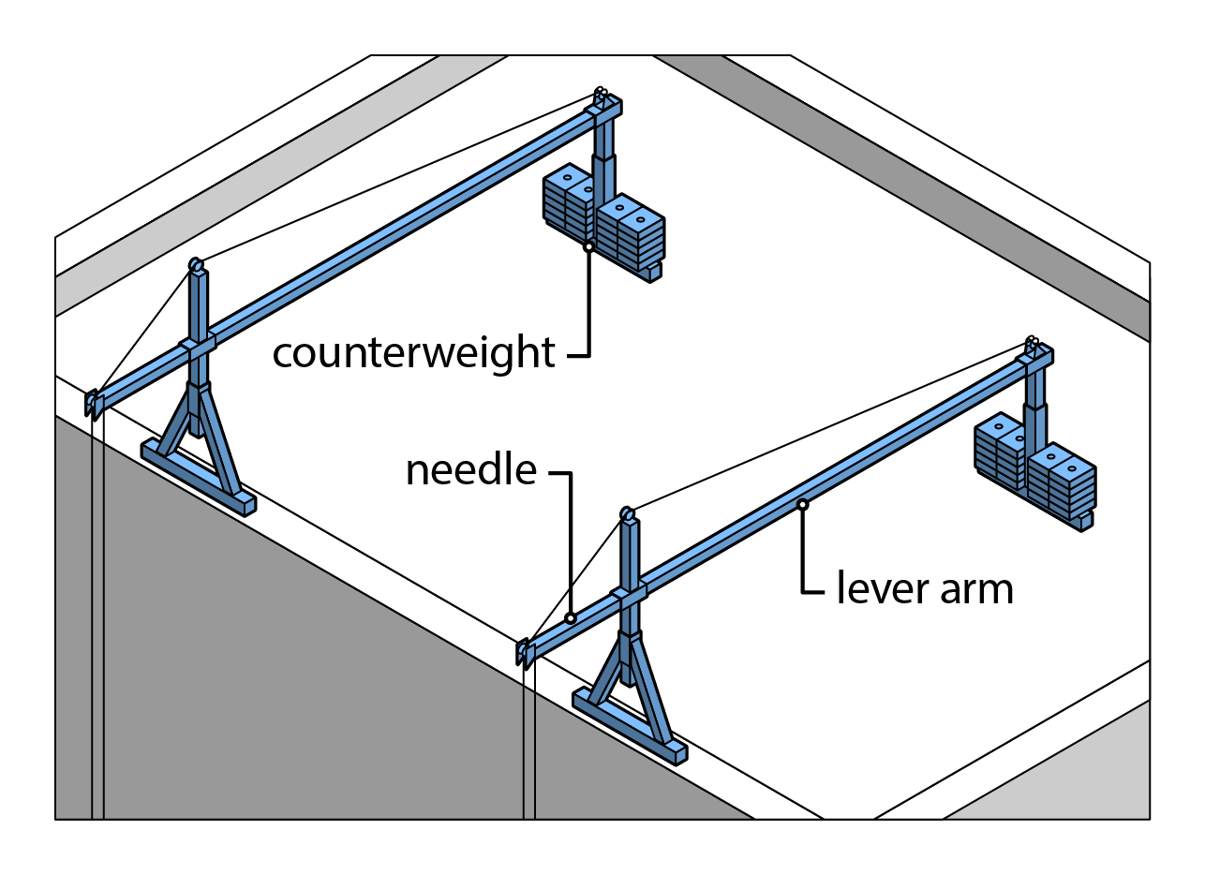

### Cradles

Cradles should be constructed in accordance with the manufacturer’s specifications. They should be clearly marked with the WLL—the length and type of material used to construct the cradle will influence the cradle’s WLL. You should verify the WLL with the manufacturer or supplier where there are no clear markings on the cradle. If the cradle varies from the original manufacturer’s specifications, a suitably qualified and experienced engineer should verify the modification before use.

When using the cradle you should:

* inspect each connection fixing before use to check they are secure
* evenly distribute materials in the cradle
* restrict the lateral movement of the cradle e.g. using suction caps or tying off the cradle with rope, and
* cease work and lower the cradle to the ground during bad weather e.g. in windy conditions.

### Trolleys

Where trolleys are used they should have lower keeper plates or a strap that wraps around the top of the beam to keep them from falling. Guidance should be obtained from manufacturers and designers on effective systems to use.

### Erecting the scaffold

The person carrying out or directly supervising the erection, dismantling or modification work on a suspended scaffold must hold either an Advanced Scaffolding or Advanced Rigging High Risk Work Licence. They should:

* ensure the way the suspended scaffold is erected does not present a risk to the health and safety of workers or others, and
* have a copy of the design plan which specifies the rigging requirements including the number, size and positioning of the counterweights, before erecting or modifying the suspended scaffold.

During erection you should:

* ensure fall protection is in position at the building edge or the scaffolders are using safety harnesses with anchorage points if working near an exposed edge
* restrict the area around the support rig to only those workers engaged in assembling the scaffold to prevent injury to workers
* barricade a large area below the scaffold to prevent entry to avoid injury to people from dropped cables, rigging components or tools, and
* position a safety observer, if necessary, to prevent people entering the barricaded area below the scaffold where there is no physical barrier at an edge to prevent objects falling off the supporting structure or when work is occurring over the edge.

The design and erection of the scaffold should include the following:

* The counterweight should be manufactured for that purpose, labelled with its mass in kilograms, be placed directly on the needle or innermost support in the designed location and secured by   
  a keyed lock.
* When used, traversing tracks should be fitted with through-bolted stops at the ends to prevent   
  a trolley from running off and each trolley should have a rated working load of a least 1000 kg.
* The outboard end of a needle should never be lower than the inboard end.
* The suspension rig should form a structure that is rigid and stable under working conditions.
* Only the wire rope recommended by the manufacturer for the hoist should be used—details of the wire rope construction can be located on the hoist data plate. Using the wrong construction of wire rope in a scaffold hoist can result in sudden failure, with the rope severing in the hoist.
* A secondary protective device should be provided for each scaffold hoist to operate on a secondary wire rope. This device provides an emergency brake to hold the cradle if the hoist   
  or wire rope within the hoist fails. Some types may also prevent an over-speed descent.
* It is essential the secondary protective device’s internal mechanism is adjusted for the size of wire rope fitted as some devices are capable of using different sizes of wire rope.
* The secondary wire rope for a scaffold hoist should be attached to the suspension rigging, at   
  a point that is independent of the main suspension rope attachment.
* Cradle components should be inspected on site before assembly and checked to ensure locating pins and clips are fitted and in position.
* A sign clearly displaying the safe WLL in kilograms should be fixed to the inside of each cradle.
* The cradle should have guardrails, mid-rails and toeboards fitted and the working deck should be fixed, of a non-slip type with drainage holes. None of these components should have visible signs of mechanical damage e.g. cracked or split welds, missing or broken decking or cut or bent guardrails.

The finished suspended scaffold should conform to the design plan. Alterations due to installation conditions should be included on an amended plan. The designer or another competent person must review these variations and approve the modified plan before the scaffold is first used.

A competent person or the high risk work licence holder responsible for erecting or altering the scaffold should supply a written statement that the scaffold is complete and safe for use before the scaffold is used for the first time and after every alteration.

### Inspection

Inspections to provide verification should be carried out as outlined in previous sections. Swing-stage components should also be inspected for damage, wear and cracks before use and at pre-determined intervals. Some cracks may not normally be visible to the eye. Non-destructive testing should be performed to check for cracks in high stress areas.

### Fall arrest systems

People located in swing-stage cradles should wear fall arrest harnesses attached to a properly designed anchorage system. A travel restraint system, where a fall is not possible, attached to a static line in the cradle may be used. A thorough risk assessment should be carried out to ensure control measures are in place to eliminate or minimise secondary risks, so far as is reasonably practicable.

Information on fall arrest systems is in the [Code of Practice: *Managing the risk of falls at workplaces*](http://www.safeworkaustralia.gov.au/sites/swa/about/publications/pages/managing-risk-falls-cop) and Part 4.4 of the Work Health and Safety Regulations.

### Protecting the public

Where work is carried out above or near pedestrian or vehicle entries and exits, satisfactory protection, for example hoarding and other falling object restriction devices should be provided to eliminate or minimise the risk to the public.

### Training and competence

A person should be provided with specific training and be competent in how to operate or work with the swing-stage scaffold safely before that person begins using the swing-stage scaffold.

### Operating the scaffold

A person conducting a business or undertaking engaging workers operating in suspended scaffolds must, so far as is reasonably practicable, have procedures and safe systems of work in place before the equipment is operated to ensure the equipment is safe to use and people are not exposed to risks to their health and safety. These operating procedures and safe systems of work include:

* Before operating the scaffold, a written statement that the scaffold is complete and safe for use must be supplied by a competent person responsible for erecting or altering the scaffold.
* The workers suspended on the platform must, so far as is reasonably practicable, have a method of safe entry and exit. Procedures must also be in place for the rapid retrieval of the suspended people in the event of an emergency. It is not appropriate to rely on the local fire and rescue service.
* The risk of objects falling onto workers in the cradle must be eliminated or minimised, so far as   
  is reasonably practicable.
* Workers must be provided with training in the safe work practices for suspended scaffolds including carrying out daily inspections, testing, load calculations and emergency procedures. Workers should be able to demonstrate safe work practices before working in the suspended scaffold.
* Effective communication should be in place between the cradle and other workers to alert others on site in case of an emergency.
* Where entry and exit is not from the ground or a protected landing, safety harnesses and lanyards should be provided and used when entering or leaving the cradle. During this procedure, safety harnesses should be attached to safe anchorage points e.g. a static line or horizontal rail within the swing stage. The cradle should also be effectively secured to prevent movement.
* If the scaffold is subjected to excessive movement due to wind forces or the work carried out, lateral restraints are required.
* The cradle platform should be in a tidy condition with unobstructed access along the entire length unless otherwise designed.
* The WLL of the suspended scaffold should not be exceeded, taking into account the total load of people, materials and equipment.
* During work breaks the platform should be landed or secured to the structure to prevent damage due to wind. Where readily accessible, the electricity should be disconnected from the scaffold hoists, supply point or control board.
* Overnight or longer periods require the platform to be parked in its storage position and secured to the structure to prevent movement or damage due to wind:
  + Where not on a secured site, it should be parked in an inaccessible position.
  + Trailing ropes and cables should be securely stored, protective devices locked onto ropes, electric cables disconnected from supply and if air operated air-lines, disconnected and pressure released.
* Each day before starting work from the scaffold, the operator should carry out a safety inspection and complete the daily log-in sheet in line with the requirements of the supplier.
* A competent person must inspect the cradle and suspension system including electrical equipment like scaffold hoists and cabling, at least every 30 days, if the scaffold has been onsite and not altered during that time.
* Portable electrical equipment should be inspected and tested every three months while the RCD protection devices should be tested for trip time and trip current, monthly.

### Operating a boatswain’s chair

When boatswain’s chairs are used the following issues should be addressed:

* Unless a large enough exclusion zone is set up under the chair to protect other people, control measures should be in place to prevent tools or equipment falling from the chair e.g. lanyards for hand tools or heavy equipment suspended from another rope.
* The operator must be able to activate every control including the emergency descent system from the seated position.
* If the chair is subjected to movement due to wind forces or the work carried out, lateral restraints are required.

## Further information

* AS 1418.2: *Cranes (including hoists and winches) – Serial hoists and winches*
* AS/NZS 1576.1: *Scaffolding – General requirements*
* AS 1576.2: *Scaffolding – Couplers and accessories*
* AS 1576.4: *Scaffolding – Suspended scaffolding*
* AS/NZS 3000:2007: *Electrical installations*
* AS/NZS 4576*: Guidelines for scaffolding*

Codes of practice, guidance material and other resources are available on the [Safe Work Australia](http://www.swa.gov.au/) website (www.swa.gov.au).

# APPENDIX A –SUSPENDED (SWING-STAGE) SCAFFOLD CHECKLISTS

### Swing stage scaffold supplier checklist

|  |  |
| --- | --- |
| **SCAFFOLD SUPPLIERS - PRE-DELIVERY OF EQUIPMENT** | **YES** **/ NO / N/A** |
| Are the powered scaffold hoists twin rope type? |  |
| Do scaffold hoists and the secondary protective devices have legible data plates bearing the necessary information? |  |
| Does the RCD in the cradle have a legible data label bearing the necessary information? |  |
| Do the controls have necessary labels and operational functions displayed? |  |
| Are the hoists and the central control box compatible? |  |
| Is the control box designed to be removed from the platform when not in use? |  |
| Has the correct type, size and length of flexible electric cord been provided? |  |
| Is the correct size and type of wire rope provided? |  |
| If required, has the secondary protective device been adjusted for the size of wire rope? |  |
| Has each hoist and secondary protective device been inspected and load tested before being installed onsite? |  |
| Have scaffold components been inspected before being sent to the site? |  |
| Are the counterweights compatible with the scaffold and correctly marked? |  |
| Are the supplied components compatible with the design plan? |  |
| Have all relevant safe use instructions and checklists been provided to the user? |  |

Unless **YES** or **N/A** is recorded the scaffold should not be used until the issue is rectified.

### Swing stage scaffolding contractor/principal contractor checklist

|  |  |
| --- | --- |
| **SCAFFOLD DESIGN ENGINEER** | **YES** **/ NO / N/A** |
| Has the supporting structure been assessed by an engineer? |  |
| Has a statement of assessment for the supporting structure been provided to the site? |  |
| Has the design and selection included the tasks to be carried out from the scaffold? |  |
| Have alterations or changes to the scaffold been amended to the design plan? |  |
| Has a detailed design plan been prepared for erecting the scaffold? |  |
| Has the protection of the public been addressed? |  |
| Has the protection of other workers been addressed? |  |
| Has the protection of workers who have to erect the scaffold been addressed? |  |
| Has the proximity to overhead electric lines been addressed? |  |
| Has vehicle traffic around the scaffold been addressed? |  |
| Has the voltage drop (electrical) limitations of the installation been considered? |  |
| If required, has lateral movement of the scaffold during operation been restricted? |  |
| Have the safe entry and exit of the workers who are to use the platform been addressed? |  |
| Has the storage and security of the scaffold, when not in use, been addressed? |  |

Unless **YES** or **N/A** is recorded the scaffold should not be used until the issue is rectified.

### Swing stage scaffold erection and installation checklist

|  |  |
| --- | --- |
| **ERECTING AND INSTALLING SCAFFOLD** | **YES** **/ NO / N/A** |
| Is the erection, alteration or dismantling of the scaffold carried out or directly supervised by the relevant licence holder? |  |
| Has the supporting structure been assessed by a competent person? |  |
| Has a statement of assessment for the supporting structure been provided to the site? |  |
| Does the scaffolder have a copy of the scaffold design plan, before erection? |  |
| Do the scaffolders erecting the scaffold have fall protection? |  |
| Has the protection of the public been addressed? |  |
| Has the protection of other workers been addressed? |  |
| Has the proximity to overhead electric lines been addressed? |  |
| During the erection**,** if needed**,** are the areas around the support rigging, underneath  and adjacent to the cradle barricaded off? |  |
| During erection**,** if needed, is a safety observer positioned to prevent entry to the area below the scaffold? |  |
| Are the supplied counterweights labelled with their weight in kilograms and have they been manufactured for the purpose? |  |
| Are the counterweights correctly and securely attached to the suspended scaffold support rigging? |  |
| If used, are traversing tracks fitted with stops at each end of the rails? |  |
| If used, are traversing trolleys rated at least to the WLL of the system? |  |
| Are the outboard ends of the needles higher than the inboard ends? |  |
| Is the suspension rig stable? |  |
| Is the wire rope used of the correct size and type for the hoist? |  |
| Is each hoist fitted with a secondary protective device? |  |
| Has the secondary protective device been adjusted for the size of wire rope fitted? |  |
| Are wire ropes independently attached to the rigging? |  |
| Has the suspended cradle been assembled correctly? |  |
| Is the safe WLL displayed in the cradle? |  |
| Is the cradle in a safe mechanical condition? |  |
| Has the scaffold been erected as per the design plan? |  |
| Have safe entries and exits been provided for workers coming into and out of the cradle? |  |
| Is the scaffold secure from unauthorised access? |  |
| Has the scaffold been erected as per the design plan, with modifications or changes approved and recorded on an amended plan? |  |

Unless **YES** or **N/A** is recorded the scaffold should not be used until the issue is rectified.

### Swing stage scaffold electrical installation checklist

| **ELECTRICAL INSTALLATION** | **YES** **/ NO / N/A** |
| --- | --- |
| Has enough electricity been provided for the suspended scaffold? |  |
| Has the voltage drop requirements for suspended flexible cable been considered? |  |
| Is the construction power-board situated near the support rigging of the suspended scaffold? |  |
| Is the suspended flexible cable prevented from being accidentally removed from the power-board? |  |
| Has the suspended flexible cable been correctly secured to the support rigging or structure and the cradle? |  |
| Is the suspended flexible cord the correct type? |  |
| Does the suspended cable have running clearance? |  |
| Is the suspended cable of enough length? |  |
| Is the control box attached to the outside guardrail? |  |
| Are the electrical cables from the control box to each hoist correctly installed? |  |
| Are the cables from the control box to each hoist protected from mechanical damage? |  |

Unless **YES** or **N/A** is recorded the scaffold should not be used until the issue is rectified.

### Swing stage scaffold handover checklist

|  |  |
| --- | --- |
| **HANDOVER OF SCAFFOLD** | **YES** **/ NO / N/A** |
| Has the completed or altered scaffold been inspected before being used for the first time? |  |
| Has a written statement of completion been supplied? |  |
| Has the user of the scaffold been supplied with all safe use information? |  |

Unless **YES** or **N/A** is recorded the scaffold should not be used until the issue is rectified.

### Swing stage scaffold and boatswain’s chair operation checklist

| **OPERATING** | **YES** **/ NO / N/A** |
| --- | --- |
| Has a statement of assessment for the supporting structure been provided? |  |
| Has the completed or altered scaffold been inspected before being used for the first time and a written statement of completion been supplied? |  |
| Has the scaffold been erected as per the design plan? |  |
| Are emergency rescue procedures in place to remove trapped workers? |  |
| Has protection been provided for the public? |  |
| Has protection been provided for other workers? |  |
| Are measures in place to protect the workers on the suspended scaffold from falling objects? |  |
| Has the supplier provided a copy of the operator’s manual and copies of the daily checklist? |  |
| Are the operators authorised by their employer to operate the scaffold hoist? |  |
| Have the operators received instruction on how to operate the equipment? |  |
| Have people working in the suspended scaffold received instruction in the safe systems of work and the emergency procedures for the equipment? |  |
| Have the dangers of overhead electric lines been addressed? |  |
| Are the supplied counterweights suitable for the purpose, of the correct number and are securely attached to the suspension support rigging? |  |
| Is the suspension rigging stable? |  |
| Is the correct wire rope used? |  |
| Is each hoist fitted with a secondary protective device? |  |
| Has the secondary protective device been adjusted for the size of wire rope fitted? |  |
| Are wire ropes independently attached to the support rigging? |  |
| Has the cradle or chair been assembled correctly? |  |
| Does the cradle or chair appear to be in a safe mechanical condition? |  |
| Is a sign with the WLL in kilograms fixed inside the cradle or to the chair? |  |
| Is the load on the platform within its safe working load? |  |
| Are safe entries and exits provided for workers coming into and out of the cradle? |  |
| If required, are lateral restraints being used? |  |
| Is there safe access along the entire work platform of the cradle? |  |
| Is there control over the movement of vehicles in the area of the scaffold? |  |
| Is there control of cranes working in the vicinity? |  |
| Are there controls over the storage, handling and using hazardous substances on the cradle? |  |
| Is the selection of the type of scaffold hoist suitable for the location? |  |
| Is there an effective method of communication between the occupants of the work platform and the ground? |  |
| Has the correct type and size of suspended flexible electrical cord been provided? |  |
| Is the suspended flexible electrical cable of enough length? |  |
| Is the suspended flexible cable installed so it cannot be accidentally removed from power-board? |  |
| Has the suspended flexible cable been correctly secured to the support rigging and the cradle? |  |
| Does the suspended flexible cable have running clearance? |  |
| Is the control box attached to the outside guardrail? |  |
| Are the electrical cables from the control box to each hoist correctly installed and are the cables protected from mechanical damage? |  |

Unless **YES** or **N/A** is recorded the scaffold should not be used until the issue is rectified.

### Unattended swing stage scaffold checklist

|  |  |
| --- | --- |
| **UNATTENDED SCAFFOLDS** | **YES** **/ NO / N/A** |
| When the scaffold is unattended for short periods, are safety measures observed? |  |
| When left unattended for longer periods, are safety measures observed? |  |
| Have hoists, ropes and secondary devices been inspected and maintained in accordance with manufacturer’s instructions. |  |
| Has electrical equipment been inspected and tested? |  |

Unless **YES** or **N/A** is recorded the scaffold should not be used until the issue is rectified.

### Inspection, servicing & maintenance checklist

|  |  |
| --- | --- |
| **INSPECTING, SERVICING & MAINTAINING** | **YES** **/ NO / N/A** |
| Before using the scaffold, have the operators been completing the daily checklist? |  |
| Has the scaffold undergone the monthly inspection? |  |
| Have electrical cords, components, and electrical protection devices been inspected and tested? See AS/NZS 3012:2010: *Electrical installations – Construction and demolition sites*. |  |

Unless **YES** or **N/A** is recorded the scaffold should not be used until the issue is rectified.