GUIDE TO SLIP, JUMP AND   
TRAVELLING FORMWORK SYSTEMS

This Guide provides practical information on the safe design and working operation of slip, jump and travelling forms. It is part of a series of guides for formwork and falsework that includes the:

* [*General guide for formwork and falsework*](http://www.safeworkaustralia.gov.au/sites/SWA/about/Publications/Documents/866/Formwork-Falsework-General-Guide.docx)
* [*Guide to formwork*](http://www.safeworkaustralia.gov.au/sites/SWA/about/Publications/Documents/866/Guide-Formwork.docx)
* [*Guide to falsework*](http://www.safeworkaustralia.gov.au/sites/SWA/about/Publications/Documents/866/Guide-Falsework.docx), and
* [Information Sheet: *Formwork and falsework*](http://www.safeworkaustralia.gov.au/sites/SWA/about/Publications/Documents/866/Formwork-Falsework-Information-Sheet.docx)*.*

While most of the following information in this Guide applies to slip and jump forms, some of the principles may also apply to travelling and crane-lifted forms incorporating working platforms and enclosed cells in which people are required to work. This is because the work systems and layout of these forms may present similar hazards and risks as with slip and jump forms.

## Safe work method statements (SWMS)

The SWMS must be developed in consultation with workers and their representatives who are carrying out the high risk construction work as defined under the Work Health and Safety (WHS) Regulations.

Further information on high risk construction work, SWMS and a SWMS template is in the [Code of Practice: *Construction work*](http://www.safeworkaustralia.gov.au/sites/swa/about/publications/pages/construction-work)*.*

## Slip and jump forms

Slip forms and jump forms are the terms given to self-climbing formwork systems designed to construct lift and stair cores in high rise buildings and other concrete structures like silos, stacks and chimneys.

The term ‘climb form’ is sometimes used to describe both slip or jump forms. The power for the climbing operation can be provided in a variety of ways, usually by hydraulic rams or electric motors connected   
to climbing feet or screw feet or screw shafts.

Slip forms and jump forms usually consist of a number of platforms or decks for workers and may also   
be fitted with trailing screens suspended from the form.

No two slip or jump forms will be identical because their design depends on the size and configuration   
of the permanent structure to be formed.

Slip forms usually climb slowly and continuously during the concrete pour. This allows high smooth concrete structures like chimneys to be constructed without obvious joints (see Figure 1).

### Figure 1 Slip form chimney construction

### This figure shows a slip form chimney construction.

Jump forms (see Figure 2) climb in steps following each concrete pour. This type of construction is more suited to high rise building cores where there are regular levels (floors) and joints will not be seen.

### Figure 2 Jump form construction

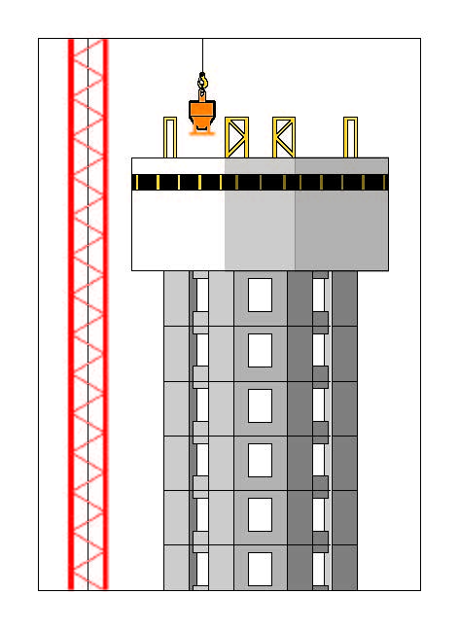

## Travelling forms

Travelling formwork (see Figure 3) moves horizontally allowing the repeated construction of structural elements, for example in-situ concrete bridge spans. The formwork is generally supported by the permanent structure as it is progressively completed so has the advantage that no falsework is required over the length of the bridge. Travelling forms are useful where there is limited capacity to construct supporting falsework,   
for example over rivers and operating roads or railways.

**Figure 3** Travelling formwork for bridge construction

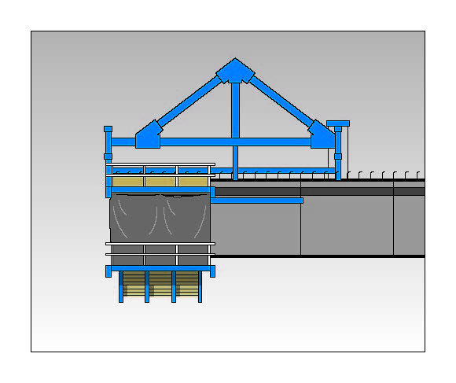

## Design

The design of slip, jump and travelling forms is more complex than the design of traditional formwork systems. The work systems and layout of some crane-lifted forms may also be similar to those associated with slip and jump forms. This may be the case for crane-lifted forms provided for the inside of lift shafts.

Greater technical input from a designer is required including consideration of structure and form load bearing capacities, concrete strength development and environmental loads, for example wind. For this reason   
the formwork designer should be a competent person, for example an engineer with experience in structural design.

When designing these complex formwork systems the designer should:

* consider known hazards
* provide safe entry to all areas and work platforms including emergency entry and stair access where possible
* seek to minimise and control risks associated with working at height by design
* provide sufficient working space and head room
* consider manual handling requirements for shutters and other components, for example using cranes   
  to lift shutters and provide safe access and working areas for people slinging and unslinging loads, and
* provide emergency access for the retrieval of an injured or incapacitated person from a work area located within the structure.

It may not always be practicable to provide an access system and working environment on a jump form   
or slip form of the same standard as elsewhere. This is primarily due to building characteristics and weight limitations. A designer must minimise the risks, so far as is reasonably practicable.

## Slip and jump form design

The jump form or slip form designer should be involved both in the initial design of the form and in addressing ongoing design issues that will occur during form erection and during the life of the building project. Many of the design problems associated with jump forms and slip forms will not be apparent until   
the job is progressing and it is likely alterations to the design of the form will be necessary. The designer should therefore inspect the form at the workplace and work closely with people involved in its operation including the principal contractor, to determine if difficulties are being encountered.

The designer should consider:

* minimum concrete strength required before climbing
* allowance for loads including dynamic and wind loads that may be applied to the form e.g. loads applied by workers and concrete placing activities and impact loading when materials are lifted onto the deck of the form
* allowance for the effects of eccentric loading on the form, both during climbing and at other times
* the maximum degree to which the form can be out-of-level during climbing and the procedure required both to minimise the likelihood of this occurring and how to remedy the situation if the form becomes   
  out-of-level
* providing fire protection throughout the system
* providing temporary electric power connections
* refuge points to protect workers from extreme heat
* rescue procedure requirements that may affect the design of the form—the rescue procedure may require entry to all levels of the form and cells, either through providing gates or removal of panels   
  on the form, and
* providing an operating manual that includes any procedures or limitations required for safe use.

## Entry and exit

Entry to the form may be provided in a variety of ways including one or more of the following:

* personnel hoists on the building
* permanent stair systems in the building
* a trailing stair system suspended from the slip form or jump form, or
* a trailing ladder system.

A trailing stair system should be used instead of a ladder system because it is easier for people to go   
up and down. Emergency evacuation is also generally easier on a stair system.

The entry area between the trailing access system and the building should be clear of trip hazards   
and there should be no gaps between platforms more than 100 mm wide.

A formwork designer should ensure a trailing access system is designed for the loads that could be applied in an emergency evacuation situation. Both the system itself and the form should be able   
to withstand applied loads from the access system.

Where the designer of the formwork specifies a lesser live load than 2.5 kPa, a person conducting   
a business or undertaking with management or control of the workplace should:

* fix a sign in a visible position stating the maximum load that can be applied to the stairs, and
* implement written procedures to ensure the maximum number of people on the form is not exceeded.

Entry ladders should be secured in place. Further information on using ladders safely is in the [Code of Practice: *Managing the risk of falls at workplaces*](http://www.safeworkaustralia.gov.au/sites/swa/about/publications/pages/managing-risk-falls-cop)*.*

Entry openings for ladders on working decks should be provided with guardrails and trapdoors that are closed except when being used. Trapdoors should be provided with a device so they can be easily opened from above. This device should not pose a trip hazard for people on the deck.

Access ways should be kept free of materials and rubbish to prevent objects falling to the levels below.

## Working platforms and penetrations

Penetrations should be covered by formply secured in position, clearly visible and identified or have leading or perimeter edge protection.

Further information is in the [Code of Practice: *Managing the risk of falls at workplaces*](http://www.safeworkaustralia.gov.au/sites/swa/about/publications/pages/managing-risk-falls-cop).

Edge protection means a barrier to prevent a person or object falling from the edge of:

* a building or other structure, or
* an opening in a surface of a building or other structure, or
* a fall arresting platform, or
* the surface from which work is to be done e.g. a formwork deck.

When placing steel or pouring concrete into a form, controls should be provided to prevent a person falling into or off the form. This is more of an issue when the width of the form is greater than 225 mm before placement of reinforcing steel. The risk of being impaled when a person is working near projecting reinforcing steel or other objects must be eliminated or minimised, so far as is reasonably practicable. Suitable controls may include edge protection on the internal side of the working platform or re-enforcement mesh temporarily placed on top of the form to allow steel to pass through the mesh. Platforms that may be affected by uplift should be positively secured so uplift cannot occur. Uplift can occur from wind loading or when a platform is cantilevered and unsecured. In the latter instance the platform can see-saw when a load is applied to the end of the platform and then drop a person off the platform if one of the platform supports moves. This may be the case where work platforms are supported by a trailing screen on one side and a parapet of the building on the other.

Where individual cells of the form are climbed at different times, edge protection should be provided on each of the raised cells.

## Trailing screens and platforms

Trailing screens can provide edge protection, a means of preventing falling objects and be designed   
to incorporate working platforms. Where platforms are provided these are usually for the purpose of patching the building or carrying out minor repairs and for entry for people climbing the form. A designer of formwork should specifically address all issues for which the trailing screen system is designed.

The following issues should be addressed in the design:

* A suitable design loading for platforms on the trailing system. Signs should be fixed to the platforms stating the maximum load permitted in kilograms where the design load is less than 2.5 kPa. People   
  at the workplace should be aware of the maximum loading that may be applied to the trailing platform and this should be stated in documentation kept at the workplace.
* The risk of falling objects must be controlled.
* Platforms should be secured to prevent uplift or other movement.

People should not be located on trailing platforms while the platforms are lifted or suspended by a crane.

When a platform is designed to have a person on the platform when it is being lifted or suspended by   
a crane, you will need to have that workbox design registered with the relevant WHS Regulator. If this is not possible, you must seek an exemption from the WHS Regulator.

If a person is located on a platform while it is being lifted or suspended by a crane, the following controls should be implemented:

* A person should be prevented from falling down a gap that may exist on the inside edge   
  of the platform, for example between the platform and the wall being constructed. It is preferable   
  to provide edge protection on the inside edge. Fall arrest harnesses may be provided for workers as   
  long as they are trained in their safe use and a rescue procedure for retrieving workers following a fall has been prepared. Use heavy duty shade cloth rather than small aperture mesh with edge protection   
  to prevent objects from falling.
* People on the platform should hold at least a dogger or rigger licence or a person with such a licence should be located on the platform as it is lifted.
* Use a clear method of communication between the crane operator and the dogger or rigger responsible for directing the lift, for example a whistle or two way radios.

## Climbing the form

It is important that the different parts of the form remain level during the climbing process. Climbing is usually carried out using a series of climbing devices set up to lift at the same time and at the same rate.

If the lifting system is not properly synchronised the form may become wedged on the structure or structural members may be overloaded. There should be a system in place to prevent the form going out-of-level during the climbing procedure. This system may be automated or may rely on operators stopping the climbing process.

To climb the form safely:

* only allow people directly involved in climbing to be located on the form during the climbing process
* identify and control potential nip or shear points where a person could be injured during the climb
* remove obstructions on the form before the form is climbed. This includes the removal of ‘Z-bars’, ferrule bolts and other material that would snag on the structure if they were not removed. A ‘sign-off’ procedure for this should be completed, and
* design services including electrical cable and water pipes so they will not snag or rupture as the form is climbed.

When removing a form from a vertical element, support the form so it never relies on suction for support. Serious incidents occur when it is assumed a form is supported from above when it is relying on ‘through bolts’ through the wall for support. When the bolts are removed the form falls with the people still standing   
on a platform attached to the form. This hazard can apply both to crane lifted forms and jump forms.

## Inspection and maintenance

Regular inspection and maintenance of the formwork during its use will help keep it functional and safe.

Inspection and maintenance should be conducted by a competent person such as an engineer.

Further information on plant inspection, maintenance and record keeping is in the:

* [Code of Practice: *Managing the risks of plant in the workplace*](http://www.safeworkaustralia.gov.au/sites/swa/about/publications/pages/managing-the-risks-of-plant-in-the-workplace)
* [*General guide to formwork and falsework*](http://www.safeworkaustralia.gov.au/sites/SWA/about/Publications/Documents/866/Formwork-Falsework-General-Guide.docx), and
* [*Guide to scaffold inspection and maintenance*](http://www.safeworkaustralia.gov.au/sites/SWA/about/Publications/Documents/865/Guide-scaffold-inspection-maintenance.docx).

## Information, instruction and training

Due to the specialised work systems and unique hazards that exist on slip and jump forms, specific instruction and training should be provided for people working on these forms. Training should include,   
but not be limited to:

* the maximum loadings that can be applied to the various areas on the form—including information   
  about areas where materials can be stored
* restricted entry areas and procedures for installing and removing edge protection
* climbing or jumping procedures for those involved in these operations
* emergency evacuation procedures for those required to work on the form
* firefighting procedures and equipment to be used in emergency situations before firefighting personnel arrive at the scene, and
* other special work procedures applying to working on the form e.g. time limits for working   
  in cells where these apply, or safely undertaking manual tasks.

## Health and workplace facilities

To protect the welfare of workers involved in slip and jump formwork provide:

* Ventilation including heating and cooling and entry to all cells in jump forms or slip forms.
  + It is difficult for people to spend extended periods in cells due to the heat and cramped working conditions. Maximum times for particular cells may be developed depending on temperature, humidity and cell size. These times should be developed as part of a SWMS in consultation   
    with the formwork installer and the workers.
* Ventilation and entry within cells—it may be necessary to provide ventilation grills or entry ways   
  in the cells.
* Clean drinking water on the top level of the slip or jump form. On larger slip forms and jump forms   
  it may be necessary to provide clean drinking water on other levels.
* A chemical toilet on the top of the jump form.
* First aid equipment.

## Emergency procedures

Fire extinguishers, hoses and other means of fire control should be provided on the slip   
or jump form.

Emergency procedures for the slip or jump form must be developed that include training and instruction   
for workers in these procedures.

The emergency procedures should include, but not be limited to:

* the method for alerting people in an emergency
* the method of extracting people from each location or cell that people have entry to or could fall into
* when to evacuate people from the form
* evacuation muster points both on and off the form
* training in using fire extinguishers
* identifying people responsible for ensuring evacuation takes place
* rescue procedures for severe medical conditions
* identifying people responsible for rescuing workers, and
* rescue training for people involved in rescuing others where outside experts will not be responsible   
  for performing the rescue.

Response to emergency situations should be considered during formwork design and during construction. Emergency arrangements for evacuating an injured worker from a formwork ‘cell’ should consider how to safely remove an immobilised or unconscious person. This may include creating emergency entry holes   
and doorways through decks and screens.

Procedures should identify how to enter lift-voids and other areas including cells within the core which   
may have limited entry.

Emergency services contacts should be clearly identified and available.

## Further information

* [Fact Sheet: *Emergency plans*](http://www.safeworkaustralia.gov.au/sites/swa/about/publications/pages/emergency-plans-fact-sheet)
* [Code of Practice*: Managing the work environment and facilities*](http://www.safeworkaustralia.gov.au/sites/swa/about/publications/pages/environment-facilities-cop)

Codes of practice, guidance material and other resources are available on the [Safe Work Australia](http://www.swa.gov.au/) website (www.swa.gov.au).