GUIDE TO SCAFFOLDS   
AND SCAFFOLDING

This Guide provides information on specific types of scaffolds and scaffolding and practical examples of ways you can control some of the risks associated with them.

It is part of a series of guidance material and should be read and used together with the [*General guide for* s*caffolds and scaffolding work*](http://www.safeworkaustralia.gov.au/sites/SWA/about/Publications/Documents/865/Scaffolds-Scaffolding-Work-General-Guide.docx)which includes information on risk management as well   
as advice on planning, erecting, altering, dismantling and working with scaffolds and the following material:

* [*Guide to suspended (swing stage) scaffolds*](http://www.safeworkaustralia.gov.au/sites/SWA/about/Publications/Documents/865/Guide-Suspended-(Swing-Stage)-Scaffolds.docx)
* [*Guide to scaffold Inspection and maintenance*](http://www.safeworkaustralia.gov.au/sites/SWA/about/Publications/Documents/865/Guide-scaffold-inspection-maintenance.docx)*, and*
* [Information Sheet: *Tower and mobile scaffolds*](http://www.safeworkaustralia.gov.au/sites/SWA/about/Publications/Documents/865/Tower-Mobile-Scaffolds-Information-Sheet.docx)*.*

Further information for scaffolding work near overhead electric lines is also available in the[Information Sheet: *Scaffolding work near overhead electric lines*](http://www.safeworkaustralia.gov.au/sites/SWA/about/Publications/Documents/859/Scaffolding-Near-OHEL-Information-Sheet.docx)*.*

In addition to the risk control measures listed in this Guide, the ‘[Scaffold Inspection Checklist](http://www.safeworkaustralia.gov.au/sites/SWA/about/Publications/Documents/865/Guide-scaffold-inspection-maintenance.docx)’ included in the [*Guide to scaffold inspection and maintenance*](http://www.safeworkaustralia.gov.au/sites/SWA/about/Publications/Documents/865/Guide-scaffold-inspection-maintenance.docx) may also be adapted to suit the needs of your business and the particular scaffolds in use.

Birdcage scaffold

**Figure 1** Bird cage scaffold

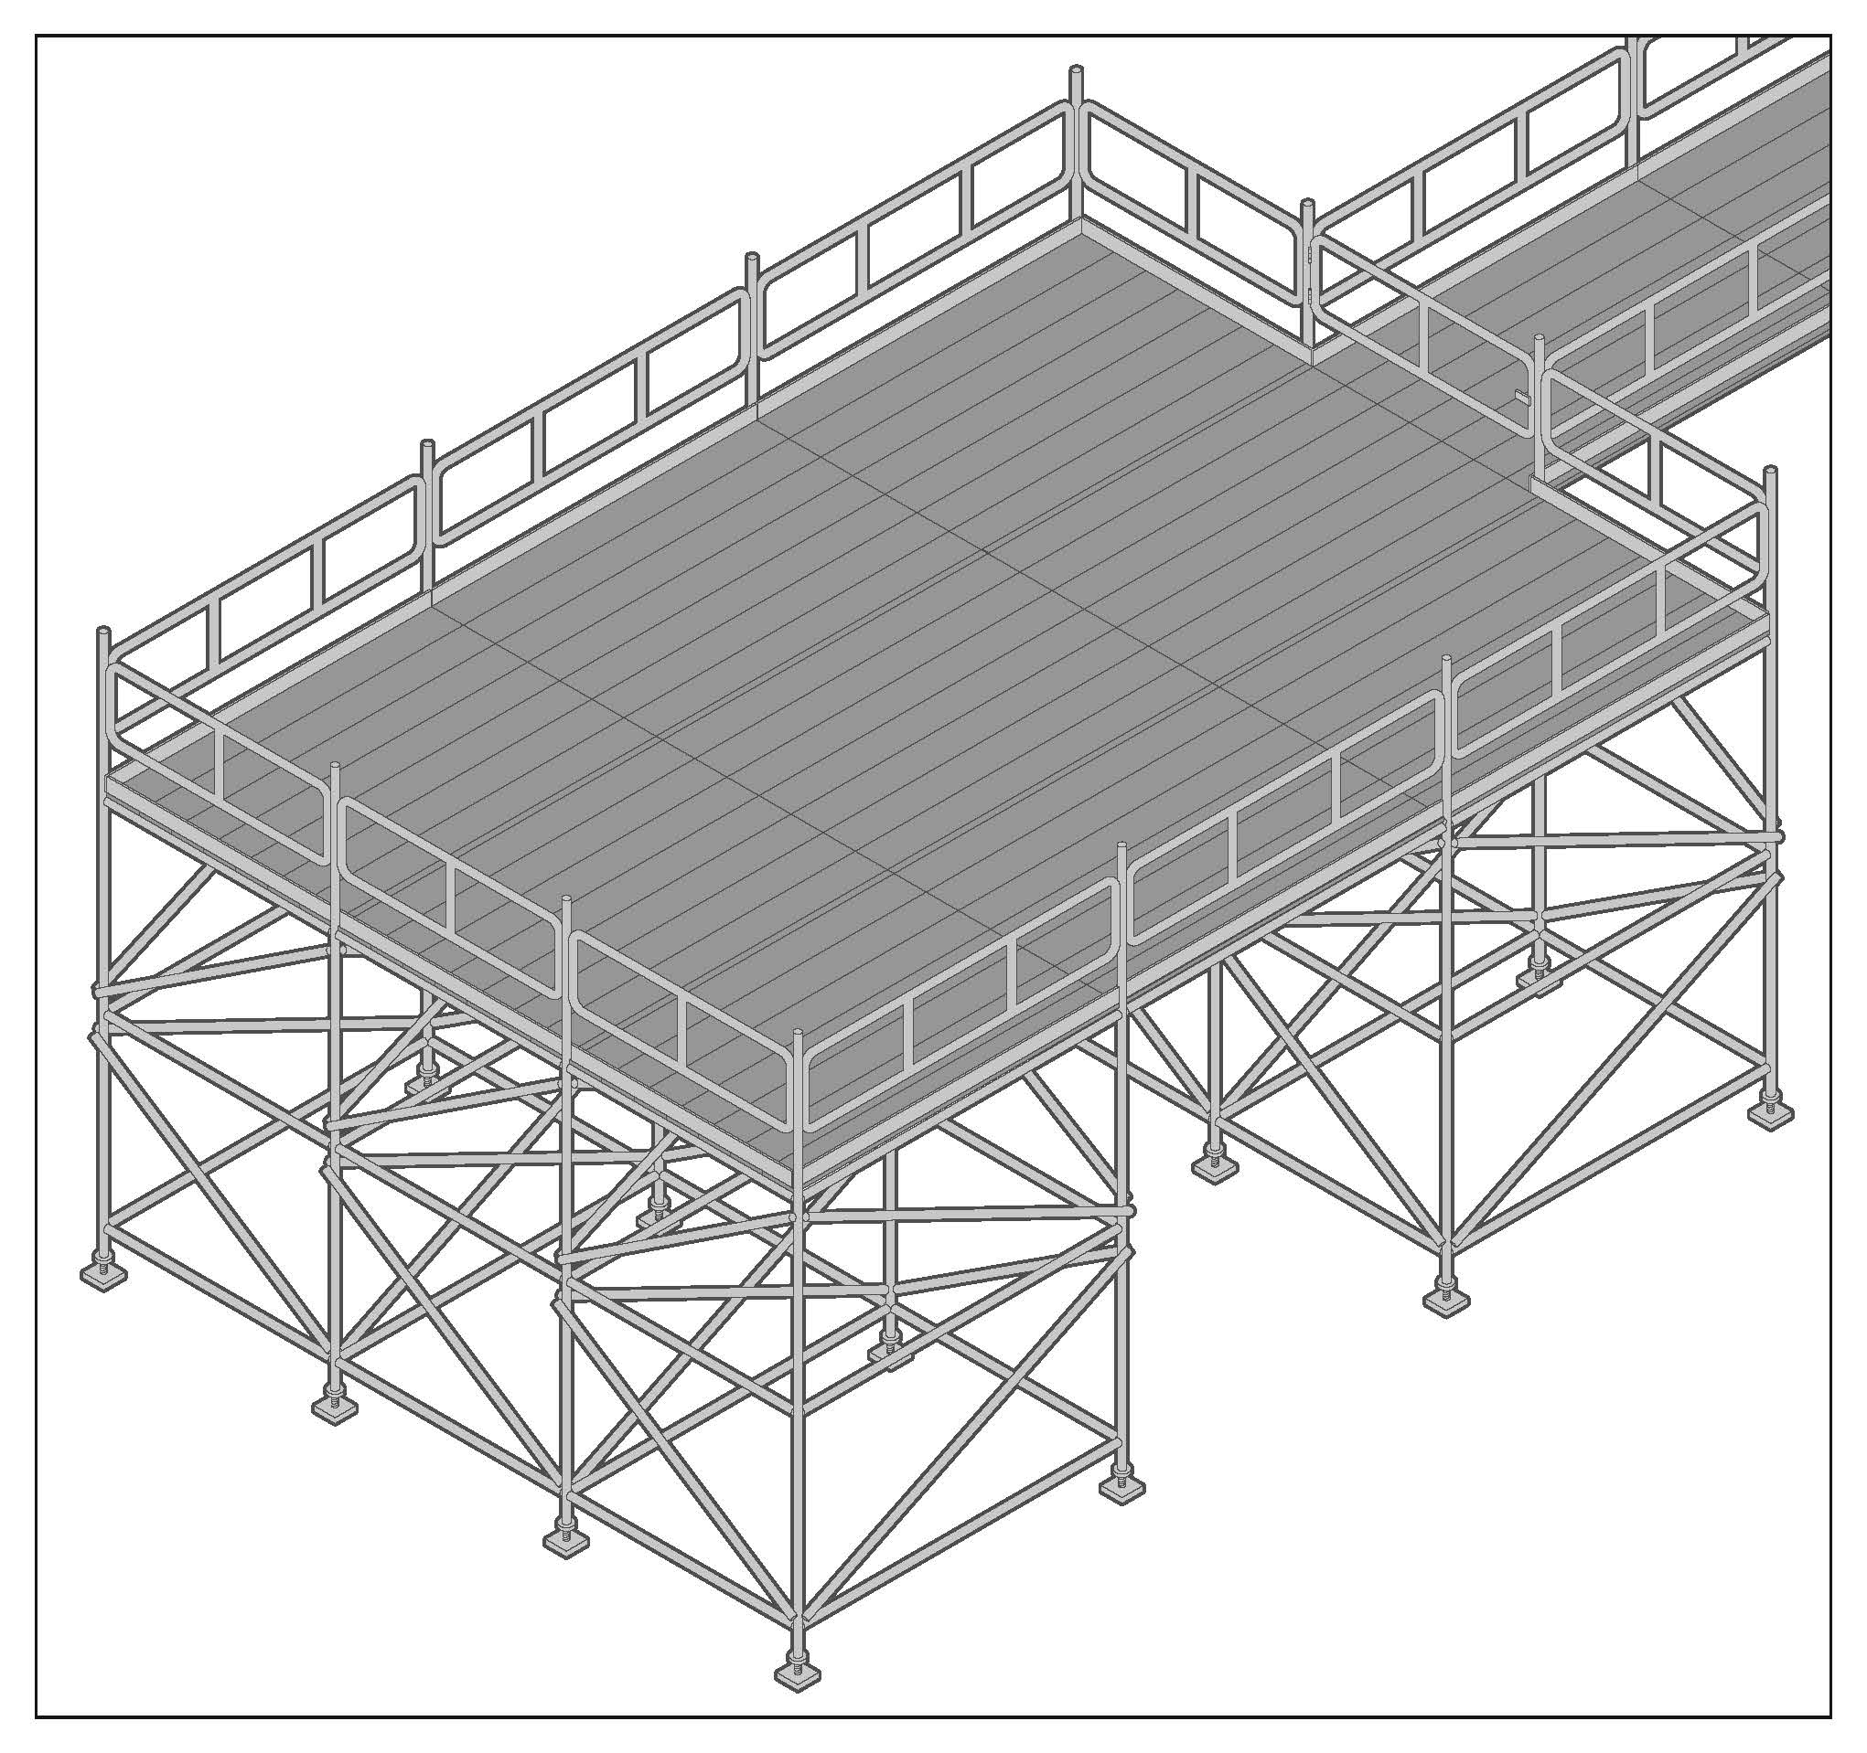A birdcage scaffold is an independent scaffold consisting of more than two rows of standards in both directions connected by ledgers and transoms (see Figure 1). It is mainly used for work carried out on a single level, for example ceilings. You should refer to the designer’s or manufacturer’s specifications when erecting and dismantling birdcage scaffolds made from modular scaffolding.

The following risk control measures should be implemented for birdcage scaffolds made from tube and coupler scaffolding:

* Only use birdcage scaffold to support formwork if it has been specifically designed for this purpose.
* Provide longitudinal bracing or a tied face at every third longitudinal row of standards.
* Brace the outside row of standards on each face and each third row internally with longitudinal bracing.
* Provide transverse bracing at every fourth bay on the ends of the scaffold.
* Consider using elevating work platforms to assist with erecting or dismantling birdcage scaffolds.

[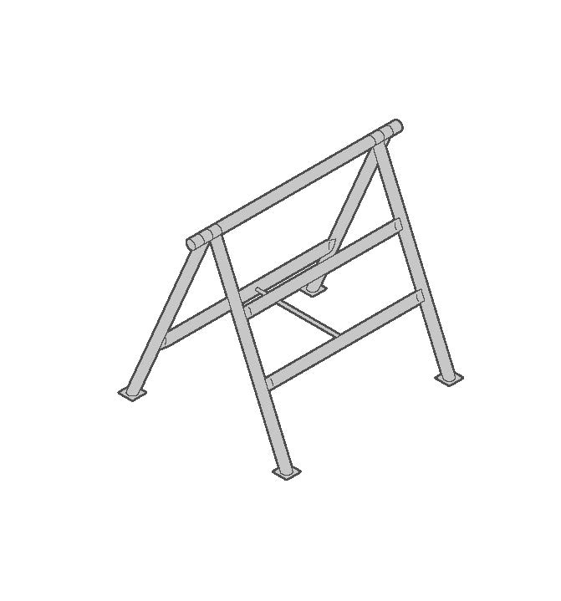](javascript:;)A fall arrest system is generally not a suitable risk control measure for the erection or dismantling of perimeter and birdcage scaffolds. You should refer to the [*General guide for* s*caffolds and scaffolding work*](http://www.safeworkaustralia.gov.au/sites/SWA/about/Publications/Documents/865/Scaffolds-Scaffolding-Work-General-Guide.docx)for further information on fall arrest systems.

**Figure 2** ’A-frame’ trestle scaffold

Trestle scaffold

A trestle scaffold is a scaffold assembled from prefabricated trestles, braces and accessories. Trestle scaffolds, for example ‘A-frame’ (see Figure 2) and ‘H-frame’ trestle scaffolds, are commonly used by bricklayers, plasterers and painters and for general fit-out and finishing work. Trestle scaffolds generally do not require a licensed scaffolder to erect or dismantle.

Trestle scaffolds should be erected and dismantled by a competent person in a progressive way   
to ensure both the installer’s safety and the stability of the overall structure. Braces should be attached to the trestles in accordance with the manufacturer’s or supplier’s instructions. As the height of trestles increase, there is a greater need to provide lateral stability to the trestles.

A trestle scaffold should be stable and erected on a suitable foundation to ensure it can safely carry and distribute loads like materials and workers evenly to each trestle. Measures to control instability and stop possible toppling can include using ties to a permanent structure or using outriggers.

Trestle scaffolds should:

* have barriers or edge protection installed where the potential fall would result in injury to people using the scaffold or the fall area contains hazards e.g. sharp objects like steel reinforcing bars
* support the relevant live load or duty rating—not exceeding load limit   
  *Note:* The full width of a trestle should be fully planked, irrespective of the duty rating.
* have scaffold planks that are uniform and in a serviceable condition e.g. no splits, cracks, knots   
  or bends, overhang their end supports between 150–250 mm and are secured against uplift
* have a horizontal work platform at least 450 mm wide. On sloping or uneven ground use a trestle that incorporates height adjustment. Bricks or blocks should not be used as soleplates
* have a safe means of entry and exit e.g. by secured ladders or from the building if approximately level with the platform
* have a safe means to load material onto the working platform e.g. use mechanical means or if this is not practicable, pass—do not throw—material up to the working platform, and
* not be used by multiple people in restricted work areas at the same time e.g. so as not to overload 450 mm, 2 plank platforms.

Most bracing systems for tubular trestle scaffolds are manufactured from light materials and are easily damaged by misuse or abuse so care should be taken during installation and dismantling. Under no circumstances should anyone climb the braces or trestles.

Cross-braces on trestle scaffolding do not satisfy the requirements for edge protection.

Hung scaffold

**Figure 3** Hung scaffold

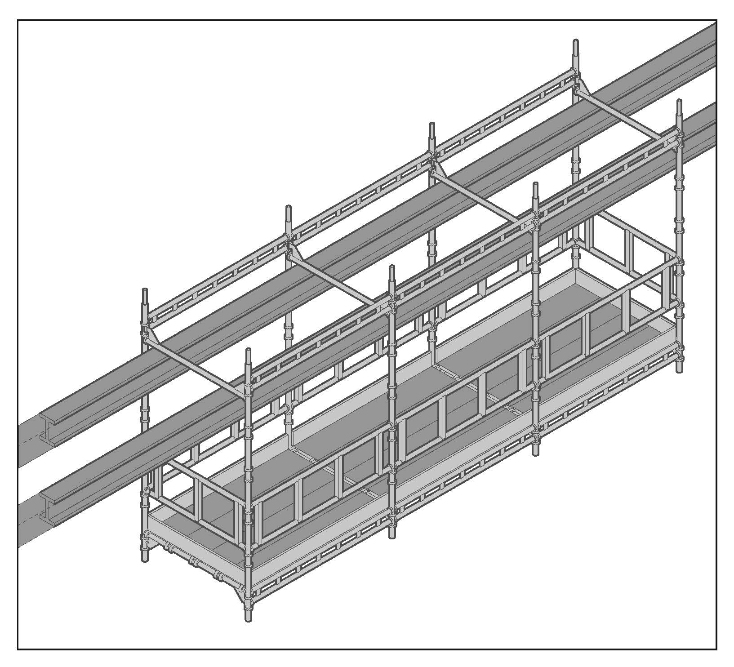A hung or hanging scaffold is an independent scaffold that hangs from another structure but is not capable of being raised or lowered when in use (see Figure 3).

The following control measures should be implemented for a hung scaffold:

* The hung scaffold should be designed by a competent person and verification obtained that the structure that is to support the hung scaffold is capable of bearing the design load.
* The scaffolding plan should include information about the position of the check couplers.
* If a cantilevered suspension rig is to be used, information should be included on how the rig is to be constructed and secured.
* Standards on a hung scaffold should be tension spliced or bolted with rated spigot connection as per the manufacturer’s specifications.
* Each vertical hanging tube should be provided with check couplers at the suspension points and underneath the platform or according to the manufacturer’s specifications.

Single pole scaffold

A single pole scaffold consists of a single row of standards connected by ledgers (see Figure 4). Putlogs are fixed to the ledgers and built into the wall of the building or structure.

A single pole scaffold is dependent upon the structure against which it is placed for support. It is important that no components of this type of scaffold are removed until the scaffold is being dismantled.

**Figure 4** Single pole scaffold

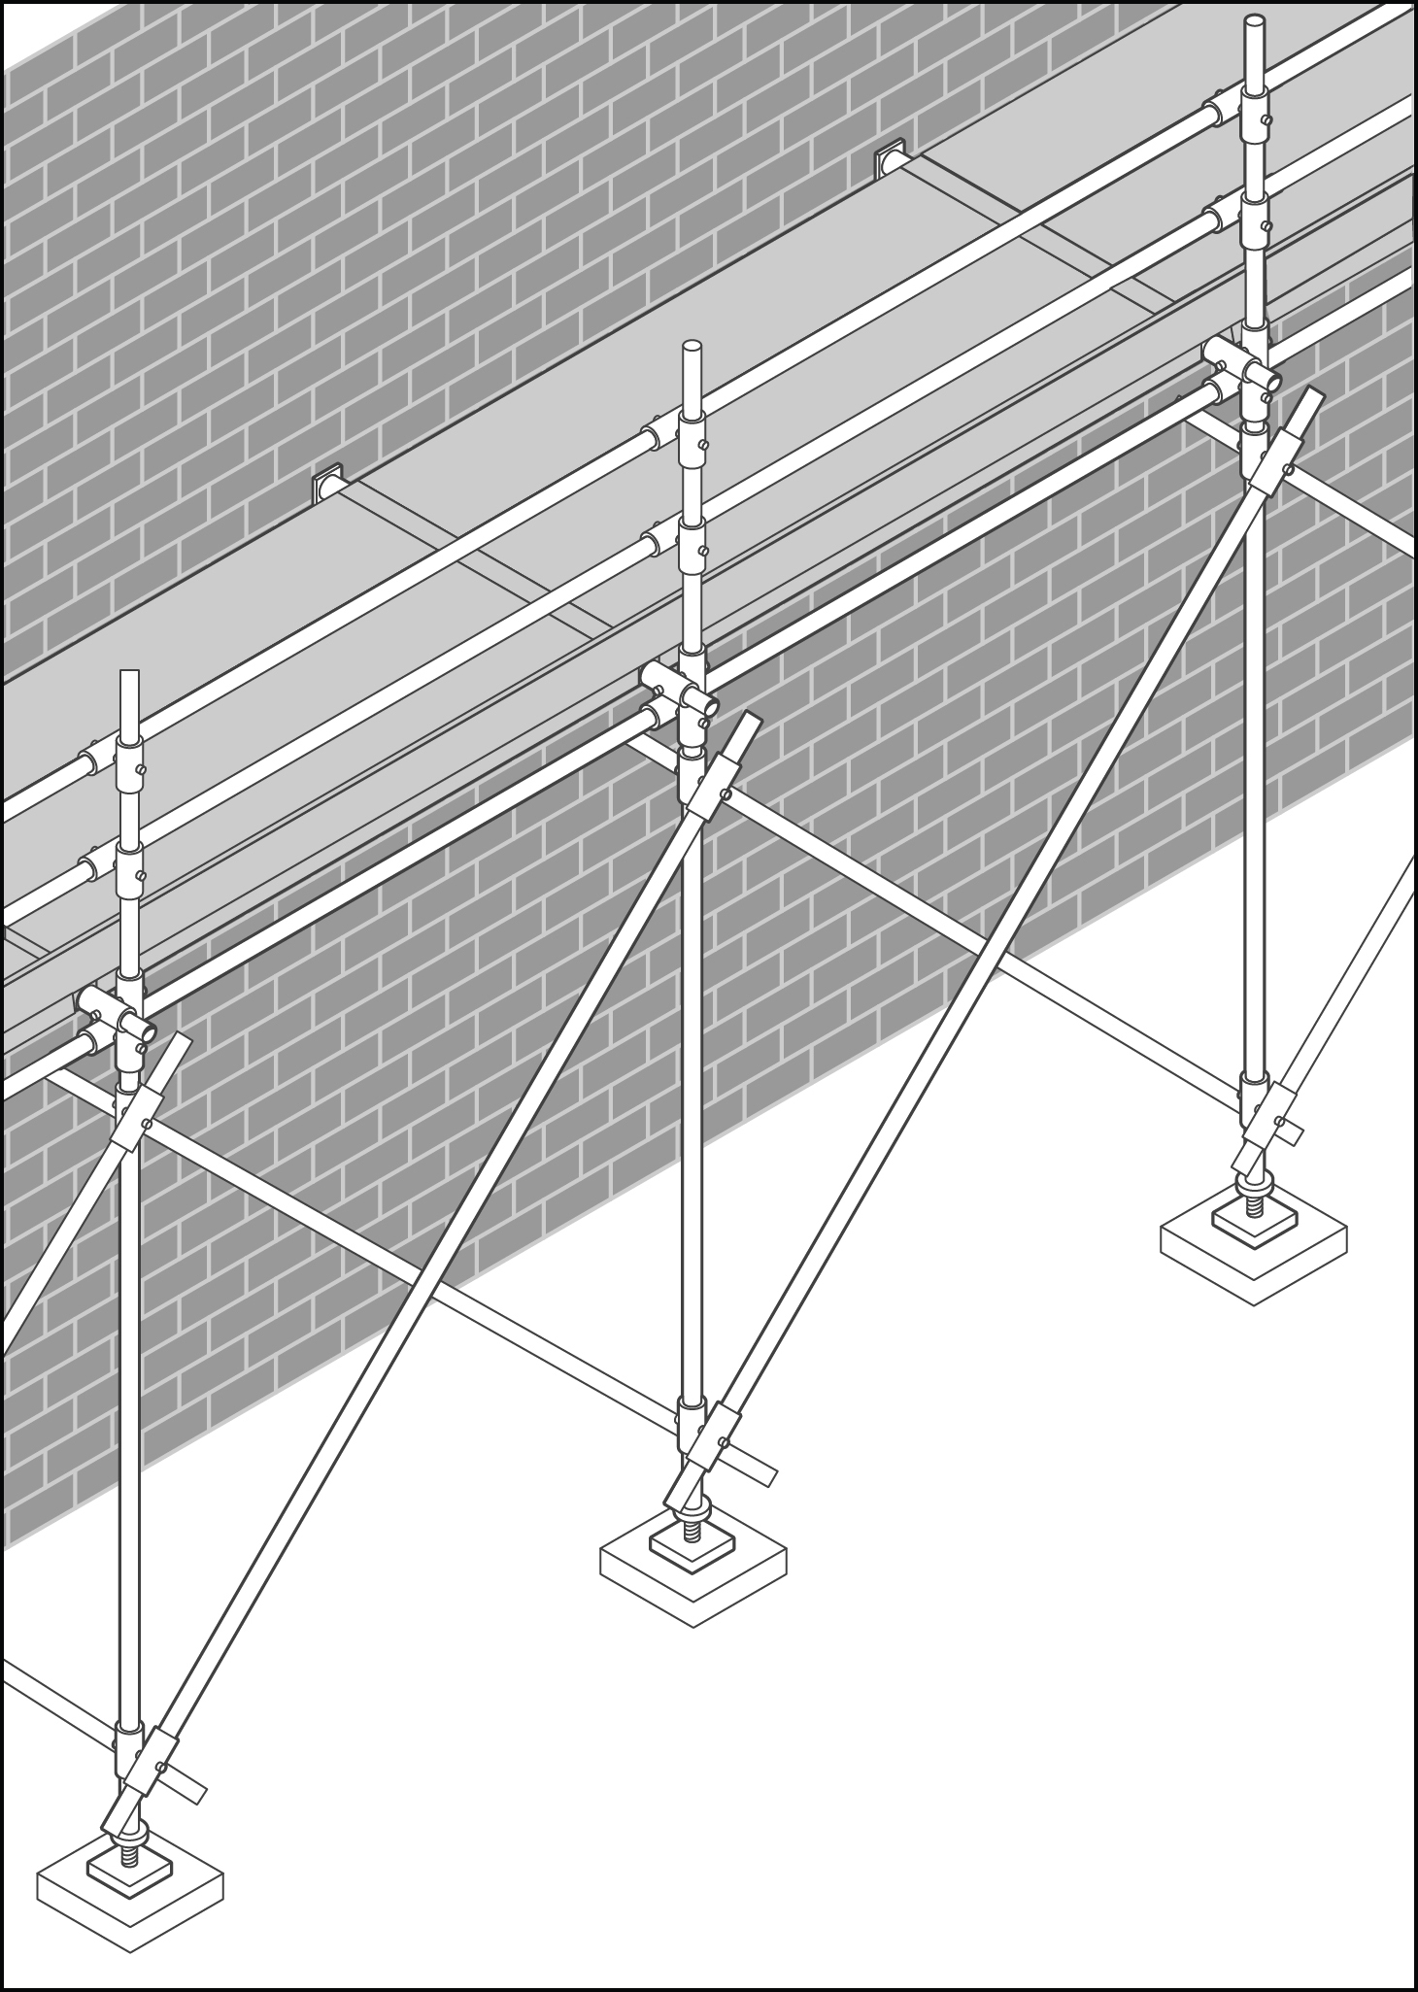

Suspended (swing stage) scaffold

A suspended scaffold incorporates a suspended platform capable of being raised or lowered when in use. An example of a suspended scaffold is a swing-stage scaffold.

Further information is in the [*Guide to suspended (swing stage) scaffolds*](http://www.safeworkaustralia.gov.au/sites/SWA/about/Publications/Documents/865/Guide-Suspended-(Swing-Stage)-Scaffolds.docx).

Tower and mobile scaffolds

A tower scaffold is an independent scaffold consisting of four vertical standards connected longitudinally and transversely or two frames in plan connected transversely to create a scaffold of one bay.

A mobile scaffold is a tower scaffold mounted on wheels.

Further information is in the [Information Sheet: *Tower and mobile scaffolds*](http://www.safeworkaustralia.gov.au/sites/SWA/about/Publications/Documents/865/Tower-Mobile-Scaffolds-Information-Sheet.docx).

Scaffolds for demolition work

At a minimum, heavy or special duty (see below) scaffold should be used during demolition work to contain dislodged materials or to provide a safe working platform and edge protection for workers.

Factors which affect the stability of a scaffold for demolition work include:

* the load imposed by demolished material dislodged onto the scaffold
* wind forces acting on containment sheeting on the scaffold face
* water retention in containment sheeting by capillary attraction
* progressive removal of building elements affecting the lateral stability of the upper portion of the scaffold, and
* progressive removal of ties and dismantling of the scaffold.

The following risk control measures should be implemented when using scaffolds for demolition work:

* The vertical spacing of scaffold ties may have to be reduced to facilitate the demolition cycle.
* Containment sheeting on the internal face of the scaffold should be installed to deflect material into the building. This reduces the potential for overloading the scaffold.
* Ensure the scaffold is dismantled progressively and in line with the demolition work.
* Scaffold planks should be secured to prevent dislodgement from falling debris.
* The scaffold should be maintained and inspected regularly.

Further information on demolition work is in the [Code of Practice: *Demolition work*](http://www.safeworkaustralia.gov.au/sites/swa/about/publications/pages/demolition-work).

Special duty scaffolds

Special duty scaffolds are scaffolds that have a specified design load for that scaffold only. A special duty scaffold differs from other scaffold working platforms which are generally rated as light, medium or heavy duty and have a standardised maximum load rating and minimum dimensions. The following are some examples of common special duty scaffolds.

Cantilever scaffold

A cantilever scaffold is a scaffold supported by cantilevered load-bearing members.

The following risk control measures should be implemented for a cantilevered scaffold:

* Design and position cantilever beams in accordance with the engineer’s requirements and the scaffolding plan.
* Ensure a competent person certifies that the supporting structure can support the cantilevered scaffold.
* Use the following preferred methods for fixing the inboard length of the cantilevered beam to the structure:
* Fix the beam to the floor below using a positive fixing e.g. a U-bolt fitted over the beam and through the concrete floor slab.
* Use counterweights on the beam.
* Install props to the top of the beam and to the underside of the floor above, ensuring the props are fixed to prevent dislodgement.

Hanging bracket scaffold

Hanging bracket scaffolds are systems supported by frames on buildings or other structures. Hanging brackets are sometimes in the shape of an upside down ‘L’, one arm of which is fixed to a vertical surface, the other projecting horizontally to support scaffold planks.

Other hanging bracket scaffold systems may include horizontal members supported by floors of buildings or other structures.

The following risk control measures should be implemented for hanging bracket scaffolds:

* Provide a safe way for people installing hanging brackets to enter.
* Use connectors where two more scaffold planks sag unevenly and cause a tripping hazard.
* Use an engineer to design hanging bracket scaffolds and their means of support—engineering verification may be provided by calculation or load testing.
* The supporting structure should be able to support dead and live loads applied by the hanging brackets.
* The spacing of brackets should not exceed the maximum plank spans specified by the manufacturer.
* Planks may overlap planks on straight runs on hanging bracket scaffolds—where butting of planks   
  at a pair of brackets cannot be achieved—provided the overlap is at least 300 mm.  
  *Note:* This does not refer to overlap of planks on putlogs.

Spur scaffold

A spur scaffold is a scaffold supported by inclined load-bearing members.

The following control measures should be implemented for a spur scaffold:

* Fix propping systems between the floor and ceiling at intervals to suit the spacing of the standards within the scaffold.
* Provide suitable headstocks at the top of each propping system to distribute the loads imposed.
* Ensure propping systems are securely tied together and braced.
* Brace spurs exceeding 1.8 metres in length in both directions at the centre unless designed otherwise.

Scaffolding

Tube and coupler scaffolding

Tube and coupler scaffolds are built from tubing (tube) and joining or fixing components (couplers) fixed together, to form a required scaffold design. They are frequently used on structures with unusual design, shape or function. The versatility of tube and coupler scaffolds means they can be assembled in a wide variety of different configurations. This also means erecting tube and coupler scaffolds can be complex when compared to prefabricated scaffolds.

The diameter and strength of the tube and components being used to form a tube and coupler scaffold will determine the load it can carry. For a scaffold incorporating plain steel tube, the analysis and design should consider the most adverse combination of tubes by wall thickness, strength of the tube material or both.

Steel tubes and aluminium tubes should not be mixed in one scaffold.

Tubes of different wall thicknesses should not be interconnected by spigots or internal-type end-to-end couplers unless extra measures are taken to positively secure the joint. For example, fix a short tube with swivel couplers over and parallel to the joint (splicing) or fix a bridle with right-angle couplers to the adjacent members.

Metal tube and coupler components should be regularly inspected for damage and particular attention given to crushing, deformation, cracks, corrosion and splitting.

Prefabricated scaffolding

Prefabricated scaffolding is defined as ‘an integrated system of prefabricated components manufactured in such a way that the geometry of assembled scaffolds is pre-determined’.

Prefabricated scaffolding can include modular, tower, cantilever, hung and suspended (swing-stage) scaffolds.

Prefabricated scaffolding must be design registered as required under Part 1 of Schedule 5 of the WHS Regulations.

Further information

* AS 1576 (series): *Scaffolding*
* AS 1577: *Scaffold decking components*
* AS/NZS 4576: *Guidelines for scaffolding*

Codes of practice, guidance material and other resources are available on the [Safe Work Australia](http://www.swa.gov.au/) website (www.swa.gov.au).