# GUIDE FOR OPERATING CRANES AND MOBILE PLANT NEAR OVERHEAD ELECTRIC LINES

This Guide provides information on managing the risks associated with operating cranes or mobile plant near overhead electric lines.

Cranes and mobile plant include mobile cranes, vehicle-loading cranes, concrete placing booms, elevating work platforms, load shifting equipment like forklifts, excavation and earthmoving equipment and high load transportation vehicles. However, this does not include cranes and mobile plant when retracted and correctly stowed for travelling on a public road or where the design envelope of the crane   
or mobile plant is less than 4.6 metres in height. Overhead electric lines include overhead electric distribution lines on poles of high or low voltage, overhead electric transmission lines on towers, dedicated overhead electric lines used by public transport authorities including tramways and railways and privately owned overhead electric lines.

This Guide is part of a series of material and should be read and used together with the [*General guide   
for* w*orking in the vicinity of overhead and underground electric lines*](http://www.safeworkaustralia.gov.au/sites/SWA/about/Publications/Documents/859/Overhead-Underground-Electric-Lines-General-Guide.docx) which provides information on planning and preparation, managing electrical risks, work zones and approach distances for overhead electric lines and specific guidance material for:

* [tree and vegetation management](http://www.safeworkaustralia.gov.au/sites/SWA/about/Publications/Documents/859/Tree-Vegetation-Management-OHEL-Information-Sheet.docx)
* [scaffolding work](http://www.safeworkaustralia.gov.au/sites/SWA/about/Publications/Documents/859/Scaffolding-Near-OHEL-Information-Sheet.docx)
* [agricultural work](http://www.safeworkaustralia.gov.au/sites/SWA/about/Publications/Documents/859/Agricultural-work-near-OHEL-Information-Sheet.docx)
* [working near low voltage overhead electric lines near structures](http://www.safeworkaustralia.gov.au/sites/SWA/about/Publications/Documents/859/Guide-Low-Voltage-Overhead-Electric-Lines-Near-Structures.docx), and
* [transporting high loads](http://www.safeworkaustralia.gov.au/sites/SWA/about/Publications/Documents/859/Guide-Transporting-High-Loads.docx).

## Approach distances

Contact with energised overhead electric lines by operating cranes or mobile plant can cause death, electric shock or other injury to plant operators and workers.

It can be difficult for crane or plant operators to see overhead electric lines or judge their height.   
You need to decide what approach distances and work zones (see Figure 1) are required for the safe operation of cranes and mobile plant and the safety of crane or plant operators and other workers.

The approach distance for each work zone will vary depending on the voltage of the overhead electric line and the level of authorisation of each person doing the work. As the risk increases a greater approach distance is required.

There are three work zones:

* **Zone C** is a No Go Zone closest to and surrounding the electric line where Electricity Supply Authority approval is required. A ‘permit to work’ may be required.
* **Zone B** surrounds the electric line and is further away than Zone C. It is for authorised persons. Authorised persons are workers who have successfully completed a recognised training course   
  in overhead line electrical hazards so are permitted to work in Zone B.
* **Zone A** is furthest away from the electric line and is for unauthorised persons. Unauthorised persons are workers who have not received training in overhead line electrical hazards and do not have sufficient training or experience to enable them to avoid the dangers from overhead electric lines   
  and associated electrical equipment.

Approach distances and work zones in each state and territory vary for people, plant and vehicles depending on the voltage of the overhead electric line, whether the electric lines are insulated or bare, and in some states with or without consultation with the person in control of the energised overhead electric line or exposed part.

For more information contact your state or territory [Electricity Supply Authority](http://www.safeworkaustralia.gov.au/sites/SWA/about/Publications/Documents/859/Electricity-Supply-Authorities.docx) or [Electricity Regulator](http://www.safeworkaustralia.gov.au/sites/SWA/about/Publications/Documents/859/Electricity-Regulators.docx).

**Figure 1** Work zones for cranes and mobile plant working near overhead electric lines

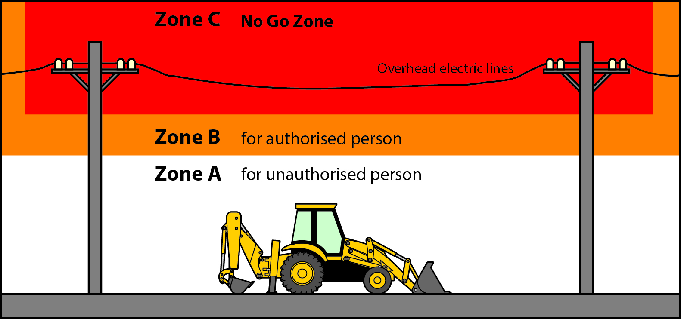

## How do I manage the risks?

Where it is reasonably practicable you must eliminate the risks by preventing people, plant, equipment and materials from coming close enough to energised overhead electric lines for direct contact or ‘flashover’ to occur.

You or the crane or plant operator should:

* discuss options for de-energising or re-routing the electricity supply with the Electricity Supply Authority. If the work involves private overhead electric lines discuss options with the person with management or control of the workplace including on land, a building, a vehicle or installation
* confirm the electric lines have been de-energised—electric lines should always be treated as energised unless you or the crane or plant operator have an access authority from the Electricity Supply Authority confirming the electric lines have been de-energised
* work at another time when the electricity supply can be isolated, or
* find out if the section of the overhead electric line that needs to be de-energised can be isolated while leaving the rest of the line connected.

If elimination is not reasonably practicable, you must minimise the risks so far as is reasonably practicable using the hierarchy of control. Table 1 provides examples of control measures you should consider to minimise the risks noting the control measures should be considered in the order they appear.

**Table 1** Control measures for operating cranes and mobile plant near overhead electric lines

| **Hierarchy of control** | **Example of control measure** |
| --- | --- |
| **Substitution** | * Set up the crane or mobile plant in a position that keeps the design envelope outside the approach distance. * Use alternative plant that cannot enter an unsafe zone. * Use an effectively tested insulated elevating work platform bucket that could prevent electric shocks from the exposed electrical equipment to the ground  via the operating plant.   *Warning*: In spite of the insulated bucket, the worker could still receive an electric shock by touching a current source with one hand and an earth point with the  other hand. |
| **Isolation** | Install or erect a physical barrier to prevent any part of the crane, mobile plant or load being moved from entering Zone Ban unsafe zone. A physical barrier should be made of non-conductive material like wood or plastic and be strong enough to withstand impact from falling objects, loose materials or contact by the operating crane or mobile plant. The barrier should be erected safely which may require isolating the electricity supply while the barrier is installed. |
| **Engineering** | * Limit the hoisting, slewing or other movements of the crane or mobile plant with:   + mechanical stops or interlocking the motion of the crane or mobile plant  to prevent it from being moved within the approach distance.   + mechanical constraints on the jib, boom, or other part of the crane or mobile plant likely to contact energised overhead electric lines or associated electrical equipment as a result of surge or backlash of hydraulic operation, or   + programmable zone limiting devices fitted to cranes or mobile plant—ensure the interlocking or warning system is designed to be ‘fail safe.’ Where the limiting device prevents movement consider sudden stopping  or the momentum of the load. * Minimise unexpected movement of the crane or mobile plant by:   + preparing the ground surface   + using extra outriggers, supports or packing to increase stability, and   + preparing the ground or surface, adjusting or servicing the crane or mobile plant to minimise surge or backlash. * Increase clearances where the load or lifting gear is likely to move or swing towards the overhead electric lines when the crane or mobile plant is operating. * Fit proximity sensors and a warning device to cranes or mobile plant to alert operators when they are about to enter and unsafe zone. |
| **Administrative** | * Make hazards more visible by:   + using warning signs to indicate the location of overhead electric lines and defined work areas (see Figure 2)   + arranging for the Electricity Supply Authority to identify exposed energised low voltage conductors (up to and including 1000 volts) by fitting them with approved visual indicators like sheeting or sleeves e.g. tiger tails. In this situation: * tiger tails should extend a minimum distance of 5 metres beyond the extremities of where the crane or mobile plant will be operating * a competent person should inspect visual indicators each day before starting crane or mobile plant operations, and * if visual indicators have moved or been damaged the electricity supply authority should be contacted so they are replaced or relocated in the correct position. * Manage and supervise the work to ensure:   + safe work practices and procedures are followed   + SWMS are developed where required   + suitably trained and qualified people are authorised to carry out the work   + emergency equipment is provided and easily accessible on site  e.g. first aid kits and fire-fighting equipment suitable for electrical fires   + an emergency plan is in place including procedures for contact with energised electric lines, and   + an emergency plan and rescue procedures are followed if contact occurs   + work is done very carefully and in an un-hurried considered manner—haste can be dangerous   + a safety observer is used whenever a crane, plant or load is in motion  and likely to come closer than the approach distances in Zone C, and   + relevant approach distances are strictly maintained. * Define areas where the crane or mobile plant should not enter by:   + using rigid or tape barriers to mark areas under overhead electric lines, or   + arranging for the Electricity Supply Authority to mark the limit of the approach distance with high visibility bunting or similar (see Figure 3). |
| **Personal protective equipment (PPE)** | * Ensure anyone who may come into contact with a conducting part of the crane, plant or load being moved wears insulated gloves. * Ensure workers stand on a rubber insulating mat or equipotential conductive mat. |

A combination of the controls set out above may be used if a single control is not enough to minimise the risks. You should also check your chosen control measures do not introduce new hazards.

**Figure 2** Overhead electric lines warning sign

**Figure 3** Visual tape bunting fitted under overhead electric lines

Warning sign says:
DANGER
KEEP CLEAR OF OVERHEAD ELECTRIC LINES
CONTACT CAN CAUSE DEATH 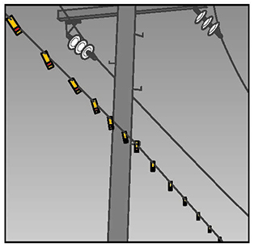

### Safe work method statement

A safe work method statement (SWMS) may be required when operating a crane or mobile plant near overhead electric lines. A written SWMS should be based on a risk assessment. The SWMS and risk assessment should be available to workers on site during the work.

More information on SWMS is in the [Code of Practice: *Construction work*](http://www.safeworkaustralia.gov.au/sites/swa/about/publications/pages/construction-work).

## Work in Zone C – No Go Zone

Zone C is the No Go Zone around overhead electric lines and associated electrical equipment where   
no part of a person, vehicle or mobile plant may enter while the electric lines and associated electrical equipment are energised, without written approval from the Electricity Supply Authority.

Equipped with relevant electrical training or experience, an authorised person can work within   
a smaller no go zone where a risk assessment has determined this as safe. On site the authorised person could be the plant operator, supervisor, electrician or worker.

## Work in Zone B for authorised persons

An operating crane or mobile plant may be in Zone B only when it is operated by an authorised person.

To carry out crane and mobile plant operations in Zone B the operator of the crane or mobile plant and the safety observer require authorisation from the Electricity Supply Authority. To authorise a worker, you or the principal contractor should ensure the worker has the necessary knowledge and technical skill to do the work.

Before starting work you should get approval from the person with management or control of the electrical line, which is usually the Electricity Supply Authority. However if it is a private electric line, for example on a farm, approval to work near the line is required from the owner before the worker can be authorised. The owner may also need to seek advice from the Electricity Supply authority.

When an operating crane or mobile plant is in Zone B or when it is intended to operate in Zone B, a safety observer or another safe system of work should be used to prevent contact with the low voltage electric line or, where contact is allowed, prevent damage to the electric line. Other safe systems of work include:

* A 1 metre distance between low voltage electric lines and an operating crane or mobile plant, or where circumstances demand a greater distance, may be necessary to ensure contact and possible damage to the electric line do not occur. The distance should allow for unplanned movement of operating plant due to unstable foundations. A 1 metre Zone B may not be necessary for low voltage communication lines.
* Use limit switches to prevent the operating crane or mobile plant from contacting the electric line.
* Position the operating crane or mobile plant so it will not contact the electric line.

## The Safety Observer Zone

A crane or mobile plant is in a safety observer zone (see Figure 4) when it is possible that:

* a part of the operating crane or mobile plant
* a person on an elevated work platform
* hand tools or other equipment held by anyone involved in the operation, and
* the load being moved

could enter Zone B during operations.

A crane or mobile plant is not operating in a safety observer zone when:

* high voltage electric lines have been de-energised, isolated or earthed
* limiting devices are used to warn the operator or prevent any part of the crane, plant or load being moved from entering Zone B—as long as the limiting device is effective under stress conditions   
  and is regularly inspected by a competent person, or
* physical barriers stop any part of the crane, mobile plant or load entering Zone B, or
* the design of the crane or mobile plant limits such movement.

**Figure 4** Safety observer zone for overhead electric lines on poles and towers

Figure 4 shows the safety observer zone in relation to Zone B around electric lines on poles and towers. It also shows the maximum slew radius of a crane where any part of the crane 
or load could encroach into Zone B. This is strictly forbidden.

## Safety Observer

A safety observer should be used when the crane, load, mobile plant or anyone working from the plant are in motion and are likely to enter Zone B. The safety observer should:

* mark the border of Zone B with suitable markers e.g. red warning tape easily seen by the crane   
  or plant operator
* warn the operator if a part of the crane, load or mobile plant is about to enter Zone B, and
* stop unauthorised people entering Zone B
* not be required to observe more than one operating crane or mobile plant at a time
* communication effectively at all times with crane or mobile plant operators and warn them about   
  an approach to Zone B
* be provided with specialist communication equipment where there is a barrier to communication
* be trained to perform the role, and
* have the authority to stop the work at any time.

## Workers in contact with cranes, loads or mobile plant

No one should remain in contact with any part of a crane, load or mobile plant and the ground or other earthed situation while the crane or mobile plant is operated closer than Zone A, unless extra precautions are taken to prevent electric shock.

Operators should handle the controls of a crane or mobile plant while standing on the ground or while   
in an earthed situation only if:

* the controls are effectively insulated—see manufacturer’s documentation
* using wireless remote controls
* the operator wears low voltage insulating gloves—provided the energised electrical equipment   
  is low voltage and does not exceed 1000 volts
* for low voltage, the operator stands on a clean and dry rubber insulating mat 900 mm x 900 mm x 6 mm thick, or
* the operator stands on an equipotential conductive mat which is electrically connected to all metalwork associated with the controls.

Other workers essential to the operation, like a dogger or people setting up the operating crane or mobile plant, may work in the safety observer zone only if they are not required to have direct contact with any part of the operating crane, plant or the load. Other workers may come into contact with the crane, plant or the load while standing on the ground or while in an earthed situation only if:

* effective insulation is provided on the overhead electric lines or associated electrical equipment,   
  the crane, load, mobile plant or its parts
* the load is controlled by non-conductive tail ropes whenever uncontrolled motion could allow it to enter Zone B—providing the insulating properties of the rope are suitable for the operating voltage
* workers are positioning or removing lifting gear from a crane hook or the load while it is stationary
* workers are adjusting outriggers, jacks, packings, chocks or similar, providing the crane, load or mobile plant is not being moved, and
* workers wear low voltage insulating gloves—provided the overhead electric lines or associated electrical equipment is low voltage.

## Earthing systems for cranes and mobile plant

The chassis of a crane or mobile plant may, where possible, be earthed and bonded. You should adopt   
a system of work that ensures workers are kept clear of cranes and mobile plant when work is carried   
out in the vicinity of energised overhead electric lines and tell workers of the effectiveness of the earthing system.

You should get specific advice and guidance on the earthing of a crane or mobile plant from the [Electricity Supply Authority](http://www.safeworkaustralia.gov.au/sites/SWA/about/Publications/Documents/859/Electricity-Supply-Authorities.docx).

## Notices to be fixed to cranes and mobile plant

Cranes or mobile plant used near energised overhead electric lines should be fitted with a warning notice or label listing the approach distances for unauthorised persons working in Zone A. The notice or label should be clear, maintained and displayed at each set of operating controls and be visible to the operator.

More information and examples of what can go wrong when approach distances are not maintained are   
in [Case studies – Incidents and scenarios](http://www.safeworkaustralia.gov.au/sites/SWA/about/Publications/Documents/859/Overhead-Lines-Case-Studies.docx).

## Further information

Codes of practice, guidance material and other resources are available on the [Safe Work Australia](http://www.swa.gov.au/) website (www.swa.gov.au).