GUIDE FOR WORKING NEAR   
LOW VOLTAGE OVERHEAD   
ELECTRIC LINES NEAR STRUCTURES

This Guide provides information on managing the risks of unauthorised persons working near low voltage overhead service lines near structures and buildings.

For example:

* painting or maintenance work
* erecting scaffolding
* operating motor vehicles e.g. concrete trucks or furniture removal vans
* minor building work e.g. erecting a small shed, or
* other non-electrical work where there is a risk of contact with a low voltage overhead line.

Unauthorised persons are people without the relevant technical knowledge and experience of electricity transmission and distribution networks and associated electrical equipment that will not be able to identify the operating voltage of electric lines and recognise the associated dangers.

Electric lines in this Guide (and Figure 1) are:

* low voltage overhead lines including service lines owned by the Electricity Supply Authority
* low voltage overhead lines forming part of a consumer’s installation
* insulated low voltage aerial conductors and associated electrical equipment connected from the point of supply–either the overhead electric pole located on the street or the consumer’s boundary–and terminated on the consumer’s building, pole or structure at the point of attachment, or
* insulated low voltage aerial consumer’s mains and associated electrical equipment forming part   
  of the consumer’s electrical installation.

**Figure 1** Low voltage overhead service lines

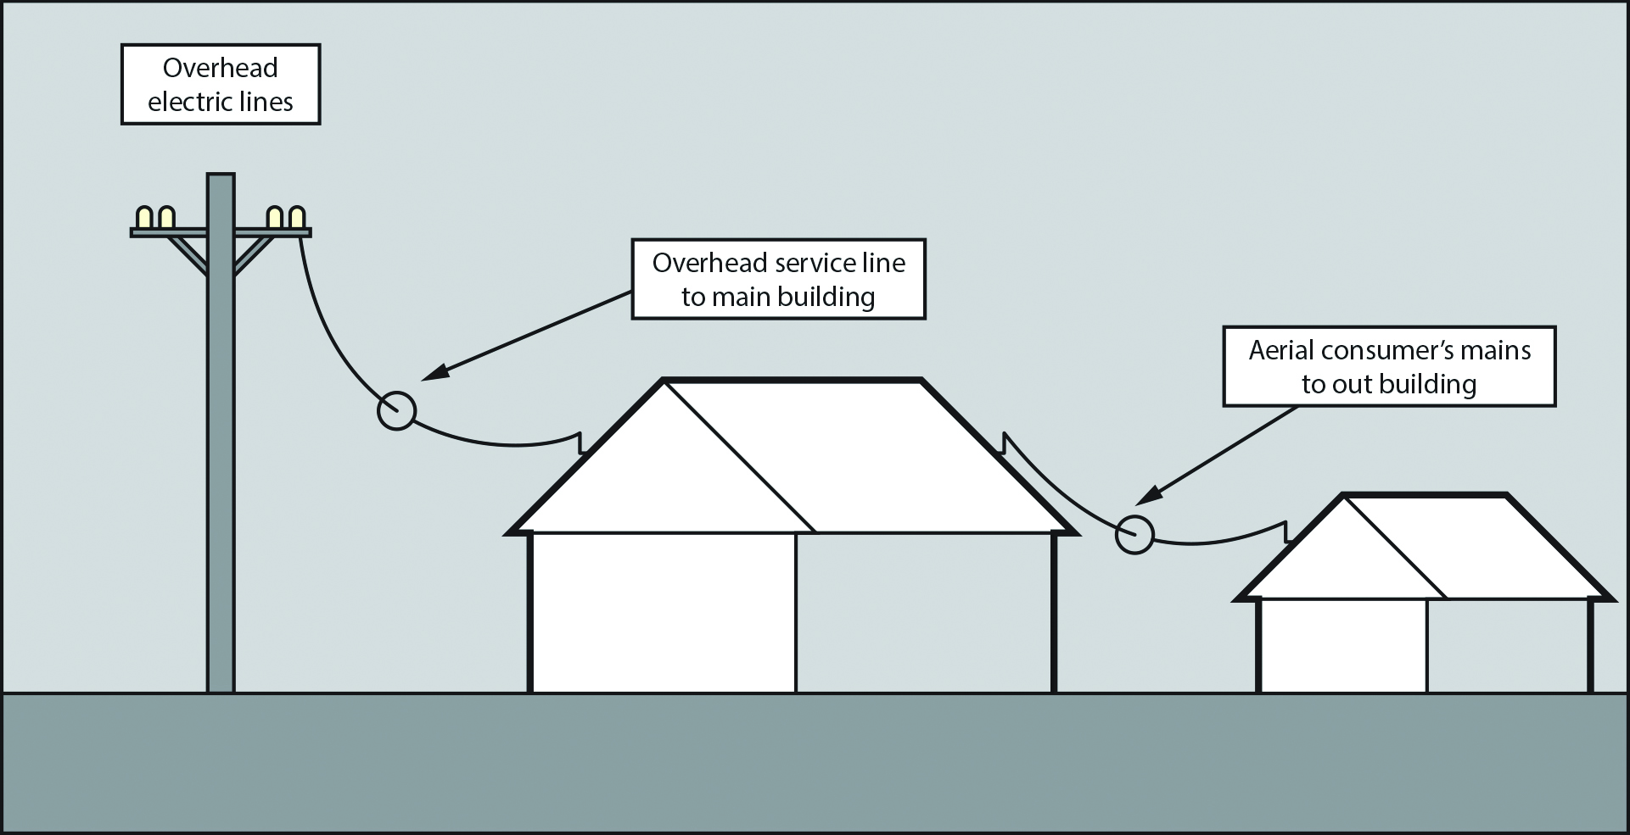

Note:

1. If the overhead line is found to be a high voltage line, this Guide does not apply.
2. If the voltage of the line cannot be determined, the line should be treated as if it were a high voltage line and (i) will apply.
3. If you cannot determine whether the line is effectively insulated, the line should be treated as if it were bare.

This Guide is part of a series of material and should be read and used together with the [*General guide for* w*orking in the vicinity of overhead and underground electric lines*](http://www.safeworkaustralia.gov.au/sites/SWA/about/Publications/Documents/859/Overhead-Underground-Electric-Lines-General-Guide.docx) which provides information on planning and preparation, managing electrical risks, work zones and approach distances for overhead electric lines and specific guidance material for:

* [tree and vegetation management](http://www.safeworkaustralia.gov.au/sites/SWA/about/Publications/Documents/859/Tree-Vegetation-Management-OHEL-Information-Sheet.docx)
* [scaffolding work](http://www.safeworkaustralia.gov.au/sites/SWA/about/Publications/Documents/859/Scaffolding-Near-OHEL-Information-Sheet.docx)
* [agricultural work](http://www.safeworkaustralia.gov.au/sites/SWA/about/Publications/Documents/859/Agricultural-work-near-OHEL-Information-Sheet.docx)
* [cranes and mobile plant](http://www.safeworkaustralia.gov.au/sites/SWA/about/Publications/Documents/859/Guide-Operating-Cranes-Mobile-Plant-OHEL.docx), and
* [transporting high loads](http://www.safeworkaustralia.gov.au/sites/SWA/about/Publications/Documents/859/Guide-Transporting-High-Loads.docx).

## What are the risks?

Contact with energised overhead electric lines when working near low voltage electric lines can expose workers to health and safety risks including death, electric shock or other injury caused directly or indirectly by electricity. An electric shock can also occur without direct contact with overhead electric lines. A close approach to line conductors may allow a ‘flashover’ to occur.   
The risk of flashover increases as the line voltage increases.

## Approach distances

Designated approach distances are one way of keeping people separated from electrical hazards.

Table 1 shows general approach distances for unauthorised persons working near low voltage service lines when:

* performing minor building work using hand tools held by a person
* operating cranes and their loads or mobile plant
* handling metal materials e.g. scaffolding, roofing materials, ladders and guttering
* handling non-conductive materials e.g. timber, plywood, polyvinyl chloride (PVC) pipes and guttering, or
* driving or operating a vehicle under overhead service lines. Note: approach distances specified   
  in Table 1 are based on the design or transit envelope of the vehicle not allowing any part of the vehicle to come closer than the 0.6 metre approach distance specified.

**Table 1** Approach distances for unauthorised persons working near low voltage service lines

|  |  |  |  |  |
| --- | --- | --- | --- | --- |
| **Approach distances for unauthorised persons** | | | | |
| Hand held tools | Operating a crane or mobile plant | **Handling metal materials** *e.g. scaffolding, roofing, ladders, guttering and pipes.* | **Handling non-conductive materials** *e.g. timber, plywood, PVC pipes and guttering.* | Driving or operating vehicle |
| 0.5 m | 3.0 m | 4.0 m | 1.5 m | 0.6 m |

*Note:* Approach distances for work near overhead electric lines vary in each state and territory for people, plant and vehicles depending on the voltage of the overhead electric line, whether the electric lines are insulated or bare, and in some states with or without consultation with the person in control of the energised overhead electric line or exposed part. Therefore for specific low voltage electric line requirements that apply in your state or territory you should contact your [Electricity Regulator](http://www.safeworkaustralia.gov.au/sites/SWA/about/Publications/Documents/859/Electricity-Regulators.docx) or your [Electricity Supply Authority](http://www.safeworkaustralia.gov.au/sites/SWA/about/Publications/Documents/859/Electricity-Supply-Authorities.docx).

More information on scaffolding work near overhead electric lines is in the [Information Sheet: *Scaffolding work near overhead electric lines*](http://www.safeworkaustralia.gov.au/sites/SWA/about/Publications/Documents/859/Scaffolding-Near-OHEL-Information-Sheet.docx)*.*

## What do I need to do?

You must prevent people, plant, equipment and materials from coming close enough to energised low voltage overhead electric lines for direct contact or ‘flashover’ to occur.

Conduct a workplace inspection to identify potential hazards before starting work near low voltage service lines where the work may come closer than the specified approach distances.

### Visual examination of low voltage overhead line

An insulated low voltage overhead line should be examined for visible defects. If the line is part of   
a customer’s installation, a licensed electrical worker should assess the line. If the line is owned by the Electricity Supply Authority, either an electrical worker with relevant experience or the Electricity Supply Authority should be engaged to have the line assessed.

The line should be visually checked to ensure:

* insulation is intact with no tears, cracks or other physical defects and there are no exposed energised parts along the line, and
* there are no exposed energised parts anywhere on the line.

Hazards may include:

* bare exposed energised conductors
* deteriorated or broken down insulation
* damaged service line mains connection box or damaged insulation around conductor clamps
* deterioration of earthing of exposed conductive parts required to be earthed
* voltage of the line is higher than the expected low voltage (240/415 volts alternating current), and
* the possibility of hand held tools and equipment contacting exposed energised parts.

When assessing the risks consider:

* Tools or equipment used and the risk of mechanical damage to the low voltage service lines if accidental contact occurs with the conductors or associated electrical equipment. Examples include:
  + Handling a sheet of roofing material that accidently contacts the service lines.
  + Using cutting or grinding tools where the operator could lose control and come within the approach distance outlined in Table 1. Using a heavy electric disc sander to sand timber near the point of attachment of a service line may create a high risk of contacting the line if control is lost. The risk of damage to and contact with the line and consequent electric shock is high if the sander touched the line. Consider manual sanding instead.
* Proximity of the work to the low voltage service lines.
* Environmental conditions e.g. rain, wind or uneven terrain that may create a risk of unexpected movement of tools or equipment held by workers.

## How do I control the risks?

Where it is reasonably practicable you must eliminate the risks by preventing people, plant, equipment and materials coming close enough to energised low voltage service lines for direct contact or ‘flashover’ to occur by arranging for the:

* de-energising of the lines for the duration of the work—this should be confirmed by the person with management or control of the electric line, or
* re-routing of the low voltage service line away from the workplace in consultation with the Electricity Supply Authority or where the overhead service lines forming part of the consumer’s electrical installation, the person with management or control of the premises.

De-energising or moving electric lines should be arranged with the [Electricity Supply Authority](http://www.safeworkaustralia.gov.au/sites/SWA/about/Publications/Documents/859/Electricity-Supply-Authorities.docx) as soon as possible.

If elimination is not reasonably practicable, you must minimise the risks so far as is reasonably practicable using the hierarchy of control. Table 2 provides examples of control measures you should consider to minimise the risks noting the control measures should be considered in the order they appear.

**Table 2** Control measures for working near low voltage overhead electric lines near structures

| **Hierarchy of control** | **Example of control measure** |
| --- | --- |
| Substitution | * Use non-conductive scaffolding instead of metal scaffolding. * Sand by hand instead of using an electric disc sander when working near the point of attachment—where an overhead line meets a building. * Use a non-conductive ladder instead of a metal ladder. |
| Isolation | * Install or erect a physical barrier to prevent a person or anything held by a person, or attached to the person, entering the specified approach distance. A physical barrier should be made of non-conductive material like wood or plastic. It should be strong enough to withstand impact from falling objects or loose materials. The barrier should be erected safely and may require isolating the electricity supply while the barrier is installed. * If work has to be done in close proximity to the point of attachment and the electricity cannot be isolated, arrange for the Electricity Supply Authority to fit insulated matting at the point of attachment of the service lines before the work starts (see Figure 2). Only competent and licensed people should fit insulated matting. |
| Engineering | * Use an insulated fibreglass extension handle on a paint roller, instead of a conductive aluminium extension handle. |
| Administrative | * Plan and document safe work practices and procedures before starting work. * Use a safety observer to warn people before they enter an unsafe zone. * Use visible indicators e.g. tiger tails (see Figure 2) installed on electric lines and stay wires to make them easier to see. Only competent and licensed people should install tiger tails. |
| Personal protective equipment (PPE) | * Electrically tested insulating gloves worn by anyone at risk of entering an unsafe zone. * Ensuring clothes are kept dry especially in wet or humid conditions. |

A combination of the controls set out above may be used if a single control is not enough to minimise the risks. You should check your chosen control measures do not introduce new hazards.

**Figure 2** Insulated matting and tiger tail fitted to overhead service line

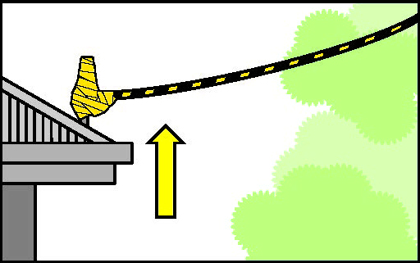

### Safe work method statement

A safe work method statement (SWMS) may be required when operating a crane or mobile plant near overhead electric lines. A written SWMS should be based on a risk assessment. The SWMS and risk assessment should be available to workers on site during the work.

More information on SWMS is in the [Code of Practice: *Construction work*](http://www.safeworkaustralia.gov.au/sites/swa/about/publications/pages/construction-work).

## Further information

Codes of practice, guidance material and other resources are available on the [Safe Work Australia](http://www.swa.gov.au/) website (www.swa.gov.au).