**FORESTRY: GUIDE TO MANAGING   
RISKS OF LOADING, TRANSPORTING AND UNLOADING LOGS**

This Guide includes information on the potential hazards of loading, transporting and unloading logs and practical examples of ways you can control the risks associated with them. It is part of   
a series of forestry industry material and should be read and used together with the [*General guide   
for managing risks in forestry operations*](http://www.safeworkaustralia.gov.au/sites/SWA/about/Publications/Documents/860/Forestry-Operations-General-Guide.docx) and specific guidance material for:

* [growing and managing forests](http://www.safeworkaustralia.gov.au/sites/SWA/about/Publications/Documents/844/Growing-managing-forests.pdf)
* [cable logging](http://www.safeworkaustralia.gov.au/sites/SWA/about/Publications/Documents/842/Managing-risks-cable-logging.pdf)
* [coupe and harvesting site access and preparation](http://www.safeworkaustralia.gov.au/sites/SWA/about/Publications/Documents/860/Guide-Coupe-Harvesting-Site-Access.docx)
* [timber harvesting operations](http://www.safeworkaustralia.gov.au/sites/SWA/about/Publications/Documents/860/Guide-Timber-Harvesting.docx)
* [log landings](http://www.safeworkaustralia.gov.au/sites/SWA/about/Publications/Documents/860/Guide-Log-Landings.docx)
* [log extraction](http://www.safeworkaustralia.gov.au/sites/SWA/about/Publications/Documents/860/Guide-Log-Extraction.docx)
* [infield processing of forest products](http://www.safeworkaustralia.gov.au/sites/SWA/about/Publications/Documents/860/Guide-Infield-Processing-Forest-Products.docx)
* [plant and equipment for forestry operations](http://www.safeworkaustralia.gov.au/sites/SWA/about/Publications/Documents/860/Guide-Plant-Equipment.docx), and
* [general hazards in forestry operations](http://www.safeworkaustralia.gov.au/sites/SWA/about/Publications/Documents/860/Guide-Other-General-Hazards-Forestry-Operations.docx).

These guides are available on the Safe Work Australia website.

## Loading and unloading logs

Loading and unloading logs may be carried out on landings or at roadside log dumps where   
the workers loading trucks often work for a different organisation to the workers driving trucks.   
It is important to implement ways to communicate hazards and safe systems of work between   
workers from different organisations.

| **High risk forestry activity** | **Loading, transporting and unloading logs** |
| --- | --- |

### Table 1 Common hazards and risks associated with loading, transporting and unloading logs

| **Hazards and risks** |
| --- |
| * driver being hit by falling, rolling or sliding logs * rollover of log truck due to the high load or load movement * working alone * loads with extreme overhang * slips, strains and falls getting in and out of machine or checking load * other road users struck by logs or other material falling off truck * struck by log when releasing load restraints * crushed or struck by logs * back strain from throwing log restraint straps or chains, and * logs moving in transit creating risk to driver and other workers when unloading. |

### Table 2 Control measures and processes for loading, transporting and unloading logs

| **Control measures** |
| --- |
| **1. Stay in the safe area at the log landing while loading (see Figure 1).**   * The driver should stay at an agreed place outside the work area of the loading machine—this should be in the loading machine operator’s line of sight. * Logs should not be lifted over the truck cabin. * Ensure no one enters an area described by the full swing radius plus half the log length in the beak while a machine is handling logs. * No person should leave the safe area and enter the loader work area described by the full swing radius plus half the log length in the beak until the loading operator has given permission and the loading machine’s beak is placed on the ground. * The driver must wear PPE including high visibility clothing, safety footwear and a safety helmet while outside cabin. * The driver should not stand or sit on an exterior part of the truck or load during loading. * The driver and loading machine operator should establish and confirm oral, visual or radio communication. It is recommended hand-held radios are used when the driver is outside the cabin. * If the driver is required to wait during loading, shelter and amenities should be provided. |
| **2. Load safely.**   * Machines selected for use should be designed to be able to lift the logs to be handled. * The loader operator should be trained and assessed against the relevant units of competency. * When working alone an effective communication system must be in place to monitor the health and safety of the operator. |
| **3. Safely marking saw logs.**   * When marking saw logs, the marker should stay in their work area and out of the machine’s work area until the load is grounded and stable and the operator has given permission to enter. * The marker should give the machine operator permission to restart operating after returning to their work area and is out of the machine’s work area. |
| **4. Safely secure the load.**   * Do not enter the machine’s work area until the operator has given you permission. * Do not lash or unlash a bay while another bay is being loaded or unloaded. * Ensure load binding equipment e.g. chains, webbing and tensioners are in working order before use. * If using chain lashings consider an alternative to an over-centre lever style load binder or dog. Consider using a turnbuckle tensioner or another type of non-rebounding tensioner. Extension bars used to increase tension are dangerous as they can rebound quickly during tightening and releasing resulting in a risk of striking workers. * Check the load for stability and security before placing load lashings. * Log loads should be restrained by lashings capable of holding the particular load weight and secured to comply with the national load restraint performance measures, contained in guidelines and road regulations. * Outer logs should be secured by at least two lashings. * Short logs should be cradled between longer logs. * Ensure the load is crowned with the load lashing in contact with all logs on the outside of the load. * A minimum distance of 300 mm between the end of a log and a load restraint device e.g. a stanchion or lashing should be maintained (see Figure 3). * Prior to leaving the site, dual wheels should be inspected to ensure there are no rocks or foreign material lodged between the tyres that could dislodge at speed and create a hazard for other road users. |
| **5. Check the load in transit.**   * The load and load lashings should be manually checked shortly after leaving the landing or loading site. * Available safety equipment like handrails and steps should be used while carrying out checks. * Visually check the load lashings regularly while in transit regardless of whether they are self-tensioning or not. |
| **6. Observe road rules including mass, dimension and load restraint requirements.**   * At all times during transport on roads, the driver must comply with the road rules. * Exit the coupe or harvesting site at speeds prescribed by the road rules or consistent with the road and weather conditions. * Be aware of other road users when exiting the coupe or harvesting site. * Care should be taken at roundabouts and off-ramps to prevent log transport vehicles rolling over due to their generally higher centre of gravity. |
| **7. Unload safely.**   * Before unloading, the driver should inspect the load for signs of movement. * If the driver thinks there is a risk of logs falling because the load moved during transport, the unloading facility should secure logs on top of the load before the driver removes the load binders. * The driver should step back from the load after binders have been released and watch the top  of the load. * Where chains are secured with dogs, stand clear of the dog handle when releasing. * Except where drop stanchion deliveries are necessary to unload large diameter logs, machines should be specifically designed to lift the logs over the top of pins and stanchions. * The driver should stay at an agreed place outside the work area of the unloading machine.  This should be in the line of sight of the loader operator (see Figure 2). * If drivers need to wait during unloading, shelter and amenities should be provided. |

### Figure 1 An example of a safe work area in a log landing

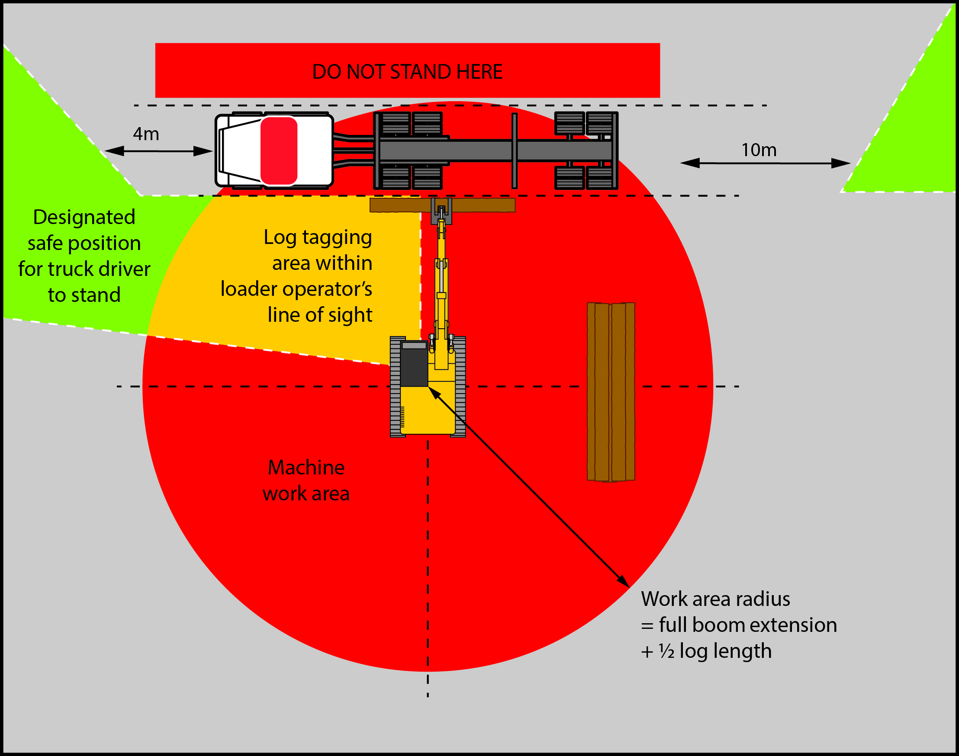

In Figure 1 a risk assessment has highlighted the designated safe area for the driver to stand while the front bunk of the truck is being loaded with native hardwood logs as:

* outside the work area of the loading machine
* 4 metres to the front of the truck or 10 metres to the rear of the truck, and
* preferably in the line of sight of the loader operator.

The work area for the log loader is the area described by the boom length plus a half log length—shown in red.

To protect the truck driver from injury a safe place to stand should be agreed with the loader operator. This should be outside the work area and within the loader operator’s line of sight—shown in green.

Log tagging should only be conducted:

* within the loader operator’s line of sight
* when the boom and log are grounded
* when the machine operator controls are isolated to stop the machine moving unintentionally, and
* when the loader operator has given permission to enter the log tagging area.

This area is shown in orange in Figure 1.

No one should enter the loader’s work area or the log tagging area unless they have been given permission using a suitable and effective means of communications, for example by UHF radio communication or mobile telephone, and no part of the log loader is moving. The loader should stay stopped after the person enters the work area. The operation should also stop if an unauthorised person enters the work area. If the loader operator is unsure about the safety of the work area the operation should stop until the area is made safe.

It is a key responsibility of contractors to establish these safe work areas and to ensure separation distances are established and maintained. Work area separation should be adhered to by workers   
as part of their duty to follow the safe work procedures of the business or undertaking.

### Figure 2 Example of a designated safe work position for a truck driver during loading

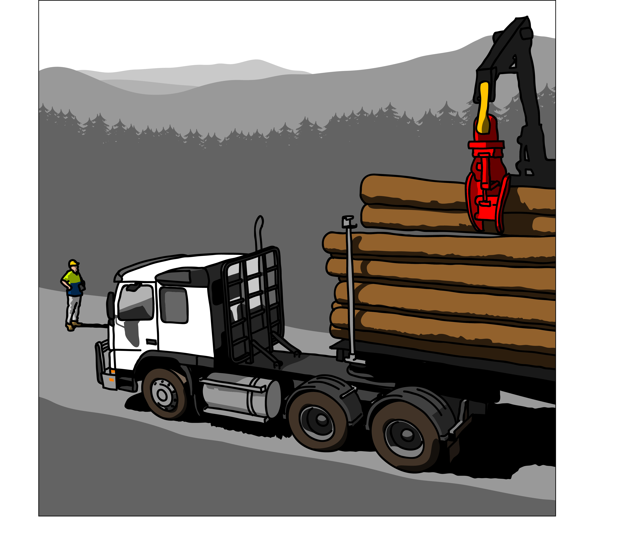

## Transport and load restraint

Maintaining safe loading and operating load-carrying vehicles used in forestry operations should   
be done according to the requirements in the *Load restraint guide – Guidelines and performance standards for the safe carriage of loads on road vehicles* (Load Restraint Guide) published by the National Transport Commission (NTC). This Guide is available on the [NTC’s website](http://www.ntc.gov.au) at www.ntc.gov.au.

Loads shouldbe constructed and secured to the transporting vehicle in compliance with the Load Restraint Guide*.*

### Figure 3 Minimum distance between the end of a log and a load restraint device

### Figure 3 shows the minimum distance between the end of a log and a load restraint device. The minimum overhang past the stanchion is 300 mm.

## Approach to landings

Trucks shouldnot approach a landing when there is danger from incoming timber.

## Moving vehicles

Workers should keep a safe distance from moving and loading vehicles.

## Using vehicles safely

Drivers should:

* hold the licence for the class of vehicle they are operating
* follow road rules at all times
* have a thorough knowledge of the regulations and instructions for operating the particular class   
  of vehicle they are driving
* check the truck is loaded correctly and securely, and
* not allow anyone to ride on the log transport vehicle except in the cabin.

## Equipment to be fitted to trucks

Log trucks and trailers used to transport logs from the forest to its destination shouldbe designed and constructed for the safe transport of forest produce.

Trucks should alsobe equipped with suitable communication equipment.

## Cab shielding or guarding

Trucks transporting logs shouldbe fitted with a cabin guard to protect the driver or passenger from the impact of a partial load from the rear loaded logs—see Figure 4. The cabin guard should be:

* designed, constructed and installed to stop logs on the truck or the trailer from impacting the rear of the cabin
* capable of withstanding
  + inertia forces generated during vehicle braking
  + wind forces generated when the vehicle is travelling at 100 km/h
  + vibration generated by the transport vehicle
* higher than the driver’s cabin
* designed to cover a cross sectional area of the load carried on the log trailer assembly
* capable of restraining all logs on the load
* securely fixed to the vehicle
* have no:
  + protrusions that can penetrate the cabin if the guard fails, and
  + sharp corners or edges which can injure operators and drivers.

The design, manufacture, construction and fitting of the cabin shield or guard should be carried out by a competent person.

*Note:* The cabin guard is not a load restraint device.

### Figure 4 Cabin guard fitted to a prime mover

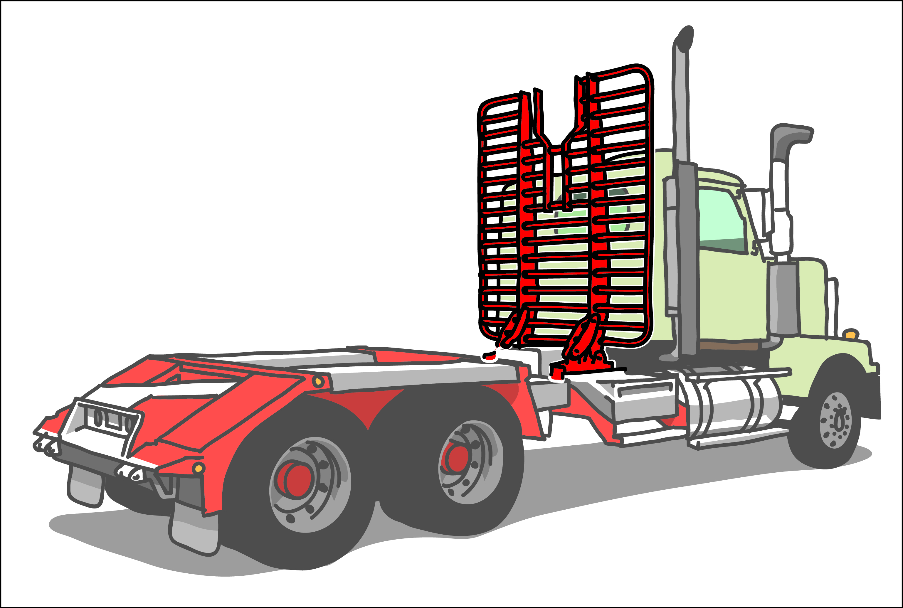

## Rear load restraining guards

To prevent the release of logs from the rear of the load, rear load restraining guards should be fitted to log trucks where the rear bunk on the load is carrying debarked eucalypt plantation logs in short form. Where possible, rear load restraining devices should also be fitted to loads carrying debarked long length eucalypt tree farm logs.

The rear guard should be:

* designed, constructed and installed so no log on the load will slide off the rear of the truck during transport
* structurally sound
* capable of withstanding
  + inertia forces generated during vehicle braking
  + wind forces generated when the vehicle is travelling at 100 km/h
  + vibration generated by the transport vehicle
* high enough to restrain all logs in the load including small logs
* free from sharp corners or edges which can injure operators and drivers, and
* securely fixed to the vehicle.

## Self-loading trucks

Self-loading trucks shouldbe fitted with outriggers and stabilisers which firmly stabilise the unit while loading and unloading.

All practical steps shouldbe taken to protect the driver of a self-loading truck from moving logs while they are operating the log-loading device. A way to stop the boom from falling if it malfunctions should be in place. A safe way to access the log loading position also needs to be provided.

Further information on outriggers and stabilisers is available in AS 1418.5-2013: *Mobile and vehicle loading cranes.*

## Load configuration

When configuring and constructing the load the driver shouldcheck:

* the load meets the requirements of the Load Restraint Guide and performance standards for the safe carriage of loads on road vehicles
* a suitable reflective device is attached where the load projects beyond the rear of the vehicle
* no more than half the diameter of a log is above the top of the cabin shield or guard of the log truck
* no part of an outside log in contact with the stanchion is above the height of the stanchion
* loads are crowned for load security and are secured within a short distance of the landing before leaving the coupe or harvesting site
* logs used to crown a load have no more than half their diameter above the height of the pin or stanchion end—see Figure 5, and
* outer ends of the outside logs extend 300 mm beyond stanchions**.**

## Load securing

When securing the load for transport the driver should ensure:

* the load is secured to the vehicle within a short distance of the landing and before leaving the coupe or harvesting site in accordance with the Load Restraint Guide
* both ends of all binders are located in the tensioning device before tensioning a binder
* each bunk is restrained by at least two binders and every load is restrained by at least three binders
* every log is restrained by a minimumof two load binders on each log, either directly in contact with the binder, or indirectly if bound by surrounding logs
* short logs e.g. less than 2.1 metres are secured in at least two places, and
* where reasonably practicable a rear restraint device should be fitted to prevent logs sliding from the back of the load.

## Load release and unloading—non sawmill sites

Unless using a de-twitching station, before load binders are released the loader operator should ensure the load is restrained to prevent the logs moving unexpectedly.

Anyone including a truck driver working next to a log truck unloading operation should be at the front or at the rear of the vehicle and to the side, not closer than 4 metres to the front or 10 metres behind the vehicle and should be in the line of sight of the loader operator or machine during unloading.

Where a machine other than a winch is used to unload a vehicle the binders should be released from the unloading side. The central binder should be removed first followed by the rear binder and then the front binder.

Where a winch is used to unload a vehicle the binders should be released from the opposite side of the vehicle to the unloading side with the rearmost binders removed first then the next set working forwards until the foremost set is removed last.

The driver of a vehicle should not use a winch for unloading logs from the vehicle except when accompanied by another person.

## Securing a jinker or trailer

Where the driver of a vehicle returns to the forest landing with an empty vehicle with a jinker or trailer loaded on the vehicle in piggyback style, the driver shouldensure:

* the jinker or trailer is secured to the prime-mover or the forward trailer by a latching mechanism   
  or a chain and load binder
* a safety chain or tensioned secondary latch is used between the jinker or trailer and the prime-mover or forward trailer, and
* chains are used and secured according to the manufacturer’s recommendations.

## Log restraining equipment

The owner of a vehicle used for transporting timber should provide load restraint equipment and maintain it in working order.

## Bolsters

The size and strength of bolsters should be able to secure and support the load and be able to   
be attached securely to the chassis members.

## Chocks

A chock should have a base of 450 mm or more in length and be fastened to the bolster with two   
or more chock pins. Each chock pin should be 22 mm or more in diameter and drilled with a hole through which a retaining clip shouldbe placed.

## Stanchions

A stanchion shouldbe securely attached and be high enough to ensure the outside logs have their diameter below the top of the stanchion.

## Stanchion extensions

Where stanchion extensions are used they should be:

* approved by the manufacturer or a certified professional engineer or other competent person
* of suitable size and strength, and
* securely fastened to the stanchion.

## Chains and tensioners

If using chain lashings consider using an alternative to an over-centre lever style load binder—known as a dog. Many workers find they cannot get satisfactory chain tension when using a dog and often use an extension bar to increase chain tension. Using an extension bar to increase tension can be hazardous during tightening and releasing as it can rebound quickly and fly into the air.

If a dog cannot be tightened without an extension bar a recoilless or pivoting dog can be used.   
These dogs do not store energy in the handle when under tension which minimises the risk of   
injuring workers when the handle is released.

Using a turnbuckle tensioner or another type of non–rebounding tensioner rather than a dog should be considered. Turnbuckles have no kickback and can achieve high tensions without using extension bars. Ratchet and sliding lever turnbuckles are also available.

## Inspecting loads

When inspecting log loads drivers should ensure:

* loads are inspected and are safe before leaving the log landing
* loose bark is removed using a safe method
* adjustments to log configuration isdone using log handling equipment
* no one climbs onto the loaded logs on a truck
* log trucks display rear warning devices and signs on the load where applicable
* the load is inspected immediately before the truck enters a public road to ensure log stability   
  and maintain load safety
* visual inspections of the load and truck include walking around the entire vehicle, and
* the load remains secure at all times throughout the journey.

The crowning of the load and the distance between the end of the log and a load restraint device,   
for example a stanchion or lashing, are critical safety requirements.

### Figure 5 Crowning a load

| **Incorrect - High risk** | **Correct - Control measures** |
| --- | --- |
| Figure 5 shows examples of a correct and incorrect way to lash and crown a load. The incorrect example shows insufficient restraint of the load. The correct example shows the load is 'crowned' and there is no more than half of a log diameter above the pin or stanchion end. | Figure 5 shows examples of a correct and incorrect way to lash and crown a load. The incorrect example shows insufficient restraint of the load. The correct example shows the load is 'crowned' and there is no more than half of a log diameter above the pin or stanchion end. |

## Further information

Codes of practice, guidance material and other resources are on the [Safe Work Australia](http://www.swa.gov.au/) website (www.swa.gov.au).