**FORESTRY: GUIDE TO MANAGING RISKS OF COUPE AND HARVESTING SITE ACCESS AND PREPARATION**

This Guide includes information on potential hazards and things you should consider when preparing logging coupes and access roads to timber harvesting areas. It is part of a series   
of forestry industry material and should be read and used together with the [*General guide   
for managing risks in forestry operations*](http://www.safeworkaustralia.gov.au/sites/SWA/about/Publications/Documents/860/Forestry-Operations-General-Guide.docx) and specific guidance material for:

* [growing and managing forests](http://www.safeworkaustralia.gov.au/sites/SWA/about/Publications/Documents/844/Growing-managing-forests.pdf)
* [cable logging](http://www.safeworkaustralia.gov.au/sites/SWA/about/Publications/Documents/842/Managing-risks-cable-logging.pdf)
* [timber harvesting operations](http://www.safeworkaustralia.gov.au/sites/SWA/about/Publications/Documents/860/Guide-Timber-Harvesting.docx)
* [log landings](http://www.safeworkaustralia.gov.au/sites/SWA/about/Publications/Documents/860/Guide-Log-Landings.docx)
* [log extraction](http://www.safeworkaustralia.gov.au/sites/SWA/about/Publications/Documents/860/Guide-Log-Extraction.docx)
* [loading, transporting and unloading logs](http://www.safeworkaustralia.gov.au/sites/SWA/about/Publications/Documents/860/Guide-Loading-Transporting-Unloading-Logs.docx)
* [infield processing of forest products](http://www.safeworkaustralia.gov.au/sites/SWA/about/Publications/Documents/860/Guide-Infield-Processing-Forest-Products.docx)
* [plant and equipment for forestry operations](http://www.safeworkaustralia.gov.au/sites/SWA/about/Publications/Documents/860/Guide-Plant-Equipment.docx), and
* [general hazards in forestry operations](http://www.safeworkaustralia.gov.au/sites/SWA/about/Publications/Documents/860/Guide-Other-General-Hazards-Forestry-Operations.docx).

These guides are available on the Safe Work Australia website.

## Site access and preparation

***Construction of access roads***

Constructing access roads to logging coupes, harvesting sites, log landing or processing areas which involve major earthworks is construction work, therefore the Work Health and Safety (WHS) Regulations for ‘construction work’ apply.

Activities like clearing vegetation from existing tracks and landings is not construction work.

When constructing access roads to logging areas a contractor involved in these works should:

* check the initial road construction plan and remove hazards from road, bridge and log landing construction areas
* remove hazardous trees within two tree lengths of the construction area
* make sure felled trees are clear of standing trees and left in a safe position where road lines are not harvested before road construction, and
* mark or tape dangerous areas or trees including trees with hang ups.

The constructing of these access roads should be carried out using safe systems of work which allow road users and adjoining landowners to pass safely through and around the road works.

Further information on traffic management is in the [*General guide for workplace traffic management*](http://www.safeworkaustralia.gov.au/sites/SWA/about/Publications/Documents/864/Traffic-Management-General-Guide.docx)*.*

Further information on construction work is in the [Code of Practice: *Construction work*](http://www.safeworkaustralia.gov.au/sites/swa/about/publications/pages/construction-work)*.*

## Maintenance of access roads

Unsealed access roads can deteriorate and have an impact on the safety of the road user. Roads should be maintained to ensure a reasonable quality of the road surface to minimise   
the risk to vehicles and users.

During future maintenance or when harvesting operations are adjacent to roads used by other people the land owner, forest manager and principal contractor should implement traffic controls where necessary and put up signs warning of the tree felling activities.

## Using explosives

Where explosives are being considered for blasting to construct access roads or log landings,   
a competent person experienced in using explosives safely and in a controlled way should be consulted before deciding to use explosives for the work.

Possessing, storing, handling and using explosives should be carried out in accordance with the relevant hazardous chemicals, dangerous goods and explosives legislation which applies in each state or territory.

Transporting explosives should be done in accordance with the Australian Code for the Transport of Explosives by Road and Rail.

If explosives are used in forestry operations a licensed and competent person must be engaged to carry out the work, develop the blast management plan and be responsible for all aspects   
of the use of explosives for the work to be carried out.

Further information about using explosives is in AS 2187.2-2006: *Use of explosives*.

## Bridges

When constructing bridges for forestry operations the contractor involved in this work should ensure:

* the machinery being used can handle materials used in bridge work
* bridges are able to carry intended loads
* a safe working area is provided to process the materials used in bridge construction
* floatation devices are worn when working over water
* no person is in the slew area of materials handling equipment and overhead movement   
  of materials, and
* no person is lifted or suspended from machinery unless in an approved work box.

## Log landings or log loading areas

Log landing or loading areas should be designed and prepared so the work area is as safe   
as possible. This can be done by minimising the risk from surrounding trees and when workers and machinery will interact. When designing safe areas you should consider:

* If the area is as flat as possible and does it allow for water run-off?
* If there is clearance from overhead electric lines?
* Are hazardous trees to be felled within two tree lengths of the landing?
* If there is enough space for parking, turning and moving mobile plant and trucks and for truck entry and exit?
* Can traffic pass the operation safely?
* If a safe place has been identified and set aside for truck drivers during loading operations?
* If there is a place for a rest area and a place to park vehicles?
* Are pedestrian accesses safe?
* Are there separation distances between major activities like loading, stacking, measuring   
  and entry of snigging tracks e.g. a track along which logs are pulled from the felling point   
  to a nearby landing?
* Is there space:
  + set aside for inspecting and maintaining machines
  + for the number of products to be stored, loaded and for the volume of wood to be handled, and
  + for storing hazardous chemicals like fuel?

Information on the design of landings for cable harvesting operations is in the [*Guide to managing risks of cable logging*](http://www.safeworkaustralia.gov.au/sites/SWA/about/Publications/Documents/842/Managing-risks-cable-logging.pdf).

## Safety signs

Safety signs should be clear, readable and placed where they give people approaching the workplace warning of the forestry operations.

Signs should be placed at each entrance of each work area and at the entrance to an area   
of intense forestry activity to:

* stop unauthorised people from entering the workplace
* give authorised people directions to a location and if necessary, contact details for the people in the crew e.g. the harvesting team leader
* tell authorised people including visitors about
  + the PPE that should be used, and
  + how to communicate with the harvesting crew.

Where tree felling is in progress signs should be used in prominent places at frequently used entry points to a coupe or harvesting site.

As a recommended minimum signs should read “Danger – Tree Felling Ahead” or “Tree Felling in Operation” and “No entry – authorised personnel only” (see Figure 1).

### Figure 1 Examples of signs for tree felling operations

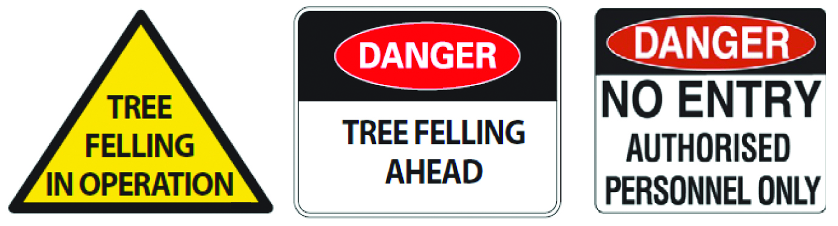

Other signs which provide useful information include those for:

* road closures
* traffic control
* truck entry and exit, and
* ultra high frequency (UHF) and other communications being used in the work area.

## Controlling authorised visitors

Arrangements should be in place to manage visitors to the work area including the provision   
of site induction.

The site supervisor is responsible for ensuring visitors understand and comply with safe work procedures and use PPE where it is required.

## Unauthorised entry to coupe or harvesting sites

A person who intentionally enters a coupe or harvesting site without permission and refuses   
to leave creates a risk to everyone on the site. In the forestry industry this is called an invasion. In some jurisdictions the police and certain government agencies have the power to remove people who invade forest operational areas.

A range of things can be done to prepare workers and others on site for an invasion, for example by developing a procedure to use when being invaded including:

* stopping working when there is an increased risk of injury
* securing the site and equipment
* instructing people to leave if safe to do so
* contacting the relevant authorities e.g. the police, the regulator or government agency
* collecting information relevant to the site and the equipment, and
* inspecting the site and machinery to ensure people are not at risk before restarting work.

## Further information

Codes of practice, guidance material and other resources are on the [Safe Work Australia](http://www.swa.gov.au/) website (www.swa.gov.au).