COMPRESSED AIR AND AIR RECEIVER  
INFORMATION SHEET

This information sheet provides guidance on how to manage risks associated with the use of compressed air in the workplace.

Associated guidance on the use of compressed air in relation to tyres is available in the *Guide for split rims*.

Air receivers can explode and cause serious injuries or death if they are not adequately inspected and maintained, or if they have been operated above the design pressure. Compressed air can also cause injuries.

## Air compressors

* Are a type of pump which takes in atmospheric air and compresses to a set pressure.
* Do not store compressed air, but are usually connected to a pressure vessel that stores the compressed air. The pressure vessel that stores compressed air is commonly referred to as an Air Receiver.
* Should include a system that will stop the compressor when the maximum working pressure, suitable to the processes serviced by the air receiver, is reached and restart the compressor when the lower limit for the working pressure is reached.

**Figure 1** Air compressor mounted on an air receiver

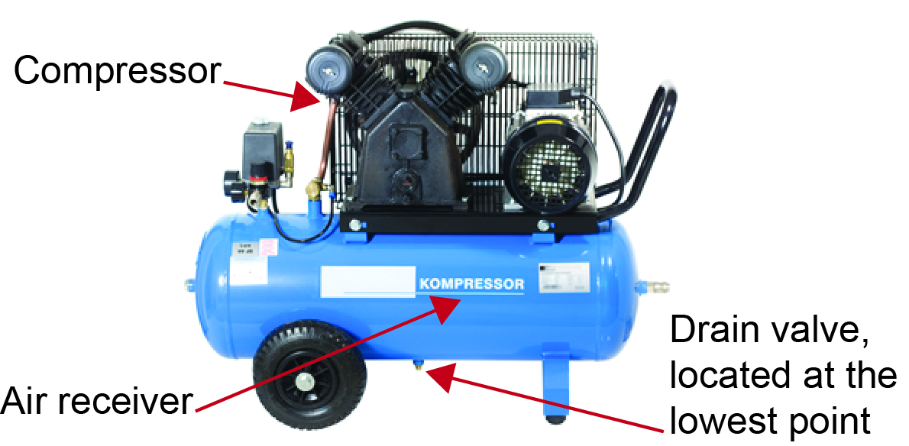

## Air receivers

* Store compressed air from a compressor.
* Should be selected so the design pressure is more than or equal to the maximum working pressure used throughout the workplace.
  + *Note:* the design pressure is the maximum pressure under which the air receiver is designed to work.
* Must be fitted with a safety (pressure) relief valve, a pressure gauge, a drain valve and inspection hole or cover. In addition, holes of suitable sizes and locations used for fitting pipes or other devices may be used for inspecting inside the vessel. This may be the only means by which smaller vessels can be inspected that do not have dedicated inspection holes or covers. Periodic inspections should only be carried out by someone qualified to perform this work.

**Figure 2** Two vertical air receivers

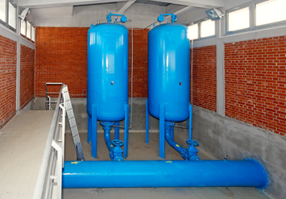

## Relief valve

* Activates and releases air from the air receiver if the pressure reaches the design pressure of the air receiver. This reduces the risk of a failure of the air receiver due to high pressure.

**Figure 3** Relief valve that incorporates a lever to test it

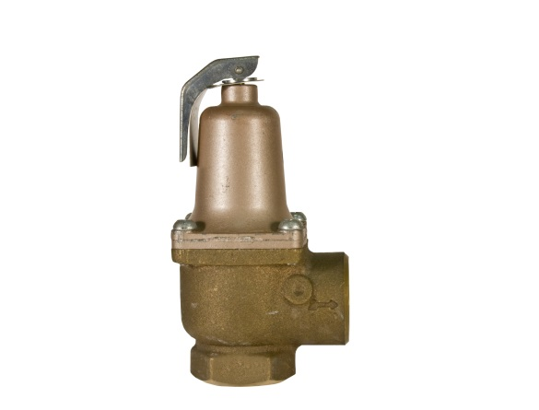

* The release pressure is set by the manufacturer and the valve is usually sealed so it cannot be tampered with by people who are not competent to service valves.
* The set pressure of the relief valve must never exceed the design pressure of the air receiver.
* Usually parts of the valve are made from material such as bronze or brass which greatly reduces the chances of mating parts sticking together due to corrosion or dirt and dust build up. Sticking can prevent the valve from opening when needed in the event the pressure increases above the set pressure.
* The valve must incorporate a mechanism to test whether the valve is free to open and will reseat correctly. Testing is usually done by pulling a lever or a pull ring.

## Drain valves

* Drain valves come in two types—automatic drain systems and manual drain valves. These must be located at the lowest point of the receiver to evacuate all condensate.
* The purpose is to drain any water condensate in the vessel to minimise corrosion that could occur on the inside of the air receiver. Corrosion can cause the walls of the air receiver to become thin, which in extreme cases can lead to a rupture or explosive failure of the air receiver.

## Control measures

* Ensure compressors and air receivers are regularly maintained and inspected by a competent person. Air receivers require both external and internal inspections at suitable intervals. Seek advice from the manufacturer or a competent pressure vessel inspector.
* Never tamper with the relief valve.
* Unless fitted with an automatic drain valve, drain water condensate daily by opening the drain valve, typically when switching off the compressor at the end of the day.
* Regularly inspect automatic drain valves as recommended by the manufacturer.
* Periodically test that the relief valve release mechanism can move freely (e.g. monthly).
* Never direct compressed air at a person as the air can penetrate the skin and cause significant health issues.
* It is not recommended to use compressed air for cleaning, especially if there are other people in the vicinity. However, if required to use air, use low pressure and wear eye protection.
* Fixed compressors and air receivers should be secured in accordance with the recommendations of the manufacturer or of a competent person. The bolt down requirements should be covered in the installation manual.

Further information is in [AS/NZS 3788:2006 *Pressure equipment – In-service inspection*](http://infostore.saiglobal.com/store/Details.aspx?ProductID=374650).

## Registration requirements

The air receiver is a type of pressure equipment that may require design and item registration under the Work Health and Safety Regulations. The registration requirement depends on the hazard level of the air receiver calculated in accordance with Australian Standard AS 4343‑2014: *Pressure equipment – Hazard levels*.

Each jurisdiction is responsible for enforcement and compliance matters relating to plant registration. If you are unsure of your obligations, refer to your regulator for information on registration requirements.