Understanding Hazardous Chemical Labels

Overview

This fact sheet provides information on how to understand the new labelling system for hazardous chemicals under the WHS Regulations.

By reading, understanding and following all of the information and instructions on a chemical label, all chemicals should be able to be used safely in the workplace.

Changes to labels under the WHS Regulations

The new Work Health and Safety (WHS) Regulations introduce a new system of labelling for hazardous chemicals based on the United Nations’ Globally Harmonised System (GHS) of Classification and Labelling of Chemicals. Manufacturers and importers of hazardous chemicals have 5 years from 1 January 2012 to move to the new labelling system.

What is a hazardous chemical label?

A label is a group of written, printed or graphical information elements about a hazardous chemical that is affixed to, printed on or attached to the container. Labels are also used on pipes and pipe-work used to transfer hazardous chemicals.

Labels contain information on the identity and proportions of the hazardous chemical and its constituents or ingredients. They also contain information on the hazards of the chemical, precautions to be followed during its use, handling and storage, and instructions for the safe disposal of the chemical.

You should always read and understand the information on a label before using a hazardous chemical.

Do I need to find further information?

Labels sometimes do not contain all of the information needed to safely use, handle, store or dispose of the chemical. For example, a container may be too small for all of the relevant information to fit on it. There are also other labelling systems used in Australia, for example on consumer chemicals, in which all hazard information is not included on the label.

Therefore, when using a hazardous chemical at work you should always refer to the chemical’s Safety Data Sheet (SDS), as this contains more detailed information.

What information should I look for in a label?

Under the GHS, labels will contain the following elements.

- Pictograms – these provide a graphical representation of the chemical’s hazardous properties. These pictograms are designed to be easily recognised so you can instantly see the hazards associated with a chemical.
There are nine new pictograms, each with a specific meaning. The following table shows these new pictograms and the types of hazards they represent.

GHS hazard pictograms
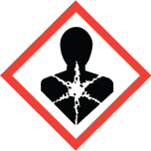 | Severe health hazards | 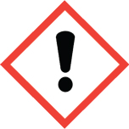 | Health hazards | 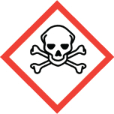 | Acute toxicity
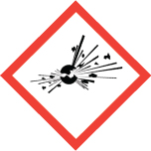 | Explosive | 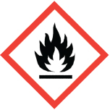 | Flammable | 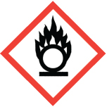 | Oxidising
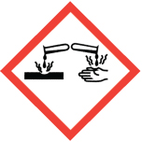 | Corrosive | 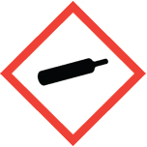 | Gases under pressure | 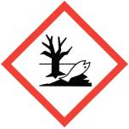 | Environmental hazard
Note: the WHS Regulations allow manufacturers and importers to continue to use dangerous goods class labels on containers for workplace hazardous chemicals. Dangerous goods class labels are those pictograms that are used on dangerous goods containers to meet transport requirements under the Australian Code for the transport of dangerous goods by road or rail (ADG) Code. Some examples of dangerous goods class labels are shown below.
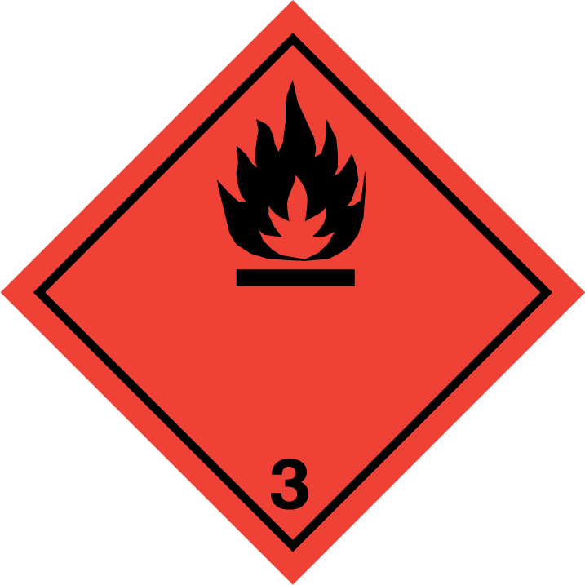 | 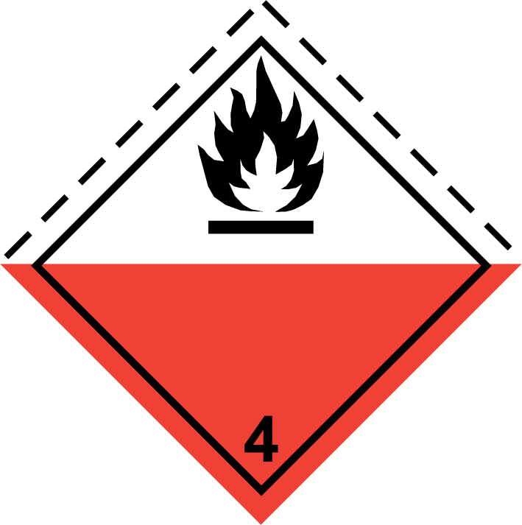 | 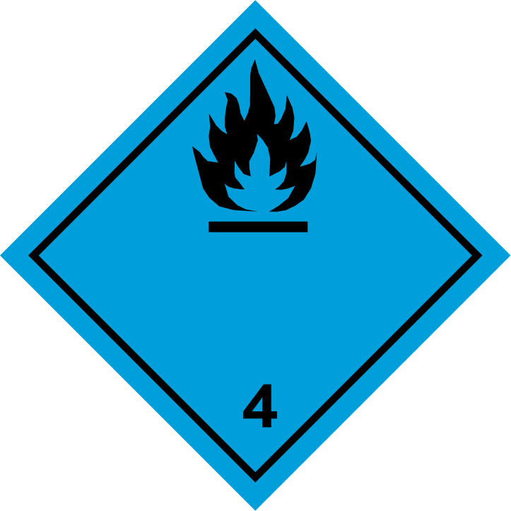 | 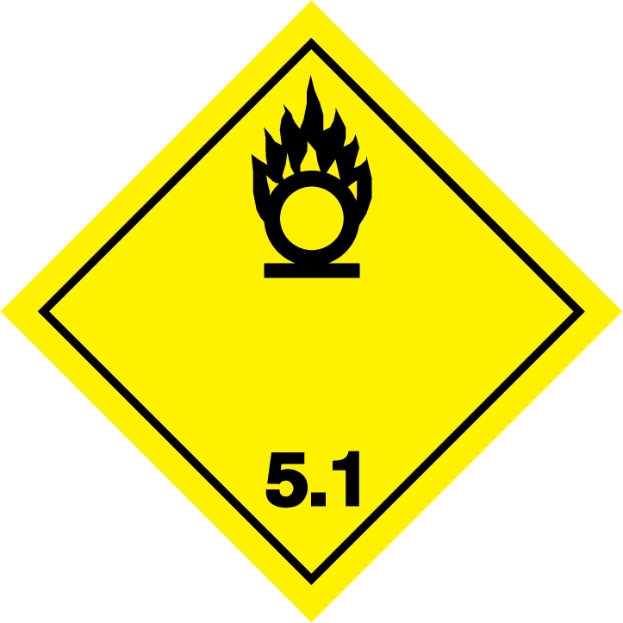 | 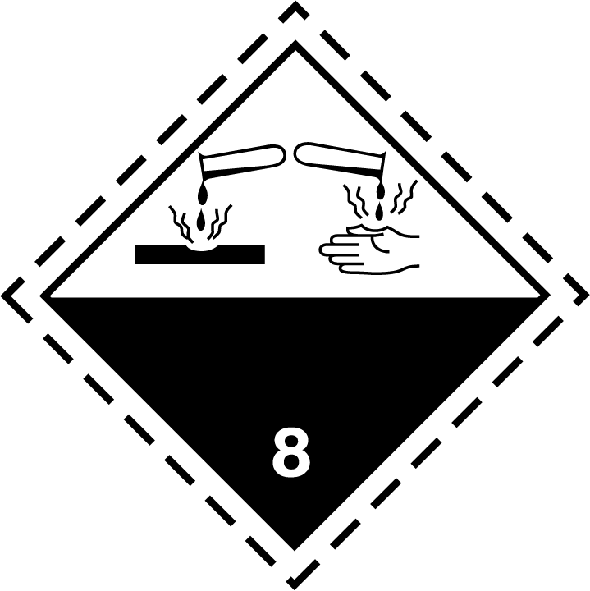
Flammable liquid | Spontaneously combustible | Substances which, in contact with water, emit flammable gases | Oxidising substances | Corrosive

- Signal words – these provide an indication of the relative severity of the hazard.
The signal words used are DANGER or WARNING. Danger indicates a higher severity of hazard.

- Hazard statements - these describe the nature and severity of the chemical hazard. Examples of hazard statements are:
  - Highly flammable liquid and vapour
  - May cause respiratory irritation
  - May cause cancer
  - Contains gas under pressure
  - Causes severe skin burns and eye damage

- Precautionary statements – these describe some recommended measures that should be taken to minimise or eliminate risks during storage, handling, use or disposal of the hazardous chemical. The GHS uses four types of precautionary statement, covering
  - Prevention of an incident (for example how to prevent poisoning from a toxic chemical or igniting a flammable liquid)
  - Response in the event of an incident (for example providing first aid information if a worker is exposed or instructions to extinguish a fire)
  - Storage instructions (for example specific conditions under which the chemical should or should not be stored)
  - Disposal (for example referring to any applicable local/state regulations)

Examples of precautionary statements are:
  - Do not breath dust/fume/gas/mist/vapours/spray
  - Keep away from heat/sparks/open flames/hot surfaces – No smoking.
  - Get immediate medical advice/attention
  - Dispose of contents in accordance with local Regulations
What does a hazardous chemical label look like?
The following is an example of a label you might see when a manufacturer moves to the new labelling system.
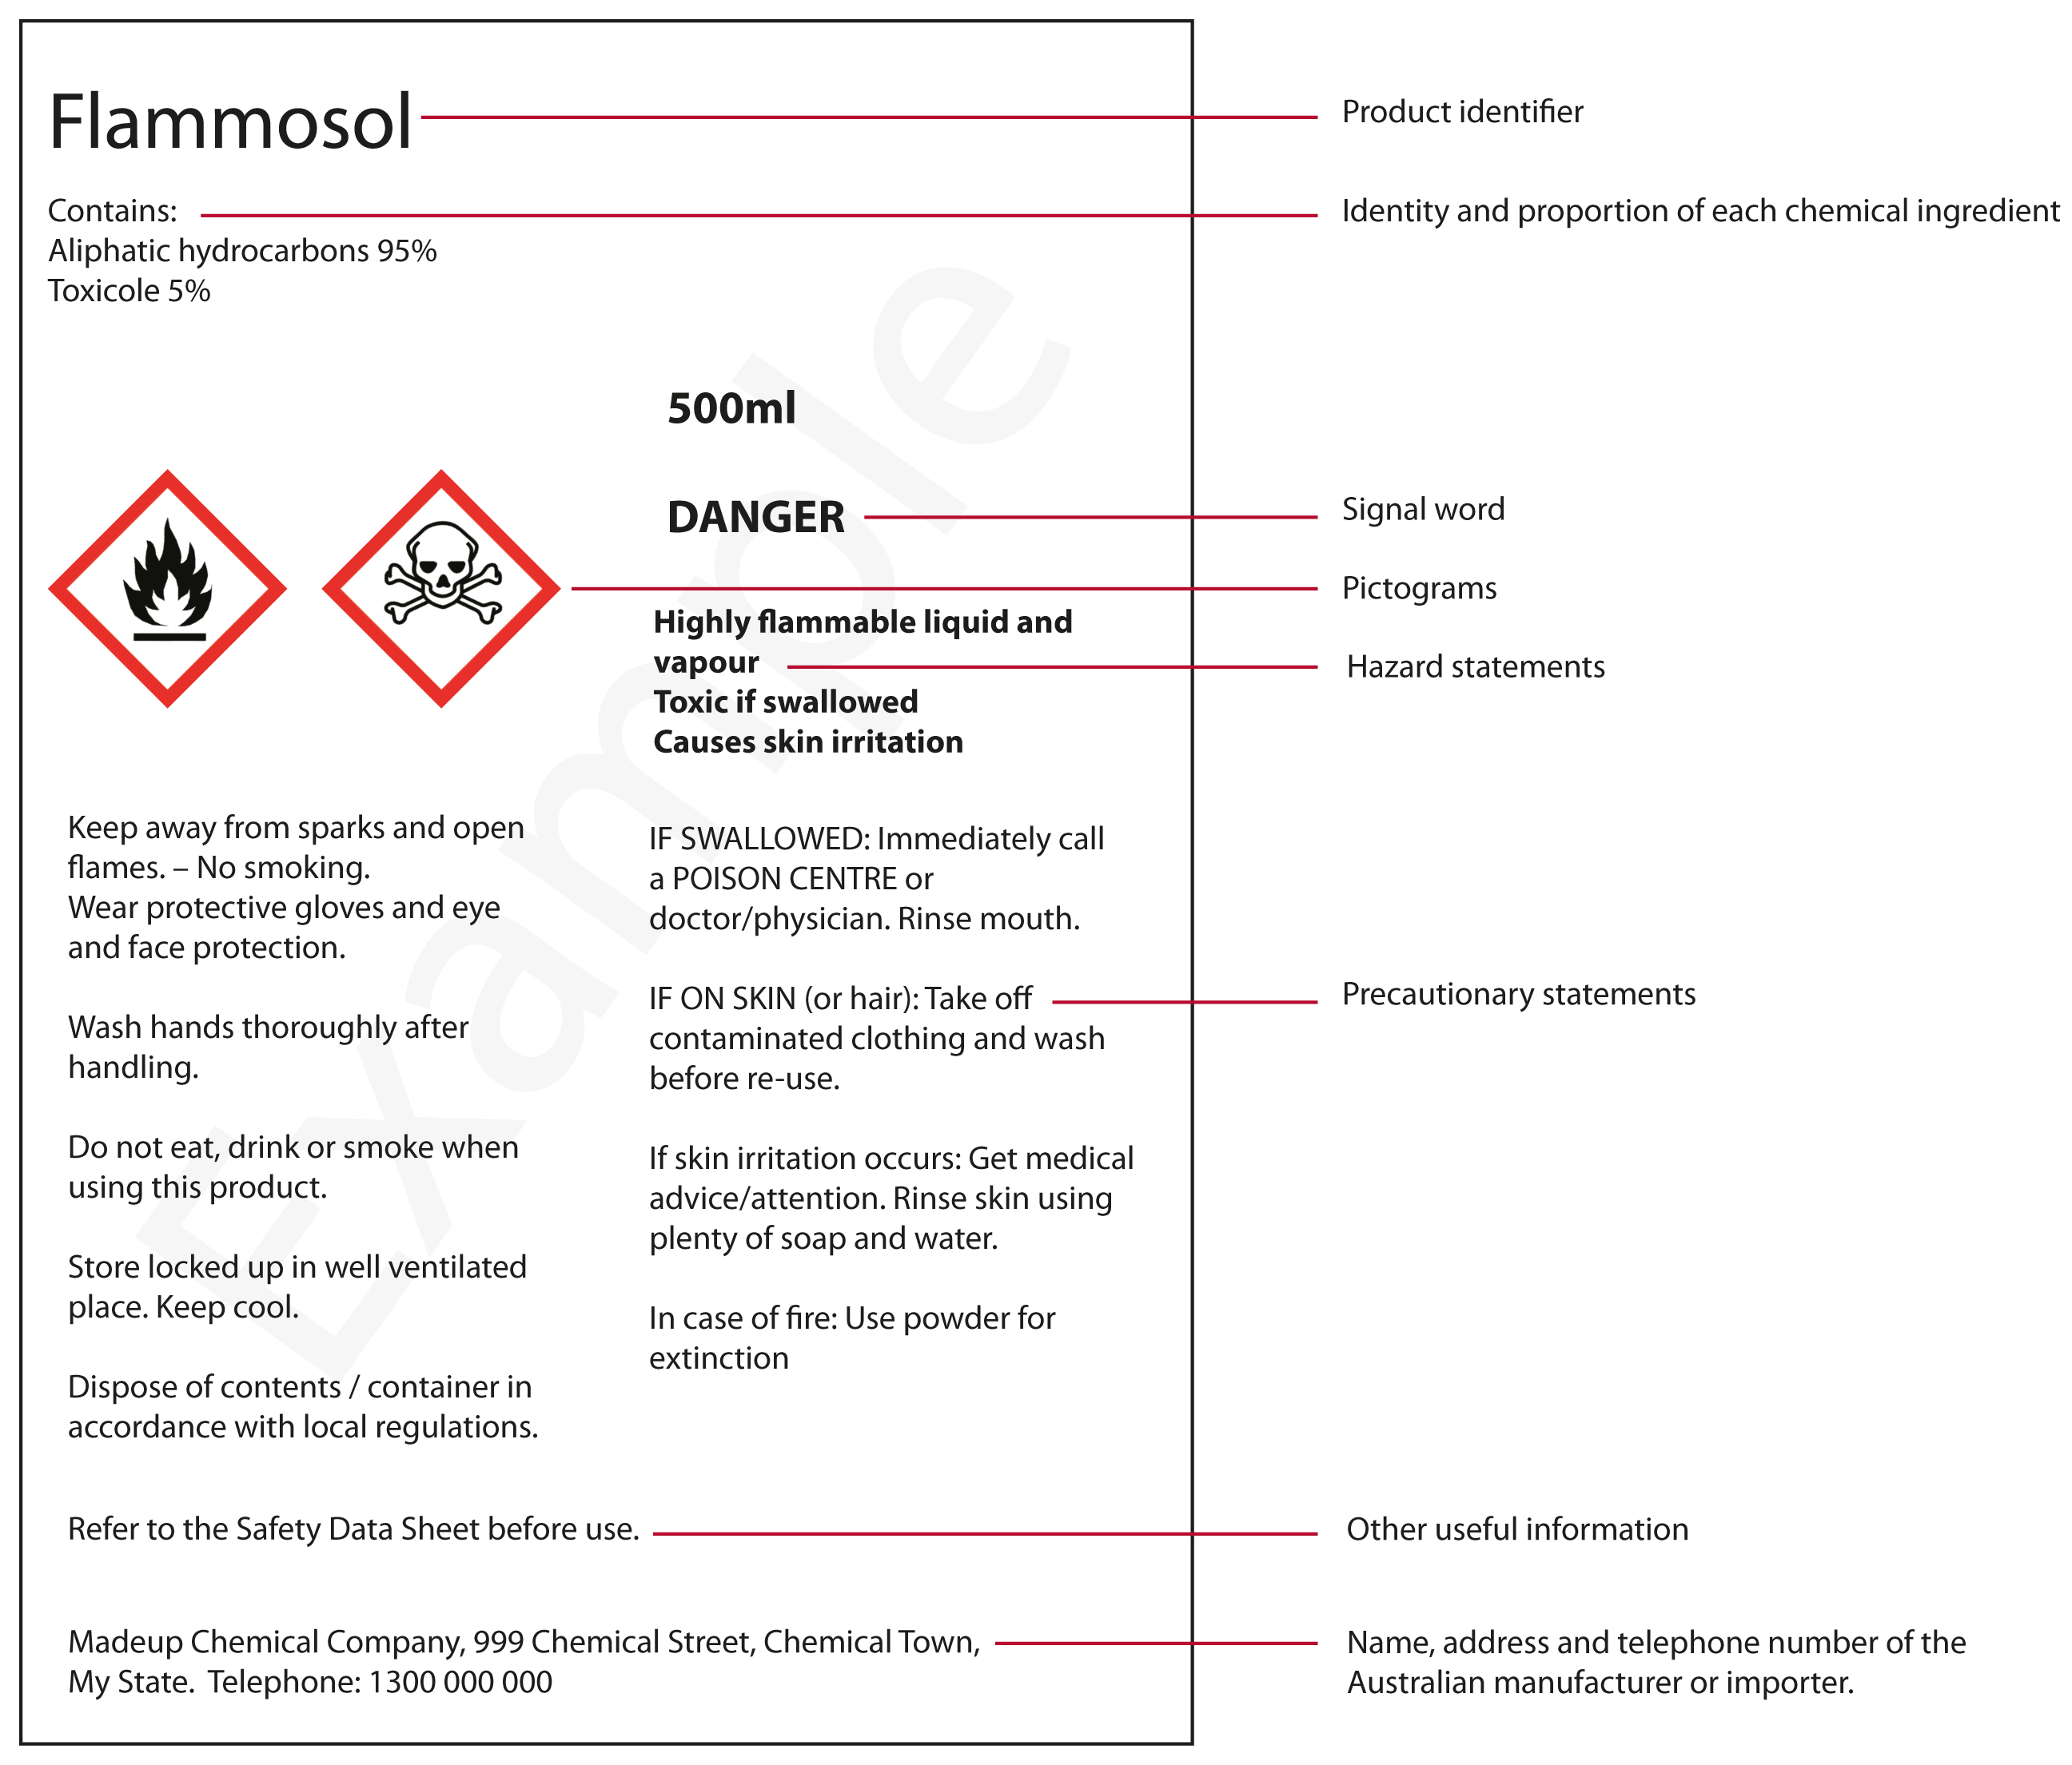

More information on labelling, including the Code of Practice for the Labelling of Workplace Hazardous Chemicals with which manufacturers and importers of chemicals must comply, and other aspects of managing the risks associated with hazardous chemicals can be found on our website at www.safeworkaustralia.gov.au.

