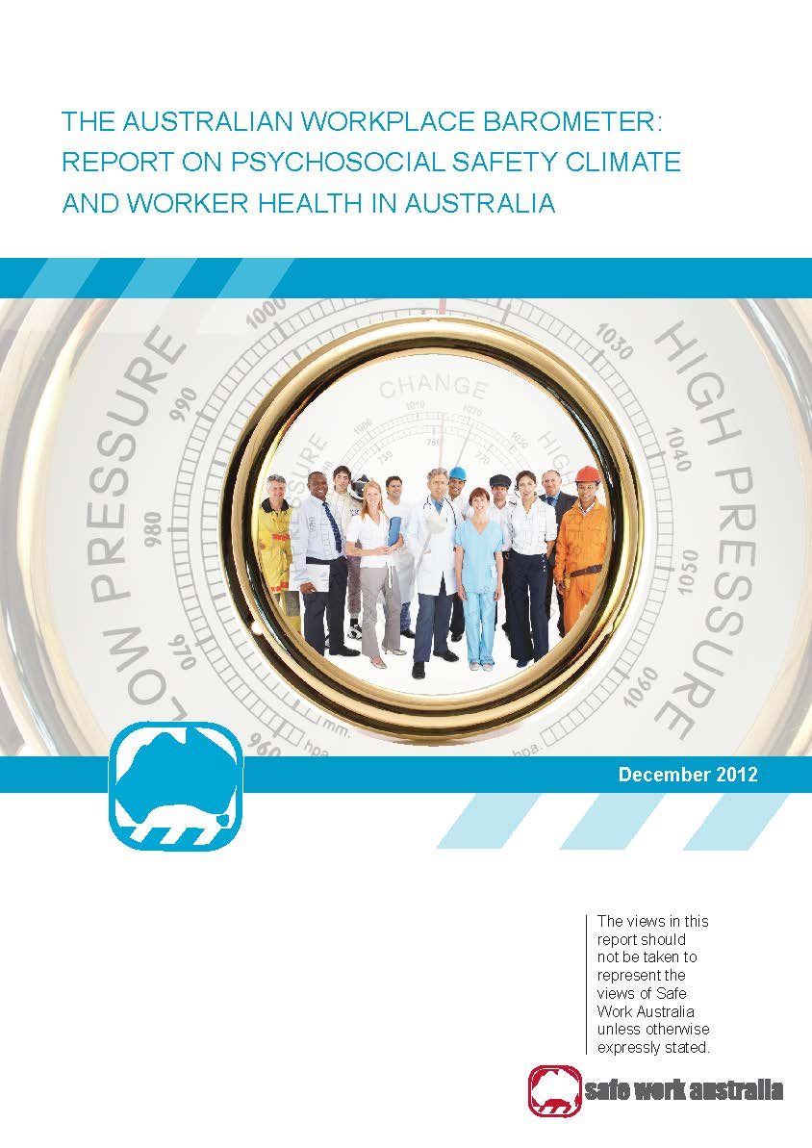

The Australian Workplace Barometer: Report on psychosocial safety climate and worker health   
in Australia

**Prepared by**

**Prof Maureen Dollard, Tessa Bailey, Dr Sarven McLinton, Penelope Richards, Wes McTernan, Assoc Prof Anne Taylor and Stephanie Bond**

**University of South Australia**

**Centre for Applied Psychological Research**

**Magill Campus, St Bernards Road**

**Magill SA 5072**

**Disclaimer**

The information provided in this document can only assist you in the most general way. This document does not replace any statutory requirements under any relevant State and Territory legislation. Safe Work Australia is not liable for any loss resulting from any action taken or reliance made by you on the information or material contained on this document. Before relying on the material, users should carefully make their own assessment as to its accuracy, currency, completeness and relevance for their purposes, and should obtain any appropriate professional advice relevant to their particular circumstances. The views in this report should not be taken to represent the views of Safe Work Australia unless otherwise expressly stated.

**Creative Commons**



With the exception of the Safe Work Australia logo, this report is licensed by Safe Work Australia under a Creative Commons 3.0 Australia Licence. To view a copy of this licence, visit http://creativecommons.org/licenses/by/3.0/au/deed.en

In essence, you are free to copy, communicate and adapt the work, as long as you attribute the work to Safe Work Australia and abide by the other licensing terms. The report should be attributed as The Australian Workplace Barometer: Report on psychosocial safety climate and worker health in Australia.

Enquiries regarding the licence and any use of the report are welcome at:

Copyright Officer

Safe Work Australia

GPO Box 641 Canberra ACT 2601

Email: [copyrightrequests@safeworkaustralia.gov.au](mailto:copyrightrequests@safeworkaustralia.gov.au)

ISBN 978 0 642 78607 4 [Online PDF]

ISBN 978 0 642 78608 1 [Online RTF]

# Table of Contents

Foreword 7

Executive summary 8

Introduction 12

Surveillance Systems 14

The Australian Workplace Barometer Project 16

Theoretical basis of the AWB 16

Psychosocial safety climate theory 18

Climate features of PSC 18

*PSC as a unique construct* 19

*PSC as a multilevel theory* 19

Previous PSC Research Evidence 21

*PSC interacts with work conditions* 23

*PSC as a target for intervention* 25

*PSC and national health* 26

Method 27

Participants 27

Measures 27

Psychosocial Safety Climate 27

Job Demands 28

Job Resources 29

Health Outcomes 30

Motivational Outcomes 31

*Procedure* 31

*Statistical analysis* 31

Demographic data for AWB population 32

*AWB and ABS Sample Comparisons* 36

Results and discussion 38

Intercorrelations between variables 38

Testing the AWB model 41

*Analysis strategy* 41

*Results* 42

PSC as a predictor of job demands and health outcomes 43

*PSC by industry by state* 45

High risk industries by demands, resources, and overall health 49

Summary for industries at risk based on PSC, demands, resources and outcomes 58

Practical implications for industries at risk 58

Urban and rural workers’ mental health 59

Age 60

*Results from the AWB* 61

Bullying and harassment 61

Work-family conflict 64

*Working hours* 65

Rates of health outcomes: Depression, distress, emotional exhaustion, general physical health 67

The cost of employee productivity loss: Depression as a significant contributor 68

Estimating lost productivity costs of poor psychological health in the workplace 69

Policy implications for intervention 71

Conclusion and future directions 72

References 74

Appendix A 86

Glossary of terms 86

Appendix B 91

Summary of Data Collection Methodology and Weighting 91

Sample selection 91

Introductory letter 91

Questions 91

Data collection 91

CATI 91

Call backs 91

Validation 92

Response rates 92

Weighting data 92

State weight 93

SPSS Command 93

Formal Definition 93

Additional Note 93

Appendix C 94

Results from structural equation model 94

Appendix D 96

Smaller versus larger states 96

# Foreword

The Australian Workplace Barometer project aims to provide science driven evidence of Australian work conditions and their relationships to workplace health and productivity, through a national monitoring and surveillance system.

This report was commissioned by Safe Work Australia to provide a summary of the results from data obtained from six Australian states and territories: New South Wales (NSW), South Australia (SA), Western Australia (WA), Tasmania, the Australian Capital Territory (ACT) and the Northern Territory (NT). The data provides evidence relating to psychosocial risk factors in the working Australian population as well as an analysis of relationships between risk factors and employee health and motivational outcomes.

The research is guided by an innovative theoretical framework, Psychosocial Safety Climate (PSC) theory, which states that work conditions, worker health and engagement can be predicted when the psychosocial safety climate of an organisation or work group is known. The report sets out to test this theory and provide details on levels of PSC, demands, resources and health status, by industry by state so that risky industries can be identified.

It is intended that this information will be used to assist employers, workers and their representatives, practitioners, and policy makers in the development of policy to reduce work stress and related injury and in the future as a means to evaluate current, and future, worker injury prevention and intervention strategies.

The outcomes published in this report were the result of jointly funded projects supported by:

* Australian Research Council (ARC) Discovery Grant: Working wounded or engaged? Australian work conditions and consequences through the lens of the Job Demands-Resources Model
* ARC Linkage Grant: State, organisational, and team interventions to build psychosocial safety climate using the Australian Workplace Barometer and the StressCafé
* SafeWork SA, and
* Safe Work Australia.

The report provides a summary of the key findings but the reader may refer to an edited volume for more supporting empirical evidence and statistical analyses in Dollard, M.F.& Bailey, T. S. (Eds). *Australian Workplace Barometer: Psychosocial Safety Climate and working conditions in Australia*: Australian Federation Press to be published in 2013.

This report was reviewed by Michael Ertel, Federal Institute for Occupational Safety and Health (BAuA), Germany. Michael played a significant role in the development of the PRIMA-EF European Framework for Psychosocial Risk Management. Michael is a BAuA expert with extensive expertise in psychosocial factors, health aspects of working time arrangements, flexible work styles, the ageing workforce, research methods and data analysis, cooperation with social partners, and networking at European level and internationally.

The Australian Workplace Barometer project won the Best Collaborative Engagement award at the 2012 University of South Australia Division of Education, Arts and Social Sciences Research Awards.

# Executive summary

*“A standout finding here is that depression costs Australian employers approximately AUD$8 billion per annum as a result of sickness absence and presenteeism and AUD$693 million per annum of this is due to job strain and bullying.”*

Work related stress represents a ‘huge cost’ for worker health and productivity and is broadly regarded as an important social determinant of global health. Scholars predict that by 2020, stress-related illnesses such as depression and cardiovascular disease will be the leading causes of the global disease burden. Psychological injury claims are steadily increasing and incur the largest proportion of expense in relation to compensation claims (Safe Work Australia, 2012).

Surveillance systems that are designed to monitor workplace psychosocial risk factors are increasingly recognised as best practice to inform national approaches towards worker injury prevention and intervention. Surveillance provides a solid evidence base to support the development of prevention and intervention strategies as well as a means to evaluate the effectiveness of any implemented policies and programs. In addition, surveillance supports the vision of the Australian Work Health and Safety Strategy 2012 – 2022 to build safety by design, to protect workers from harm, and improve their health and productivity.

Understanding how workplace psychosocial risk factors interact and contribute to worker wellbeing and productivity can be obtained through systematic measurement and analysis at both the population and organisational level.

Importantly the Australian Workplace Barometer (AWB) project was developed in order to set national benchmarks and provide evidence needed to develop best practice standards in the area of worker psychological health and wellbeing and provide crucial evidence for policy development, intervention targets and the provision of resources at the national, state and industry levels. The main objectives of the AWB project are to:

* provide nationally representative data on psychosocial risk levels and working conditions
* build upon existing knowledge and understanding of psychosocial risk factors such as bullying and harassment, and work-family conflict
* investigate relationships between psychosocial risk and workplace outcomes such as employee health and productivity
* determine the cost of poor employee wellbeing to businesses based on aspects such as depression, absenteeism and presenteeism
* identify industries and occupations at risk, and
* provide evidence to support strategies for prevention and intervention.

Since organisational access to investigate work stress is often restricted and resisted, a superior approach to gain access to most employees, important for standard setting, is to use a population-based approach. The sampling approach used in the AWB project was selected to maximise access to a representative sample of employees. Computer assisted telephone interviews (N = 5743) were conducted across the population in six Australian states and territories (excluding Queensland and Victoria), to gain information from working Australians regarding their work and health conditions. Data was collected in New South Wales (NSW) (N = 1074) and Western Australia (WA) (N = 1156) in 2009. In 2010 a second wave of data was collected from NSW (N = 725) and WA (N = 804) as well as a first wave of interviews in South Australia (SA) (N = 1143). In 2011 further interviews were conducted with participants from Australian Capital Territory (ACT) (N = 255), Tasmania (TAS) (N = 416) and the Northern Territory (NT) (N = 170). A comparison of demographic data between AWB and Australian Bureau of Statistics (ABS) workforce statistics shows that the AWB sample is representative of the national working population on a range of factors such as participation in industry, contract and work hour status, mean age by industry and other general population characteristics.

The AWB research is driven by an emerging theory, Psychosocial Safety Climate (PSC) theory (Dollard & Bakker, 2010). This theory extends other well-known job stress theories such as the Job-Demands Resources (JD-R) model (Demerouti, Nachreiner, Bakker, & Schaufeli, 2001). There is ample empirical evidence already that shows high levels of demands and low resources are a problem for worker health and poor engagement. We are adding new evidence to this stock of knowledge by proposing a new theory and empirical evidence that suggests that PSC is a ‘cause of the causes’ of work stress factors (Law et al., 2011). Crucially PSC theory answers the question “where do job demands and resources come from?”.

Psychosocial safety climate measures an organisation’s priorities and commitment in relation to the protection of worker psychological health and wellbeing, including psychosocial risk assessment. In high PSC contexts managers will be cognizant of risk factors and will help to shape jobs where demands are manageable, and resources are adequate. Therefore if PSC is assessed, levels of demands and resources can be predicted. Psychosocial safety climate also acts as a moderator, reducing the negative impact of psychosocial hazards on employee health and productivity outcomes. Importantly as a leading indicator of work conditions, employee health and productivity (Law, et al., 2011), the utility of PSC over lag indicators such as workers’ compensation claims in informing preventative policy is clear.

Australian Workplace Barometer results support the main premises of PSC theory; PSC is significantly related to all demands (negatively), resources (positively), health (positively) and productivity (positively) outcomes. Further analysis using hierarchical multiple regression showed that PSC explains nine per cent of the variance in psychological health outcomes and 13 per cent of variance in engagement. The research suggests that a 10 per cent increase in PSC within organisations would lead to a 4.5 per cent decrease in bullying, a 4 per cent decrease in demands, a 4 per cent reduction in exhaustion and a 3 per cent reduction in psychological health problems as well as an 8 per cent increase in resources and a 6 per cent increase in engagement. It was also evident that PSC is related to health and work outcome via its effect on demands and resources. In other words PSC precedes work conditions and its effects flow on to health and work outcomes. These results, along with previous empirical evidence, strongly suggest that PSC is a logical upstream target for injury prevention as it is an antecedent for demands and resources as well as health and productivity outcomes.

In prior research we established a 2009-10 benchmark for PSC (Bailey, Richards & Dollard, in review). Mean scores for PSC were assessed for NSW and WA at Time 1 (2009) and Time 2 (2010) as well as SA (2010) against clinical cut-offs for depression and levels of job strain. We determined the 2009-10 benchmark for a satisfactory level of PSC was the score of 41 out of a possible 60 on the PCS-12 scale; this is the ideal standard for optimal employee health and productivity. PSC scores between 37 and 41 suggest a moderate risk and scores below 37 indicate high risk for employee depression and job strain.

National and state based industry differences were then calibrated for levels of PSC along with high job demands, low job resources and unfavourable health outcomes. Three industries were deemed high risk across a number of states including Transport and storage, Accommodation, cafes and restaurants and Health and community services thus requiring national strategies and campaigns for injury prevention and interventions. Since industry PSC levels and health outcomes vary substantially by state and territory results indicate that interventions need to be specific in targeting the particular industries, in each state or territory, which are identified as being high risk.

For instance, the results show industries at high risk of poor psychological health within SA are the Communications services, Personal and other services and Retail trades, and these would likely benefit from state based strategies for intervention. Results also indicate that further examination of risk to wellbeing for the Health and community services industry in NT is warranted. Tasmanian workers would benefit from interventions focusing on Health and community services, Manufacturing and Personal and other services, which showed poorer outcomes compared to other industries in Tasmania.

For WA the Accommodation, cafes and restaurants and Transport and storage; industries all reported unfavourable outcomes and PSC levels below the 2009-10 benchmark indicating a need for state based interventions to address psychosocial risk. In NSW the Accommodation, cafes and restaurants; Health and Community Services; Mining; Retail and Transport and storage industries were all identified as having unfavourable demands, resources and outcomes scores as well as PSC levels below the 2009-10 benchmark and therefore warrant state based investigations in addition to any national campaigns.

Other at risk groups included workers aged between 25 – 34 years as they show the poorest psychological health, likely due to factors such as competing work and family demands as well as entering the workforce following study, working hard and using long hours to advance in their careers, as well as experiencing low levels of skill discretion. The youngest workers (18 – 24) exhibit the lowest levels of engagement. For younger workers the results suggest that increased skill discretion would likely improve their work engagement.

Urban workers report higher psychological demands compared to rural workers, albeit with a small effect size. Rural workers report more physical demands, more work-family conflict and are more at risk for poor mental and physical health outcomes suggesting additional resources and awareness for rural workers are important for policy development.

There is a serious concern regarding levels of bullying and harassment. Results from the AWB show that levels of bullying are at 6.8 per cent, which are substantially higher than international rates. Using a similar definition international research usually shows levels of around 1 to 4 per cent (Einarsen, Hoel, & Vartia, 2003). The results are particularly alarming for women as they report significantly higher levels of bullying and for significantly longer periods of time. By international standards levels of harassment also appear high in the workplace. Nearly 42 per cent of males report that they have been sworn or yelled at in the workplace. Over 20 per cent of workers are humiliated in front of others and almost 20 per cent state experience discomfort due to sexual humour. In addition 6.9 per cent of women experience unwanted sexual advances and 14.8 per cent of females in this sample experience unfair treatment due to gender. Urgent attention is needed to address these harassment issues in Australian workplaces.

A standout finding here is that depression costs Australian employers approximately AUD$8 billion per annum as a result of sickness absence and presenteeism and AUD$693 million per annum of this is due to job strain and bullying. A prominent finding is that the cost is mostly due to workers showing mild symptoms of depression as they take twice as many sick days as those who do not show any symptoms of depression at all. The results further suggest that potentially AUD$ 17.84 billion in costs to the employer could be saved if the mental wellbeing of the 25 per cent least psychologically healthy working Australians could be raised to the level of the 25 per cent most psychologically healthy workers.

Results indicate that working hours are a major issue in the workplace with over 40 per cent of participants working more than the national standard of 38 hours and 18 per cent working longer than 48 hours per week. This is of particular importance as work-family conflict is one of the major contributors to poor health and wellbeing. For all workers, factors including PSC, emotional demands, work pressure, bullying, justice, rewards, and decision authority were significant contributors to poor psychological health, and prevention strategies should focus on addressing these aspects.

This report provides a snapshot of evidence emerging from the AWB study. By assessing leading indicators and psychosocial risk factors, an evidence basis for targeted prevention and intervention is provided and groups at risk are identified. Suggestions are also made to target specific factors focal to strategy and policy development, such as PSC, and reducing working hours and harassment as they will likely make the most impact on health and productivity outcomes. The results from this national surveillance project shifts attention away from lag indicators, such as compensation claims, and brings Australia up to international best practice standards for proactive psychosocial risk prevention and intervention policy implications, providing a science driven basis for improving working conditions and worker wellbeing. For the first time national standards, industry and occupational risks are established with important implications for Australian workers, unions, employers, employer associations, community groups, practitioners, policy makers and other key stakeholders.

# Introduction

There has been increasing recognition in Australia and internationally of the urgent need to address work factors that influence employee health and wellbeing with a particular focus on developing strategies for worker injury prevention (European Agency for Safety and Health at Work, 2007; Häusser, Mojzisch, Niesel, & Schulz-Hardt, 2010; LaMontagne, Keegal, Vallance, Ostry, & Wolfe, 2008; Leka & Jain, 2010; Leka, Jain, Cox, & Kortum, 2011). Work related stress represents a ‘huge cost’ for worker health and productivity (European Agency for Safety and Health at Work, 2009) and more broadly is regarded as an important social determinant of global health (Commission on Social Determinants of Health, 2008). By 2020, stress-related illnesses such as depression and cardiovascular disease are forecast to be the leading causes of the global disease burden (Murray & Lopez, 1996).

The increased need to protect worker psychological wellbeing has arisen due to the recognition of the potential negative outcomes of psychosocial risk at work (Johnstone, Quinlan, & McNamara, 2011). These outcomes include increased rates of psychological illnesses such as depression (Murray & Lopez, 1996), physical health problems (Leka & Jain, 2010), declines in productivity due to work stress and poor worker health (LaMontagne et al., 2008; McTernan, Dollard, & LaMontagne, in review), and rising costs associated with work-related injuries and workers’ compensation claims (Comcare & Safety Rehabilitation and Compensation Commission, 2009).

There are several factors contributing to the emergence of psychosocial risk as a recognised work health and safety issue around the world. First, globalisation is increasing competition and is perpetuating organisational change, downsizing, job insecurity, work intensification, longer working hours and reduced resources (Green & McIntosh, 2001; Houtman, Goudswaard, Evers, & van de Bovenkamp, 2005; TNO Quality of Life, 2008). Increasing demands and reduced resources are thought to be a factor in the rise of bullying and harassment as a major concern in the workplace (Bond, Tuckey, & Dollard, 2010). Second, new technologies threaten work-life balance because of the disappearing distinction between work and family, recovery, and leisure time (TNO Quality of Life, 2008). New technologies have also increased the opportunities for service work with knowledge and information based employment growing. Third, demographic changes mean that there are more older and migrant workers being employed that may face additional work health and safety risks. Through regular surveillance these factors are monitored and their effects can then be better controlled through prevention and intervention.

In Australia, workers’ compensation statistics show a relatively consistent increasing trend in the rate of mental stress claims and associated costs. Although the frequency of stress claims somewhat decreases after 2005-06, potentially due to changes in legislation, rates are again on the rise (Safe Work Australia, 2012). Data from Safe Work Australia shows that in 2008-09 the median time loss at work due to mental disorder claims (11.8 weeks) was more than three times longer than the median time lost for all serious claims (3.8 weeks). It is therefore not surprising that the median payment associated with mental disorders (AUD$18 000) for 2008-09, was over 32 per cent higher than the, median cost for all serious claims (AUD$ 12 200) (Safe Work Australia, 2012).

Research has consistently identified numerous workplace factors that contribute to poor employee health. Psychosocial risk factors found to correlate with employee health outcomes include workload, emotional demands, role conflict, bullying and harassment, feedback, opportunities for development, sense of community, autonomy, leadership, co-worker support, and organisational (Demerouti, Nachreiner, Bakker, & Schaufeli, 2001; Karasek & Theorell, 1990). In a major review, the World Health Organisation found that the influence of psychosocial risk at work is of increasing concern globally (Leka & Jain, 2010).

Consequently this empirical evidence has influenced regulatory bodies and multinational organisations to recognise the important effect that psychosocial risk factors play on employee health and wellbeing, as well as engagement and productivity. The International Labour Organisation (ILO) (International Labour Organisation, 1986) defined psychosocial risk as arising from the combination of job content, work organisation and management, environmental workplace conditions, and employees’ competencies, and it is the interaction of all these variables that is recognised as having a potentially hazardous effect on employee health (ILO, 1986).

# Surveillance Systems

“Surveillance is key in providing a solid evidence base to support the development of prevention and intervention strategies as well as a means to evaluate the effectiveness of any implemented policies and programs.”

Attention has been given to the work stress issue in Australia because of rising rates of reported psychological injury claims, longer periods of time off due to psychological injury and escalating costs associated with the rehabilitation of employees with work related injuries (Leka & Jain, 2010; Safe Work Australia 2012). But these are lag indicators of the problem. In order to proactively address these issues a strategic focus on identifying leading indicators of stress is required, and surveillance which involves measuring workplace factors that lead to poor health outcomes, provides the means to do this. To date most research has been informed by studies conducted within industries which cannot adequately inform national policy. In their overview Leka and Jain (2010) found that the surveillance of these factors at national level is growing steadily.

In a review of surveillance systems across the globe, Dollard, Skinner, Tuckey and Bailey (2007), identified 35 national surveillance systems of psychosocial risk across 20 countries, 16 of which were in Europe. Comprehensive psychosocial risk surveillance systems were also found in the North Americas, which had several systems in place. Many systems measure a wide range of psychosocial risk and health related factors as well as demographic variables. Researchers identified seven major stress related workplace characteristics that were commonly measured within these systems that included autonomy, skill/task variety, job demands, social support, feedback, task identity/meaning, job security and pay/remuneration (Dollard et al., 2007).

Organisational and individual based approaches to address psychosocial risk factors may not be adequate in alleviating poor health outcomes at work. National surveillance systems can be utilised by governments, unions and industry regulators as a mechanism to drive changes in organisational policies, practices and procedures that ensure employers are clearly addressing psychosocial risk factors and employee psychological health. The results can be used to set benchmarks, develop codes of practice and accountability methods to encourage best practice standards that keep workers safe from psychological harm. Surveillance systems also provide identification of emerging trends in a rapidly changing and globally competitive environment so that resources at the state and federal levels can be funnelled to the most important issues. Regular surveillance also allows for evaluation of the effectiveness of intervention and prevention programs.

Australia has very limited data for measuring psychosocial risk factors and working conditions. The most common method has been by focusing on compensation claims for psychological injury at work. As mentioned this is a lag indicator and does not provide an understanding of the factors that precede an injury claim. It also does not account for workers suffering psychological issues as a result of their work that do not put forward for compensation. The Household, Income and Labour Dynamics (HILDA) survey in Australia does provide some data on working conditions and income as well as general health and wellbeing. However, it is not comprehensive enough to identify the wide range of psychosocial risk factors at work to allow for appropriate analysis of relationships between risk factors and health or productivity outcomes.

The lack of effective psychosocial risk surveillance in Australia was identified by 26 experts from 14 different countries at a meeting (led by Professor Maureen Dollard) during the 2nd International Commission on Occupational Health (ICOH) International Conference on Psychosocial Factors at Work, held in Okayama, 2005. Recommendations from this workshop identified that national surveillance of psychosocial risk factors was a chief Australian national research priority and required immediate action. The outcomes from this meeting fuelled an agenda that resulted in the development of the AWB.

# The Australian Workplace Barometer Project

The Australian Workplace Barometer (AWB) project aims to provide science-driven evidence of Australian work conditions and their relationships to workplace health and productivity. The AWB is a surveillance system that systematically monitors and benchmarks psychosocial risk factors in Australian workplaces and investigates their relationship to employee health and wellbeing and engagement outcomes. The project is supported by an ARC Discovery grant, an ARC Linkage grant, funding from Safe Work Australia and SafeWork SA, and involves the collaboration of industry experts and academics from across Australia and international institutions. The AWB tool was developed at the Centre for Applied Psychological Research (CAPR) located at the University of South Australia (Dollard et al., 2009).

The main objectives of the AWB project are to:

* provide nationally representative data on psychosocial risk levels and working conditions
* build upon existing knowledge and understanding of psychosocial risk factors such as bullying and harassment, and work-family conflict
* investigate relationships between psychosocial risk and workplace outcomes such as employee health and productivity
* determine the cost of poor employee wellbeing to businesses based on aspects such as depression, absenteeism and presenteeism
* identify industries and occupations at risk, and
* provide evidence to support strategies for prevention and intervention.

The AWB incorporates a combination of well-known psychometric measures and assesses a wide range of psychosocial risk factors and health related outcomes. The results from the AWB will assist in identifying lead indicators of employee psychological health and wellbeing. It will also assist in identifying the prevalence of outcomes such as sickness absence, depression and workers’ compensation. Action can then be taken to tackle leading risk indicators, provide increased support for workers most at risk, implement better injury prevention strategies, as well as improve work conditions and health outcomes for all working Australians.

## **Theoretical basis of the AWB**

*“Crucially PSC theory answers the question where do job demands and resources come from?”*

The theoretical basis of the AWB is driven by Psychosocial Safety Climate (PSC) theory (Dollard, 2012). There is ample empirical evidence and large reviews that show that high levels of demands (work pressure, emotional demands) and low resources (low control, low support) are a problem for worker health (Häusser, Mojzisch, Niesel, & Schulz-Hardt, 2010; LaMontagne, Keegel, Louie, & Ostry, 2010), and poor engagement (Bakker & Demerouti, 2007). Increasingly scholars have been asking the question, “where do the job level psychosocial factors emerge from?”. We add new evidence to this stock of knowledge by proposing new theory and empirical evidence to answer this question.

Recent research frameworks have articulated a hierarchy of causes in relation to work health and safety (Sauter et al., 2002) with external and organisation factors likely to influence job design. Psychosocial safety climate has been proposed by Australian and international researchers as the ‘cause of the causes’ of work stress. In this regard PSC is viewed as a preeminent psychosocial risk factor (Dollard & Bakker, 2010; Dollard & Karasek, 2010; Hall, Dollard, & Coward, 2010; Idris, Dollard, & Winefield, 2011).

To date, theoretical and empirical research in the work-related stress domain has mainly focused on job design, or individual causes of work stress (Kang, Staniford, Dollard, & Kompier, 2008). Accordingly, interventions have been mainly pitched at these levels (the individual or the job design). The fact that they often do not target organisational factors, or more distant sources of stress, may be the reason that stress interventions at these levels alone appear to be ineffective. In line with the idea of a hierarchy of causes, we argue that the greatest impact on psychological health in the workplace over time should arise from targeting more distant causes, such as PSC.

Psychosocial safety climate refers to an organisation’s true priorities for the protection of worker psychological health (Dollard & Bakker, 2010) that are largely reflected through enacted organisational policies, practices and procedures (Zohar & Luria, 2005). PSC is defined as ‘policies, practices, and procedures for the protection of worker psychological health and safety’ (Dollard & Bakker, 2010, p. 580; Dollard, 2012). PSC reflects senior management commitment, participation, and consultation in relation to stress prevention, and a communicated position from management about the value of human psychological health and safety at work (Dollard & Bakker, 2010). Psychosocial safety climate is a specific attribute of organisational climate, in that it is more specific to the psychological health of workers than other organisational climate constructs (Dollard & Bakker, 2010).

In a landmark report detailing the cost of work stress in Australia, the Productivity Commission (2010) reported that much less attention is given in work health and safety legislation and by workplace inspectors to work stress and psychosocial hazards as it is to physical hazards. It is commonly understood that industrial incidents that result in industrial death and injury (such as oil spills and aeroplane crashes) arise from a poor safety climate (Neal & Griffith, 2006), with good reason. Empirical evidence and reviews suggest that safety climate predicts safety outcomes (i.e. injury rates, incidents) (Christian, Bradley, Wallace, & Burke, 2009). For 30 years the safety climate construct has been studied extensively and been proposed as an underlying contributing factor towards the likelihood of physical hazards injury and workplace incidents (Reason, 1997; Zohar, 2010). Particularly in high risk industries the safety climate construct has been very useful for promoting best work health and safety practice (Cox & Cheyne, 2000). Yet a climate construct specifically for psychological health and safety had not been identified or proposed until recently.

Theories help shape a body of knowledge, drawing attention to an issue thus enabling dialogue about the issue, and helping to shape public policy (Pfeffer, 2010). PSC theory addresses a major gap in theory that has emerged between safety climate and work stress research, making it a significant scientific and practical breakthrough in the work health, safety, and work stress literatures.

PSC theory builds on earlier work that identifies a link between work safety and work stress (for example, Glendon, Clarke, & McKenna, 2006). It is broadly consistent with organisational health frameworks (e.g. Cotton & Hart, 2003; Wilson, DeJoy, Vandenberg, Richardson, & McGrath, 2004) that emphasise the important influence of organisational climate on job design and in turn psychological health and morale (Hall et al., 2010). Although there is some research linking safety climate to the psychological health and wellbeing of workers (such as work pressure leads to job strain that in turn leads to incidents, near misses, injuries, and errors), (Goldenhar, Williams, & Swanson, 2003), the safety climate construct has not been focally related to psychological health and wellbeing.

The definition of PSC falls within the scope of organisational climate (Reichers & Schneider, 1990) but following recommendations from Schneider (2000) it is more specific. Therefore PSC is a facet-specific aspect of organisational climate, a climate for psychological health and safety (freedom from psychological harm). Although in the genre of safety climate, PSC is a work safety climate construct that focuses on psychological rather than physical health (Dollard, 2012). Moreover, Zohar and Luria (2005) argued that the best indicators of an organisation’s true priorities are enacted policies, procedures and practices. Hence PSC theory focuses on perceptions of enacted organisational policies, practices, and procedures.

In sum, psychological health at work is an important work health and safety issue, yet the areas of work health and safety and work stress research have developed quite separately and in different traditions. Psychosocial safety climate is a unifying construct that draws together the fragmented areas of work health and safety as well as work stress research.

## Psychosocial safety climate theory

“In high PSC contexts managers will be cognizant of risk factors and will help to shape jobs where demands are manageable, and resources adequate. Therefore if PSC is assessed, levels of demands and resources can be predicted.”

### **Climate features of PSC**

Scholars suggest that to demonstrate climate like characteristics, self-reported responses may be aggregated to the group or organisational level (Neal & Griffin, 2006). Psychosocial safety climate is a property of an organisation and is largely driven from senior management (Dollard & Bakker, 2010). Even worker participation in stress control is heavily influenced by workplace policy and practices. As management and supervisors play a significant role in its development we expect that PSC will vary (climates will be created) between organisations, work units, and teams. Therefore in the study of PSC using self-report measures, individual perceptions of PSC should ideally be aggregated to the team, unit, or organisational level to reflect ‘shared perceptions’.

Two main considerations should be given to demonstrate climate. Firstly the climate measure should vary sufficiently between units, teams, or organisations. Second there should be sufficient within-group agreement, indicating that perceptions converge within the group. Satisfying the first condition, our research suggests that the variance in PSC due to team or work unit effects is between 13 per cent and 22 per cent (in Australia, Spain and Malaysia samples) (Dollard & Bakker, 2010), and variance shared between workers based within organisations is approximately 12 per cent (Australia) (Law et al., 2011). In relation to the second issue, we have used the James, Demaree, and Wolf (1984) mean r(WG)(j) agreement index as a measure of within-group rating agreement. Studies that have aggregated data using this measure show acceptable levels of PSC agreement within groups: Dollard and Bakker (2010) Australian education workers r(WG)(j) =.76 (SD = .18); Law et al., (2011), AWB SA Time 1 was r(WG)(j) = .90, SD = .18; Idris, Dollard, Coward, & Dormann, (2012), in an Australian sample of health care workers was r(WG)(j) = .96 (SD = .21), and in a Malaysian sample was r(WG)(j) = .97 (SD = .02).

A 12–item tool has been developed to assess PSC (Hall, Dollard, & Coward, 2010), and shows sound psychometric properties in terms of validity and reliability. Importantly PSC items have now been included in the Job Content Questionnaire-2 (JCQ-2) developed by Prof Robert Karasek, University of Massachusetts. The JCQ-2 is arguably the most influential international tool used to collect data in relation to workplace psychosocial factors.

### PSC as a unique construct

It is important with the introduction of a new construct into the literature that it is accompanied by evidence that demonstrates its uniqueness. Using confirmatory factor analysis, Idris, Dollard, Coward and Dormann (2012) showed in an Australian sample (N = 126 workers in 16 teams within a primary health care organisation) and a Malaysian sample (N = 180 workers in 31 teams from different organisations) that PSC was uniquely different from related constructs, such as physical safety climate, perceived organisational support (Eisenberger, Stinglhamber, Vandenberghe, Sucharski, & Rhoades, 2002), and psychological safety (Edmonson, 1999). Aggregating PSC and using hierarchical linear regression, results showed that PSC was superior to these measures in predicting psychological health problems in both the Australian and Malaysian sample. An important observation was that altering the reference from psychological health to physical health in the PSC scales rendered the new measure, physical safety climate, not as important in its relationship to psychological distress and emotional exhaustion in the both samples, compared with PSC. Further the physical safety climate was significantly higher (better) than PSC among the Australian primary health care workers, as would be predicted by the Productivity Commission findings (less attention to psychosocial factors).

### PSC as a multilevel theory

PSC is theorised to be a macro or upstream factor, and therefore a leading indicator of psychosocial work conditions, psychological health, and engagement (Law, Dollard, Tuckey, & Dormann, 2011) (see Figure 1). Next we explain how PSC as influenced by senior management affects psychosocial working conditions and in turn psychological health problems and work outcomes via mediation paths. The following model adapted from Dollard and McTernan (2011) demonstrates the theoretical basis of the AWB project.

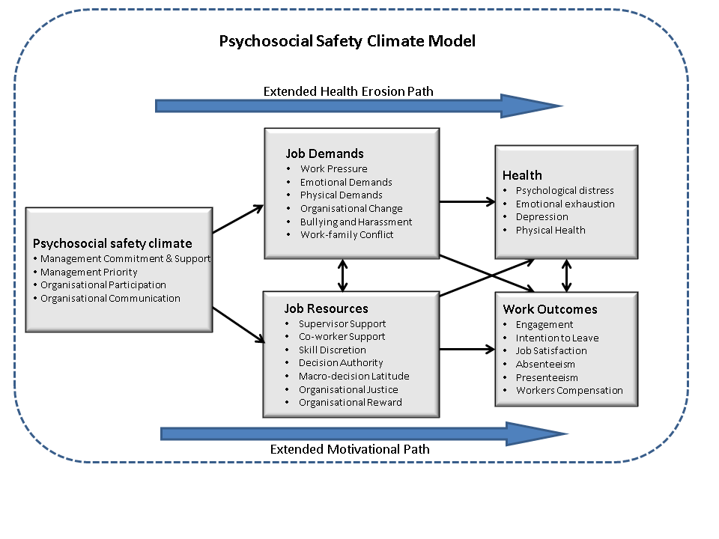

Figure 1. AWB theoretical model

The theoretical model of PSC extends the Job Demands-Resources (JD-R) theory (Demerouti, Nachreiner, Bakker, & Schaufeli, 2001), which builds on earlier work stress models such as the Demand-Control model (Karasek, 1979). According to JD-R, psychosocial work factors can be classified in terms of job demands (that is, things that have to be done) and job resources (that is, things that assist in achieving work goals), and can reduce job demands.

Job Demands-Resources theory considers psychosocial work conditions, particularly job demands (e.g. workload, emotional demands, bullying) as significant predictors of employee health via a health erosion pathway. Coping with chronic job demands leads to an erosion of a worker’s energy reserve; in turn this leads to negative responses (such as psychological distress), and in the longer term, psychological injury (such as depressive disorder) and health problems (including cardiovascular disease or musculoskeletal disorders) (Schaufeli & Bakker, 2004).

A second pathway is proposed in the JD-R model. The motivational pathway describes how adequate resources (e.g. control, support, rewards, procedural justice) are motivating and lead to engagement, and in turn to positive organisational outcomes such as improved performance (Bakker & Demerouti, 2007).

Considering the JD-R model, it is important to remember that jobs are by human design and the levels and types of demands are a result of discretionary management decisions. PSC reflects the level of regard for psychological health implications of working conditions. PSC is a normative/ value based concept of “good work/healthy work”. Managers who are concerned about worker wellbeing will design job demands that are manageable. In a high PSC organisation, work demands would likely be manageable and psychological health problems less prominent. In poor PSC organisations, managers would not be concerned about high work-loads, or other hazardous conditions, like high levels of bullying. The low PSC scenario is likely to be stressful for workers. PSC reflects a level of regard for worker wellbeing and clearly precedes work conditions. We therefore extend JD-R theory and propose the extended health erosion hypothesis (see Figure 1):

**Hypothesis 1**. PSC is negatively related to job demands that in turn positively relate to psychological health problems.

We also expect that managers cognisant of psychosocial risks and concerned for worker psychological health would allocate sufficient resources. High levels of PSC would foster growth in other resources, such as co-worker support and local supervisor support. A management style supportive of psychological health would be attentive to organisational justice issues, and would provide adequate esteem and financial rewards. According to social exchange theory when workers perceive that their needs are being met, they will respond with greater levels of motivation, energy and commitment. These relationships are captured in the *extended motivation hypothesis (see Figure 1):*

**Hypothesis 2**. PSC is positively related to resources that in turn positively relate to work engagement.

Cross-links between the health and motivation pathways are theoretically and practically important because they may explain for example, how work performance can be impaired through the reduced health of workers (Schaufeli & Bakker, 2004). Further there is empirical support for them (Hakanen, Bakker, & Schaufeli, 2006). In particular the relationship between job resources such as lack of control and psychological health problems is strongly supported in the literature (Karasek & Theorell, 1990).

**Hypothesis 3.** PSC is positively related to job resources that in turn negatively relate to psychological health problems.

These mediation hypotheses are important because they propose a work stress process PSC🡪work conditions🡪stress outcomes.

## Previous PSC Research Evidence

Several studies have been conducted to test these PSC theoretical premises. The first study was by Dollard and Bakker (2010) of 209–288 employees in 18 schools in an Australian state education department. Since PSC is considered a climate construct, researchers first aggregated individual PSC survey scores to the school level. The first important result noted was that aggregated PSC was negatively related to objective sickness absence rates at the school. Since PSC was estimated using only survey respondents, and given it related to sickness absence rates that were for *all* employees in the schools, and this latter measure was supplied by the department, results that were generated support the notion that PSC is an important pervasive robust group-level climate for health outcomes. Knowing about PSC levels, one could predict sickness absence rates in the school.

Next the researchers tested the three hypotheses above, using hierarchical linear modelling. Using a longitudinal design, PSC as an aggregate measure was significantly related to perceived demands (work pressure, emotional demands), resources (skill discretion but not decision authority), psychological health (psychological distress, emotional exhaustion) and engagement, all assessed 10 months later. In support of Hypothesis 1 they found the PSC predicted change in individual psychological health problems (psychological distress, emotional exhaustion) through its relationship with individual job demands (work pressure and emotional demands). In support of Hypothesis 2, PSC predicted change in employee engagement, through skill discretion. Hypothesis 3 was not supported in this study. The design of this study was strong because it used an aggregated measure of PSC, and a longitudinal design that controlled for baseline measures by adjusting for the potential influence of these factors; stronger causal conclusions can be drawn with this design compared to cross-sectional studies.

A South Australian cross-sectional population telephone interview study (AWB data) also tested the hypotheses. Participants were asked to name the organisation that they worked for (92 per cent of participants obliged) (Law, Dollard, Tuckey, & Dormann, 2011). PSC was again aggregated to the organisational level by combining data from organisations with at least four respondents (range 4 -33). The final multi-occupational sample comprised 30 organisations and 220 employees. Using hierarchical linear modelling, in support of Hypothesis 1, researchers found that organisational PSC was negatively associated with demands (in particular workplace bullying and harassment) that in turn related to psychological health problems. In support of Hypothesis 2, PSC was also positively associated with resources (work rewards) and in turn work engagement. Hypothesis 3 was not tested.

The Malaysian-Australian study (Idris, Dollard, Coward, & Dormann, 2012) mentioned above also supported Hypothesis 1; PSC was related to demands that in turn were related to psychological health problems, but only in the Malaysian sample. The results may not have been replicated in the Australian sample due to there not being a large enough sample size for the statistical analysis to find the desired effect.

In an Australian study of remote area nurses, Dollard and colleagues (2012) reasoned that if PSC was a climate construct and related to fairly stable organisational functions, then knowing about levels of PSC in work units should predict work conditions and health in *other* workers some time later. They used survey data from remote area nurses at Time 1 (*N* = 202, Time 1) to assess PSC aggregated to the unit level (*N* = 48). Then 24 months later they surveyed completely different nurses in the same work unit (*N* = 163 Time 2). Remarkably, using hierarchical linear modelling, they found that unit psychosocial safety climate predicted work conditions demands (workload) and resources (control, supervisor support) in other nurses in the same work unit 24 months later. There was support for Hypothesis 1 because the relationship between unit psychosocial safety climate at Time 1 and psychological strain at Time 2 was mediated via Time 1 demands (emotional demands), and Time 2 demands (workload). Hypothesis 3 was also supported as resources (job control) at Time 2 also mediated the relationship between PSC and psychological strain. Hypothesis 2 was not tested.

Several international studies support the hypotheses. Using a population-based sample consisting of 269 public and private employees from Malaysia, Idris and Dollard (2011) found support for Hypothesis 1. PSC had an indirect effect on specific negative emotions (e.g. anger, depression) via job demands (emotional demands, role conflict). In support of Hypothesis 2, job resources (supervisor support, co-worker support) carried the influence of PSC onto engagement. They used structural equation modelling and multigroup analysis, and found that the model held in both the public and private sectors.

Using a different Malaysian sample, Idris, Dollard and Winefield (2011) went further and proposed that work performance could be affected via both the extended health erosion pathway and the extended motivational pathway. They used a random population based sample of 291 Malaysian employees (response rate 50.52 per cent) from the State of Selangor. Cross-sectional data were analysed using structural equation modelling, and bootstrapping in AMOS (Analysis of Moment Structures), which is a statistical technique used to test the amount of influence one variable has on another through any number of mediating variables. All data was analysed at the individual level since the identity of the organisations was not known. In support of Hypothesis 1, PSC was negatively related to job demands that in turn were associated with burnout (i.e. exhaustion and cynicism). PSC was related to performance, but only via its direct relationship to burnout. Hypothesis 2 was also supported: PSC was related to performance via its positive relationship with resources and in turn engagement.

In a Spanish study of 54 different organisations and 1204 employees (Escartín, Dollard, & Zapf, in review), low PSC aggregated to the organisational level was associated with higher levels of victim reports of bullying, and in turn, higher between-organisational levels of anger and emotional exhaustion. Perceived low PSC at an individual level was associated with higher reports of bullying by perpetrators themselves, and in turn higher individual exhaustion and anger, suggesting ‘bullying is bad for you’. Notably low PSC is an underlying cause of hazardous behaviour in this case bullying.

In summary, research to date supports the proposition that PSC is a shared construct and a property of the organisation. Evidence backs PSC as a multilevel theory of work stress that combines organisation, job and individual level aspects. PSC acts as a trigger for both the health impairment and motivational pathways, thus justifying extending the JD-R model. The findings provide evidence of PSC as a ‘cause of the causes’ and as a lead indicator of workplace psychosocial hazards (high demands, low resources), psychological health and employee engagement.

### PSC interacts with work conditions

This report focuses on the hypotheses articulated above because they help to tackle the question “from where do stressful work conditions arise?”. It is important to note however that PSC also acts to moderate the relationship between work conditions, health and engagement outcomes. PSC supports employees to cope with their job demands, for example, by providing relevant policies or practices, such as flexibility in the workplace or opportunities to debrief after emotionally challenging experiences. Importantly PSC may be viewed as an organisational resource. Higher levels of resources to cope with demands should lead to active jobs (Karasek, 1979) and a reduction in stress. In high PSC workplaces, increased coping capacity may reduce the impact of demands on employee health outcomes. PSC could act like a safety signal indicating to workers that when it is present, that it is safe to utilise available resources. It is not hard to imagine in some workplaces that accessing resources (e.g. actually utilising autonomy; accessing counseling) may have negative consequences. This may occur in a low PSC scenario.

Underpinning several of the main work stress theories is the proposition that high levels of resources (control, support) will moderate the demand 🡪 psychological health relationship. Since PSC is like an organisational resource we expect that it would moderate the detrimental effects of job demands on psychological health. Empirical support for the interaction of PSC and job demands (PSC X D) 🡪 psychological health was found in Dollard and Bakker (2010) and Law, Dollard et al., (2011). In a sample of police officers from South Australia, PSC at high levels also moderated the effect bullying on post-traumatic stress disorder (Bond, S., et al., 2010).

Dollard and Karasek (2010) argued that PSC could be operationalised in terms of actions taken, process used and progress made in a stress intervention project. Using a similar data set to Dollard and Bakker (2010), they found in schools with high levels of PSC as indicated by intervention actions, process and progress, that job control measured in terms of decision latitude acted to reduce the level of psychological distress and emotional exhaustion over time. In groups with low PSC, the relationship between control and the outcome measures was not as strong. In other words the intervention worked by modifying the work conditions – stress outcome relationship. High PSC did not increase the level of control, but rather enabled or facilitated its utilisation. Although they found evidence of the interaction of PSC and resources (PSC X R)🡪 psychological health, they did not find support for PSC and demands (PSC X D)🡪 psychological health.

Using a large multi-occupational population sample of 2343 Australian workers (from wave 1 of the AWB data, NSW and WA), Hall, Dollard, Winefield, Bakker, and Dormann (2012) tested the role of psychosocial safety climate (PSC) as a moderator between job demands (emotional and work pressure) and worker depression. Using moderated structural equation modelling, they found that PSC moderated the relationship at least as well as other well known resources i.e. job control, and social support. When PSC was low, the relationship between demands and depression was significant and positive. When PSC was high, the detrimental (positive) relationship between demands and depression was reduced. They also theorised and found support for PSC as a moderator of the impact of depression on work engagement and satisfaction. High levels of PSC reduced the negative impact of depression on engagement that was evident under conditions of low PSC. Again this moderation effect was at least as good as other resources (control and social support). These results show that PSC has a beneficial impact for handling adverse work conditions, and also for helping with handling depression on the job. This is particularly important because some depression may arise from circumstances beyond the job.

Several major reviews of the Demand-Control-Support models (van der Doef & Maes, 1999; Häusser, et al., 2010), have found a lack of support for the much hypothesised interaction effect between demands and resources (i.e. control, support) and its effect on psychological health. A proposed reason is that studies fail to assess the context or climate (de Lange et al., 2003). This suggests the interaction of demands by resources to reduce the negative impact of demands may only occur in high PSC contexts.

A study of Australian police officers theorised that the demand-resource interaction depends on the organisational context; that high levels of psychosocial safety climate will enable the safe utilisation of resources to reduce demands (Dollard, Tuckey & Dormann, 2012). Researchers tested this hypothesis in a sample of police constables (Time 1, N = 319, Time 2, N = 139), from 23 police stations. PSC was measured by officer perceptions, aggregated to the station level. Controlling for Time 1 levels of distress, using hierarchical linear modelling, they found that D X R interaction only worked when there were high levels of PSC. High levels of emotional resources reduced the detrimental relationship between emotional demands and workgroup distress, but only when there were high levels of psychosocial safety climate in the police station. Importantly these results were validated when the PSC was also measured using a different sample of officers to those who participated at Time 2 (those who eventually left the study). The study demonstrated that PSC enabled resources to do their job (i.e. reduce the impact of demands).

Finally, PSC moderated the negative relationship between bullying/harassment and engagement (Law et al., 2011). When PSC was low, bullying and harassment affected engagement whereby high levels of bullying and harassment were related to low levels of engagement. High levels of PSC offset the impact of bullying so that the relationship between bullying and engagement disappeared.

A German study of 50 service car dealer employees, and some 300 interactions with clients, investigated whether higher levels of PSC within the dealerships was able to protect employees from the negative consequences of interactions with difficult customers (Zimmermann, Haun, Dormann, & Dollard, 2009). PSC was assessed prior to customer interactions. Employees rated PSC, and customer behaviour, as well as their own emotional reactions. They found that employees’ negative affect was higher directly after a negative interaction with a customer. Further, a significant interaction was found between PSC and customer behaviour in predicting negative affectivity. Under conditions of low PSC, there was a positive relationship between negative customer behaviour and employee negative affectivity. Under conditions of high PSC, the relationship reduced. The study underscores the importance for organisations to improve PSC to protect employee psychological well-being.

In summary, PSC can act to moderate the relationship between psychosocial risk factors with employee health and productivity outcomes.

### PSC as a target for intervention

PSC theory and the empirical evidence highlights the dual functionality of PSC. Primarily it can be used to prevent work stress through job design; secondarily it can be used to prevent the adverse impact of stressors. Based on PSC theory, we propose that the most efficient organisational intervention target to reduce stress and increase work productivity will be to build PSC. Primary interventions are generally concerned with strategies aimed at the organisational level such as policy and procedure. Secondary interventions are aimed more at the job design aspects including levels of demands and resources. Tertiary interventions focus on the individual and may involve enhancing coping skills to reduce the effects of the psychosocial risk factors (Murphy & Sauter, 2004). Taken together the evidence above suggests that PSC is an efficient target for primary prevention and secondary intervention (to reduce impact of hazards).

PSC measures provide information about what to change in an organisation at the primary level - to improve working conditions (such as management priority, communication or participation systems), and at the secondary level – to reduce the impact of psychosocial hazards.

Moreover there is evidence that the PSC starting conditions may determine the success of a stress intervention. Researchers have outlined a number of process and contextual issues influencing the developmental stage of an organisational stress intervention (Biron, Gatrell, & Cooper, 2010; Dollard & Karasek, 2010). In particular, organisational capacity and resource issues (financial, human, expertise, and skills) are crucial, as is the political will of stakeholders (Dollard & Karasek, 2010). In a participatory action work stress risk-assessment based intervention study, involving 18 different intervention work groups in two Australian public sector agencies (education and community health services), researchers found strong support for the proposition that the starting condition, PSC assessed at a group level, predicts how successful the implementation of the intervention is. PSC was associated with the extent to which the intervention groups attended the capacity building sessions, the quality of the intervention (e.g. whether trust was developed, being listened to) and the progress (e.g. the extent of implementation of action plans) of the intervention.

### PSC and national health

To date research has found worker health effects due to PSC when it has been assessed at an individual level (Idris, Dollard, & Winefield, 2011), at a work unit level (Dollard & Bakker, 2010; Dollard, Tuckey, & Dormann, 2012) and at an organisational level (Law et al., 2011). Scholars have for some time investigated income inequality and absolute income as determinants of health differences between nations. Given the impact of psychosocial factors at work on worker health, it is reasonable to consider the possibility that national differences in workplace psychosocial conditions may be related to national differences in health. Emerging research links workplace psychosocial factors to national health differences between countries.

A European study considered a range of factors that might explain health differences between 24 different EU countries (Dollard & Neser, in review). Factors considered were: workplace psychosocial risks, including stress, bullying and violence; psychosocial safety climate; union representation; corruption; income inequality; and absolute income. Importantly worker self-reported health was related to life expectancy at the national level. This initial evidence provides weight to the importance of worker health in national health accounting. Further, as expected PSC was related to psychosocial work conditions; high levels of PSC[1] were related to lower risk of bullying, violence and stress. Researchers found that results were consistent with a novel psychosocial pathway whereby union representation within organisations, and psychosocial safety climate explained national differences in worker self-reported health. In turn, worker health was related to national differences in life expectancy. This result was evident over and above the significant main effect of absolute income on life expectancy. This evidence supports the significance for PSC at a national level for worker health, and points to national work, work health and safety, and social policy differences between countries as an explanatory mechanism (via PSC) for between country differences in worker health.

## Method

### **Participants**

Data was collected from employed workers over the age of 18, randomly selected from New South Wales (NSW) (N = 1074) and Western Australia (WA) (N = 1156) in 2009. Further data collections occurred in 2010 with workers from NSW[2] (N = 725), WA (N = 804), as well as participants randomly selected from South Australia (SA) (N = 1143). In 2011 additional data was collected from the Australian Capital Territory (ACT) (N = 255), Tasmania (N = 416) and the Northern Territory (NT) (N = 170). This resulted in a total of 5743 interviews from a wide range of occupations and industries. Demographic data shows the sample included approximately 45 per cent males and 55 per cent females with 60 per cent working full-time.

### **Measures**

The scales selected for the AWB tool were taken from internationally recognised and psychometrically validated measures to capture data on the following aspects:

* Psychosocial Safety Climate (PSC)
* Job demands - (work pressure, physical, emotional)
* Organisational Change
* Harassment and Bullying
* Work-Family Conflict (WFC)
* Job control - (skill discretion, decision authority, macro-decision latitude)
* Resources - (support supervisor social support, co-worker social support, justice, rewards)
* Mental Health - (emotional exhaustion, psychological distress, depression)
* Physical health - (general health)
* Work outcomes - (productivity, absenteeism, stress claims), and
* Engagement - (vigour, dedication, absorption).

The AWB tool was developed from combining various well-known and internationally recognised psychometric measures. It includes the following measures:

### Psychosocial Safety Climate

The PSC-12 (Hall, Dollard, & Coward, 2010) comprises four domains each with three items; (1) senior management commitment and involvement in relation to stress prevention practices; (2) management priority measures employee perceptions of how management values employee psychological health and safety in comparison to productivity goals; (3) organisational communication, encompasses processes for employees to provide feedback on psychological wellbeing; and (4) organisational participation, which relates to consultation regarding psychological health and safety issues with employees’ unions and Health and Safety Representatives. Responses were made on a 5-point Likert scale from 1 (*strongly disagree*) to 5 (*strongly agree*). Scores for each of the 12 items from all subscales are combined to provide the overall score ranging from a minimum 12 to maximum score of 60.

### Job Demands

#### Job Demands

Job Demands were measured with the Job Content Questionnaire (JCQ 2.0) (Job Content Questionnaire Centre, 2012) which includes the following subscales; physical demands (six items), work pressure (five items), and emotional demands (four items). Self-report data was recoded on reverse scored items to reflect the 4-point Likert scale from 1 (*strongly disagree*) to 4 (*strongly agree*).

#### Organisational Change

The JCQ 2.0 was also used to measure organisational change. Five items were included, rated on the same 4-point Likert scale, asking participants to report the extent to which the given statement reflects their experiences at work. For example, *‘In your company/organisation, there have been changes such as restructuring, downsizing, and layoffs that have significantly affected your job’.*

#### Organisational Harassment

A seven item scale employed by Richman, Flaherty and Rospenda (1996) was used to measure organisational harassment in the present study. Participants were asked to respond with the frequency that they experienced a variety of harassment situations in their workplace, from 1 (*very rarely/ never*) to 5 (*very often/ always*).

#### Bullying

Although some differences in legislation exist between each Australian state, in general bullying is defined as “*repeated, unreasonable behaviour directed towards a worker or a group of workers, that creates a risk to health and safety*” (Australian Government Productivity Commission, 2010, p.288). This definition is consistent with that used in this study.

A clear definition of bullying was given for the present study as prior research shows wide variation in individual interpretations of bullying when participants self-label as being bullied. The following was provided for the participant:

“Bullying is a problem at some work-places and for some workers. To label something, as bullying, the offensive behaviour has to occur repeatedly over a period of time, and the person confronted has to experience difficulties defending him or herself. The behaviour is not bullying if two parties of approximate equal “strength” are in conflict or the incident is an isolated event” (Lindström et al., 2000).

Further, the following three questions were asked:

1. ‘*Have you been subjected to bullying at the workplace during the last 6 months?*’ (answer *yes* or *no*)
2. *‘How often were you exposed to these bullying behaviours overall?’* (5-point scale from 0 (*never*) to 4 (*daily*)), and
3. *‘How long were you exposed to these bullying behaviours overall?’* (5-point scale from 1: *less than one month* to 5: *more than 2 years*).

#### Work-Family Conflict

Work-Family Conflict was measured by asking participants about how work affected their home lives. Five items measuring time and strain-based conflict from Netemeyer, Boles and McMurrian’s (1996) work-family conflict scale were selected for use in the present study. An example of the former includes *‘My job produces strain that makes it difficult to fulfil family duties’*, while the later included *‘The amount of time my job takes up makes it difficult to fulfil my family responsibilities’*. Responses to the items were made on a 7-point Likert scale from 1 (*strongly disagree*) to 7 (*strongly agree*).

#### Working hours

Working hours was measured in this study using a single item which asked participants to report how many hours they worked in the last seven days.

### Job Resources

#### Job Control

Scales from the JCQ 2.0 were also used to measure the following three job control constructs; skill discretion (6 items, e.g. ‘*I have an opportunity to develop my own special abilities*’); decision authority (4 items, e.g. ‘*My job allows me to make decisions on my own*’); and macro-decision latitude (3 items, e.g. ‘*In my company/organisation, I have significant influence over decisions made by my work team or department*’). A Likert response format was used for all items, with responses ranging from 1 (*strongly disagree*) to 4 (*strongly agree*).

#### Social Support

Measures were taken from the JCQ 2.0 to measure both supervisor social support (3-item scale, e.g. ‘*My supervisor/manager is helpful in getting the job done*’), and co-worker social support (3-item scale, e.g. ‘*I am treated with respect by my co-workers*’). Responses ranged from 1 (*strongly disagree*) to 4 (*strongly agree*), plus an alternate option to complete if the participant did not have a supervisor or co-workers.

#### Organisational Justice

The JCQ 2.0 was again used to measure organisational procedural justice using a total of four items, scored on a 4-point Likert scale, ranging from 1 (*strongly disagree*) to 4 (*strongly agree*). An example item from this scale includes: ‘*In my company/ organisation, procedures are designed to provide opportunities to appeal or challenge a decision*’.

#### Organisational Rewards

The Effort-Reward Imbalance scale (ERI; Siegrist, 1996) was sourced to measure organisational rewards. Four specific items were selected for use in the present study taken from the esteem reward component (1 item), the job promotion reward component (2 items), and the job security reward component (1 item). Responses were made on a 4-point Likert scale to be consistent with above measures 1 (*strongly disagree)* to 4 (*strongly agree*).

### Health Outcomes

#### Emotional Exhaustion

Emotional exhaustion was measured through a selection of five items from the Maslach Burnout Inventory (MBI; Schaufeli, Leiter, Maslach, & Jackson, 1996). Items such as *‘I feel tired when I get up in the morning and have to face another day on the job’* were answered on a 7-point scale, ranging from 1 (*never*) to 7 (*every day)*.

#### Psychological Distress

All 10 items from the Kessler 10 (K10; Kessler & Mroczek, 1994) were included to measure psychological distress, which investigates the degree of anxiety and depressive symptoms that the participant has experienced over the last month. For example, *‘In the past four weeks, about how often did you feel everything was an effort?’* Responses were scored on a 5-point scale, from 1 (*none of the time*) to 5 (*all of the time*).

#### Recovery

Five items from the inter-shift recovery section of the Occupational Fatigue Exhaustion Recovery Scale (OFER15; Winwood, Winefield, Dawson, & Lushington, 2005) were employed to measure the worker ability to recover between work periods. Items such as *‘I never have enough time between work periods to recover my energy completely’* were answered on a 7-point Likert scale, ranging from 1 (*strongly disagree*) to 7 (*strongly agree*).

#### Depression

Depression was measured using all items from the Patient Health Questionnaire (PHQ-9; Spitzer, Kroenke, & Williams, 1999). These nine items apply to the nine criteria for clinical diagnoses of depressive episodes in the DSM-IV, for example *‘During the last month, how often were you bothered by little interest or pleasure in doing things?’* These items are all scored on a 4-point Likert scale 1 (*not at all*) to 4 (*nearly every day*).

#### General Physical Health

Nine items from the University of Queensland Work Outcomes Research Cost-Benefit (WORC) project (QIDS-SR, Rush et al., 2003; Section A – Health) were used to measure the participant’s current physical health. Items included ailments such as musculoskeletal problems experienced in the last week, as measured on a 4-point scale, 1 (not at all/never) to 4 (a lot). For example, *‘During the last 7 days, how much were you bothered by headaches?’.* In addition, one global item (the SF1) was included to measure general health from the MOS Short Form 36 (SF36; Ware & Sherbourne, 1992). The SF1 asks *‘In general, would you say your health is…?’* to which individuals assess their own physical and mental health, responding on a 5-point scale from 1 (*poor*) to 5 (*excellent*).

#### Work Stress Claims

Stress claims are worker’s compensation claims made for psychological conditions, such as depression, that arise largely from work conditions. To measure worker’s compensation claims, participants were asked to answer yes or no to the following question, ‘*Have you ever put in a worker’s compensation claim*’ and if yes, the participant was then asked ‘*Was this claim for a stress or psychological injury related problem*?’

### Motivational Outcomes

#### Absenteeism

Two items from the World Health Organisation Work Performance Questionnaire (HPQ; Kessler et al., 2003) were used to measure absenteeism. In specific, sickness absence was the measure used for results in this report, which refers to the rate of absenteeism based solely on illness (psychological and physical). The items were ‘*How many hours does your employer expect you to work in a typical 7-day week*?’ and ‘*In the past 4 weeks (28 days), how many days did you miss an entire work day because of problems with your physical or mental health*?’ A ratio was created between the two items to create a percentage absence due to sickness over expected monthly hours of work, adjusting for the possibility of negative scores due to working longer than expected hours.

#### Presenteeism

One item that investigates job performance from the World Health Organisation Work Performance Questionnaire (HPQ; Kessler et al., 2003) was used to measure presenteeism. This was ‘*how would you rate your overall job performance on the days you worked during the past 4 weeks*?’ It was answered on a scale from 0 to 10, where 0 is the worst performance and 10 is the performance of a top worker. The reported number was multiplied by 10 to produce a percentage of productivity, with a low score indicating the worker is more prone to ‘presenteeism’.

#### Engagement

Nine items from the Utrecht Work Engagement Scale – Shortened Version (UWES-9; Schaufeli, Bakker, & Salanova, 2006) were employed to measure work engagement. The three subscales each consist of three items to measure a different facet of engagement; vigour, e.g. *‘At my work, I feel bursting with energy’*; dedication, e.g. *‘My job inspires me’*; and absorption, e.g. *‘I get carried away when I am working’*. These items were all measured on a 7-point scale which ranged from 1 (*never*) to 7 (*every day).*

## Procedure

Computer assisted telephone interviewing (CATI) system was used to contact participants identified via the Electronic White Pages. Participants were sent an introductory letter providing details of the study and advised that they will be contacted. The data were weighted based on factors including age, sex, number of phone numbers in the white pages and number of members of the household, to establish representativeness of the sample to the wider state or Australian population. The analysis utilised a cross-sectional design to establish correlational relationships in order to provide implications for policy development.

## Statistical analysis

The main statistical analyses utilised the Statistical Package for the Social Sciences (SPSS) program. Correlations were conducted to measure of the degree of linear relationship between two variables. Regression analyses were also used to model the relationship between dependent variables such as health outcomes and one or more explanatory variables denoted such as demands or resources. Structural equation modelling (SEM) was conducted using AMOS in order to establish the model presented in Figure 1.

# Demographic data for AWB population

See Table 1 for details relating to age, gender and other demographic information for the sample population.

Table 1. Demographics of participants by state (not weighted)

|  |  |  |  |  |  |  |  |  |  |  |  |  |
| --- | --- | --- | --- | --- | --- | --- | --- | --- | --- | --- | --- | --- |
|  | Data collected 2009 to 2011* | | | |  | Data collected 2010 to 2011** | | | | | | |
|  | Australia  (*N* = 4214)a | NSW  Time 1  (*N* = 1074) | WA  Time 1  (*N* = 1156) | |  | Australia  (*N* = 3513)b | NSW  Time 2  (*N =* 725) | WA  Time 2  (*N =* 804) | SA  (*N =* 1143) | ACT  (*N =* 255) | TAS  (*N =* 416) | NT  (*N =* 170) |
|  |  | 2009 | 2009 | |  |  | 2010 | 2010 | 2010 | 2011 | 2011 | 2011 |
| Age (years) | M 45.66 | M 45.47 | M 45.66 | |  | M 46.62 | M 47.53 | M 47.92 | M 46.09 | M 45.27 | M 45.85 | M 44.15 |
|  | SD 12.22 | SD 12.17 | SD 12.45 | |  | SD 11.85 | SD 11.29 | SD 11.49 | SD 12.36 | SD 12.46 | SD 11.58 | SD 11.20 |
|  | Percentage (%) of sample | | |  | | Percentage (%) of sample | | | | | | |
| Gender |  |  |  | |  |  |  |  |  |  |  |  |
| Men | 45.7 | 44.7 | 47.1 | |  | 45.5 | 43.6 | 47.3 | 44.5 | 49.8 | 45.7 | 44.7 |
| Women | 54.3 | 55.3 | 52.9 | |  | 54.5 | 56.4 | 52.7 | 55.5 | 50.2 | 54.3 | 55.3 |
| Indigenous Australian (ATSI) |  |  |  | |  |  |  |  |  |  |  |  |
| No / Not stated | 98.1 | 98.2 | 98.0 | |  | 98.4 | 98.2 | 99.2 | 99.6 | 99.0 | 97.3 | 90.8 |
| ATSI | 1.9 | 1.8 | 2.0 | |  | 1.6 | 1.8 | 0.8 | 0.4 | 1.0 | 2.7 | 9.2 |
| Marital Status |  |  |  | |  |  |  |  |  |  |  |  |
| Married | 58.7 | 57.4 | 59.0 | |  | 60.5 | 61.2 | 63.1 | 59.1 | 59.2 | 63.7 | 50.0 |
| Living with partner | 10.2 | 10.6 | 9.9 | |  | 9.5 | 8.8 | 8.8 | 9.8 | 8.2 | 8.9 | 17.6 |
| Separated | 3.6 | 3.2 | 3.2 | |  | 3.6 | 4.0 | 2.5 | 3.3 | 5.9 | 3.4 | 7.1 |
| Divorced | 9.1 | 9.3 | 8.6 | |  | 9.5 | 9.8 | 9.6 | 10.2 | 8.2 | 8.2 | 7.1 |
| Widowed | 2.0 | 2.7 | 2.2 | |  | 2.0 | 2.9 | 2.4 | 1.8 | 1.6 | 1.0 | 1.8 |
| Never married / Refused | 16.4 | 16.8 | 17.1 | |  | 14.9 | 13.2 | 13.7 | 15.8 | 16.9 | 14.9 | 16.5 |
| Education level |  |  |  | |  |  |  |  |  |  |  |  |
| Bachelor degree or higher | 33.7 | 35.8 | 33.3 | |  | 34.6 | 37.1 | 36.8 | 27.7 | 50.2 | 33.9 | 38.8 |
| Below bachelor level | 66.3 | 64.2 | 66.7 | |  | 65.4 | 62.9 | 63.2 | 72.3 | 49.8 | 66.1 | 61.2 |

Note: Statistics are drawn from the total number of interviews (N = 5,743) which includes six states over two waves of data collection from 2009 to 2011; *includes NSW and WA Time 1 (2009) and all other states; *includes NSW and WA Time 2 (2010) and all other states.

Table 2. Individual and Employment Characteristics: Comparison between AWB and ABS data as a percentage of overall sample

|  |  |  |  |
| --- | --- | --- | --- |
|  | AWB |  | ABS |
| *Individual Characteristics:* |  |  |  |
| Gender |  |  |  |
| Men | 45.7 |  | 50.1 |
| Women | 54.3 |  | 49.9 |
| Education level |  |  |  |
| Bachelor degree or higher | 33.7 |  | 23.8 |
| Below bachelor level | 66.3 |  | 76.2 |
| Country of birth |  |  |  |
| Australia | 77.3 |  | 72.4 |
| Outside Australia | 22.7 |  | 27.6 |
| *Job Characteristics:* |  |  |  |
| Working hours |  |  |  |
| Full-time | 71.8 |  | 70.4 |
| Part-time | 28.2 |  | 29.6 |
| Contract type |  |  |  |
| Permanent/fixed term (with paid leave) | 85.7 |  | 80.2 |
| Casual (without paid leave entitlements) | 14.3 |  | 19.8 |
| Small-to-medium enterprise employment |  |  |  |
| Small (up to 19 employees) | 17.0 |  | 47.2 |
| Medium ( 20 – 199 ) | 21.0 |  | 23.3 |
| Large ( 200 + ) | 62.0 |  | 29.5 |
| Yearly Income (average, AUD) | $51 636 |  | $52 536 |

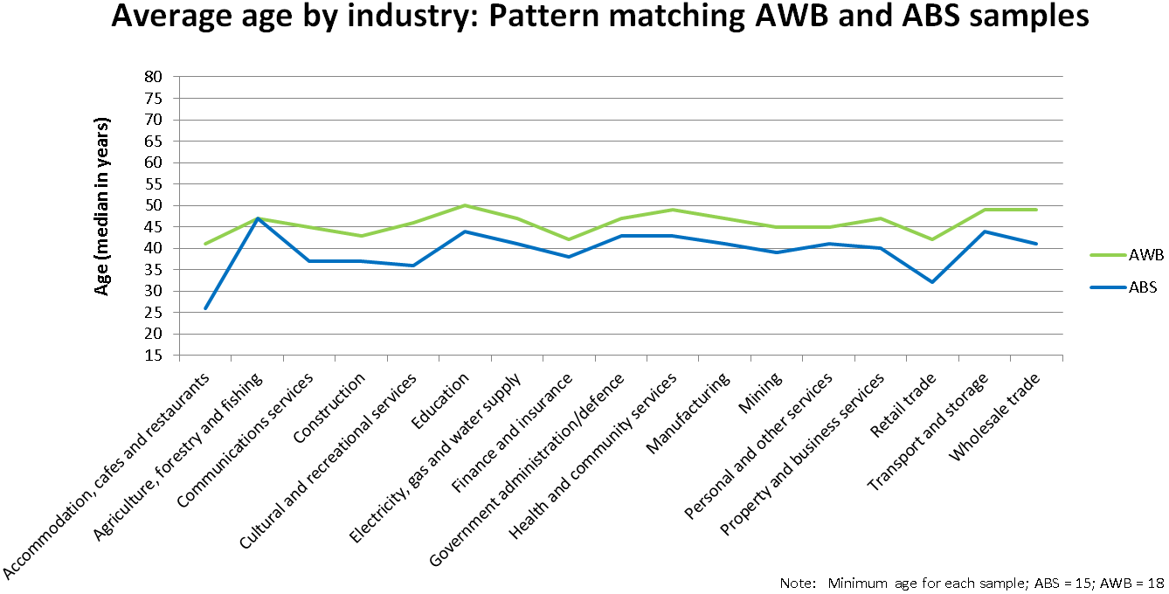

Figure 2. Average age by industry: Demonstrating the close fit of the AWB data to ABS statistics

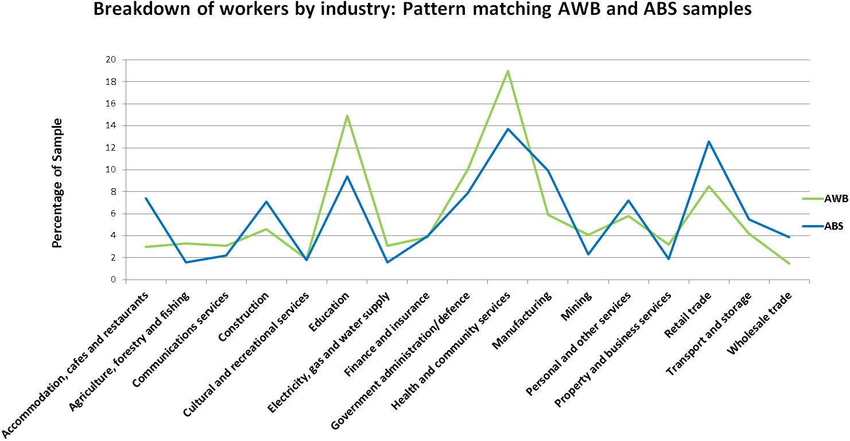

Figure 3. Breakdown of workers in each sample by industry

## AWB and ABS Sample Comparisons

The AWB sample is a good representation of working adults. In order to support the generalisability of AWB results, the following comparisons were made with population data collected by the Australian Bureau of Statistics. When the opportunity was available, data comparisons were made to ABS data that was collected in 2010, which would line up in the central time period of AWB data collection (from 2009 to 2011). Comparisons between the AWB data set and existing ABS statistics are presented in Table 2 and Figures 2 and 3.

Some data was not directly comparable with AWB variables, so further calculations based on ABS data were made. These are detailed as follows, in the order they are presented in text.

***Gender:*** Gender distributions from ABS data are reported in the Survey of Employee Earnings and Hours, which was collected in May 2010 (Australian Bureau of Statistics, 2011). In comparison, the AWB displays a slight overrepresentation of women. This effect is often observed in self-report research wherein women are more likely to participate in voluntary research, whereas the census data collected by the ABS is compulsory.

***Education level:*** ABS data presents statistics for education level in Males and Females, so subsequent calculations were made to match these levels to AWB demographics (male and female together). The resulting 23.8 per cent in ABS data is lower than in the AWB, however the ABS sample for education level was capped at 64 year old workers, whereas the eldest candidate in the AWB data was 80. This may suggest a possible reason for the slight overrepresentation of bachelor degree qualified individuals (Australian Bureau of Statistics, 2008a).

***Country of birth:*** Statistics on country of birth were obtained from statistics on employed workers from November 2010 (Australian Bureau of Statistics, 2010a).

***Working hours:*** The breakdown of full-time and part-time workers from ABS data in the 2010 to 2011 period was reflected in AWB data to within a small margin (Australian Bureau of Statistics, 2012a). This, along with the following statistic on contract types, suggests that AWB data is largely representative of the working Australian population.

***Contract type:*** Data on contracts were based on whether the worker was entitled to paid leave (typically, permanent and fixed term contracts) or otherwise (casual or no contract at all). ABS data on paid leave entitlements from November 2010 lined up well with the AWB to within around 5 per cent (Australian Bureau of Statistics, 2012b). Nevertheless, the sample for the AWB study displays a marginal 5 per cent higher rate of employees with paid leave entitlements. This may result from the ABS cut-off for the working population being only 15 years and older, so more likely to include younger members with casual or temporary employment than the AWB which has a cut-off at 18 years.

***Small to medium enterprise:*** Small to medium enterprise (SME) is defined in one of two ways; when a workplace has fewer than 200 employees, or when it falls short of a threshold for annual turnover (Clark, Eaton, Lind, Pye, & Bateman, 2011). Only data on the former was collected with the AWB, so statistics for comparison of SMEs are made based on organisation size. Based on ABS data, the AWB sample is not particularly representative of SMEs. These accounted for around 70 per cent of all employment figures in ABS statistics from June 2010, whilst the AWB reports only around a 40 per cent rate of employees working in SME. When broken down further, medium enterprise (20-199 workers) employed almost identical numbers between both AWB and ABS data. Small enterprise (under 19 workers) was underrepresented, suggesting that AWB data may not be as generalizable to employees in small workplaces, or self-employed individuals.

***Income:*** Data on income for both ABS (May 2010) and AWB samples needed to be calculated from available statistics for the purpose of direct comparison. The figure for the mean yearly wage in ABS data was derived from average weekly total cash earnings ($1 010.30) multiplied by 52 weeks (Australian Bureau of Statistics, 2011) averaging $52 536. AWB data only measured income through a categorical variable, with the median income category being $50 001 to $60 000. We calculated a ballpark value for the actual median income based on a conservative assumption that fractional divisions within each category will be equal. We divided the interspersing value of the category (a $10 000 spread) by the percentile for the category (an 11 per cent spread), indicating that each 1 per cent value within this median income category represents roughly $909 of yearly income. The previous income categories comprised 48.2 per cent of the sample ($50 000 or less), so in adding 1.8 per cent ($1 636) we reach an estimated median income value of $51 636pa for workers sampled in the AWB.

***Average age by industry:*** This graph is based on ABS statistics for the median age of workers in each industry during 2011 (Australian Bureau of Statistics, 2012, August). AWB data tracks the pattern for higher and lower median ages by industry, suggesting that the sample is largely generalisable to the Australian working population. One minor difference based on sample categorisation is the slightly higher age on average (across industries) in the AWB sample. This is likely to be due largely to the minimum cut-off for age being 18 years in the AWB, whereas the ABS defines working Australians to be 15 years and older.

***Breakdown of workers by industry:*** The pattern for percentage of workers in each industry also maps well between the AWB and ABS samples (Australian Bureau of Statistics, 2010a). It should be noted however that the AWB collection took place under the 2006 ANZSIC set of industry classifications, however 2010 census data uses an updated form of these classifications. The only difference to be noted in this graph is that 2010 ABS data uses a combination of ‘Administrative support services’ and ‘Other services’ to match to the AWB ‘Personal and Other Services’ category. Further, the new category in ANZSIC 2010 for ‘Professional, scientific, and technical services’ was suppressed from ABS data (and percentage distributions recalculated accordingly), as the ANZSIC 2006 classification system used for the AWB did not include this new category.

# Results and discussion

## Intercorrelations between variables

Table 3 shows all of the Pearson correlations between the variables. With such a large sample correlations can be expected between all measures. To extract better meaning from the results it is important to consider effect size. Cohen (1992) rates a correlation coefficient *r*, to be weak when *r* = .20, moderate when *r* =.30, and strong when *r* = .50.

In relation to the demographic variables, age showed a moderate correlation with income, older workers reporting significantly higher income than younger workers. Older workers reported higher emotional demands, higher organisational change, higher skill discretion, higher engagement and higher presenteeism.

In relation to gender, men reported significantly more income, and worked longer hours than women. Women had significantly less decision authority, and macro-decision latitude, and more physical health problems.

Workers reporting higher income levels report significantly longer working hours, and higher levels of control (skill discretion, and decision authority), but higher levels of work-family conflict, and less opportunity for recovery.

In relation to work hours, those reporting working longer hours were more likely to be men, and also report more work pressure, more work-family conflict, more exhaustion, but more control (decision authority and skill discretion), less sickness absence, and also higher levels of engagement, than those reporting fewer work hours in the past seven days.

Psychosocial safety climate as expected was negatively related to all of the demand measures, showing several moderate relationships. In particular high PSC was associated with low work pressure, low emotional demands, less bullying and organisational change, less work-family conflict, and less harassment (strongest effect). PSC was positively related to the resource measures, showing a strong relationship with supervisor support, macro-decision latitude, organisational justice, and organisational rewards. Psychosocial safety climate was negatively related to all adverse health measures, showing a moderate negative relationship to emotional exhaustion. It was positively related to presenteeism, negatively related to sickness absence, and was negatively related to stress claims. PSC showed a moderate positive relationship with engagement.

All of the demand measures were positively related to each other, and as expected showed negative relationships to resources; as demands increased, resources decreased. In general, consistent with the health erosion hypothesis, the demand measures were positively related to psychological health problems (psychological distress, emotional exhaustion, and depression), with nearly 50 per cent of the relationships of at least moderate size. Moderate-strong relationships were found between both emotional demands and work pressure, and emotional exhaustion, and a strong relationship was found between work-family conflict and exhaustion. As expected, work demands in general showed fairly weak relationships to work outcome measures. Harassment showed the strongest relation to stress compensation claims (see Table 3).

Resources in general showed significant but weak relationships with health problems. Organisational rewards and organisational justice were moderately related to exhaustion; higher levels of these resources were related to lower levels of exhaustion. Organisational rewards were also moderately negatively linked to psychological distress. Consistent with the motivational hypothesis of the JD-R model, nearly all of the resources were moderately-strongly related to engagement.

The health outcome measures were all related to each other. As expected they showed a negative relationship to engagement; higher level of health problems were associated with lower level of engagement. These relationships were moderate for all of the psychological health measures.

In relation to the work outcomes, engagement was most strongly related to PSC, resources, and psychological health measures (all moderate effects). Sickness absence was best predicted in individuals displaying the following characteristics; low work hours, psychological distress, depression, and low engagement, all showing weak effects. Low presenteeism was associated with psychological distress, and depression; high presenteeism was associated with high engagement (moderate effect). Finally stress leave was negatively related to PSC, and positively related to harassment, exhaustion, and depression (all weak effects).

|  |  |  |  |  |  |  |  |  |  |  |  |  |  |  |  |  |  |  |  |  |  |  |  |  |  |  |  |
| --- | --- | --- | --- | --- | --- | --- | --- | --- | --- | --- | --- | --- | --- | --- | --- | --- | --- | --- | --- | --- | --- | --- | --- | --- | --- | --- | --- |
| Table 3. Pearson intercorrelations of variables | | | | | | | | | | | | | | | | | | | | | | | | | | | |
| **Demographics** | 1 | 2 | 3 | 4 | 5 | 6 | 7 | 8 | 9 | 10 | 11 | 12 | 13 | 14 | 15 | 16 | 17 | 18 | 19 | 20 | 21 | 22 | 23 | 24 | 25 | 26 | 27 |
| 1. Age | 1 |  |  |  |  |  |  |  |  |  |  |  |  |  |  |  |  |  |  |  |  |  |  |  |  |  |  |
| 2. Gender | -.05* | 1 |  |  |  |  |  |  |  |  |  |  |  |  |  |  |  |  |  |  |  |  |  |  |  |  |  |
| 3. Income | .34† | -.36† | 1 |  |  |  |  |  |  |  |  |  |  |  |  |  |  |  |  |  |  |  |  |  |  |  |  |
| 4. Hours worked | .12† | -.30† | .46† | 1 |  |  |  |  |  |  |  |  |  |  |  |  |  |  |  |  |  |  |  |  |  |  |  |
| **Psychosocial Safety Climate** |  |  |  |  |  |  |  |  |  |  |  |  |  |  |  |  |  |  |  |  |  |  |  |  |  |  |  |
| 5. PSC | -.07† | -.01 | -.05‡ | -.05‡ | 1 |  |  |  |  |  |  |  |  |  |  |  |  |  |  |  |  |  |  |  |  |  |  |
| **Job Demands** |  |  |  |  |  |  |  |  |  |  |  |  |  |  |  |  |  |  |  |  |  |  |  |  |  |  |  |
| 6. Work Pressure | .07† | .07† | .22† | .21† | -.25† | 1 |  |  |  |  |  |  |  |  |  |  |  |  |  |  |  |  |  |  |  |  |  |
| 7. Emotional Demands | .16† | .11† | .15† | .11† | -.25† | .49† | 1 |  |  |  |  |  |  |  |  |  |  |  |  |  |  |  |  |  |  |  |  |
| 8. Physical Demands | -.10† | -.10† | -.14† | .10† | -.11† | .19† | .13† | 1 |  |  |  |  |  |  |  |  |  |  |  |  |  |  |  |  |  |  |  |
| 9. Organisational Change | .16† | -.03 | .17† | .04* | -.22† | .33† | .25† | .04* | 1 |  |  |  |  |  |  |  |  |  |  |  |  |  |  |  |  |  |  |
| 10. Bullying | .00 | .08† | .04* | .03 | -.21† | .17† | .14† | .08† | .13† | 1 |  |  |  |  |  |  |  |  |  |  |  |  |  |  |  |  |  |
| 11. Harassment | .04* | -.02 | .05‡ | .06† | -.34† | .25† | .29† | .19† | .23† | .35† | 1 |  |  |  |  |  |  |  |  |  |  |  |  |  |  |  |  |
| 12. Work-family Conflict | .07† | -.09† | .28† | .31† | -.26† | .42† | .43† | .20† | .20† | .14† | .31† | 1 |  |  |  |  |  |  |  |  |  |  |  |  |  |  |  |
| **Job Resources** |  |  |  |  |  |  |  |  |  |  |  |  |  |  |  |  |  |  |  |  |  |  |  |  |  |  |  |
| 13. Supervisor Support | -.08† | .03 | -.02 | -.05‡ | .52† | -.22† | -.17† | -.25† | -.18† | -.20† | -.27† | -.15† | 1 |  |  |  |  |  |  |  |  |  |  |  |  |  |  |
| 14. Co-worker Support | -.07† | .08† | -.04* | -.03 | .25† | -.06‡ | -.02 | -.19† | -.09† | -.16† | -.15† | -.04* | .47† | 1 |  |  |  |  |  |  |  |  |  |  |  |  |  |
| 15. Skill Discretion | .15† | -.05‡ | .34† | .18† | .19† | .16 | .20† | -.13† | -.06‡ | -.01 | -.01 | .15† | .23† | .25† | 1 |  |  |  |  |  |  |  |  |  |  |  |  |
| 16. Decision Authority | .08† | -.12† | .24† | .19† | .26† | -.03 | -.02 | -.16† | -.14† | -.11† | -.10† | .01 | .29† | .25† | .49† | 1 |  |  |  |  |  |  |  |  |  |  |  |
| 17. Macro-decision Latitude | -.05‡ | -.13† | .08† | .11† | .53† | -.14† | -.13† | -.07† | -.18† | -.18† | -.20† | -.07† | .35† | .16† | .26† | .46† | 1 |  |  |  |  |  |  |  |  |  |  |
| 18. Organisational Justice | -.04* | -.06‡ | -.02 | -.02 | .63† | -.20† | -.16† | -.06‡ | -.20† | -.13† | -.27† | -.19† | .39† | .20† | .18† | .28† | .56† | 1 |  |  |  |  |  |  |  |  |  |
| 19. Organisational Rewards | -.04* | -.09† | .10‡ | .00 | .50† | -.23† | -.20† | -.20† | -.23† | -.23† | -.29† | -.18† | .47† | .31† | .24† | .34† | .44† | .49† | 1 |  |  |  |  |  |  |  |  |
| **Health Problems** |  |  |  |  |  |  |  |  |  |  |  |  |  |  |  |  |  |  |  |  |  |  |  |  |  |  |  |
| 20. Psychological Distress | -.06† | .05‡ | -.02 | .04* | -.23† | .25† | .29† | .14† | .13† | .20† | .24† | .29† | -.18† | -.08† | -.04* | -.15† | -.17† | -.19† | -.26† | 1 |  |  |  |  |  |  |  |
| 21. Exhaustion | -.09† | .03 | .08† | .14† | -.33† | .42† | .41† | .24† | .19† | .13† | .27† | .50† | -.22† | -.10† | -.04* | -.16† | -.23† | -.28† | -.31† | .51† | 1 |  |  |  |  |  |  |
| 22. Recovery | -.04* | -.02 | -.18† | -.21† | .30† | -.41† | -.42† | -.22† | -.20† | -.18† | -.28† | -.58† | .18† | .13† | -.01 | .11† | .18† | .27† | .30† | -.38† | -.62† | 1 |  |  |  |  |  |
| 23. Depression | -.04* | .08† | -.03 | .04* | -.23† | .23† | .28† | .11† | .13† | .15† | .23† | .32† | -.13† | -.05* | -.06† | -.15† | -.19† | -.20† | -.24† | .76† | .51† | -.42† | 1 |  |  |  |  |
| 24. Physical Health | .05† | .13† | -.07† | -.04* | -.16† | .18† | .24† | .17† | .09† | .13† | .20† | .22† | -.09† | -.03 | -.05‡ | -.14† | -.19† | -.17† | -.21† | .48† | .37† | -.33† | .49† | 1 |  |  |  |
| **Work Outcomes** |  |  |  |  |  |  |  |  |  |  |  |  |  |  |  |  |  |  |  |  |  |  |  |  |  |  |  |
| 25. Engagement | .12† | .01 | .11† | .13† | .34† | -.00 | -.01 | -.08† | -.12† | -.05‡ | -.12† | -.07† | .28† | .15† | .39† | .33† | .28† | .30† | .31† | -.28† | -.27† | .17† | -.29† | -.18† | 1 |  |  |  |
| 26. Absence | -.02 | .05‡ | -.05‡ | -.22† | -.07† | .01 | .10† | .01 | .08† | .08† | .09† | .03 | -.03 | -.03 | -.07† | -.10† | -.06† | -.02 | -.07† | .12† | .08† | -.10† | .24† | .21† | -.12† | 1 |  |  |
| 27. Presenteeism | .14† | .07† | -.03 | .06† | .13† | .06‡ | -.06‡ | .05‡ | -.00 | -.02 | -.08† | -.03 | .07† | .04* | .07† | .10† | .10† | .12† | .08† | -.22† | -.17† | .09† | -.22† | -.13† | .26† | -.11† | 1 |  |
| 28. Stress Claim | -.07 | .01 | .02 | .06 | -.17† | .10‡ | .13‡ | .05 | .07 | .09* | .17† | .12‡ | -.11‡ | -.15† | -.02 | -.06 | -.07 | -.15† | -.16† | .13‡ | .21† | -.13† | .18† | .06 | -.15† | -.01 | -.11‡ |  |

Note. * = *p* < .05; ‡ = *p* < .01;† *p* < .001; Gender, 1 = male, 2 = female; Stress claim, 0 = no, 2 = yes; high scores equal higher levels of the variable.

## Testing the AWB model

### Analysis strategy

Next we considered all of the measures simultaneously and tested the theoretical framework as outlined in Figure 1, including the underlying constructs PSC, demands, resources, health and motivational outcomes.

First we considered all of the factors that underpin these constructs. Using structural equation modelling we found that all of the four subscales of PSC loaded well on the underlying measure psychosocial safety climate, as indicated by Beta values greater than .70 (see Figure 4). For the demand measure, preliminary analysis suggested that the demand scales measured different kinds of demands. Accordingly we created three demand measures: psychological demands comprised the work-family conflict, work pressure and emotional demands measures; bullying and harassment loaded together and physical demands were considered separately. In a complex model with many different measures it is likely that some cannot be modelled because they do not load well on the main constructs. This was the case with organisational change, and work hours, and these were removed from the model.

In relation to resources, all of the resource scales loaded on the resource factor. The fit of the model improved when skill discretion was removed. In relation to health, two factors were better than one: psychological health problems were indicated by depression and distress; exhaustion was represented by emotional exhaustion and poor recovery. For the work outcome measure, engagement, intention to leave, and job satisfaction all loaded on this factor. This model reflects Hypothesis 1 -3 outlined above.

To test the model we used structural equation modelling using AMOS (Arbuckle, 2005). We controlled for age, gender and income. For additional analysis details please refer to Appendix C.

### Results

Results showed that the model was a good fit to the data. Figure 4 shows all of the effects.

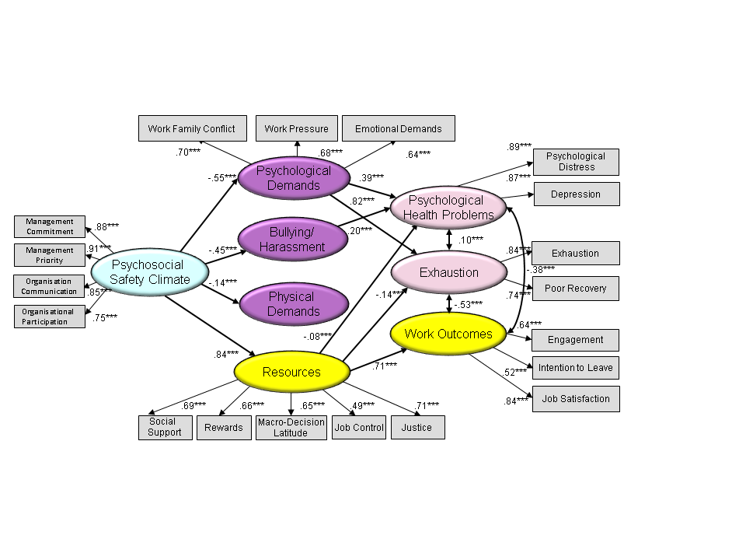

Figure 4. Full Study Model

The final simplified model is shown in Figure 5. As shown in Table 3, the fit indices of the study model M1 ranged from acceptable to good on the fit indices; although the chi-square test was significant this is not unusual with a large sample size. Taken together the fit indices suggest that we can accept the proposed model. For additional details of the analysis refer  
to Appendix C.

As shown in Figure 4, PSC is significantly related to demands (all negative relationships), and to resources (positive relationship). For example the relationship between PSC and psychological demands is Beta = -.55, *p* < .001.

The most important demands as determined by their relationship to psychological health problems and exhaustion are:

* Work-family conflict
* Work pressure
* Emotional demands, and
* Bullying and harassment.

The most important resources as determined by their relationship to psychological health, exhaustion and engagement are:

* Justice
* Social Support
* Organisational rewards, and
* Macro-decision latitude.

### PSC as a predictor of job demands and health outcomes

“PSC is significantly related to all demands (negatively), resources (positively), psychological health problems and exhaustion (negatively) and productivity (positively) outcomes.”

Returning to the importance of PSC we formally tested the hypotheses to consider the indirect (mediated) effects of PSC on health problems and work outcomes. In support of Hypothesis 1 that PSC is indirectly negatively related to psychological health problems and exhaustion through its negative relationship with job demands (H1) we found a significant indirect relationship between PSC and psychological health problems (Beta = -.30, *p* < .01), and exhaustion (Beta = -.44, *p* < .01). In other words PSC affects job demands that in turn carry this effect to psychological health problems and exhaustion.

In support of Hypothesis 3 that PSC is indirectly negatively related to psychological health problems and exhaustion through its positive relationship with job resources, we found a significant indirect relationship between PSC and psychological health problems (Beta = -.12, *p* < .01), and exhaustion (Beta = -.17, *p* < .01). As expected these relationships are not as strong as when demands are the mediator.

Table 4 reports the total indirect effects of PSC via both demands and resources incorporating the 90 per cent confidence interval using a bias corrected percentile method. The standardised indirect (mediated) effect of PSC on psychological health problems is -.30. In other words, due to the indirect (mediated) effect of PSC on depression and distress, when PSC goes up by 1 standard deviation, depression and distress goes down by 0.30 standard deviations; exhaustion goes down by .44 standard deviations. Another way of considering this is a 10 per cent increase in PSC would lead to a 3 per cent decrease in depression and distress, and a 4.4 per cent decrease in exhaustion.

Table 4. Indirect (Mediated) Effects of PSC on Outcomes

|  |  |  |  |  |
| --- | --- | --- | --- | --- |
|  | Beta | *p* | 90% Confidence Interval | |
| Lower Bound | Upper Bound |
| PSC 🡪 Psychological health problems | -.30 | .01 | -.33 | -.27 |
| PSC 🡪 Exhaustion | -.44 | .01 | -.47 | -.41 |
| PSC🡪Work Outcomes | .59 | .01 | .57 | .61 |

In support of Hypothesis 2, we found that PSC has a positive effect on work engagement through its positive relationship with job resources. As shown in Table 4, the standardised indirect (mediated) effect of PSC on work outcomes is .59. In other words, due to the indirect (mediated) effect of PSC on work outcomes, when PSC goes up by 1 standard deviation, work outcomes goes up by 0.59 standard deviations. A ten per cent increase in PSC would lead to a 6 per cent increase in engagement.

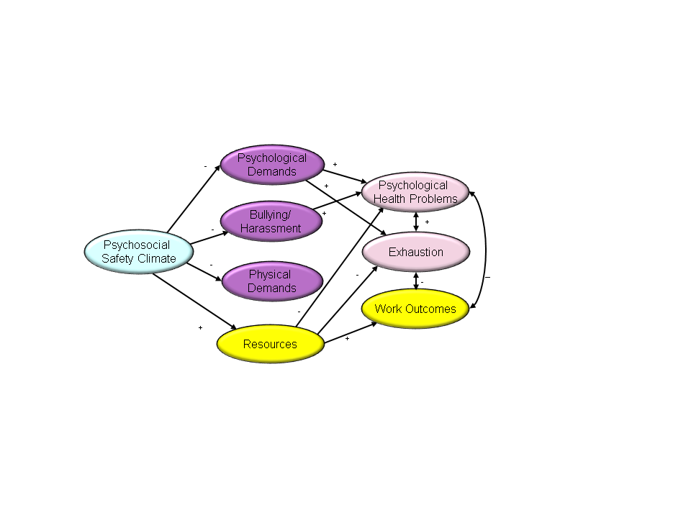Figure 5. Final AWB Model

Overall the model explained 30 per cent of the variance in psychological health problems. In other words, it is estimated that the predictors of psychological health problems explain 30 per cent of the variability in participant scores. We found that the model explained 75 per cent of the variance in exhaustion, and 50 per cent of the variance in work outcomes.

Results show that a 10 per cent increase in PSC within organisations would lead to a 4 per cent decrease in demands, a 4.5 per cent decrease in bullying, an 8 per cent increase in resources. These results strongly suggest that PSC is theoretically a logical upstream target for injury prevention as it is an antecedent for demands and resources *as well as* health and productivity outcomes.

This model is based on cross-sectional data, so causal conclusions cannot be drawn about the direction of the relationships. However the results are consistent with our theoretical framework, as well as empirical evidence drawn from longitudinal studies that support PSC as the genesis of work conditions (Dollard & Bakker, 2010; Dollard et al., 2012) and stress reactions (Dollard, 2012).

Taken together the results indicate that the study model is a plausible representation of how PSC is associated with work conditions that in turn relate to health and work outcomes, in the Australian working population.

### PSC by industry by state

*“Results for Australia show that many industries fall below the 2009-10 benchmark of 41 where workplaces support practices and processes that actively promote positive employee health and wellbeing.”*

In order to identify industries at risk benchmarks for PSC were developed from the AWB data deriving an average value of PSC as rated by individuals with no levels of clinical depression (PSC for individuals with mild, moderate or higher clinical levels of depression were excluded). This yielded a value of 41.16, which was rounded to the nearest whole number, 41, for a benchmark. PSC was further examined with longitudinal data for NSW and WA in a mediational model using regression following four steps suggested by Baron and Kenny (1986) with a further step to assess the indirect effect via the Sobel test (Sobel, 1982).

The results show PSC at Time 1 (2009) for NSW and WA had a significant negative relationship with new depression at Time 2 (2010) through its relationship with job strain. Additional PSC benchmarks were then developed based on mean scores for workers with no symptoms of depression and low job strain as shown in Table 5. Moderate risk and low risk were determined using mean scores for clinical cut-off points for mild depressions and moderate to severe depression as well as high strain, active, passive and low strain jobs. See Bailey, Richards and Dollard (in review) for additional details.

Table 5. Level of risk for employee job strain and depression based on average organisational PSC scores

|  |  |
| --- | --- |
| Level of Risk | 2009-10 PSC benchmark |
| Low Risk | 41.00 or above |
| Moderate Risk | 37.00 to 40.99 |
| High Risk | 36.99 or below |

In sum, these benchmarks were cross validated using three separate AWB samples including NSW and WA at Time 1 (2009) and Time 2 (2010) as well as SA data. The results support a 2009-10 PSC benchmark of 41 and below this cut-off indicates industries, occupations or worksites at more risk for job stress and poor health outcomes.

Next we assessed PSC standards within industries across the nation. Industries in the AWB were categorised according to the Australian and New Zealand Standard Industrial Classification (Castles & Cook, 1993): 17 broad industries were included in the survey. Any industry with an N of less than 10 was excluded from the figures as to avoid misrepresenting the data due to small sample size in some industries tested. The following results suggest specific yet coordinated state and national strategies are needed to improve working environments and reduce risk of psychological harm to employees.

|  |  |
| --- | --- |
| **Australia** | |
| **Moderate PSC** | **High PSC** |
| * **Education** * **Government administration and defence** * **Health and community services** * **Communications services** * **Cultural and recreation services** * **Accommodation, cafes and restaurants** * **Personal and other services** * **Property and business services** * **Agriculture, forestry and fishing** * **Manufacturing** * **Transport and storage** | * **Construction** * **Finance and insurance** * **Electricity, gas and water supply** * **Mining** * **Retail trade** * **Wholesale trade** |

Note: NSW Time 1 (2009) and WA Time 1 (2009) data was used for national PSC.

Figure 6****. Psychosocial Safety Climate in Australia****

Overall results for Australia show that there are no industries with PSC levels in the high risk range below 37. PSC levels for the majority of Australian industries fall in the moderate risk range suggesting that these industries would be experiencing unfavourable levels of psychosocial risk including job strain, potentially leading to poorer health and productivity outcomes.

|  |  |
| --- | --- |
| **South Australia (2010)** | |
| **Moderate PSC** | **High PSC** |
| * **Communications services** * **Accommodation, cafes and restaurants** * **Personal and other services** * **Property and business services** * **Construction** * **Agriculture, forestry and fishing** * **Retail trade** * **Finance and insurance** * **Manufacturing** * **Transport and storage** | * **Government administration and defence** * **Cultural and recreation services** * **Health and community services** * **Education** * **Electricity, gas and water supply** * **Mining** * **Wholesale trade** |

Figure 7. Psychosocial Safety Climate in South Australia

In SA none of the industries reported PSC scores wihtin the high risk range (37) with many industries scoring above the 2009-10 PSC benchmark of 41. The majority reported scores within the moderate risk zone. It was noted that Mining in SA scored the highest levels for PSC when compared at a national level.

|  |  |  |
| --- | --- | --- |
| **Western Australia (2010)** | | |
| **Low PSC** | **Moderate PSC** | **High PSC** |
| * **Transport and storage** | * **Cultural and recreation services** * **Accommodation, cafes and restaurants** * **Wholesale trade** * **Retail trade** * **Education** * **Government administration and defence** * **Health and community services** | * **Electricity, gas and water supply** * **Communications services** * **Construction** * **Property and business services** * **Mining** * **Manufacturing** * **Agriculture, forestry and fishing** * **Personal and other services** * **Finance and insurance** |

Figure 8****. Psychosocial Safety Climate in Western Australia (2010)****

For WA Transport and storage reported a PSC below 37 indicating high psychosocial risk to these workers that can lead to job strain and depression. It was noted that the majority of industries reported PSC levels higher than the 2009-10 PSC benchmark (41) suggesting organisations and management within these idustries in WA value and protect worker mental health.

|  |  |  |
| --- | --- | --- |
| **New South Wales (2010)** | | |
| **Low PSC** | **Moderate PSC** | **High PSC** |
| * **Transport and storage** * **Wholesale trade** | * **Electricity, gas and water supply** * **Accommodation, cafes and restaurants** * **Cultural and recreation services** * **Personal and other services** * **Property and business services** * **Health and community services** * **Mining** * **Construction** * **Agriculture, forestry and fishing** * **Retail trade** * **Education** * **Manufacturing** | * **Government administration and defence** * **Communications services** * **Finance and insurance** |

Figure 9. Psychosocial Safety Climate in New South Wales (2010)

The above results indicate levels of PSC in the high risk range for Transport and storage and Wholesale trade. Some industries reported levels of PSC above the 2009-10 benchmark (41) with the majority scoring within the moderate risk zone.

|  |  |
| --- | --- |
| **Australian Capital Territory (2011)** | |
| **Moderate PSC** | **High PSC** |
| * **Health and community services** * **Education** * **Government administration and defence** | * **Communications services** * **Personal and other services** * **Retail trade** |

Figure 10. Psychosocial Safety Climate in Australian Capital Territory

In the ACT industries were balanced in terms of PSC levels above and below 41. A number of industries did not have enough participants representing them to be included in these scores.

|  |  |  |
| --- | --- | --- |
| **Tasmania (2011)** | | |
| **Low PSC** | **Moderate PSC** | **High PSC** |
| * **Personal and other services** * **Transport and storage** * **Electricity, gas and water supply** * **Accommodation, cafes and restaurants** | * **Manufacturing** * **Education** * **Health and community services** | * **Retail trade** * **Government administration and defence** * **Construction** * **Property and business services** * **Agriculture, forestry and fishing** * **Finance and insurance** |

Figure 11. Psychosocial Safety Climate in Tasmania

For Tasmania a number of industries scored in the lower PSC threshold suggesting higher levels of risk of poor health and wellbeing for these workers. In contrast, many industries reported levels of PSC higher than the 2009-10 benchmark suggesting more positive outcomes for these workers. A few industries are not included due to having less than 10 respondents.

|  |  |
| --- | --- |
| **Northern Territory (2011)** | |
| **Low PSC** | **Moderate PSC** |
| * **Health and community services** | * **Education** * **Government administration and defence** |

Figure 12. Psychosocial Safety Climate in the Northern Territory

Last, in the NT Health and community services fell below the lower PSC benchmark of 37 with no industries reporting PSC levels above the 2009-10 benchmark of 41. Many industries could not be included due to low numbes of participants.

## High risk industries by demands, resources, and overall health

“There are three high risk industries across the nation; they are Transport and storage, Accommodation, cafes and restaurants and Health and community services and they require national strategies and campaigns for injury prevention and interventions.”

As psychosocial work conditions are often a function of job design and industry, it is likely that levels of psychosocial risks and hazards may fluctuate as a function of occupation and/or industry. By having an in-depth understanding of the unique characteristics of each industry type, researchers and organisational representatives will be better equipped to design tailored interventions to address psychosocial working conditions and to develop relevant best practice guidelines to maximise mental health outcomes for workers.

Previous research has indicated that the experience of mental health concerns in the workplace differs according to industry, occupation and/or employment level (Bültmann, Kant, van Amelsvoort, Van Den Brandt, & Kasl, 2001; Marchand, 2007; Niedhammer, Goldberg, Leclerc, Bugel, & David, 1998; Weiclaw, Agerbo, Mortensen, & Bonde, 2005). Caring, health care, manufacturing, wholesale trade and transportation industries have been identified as industries at higher risk of poorer mental health than the average working population, however unanimous support for which industries are the riskiest has not been demonstrated in the literature (Marchand, 2007; Weiclaw, et al., 2005).

We conducted an analysis of risk looking closer at demands, resources and health. This was conducted across all six states and territories, and further divided by industry. To identify industries at risk overall, scores were generated by combining the z-scores of individual measures to provide a composite score for each of job demands, job resources, and overall health. Job demands have been reverse coded so that high scores reflect lower levels of job demands, hence the key is relabelled to ‘low demands’. This permits easy interpretation of the bar graphs as higher levels of each of the three measures indicates favourable working conditions. Job demands were computed using total z-scores for harassment, bullying, organisational change, and work-family conflict, as well as work pressure, physical, and emotional demands. Job resources were comprised of skill discretion, decision authority, organisational rewards, as well as both supervisor and co-worker social support. Overall health was derived from the five health outcome measures, namely emotional exhaustion, psychological distress, depression, recovery and physical health.

The following graphs display mean composite scores for job demands, job resources and overall health for all 17 industries by state. Graphs for the smaller states do not report these composite scores for some industries, as industries with fewer than 10 participants were excluded (strong conclusions cannot be drawn on the generalisability of small samples). Favourable and unfavourable classifications have been marked on each graph based on a standardised bell curve used commonly in statistics (with 68 per cent of the population lying within the average of one standard deviation above and below the mean). For ease of reference, all standardised scores have been set about a mean of 100, with a standard deviation of 15 above and below the mean. Any demand, resource or health score falling greater than a single standard deviation either side (less than 85, or more than 115) is considered either a favourable or unfavourable situation in that industry. Based on this, industries at risk have been highlighted in red. Identification of industries at risk was made using the following criteria:

1. not a single measure of demands, resources or health in the favourable zone, and
2. at least one of these measures falling in the unfavourable zone.

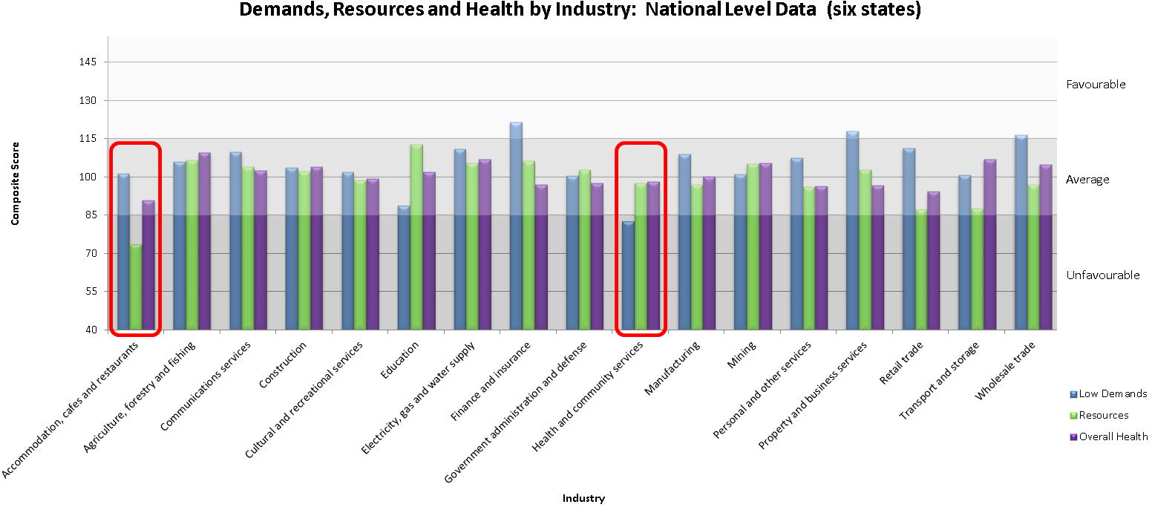

*Note: Job demands have been recoded so that high scores reflect favourable working conditions across all measures. Time 1 (2009) data for NSW and WA was used for this analysis.*

Figure 13. High risk industries for Australia 2009 – 2011

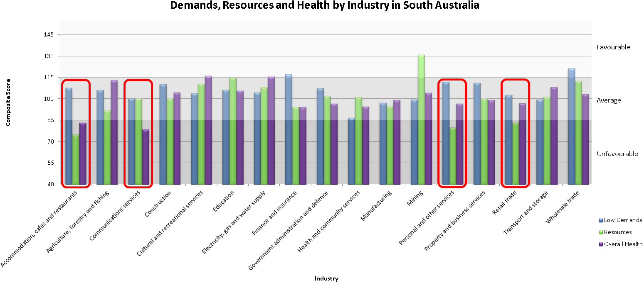

*Note: Job demands have been recoded so that high scores reflect favourable working conditions across all measures.*

Figure 14. High risk industries for SA (2010)

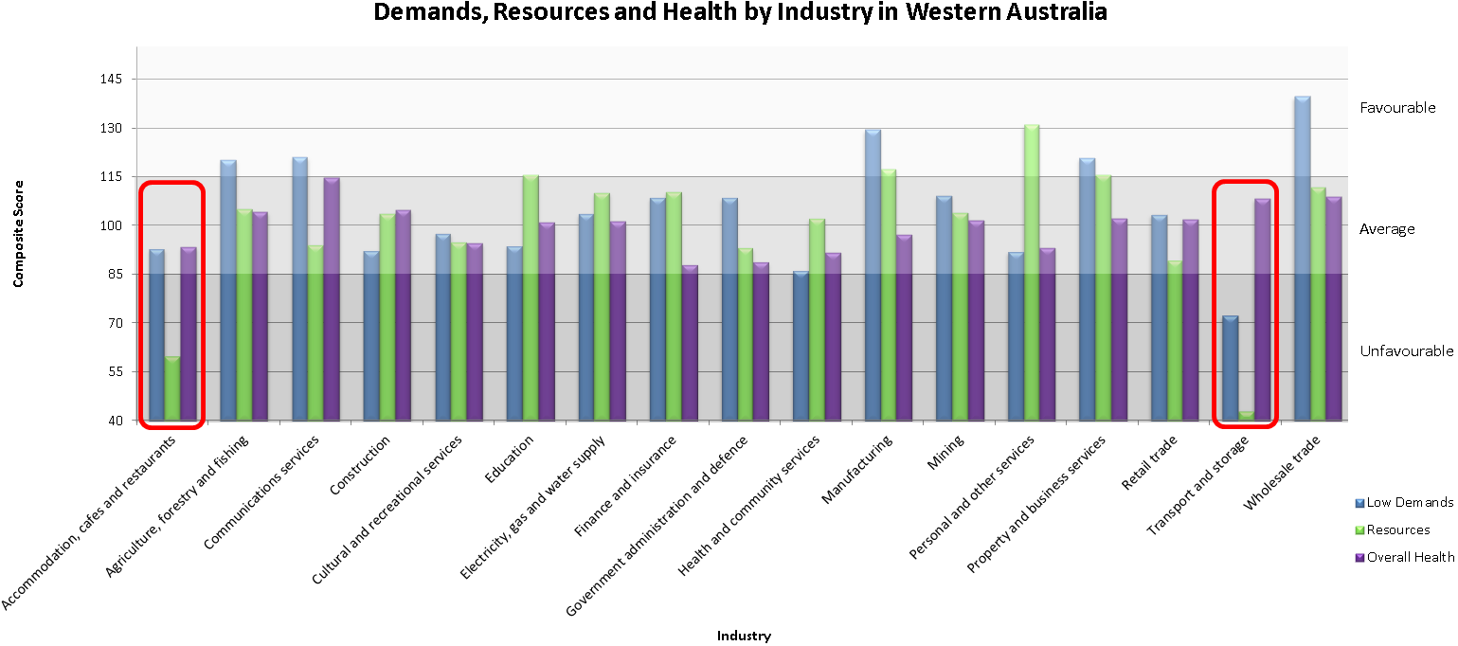

*Note: Job demands have been recoded so that high scores reflect favourable working conditions across all measures.*

Figure 15. High risk industries for WA Time 2 (2010)

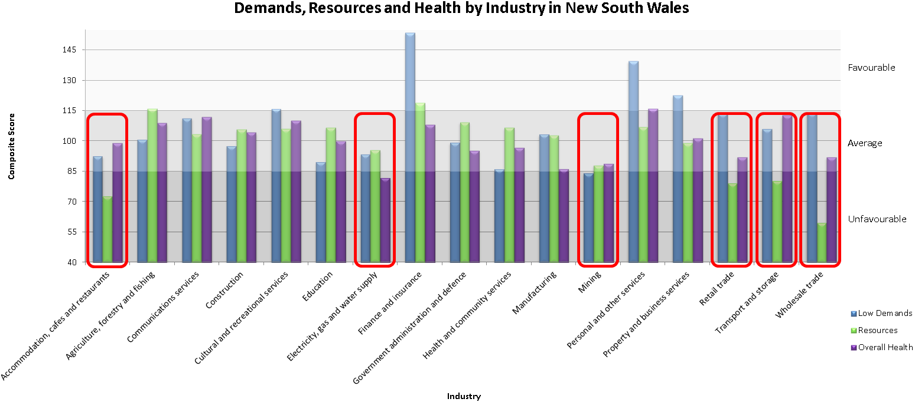

*Note: Job demands have been recoded so that high scores reflect favourable working conditions across all measures.*

Figure 16. High risk industries for NSW Time 2 (2010)

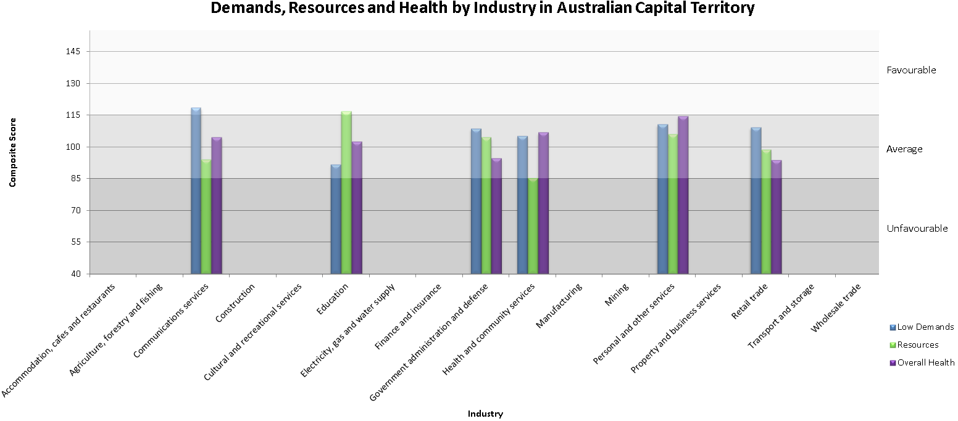

*Note: Job demands have been recoded so that high scores reflect favourable working conditions across all measures.*

Figure 17. High risk industries for ACT (2011)

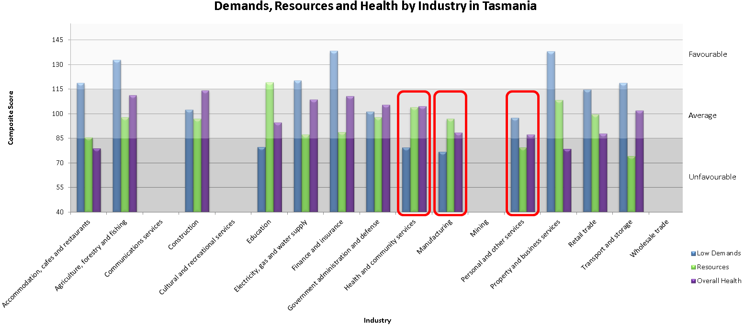

*Note: Job demands have been recoded so that high scores reflect favourable working conditions across all measures.*

Figure 18. High risk industries for Tasmania (2011)

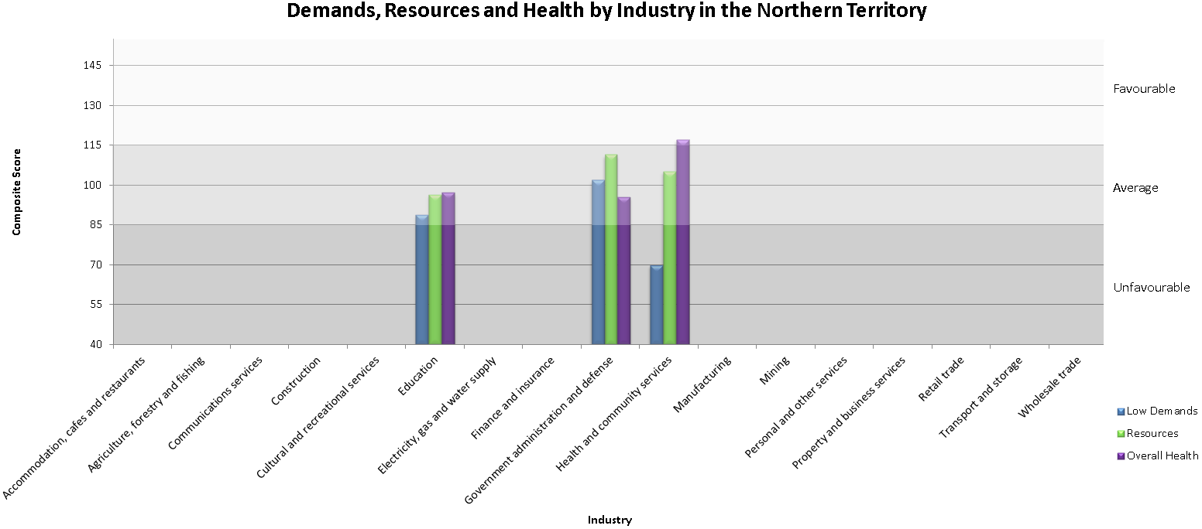

*Note: Job demands have been recoded so that high scores reflect favourable working conditions across all measures*

Figure 19. High risk industries for NT (2011)

*.*

### **Summary for industries at risk based on PSC, demands, resources and outcomes**

Several patterns emerge in the data when taking these results together with those previously presented regarding industry PSC levels. For workers in SA each of the high risk industries (Accommodation, cafes and restaurants; Communications services; Personal and other services; Retail) also showed PSC levels below the 2009-10 benchmark of 41 (See Figure 7). Poor psychosocial conditions and PSC results suggest state based strategies are needed to address a range of risk factors in these industries.

Results for WA show that industries identified as high risk (Accommodation, cafes and restaurants and Transport and storage) also found to have levels of PSC lower than the 2009-10 benchmark score of 41 (See Figure 8) suggesting a need for state based strategies to address psychosocial risk factors in these industries. Similar to WA, in NSW Accommodation, cafes and restaurants; Retail; Transport and storage industries showed unfavourable demands, resources or outcomes scores as well as PSC scores below the 2009-10 PSC benchmark of 41 (see Figure 9). In addition Health and community services, Mining, and Retail also showed PSC levels below 41. In particular the Transport and storage and Wholesale industries displayed PSC scores in the high risk range and therefore require urgent attention to address psychosocial risk factors for these workers.

In the ACT, excluding industries with less than 10 representatives, none of the industries showed unfavourable demands, resources and health outcomes. Several industries showed a PSC score below the national benchmark of 41 (see Figure 10), including Health and community services, Government administration and defence, and Education. In particular, Health and community services reported low levels of resources.

For workers in Tasmania, those identified in high risk industries (Health and community services; Manufacturing; Personal and other services) also reported PSC scores lower than the national standard of 41 (see Figure 11). Specifically, Personal and other services reported a PSC score below the lower bound benchmark of 37 indicating an urgent need for state based strategies to address psychosocial risk factors for this industry.

In the NT low numbers in a range of industries limited the identification of industries at risk. However Health and community services industry showed PSC levels (see Figure 12) in the lowest range as well as unfavourable demands (high levels of demands).

The above graphs show differences between industries *within* each state, this does not necessarily represent significant differences in overall risk between states, therefore state to state comparisons should not be made based solely on this information. The above information was developed with the intention of identifying industries at risk to provide an evidence base for state and national strategies targeting worker health.

### **Practical implications for industries at risk**

The above outcomes provide evidence that state based interventions are needed for specific industries at risk in each state, due to the wide variation in industries at risk between most states and territories. Strategies for improving overall health in industries with high demands may include increasing (or further increasing) PSC and job resources (such as organisational reward, supervisor and co-worker support), a process which has been demonstrated to buffer the effects of high job demands on poor overall health (Bakker, Demerouti, & Euwema, 2005; Xanthopoulou et al., 2007; Dollard & Bakker, 2010; Law et al., 2011); or lowering job demands (such as reducing hard and fast paced work, actual workload, bullying, emotional and physical demands).

The results also further suggest that a national initiative focusing on industries that show high levels of risk and low PSC across a number of states. For instance Transport and storage shows consistently low levels of PSC recorded by workers in this industry in NSW, WA and Tas as well as unfavourable psychosocial risk levels in NSW, WA in addition to Safe Work Australia statistics (Safe Work Australia, 2011), showing high levels of serious injuries for these workers. National initiatives may also need to focus on the Accommodation, cafes and restaurants industry which recorded PSC levels below the 2009-10 benchmark across most states and was identified having unfavourable psychosocial risk levels at the national level, as well as state level for NSW, WA and SA. In addition, the Health and community services industry shows poor psychosocial conditions at the national level NSW and Tas as well as PSC scores below the 2009-10 benchmark (41) for most states. Further investigations at the national level are warranted for the Health and community services industry. See Appendix B for additional comparisons between larger and smaller states.

## Urban and rural workers’ mental health

“Urban workers report marginally higher psychological demands compared to rural workers whereas rural workers report more physical demands and work-family conflict and are more at risk for poorer mental and physical health outcomes suggesting additional resources and awareness for rural workers are important.”

Research into psychosocial risk factors is predominantly conducted in urban settings (Kang, Staniford, Dollard, & Kompier, 2008). Australia has a heavily urbanised workforce. In 2005, 88 per cent of Australia’s population lived in urban areas, which is roughly 8 per cent more than the US (Danaher, 2010). Despite the smaller numbers of rural workers, concerns have been raised about the mental health of those that work in rural enterprises or services. In this section we examined urban and rural variations in worker demands, resources, health, and engagement outcomes, and investigated the common belief that rural workers are at a higher risk of stress at work than urban workers – we call this the disparity hypothesis.

Most mental health research into rural and urban comparisons has investigated depression prevalence. The international research provides conflicting results. Several studies show a greater prevalence of depression in rural areas (Mechakra-Tahiri, Zunzunegui, Préville & Dubé, 2009; Mumford, Minhas, Akhtar, Akhter & Mubbashar, 2000), several find greater prevalence in urban areas (Mueller, 1981; Walters, Breeze, Wilkinson, Price, Bulpitt, & Fletcher, 2004; Wang, 2004), but most find no significant differences between either (Blazer, Kessler, McGonagle, & Swartz, 1994; Caldwell, Jorm, & Dear, 2004; Kim, Shin, Yoon, & Stewart, 2002; Parikh, Wasylenki, Goering & Wong, 1996; Probst et al., 2006; Sears, Urizar, & Evans, 2000). As it stands the effects of a community urbanisation on workplace factors and worker health has gone largely unexplored. The following significant differences were established using AWB data:

Demands

* urban workers reported marginally more work pressure
* rural workers reported moderately more physical demands, and
* rural workers reported moderately more work-family conflict.

Resources

* rural workers reported marginally more organisational rewards.

Outcomes

* rural workers reported marginally lower levels of recovery
* rural workers reported marginally more emotional exhaustion
* rural workers reported marginally more depression
* rural workers reported marginally more physical health problems, and
* rural workers reported marginally more engagement.

For the majority of workplace factors reviewed, there were few significant differences between urban and rural, work demands and resources. The most noticeable differences were that rural workers reported greater physical demands and work-family conflict.

A primary concern for people living in rural areas is that when they experience psychological health problems, their distance from city centres, disadvantages them when accessing support services. It could be argued that communication technology development (e.g. moving from dial-up to broadband and telecommunication technology development) has reduced the divide between urban and rural areas and in this regard there is likely greater connectivity between health care professionals. Another core concern is that rural Australians hold negative attitudes towards seeking professional help for physical (Elliot-Schmidt & Strong, 1997) and psychological illness (Komiti, Judd, & Jackson, 2006; Staniford, Dollard, & Guerin, 2009), and engage in more risk taking behaviour (AIHW, 2005). Together these factors may exacerbate work related negative health states.

Strategies could be undertaken by rural employers to address the higher psychosocial risks in rural workplaces. Increased social support can buffer conflicts between employee work and family life (Van Daalen, Willemsen, & Sanders, 2006) and this could be achieved by orchestrating workplace social activities. Rural employers need to be mindful of the higher levels of physical health problems in the workforce, which can lead to increased fatigue and poorer sleep quality (Åkerstedt, Fredlund, Gillberg, & Jannson, 2002; de Lange et al., 2009), and increase the risk of work incidents (Nakata et al., 2006). The higher prevalence of depression in rural workers is important considering the negative impact that depression has on workplace productivity (McTernan, Dollard & LaMontagne, in review) and the associated increased risk of suicide (Blair-West, Cantor, Mellsop, & Eyeson-Annan, 1999; Beck, Steer, Kovacs, & Garrison, 1985; Garlow et al., 2008; Kessler et al., 1999; Witte, Timmons, Fink, Smith, & Joiner, 2009). The improved productivity by reducing depression in the workplace could far out-weigh the costs of treatment according to Simon and colleagues (2001), and therefore strategies such as mental health first aid (Kitchener & Jorm, 2006) could be cost efficient for rural employers.

## Age

“Workers aged between 25 – 34 show the poorest psychological health, likely due to factors such as competing work and family demands as well as entering the workforce following study, working hard and using long hours to advance in their careers, and they experience low levels of skill discretion.”

The literature exploring the experience of older employees in the workforce largely focuses on health and productivity outcomes, whereas the literature examining the experience of the younger generations of employees is largely focused on motivational outcomes and job performance. In terms of both engagement and overall wellbeing, younger workers seem to respond well to career advancement opportunities, professional development and challenging assignments, while older workers seem to benefit from increased autonomy, flexibility and task specialisation (Kim, Knight, & Crutsinger, 2009; Leka & Jain, 2010; Shultz, Wang, Crimmins, & Fisher, 2010). The needs of older people in the workplace clearly differ from younger workers.

### Results from the AWB

* The experience of job demands, job resources and their relationship with health and motivational outcomes differ across age groups.
* Workers who remain in the workforce beyond the age of retirement (aged 65 and over) experience low levels of job demands, high levels of job resources and positive health outcomes.
* For older workers (65+) work pressure was strongly related to poor psychological health and decision authority was strongly related to engagement.
* Workers aged 25 – 34 had the poorest psychological health overall, however this was not strongly associated with job demands and resources.
* Workers in the youngest age group (18 – 24) experienced the lowest levels of engagement.
* Engagement was strongly associated with PSC and skill discretion for workers in the youngest age group.

In older workers, since work pressure (such as ‘working hard and fast’) is strongly associated with poor psychological health, and decision authority is strongly related to engagement, results from the AWB support an increased focus on providing older workers with roles suited to their skill set and experience, that are high in autonomy and flexibility.

In younger workers, PSC and skill discretion are strongly related to engagement. Results from the AWB data advocate for an increased focus on high levels of PSC for younger workers. For example, we could reasonably expect an increase in organisational PSC will lead to an increase in both skill discretion and engagement in workers aged 18 – 24 due to its relationship with job demands and resources. Consequently, interventions targeting psychosocial safety climate within organisations that have a strong representation of younger workers (such as retail trade) will likely also result in increased tenure, and lower turnover.

Workers in the early stages of career development, aged 18 – 34, are innovative, have up-to-date knowledge and are fresh, yet are a high-risk group for the development of workplace stress and mental health concerns, and accordingly require a positive workplace environment, increased psychosocial safety climate and increased resources and support to manage job demands. Conversely, workers who remain in the workforce post retirement age are experienced and knowledgeable, with skills and experience that are likely assets to the organisation. Retaining such workers in a positive working environment should be of utmost importance to employers, and the working population.

## Bullying and harassment

“There is a serious concern regarding levels of bullying and harassment. Results from the AWB show that levels of bullying are at 6.8 per cent, which are substantially higher than international rates.”

Workplace bullying and harassment is well-known to be an ongoing issue for organisations and communities both in Australia and around the world. The impact of workplace bullying on individual and organisational outcomes is evident with increases in mental stress compensation claims as well as changes in legislation and codes of practice that highlight the important influence bullying and harassment has over worker health and wellbeing. All work health and safety laws in Australia recognise workplace bullying as a work health and safety issue with the responsibility to prevent workplace bullying covered by the primary duty of care held by employers. Harassment is generally covered by state based anti-discrimination legislation. Although some differences in legislation exist between each Australian state, in general bullying is defined as “*repeated, unreasonable behaviour directed towards a worker or a group of workers, that creates a risk to health and safety*” (Australian Government Productivity Commission, 2010, p.288). Regrettably, research shows that many issues still exist in relation to addressing bullying and harassment in the workplace such as problems with enforcing codes of practice, witness fear of victimisation, issues with the law, and inadequate resources and training (Johnstone, Quinlan, & McNamara, 2011).

Regardless of the importance placed on recognising and addressing workplace bullying and harassment, there is limited data on actual prevalence rates in Australian workplaces. Measures of bullying and harassment vary widely making international comparisons difficult to interpret. In an overview of international perspectives by Zapf and colleagues (Zapf, Einarsen, Hoel, & Vartia, 2003) the research showed that when participants are presented with a precise definition, similar to the AWB, this results largely in small prevalence rates of 1 to 4 per cent. In studies that ask more generally “have you been bullied during the last 6 months” without providing a definition, higher rates are noted, between 10 to 25 per cent. In Australia, prevalence statistics vary greatly, generally ranging from 3.5 to 21.5 per cent of the population reporting that they experience bullying and harassment at work.

Participants in the AWB project were provided with the following definition of bullying:

“Bullying is a problem at some work-places and for some workers. To label something, as bullying, the offensive behaviour has to occur repeatedly over a period of time, and the person confronted has to experience difficulties defending him or herself. The behaviour is not bullying if two parties of approximate equal “strength” are in conflict or the incident is an isolated event.” (Lindström et al., 2000; Dollard et al., 2009)

Based on the above definition results from the AWB data show that 6.8 per cent of respondents experienced bullying in the last six months. Of this 6.8 per cent it was found that approximately half (3.5 per cent of the total sample) also reported experiencing bullying for longer than a 6 month period. Females reported significantly higher levels of overall bullying and stated that they experienced bullying for significantly longer periods of time.

Notably, our measures did not account for people who witnessed bullying or those who were bullied by co-workers of equal power. The AWB bullying questions are based on a Nordic tool that provides a definition stating that bullying can only occur if it is between parties of different strength and the victim experienced difficulties defending themselves. This restriction of what *bullying* specifically entails may have limited participant responses and may not be capturing all potential risks involved with bullying such as trauma experienced by witnesses and instances where people felt capable of defending themselves. Therefore, we caution that these figures should be considered a conservative estimate.

In relation to harassment, specific questions were asked to gauge the particular types of harassment experienced by participants at some stage in their workplace. The results showed that females reported experiencing significantly more unwanted sexual advances, humiliation, and unfair treatment due to gender, than men. Alternatively, men reported significantly higher rates of physical violence and being yelled at or sworn at than women. No significant differences were found between the Australian states for most bullying and harassment items, although a small difference was found showing NSW participants reported marginally higher levels of humiliation in front of others than WA respondents.

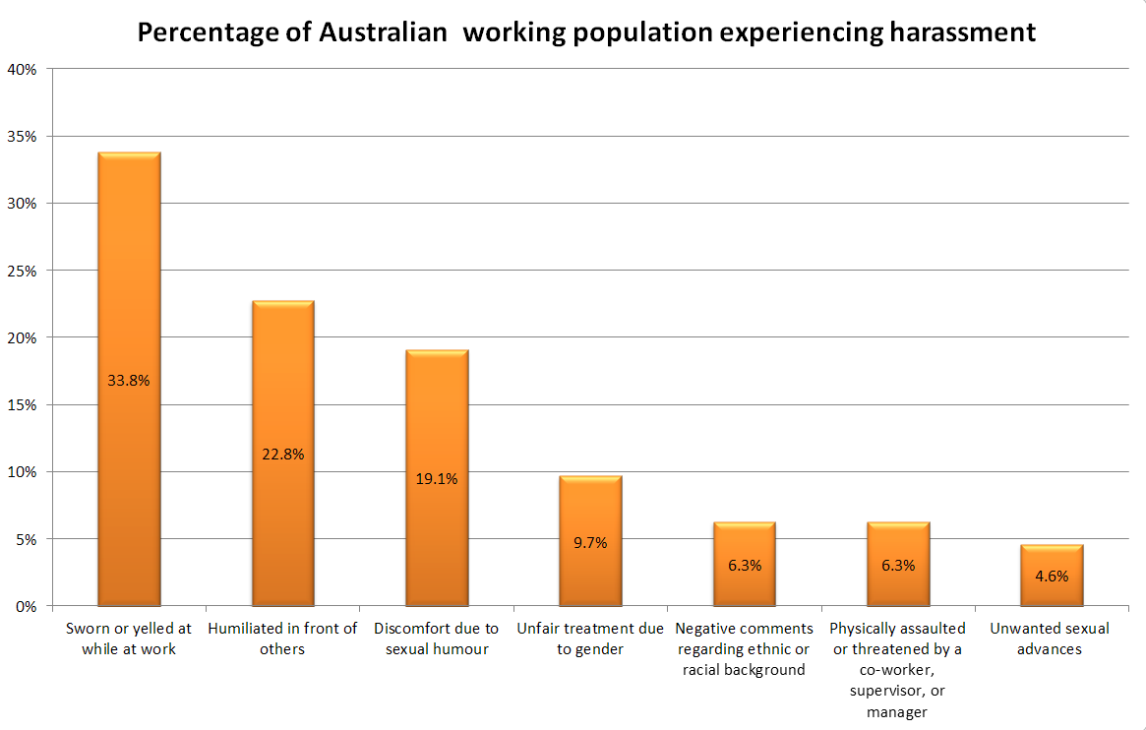

Figure 20. Percentages of harassment for AWB sample population

“Females report significantly higher levels of overall sexual harassment and bullying and experience bullying for significantly longer periods of time than men.”

Since harassment shows one of the strongest relationships to psychological health, the AWB results suggest that continued efforts must be made in order to protect women from sexual harassment and bullying and to promote equality in the workplace. There is also a substantial need to promote better practices to protect men including reduced sexual based humour and to discourage swearing or yelling. All employees would benefit from safe work practices that specifically focus on creating a healthier working environment where sexual harassment, gender based bias, sexual humour, swearing and yelling is considered not acceptable or appropriate workplace behavior. Given their impact, harassment behaviour should be high priority for better health outcomes and reduced psychosocial risk at work.

## Work-family conflict

“Work-family conflict is one of the major contributors to poor worker health and wellbeing.”

As a consequence of globalisation there is an increased pressure to perform in the workplace. Workers are laboring for longer hours, there are increased concerns regarding job security, and an unwanted pressure to manage the competing demands of work and life (Geurts & Demerouti, 2003). Work-family conflict (WFC) is one of the most researched constructs in the work-life balance literature and has been strongly linked to work domain factors as well as poor psychological health outcomes (Canivet et al., 2010; Geurts & Demerouti, 2003; Jianwei & Yuxin, 2011). Work-family conflict occurs when the demands of a person’s role adversely impacts on their ability to adequately fulfil their role as part of their family (e.g. parent, spouse, child, carer, etc.) (Geurts & Demerouti, 2003; Kattenbach, Demerouti, & Nachreiner, 2010; Leka & Jain, 2010). Consequences of WFC include work and family stress (Grandey & Cropanzano, 1999), burnout and psychological strain (Frone, Russell, & Cooper, 1997; Geurts & Demerouti, 2003; Hall, Dollard, Tuckey, Winefield, & Thompson, 2010; Jianwei & Yuxin, 2011; Leka & Jain, 2010), and reduced performance at work (Geurts & Demerouti, 2003; Grandey & Cropanzano, 1999). Accordingly, WFC comes at a cost to individuals, families, and employers (Skinner & Pocock, 2011) and therefore warrants intervention.

Results from the AWB relating to WFC in Australia were explored and interpreted in the light of previous research. Results indicate:

* WFC had a strong association with poor psychological health and general physical health
* WFC was most strongly correlated with emotional demands, work pressure, organisational harassment and PSC
* greater levels of WFC were reported by men, although there was no significant difference between men and women in the strength of the relationship between WFC and poor psychological health, i.e. WFC affects psychological wellbeing of workers similarly for both genders
* WFC was highest in middle aged workers
* the relationship between WFC and poor psychological health was strongest for the oldest (65+) and youngest (18-24) workers, and
* levels of WFC were highest in the Mining, and Transport and storage industries.

Assessment of risk factors for WFC in the AWB sample indicated that WFC was highest in workers who were male, between 35 and 54 years of age, had two or more children, worked more than 40 hours per week, were employed full-time, and worked day or rotating shifts. High levels of all risk factors were particularly evident in the Mining and Transport and storage industries, which had the highest levels of WFC. These risk factors were congruent with existing research (Barnett, 1998; Frone et al., 1997; Geurts & Demerouti, 2003; Jianwei & Yuxin, 2011).

The job demands most strongly associated with WFC included work pressure, emotional demands, harassment and PSC. This is congruent with previous research linking workplace psychosocial demands to the development of WFC (Geurts & Demerouti, 2003; Jianwei & Yuxin, 2011). Interventions beyond the implementation of flexible work environments to improve work-family conflict could therefore be directed at reducing harassment (team building), reducing emotional demands (one-to-one supervision and debriefing), reducing work pressure (appropriate management of workload and deadlines) and increasing overall PSC. Organisational interventions aimed at improving WFC should consider targeting PSC, which would focus on improving policies, practices and procedures within the organisation that eventually affect psychological health. For example, an environment high in PSC would ensure flexible workplace policies were in place and workers felt confident that they would be supported by their managers to utilise these procedures so that WFC was reduced for employees.

As WFC is related to poor psychological and physical health, it is crucial that employers consider this demand as having a serious impact on worker wellbeing and hence productivity, which may result in increased costs to employers via increased staff turnover, sickness absenteeism and workers’ compensation claims. WFC is a workplace issue that warrants intervention in order to reduce organisational costs and increase worker wellbeing and PSC should be considered as an appropriate target for intervention.

### Working hours

*“A major issue in the workplace is that 40 per cent of Australian workers are working more than the national standard of 38 hours and 18 per cent work longer than 48 hours per week.”*

The *Fair Work Act 2009* states that employees are to work a maximum of 38 hours per work unless a request of additional hours is reasonable. Data from the Organisation for Economic Cooperation and Development (OECD; 2011) shows that full-time employees in Australia are working on average 42.6 hours per week (see Figure 21). This places Australia as the fifth highest country for average working hours.

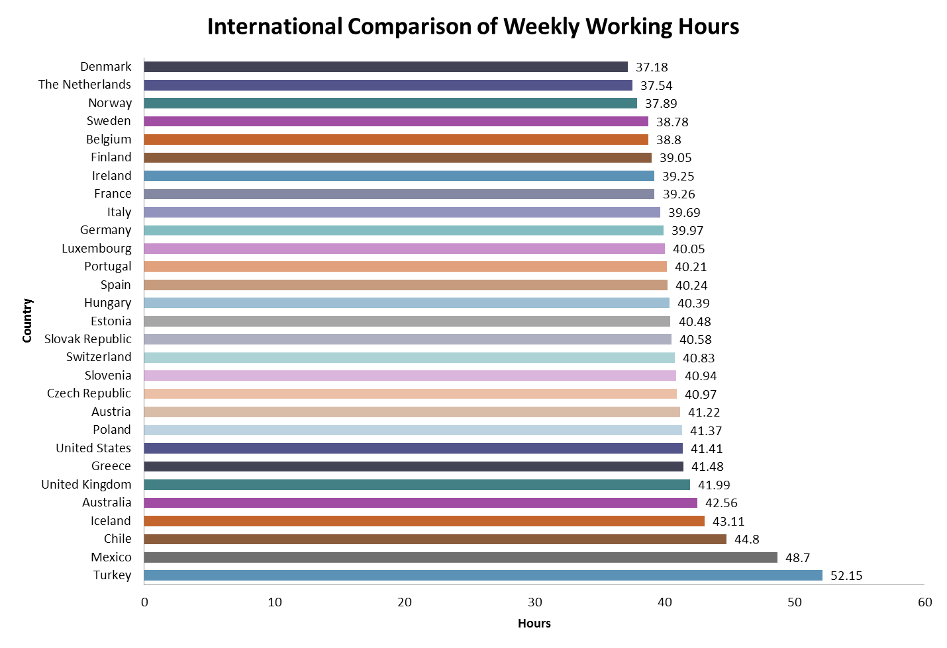

Figure 21. Average weekly working hours by country.

AWB data of 2171 full time employees reported an average of 39 hours with a median and mode of 40 hours per week. The following fraction of workers engaged in long working hours was based on the ILO benchmark for long work hours of 48+ hours and the ABS benchmark for long hours as 50+ hours.

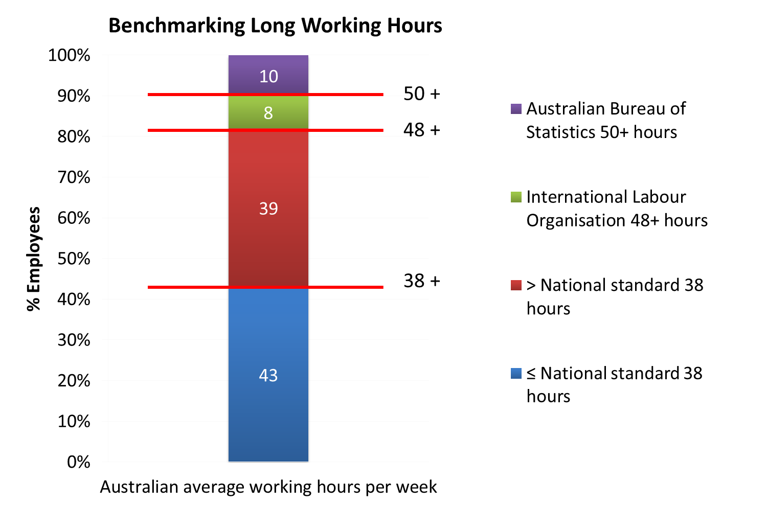

Figure 22. Long working hours defined by national standard, ILO and ABS.

Our sample suggests that 18 per cent of Australian full-time employees are working longer than the ILO benchmark of 48+ hours per work week and 10 per cent are working longer than the ABS benchmark of 50+ hours. This an important issue as working hours was an important factor contributing to WFC, which is consistently associated with poor health outcomes in this sample.

## Rates of health outcomes: Depression, distress, emotional exhaustion, general physical health

“For all workers, factors including PSC, emotional demands, work pressure, bullying, justice, rewards, and decision authority were significant contributors to poor psychological health, and prevention strategies should focus on addressing these aspects.”

There is an extensive evidence base which consistently demonstrates that psychosocial factors in the workplace, such as job demands and resources, impact on mental health as well as physical wellbeing (Bakker, Demerouti, & Euwema, 2005; Demerouti & Bakker, 2011; Demerouti, Nachreiner, Bakker, & Schaufeli, 2001; Häusser, Mojzisch, Niesel, & Schulz-Hardt, 2010; Law, Dollard, Tuckey, & Dormann, 2011; Leka & Jain, 2010; Purvanova & Muros, 2010; Xanthopoulou et al., 2007).

Prevalence rates of emotional exhaustion (burnout), psychological distress, depression and overall physical health for the AWB sample were examined and compared with ABS population statistics. ABS data reports that in 2010 there were approximately 10.2 million working Australians. Based on this figure results from the AWB participants were equated to a wider Australian working population estimating that approximately 4 million working Australians (39.15 per cent) scored in the two upper quartiles of emotional exhaustion. Further, approximately 500 000 (4.78 per cent) reported experiencing levels of psychological distress in the two upper quartiles.

The depression measure provides clinical indicators for levels of depression in the sample population. Results suggest that approximately:

* 1.7 million (16 per cent) workers in Australia experience mild levels of depression, and
* 562 000 (5.5 per cent) Australian workers experience symptoms of clinical depression ranging from moderate to severe.

For physical health results show 1.1 million workers in Australia reported in the poorest two quartiles (11.85 per cent). The prevalence of mental health problems was higher than the prevalence of general physical health issues.

Comparisons between health outcomes from the AWB with workforce statistics from ABS are problematic due to differences in definitions and scales used to measure mental health. However, it was noted that in the AWB sample of working Australians prevalence rates for clinical depression (5.5 per cent), as set by the PHQ-9 Spitzer, Kroenke, and Williams (1999), are similar to the prevalence rates for affective disorders (including depression) within the working population data reported by the ABS (2008). Rates of psychological distress (4.7 per cent) within the AWB working population were lower than the anxiety disorder rates (14.2 per cent; including distress) for the working population as found by the ABS (ABS, 2008). Again, these similarities and variations may be more reflective of differences in definitions and methods of data collection.

## The cost of employee productivity loss: Depression as a significant contributor

“A prominent finding is that the cost is mostly due to workers showing mild symptoms of depression taking twice as many sick days compared with those who show no symptoms of depression at all.”

Research has established that depression is linked to increased absenteeism rates (Laitinen-Krispijn & Bijl, 2000; Lim, Sanderson, & Andrews, 2000). For example Kessler and colleagues (1999) found in a US sample that depressed workers take 1.5 to 3.2 times as many short-term work-disability days (absent days and low productivity days) than non-depressed workers. In support of this finding, results extrapolated from longitudinal data within the AWB sample using NSW and WA Time 1 (2009) and Time 2 (2010) indicate that:

* severely depressed workers were nearly 6 per cent less productive at work (presenteeism) as mildly depressed workers, and
* severely depressed workers take nearly three times as many sick days as mildly depressed workers (McTernan, Dollard & LaMontagne, in review).

The study also estimated that depression costs Australian employers approximately AUD$8 billion annually because of sickness absence and presenteeism (that is being at work but not being fully productive for reasons such as illness, personal issues or distractions in the environment). Importantly the majority of dollars lost are due to employees who report only *mild* symptoms of depression, when compared to those reporting moderate to severe depression. Furthermore, the findings suggest that up to 8.66 per cent of that burden, AUD$693 million could be alleviated by eliminating workplace bullying and job strain.

* The estimated national burden to employers of depression related to bullying and job strain is AUD$693 million.
* Despite the more severe levels of depression leading to greater productivity loss per worker, the large number of mildly depressed workers (24 per cent, compared to 0.6 per cent severely depressed) represent the greater productivity cost.
* Participants with mild depression actually represent the greatest volume of the financial burden (61 per cent).

This information is crucial to intervention as employers may not be aware of the high costs associated with even mild levels of depression, and may also struggle to recognise or address these lower levels of depression in the workplace. Therefore there is a need to focus on known lead risk indicators of depression. In light of these findings, it is reasonable to suggest that a national intervention program aimed at reducing bullying and managing job strain will not only improve worker wellbeing but also reduce tangible costs and increase productivity outcomes in the workplace, benefiting both employers and the wider Australian community. Finally it is important to note when interpreting these findings that other negative outcomes from depression were not measured, such as tenure and turnover rates and the effect depressed worker’s behaviour may have on the productivity of co-workers; in other words the cost estimate is conservative.

## Estimating lost productivity costs of poor psychological health in the workplace

“Regardless of cause, the estimated cost of productivity loss for the most psychologically unhealthy 25 per cent of the Australian workforce was AUD$17.84 billion.”

The results from our report add to the growing evidence that other aspects of psychological health aside from depression, such as psychological distress and emotional exhaustion, affect productivity via presenteeism and absenteeism. The volume of available literature is limited however, and cost estimates have not been reviewed. Additionally, a variety of causes of poor mental health exist in the workplace with differing time-related exposure effects. To address this void we examined the collective end point of the problem: a combined index of poor mental health, and its relationship to productivity loss. This study considers that poor mental health has an impact at work, despite its origins. Psychological health *arising from all causes* is considered here.

To create the index, two additional psychological health outcomes were used in addition to depression. Psychological distress is a mental state that encompasses both depressive and anxiety symptoms (Kessler & Mroczek, 1994). Psychological distress has been found to relate to higher work and family life interference (Major, Klein, & Ehrhart, 2002), greater absence from work (Hardy, Woods & Wall, 2003) and specifically sickness absenteeism (Bültmann et al., 2005; Munir et al., 2007), and higher presenteeism (Munir et al., 2007).

Another form of poor psychological health, emotional exhaustion – a core component of burnout, encompasses physical and emotional fatigue that occurs in the workplace (Maslach, Schaufeli, & Leiter, 2001) was also used. High levels of emotional exhaustion have been linked to decreased job performance (Babakus, Cravens, Johnston, & Moncrief, 1999; Wright & Bonett, 1997; Wright & Cropanzano, 1998), an increased risk of job turnover (Babakus et al., 1999; Jackson, Schwab, & Schuler, 1986; Wright & Cropanzano, 1998), and negative attitudes towards work (Leiter & Maslach, 1988; Wolpin, Burke, & Greenglass, 1991).

Psychological distress, emotional exhaustion and depression were standardised, and then combined into a composite score that was divided into four quadrants. Quadrants were separated by the participants’ scores (the lowest scoring 25 per cent, the next lowest 25 per cent, the next highest 25 per cent and the highest 25 per cent), reflecting levels of psychological health. Means for each quadrant were then generated for sickness absence (days missed in the last month) and presenteeism scores (measured on a scale from 0-10 regarding how hard they felt they worked in the last month). This information was combined with national wage data (ABC Diamond, 2009) and national labour figures to estimate cost of sick days and presenteeism. Our findings showed:

* the least psychologically healthy workers (lowest quartile) had nearly 6 times as much sickness absence compared to the healthiest
* the annual productivity loss per worker through sickness absence and presenteeism was nearly double for the least psychologically healthy (AUD$15,050) compared to the healthiest (AUD$8,334)
* improving the psychological health of the most unhealthy 25 per cent to the levels of the 25 per cent most psychologically healthy, would save an estimated AUD$17.8 billion and
* the estimated cost of all other workers over the most psychologically healthy was AUD$32.2 billion.

The estimated cost of productivity loss for the most psychologically unhealthy 25 per cent of the Australian workforce was AUD$17.84 billion, which reflects the size of the burden that could be potentially reduced by improving the psychological health of Australian employees. The study goes further to see the cost that could be saved by potentially improving all worker psychological health levels to the top 25 per cent, which was an estimated AUD$32.18 billion. The present study therefore not only reflects the cost of poor health, but the cost-benefits of highly psychologically healthy workers.

As mentioned earlier there are additional costs that need to be considered that the present study does not encapsulate. In addition to lost productivity by the absence and presenteeism of an employee canvassed here, additional costs include recruitment, hiring, training and administration costs arising from job turnover. These costs would be significant as LaMontagne, Sanderson and Cocker (2010) found that turnover was the largest contributor (AUD$8.93 billion) of an estimated AUD$12.6 billion cost associated with depression in the workplace. There would also be additional knock on effects to co-worker productivity while replacements are found and trained. As none of these costs are included in our estimate, the overall cost could be considerably greater.

Regardless of the cause, work or non-work related, poor psychological health at work is an issue for the health of the organisation, as well as its revenue. This relationship was supported by previous literature and demonstrated in our findings (previous section), which showed considerable differences in productivity outcomes (sickness absence and presenteeism) between each level of psychological health.

Systematic reviews in the literature show a variety of interventions that are available to minimise psychosocial risks at work (Bambra, Egan, Thomas, Petticrew, & Whitehead, 2007; Bambra et al., 2009; Egan et al., 2007; LaMontagne, Keegel, Louie, Ostry, & Landsbergis, 2007). With various intervention strategies available, such as psychosocial risk assessment tools, employers stand to benefit from improving and promoting psychological wellbeing at work via assisting workers experiencing poor psychological health *from any cause*.

# Policy implications for intervention

“The results from this national surveillance project shifts attention away from lag indicators, such as compensation claims, and brings Australia up to international best practice standards for proactive psychosocial risk prevention and intervention policy by providing a science driven basis for improving working conditions and worker wellbeing.”

In summary, the AWB results confirm important relationships exist with psychosocial risk factors at work. The results also indicate that safe work strategies and workplace interventions will be most effective if directed at reducing emotional demands and work pressure, improving work-life balance, and proactively addressing bullying and harassment issues by promoting appropriate workplace behaviour. Organisations and employers will also benefit from addressing levels of organisational reward provided to employees by encouraging employers to consider the importance that respect, recognition, job security, and the opportunity for career development can have on improving employee productivity and wellbeing. These aspects are becoming increasingly important with growing trends towards casual, contract, and part-time employment and should therefore feature in Australian work health and safety strategy development.

Other influential factors include supervisor support, organisational justice, and increasing employee control concerning how they utilise their skills and ability to influence decision-making processes. Those at most risk such as workers aged 25 to 44, and employees in the Transport and storage and Accommodation, cafes and restaurants industries would benefit from specific and immediate national intervention. State based interventions are needed to target at risk industries that are particular to each state or territory.

Health outcomes for women would likely improve if provided with more control in their work as well as continuing efforts to reduce sexual harassment and improve gender equality. Men would likely benefit from more flexible working conditions and increased work-life balance as well as the promotion of positive working environments where sexual humour, swearing and yelling are not considered an acceptable practice.

It should also be noted that interventions to address these issues may not be effective if organisations have low PSC as research indicates that strategies to improve psychosocial risk factors may only be effective in organisations when the starting conditions are amenable (i.e. high PSC) (Dollard, 2012). This implies a multi-stage intervention strategy. Improving organisational PSC, which will likely lead to reduced risk and improved employee health, should be considered a priority for all intervention and primary prevention strategies. Psychosocial risk assessment and management play is an important component of a strong PSC.

In order to ensure that organisations are adhering to best practice standards for psychological injury prevention it is recommended that regular systematic measures of factors such as PSC be required by legislation, particularly for those industries that have been identified as being at high risk. Other best practice strategies may include codes of practice requiring psychosocial safety climate and/or risk factor statistics to be provided in annual workforce health and safety reports.

# Conclusion and future directions

“PSC precedes work conditions and its effects flow on to health and work outcomes.”

The main objectives of the AWB project were achieved in that the results were used to develop a nationally representative database of psychosocial risk levels. This led to the identification of at risk groups based on aspects such as age and industries. Risk levels were also reported for industries in each state to guide state and nationally based interventions. The cost of poor worker wellbeing was also calculated and provides evidence for potential benefits to workers, organisations, employers and the wider Australian society. These results can now be used in the design and evaluation of work health and safety interventions, prevention campaigns, policies and codes of practice. To date data from over 5 743 interviews from NSW, WA, SA, the NT, the ACT and Tasmania has been collected. Repeat measures have been collected from NSW and WA, and will be collected in SA in 2012.

Continued systematic surveillance of psychosocial risk factors at work is required at the national level to inform national policy and interventions. Most intervention studies focus on job specific or individual based interventions, whereas interventions at the organisational and macro-level (i.e. state) have been largely ignored (Leka, Cox, & Zwetsloot, 2008). To date research has found worker health effects due to PSC assessed at an individual level (Idris, Dollard, & Winefield, 2011), at a work unit level (Dollard & Bakker, 2010; Dollard, Tuckey, & Dormann, 2012), at an organisational level (Law et al., 2010), and at an industry level (this research) and now at a national level (Dollard & Neser, in review). Considering the concept of hierarchy of levels, the recommended focus is on the organisational level or on higher-order interventions. A growing body of evidence suggests that building PSC at an organisational level will assist in improving Australian working conditions for psychological health and productivity. Future research will also investigate the possibility of building PSC at the state and national levels, and evaluating efforts towards this.

There are a number of limitations in relation to the generalisability of these results for the following reasons. First, state levels of analysis were based on reported location of where the participant lives. It is possible that some participants work in a state different from where they reside, so their reported levels of psychosocial risk would be counted in their state of residence rather than state of employment. In addition, this research is focused on psychosocial risk assessment from a psychological perspective. It may not necessarily reflect a range of risks for more physical based industries and environments. Results for these industries should be taken in consideration with other analyses of a more physical nature in order to provide a more holistic review of safety factors relevant to these workers (such as utilising safety climate theory).

Several projects have been proposed by members of the Centre for Applied Psychological Research such as organisation specific psychosocial risk assessment, development of a psychosocial risk audit tool and workshops for work health and safety workers to build PSC at the organisational and industry levels. Before and after evaluations of interventions within different organisations will be conducted using the AWB tool. A secondary but important goal here is to develop a short industry friendly tool based on the AWB instrument to assess psychosocial risk within the industry. A state-level intervention to train workplace inspectors about identifying and assessing psychosocial risks as well as utilising tools such as online AWB reports is underway in South Australia, with plans to extend this training nationally and internationally.

Future objectives of the AWB project, that require continued data collection and collaborative partnerships, will involve a more thorough examination of causal factors based on longitudinal data outcomes. These objectives include to:

* track cohorts over time and monitor changing trends
* test a multilevel model of PSC longitudinally combining data from all states and territories
* evaluate the impact of national policy or legislation changes. Australia is currently introducing national harmonisation of work health and safety legislation. The effects of this reform on work conditions are completely unknown. Our data set will enable us to evaluate the impact of work health and safety national harmonisation on psychosocial risks, health and well-being in Australian work environments
* act to get the best from current data sets through data linkage to other data sets, e.g. Medicare, Safe Work Australia data sets, work health and safety data re rates of injury by occupation, and the National Coroners Information System to link national death and suicide data to the AWB
* develop productivity metrics and estimate costs of psychosocial risks to employers in terms of lost productivity due to presenteeism and absenteeism in dollar terms, and
* testing of the recently developed PSC Hierarchy of Control (PSC HOC), which is a practical tool based on PSC theory that can be used to address psychosocial risk factors in a top-down process similar to work health and safety hierarchies used for physical risks and hazards. See Dollard, M.F. & Bailey, T. S. (Eds)., Australian Workplace Barometer: Psychosocial Safety Climate and working conditions in Australia: Australian Federation Press to be published in 2013 from more details.

The AWB project is in the national interest. The approach and findings of this project are consistent with the priorities of the Australian Work Health and Safety Strategy 2012-2022. Future funding will enable the continued development of work into PSC and necessary longitudinal data collection in Australia. Only by conducting ongoing longitudinal data collection using the same measures on the same participants from a representative sample, over an extensive period of time, can the actual causes of poor employee health be identified enabling more effective strategies for improving worker wellbeing to be developed.

# References

[ABC Diamond. (2009). Median wage in Australia. Retrieved March 15, 2011](http://www.abcdiamond.com/australia/australian-median-wage)

Åkerstedt, T. A., Fredlund, P., Gillberg, M., & Jannson, B. (2002). Work load and work hours in relation to disturbed sleep and fatigue in a large representative sample. *Journal of Psychosomatic Research, 53*, 585-588.

Arbuckle, J. L. (2005). *Amos 6.0 User’s Guide.* Chicago, IL: SPSS, Inc.

[Australian Bureau of Statistics. (2008a). Australian Social Trends, 2007: Qualification profile of Australians. Retrieved on 18th October, 2012](http://www.abs.gov.au/ausstats/abs@.nsf/0/FFEDA0779C20049DCA25732C00207383?opendocument).

[Australian Bureau of Statistics. (2008b). National survey of mental health and wellbeing: Summary of results, 2007. Retrieved 20 October, 2011](http://www.abs.gov.au/AUSSTATS/abs@.nsf/DetailsPage/4326.02007).

[Australian Bureau of Statistics. (2010a). Forms of employment, Australia, November 2010. Canberra: ABS.](http://www.ausstats.abs.gov.au/Ausstats/subscriber.nsf/0/ED7010B1774DA4D4CA2578800019CAFB/$File/63590_november%202010.pdf)

[Australian Bureau of Statistics. (2010b). Employment and earnings, public sector, Australia, 2009-10. Retrieved on 29th October, 2012.](http://www.abs.gov.au/AUSSTATS/abs@.nsf/allprimarymainfeatures/4D418C2BAE75A796CA25796C0014351E?opendocument)

[Australian Bureau of Statistics. (2010c). Labour Force, Australia, Jun 2010: June Key figures. Retrieved on 29th October, 2012.](http://www.abs.gov.au/AUSSTATS/abs@.nsf/allprimarymainfeatures/85DB64AE72291A6ACA25777C00172E0F?opendocument)

[Australian Bureau of Statistics. (2011). Employee earnings and hours, Australia, May 2010. Retrieved on 16th October, 2012](http://www.abs.gov.au/ausstats/abs@.nsf/mf/6306.0/)

[Australian Bureau of Statistics. (2012a). Year book Australia, 2012: Labour. Retrieved on 18th October, 2012](http://www.abs.gov.au/ausstats/abs@.nsf/Lookup/1301.0Main+Features462012).

[Australian Bureau of Statistics. (2012b). Australian labour market statistics, July 2011: Summary commentary. Retrieved on 18th October, 2012](http://www.abs.gov.au/ausstats/abs@.nsf/Lookup/6105.0Chapter29July%202011).

Australian Bureau of Statistics. (2012, August). *Four quarter average based on ABS labour force, Australia.* Report catalogue number 6291.0.55.003. Canberra: Australian Bureau of Statistics.

[Australian Government Productivity Commission. (2010). Performance benchmarking of Australian business regulation: Occupational health & safety. Canberra: AGPC. Retrieved April 22, 2011](http://www.pc.gov.au/projects/study/regulationbenchmarking/ohs/report)

Australian Institute of Health and Welfare. (2005). *Rural, regional and remote health*. Canberra: AIHW.

Babakus, E., Cravens, D. W., Johnston, M., & Moncrief, W. C. (1999). The role of emotional exhaustion in sales force attitude and behaviour relationships. *Journal of the Academy of Marketing Science, 27*(1), 58–70.

Bakker, A. B., & Demerouti, E. (2007). The Job Demands-Resources model: State of the art. *Journal of Managerial Psychology, 22,* 309-328.

Bakker, A. B., Demerouti, E., & Euwema, M. C. (2005). Job resources buffer the impact of job demands on burnout. *Journal of Occupational Health Psychology, 10*(2), 170-180.

Bakker, A. B., Demerouti, E., Taris, T., Schaufeli, W. B., & Scheurs, P. J. G. (2003). A multigroup analysis of the Job Demands-Resources Model in four home care organisations. *International Journal of Stress Management, 10*, 16- 38.

Bailey, T. S., Richards, P. A. M., & Dollard, M. F. (in review). National standards for Psychosocial Safety Climate (PSC): Benchmarking a lead indicator of employee job strain and new depression for practical OHS tool development. *Work and Stress.*

Bambra, C., Egan, M., Thomas, S., Petticrew, M., & Whitehead, M. (2007). The psychosocial and health effects of workplace reorganisation: A systematic review of task restructuring interventions. *Journal of Epidemiology & Community Health, 61*(12), 1028–1037.

Bambra, C., Gibson, M., Sowden, A. J., Wright, K., Whitehead, M., & Petticrew, M. (2009). Working for health? Evidence from systematic reviews on the effects on health and health inequalities of organisational changes to the psychosocial work environment. *Preventative Medicine, 48*(5), 454–461.

Barnett, R. C. (1998). Toward a review and reconceptualisation of the work/family literature. *Genetic, Social & General Psychology Monographs, 124*(2), 125.

Baron, R. M., & Kenny, D. A. (1986). The moderator-mediator variable distinction in social psychological research: Conceptual, strategic, and statistical consideration. *Journal of Personality and Social Psychology, 51*(6), 1173-1182.

Beck, A., Steer, R., Kovacs, M., & Garrison, B. (1985). Hopelessness and eventual suicide: A 10-year prospective study of patients hospitalised with suicidal ideation. *American Journal of Psychiatry, 142*, 559–563.

Biron, C., Gatrell, C. J., & Cooper, C. L. (2010). Autopsy of a failure, evaluating process and contextual issues in an organisational-level work stress intervention. *International Journal of Stress Management, 17*(2), 135-158.

Blair-West, G. W., Cantor, C. H., Mellsop, G. W., & Eyeson-Annan, M. L. (1999). Lifetime suicide risk in major depression: Sex and age determinants. *Journal of Affective Disorders, 55*, 171-178.

Blazer, D. G., Kessler, R. C., McGonagle, K. A., & Swartz, M. S. (1994). The prevalence and distribution of major depression in a national community sample: The National Comorbidity Survey. *The American Journal of Psychiatry, 151*(7), 979–986.

Bond, S. A., Tuckey, M. R., & Dollard, M. F. (2010). Psychosocial safety climate, workplace bullying, and symptoms of posttraumatic stress. *Organization Development Journal, 28,* 37-56.

Browne, M. W., & Cudeck, R. (1993). Alternative ways of assessing model fit. In K. A. Bollen, & J. S. Long (Eds.), Testing structural equation models (pp. 136–162). Beverly Hills, CA: Sage.

Bültmann, U., Huibers, M. J. H., van Amelsvoort, L. P. G. M., Kant, I., Kasel, S. V., & Swaen, G. M. H. (2005). Psychological distress, fatigue and long-term sickness absence: Prospective results from the Maastricht cohort study. *Journal of Occupational and Environmental Medicine*, *47*(9), 941–947.

Bültmann, U., Kant, I., van Amelsvoort, L. G., van den Brandt, P. A., & Kasl, S. V. (2001). Differences in fatigue and psychological distress across occupations: Results from the Maastricht cohort study of fatigue at work. *Journal of Occupational and Environmental Medicine, 43*(11), 976-983.

Caldwell, T. M., Jorm, A. F., & Dear, K. B. G. (2004). Suicide and mental health in rural, remote and metropolitan areas in Australia. *Medical Journal of Australia, 181*(7), 10-14.

Canivet, C., Östergren, P. O., Lindeberg, S. I., Choi, B., Karasek, R., Moghaddassi, M., & Isacsson, S. O. (2010). Conflict between the work and family domains and exhaustion among vocationally active men and women. *Social Science & Medicine, 70*(8), 1237-1245.

[Castles, I., & Cook, L. (1993). Australian and New Zealand standard industrial classification. Retrieved April 1, 2011](http://www.abs.gov.au/ausstats/abs@.nsf/2f762f95845417aeca25706c00834efa/7cd8aebba7225c4eca25697e0018faf3!OpenDocument).

Christian, M. S., Bradley, J. C., Wallace, J. C., & Burke, M. J., (2009). Workplace safety: A meta-analysis of the roles of person and situation factors. *Journal of Applied Psychology, 94*, 1103–1127.

[Clark, M., Eaton, M., Lind, W., Pye, E., & Bateman, L. (2011). Key statistics: Australian small business. Canberra, ACT: Australian Government, Department of Innovation, Industry, Science and Research.](http://www.innovation.gov.au/SmallBusiness/KeyFacts/Documents/SmallBusinessPublication.pdf)

Cohen, J. (1992). A power primer. *Psychological Bulletin, 112*, 155-159.

Comcare & Safety Rehabilitation and Compensation Commission (2009). *Australia’s safest workplaces: Compendium of OHS and workers’ compensation statistics.* Canberra: Comcare.

Commission on Social Determinants of Health (2008). *Closing the gap in a generation: Health equity through action on the social determinants of health* (Final Report of the Commission on Social Determinants of Health). Geneva: World Health Organization.

Cotton, P., & Hart, P. M. (2003). Occupational wellbeing and performance: A review of organisational health research. *Australian Psychologist*, *38*, 118–27.

Cox, S. J., & Cheyne, A. J. T. (2000). Assessing safety culture in offshore environments. *Safety Science, 34*, 111-129.

Danaher, P. A. (2010). Places and spaces for circus performers and show people as Australian migratory workers. *Sociologia Ruralis, 50*(3), 242–257.

de Lange, A. H., Kompier, M. A. J., Taris, T. W., Geurts, S. A. E., Beckers, D. G. J., Houtman, I. L. D., & Bongers, P. M. (2009). A hard day’s night: A longitudinal study on the relationships among job demands and job control, sleep quality and fatigue. Journal of Sleep Research, 18, 374-383.

de Lange, A. H., Taris, T. W., Kompier, M. A. J., Houtman, I. L. D., & Bongers, P. M. (2003). The very best of the millennium: Longitudinal research and the demand-control-support model. *Journal of Occupational Health Psychology, 8*, 282-305.

Demerouti, E., & Bakker, A. B. (2011). The Job Demands-Resources model: Challenges for future research. *SA Journal of Industrial Psychology, 37*(2), 1-9.

Demerouti, E., Nachreiner, F., Bakker, A. B., & Schaufeli, W. B. (2001). The Job Demands-Resources model of burnout. *Journal of Applied Psychology, 86,* 499-512.

Dollard, M. F. (2012, in press). Psychosocial safety climate: A lead indicator of work conditions, workplace psychological health and engagement and precursor to intervention success. In C. Biron, M. Karanika-Murray, & C. L. Cooper (Eds.), *Managing psychosocial risks in the workplace: The role of process issues.* Psychology Press.

Dollard, M. F., & Bailey, T. S. (to be published 2013). *Australian Workplace Barometer: Psychosocial safety climate and working conditions in Australia*: Australian Federation Press.

Dollard, M. F., & Bakker, A. B. (2010). Psychosocial safety climate as a precursor to conducive work environments, psychological health problems, and employee engagement. *Journal of Occupational and Organizational Psychology, 83,* 579-599.

Dollard, M. F., & Karasek, R. (2010). Building psychosocial safety climate: Evaluation of a socially coordinated PAR risk management stress prevention study. In J. Houdmont, & S. Leka (Eds), *Contemporary occupational health psychology: Global perspectives on research and practice* (pp. 208-234). Chichester: Wiley Blackwell.

Dollard, M. F., & McTernan, W. (2011). Psychosocial safety climate a multilevel theory of work stress in the health and community sector. *International Journal for Epidemiology and Psychiatric Services, 1,* 1-7.

Dollard, M. F., & Neser, D. (2012, *,* in review). Work psychosocial determinants of European country differences in health beyond absolute income and income inequality. *Scandinavian Journal of Work, Environment & Health,* in review.

Dollard, M. F., & Skinner, N. (2007). Keynote: *Throw-away workers or sustainable workplaces? The Australian Workplace Barometer.* Proceedings of the Annual Conference of the Human Factors and Ergonomics Society of Australia, Perth, WA.

Dollard, M. F., Hall, G., LaMontagne, A. D., Taylor, A. W., Winefield, A. H., & Smith, P. (2009). *Australian Workplace Barometer (AWBQ2009).* Adelaide, Australia: University of South Australia, Centre for Applied Psychological Research.

Dollard, M. F., Skinner, N., Tuckey, M. R., & Bailey, T. (2007). National surveillance of psychosocial risk factors in the workplace: An international overview. *Work & Stress, 21,* 1-29.

Dollard, M. F., Tuckey, M. R., & Dormann, C. (2012). Psychosocial safety climate moderates the demand-resource interaction in predicting workgroup distress, *Accident Analysis and Prevention, 45,* 694-704.

Edmonson, A. (1999). Psychological safety and learning behavior in work teams. *Administrative Science Quarterly, 44*, 350-383.

Egan, M., Bambra, C., Thomas, S., Petticrew, M., Whitehead, M., & Thomson, H. (2007). The psychosocial and health effects of workplace reorganisation: A systematic review of organisation-level interventions that aim to increase employee control. *Journal of Epidemiology & Community Health, 61*(11), 945–954.

Eisenberger, S., Stinglhamber, F., Vandenberghe, C., Sucharski, I. L., & Rhoades, L. (2002). Perceived supervisor support: Contributions to perceived organisational support and employee retention. *Journal of Applied Psychology, 87*, 565-573.

Elliot-Schmidt, R., & Strong, J. (1997). The concept of well-being in a rural setting: Understanding health and illness. *The Australian Journal of Rural health, 5*(2), 59–63.

Escartín, J., Dollard, M. F., & Zapf, D. (2012, in review). Workplace bullying as a mediator between psychosocial safety climate and psychological health and well-being: A multilevel mediation model. *Applied Psychology: An International Review,* in review.

European Agency for Safety and Health at Work. (2007). *Expert forecast on emerging psychosocial risks related to occupational safety and health* (European Risk Observatory Report No. 5). Bilbao: European Agency for Safety and Health at Work.

[European Agency for Safety and Health at Work. (2009). OSH in figures: Stress at work – facts and figures. Luxembourg: Office for Official Publications of the European Communities. Retrieved May 2, 2012](http://osha.europa.eu/en/publications/reports/TE-81-08-478-EN-C_OSH_in_figures_stress_at_work).

Frone, M. R., Russell, M., & Cooper, M. L. (1997). Relation of work-family conflict to health outcomes: A four-year longitudinal study of employed parents. *Journal of Occupational & Organizational Psychology, 70*(4), 325-335.

Garlow, S. J., Rosenberg, J., Moore, J. D., Haas, A. P., Koestner, B., Hendin, H., & Nemeroff, C. B. (2008). Depression, desperation, and suicidal ideation in college students: Results from the American Foundation for Suicide Prevention College Screening Project at Emory University. *Depression and Anxiety, 25*(6), 482–488.

Geurts, S. A. E., & Demerouti, E. (2003). Work/non-work interface: A review of theories and findings. In M. J. Schabracq, J. A. M. Winubst, & C. L. Cooper (Eds.), *The Handbook of Work and Health Psychology* (pp. 279 - 312). Chichester: John Wiley & Sons.

Glendon, A. I., Clarke, S. G., & McKenna, E. (2006). *Human Safety and Risk Management* (2nd ed.). Boca Raton, Florida: CRC Press.

Goldenhar, L. M., Williams, L. J., & Swanson, N. G. (2003). Modelling relationships between job stressors and injury and near-miss outcomes for construction laborers. *Work & Stress, 17,* 218–240.

Grandey, A. A., & Cropanzano, R. (1999). The conservation of resources model applied to work-family conflict and strain. *Journal of Vocational Behavior, 54*, 350-370.

Green, F., & McIntosh, S. (2001). The intensification of work in Europe. Labor Economics, 8, 291-308.

Hakanen, J. J., Bakker, A. B., & Schaufeli, W. B. (2006). Burnout and work engagement among teachers. *Journal of School Psychology, 43*, 495-513.

Hall, G. B., Dollard, M. F., & Coward, J. (2010). Psychosocial safety climate: Development of the PSC-12. *International Journal of Stress Management, 4,* 353-383.

Hall, G. B., Dollard, M. F., Tuckey, M. R., Winefield, A. H., & Thompson, B. M. (2010). Job demands, work-family conflict, and emotional exhaustion in police officers: A longitudinal test of competing theories. *Journal of Occupational & Organizational Psychology, 83*(1), 237-250.

Hall, G. B., Dollard, M. F., Winefield, A. H., Bakker, A. B., & Dormann, C. (2012, in press). Psychosocial safety climate buffers effects of job demands on depression and positive organisational behaviours. *Anxiety, Stress & Coping in press.*

Hardy, G. E., Woods, D., & Wall, T. D. (2003). The impact of psychological distress on absence from work. *Journal of Applied Psychology, 88*(2), 306–314.

Häusser, J. A., Mojzisch, A., Niesel, M., & Schulz-Hardt, S. (2010). Ten years on: A review of recent research on the Job Demand-Control-Support model and psychological well-being. *Work & Stress, 24*, 1-35.

Houtman, I., Goudswaard, A., Evers, M., & van de Bovenkamp, M. (2005). *Emerging organisational, social and human risks: Expert forecasts and literature review.* Bilbao: European Agency for Safety and Health at Work.

Hoyle, R. H. (1995). The structural equation modelling approach: Basic concepts and fundamental issues. In R. H. Hoyle (Ed.), *Structural equation modelling, concepts, issues, and applications* (pp. 1-15). Thousand Oaks, CA: Sage.

Hu, L., & Bentler, P. (1999). Cutoff criteria for fit indexes in covariance structure analysis: Conventional criteria versus new alternatives. *Structural Equation Modelling*, *6*, 1-55.

Idris, M. A., & Dollard, M. F. (2011). Psychosocial safety climate, work conditions, and emotions in the workplace: A Malaysian population-based work stress study. *International Journal of Stress Management, 18*(4), 324-347.

Idris, M. A., Dollard, M. F., & Winefield, A. H. (2011). Integrating psychosocial safety climate in the JD-R model: A study amongst Malaysian workers. *South African Journal of Industrial Psychology, 37,* 1-11.

Idris, M. A., Dollard, M. F., Coward, J., & Dormann, C. (2012). Psychosocial safety climate: Conceptual distinctiveness and effect on job demands and worker psychological health. *Safety Science, 50*(1), 19-28.

International Labour Organisation. (1986). *Psychosocial factors at work: Recognition and control.* Geneva: International Labour Office.

Jackson, S. E., Schwab, R. L., & Schuler, R. S. (1986). Toward an understanding of the burnout phenomenon. Journal of Applied Psychology, 71(4), 630–640.

James, L. R., Demaree, R. G., & Wolf, G. (1984). Estimating within-group interrater reliability with and without response bias. *Journal of Applied Psychology*, *69*, 85-98.

Jianwei, Z., & Yuxin, L. (2011). Antecedents of work-family conflict: Review and prospect. *International Journal of Business & Management, 6*(1), 89-103.

[Job Content Questionnaire Centre. (2012). The job content questionnaire (JCQ). Department of Work Environment: University of Massachusetts. Retrieved April 1, 2009](http://www.jcqcenter.org/).

Johnstone, R., Quinlan, M., & McNamara, M. (2011). OHS inspectors and psychosocial risk factors: Evidence from Australia. *Safety Science, 49,* 547-557.

Kang, S. Y., Staniford, A., Dollard, M. F., & Kompier, M. (2008). Knowledge development and content in occupational health psychology: A systematic analysis of the Journal of Occupational Health Psychology, and Work & Stress, 1996-2006. In J. Houdmont & S. Leka (Eds.), *Occupational health psychology: European perspectives on research, education and practice* (pp. 27–63). Maia, Portugal: ISMAI Publishers.

Karasek, R. A, (1979). Job demands, job decision latitude, and mental strain: Implications for job redesign. *Administration Science Quarterly, 224*, 285-307.

Karasek, R., & Theorell, T. (1990). *Healthy work: Stress, productivity, and the reconstruction of working life.* New York: Basic Books.

Kattenbach, R., Demerouti, E., & Nachreiner, F. (2010). Flexible working times: Effects on employees' exhaustion, work-nonwork conflict and job performance. *Career Development International, 15*(3), 279-295.

Kessler, R. C., Barber, C., Beck, A., Berglund, P., Cleary, P. D., McKenas, D., & Wang, P. (2003). The World Health Organization health and work performance questionnaire (HPQ). *Journal of Occupational and Environmental Medicine, 45*(2), 156-174.

Kessler, R. C., Barber, C., Birnbaum, H. G., Frank, R. G., Greenberg, P. E., Rose, R. M., & Wang, P. (1999). Depression in the workplace: Effects on short-term disability. Health Affairs, 18(5), 163-171.

Kessler, R., & Mroczek, D. (1994). *Final version of our non-specific psychological distress scale* (memo, March 10, 1994). Ann Arbor, MI: Institute for Social Research.

Kim, H., Knight, D. K., & Crutsinger, C. (2009). Generation Y employees’ retail work experience: The mediating effect of job characteristics. *Journal of Business Research, 62,* 548-556.

Kim, J. M., Shin, I. S., Yoon, J. S., & Stewart, R. (2002). Prevalence and correlates of late-life depression compared between urban and rural populations in Korea. *International Journal of Geriatric Psychiatry, 17*(5), 409–415.

Kitchener, B. A., & Jorm, A. F. (2006). Mental health first aid training: review of evaluation studies. *Australian and New Zealand Journal of Psychiatry, 40*, 6–8.

Komiti, A., Judd, F., & Jackson, H. (2006). The influence of stigma and attitudes on seeking help from a GP for a mental health problems: A rural context. Social Psychiatry and Psychiatric Epidemiology, 41(9), 738–745.

Laitinen-Krispijn, S., & Bijl, R. V. (2000). Mental disorders and employee sickness absence: The NEMESIS study. *Social Psychiatry & Psychiatric Epidemiology, 35*, 71-77.

LaMontagne, A. D., Keegel, T., Louie, A. M., Ostry, A., & Landsbergis, P. A. (2007). A systematic review of the job-stress intervention evaluation literature, 1990-2005*. International Journal of Environmental Health, 13*(3), 268–280.

LaMontagne, A. D., Sanderson, K., & Cocker, F. (2010). *Estimating the economic benefits of eliminating job strain as a risk factor for depression*.  Melbourne: Victorian Health Promotion Foundation.

LaMontagne, A., Keegel, T., Vallance, D., Ostry, A., & Wolfe, R. (2008). Job strain-attributable depression in a sample of working Australians: Assessing the contribution to health equalities. *BMC Public Health, 8*, 1 - 9.

Law, R., Dollard, M. F., Tuckey, M. R., & Dormann, C. (2011). Psychosocial safety climate as a lead indicator of workplace bullying and harassment, job resources, psychological health and employee engagement. *Accident Analysis and Prevention, 43*(5), 1782-1793.

Leiter, M. P., & Maslach, C. (1988). The impact of interpersonal environment on burnout and organisational commitment. *Journal of Organizational Behavior, 9*, 297-308.

Leka, S., & Jain, A. (2010). *Health impact of psychosocial hazards at work: An overview.* Nottingham: World Health Organisation.

Leka, S., Cox, T., & Zwetsloot, G. (2008). The European framework for psychosocial risk management (PRIMA-EF). In S. Leka, & T. Cox (Eds), *The European Framework for Psychosocial Risk Management* (pp. 1-16).Nottingham: I-WHO.

Leka, S., Jain, A., Cox, T., & Kortum, E. (2011). The development of the European framework for psychosocial risk management: PRIMA-EF. *Journal of Occupational Health, 53,* 137-143.

Lim, D., Sanderson, K., & Andrews, G. (2000). Lost productivity among full-time workers with mental disorders. *The Journal of Mental Health Policy and Economics, 3*, 139-146.

Lindström, K., Elo, A. L., Skogstad, A., Dallner, M., Gamberale, F., Hottinen, V., & Ørhede, E., (2000) *User’s Guide for QPSNordic. General Nordic questionnaire for psychological and social factors at work.* Copenhagen: Nordic Council of Minister.

Major, V. S., Klein, K. J., & Ehrhart, M. G. (2002). Work time, work interference with family, and psychological distress. *Journal of Applied Psychology, 87*(3), 427–436.

Marchand, A. (2007). Mental health in Canada: Are there any risky occupations and industries? *International Journal of Law and Psychiatry, 30*(4-5), 272-283.

Marsh, H.W., Hau, K., & Wen, Z. (2004). In search of golden rules: Comment on hypothesis-testing approaches to setting cutoff values for fit indexes and dangers in overgeneralising Hu and Bentler’s (1999) findings. *Structural Equation Modelling, 11*, 320-341.

Maslach, C., Schaufeli, W. B., & Leiter, M. P. (2001). Job burnout. *Annual Review of Psychology, 52*(1), 397 - 422.

McTernan, W. P., Dollard, M. F., & LaMontagne, A. D. (2012, in review). Clinical and sub-clinical depression in Australian workplaces: an economic cost analysis of depression-related productivity loss attributable to job-strain and bullying. *Scandinavian Journal of Work, Environment and Health*, in review.

Mechakra-Tahiri, S., Zunzunegui, M. V., Préville, M., & Dubé, M. (2009). Social relationships and depression among people 65 years and over living in rural and urban areas of Quebec. *International Journal or Geriatric Psychiatry, 24*(11), 1226-1236.

Mueller, D. P. (1981). The current status of urban-rural differences in psychiatric disorder: An emerging trend for depression. *The Journal of Nervous and Mental Disease, 169*(1), 18-27.

Mumford, D. B., Minhas, F. A., Akhtar, I., Akhter, S., & Mubbashar, M. H. (2000). Stress and psychiatric disorder in urban Rawalpindi. *The British Journal of Psychiatry, 177*(6), 557–562.

Munir, F., Yarker, J., Haslam, C., Long, H., Leka, S., Griffiths, A., & Cox, S. (2007). Work factors related to psychological distress among employees with chronic illness. *Journal of Occupational Rehabilitation, 17*(2), 259–277.

Murphy, L. R., & Sauter, S. L. (2004). Work organisation interventions: Stage of knowledge and future directions. *Social & Preventive Medicine, 49*, 79-86.

Murray, C. J. L., & Lopez, A. (1996). *Global health statistics: A compendium of incidence, prevalence and mortality estimates for over 2000 conditions.* Cambridge: Harvard School of Public Health.

Nakata, A., Ikeda, T., Takahashi, M., Haratani, T., Hojou, M., Fukioka, Y., & Araki, S. (2006). Impact of psychosocial job stress on non-fatal occupational injuries in small and medium-sized manufacturing enterprises*. American Journal of Industrial Medicine, 49*(8), 658-669.

Netemeyer, R. G., Boles, J. S., & McMurrian, R. (1996). Development and validation of work–family conflict and family–work conflict scales. *Journal of Applied Psychology, 81*(4), 400-410.

Niedhammer, I., Goldberg, M., Leclerc, A., Bugel, I., & David, S. (1998). Psychosocial factors at work and subsequent depressive symptoms in the gazel cohort. *Scandinavian Journal of Work, Environment and Health, 24,* 197-205.

[Organisation for Economic Co-operation and Development. (2011). Stat Extracts: Average annual hours actually worked per worker. Retrieved 10 November, 2011](http://stats.oecd.org/Index.aspx?DataSetCode=ANHRS).

Parikh, S., Wasylenki, D., Goering, P., & Wong, J. (1996). Mood disorders: Rural/urban differences in prevalence, health care utilisation, and disability in Ontario. *Journal of Affective Disorders, 38*(1), 57–65.

Pfeffer, J. (2010). Building sustainable organisations: The human factor. *The Academy of Management Perspectives, 24,* 34-45.

Probst, J. C., Laditka, S. B., Moore, C. G., Harun, N., Powell, M. P., & Baxley, E. G. (2006). Rural-urban differences in depression prevalence: Implications for family medicine. *Family Medicine, 38*(9), 653–660.

Purvanova, R. K., & Muros, J. P. (2010). Gender differences in burnout: A meta-analysis. *Journal of Vocational Behaviour, 77*, 168-185.

Reason, J. T. (1997). *Managing the risks of organisational accidents.* Aldershot, U.K.: Ashgate.

Reichers, A. E., & Schneider, B. (1990). Climate and culture: An evolution of constructs. In Schneider B. (Ed.), *Organizational Climate and Culture* (pp. 5-39). San Fransico: Jossey-Bass.

Richman, J. A., Flaherty, J. A., & Rospenda, K. M. (1996). Perceived workplace harassment experiences and problem drinking among problem drinking physicians: Broadening the stress/alienation paradigm. *Addiction, 91*(3), 391-403.

Rush, A. J., Trivedi, M. H., Ibrahim, H. M., Carmody, T. J., Arnow, B., Klein, D. N., & Keller, M. B. (2003). The 16-Item quick inventory of depressive symptomatology (QIDS), clinician rating (QIDS-C), and self-report (QIDS-SR): A psychometric evaluation in patients with chronic major depression. *Biological Psychiatry, 54*(5), 573-583.

[Safe Work Australia. (2012). Compendium of Workers’ Compensation Statistics 2009-10, February 2011. Retrieved April 1, 2012](http://safeworkaustralia.gov.au/AboutSafeWorkAustralia/WhatWeDo/Publications/Documents/661/Compendium%202009_10%20report.pdf).

Safe Work Australia. (2011). Transport and storage. Retrieved May 2, 2012.

Sauter, S. L., Brightwell, W. S., Colligan, M. J., Hurrell, J. J. Jr., Katz, T. M., LeGrande, D. E., & Tetrick, L. E. (2002). *The changing organisation of work and the safety and health of working people.* Cincinnati, USA: The National Institute for Occupational Safety and Health (NIOSH).

Schaufeli, W. B., & Bakker, A. B. (2004). Job demands, job resources, and their relationship with burnout and engagement: A multi-sample study. *Journal of Organizational Behavior*, *25*, 293-315.

Schaufeli, W. B., Bakker, A. B., & Salanova, M. (2006). The measurement of work engagement with a brief questionnaire: A cross-national study. *Educational and Psychological Measurement, 66,* 701-716.

Schaufeli, W. B., Leiter, M. P., Maslach, C., & Jackson, S. E. (1996). The Maslach Burnout Inventory-General Survey. In C. Maslach, S. E. Jackson, & M. P. Leiter (Eds.), *Maslach Burnout Inventory*. Palo Alto, CA: Consulting Psychologists Press.

Schermelleh-Engel, K., Moosbrugger, H., & Muller, H. (2003). Evaluating the fit of structural equation models: Tests of significance and descriptive goodness-of-fit measures. *Methods of Psychological Research Online, 8,* 23-74.

Schneider, B. (2000). The psychological life of organisations. In N. M. Ashkanasy, C. Wilderom, & M. F. Peterson (Eds.), *Handbook of organizational culture and climate* (pp. xvii-xxx). Thousand Oaks, CA: Sage.

Sears, S. F., Urizar, G. G., & Evans, G. D. (2000). Examining a stress-coping model of burnout and depression in extension agents. *Journal of Occupational Health Psychology, 5*(1), 56–62.

Shultz, K. S., Wang, M., Crimmins, E. M., & Fisher, G. G. (2010). Age differences in the demand-control model of work stress: An examination of data from 15 European countries. *Journal of Applied Gerontology, 29*(1), 21-71.

Siegrist, J. (1996). Adverse health effects of high-effort/low-reward conditions. *Journal of Occupational Health Psychology, 1*(1), 27-41.

Simon, G. E., Barber, C., Birnbaum, H. G., Frank, R. G., Greenberg, P. E., Rose, R. M., & Kessler, R. C. (2001). Depression and work productivity: The comparative costs of treatment versus nontreatment. *Journal of Occupational and Environmental Medicine, 43*(1), 2–9.

Skinner, N., & Pocock, B. (2011). Flexibility and work-life interference in Australia. *Journal of Industrial Relations, 53*(1), 65-82.

Sobel, M. E. (1982). Asymptotic confidence intervals for indirect effects in structural equation models. In S. Leinhardt (Ed), *Sociological Methodology* (pp. 290-312). Washington DC: American Sociological Association.

Spitzer, R., Kroenke, K., & Williams J. (1999). Validation and utility of a self-report version of PRIME-MD: The PHQ Primary Care Study. *Journal of the American Medical Association, 282,* 1737-1744.

[Staniford, A., Dollard, M. F., & Guerin, B. (2009). Stress and help seeking for drought-stricken citrus growers in the Riverland of South Australia. *Australian Journal of Rural Health, 17*, 147-154.](http://www.tno.nl/downloads/TNO-KvL_NEA_Brochure_2007_Eng.pdf)

Van Daalen, G., Willemsen, T. M., & Sanders, K. (2006). Reducing work–family conflict through different sources of social support. *Journal of Vocational Behavior, 69,* 462–476.

Van der Doef, M., & Maes, S. (1999). The job demand-control (support) model and psychological well-being: A review of 20 years of empirical research. *Work and Stress, 13*, 87–114.

Walters, K., Breeze, E., Wilkinson, P., Price, G. M., Bulpitt, C. J., & Fletcher, A. (2004). Local area deprivation and urban-rural differences in anxiety and depression among people older than 75 years in Britain. *American Journal of Public Health, 94*(10), 1768–1774.

Wang, J. L. (2004). Rural–urban differences in the prevalence of major depression and associated impairment. *Social Psychiatry and Psychiatric Epidemiology, 39*(1), 19–25.

Ware, J. E. Jr., & Sherbourne, C. D. (1992). The MOS 36-item short-form health survey (SF-36). I. Conceptual framework and item selection. *Medical Care, 30*(6), 473-483.

Weiclaw, J., Agerbo, E., Mortensen, P. B., & Bonde, J. P. (2005). Occupational risk of affective and stress-related disorders in the Danish workforce. *Scandinavian Journal of Work, Environment & Health, 31*(5), 343-351.

Wilson, M. G., DeJoy, D. M., Vandenberg, R. J., Richardson, H. A., & McGrath, A. L. (2004). Work characteristics and employee health and well-being: Test of a model of healthy work organisation. *Journal of Occupational and Organizational Psychology, 77,* 565–588.

Winwood, P. C., Winefield, A. H., & Lushington, K. (2006). Further development and validation of the Occupational Fatigue Exhaustion Recovery (OFER) scale. *Journal of Occupational and Environmental Medicine, 48*(4), 381-389.

Witte, T. K., Timmons, K. A., Fink, E., Smith, A. R., & Joiner, T. E. (2009). Do major depressive disorder and dysthymic disorder confer differential risk for suicide? *Journal of Affective Disorders, 115*(1), 69–78.

Wolpin, J., Burke, R. J., & Greenglass, E. R. (1991). Is job satisfaction an antecedent or a consequence of psychological burnout? Human Relations, 44(2), 193–209.

Wright, T. A., & Bonett, D. G. (1997). The contribution of burnout to work performance*. Journal of Organizational Behavior, 18*(5), 491–499.

Wright, T. A., & Cropanzano, R. (1998). Emotional exhaustion as a predictor of job performance and voluntary turnover. *Journal of Applied Psychology, 83*(3), 486–493.

Xanthopoulou, D., Bakker, A. B., Dollard, M. F., Demerouti, E., Schaufeli, W. B., Taris, T., & Schreurs, P. (2007). When do job demands particularly predict burnout? The moderating role of job resources. *Journal of Managerial Psychology, 22,* 766-786.

Zapf, D., & Gross, C. (2001). Conflict escalation and coping with workplace bullying: A replication and extension. European Journal of Work and Organizational Psychology, 10, 497-522.

Zapf, D., Einarsen, S., Hoel, H., & Vartia, M. (2003). Empirical findings on bullying in the workplace. In S. Einarsen, H. Hoel, D. Zapf, & C. L. Cooper (Eds.), *Bullying and emotional abuse in the workplace: International perspectives in research and practice* (pp. 103–126). London: Taylor & Francis.

Zimmermann, B. K., Haun, S., Dormann, C., & Dollard, M. (2009). Stress and reciprocity in service interactions: Main and moderating effects of psychosocial safety climate. In P. H. Langford, N. J. Reynolds, & J. E. Kehoe (Eds.), *Meeting the future: Promoting sustainable organisational growth, 8th Industrial and Organisational Psychology Conference proceedings* (pp. 150-155). Sydney: Australian Psychological Society.

Zohar, D. (2002). The effects of leadership dimensions, safety climate, and assigned priorities on minor injuries in work groups, Safety climate in industrial organisations: Theoretical and applied implications. *Journal of Organizational Behavior, 23*, 75-92.

Zohar, D., & Luria, G. (2005). A multilevel model of safety climate: Cross-level relationships between organisation and group-level climates. *Journal of Applied Psychology, 90,* 616-628.

# Appendix A

## Glossary of terms

**Absenteeism** refers to when an employee does not turn up for scheduled work due to illness (mental or physical).

**Absorption** *relates to being deeply immersed in one’s work in a positive manner*.

**Australian Workplace Barometer** *a surveillance system that systematically monitors and benchmarks psychosocial risk factors in Australian workplaces and investigates their relationship to employee health and wellbeing outcomes.*

**Australian Workplace Barometer project** *aims to provide science-driven evidence of Australian work conditions and their relationships to workplace health and productivity.*

**Autonomy** *refers to having control in relation to decision making and skill discretion at work.*

**Bullying** *repeated unreasonable behaviour that creates risk to health and safety.*

**CATI** *Computer assisted telephone interviewing*.

**Clustering at the organisational level** *is clustering groups of individuals from different organisations to get more accurate average perceptions of PSC and other organisational factors to compare different organisations.*

**Correlations** *are a measure of the degree of linear relationship between two variables, for example, a positive correlation between PSC and organisational rewards indicates that at PSC improves, so do rewards.*

**Co-worker support** *is social support given by co-workers on the job.*

**Cross-sectional design** *uses data gathered once at roughly the same time to establish correlational relationships.*

**Decision authority** *is a person’s ability to influence decisions in the workplace.*

**Dedication** *concerns enthusiastic involvement in challenging tasks.*

**Demographic variables** *are factors such as age, gender and other variables such as income or migration status.*

**Depression** *is a mental disorder characterised by often chronic impairment of the individual’s ability to fulfil daily responsibilities such as self-care. Symptoms include lowered mood, reduced interest and self-worth, disturbed sleep/appetite, and lethargy.*

**Emotional demands** *are the level of emotional effort required to perform in a given situation.*

**Employee health** *is the physical and mental status of a worker’s wellbeing.*

**Engagement** *consists of vigour, dedication, and absorption, the three of which comprise the affective-motivational state of an ‘engaged’ worker. With all these characteristics combined, the engaged worker is enthusiastic and tackles work energetically to the point that time passes relatively quickly for them.*

**Exhaustion** *at work is a negative state that results from extended involvement in demanding environments.*

**Harassment** *is a wide range of offensive and/or unwanted behaviours based on factors such as race, gender or sexual orientation.*

**Health erosion pathway** *suggests that effort to cope with chronic job demands leads to an erosion of a worker’s energy reserve which in turn leads to negative responses, and in the longer term to psychological injury and health problems.*

**Health outcomes** *are a change in the health status of a person or group such as mental or physical wellbeing.*

**High risk groups** *collections of individuals with the immediate potential to succumb to negative outcomes because of an impending factor (groups may be industries, etc.).*

**Job control** refers to *skill discretion, decision authority, macro-decision latitude.*

**Job demands** *factors that have to be completed at work that create any psychological, physical, or emotional job demands*.

**Job Demands-Resources (JD-R) model proposes that** *psychosocial work conditions, particularly job demands are significant predictors of employee health via a health erosion pathway. The model further predicts that job resources will be related to work engagement and productivity outcomes via a motivation pathway.*

**Job resources** *factors that assist in achieving work goals, such as justice and rewards.*

**Job satisfaction** is *a one item measure of an individual’s overall satisfaction with work.*

**Job security** is *the knowledge that one’s position at work is safe and stable.*

**Macro-decision latitude** *is the capacity for influencing decision making processes at the organisational level.*

**Management commitment** *is a PSC subscale that reflects the commitment and support management give to work stress prevention and the protection of psychological health.*

**Management priority** *is a PSC subscale that relates to the priority of concern management has about the psychological health of workers versus productivity imperatives.*

**Mediation** *is when a variable explains all or part of the relationship between a predictor and outcome.*

**Mental health outcomes** *psychological states including emotional exhaustion, psychological distress, and depression.*

**Moderation** *is when a variable affects the direction and/or strength or a relationship between a predictor and outcome.*

**Motivational outcomes** included *individual propensity to perform well or poorly in their workplace, such as work engagement.*

**Motivational pathway** *adequate resources are motivating and lead to engagement, and in turn to positive organisational outcomes such as improved performance.*

**Organisation communication** *is a PSC subscale that refers to communication of information about psychological well-being and psychological safety issues, and listening to the contributions of employees about occupational health and safety concerns.*

**Organisation participation** *is a PSC subscale that reflects the extent of participation, consultation and involvement of all stakeholders and levels of the organisation in stress prevention.*

**Organisational justice** *relates to adherence to fair processes, equal say, the expectation of respect from others, and general equality expected in implicit norms in the workplace.*

**Organisational level**, *for example PSC is largely determined by management attitudes and values - we theorise that PSC will vary within and between organisations.*

**Overall psychological health** is *a score derived from the standardisation of emotional exhaustion, psychological distress, and depression.*

**Overall wellbeing** *is a score derived from the standardisation of general physical health with emotional exhaustion, psychological distress, and depression.*

**Physical health** *outcomes refer to physical conditions that adversely affect their health.*

**Presenteeism** *unlike absenteeism, is where the employee does attend work but is not able to fully engage on the job due to distractions (physical, mental or emotional health, and problems such as job characteristics, or disruptions due to other life issues).*

**Primary interventions** *concerned with strategies aimed at the organisational level such as policy and procedure.*

**Productivity** *is a measure of the efficiency in producing useful outputs.*

**Work pressure** *is the effort required within a work role such as how hard and fast a person is required to perform their work tasks.*

**Psychological distress** *is the effect of internal conflict or external stressors that causes a person suffering.*

**Psychological health** is *a state of mental and emotional wellbeing where a person is able to cope with the demands required of them.*

**Psychological illnesses** *involve a variety of conditions that impair an individual’s cognitive, emotional or behaviour functioning such as stress, anxiety or depression.*

**Psychological injury claims** *are made when a worker formally requests compensation for a substantial impact of work on their psychological health under Australian law.*

**Psychosocial hazards** *are defined as aspects in the workplace such as job content, work organisation and management, environmental and organisational conditions, and the employees' competencies and needs that have a hazardous influence over employees' health and wellbeing.*

**Psychosocial risk** *consists of workplace factors such as job content, work organisation and management, environmental workplace conditions, and employee’s competencies and the interaction of all these variables that is recognised as having a potentially hazardous effect on employee health.*

**Psychosocial risk factors** *are factors in the workplace such as demands and resources that have the potential to cause psychological or physical harm.*

**Psychosocial safety climate** *refers to an organisation’s true priorities for the protection of worker psychological health that are largely reflected through enacted organisational policies, practices and procedures.*

**Recovery** *refers to the ability to recover between work periods.*

**Regression analysis** *tests how much variance is explained in a dependent variable by a number of explanatory variables.*

**Role conflict** *is when there is lack of compatibility between expectations within a person’s job role.*

**Second wave of data***are follow-up responses from the participants at a later date. When time has passed between two waves of data collection it allows prediction of causal effects.*

**Secondary interventions** *are aimed more at the job design aspects including levels of demands and resources.*

**Sickness absence** *as per absenteeism, but only when the reason for absence is illness.*

**Stress claims** *are worker’s compensation claims made for psychological conditions, such as depression, that arise largely from work conditions.*

**StressCafé** *is a website permitting collection of national level data using the Australian Workplace Barometer in an online medium.*

**Support** *is emotional and instrumental aid received from others in the workplace, such as supervisors and co-workers.*

**Surveillance** means *measuring levels of workplace factors, health and productivity outcomes.*

**Task specialisation** *is a specific activity, action or process within a job role.*

**Tertiary interventions** *focus on the individual such as improving coping skills to reduce the effects of the psychosocial risk factors.*

**Vigour** *refers to energy levels during work as well as mental resilience.*

**Weighting** *based on factors including age, gender, number of phone numbers in the white pages and number of members of the household, to establish representativeness of the sample to the wider Australian population.*

**Work outcomes** are *measurable workplace outcomes such as productivity and absenteeism.*

**Work stress** *is a harmful physical and emotional condition resulting from a variety of workplace conditions.*

**Work-family conflict** *occurs when the demands of a person’s role adversely impacts on their ability to adequately fulfill their role as part of their family.*

**Working hours** *is a measure of how many hours are worked over the last seven days in total.*

# Appendix B

## Summary of Data Collection Methodology and Weighting[3]

### **Sample selection**

Interviews were conducted in Tasmania, the Australian Capital Territory (ACT) and the Northern Territory (NT). All households with a telephone number listed in the Electronic White Pages (EWP) were eligible for selection. Initially a sample of 7 354 (3 750, 2 104, and 1500 for Tasmania, the ACT and the NT respectively) was selected. Within each household, one adult, aged 18 years or over, who was the last to have a birthday and was currently in paid employment was selected for interview.

### **Introductory letter**

A letter introducing the study was sent to the household of each selected telephone number. There was no replacement for non-contactable persons. The letter informed people of the purpose of the survey and indicated that they could expect a telephone call within the time frame of the survey. Overall, 56.2 per cent of those who participated indicated that they had received the letter.

### **Questions**

Questions were provided by the Chief Investigators for the project in conjunction with other researchers in the field and based on those previously asked in New South Wales and Western Australia. The average interview time was 31.5 minutes.

### **Data collection**

Data were collected by a contracted agency and interviews were conducted in English.

### **CATI**

The CATI (Computer Assisted Telephone Interview) system was used to conduct the interviews. This system allows immediate entry of data from the interviewer’s questionnaire screen to the computer database. The main advantages of this system are the precise ordering and timing of call-backs and correct sequencing of questions as specific answers are given. The CATI system enforces a range of checks on each response with most questions having a set of pre-determined response categories. In addition, CATI automatically rotates response categories, when required, to minimise bias. When open-ended responses are required these are transcribed exactly by the interviewer.

### **Call backs**

At least 10 call-backs were made to the telephone number selected at random from EWP to interview household members. Different times of the day or evening were scheduled for each call back. If a person could not be interviewed immediately they were re-scheduled for interview at a time suitable to them. Replacement interviews for persons who could not be contacted or interviewed were not permitted.

### **Validation**

Of each interviewer’s work, 10% was selected at random for validation by the supervisor. The contracted agency is a member of Interviewer Quality Control Australia (IQCA).

### **Response rates**

The overall sample response rate was 27.7 per cent and the participation rate was 42.1 per cent. Initially a sample of 7 354 was drawn. Sample loss of 3720 occurred due to non-connected numbers (1 755), non-residential numbers (85), fax/modem connections (60) and ineligible (not working or self-employed or not in area (1 762). From the eligible sample of 3634, the overall response rate was calculated as shown in Table 6.

Table 6: Response rate

|  |  |  |
| --- | --- | --- |
|  | **n** | **%** |
| Initial eligible sample | 3634 |  |
| Refusals | 1237 | 34.0 |
| Non-contact after 15 attempts | 1271 | 35.0 |
| Respondent unable to speak English | 49 | 1.3 |
| Incapacitated and unable to be interviewed (i.e. too ill, hearing impaired, deceased) | 25 | 0.7 |
| Terminated interview | 6 | 0.2 |
| Respondent unavailable | 40 | 1.1 |
| Completed interviews | 1006 | 27.7 |

#### The response rate is determined by the following formula:

*Response rate = completed interviews / initial eligible sample.*

#### The participation rate is determined by the following formula:

*Participation rate = completed interviews / (initial eligible sample - non-contact after ten attempts).*

### Weighting data

For every survey there is usually a difference between the actual proportion (based on sex and age groups) identified by the Australian Bureau of Statistics (ABS) data and the proportion in each sex and age group actually interviewed. If correction for the non-responders is not undertaken, the results of any analyses will be biased. To eliminate or reduce potential biases and to make sure that the results accurately reflect the population of interest, the data were weighted. This is common in probability-based sample surveys and ensures that the sample is representative. Those groups that are over-represented include respondents easier to access and under-represented groups include respondents whom are harder to access. The weighting process will weight down the age/sex/area groups where too many respondents were interviewed and weight up the groups where not enough respondents were interviewed in order to be representative of the population structure. The overall number of observations (the total number of records) does not change.

The data in this survey have been weighted to the Australian Census (2006) released by the ABS in 20071. The number of people in paid employment but not self employed by age group and sex was determined from these figures.

One respondent did not provide an age and could not be weighted. This respondent was removed from the data.

### **State weight**

The data are weighted by age, sex and probability of selection for those aged 18 years and over in the household who worked in paid employment, but were not self-employed, to reflect the structure of those employed full or part time in Tasmania, the ACT and the NT. A weight variable (called statewt) has been produced.

**Analyses should use the overall weight.**

### **SPSS Command**

We recommend that the weight variable is permanently set on. Once a weight variable has been applied it remains in effect until it is turned off. The SPSS instructions to weight cases are as follows:

* From the menus choose:

Data

Weight cases…..

* Select Weight *cases by* (and select “wt” from the list of variable names).

All further analysis will use weighted data. Saving the dataset with the weighted variable switched on will ensure that the weighting is applied when the data is next opened. The status bar at the bottom of the SPSS application window displays the message “Weight on” if weighting is in effect in the working data file.

### **Formal Definition**

The sample weight is the inverse of that person’s selection probability, and signifies the number of individuals in the target population that the sampled individual represents.

### **Additional Note**

Although in most examples the weight is applied to correct for selection bias, the data can be weighted to change a population base - for example the sample data could be used to provide expected estimates for another population (Australia instead of SA) or to be used in a meta-analysis. Advice on these procedures is available from PROS.

# Appendix C

## Results from structural equation model

We controlled for age, gender and income. To test how well the theoretical model fit the data we used a range of indices; the Root Mean Square Error of Approximation (RMSEA); the χ2 goodness-of-fit statistic; the Goodness of Fit Index (GFI); the Comparative Fit Index (CFI); the Non-Normed Fit Index (NNFI); and the Akaike Information Criterion (AIC). The χ2 goodness-of-fit statistic should be ≤ .05. This indicator is sensitive to large sample sizes and the probability of rejecting a model when it is true may increase with larger sample sizes (Marsh, Hau, & Wen, 2004). Therefore it is important to use relative fit indices (CFI and NNFI); values typically range from zero to unity, and ≥ .90 are considered to indicate an acceptable fit (Hoyle, 1995). Hu and Bentler (1999) and others (Schermelleh-Engel, Moosbrugger, & Mueller, 2003) recommend a higher cut off for a good fit of at least .95 for these relative fit indices. Recently scholars have argued that these levels are too restrictive and other considerations need to be made (Marsh, Hau, & Wen, 2004). GFI values also range from zero to unity; GIF ≥ .90 is considered a reasonable fit and GFI ≥ .95 is considered a good fit (Hoyle, 1995; Schermelleh-Engel et al., 2003). RMSEA values should be close to zero; values ≤ .08 are considered sufficient (Browne & Cudeck, 1993), and ≤ .05 a good fit (Schermelleh-Engel et al., 2003). Smaller levels of AIC indicate a better fit (Schermelleh-Engel et al., 2003). Maximum likelihood estimation methods were used in the SEM analysis.

To validate the model, we randomly split the data into two files (*N*1 = 1 577, *N*2 = 1 575) and reran the model as an SEM multi-group analysis. First we compared the structural paths of the model when the paths were allowed to vary between the two groups (M2). Then we compared the fit of the model when the paths were constrained to be equal between the two groups (M3); in this case we assume the model is equal in the two separate data sets. If there is no deterioration in fit between the unconstrained and constrained model, we can assume that the models are equivalent, and the structural relationships between the constructs are equivalent. In this case a conclusion that the model as outlined in Figure 4 is validated in two separate samples is warranted.

Table 7. Comparison of Alternative Models

|  |  |  |  |  |  |  |  |  |
| --- | --- | --- | --- | --- | --- | --- | --- | --- |
|  | χ2 | df | p | GFI | CFI | NNFI | RMSEA | AIC |
| M1. Study Model | 2192.29 | 228 | .001 | .95 | .94 | .92 | .05 | 2386.20 |
| M2. Unconstrained Model | 2431.07 | 456 | .001 | .94 | .94 | .92 | .04 | 2819.07 |
| M3. Constrained Structural Model | 2502.24 | 506 | .001 | .94 | .94 | .92 | .04 | 2793.24 |
| Null Model | 33959.78 | 300 | .001 | .34 | .00 | .00 | .19 | 34009.78 |

*Note.* χ2 goodness-of-fit statistic; df = degrees of freedom; *p* = probability level; GFI = Goodness of Fit Index; CFI = Comparative Fit Index; NNFI = Non-Normed Fit Index; RMSEA = Root Mean Square Error of Approximation; Akaike Information Criterion (AIC).

Taking account of all the loadings on the factors as well as the structural relationships we found that when the paths were constrained the model fit the data quite well (M3). Although there was a significant deterioration in Chi-square, all of the other fit indices were identical, and the AIC improved. This indicates overall, that variations between the models are very small, and that the unconstrained model is not superior (Bakker, Demerouti, Taris, Schaufeli, & Schreurs, 2003). Results indicate that the study model is a plausible account of the relationships among the variables in the validation samples.

A final point to make is that the study model controls for covariates, and these are allowed to correlate with all of the constructs in the model. In many cases the relationships reduce the overall fit of the model. If these are removed the fit of the model is further improved, GFI and CFI > .95, and the significance of RMSEA is PCLOSE > .05, indicating the model is a close fit to the data.

# Appendix D

## Smaller versus larger states

|  |  |  |  |  |  |  |  |  |  |  |  |  |  |
| --- | --- | --- | --- | --- | --- | --- | --- | --- | --- | --- | --- | --- | --- |
| Table 8. Multivariate analysis of variance in both large and small states | | | | | | | | | | | | | |
|  | | Mean | | | |  | Std. Deviation | |  | | |  | |
| Large  *N* =2672 | Small  *N* = 841 |  | Large  *N* =2672 | | | Small  *N* = 841 | F Corrected | Partial Eta Squared | Effect size | |  | |
| **Psychosocial Safety Climate†** | |  |  |  |  | | |  |  |  |  | |  | |
| Psychosocial Safety Climate | | 40.64 | 39.34 |  | 10.20 | | | 10.74 | 1.00 | .015 |  | |  | |
| **Demands** | |  |  |  |  | | |  |  |  |  | |  | |
| Emotional Demands | | 10.36 | 10.60 |  | 2.41 | | | 2.50 | .72 | .008 |  | |  | |
| Work pressure | | 30.88 | 31.56 |  | 5.41 | | | 5.68 | 1.10 | .027 |  | |  | |
| Physical Demands | | 10.32 | 10.08 |  | 2.81 | | | 3.17 | 1.42 | .014 |  | |  | |
| Work-Family Conflict | | 17.95 | 18.43 |  | 8.33 | | | 8.51 | 1.21 | .014 |  | |  | |
| Harassment | | 8.57 | 8.86 |  | 2.32 | | | 2.51 | 1.34 | .014 |  | |  | |
| Bullying | | .46 | .83 |  | 2.04 | | | 3.00 | .55 | .002 |  | |  | |
| Organisational Change | | 7.19 | 7.57 |  | 1.71 | | | 1.79 | 1.58* | .014 | small | |  | |
| **Resources** | |  |  |  |  | | |  |  |  |  | |  | |
| Rewards | | 11.51 | 11.53 |  | 1.68 | | | 1.88 | 1.29 | .014 |  | |  | |
| Organisational Justice | | 11.01 | 10.95 |  | 1.96 | | | 1.97 | 1.20 | .019 |  | |  | |
| Co-worker Social Support | | 9.73 | 9.71 |  | 1.31 | | | 1.25 | 1.68* | .010 | small | |  | |
| Supervisor Social Support | | 9.14 | 9.09 |  | 1.54 | | | 1.62 | 1.08* | .008 |  | |  | |
| Decision Authority | | 34.87 | 34.83 |  | 6.29 | | | 6.32 | .80 | .006 |  | |  | |
| Skill Discretion | | 34.58 | 35.35 |  | 5.09 | | | 5.11 | 1.79** | .024 | small | |  | |
| Macro-Decision Latitude | | 7.61 | 7.41 |  | 1.64 | | | 1.67 | .92 | .008 |  | |  | |
| **Outcomes †** | |  |  |  |  | | |  |  |  |  | |  | |
| Depression | | 3.46 | 3.62 |  | 3.81 | | | 4.04 | 1.37 | .015 |  | |  | |
| Psychological Distress | | 1.46 | 1.53 |  | .50 | | | .53 | 1.41* | .020 | small | |  | |
| Emotional Exhaustion | | 15.15 | 16.40 |  | 7.73 | | | 8.13 | 1.63** | .023 | small | |  | |
| Work Engagement | | 50.99 | 51.23 |  | 9.75 | | | 9.42 | 1.11 | .035 |  | |  | |

Note. Covariates, age, gender, income. † test failed to satisfy assumption of homogeneity of variance. * = *p* < .05; **= *p* < .01.

To test differences between large (NSW, WA, and SA) and small states (Tasmania, the ACT, the NT) we combined data for the large and small states. An ANCOVA run with the demand variables, showed that the underlying assumption of homogeneity of variance was met, *F*(3 353, 159) = 1.009, *p* = .483. The same assumption was satisfied with the ANCOVA run for resource variables, evidenced by *F*(2 963, 188) = 1.042, *p* = .364. However, the ANCOVA for the PSC variable did not meet the assumption of homogeneity of variance, *F*(48, 3 103) = 3.723, *p* < .001. The same is true for the ANCOVA on outcome variables, *F*(3 122, 390) = 1.170, *p* = .022. These results means that the ratio of the variance between the two groups on these four outcome variables is likely to make ANCOVA an inappropriate test for differences, and the results are to be interpreted with caution.

Between these ANCOVA tests only two variables registered as having statistically significant differences between large and small states, but further analysis was required due to the caution with false positives when the assumption of homogeneity of variance is not met. Consequently, psychological distress and emotional exhaustion were each subjected to an unpaired samples *t*-test. The existence of significant differences with small effects was supported in both psychological distress, *t*(3 511) = -3.23, *p* <.01, and emotional exhaustion, *t*(3 511) = -4.02, *p* <.001.

Analyses indicate significant weak differences between the three large states (NSW, WA, and SA) in comparison with the three small states (Tasmania, the ACT, the NT). Larger states represent better workplaces as they report less demands in the form of organisational change, more resources through co-worker support and less incidence of the psychological health outcomes emotional exhaustion and distress. On the other hand, the smaller states report greater skill discretion on the job. Overall, significant (albeit small) differences were observed between groups indicating more stable workplaces with the support of co-workers in larger states, as well their workers reporting lower incidences of poor psychological health.

1. PSC was assessed via interview with N = 28 649 OHS managers with the following questions; Does your establishment have a procedure to deal with work-related stress, bullying or harassment, and work-related violence? Have employees been consulted regarding measures to deal with psychosocial risks? Are employees encouraged to participate actively in the implementation and evaluation of the measures?.
2. The NSW and WA Time 2 data used for cross-sectional analysis in this report comes from a 2nd wave of data collection that occurred in 2010, unless otherwise specified, which included only participants from the original 2009 sample that responded for a 2nd time. The NSW and WA 2010 sample was chosen due to the timeframe of the 2nd wave being closer to the date that data was collected from the other four states to reduce differences that could occur due to temporal factors such as the global financial crisis.
3. The method here pertains to data collected from ACT, NT and TAS. A similar procedure was implemented for the other data collection phases. For further details contact the authors.