SAFE WORK AUSTRALIA

Attitudes towards risk taking and rule breaking in Australian workplaces
  - December 2014

Disclaimer
The information provided in this document can only assist you in the most general way. This document does not replace any statutory requirements under any relevant state and territory legislation. Safe Work Australia is not liable for any loss resulting from any action taken or reliance made by you on the information or material contained in this document. Before relying on the material, users should carefully make their own assessment as to its accuracy, currency, completeness and relevance for their purposes, and should obtain any appropriate professional advice relevant to their particular circumstances.
To the extent that the material on this document includes views or recommendations of third parties, such views or recommendations do not necessarily reflect the views of Safe Work Australia or indicate its commitment to a particular course of action.

Creative Commons
ISBN 978-1-74361-974-2 [Online pdf ]
ISBN 978-1-74361-975-9 [Online doc ]
With the exception of the Safe Work Australia logo, this report is licensed by Safe Work Australia under a Creative Commons 3.0 Australia Licence. To view a copy of this licence, visit http://creativecommons.org/licenses/by/3.0/au/deed.en
In essence, you are free to copy, communicate and adapt the work, as long as you attribute the work to Safe Work Australia and abide by the other licensing terms. The report should be attributed as Attitudes towards risk taking and rule breaking in Australian workplaces.
Enquiries regarding the licence and any use of the report are welcome at:
Copyright Officer
Stakeholder Engagement
Safe Work Australia
GPO Box 641 Canberra ACT 2601
Email: copyrightrequests@safeworkaustralia.gov.au

Contents

Key Messages iv
Executive Summary 6
The Study 9
Risk Taking 11
Rule Breaking 19
Appendix A 25

Preface
The Australian Work Health and Safety Strategy 2012-2022 (the Strategy) seeks to explore Leadership and Culture: Health and safety is given priority in all work processes and decisions.
This report summarises findings from the Perceptions of Work Health and Safety Survey 2012 for attitudes towards risk taking and rule breaking amongst Australian workers The report presents this information with regard to worker type, business/ workplace size, occupation and industry. This report identifies where workers are doing well and where workers are potentially putting themselves at risk in the workplace.
Conducting and publishing research to inform the development and evaluation of work health and safety policies is a function of Safe Work Australia. This research report was written to inform the development of polices in relation to work health and safety. The views and conclusions expressed in this report do not necessarily reflect the views of Safe Work Australia Members.
Perceptions of Work Health and Safety Survey: Sole traders, employers and workers
This report presents findings from a nation-wide survey of sole traders, employers and workers. Responses to the survey questionnaire were weighted to reflect the size, primary location and main industry of businesses in Australia. As is often the case with large surveys, the response rate was low. This increases the risk that the views and experiences of the study sample are biased and affects the extent to which those views and experiences can be generalised to the population of interest. In short, the survey provides potentially valuable information from 520 sole traders, 1052 employers and 1311 workers but we cannot be confident that the information is representative of the whole population. It is therefore important that estimates or comparisons, particularly those based on the relatively small number of medium-sized and large businesses, are seen as indicative or suggestive rather than representative or definitive.
As with all statistical reports, the potential exists for minor revisions over time.

Key Messages
  - Key findings
- Just over 90% of sole traders, employers, workers and Health and Safety Representatives/ Work Health and Safety Professionals (HSRs/WHSPs) indicated that they do not accept dangerous behaviour as long as there are no accidents. In addition, very few employers accepted risk taking in the workplace, while workers tended to be more accepting or risk taking.
- Just under half of sole traders and just over half of workers disagreed that they would never accept risk taking even if the work schedule was tight. This was higher than that reported by HSRs/ WHSPs and employers.
- Labourers were generally more accepting of risk taking and much more accepting of rule breaking within the workplace in comparison to workers in other occupations. Within the Labourers group Construction & mining labourers and Factory process workers appeared to be the most accepting of risk taking.
- Employers operating in the Transport, postal & warehousing industry were much more likely than employers in the other priority industries to agree that their workplace does not suit those worried about being injured, that they accept risk taking at work and break safety rules in order to complete work on time. Employers in this industry were also much more likely to agree that conditions in the workplace stop workers from working safely, that workers bend rules to achieve a target and that workers are under pressure from work mates and management to break safety rules.
  - What does it mean?
- These findings may help explain the high rates of injury and fatality within the Labourers occupation group and within the Transport, postal & warehousing industry. This suggests that urgent action in the area of leadership to improve attitudes to work health and safety may make an important contribution to reducing the incidence of injury and fatality amongst these groups of workers.
- These findings strongly suggest that health and safety is not being given priority in all work processes and decisions. Workplace cultures appear to play a role in the acceptance of risk taking and rule breaking. There is a need for workplaces to think about attitudes towards risk taking and rule breaking. Urgent leadership is needed to change what appears to be a culture in many Australian workplaces that it is acceptable to take risks. This indicates a need to rethink the way work is designed to help to remove pressures that lead to risk taking and rule breaking in Australian workplaces.

Executive Summary
  - Background
Risk taking and rule breaking in the workplace has been identified as an area of interest in The Australian Work Health and Safety Strategy 2012-22 (The Australian Strategy) under the action area of Leadership and Culture: Health and safety is given priority in all work processes and decisions.
The Australian Strategy also identifies national priority industries to help direct prevention activities to where they are needed the most. In order to achieve the 2012-22 Australian Work Health and Safety Strategy’s outcome of reduced incidence of work-related death, injury and disease, there needs to be a reduction in exposure to hazards through improved use of control measures, especially in industries requiring the greatest improvement. The priority industries have high numbers and rates of deaths and/ or injuries or by their nature are hazardous and they include:
- Agriculture
- Road transport
- Manufacturing
- Construction
- Accommodation & food services
- Public administration & safety, and
- Health care & social assistance.
Further information on these priority industries can be found on the Safe Work Australia website.
This paper reports on the attitudes of Australian workers towards acceptance of risk taking and rule breaking in the workplace as measured by the Perceptions of Work Health and Safety Survey 2012. The influence of key factors including worker type, size of business, industry and occupation of the sole trader, employer and worker are investigated.
Perceptions of Work Health and Safety Survey 2012
The Perceptions of Work Health and Safety Survey aimed to provide a baseline measure of work health and safety attitudes, beliefs and actions shortly after the model Work Health and Safety laws were introduced. The survey targeted four types of respondents: employers, sole traders, health and safety representatives and workers.

  - Main findings
Risk taking
Fifteen percent of workers and 11% of sole traders agreed that they accept risk taking at work. This was higher than the proportion of employers and HSRs/ WHSPs that agreed with this statement (4% each). When examining risk taking by business size, sole traders were generally more accepting of risk taking in the workplace compared to employers in small, medium and large businesses.
Labourers had comparatively high levels of agreement with risk taking questions. At the detailed occupation level it was found that one third of Other labourers (handypersons, rubbish collectors), Farm, forestry & garden workers, Construction & mining labourers and Food preparation assistants agreed that they accept risk taking at work.
Rule breaking
Almost 40% of employers operating in the Transport, postal & warehousing industry agreed that their workplace does not suit those worried about being injured. In addition, compared to the other priority industries Transport, postal & warehousing employers were much more likely to agree that they break safety rules in order to complete work on time and were more accepting of risk taking at work.
Employers in large businesses were more likely to agree that workers ignore safety rules to get the job done, achieve a target and take short cuts that involve little or no risk compared to employers in medium and small businesses.
In comparison to employers in the other priority industries those operating in Transport, postal & warehousing had a much higher level of agreement with rule breaking questions. Thirty-two percent of these employers agreed that conditions in the workplace stop workers from following the rules and workers ignore safety rules to get the job done.
  - Conclusions
Greater acceptance of risk taking and rule breaking in the workplace was associated with particular groups of workers. Acceptance of risk taking was particularly high for sole traders and employers operating in Transport, postal & warehousing. Similarly, acceptance of rule breaking was high among Transport, postal & warehousing employers.
Labourers had much greater acceptance of risk taking and rule breaking within the workplace than other occupations with risk taking particularly high amongst Construction & mining labourers and Factory process workers.
The finding of an increased acceptance of risk taking and rule breaking in the workplace among these groups of workers coincides with the higher incidence of serious workers’ compensation claims and work-related fatality observed for these groups. Detailed reports can be found on the Safe Work Australia website.
These findings suggest that aspects of the economic/ social environment as well as culture within the workplaces of these groups of workers are likely to play a role in the acceptance of risk taking and rule breaking. These workplaces need to pay particular attention to factors within the working environment that may contribute to the acceptance of risk taking and rule breaking.
  - Disclaimer
This research report was written to inform the development of polices in relation to work health and safety. The views and conclusions expressed in this report do not necessarily reflect the views of Safe Work Australia members.

The Study
  - Perceptions of Work Health and Safety Survey 2012
The Perceptions of Work Health and Safety Survey collected information on awareness of work health and safety responsibilities and law changes, awareness of workplace risks, due diligence in undertaking activities to eliminate or minimise risks, and work health and safety communication, consultation and attitudes. The project’s broader ongoing aim is to examine the changes that have occurred in the health and safety performance of Australian workplaces since the introduction of the model legislation and to determine why these changes have occurred.
The survey involved four groups of respondents: businesses that employed workers, businesses that did not employ other people (sole traders or partnerships working in their own premises or in others’ premises), people who were employed and were either a Health and Safety Representative or Work Health and Safety Professional (HSR/ WHSP) and people in paid employment (excluding self-employed). A different
Questionnaire was designed for each of the respondent groups.
The survey of businesses collected completed surveys from 1052 employers and 520 sole traders and the survey of workers collected completed surveys from 1311 workers and 669 HSRs/ WHSPs. To create a representative sample, the responses for sole traders, employers and workers were weighted to produce estimates of the number of businesses and workers within Australia that hold particular views about work health and safety. See Appendix A for further information on the survey methodology.
The survey items measuring risk taking and rule breaking were developed specifically for work health and safety purposes to measure aspects of safety climate. They have been extensively piloted over many years in several European studies, validated and deemed reliable and suitable for use in different industry contexts.
Risk taking questions
The risk taking questions are part of the Nordic Occupational Safety Climate Questionnaire (NOSACQ-50). The questionnaire was developed by a network of occupational safety researchers to diagnose occupational safety climate. The dimension included in the Perceptions of Work Health and Safety survey measures ‘workers’ safety priority and risk non-acceptance’.
Rule breaking questions
The UK Health and Safety Executive (HSE) compared the Offshore Safety Questionnaire with five other safety climate survey tools and combined these concepts to develop a set of key items relating to rule breaking which were included in their Core Safety Climate Item Set (HSE, 1999). The HSE’s suggested core items were used in the WHS Perceptions survey. Note rule breaking questions were not included in the WHS Perceptions survey for sole traders.

  - The Paper
This paper reports on the attitudes toward risk taking and rule breaking within Australian workplaces of sole traders, employers, workers and HSRs/ WHSPs as measured by the Perceptions of Work Health and Safety Survey. The paper examines responses to questions relating to these attitudes by worker type, business size for employers as well as occupation and the priority industries according to The Australian Strategy.
Results preamble
Due to the qualitative nature of the findings, there are no accompanying statistics such as confidence intervals to indicate the reliability of estimates or inferences.

Risk Taking
  - Worker Type
Figure 1 shows that less than 10% of all worker types indicated that they accept dangerous behaviour as long as there are no accidents. For risks within the workplace workers had the highest level of agreement - 36% regarded risks as unavoidable in their workplace, 24% considered minor accidents as a normal part of their daily work and 22% agreed that their workplace does not suit those overly worried about being injured.
In terms of attitudes towards risk taking behaviour, workers were far more likely to accept risk taking than their bosses. Seventy percent of HSRs/ WHSPs and 64% of employers said that they never accept risk taking even if the work schedule is tight, while workers and sole traders were more accepting of risk taking (47% and 55% respectively). Workers were also more likely to agree that they accept risk taking at work and that they break safety rules in order to complete work on time.
Figure 1: Attitudes toward risk taking by worker type

  - Business Size
Figure 2 shows that sole traders were slightly more accepting of risk taking than their employing counterparts. Twenty two percent of sole traders indicated that they regarded risks as unavoidable in their workplace and 16% indicated that they considered minor accidents a normal part of their daily work.
In terms of attitudes towards risk taking 80% of employers in large businesses said they do not accept risk taking when the work schedule is tight, while 55% of sole traders said that they do not accept risk taking in this circumstance. Sole traders were also more likely to accept risk taking at work compared to the other business sizes, however levels of agreement were similar for breaking safety rules in order to complete work on time and accepting dangerous behaviour as long as there are no accidents.
Figure 2: Attitudes toward risk taking by business size

  - Occupation
Sole traders
Figure 3 shows that there were a number of occupations among sole traders that were associated with relatively high levels of risks in their workplaces. In particular, large proportions of Machinery operators & drivers regarded risks as unavoidable in their work (47%). Furthermore, Machinery operators & drivers and Technicians & trades workers were more likely to think that their workplace does not suit those concerned about being injured (26% and 23% respectively). In addition 29% of Machinery operators & drivers and 28% of Technicians & trades workers also agreed that they consider minor accidents as part of their daily work.
Despite these acknowledged risks in the workplace 20% of sole traders who were Machinery operators & drivers agreed that they accept risk taking when working. On a more positive note, 67% of Labourers and 63% of Professionals agreed that they would never accept risk taking even if the work schedule was tight.

Figure 3: Attitudes toward risk taking among sole traders by occupation*
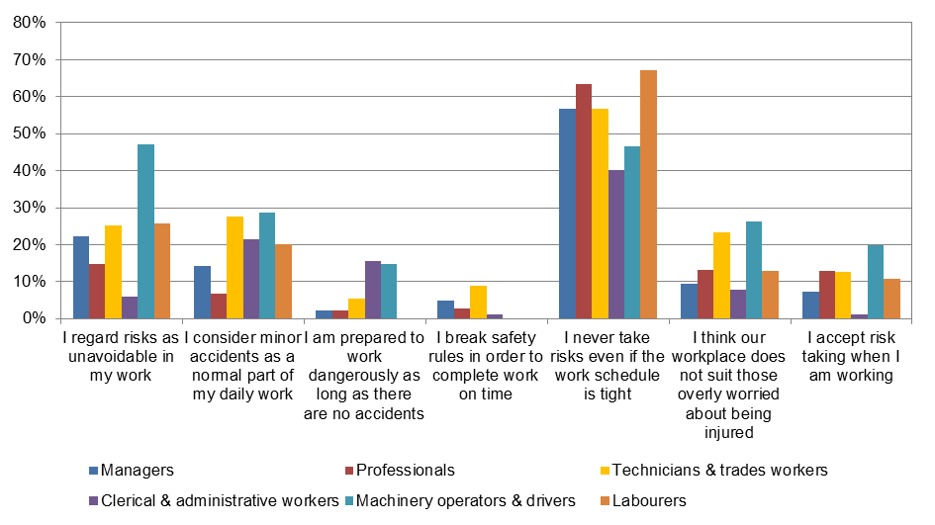
* Community and personal service workers and Sales workers are not shown due to very small numbers of survey respondents
Employers
Figure 4 shows that 23% of employers working as Clerical & administrative workers agreed that their workplace does not suit those concerned about being injured.
Very few employers reported that they accept dangerous behaviour, risk taking, or break safety rules in order to complete work on time.

Figure 4: Attitudes toward risk taking among employers by occupation*
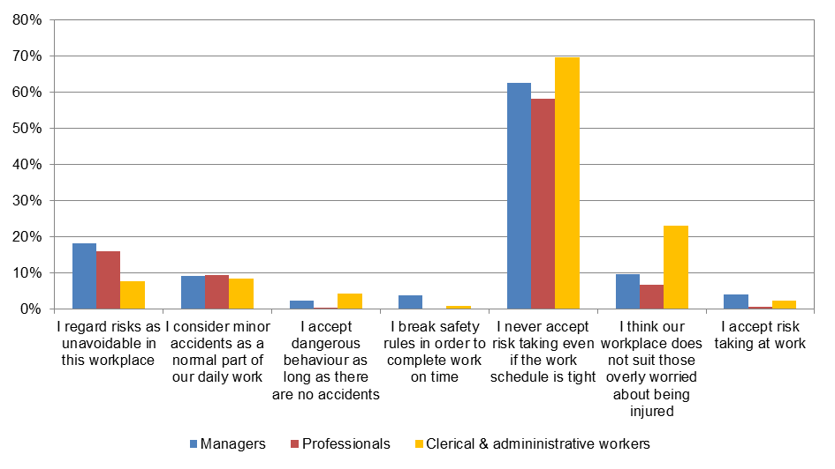
* Some occupation groups including Technicians and trades workers, Machinery operators and drivers and Labourers are not shown due to very small numbers of survey respondents
Workers
Figure 5 shows that half of all Labourers, almost half of Community & personal service workers and Machinery operators & drivers (46% and 44%, respectively) and 41% of Sales workers and Technicians & trades workers regarded risks as unavoidable in their workplace. Forty three percent of Labourers agreed that their workplace doesn’t suit those concerned about being injured, while 43% of Labourers also agreed that their workplace doesn’t suit those worried about being injured.
Very few workers accepted dangerous behaviour as long as there were no accidents. Despite the acknowledged risks in their workplaces 22% of Labourers and Machinery operators & drivers agreed that they break safety rules in order to complete work on time. Twenty eight percent of Labourers also indicated that they accept risk taking at work.

Figure 5: Attitudes toward risk taking among workers by occupation

Workers working as Labourers
As a result of the comparatively high levels of Labourers attitudes towards risk taking questions were examined at the detailed occupation level. For risks in the workplace 63% of Construction & mining labourers, 61% of Factory process workers, 55% of Cleaners & laundry workers and 53% of Farm, forestry & garden workers agreed that risks were unavoidable in their workplace. Similarly, 66% of Factory process workers, 53% of Construction & mining labourers and 51% of Farm, forestry & garden workers agreed that they consider minor accidents as a normal part of their daily work. Sixty four percent of Factory process workers and 54% of Construction & mining labourers also agreed that their workplace did not suit those worried about being injured.
Regardless of the perceived risks in their workplaces 34% of Farm, forestry & garden workers and 33% of Construction & mining labourers agreed that they accept risk taking at work. Thirty six percent of Other labourers and 33% of Food preparation assistants also agreed that they accept risk taking at work.
  - Industry
Sole Traders
Figure 6 shows 44% of sole traders operating in the Transport, postal & warehousing industry, 41% of Health care & social assistance and 35% in Construction regarded risks as unavoidable in their workplace. Forty two percent of sole traders operating in the Transport, postal & warehousing industry considered minor accidents as a normal part of their work.
Seventy nine percent of sole traders in Accommodation & food services indicated that they never accept risk taking even if the work schedule is tight. Despite the acknowledged risks in the workplace 33% of sole traders operating in Transport, postal & warehousing indicated that they accepted risk taking when working. This was followed by 20% operating in Accommodation & food services. Twenty eight percent of sole traders operating in Transport, postal & warehousing also indicated that they are prepared to work dangerously as long as there are no accidents.
Figure 6: Attitudes toward risk taking among sole traders by industry*
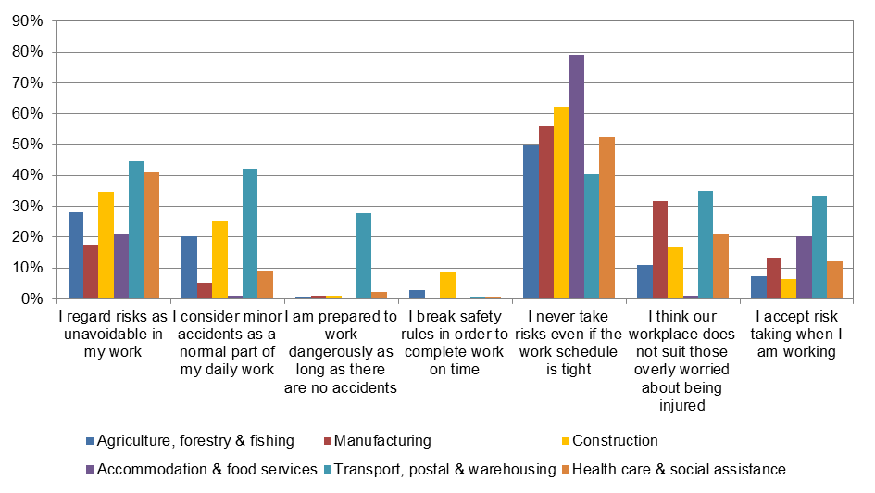* Public administration and safety not shown due to very small numbers of survey respondents
  - Employers
As shown in Figure 7 almost half of employers operating in the Construction and Transport, postal & warehousing (46% and 44%, respectively) industries regarded risks as unavoidable in their workplace. Compared to employers in the other priority industries, employers operating in Transport, postal & warehousing were more likely to agree that their workplace does not suit those overly concerned about being injured (39%). Twenty percent of employers in Transport, postal & warehousing and 19% in Construction indicated that they consider accidents as a normal part of their daily work.
Seventy six percent of employers in the Manufacturing industry and 73% in the Construction industry indicated that they never accept risk taking even if the work schedule is tight. Despite the perceived risks employers operating in Transport, postal & warehousing were more likely to agree that they break safety rules in order to complete work on time and accept risk taking at work (20% each) in comparison to the other priority industries.

Figure 7: Attitudes toward risk taking among employers by industry*
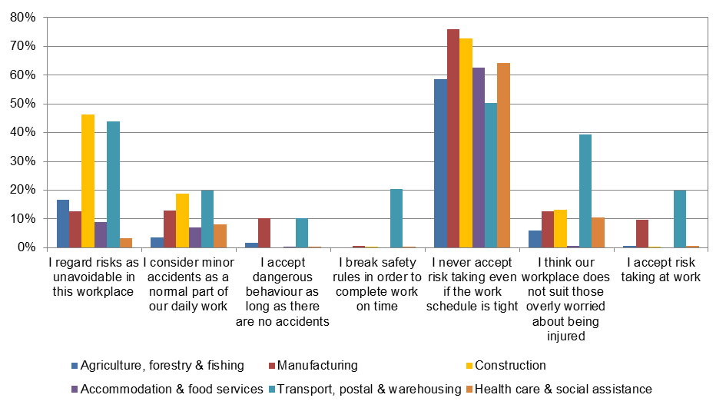
* Public administration and safety not shown due to very small numbers of survey respondents
  - Workers
Figure 8 shows that half of all workers in Construction and Accommodation & food services (51% and 48%, respectively) regarded risks as unavoidable in their workplace, followed by 45% of workers in Transport, postal & warehousing, 41% in Agriculture, forestry & fishing, 40% in Health care & social assistance. Construction workers were more likely to think their workplace does not suit those worried about being injured and that minor accidents are part of their normal work than workers in the other priority industries.
Even though workers in a number of priority industries recognised risks within their workplace, 23% of workers in the Transport, postal & warehousing industry agreed that they break safety rules in order to complete work on time, followed by 18% of workers in Accommodation & food services. Twenty five percent of Construction workers also accepted risk taking at work, followed by 18% in Health care & social assistance and Accommodation & food services.

Figure 8: Attitudes toward risk taking among workers by industry

Rule Breaking
  - Worker Type
Rules in this context refer to one or a set of explicit or understood regulations or principles governing conduct or procedure within the workplace. Figure 9 shows that 37% of HSRs/ WHSPs agreed that not all health and safety instructions are strictly followed in their workplace, which was much higher than the level of agreement from employers (8%). Twenty seven percent of workers agreed that they take short cuts that involve little or no risk, which was higher than reported by HSRs/ WHSPs and employers (11% and 8%, respectively). In terms of reasons for breaking rules less than 10% of all types of workers agreed that workers break rules due to pressure from work mates and/ or management and incentives and financial rewards encourage workers to break rules. Ten percent of workers agreed that they ignore safety rules to get the job done, while 15% agreed that conditions at the workplace stop them from working safely.
Figure 9: Attitudes toward rule breaking by worker type**

* Not asked of workers
** Rule breaking questions were not included in the WHS Perceptions Survey for sole traders
  - Business Size
Figure 10 shows that while two thirds of employers in medium and large businesses (66% and 69%, respectively) agreed that workers would react strongly against those who break health and safety rules, only 52% of employers in small businesses agreed with this statement. However, employers in large businesses were more likely to agree that not all health and safety instructions are strictly followed compared to those in small businesses and to a lesser extent medium businesses (22% compared to 7% and 17%, respectively). A similar pattern was observed for levels of agreement regarding whether workers take short cuts that involve little or no risk. In terms of why rules are broken employers in large businesses were more likely to indicate that workers bend rules to achieve a target and ignore safety rules to get the job done. Employers in medium businesses were slightly more likely to indicate that incentives encourage workers to break rules and workers get financial rewards for breaking rules.
Figure 10: Attitudes toward rule breaking by business size

  - Occupation
Employers
As shown in Figure 11 28% of employers working as Clerical & administrative workers agreed that not all health and safety instructions are strictly followed in their workplace, followed by workers and 10% of Professionals.
Ten percent of Clerical & administrative workers agreed that incentives encourage workers to break rules and workers get financial rewards for breaking rules.

Figure 11: Attitudes toward rule breaking among employers by occupation*
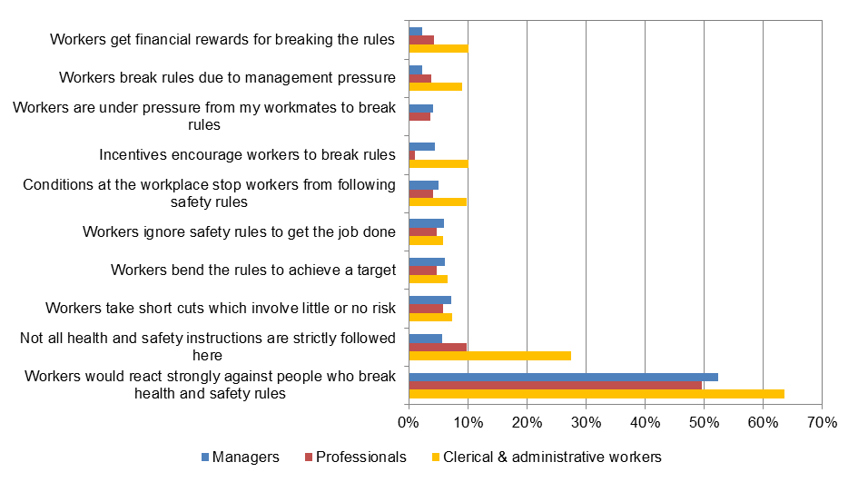
* Some occupation groups including Technicians and trades workers, Machinery operators and drivers and Labourers are not shown due to very small numbers of survey respondents
  - Workers
Figure 12 shows that 40% of Labourers as well as 30% of Sales workers and Machinery operators & drivers agreed that they take shortcuts that involve little or no risk. In terms of reasons why workers break rules, 24% of Labourers agreed that they ignore safety rules to get the job done, followed by 14% of Sales workers and 12% of Machinery operators & drivers. Thirty percent of Labourers and 21% of Sales workers agreed that conditions in their workplace stop them from working safely. Twenty percent of Labourers agreed that they break rules due to management pressure while 15% of Labourers agreed that they are under pressure from work mates to break rules and that incentives encourage them to break rules.

Figure 12: Attitudes toward rule breaking among workers by occupation

Workers working as Labourers
As a result of the comparatively high levels of agreement with rule breaking in the workplace by workers working as Labourers, responses were examined at the detailed occupation level. Sixty six percent of Farm, forestry & garden workers agreed that they take short cuts that involve little or no risk, followed by 49% of Cleaners & laundry workers and 41% of Construction & mining labourers. In addition, 42% of Cleaners & laundry workers and 35% of Factory process workers agreed that conditions in their workplace stop them from working safely. Thirty seven percent of Cleaners & laundry workers, 35% of Other labourers, and 32% of Farm, forestry & garden workers agreed that they ignored safety rules in order to get the job done, while 24% of Cleaners & laundry workers and 23% of Farm, forestry & garden workers agreed that incentives encourage them to break rules. In terms of pressure to break rules, 34% of Other labourers and 31% of Factory process workers agreed that they break rules due to management pressure, while 24% of Construction & mining labourers and 20% of Food preparation assistants agreed that they are under pressure from their work mates to break rules.
  - Industry
Employers
Figure 13 shows that twenty two percent of Transport, postal & warehousing employers agreed that workers take short cuts that involve little or no risk, followed by 17% of Manufacturing and Construction employers.
In comparison to employers in the other priority industries, employers in the Transport, postal & warehousing industry had much higher levels of agreement with questions about why workers break rules: 31% agreed that workers ignore safety rules to get the job done, while 21% agreed that workers bend the rules to achieve a target. Furthermore, 22% agreed that they are under pressure from management to break rules while 21% agreed that they are under pressure from work mates to break rules. Thirty two percent of Transport, postal & warehousing employers agreed that conditions at the workplace stop workers from working safely, much higher than observed in the other priority industries. Fifteen percent of Construction and 10% of Transport, postal & warehousing employers agreed that incentives encourage workers to break rules and that workers get financial rewards for breaking the rules. Despite this, 68% of employers in Transport, postal & warehousing indicated that workers would react strongly against people who break health and safety rules.
Figure 13: Attitudes toward rule breaking among employers by industry*
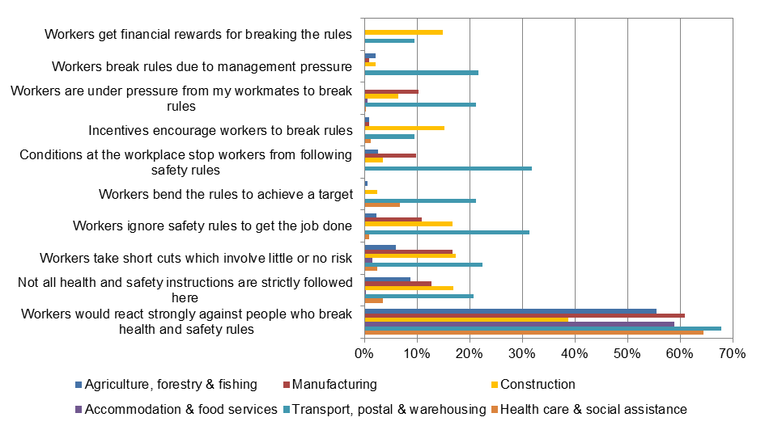
* Public administration and defence not shown due to very small numbers of survey respondents
Workers
Figure 14 shows that 41% of Construction, 36% of Agriculture, forestry & fishing and 31% of Health care & social assistance workers agreed that they take short cuts that involve little or no risk. In terms of why workers break rules, thirty percent of Construction and 24% of Accommodation & food service workers agreed that conditions in their workplace stop them from working safely. Seventeen percent of workers in the Accommodation & food services industry agreed that they break rules due to management pressure, while 18% of these workers also felt that they were under pressure from work mates to break rules. Twelve percent of Construction, 12% of Accommodation & food services and 10% of Agriculture, forestry & fishing workers agreed that incentives encourage them to break rules.
Figure 14: Attitudes toward rule breaking among workers by industry

Appendix A
  - Methodology
Work Health and Safety Perceptions Worker and Employer Surveys 2012
The Perceptions of Work Health and Safety Survey aimed to provide a baseline measure of work health and safety attitudes, beliefs and actions shortly after the model WHS laws were introduced. The survey targeted four types of respondents: employers, sole traders, health and safety representatives and workers. There were four separate questionnaires tailored for the four types of respondents. All four questionnaires covered similar themes and questions.
Work Health and Safety Perceptions Worker Survey 2012
The worker survey was conducted using Computer Assisted Telephone Interviews (CATI) during September to October 2012. The survey used a dual frame approach (both landline and mobile). A sample for random digit dialling was purchased from the commercial sample provider SampleWorx with an aim of completing 650 interviews from landline numbers and 650 interviews from mobiles. For the landline sample the qualifying respondent was chosen by asking to speak with the person who had the most recent birthday of all those in the household who were at least 18 years of age and had worked in paid employment (for an employer) in the past 6 months. For the mobile sample the person who answered was qualified to answer the survey if they were at least 18 years and had worked in paid employment (for an employer) in the past 6 months. A total of 1311 interviews were completed out of 5618 in scope contacts, giving a response rate of 23%. The worker survey data were weighted by state/territory, sex, age and occupation to match population proportions obtained from the August 2012 quarter of the Australian Bureau of Statistics Labour Force Survey. This report presents findings from this weighted dataset.
Work Health and Safety Perceptions Employer and Sole Trader Survey 2012
The employer survey was a paper based survey, conducted from October 2012 to January 2013. A random sample of 10 000 employing businesses were drawn by the Australian Bureau of Statistics for this survey and the same sample was used for the survey of sole traders. The sample took into account the number of businesses in each industry. A total of 1052 employers completed the survey. Taking into account the completed interviews by sole traders (N = 520) the response rate was about 16%. The data were weighted by business size, industry and state/territory.
Risk Taking items
The risk taking questions are part of the Nordic Occupational Safety Climate Questionnaire (NOSACQ-50). The questionnaire has been pilot tested in a range of industries in all Nordic countries with its reliability and validity confirmed. It can be used either in full or individual dimensions. The questionnaire was developed by a network of occupational safety researchers to diagnose occupational safety climate. The dimension included in the WHS Perceptions survey measures ‘workers’ safety priority and risk non-acceptance’.
Rule breaking items
The original questions were developed as part of research by academics in the 1990s into safety climate in offshore environments. From this work the Aberdeen University developed the Offshore Safety Questionnaire (OSQv1, OSQ99) which was used by the UK Health and Safety Executive (HSE) in their two year Benchmarking Offshore Safety project in collaboration with 13 oil and gas companies. Two of the concepts measured were ‘general unsafe behaviour’ and ‘unsafe behaviour under incentives’. The HSE compared the Offshore Safety Questionnaire with five other safety climate survey tools and combined these concepts to develop a set of key items relating to rule breaking which were included in their Core Safety Climate Item Set (HSE, 1999). The HSE’s suggested core items were used in the WHS Perceptions survey.

As expected the majority of employers indicated that their occupation was Manager.

