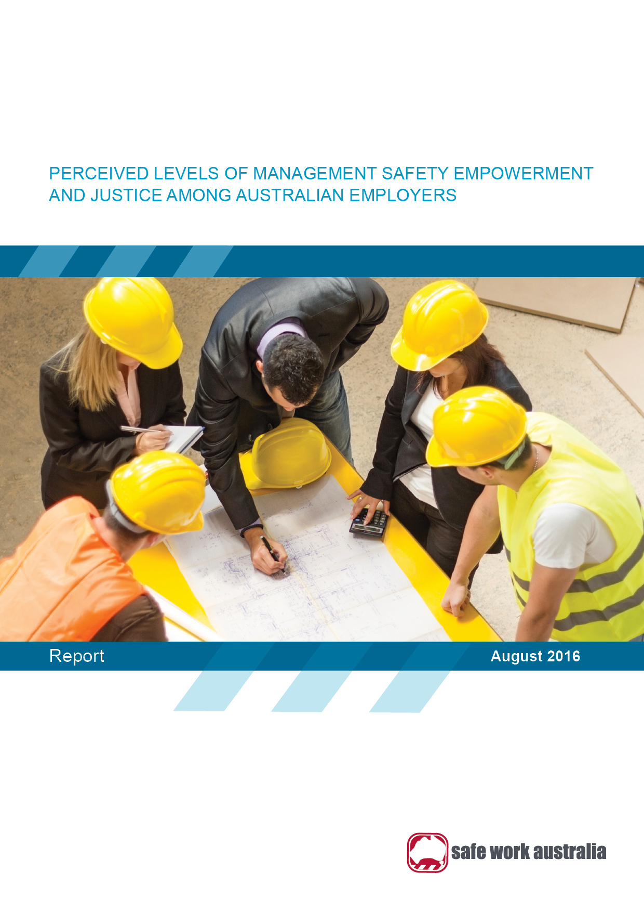

# SAFE WORK AUSTRALIA

# Perceived levels of management safety empowerment and justice among Australian employers

August 2016

Disclaimer

The information provided in this document can only assist you in the most general way. This document does not replace any statutory requirements under any relevant state and territory legislation. Safe Work Australia is not liable for any loss resulting from any action taken or reliance made by you on the information or material contained in this document. Before relying on the material, users should carefully make their own assessment as to its accuracy, currency, completeness and relevance for their purposes, and should obtain any appropriate professional advice relevant to their particular circumstances.

To the extent that the material on this document includes views or recommendations of third parties, such views or recommendations do not necessarily reflect the views of Safe Work Australia or indicate its commitment to a particular course of action.



Creative Commons

ISBN 978-1-76028-665-1 [Online pdf ]  
ISBN 978-1-76028-666-8 [Online doc ]

With the exception of the Safe Work Australia logo, this report is licensed by Safe Work Australia under a Creative Commons 3.0 Australia Licence. To view a copy of this licence, visit <http://creativecommons.org/licenses/by/3.0/au/deed.en>

In essence, you are free to copy, communicate and adapt the work, as long as you attribute the work to Safe Work Australia and abide by the other licensing terms.

Suggested citation:

Safe Work Australia (2016). Perceived levels of management safety empowerment and justice among Australian employers. Canberra: Safe Work Australia.

Enquiries regarding the licence and any use of the report are welcome at:

Copyright Officer  
Stakeholder Engagement  
Safe Work Australia   
GPO Box 641 Canberra ACT 2601

Email: [copyrightrequests@safeworkaustralia.gov.au](mailto:copyrightrequests@safeworkaustralia.gov.au)

# Preface

The Australian Work Health and Safety Strategy 2012­­­–2022 (the Australian Strategy; Safe Work Australia 2012) seeks to explore the action area of *Leadership and culture:* *Leaders in communities and organisations promote a positive culture for health and safety.*

This report summarises findings from the Perceptions of Work Health and Safety Survey 2012 in terms of Australian employers perceptions of how well they managework health and safety in their businesses. The report presents this information with regard to size of business, length of operation, industry and occupation.

Conducting and publishing research to inform the development and evaluation of work health and safety policies is a function of Safe Work Australia per the *Safe Work Australia Act 2008*. This research report was written to inform the development of polices in relation to Australian employers perceived ability to manage work health and safety in their workplaces. This report is intended to inform policy makers, regulators and researchers. The views and conclusions expressed in this report do not necessarily reflect the views of Safe Work Australia members.

Perceptions of Work Health and Safety: Sole traders, employers and workers Surveys 2012

This report presents responses from a survey questionnaire that were weighted to reflect the size, primary location and main industry of businesses in Australia. As is often the case with large surveys, the response rate was low. This increases the risk that the views and experiences of the study sample are biased and affects the extent to which those views and experiences can be generalised to the population of interest. In short, the survey provides potentially valuable information from 1052 employers but we cannot be confident that the information is representative of the whole population. It is therefore important that estimates or comparisons, particularly those based on the relatively small number of medium-sized and large businesses, are seen as indicative or suggestive rather than representative or definitive.

As with all statistical reports, the potential exists for minor revisions over time.

**Contents**

Preface ii

Summary iv

Executive Summary v

The Study 1

Main findings 5

Discussion 12

Conclusions 14

Appendix A 15

References 17

# Summary

**Why has this research been done?**

* The safety climate (shared perceptions of policies, procedures and practices relating to work health and safety) of an organisation has been shown to be related to work health and safety outcomes.
* Two important aspects of safety climate are management safety empowerment and management safety justice, which are the perceived degree to which employers respectively empower their workers to influence aspects of their own safety and deal with health and safety incidents fairly and justly.
* This research investigated how Australian employers believe they demonstrate management safety empowerment and justice in their workplaces so as to better understand leadership and culture as it relates to work health and safety.

**Who did we study?**

* A random sample of 10 000 employing and non-employing businesses was selected to participate in this survey and a total of 1052 employers completed the survey.
* The findings of this study should be considered indicative only owing to the low response rate and it should be borne in mind that employer self-assessment of management safety empowerment and justice may be a source of bias in these findings.

**What did we find?**

* Most employers (80 to 90 per cent) believed that they performed management safety empowerment behaviours frequently in their businesses, including consultation, fostering a safe environment and ensuring workers have a high level of competence regarding safety.
* Around three-quarters of employers thought that they demonstrated management safety justice behaviours frequently in their business, such as listening carefully to everyone involved in an accident and looking for causes of incidents, not guilty persons.
* Small business employers were generally less likely to say that they exhibited management safety empowerment and justice in their workplaces.
* A proportion of employers indicated that they did not display management safety empowerment or justice frequently in their workplaces (around one-fifth and one-quarter of employers, respectively).

**What do the findings suggest?**

* An overall positive finding was that most employers believed that they managed these two aspects of safety climate well and frequently.
* The results also suggest areas for improvement: up to one-quarter of employers indicated that they did not empower their workers through active consultation around safety frequently and did not always treat their workers justly, especially when investigating accidents.

**What can be done?**

* Managers, particularly in small businesses, may need greater support to help them improve compliance with aspects of work health and safety, including consulting with workers and notifying the work health and safety authority of incidents.
* What remains to be discovered is why different groups of employers were more or less likely to display management safety empowerment and justice in their businesses.

# Executive Summary

Background

How well employers feel they manage work health and safety in their businesses has been identified as an area of interest in the Australian Work Health and Safety Strategy 2012–2022 (the Australian Strategy) under the action area of *Leadership and culture:* *Leadership in communities and organisations to promote a positive culture for health and safety.*

Perceptions such as these make up what is often referred to as safety climate; the shared perceptions among the members of a social unit, of policies, procedures and practices related to safety in the organisation (Kines et al, 2011).

This report examines two aspects of safety climate: Management safety empowerment; where employers are perceived to empower their workers to influence aspects of their own work health and safety, and Management safety justice; where employers are perceived to deal with health and safety incidents fairly and justly.

The report provides information on the degree to which employers believe they demonstrate management safety empowerment and management safety justice in their businesses as measured by the Perceptions of Work Health and Safety Survey 2012. The influence of factors such as industry of employer, size of business, length of business operation and types of workers employed are investigated.

Perceptions of Work Health and Safety Survey 2012

The Perceptions of Work Health and Safety Survey aimed to provide a baseline measure of work health and safety attitudes, beliefs and actions shortly after the model Work Health and Safety laws were introduced. The survey targeted four types of respondents: employers, sole traders, health and safety representatives and workers. Different surveys were provided to each group of respondents. This report deals with responses from the employer survey.

Main findings

The majority of employers indicated that they displayed management safety empowerment and management safety justice frequently in their businesses. There were however differences according to business size and industry. Small business employers were generally less likely to perceive that they displayed these behaviours frequently, while there were differences in perceptions among employers working in the priority industries.

Management safety empowerment

Employers generally perceived that management safety empowerment was performed frequently in their businesses. In terms of consultation, 90% of employers indicated that their business considers workers’ suggestions regarding safety most of the time or always, and 88% of employers indicated that their business encourages workers to participate in decisions which affect their safety. The majority of employers also indicated that their businesses worked to foster a safe environment by designing useful systems of work (82%) and ensuring that workers have a high level of competence regarding safety (89%) most of the time or always.

A high level of management safety empowerment was indicated by employers in Manufacturing and Accommodation and food services. All employers in Accommodation and food services indicated that their businesses strive for workers to have high competence regarding safety and risks, encourage workers to participate in decisions affecting their safety and consider workers’ suggestions regarding safety. However, half of employers in Transport, postal and warehousing indicated that their businesses ask workers for their opinions when making decisions regarding safety most of the time or always, much less than the other priority industries.

Employers with apprentices and young workers employed in their businesses tended to have higher perceptions of the frequency of management safety empowerment than employers without these workers. Specifically, almost all employers indicated that either most of the time or always their business strives to design systems that work, workers have a high level of competency regarding safety and risks, makes sure everyone can influence safety in their work, considers workers suggestions regarding safety and encourages workers to participate in decisions that may affect their safety.

Management safety justice

Just over half (59%) of employers indicated that their business collects accurate information from incident investigations, although small businesses were much less likely to indicate that they collected this information (54%) compared to employers in medium and large businesses (95% and 94% respectively). Across all perceptions of management safety justice items, small businesses were generally less likely to agree that this occurred in their businesses.

Ten per cent of employers in the Manufacturing and Transport, postal and warehousing industries indicated that fear of negative consequences discourages workers in their business from reporting near miss incidents either most of the time or always, much higher than the other priority industries. Employers in the Accommodation and food services industry were much less likely to indicate that their business collects accurate information in accident investigations (32%) compared to the other priority industries. Just over half of employers in the Health care and social assistance industry (57%) indicated that their business knows when to report incidents to the regulator, much lower than the other priority industries.

Employers generally displayed more frequent management safety justice in their businesses if they employed apprentices and young workers. For example, almost all employers who worked with apprentices (97%) indicated that their business knows when to report incidents to the health and safety regulator most of the time or always.

Work health and safety management capabilities and work health and safety outcomes

Employers in the Manufacturing industry had the highest perceptions of work health and safety management capabilities occurring in their businesses of all the priority industries. In terms of safety outcomes, over the five year period from 2008–09 to 2012–13 (preliminary), the incidence rate of serious claims in the Manufacturing industry has fallen by 16%, from 21.2 serious claims per 1000 employees to 17.9. This was the second highest decrease of all the priority industries, with Transport, postal and warehousing having the largest decrease in incidence rates (18%).

Disclaimer

This report was written to inform the development of polices in relation to perceptions of the management capabilities of Australian employers regarding work health and safety. The views and conclusions expressed in this report do not necessarily reflect the views of Safe Work Australia Members.

# The Study

Rationale

Knowing how Australian employers perceive they manage work health and safety in their businesses provides valuable insights into how leadership approaches influence safety in the workplace. Beliefs such as these have been the subject of safety climate research. Safety climate refers to shared perceptions of management and workgroup safety related policies, procedures and practices (Neal & Griffin, 2002; Abrahamson, Ramanujam & Anderson, 2011; Kines et al, 2011; Nielsen et al, 2011). In essence, safety climate represents the employee perceptions regarding overall safety at their workplace, and has also been defined as workers’ perception of the management’s commitment to safety (Nielsen et al, 2011). Studies have found that management’s commitment to safety is a critical factor in worker perceptions of risk and safety (See Nielsen et al, 2001).

Research has shown that safety climate has an influence on perceived risk levels. In a study of 293 offshore oil installation workers from a single company, Nielson, Eid, Mearns and Larsson (2011) found that safety climate mediated the relationship between authentic leadership and risk perception, and when assessed as a higher order construct safety climate had the strongest relationship with risk perception.

Empirical research has shown that perceptions of safety climate, including management safety empowerment and justice, have an influence on safety outcomes. In a study of 1127 nurses working in 81 general medical-surgical units in 42 randomly selected hospitals in the United States of America, safety climate was found to predict medication errors, nurse back injuries, urinary tract infections, patient satisfaction, patient perceptions of nurse responsiveness and nurse satisfaction (Hoffman & Barbara, 2006). In another study investigating safety climate and worker injuries in the repair, maintenance, minor alteration and addition sector, it was found that two aspects of safety climate - positive workforce attitude and acceptance of safety rules and regulations - reduced workers’ likelihood of being injured (Hon, Hinze & Chan, 2014).

Safety climate can be measured in many ways. The Nordic Safety Climate Questionnaire (NOSACQ-50) was developed by a team of Nordic occupational safety researchers based on organisational and safety climate theory, psychological theory, previous empirical research, empirical results acquired through international studies, and a continuous development process (Gravseth, et al 2014*;* Kines et al, 2011).

The NOSACQ-50 consists of 50 items across seven dimensions:

1) Management safety priority, commitment and confidence

**2) Management safety empowerment**

**3) Management safety justice**

4) Workers’ safety commitment

5) Workers’ safety priority and non-risk acceptance

6) Safety communication, learning and trust in co-workers’ safety competence, and

7) Workers’ trust in the efficacy of safety systems.

The Perceptions of Work Health and Safety Survey 2012 measured two of these dimensions, management safety empowerment and management safety justice. As demonstrated below, these two safety climate dimensions can be used to represent how well Australian employers think they manage work health and safety in their businesses.

**Perceptions of Work Health and Safety Survey 2012**

The Perceptions of Work Health and Safety Survey 2012 collected information on awareness of work health and safety responsibilities and law changes, awareness of workplace risks, due diligence in undertaking activities to eliminate or minimise risks, and work health and safety communication, consultation and attitudes. This survey is part of a larger evaluation program, with the broader ongoing aim to examine the changes that have occurred in the health and safety performance of Australian workplaces since the introduction of the model legislation and why these changes have occurred.

The survey involved four groups of respondents: owners, operators, senior managers (‘employers’) that employed workers and that did not employ workers (‘sole traders’ or partnerships working in their own premises or in others’ premises), people who were employed and were either a Health and Safety Representative or Work Health and Safety Professional (HSR/ WHSP) and people in paid employment (workers; excluding self-employed). A different questionnaire was designed for each of the respondent groups.

The survey of businesses collected completed surveys from 1052 employers and 520 non-employing businesses across Australia. To better represent the population from which they were drawn, the responses for sole traders and employers were weighted to produce estimates of the number of businesses and workers within Australia that hold particular views about work health and safety.

See Appendix A for further information on this survey.

Management safety empowerment

To empower someone is to enable that person to authoritatively take independent action (Breeding, 1996). Empowerment is a delegation of power, and as such it demonstrates that managers trust workers’ ability and judgement, and that managers value workers’ contributions (Kines et al, 2011). Managers can convey trust by empowering their employees. Empowerment would strengthen social exchanges, and in conditions where safety is highly valued by an organisation empowerment would encourage reciprocation and reinforce safety behaviour (Kines et al, 2011).

Breeding (1996) argued that empowerment, if utilised positively by a proactive manager, holds excellent potential as a tool for effective safety management. In a review of 10 studies, Shannon et al (1997) found that empowerment of workers and delegation of safety activities were associated with reduced rates of injury. However in another study, Greasley et al (2005) investigated how empowerment is perceived by employees working on construction projects. Health and safety was perceived by workers as a major barrier to empowerment due to the strict health and safety rules that they were required to follow (Greasley et al, 2005).

In the Perceptions of Work Health and Safety Survey perceptions of management safety empowerment behaviours were measured through the following questions on a 5-point scale ranging from *Never* to *Always*:

1. The business/ the managers strive(s) to design systems of work that are meaningful and actually work.
2. The business/ the managers make(s) sure that everyone can influence their safety at work.
3. The business/ the managers encourage(s) workers here to participate in decisions which affect their safety.
4. The business/ the managers consider(s) workers suggestions regarding safety.
5. The business/ the managers strive(s) for everybody here to have high competence concerning safety and risks.
6. The business/ the managers ask(s) workers for their opinions before making decisions regarding safety.
7. The business/ the manager(s) involves workers in decisions regarding safety.

Management safety justice

Failing to discipline employees who knowingly act unsafely challenges widely accepted moral principles just as much as punishing those who make honest mistakes (Kines et al, 2011). The NOSACQ-50 assumes that employee safety responsibility and safety behaviour would be positively influenced by management procedural and interactional safety justice, such as just treatment and procedures when handling incidents or near-incidents (Kines et al, 2011).

However, at this stage, there is little evidence that management safety justice alone influences work health and safety outcomes.

In the Perceptions of Work Health and Safety Survey perceptions of management safety justice were measured through the following questions on a 5-point scale ranging from *Never* to *Always*:

1. The business collects accurate information in accident investigations.
2. Fear of negative consequences discourages workers here from reporting near miss incidents.
3. The business listens carefully to all who have been involved in an incident.
4. The business looks for causes, not guilty persons, when an accident occurs.

An additional item along the same lines as management safety justice was added into the survey:

5) The business knows when to report incidents to the health and safety inspectorate.

These scales were included in the Perceptions of Work Health and Safety survey to assess the frequency of processes for compliance with Duties or Obligations under the Model Work Health and Safety Act. They also provide insight into how Australian employers’ think they manage work health and safety in their businesses.

Limitations

A limitation of this study is that it relies on self-reported data and the findings presented in this report are based on people’s perceptions. The frequency of perceived management safety empowerment and management safety justice nominated by survey respondents may differ from the actual frequency of this when at work.

The business survey was professionally sampled. However, due to low response rates response bias cannot be discounted. Therefore, the findings should be taken as indications only and not as statistically reliable estimates or statistically significant differences between groups. Findings presented by business size should be taken only as indicative, particularly for medium and large businesses as a high proportion of the survey respondents were small businesses. However, the substantial number of surveys completed for these surveys means that responses do provide an indication of work health and safety perceptions and practices and baseline data for comparison with follow-up surveys.

The report covered a large amount of information available while attempting to be as concise as possible. As such some of the findings and conclusions may appear too simplistic.

Results preamble

Due to the qualitative nature of the findings, there are no accompanying statistics such as confidence intervals to indicate the reliability of estimates or inferences.

# Main findings

Perceptions of management safety empowerment

Overall, employers indicated that they had high levels of management safety empowerment. More than 80% of employers indicated that either most of the time or always their business:

* strives to design systems of work that are meaningful and actually work (82%)
* makes sure that everyone can influence their safety in their work (87%)
* encourages workers to participate in decisions which affect their safety (88%)
* considers workers’ suggestions regarding safety (90%), and
* strives for everybody in the workplace to have a high competence concerning safety and risks (89%).

Business size

Business size is defined as follows:

* Small businesses: 1-19 employees
* Medium businesses: 20-199 employees
* Large businesses: 200+ employees

Small business employers were the most common group (87%) followed by medium business employers (11%) and large business employers (1%)[1].

Figure 1 shows that while perceptions of management safety empowerment were high across the business sizes, employers operating in small businesses generally perceived lower levels of management safety empowerment occurred in their businesses compared to employers in medium and large businesses. Specifically they were less likely to indicate that their business:

* strives to design systems of work that are meaningful and actually work compared to almost all employers in medium and large businesses.
* involves workers in decisions regarding safety.
* asks workers for their opinions before making decisions regarding safety either most of the time or always.

Medium sized businesses were more likely to indicate that nearly all forms of management safety empowerment occurred more frequently in their businesses than large businesses on nearly all items.

Figure 1: Management safety empowerment by business size

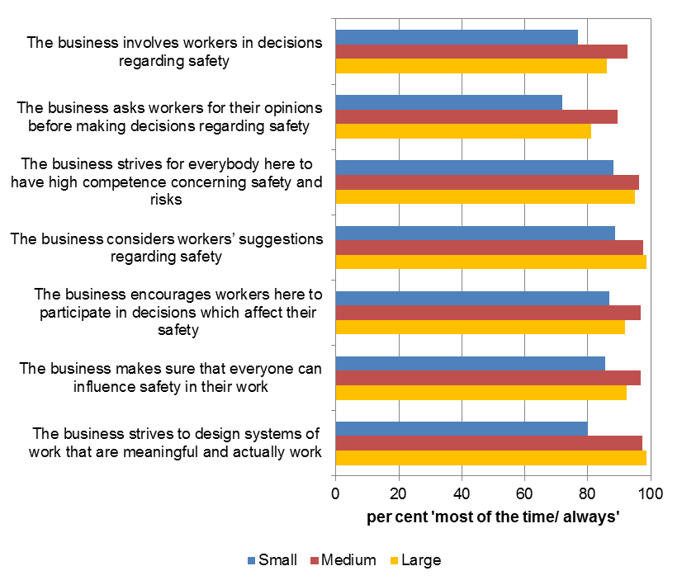

Industry

Figure 2 shows that perceptions of management safety empowerment among employers varied across the priority industries. Across each of the items, employers operating in Accommodation and food services and Manufacturing perceived consistently high frequencies of management safety empowerment occurring in their businesses.

Employers operating in the Construction and Transport, postal and warehousing industries were least likely to indicate that their business strives to design systems of work that are meaningful and actually work frequently while employers in the Manufacturing industry were most likely to indicate this.

All employers in the Accommodation and food services industry agreed that their business frequently:

* encourages workers to participate in decisions that affect their safety
* considers workers’ suggestions regarding safety, and
* strives for everybody here to have high competence concerning safety and risks.

Two items in this scale resulted in a fair degree of differentiation between the industries. For *‘the business involves workers in decisions regarding safety’*, almost all employers in Accommodation & food services and Manufacturing indicated that this occurred most of the time or always, while employers in Transport, postal & warehousing and Agriculture, forestry & fishing were less likely to indicate that this occurs.

For *‘the business asks workers for their opinions before making decisions regarding safety’*, almost all Manufacturing employers indicated that this occurs most of the time or always, while only around half of employers in Transport, postal & warehousing indicated that this was the case in their businesses.

Figure 2: Employer perceptions of management safety empowerment by industry

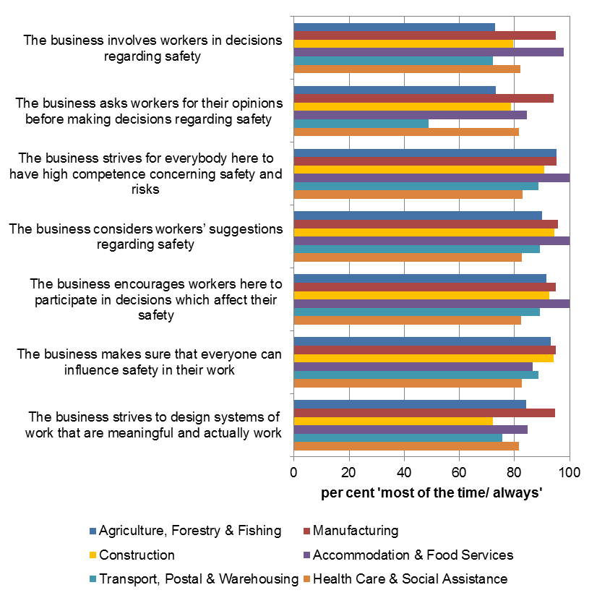

Length of business operation

Seventy three per cent of employers indicated that their business had been in existence for six years or more. Employers tended to be as likely to indicate that they had high levels of management safety empowerment regardless of how long their business had been in existence, with two exceptions. Employers whose business had been in existence for four to five years were less likely to indicate that their business strives to design systems of work that are meaningful and actually work most of the time or always compared to employers whose business had been operating for one to three years and six years or more. In addition, Employers whose business had been in existence for four to five years were much less likely to indicate that their business asks workers for their opinions before making decisions on safety either most of the time or always, compared to employers whose business had been in existence for one to three years and six years or more.

Type of worker employed in business

Employers who employed apprentices and young workers in their businesses tended to have higher perceptions of the frequency of management safety empowerment compared to employers who did not employ these workers.

Almost all employers who employed apprentices and young workers indicated that either most of the time or always their business:

* strives to design systems of work that are meaningful and actually work
* makes sure that everyone can influence safety in their work
* encourages workers here to participate in decisions which affect their safety
* considers workers’ suggestions regarding safety, and
* strives for everybody here to have high competence concerning safety and risks.

There were no substantial differences for employers that employed full-time and part-time staff and contractors.

Perceptions of management safety justice

The majority of employers perceived that they demonstrated management safety justice frequently in their business. Specifically, three quarters of employers indicated that their business listens carefully to all who have been involved in an incident either most of the time or always, with three quarters of employers also agreeing that their business knows when to report incidents to the health and safety regulator. Almost three quarters of employers indicated that the business looks for causes, not guilty persons, when an incident occurs. Two per cent of employers indicated that fear of negative consequences discourages workers in their workplaces from reporting near miss incidents.

Conversely, just over half of employers indicated that their business collects accurate information in incident investigations either most of the time or always.

Business size

Figure 3 shows that employers in small businesses were generally less likely to agree that management safety justice occurred frequently in their businesses. Specifically small business employers were less likely to:

* collect accurate information in accident investigations either most of the time or always.
* indicate that their business looks for causes, not guilty persons, when an incident occurs.
* indicate that their business listens carefully to all who have been involved in an incident and their business knows when to report incidents to the health and safety regulator compared to employers in medium and large businesses.

Figure 3: Management safety justice by business size

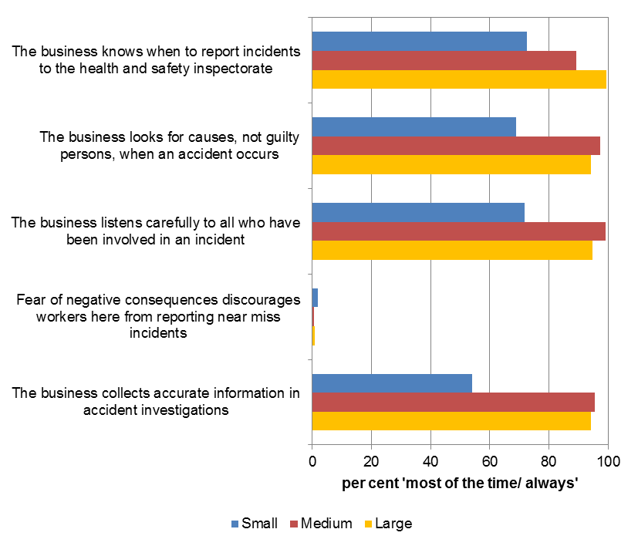

Industry

Figure 4 shows that employers operating in Manufacturing and Construction consistently had a high frequency of perceived management safety justice in their business.

Almost all employers in the Manufacturing and Construction industries indicated that their business frequently knows when to report incidents to the health and safety regulator, while just over half of employers in the Health care and social assistance industry indicated that this was the case in their business.

Employers operating in Accommodation and food services were much less likely to indicate that their business collects accurate information in accident investigations frequently (32%) while employers in Manufacturing, Construction (75% each) and Transport, postal and warehousing (73%) were the most likely to indicate that this occurs in their business frequently.

Ten per cent of employers in the Manufacturing and Transport, postal and warehousing industries indicated that fear of negative consequences discourages workers in their business from reporting near miss incidents frequently.

Ninety-one percent of employers operating in Manufacturing indicated that their business listens carefully to all who have been involved in an incident frequently, while 76% of employers operating in Agriculture, forestry and fishing indicated that this was the case in their business.

Figure 4: Management safety justice by industry

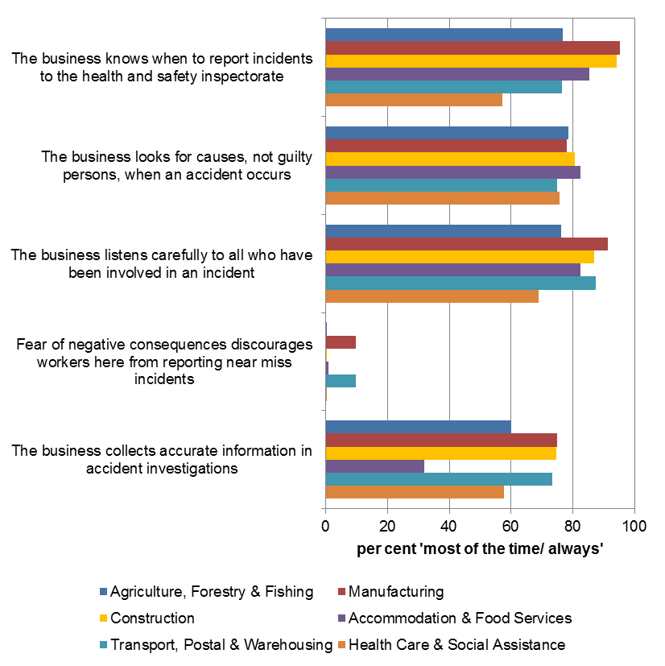

Length of business operation

Almost all employers whose business had been in existence for one to three years (94%) indicated that their business knows when to report incidents to the health and safety inspectorate frequently, compared to 80% of employers whose business had been in existence for four to five years and 71% of employers whose business had been in existence for six years or more.

Type of worker employed in business

If employers employed apprentices or young workers in their businesses they tended to have higher perceptions of the frequency of management safety justice occurring in their business.

Almost all employers whose business employed apprentices (97%) indicated that their business frequently knows when to report incidents to the health and safety regulator most of the time or always, followed by 88% of employers who business employed young workers.

Eighty-nine per cent of employers who employed apprentices and young workers in their business indicated that their business frequently listens carefully to all who have been involved in an incident.

Eighty-six per cent of employers whose business employed apprentices and young workers indicated that the business frequently collects accurate information in incident investigations.

# Discussion

Employers generally perceived they displayed management safety empowerment and management safety justice in their businesses relatively frequently. This suggests that employers appear to have a positive attitude towards empowering workers to play a role in their own health and safety as well as ensuring that these matters are handled appropriately and justly.

However, this study has revealed that between 10–-20% of employers indicated that they did not display management safety empowerment in their businesses. In addition, around 25% of employers indicated that they did not display aspects of management safety justice in their businesses frequently, with around half of employers indicating that they did not collect information regarding incident investigations frequently.

In particular, employers in small businesses perceived that they reported management safety empowerment and management safety justice less frequently than those in medium and large businesses. This could suggest that some small business employers struggle to involve workers in work health and safety processes and may also have difficulty investigating incidents and reporting these appropriately. Anecdotal evidence from verbatim comments provided by respondents to the Perceptions of Work Health and Safety Survey indicates that at least some small business employers find legislation complex and onerous, which may lead to small businesses being unsure of when it is appropriate to involve workers in health and safety decisions and how incidents should be managed and reported. Consulting with workers is a duty under the model work health and safety legislation, as is the notification of incidents. Failure to comply with these provisions attracts monetary penalties, which would be a substantial cost to small businesses.

Management safety empowerment

Employers in the Accommodation and food services and Manufacturing industries had consistently high perceptions of management safety empowerment occurring frequently in their businesses. This indicates that in these workplaces employers perceived that they frequently empower staff to take responsibility for health and safety in their workplaces as well as their own health and safety. It is possible that these industries including many instances of workers undertaking discrete tasks in a discrete manner with lower risks of fatalities may give greater scope for employers to empower their workers over decisions relating to work health and safety. This compares to work undertaken in other industries like Construction that may need significant technical expertise (e.g. Greasley et al, 2005) and with a higher risk of fatal incidents in these industries (see Safe Work Australia, 2014a).

Employers with apprentices and young workers were more likely to perceive that management safety empowerment occurred in their businesses more frequently than employers who did not employ these workers. This finding suggests that these employers may be more aware of their duties towards the work health and safety of these vulnerable groups. They may work to foster a positive working environment for these workers by encouraging consultation and input regarding safety, as well as working to ensure that systems of work are well designed and workers have a high level of safety competence (potentially as a form of training to substitute for lack of job experience). Data from the Australian Bureau of Statistics Work-related Injuries Survey 2009–10 revealed that one fifth of all work-related injuries experienced by Australian workers were incurred by workers aged 25 years and under, and also revealed that the incidence rate of injuries per 1000 workers for young workers was 18% higher than that for workers aged over 25 (ABS, 2011 cat. No. 6324.0). In 2009–10, 24% of young workers worked in the Retail trade industry, followed by 19% in Accommodation and food services, 9% in Construction and 8% in Manufacturing (Safe Work Australia, 2013). Three of these industries have been selected under the Australian Strategy for attention due to high rates of injury or the inherent risk associated with working in these industries.

Management safety justice

One in 10 employers operating in Manufacturing and Transport, postal and warehousing industries indicated that fear of negative consequences discourages workers in their businesses from reporting safety incidents most of the time or always. The fact that employers perceive this to be the case indicates that there is potentially a cultural issue regarding health and safety in these workplaces. In other research conducted by Safe Work Australia it was found that employers in Manufacturing and Transport, postal and warehousing were least likely to agree that if a worker makes a mistake it is not held against them, compared to the other priority industries (Safe Work Australia, 2014b).

Work health and safety management capabilities and work health and safety outcomes

This report examined two aspects of safety climate: management safety empowerment and management safety justice to gain an indication of how well Australian employers think they manage work health and safety in their businesses. Previous research has shown that safety climate is related to work health and safety outcomes by way of work-related injuries and perceptions of risk. Previous research has also shown that high levels of management safety empowerment are associated with a reduction in workplace injuries, whereas there is no evidence available regarding the impact of management safety justice on health and safety outcomes.

Employers in the Manufacturing and Accommodation and food services industries perceived that management safety empowerment occurred frequently in their businesses generally to a higher degree than the other priority industries. For management safety justice, employers in Manufacturing and Construction had consistently higher perceptions of the frequency of management safety justice in their businesses compared to the other priority industries.

Over the five year period from 2008–09 to 2012–13 (preliminary), the incidence rate of serious claims in the Manufacturing industry has fallen by 16%, from 21.2 serious claims per 1000 employees to 17.9 (Safe Work Australia, 2015). This was the second highest decrease of all the priority industries, with Transport, postal and warehousing having the largest decrease in incidence rates (18%). Incidence rates of serious claims in the Construction industry also fell 14% during this period, from 19.8 serious claims per 1000 employees to 17. While the Accommodation and food services industry also experienced a decrease in incidence rates this decline was to a lesser extent (7%). However this industry has the lowest incidence rate of serious claims of all priority industries at 8.9. While it is plausible that levels of management safety empowerment and management safety justice have an impact on the number of workers’ compensation claims lodged, a study involving the measurement of these aspects of safety climate against objective safety outcomes is necessary to investigate this potential relationship.

# Conclusions

Although most employers think that they manage work health and safety well, this study has shown that between 10–20% of employers did not display management safety empowerment frequently in their businesses. In addition, around 25% of employers did not display aspects of management safety justice in their businesses frequently, and around half of employers indicated that they did not collect information regarding incident investigations frequently. Consulting with workers and notifying work health and safety authorities of incidents are duties under the model work health and safety legislation. This suggests that a proportion of Australian employers are not complying with these requirements of the Act.

The finding that employers in small businesses tend to display management safety empowerment and management safety justice less frequently than employers in medium and large businesses potentially indicates that small businesses may need further assistance in performing their WHS obligations with regards to consulting with workers and notifying the work health and safety authority of incidents.

Employers in the Manufacturing industry had the highest frequency of management safety empowerment and justice in their business, as well as the second largest decline in the incidence rate of serious claims over the past five years. However, these declines may be due to a range of factors which may or may not include work health and safety management capabilities. This report does set the scene for future research into the influence of leadership and culture, potentially through a more comprehensive assessment of safety climate, on work health and safety outcomes.

Findings in this report indicate that Manufacturing and Transport, postal and warehousing employers’ treatment of workers who report incidents in these industries could be improved and may be a target for intervention. Future research could measure safety climate among the priority industries to determine whether levels of safety climate are indeed lower in these industries and what may account for these differences and what impact they might have on work health and safety.

# Appendix A

Work Health and Safety Perceptions Worker and Employer Surveys 2012

The Perceptions of Work Health and Safety Survey aimed to provide a baseline measure of work health and safety attitudes, beliefs and actions shortly after the model WHS laws were introduced. The survey targeted four types of respondents: employers, sole traders, health and safety representatives and workers. There were four separate questionnaires tailored for the four types of respondents. All four questionnaires covered similar themes and questions.

Employer Survey 2012

The employer survey was a paper based survey, conducted from October 2012 to January 2013. A stratified random sample of 10 000 employing and non-employing businesses were drawn by the Australian Bureau of Statistics for this survey and the same sample was used for the survey of sole traders. The sample took into account the number of businesses in each industry. A total of 1052 employers completed the survey. Taking into account the completed interviews by non-employing businesses (N = 520) the response rate was about 16%. The data were weighted by business size, industry and state/territory.

Table 1 shows the unweighted employer sample characteristics by business size and priority industry.

Table 1: Number of employers by business size and priority industry (unweighted)

|  | Agri. | Man. | Construction | Accom. | Trans. | Pub. | Health. | Other | **Total** |
| --- | --- | --- | --- | --- | --- | --- | --- | --- | --- |
| Small | 55 | 17 | 45 | 21 | 20 | 3 | 40 | 211 | **422** |
| Medium | 14 | 46 | 32 | 23 | 20 | 2 | 53 | 186 | **386** |
| Large | 9 | 45 | 10 | 12 | 14 | 1 | 57 | 87 | **238** |
| **Total** | **78** | **108** | **87** | **56** | **54** | **6** | **150** | **484** | **1046\*** |

**Key**

Agri. - Agriculture, forestry & fishing

Man. – Manufacturing

Accom. – Accommodation & food services

Trans. – Transport, postal & warehousing

Pub. – Public Administration & safety

Health – health care and social assistance

* Excludes missing values

# References

Australian Bureau of Statistics (2011). *Work-Related Injuries, Australia 2009-10* (cat. No. 6324.0). Retrieved from: <http://www.ausstats.abs.gov.au/Ausstats/subscriber.nsf/0/04A80CA5D52DFAA8CA25793B000E2236/$File/63240_2009-10.pdf>

Abrahamson, K., Ramanujam, R., & Anderson,J.G. (2011). Co-worker characteristics and nurses’ safety-climate perceptions. *International Journal of Health Care Quality Assurance, 26(5),* pp 447- 454.

Breeding, D.C. (1996). Worker empowerment: A useful tool for effective safety management. *Occupational Health and Safety, 65(9),* pp 16-17.

Gravseth, H.M., Holte, K.A., Kines, P., Lappalainen, J., Mikkelsen, K.L., Olsen, E., Pousette, A., Tharaldsen, J., Tómasson, K., & Törner, M. (2014*). Safety Climate Questionnaire – NOSACQ-50*. Retrieved from: <http://www.arbejdsmiljoforskning.dk/da/publikationer/spoergeskemaer/nosacq-50>

Greasley, K., Bryman, A., Dainty, A., Price, A., Soetanto, R., & King, N. (2005). Employee perceptions of empowerment. *Employee Relations, 27 (4/5),* pp 354-368.

Hoffman, D.A., & Barbara, M. (2006). An investigation of the relationship between safety climate and medication errors as well as other nurse and patient outcomes. *Personnel Psychology, 59(4),* pp 847-869.

Hon, C.K.H., Hinze, J., & Chan, A.P.C. (2014). Safety climate and injury occurrence of repair, maintenance, minor alteration and addition works: A comparison of workers, supervisors and managers. *Facilities, 32(5/6),* pp 188-207.

Kines, P., Lappalainen, J., Mikkelsen, K.L., Olsen, E., Pousette, A., Tharaldsen, J., Tómasson, K., & Törner, M. (2011). Nordic Safety Climate Questionnaire (NOSACQ-50): A new tool for diagnosing occupational safety climate*. International Journal of Industrial Ergonomics, 41*, pp 634-646.

Neal, A. & Griffin, M.A.., (2002). Safety climate and safety behaviour. *Australian Journal of Management, 27*, pp 67-77.

Nielson, M.B., Eid, J., Mearns, K., & Larsson, G. (2011). Authentic leadership and its relationship with risk perception and safety climate. *Leadership & Organisation Development Journal, 34(4),* pp 308-325.

Safe Work Australia (2015). National Dataset for Compensation-based Statistics. Safe Work Australia: Canberra.

Safe Work Australia (2014a). *Work-related traumatic injury fatalities Australia 2013*. Retrieved from: <http://www.safeworkaustralia.gov.au/sites/SWA/about/Publications/Documents/870/Traumatic-Injury-Fatalities-Report-2013.pdf>

Safe Work Australia (2014b). Attitudes towards risk taking and rule breaking in Australian workplaces. Safe Work Australia, Canberra.

Safe Work Australia (2013). Work-related injuries experienced by young workers in Australia, 2009-10. Canberra: Safe Work Australia. Retrieved from: <http://www.safeworkaustralia.gov.au/sites/swa/about/publications/pages/work-related-injuries-experienced-by-young-workers-in-australia-2009-10>

Safe Work Australia (2012) *Australian Work Health and Safety Strategy 2012-22*. Retrieved from: <http://www.safeworkaustralia.gov.au/sites/swa/about/publications/pages/australian-work-health-and-safety-strategy-2012-2022>

Shannon, H.S., Mayer, J., Haines, T. (1997). Overview of the relationship between organisation and workplace factors and injury rates. *Safety Science, 26(3),* pp 201-217.

1. These data were weighted