Emissions of Nanomaterials during Machining Processes

Information Sheet

Background
The benefits of more durable, tough and light composite materials that contain engineered nano-objects (for example nanomaterial particles) are promoting their use in a number of applications including wind turbine blades, car body parts and high performance sports equipment.
Investigating the emissions of nanomaterials from composites and other solid articles during machining processes

This review was commissioned by Safe Work Australia and undertaken by the Commonwealth Scientific and Industrial Research Organisation (CSIRO), through funding provided under the National Enabling Technologies Strategy.
This report considers whether machining of solid articles can give rise to work health issues due to inhalation of emitted particles.
The report examines particle release from the machining of composite materials and other solid articles that contain nano-objects. It describes how particle release was measured, precautions taken to control particle release in the workplace, levels of releases, types of particles emitted and from these results, considers the potential risk to workers’ health.
The report notes that the machining of a number of different composite forms has been examined by investigators. Matrices include epoxy, polycarbonate, polyurethane, polymethyl methacrylates and polyamide and nano-objects used for reinforcing include silica, carbon fibres, carbon nanotubes and nanoclay. The report also notes that machining processes investigated include wet and dry cutting, drilling, grinding, sanding and abrasion.

Summary of findings

A summary of the findings from this review of experimental work is:
- The mass of emissions from the machining of composites containing reinforcing engineered nano-objects is in most instances not significantly different from the machining of composites that do not contain nano-objects.
- High energy machining processes emit significantly higher numbers of particles and produce higher airborne mass concentrations than low energy processes.
- For some processes, lower emissions can be achieved using wet machining in comparison to dry machining.
- A mixture of particles is released from composites during machining. Most particles emitted come from the matrix or are particles of matrix with nano-objects embedded, though some free engineered nano-objects are released.
- The use of engineering controls for machining processes can significantly reduce worker exposure, if designed appropriately and maintained adequately.

Potential risk to workers’ health

Significant quantities of material can be released from composites containing nano-objects by high energy machining processes such as cutting with an electric disc saw or band saw. However, similar quantities are released during machining of composites that do not contain reinforcing nano-objects. Thus, unless reinforcing particles are of high toxicity, the potential health risk from particles emitted during machining will be similar for composites that do and do not contain reinforcing nano-objects. Given the large quantities of materials emitted, although processes are typically of short duration, a potential health risk exists from high energy machining processes.

Lower energy machining processes such as manual grinding or cutting generally emit significantly lower levels of material. These levels of emissions should not present a significant health risk if low toxicity particles are emitted, but may present a health risk if emitted particles have high toxicity.

Carbon nanotubes and carbon nanofibres are used as reinforcing nano-objects in some composites. Two studies have reported the emission of free carbon nanotubes and carbon nanofibres during machining, though a number of other machining studies did not detect the emission of any free carbon nanotubes.

The duration that particles remain suspended in the air after the machining process has stopped is of significance to workers in the vicinity of the process area. While coarse particles settle on the floor or other surfaces after a relatively short period of time, nanoscale particles remain suspended in air for significantly longer times.

Regulations
Australia’s work health and safety (WHS) legislation aims to protect the health and safety
of workers researching, developing, manufacturing or using engineered nanomaterials. General duties under the legislation apply to working with engineered nanomaterials as they do to technologies, substances, chemicals and materials generally. These general duties require risks to be eliminated or minimised.

There are also specific WHS Regulations for workplace hazardous chemicals, which cover engineered nanomaterials in the same way as other chemicals if they are classifiable as hazardous.

The findings of this review of the emissions from composites and other solid articles during machining processes have implications for duty holders under the WHS Regulations.

Risk management approach
The general risk management process is illustrated in Figure 1. Details are in the model Code of Practice: How to manage work health and safety risks and for chemicals generally in the Code of Practice: Managing risks of hazardous chemicals in the workplace. It can be applied to working safely with composites containing engineered nanomaterials and the approach to choosing controls is the same as for working with chemicals generally, for example following the hierarchy of controls.

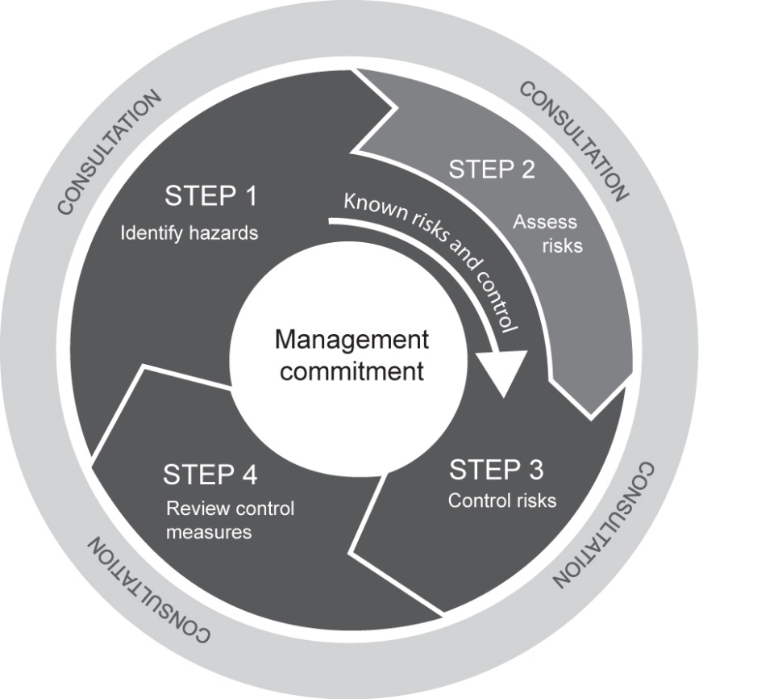
Figure 1: The risk management process

Providing relevant product information
Manufacturers and importers of solid articles (for example composites) containing high toxicity particles such as biopersistent fibres should identify the presence of these particles in product data sheets.

Persons conducting a business or undertaking (PCBUs) and workers should examine product information on articles they are going to do machining work on. If no product information is available, a precautionary approach should be taken and it should be assumed that high toxicity particles may be emitted.

Choice of workplace controls
Unless reinforcing particles have high toxicity, the choice of controls for machining processes can be the same for composites that do and do not contain reinforcing nano-objects.
For some processes, lower emissions can be achieved using wet machining in place of dry machining.

For high energy machining of composites or other solid articles containing engineered nanomaterials, the report recommends the use of well-maintained engineering controls to minimise exposure and especially if:
- particles released from the matrix are highly toxic, or
- the reinforcing nano-objects are fibre-like (such as carbon nanotubes or carbon nanofibres) or otherwise have high toxicity, or
- the composition of the composite is unknown, or the toxicity of components is unknown.
Engineering controls may be supplemented by the use of respiratory protective equipment.

Emissions from lower energy machining processes should not present a significant health risk if low toxicity particles are emitted, but may present a health risk if emitted particles have high toxicity. Given the uncertainty regarding the health effects of emitted particles, the use of respirators for all low energy machining work is recommended. Where high toxicity particles are known to be emitted, the use of local exhaust ventilation is recommended.

In addition to controls on equipment, effective extraction is required to remove fugitive emissions from the surroundings of the processing area.

Specific recommendations on controls to use when machining composites or other solid articles containing carbon nanotubes are provided in the guidance document Safe handling and use of carbon nanotubes.

Measuring workplace emissions and exposures
Measurements to assess the airborne concentration of emissions arising from the machining of composites can be undertaken using the approaches described in the research report recently published by Safe Work Australia entitled Measurements of Particle Emissions from Nanotechnology Processes, with Assessment of Measuring Techniques and Workplace Controls.

More information
Information on nanotechnology work health and safety is available on the Safe Work Australia website including:
- Investigating the Emissions of Nanomaterials from Composites and Other Solid Articles during Machining Processes
- Measurements of Particle Emissions from Nanotechnology Processes, with Assessment of Measuring Techniques and Workplace Controls
- Safe Handling and Use of Carbon Nanotubes.

www.safeworkaustralia.gov.au

Contact Us
General Enquiries (02) 6121 5317
Email info@safeworkaustralia.gov.au
Postal Address GPO Box 641 Canberra ACT 2601
Media Enquiries 0434 644 294

