GUIDE TO MANAGING RISKS OF
TREE TRIMMING AND REMOVAL WORK
TABLE OF CONTENTS
1. Introduction 2
1.1 What is tree trimming and removal work? 2
1.2 Who should use this Guide? 2
1.3 Who has duties under the law? 2
1.4 How can risks of tree trimming and removal work be managed? 3
1.5 Who is involved? 6
1.6 Information, training, instruction and supervision 6
2. Ground work 7
2.1 Worksite communication 7
3. METHODS for accessing trees 8
3.1 Elevating work platforms 9
3.2 Climbing a tree 12
3.3 Other methods 14
4. Tree work near OVERHEAD ELECTRIC lines 15
5. machinery and equipment 16
5.1 Wood chippers 16
5.2 Stump grinders 20
5.3 Chainsaws 21
5.4 Pole saws 29
5.5 Powered hedge trimmers 31
5.6 Manual task risks 33
6. Tree Felling 34
6.1 Felling trees with chainsaws 34
6.2 Clear felling 35
6.3 Controlled directional felling 37
6.4 Sectional felling 39
7. Rescue and emergency planning 41
8. Further information 43

Introduction
This Guide provides information on how to manage risks associated with tree trimming and removal work.
A range of terms are used across the arboriculture industry including lopping, trimming, pruning, thinning, felling and removal. This Guide uses ‘tree trimming’ and ‘removal work’ to cover the range of terms used in industry and the Work Health and Safety (WHS) Regulations.

What is tree trimming and removal work?
Tree trimming and removal work includes lopping, pruning, trimming, repairing, maintaining and removing amenity trees as well as ground operations relating to tree work like wood chipping, stump grinding and root pruning.
Amenity trees are trees with recreational, functional, environmental, ecological, social, health or aesthetic value rather than for production purposes.

Who should use this Guide?
This Guide assists duty holders including arborists, tree climbers, horticulturalists, gardeners, tree workers, landscapers, builders, developers and others involved in the amenity tree industry manage their obligations under the WHS laws.
It does not apply to commercial forestry or work done in relation to growing and managing forests. Guidance on forestry and growing and managing forests is in the General guide for managing risks in forestry operations and Guide to growing and managing forests.
This Guide is also useful for workers and helps to ensure the health and safety of other people who may be affected by tree trimming and removal work including members of the public.
More specific information on the requirements to manage the risks from falls, machinery and other hazards associated with tree trimming and removal work like noise and hazardous manual tasks is available on the Safe Work Australia website.

Who has duties under the law?
Everyone in the workplace has a work health and safety duty. The main duties are set out in Table 1.
Table 1 Duty holders and their obligations
Who | Duties
A person conducting a business or undertaking | A person conducting a business or undertaking (PCBU) must ensure, so far as is reasonably practicable, that workers and other people are not exposed to health and safety risks arising from the business or undertaking.  For tree trimming and removal work this includes ensuring, so far as is reasonably practicable, the:  - provision and maintenance of safe plant  - safe use, handling, storage and transport of plant  - provision of an emergency plan  - provision and maintenance of safe systems of work, and  - where a fall-arrest harness is used, provision and testing of emergency procedures including rescue procedures.  A PCBU who has management or control of a workplace must ensure, so far as is reasonably practicable, the means of entering and exiting the workplace and anything arising from the workplace is without risks to health and safety.  A PCBU involved in the management or control of plant at a workplace has a duty to ensure, so far as is reasonably practicable, the plant is without risk to the health and safety of any person.
Designers, manufacturers, importers and suppliers | Designers, manufacturers, importers, and suppliers of plant including machinery likely to be used in tree trimming or removal work must ensure, so far as is reasonably practicable, the plant is without risks to health and safety. This duty includes carrying out testing and analysis as well as providing specific information about the plant.
Officers | Officers, such as company directors, have a duty to exercise due diligence to ensure the business or undertaking complies with the WHS Act and Regulations. This includes taking reasonable steps to ensure the business or undertaking has and uses appropriate resources and processes to eliminate or minimise risks including those from tree trimming and removal work and plant used at the workplace.
Workers and others | Workers and other people at the workplace must take reasonable care for their own health and safety, co-operate with reasonable policies, procedures and instructions and not adversely affect other people’s health and safety.

How can risks of tree trimming and removal work be managed?
The following steps should be used to decide what is reasonably practicable to ensure workers and other people are not injured when carrying out tree trimming and removal work.
- Find out what could cause harm. The following can help identify potential hazards:
- Observe the workplace to identify how work will be carried out. Consider the physical work environment; equipment; materials and substances used; work tasks and how they are performed; and work design and management. Hazards associated with tree trimming and removal work can include:
- tree hazards—see Visual tree assessment
- slips, trips and falls
- manual tasks i.e. lifting, pushing, pulling, repetitive movements, holding machinery
- contact with energised overhead electric lines or underground services
- crush injuries, entanglement, cuts and abrasions from the incorrect use or lack of maintenance of machinery e.g. chainsaws, wood chippers and stump grinders
- being struck by vehicles or mobile plant moving on or working near the work site
- falling objects
- punctures and cuts from tree branches
- allergic reactions to trees and poisonous plants, and
- biting or stinging hazards including ants, bees, wasps and snakes.
- Ask workers about problems they have found at the workplace.
- Discuss the risks in carrying out tree trimming and removal work with the operators of cranes or other machinery you may be using at the site.
- Talk to manufacturers, industry associations, suppliers and health and safety specialists and review incident and injury records including near misses.

Visual tree assessment
The integrity of a tree is critical to the safety of those working in, under and around it. Before working on or accessing a tree by any method, a thorough visual assessment of the tree should be carried out by a competent person. The assessment should consider hazards, condition, wind loading, structural integrity and location. This assessment should form the basis of a site-specific risk assessment and decision-making on whether the tree is safe to access, the method chosen to access the tree and the safe systems of work to be used on the site.
Figure 1 shows many of the conditions which could result in serious risk if they are not identified prior to starting work.
Figure 1 Tree hazards
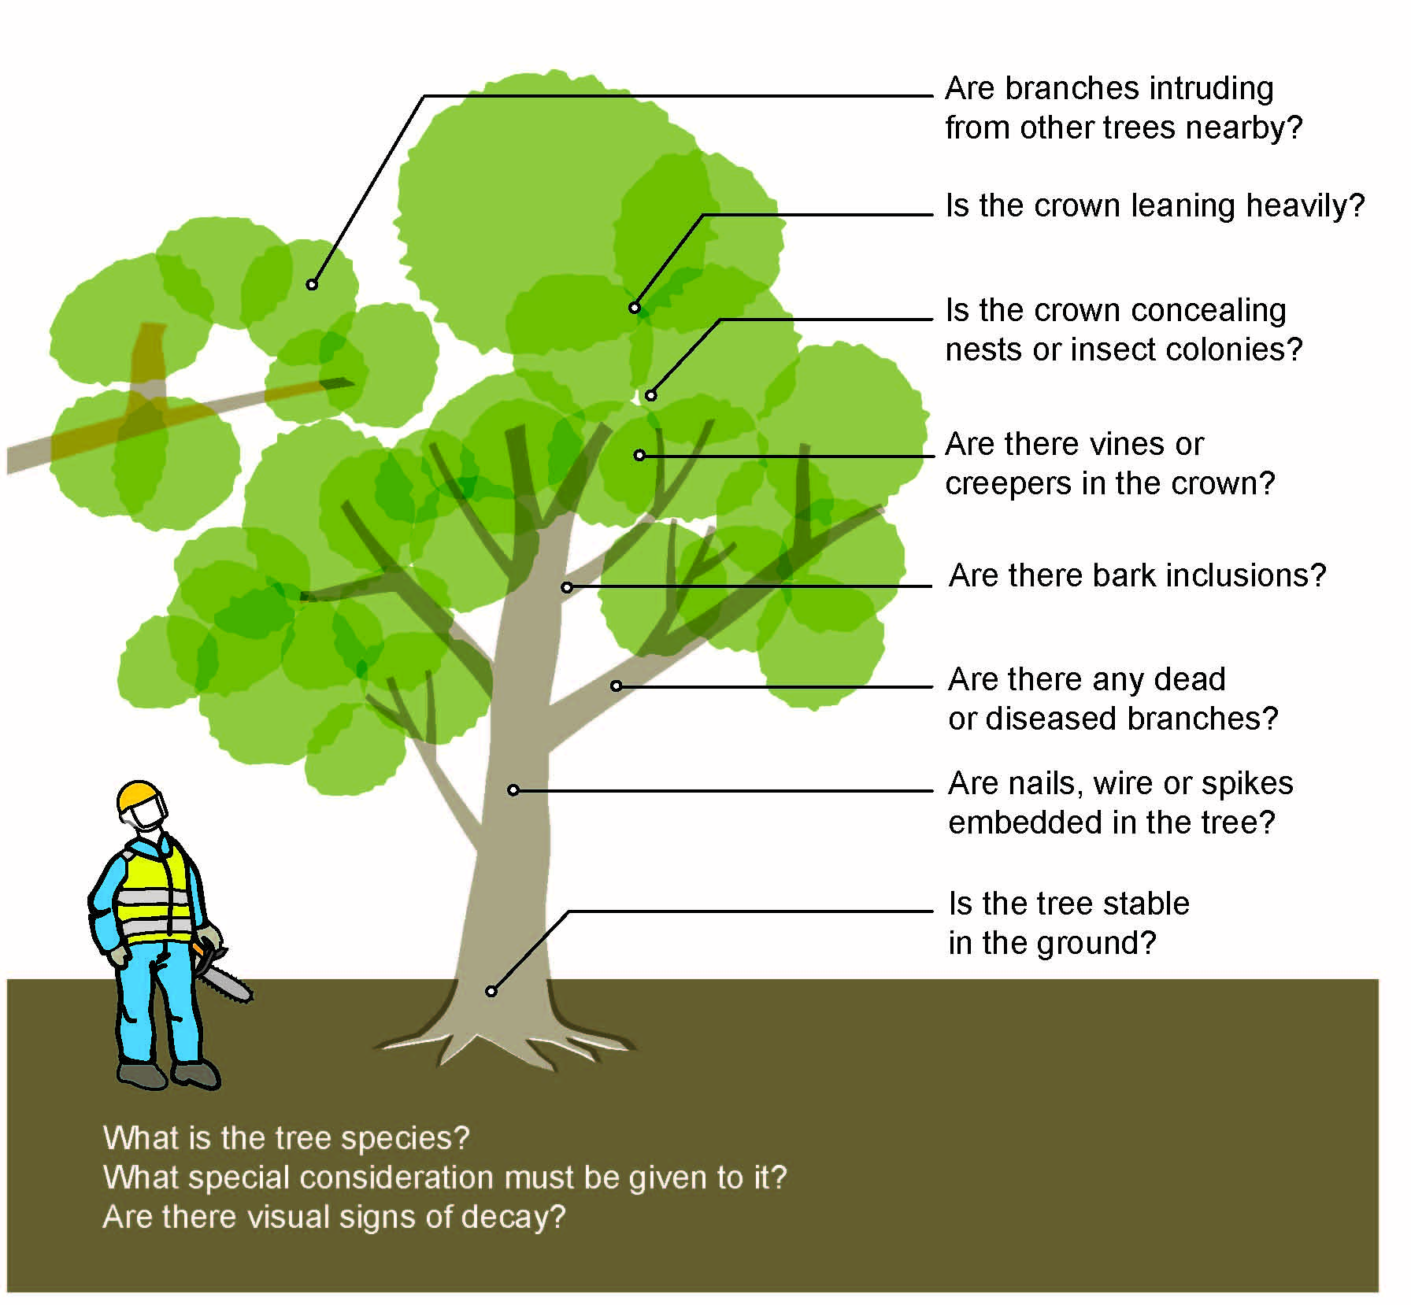
- Assess the risk. In many cases the risks and related control measures will be well known. In other cases you may need to carry out a risk assessment to identify the likelihood of somebody being harmed by the hazard and how serious the harm could be. A risk assessment can help you determine what action you should take to control the risk and how urgently the action needs to be taken.
When carrying out a risk assessment think about:
- The stability and integrity of the tree:
- Is the tree decayed or dead and unsafe to climb or be attached to?
- Is the species or the particular tree susceptible to branch failure when under load?
- Is the tree stable in the ground?
- Is the crown of the tree leaning heavily in one direction?
- Is the tree suitable to be climbed?
- Ensure that no person, plant or thing will come within an unsafe distance of an overhead electric line.
- Ground surface condition including type of soil, underground services, underground tanks, leach drains and gradients of ground surface.
- Maintenance of plant and equipment.
- Access by people and management of traffic.
- Animal and insect management e.g. are there insects or other animals in the tree that may be a risk to a worker?
- Workers being trained including in emergency procedures, working near overhead or underground services, use of equipment, work tasks and on-site communication.
- Action plans about hazards and the nature of the work including number of workers, each worker’s role and job process after discussion with workers.
- Weather conditions including heat, humidity and wind speed are suitable to start the job and are monitored to ensure they are suitable to continue working.
- Common hazards like vines, creepers in crown, nails and wire are identified and removed or controlled.
- Personal protective equipment (PPE) is fit for purpose and, where appropriate, in accordance with the relevant Australian Standard.
- Establishment of exclusion zones.
- Take action to control the risk. The WHS laws require a business or undertaking to do all that is reasonably practicable to eliminate or minimise risks.
The ways of controlling risks are ranked from the highest level of protection and reliability to the lowest. This ranking is known as the hierarchy of risk control. You must work through this hierarchy to manage risks.
The first thing to consider is whether hazards can be completely removed from the workplace. For example, carry out the work from the ground as this eliminates the risk of falls and issues with tree integrity.
If it is not reasonably practicable to completely eliminate the risk then consider the following options in the order they appear below to minimise risks, so far as is reasonably practicable:
- Substitute the hazard for something safer e.g. redesign the work process so less hazardous equipment, materials or quantities are used; use plant specifically designed to lift a person like an elevating work platform (EWP) to gain access to the tree rather than climbing the tree.
- Isolate the hazard from people e.g. set up a restricted work area; minimise emissions and noise from machinery through venting and containment or isolation barriers.
- Use engineering controls e.g. a boom-mounted pruner.
If after implementing the above control measures a risk still remains, consider the following controls in the order below to minimise the remaining risk, so far as is reasonably practicable:
- Use administrative controls e.g. rotate jobs and vary tasks to minimise the risks associated with repetitive manual handling tasks; provide safety information, training and instruction; use written safe work procedures.
- Use PPE e.g. safety eyewear, face shields, hearing protection, safety helmets, boots, cut-resistant leg protection and reflective, high-visibility clothing.
A combination of the controls set out above may be used if a single control is not enough to minimise the risks.
Consider all possible control measures and make decisions about those controls which are reasonably practicable for the workplace. Deciding what is reasonably practicable includes the availability and suitability of control measures, with a preference for using substitution, isolation or engineering controls to minimise risks before using administrative controls or PPE. Cost may also be relevant, but only consider this after all other factors have been taken into account.
- Check control measures regularly to ensure they remain effective and that the system is working as planned, taking into consideration any changes in how the work is carried out.

Who is involved?
Workers and their health and safety representatives (if any) must be consulted when deciding how to manage the risks of tree trimming and removal work.
If there is more than one business or undertaking involved at the workplace they must also be consulted to find out who is doing what. The businesses must work together so risks are eliminated or minimised, so far as is reasonably practicable.
This may involve discussing site-specific requirements, for example the location, maintenance and monitoring of exclusion zones, pedestrian access and traffic management on and around the work site; and developing job safety plans.

Information, training, instruction and supervision
Tree trimming and removal of trees—especially large trees—is dangerous work. This work should be carried out by workers appropriately trained and experienced.
PCBU’s must ensure workers have the level of training to enable them to perform their designated tasks safely and competently. Information, training, instruction and supervision given to workers must take into account the nature of the work carried out by the worker, the associated risks and measures implemented to control the risks. This includes providing relevant site specific or equipment specific training before work starts.
Most tasks carried out in tree trimming and removal work are covered by National Units of Competency (UoC) developed by the arboriculture industry.
There are a number of recognised qualifications available for anyone who wants to work in the arboriculture industry. These qualifications include a Statement of Attainment, Certificate III in Arboriculture, a Diploma of Arboriculture and an Advanced Diploma of Horticulture.
Training for these national units of competency is available from registered training organisations throughout Australia.
Further information can be found on the Australian Government’s training website.

Ground work
Ground work for tree trimming and removal work can involve different work activities. In some instances the work may need a minimum of two workers carrying out the activity for the safety of workers and those passing by. The tasks assigned to each worker should also take into account the worker’s ability to carry out the work.
When assessing the risks associated with work tasks, the following should be considered:
- the worker’s experience
- their familiarity with the specific task
- their understanding of the hazards
- their knowledge of the planned control measures, and
- their skills and qualifications with the plant and equipment being used.

Worksite communication
Worksite communication methods should be agreed before workers start work. The way workers communicate will depend on the tasks being carried out, the equipment being used, noise implications and the location of workers at the worksite.
Methods for communicating at a worksite include using:
- two-way devices especially if a worker is elevated in a tree or on a temporary work platform
- hand signals
- whistles, and
- mobile telephones.

METHODS for accessing trees
Trees can be accessed by using EWPs or climbing.
PPE should be used for all access tasks. This can include eye, hearing, hand and leg protection as well as protective boots and helmet.
Clothing should generally be close fitting and of high-visibility. If using a chainsaw in a tree pants should be cut-resistant—see AS/NZS 4453.3:1997 Protective clothing for users of hand-held chainsaws – protective legwear.
Workers carrying out above ground work should be qualified for the type of work being done.
Before accessing a tree by any method a visual tree assessment should be carried out by a competent person. The assessment should include the tree’s overall condition and structural integrity with consideration given to structural faults like bark inclusions, decay, hollows, growth habit, species of tree and root plate failure. The assessment should also consider wind loading and the tree’s location. This information should inform whether the tree is safe to access, the method to access and attach to the tree, emergency rescue measures along with rigging and removal techniques. Common hazards and risks of accessing trees are outlined in Table 2 with example control measures in Table 3.
Table 2 Common hazards and risks of accessing trees
- slipping out of harness not positioned correctly
- slipping or falling from branches due to failure of anchor points
- dehydration and fatigue
- musculoskeletal disorders from awkward positions
- falling from height due to incorrect use of ropes, knots and devices like descenders
- being struck by falling objects or a throw bag
- wildlife related injuries e.g. from wasps, bees, birds, possums
- falling from an EWP
- contact with overhead electric lines

Table 3 Examples of control measures for accessing trees
- checking the location of overhead electric lines before starting work—further information is in Chapter 4 - Tree work near overhead electric lines
- conducting a site specific hazard and risk assessment
- using an EWP
- using a rope access system
- establishing and maintaining an exclusion zone
- having a spotter to maintain the exclusion zone while work is being done in the tree
- ensuring the harness and climbing spikes fit correctly and are comfortable
- being attached at all times e.g. to an EWP
- planning a clear access route
- checking the tree for bees, wasps or other animals before accessing
- checking anchor points thoroughly before leaving the ground
- weighting your climbing system before disconnecting your second point of attachment
- having an emergency plan including an aerial rescue procedure
- ensuring traffic control measures are in place within the established exclusion zone when working on or above roads

Elevating work platforms
EWPs specifically designed to lift people should be used to access a tree, where reasonably practicable. These minimise hazards like dehydration and fatigue from climbing trees and are designed as a working platform to prevent the worker falling.
If an EWP is being considered to trim or remove a tree the following should be considered:
- If it is safer to trim or remove the tree from the ground?
- Are there obstacles, structures like buildings and other trees present at the site posing a risk to health and safety or make access impossible using an EWP?
- Are there underground services present, for example water, gas, telephone, electricity that may restrict access or locations to set up temporary platforms?
- Do overhead electric lines create a risk for a worker because of the EWP’s position?
- Is the ground level, uneven, sloping, firm or loose and could this lead to the EWP overturning? Unless designed for rough terrain, EWPs should only be used on a solid, firm and level surface where there are no obstacles that may cause uncontrolled movement.
- Can the EWP safely reach the height necessary to trim or remove the tree?
- Does the worker need to lean outside the structure of the EWP?
- Will the cutting or lowering of the limb, branch or section of the tree be impeded by the use of the EWP?
Types of EWPs commonly used to access trees for trimming and removal work include:
- trailer mounted EWPs (see Figure 2)
- self-propelled EWPs with telescoping boom including knuckle boom (see Figure 3), and
- vehicle mounted EWPs (see Figure 4).
Figure 2 Figure 3 Figure 4
Trailer mounted EWP Self-propelled EWP Vehicle mounted EWP
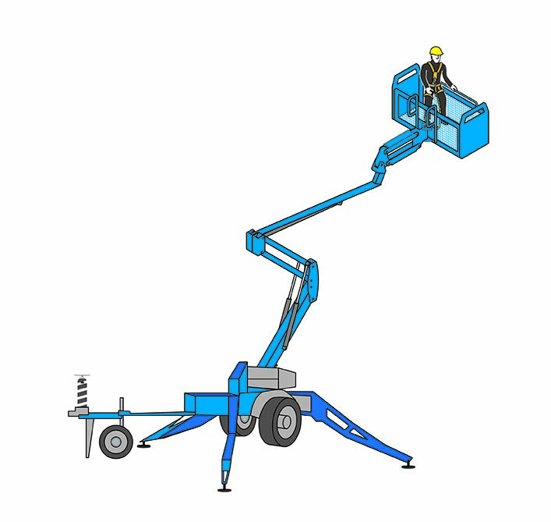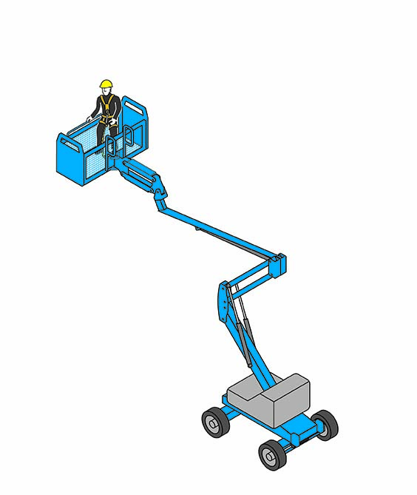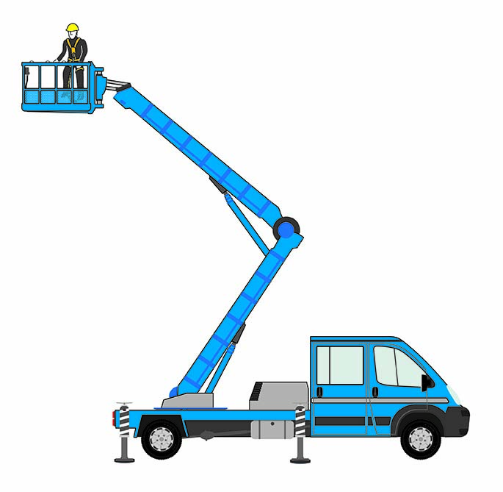
Scissor lifts are another common type of EWP but their use in tree trimming and removal work is limited because they have a greater risk than a boom-type EWP of being struck or knocked over by falling branches or trunks. This is because their supporting structure is directly underneath the working platform. Their use is also generally restricted to flat and firm unsealed surfaces. Scissor lift-type EWPs should not be used unless the risk of falling branches or trunks striking the unit can be eliminated.
The correct type of EWP must be selected for the type of work being carried out. When selecting the type of EWP to be used the following things should be considered:
- the ground and weather conditions
- access limitations
- the type of tree trimming and removal work to be done
- the height and reach required
- the number of workers required on the EWP, and
- the lifting capacity required.
EWPs may not be reasonably practicable to use where:
- a worker cannot get close enough to the tree to trim the tree safely
- a tree is too large
- the EWP may impede the cutting or lowering of the limb, branch or section of tree
- the ground is sloping or unstable, or
- there are buildings or other infrastructure in the way.
Common hazards and risks of using an EWP are outlined in Table 4.
Table 4 Common hazards and risks of using an EWP for tree trimming and removal work
- coming in contact with overhead electric lines and adjacent structures
- windy conditions
- falls from height
- unstable, sloping, uneven or soft ground e.g. recently filled excavations that could lead the EWP to overturn
- being struck by falling objects
- wildlife related injuries e.g. from wasps, bees, birds, possums
Operators of EWPs should be assessed as competent against the relevant national UoC. As different types of EWP require different competencies to operate, training in the specific type of EWP being considered for the work should be provided.
Note: The use of a boom-type EWP with a boom length of 11 metres or more requires the operator to hold an EWP high risk work licence.
The operating crew should consist of at least two workers, with one to remain on the ground as a safety observer or spotter. The nominated ground worker should also be trained in the operation of the lower vehicle-mounted controls to lower the platform in an emergency.
A copy of the operator’s manual should be kept with every EWP. Operators should read the manual and be familiar with it before operating the machine. EWPs should be operated according to the manufacturer’s instructions.
A pre-start safety check should be carried out on the EWP in accordance with the manufacturer’s instructions to identify damaged or faulty equipment and to ensure the EWP is safe to operate. The safety check should also ensure the emergency descent is functioning correctly.
The EWP operator and safety observer should establish an exclusion zone prior to work commencing to ensure pedestrians and others are not entering the danger zone.
An appropriately trained safety observer or spotter should be in place to monitor clearances between the operating EWP and overhead electric lines, traffic, adjacent structures or other hazards. The safety observer should have a means of communicating with the EWP operator at all times.
The safety observer function should be a designated role. They should not be distracted by carrying out other tasks or duties while the EWP is being used.
In addition to the above, Table 5 outlines control measures that should be considered when using EWPs for tree trimming and removal work.
Table 5 Examples of control measures for using an EWP for tree trimming
Control measures for EWP use include:
- Ensuring every person in the EWP wears a full body fall-arrest harness complying with AS/NZS 1891.1:2007: Industrial fall-arrest systems and devices – Harnesses and ancillary equipment. Harnesses must be attached to the purpose-built anchor points provided on the EWP.
- Checking the location of overhead electric lines before starting work. If overhead electric lines are present the state or territory Electricity Supply Authority or Electricity Regulator should be contacted to find out the extent of the work zones, approach distances and any specific work requirements that apply to working in the vicinity of the overhead electric lines.
- Ensuring the rated capacity of the EWP is not exceeded. The rated capacity includes the weight of the operator, any other person on the platform, tools and branches or other debris.
- Not operating the EWP on gradients that exceed the manufacturer’s instructions and where possible keeping the EWP’s boom on the uphill side of the EWP’s base.
- Ensuring traffic control measures are in place within the established exclusion zone when working on or above roads. All parts of the EWP should remain clear of traffic hazards. Operators should be aware of potential tail or knuckle swing into traffic areas.
- Not using the EWP when wind speeds exceed the manufacturer’s recommendations.
- Ensuring tyres are inflated to the correct pressure in accordance with the manufacturer’s recommendations. This is critical for the stability of EWPs when outriggers are not being used. If outriggers are required for stability they should be engaged before the platform is raised.
- Ensuring ground surface conditions are checked. Soft soil, underground services, tanks, drains and pipes can collapse under the weight of the EWP or outriggers and cause the EWP to tip over.
Suggested controls for working from the EWP include:
- Not positioning the EWP under the branch to be trimmed or removed. The EWP should be located at or above the level of the cut.
- Keeping the platform free of debris and tree off cuts. Hand tools carried within the platform should be secured.
- Ensuring no fuel is carried in the EWP and refuelling is done on the ground outside the EWP cage or bucket.
- Not attaching ropes between the EWP and any part of the tree. An EWP is not to be used as a crane. An independent rope should be used to lower offcuts.
- Wearing PPE e.g. a safety helmet, gloves, eye protection and safety footwear. Chainsaw operators should also wear cut-resistant leg protection and hearing protection.
- Always keeping harnesses attached to the anchor points within the EWP.
- If climbing from the EWP into a tree, the climber should wear a harness suitable for tree climbing and be attached to the tree—having loaded the anchor point—before releasing the anchorage on the EWP.
Further information on the safe use of EWPs is in AS 2550.10-2006: Cranes, hoists and winches – Safe use – Mobile elevating work platforms.
Further information on fall-arrest harnesses is in AS/NZS 1891.1:2007: Industrial fall-arrest systems and devices – Harnesses and ancillary equipment and AS/NZS 1891.4:2009: Industrial fall-arrest systems and devices – Selection, use and maintenance.

Climbing a tree
Other methods of accessing trees, for example using EWPs should be considered before attempting to climb a tree. Tree climbing is a dangerous and complex activity. It should only be done by workers assessed as competent against the relevant national UoC. Tree climbing should only be done by people who are physically fit and not affected by alcohol or drugs including prescribed medication which may affect or impair their ability to work at heights. Before climbing a tree a risk assessment should be conducted by a competent person to consider any special techniques required and weather conditions.
Tools carried and used by the climber should be safely secured when not in use. If the climber is using a chainsaw the climber should be secured to the tree using steel-core rope flip-lines that provide two points of attachment at all times. Some species of tree or damaged trees may require two points of attachment when moving location.
The chainsaw should be secured to the climber in a way that allows the chainsaw to hang in a position that will not hinder the climber’s free movement or create a hazard for the climber or other workers.
When climbing large trees in hot or humid climates the climber can suffer dehydration and fatigue from humidity and heat. Therefore frequent drinks and work breaks may be required.
Overhead electric lines running through trees may also expose a climber to the risk of electric shock resulting in electrocution.
The climbing crew should consist of at least two workers with one worker to stay on the ground as a safety observer or spotter. The nominated ground worker should also be trained in aerial rescue techniques. The tree climber and ground worker should ensure regular visual or verbal communication is maintained. Chapter 7 – Rescue and emergency planning provides further information on considerations on developing emergency and rescue procedures. An exclusion zone must be established before work starts to ensure pedestrians and others are not entering the danger zone.

Tree climbing equipment
Tree climbing equipment must be suitable for its intended use, be used and maintained in accordance with the manufacturer’s instructions and be stored and protected from damage including during transit.
Equipment used to climb a tree can include:
- rope
- harnesses
- karabiners and snap hooks
- ascenders, descenders and rope grabs
- climbing irons (spikes)
- lanyards, and
- pulleys.
Tree climbing equipment should be inspected and assessed by the climber before and after each use. A competent person who is not the regular user of the equipment should also check the equipment regularly, for example every three months. Cleaning and maintenance of tree climbing equipment should be carried out on a regular basis according to manufacturer’s instructions.
Further guidance is in relevant Australian Standards including AS/NZS 1891.4:2009 Industrial fall-arrest systems and devices – Selection, use and maintenance.

Single rope access systems
Single rope access systems can be used to access some trees, usually by vertically suspended ropes. This should only be carried out by workers who have been trained and are competent in this method of accessing trees.
When the integrity of the tree may make it unsafe for a worker to work in the tree or where there are doubts the tree can hold the load, other methods for access should be used, for example EWPs. The potential for contact with overhead electric lines should also be considered when using this method.

Other methods

Crane access method
Another access method for carrying out tree trimming and removal work is by lifting or suspending a person in a harness with a crane—Regulation 221 of the model WHS Regulations. Queensland, the Northern Territory and New South Wales allow this method to be used to access a tree. You should contact your local regulator for further information.

Ladders
There are significant risks accessing trees using ladders. Tree trimming or removal work should not be done from ladders.

Tree work near OVERHEAD ELECTRIC lines
Overhead electric lines pose significant risks when carrying out tree trimming and removal work. When assessing the risks of working near overhead electric lines the following should be considered:
- overhead electric lines hidden in trees
- de-energising overhead electric lines running through tree branches before accessing the tree, and
- contacting the relevant electricity supply authority for information on specific requirements when working near overhead electric lines including qualifications required for people working near overhead electric lines.
Most risks can be addressed by observing safe working distances for workers and plant when near overhead electric lines. The distances will depend on the type of work being carried out and the voltage of the overhead electric lines.
Table 6 provides examples of control measures when operating in the vicinity of overhead electric lines.
Table 6 Examples of control measures when operating in the vicinity of overhead electric lines
- ensuring no person, plant or equipment goes too close to overhead electric lines by using a safety observer (spotter) on the ground who has received training on working in the vicinity of overhead electric lines
- providing and maintaining insulated tools and equipment e.g. an EWP which is tested regularly
- connecting the chassis of the EWP to the ground by braided copper cabling or metal earthing spikes when working near high voltage electric lines
- using PPE e.g. cotton or fire retardant long sleeve clothing, insulating gloves, protective non-slip safety boots and a safety helmet
- contacting the state or territory Electricity Supply Authority or Electricity Regulator to find out the extent of work zones, approach distances and specific work requirements that apply to working in the vicinity of overhead electric lines e.g. getting a permit to work when likely to come within approach distances

machinery and equipment

Wood chippers
Wood chippers are used in tree trimming and removal work to reduce tree waste—generally tree limbs and branches—into wood chip or mulch. Although the design of individual wood chippers may vary they all use the same principle—a rotating disc or drum fitted with hardened steel blades to chip the wood.
It is easier to use wood chippers to chip tree branches at the location where the tree has been trimmed or felled than transport whole branches elsewhere to be chipped. Table 7 outlines some of the common hazards and risks during wood chipper operation.
Table 7 Common hazards and risks of wood chipper operation
- being drawn into the machine from in-feed rollers
- coming into contact with the blades
- becoming entangled in the branches or attached ropes and drawn into the wood chipper
- being struck by ejected material
- being struck by in-feeding branches, limbs or logs
- crush injuries
- exposure to noise from the wood chipper
- being struck by a passing vehicle when the wood chipper is parked on the road
- manual handling injuries
The wood chipper operator should stand to the side of the infeed chute and feed tree waste into the wood chipper butt end first. A push-stick should be used for shorter branches to avoid reaching into the infeed chute (see Figure 5). This activity creates a hazard for workers with the potential for serious injury or death if the wood chipper operator becomes entangled or material is ejected from the wood chipper during the feeding process.
Figure 5 Using a push-stick to feed shorter branches into a wood chipper
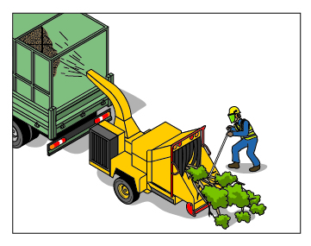
Examples of controlling risks associated with operating wood chipping machines are in Table 8.
Table 8 Examples of control measures for wood chipper operation
- Parking the machine off the road wherever possible. If this cannot be achieved ensure adequate traffic management is in place.
- Ensuring guards for all dangerous parts e.g. cutting discs, drive shafts, belts and pulleys are in place, secure and undamaged.
- Stopping the machine, isolating the power and waiting for moving parts to stop spinning before attempting to remove blockages.
- Ensuring a plant isolation process is carried out as per manufacturer’s instructions.
- Ensuring the wood chipper is set up with sufficient clearance from the immediate working area or drop zone to remove the risk of entanglement from climbing or lowering ropes.
- Conducting pre-start checks to ensure equipment has been set up correctly and systems are performing accurately.
- Ensuring emergency stops and control bar are functioning properly.
- Operating the machine in accordance with the manufacturer’s instructions.
- Ensuring operator controls on the machine are clearly labelled to indicate their nature and function.
- Ensuring operating teams consist of at least two people competent in the use of wood chipping machines and have received specific training on the individual machine being used.
- Ensuring the material to be chipped is free from metal, stones, plastic, rope and other forms of contamination that could damage and effect the safe operation of the machine.
- Feeding branches into the machine butt first and releasing the material when it is gripped by the in-feed rollers.
- Feeding branches off the centre line. Where reasonably practicable, the operator feeding the branches into the wood chipper should do so from the kerb side.
- Using a ‘push-stick’ at least 1.5 m long to feed shorter material into the machine (see Figure 5).
- Never reaching into the in-feed chute without stopping the in-feed rollers.
- Fitting the drop down table at the rear.
- Ensuring no rings, watches, necklaces or other jewellery are worn by operators.
- Ensuring the wood chipper is not left unattended while in operation.
- Ensuring operators wear PPE to protect their eyes and hearing. Wearing close-fitting clothing without loose cuffs, straps or strings. Gloves should be single-stitched and have long close-fitting cuffs that can be tucked into the sleeves.

Rotating in-feed rollers and the cutting disc or drum
Rotating in-feed rollers and the cutting disc or drum are the most hazardous components of wood chipping machines.
The in-feed rollers and cutting disc are shown in Figure 6. It is these rollers and cutting disc that can cause serious injury to the wood chipper operator if they reach into the machine past the safety curtain or control bar.
Figure 6 Disc-type wood chipper showing in-feed rollers and cutting disc
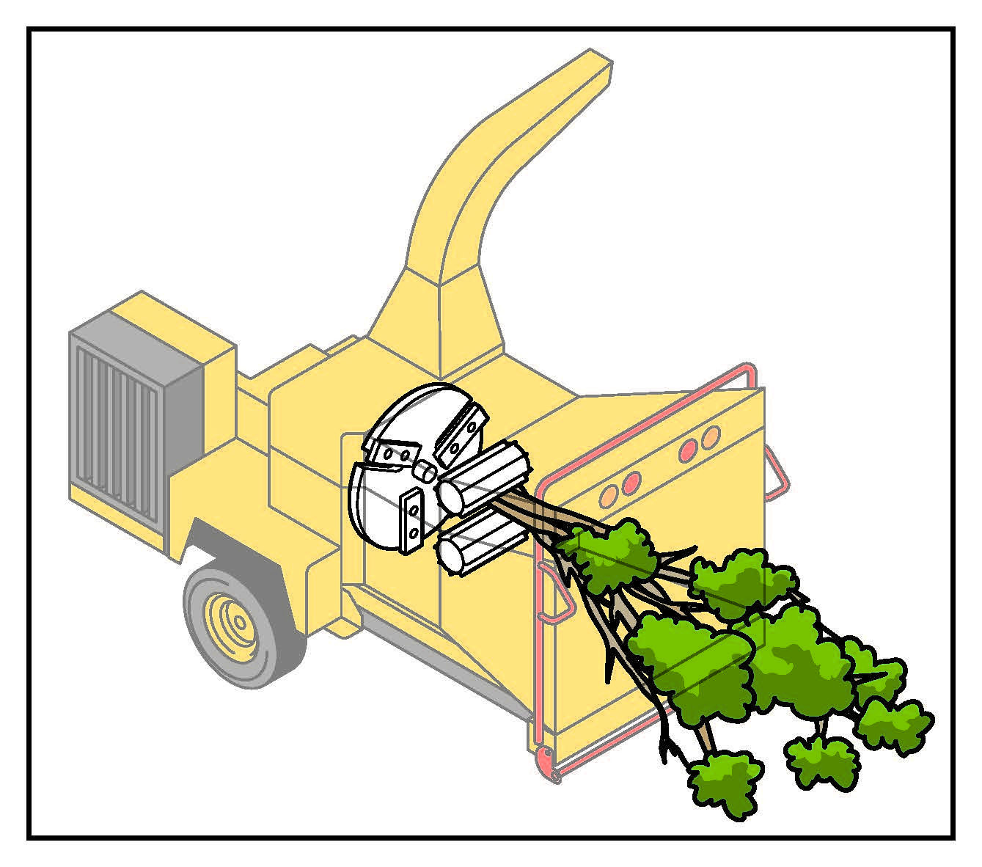
Workers operating wood chippers can also become entangled while standing beside or in front of the in-feed chute or while they are feeding material into the wood chipper. If ropes, clothing or gloves are caught on a branch being fed into the wood chipper, the worker can be dragged past the safety curtain and the in-feed rollers onto the cutting blades.
All wood chippers require access to the cutting disc or drum for maintenance, operation and cleaning purposes. Opening the access hatch or cover can allow the operator to come into contact with the moving disc or drum and expose them to the risk of entanglement, cutting and being hit by ejected fragments of vegetation or cutting blades.
You can prevent access to the in-feed rollers by:
- ensuring the design of the in-feed hopper or chute includes a suitable minimum-reach distance guarding (1500 mm is recommended) from the leading edge of the feed hopper to the in-feed rollers, and
- ensuring the side panels of the in-feed chute are also of a sufficient height to prevent a person reaching the in-feed rollers or prevent access from the side or top of the unit by a fixed or interlocked guard.
Before accessing the inside of a wood chipper, the controls for the chipper should be isolated to prevent inadvertent operation of the unit. One method is to have the starter key in the possession of the worker inside the wood chipper. This will minimise another worker being able to turn on the machine with someone inside.
An emergency stop or emergency shut-off device that shuts down power to the machine should also be provided. This device should immediately stop the in-feed rollers and cut the power to the cutting disc or drum which will typically have a run down time. These devices should be immediately accessible to the operators in an emergency and tested and verified to be functioning properly during the pre-start check each time the wood chipper is to be used.
The operator control device used to set the rotation of the in-feed rollers from feed to reverse should be clearly identified showing the four stages of operation – reverse, neutral/stop, feed and reverse (see Figure 7).
Figure 7 Four stages of wood chipper operation
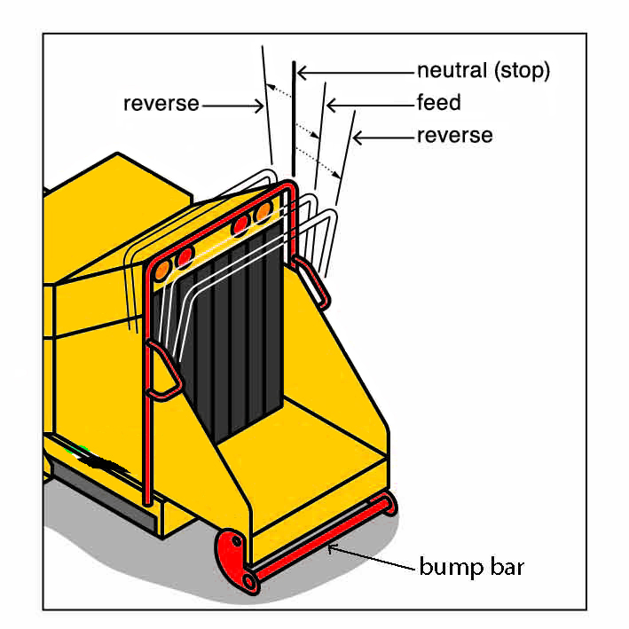
For extra protection, consideration should be given to retro-fitting existing wood chippers with an in-feed stop control device also known as a push bar or bump bar, along the bottom leading edge of the in-feed chute. This device should stop the in-feed rollers when a person uses body pressure to push against the bar.
On wood chippers where the tray of the in-feed chute is less than 600 mm high, consideration should also be given to fitting side in-feed stop control bars that have the same function as the push bar devices and are also activated by limb or body pressure.
Wood chippers not fitted with an in-feed stop control device or where the tray of the in-feed chute is less than 600 mm high should be operated by two operators to ensure unhindered access to the emergency stop button.
Access to the cutting disc or drum can be prevented by providing interlocked physical barriers. These may include:
- electronic interlocked systems e.g. motion control sensors or timed solenoids, or
- mechanical interlocking systems e.g. the method of attachment (bolts, screws) of any access hatch or cover over the cutting disc or drum requires the time taken to remove the bolts or screws is longer than the time taken for the disc or drum to come to a complete stop after the power has been isolated (run down time)—a disc or drum chipper can have a run down time of up to five minutes if it is an un-clutched system.
The cutting disc or drum should be maintained to the manufacturer’s specifications. A mechanical means of preventing the disc or drum from rotating should be used while performing maintenance operations.

Winches
Wood chippers can be fitted with a winch to assist in pulling branches or trunks toward the chipper.
Anyone operating a wood chipper with a winch attached should:
- be assessed as competent against the relevant national UoC
- be trained in the correct operation of the winch on each specific machine, and
- maintain any ropes that form part of the winch and ensure the ropes are checked for suitability on a regular basis.

Stump grinders
Stump grinders use a rotating cutting disc or wheel to grind away stump wood and surface roots to below ground level. Figure 8 shows an example of a stump grinder.
Figure 8 Example of a stump grinder
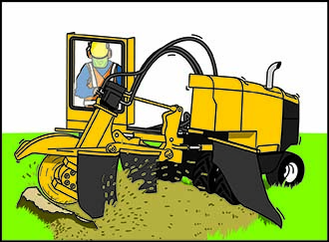
Stump grinders can create hazards for workers and other people who may be near the stump grinding operation. Table 9 outlines some common hazards associated with this work.
Table 9 Common hazards and risks of stump grinder operation
- roll-over of plant
- coming into contact with grinding disc or wheel
- being struck by ejected material
- exposure to noise from the stump grinder
- arm or hand vibration
- manual handling injuries
- dust inhalation
- contact with live underground services
Before stump grinding is carried out a number of precautions should be considered including:
- Checking for underground services around the stump (call Dial Before You Dig).
- Establishing an exclusion zone.
- Looking for loose stones, pipes, metal, concrete or other debris that could affect the safe operation of the machine or become dangerous projectiles.
- Manually excavating and exposing buttress roots.
- Ensuring machine guards and debris curtains are suitable to the task and securely in place.
- Making sure teeth and teeth mounting pockets on the cutting wheel are sharp and secure.
- Checking the safety cut-off or emergency stop is in working order during the pre-start check each time the grinder is used.
The operator must be fully trained in the stump grinder’s operation including any safety features and the manufacturer’s instructions. Contact with the stump should be with the lower-outer quadrant of the grinding wheel to prevent a kickback reaction.
Stump grinders should be used in accordance with the manufacturer’s instructions.
Respiratory protection should be used for dust and when chemicals have been used to poison stumps.
A protective screen or barrier (see Figure 9) should be set up to separate people from the stump grinding operation. The barriers should also stop flying debris and warn people stump grinding is in progress.
When stump grinding operations are carried out close to road verges or footpaths the cutting head should be positioned to direct wood chips away from passing traffic and pedestrians.
Figure 9 Protective barriers separating people from stump grinding operations.
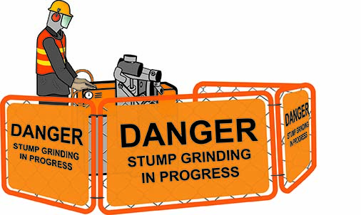
Table 10 outlines control measures for stump grinder operation.
Table 10 Examples of control measures for stump grinder operation
- Setting up an exclusion zone to ensure pedestrians are kept a safe distance from stump grinder operations.
- Not leaving the controls while the cutting wheel is moving.
- Avoiding working downhill from the machine wherever possible.
- Ensuring the cutting wheel is not moving before cleaning excess grindings away from the grinding area.
- Stopping the machine, isolating the power and waiting for moving parts to stop spinning before attempting to clear blockages.
- Wearing PPE e.g. respiratory, eye, hearing and foot protection.
Control measures may be needed to ensure excavations do not create a trip hazard for pedestrians or other workers once the stump grinding operations are completed.

Chainsaws
Chainsaws are potentially dangerous types of plant that can cause fatal or major injuries especially if used by untrained workers. Operators should have received training in the use of the chainsaw. Workers should be assessed as competent against the relevant national UoC for the task to be carried out.
Chainsaws should not be operated above shoulder height due to the risk of musculoskeletal disorders, vibration and reaction forces from the chainsaw. A pole saw could be used for small branches above shoulder height. For larger branches an EWP or other alternatives should be considered.
Common hazards for using chainsaws in tree trimming and removal are outlined in Table 11.
Table 11 Common hazards and risks of chainsaw use in tree trimming
- chainsaw kickback, push-back and pull-in reactions
- severe lacerations
- eye injuries from wood fragments
- being struck by falling trunks, branches and other objects
- exposure to high levels of noise and hand/arm vibration
- musculoskeletal disorders
- fire from fuel source of chainsaw

Chainsaw selection
Chainsaws should be selected for their suitability for the intended work. In general, a chainsaw with the shortest practicable guide bar length for the work to be done should be selected. For tree trimming and removal work, this may mean a range of chainsaws with different guide bar lengths will be required.
Further information on safety requirements for chainsaws is in:
- AS 2726.1-2004: Chainsaws – Safety requirements – Chainsaws for general use
- AS 2726.2-2004: Chainsaws – Safety requirements – Chainsaws for tree service.

Working with chainsaws
Chainsaw operators should observe the safety precautions in AS 2727–1997: Chainsaws – Guide to safe working practices (AS 2727-1997) and Chainsaw operator’s manual.

Starting chainsaws
When starting a chainsaw operators should maintain a safe working distance from other people and ensure the saw chain is clear of obstructions. After refuelling the chainsaw, move away from the fuel source before starting the engine.
When starting a chainsaw with a cold engine, operators should:
- place the saw on level ground and apply the chain brake
- set the controls as stated in the manufacturer’s instructions
- secure the saw e.g. place a foot on the rear handle base plate and a hand on the front handle (see Figure 10), and
- pull the starter cord firmly.
Figure 10 Position to start a cold chainsaw
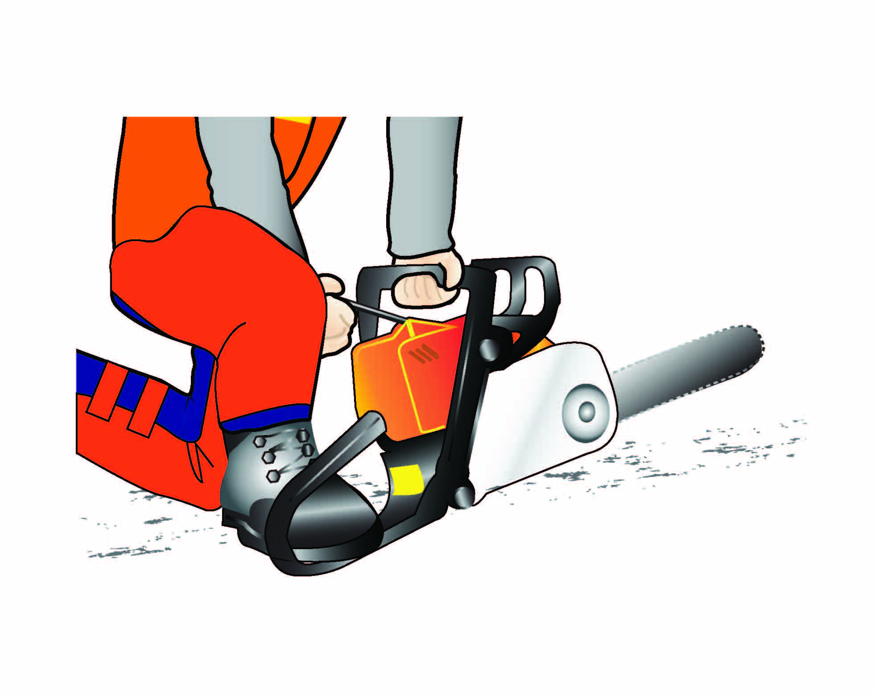
When starting a chainsaw with a hot engine, operators may choose the alternative method of:
- gripping the rear handle firmly between the knees and applying the chain brake
- holding the front handle with their left hand, and
- pulling the starter cord with their right hand.
When preparing to use a chainsaw in a tree the chainsaw should be checked, fuelled, started and warmed up on the ground before it is sent up to the operator in the tree.
Before restarting the saw in the tree operators should ensure the chain brake is applied and the chain tension is adjusted correctly. The saw chain is to be clear of tree climbing equipment, protective clothing and parts of the tree.
Except when working in trees, chainsaws should not be drop started, that is, holding the front handle with one hand and moving the saw in a downward motion while pulling the starter cord up with the other hand.

Kickback
The reaction known as kickback may occur when the saw chain on the upper quadrant of the guide bar tip (see Figure 11) touches an object. In some cases tip contact may cause a rapid reverse reaction, kicking the guide bar up and back towards the operator.
Figure 11 Kickback zone of a chainsaw guide bar
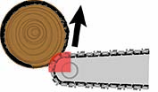

Pushback
Pushback may occur when the chain on top of the guide bar is suddenly stopped due to being pinched, caught or encountering a foreign object in the wood (see Figure 12). The sudden reaction of the saw chain pushes the chainsaw back. Pushback can also occur when the saw chain is not rotating at full speed before it contacts the wood or when the saw is not held securely against the tree or limb being cut.
Figure 12 Chainsaw pushback
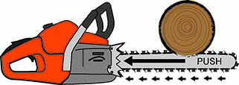

Pull-in
Pull-in may occur when the chain on the bottom of the guide bar is suddenly stopped due to being pinched, caught or encountering a foreign object in the wood (see Figure 13). The sudden reaction of the saw chain pulls the chainsaw forward. Pull-in can also occur when the saw chain is not rotating at full speed before it contacts the wood or when the saw is not held securely against the tree or limb being cut.
Figure 13 Chainsaw pull-in
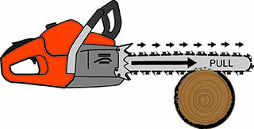
Each of these sudden reactions may cause the operator to lose control of the chainsaw which could result in serious personal injury.
Chainsaw operators should consider the measures outlined in Table 12 to help prevent injuries from the reaction forces that may occur during chainsaw operation.
Table 12 Examples of control measures for chainsaw reaction forces
- The operator is trained and competent to use a chainsaw. Understanding potential reaction forces and when they could occur—an understanding and awareness of kickback, push-back and pull-in can eliminate or reduce the element of surprise.
- Establishing secure footing and maintaining correct balance throughout the cutting operation—operator to stand with the left leg forward to support their back and stabilise them.
- Keeping a firm grip on the chainsaw with both hands when the engine is running. The right hand should be on the rear handle and the left hand on the front handle with the thumbs and fingers encircling the chainsaw handles (see Figure 14). Left handers should grip the chainsaw in the same way. A firm grip will help operators reduce kickback and maintain control of the saw.
- Ensuring the cutting area is free from obstructions and not letting the nose of the guide bar contact a log, branch or other obstruction while the saw is being operated.
- Making the cuts at full or high engine speeds.
- Only cutting one piece at a time and ensuring it is stable before starting the cut.
- Being aware of potential contact with the kickback zone when re-entering a previous cut and not twisting the chainsaw when withdrawing the guide bar from an undercut or bore cut.
- Starting a cut with the spiked bumper or body of the chainsaw in contact with the wood.
- Following the manufacturer’s sharpening, tensioning and maintenance instructions for the saw chain.
Figure 14 Correct chainsaw hold
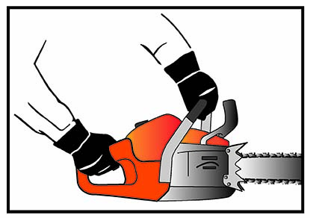

Working with chainsaws in trees
Only trained and competent chainsaw operators should use chainsaws in trees. The size of the chainsaw used should be appropriate for the work task being performed. When a tree climber carries equipment including chainsaws, ensure the total weight of the climber and the equipment is within the working load limit of the climbing system.
When working in a tree above ground the chainsaw should be attached to the climber at all times. A tool lanyard can be used to maintain this attachment. The tool lanyard should be long enough to allow full reach and for the chainsaw to hang in a position that will not hinder the climber’s free movement or create a hazard for the climber or other workers when not in use. The attachment may vary from time to time and may depend on the task being performed. For refuelling or changing chainsaws a rope is used to lower the chainsaw to the ground. Table 13 provides examples of control measures when operating a chainsaw in a tree.
Table 13 Examples of control measures when operating a chainsaw in a tree
- Starting or operating chainsaw only when in a safe and stable working position.
- Using two points of attachment when operating the chainsaw—as far as is reasonably practicable, the two points of attachment should be from independent anchor points.
- Starting the chainsaw close to the working position and ensuring the chain is clear of the operator, obstacles and equipment before starting.
- Using two hands to operate a chainsaw and not operating the chainsaw above shoulder height.
- Switching the chainsaw off when moving between work positions and applying the chain brake between cuts.
- Sharpening, refuelling or maintaining chainsaw out of the tree.
- Wearing cut resistant pants when operating chainsaws.

Chainsaw use on elevating work platforms
When starting a chainsaw on an EWP, the chainsaw should be started outside the bucket or platform. The chainsaw should be attached to the operator, bucket or platform by a tool lanyard.

Personal protective equipment
Chainsaw specific PPE, for example a safety helmet, hearing, eye, leg and foot protection should be worn when using chainsaws for tree trimming and removal work.
Further information on PPE for chainsaw use is in AS 2727–1997.

Cross-cutting
Cross-cutting is cutting wood fibres across the grain and is the most common practice carried out by a chainsaw operator in tree trimming and removal work (see Figure 15).
Operators should stand to the left of the cut when cross-cutting and should not put pressure on the saw when reaching the end of a cut, as excessive pressure may cause the rotating chain and guide bar to suddenly exit the cut and strike the operator.
Figure 15 Cross-cutting the trunk of a felled tree
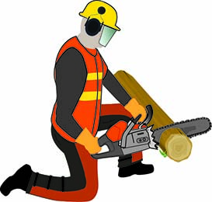
Operators should assess the felled tree, its location and stability for conditions likely to affect the safety of cutting activities.
Operators need to identify the stresses within the tree or section to be cut. Operators should determine the location of the cuts by considering these stresses and plan their sequence of cuts to:
- maintain safe control of the chainsaw and the cut sections, and
- minimise cutting problems.
Compression and tension are the two stresses encountered and these will vary in strength depending on the size and position of the log.
It is the compression forces that normally cause pinching of the chain and jamming of the saw. Normally, compression wood needs to be cut first to avoid jamming (see Figure 16).
Figure 16 Compression and tension forces and cutting sequence
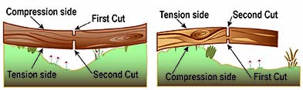
During the cutting process operators should continually assess the tensions and resultant movement to minimise the risk of jamming. Operators should be aware that a kickback hazard may occur if the upper tip of the guide bar is pinched in the cut. They should adjust their cutting techniques in response to any movement in the tree or limbs being cut.
When cross-cutting on slopes there is a risk of the log rolling. Control measures should be implemented to prevent logs rolling down hill, for example planning cut locations to leave downhill branches attached; securing the log with rope or chocking; and having operators working on the uphill side.
Further information on cross-cutting and the safe use of chainsaws is in AS 2727–1997.

De-limbing
The removal of branches and limbs from felled trees can be a dangerous process due to the number of potential chainsaw kickback hazards.
It is common for branches and limbs on the sides and under-side of the tree to be under extreme tension or compression from the tree’s overlying weight. Common hazards of de-limbing are outlined in Table 14.
Table 14 Common hazards and risks of de-limbing
- kickback from the chainsaw
- recoil of springing branches
- rolling or sudden movement of the tree
It is important to identify the tension and compression forces in branches before the removal process starts. This can be done visually by examining the branch and assessing where the tension is, or manually by lifting or pushing against the branch to feel where the tension exists.
In addition to identifying the compression and tension forces in limbs and branches, operators should also observe the control measures outlined in Table 15 when performing de-limbing operations.
Table 15 Examples of control measures when de-limbing
- Working on the upper side of the tree when on slopes or in situations where the tree may roll.
- Maintaining a safe working position by adopting a secure and balanced stance and not using the chainsaw above shoulder height.
- Ensuring the chainsaw remains on the opposite side of the tree (see Figure 17) and activating the chain brake when moving along or around the tree.
Figure 17 De-limbing
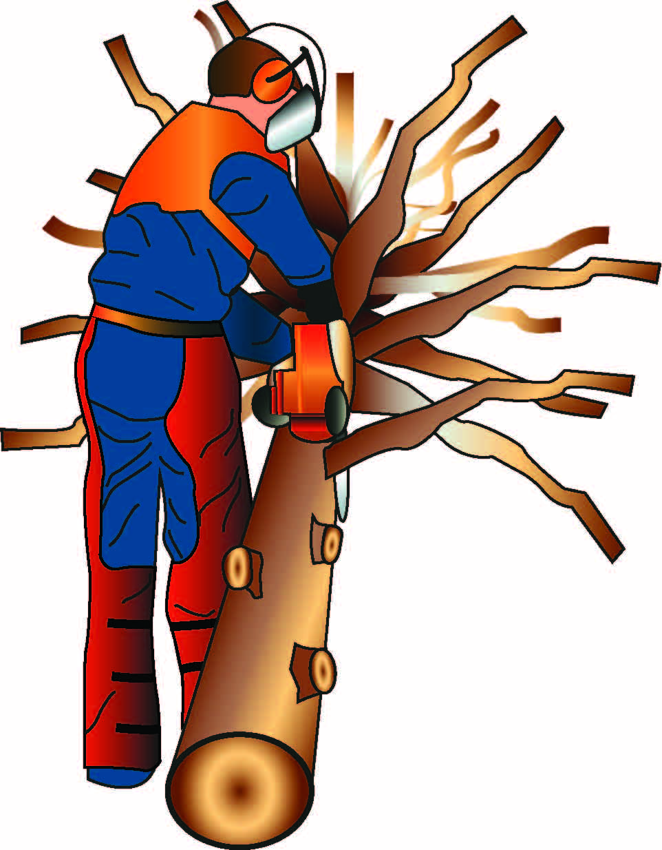
Further information can be found in AS 4373-2007: Pruning of amenity trees.

Boring or plunge cutting
A boring or plunge cut is the term used to describe a cut where the nose of the guide bar is pushed into the tree or log. The activity is very dangerous due to a high risk of kickback if the operation is not carried out correctly. It should not be attempted by inexperienced chainsaw operators.
In situations where it is necessary to use the boring cut, operators should implement the control measures outlined in Table 16 to minimise the risk of kickback.
Table 16 Examples of control measures of boring or plunge cutting
- Ensuring the saw chain is sharpened to the manufacturer’s specifications paying particular attention to the depth gauges.
- Ensuring the saw chain is tensioned correctly.
- Keeping a firm grip on the saw with both hands and with the thumb around the front handle (see Figure 14).
- Running the chainsaw at full speed before making contact with the wood and maintaining full speed as contact is made.
- Making the cut using the following technique:
- Starting the cut at an angle to the direction in which the boring cut is to be made (see Figure 18).
- As the saw enters the wood allowing it to feed itself without placing undue force on the guide bar.
- Gradually pivoting the saw when the tip of the guide bar is covered by the log and is boring straight into the wood.
- Keeping out of the line of the guide bar during the cutting operation.
Figure 18 Cutting sequence for boring or plunge cutting
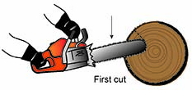
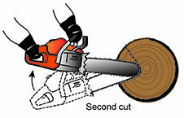
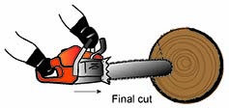

Pole saws
Pole saws are designed for light to medium trimming of elevated tree limbs and branches. They can be petrol, electric (battery or mains), hydraulically or manually powered.
Pole saws are available in a variety of rigid, fixed length; and extendable models (see Figure 19).
Operators of pole saws should be assessed as competent against the relevant national UoC and have the relevant skills and knowledge to use the pole saw safely. Operators should not stand directly under the branch being removed. Care should also be taken to minimise the risk of musculoskeletal disorders when using such equipment as long-handled tools can become difficult and tiring to operate after prolonged use.
Operators should also take care to avoid jamming the saw when attempting to cut branches with a diameter greater than the length of the guide bar.
Figure 19 Extendable pole saw
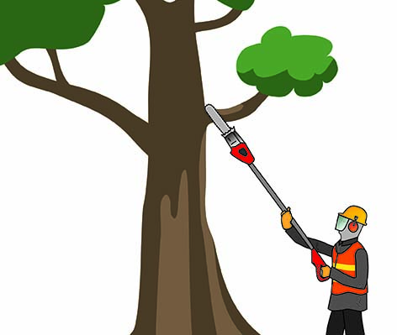
Common hazards and risks of pole saw use in tree trimming and removal work are outlined in Table 17 with examples of control measures in Table 18.
Table 17 Common hazards and risks of using a pole saw
- coming into contact with overhead electric lines and adjacent structures
- falling from height
- being struck by falling objects e.g. branches, leaves, other debris
- musculoskeletal disorders
- tripping on cut debris
- fatigue from looking up and operating saw
- instability of saw in long-reaching position
- fire or electric shock

Table 18 Examples of control measures for using a pole saw
- Identifying and assessing the type, quantity and stability of trees to be trimmed for conditions likely to affect the safety of tree trimming operations.
- Ensuring the pole saw does not go near overhead electric lines. See Chapter 4 Tree work near overhead electric lines.
- Avoiding long periods of use.
- Sharing the work load with others.
- Conducting pre-start up checks on equipment to ensure:
- it has been set up correctly
- is operating to optimum performance, and
- systems are performing accurately.
- Planning tree trimming work in line with site procedures.
- Not performing tree trimming work in adverse weather conditions.
- Not starting or operating the pole saw unless the operator is in safe and stable working position.
- Ensuring the cutting chain is clear of people, overhead electric lines, equipment and other obstacles before starting.
- Operating the pole saw with two hands and not operating it at heights without an attachment in place to stop the saw from falling to the ground.
- Switching the pole saw off, ensuring the chain rotation has come to a stop, when moving between work positions.
- Not sharpening or refuelling the pole saw on an EWP or in an elevated position.
- Operating the pole saw in line with the manufacturer’s recommendations and using recognised industry accepted cutting techniques for branch removal (see Figure 20).
- Keeping the work site clear of cut branches and related debris.
- Taking special care when operating a pole saw in slippery conditions e.g. damp, snow or ice, on slopes or uneven ground.
- Fitting the blade guard or scabbard before transporting or storing.
- Wearing PPE e.g. respiratory, eye, head, hearing and foot protection and a harness.
Figure 20 Three cut method of branch removal
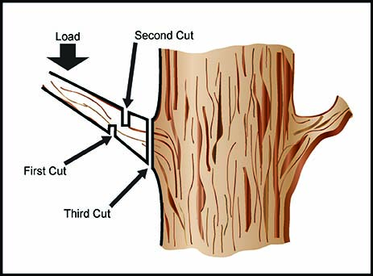

Powered hedge trimmers
Hand-held powered hedge trimmers are commonly used in arboriculture for cutting hedges, shrubs, scrub and similar material (see Figure 21).
Whether petrol or electrically powered, safety precautions must be observed to avoid contact with the sharp, high-speed cutting blades.
Figure 21 Powered hedge trimmer
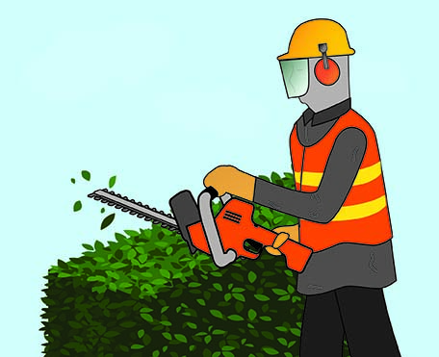
Common hazards and risks of powered hedge trimmer use are outlined in Table 19 with example control measures in Table 20 below.
Table 19 Common hazards and risks of using a powered hedge trimmer
- coming in contact with cutting blades and other moving parts
- being hit by debris
- fire or electric shock
- falling from height
- hand and arm vibration
- musculoskeletal disorders
- instability of the machine in long-reaching positions

Table 20 Examples of control measures for using a powered hedge trimmer
- Selecting the appropriate type of trimmer for the work task e.g. using a trimmer with an adjustable cutter bar to trim the tops of hedges instead of standing on a ladder or elevated platform.
- Conducting a pre-start-up check on the trimmer to ensure it has been assembled correctly and is in good condition.
- Ensuring operators are well-balanced and have secure footing when starting and operating the trimmer.
- Holding and operating the trimmer firmly with both hands on the handles—the trimmer should be held so the cutting blades are always away from the body.
- Watching the cutting area—operators should not cut areas of hedges they cannot clearly see.
- Checking there are no bystanders in the general work area—operators should be particularly careful when cutting tall hedges and should always check the other side of the hedge before starting trimming work.
- Taking special care when operating trimmers in slippery conditions e.g. damp, snow or ice, on slopes or uneven ground—cuttings, fallen branches and scrub should always be cleared away.
- Avoiding using electric hedge trimmers in wet or damp areas. If this is not reasonably practicable a residual current device (RCD) should protect the power supply.
- Fitting the blade guard or scabbard before transporting or storing the trimmer—the trimmer should only be carried by the handle with the cutting blades behind the operator.
- Wearing PPE e.g. gloves, eye, head, hearing and foot protection.

Manual task risks
Manual tasks include activities requiring the use of force exerted by a person to lift, lower, push, pull, carry or otherwise move, hold or restrain an object. Manual tasks can also mean exposure to hand and arm vibration, for example from using a chainsaw.
Work around trees involves manual tasks. A PCBU must identify, assess and eliminate or control these risks. No task should involve working above shoulder height, whether from the ground or from an EWP. See guidance material on workplace vibration and Code of Practice: Hazardous manual tasks for further information.

Tree Felling

Felling trees with chainsaws
The manual felling of trees with a chainsaw is a dangerous process that should only be carried out by people assessed as competent against the relevant national UoC.
The common hazards and risks of felling trees with chainsaws are outlined in Table 21.
Table 21 Common hazards and risks of felling trees with chainsaws
- hazardous trees
- unsuitable ground conditions and slope
- escape routes not clearly identified
- kickback or recoil from the chainsaw
- falling objects e.g. limbs, dry stags, dead and brittle tops and widow makers
- nearby structures and overhead electric lines
- standing vegetation in the intended direction of fall
- being struck by the butt of the tree
- cutting of the operator’s climbing or attachment ropes resulting in falls from height
- weather conditions including heat, wind, rain and cold
- damage to underground services
- internal wood affected by decay which will quickly dull the blade
- foreign objects inside the tree or within cavities
As detailed in the Chapter 1 Introduction of this guide, before attempting to fell a tree by any method, a visual tree assessment should be carried out by a competent person. This is to identify hazards associated with the type of tree and consider its condition, wind loading, structural integrity and location. This assessment should form the basis of a site-specific risk assessment to determine the safest method to bring down the tree.
Trees should be felled using a scarf and back cut (see Figure 22). Workers should follow the training from the relevant national UoC.
Figure 22 Manual tree felling cuts
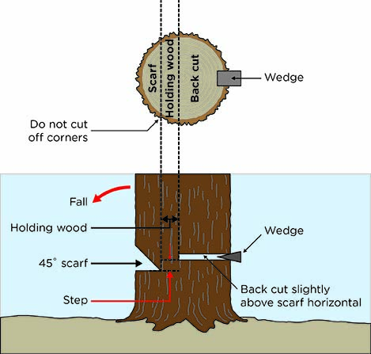
There are three types of felling processes normally associated with tree trimming and removal work. These are:
- clear felling
- controlled directional felling, and
- sectional felling.

Clear felling
Clear felling is the process of felling whole trees or standing trunks from the ground where there is a minimum of two tree lengths of open space in all directions from the base of the tree.
Clear felling is not a common option in urban environments as the minimum clear zone of two tree lengths is often hard to establish.
Before clear felling whole trees or standing trunks it is important to establish an area where the tree will drop and to ensure there is a minimum of two tree lengths of open space in all directions from the base of the tree. The processes outlined in Table 22 should be used.
Table 22 Processes for clear felling
1. Assess the tree as safe to fell
- Check the condition of the tree. Identify all hazards and the presence of defects or conditions that could influence the direction of fall e.g. natural lean, uneven growth, vines or intergrowth with adjacent trees, the shape and weight distribution of the crown and branches that could catch on other trees.
- Carry out ongoing checks for hazards, especially overhead hazards e.g. broken crowns, branches that could fall and changing conditions.
- Ensure there are no overhead electric lines and structures within the two tree length clear zone or underground services that could be damaged by the impact of the tree hitting the ground.
- Check the wind conditions. The strength and direction of wind will influence the direction of fall. Stop all operations in high winds.
2. Maintain suitable separation distances from other people and work areas
- Maintain a minimum separation distance of two tree lengths in all directions from the base of the tree. Establish a safe area or exclusion zone to ensure people not involved in the felling operation, and machines not required for the felling operation, do not come within two tree lengths of the operation. Observers should be used to monitor the exclusion zone.
- On steep ground where there is a risk of felled trees sliding or rolling downhill, ensure no one is working below the tree feller. On steep slopes the safe area or exclusion zone may need to be extended if the tree is liable to slide downhill after hitting the ground.
- If roads and other public access ways fall within the two tree length separation distance, road traffic and pedestrians must be prevented from entering the exclusion zone. Temporary road closures, diversions or traffic control may be required.
3. Ensure escape routes are identified
- Two 45 degree escape routes should extend to an area at least six metres away from the base of the tree (see Figure 23).
- Where the base of the tree and escape routes are impeded by undergrowth remove the material from around the tree. Ensure designated escape routes are cleared before felling.
4. Use chainsaw safely
- Follow safe work practices, for example as in AS 2727-1997.
- Ensure equipment is maintained including safety features of chainsaw e.g. hand guard and chain brake.
- Carry felling equipment including an axe, lifting and holding wedges suitable for the trees to be felled, a two-way communication device, chainsaw fuel and oil in an approved way.
- Use PPE suitable for the task being carried out e.g. a safety helmet, hearing protection, eye and face shields, high visibility clothing, safety footwear and leg protection.
Figure 23 Escape routes and direction of fall
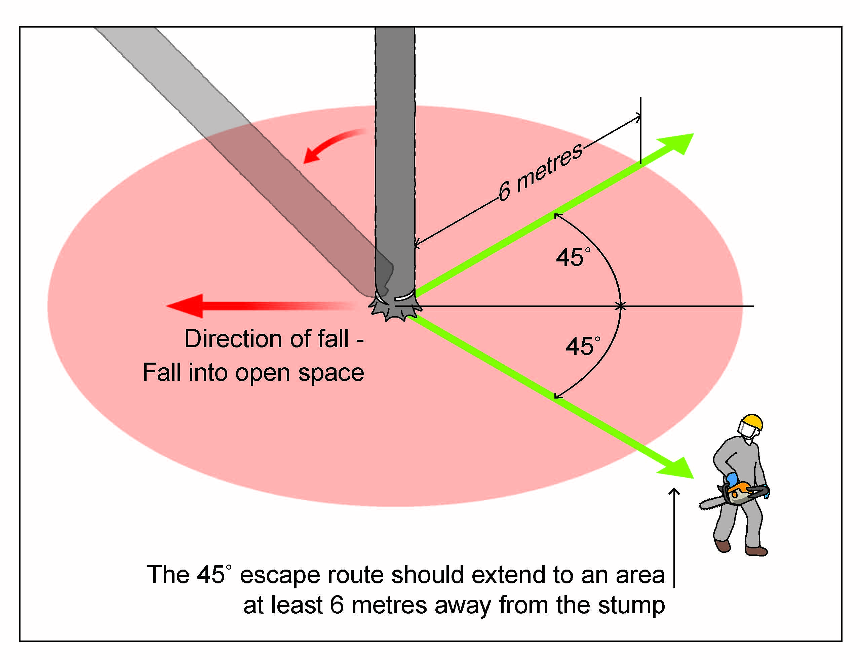

Controlled directional felling
Controlled directional felling is the process of felling whole trees or standing trunks from the ground where there is less than two tree lengths of open space in every direction from the base of the tree. Ropes or cables are attached to the tree being felled and cuts are made in the tree. The line is tensioned using a winch and suitable anchor point or mobile plant to bring the tree down (see Figure 24). Alternatively, mechanical plant can be used to push the tree in the desired fall direction.
This technique is useful where the natural fall direction of the tree would bring it into contact with overhead electric lines, other structures or would otherwise create an unsafe situation like hung trees. The process is typically used in urban environments where adjacent services or structures prevent use of the clear felling method.
Before directional felling work commences there should be consultation and agreement between the relevant workers on how the task is to be performed.
Figure 24 Attachment point for directional felling
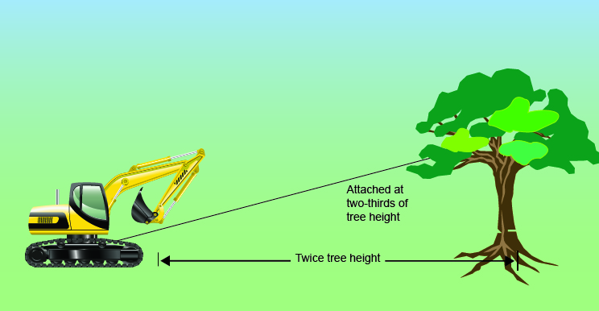
Powered mobile plant, for example excavators and bulldozers, can be used to push trees in a desired fall direction provided they:
- have the capacity including sufficient height and reach to push the tree safely
- are fitted with operator protective structures like a falling object protective structure suitable for tree trimming and removal work, and
- are able to safely control the fall direction of the tree.
Where an excavator or other mobile plant is to be used to push the tree in a direction other than its natural lean the machine should be placed in position before the tree feller approaches the tree.
The pushing attachment on the mobile plant should be:
- in contact with the trunk of the tree with only enough push force applied to prevent the tree sitting back during the felling operation, and
- high enough above the ground so it can provide enough force to push the tree after the felling cuts are made (see Figure 25).
Figure 25 Mobile plant used for directional felling
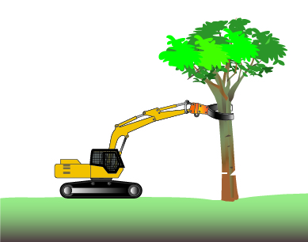
When the mobile plant is in position:
- the controls should be isolated to stop it or it’s attachments from moving unexpectedly and the operator should remain in the machine, and
- once the controls have been isolated the tree feller may approach the tree and place the scarf cuts. The depth of the scarf should be approximately one third of the tree diameter and not exceed one half of the diameter of the tree.
After the scarf is removed the feller should place a back cut in the tree but leave sufficient even holding wood to stop the tree moving backwards.
While the back cut is being made the mobile plant operator should not apply extra force to the trunk of the tree, unless told to by the feller.
Once the scarf cuts and the back cut are done the tree feller should leave the area by the safest route to a safe zone. This zone should be agreed between the feller and the mobile plant operator before starting work.
The mobile plant operator may then push the tree steadily and in a controlled way until it is committed to fall.
In addition to the guidelines for clear felling above, the guidance in Table 23 should be considered for directional felling operations.
Table 23 Examples of control measures for directional felling
Relevant training—controlled directional felling should only be carried out by appropriately trained operators with experience relevant to the task. The control measures and sequence of events in the felling operation should be agreed and understood by workers before starting the felling operation.
Establishing exclusion zones—before directional felling takes place it is important to determine the area where the tree is intended to fall and then establish an exclusion zone around this area.
Using ropes, cables and winches for pulling or holding trees—this equipment must be rated to a capacity appropriate for the total force applied and suitable anchor points must be established that are also capable of holding the total force.
Using powered mobile plant or plant mounted winch combinations as a fixed anchor point—in these instances the mobile plant should be:
- at least two times the tree height away from the tree being felled
- capable of holding the entire load, and
- able to operate safely on the terrain where the tree is being felled.
Attaching lines to trees—when attaching lines to trees they should be firmly fixed high enough in the tree to ensure the pulling or holding angle applies sufficient leverage on the tree to control the direction of fall. Tension is then applied and maintained on the line before felling starts.
Communication between workers—the tree feller and the mobile plant or winch operator should be able to communicate clearly with each other and where possible, be able to see each other. Systems like two-way radios, mobile telephones and agreed hand signals or whistles can be used to communicate.
Using machinery to pull trees—mobile plant used for pulling trees should be operated at least two times the tree height away from the tree being felled (see Figure 24) where possible. If this is not possible an assessment should be carried out by a competent person to identify an alternate safe method to bring the tree down, for example by using sectional felling.
Using machinery to push trees—mobile plant used for pushing trees should be operated by appropriately trained operators with experience relevant to the task.
Machinery used to push trees should be positioned with controls isolated and the operator inside the mobile plant before any cutting occurs. The mobile plant operator and tree feller should be in communication with each other at all times.

Sectional felling
Sectional felling is the process of felling a tree by working at height to gradually cut the tree into sections and allowing each section to fall to the ground or be lowered to the ground in a controlled manner.
Accessing trees by climbing or using EWP’s is covered in detail in Chapter 3 Methods for accessing trees. This chapter should be referred to for guidance on accessing trees for sectional felling purposes.
When the controlled directional lowering of sections is required the control measures for controlled directional felling above should be considered. You should also consider the examples of control measures outlined in Table 24.
Table 24 Examples of control measures for sectional felling
- In addition to establishing an exclusion zone, a drop zone should also be established where parts of the tree or sections of the limbs and trunk may be felled or dropped.
- The drop zone should be a minimum of 1.5 times the length of the section being felled or dropped, however this may be increased if there is a tendency for the dropped sections to bounce or cartwheel. The extent of the drop zone must be fully contained within the exclusion zone. Where the drop zone is not the minimum of 1.5 times the length of the section being felled or dropped, the controlled lowering technique should be used.
- Extra control measures may be required when felling or dropping sections uphill as there is an increased possibility the dropped section will rebound into the tree.
- If there is an increased risk to underground services from the impact of dropped sections impact protection may be required.
- The climber in the tree or the worker using an EWP cutting the tree should ensure the section being cut is short enough that, if stood on end, it would not make contact with the climber or the EWP.
Further information on manual tree felling techniques is in the relevant chainsaw operators’ manuals, AS 2727-1997 and the Tree faller’s manual.

Rescue and emergency planning
There are many situations in tree trimming and removal work that may require emergency action. It is important to develop emergency procedures and ensure workers are adequately trained in these procedures. Workers must be familiar with these procedures.
Rescue and first aid training must be an integral part of an induction program for workers. Workers must know these procedures and any changes to these procedures that are specific to a new site before starting work.
All types of emergency and rescue scenarios should be considered when developing emergency and rescue procedures. Information from the risk assessment will help with this task. Some questions to consider when establishing these procedures are in Table 25.
Table 25 Considerations when developing emergency procedures
Relevant considerations
Location of the work area | - Is the work being carried out in a remote or isolated place? How accessible is it in an emergency and how far away is it from medical facilities?  - Is a second rescue climber or a trained rescue climber onsite?  - Is the worker in a vulnerable position that could be life threatening?  - Can a person be recovered immediately after a fall without relying on emergency services?
Communication | - How can workers communicate in an emergency?  - A minimum of two people should be present during tree-climbing operations. One of the ground team should be available, competent and equipped to carry out an aerial tree recovery without delay.
Rescue/recovery equipment | - What kinds of emergencies may arise? The equipment depends on the nature of the work and control measures used and should include equipment necessary to carry out the planned emergency procedures.  - Equipment should be kept close to the work area for immediate use.
Capabilities of rescuers | - Are rescuers properly trained and sufficiently fit to carry out their task and capable of using equipment provided for rescue, for example access equipment?  - Have emergency procedures been tested to show they are effective?
First aid | - Is first aid available for injuries associated with falls, crush and cut injuries, for example from chainsaws?  - Are trained first aiders available to use the necessary first aid equipment?  - Workers may be exposed to insects and animals, like wasps, bees, spiders, possums, birds, snakes, rats and cats whilst working in and around trees. A single wasp or bee sting could be fatal if the worker has an allergic reaction. Contact with some plants can also cause allergic reactions. Identifying workers’ sensitivities and allergies should be considered as part of the emergency planning process.  - Workers must have access to first aid equipment and facilities to administer first aid. Workers must also be trained to administer first aid or have access to people who are trained in first aid.
Local emergency services | - Should local emergency services be relied on for rescue? Other arrangements should be made if they cannot respond quickly.  - How will the local emergency services, for example ambulance be notified of an incident?  - Are there ways to ensure information is given about the location of the site and access problems, personal details about the casualty including names and relevant medical history as well as the approximate time of the incident, treatment given and any chemicals involved?
Rescue operation | - When an injured worker needs rescuing, all possible precautions should be taken to protect other members of the work team and others entering or approaching the worksite.

Further information
Code of Practice: How to manage work health and safety risks
Code of Practice: Work health and safety consultation, co-operation and co-ordination
Code of Practice: Managing risks of plant in the workplace
Code of Practice: Hazardous manual tasks
Code of Practice: Managing the risk of falls at workplaces
General guide for working in the vicinity of overhead and underground electric lines
Guidance material on operating cranes and mobile plant near overhead electric lines
Guidance material on tree and vegetation management near overhead electric lines
Guidance material on workplace vibration
Emergency Plans Fact Sheet
Code of Practice: First aid in the workplace
Forestry operations guidance material
Pole saw operation and maintenance
Australian Quality Framework training

ForestWorks 2009, Chainsaw operator’s manual: chainsaw safety, maintenance and cross-cutting techniques, CSIRO Publishing, Australia.
ForestWorks 2011, Tree faller’s manual: techniques for standard and complex tree-felling operations, CSIRO Publishing, Australia.

