**GUIDE TO MANAGING RISKS**

**ASSOCIATED WITH**

**FOUNDRY WORK**

***April 2013***

Table of Contents

1 INTRODUCTION 4

1.1 What is foundry work? 4

1.2 Who has duties associated with foundry work? 5

1.3 How to manage health and safety risks 6

1.4 Information, instruction and training 7

2 CONTROLLING RISKS FROM FOUNDRY WORK 8

2.1 Molten metal explosions 8

2.2 Heat stress 8

2.3 Burns 9

2.4 Hazardous chemicals 10

2.5 Physical hazards 11

2.6 Health hazards 11

2.7 Hazardous waste and the environment 16

3 OTHER HAZARDS AND CONTROL MEASURES 17

3.1 Slips, Trips and Falls 17

3.2 Hazardous Manual Handling Tasks 17

3.3 Plant 18

3.4 Noise 19

3.5 Vibration 20

3.6 Working near electricity 21

3.7 Access 22

4 WORKING WITH MOLTEN METAL AND OTHER FOUNDRY PROCESSES 23

4.1 Foundry layout and general practices 23

4.2 Furnaces and tapping 25

4.3 Furnace tools 27

4.4 Inspecting raw material 27

4.5 Charging metal into the furnace 28

4.6 Alloying and fluxing additions 29

4.7 Dross 29

4.8 Moving molten metal 30

4.9 Slagging 31

4.10 Casting 31

4.11 Molten metal spills 32

4.12 Fettling 32

4.13 Abrasive blasting and rumbling 34

4.14 Grinding 34

4.15 Housekeeping 34

5 PERSONAL PROTECTIVE EQUIPMENT 37

5.1 Types of secondary fire-retardant clothing 38

5.2 Storage and care of PPE 39

6 EMERGENCY PLANS AND FIRE FIGHTING EQUIPMENT 41

APPENDIX A - HEALTH HAZARDS ASSOCIATED WITH COMMON HAZARDOUS CHEMICALS USED OR GENERATED IN FOUNDRIES 44

APPENDIX B – REFERENCES AND FURTHER INFORMATION 50

# INTRODUCTION

## What is foundry work?

Foundry work involves casting molten metal into a mould. Casting can be done manually by static casting or automatically by injection, dye, continuous, spin or spray casting. A typical process includes preparing a mould for casting, melting (shown in Figure 1), pouring metal into the mould, and removing and finishing the casting.

Working in a foundry presents a range of work health and safety risks including:

* explosion and burns from molten metal and other hot materials
* respiratory effects from exposure to gases, vapours, fumes and dusts
* skin effects from contact with corrosive or sensitising chemicals
* eye damage from light radiation, metal fragments, dusts and chemical splashes
* heat stress, heat stroke and fatigue from hot working conditions
* slips, trips and falls
* joint, muscle sprains and strains
* physical injuries from machinery and equipment e.g. by entanglement or crushing
* health effects from machinery and equipment e.g. caused by vibration and noise.

**Figure 1** Pouring liquid metal from a furnace - showing molten metal and heat hazards

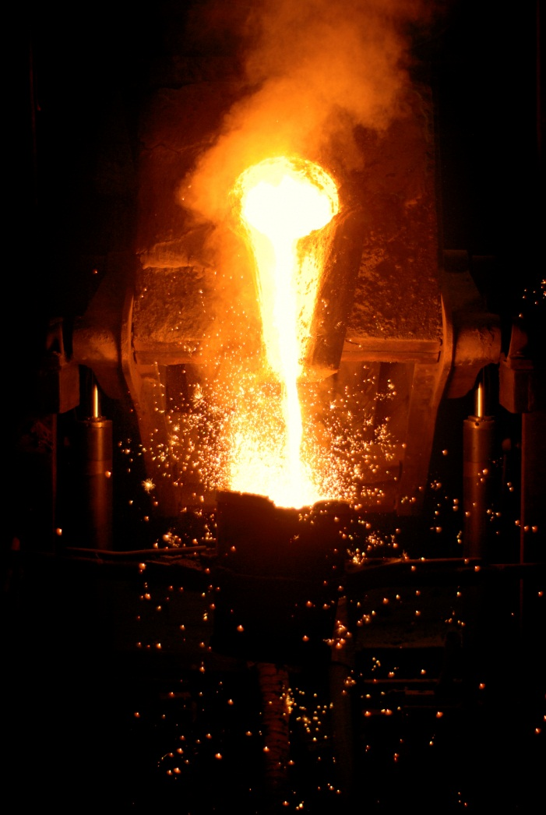

## Who has duties associated with foundry work?

**Table 1** Health and safety duties for foundry work

| **Who** | **Duties** | **Provisions** |
| --- | --- | --- |
| A person who conducts a business or undertaking | * ensure, so far as is reasonably practicable, workers and other people are not exposed to health and safety risks arising from the business or undertaking * eliminate health and safety risks so far as is reasonably practicable, and if this is not reasonably practicable, minimise those risks so far as is reasonably practicable.   This includes risks associated with using, handling and storing hazardous chemicals safely, airborne contaminants and plant, as well as other hazards associated with foundry work like noise and heat. | WHS Act  s 19  WHS Regulationsr 35 |
| Designers, manufacturers, importers, suppliers or installers of plant or substances | Ensure, so far as is reasonably practicable, the plant or substances they design, manufacture, import or supply is without risks to health and safety, including carrying out testing and analysis and providing information about the plant or substances. | WHS Act  s 22-26 |
| Officerssuch as company directors | Exercise due diligence, including by taking reasonable steps to ensure the business or undertaking has and uses appropriate resources and processes to eliminate or minimise risks from foundry work. | WHS Act  s 27 |
| Workers | * take reasonable care for their own health and safety * take reasonable care not adversely affect other people’s health and safety * co-operate with reasonable work health and safety policies or procedures * comply, so far as they are reasonably able, with reasonable instructions | WHS Act  s 28 |
| Other persons at the workplace, like visitors | * take reasonable care for their own health and safety * take reasonable care not to adversely affect other people’s health and safety * comply, so far as they are reasonably able, with reasonable instructions. | WHS Act  s 29 |

## How to manage health and safety risks

A person conducting a business or undertaking must manage risks associated with hazardous chemicals, plant, hazardous manual tasks, noise and electrical risks.

**R.32-38:** To manage risk, a person conducting a business or undertaking must:

* identify reasonably foreseeable hazards that could give rise to risks to health and safety
* eliminate risks to health and safety so far as is reasonably practicable
* if it is not reasonably practicable to eliminate risks to health and safety—minimise those risks so far as is reasonably practicable by implementing risk control measures according to the hierarchy of control in regulation 36
* ensure the control measure is, and is maintained so that it remains, effective, and
* review and as necessary revise control measures implemented to maintain, so far as is reasonably practicable, a work environment that is without risks to health or safety.

This Guide provides information on how to manage the risks associated with foundry work by following a systematic process which involves:

* identify hazards – find out what could cause harm from foundry work
* assess risks if necessary – understand the nature of the harm that could be caused by the hazard, how serious the harm could be and the likelihood of it happening
* control risks – implement the most effective control measures that are reasonably practicable in the circumstances, and
* review control measuresto ensure they are working as planned.

Further guidance on the risk management process generally is available in the Code of practice: *How to Manage Work Health and Safety Risks.*

### Consulting your workers

**S.47:** The person conducting a business or undertaking must, so far as is reasonably practicable, consult with workers who carry out work for the business or undertaking who are, or are likely to be, directly affected by a matter relating to work health or safety.

**S.48:** If the workers are represented by a health and safety representative, the consultation must involve that representative.

Consultation involves sharing information, giving workers a reasonable opportunity to express views and taking those views into account before making decisions on health and safety matters.

Consultation with workers and their health and safety representatives is required at each step of the risk management process. By drawing on the experience, knowledge and ideas of your workers you are more likely to identify all hazards and choose effective control measures, including:

* knowledge of the particular foundry processes under assessment
* work methods used in the foundry processes including implementation of control measures and emergency procedures

You should encourage your workers to report hazards and health and safety problems immediately so the risks can be managed before an incident occurs.

### Consulting, co-operating and co-ordinating activities with other duty holders

**S.46:** If more than one person has a duty for the same matter under this Act, each person with the duty must, so far as is reasonably practicable, consult, co-operate and co-ordinate activities with all other persons who have a duty for the same matter.

There is often more than one business or undertaking involved in foundry work. Each has responsibility for health and safety to the extent they influence and control aspects of foundry work.

You must also consult with other people who may be affected by your business or undertaking. This could include other businesses or residents located nearby, particularly about emergency procedures.

Further guidance on consultation requirements is available in the Code of practice: *Work Health and Safety Consultation, Co-operation and Co-ordination*.

## Information, instruction and training

**S.19:** A person conducting a business or undertaking must ensure, so far as is reasonably practicable, the provision of any information, training, instruction or supervision that is necessary to protect all persons from risks to their health and safety arisingfrom work carried out as part of the conduct of the business or undertaking.

**R.39:** A person conducting a business or undertaking must ensure that information, training and instruction provided to a worker is suitable and adequate having regard to:

* the nature of the work carried out by the worker
* the nature of the risks associated with the work at the time of the information, training and instruction, and
* the control measures implemented.

The person must ensure, so far as is reasonably practicable, that the information, training and instruction provided under this regulation is provided in a way that is readily understandable by any person to whom it is provided.

Workers must be trained and have the appropriate skills to carry out a particular task safely. Training should be provided to workers by a competent person.

The training provided should be relevant to the work carried out at the foundry workplace and must be readily understandable by any person to whom it is provided.

# CONTROLLING RISKS FROM FOUNDRY WORK

Some control measures are more effective than others. Control measures can be ranked from the highest level of protection and reliability to the lowest.

## Molten metal explosions

### Steam explosions

Steam explosions are caused by introducing moisture into molten metal or by pouring molten metal onto materials containing moisture. Sources of moisture include:

* containers holding liquids e.g. drink cans, aerosols or mobile phone batteries
* heavily oxidised or rusted materials, or rust on the surface of tools or equipment
* damp refractories or tools.

To minimise the risks so far as is reasonably practicable, a person conducting a business or undertaking must identify potential sources of moisture that could come into contact with molten metal and take steps to stop contact occurring. For example, by ensuring:

* Delivered materials are free from moisture and stored in a dry place.
* Furnaces and refractories are preheated before use.
* Equipment and tools are free from rust, dry and preheated before use.
* Charges are dry and free from entrapped moisture before being added to molten metal.
* Bottles and containers holding liquid and sealed or pressurised cans are not taken into molten metal areas. If these items are needed for maintenance or use, they should be stored, used and disposed of elsewhere.

### Chemical explosions

Chemical explosions can occur by introducing reactive chemical substances to molten metal directly or as a contaminant in charge material, causing gas pressure build-up within the molten metal. Not every addition of a reactive substance is potentially explosive, for example adding aluminium or ferrosilicon as a de-oxidant.

Explosions can result from accidentally mixing oxidising substances, for example ammonium or potassium nitrate or other oxidising salts, into smelters or crucibles containing molten metal or aluminium. Explosions may also occur if other incorrect combinations of chemicals are put into a furnace, for example furan and acid.

Control measures include:

* banning personal butane cigarette lighters in molten metal areas
* using storage systems to ensure products not suitable for use with molten metal are clearly labelled, secured against accidental use and stored outside molten metal areas
* storing paints, solvents and other combustible or flammable materials in designated areas to avoid ignition and cross-contamination
* as the last step before adding anything to molten metal, confirming it is the correct product and is safe for use in that particular melt.

## Heat stress

Working in hot conditions can be hazardous to health. Effects range from discomfort or heat rash to heat exhaustion or heat stroke which can cause permanent injury or death. Heat stress can occur without the worker being aware of how much they are affected until it is almost too late. It affects concentration, perception and decision making, so heat stress can also affect behaviour and judgement.

Other factors besides furnace heat contribute to the body overheating for example:

* job factors including strenuous work, sustained work and inadequate recovery time
* seasonal factors including high air temperature and relative humidity, or low air movement
* fatigue
* excessive or unsafe clothing
* unsuitable personal protective equipment (PPE).

Workers in hot environments can acclimatise or adapt to the heat. Discomfort can reduce, sweating becomes more effective, salt loss reduces and recovery rates can return to normal. Acclimatisation takes time and is lost when workers are away from the environment, for example, if workers go on vacation. Workers who have been away for a week or more should be given time to reacclimatise. Acclimatising only provides partial protection. While acclimatised workers are at less risk than un-acclimatised, they are still at risk.

Control measures include:

* Eliminating unnecessary heat and water vapour sources.
* Shielding radiant emissions from plant and other hot surfaces.
* Installing spot coolers, blowers, fans or air-conditioning to relieve humidity and move the air.
* Using de-humidifiers and other humidity reduction methods.
* Using ventilation to draw in cooler air, for example flues.
* Automating tasks where practicable.
* Supplying clean fresh water.
* Providing respite areas for workers, for example a cool room or heat refuge.
* Developing a heat stress policy and procedures to prevent heat stress. The policy should include:
  + educating workers about the signs and symptoms of excessive heat exposure and heat stroke and the acclimatisation process
  + ensuring a ‘buddy system’ where each worker looks after the other
  + providing for frequent short water breaks at regular intervals during the shift e.g. a cup of water (250 ml) every 15–20 minutes
  + pacing work to suit the conditions
  + scheduling hot work in cooler parts of the day
  + isolating hot work by distance from other workers
  + rotating hot tasks between workers to minimise exposure time
  + continuous monitoring for signs or symptoms of excessive heat exposure and heat stroke
  + contingency plans and treatment for affected workers.
* Providing task-specific PPE, for example water cooled clothing or heat reflective clothing.

## Burns

Burns are a major source of injury in molten metal foundries and are generally caused by touching hot surfaces, radiation or splashing molten metal.

Control measures include:

* separating workers not directly involved in casting operation from the casting area
* automating machinery to minimise risks associated with manual handling of casting moulds and other equipment if practicable
* designing and controlling processes to prevent unexpected reactions occurring
* providing protective barriers to prevent exposure to heat and splashes when a safe distance cannot be provided e.g. screens around the pouring station
* providing task-specific PPE in addition to other control measures
* providing dry PPE when working with molten or hot metal

It is important to apply first aid to burns in order to reduce the risk of infection.

### Light radiation

Eye disorders and skin burns may be caused by intense ultraviolet and infrared radiation from molten metal in furnaces, particularly around pouring areas and in welding operations.

Control measures include:

* providing workers who are likely to be exposed with shielding and PPE e.g. filtered eye protection
* signing work areas indicating eye protection is required where there is a radiation risk
* telling workers of the risks associated with intense ultraviolet and infrared radiation
* protecting bystanders and people passing preferably by exclusion.

## Hazardous chemicals

Foundry workers may be exposed to hazards and risks from a range of hazardous chemicals. A list of hazardous chemicals workers often come across in foundries is provided in Appendix A. These include fumes and dusts generated from foundry processes.

There are two broad types of hazards associated with hazardous chemicals which may present an immediate or long term injury or illness to people. These are physical hazards discussed in section 2.5 and health hazards discussed in section 2.6.

### Hazard information

Information on the hazards of hazardous chemicals used in foundries can be found on the chemical’s label and its safety data sheet (SDS). The SDS is a key document provided by the supplier of hazardous chemicals. It gives information on hazards and risks of hazardous chemicals as well as how people may be exposed and instructions on how to use, store, handle and dispose of the chemical safely. You should always read the label and SDS before using a chemical.

Chemical hazard information is provided on Safe Work Australia’s Hazardous Substances Information System (HSIS). Further chemical hazard information can be found on the [European chemical Substances Information System](http://esis.jrc.ec.europa.eu/) (ESIS) for classification of chemicals which are mandatory within the European Union and the [European Classification and Labelling Inventory](http://echa.europa.eu/information-on-chemicals/cl-inventory) which contains classifications of chemicals according to the Globally Harmonised System of Classifying and Labelling Chemicals (GHS) made by manufacturers.

Examples of chemicals used in foundries for which labels and SDS should be available include:

* cleaning chemicals
* resins or binding agents used in moulds
* catalysts or alloying ingredients
* gases in cylinders
* abrasive blasting materials.

Not every chemical in a foundry has a label or SDS as many hazardous chemicals are generated during foundry processes. Examples of hazardous chemicals generated at a foundry include:

* wood dust generated during pattern making
* metal fumes from heated or molten metals
* carbon monoxide, lead, zinc and other metal oxide fumes during charging and melting processes
* cadmium fumes from overheating
* chromium III (trivalent chromium) and chromium VI (hexavalent chromium) from melting, pouring and grinding of stainless steel or chrome alloys.

Methods to prevent exposure to generated chemicals are discussed in section 2.6 Health hazards.

The person conducting a business or undertaking must maintain a register of hazardous chemicals used at the workplace and an up to date SDS for each of those chemicals.

Further information about registers is provided in the Hazardous Chemicals Register Information sheet. <http://www.safeworkaustralia.gov.au/sites/swa/about/publications/pages/hazardous-chemicals-register>

## Physical hazards

Physical hazards are properties of chemicals created from chemical reactions. They can present a risk through incorrect handling or use and can often cause injury to people or damage to property. Examples include chemicals which are flammable, corrosive, explosive, or have oxidising properties.

One of the biggest potential hazards in foundries is from physical hazards posed by some hazardous chemicals. Fires and explosions at foundries have caused deaths and substantial property damage. The risk of explosion is discussed in section 2.1.

Control measures include:

* labelling hazardous chemicals correctly
* controlling ignition sources and not introducing hazardous chemicals presenting a fire risk into an area where ignition sources exist e.g. in areas with molten metal
* providing SDS
* storing incompatible chemicals well apart
* locating placards on or near bulk stores of hazardous chemicals in accordance with Schedule 13 of the WHS Regulations
* preparing an Emergency Plan
* preparing manifests where required in accordance with Schedule 12 of the WHS Regulations.

## Health hazards

Health hazards are properties of a chemical which can potentially cause adverse health effects. Exposure occurs by inhaling, skin contact or ingesting the chemical. Adverse health effects can be acute in the short term or chronic in the long term and can be minor or serious. Typical acute health effects include headaches, nausea or vomiting and skin corrosion, while chronic health effects include asthma, dermatitis, nerve or organ damage or cancer. Skin and respiratory sensitivity and other respiratory effects are common for people who work in foundries.

Examples of how to eliminate or minimise, so far as is reasonably practicable, the health risks from exposure to hazardous chemicals used or generated by processes include:

### Eliminating the risk

This means removing the hazard or hazardous work practice from the workplace. This is the most effective control measure and must always be considered before anything else. For example eliminate the risk of exposure to hazardous chemicals by using other methods of work which do not include using chemicals.

If eliminating the risk is not reasonably practicable, you must consider using substitution, isolation or engineering controls, or a combination of these control measures, to minimise the risk.

### Minimising the risk

#### Substitution

Minimise the risk by substituting or replacing a hazardous chemical or hazardous work practice with a safer one. For example, use shot blasting of castings instead of sand blasting.

#### Isolation

Minimise the risk by isolating or separating the hazard or hazardous work practice from people. For example by carrying out a process from a filtered air control room.

#### Separation

#### Minimise the risk by separating chemicals from the workplace, for example by using dust filtering or settling devices from which contaminants may escape and positioning them outside or in an enclosure vented to the open air.

#### Engineering Controls

Engineering controls are physical control measures to minimise risk, for example:

* + canopy hoods near furnaces and extractor hoods above furnaces capture fumes and route them through an emission control system
  + fully enclosed extraction systems draw airborne contaminants away from workers rather than through their breathing zone
  + melting operations use automatic thermocouple control systems to manage the melting process and prevent excessive fume production due to overheating
  + down-draught tables and grilles large enough to allow cleaning to be conducted within the boundaries of the down-draught.

#### Administrative controls

Administrative controls should only be considered when other higher order control measures are not reasonably practicable, or to increase protection from the hazard. These are work methods or procedures that are designed to minimise the exposure to a hazard, for example:

* restricting worker access to process areas
* not allowing eating, drinking and smoking in work areas
* implementing a ‘clean as you go’ policy and cleaning methods involving wet and vacuum systems
* regularly checking ventilation systems so they are safe and function correctly and ensuring defects are repaired immediately
* carrying out air monitoring where required to ensure exposure standards in the *Workplace Exposure Standards for Airborne Contaminants* are not exceeded
* carrying out health monitoring where required and keeping the records for 30 years as described in *Health monitoring for exposure to hazardous chemicals – guide for persons conducting a business or undertaking*

#### Personal protective equipment

Personal protective equipment (PPE) is the lowest order control measure in the hierarchy of controls. PPE should also only be considered when other higher order control measures are not reasonably practicable or to increase protection from the hazard. For example by ensuring task-specific protective equipment and clothing is worn by workers in the foundry.

More information about risks from hazardous chemicals is provided in Part 3.2 of the WHS Regulations for hazardous atmospheres, Chapter 7 for hazardous chemicals, including lead and the *Code of Practice: Managing Risks of Hazardous Chemicals in the Workplace*.

### Inorganic Lead

Foundry work can involve working with lead.

**R.392(r):** A ***lead process*** in a foundry means foundry processes involving:

* melting or casting lead alloys containing more than 1% by weight of lead metal in which the temperature of the molten material exceeds 450°C
* dry machine grinding, discing, buffing or cutting by power tools lead alloys containing more than 1% by weight of lead metal.

**R.394:** ***Lead risk work*** means work carried out in a lead process that is likely to cause the blood lead level of a worker carrying out the work to exceed:

* for a female of reproductive capacity—10μg/dL (0.48μmol/L); or
* in any other case—30μg/dL (1.45μmol/L).

Part 7.2 of the WHS Regulations sets out the requirements to manage lead risk work and provides ways of minimising exposure to lead including:

* containment of lead contamination - R.396
* cleaning methods - R.397
* prohibition on eating, drinking and smoking in a lead process area - R.398
* provision of changing and washing facilities - R. 399
* laundering, disposal and removal of PPE - R.400
* notification to the regulator of lead risk work - R.403
* duty to ensure that appropriate health monitoring is provided - R.406.

Exposure to lead must be kept to the lowest level practicable and control measures continually reviewed to ensure they are effective at minimising exposure so far as is reasonably practicable. Lead is a poison that accumulates in the body and can never be fully removed. It enters the body by ingesting or inhaling it. Symptoms of lead exposure include headaches, tiredness, irritability, constipation, nausea, stomach pains and anaemia. Signs and symptoms of toxicity will not appear unless exposures are very high. Other illnesses can trigger the release of lead accumulated in the bones into the blood. In excess it leads to kidney, nerve and brain damage. Lead is extremely hazardous to the unborn child and to breastfeeding infants and it is recommended that women intending to become pregnant be excluded from lead exposed work.

Examples of how to minimise exposure to inorganic lead include:

* using engineering control measures e.g. extractor hoods above furnaces, dust extraction systems for buffing, discing, grinding or cutting of castings containing lead; lead melting operations using automatic thermocouple control systems to manage the melting process
* providing task specific protective clothing and respiratory equipment for workers
* ensuring strict hygiene measures
* monitoring dust exposure.

#### Review of control measures when working with lead

| **R.401**: A person conducting a business or undertaking at a workplace must ensure that any measures implemented to control health risks from exposure to lead at the workplace are reviewed and as necessary revised in the following circumstances:   * a worker is removed from carrying out lead risk work at the workplace * the person obtains a health monitoring report for a worker that contains: * test results that indicate that the worker has reached or exceeded the relevant blood lead level for that worker * any advice that test results indicate that the worker may have contracted a disease, injury or illness as a result of carrying out the lead risk work that triggered the requirement for health monitoring * any recommendation that the person conducting the business or undertaking take remedial measures, including a recommendation that the worker be removed from carrying out lead risk work at the workplace * the control measure does not control the risk it was implemented to control so far as is reasonably practicable, for example results of any monitoring or a notifiable incident occurs because of the risk * before a change at the workplace that is likely to give rise to a new or different risk to health or safety that the measures may not effectively control * a new relevant hazard or risk is identified * the results of consultation by the person under the Act or these Regulations indicate that a review is necessary * a health and safety representative requests a review * the regulator requires the review * at least once every 5 years. |
| --- |

#### Health monitoring for lead risk work

Health monitoring must be provided before a worker starts lead risk work - R.405.

Where excessive blood lead levels are detected in a worker control measures must be reassessed and new ones implemented.

Dust or fume levels are a good indicator of the effectiveness of control measures but must be combined with blood lead monitoring.

### Silica

Silica dust presents one of the greatest risks to the health of foundry workers. Fine silica dust is produced in foundries by the rubbing, abrading or mechanical action on quartz: a material primarily composed of crystalline silica. The major foundry operations producing fine silica dust are mould and core making, shakeout, cleaning of castings, sand reclamation and sand preparation. Silica exposure can also occur during abrasive blasting and furnace maintenance and silica may be found in the lining of induction furnaces.

The principal health effect from silica dust is silicosis­—stiffening and scarring of the lungs. Silicosis is a chronic disease and usually takes a number of years for the symptoms to appear. It results in increasing shortness of breath, coughing and chest pain. The effects are irreversible, and lead to degeneration in the person’s health, invariably resulting in the premature death of the worker.

Silica exposure control measures include:

* substituting silica with non-silica products e.g. chromite or olivine sand
* using wet or vacuum cleaning and other methods e.g. adding binders or sand delivery processes to reduce the amount of loose sand which stops airborne particulate being generated
* avoiding mechanical handling or preparation likely to generate significant concentrations of airborne dust and avoid using sand containing less than two per cent moisture or an alternative binding agent
* using extractive exhaust ventilation to collect and ventilate dust away from people.

### Compliance with exposure standards

Many hazardous chemicals in the foundry have mandatory workplace exposure standards. Where there is no mandated Australian workplace exposure standard, exposure limits and standards established in other countries may be used to monitor the effectiveness of control measures. Regardless of an exposure standard, exposure must be minimised so far as is reasonably practicable.

**R.49:** A person conducting a business or undertaking at a workplace must ensure that no person at the workplace is exposed to a substance or mixture in an airborne concentration that exceeds the exposure standard for the substance or mixture.

Regulation 50 also describes the circumstances in which air monitoring must be carried out.

Further information on compliance with exposure standards and air monitoring is provided in:

* *Workplace Exposure Standards for Airborne Contaminants* and
* *Guidance on the Interpretation of Workplace Exposure Standards for Airborne Contaminants.*

### Health monitoring

Working in a foundry creates a risk of exposure to a number of hazardous chemicals for which health monitoring may be required, for example inorganic lead, crystalline silica, isocyanates and benzene. Requirements for health monitoring are set down in Regulation 368. Inorganic lead, crystalline silica, isocyanates and benzene are Schedule 14 chemicals.

| **R.368:** A person conducting a business or undertaking must ensure that health monitoring is provided to a worker carrying out work for the business or undertaking if:   * the worker is carrying out ongoing work at a workplace using, handling, generating or storing hazardous chemicals and there is a significant risk to the worker's health because of exposure to a hazardous chemical referred to in Schedule 14, table 14.1, column 2, or * the person identifies that because of ongoing work carried out by a worker using, handling, generating or storing hazardous chemicals there is a significant risk that the worker will be exposed to a hazardous chemical (other than a hazardous chemical referred to in Schedule 14, table 14.1) and either: * valid techniques are available to detect the effect on the worker's health, or * a valid way of determining biological exposure to the hazardous chemical is available and it is uncertain, on reasonable grounds, whether the exposure to the hazardous chemical has resulted in the biological exposure standard being exceeded. |
| --- |

Health monitoring of a person, means monitoring the person to identify changes in the person's health status because of exposure to certain substances. It involves collecting data to evaluate the effects of exposure and to determine or confirm the absorbed dose is within acceptable levels. This allows decisions to be made about implementing ways to further eliminate or minimise the worker’s risk of exposure, for example reassigning duties involving less exposure or improving control measures.

Further information on health monitoring is provided in:

* *Health monitoring for exposure to hazardous chemicals – guide for workers*
* *Health monitoring for exposure to hazardous chemicals – guide for persons conducting a business or undertaking*
* *Health monitoring for exposure to hazardous chemicals – guide for medical practitioners.*

## Hazardous waste and the environment

Part 7.2 of the WHS Regulations also applies when using, storing, handling and disposing of hazardous waste. Hazardous waste should be clearly identified and sealed in suitable containers that are protected against damage. Other legislation applies to the transport of hazardous waste.

There may also be specific legislation about protecting the environment, for example about releasing hazardous fumes into the atmosphere from foundry processes, or for the disposal of hazardous waste. You should contact the relevant environment protection authority in your jurisdiction for more information.

Where no legislative control measures apply, transporting and disposing should be done safely having regard to the nature of the hazard, for example use sealed, marked containers suitably protected from possible damage and able to be handled safely.

# OTHER HAZARDS AND CONTROL MEASURES

## Slips, Trips and Falls

**R.40:** A person conducting a business or undertaking at a workplace must ensure, so far as is reasonably practicable:

* the layout of the workplace allows, and the workplace is maintained so as to allow, for persons to enter and exit and to move about without risk to health and safety, both under normal working conditions and in an emergency
* work areas have space for work to be carried out without risk to health and safety

floors and other surfaces are designed, installed and maintained to allow work to be carried out without risk to health and safety.

Slips, trips and falls are particularly hazardous in a foundry, for example when handling molten metal.

Control measures include:

* eliminating trip hazards e.g. hoses, cords and rubbish
* designing or rearranging foundry layout around workflow to avoid slips, trips and falls
* ensuring floors are level, firm and durable and do not accumulate water
* ensuring floor surface material resists damage from the foundry process e.g. in areas where molten metal may spill use sand or refractory surfaces resistant to very high temperatures.
* maintaining regular housekeeping procedures so sand or other process by-products do not build up
* ensuring clothing and other PPE fits well so the risk of tripping is minimised
* using signs to indicate trip hazards shown in Figure 2.

**Figure 2** Example of a trip hazard sign

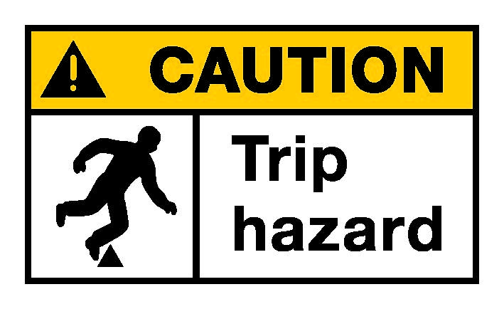

## Hazardous Manual Handling Tasks

A hazardous manual task is a task requiring a person to lift, lower, push, pull, carry or otherwise move, hold or restrain any person, animal or thing and that involves repetitive or sustained force, high or sudden force, repetitive movement, sustained or awkward posture, or exposure to vibration. These occur during pattern and core making, loading furnaces, moulding, fettling, dispatch, inspection and surface coating.

**R.60:** A person conducting a business or undertaking must manage risks to health and safety relating to a musculoskeletal disorder associated with a hazardous manual task.

When deciding what control measures to implement you must consider all relevant matters that may contribute to a musculoskeletal disorder, including:

* postures, movement, forces and vibration
* duration and frequency of the task
* workplace environmental conditions that may affect the hazardous manual task or the worker performing it
* design of the work area
* layout of the workplace
* systems of work used, and
* the nature, size and weight or number of things involved in carrying out the hazardous manual task.

Control measures include:

* eliminating hazardous manual handling tasks where possible by providing suitable equipment to carry out the task
* designing the work layout to make the task less hazardous e.g. carrying items less distance or using conveyors
* providing and ensuring mechanical aids are used where possible e.g. conveyors, cranes or forklifts
* ensuring the design of tools, equipment and PPE minimise the risks of manual handling
* ensuring workers are trained, educated and supervised in hazardous manual task safety.

Further information is provided in the Code of practice: *Hazardous Manual Tasks.*

## Plant

**R.203:** A person with management or control of plant at a workplace must manage risks to health and safety associated with plant.

A person with management or control of plant at a workplace must also:

* so far as is reasonably practicable, prevent alterations to or interference with the plant that are not authorised by the person – **R. 205**
* take all reasonable steps to ensure that plant is used only for the purpose for which it was designed, unless the person has determined that the proposed use does not increase the risk to health or safety – **R.206**, and
* take all reasonable steps to ensure that all health and safety features and warning devices (including guarding, operational controls, emergency stops and warning devices) are used in accordance with the instructions and information provided – **R. 206**.

Plant includes the machinery and equipment used in pattern and core making as well as casting and moulding. Cranes, hoists, forklifts and conveyors are used as mechanical handling devices within foundries.

There are three kinds of hazards associated with machinery and equipment:

* mechanical hazards due to moving parts, ejected objects and equipment e.g. associated with moulding machines
* non-mechanical hazards e.g. airborne contaminants, explosive atmospheres, heat, radiation, chemicals, vibration, electricity and noise
* access hazards including confined spaces, falls and manual handling.

Plant must be maintained and inspected so it remains safe to use. The adverse environmental conditions in foundries, for example excessive vibration, machine lubricant contaminants, extreme heat and airborne contaminants, increase wear rate or stress on fittings and components, potentially exposing machinery and equipment to premature failure.

Further information about licensing requirements which may apply to foundry work is provided in Part 4.5 of the WHS Regulations.

Further information about plant is provide in, Part 5.1 of the WHS Regulations and in the Code of practice: *Managing Risks of Plant in the Workplace.*

### Mechanical hazards

Mechanical hazards include hard surfaces coming together, rotating shafts, and cutting actions. Risks include entanglement, crushing, severing, cutting and slips, trips and falls.

Control measures include:

* separating workers from machinery and equipment by:
  + distance e.g. by positioning equipment in enclosures
  + barriers e.g. guards
  + time e.g. allowing access only when machine is disabled
* implementing isolation procedures to follow before, during and at the end of maintenance or repair works
* examining and maintaining machinery and equipment regularly so it is safe to use, functioning correctly and maintained to the manufacturer’s specifications
* ensuring maintenance, repair, installation, servicing and cleaning are planned and safety supervision provided accordingly
* considering safety when purchasing decisions are being made.

## Noise

Noise induced hearing loss is a common injury occurring in foundry work. Hazardous noise may affect how the inner ear works, which can cause temporary or permanent hearing loss, tinnitus and difficulties in communication. Hazardous noise can destroy the ability to hear clearly and can also make hearing sounds necessary for working safely more difficult, for example instructions and warning signals.

**R.57:** A person conducting a business or undertaking at a workplace must manage risks to health and safety relating to hearing loss associated with noise.

The noise a worker is exposed to at the workplace must not exceed the exposure standard for noise.

Hazardous noise for hearing loss means noise that exceeds the exposure standard for noise in the workplace. The exposure standard for continuous noise is 85 decibels dB(A) averaged over an 8 hour equivalent, and is 140 dB(C) peak for impulse noise. Regardless of the exposure standard, exposure to noise should be minimised so far as is reasonably practicable.

Noise levels for foundry equipment and processes often used in foundries are shown in Table 1. Pattern and core making, moulding, knockout and cleaning operations, fettling and some furnace operations are among processes which are likely to produce noise levels above the exposure standard.

**Table 1** The dB(A) levels of common foundry equipment and processes

| **Foundry equipment and processes** | **dB(A)** |
| --- | --- |
| Mould vibrators | 85-114 |
| Inverter | 83-116 |
| Arc/air gauging | 82-107 |
| 9-inch angle grinder | 97-110 |
| Shot blasting | 86-101 |
| Shake out | 84-95 |

Source: *Your health and safety guide to Foundries*, WorkSafe Victoria, 2007

Control measures include:

* eliminating exposure to hazardous noise e.g. by replacing existing plant or processes with quieter plant or processes
* modifying or replacing plant and processes to reduce the noise using engineering control measures
* isolating workers from the source of the noise by using soundproofing enclosures or using distance, barriers and sound absorbing surfaces
* providing quiet rest areas
* providing task-specific hearing protection for workers and continually reviewing noise levels while consulting with workers about the means to reduce noise
* checking the effectiveness of risk control measures so the noise exposure standard is not exceeded.

**R.58:** A person conducting a business or undertaking must provide audiometric testing to a worker who is frequently required by the person conducting the business or undertaking to use personal protective equipment to protect the worker from the risk of hearing loss associated with noise that exceeds the exposure standard for noise.

The purpose of audiometric testing is to determine whether workers have suffered noise induced hearing loss. If so, the control measures should be reviewed and workers consulted about the most effective way to reduce noise.

Some chemicals can contribute to hearing loss and are known as ototoxins. In a foundry, workers may be exposed to ototoxins like mercury or lead.

Further information on managing noise is provided in the *Code of Practice: Managing Noise and Preventing Hearing Loss at the Work.*

## Vibration

Exposure to whole body (1–80 Hz) vibration can occur during a number of foundry operations, including shake out, sand-slinging, on forklifts, in cranes and during pneumatic ramming operations. The adverse effects of whole body vibration include increased blood pressure and heart problems, nervous disorders, stomach problems as well as lower back pain.

Exposure to hand-arm or segmental (8 Hz–1 kHz) vibration can occur when using hand held grinders or hand guided tools, for example grinders, rattle guns, scalers, chippers and other pneumatic tools. Adverse effects include tingling and numbness in the fingers and hands, vibration white finger or finger blanching, reduced grip strength and dexterity.

Factors affecting exposure to vibration includes the how often and how long the person is exposed to vibration, the insulation level, how hard the material being worked on and the grip force.

Control measures include:

* establishing a policy focusing on buying low vibration tools and equipment
* redesigning processes to minimise the use of hand held tools e.g. grinders and scalers where possible
* correctly maintaining tools and equipment
* replacing old tools with modern vibration reduced tools or using tools which are dampened or insulated
* ensuring workers take frequent breaks and rotating jobs to minimise exposure
* reviewing control measures if workers experience discomfort from the vibration because if they are, the levels are likely to be too high
* arranging for vibration to be measured if there are concerns current control measures may not be effective

Further guidance on reducing exposure to vibration is provided in the Fact Sheet: Whole Body Vibration and the Fact Sheet: Hand-arm vibration.

## Working near electricity

**R.147:** A person conducting a business or undertaking at a workplace must manage risks to health and safety associated with electrical risks at the workplace.

**R.154:** A person conducting a business or undertaking must ensure that electrical work is not carried out on electrical equipment while the equipment is energised.

Exposure to electricity may electrocute a person and kill them or cause minor burns. It is not necessary to touch an electrical source to be electrocuted. A ‘flashover’ or ‘arc’ can electrocute you when you are close to a line conductor. Explosions and fire can also occur cause burns and produce toxic gases, including ozone, cyanide and sulphuric acid and may resulting in hazardous low oxygen levels. The risk of injury and death increases if a person sweats excessively, for example from a hot work environment, because wet skin is more conductive than dry skin.

Using high currents can induce strong electromagnetic fields which can be hazardous to people with heart pacemakers or other medical implants.

The following should be considered:

* What sources of electrical risk are in the workplace? Can these be eliminated?
* Is machinery de-energised before maintenance starts?
* Has testing and tagging been done on all plant at least within the last 12 months?
* Are safety switches installed and tested regularly?
* Are there any damaged cords? They should be replaced before using the plant again.
* Are there any double adaptors, portable power leads and adaptors being used? They should be replaced with safer sources of power.
* Are workers wearing task-specific protective clothing in the foundry?
* Do you use thermal imaging or infrared scanning to identify electrical faults or hazards?
* Is access to high-voltage areas restricted?
* Do you use a permit system for work on energised electrical equipment?
* Are contractors supervised at the foundry?

Further information on electrical risks is provided in the *Code of Practice: Managing Electrical Risks at the Workplace.*

## Access

Access hazards are often complex, involving several risks at the same time, for example during chemical dosing in confined spaces or working at heights.

Part 4.3 of the WHS Regulations covers requirements for confined spaces and Part 4.4 for falls.

**R.66:** A person conducting a business or undertaking must manage risks to health and safety associated with a confined space at a workplace including risks associated with entering, working in, on or in the vicinity of the confined space (including a risk of a person inadvertently entering the confined space).

**R.78:** A person conducting a business or undertaking at a workplace must manage risks to health and safety associated with a fall by a person from one level to another that is reasonably likely to cause injury to the person or any other person.

### Exposure

Control measures include:

* using suitable platforms, travel restraints and fall-arrest systems when workers are working at heights
* providing fall prevention devices where practicable
* using signs to alert workers to access hazards as shown in Figure 3.

**Figure 3** Example of an access warning sign

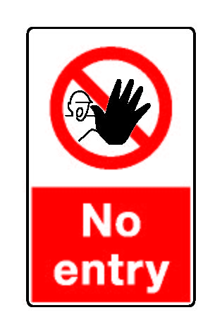

Workers should be educated, trained, monitored and supervised and use a permit system for confined space entry. Emergency procedures should be in place.

Further information on managing specific risks is provided in the Code of practice*: Managing the Risks of Confined Spaces* and the Code of practice: *Managing the Risk of Falls at Workplaces.*

# WORKING WITH MOLTEN METAL AND OTHER FOUNDRY PROCESSES

Working with molten metal is an integral part of foundry operations. Figure 4 below shows a worker pouring liquid metal.

**Figure 4** Worker pouring liquid metal

Worker pouring liquid metal

## Foundry layout and general practices

When designing the layout of the work area you should take into account the hazards associated with molten metal. There are a number of ways in which risks can be eliminated or minimised so far as is reasonably practicable.

**R.40:** A person conducting a business or undertaking at a workplace must ensure, so far as is reasonably practicable the layout of the workplace allows, and the workplace is maintained so as to allow, for persons to enter and exit and to move about without risk to health and safety, both under normal working conditions and in an emergency.

### Work flow and general work practices

Control measures include:

* Ensuring secondary processes not directly related to furnace work do not take place near furnaces, for example cleaning or rattling finished products, because they restrict movement around furnaces and put workers at risk. When it is necessary to conduct a process unrelated to furnace work near a furnace, workers should be protected by barriers and protective clothing.
* Notifying workers, contractors and visitors about the hazards associated with medical implants, including pace makers or artificial joints. These devices can be hazardous near induction furnaces that can make these things fail or burn the person with the implant.
* Enforcing quarantine procedures when entering an operational area in a foundry. The following types of items should not be allowed in an operational area due to the hazards they pose when exposed to extreme heat, molten metal, radiation or for health reasons:
  + mobile phones, portable radios or MP3 players e.g. iPods and other battery-operated devices
  + items containing liquid fuels e.g. cigarette lighters
  + food and food containers, especially open drink containers. Food and drink must not be consumed in an operational area in a foundry and fresh water and meal facilities should be well away from the foundry work environment
  + personal items e.g. jewellery and watches, especially if using electromagnetic or induction based furnaces.
* Ensuring safety checks are developed and tested for standard work and emergency procedures. Emergency procedures, for example first aid and fire drills, should take place at intervals consistent with the risks at site.
* Preventing workers from working under suspended objects, for example castings, moulding boxes or ladles.
* Ensuring items not being used are stored safely in non-working areas.
* Checking drains regularly for water, rusted steel or other materials that may react with molten metal if a spill occurs. If possible avoid having drains in the foundry area.

### Facilities and equipment

Control measures include:

* Providing enough class D fire extinguishers and dry sand for fire fighting. Sprinklers and water hoses should be not be used for fire fighting in a casting facility to eliminate the risk of a steam explosion.
* Providing safety showers and eyewash stations where they are easily accessible, for example within 10 seconds access, at the same level and near the hazard. Safety showers and eyewash stations should be located next to hazards where they do not pose a threat of explosion, and 15-20 metres from furnaces and casting areas. They should be protected from extremes of temperature, well lit and use high-visibility signs. They should release a controlled flow of flushing liquid and the nozzles and stored fluid should be protected from contaminants and tested regularly.
* Providing workers with amenities, for example toilets, shelters, seating, dining rooms, change rooms, drinking water, washing facilities and personal storage. The amenities should be enough for the number of workers and suitable for the size of the workplace.

Further information is provided in theCode of practice: *Managing the Work Environment and Facilities.*

### Foundry buildings and work areas

Control measures include:

* Ensuring work platforms are horizontal where possible and a minimum of 600 mm wide to allow workers to move unobstructed. The risk of objects falling from the platform should be prevented by a wall or in-filled handrail.
* Ensuring the work area is clear of rubbish and hoses and cords should not cross the floor.
* Repairing leaking or dripping water pipes or fittings immediately.
* Ensuring aisles are open and clear.
* Storing flammable and combustible substances and other hazardous chemicals safely to minimise unnecessary exposure of workers to chemical and handling hazards. Cylinders containing gases should be chained into position outside furnace areas, with clear and controlled access. They should be protected from vehicle impact and other shocks and located away from doorways and windows. The area should be clear of rubbish and have lighting and signs.
* Positioning cables and pipe work where they are protected from molten metal splashes.
* Minimising the number ledges and exposed beams.
* Ensuring the work area is well lit.
* Ensuring the roof is high allowing natural convection of gases and fumes, along with ventilation allowing air exchange.
* Checking the floor surface is suitable. Concrete can spall and explode when in contact with molten metal due to trapped moisture. Refractory brick is a safer floor surface for the foundry area.
* Fencing open pits, deep moulds and other floor openings securely to stop workers falling in. The fence may consist of railings, chains and stanchions or a wall. It should be at least 900 mm to 1100 mm high.
* Ensuring where pits and deep moulds are used permanently, their internal walls are lined with bricks, concrete or other similar material. This lining should:
  + retain the shape and safe condition of the pit
  + keep the pit or mould free of moisture.
* Ensuring pouring pits are large enough to safely accommodate a ladle. At least 300 mm clearance should be provided between parts of, and attachments to, a ladle and the sides of the pit to allow unhindered removal of the ladle.
* Ensuring where a worker has to stand or work over or near a floor opening, the edge of the opening is covered by substantial grating to stop them falling into the opening. The grating should be flush with the surrounding floor or have ramps to eliminate the risk of tripping.

## Furnaces and tapping

Furnaces pose a serious risk to workers through exposure to excessive heat, molten metal and fumes. The lining of the furnace (shown in Figure 5) must be in a good condition to stop molten metal breakout.

### Furnaces

Control measures include:

* ensuring services to the furnace can be shut-off quickly e.g. gas or oil supplies, including hydraulic oil
* preventing build-up of explosive gas or fuel by purging gas-fired and oil-fired furnaces
* preventing physical contact with hot furnaces or furnace parts by using barriers or other means e.g. doors which swing, pivot or slide in a way directing hot surfaces away from workers
* ensuring furnaces have a reservoir to receive run-outs of molten metal in case of refractory failure. If the reservoir is not large enough to hold all the potential molten metal run-out, containment plans should be devised for controlling and containing metal spills
* ensuring reservoirs are kept clean and dry
* ensuring workers not involved in using the furnace stay outside the defined dangerous area
* ensuring furnace dropping is done over a refractory floor or layer of dry sand
* ensuring workers wear primary PPE e.g. hard hats, eye protection, face shields, aluminised clothing and boots during tapping—a respirator may also be needed.

**Figure 5** Diagram of a furnace – the lining must be kept in good condition to prevent liquid metal breakout

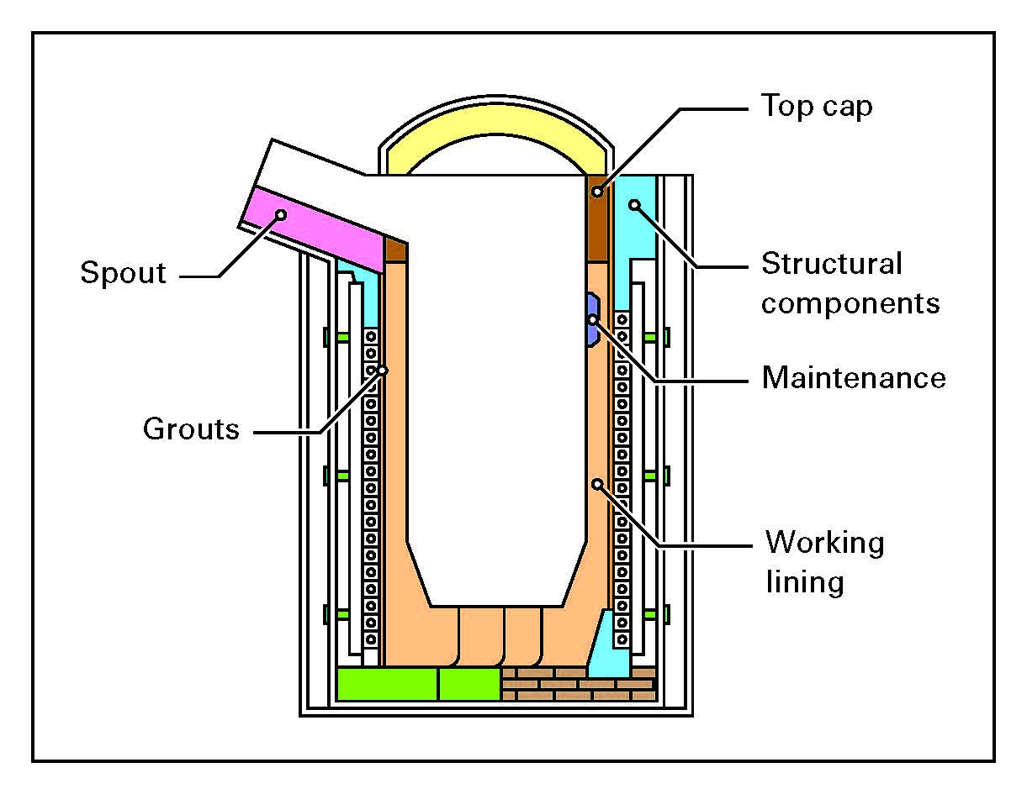

### Ladles

Control measures include:

* ensuring ladles have an integral locking device to stop accidental tipping
* installing safety devices to stop swinging or overturning of casting ladles with rigid ladle bails
* ensuring ladles transported by forklift are stable
* inspecting ladles before filling
* ensuring ladles are not overfilled, as shown in Figure 6
* securing stopper-operating devices before transport
* avoiding suspending ladles during filling if possible.

**Figure 6** Ladle containing liquid metal after tapping of furnace. Note the ladle is not overfilled

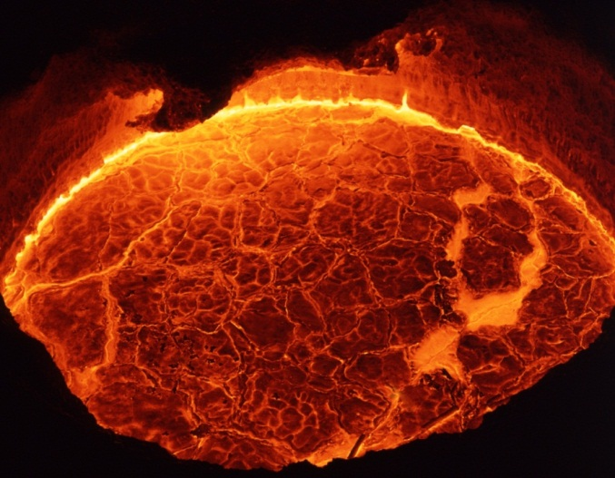

## Furnace tools

Rusty, cracked, worn and otherwise defective tools and equipment, for example ladles, bars and their attachments, can cause bubbling, popping or explosions when introduced to molten metal. Modern graphite tools are especially porous and absorb more moisture than traditional tools so preheat them to eliminate the moisture.

Control measures include:

* inspecting tools for defects before use
* keeping tools free from rust
* keeping tools completely dry, clean, preheated before use and stored near a heat source
* keeping tools free from totally enclosed cavities—cavities should include a vent hole directed away from the operator and positioned to prevent blockages
* repairing and relining ladles in a designated area with dust extraction.

## Inspecting raw material

Material containing contaminants may trigger a violent reaction when added to molten metal. Materials and packaging should be thoroughly inspected before charging to check materials are clean, dry and free from corrosion. Hollow objects, for example tubes or pipes can contain moisture. Add these items as the primary charge or return to the supplier.

Control measures include:

* Inspecting materials to be introduced to molten metal.
* Inspecting materials charged into molten metal when received for contaminants, for example:
  + Moisture.
  + Excessive grease and oil.
  + Corroded or oxidised metal.
  + Chemicals or unknown substances. Powdery substances should be treated as suspect, and residual fertiliser, nitrates and sulphates are particularly dangerous.
* Quarantining contaminated material until it has been cleaned. In cases of heavy contamination or if the source of the contamination cannot be identified, the material should be returned to the supplier.
* Ensuring where possible, porous charge or scrap containing moisture is added to the furnace as the primary charge.
* Preheating alloys and scrap if charging to molten metal.

## Charging metal into the furnace

Charging the furnace is one of the most dangerous operations carried out in the foundry. Incidents can range from minor injuries to fatalities and serious damage to plant and equipment.

When using a refractory or crucible-type furnace, carefully check the furnace for cracks or excessive slag or skull build-up. The refractory or crucible should be changed or repaired if:

* there are visible cracks on the inner side walls indicating risk of failure
* there is a significant skull on the side walls
* metal is seen exiting the drain port.

Various crucible types are used in foundry processes. You should ask the supplier or manufacturer about maintenance, repair and disposal requirements.

If metal is charged into a molten metal bath, it is important the metal is dry before immersing into the bath, see preheat charges below. Risks can also be minimised when adding metal to a molten metal bath by:

* Adding cracked or suspect metal to a furnace with a dry hearth.
* Gradually adding metal and alloying additions to the melt.
* Quarantining and inspecting for contamination charge material when the charge produces excessive bubbling or small eruptions when added to a melt.
* Ensuring where possible, furnace charging is conducted by mechanical means. If manual aids, for example barrows and trolleys are used, they should be stable and easy for workers to control.
* Ensuring primary PPE is worn by workers .

### Preheat charges

Water and other materials allow gases to be released causing explosions when submerged below the surface of molten metal. For this reason, it is safest to assume received metal is wet and to preheat to get rid of the water. The preheat temperature and duration will vary depending on the type of material, the dimensions and the quantity of charge.

Control is very important in preheating. Preheating could be done with heat from the furnace by passing charge through hot zones or flues for a predetermined time. Alternatively, hearth type furnaces in which the charge melts through a hearth and joins a pool of molten metal overcomes this problem of moist charge reacting with molten metal. Materials heated around the sides of an older style crucible furnace may not receive enough heat and are at risk of prematurely falling into the melt. However, materials stacked in front of newer larger furnaces may receive enough heat.

Preheated charge can pick up moisture from the atmosphere if there is a delay in using it, so whatever method is chosen, there should be a procedure for determining if the material has been sufficiently preheated before adding to a melt. If charging into an empty furnace or dry hearth, pre-heating may not be required.

Control measures include ensuring:

* cracked or suspect metal is added to a furnace with a dry hearth
* sealed or closed sections of scrap and charge containing moisture or contaminant are opened
* close-packed blocks and bundles are broken down to so air circulates.

## Alloying and fluxing additions

Where a substance is introduced to molten metal, for example in fluxing, de-gassing or inoculation processes, the substance should be clearly identified to avoid the risk of mistaking it for something else. It should be presented in a way allowing for its safe addition into the melt.

For example workers who add substances to molten metal should be made aware of the correct procedures recommended by the alloy supplier and fully trained in the hazards of adding substances, and should be supervised.

### Alloying

Materials to be charged into molten metal should be inspected for contamination and cleaned if necessary before charging in the same way as metal. Preheating using the same method as for metal charge is recommended for alloying additions for example, adding uncoated graphite particles to the molten metal in preparing to cast aluminium alloy-graphite particle composites. However, there are some exceptions where preheating is not required or not recommended, for example if it will cause excessive oxidation. In every case, the alloy supplier should be consulted for correct practices for addition to molten metal.

### Fluxing

Fluxes can be added to the melt for many reasons, including to:

* release metal from the dross to the melt
* help remove dross from furnace refractory linings
* remove inclusions
* remove alkali metals, e.g. sodium, lithium and calcium
* prevent oxidation or hydrogen pick-up—flux addition can also be a source of hydrogen pick-up.

Many fluxes easily absorb moisture from the atmosphere and this can result in violent explosions if added to a melt.

Control measures include:

* storing fluxes according to the manufacturer’s instructions
* ensuring primary PPE is worn by workers—a respirator may also be required.

## Dross

Dross or slag is the mass of impurities, usually a mixture of metal oxides and silicon dioxide that forms on the surface of molten metal. When skimming the dross, workers handle hot tools and are exposed to molten metal and extreme radiant heat, so there is significant risk of burns and molten metal splashing.

Control measures include:

* eliminating moisture and contaminant sources where possible
* ensuring forklifts used in skimming operations have protective screens fitted to the driver’s cabin
* ensuring tools and dross pans are clean and dry, have a refractory coating and are preheated before use
* ensuring primary PPE is worn by workers
* checking whether a respirator is also needed.

## Moving molten metal

Precautions should be taken when moving molten metal around the foundry, regardless of how much metal is being moved. Putting a lid on the transfer vessel when practical is a good way of reducing spills and minimising heat loss.

Control measures include:

* preparing and implementing a traffic management plan so personnel not required to be in the area are not near molten metal when it is moving
* using mechanical aids where possible to transport, position and pour molten metal—mechanical ladles should be fitted with devices for smooth positive control when tilting and pouring to stop accidental tilting
* observing safe manual handling practices i.e. using a two-person lift, safe-grip points and other ergonomic precautions when ladles are carried by hand
* ensuring single-hand carried ladles should be fitted with a shield or guard protecting the worker from exposure to radiant heat
* ensuring the route used to transport molten metal is marked, as short as possible, and clear of other people and objects
* ensuring there are no gas or water lines in the work area to cause an explosion if a spill occurs
* ensuring the floor is clean, dry and able to withstand molten metal temperatures
* ensuring molten metal carriers have right of way
* ensuring aisles and passageways are at least 800 mm wide where molten metal is transported by hand and there are no potential tripping hazards
* ensuring workers in the area are notified when molten metal is being moved e.g. by flashing lights or horns
* ensuring ladles and transfer vessels and their refractory linings are inspected regularly for cracks
* ensuring ladles and transfer vessels are preheated before use to remove moisture absorbed from the atmosphere.

### Moving molten metal with a forklift

A forklift is often used to move crucibles or receptacles of molten metal in foundry operations and creates a high risk to workers.

Control measures include:

* using electric-powered forklifts where possible rather than gas or diesel when working with or near molten metal to minimise the risks of ignition of flammable or combustible fuels
* if using gas-powered forklifts, shielding the gas line and couplings with a heat-resistant guard
* ensuring forklifts have see-through heat-resistant splashguards i.e. wind or blast shields fitted between the driver’s cabin and the load
* ensuring forklifts have enough load capabilities and enough safe lifting and reach requirements
* ensuring forklifts use appropriately designed and rated lifting attachment
* ensuring forklifts have well-designed cabin access and ergonomic seating
* ensuring forklifts have solid not pneumatic tyres
* ensuring forklifts have restraints fitted and they are used by the operator every time
* ensuring forklifts undergo routine maintenance as specified by the manufacturer or supplier including tyres, tynes and lifting attachments.

## Slagging

Slagging hazards include heat, hot metal splashes and radiation.

If a slagging operation is carried out on a ladle transported by a crane, the operation could be conducted at a separate station where permanent control measures are implemented to protect workers from the hazards of the slagging process.

Control measures include:

* protecting workers with shielding
* positioning ventilation to draw fumes away from workers rather than through their breathing zone
* ensuring workers wear primary PPE.

## Casting

This is the process of transferring the molten metal into the prepared mould for solidification, as shown in Figure 7. The molten metal is poured into moulds by one of a number of methods depending on the process used but will usually involve a refractory lined steel ladle. When molten metal is poured into sand moulds the sand is subjected to high temperatures—about 1600ºC in the case of steel. This temperature is high enough to convert some of the quartz in the sand of the mould to cristobalite which is a significant respiratory hazard. Other potential hazards are molten metal, heat, fumes, dusts, materials and manual handling, equipment failure, moisture and explosions.

**Figure 7** Worker wearing primary PPE pouring liquid metal into moulds

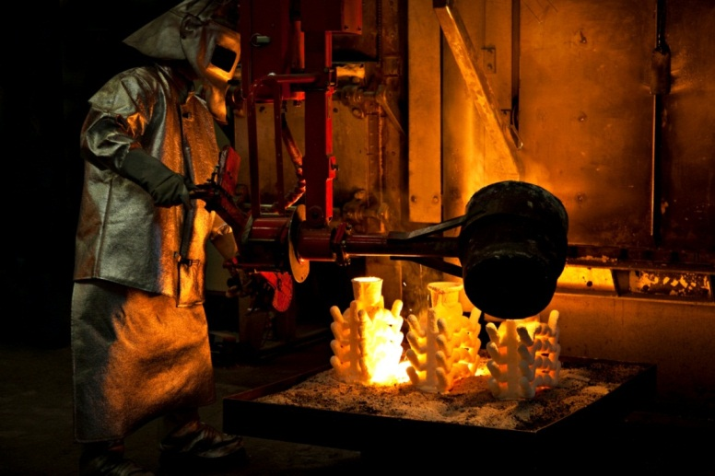

Control measures include:

* ensuring workers not directly involved in casting are not present during the operation
* ensuring workers wear primary PPE in the immediate area
* checking whether a respirator should also be used
* positioning suitable protective barriers e.g. screens around the pouring station to protect against the heat and splash when a safe distance cannot be provided.

Spin casting, also known as centrifugal rubber mould casting, utilizes centrifugal force to produce castings. Hazards include molten metal flashing, that is, molten metal and fragments being thrown out of the mould. The casting equipment should be therefore placed inside a body which shields against the material being thrown out. Without the proper containment, hot melted flashing can be a serious hazard to the machine operator and anyone else nearby. Workers should wear primary PPE for pouring liquid metal into the casting machine.

In spray forming (spray casting), molten metal is slowly poured through a conical tundish into a small-bore ceramic nozzle. The molten metal exits the nozzle as a thin free-falling stream and is broken up into droplets by gas jets. The droplets deposit on a substrate and form the metal component. The spray forming process is fully contained.

## Molten metal spills

### Containing flow

Spills may occur when removing molten metal from the electric arc, resistance, oil or gas, cupola, induction or resistance furnace and during transfer to a mould by a ladle or other means. When a metal spill occurs, worker safety must be the primary focus. Boots, shovels or hand tools should not be used to stop the flow. Water should not be used on metal spills. Potential hazards include moisture, extreme heat, fumes, explosions, equipment failure, as well as burns from the molten metal itself.

Control measures include:

* storing a bucket of clean, dry sand near the furnace to be used to stop the flow of spills if this can be done safely
* ensuring workers wear primary PPE.

### Cleaning up metal spills

Before action is taken to clean up metal spills, the risks of the situation should be fully assessed. If it is safe to do so, it may be possible to break the metal into sections before it fully solidifies, using a furnace tool. Primary PPE should be worn when doing this.

If it is unsafe to intervene, clean the spill when the metal has solidified by lifting it from the ground with mechanical or hand tools depending on the size. For metal difficult to remove, an oxygen lance may be necessary. An oxygen lance is extremely hazardous and extra precautions are necessary like wearing suitable PPE and being fully trained to use the lance. It is also important to make sure the surrounding area is free from standing water or flammable materials because molten metal can spray off the lance and onto these items, causing an eruption.

Control measures include:

* carrying out a risk assessment to determine the safest way to proceed
* ensuring surrounding areas are free from water and other contaminants
* ensuring workers wear primary PPE.

## Fettling

Fettling is the process of removing excess material from the casting to meet specified dimensions and finishing the product. It involves a number of different processes for example cutting, swing frame grinding, finish grinding and shot blasting, depending on the type of foundry. This is an area where many hazards are found, making it a work process requiring significant control measures. An example of manual work is shown in Figure 8.

**Figure 8** Manual work showing heavy sparking

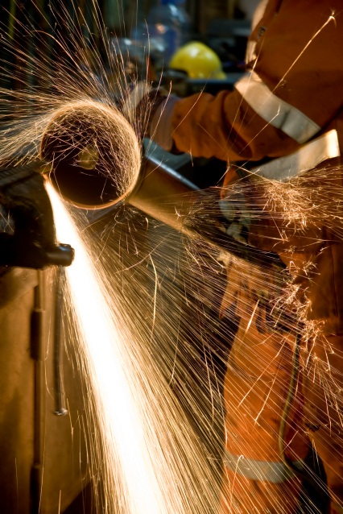

There are many potential hazards in fettling for example:

* noise and vibration
* dusts and fumes
* sharp edges
* abrasives
* manual handling
* grinding and cutting machines
* cutting oils
* x-rays and ultraviolet light for inspection
* welding hazards
* acid hazards during pickling
* heat exposure e.g. due to repetitive manual fettling

Control measures include:

* Using automatic processes if possible for example, fettling robots, Computer Numerical Control (CNC) grinding machines and automatic cropping.
* Replacing manual fettling with rough or even finish machining where possible for example chipping hammers can be replaced by grinders or linishers.
* Minimising noise levels. Very high levels of noise are common during manual fettling. It is not uncommon to find levels in excess of 110 dB(A). Risks of hearing damage are very high at these noise levels, with only 5 minutes of exposure exceeding the daily dose to exceed the workplace exposure standard. In addition to engineering control measures like acoustic guards or enclosures, hearing protection may be mandatory in such areas.
* Buying noise reduced equipment for example noise reduced grinding discs are available.
* Fitting air exhausts in pneumatic systems with silencers where possible.
* Lining fettling booths with mineral wool.
* Lining or covering work surfaces and chutes with abrasion resistant rubber to reduce impact noise of falling castings where practicable.
* Rotating manual fettling work with short shifts e.g. to reduce heat exposure
* Maintaining equipment for example keeping tools sharp and in good condition.
* Reducing the ringing of casting by clamping the piece, using rests on pedestal grinders or by using damping devices.
* Reducing vibration to a minimum through careful purchase of tools, correct operation and short work periods.
* Considering use of air-cooled hoods as PPE when carrying out fettling to reduce use of heat exposure

## Abrasive blasting and rumbling

Abrasive blasting and rumbling create hazards for workers from airborne contaminants and noise. Abrasive blasting using silica is not permitted.

Control measures include:

* using an exhaust ventilation system which operates when the enclosure or chamber is occupied, including during cleaning, maintenance and repair work
* ensuring exhaust ventilation is designed and installed by a person trained and experienced in industrial ventilation and includes provision for the routine measurement of static pressure behind each hood
* ensuring a procedure is in place so remedial action is initiated immediately if faults or defects are identified in the ventilation system
* closing doors to the enclosure or chamber while blasting or rumbling is in progress
* fitting windows of impact-resistant and shatterproof glass to chambers to enable occupants to be clearly seen
* allowing enough time for the evacuation of abrasives and dust from the enclosure or chamber between finishing blasting or rumbling and opening the door
* ensuring workers do not enter or leave while blasting is being carried out
* ensuring control measures can be operated from inside and outside the blasting area.

Further information on abrasive blasting is provided in the Code of practice: *Managing the Risks of Abrasive blasting.*

## Grinding

Grinders present hazards to workers from airborne contaminants and noise.

Control measures include:

* guarding grinding areas to minimise exposure of other workers to dust, particles and noise
* limiting where hand-held grinders are used for process work e.g. to as few areas in the workplace as possible
* ensuring facilities for the connection of fixed machines to dust-control equipment are incorporated in guard design
* guarding abrasive wheels on pedestal benches to control particulates
* ensuring tool rests incorporate a tongue piece, enclosing the wheel edge below the rest, to direct particles into the guard or dust control equipment.

## Housekeeping

### After casting

When casting is finished, a number of tasks should be done to ensure the foundry is safe for the next casting process.

Control measures include:

* emptying, cleaning and inspecting the furnace regularly
* inspecting furnaces for cracks or damage
* removing spills
* examining materials for dryness and lack of contamination
* cleaning and recoating tools.

### Cleaning up dusts

Compressed air should not be used for cleaning unless the task cannot be done other ways. If compressed air is used, control measures, for example reducing air pressure and providing protective equipment should be in place. Compressed air should never be used to clean clothing or the body.

Control measures include:

* Ensuring work practices and equipment produce a minimal residue.
* Cleaning plant, fixtures and structures regularly.
* Managing sand or earth floors in foundries to stop dust rising. If this involves using moisture, the sand or earth floors should not be wet enough to trigger a steam explosion.
* Using exhaust ventilation to extract dust.
* Considering other technologies, for example fogging to minimise dust.
* Considering the impact of fogging on the work environment, for example humidity and heat stress and other risks associated with increases in atmospheric moisture.
* Carrying out wet cleaning where it creates no extra risk.
* Ensuring workers use vacuum cleaners with high efficiency particulate air (HEPA) filters.
* Ensuring cleaning is a regular part of preventative maintenance programs.

### Storing equipment

Equipment should be stored in areas readily accessible to the task it is required for, and should be stored in a clean and well-maintained condition. Markings should be provided to identify the task and location where the equipment is to be used. Equipment removed from storage should be returned to the correct storage area in a clean and usable condition.

Control measures include:

* ensuring equipment e.g. stacked moulding boxes, patterns and equipment, are stable and free from dangerous projections
* storing furnace tools so they are clean and dry and off the floor in suitable racks at an easily accessible height.

### Storing material

Materials used in processes should always be identifiable using labels, and should be clean and uncontaminated.

Control measures include:

* Inspecting materials before and after use—they should be clean and dry and then stored in clearly labelled containers in permanent, specifically designated areas.
* Ensuring metal charges and materials coming into contact with molten metal are kept undercover to prevent or control the absorption of moisture where possible.
* Ensuring containers include holes or other design features to facilitate drainage and prevent the accumulation of contaminants, for example oil or water.
* Storing specific process materials and other substances in separate containers. Process residues are stored safely and in a manageable form and materials not used in the process are stored separately from the process materials.
* Avoiding storing materials not suited for use in molten metal with the raw materials or in the foundry area.
* Ensuring a register of hazardous chemicals at the foundry is maintained in accordance with the WHS Regulations and includes the current SDS for each chemical.
* Providing extra training and information on hazardous chemicals, fumes, dusts and other substances generated at the foundry to workers who may be exposed.

# PERSONAL PROTECTIVE EQUIPMENT

| | **R.44:** If personal protective equipment is to be used to minimise a risk to health and safety in relation to work at a workplace in accordance with regulation 36, person conducting a business or undertaking who directs the carrying out of work must provide the personal protective equipment to workers at the workplace, unless the personal protective equipment has been provided by another person conducting a business or undertaking.  The person conducting the business or undertaking who directs the carrying out of work must ensure the equipment is:   * selected to minimise risk to health and safety * suitable having regard to the nature of the work and any hazard associated with the work * a suitable size and fit and reasonably comfortable for the worker who is to use or wear it * maintained, repaired or replaced so that it continues to minimise risk to the worker who uses it * clean, hygienic and in good working order, and * used or worn by the worker, so far as is reasonably practicable.   **R.46:** The worker must, so far as the worker is reasonably able, use or wear the equipment in accordance with any information, training or reasonable instruction given by the person conducting the business or undertaking.  The worker must not intentionally misuse or damage the equipment. | | --- | |
| --- | --- |

Personal protective equipment (PPE) should be supplied to every worker, including labour hire staff and contractors. It should be replaced when it is no longer capable of providing the necessary protection, for example when it is damaged or worn.

PPE should not be the only control measure chosen as it is the least effective control, however in foundries a combination of control measures will often provide the best solution to minimise risk to the lowest possible level.

Protective clothing used for foundry work can be categorised into two types, primary protective clothing and secondary protective clothing. Figure 9 shows workers pouring liquid metal wearing PPE.

**Figure 9** Workers pouring liquid metal wearing PPE

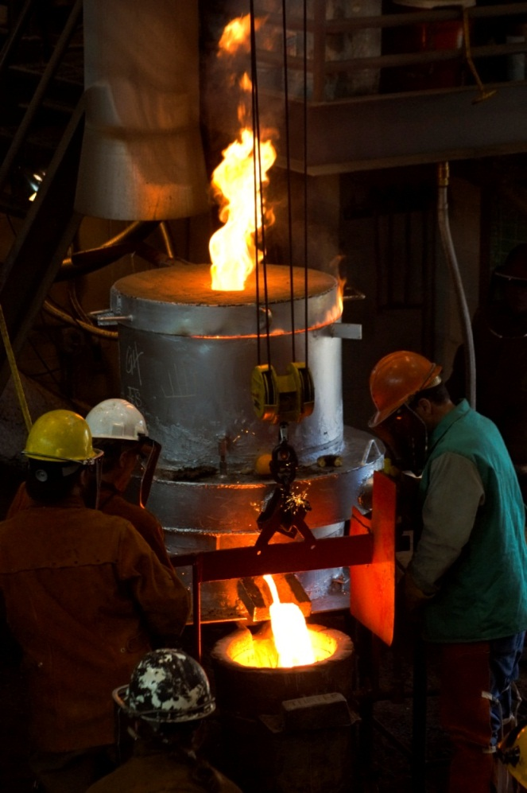

## Primary protective clothing

Primary protective clothing is used for specific hazardous tasks, and then removed. It provides protection from acute and serious hazards, for example metal splash and radiant heat. The garments should be made from inherently fire-retardant fabrics to ensure their protective properties are intact as long as the garment is intact. They should be comfortable to wear and breathable in extreme working conditions. Leather options offer some durability and protective benefits but can compromise comfort and add to heat stress in certain situations.

## Secondary protective clothing

Secondary protective clothing is all-day or everyday clothing. The clothing should be fire-retardant. The choice of inherent or treated fire-retardant clothes can take comfort and cost into account, but these garments are the last defence for the body if primary protection fails. A cotton fabric is the minimum standard, but specially treated cotton or wool fabric is recommended.

There are two types of fire-retardant clothing:

* Treated garments – these require extra attention to preserve their protective properties, for example use of particular cleaning methods, protection from some kinds of chemicals or excessive heat. Many have limited life spans or efficacy that declines over time.
* Inherent and permanent garments - these do not require special care to preserve their protection. Their protection lasts as long as the garment does.

Garments should be designed to withstand fire and shed molten metal quickly and effectively. Badly fitted garments can create folds that catch and hold the metal, making them less protective. The style of garment is also important, for example pockets and flaps create catch points, metal buttons heat up from radiant heat and fire-retardant tape can stop the fabric breathing and cause sweat and burn marks if not placed well on a garment. High-visibility colour options can assist with visibility in the workplace.

### Types of secondary fire-retardant clothing

Two types of fire retardant clothing are cotton shirts and wool viscose shirts.

Clothing should avoid having areas where molten metal can be trapped or rest against the material, for example pockets, button holes, inside gloves or at the waistband of pants. It can burn through rapidly and cause the clothing to catch alight.

Wool viscose does not burn through as quickly, giving the wearer time to remove the clothing before further injury occurs and providing increased protection from molten metal splashes.

Information provided in Table 2 is intended as a guide only. The UK Health and Safety Executive has a guide to PPE in foundries: *The selection, use and maintenance of molten metal protective clothing.* Different metals and foundry processes have different PPE requirements. PPE used must be matched to the work being done and the risks to be controlled by the PPE.

## Storage and care of PPE

To remain effective PPE should be regularly maintained and stored correctly. Examples of how to control the risks include:

* maintaining protective equipment and clothing provided to workers in a sound condition
* testing PPE routinely and checking it is capable of performing the protective functions for which it was provided
* training workers about how to use, care for and properly fit the PPE
* ensuring equipment and clothing is only worn by the worker to whom it was issued, and can be marked with the name of the worker
* providing clean storage for protective equipment and clothing
* maintaining clothing and equipment when required and in the manner prescribed by the manufacturer or supplier.

Protective clothing must be replaced when it is no longer capable of providing the necessary protection, for example when it is damaged or worn.

**Table 2** Primary and Secondary protective clothing categories

|  |  |  |
| --- | --- | --- |
|  | **Primary PPE** for molten metal work, in addition to secondary PPE | **Secondary PPE** for general foundry work |
| **Head** | Use helmets where there is potential for items to fall from height or where work takes place above head height, for example on a mezzanine. Industrial safety helmets should be considered. Where tasks result in dust or particulates, a head covering should be considered. | |
| **Ears** | The choice of hearing protection should consider level of occupational noise, the wearer, for example personal characteristics, comfort, communication requirements, and compatibility with the job and workplace.  Guidance on hearing protectors is provided in AS/NZS 1269.3 *Acoustics: Hearing Conservation* | |
| **Eyes and Face** | Face shields with neck protection. | Industrial safety glasses with side shields are the minimum |
| **Respiratory** | The type of respirator selected should consider: the operator and physiological and psychological factors - facial hair should not be allowed; the task and how the job is done, duration, frequency; and the substance - type of contaminant, concentration. Guidance can be sourced from suppliers of respiratory protective equipment and AS/NZS 1716 *Respiratory protective devices*. | |
| **Trunk and Arms** | A jacket of leather or other suitably resistant material must be worn outside other clothing. It must be free of features, for example cuffs and pockets may trap molten metal. It must be worn properly and fastened every time. | Long-sleeved shirt made from flame-resistant fabric, for example wool, heavy cotton drill. Garments should fasten at the neck and wrists to prevent molten metal splashes, dust, chemicals and other substances from entering through the collar and cuffs. |
| **Hands** | Heat-resistant Kevlar or heavy leather gauntlets covering the lower part of arm. | Gloves selected should take into account the: hazard, for example burns, abrasion, chemicals and cuts; work environment; and the wearer, for example fit, comfort and dexterity. Guidance on the selection, use and maintenance of protective gloves is provided in AS/NZS 2161.1 *Industrial Safety Gloves and Mittens* |
| **Legs** | Where risk of molten metal spills or splashes exists, trousers of leather or other suitably resistant materials must be worn. The trousers should cover the top of the footwear and be free of features, for example cuffs and pockets could trap molten metal. | Heat-resistant trousers. |
| **Feet** | Workers should always wear safety footwear in the workplace, unless there are sound medical reasons, for example if wearing safety footwear would injure the wearer. In such cases, the reason for such an opinion should be given and the most effective alternative protective equipment sought. | |

# EMERGENCY PLANS AND FIRE FIGHTING EQUIPMENT

**R.43:** A person conducting a business or undertaking must ensure that an emergency plan is prepared and maintained so it remains effective for the workplace.

**R.359:** A person conducting a business or undertaking at a workplace must ensure

that fire protection and fire fighting equipment:

* is provided for the workplace
* is designed and built for the types of hazardous chemicals at the workplace in the quantities in which they are used, handled, generated or stored at the workplace, and the conditions under which they are used, handled, generated or stored
* is compatible with firefighting equipment used by the primary emergency services organisation
* is properly installed, tested and maintained
* has a dated record kept of the latest testing results and maintenance until the next test is conducted.

**R.360:** A person conducting a business or undertaking at a workplace that uses, handles, generates or stores hazardous chemicals must ensure that equipment is always available at the workplace for use in an emergency.

**R.362:** A person conducting a business or undertaking at the workplace must ensure that, if safety equipment is required to control an identified risk in relation to using, handling, generating or storing hazardous chemicals at a workplace, the safety equipment is provided, maintained and readily accessible to persons at the workplace.

Regardless of control measures put in place to prevent incidents occurring in the workplace, incidents can still occur. It is therefore necessary to be prepared for foreseeable incidents by developing an emergency plan and practising procedures.

The extent of emergency procedures required will depend on the size and complexity of the workplace, the number of workers, the various types of processes involved and the types and quantities of material and articles used and stored at the workplace.

As a minimum, emergency procedures should include instructions on:

* How to raise the alarm, including how to contact the emergency services authorities.
* Actions to be taken by workers in an emergency to ensure the health and safety of people at the workplace.
* Actions to be taken by prescribed people like operators and fire wardens, for example on how to evacuate the workplace, or use fire extinguishers or to shut off furnaces if there is a spill or failure.

An example of an effective emergency procedure is a simple one-page document in point form, which can be displayed on signs or carried by workers or visitors as a pocket card. It should explain evacuation procedures, assembly areas, identify first aid officers and emergency wardens at the workplace and contact numbers of emergency services, like the fire brigade, police, ambulance, local hospital and regulatory authorities.

For emergency procedures to be effective, workers should be trained, and current procedures tested. Ideally, workers should be directly involved in the development of emergency procedures.

A specific evacuation or emergency procedure should be developed and implemented if a furnace superheating or overheating situation occurs. This means the furnace is about to explode. This is in addition to the usual emergency evacuation procedure. The alert is raised by the furnace operators and should be covered in the standard training for furnace operators. This was a specific issue identified in a previous furnace explosion and fatality.

Further guidance on first aid and emergency planning is provided in the Code of practice*: First Aid in the Workplace* and in the Fact Sheet: Emergency Plans.

# APPENDIX A - HEALTH HAZARDS ASSOCIATED WITH COMMON HAZARDOUS CHEMICALS USED OR GENERATED IN FOUNDRIES

Table A1 provides a guide to some of the health hazards associated with common chemicals used or generated in foundries. Hazard classifications of these chemicals according to the GHS by manufacturers are provided in the European Classification and Labelling Inventory. See Appendix B for a web link to the database.

**Table A1** Health hazards associated with common chemicals used or generated in foundries

|  |  |  |
| --- | --- | --- |
| **SUBSTANCE** | **PROCESS/USE** | **HEALTH HAZARDS** |
| Acids | Used as amine neutralisers in effluent gas washers.  Used as a catalyst in some sand binding systems. | Skin, eye and respiratory irritation. |
| Acrolein | Decomposition product from core ovens. Emitted during pouring and shakeout where oil sand cores are used. | Eye, nose and throat irritation, lachrymation, pulmonary oedema. |
| Aluminium oxide | Melting and pouring of aluminium alloys.  Produced when aluminium is used as a de-oxidant for steel alloys. | Respiratory irritation. May possibly result in pulmonary fibrosis.  Peripheral neuropathy and cognitive impairment from fume. |
| Ammonia | Core-making decomposition product of nitrogen-containing binding materials. | Eyes and respiratory tract irritation which can be severe. High concentrations may result in chronic lung disease and eye damage. Skin contact can result in burns, blistering and permanent scarring. |
| Antimony | Alloying element in brass foundry and for lead alloys. | Respiratory, skin and eye irritant. May cause dermatitis. Ingestion may cause severe irritation of lining of stomach and intestines. Inhalation may cause systemic poisoning with symptoms including abdominal pain, nausea, dizziness and dry throat.  Chronic Exposure: liver and kidney abnormalities or pneumonitis may result from chronic antimony exposure. |

|  |  |  |
| --- | --- | --- |
| **SUBSTANCE** | **PROCESS/USE** | **HEALTH HAZARDS** |
| Benzene | Solvent used in core-washing. | Long term exposure can damage the bone marrow and lead to leukaemia. A known human carcinogen (Carc 1A). Chronic exposures may result in convulsions and ventricular fibrillation. Acute exposures may result in central nervous system (CNS) depressions marked by dizziness, headache, nausea, loss of coordination, confusion. |
| Beryllium | Used in a copper alloy, emitted during melting and pouring. | Presumed human carcinogen (Carc 1B) lung cancer. Skin sensitiser. |
| Cadmium | Casting of cadmium alloy products. | Presumed human carcinogen (Carc 1B), may cause kidney damage, suspected mutagen and human reproductive toxin.  Acute exposures may cause nose and throat irritation. At high levels of exposure, after a delay of several hours a person may experience symptoms including a cough and chest pains, and death may result. |
| Carbon | Graphite. | Respiratory and eye sensitisation. |
| Carbon dioxide | Emitted from core ovens, during melting and pouring processes and welding. | Asphyxiant, may contribute to oxygen deficiency if in excessive concentrations. |
| Carbon monoxide | Emitted during melting and pouring processes, or processes involving pyrolysing carboniferous compounds.  Decomposition product of core-making. | Chemical asphyxiant interferes with oxygen carrying capacity of blood which may lead to anoxia. This can give rise to headaches, irregular heartbeat, dizziness, drowsiness, nausea, vomiting, loss of co-ordination, loss of consciousness or death. |
| Chlorine | Degassing agent used with non-ferrous alloys. | Severe eye, nose and throat irritation, pulmonary oedema and congestion. It can aggravate bronchitis or asthma.  Acute exposures may cause asphyxia. |
| Chromium III | Welding, thermal cutting, grinding of castings. | Skin and eye sensitisation. Presumed human carcinogen (Carc 1B). |
| Chromium VI | Melting, pouring and grinding of low alloy and stainless steel and chrome alloys. Welding. Chromate sand constituent. | Presumed human lung carcinogen (Carc 1B).  Chromium (VI) trioxide is a known human carcinogen (Carc 1A). |
| **SUBSTANCE** | **PROCESS/USE** | **HEALTH HAZARDS** |
| Cobalt | Melting, pouring, grinding. | Skin, eye, respiratory sensitisation, asthma, bronchitis, allergic dermatitis.  Presumed human carcinogen (Carc 1B) lung. |
| Copper (fume) | Melting, pouring and grinding copper alloys. | Acute respiratory irritation, metal fume fever. |
| Cyclohexane | Used in the production of mould cores. | Acute inhalation can cause headache, nausea, dizziness, drowsiness and confusion. In very high concentrations, unconsciousness and death can result. |
| Dimethylamine (DMEA) | Catalyst for cold-box binder systems. | Skin irritation, corneal oedema, ‘halovision’, contact dermatitis. |
| Diphenylmethane diisocyanate (MDI) | Binder component used in urethane binders. | Eye, respiratory tract and skin irritation, bronchitis, nausea, vomiting, abdominal pain, occupational asthma. Suspected human carcinogen (Carc 2). |
| Formaldehyde | Constituent of various resinous binders. Vapours emitted in moulding, pouring and shakeout areas from the decomposition of binder materials. | Strong irritant and sensitiser to skin causing tingling, drying and reddening of skin, eyes and respiratory tract, pulmonary oedema, bronchitis, contact dermatitis. Long term exposure through inhalation causes irritation of mucous membranes and the upper respiratory tract. Long term skin contact can cause allergy. A presumed human carcinogen (Carc 1B). |
| Furfuryl alcohol | Added to urea-formaldehyde resins. Component in furan resin systems. | Lacrimation of eyes, bronchitis, allergic contact dermatitis. Suspected human carcinogen  (Carc 2). |
| Hydrogen chloride | Mist produced during the degassing and fluxing of non-ferrous metals. | Respiratory irritation, burns. |
| Hydrogen cyanide | Decomposition product of nitrogen-containing binding agents. | Short term inhalation causes weakness, headache, dizziness, confusion, anxiety, nausea and death at high concentrations. Long term exposures cause a persistent runny nose weakness, giddiness, headache, nausea, abdominal pain, vomiting, throat irritation, changes in taste and smell, muscle cramps, weight loss, flushing of the face and enlargement of the thyroid gland. |

|  |  |  |
| --- | --- | --- |
| **SUBSTANCE** | **PROCESS/USE** | **HEALTH HAZARDS** |
| Hydrogen sulphide | Emitted during water quenching of slag. Decomposition product of some binders and catalysts during pouring. | Eye and respiratory irritation, nervous system changes, respiratory paralysis. |
| Iron oxide (fume) | Melting, pouring and grinding of iron and steel. | Pulmonary irritation. |
| Lead (fume) | Alloying agent for copper-based alloys.  Emitted during melting, pouring and grinding of lead, iron and steel. | Kidney, blood, gastrointestinal and nervous system changes. |
| Magnesium oxide (fume) | Melting and pouring of ductile or nodular iron and magnesium. Corewash refractory. | Metal fume fever, for example fever, fatigue, aches, metallic taste in mouth. |
| Manganese | Welding, arc air gouging of manganese steel castings. | Neurological disorders involving the central nervous systems including apathy, anorexia, sleepiness, leg weakness, mental excitement, uncontrolled laughter, speech disturbance, muscular rigidity or spastic gait. |
| Methane | Emitted from ovens and furnaces and during pouring and shakeout. | Asphyxiant, unconsciousness and death. |
| Methyl formate | Chemical bonding systems. | Inhalation may cause irritation to nasal passages and conjunctiva, optic neuritis, narcosis, retching and death from pulmonary irritation. |
| Molybdenum sulphide/trioxide | Melting, pouring. | Suspected human carcinogen (Carc 2), eye and respiratory irritation. |
| Nickel oxide | Melting, pouring and grinding of nickel and stainless steel. | Dermatitis, skin sensitiser, known human carcinogen (Carc 1A), lung and nasal cancers. |
| Nitrogen | Emitted from furnaces. | Oxygen deficiency, asphyxiant. |
| Nitrogen dioxide | Produced in electric welding and arc air gouging. | Respiratory effects, lung oedema. |
| Ozone | Produced in electric welding and arc air gouging. | Respiratory effects, lung oedema. |

|  |  |  |
| --- | --- | --- |
| **SUBSTANCE** | **PROCESS/USE** | **HEALTH HAZARDS** |
| Phenol | Binder constituent.  Decomposition product of binding system. | Short term contact with skin, eye or mucous membranes leads to numbness or slight tingling, then burns, blisters, permanent skin damage and gangrene, damage to the mouth, throat and stomach, internal bleeding, vomiting, diarrhoea and decreased blood pressure. Shock, collapse, coma and death may result from acute serious exposures. A presumed human carcinogen (Carc 1B) - skin cancer. |
| Phosphoric acid | Furan resin catalyst. | Eye, skin and respiratory tract irritation, dermatitis. |
| Polycyclic aromatic hydrocarbons (PAH’s) | Produced in pyrolysis of organic compounds.  Pouring decomposition product of sand moulds, furnace melting. | Associated with lung cancer, skin erthyema and sensitisation to ultra violet radiation.  Benzo[a]pyrene, benzo[a]anthracene and dibenzo[a,h]anthracene. Presumed human carcinogens (Carc 1B). |
| Silica (quartz) | Dusts emitted during moulding, core-making, shakeout, fettling and sand reclamation processes. Abrasive blasting of metal castings. Some mould release agents. Used in some furnace linings. | Chronic lung disease, silicosis. |
| Sulphuric acid | Sulphuric acid used in production of furan resins for sand bonding. | Severely corrosive to skin, eyes and respiratory tract. Permanent scarring and blindness can result from serious exposures. Less serious exposures can result in difficulty in swallowing, intense thirst, coughing and shortness of breath. |
| Sulphur dioxide | Catalyst for cold-box binder system. Emitted from furnaces and during magnesium casting. Breakdown product of toluene sulphonic acid or benzene sulphonic acid used as catalysts. | Eye and respiratory irritation, chronic bronchitis, asphyxia. |
| Sulphur hexafluoride | Cover gas in magnesium casting.  Pre-treating aluminium melt before casting. | Asphyxiant, may contribute to oxygen deficiency if in excessive concentrations. |
| **SUBSTANCE** | **PROCESS/USE** | **HEALTH HAZARDS** |
| Toluene | Solvent used in corewashing.  Mould decomposition product. Solvent in polyurethane resins. | Short term low level exposures can result in dermatitis, CNS depression, eye, skin and respiratory tract and mucous membrane irritation. |
| Triethylamine | Catalyst used in coldbox. binder system. | Irritation, oedema, chemical sensitisation. |
| Wood dusts  (hardwoods) | Pattern making. | Alteration to structure of mucous membrane linings. Known human carcinogen, nasal cancer, respiratory sensitisation and asthma. |
| Wood dusts  (softwoods) | Pattern making. | Potential human carcinogen, nasal cancer. Allergic reactions, skin sensitisation, occupational asthma. |
| Xylene | Solvent used in corewashing.  Mould decomposition product. | Irritation, CNS depression, liver and kidney damage, pulmonary oedema. |
| Zinc oxide  (fume) | Melting, pouring and grinding or zinc, galvanised metal and brass. | Dermatitis, metal fume fever. |

# APPENDIX B – REFERENCES AND FURTHER INFORMATION

The following list of published technical standards and guides provide guidance only and compliance with them does not guarantee compliance with the WHS Act and Regulations in all instances. This list is not exhaustive.

**National and International Resources**

Safe Work Australia’s Hazardous Substances Information System <http://hsis.safeworkaustralia.gov.au/>

Workplace Exposure Standards for Airborne Contaminants

http://www.safeworkaustralia.gov.au/sites/swa/about/publications/pages/exposure-standards-airborne-contaminants

European chemical Substances Information System (ESIS)

<http://esis.jrc.ec.europa.eu/> and click on the CLP/GHS tab

European Classification and Labelling Inventory

<http://echa.europa.eu/information-on-chemicals/cl-inventory>

Hazardous Chemicals Register Information sheet<http://www.safeworkaustralia.gov.au/sites/SWA/AboutSafeWorkAustralia/WhatWeDo/Publications/Pages/Hazardous-chemicals-register.aspx>

The UK Health and Safety Executive - Guide to PPE in foundries: *The selection, use and maintenance of molten metal protective clothing*

<http://www.hse.gov.uk/pubns/priced/molten-metal-ppe.pdf>

**Australian and New Zealand Standards**

AS/NZS 1269.3 Acoustics: Hearing Conservation

AS/NZS 1716 Respiratory protective devices

AS/NZS 2161.1 Industrial Safety Gloves and Mittens

**Codes of Practice**

Code of practice: *First Aid in the Workplace*

Code of practice: *How to Manage Work Health and Safety Risks*

Code of practice: *Work Health and Safety Consultation, Co-operation and Co-ordination*

Code of practice: *Managing Risks of Hazardous Chemicals in the Workplace*

Code of practice: *Hazardous Manual Tasks*

Code of practice: *Managing Risks of Plant in the Workplace*

Code of practice: *Managing Noise and Preventing Hearing Loss at the Work*

Code of practice: *Managing Electrical Risks at the Workplace*

Code of practice: *Managing the Risks of Abrasive blasting*

Code of practice: *Managing the Risks of Confined Spaces*

Code of practice: *Managing the Risk of Falls at Workplaces*

Code of practice: *Managing the Work Environment and Facilities*

**Guides**

Health monitoring for exposure to hazardous chemicals – guide for workers

Health monitoring for exposure to hazardous chemicals – guide for persons conducting a business or undertaking

Health monitoring for exposure to hazardous chemicals – guide for medical practitioners

Guidance on the Interpretation of Workplace Exposure Standards for Airborne Contaminants

**Fact Sheets**

Fact Sheet: Whole Body Vibration

Fact Sheet:Hand-arm vibration

Fact Sheet: Emergency Plans