GUIDE ON EXPOSURE
TO SOLAR ULTRAVIOLET RADIATION (UVR)

AUGUST 2013

Safe Work Australia is an Australian Government statutory agency established in 2009. Safe Work Australia consists of representatives of the Commonwealth, state and territory governments, the Australian Council of Trade Unions, the Australian Chamber of Commerce and Industry and the Australian Industry Group.
Safe Work Australia works with the Commonwealth, state and territory governments to improve work health and safety and workers’ compensation arrangements. Safe Work Australia is a national policy body, not a regulator of work health and safety. The Commonwealth, states and territories have responsibility for regulating and enforcing work health and safety laws in their jurisdiction.

ISBN 978-1-74361-134-0 [PDF]
ISBN 978-1-74361-135-7 [DOXC]

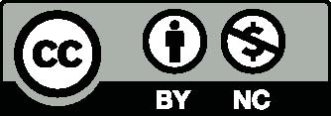
Creative Commons
Except for the logos of Safe Work Australia, SafeWork SA, Workplace Standards Tasmania, WorkSafe WA, Workplace Health and Safety QLD, NT WorkSafe, Work Cover NSW, Comcare and WorkSafe ACT, this copyright work is licensed under a Creative Commons Attribution-Noncommercial 3.0 Australia licence. To view a copy of this licence, visit
http://creativecommons.org/licenses/by-nc/3.0/au/
In essence, you are free to copy, communicate and adapt the work for non commercial purposes,
as long as you attribute the work to Safe Work Australia and abide by the other licence terms.
Contact information
Safe Work Australia
Phone: 1300 551 832
Email: info@swa.gov.au
Website: www.swa.gov.au

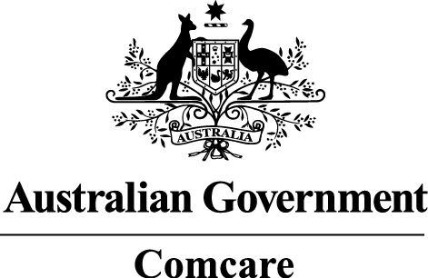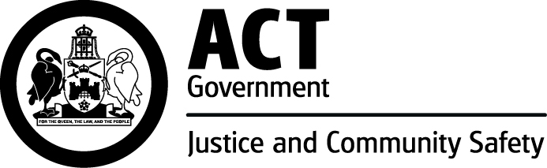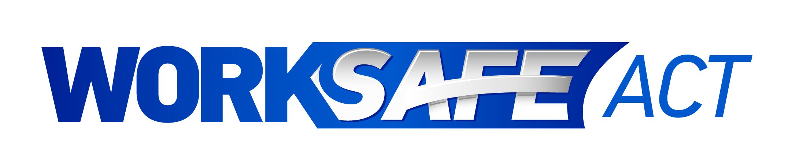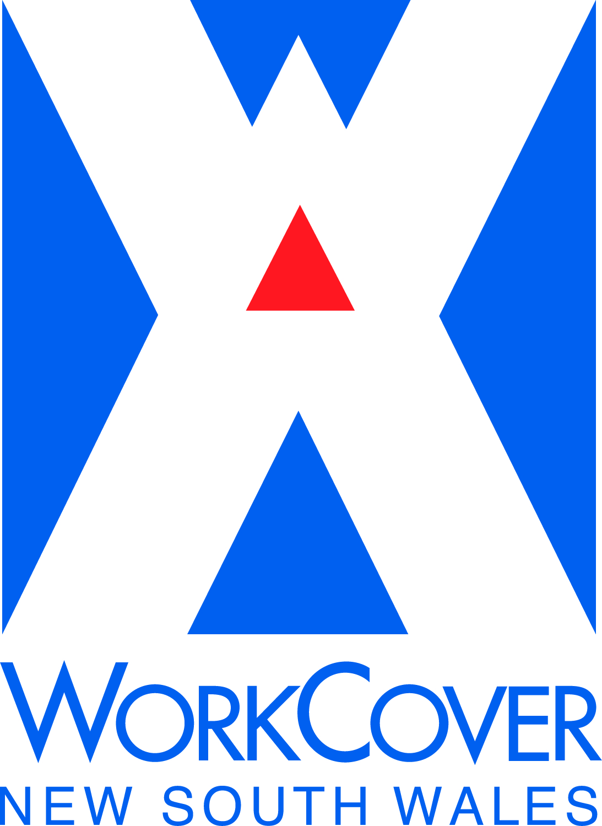
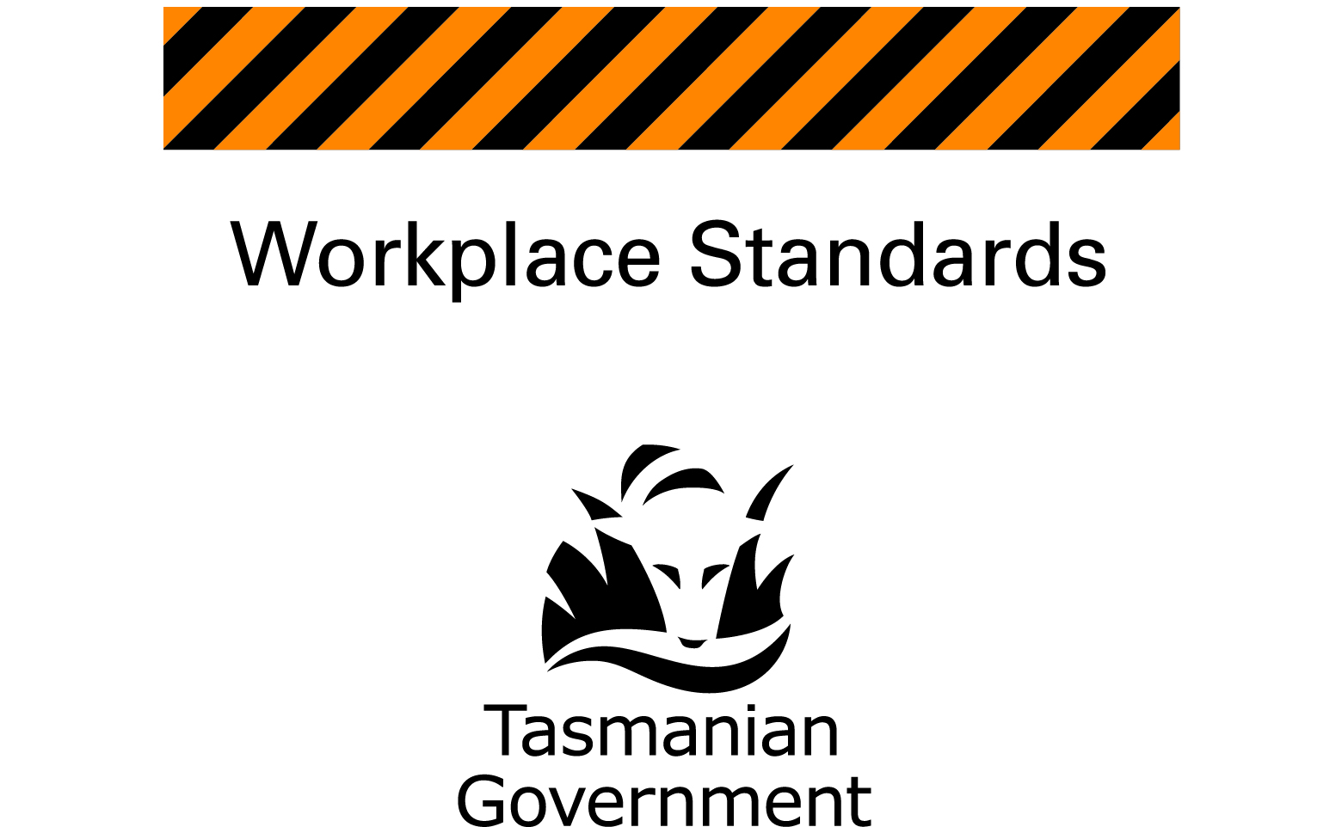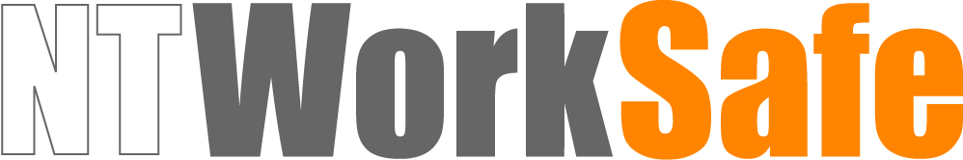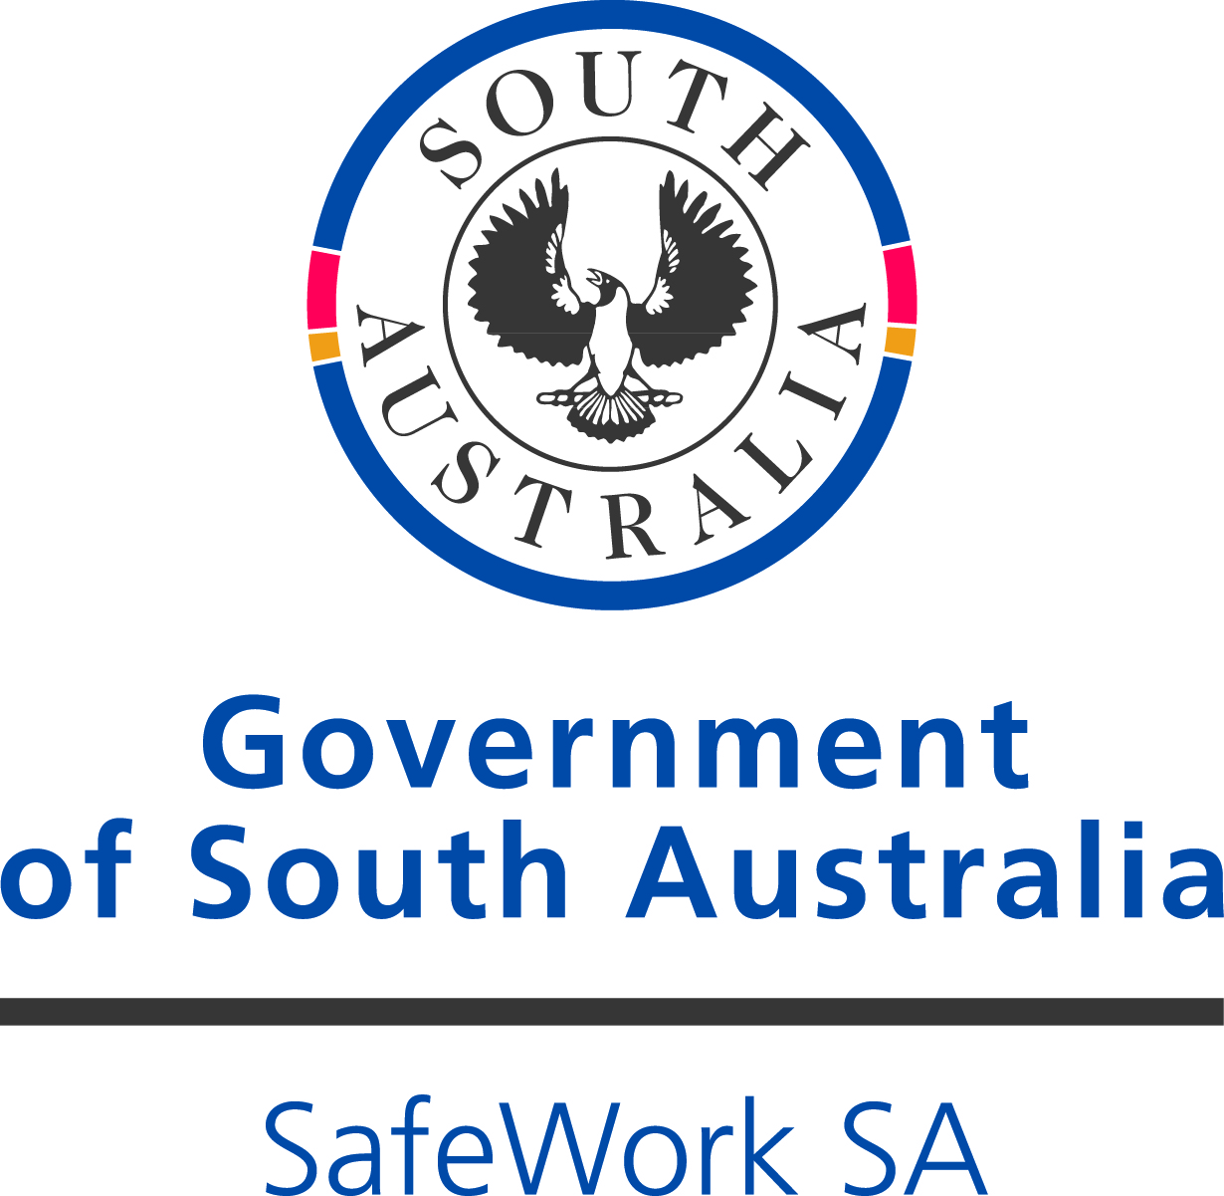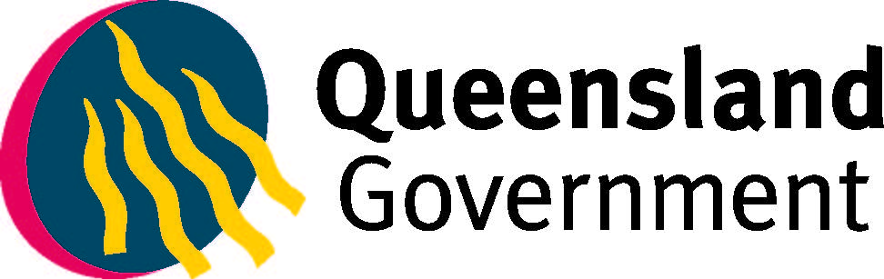

TABLE OF CONTENTS
1. INTRODUCTION 4
1.1 Who should use this Guide? 4
1.2 What is UVR? 4
1.3 Who has health and safety duties? 4
1.4 What is involved in managing risks? 5
1.5 Consultation 6
2. SOLAR ULTRAVIOLET RADIATION 7
2.1 Levels of solar UVR 7
2.2 Solar UVR and heat 8
2.3 Photosensitivity 9
3. SPECIFIC HAZARDS AND CONTROL MEASURES 10
3.1 Identifying and assessing solar UVR exposure 10
3.2 What are the key risks? 10
3.3 Hierarchy of control 11
3.4 Sun protection control measures 12
3.5 Information, training and instruction 18
4. SUN PROTECTION POLICY 20
5. SKIN CANCER CHECKS 21
APPENDIX A – SAMPLE SUN PROTECTION POLICY 22

- INTRODUCTION
  - Who should use this Guide?
This Guide provides practical guidance for persons conducting a business or undertaking and workers about managing health and safety risks associated with exposure to solar ultraviolet radiation (UVR).
This Guide contains information on the risks of solar UVR exposure, the control measures which can be used to help eliminate or minimise, so far as is reasonably practicable, a worker’s exposure to solar UVR in the workplace and guidance on how to implement a sun protection program at your workplace.
Workers who spend all or part of the day working outdoors are at risk of skin cancer and adverse health effects to their eyes. The risk of exposure to solar UVR may not be obvious for some workers, for example vehicle drivers like taxi, bus, truck, delivery and courier services. Certain workers like physical education teachers may be in and out of the sun during the day
so exposure may be intermittent. The accumulated exposure creates a risk to their health
and safety.
  - What is UVR?
While the sun is the main source of UVR it is not the only source. UVR also comes from phototherapy, solariums, fluorescent, neon and halogen lighting, industrial arc welding,
UVR lamps, ‘black lights’, germicidal UVR lamps and UV lasers.
Solar UVR is part of the electromagnetic spectrum emitted by the sun and is composed
of three wavelengths: UVA, UVB and UVC.
While all UVC and most UVB radiation is absorbed by the atmosphere, all UVA and about
10 percent of UVB radiation reaches the earth’s surface. Both UVA and UVB are known
causes of skin cancer.
Solar UVR:
- can cause damage to living organisms
- is carcinogenic to humans i.e. can cause cancer
- cannot be seen or felt
- does not depend on temperature
- can be high even on cool and cloudy days
- can pass through clouds
- can pass through loosely woven material
- can bounce off reflective surfaces like metal, concrete, water and snow, and
- is the best natural source of vitamin D which in small amounts is essential for good health.
  - Who has health and safety duties?
Under the model Work Health and Safety (WHS) laws a person conducting a business
or undertaking must manage risks to health and safety. This includes the risk of workers
being exposed to solar UVR.

Table 1 Duties in relation to exposure to solar UVR
Who | Duties | Provisions
A person who conducts a business or undertaking | Ensure, so far as is reasonably practicable, workers including volunteers and other people are not exposed to health and safety risks arising from the business or undertaking. This duty requires the person to manage health and safety risks by eliminating them so far as is reasonably practicable, and if this is not reasonably practicable, by minimising those risks so far as is reasonably practicable. | WHS Act  s 19
Designers, manufactures, importers, suppliers or installers of plant, substances or structures | Must ensure, so far as is reasonably practicable, the plant, substance or structure they design, manufacture, import, supply or install is without risks to health and safety. | WHS Act  s 22-26
Officers such as company directors | Must exercise due diligence to ensure the business or undertaking complies with the WHS Act and Regulations. This includes taking reasonable steps to ensure the business or undertaking has and uses appropriate resources and processes to eliminate or minimise risks to health and safety. | WHS Act  s 27
Workers | Must take reasonable care for their own health and safety and not adversely affect the health and safety of other people. Workers must comply with reasonable instruction and co-operate with any reasonable policy or procedure relating to health and safety at the workplace. | WHS Act  s 28
Other persons at the workplace | Must take reasonable care for their own health and safety and take reasonable care not to adversely affect other people’s health and safety. Other persons at the workplace must comply, so far as they are reasonably able, with reasonable instructions. | WHS Act s 29
  - What is involved in managing risks?
Workers who spend all or part of the day working outdoors are at risk of exposure to solar UVR.
All skin types can be damaged by exposure to solar UVR, however those with fairer skin are at an increased risk. Damage is permanent and irreversible and increases with each exposure. Implementing a sun protection program which includes a range of simple protective measures can prevent sun-related diseases and injuries.

You should manage the risks associated with exposure to solar UVR by following a systematic process of:
- identifying hazards – find out what could cause harm
- assessing risks if necessary – understand the nature of the harm that could be caused by the hazard, how serious the harm could be and the likelihood of it happening
- controlling risks – implement the most effective control measures that are reasonably practicable in the circumstances, and
- reviewing control measures to ensure they are working as planned.
Further guidance on the risk management process is in the Code of Practice: How to manage work health and safety risks.
  - Consultation
Consultation involves sharing information, giving workers a reasonable opportunity to express views and taking those views into account before making decisions about health and safety matters.
Consultation with workers and their health and safety representatives is required at each step
of the risk management process. By drawing on the experience, knowledge and ideas of your workers you are more likely to identify hazards and choose effective control measures.
You should encourage your workers to report hazards and health and safety problems immediately so the risks can be managed before an incident occurs.
Consulting, co-operating and co-ordinating activities with other duty holders
There may be more than one business or undertaking involved where workers are exposed to solar UVR, for example ensuring sun protection control measures are in place at a construction site. In these situations the duty holders should share information about the hazards and risks and work together in a co-operative and co-ordinated way to eliminate or minimise the risks so far as is reasonably practicable.
Further guidance on consultation is in the Code of Practice: Work health and safety consultation, co-operation and co-ordination.

- SOLAR ULTRAVIOLET RADIATION
Solar UVR can reach you directly from the sun. It can also be scattered by particles in the air and reflected by ground surfaces like metal, concrete, sand and snow.
The total amount of solar UVR present is affected by a range of things described in Table 2.
Table 2 Influences on intensity of solar UVR
Influences | Factors to Consider
Sun elevation | - The higher the sun in the sky, the higher the level of solar UVR.  - Solar UVR levels are higher in the middle of the day and during summer.
Latitude | - The closer to equatorial regions, the higher the level of solar UVR.
Cloud cover | - Solar UVR can pass through light cloud cover and on lightly overcast days the intensity of solar UVR can be similar to a cloud free day.  - Heavy cloud can reduce the intensity of solar UVR.  - Scattered cloud has a variable effect on levels of solar UVR, which rise and fall as clouds pass in front of the sun.
Altitude | - At higher altitudes, the atmosphere is thinner and absorbs less solar UVR.
Ozone | - Ozone absorbs some of the solar UVR that would otherwise reach the earth’s surface.
Reflective surfaces | - Some building and ground surfaces like polished aluminium, construction materials, lightly coloured concrete and water can reflect solar UVR.
  - Levels of solar UVR
The UV Index is a simple way of describing the amount of solar UVR.
The values of the UV Index range from zero upward. The higher the number, the stronger the levels of solar UVR and the less time it takes for damage to occur.
The World Health Organisation recommends when the UV level reaches three or higher
a combination of sun protection control measures including sun protective clothing, hat, sunglasses, sunscreen and shade may be needed to eliminate or minimise, so far as is reasonably practicable, exposure to solar UVR.
The UV Index has five categories described in Table 3.

Table 3 UV Index categories
Categories | UV Index
Low | UV Index of 1–2
Moderate | UV Index of 3–5
High | UV Index of 6–7
Very High | UV Index of 8–10
Extreme | UV Index of 11 and above

When the UV Index is at three or above, sun protection should be used as the solar UVR is strong enough to damage the skin.
When the UV Index is below three it is safe to go out in the sun without protection. However
it is recommended sun protection is used when the UV Index is below three for:
- outdoor workers who spend extended periods of time outdoors
- those who work in alpine regions, and
- those who work near highly reflective surfaces.
  - Solar UVR and heat
Heat illness can occur when the body is unable to cope with working in heat. Heat illness covers a range of medical conditions including heat stroke, heat exhaustion, heat cramps and skin rashes.
Exposure to solar UVR and heat illness are separate hazards for outdoor workers. You should consider the effect of heat when implementing a sun protection program.
Working in hot conditions may lead to workers not following sun protection or other control measures. For example, workers may stop using personal protective equipment (PPE) and
sun protective work clothing due to heat discomfort.
Heavy clothing worn for sun protection can contribute to a worker’s risk of heat illness. You should select material and a design that provides sun protection while keeping workers cool
in hot conditions.
In some cases control measures can minimise the risk of both heat illness and exposure to solar UVR. These include:
- providing shade for outdoor work
- having rest breaks in cooler, shaded or indoor areas
- having extra breaks
- providing loose fitting, lightweight clothing for air movement and sun protection
- changing work schedules to allow heavy work to occur during cooler times of the day this may also coincide with the times when solar UVR is less intense e.g. early in the morning or late in the afternoon, and
- rotating workers between cooler, shaded tasks and hot outdoor work.
Further guidance on working in the heat is in the Code of Practice: Managing the work environment and facilities.
  - Photosensitivity
Photosensitivity is an abnormally high sensitivity of the skin or eyes to solar UVR. This can cause the skin to burn more easily and increase the risk of skin cancer.
Photosensitivity is caused by ingesting, inhaling or having skin contact with substances known as photosensitisers. Substances that cause photosensitivity include industrial chemicals through skin contact or inhaling, plants and essential oils and fragrances through skin contact.
Medications can also cause photosensitivity, for example some antibiotics. Workers should review the medications they are or have been taking for photosensitivity side-effects.
When assessing risks you should identify photosensitising substances which may be associated with the work people do.
Table 4 Common substances that cause photosensitivity through skin contact
Coal tar and derivatives
anthracene | phenanthrene | creosote | pitch
Dyes
acridine | fluorescin | erythrocin | rhodamine
bromofluorescein | methylene blue | rose bengal | eosine
Chlorinated hydrocarbons
chlorobenzols | triphenyls | diphenyls
Plants
bergamot | fennel | St John’s Wort | chrysanthemum
bind weed | fig | dill | lime
buttercup | lemon

- SPECIFIC HAZARDS AND CONTROL MEASURES
The health and safety risks associated with exposure to solar UVR at the workplace should be managed by:
- identifying and assessing the solar UVR exposure risk to workers
- eliminating or minimising, so far as is reasonably practicable, the risk by implementing and reviewing sun protection control measures, and
- providing information, instruction, training and supervision.
  - Identifying and assessing solar UVR exposure
To assess the risks to workers from solar UVR exposure you should identify workers who have a high risk of exposure to solar UVR and situations or work systems where high exposure to solar UVR occurs.
The total exposure to solar UVR during outdoor work depends on:
- the geographical location of the work
- the time of year when outdoor work occurs
- the times of the day when outdoor work occurs
- the pattern and length of exposure – exposure can occur in an ongoing episode or via
a series of shorter episodes which accumulate over time
- the availability and use of control measures
- the presence of reflective surfaces, and
- the presence of photosensitisers.
  - What are the key risks?
Exposure to solar UVR is known to cause adverse health effects on the skin, eyes and immune system.
Skin cancer
The most serious health effect of exposure to solar UVR is skin cancer.
The top layer of the skin contains three different types of cells: basal cells, squamous cells
and melanocytes. Skin cancers are named after the skin cell where the cancer develops.
The three types of skin cancer are:
- Basal cell carcinoma (BCC) is the most common type of skin cancer. It grows slowly
over months and years and may damage nearby tissues and organs if left untreated.
- Squamous cell carcinoma (SCC) is less common but grows faster. It may spread
to other parts of the body if left untreated.
- Melanoma is the least common but most dangerous type of skin cancer. Most skin cancer deaths are from melanoma. It is often fast growing and can spread to other
parts of the body where it can form a new cancer.
Basal cell carcinomas and squamous cell carcinomas are often grouped together and called non-melanoma or common skin cancers.
The amount of exposure required to cause skin cancer varies from one person to another. In most people the risk of skin cancer increases with increasing amounts of exposure to the sun.
The workplace is a major source of solar UVR exposure for many adult Australians with outdoor workers having between five and ten times more sun exposure than indoor workers.
Exposure to solar UVR is the cause of about 99 percent of non-melanoma skin cancers
and 95 percent of melanoma in Australia. A small number of skin cancers are from a genetic predisposition. Both melanoma and non-melanoma skin cancers can appear anywhere on the body, not just sun exposed areas.
Sunburn
Sunburn is a solar UVR burn to the skin. In Australia, sunburn can occur in as little as 11 minutes on a fine January day. Sunburn, whether serious or mild can cause permanent
and irreversible skin damage.
Mild sunburn that reddens and inflames the skin is known as first-degree sunburn. Second-degree sunburn occurs with more serious reddening of the skin and water blisters. Third-degree sunburn requires medical attention.
Eye damage
Acute effects of exposure to solar UVR on the eye include:
- photokeratitis—inflammation of the cornea and the iris, and
- photoconjunctivitis—inflammation of the conjunctiva—membrane lining the inside of the eyelids and white of the eye. It is more commonly known as snow blindness or welder’s flash.
Evidence shows ongoing exposure to solar UVR contributes to age-related macular degeneration and cataracts which both cause blindness. Long-term effects may also include pterygium which is white or creamy opaque growths on the cornea, squamous cell carcinoma
of the conjunctiva and cancer on the skin surrounding the eye.
  - Hierarchy of control
Some control measures are more effective than others. Control measures can be ranked from the highest level of protection and reliability to the lowest. This ranking is known as the hierarchy of control.
Eliminating the risk
This means removing the hazard or hazardous work practice from the workplace. This is
the most effective control measure and must always be considered before anything else.
For example, eliminate the risk of solar UVR exposure by carrying out the work indoors.
If eliminating the risk is not reasonably practicable, you must consider using substitution, isolation or engineering controls, or a combination of these control measures, to minimise
the risk.

Minimising the risk
Substitution
Minimise the risk by substituting or replacing a hazard or hazardous work practice with a safer one, for example carrying out the work during the early morning and late afternoon when the risk of solar UVR exposure is lower.
Isolation
Where possible minimise the risk by isolating or separating the hazard or hazardous work practice from people.
Engineering controls
Engineering controls are physical control measures to minimise risk, for example installing
a sun shade.
If a risk then remains, the duty holder must minimise the remaining risk, so far as is reasonably practicable, by using:
Administrative controls
Administrative controls should only be considered when other higher order control measures are not reasonably practicable, or to increase protection from the hazard. These are work methods or procedures designed to minimise the exposure to a hazard, for example rotating jobs and varying tasks.
Any remaining risk must be minimised, so far as is reasonably practicable, by providing and ensuring the use of:
Personal protective equipment
PPE is the lowest order control measure in the hierarchy of controls. PPE should only be considered when other higher order control measures are not reasonably practicable or to increase protection from the hazard. Examples of PPE include sun protective work clothing, sun protective hats, sunglasses and sunscreen. These types of PPE are discussed in section 3.4.
Combining control measures
In most cases, a combination of control measures will provide the best solution to minimise the risk to the lowest level reasonably practicable. For example, use engineering controls like shade structures along with PPE like sun protective clothing and administrative controls like rotating workers. You should check your chosen control measures do not introduce new hazards, for example PPE might make heat stress worse and temporary shade structures may not be secured properly.
  - Sun protection control measures
Once the risk has been assessed you should work together with your workers to identify control measures that suit your workplace.
When developing your sun protection program it is important to remember your workers will need protection from exposure to both direct and indirect sources of solar UVR.
What is ultraviolet protection factor?
Ultraviolet protection factor (UPF) is a measure for how effective a material is at blocking solar UVR. UPF ratings range from 15 to 50 with higher ratings indicating better protection from solar UVR. Materials testing higher than UPF 50 are rated as UPF 50+.
Solar UVR protection identification is provided on items like clothing, hats, shade materials, fabric and glass.
Shade
Shade is one of the most effective forms of sun protection for outdoor workers. Shade can come naturally from permanent structures like buildings or trees or from portable structures like canopies, tents or screens.
If it is difficult for work to be carried out in the shade, workers should seek shaded areas during breaks, especially lunch breaks.
Where shade protection is used consider:
- the effectiveness of the shade i.e. how much protection and coverage is provided
- the quality of shade from natural sources like vegetation – this depends on the density
of the foliage, the size of the canopy, the shape of the vegetation and how far the canopy is from the ground
- shade materials – check the UPF rating of shade material used. Look for UPF 20 or more
- position under the shade – levels of solar UVR are greater near the edge of shaded areas than at the centre
- UPF ratings for shade – these ratings apply to material only. The overall protection provided also depends on the design of the structure itself, its placement relative to the sun and how it is used
- portable shade – this is a quick and cheap solution to shade small numbers of people and is ideal for places where no other shade options are available, and
- existing shade at the worksite from buildings, trees and other structures and relocating jobs to take advantage of existing shade where possible.
You should not rely on shade alone. A person working in the shade may still receive a substantial amount of exposure from indirect sources of UVR, for example from reflection off
a nearby surface.
For the best protection use a combination of shade protection control measures.
Reflective surfaces
Some reflective surfaces can be changed to minimise exposure to UVR. For example, consider painting a surface a less reflective colour or work near soft or rough surfaces rather than hard
or smooth surfaces.

Table 5 Materials and the level of reflected UVR
Material |  | Level of reflected solar UVR (%)
Asphalt | New black roadway | 4.1
Asphalt | Old grey roadway | 8.9
Concrete | Footpath | 8.2 – 12.0
Grass | Grasslands | 0.8 – 1.6
Grass | Lawn | 2.0 – 5.0
Fibreglass | Fibreglass boat deck | 9.1
Paint | White house paint | 22.0
Sand | Wet beach sand | 7.1
Sand | Dry beach sand | 15.0 – 18.0
Soil | Clay/humus | 4.0 – 6.0
Water | Open water | 3.3
 | Open ocean | 8.0
 | Sea surf/white foam | 25.0 – 30.0
 | Snow old/new | 50.0 – 88.0
Wood | Wood boat deck | 6.6
Window tinting and glass
A person sitting in a vehicle can receive significant exposure to solar UVR.
Clear or tinted films applied to the side windows can substantially reduce the amount of solar UVR coming into a vehicle. As the amount of protection varies with different products you should check the most suitable product for your purpose with the product supplier.
Applying films and tints will only be effective if the windows are closed so air conditioning may also be needed.
Office building glass has a UPF of 50+, which means one fiftieth—approximately two percent—of UVR will pass through. The window absorbs the remaining 98 percent. This type of glass provides excellent protection.
Scheduling work
You should consider making changes to outdoor work schedules to minimise exposure:
- Plan work routines so outdoor work tasks are done early in the morning or later in the afternoon when levels of solar UVR are lower.
- Plan work routines so indoor or shaded work tasks are done during the middle of the day when levels of solar UVR are strongest.
- Move the job indoors or into shaded areas.
- Share outdoor tasks and rotate staff so the same person is not always out in the sun.
SunSmart UV Alert
The Bureau of Meteorology issues the SunSmart UV Alert which is based on the UV Index, when the UV Index is forecast to reach three or above.
The SunSmart UV alert can be accessed from:
- www.myuv.com.au
- a smart phone application and a widget for your website at www.sunsmart.com.au/uvwidget.html
- television, radio and newspapers
- the Bureau of Meteorology website at www.bom.gov.au/uv, and
- the Australian Radiation Protection and Nuclear Safety Agency (ARPANSA) website at www.arpansa.gov.au
You should consider implementing a system where workers are aware of the UV Alert each day, for example printing out the forecast and leaving it in shared areas and encouraging workers to check the alert on their phone or in the newspaper.
Figure 1 shows a typical SunSmart alert and explains its features.
Figure 1 SunSmart UV alert
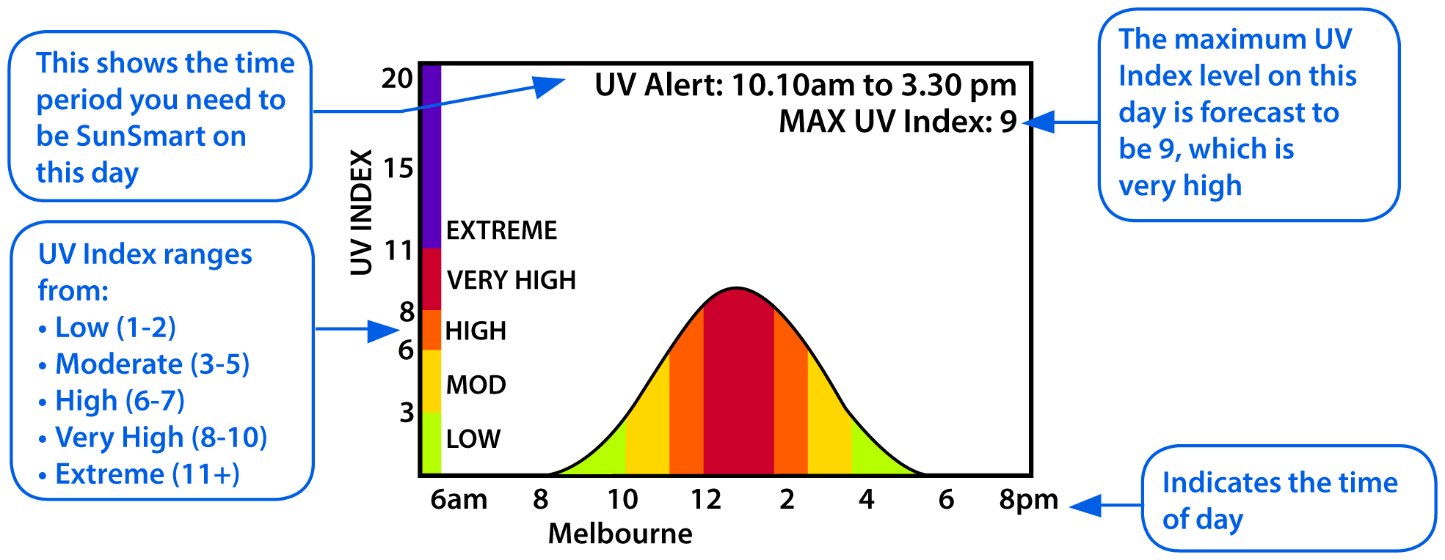
Personal protective equipment
PPE used for sun protection includes:
- sun protective work clothing
- sun protective hats
- sunglasses, and
- sunscreen.
You should carefully choose when PPE is used to minimise the risk of solar UVR exposure and consider the type of outdoor work being performed. The design should balance sun protection with the need to stay cool in hot conditions.
Workers must be trained and instructed to use PPE correctly. It is important that design and use of the PPE does not create a secondary hazard, for example loose clothing becoming caught in machinery.
Sun protective work clothing
One of the most effective barriers between skin and the sun is clothing. The overall protection provided by clothing depends both on the clothing’s material and the garment’s design.
When selecting sun protective clothing for outdoor workers consider:
- Different types of fabric provide different protection – closeness of weave, colour and condition can affect the ability of material to absorb solar UVR.
- The design should cover as much skin as possible – long pants and shirts with a collar and long sleeves provide the best sun protection.
- Fabrics may have a UPF rating – these fabrics have been tested to determine how effective they are at blocking solar UVR. The higher the UPF rating, the more protection provided. UPF 50+ provides the best protection. Fabrics that do not have a UPF rating do not necessarily offer less protection. It just means they have not been tested for sun protection.
- Keep cool. Specially designed lightweight and cool work clothing that provides maximum sun protection should be considered. In the heat it is important garments draw perspiration away from the body to help the body stay cool.
Sun protective hats
A sun protective hat shades the face, head, ears and neck. The overall protection provided depends on the material the hat is made from and the design of the hat.
Hats should be used in combination with other forms of sun protection. A broad brimmed hat alone can reduce sun exposure to the eyes by 50 percent. When used with sunglasses and sunscreen, protection from solar UVR is substantially increased.
When selecting sun protective hats for outdoor workers consider:
- The UPF rating of the fabric. If you can see through the material the sun will get through, which is why a close weave is important. Similar to clothing, hats will have a tag attached to them if the material has been tested to determine how effectively it blocks UVR.
- Broad brimmed and bucket hats provide the most sun protection for the face and head. Broad brimmed hats should have a brim of at least 7.5 cm. Bucket hats should have a deep crown, sit low on the head and have an angled brim of at least 6 cm.
- Legionnaire hats provide satisfactory sun protection and are more suitable when work involves a lot of bending. Legionnaire style hats should have a flap to cover the neck. The side of the flap should meet with the peak to protect the side of the face.
- Attachable brims and neck flaps are available for hard hats or helmets.
- Baseball caps are not recommended as they fail to shade most of the face, neck or ears.
Sunglasses
Sunglasses can provide excellent protection for the eyes depending on the protective qualities of the lens and the design of the sunglasses.
When selecting sunglasses for your workers consider:
- Sunglasses sold in Australia must comply with AS/NZS 1067:2003: Sunglasses and fashion spectacles.
- The Standard defines five categories of lenses and sunglasses sold in Australia.
They must be labelled to indicate which category they comply with. The categories, description and any additional markings found on the sunglasses are listed in Table 6. You should look for the words ‘good UV protection’ on the label. Be aware—category 0 and 1 are fashion spectacles not sunglasses.
- Due to colour or darkness of the lens some sunglasses must not be used when driving.
If your workers use vehicles, read the label description carefully to ensure sunglasses are suitable for driving.
- In addition to the labels required under AS/NZS 1067:2003: Sunglasses and fashion spectacles, some sunglasses may be labelled with an eye protection factor (EPF).
This is a scale from one to 10 which is used to classify how well a lens blocks solar UVR. If a lens has been tested it may state an EPF rating on the label. Sunglasses with an EPF of nine and 10 let through almost no solar UVR.
- Close-fitting, wrap around style sunglasses are best. This design stops solar UVR from entering the sides and top of the lenses.
- Polarised lenses reduce glare which is reflected visible light. This makes it easier to see on a sunny day. However polarised lenses will not necessarily block solar UVR and the category and the EPF should be checked.
- Some workers may need extra eye protection from flying objects or glare. In this case, choose specialist safety sunglasses to meet AS/NZS 1337.1:2010 Eye and face protectors for occupational applications. Safety glasses still provide good solar UV protection but will require tinting for use outdoors.
- Prescription glasses—either clear or tinted—are not tested against AS/NZS 1067:2003 Sunglasses and fashion spectacles but may still provide protection against solar UVR. Fit-overs are recommended for prescription glasses as few are close fitting and wrap around in style.
Table 6 Categories of sunglasses sold in Australia
Lens category | Description | Additional markings
0 | Fashion spectacles - not sunglasses  very low sunglare reduction - some UV protection | NONE
1 | Fashion spectacles - not sunglasses  limited sunglare reduction - some UV protection | NOT SUITABLE FOR DRIVING AT NIGHT
2 | Sunglasses –  medium sunglare reduction and good UV protection | NONE
3 | Sunglasses –  high sunglare reduction and good UV protection | NONE
4 | Sunglasses –  Very high sunglare reduction and good UV protection | MUST NOT BE USED WHEN DRIVING

Sunscreen
Sunscreen should always be used with other sun protection control measures. It is important
to understand that no sunscreen offers 100 percent protection from solar UVR.
Sunscreen must carry a sun protection factor (SPF). The SPF rating indicates how protective
a sunscreen is against solar UVR. It measures how much energy it takes to produce minimal sunburn through a sunscreen compared to how much energy it takes to produce the same sunburn without the sunscreen. For example, if you normally get a minimal burn in twenty minutes it would take thirty times as long to get one using a sunscreen with an SPF of 30.
A SPF 30 filters about 96.7 percent of solar UVR, leaving about 1/30th of the solar UVR to
get through. A SPF 50 sunscreen filters about 98 percent, leaving 1/50th of solar UVR to
get through. These numbers are general and vary with weather conditions and skin type.
Workers should use a sunscreen with a SPF of 30 or higher that is broad-spectrum, meaning
it filters UVA and UVB radiation and is water resistant. Lips should also be protected with a lip balm containing SPF 30 or higher.
Workers should be trained and instructed to apply and use sunscreen effectively including:
- applying sunscreen 20 minutes before going outdoors so it can be absorbed into the skin properly
- reapplying sunscreen regardless of the instructions on the bottle every two hours or more often if perspiring or the area has been rubbed excessively or washed
- applying sunscreen to clean dry skin, and
- using a generous amount of sunscreen. The average-sized adult should apply at least one teaspoon of sunscreen to each arm, leg, front of body and back of body and at least half a teaspoon to the face including the ears and neck.
Sunscreen should be kept in a cool place below 30°C in easily accessible places like tearooms and site offices.
Sunscreen has an expiry date therefore stock should be checked and replaced as required.
  - Information, training and instruction
Raising awareness and providing training and instruction to safety officers, health and safety representatives, supervisors, outdoor workers and new workers is essential to the success
of a workplace sun protection program.
A workplace sun protection program can:
- raise the profile of sun protection as a health and safety issue
- improve knowledge and understanding of sun protection control measures
- dispel common misconceptions about solar UVR and various sun protection control measures
- help workers detect the early signs of skin cancer
- improve sun protection behaviour of workers both ‘on’ and ‘off’ the job
- raise workers’ awareness about your workplace sun protection program and policy, and
- provide a forum for feedback from workers.
Information and training should cover:
- the harmful health effects of exposure to solar UVR
- factors affecting levels of solar UVR
- effective identification, application and use of sun protection control measures
- risk factors for skin cancer
- how to check for skin cancer and what to look for, and
- what to do if you find something.
The Cancer Council can provide resources, advice and services to help with the design and delivery of information and training for workers. The Cancer Council can be contacted through their Cancer Council Helpline on 13 11 20 or their website at www.cancer.org.au.

- SUN PROTECTION POLICY
A sun protection policy records how the solar UVR risk at your workplace will be managed.
A sun protection policy can outline:
- the hazards, risks and sun protection control measures at the workplace
- information and training requirements
- responsibilities at the workplace, and
- review processes.
When sun protection control measures have been implemented they should be monitored and reviewed regularly. Supervision should also be provided to ensure the control measures are used effectively and are complied with.
Where possible, you should incorporate the monitoring of sun protection control measures into existing audit tools used in the workplace including work health and safety inspections, on-site supervisor reports and checklists.
You should:
- consider establishing a system for collecting regular feedback from workers e.g. using surveys or focus groups, and
- ensure workers and their representatives are consulted and feedback is considered before making changes.
A sample sun protection policy is provided at Appendix A.

- SKIN CANCER CHECKS
Skin cancer may appear as either a new skin growth or one that has changed in colour, size, shape or texture. Skin cancer can usually be cured if it is treated early. The early diagnosis and treatment of skin cancer relies heavily on early detection with an emphasis on self-examination.
Consider providing regular skin checks at skin clinics for workers who are exposed to solar UVR and provide information on how workers can check their own skin.
Note: Having regular skin checks to detect skin cancer is not an alternative to using sun protection control measures.
Some tips on how to carry out a self-check include:
- checking your whole body including the soles of your feet, between your toes, your armpits, ears, eyelids, under your fingernails and scalp
- using a hand held mirror or have someone help you check areas you cannot see like your back, back of your neck and legs
- looking for a new spot or a spot that is different from the ones around it
- looking for a sore that does not heal, and
- looking for a spot or mole that has changed in size, shape or colour.
Workers should be told to see their doctor as soon as possible if they notice anything unusual
or have concerns about their skin.
Further information on skin cancer including pictures and descriptions of skin spots to keep
a watch on is available from the Cancer Council. As previously advised the Cancer Council
can be contacted through their Cancer Council Helpline on 13 11 20 or their website at www.cancer.org.au.

APPENDIX A – SAMPLE SUN PROTECTION POLICY
This sample sun protection policy is intended as a guide only. Persons conducting a business
or undertaking should tailor a policy to suit the needs and practicalities of their organisation.
(ORGANISATION NAME) SUN PROTECTION POLICY
Rationale
Australia has one of the highest rates of skin cancer in the world. Despite being an almost entirely preventable disease at least two in every three Australians will develop skin cancer before they reach the age of 70. Of all new cancers diagnosed in Australia each year,
80 percent are skin cancers.
Workers who work outdoors for all or part of the day have a higher than average risk of skin cancer. This is because ultraviolet radiation in sunlight or ‘solar UVR’ is a known carcinogen.
All skin types can be damaged by exposure to solar UVR. Damage is permanent and irreversible and increases with each exposure.
(Organisation Name) has an obligation to provide a work environment without risks to health and safety, so far as is reasonably practicable. This obligation includes eliminating or minimising, so far as is reasonably practicable, the risks from exposure to solar UVR for
outdoor workers.
Aims
This policy aims to provide ongoing organisational support to minimise worker exposure to solar UVR by implementing sun protection control measures.
Our commitment
(Organisation Name) will assess the risks in consultation with health and safety representatives and workers to identify workers who have a high risk of exposure to solar UVR and work situations where exposure to solar UVR occurs.
(Organisation Name) will minimise, so far is reasonably practicable, workers’ exposure to solar UVR by consulting with workers and ensuring workers use sun protection control measures during sun protection times and at all times when working outdoors for extended periods,
in alpine regions or near highly reflective surfaces.
(Organisation Name) recognises the SunSmart UV Alert is issued whenever the UV Index is forecast to reach three and above and will use the sun protection times displayed to inform workers when it is necessary to use sun protection control measures while working outdoors.
(Organisation Name) will actively supervise outdoor workers and monitor their use of sun protection control measures.
(Organisation Name) will ensure injury reporting procedures are followed when an incident
of sunburn or excessive exposure to solar UVR occurs in the workplace.
(Organisation Name) recognises a combination of sun protection control measures provides
the best protection to workers from exposure to solar UVR.

(Organisation Name) will, where possible:
- Provide shaded areas or temporary shade.
- Encourage workers to move jobs to shaded areas.
- Apply window tinting to work vehicles.
- Modify reflective surfaces.
- Identify and minimise contact with photosensitising substances.
- Provide indoor areas or shaded outdoor areas for rest and meal breaks.
- Schedule outdoor work tasks to occur when levels of solar UVR are less intense e.g. earlier in the morning or later in the afternoon.
- Schedule indoor and shaded work tasks to occur when levels of solar UVR are strongest e.g. in the middle part of the day.
- Encourage workers to rotate between indoor, shaded and outdoor tasks to avoid exposure to solar UVR for long periods of time.
- Provide daily access to the SunSmart UV Alert or UV Index.
- Provide PPE and ensure it is used effectively including:
  - sun protective work clothing like long-sleeved shirts with a collar and trousers
or knee-length shorts
  - sun protective hats covering the face, head, ears and neck
  - sunglasses meeting Australian Standards, and
  - broad spectrum, SPF 30 or higher, water resistant sunscreen.
Information, Training and Instruction
Management will:
- Provide training to workers to enable them to work safely in the sun.
- Ensure training is provided as part of induction for new workers.
- Ensure workers are provided with information to effectively examine their own skin.
- Ensure managers and supervisors act as positive role models.
- Adopt sun protection practices during work related social events.
- Promote the use of sun protection control measures ‘off the job’.
Workers will:
- Co-operate with measures introduced by management to minimise the risks associated with exposure to solar UVR.
- Follow information, training and instructions about using sun protection control measures.
- Participate in sun protection education programs.
- Act as positive role models.
- Be responsible for their own sun protective practices at work.

Review
This policy will be reviewed regularly or at least every 2 years.
Name (please print):
Position:
Signature:
Date:
Date of next policy review:

Samenek AJ, Croager EJ, Gies P, Milne E, Prince R, McMichael AJ, Lucas RM, Slevin T. Estimates of beneficial and harmful sun exposure times during the year for major population centres. Med J Aust 2006; 184 97):338 341

