Guide for Preventing and   
Responding to Cyanide Poisoning   
in the Workplace

Safe Work Australia is an Australian Government statutory agency established in 2009. Safe Work Australia consists of representatives of the Commonwealth, state and territory governments, the Australian Council   
of Trade Unions, the Australian Chamber of Commerce and Industry and the Australian Industry Group.

Safe Work Australia works with the Commonwealth, state and territory governments to improve work health   
and safety and workers’ compensation arrangements. Safe Work Australia is a national policy body, not   
a regulator of work health and safety. The Commonwealth, states and territories have responsibility for   
regulating and enforcing work health and safety laws in their jurisdiction.

ISBN 978-1-74361-059-6  [PDF]  
ISBN 978-1-74361-060-2  [DOCX]­



### Creative Commons

Except for the logos of Safe Work Australia, SafeWork SA, Workplace Standards Tasmania, WorkSafe WA, Workplace Health and Safety QLD, NT WorkSafe, Work Cover NSW, Comcare and WorkSafe ACT,   
this copyright work is licensed under a Creative Commons Attribution-Noncommercial 3.0 Australia licence.   
To view a copy of this licence, visit

<http://creativecommons.org/licenses/by-nc/3.0/au/>

In essence, you are free to copy, communicate and adapt the work for non-commercial purposes,   
as long as you attribute the work to Safe Work Australia and abide by the other licence terms.

Contact information  
Safe Work Australia  
Phone: 1300 551 832  
Email: [info@swa.gov.au](mailto:info@swa.gov.au)

Website: [www.swa.gov.au](http://www.safeworkaustralia.gov.au)

Contents

1. Introduction 4

2. Managing risks to health and safety at the workplace 5

3. Hazards of cyanides 6

3.1 Routes of exposure 6

3.2 Acute poisoning 6

3.3 Chronic poisoning 7

3.4 Workplace exposure standard for cyanides 7

3.5 Biological monitoring for cyanides 8

4. Controlling risks 9

4.1 Storage 11

4.2 Disposal 11

5. Responding in an emergency 12

5.1 Emergency response plan 12

5.2 Leaks and spills 12

5.3 Fire 13

5.4 First aid 13

5.5 Cyanide emergency kit 14

5.6 Medical facility care 15

Appendix A – Workplace First aid procedures 18

# 

# Introduction

This document provides guidance on how to manage risks during the storage, handling   
and use of cyanides. It includes guidance on recognising symptoms of cyanide poisoning and responding to cyanide exposure in the workplace.

Throughout this document, the term ‘cyanides’ means cyanide salts like sodium or potassium cyanide, and hydrogen cyanide gas.

Most cyanides are fast acting and highly toxic chemicals which can exist in various forms,   
for example, hydrogen cyanide is a colourless gas or liquid and cyanide salts like sodium cyanide or potassium cyanide are crystalline solids. Hydrogen cyanide is extremely flammable.

Cyanides are used in the chemicals industry in the production of other chemicals and are widely used in the mining and electroplating industries. Hydrogen cyanide has been used   
in the leather tanning industry and as a fumigant and rodenticide. Hydrogen cyanide is   
a by-product from blast-furnaces, coke ovens, gas works, petroleum refining, photographic development and when certain materials, like nitrogen-containing plastics, are burned.

Cyanides are often described as having an odour of bitter almonds, however, not everyone can detect this smell. At higher concentrations the sensory receptors can become overloaded which means, even for people who can normally smell cyanides, the odour cannot be perceived. The sense of smell should never be relied on as a means to detect cyanides.

# Managing risks to health and safety at the workplace

The Work Health and Safety (WHS) Regulations require persons conducting a business   
or undertaking to *manage risks* to health and safety associated with using, handling, generating or storing hazardous chemicals at a workplace.

| **Regulations 32–38:** In order to manage risk to health and safety under the WHS Regulations, a duty holder must:   * identify reasonably foreseeable hazards that could give rise to the risk to health  and safety * eliminate the risk to health and safety, so far as is reasonably practicable * if it is not reasonably practicable to eliminate the risk to health and safety, minimise  it so far as is reasonably practicable by implementing control measures in accordance with the hierarchy of risk control * maintain the implemented control measure so that it remains effective * review and, if necessary, revise risk control measures so as to maintain, so far as is reasonably practicable, a work environment that is without risks to health and safety. |
| --- |

When managing risks from chemicals, you must take into consideration the following factors:

* the hazardous properties of the chemical
* potentially hazardous chemical or physical reactions between the chemical and another substance or mixture, including substances that may be generated by the reaction
* the nature of the work to be carried out with the hazardous chemical
* a structure, plant or system of work that:
  + is used in the handling, generation, storage or use of the hazardous chemical
  + could interact with the hazardous chemical at the workplace.

Further guidance on the risk management process for hazardous chemicals is available   
in the Code of practice: *Managing risks of hazardous chemicals in the workplace*.   
Further information on the use of cyanides in electroplating processes is available   
in the *Controlling Risks Associated with Electroplating* guide.

# Hazards of cyanides

Most cyanides are highly toxic. Before using a chemical in the workplace, the Safety Data Sheet (SDS) should be referred to as it contains relevant information on the chemical’s hazards, potential routes of exposure and instructions on its safe use, handling, storage   
and disposal.

## Routes of exposure

The main route of exposure to cyanides in the workplace is through inhalation. This results   
in fast absorption and circulation around the body. Exposure to cyanides through ingestion is less common and cyanide poisoning can result from absorption through eye or skin contact. Attention should also be paid to preventing skin and eye contact as well as inhalation.

### Symptoms of cyanide poisoning

Workers handling, storing, using or generating cyanides should be trained to recognise symptoms of cyanide poisoning. Workers must have access to suitably-qualified first aiders who can deal with cyanide poisoning emergencies.

The onset of symptoms of cyanide poisoning is generally fast, but can depend on:

* its form—whether it is solid, liquid or gas
* the route of exposure
* the amount of cyanide the person is exposed to.

Exposure to, and inhalation of, cyanide gas generally results in the quickest onset   
of symptoms. People who work with cyanides should be aware of the symptoms   
of over-exposure. Poisoning can be classed as acute (short-term) or chronic (long-term). The symptoms and health effects of cyanide poisoning are independent of the route   
of exposure.

## Acute poisoning

Depending on the level of exposure, the level of poisoning can be described as *mild*   
or *moderate to severe*.

*Mild poisoning* can produce the following symptoms:

* headache
* anxiety
* dizziness
* nausea and vomiting—particularly if the cyanide has been ingested
* shortness of breath and a sense of suffocation
* general weakness with heaviness of arms and legs.

If treatment is not started quickly, symptoms may progress and the person’s condition   
can deteriorate to include signs of:

* increased shortness of breath or gasping for air
* falling blood pressure
* cardiac arrhythmia—disturbance in heart rhythm and pulse
* cyanosis—blue or purple colouration of the skin or mucous membranes
* deteriorating levels of consciousness.

*Moderate to severe poisoning* results from exposure to higher concentrations of cyanides and symptoms include:

* rapid loss of consciousness
* seizures
* gasping for breath, weakness or absence of breathing
* cardiac arrest.

Death may occur within a few minutes of exposure to moderate or high amounts of cyanides. Survivors may suffer brain injuries due to toxic effects or lack of oxygen.

## Chronic poisoning

Chronic exposure to cyanides is rare because cyanides are metabolised quickly in the body and subsequently excreted. Chronic exposure can produce the following symptoms:

* headache
* eye irritation
* fatigue
* chest symptoms like shortness of breath
* nose bleeds.

## Workplace exposure standard for cyanides

Cyanide salts and hydrogen cyanide have workplace exposure standards. A person conducting a business or undertaking must ensure no worker is exposed above the exposure standard. The following exposure standards for cyanides currently apply:[1]

|  | TWA / ppm | TWA / mg/m3 | Notation |
| --- | --- | --- | --- |
| Cyanides (as CN) | - | 5 | Sk |
| Hydrogen cyanide | 10 peak limitation | 11 peak limitation | Sk |

For cyanides (as CN), the value is a time-weighted average (TWA) that applies to a normal eight-hour working day for a five-day working week and must not be exceeded. Peak limitation, in relation to hydrogen cyanide, means a maximum or peak airborne concentration of a substance determined over the shortest analytically practicable period of time which does not exceed fifteen minutes. The Sk notation means absorption can occur through the skin as well as through inhalation.

Air monitoring may be required in order to determine whether a worker may be exposed   
to cyanides above the exposure standard and to determine the level of risk to workers.

Guidance on compliance with exposure standard provisions in the WHS Regulations is available in Safe Work Australia’s *Guidance on the Interpretation of Workplace Exposure Standards for Airborne Contaminants*

## Biological monitoring for cyanides

Low-level, chronic exposure to cyanides in the workplace can be determined by analysing the level of thiocyanate in urine. Thiocyanate is the major metabolite of cyanide and it has a half-life of approximately four to six days. This means thiocyanate can be used as a biological marker to detect cyanide in the body.

The presence of thiocyanate in urine does not necessarily indicate workplace exposure to cyanide as a number of non-workplace related sources, including smoking tobacco and eating certain foodstuffs like broccoli, cauliflower, cabbage and other green vegetables, produce low levels of cyanide in the body. It is important background levels of thiocyanate are taken into account when measuring potential workplace exposure.[2]

Further details on health monitoring and biological monitoring can be found in the guidance materials on *Health monitoring for exposure to hazardous chemicals.*

# 

# Controlling risks

### The hierarchy of control

There are a number of ways to control the risks associated with the use of cyanides. Some control measures are more effective than others. Control measures can be ranked from the highest level of protection and reliability to the lowest. This ranking is known as the *hierarchy of control*.

The first aim must always be to try and eliminate a hazard and associated risk. If this is not reasonably practicable, the risk must be minimised by using one or more of the following approaches:

* substitution
* isolation
* implementing engineering controls.

Remaining risk must be minimised by implementing administrative controls, so far as is reasonably practicable. If there is still any risk this must be minimised with suitable personal protective equipment (PPE).

### Figure 1 Sign warning cyanide is present and to wear PPE - administrative control

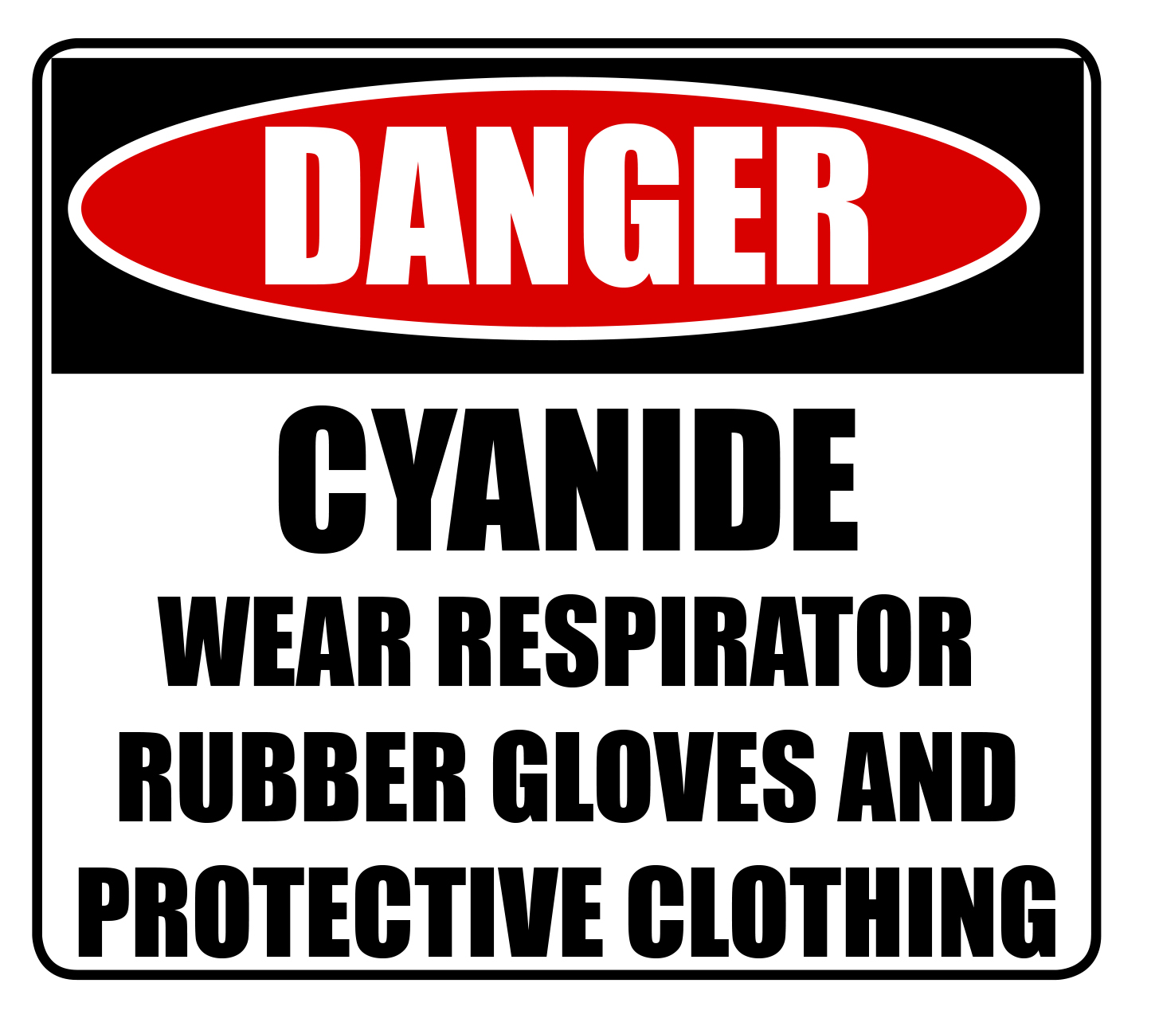

Examples of application of the hierarchy of controls for cyanide storage, handling and use are provided in Table 1. A combination of control measures may be needed to effectively eliminate or minimise risk.

### Table 1 Hierarchy of controls

| **Hierarchy Steps** | **Examples** |
| --- | --- |
| ELIMINATION | * Where possible, eliminating the use of cyanides in the work process. |
| SUBSTITUTION | * Where practicable, substituting the use of cyanides in a work process with a less hazardous chemical—for example replacing copper cyanide with copper pyrophosphate in electroplating. |
| ISOLATION | * Isolating cyanides from incompatible substances to avoid dangerous reactions that could generate hydrogen cyanide  or other hazardous gases, for example storing cyanides away from acids, oxidising agents and other incompatible substances. * Enclosing processes involving cyanides to eliminate the possibility of worker exposure. |
| ENGINEERING  CONTROLS | * Installing a local exhaust ventilation system. * Using a scrubbing system in conjunction with local exhaust ventilation to further minimise potential exposure to cyanide fumes, mists and gases. * Automating handling and processing operations like transferring of cyanides, for example from storage containers to processing vessels, to minimise potential worker contact. * Installing high efficiency particulate air (HEPA) filters in air handling systems to remove and contain dusts of cyanide salts. |
| ADMINISTRATIVE  CONTROLS | * Providing workers with relevant information, training and instructions regarding:   + potential hazards and risks associated with cyanide work, including the safe use, handling and storage of cyanides   + the operation and maintenance of engineering control measures, e.g. regular testing of ventilation and emergency systems   + the proper use and maintenance of PPE   + emergency procedures at the workplace   + awareness of procedures to be followed in case of fire or  a spill or leak. * Restricting access to areas where cyanides are being used, processed or stored to authorised personnel only. * Placing a notice of action to be taken in case of emergencies in a prominent position in areas where cyanides are handled and stored. * Making sure containers are labelled: GHS  skull and crossbones symbol.GHS health hazard symbol.GHS environment symbol. |
| PERSONAL  PROTECTIVE  EQUIPMENT | * Wearing impervious gloves when handling cyanides. * Wearing a protective apron, rubber boots and face shield or goggles whenever there is the possibility of being splashed with cyanides. * Using appropriate respiratory equipment for the concentration of cyanide dust or gas that may be in the air. |

## Storage

The following control measures should be implemented when storing cyanides:

* Small quantities of cyanides should be stored separately in a locked poisons cupboard.
* For large quantities of cyanides, storage areas should be fire-resistant with a concrete floor or be raised off the ground. The store should be well-ventilated   
  and lockable.
* The store should have no sharp edges or protrusions which might damage cyanide containers or labels. Strict procedures should be in place to check the condition   
  of the containers and to ensure damaged containers are disposed of properly.
* Keep cyanides in original containers and keep them securely closed and arrange stock so the oldest material is used first.
* Do not eat, drink or smoke in a cyanide store and ensure food, drinks, utensils   
  and smoking materials are not kept in areas where cyanides are stored.
* Do not store respiratory equipment, clothing or other protective equipment where cyanides are kept.
* Minimise the likelihood of unintended reactions with incompatible materials by:
  + ensuring cyanide stores do not contain acids or other incompatible substances such as oxidising agents, for example nitrates, nitrites, peroxides and chlorates, which can react to give off hydrogen cyanide and other hazardous gases
  + keeping workplaces and storage areas dry. Cyanide salts can react with water to give off hydrogen cyanide.

## Disposal

Cyanides are an environmental hazard and require treatment in a cyanide disposal system.

Empty containers which cannot be re-used should be thoroughly rinsed with large amounts of water. The rinse water should not be released into drains. Where possible, rinse water should be re-used in process and if it cannot be re-used, it must be disposed of in accordance with environmental regulations. Containers, once thoroughly clean, should be punctured or crushed and disposed of in an appropriate manner, or returned to the supplier if it accepts returns.

# Responding in an emergency

A critical aspect of managing risks to workers from exposure to cyanides is the development and implementation of effective emergency procedures. To be effective, emergency procedures should include information on:

* medical treatment of people who may be exposed
* dealing with spills or losses of containment
* dealing with fires
* evacuation procedures.

## Emergency response plan

The WHS Regulations require an emergency plan be prepared. An emergency plan for workplaces which use cyanides should include the following details:

* the names and contact details of workers trained in performing cyanide rescues
* the location and number of cyanide emergency kits and oxygen cylinders that may be required given the size of the workplace and number of workers who could potentially be exposed to cyanides
* location of safe evacuation points where workers can go in the event of an emergency
* the contact details and location of the nearest medical facility capable of treating cyanide poisoning and whether they maintain stocks of cyanide antidote
* provision of emergency response actions to neighbouring businesses and residents that should be taken upon an incidental release of cyanides
* procedures for inspecting and maintaining cyanide emergency kits, paying particular attention to PPE and expiry dates of antidotes—if stocked—and breathing oxygen to ensure supplies are fresh and useable.

## Leaks and spills

In the event of spills or leaks, emergency procedures should include:

* The correct PPE should be worn when attempting to deal with a spill or the source   
  of a leak, for example self-contained breathing apparatus and full protective clothing, including boots.
* Evacuate the area and, if necessary, move upwind to avoid inhalation of vapours   
  and contact with skin and eyes.
* Depending on the size and location of the spill, notify the relevant emergency services.
* If safe to do so, stop the leak and remove the spillage, placing it in a clean, dry, sealable container labelled for disposal or reclamation.
* Do not wash away the spilled material down the drain.
* Treat the spillage area with sodium hypochlorite solution to deactivate uncollected traces of cyanides.
* Prevent the spillage from spreading or entering drains, waterways or water storage by banking with sand or earth, or using a suitable absorbent material or by sealing drain covers.

### Figure 2 Sign warning that mixing cyanide and acid can produce gases

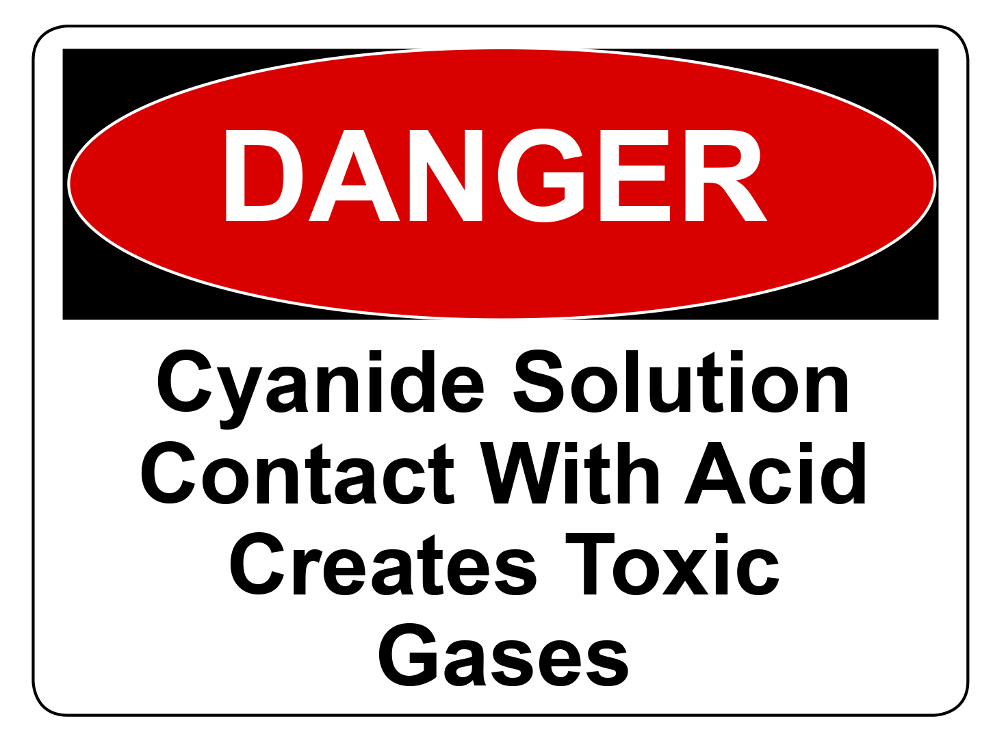

## Fire

The majority of cyanide salts, like sodium or potassium cyanide, are not combustible and will not burn and offer little risk when stored properly in sealed containers. Hydrogen cyanide gas is extremely flammable and may be produced, for example on contact of solid cyanides with heat, water or acids. When a significant amount of this gas is present, there is a risk of explosion. There is also a risk of explosion if water comes into contact with molten cyanides.

If there is a fire where cyanides are used or stored:

* Evacuate the area immediately, keeping upwind to avoid inhalation of smoke or fumes, and call the fire brigade
* People entering the area should wear self-contained breathing apparatus and full protective clothing, including boots.
* Use dry chemical fire extinguishers or sand to put out the fire—do not use water.

## First aid

Workplaces that use cyanides should ensure first-aiders are competent and trained   
to deal quickly with anyone who is, or is suspected to have been, poisoned. At all times, rescuers should ensure their own safety while attending to the casualty.

The first aim should be to remove the casualty from further exposure to cyanides.   
This can often result in a quick improvement in the condition of the casualty.

The application of prompt and effective first aid is crucial to maximise the chances of survival following cyanide poisoning. If first aid is applied quickly enough, it can, depending on the severity of exposure, avoid the need for administration of cyanide antidotes. Antidotes should only be administered by, or under the direction of, a registered medical practitioner.

Appendix A provides further information on first aid procedures in case of cyanide poisoning. These procedures should be kept in a suitable location, for example with a cyanide emergency kit, for quick reference in the case of emergency.

### Administration of 100 per cent oxygen

100 per cent oxygen should be administered to people exposed to cyanides. This is often the most useful treatment for early cyanide poisoning and should be administered whether the casualty is conscious or not or whether breathing or not.

**In all cases of cyanide exposure, even if the casualty appears to recover quickly,   
he or she should be taken to the nearest hospital or medical facility for assessment   
and monitoring by a registered medical practitioner.**

For further guidance on the requirements for first aid and emergency plans, see the Codeof practice: *First aid in the workplace.*

## Cyanide emergency kit

Workplaces that use cyanides should keep a cyanide emergency kit. This kit should be easily accessible and clearly marked. Workers, especially those trained in cyanide rescue, should be aware of its location.

The following is a checklist of recommended items that should be kept in a cyanide emergency kit:

* An oxygen resuscitator and a source of oxygen and a resuscitation bag or mask
* An approved airway
* A minimum of four pairs of impervious gloves—double gloving is recommended
* Safety eyewear
* Plastic bags labelled as ‘Contaminated with Cyanide’
* A copy of the current SDS for the cyanide compound(s) being used—ensure the correct SDS is given to the medical staff
* A copy of first aid procedures and emergency contact numbers.

The inclusion of a cyanide antidote in the emergency kit should be considered. In making   
the decision to include or not to include an antidote in the emergency kit, consider the level of risk of exposure in the workplace, including the location of the nearest medical facility where exposed persons would be treated and whether they stock supplies of antidote.

If an antidote is kept with the emergency response kit, it should be stored according to the manufacturer’s instructions in a closed and tagged container which contains the following recommended items:

* + An elasticised tourniquet
  + Disposable indwelling intravenous cannulae—at least two
  + Sterile disposable syringes and needles
  + Fluoride heparinised blood sample tubes
  + Skin prep swabs, dressings and adhesive tape
  + Ampoule(s) of antidote including the prescribing information outlining side effects, precautions and incompatibilities.

Emergency kits should be regularly checked, maintained and, where appropriate, antidotes and breathing oxygen restocked if they have passed or are close to their expiry dates. The location and number of emergency kits and breathing oxygen cylinders should be carefully considered based on the size of the workplace, where in the workplace cyanides are used and the potential for exposure.

### Antidotes

Several antidotes can be used to treat cyanide poisoning. A brief description of some of the most commonly used antidotes is given below.

Due to the potential for serious side-effects if administered incorrectly, antidotes should only be injected by, or under the direction of, a registered medical practitioner. The prescribing information should be kept with the antidote.

The following antidotes are most commonly used:

* ***Hydroxocobalamin*** *(Cyanokit)*This antidote has been used in overseas jurisdictions for many years as the preferred antidote for cyanide poisoning. Evidence suggests it is less toxic than other antidotes and is biologically well-tolerated, even when cyanide poisoning has not actually occurred. It converts cyanide to cyanocobalamin which is excreted by the kidneys.   
  It can be obtained under the Therapeutic Goods Administration’s Special Access Scheme.
* ***Dicobalt edetate*** *(Kelocyanor)*Dicobalt edetate should notbe used as a precautionary measure and should only be used when cyanide poisoning is unequivocal. Dicobalt edetate may produce an adverse reaction including oedema of the face and neck, urticaria, palpitations, collapse, convulsions, vomiting, chest pains and difficulty breathing if administered when cyanide poisoning is not present. It works by binding strongly to cyanide in   
  the body.
* ***Sodium thiosulphate***  
  Sodium thiosulphate is administered intravenously and converts cyanide to thiocyanate which is then excreted in urine. This antidote is generally slower acting and may not be appropriate for emergency use on its own due to its slower effect.   
  It is considered to be a useful adjunct to hydroxocobalamin—which should be administered *via a separate* intravenous line.
* ***Sodium nitrite/Sodium thiosulphate*** *(Nithiodote)*  
  The combination of these two drugs enhances the detoxification of cyanide compared to their individual effects. Sodium nitrite is injected first and causes the body to produce methaemoglobin which has a high affinity for cyanide. Sodium thiosulphate is then administered. Sodium nitrite can cause severe adverse reactions and death even if administered in doses less than twice the recommended amount because it induces hypotension and methaemoglobin formation, which diminishes oxygen carrying capacity. Sodium nitrite should notbe used as a precautionary measure and should only be used when cyanide poisoning is unequivocal.

The cyanide antidote kit and the prescribing instructions should be transported with the casualty to a medical facility and given to the registered medical practitioner when required.

## Medical facility care

The use of a cyanide antidote is not as critical as the quick administration of effective first aid, oxygen therapy and other life-supporting measures.

Patients whose condition deteriorates or present with severe symptoms of cyanide poisoning may require antidote administration, particularly if the patient loses consciousness or enters cardiac arrest and exposure to cyanide has been confirmed. Advanced first aid procedures may be required if the patient is in shock or suffering from seizures or hypotension. Oxygen administration should be continued.

Often the symptoms of fear of exposure to cyanides can appear to be the same as those   
of cyanide poisoning. Therefore, it is necessary to establish cyanide poisoning has actually occurred before administering an antidote because some antidotes have the potential to cause severe harm if administered when no cyanide poisoning has occurred or if the dose   
is too great.

### Immediate treatment

After transporting the patient to the care of a registered medical practitioner, immediate attention should be directed toward assisted ventilation, administration of 100 per cent oxygen, insertion of intravenous lines and cardiac monitoring, if available.

* Insert two intravenous lines for taking of blood samples and for administering antidote—if required.
* Monitor the heart rate and blood pressure and pulse oximetry—level of oxygenation of the blood—if possible.
* Monitor the level of consciousness on the Glasgow coma scale. If the patient remains conscious, antidote administration may not be necessary and oxygen therapy should be continued.
* Obtain arterial/venous blood gas as metabolic acidosis, often severe, combined with a small difference between the arterial and venous oxygen saturation levels (<10 mmHg) suggests cyanide poisoning in a suspect patient:
  + Take a blood sample in a fluoride heparinised tube for analysis of blood cyanide levels to confirm poisoning, but do not delay treatment while awaiting results.
* Administer antidote, if required, if signs of severe cyanide poisoning are present or diagnosed. Inject the antidote as per the prescribing information of the manufacturer taking into account precautions and incompatibilities.
* If cyanides have been swallowed, gastric lavage, charcoal and cathartics may be used after antidote therapy if less than two hours have passed since ingestion.
* Correct any severe metabolic acidosis (pH below 7.20).
* Medical staff treating the patient should wear protective clothing to prevent poisoning to themselves.
* Safety data sheets should be referred to as necessary.

### Monitoring of the patient

After initial emergency treatment:

* Monitor the patient’s progress for at least 48–72 hours to ensure there are no delayed effects or relapses, especially if antidote administration has been required.
* Continuation of 100 per cent oxygen administration should be determined based upon response to antidote.
* Watch for the development of pulmonary oedema, aspiration pneumonia and seizures in comatose patients.
* Correct any further metabolic acidosis if blood pH falls below 7.20 and correct   
  any electrolyte imbalance, for example hyperkalaemia and hypercalcaemia.
* Further antidote administration may be required if metabolic acidosis persists.
* Re-assess eye splashes within 24 hours—assessment by an ophthalmologist   
  is recommended.
* Monitor the patient for at least six hours following skin exposure to cyanides to ensure there are no delayed effects.

# Appendix A – Workplace First aid procedures

The swift application of first aid is crucial in maximising the chances of survival and recovery of anyone who is exposed to cyanides. In all cases of exposure to cyanides, emergency transport to the nearest medical facility should be arranged.

The following first aid steps may prove useful.

### Step 1 – Remove casualty from cyanide exposure

The first priority in a rescue is to try and remove the casualty, if possible, from further exposure to cyanides and ideally into a source of fresh air. Rescuers must be properly trained in emergency procedures and wear appropriate PPE, especially goggles and protective gloves and, where hydrogen cyanide or cyanide solutions/liquids are involved, a suitable respirator which protects the wearer—for instance those respirators which comply with Australian Standard AS/NZS 1716: *Respiratory protective devices*. Rescuers should ensure their own safety while assisting the casualty.

Even if the casualty recovers quickly after removing from exposure to cyanide, administer 100 per cent oxygen and arrange transfer to a medical facility, whilst continuing to monitor   
his or her condition.

### Step 2 – Support airway, breathing and circulation

Speed is critical in treating a casualty with cyanide poisoning.

* Check the casualty’s airway. Remove blockages or restrictions as necessary.
* Check the casualty’s breathing.

If the casualty is breathing, place in recovery position and administer 100 per cent oxygen.   
If the casualty is unconscious, insert an oral airway if available and the first aider has been trained in its use.

If the casualty is not breathing, begin resuscitation using a resuscitation bag or mask connected to an oxygen source or 100 per cent oxygen via a non-rebreathing facemask.

***Mouth-to-mouth resuscitation should be avoided*** due to the risk of contamination of the rescuer either through exhaled breath from the victim or from skin contamination. It is less efficient than mechanical resuscitation.

* Check for a pulse. If no pulse is present, start external cardiac massage.

### Step 3 – Decontamination

Care should be taken in handling a casualty whose clothing has been contaminated with cyanides. Contaminated clothing should be carefully removed and placed in a sealed bag   
for decontamination or disposal. Wash down the casualty with copious fresh water. Do not delay first aid by decontaminating the casualty. Treatment should be started immediately.

### 

### Step 4 – Transfer of casualty to medical care

If not already arranged, immediately organise urgent ambulance transfer to the nearest medical facility. If located remotely, arrange for transfer to the nearest registered medical practitioner. The casualty should be accompanied by someone trained in cardiopulmonary resuscitation (CPR) and able to continue the rescue. A cyanide antidote kit, if available, should accompany the casualty.

### Further information for mild poisoning

In such instances, administration of 100 per cent oxygen may be all that is required for effective treatment. If the casualty’s condition quickly improves after removal from cyanide exposure then no further management beyond supplemental oxygen and reassurance may be needed. The casualty should be monitored and transferred to the care of a registered medical practitioner.

### Further information for poisoning by ingestion

In the case of poisoning by ingesting cyanides, vomiting should not be induced unless told to do so by a registered medical practitioner. If possible, rinse the mouth with water, but do not make the casualty swallow, and get the casualty to a hospital/medical facility as quickly as possible. Cyanide salts can react with gastric acid to produce hydrogen cyanide, which the patient may exhale or can be evolved from vomit.

### Further information for exposure to cyanides by eye contamination

In the case of splashes of cyanides in the eye, wash the eye with copious water or saline   
for at least 10 minutes. Monitor the casualty for signs of cyanide poisoning and if the condition of the patient deteriorates, quickly begin administration of first aid.

**In all cases of cyanide exposure, even if the casualty appears to recover quickly,   
he or she should be taken to the nearest medical facility for assessment and monitoring by a registered medical practitioner.**

1. All workplace exposure standards are published in the Safe Work Australia publication titled *Workplace Exposure Standards for Airborne Contaminants*.
2. The background levels of thiocyanate for non-smokers should be around < 22 µmol/L and for smokers the background levels should be < 99 µmol/L. For workers exposed to cyanides in the workplace levels of thiocyanate may be around < 210 µmol/L for non-smokers and < 580 µmol/L for smokers. Reference, *Guidance on Laboratory Techniques in Occupational Medicine,* 12th Edition 2012, Health & Safety Laboratory, UK. This is available on request from the Health & Safety Laboratory. See the Health and Safety Laboratory website for contact details[**www.hsl.gov.uk**](http://www.hsl.gov.uk)