Safe Work Australia logo

Principles of Good Work Design

A work health and safety handbook





# Introduction

The *Australian Work Health and Safety Strategy 2012-2022* is underpinned by the principle that well-designed healthy and safe work will allow workers to have more productive lives. This can be more efficiently achieved if hazards and risks are eliminated through good design.

# The ten principles of good work design

This handbook contains ten principles which demonstrate how to achieve good design of work and work processes. Each is general in nature so they can be successfully applied to any workplace, business or industry.

The ten principles for good work design are structured into three sections:

1. Why good work design is important
2. What should be considered in good work design, and
3. How good work is designed

These principles are shown in the diagram at Figure 1.

This handbook complements a range of existing resources available to businesses and work health and safety professionals including guidance for the safe design of plant and structures see the [Safe Work Australia Website.](http://swa.gov.au/)

# Scope of the handbook

This handbook provides information on how to apply the good work design principles to work and work processes to protect workers and others who may be affected by the work.

It describes how design can be used to set up the workplace, working environment and work tasks to protect the health and safety of workers, taking into account their range of abilities and vulnerabilities, so far as [reasonably practicable](http://www.safeworkaustralia.gov.au/sites/swa/about/publications/pages/interpretive-guideline-reasonably-practicable).

The handbook does not aim to provide advice on managing situations where individual workers may have special requirements such as those with a disability or on a return to work program following an injury or illness. Contact your regulator for further information.

# Who should use this handbook?

This handbook should be used by those with a role in designing work and work processes, including:

* Persons conducting a business or undertaking (PCBUs) with a primary duty of care under the [model Work Health and Safety (WHS) law*s*](http://www.safeworkaustralia.gov.au/sites/swa/model-whs-laws/pages/model-whs-laws).
* PCBUs who have specific design duties relating to the design of plant, substances and structures including the buildings in which people work.
* People responsible for designing organisational structures, staffing rosters and systems of work.
* Professionals who provide expert advice to organisations on work health and safety matters.

Good work design optimises work health and safety, human performance, job satisfaction, and business success.

***Information:*** Experts who provide advice on the design of work may include: engineers, architects, ergonomists, information and computer technology professionals, occupational hygienists, organisational psychologists, human resource professionals, occupational therapists and physiotherapists.

## Figure 1 – Good work design principles

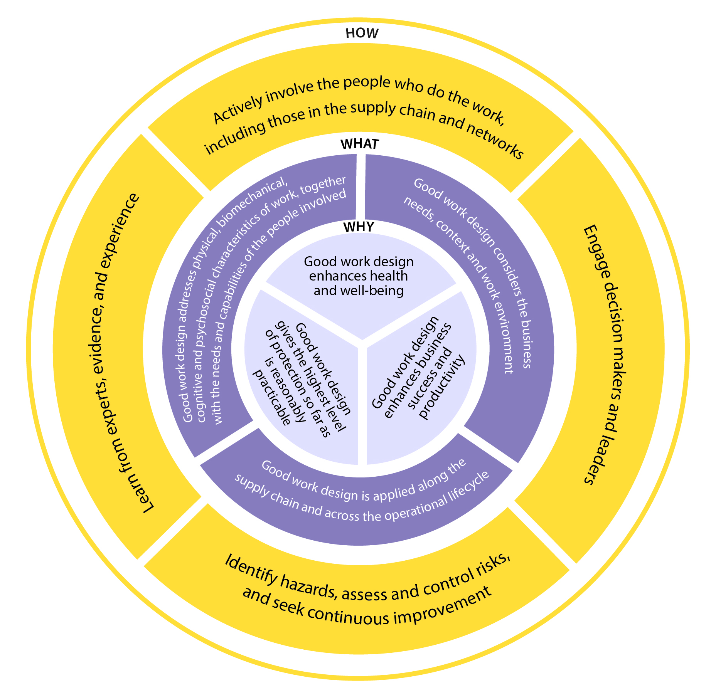

# What is ‘good work’?

‘Good work’ is healthy and safe work where the hazards and risks are eliminated or minimised so far as is reasonably practicable. Good work is also where the work design optimises human performance, job satisfaction and productivity.

Good work contains positive work elements that can:

* protect workers from harm to their health, safety and welfare
* improve worker health and wellbeing, and
* improve business success through higher worker productivity.

# What is good work design?

The most effective design process begins at the earliest opportunity during the conceptual and planning phases. At this early stage there is the greatest chance of finding ways to design-out hazards, incorporate effective risk control measures and design-in efficiencies.

Effective design of good work considers:

## The work:

* how work is performed, including the physical, mental and emotional demands of the tasks and activities
* the task duration, frequency, and complexity, and
* the context and systems of work.

## The physical working environment:

* the plant, equipment, materials and substances used, and
* the vehicles, buildings, structures that are workplaces.

## The workers:

* physical, emotional and mental capacities and needs.

Effective design of good work can radically transform the workplace in ways that benefit the business, workers, clients and others in the supply chain.

Failure to consider how work is designed can result in poor risk management and lost opportunities to innovate and improve the effectiveness and efficiency of work.

The principles for good work design support duty holders to meet their obligations under the WHS laws and also help them to achieve better business practice generally.

For the purposes of this handbook a work designer is anyone who makes decisions about the design or redesign of work. This may be driven by the desire to improve productivity as well as the health and safety of people who will be doing the work

# The WHY Principles

# Why is good work design important?

## **Principle 1: Good work design gives the highest level of protection so far as is reasonably practicable**

* All workers have a right to the highest practicable level of protection against harm to their health, safety and welfare.
* The primary purpose of the WHS laws is to protect persons from work-related harm so far as is reasonably practicable.
* Harm relates to the possibility that death, injury, illness or disease may result from exposure to a hazard in the short or longer term.
* Eliminating or minimising hazards at the source before risks are introduced in the workplace is a very effective way of providing the highest level of protection.

Principle 1 refers to the legal duties under the WHS laws. These laws provide the framework to protect the health, safety and welfare of workers and others who might be affected by the work. During the work design process workers and others should be given the highest level of protection against harm that is reasonably practicable.

## Prevention of workplace injury and illness

Well-designed work can prevent work-related deaths, injuries and illnesses. The potential risk of harm from hazards in a workplace should be eliminated through good work design.

Only if that is not reasonably practicable, then the design process should minimise hazards and risks through the selection and use of appropriate control measures.

New hazards may inadvertently be created when changing work processes. If the good work design principles are systematically applied, potential hazards and risks arising from these changes can be eliminated or minimised.

Information: Reducing the speed of an inappropriately fast process line will not only reduce production errors, it can diminish the likelihood of a musculoskeletal injury and mental stress.

## **Principle 2: Good work design enhances health and wellbeing**

* Health is a “state of complete physical, mental, and social wellbeing, not merely the absence of disease or infirmity” (World Health Organisation).
* Designing good work can help improve health over the longer term by improving workers’ musculoskeletal condition, cardiovascular functioning and their mental health.
* Good work design optimises worker function and improves participation enabling workers to have more productive working lives.

Health benefits

Effective design aims to prevent harm, but it can also positively enhance the health and wellbeing of workers for example, satisfying work and positive social interactions can help improve people’s physical and mental health.

As a general guide, the healthiest workers have been found to be three times more productive than the least [healthy (PDF file)](https://www.medibank.com.au/Client/Documents/Pdfs/The_health_of_Australia%27s_workforce.pdf). It therefore makes good business sense for work design to support people’s health and wellbeing.

**Information:** Recent research has shown long periods of sitting (regardless of exercise regime) can lead to increased risk of preventable musculoskeletal disorders and chronic diseases such as diabetes. In an office environment, prolonged sitting can be reduced by allowing people to alternate between sitting or standing whilst working.

## **Principle 3: Good work design enhances business success and productivity**

* Good work design prevents deaths, injuries and illnesses and their associated costs, improves worker motivation and engagement and in the long-term improves business productivity.
* Well-designed work fosters innovation, quality and efficiencies through effective and continuous improvement.
* Well-designed work helps manage risks to business sustainability and profitability by making work processes more efficient and effective and by improving product and service quality.

## Cost savings and productivity improvements

Designing-out problems before they arise is generally cheaper than making changes after the resulting event, for example by avoiding expensive retrofitting of workplace controls.

Good work design can have direct and tangible cost savings by decreasing disruption to work processes and the costs from workplace injuries and illnesses.

Good work design can also lead to productivity improvements and business sustainability by:

* allowing organisations to adjust to changing business needs and to streamline work processes by reducing wastage, training and supervision costs
* improving opportunities for creativity and innovation to solve production issues, reduce errors and improve service and product quality, and
* making better use of workers’ skills resulting in more engaged and motivated staff willing to contribute greater additional effort.

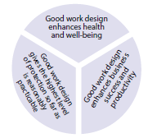

# The WHAT Principles

# What should be considered by those with design responsibilities?

## **Principle 4: Good work design addresses physical, biomechanical, cognitive and psychosocial characteristics of work, together with the needs and capabilities of the people involved**

* Good work design addresses the different hazards associated with work e.g. chemical, biological and plant hazards, hazardous manual tasks and aspects of work that can impact on mental health.
* Work characteristics should be systematically considered when work is designed, redesigned or the hazards and risks are assessed.
* These work characteristics should be considered in combination and one characteristic should not be considered in isolation.
* Good work design creates jobs and tasks that accommodate the abilities and vulnerabilities of workers so far as reasonably practicable.

## All tasks have key characteristics with associated hazards and risks, as shown in Figure 2 below:

## Figure 2 – Key characteristics of work

## A diagram of key characteristics of work

Hazards and risks associated with tasks are identified and controlled during good work design processes and they should be considered in combination with all hazards and risks in the workplace. This highlights that it is the combination that is important for good work design.

Workers can also be exposed to a number of different hazards from a single task. For example, meat boning is a common task in a meat-processing workplace. This task has a range of potential hazards and risks that need to be managed, e.g. physical, chemical, biological, biomechanical and psychosocial. Good work design means the hazards and risks arising from this task are considered both individually and collectively to ensure the best control solutions are identified and applied.

Good work design can prevent unintended consequences which might arise if task control measures are implemented in isolation from other job considerations. For example, automation of a process may improve production speed and reduce musculoskeletal injuries but increase risk of hearing loss if effective noise control measures are not also considered.

Workers have different needs and capabilities; good work design takes these into account. This includes designing to accommodate them given the normal range of human cognitive, biomechanical and psychological characteristics of the work.

**Information:** The Australian workforce is changing. It is typically older with higher educational levels, more inclusive of people with disabilities, and more socially and ethnically diverse. Good work design accommodates and embraces worker diversity. It will also help a business become an employer of choice, able to attract and retain an experienced workforce.

## **Principle 5: Good work design considers the business needs, context and work environment.**

* Good work design is ‘fit for purpose’ and should reflect the needs of the organisation including owners, managers, workers and clients.
* Every workplace is different so approaches need to be context specific. What is good for one situation cannot be assumed to be good for another, so off-the-shelf solutions may not always suit every situation.

## The work environment is broad and includes: the physical structures, plant and technology, work layout, organisational design and culture, human resource systems, work health and safety processes and information/control systems.

The business organisational structure and culture, decision making processes, work environment and how resources and people are allocated to the work will directly and indirectly impact on work design and how well and safely the work is done.

The work environment includes the physical structures, plant, and technology. Planning for relocations, refurbishments or when introducing new engineering systems are ideal opportunities for businesses to improve their work designs and avoid foreseeable risks.

These are amongst the most common work changes a business undertakes yet good design during these processes is often quite poorly considered and implemented. An effective design following the processes described in this handbook can yield significant business benefits.

**Information:** Off the shelf solutions can be explored for some common tasks, however usually design solutions need to be tailored to suit a particular workplace.

Good work design is most effective when it addresses the specific business needs of the individual workplace or business. Typically work design solutions will differ between small and large businesses.

However, all businesses must eliminate or minimise their work health and safety risks so far as [reasonably practicable](http://www.safeworkaustralia.gov.au/sites/swa/about/publications/pages/interpretive-guideline-reasonably-practicable). The specific strategies and controls will vary depending on the circumstances.

The table on the next page demonstrates how to step through the good work design process for small and large businesses.

## Table 1 – steps in good work design for large and small businesses

| Good design steps | In a large business that is downsizing | In a small business that is undergoing a refit |
| --- | --- | --- |
| Management commitment | Senior management make their commitment to good work design explicit ahead of downsizing and may hire external expertise. | The owner tells workers about their commitment to designing-out hazards during the upcoming refit of the store layout to help improve safety and efficiency. |
| Consult | The consequences of downsizing and how these can be managed are discussed in senior management and WHS committee meetings with appropriate representation from affected work areas. | The owner holds meetings with their workers to identify possible issues ahead of  the refit. |
| Identify | A comprehensive workload audit is undertaken to clarify opportunities for improvements. | The owner discusses the proposed refit with the architect and builder and gets ideas for dealing with issues raised by workers. |
| Assess | A cost benefit analysis is undertaken to assess the work design options to manage the downsizing. | The owner, architect and builder jointly discuss the proposed refit and any worker issues directly with workers. |
| Control | A change management plan is developed and implemented to appropriately structure teams and improve systems of work. Training is provided to support the new work arrangements. | The building refit occurs. Workers are given training and supervision to become familiar with new layout and safe equipment use. |
| Review | The work redesign process is reviewed against the project aims by senior managers. | The owner checks with the workers that the refit has improved working conditions and efficiency and there are no new issues. |
| Improve | Following consultation, refinement of the redesign is undertaken if required. | Minor adjustments to the fit out are made if required. |

## **Principle 6: Good work design is applied along the supply chain and across the operational lifecycle.**

* Good work design should be applied along the supply chain in the design, manufacture, distribution, use and disposal of goods and the supply of services.
* Work design is relevant at all stages of the operational life cycle, from start-up, routine operations, maintenance, downsizing and cessation of business operations.
* New initiatives, technologies and change in organisations have implications for work design and should be considered.

**Information:** Supply chains are often made up of complex commercial or business relationships and contracts designed to provide goods or services. These are often designed to provide goods or services to a large, dominant business in a supply chain. The human and operational costs of poor design by a business can be passed up or down the supply chain.

Businesses in the supply chain can have significant influence over their supply chain partners’ work health and safety through the way they design the work.

Businesses may create risks and so they need to be active in working with their supply chains and networks to solve work health and safety problems and share practical solutions for example, for common design and manufacturing problems.

Health and safety risks can be created at any point along the supply chain, for example, loading and unloading causing time pressure for the transport business.

There can be a flow-on effect where the health and safety and business ‘costs’ of poor design may be passed down the supply chain. These can be prevented if businesses work with their supply chain partners to understand how contractual arrangements affect health and safety.

Procurement and contract officers can also positively influence their own organisation and others work health and safety throughout the supply chain by the good design of contracts.

When designing contractual arrangements businesses could consider ways to support good work design safety outcomes by:

* setting clear health and safety expectations for their supply chain partners, for example through the use of codes of conduct or quality standards
* conducting walk through inspections, monitoring and comprehensive auditing of supply chain partners to check adherence to these codes and standards
* building the capability of their own procurement staff to understand the impacts of contractual arrangements on their suppliers, and
* consulting with their supply chain partners on the design of good work practices.

**Information:** The road transport industry is an example of the application of how this principle can help improve drivers’ health and safety and address issues arising from supply chain arrangements. For example, the National Heavy Vehicle Laws ‘chain of responsibility’ requires all participants in the road transport supply chain to take responsibility for driver work health and safety. Contracts must be designed to allow drivers to work reasonable hours, take sufficient breaks from driving and not have to speed to meet deadlines.

The design of products will strongly impact on both health and safety and business productivity throughout their lifecycles. At every stage there are opportunities to eliminate or minimise   
risks through good work design. The common product lifecycle stages are illustrated in   
Figure 3 below.

## Figure 3 – common product lifecycle

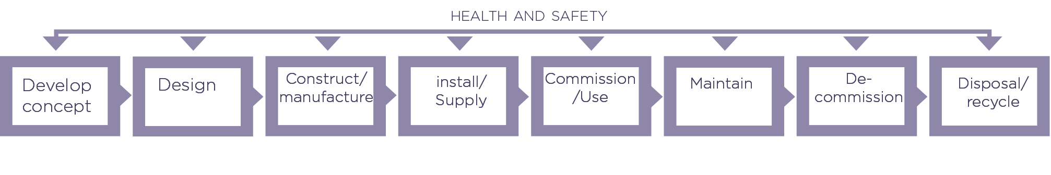

**Information:** For more information on the design of structures and of plant see ‘[Safe design of structures](http://www.safeworkaustralia.gov.au/sites/swa/about/publications/pages/safe-design-of-structures)’ and [Managing the risks of plant in the workplace](http://www.safeworkaustralia.gov.au/sites/swa/about/publications/pages/managing-the-risks-of-plant-in-the-workplace) and other design guidance on the Safe Work Australia website.

The good work design principles are also relevant at all stages of the business life cycle. Some of these stages present particularly serious and complex work health and safety challenges such as during the rapid expansion or contraction of businesses. Systematic application of good work design principles during these times can achieve positive work health and safety outcomes.

View the [Bureau of Meteorology case study on fatigue management](http://www.safeworkaustralia.gov.au/sites/swa/australian-strategy/case-studies/pages/good-work-design.aspx).

New technology is often a key driver of change in work design. It has the potential to improve the quality of outputs, efficiency and safety of workers, however introducing new technology could also introduce new hazards and unforeseen risks. Good work design considers the impact of the new initiatives and technologies before they are introduced into the workplace and monitors their impact over time.

**Information:** When designing a machine for safe use, how the maintenance will be undertaken in the future should be considered.

In most workplaces the information and communication technology (ICT) systems are   
an integral part of all business operations. In practice these are often the main drivers of work changes but are commonly overlooked as sources of workplace risks. Opportunities   
to improve health and safety should always be considered when new ICT systems are planned and introduced.

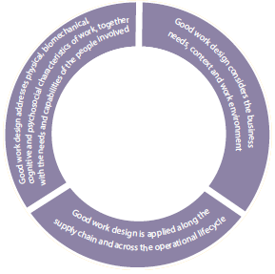

# The HOW Principles

## **Principle 7: Engage decision makers and leaders**

* Work design or redesign is most effective when there is a high level of visible commitment, practical support and engagement by decision makers.
* Demonstrating the long-term benefits of investing in good work design helps engage decision makers and leaders.
* Practical support for good work design includes allocation of appropriate time and resources to undertake effective work design or redesign processes.

**Information:** Leaders are the key decision makers or those who influence the key decision makers. Leaders can be the owners of a business, directors of boards and senior executives.

Leaders can support good work design by ensuring the principles are appropriately included or applied, for example in:

* key organisational policies and procedures
* proposals and contracts for workplace change or design
* managers’ responsibilities and as key performance indicators
* business management systems and audit reports
* organisational communications such as a standing item on leadership meeting agendas, and
* the provision of sufficient human and financial resources.

Good work design, especially for complex issues will require adequate time and resources to consider and appropriately manage organisational and/or technological change. Like all business change, research shows leader commitment to upfront planning helps ensure better outcomes.

Managers and work health and safety advisors can help this process by providing their leaders with appropriate and timely information. This could include for example:

* identifying design options which support both business outcomes and work health and safety objectives
* assessing the risks and providing short and long term cost-benefit analysis of the recommended controls to manage these risks, and
* identifying what decisions need to be taken, when and by whom to effectively design and implement the agreed changes.

## **Principle 8: Actively involve the people who do the work, including those in the supply chain and networks**

* Persons conducting a business or undertaking (PCBUs) must consult with their workers and others likely to be affected by work in accordance with the work health and safety laws.
* Supply chain stakeholders should be consulted as they have local expertise about the work and can help improve work design for upstream and downstream participants.
* Consultation should promote the sharing of relevant information and provide opportunities for workers to express their views, raise issues and contribute to decision making where possible.

Effective consultation and co-operation of all involved with open lines of communication, will ultimately give the best outcomes. Consulting with those who do the work not only makes good sense, it is required under the WHS laws.

**Information:** Under the model [WHS laws (s47)](http://www.safeworkaustralia.gov.au/sites/swa/model-whs-laws/pages/model-whs-laws), a business owner must, so far as is reasonably practicable, consult with ‘workers who carry out work for the business or undertaking who are, or are likely to be, directly affected by a matter relating to work health or safety.’ This can include a work design issue.

If more than one person has a duty in relation to the same matter, ‘each person with the duty must, so far as is reasonably practicable, consult, co-operate and co-ordinate activities with all other persons who have a duty in relation to the same matter’ [(model WHS laws s46)](http://www.safeworkaustralia.gov.au/sites/swa/model-whs-laws/pages/model-whs-laws).

Workers have knowledge about their own job and often have suggestions on how to solve a specific problem. Discussing design options with them will help promote their ownership of the changes. See [*Code of practice on consultation.*](http://www.safeworkaustralia.gov.au/sites/SWA/about/Publications/Documents/624/Work_Health_and_Safety_Consultation_CoOperation_and_CoOrdination.pdf)

Businesses that operate as part of a supply chain should consider whether the work design   
and changes to the work design might negatively impact on upstream or downstream businesses. The supply chain partners will often have solutions to logistics problems which can benefit all parties.

## **Principle 9: Identify hazards, assess and control risks, and seek continuous improvement**

* A systematic risk management approach should be applied in every workplace.
* Designing good work is part of the business processes and not a one-off event.
* Sustainability in the long-term requires that designs or redesigns are continually monitored and adjusted to adapt to changes in the workplace so as to ensure feedback is provided and that new information is used to improve design.

Good work design should systematically apply the risk management approach to the workplace hazards and risks. See Principle 4 or more details.

Typically good work design will involve ongoing discussions with all stakeholders to keep refining the design options. Each stage in the good work design process should have decision points for review of options and to consult further if these are not acceptable. This allows for flexibility to quickly respond to unanticipated and adverse outcomes.

Figure 5 outlines how the risk management steps can be applied in the design process

Continuous improvements in work health and safety can in part be achieved if the good work design principles are applied at business start up and whenever major organisational changes are contemplated. To be most effective, consideration of health and safety issues should be integrated into normal business risk management.

## Figure 5 – Steps in the good work design process

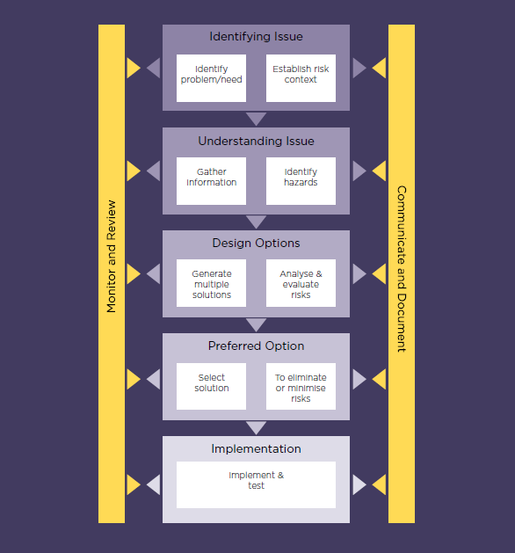

## **Principle 10: Learn from experts, evidence, and experience**

* Continuous improvement in work design and hence work health and safety requires ongoing collaboration between the various experts involved in the work design process.
* Various people with specific skills and expertise may need to be consulted in the design stage to fill any knowledge gaps. It is important to recognise the strengths and limitations of a single expert’s knowledge.
* Near misses, injuries and illnesses are important sources of information about poor design.

Most work design processes will require collaboration and cooperation between internal and sometimes external experts. Internal advice can be sought from workers, line managers, technical support and maintenance staff, engineers, ICT systems designers, work health and safety advisors and human resource personnel.

Depending on the design issue, external experts may be required such as architects, engineers, ergonomists, occupational hygienists and psychologists.

**Information**: If you provide advice on work design options it is important to know and work within the limitations of your discipline’s knowledge and expertise. Where required make sure you seek advice and collaborate with other appropriate design experts.

For complex and high-risk projects, ideally a core group of the same people should remain involved during both the design and implementation phases with other experts brought in   
as necessary.

The type of expert will always depend on the circumstances. When assessing the suitability of an expert consider their qualifications, skills, relevant knowledge, technical expertise, industry experience, reputation, communication skills and membership of professional associations.

**Information:** Is the consultant suitably qualified?  
A suitably qualified person has the knowledge, skills and experience to provide advice on the specific design issue. You can usually check with the professional association to see if the consultant is certified or otherwise recognised by them to provide work design advice.

The decision to design or redesign work should be based on sound evidence. Typically this evidence will come from many sources such as both proactive and reactive indicators, information about a new technology or the business decisions to downsize, expand or restructure or to meet the requirements of supply chain partners.

Proactive and reactive indicators can also be used to monitor the effectiveness and efficiency of the design solution.

**Information:** Proactive indicators provide early information about the work system that can be used to prevent accidents or harm. These might include for example: key process variables such as temperature or workplace systems indicators such as the number of safety audits and inspections undertaken.

## Reactive indicators are usually based on incidents that have already occurred. Examples include number and type of near misses and worker injury and illness rates.

Useful information about common work design problems and solutions can also often be obtained from:

* work health and safety regulators
* industry associations and unions
* trade magazines and suppliers, and
* specific research papers.

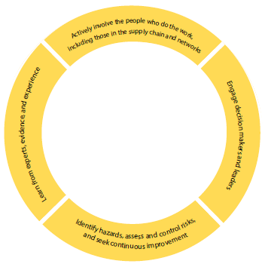

# Summary

The ten principles of good work design can be applied to help support better work health and safety outcomes and business productivity. They are deliberately high level and should be broadly applicable across the range of Australian businesses and workplaces. Just as every workplace is unique, so is the way each principle can be applied in practice.

When considering these principles in any work design also ensure you take into account your local jurisdictional work health and safety requirements.