GUIDE TO MANAGING RISKS IN
CATTLE HANDLING
TABLE OF CONTENTS
1. INTRODUCTION 2
1.1. What is cattle handling? 2
1.2. Who should use this Guide? 2
1.3. Who has duties under the law? 2
2. risk management 4
2.1. How can cattle handling risks be managed? 4
2.2. Who is involved? 5
3. Cattle behaviour 6
3.1. Cattle field of vision 6
3.2. Cattle zones 7
4. Cattle handling techniques 8
4.1. Point of balance 8
4.2. Pressure 10
4.3. Moving in straight lines 12
4.4. The ‘inverted T’ technique 13
4.5. The ‘dot the i’ technique 15
4.6. Drafting cattle 16
4.7. Handling bulls 18
4.8. Handling cows and calves 18
4.9. Other cattle handling tips 18
5. paddock, laneway and yard Design 21
5.1. Paddocks 21
5.2. Laneways 22
5.3. Yards 22
6. On-farm cattle sale facilities 32
7. truck crate and trailer design for livestock transport 33
7.1. Hazards when transporting cattle 33
7.2. Crate and trailer design 34
8. people at increased risk of harm 37
8.1. Children 37
8.2. Visitors 37
8.3. Contractors 37
8.4. Older livestock handlers and livestock handlers with a disability 38
8.5. Livestock handlers with literacy issues 38
9. cattle husbandry activities and occupational disease 39
9.1. Cattle husbandry activities 39
9.2. Occupational disease 39
10. emergency plan 41
appendix 1 – Cattle yard design safety checklist 42
appendix 2 – Cattle crush and calf cradle checklist 43
appendix 3 – Loading ramp checklist 44

INTRODUCTION
This Guide provides information on how to manage risks associated with cattle handling at a workplace.
Cattle handling can present significant risks to workers including injuries and fatalities, for example from being crushed, gored, trampled, hit or bitten by cattle.

What is cattle handling?
Cattle handling involves any activities where workers handle cattle. This can include working with cattle in paddocks, laneways, yards, cattle transportation, feedlots, abattoirs, saleyards and activities relating to on-farm cattle sales. A person that handles cattle at a workplace is referred to as a livestock handler throughout this Guide.
The Guide focusses on natural cattle handling techniques that use cattle behaviour and livestock handler position to achieve the goal rather than other techniques that ‘make’ the cattle do the activity.

Who should use this Guide?
This Guide assists duty holders manage their obligations under the work health and safety (WHS) laws. You should use this Guide if you or your livestock handler handles cattle in a workplace or you commission the design, construction, erection, alteration and maintenance of facilities that assist in the handling of cattle, for example cattle yards.
This Guide is also relevant for other people who handle cattle, for example livestock agents, transporters and veterinarians.

Who has duties under the law?
Everyone in the workplace has a work health and safety duty. The main duties are set out in Table 1.
Table 1 Duty holders and their obligations
Who | Duties
A person conducting a business or undertaking | A person conducting a business or undertaking has the primary duty to ensure, so far as is reasonably practicable, workers and other people are not exposed to health and safety risks arising from the business or undertaking.  This duty requires the person to manage risks by eliminating health and safety risks, so far as is reasonably practicable and if it is not reasonably practicable to eliminate the risks, by minimising those risks, so far as is reasonably practicable.  For cattle handling this includes ensuring, so far as is reasonably practicable the:  - design, provision and maintenance of safe cattle handling plant  and structures  - safe erection, alteration, dismantling and use of cattle handling facilities, and  - safe use, handling, storage and transport of cattle handling equipment.  The duty also includes providing any information, training, instruction or supervision that is necessary to protect all persons from risks to their health and safety arising from work carried out as part of the conduct of the business or undertaking.
Designers, manufacturers, suppliers and importers | Designers, manufacturers, suppliers and importers of plant or structures must ensure, so far as is reasonably practicable, the plant or structure is without risks to health and safety. This duty includes providing information to manufacturers so that plant and structures can be manufactured and erected to the design specifications.
People installing, constructing or commissioning plant or structures | People installing, constructing or commissioning plant or structures must ensure, so far as is reasonably practicable, all workplace activity relating to the plant or structure including its decommissioning or dismantling is without risks to health or safety.
Officers | Officers, such as company directors, have a duty to exercise due diligence to ensure the business or undertaking complies with the WHS Act and Regulations. This includes taking reasonable steps to ensure the business or undertaking has and uses appropriate resources and processes to eliminate or minimise risks from cattle handling.
Workers and others | Workers and other people at the workplace must take reasonable care for their own health and safety, co-operate with reasonable policies, procedures and instructions and not adversely affect other people’s health and safety.  Other people include visitors and contractors like veterinarians and livestock transporters.

For more information on the duties relating to plant see the Code of Practice: Managing risks of plant in the workplace. For more information on the duties relating to construction see the Code of Practice: Construction work.
Animal welfare legislation is also relevant to cattle handling and you should be aware of your obligations under such laws.

risk management

How can cattle handling risks be managed?
Use the following steps to ensure, so far as is reasonably practicable, workers and other people are not exposed to health and safety risks:
1. Find out what could cause harm. The following can help you identify potential hazards:
- Observe the workplace where the cattle handling work will be carried out and identify where there is interaction with other work, vehicles, pedestrians, fixed structures like overhead electric lines and the work environment e.g. ground and weather conditions.
- Ask workers about any problems they encounter or anticipate at the workplace when handling cattle—consider operation, inspection, maintenance, repair, transport and equipment storage requirements.
- Review your inspection, maintenance, incident and injury records including near misses.
2. Assess the risk. In many cases the risks and related control measures will be well known. In other cases you may need to carry out a risk assessment to identify the likelihood of somebody being harmed by the hazard and how serious the harm could be. A risk assessment can help you determine what action you should take to control the risk and how urgently the action needs to be taken.
In assessing the risk, you should consider things like the:
- type of cattle example e.g. Brahmans or Herefords
- operation you are running, e.g. breeding, trading or feed lotting
- skills required to run the operation, and
- facilities and equipment you have.
3. Take action to control the risk. The WHS laws require a business or undertaking to do all that is reasonably practicable to eliminate or minimise risks.
The ways of controlling risks are ranked from the highest level of protection and reliability to the lowest. This ranking is known as the hierarchy of risk control. You must work through this hierarchy to manage risks.
Consider whether hazards can be completely removed from the workplace. For example, a risk associated with cattle handling is working with ‘rogue’ cattle that are not used to being handled and are therefore unpredictable. This risk can be eliminated by culling the ‘rogue’ cattle from the mob.
If it is not reasonably practicable to completely eliminate the risk then consider one or more of the following options in the order they appear below to minimise risks, so far as is reasonably practicable:
- Substitute the hazard for something safer e.g. running cattle that have been dehorned instead of cattle that have not or, using pour-on or backline drenches instead of oral drenching.
- Isolate the hazard from people e.g. by designing and constructing handling facilities to minimise workers’ physical interaction with cattle.
- Use engineering controls e.g. handrails and edge protection to prevent falls from livestock transport trucks and loading ramps.
If after implementing the above control measures a risk still remains, consider the following controls in the order below to minimise the remaining risk, so far as is reasonably practicable:
- Use administrative controls e.g. training workers in natural livestock handling techniques.
- Use personal protective equipment (PPE) e.g. sun protection like hats and long-sleeved shirts and protective hand and foot wear.
A combination of the controls set out above may be used if a single control is not enough to minimise the risks.
Consider all possible control measures and make a decision about which control measures are reasonably practicable for the workplace. Deciding what is reasonably practicable includes the availability and suitability of control measures, with a preference for using substitution, isolation or engineering controls to minimise risks before using administrative controls or PPE. Cost may also be relevant, but this can only be considered after all other factors have been taken into account.
4. Check your control measures regularly to ensure they are effective and working as planned, taking into consideration any changes in how the work is carried out.
Further information on the risk management process is in the Code of Practice: How to manage work health and safety risks.

Who is involved?
Workers and their health and safety representatives (if any) must be consulted when deciding how to manage the risks associated with cattle handling activities.
If there is more than one business or undertaking involved at the workplace they must also be consulted to find out who is doing what and the businesses must work together so risks are eliminated or minimised, so far as is reasonably practicable.
This may involve discussing site-specific requirements including entering and exiting the site, scheduling suitable times for loading and unloading cattle and site specific training on procedures for working cattle.
Further information on consultation requirements is in the Code of Practice: Work health and safety consultation, co-operation and co-ordination.

Cattle behaviour
Cattle are large animals that can move quickly and be aggressive, and more so if mistreated and provoked. Stressed and agitated cattle are a risk to livestock handlers and to themselves.
Effective handling techniques are vital to ensuring the safety of livestock handlers working cattle, as well as the welfare of the cattle themselves. There are training courses available like Low Stress Stockhandling and Stress Free Stockmanship to help livestock handlers develop their skills in these techniques. Information on training is available at the Australian Government training website. Further information is available through a series of livestock handling videos on the Australian Veterinary Association’s website.
Cattle are a herding animal and have evolved as ‘prey’. When threatened, their first reaction is to stand and assess the situation. If frightened, the animal’s natural instinct is to escape.
Social order in a mob of cattle is usually established at about two years of age. When mobs are mixed in yards or while being transported the social order of the mob has to be re-established. The cattle may become aggressive until the new order within the mob is established. This may hinder effective movement of livestock.
Young bulls, when moved in groups, show a degree of playfulness—pushing and shoving—but bulls become more aggressive and territorial with age. Adult bulls have a large personal space of six metres or more. When adult bulls are crowded, fighting may occur at gateways or in yards.
Bulls are uncontrollable when fighting. They become highly unpredictable and will break away suddenly. Livestock handlers must be careful to avoid injury.
Cows with young calves can be very protective, so handling them in the presence of their mothers can be dangerous.
Cattle do not like being singled out in the paddock or in yards. They can become extremely agitated and unpredictable.

Cattle field of vision
With eyes on the sides of their heads, cattle have a wide range of vision of approximately 330 degrees. However, they cannot judge distances well as they usually see the object with one eye only.
Cattle have a blind area directly behind them—see Figure 1. If they detect movement to the side or rear they will seek to turn to the object so both eyes can be used to assess whether the object presents a risk and gauge the object’s distance more accurately.
Figure 1 Cattle field of vision
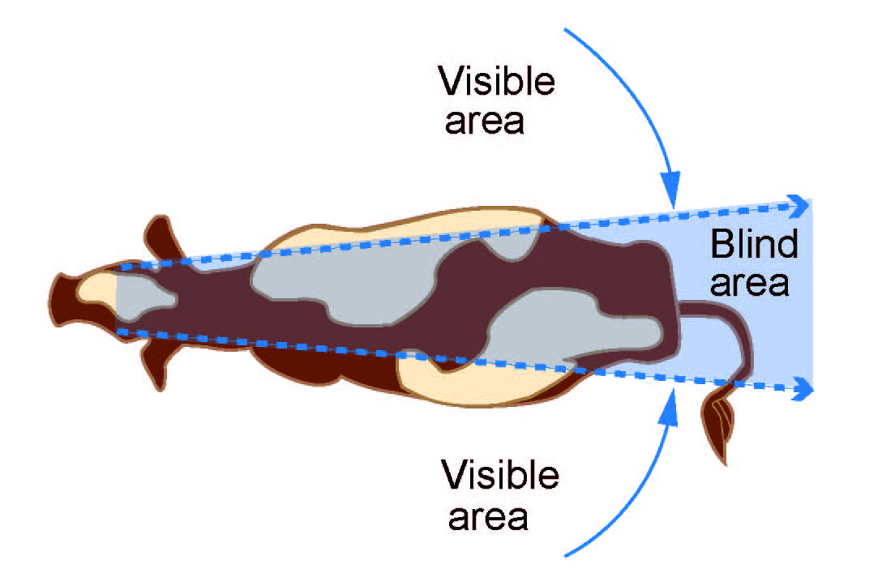

Cattle zones
Cattle have three personal space zones surrounding them: pressure, flight and fight zones—see Figure 2.
Figure 2 Cattle personal space zones
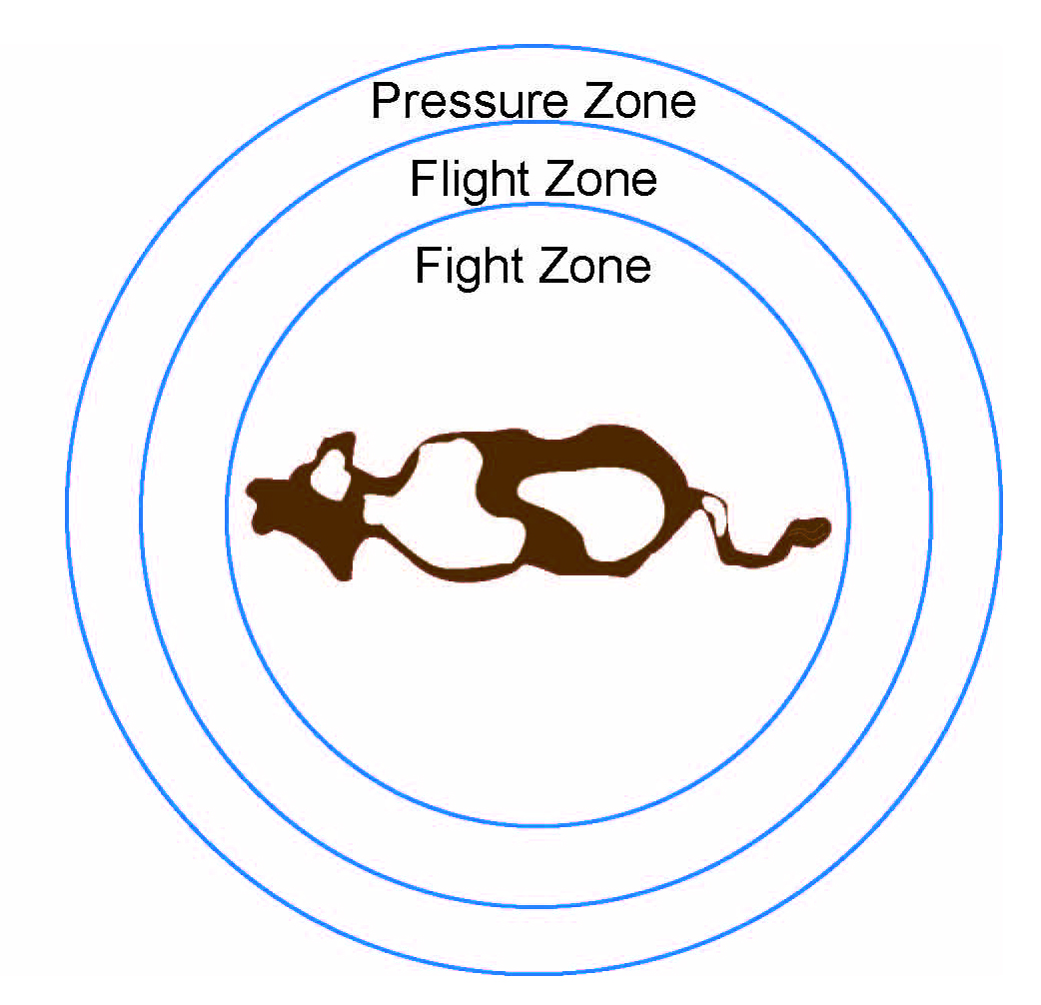
Cattle can be moved by entering their pressure zone. If livestock handlers move into the flight zone this will cause the animals to panic and scatter. If livestock handlers then move further into the fight zone and the animal is in a small pen for example, the animal will become aggressive and turn on the handler.
The size and shape of these zones will vary depending on the animal. For example, a dairy cow may have a smaller pressure zone compared to a wild bull on a cattle station in northern Australia.
A mob of cattle will also have collective pressure, flight and fight zones—see Figure 3.
Figure 3 Mob personal space zones
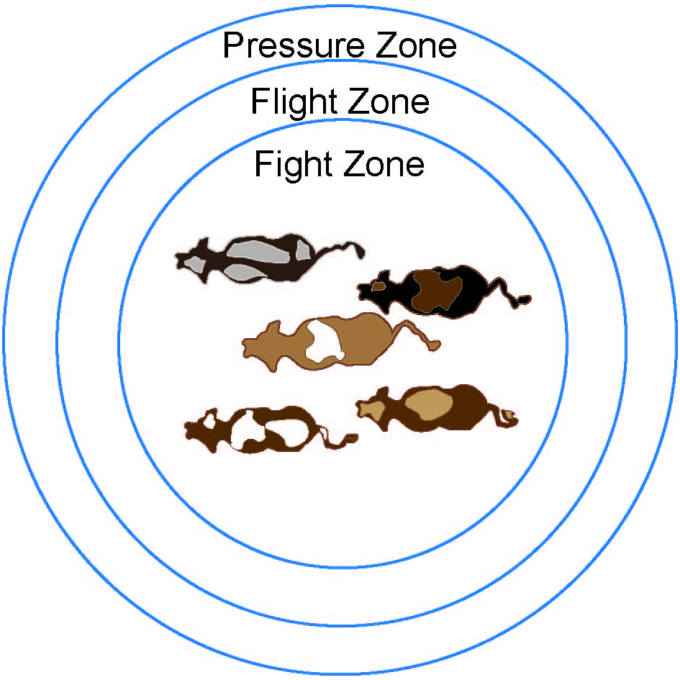
These zones can be reduced to make handling cattle easier and safer by employing natural handling techniques as described in Chapter 4 – Cattle handling techniques.

Cattle handling techniques
Natural cattle handling techniques seek to encourage cattle’s instinctive behaviours through the actions and positioning of livestock handlers to achieve the desired result. Whether mustering in paddocks, working through yards or loading trucks, these techniques can be applied to situations where an animal can physically go.
By encouraging natural behaviours in cattle, animals are less stressed, do not feel threatened and are less likely to react unpredictably and aggressively to livestock handlers. Other benefits from these cattle handling techniques can include:
- better animal welfare, with animals less likely to injure themselves or other animals
- increased production
- less labour is needed, and
- facilities do not need to be as strong and costly.

Point of balance
An animal has two points of balance. When inside the pressure zone, the livestock handler’s position in relation to an animal’s point of balance can affect which way the animal will go.
The first point of balance is behind the shoulder blades—see Figure 4. If the handler moves behind this line the animal moves forward. By moving in front of this line the animal will move backwards or turn away.
Figure 4 First point of balance
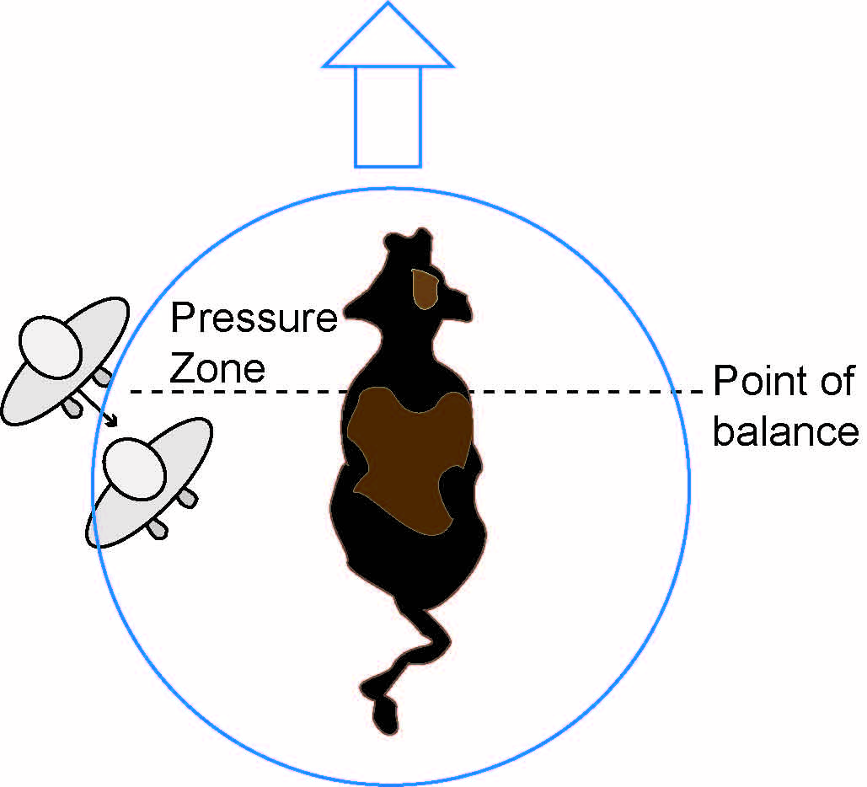

The second point of balance is from the centre of the head to the tail—see Figure 5. The livestock handler will move an animal sideways by moving either side of this line.
Figure 5 Second point of balance
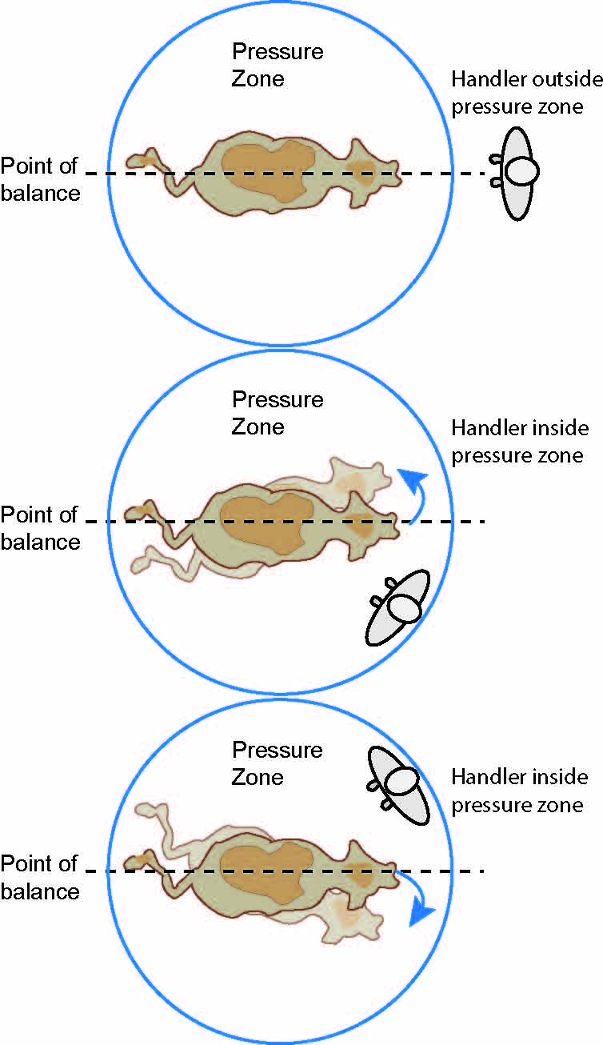

The points of balance apply equally to a mob of cattle as they do to individual animals—see Figure 6.
Figure 6 Mob points of balance
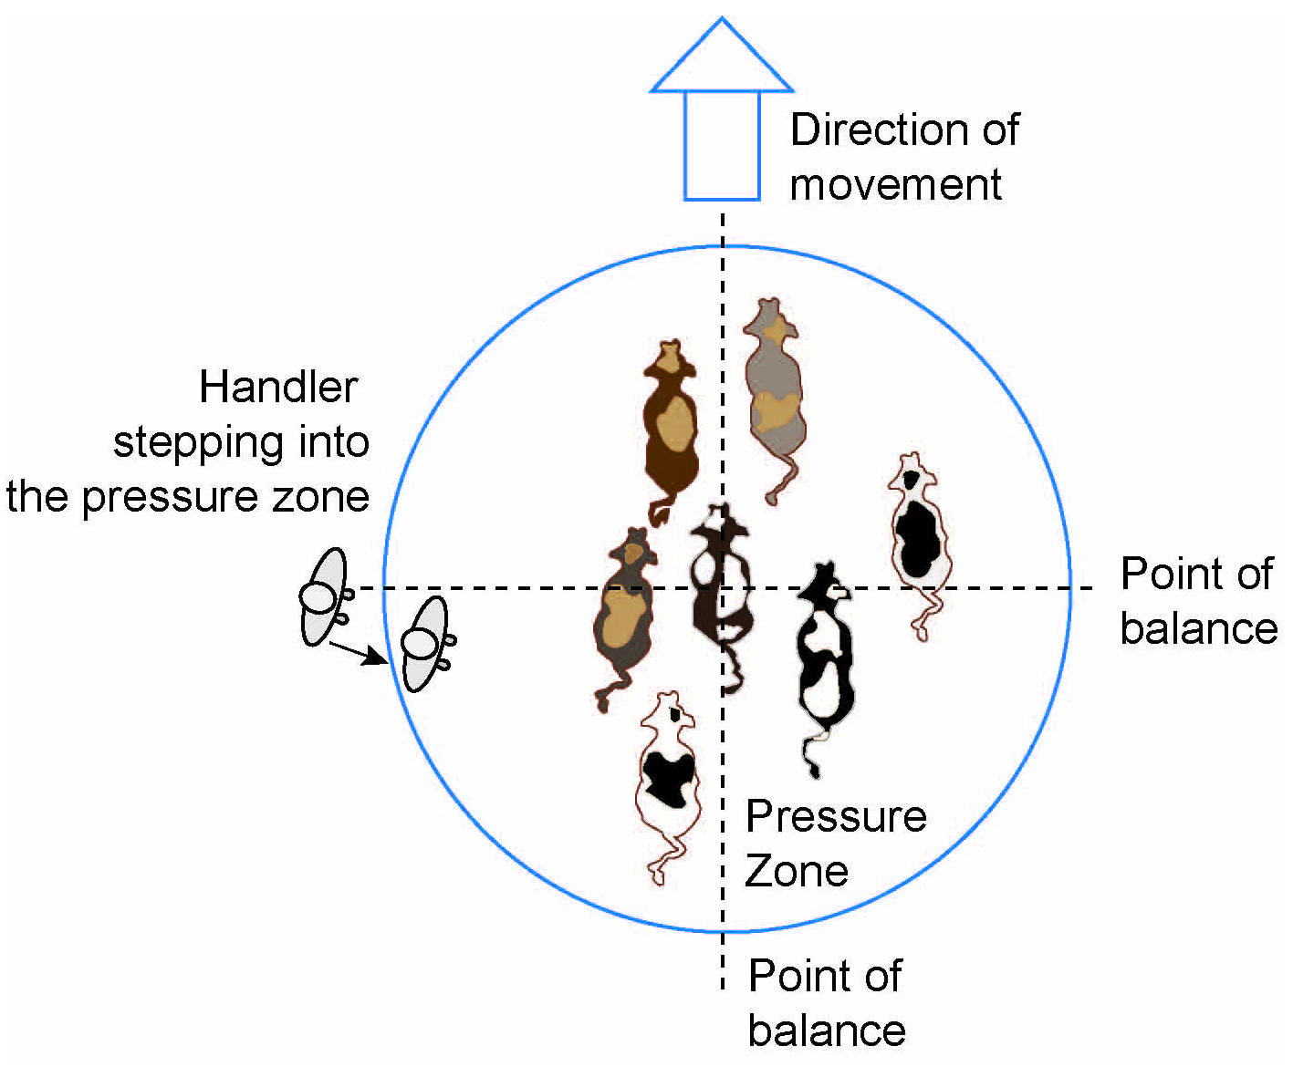

Pressure
To move cattle using natural techniques, livestock handlers must move into the pressure zone of the animal but stop before the flight zone. Stepping beyond the pressure zone into the flight zone will cause an unpredictable reaction as it increases the animal’s stress and generates a flight response—see Figure 7.
Figure 7 Livestock handler’s position in pressure zones
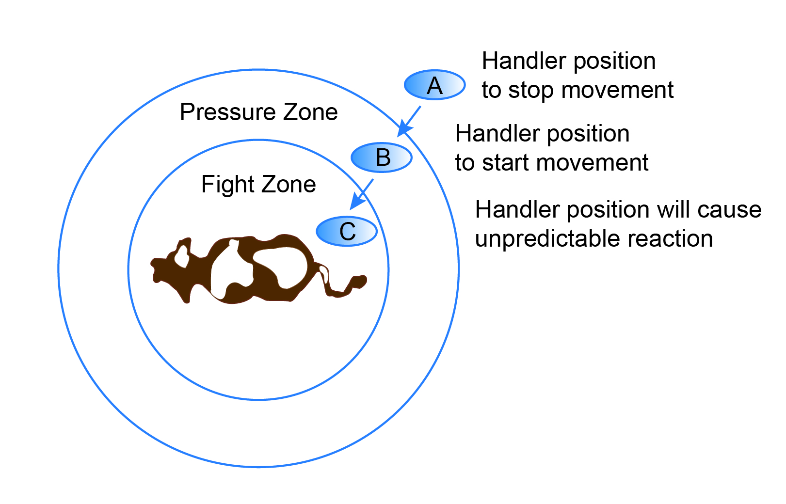
Once pressure is applied and the cattle respond to the pressure, the cattle must be ‘rewarded’ by releasing the pressure. Continual pressure is not tolerated by cattle and this will cause them to respond by lying down, breaking away from the herd or fighting the livestock handler.
Livestock handlers release pressure by exiting the pressure zone or allowing the animal to move away—see Figure 8.
Figure 8 Releasing pressure
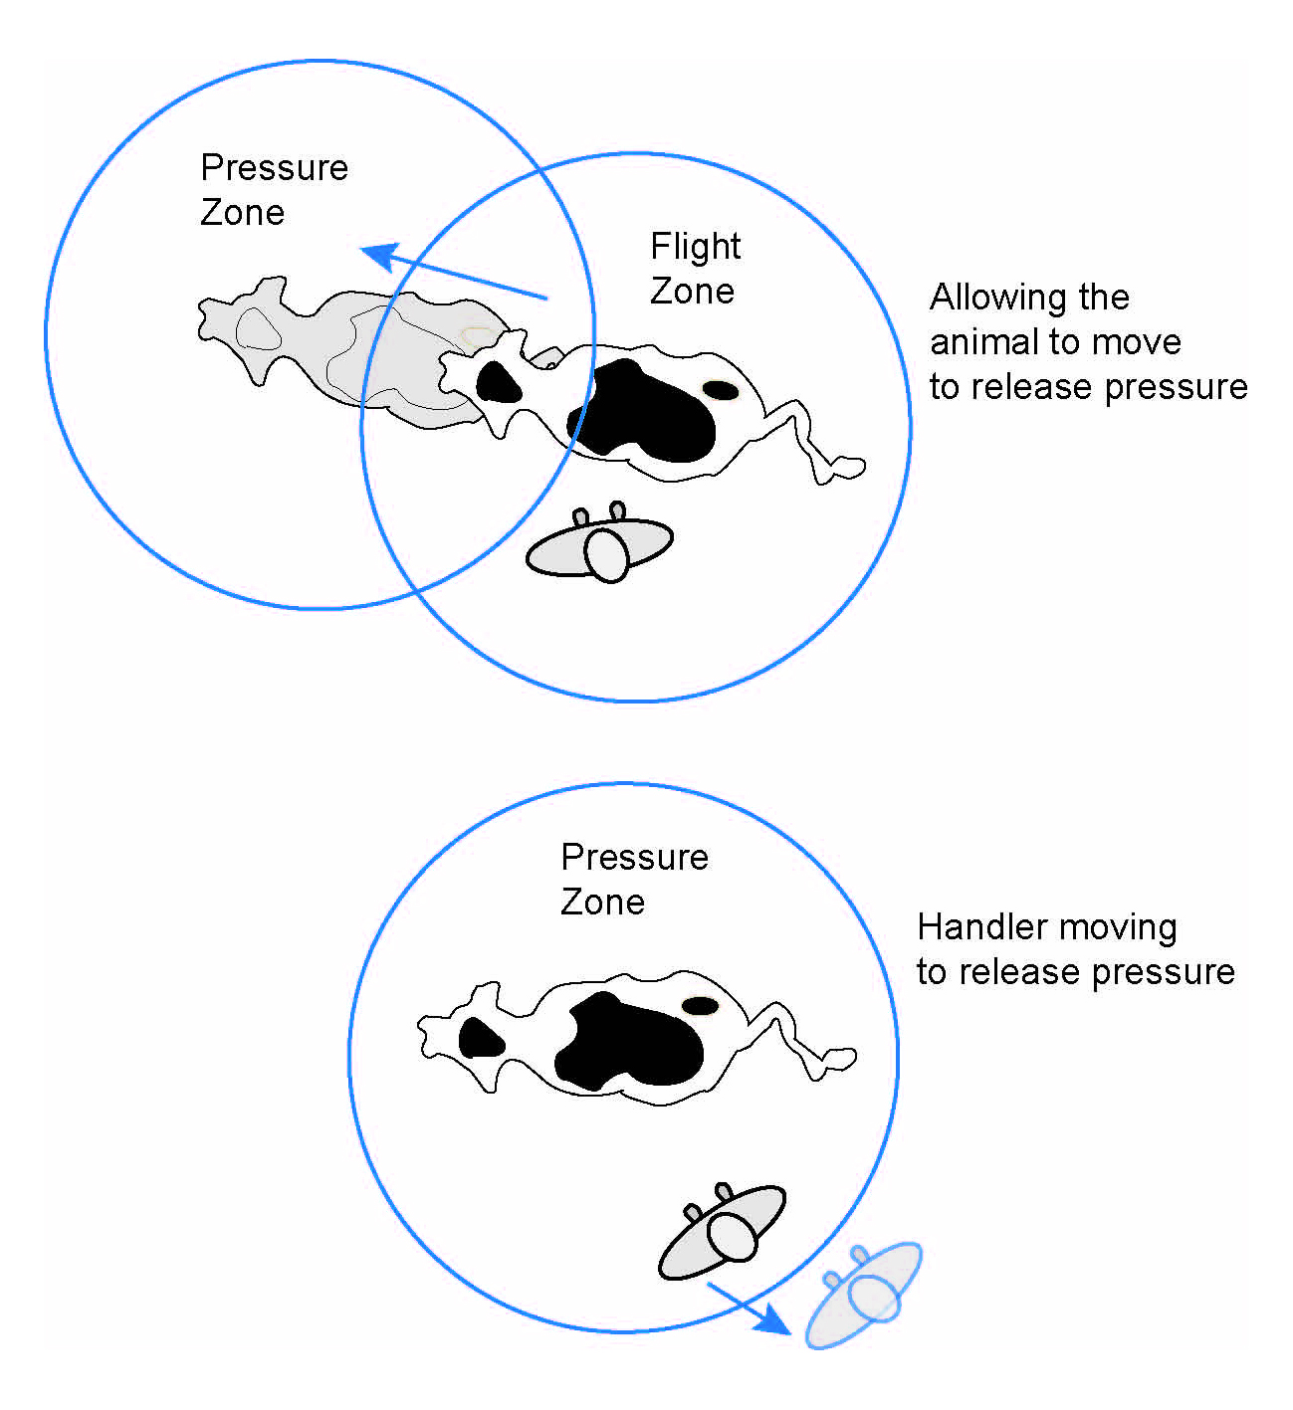
By teaching cattle how to take pressure and rewarding them with pressure release, cattle will respond better to other livestock handlers including those that do not use natural handling techniques.

Moving in straight lines
Livestock handlers should move in straight lines and not curves to handle cattle. Curves are used by predators to stalk prey and will cause cattle to want to escape, rather than cooperate with the handler. Figure 9 shows the correct path of a livestock handler in the forward movement of cattle in a race.
Figure 9 Livestock handler movement - straight lines
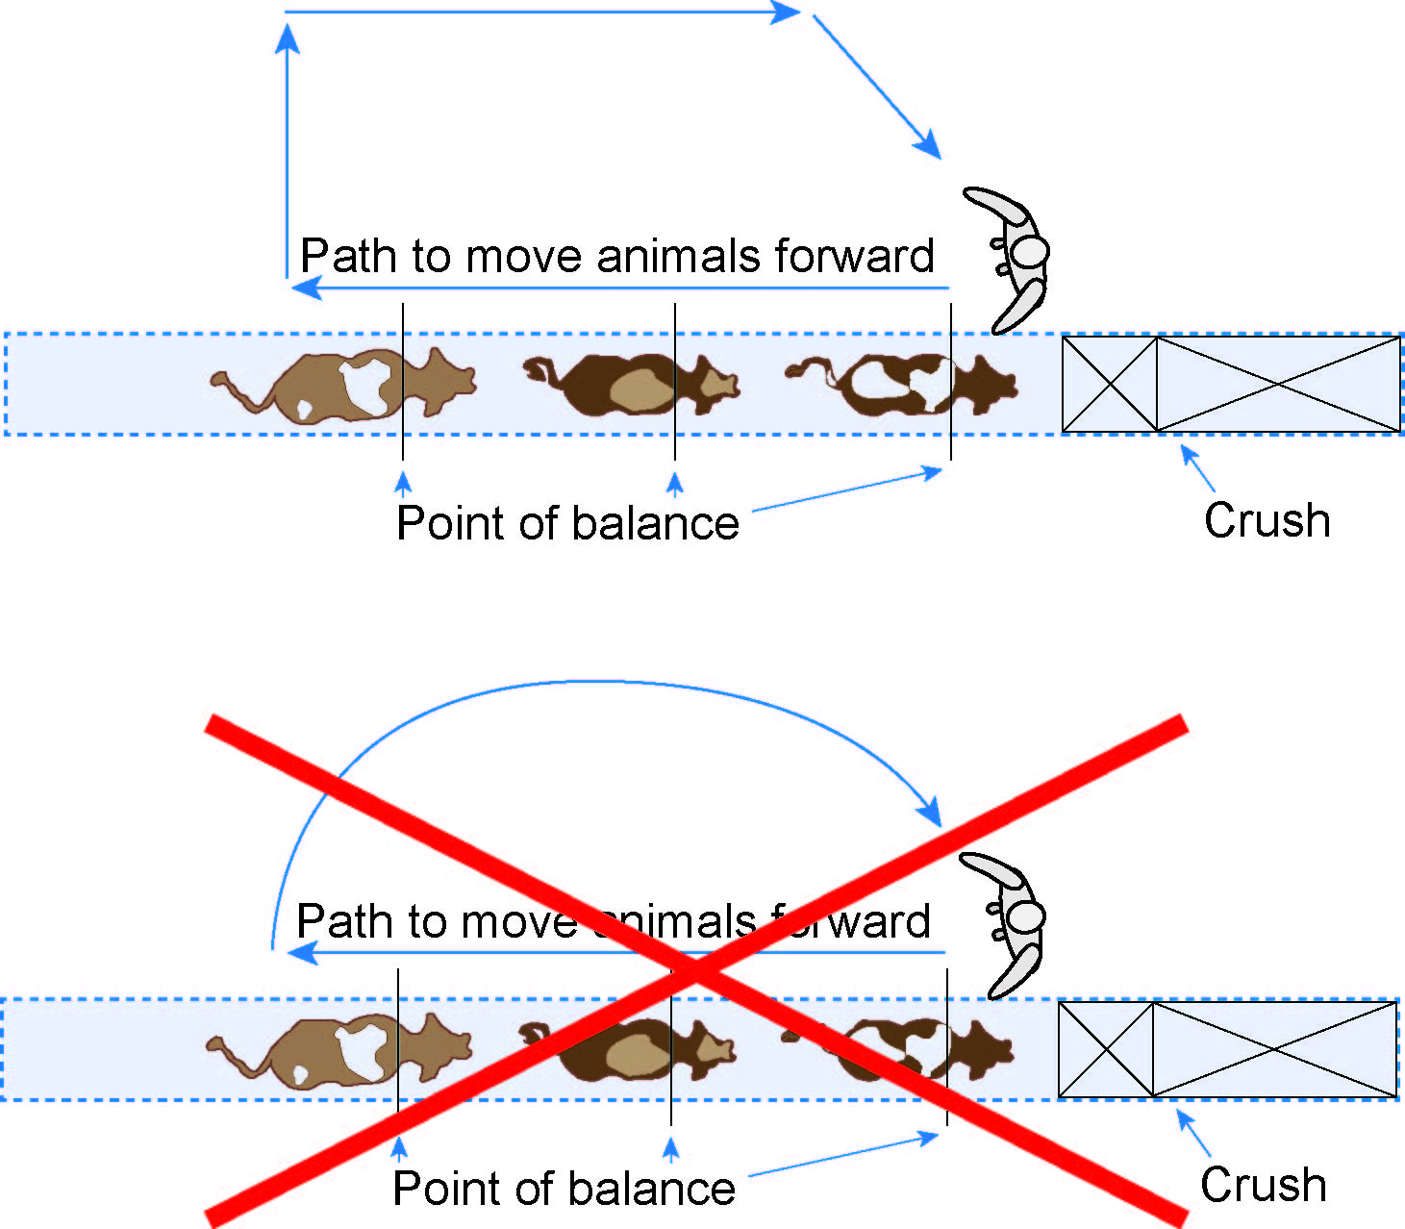
Moving in curves can also apply pressure unevenly across a mob, prompting cattle to react poorly as described above.
A zig-zag approach is the preferable method, with the first line aimed so the livestock handler would go past the cattle if they continued on that line—see Figure 10. Using zig zags to move livestock can be used by livestock handlers on foot, motorbikes, horses, vehicles and aircraft.
Figure 10 Zig-zag technique
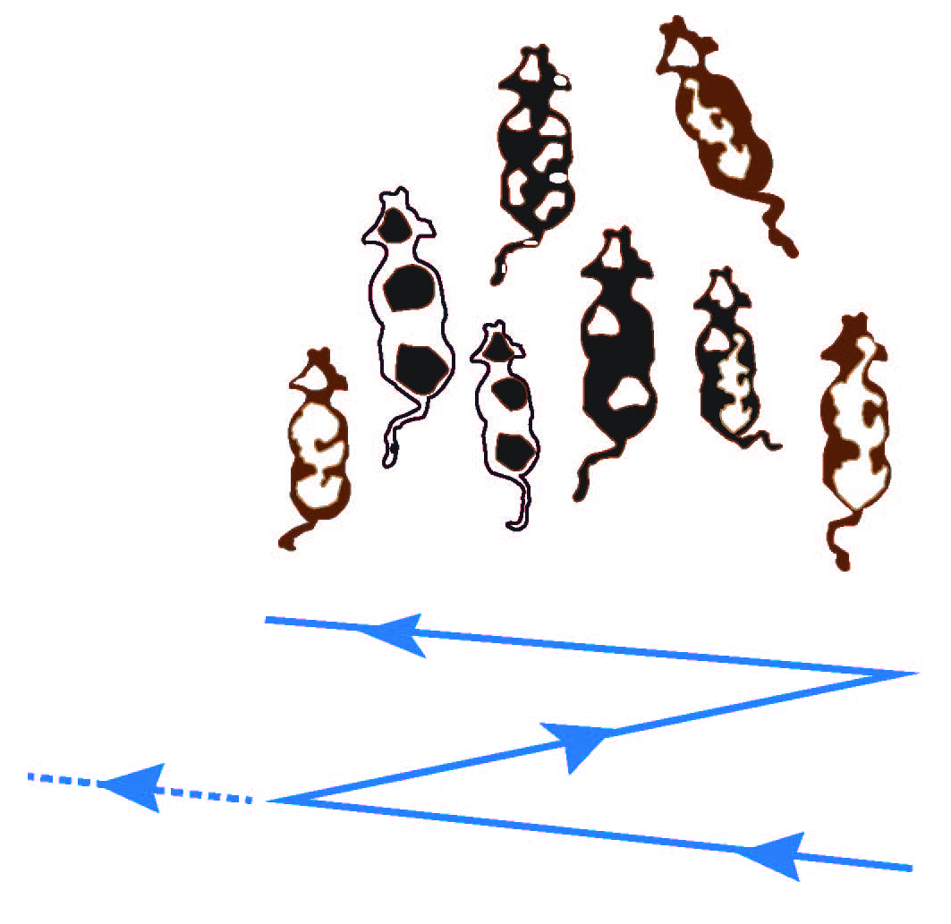

The ‘inverted T’ technique
To move cattle towards the goal, like a gateway or water point, livestock handlers should work the livestock using the inverted T approach. The horizontal line in the ‘T’ represents the line along which the livestock handler can move to apply pressure to the mob, while the vertical line reaches straight to the goal—see Figure 11.
Figure 11 Inverted T technique
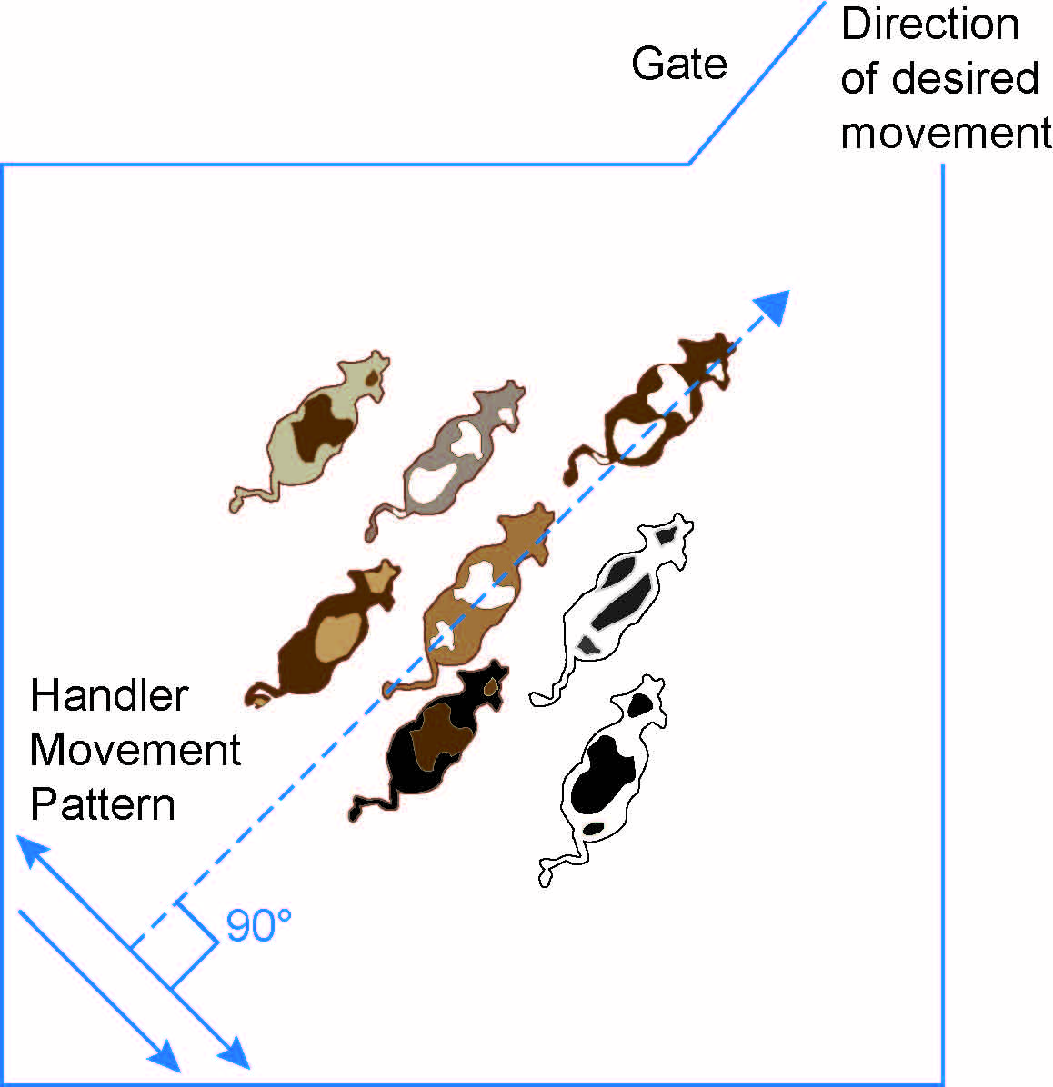
Livestock handlers should avoid curving or hooking the edges of the horizontal line they are working along as this mimics predatory behaviour and will cause the cattle to respond poorly—see Figure 12.
Figure 12 Inverted T technique - livestock handler movement
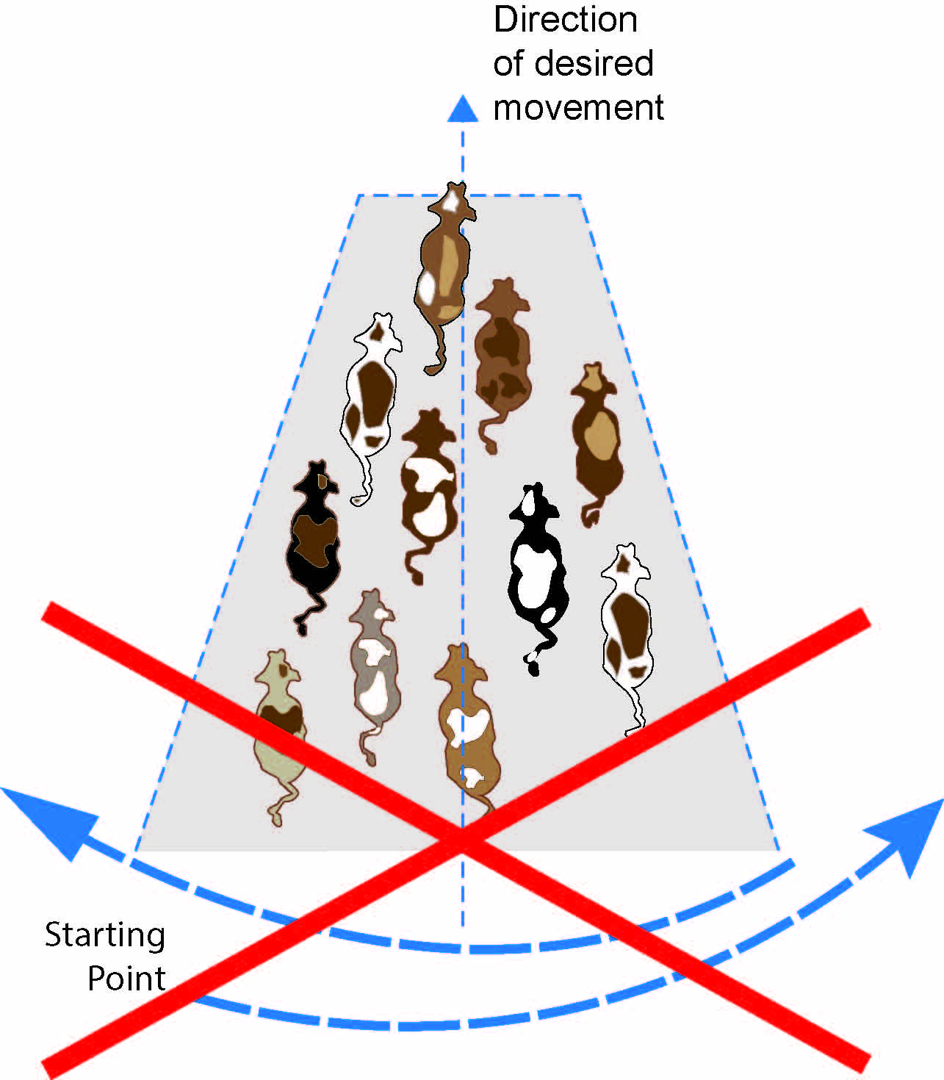

The horizontal line of this technique does not need to be perfectly 90 degrees to the vertical line, instead the zig zag action is to be used by the livestock handler—see Figure 13.
Figure 13 Inverted T technique - with zig-zag
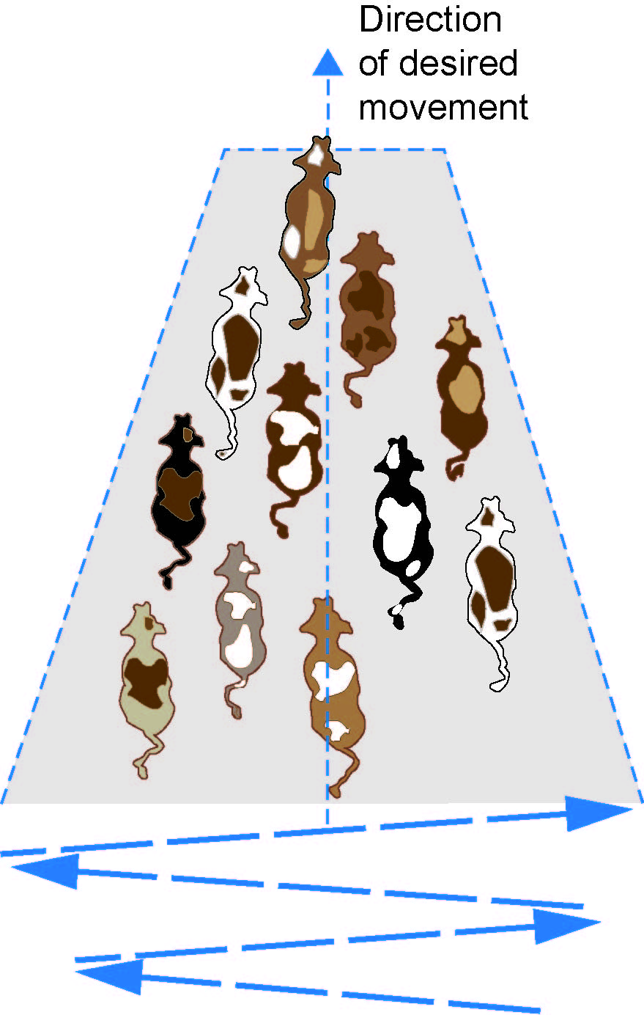
The inverted T technique can be used by livestock handlers on foot, motorbikes, horses, vehicles and aircraft. However it should be noted when not on foot, livestock handlers must be particularly aware not to hook the edges of the T. This technique is suited to mustering in paddocks, laneways and large yards.

The ‘dot the i’ technique
This technique is suitable for use in smaller yards or where cattle must pass through a narrow area like a gateway.
The livestock handler stands to the side of the animals, pressuring towards the rear of the yards. This pressure encourages the cattle to move past the handler to have the pressure released. As the cattle move past the livestock handler they place pressure on the animal’s side and then back away to repeat the process on the next animal—see Figure 14.
This pressure is sufficient to encourage the animal to move through the yard or gate for the pressure release reward.
Figure 14 Dot the i technique – cattle movement
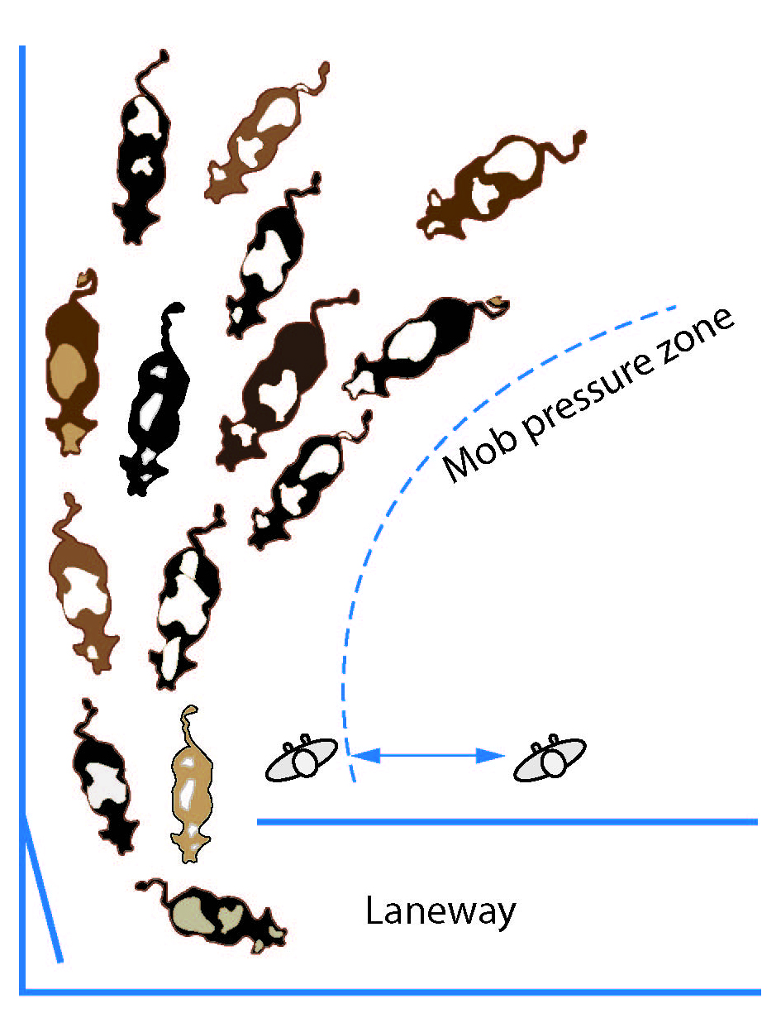

Drafting cattle
Where livestock are drafted in separate groups without using a dedicated drafting facility like in yards, then all techniques should be employed.
Draft quiet cattle from more excitable livestock, rather than the other way around, for example cows from bulls, cows from calves and old from young.
If livestock handlers need to stop or block an animal then they should not move or jump into its path. Blocking the path will increase the stress level for the animal and may lead to injury for livestock handlers if the animal continues to charge. Instead livestock handlers should step backwards to release the pressure and the animal will typically return back to the group they are being drafted from—see Figure 15.
Figure 15 Backward pressure release
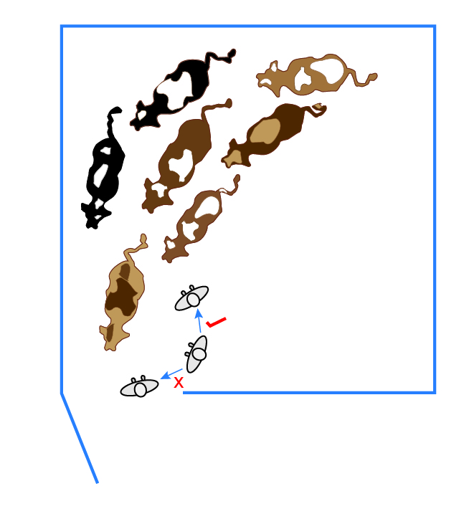
Drafting may be better done after an animal has passed through the crush. Figure 16 shows a three-way draft which can be used for this purpose. This can allow drafting of one animal at a time with the handler separated and may be useful following a husbandry activity, like pregnancy checking, artificial insemination (AI), pulling calves, castration, dehorning, e-tagging or weighing for market.
Figure 16 Three-way draft
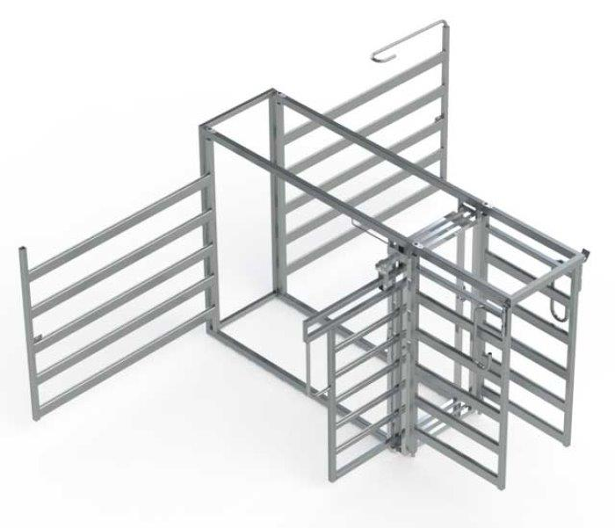

Handling bulls
Bulls are more aggressive during mating season and extremely dangerous when fighting. Livestock handlers should remember:
- never trust a bull—particularly the ‘lonely bull’ reared or kept in isolation
- to never work bulls on their own
- to never trust a quiet bull
- to never turn their back on a bull
- the older the bull, the more dangerous it can become
- to avoid working bulls when other bulls are around, and
- where reasonably practicable, when joining cows, take the cows to the bull rather than bringing the bull to the cows—if reasonably practicable AI can also be considered.

Handling cows and calves
A cow, but particularly a beef cow, is often aggressive just after calving. Livestock handlers should remember:
- the younger the calf means that the mother may be more dangerous
- to avoid having a dog with them when doing work involving cows with calves, and
- to avoid situations where they come between a cow and her newborn calf without some form of barrier for protection–this is especially important when weighing and applying identification to a newborn calf.

Other cattle handling tips
The cattle handling techniques described above will assist livestock handlers handle cattle with natural techniques, keeping the animal’s stress levels low and therefore reducing the risk to livestock handlers.
The following techniques may also assist livestock handlers minimise the risk of incidents when working cattle:
- Give cattle time to settle after they have been mustered into yards or unloaded from a truck. A 30 minute rest is a useful rule of thumb.
- Feed cattle in the yards, especially following weaning and move them quietly through the yards so they become easier to handle in the future.
- Fill cattle yard pens approximately one quarter to one half full. For example, if a pen can fit 40 animals, only put 10-20 cattle in.
- Assess the type of livestock and their behaviour. Bos indicus cattle like Brahmans will potentially be more excitable than European and British breeds like Simmentals and Herefords. Livestock handlers should continue to assess the cattle while handling them by looking around and observing what is going on.
- Never isolate an animal unless necessary, for example due to ill health. As cattle are herders, an isolated animal will become stressed and potentially aggressive attempting to return to the mob.
- Plan a likely escape route or what may be used as a safe refuge before entering a pen, for example behind a barrier or through an escape gap.
- Give the cows time to collect their calves before mustering. This can generally be achieved by entering the mob’s collective pressure zone to generate initial movement, then pausing to allow the cows to gather their calves, before continuing to muster.
- Dogs may be helpful handling cattle but only if the dogs are well trained and the cattle are used to being mustered by dogs. Avoid trying to work cows and calves with dogs. Ensure untrained dogs are restrained or kept in an enclosure until cattle movement has been completed.
- Livestock handlers should not put their arms, heads and legs through panel railings – reversing cattle might not see them or be able to stop. Limbs may be caught between rail openings resulting in serious injury.
- Only use trained or experienced staff. Livestock handlers should operate in pairs and communicate regularly.
- When working with cattle in a crush to perform tasks, for example vaccinations, livestock handlers should be aware of sudden cattle movements that could injure their arms or hands. Using crushes with backing bars and head scoops minimises the risks of these types of injuries.
- Do not underestimate the speed, reach and accuracy of an animal’s kick. Livestock handlers should stand well back and out of range of an animal, unless they are working close to it, then they should turn side-on and move in against the animal. Space between the livestock handler and the animal increases the likelihood of being kicked by the animal.
- PPE should be worn, like long sleeved shirts, long trousers and boots for the task e.g. steel cap or riding boots. High-visibility clothing should not be worn when handling cattle as it will affect the cattle’s behaviour. However, high-visibility clothing should be worn for other cattle-handling related activities e.g. by spotters when assisting truck drivers.
- Canes, ‘poly pipe’ and electric prodders should not be used as they can stir up cattle and make them aggressive. Inappropriate use of canes and ‘poly pipe’ can also mark the hide causing the carcass to be downgraded. If it is necessary to use these devices they should only be used sparingly with the use of rattles considered as an alternative.
- Be aware of the possibility of contracting diseases from cattle like leptospirosis and Q Fever. These diseases are transmitted through contact with blood, saliva and urine and in the case of Q Fever also through the air. Good hygiene should be practised by thoroughly washing after handling cattle. Further information on occupational disease is in Chapter 9 - Cattle husbandry activities and occupational disease.
- Know what to do in an emergency. Further information on emergency preparedness is in Chapter 10 - Emergency plan.
- When closing a gate behind cattle, stand to the side so if the gate is pushed backwards the impact zone is avoided—see Figure 17. If the gate cannot be closed without getting behind it, then an alternative method of closing the gate should be fitted, for example using a slam shut catch or changing the post from which the gate is swung.
Figure 17 Gate impact zone
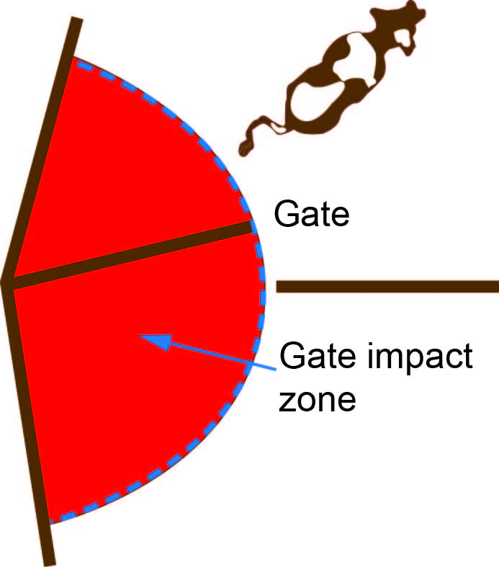

paddock, laneway and yard Design
While natural cattle handling techniques will assist in eliminating and reducing the risk associated with cattle handling, facility design, construction and maintenance is also important. This chapter identifies hazards and risks associated with design for paddocks, laneways and yards when handling cattle and controls to help eliminate and minimise these risks.

Paddocks
Paddock design is based on a range of factors including soil and pasture type, livestock and cropping enterprises, water availability and tradition. When designing paddocks the control measures in Table 2 should be considered.
Table 2 Paddock hazards, risks and controls
Hazards and risks | Control measures
Poor fencing, which can lead to cattle going through fences into other paddocks or getting caught up in wire requiring the livestock handler to rescue an injured and stressed animal. This can also mean livestock handlers cannot use the fence as an ‘extra’ livestock handler, which increases the number of handlers needed to do the work. | - Maintain fencing depending on the cattle enterprise, for example three or four barb wire fences may be suitable for some farm operations, whereas a combination of barb, plain and prefabricated, like hinge joint wire, fencing may be required where mixed farming operations are carried out.  - Electric fences should also be considered.
Uneven terrain with rocks, holes, fallen timber, gullies and bore drains may lead to injuries from incidents involving vehicles and motorbikes or stockhorses tripping. | Where reasonably practicable:  - remove fallen timber and rocks  - fill in holes and gullies  - implement land management techniques to decrease the effects of soil erosion  - use fencing to exclude livestock from these areas  - cap bores and pipe water to tanks and troughs to remove the need for bore drains, and  - only use working dogs or aircraft to muster these types of areas.
Gates located in the middle of fence lines may lead to animals ‘missing’ the gate. | - Where reasonably practicable, locate gates in the corners of paddocks.  - Install gates that can accommodate the largest cattle mob and machinery likely to use this access point.
Difficult water crossing points on rivers and creeks for cattle and their handlers may lead to livestock handlers operating at high speeds near unstable, steep water edges while attempting to muster cattle across the crossing point. | - Consider the suitability of river and creek crossing points and whether they can be improved.  - Consider installing fence wings to assist livestock handlers move cattle through the crossing.  - Where reasonably practicable, design the paddock so livestock handlers are not required to move cattle across the waterway.

Laneways
Laneways assist livestock handlers move cattle between different paddocks and yards. This reduces stress on animals and livestock handlers, reduces labour requirements as less livestock handlers are needed to move cattle over longer distances and can eliminate and minimise hazards associated with musters, like droving over uneven terrain. When designing laneways the control measures in Table 3 should be considered.
Table 3 Laneway hazards, risks and controls
Hazards and risks | Control measures
Poor fencing, which can lead to cattle going through fences into other paddocks or getting caught up in wire requiring the livestock handler to rescue an injured and stressed animal. This can also mean livestock handlers cannot use the fence as an ‘extra’ livestock handler, which increases the number of handlers needed to do the work. | - Maintain fencing depending on the cattle enterprise, for example three or four barb wire fences may be suitable for some farm operations, whereas a combination of barb, plain and prefabricated, like hinge joint wire, fencing may be required where mixed farming operations are carried out.  - Electric fences should also be considered.
The laneway size is inappropriate i.e. too wide or too narrow for the type and number of cattle being handled. Livestock handlers are unable to move past the mob if necessary or handlers do not have control over the mob. | - Where reasonably practicable, construct laneways wide enough to allow a livestock handler to pass beside the largest cattle mob, but not so wide that livestock handlers do not have control over the mob.
Gates are not provided at regular points to prevent cattle from progressing too far along the laneway in front of the livestock handler or block break backs should that happen. | - Where reasonably practicable, install gates at regular intervals along the laneway making sure they are positioned to suit the cattle’s natural movement. Make sure gateways are wide enough to not impede cattle flow along the laneway.

Yards
Regardless of the number of cattle–whether 10 or 10 000–a well-designed, functional set of yards is essential for safe and productive management. Generally, the yards should allow safe, efficient handling of cattle for drafting and loading as well as for husbandry procedures like drenching, vaccination and pregnancy testing. A basic cattle yard layout is shown in Figure 18.
This section will assist you when designing, constructing and refitting yards to control risks while improving cattle processing efficiency.
More information is available from commercial manufacturers and state and territory departments of primary industries or agriculture. A cattle yard is typically comprised of a holding yard, forcing yard, race, crush and loading ramp.
Figure 18 Basic cattle yard layout
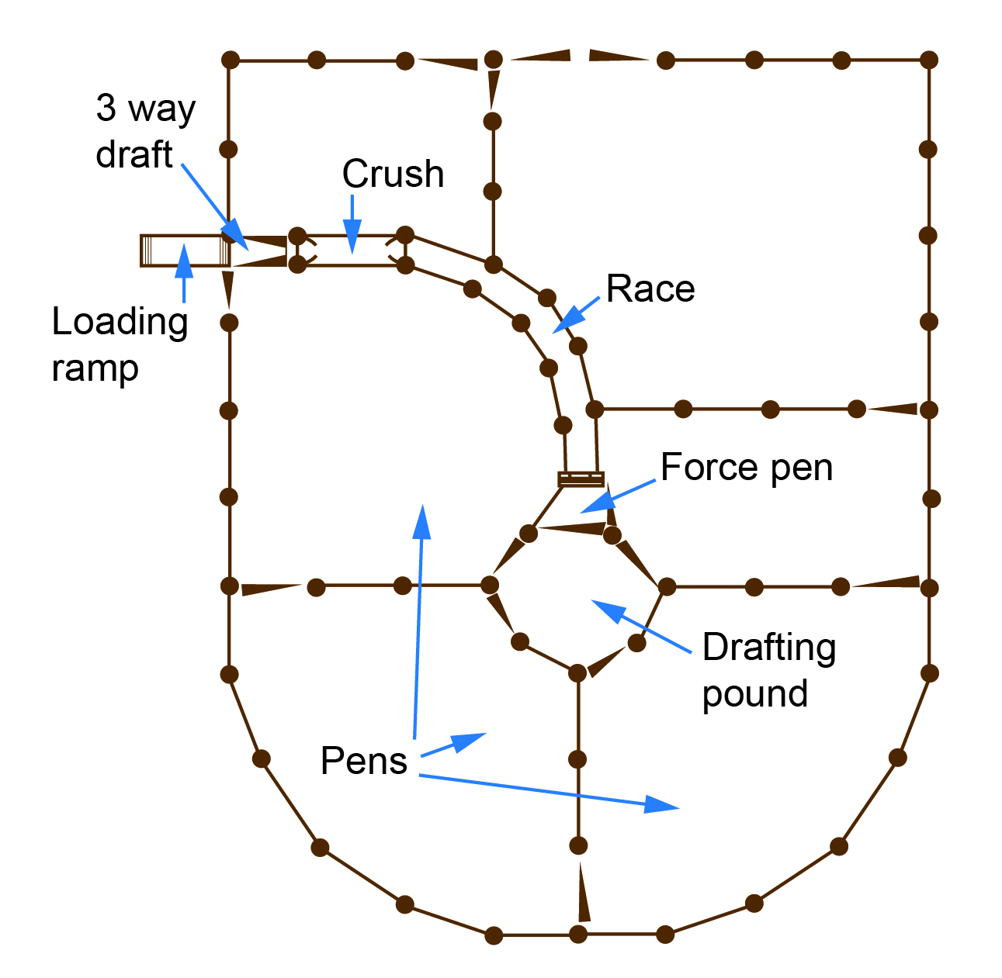
Issues for cattle yards arise when:
- livestock handlers and cattle are not physically separated from each other, particularly in high pressure areas like the forcing yard
- the design does not take into account natural cattle behaviours, meaning cattle movements through yards are unnatural and are therefore forced, increasing the stress and unpredictability of cattle, and
- yards are not maintained and in a sound working order.
When designing cattle yards:
- build in features for the convenience and safety of the livestock handlers and, where reasonably practicable, separate humans from animals
- have a clear understanding of animal behavioural traits affecting the way animals move in a yard including the position of the handler in relation to the cattle
- provide the appearance of clear space and minimise distractions to draw cattle through the yard, and
- design race and livestock pressure areas for livestock and operator comfort and safety, using appropriate materials and ensuring these materials are properly maintained.
A checklist of cattle yard design safety features is available at Appendix 1.

Cattle behaviours that affect yard design
Knowing the natural instincts and common behaviour of livestock will help operators handle animals quietly and calmly and design yards that work with and not against these behaviours. Some cattle behaviours affecting yard design include that cattle:
- like to be with the herd and follow other animals as natural herders—if they see the herd beside them in a race or forcing yard they will stop. Solid sides on races, loading ramps and forcing pens can help to keep cattle calm and moving
- move more easily through a curved race because they cannot see people standing by the crush
- move more easily if they do not think the race is a dead end—cattle standing in the forcing pen should be able to see a minimum of two body lengths up the single file race and the entrance of the race should be well lit so cattle can see there is a path into the race, and
- prefer to move towards their paddock—so circular yards work better if the livestock are moving back to where they entered the yard.

Location and site
The following should be considered when choosing a site for yards or redesigning yards:
- Accessibility to vehicles via an all-weather road. Access to stockyards should consider the flow of livestock trucks and farm vehicles as much as how livestock and people will access the yards. Hazards like the proximity of electric lines, structures and domestic premises must be managed during initial planning or when redesigning access points.
- Location so livestock carriers do not reverse on or off properties onto a public road and if hard standing (parked) do not block or partially block traffic.
- Centrally locating yards to allow mustering from all parts of the property. Depending on the size of the property it may be better to build multiple sets of yards throughout the property.
- Drainage to minimise slips, trips and falls. A firm dry base in the pens with at least 3 per cent of surface fall will provide effective drainage.
- The ground levels as cattle resist going downhill.
- Orientation so cattle in the race or on the load ramp aren’t moving into shadows and the handler is not looking into the sun.
- Whether shade trees and structures are available.
- Whether water is available or could be made available for livestock.

Materials
A combination of materials can be used in the construction of yards, for example steel, concrete and timber. The choice depends on:
- availability of materials
- budget, noting cost may be relevant when considering all possible risk control measures but can only be considered after all other factors have been taken into account
- the type of cattle and enterprise e.g. dairy cattle will have different requirements to northern pastoral beef cattle, and
- suitability for the environment e.g. timber materials may be unsuitable for bushfire prone areas.
When constructing or redesigning yards, consider that different areas of the yards have different requirements. For example:
- Areas receiving a lot of pressure from livestock—like gateways, forcing yards and races—should be sturdy, well-constructed and made of quality materials. Panels should be made of timber, steel pipe or special cattle mesh.
- Wire rope or cable is well suited for the outer fence in circular yards. Sheep mesh with timber or steel rails on top is suitable where the yards are also used for holding sheep.

Designing yards
The following should be considered when undertaking a cattle yard design:
- Current and future workloads and the ability to cater for various livestock handling operations.
- The yard capacity, the slope of the site and the floor or ground surface.
- Using surfaces that minimise the risk of trips and falls.
- Separating people from livestock.
- Legislative and Australia Standard requirements e.g. Australian Standard AS1657-2013: Fixed platforms, walkways, stairways and ladders – Design, construction and installation (AS1657).
Yards should have:
- A clear trafficable yard entrance.
- Strengthened yard gate posts with ties or adjustable hinges to reduce gates dropping or lifting.
- Gate catch handles and latch design with minimal obstruction or protrusions. Gate latches should be positive bolt, slam shut, spring-loaded type, especially in forcing yards. Chain and slot-style latches are more dangerous to operators but are a good addition in some parts of the yards to prevent cattle escapes, for example low pressure areas like holding yards. Ensure latches, bolts and chains on gates are in working order and robust enough to contain livestock. Wrap-around chains should be avoided.
- A sheltered, spacious, barricaded working area to protect handlers and equipment, with a non-slip concrete base. The concrete should be ramped under the surrounding yard surface on the edges to minimise tripping hazards.
- A lockable storage facility to secure chemicals. Where vaccines and antibiotics are used these may be stored in a lockable fridge used solely for this purpose.
- Numerous access ways and emergency escapes between and around yards. In large yards these could be highlighted in yellow so they are easily and quickly sighted by workers however care should be taken where these markings are visible to cattle as they may change the cattle’s behaviour. Access ways and emergency escapes are particularly important between the forcing yard and working area.
- Race sides covered up to reduce distractions that may impede forward movement of cattle.
- A concreted race and forcing pen.
- Bottom rails of yard fence no less than 300 mm above ground level to allow a handler to escape—drop and roll under the rail.
- Secure race and gate overhead ties at a safe working height—a minimum of 2.6 metres and up to 3.6 metres if a horse is used for mustering in the yards is suggested.
- A race side panel release system, to allow for the safe and easy escape of livestock should they go down.
- If work is required between rails, a race designed to prevent cattle pushing handlers’ arms against posts.
- Non-slip pressed steel or concrete catwalks beside forcing pens, races and loading ramps assist in animal husbandry operations.
- Artificial lighting if being used at night or for use in inclement weather.

Holding yard
A holding yard is the first yard cattle enter when being mustered from a paddock or laneway. Holding yards should be designed or refitted with:
- Large entrance gateways so cattle can move into the yards unimpeded and livestock handlers are not using excessive pressure.
- Water and shade facilities so cattle remain in good condition and without stress, making it easier for livestock handlers to move these cattle through the yard facility.
- Rectangular type design, rather than square shape. This allows livestock handlers to have greater control over the mob.
- Corners removed or curved so the only place cattle will bunch is in the directions they need to move, for example towards forcing yards.

Forcing yard
Forcing yards are the pens used to move cattle from larger yards into the race and crush. This is a high pressure area and people should not go into this yard.
There are different designs available and you should design, construct and retrofit to suit your cattle, yard configuration and handling techniques. The following are examples of forcing yard designs:
- A triangle forcing pen is, as the name suggests, a forcing pen triangular in shape—see Figure 19. These can be designed to fit different yard designs although they can result in cattle becoming wedged in corners so livestock handlers must take care not to overfill.
Figure 19 Triangle forcing pen

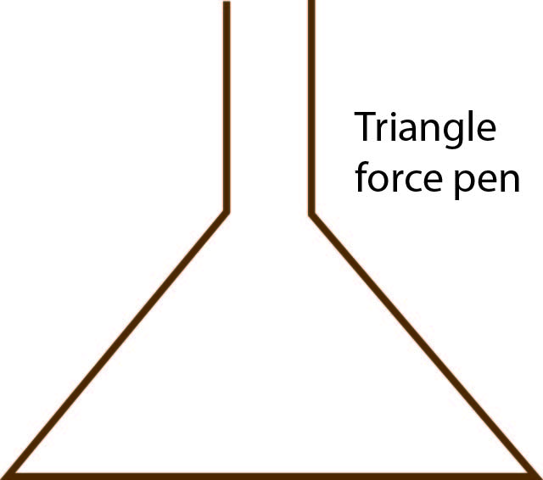

- A round forcing pen or ‘tub’ pen is a half-circle yard with gates that swing 300 degrees allowing operators to push cattle up the race from behind the gate and at arms’ length—see Figure 20.
Figure 20 Round forcing pen
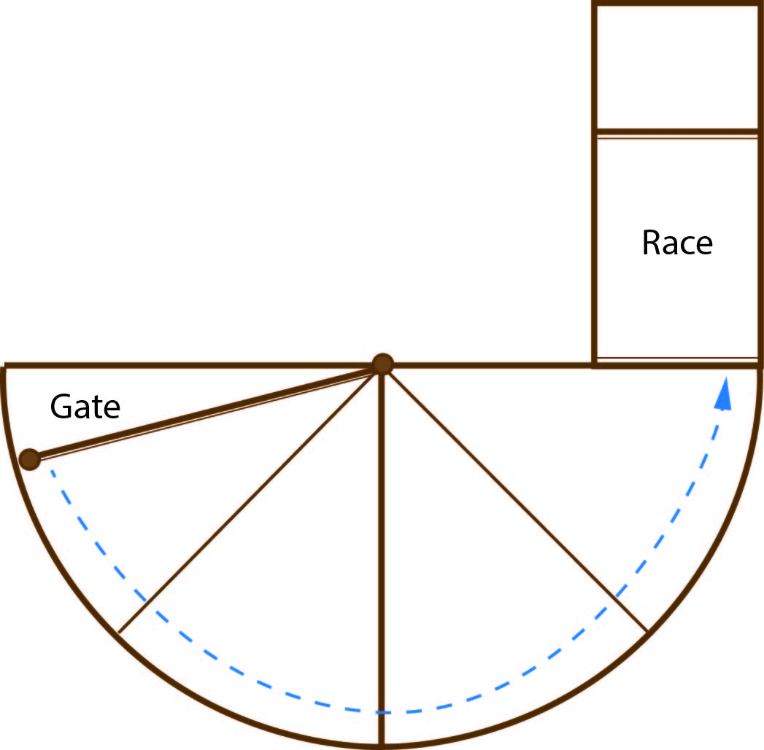
- A Bud Box is a rectangular yard with dimensions of approximately 9 m x 4.5 m—see Figure 21. Cattle enter the Bud Box with momentum, before turning at the yard end and circling back around the livestock handler to enter the race. To have the Bud Box operate effectively it must be setup so cattle enter and go past the race entrance before circling back. It is important the livestock handler stays to the inside panel and does not get behind the cattle to ‘push’ them in. It is also important that only the number of cattle the race is capable of holding are put into the Bud Box e.g. if the race can hold 10 cows then only 10 cows should be put into the Bud Box.
Figure 21 Bud Box
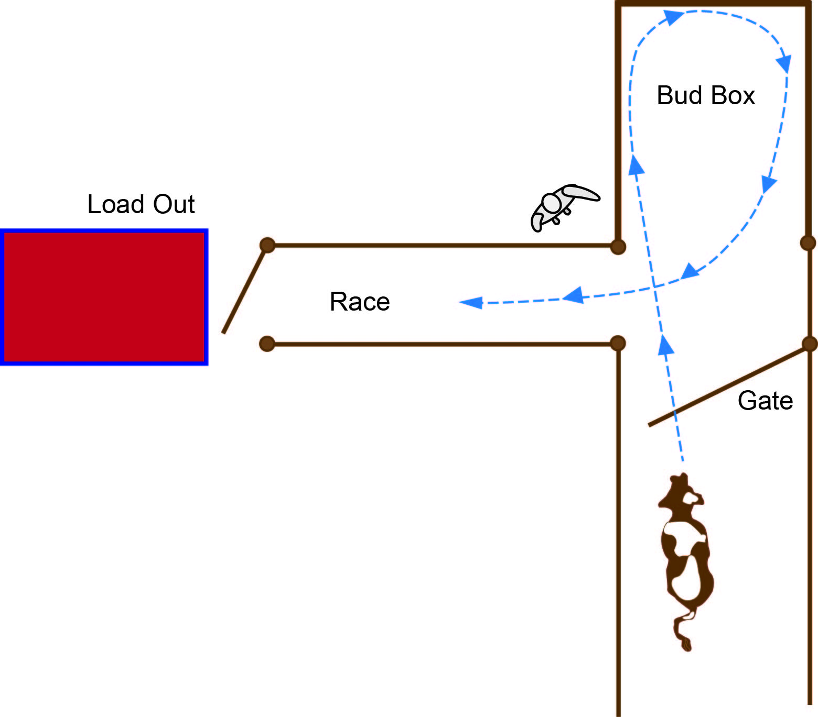

Race
The race is the single-file corridor cattle move down from the forcing pen to the crush for animal husbandry operations. This is a high pressure area and people should not go into this space. Race design can include:
- The internal race width for a straight race should be 675 mm and for a curved race 700 mm—see Figure 22. The entry width from the forcing yard into a curved race should be 750 mm to minimise the tendency for cattle to bump their shoulders and hips as they enter the race.
- When placing race posts be sure to allow for the width of the rails to achieve the desired internal width. Overhead bows should be attached to posts to prevent the race from being widened.
- Concreting the race will reduce bogging and allow easy cleaning.
Figure 22 Race design with dimensions
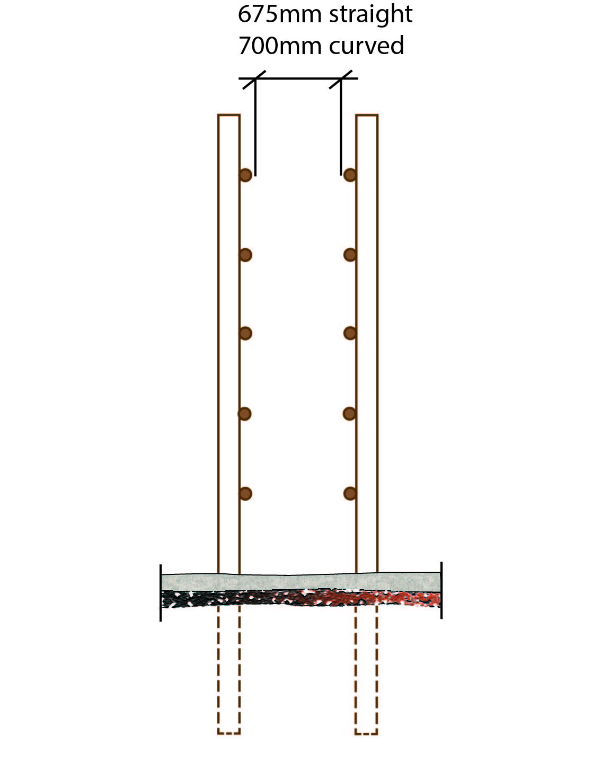

Crushes
A crush is the equipment at the end of the race where animal husbandry operations take place. Similarly, a calf cradle is a smaller version of a crush that allows husbandry operations to be performed on calves like marking.
Most commercial crushes are approximately three metres long. Where a commercial crush is used, the length of the race panels or the gate in front of the head bail should be adjusted to accommodate the larger crush. Walk-through type head bails operated by livestock handlers from the front or rear are the most functional.
A list of features to be considered when building, purchasing or refitting a crush and calf cradle is available at Appendix 2.

Loading ramps
Loading ramps allow livestock to be loaded and unloaded from vehicles like trucks, trains, ships and aircraft. While this section focusses on loading ramps for trucks this information can be adapted for trains, ships or aircraft.
If property entrances with gates are located near a public road ensure a hard stand area is provided for trucks clear of the road. This area needs to allow space for the largest truck used including any reversing activities. Traffic management systems should be put in place for truck movements to protect drivers, traffic control officers or ‘spotters’ and livestock handlers.
Loading ramps should not intrude onto the road or outside the property fence line and the loading position of the vehicle should be inside the property. More detailed information on property access for trucks is available from your road traffic authority.
A list of features of a well-designed loading ramp and where to locate them is available at Appendix 3.
Further information is available in the Australian Livestock and Rural Transporters Association’s Guide for safe design of livestock loading ramps and forcing yards.

Maintaining yards
Yards should be maintained in a workable condition. This will help to protect livestock handlers and livestock when using the yards.
Livestock handlers should:
- regularly inspect the yards
- inspect the yards before they are used, and
- action maintenance issues discovered during use of the yards.
Livestock handlers should consider:
- keeping pens and yards free of obstructions to avoid injury like protruding nails, bolts, wire, trip hazards and broken rails and ensuring free-flowing livestock
- ensuring gates swing freely
- keeping the crush and head bail in working order
- removing stray posts, timbers, containers and large stones
- lubricating and adjusting the slides, latches and hinges on gates
- having a general clean-up including picking up string and rubbish
- watering working areas to minimise dust, and
- maintaining shade structures in good condition.

Refitting and redesigning existing yards
Building new yards is not always reasonably practicable given ongoing operations and cost. Existing yards can be redesigned and refitted to make them safer. When doing so the following should be considered:
- building in access and escape points, especially between the forcing pen and the working area—escapes with bat wing gates enable a larger exit space
- concreting the race and forcing areas to provide a non-slip surface for cattle and livestock handlers
- building non-slip pressed steel or concrete catwalks beside forcing pens, races and loading ramps
- constructing barriers to protect work areas like around the crush
- closing in the forcing pen and both sides of the race mouth to prevent baulking. If closing in yards with panels or belting, ensure emergency escapes are fitted and identified—painting these yellow or another bright colour will help prevent baulking
- angling corners in pens to improve cattle flow
- locating water troughs in inactive areas of the yard
- providing sprinklers to minimise dust
- dividing large, square pens into longer, narrower rectangular ones
- providing shelter over the working area
- installing rubber conveyer belting or similar on panels to reduce baulking due to outside influences
- installing sliding gates in race ways, loading races and ramps with no head-high projections. This type of gate needs to be strong enough for the largest cattle. Similarly remove or modify head-high projections e.g. gate slides, crush handles and low gate ties
- installing slam-shut gates in entrances to races, forcing areas and other high pressure areas
- engineering smooth surfaces on gate latches and catches, and
- providing lockable storage for chemicals remaining at yards—this may include a lockable fridge used solely for vaccines and antibiotics.

On-farm cattle sale facilities
This chapter will help beef cattle and stud livestock producers establish a safe environment to conduct on-farm cattle sales.
Both the owner and the livestock agents have responsibilities in relation to the conduct of on-farm cattle sales.
The owner has the principal duty to protect the health and safety of livestock handlers and contractors as well as livestock agents, visitors and clients. Defined responsibilities and procedures for resolving safety issues should be agreed and documented and should form part of a site induction process. Induction could be included as part of the buyer registration process. The livestock agents, as contractors, have health and safety responsibilities to their livestock handlers.
For a safe environment to be created on the day of sale, the owner and the livestock agent must work together to eliminate or minimise risks associated with the conduct of the sale.
The risks with on-farm cattle sales are those associated with:
- access by the public including inexperienced cattle people and children to pre-sale inspection yards
- supervision provided during the inspection before, during and after the sale
- design and construction of inspection, handling and sale facilities including truck parking facilities
- traffic management, and
- inexperienced and untrained livestock handlers involved in cattle handling during the sale.
To minimise the risks, as far as is reasonably practicable, the following control measures should be implemented:
- limiting and controlling access by the public to pre-sale inspection yards
- providing supervision
- designing and constructing facilities, even temporary facilities, to a standard to ensure the security and welfare for the largest animal being sold
- having traffic management plans, and
- ensuring experienced and trained people are involved with cattle handling during the sale, have been inducted into the property’s procedures and understand the emergency processes.

truck crate and trailer design for livestock transport
Transporting cattle on a vehicle can involve the risk of injury or fatality to people handling cattle. This chapter provides information on the risks and hazards encountered at critical control points in transporting cattle and includes suggested design controls to eliminate or minimise these hazards.
Note: The information in this chapter is not intended to duplicate or supersede relevant legislative requirements, for example driver fatigue and animal welfare requirements.

Hazards when transporting cattle
Hazards that may be present when transporting cattle include:
- No design standard that considers the livestock handler using the truck crate—crates are generally made to a customer request and based on animal welfare requirements regarding size, depth and width. Similarly, where users have the capacity to manufacture the crate in-house e.g. on larger farms, there is no set level to ensure the trailer is made to a certain level regarding safety issues.
- Trailers can be mismatched—see Figure 23—trailer designs change through the introduction of new innovations e.g. being able to stand outside a road train to open internal gates. Different types of trailers including old and new trailers are often used simultaneously. Trailers used in combination e.g. a B-double may have variations in the placement of doors, gates, walkways, access points, storage facilities and inspection points. These variations can lead to injuries:
- in animals e.g. a misaligned trailer may result in space for a cow’s leg to be caught and damaged
- to livestock handlers e.g. when mismatched doors are opened between trailers meaning as the cattle walk through there may be no area for the livestock handler to safely stand
Figure 23 Mismatching trailers
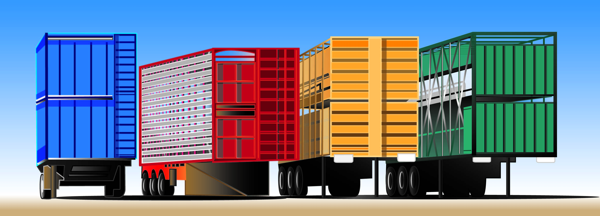
- Secondary locking mechanism for rear doors are not provided e.g. a slam shut gate may not have completely locked which may lead to the door opening in transit. Rotating drop pins can also be an issue as ramps with upright posts butting against a trailer cannot be turned when flush against the ramp. Therefore the drop pin is required to be removed before the trailer is against the ramp, leaving the rear gate unsecured for a period of time. Care should be taken to ensure the pin is inserted to lock the gate before commencing travel.
- Crates are not maintained as required. Safety devices may also not be assessed, maintained and included on the regular inspection schedule e.g. ladders, gates, pins and hinges.
- Livestock handlers working at heights—access to the catwalk on top of a truck requires a livestock handler climbing up and down over an edge with no portion of the ladder higher than the platform—in construction and scaffolding a ladder should be at least one metre above the platform. Potential controls also raise issues including:
- A crate cannot be fully contained as larger cattle, like Brahmans with large humps, will not fit. An animal that has gone down is also hard to entice back to standing in a fully enclosed crate.
- Harnesses require attachment points, which are difficult to place to allow the livestock handler to move the length of the truck but still be restrained from impacting the ground if they fell. This may also result in a further hazard where a livestock handler who falls into a crate wearing a harness and lanyard may become entangled with an animal that has either been frightened or is aggressive.
- In-crate ramps can create crush and pinch points and must be maintained regularly. Ramps are required to load two decks where a double decker ramp has not been provided.
- Crate floors can become slippery from effluent, plus the effluent creates a corrosive effect that can be dangerous. Effluent capture should also be considered to prevent distribution onto roadways creating health and safety issues for other people.
- Trailer gates can be made solid or grill style, noting open style gates do not shield a livestock handler from an aggressive animal. Hinged gates can be difficult to manoeuvre from the outside of the crate if not maintained. Pulley systems for the gates, if not put in properly become hook up points for horned cattle. Slide gates become difficult after time typically due to dipping rails or the rollers become compromised by dust and grease.
- Being in close, confined quarters with animals. Transporters typically do not know the cattle’s history, prior treatment and temperament so being in such close proximity with few, if any, escape pathways increases the risk of injury.
- Time pressures to ‘get the work done’ may lead to transporters taking shortcuts, like not wearing harnesses and working with livestock handlers in the yards. These shortcuts may create confusion, increase animal stress, lead to time delays where the livestock handlers are not used to working with other people and elevate their risk of an incident.
- Poor access from ramp to trailer. In situations where the top catwalk is used there may be difficulties with accessing this platform from the loading ramp, leading to livestock handlers operating at height without controls in place.

Crate and trailer design
In addition to handling cattle using natural methods, crate and trailer design can assist in eliminating and reducing the risks to livestock handlers when transporting cattle.

Making existing vehicles safer
Risks to livestock handlers can be minimised when inspecting cattle already loaded for transport by using existing equipment. This includes:
- Retrofitting improvements so work can be done from the ground. For example providing:
- inspection points in the crate so cattle welfare can be assessed from the ground, noting consideration should be given to effluent escape in transit—see Figure 24
- permanent water jets to clean the crate without having to enter it—while ensuring that no new hazards are introduced like protrusions into the crate, and
- internal gates operated from outside of the crate manually, air-operated or pneumatic system.
Figure 24 Cattle crate inspection point
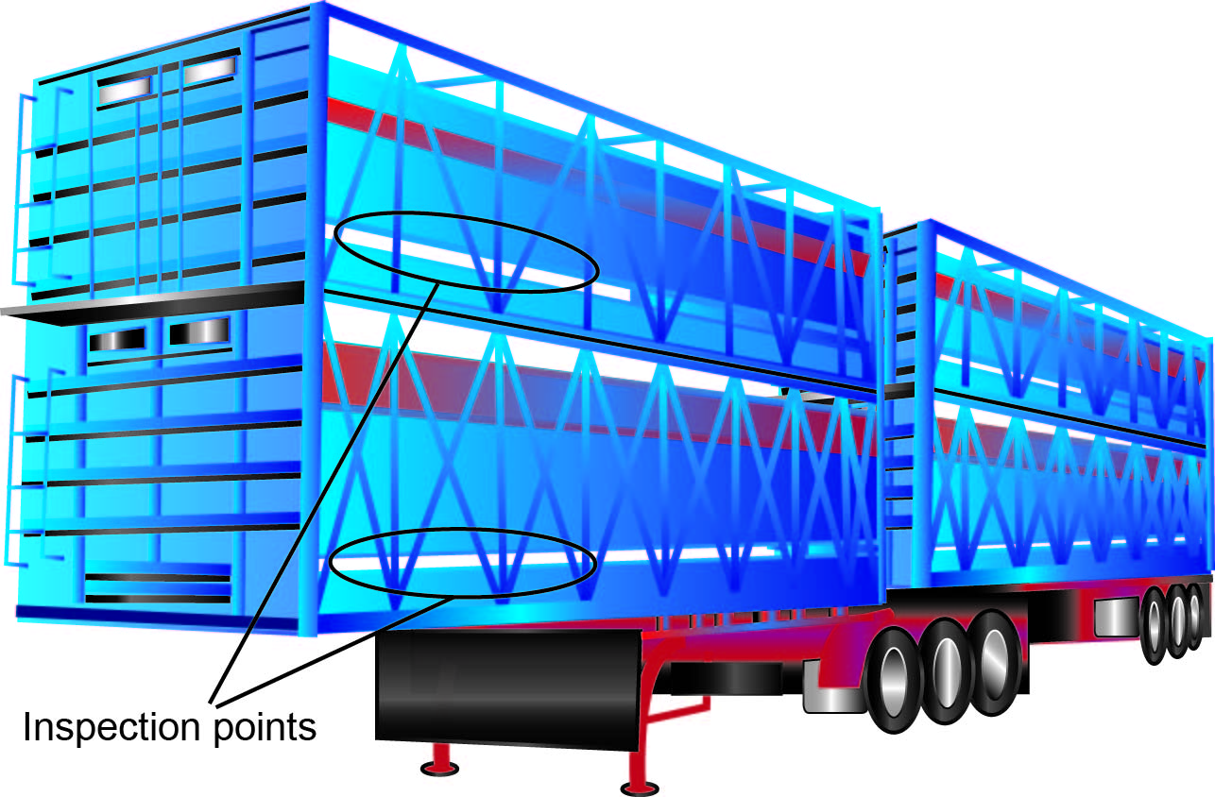
- Installing:
- Platforms or walkways with protective handrails or siderails—see Figure 25. Consideration should be given to access from the ramp to the trailer. If the trailers are used in combination with mismatching trailers think about how these can be standardised to eliminate or minimise the risk from using mismatched trailers. These modifications must align with animal welfare requirements, Australian Design Rules and relevant state and territory regulations.
- Travel restraint systems.
- Fall arrest equipment noting the use of this equipment may not be suitable in some situations e.g. remote work where the driver is working alone. If fall arrest equipment is used then training and information on safe work and rescue procedures is to be provided to the workers who are using the fall arrest equipment or who may be involved in the rescue of worker who has fallen.
- Abseil systems.
- Fixed ladders.
- Relying on portable ladders or on reducing harm caused by impact.
With any modification it is important livestock handlers are trained in its proper use. The modification should be added to the maintenance schedule for the plant.
Figure 25 Cattle crate walkway
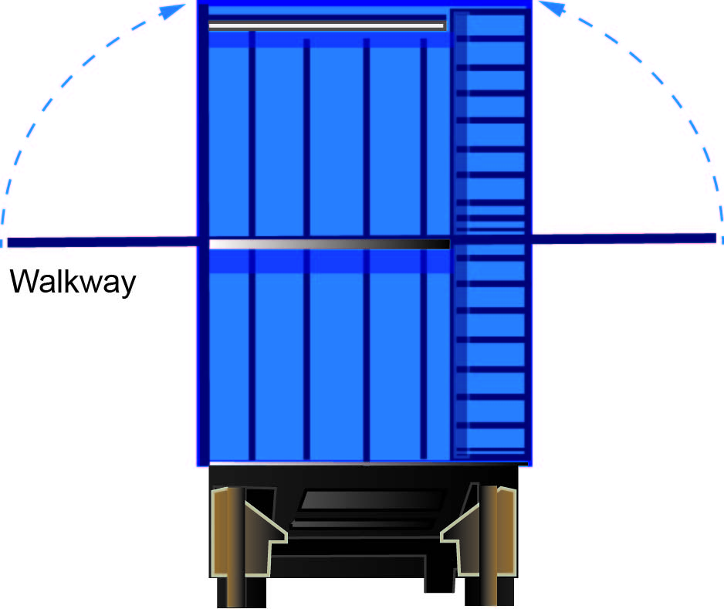

New vehicles, crates and trailers
This applies to the purchase of new trucks, crates or trailers. Similar to the above, new designs must align with animal welfare requirements, Australian Design Rules and relevant state and territory regulations.
With those requirements in mind, the two primary issues that should be addressed through the design process are to eliminate the need for livestock handlers to:
- directly interact with cattle in the same space, and
- work at height.
If this is not possible then these hazards should be minimised, so far as reasonably practicable.
Ground-based methods and design should be focused on livestock handlers not having to interact with animals in close quarters. Ground-based design eliminates the need for livestock handlers to work at height.
Where eliminating the direct interaction with animals and working at height is not possible, livestock handlers should minimise how often and for how long they are required to do this work and are protected while doing so. This may involve remote or externally operated gates and internal ramps.
Consideration should also be given to existing trailers (if any) that a new trailer will be put in combination with to ensure risks associated with a mismatched trailer set are eliminated or minimised e.g. ensuring an A-trailer is compatible with a B-trailer in a B-double combination.

people at increased risk of harm
This chapter provides information on the issues associated with people at increased risk of harm from cattle handling.
Cattle are large, strong and fast animals that can react unpredictably when provoked, stressed or spooked. Cattle handling requires a livestock handler to have a level of skill, speed, strength and fitness. The following people may be at increased risk of harm from cattle handling:

Children
Table 4 Hazards, risks and controls associated with children in the workplace
Hazards and risks | Control measures
Children do not have the physical stature, speed, confidence or experience to handle cattle. | - Ensure children have PPE, like solid footwear.  - Match work tasks with the child’s capacity, which may change over time as they grow and mature.  - Demonstrate and provide instruction to children including the opportunity for children to make mistakes but ensuring the mistakes do not place them in harm’s way.  - Identify and prevent child entry to off limit areas, like water troughs, water tanks, dams, chemical and veterinary medicine storage areas.  - Supervise children at all times.

Visitors
Table 5 Hazards, risks and controls associated with visitors in the workplace
Hazards and risks | Control measures
Visitors may not have the skills or ‘livestock sense’ to be in close proximity to cattle. | - Complete a property induction so visitors know relevant procedures, emergency response and facility layout.  - Ensure visitors have PPE like solid footwear.  - Match work tasks with visitor’s capacity.  - Provide signage and designate visitor areas.  - Demonstrate and provide instruction to visitors.  - Supervise visitors at all times.

Contractors
Table 6 Hazards, risks and controls associated with contractors in the workplace
Hazards and risks | Control measures
Contractors, like veterinarians and cattle transporters, may be inexperienced with a particular mob of cattle, cattle handling techniques, the facilities, be under time pressure or a combination of these. | - Complete a property induction so contractors know relevant procedures, emergency response and facility layout including location of hazards like overhead electric lines and electric fences.  - Ensure livestock handlers, the facilities and animals are organised for the contractor.  - Outline what each livestock handler and contractor will do and be responsible for.  - Review the operation and implementing new controls should hazards arise.

Older livestock handlers and livestock handlers with a disability
Table 7 Hazards, risks and controls associated with older livestock handlers and livestock handlers with a disability
Hazards and risks | Control measures
Older livestock handlers and livestock handlers with a disability may have reduced reaction speed, fitness and strength. | - Ensure all gates latch and swing easily, in yards, laneways and paddocks.  - Create more access and escape points in the yards so livestock handlers do not have to move far to escape or access animals.  - Match work tasks with livestock handler’s capacity including work hours and fatigue levels.  - Incorporate more aid devices into yards and operations e.g. handrails, steps and wheels on heavy items.

Livestock handlers with literacy issues
Table 8 Hazards, risks and controls associated with livestock handlers with literacy issues
Hazards and risks | Control measures
Livestock handlers whose first language is not English or who have low literacy levels may have reduced ability to understand verbal and written instructions provided in English. | - Use illustrations in signs and instruction manuals rather than text to communicate with livestock handlers.  - Train livestock handlers using videos and physical demonstrations, rather than verbal instruction.  - Match work tasks with livestock handler’s capacity e.g. instructions on a veterinary medicine product, for example vaccine may only be in English and a translated text is not available. In these circumstances it may be better to task an English speaking livestock handler with vaccinating the animals, while a non-English speaker brings the cattle to the crush.

cattle husbandry activities and occupational disease
To maintain a healthy cattle herd, livestock handlers should regularly carry out animal husbandry activities. While these activities can themselves present hazards to livestock handlers, people may also be faced with the risk of occupational disease when working with cattle and steps should be taken to minimise this risk.

Cattle husbandry activities
Livestock handlers carry out a range of husbandry tasks. Common tasks include drenching, vaccinating, castration, pregnancy testing, artificial insemination, pulling calves, assisting with difficult births and dehorning.
Due to the continuing advances in veterinary medicine, this section does not provide comprehensive instructions on the proper techniques for these tasks. Instead, livestock handlers should seek advice from veterinarians, animal health agencies and rural supply stockists about methods and medicines.
The following controls may be used to minimise the risk of carrying out these tasks including whether:
- the task needs to be carried out, for example a faecal worm egg count may assist in determining whether drenching needs to occur
- a different operation can be carried out that minimises the risk of injury, for example pour-on or backline drenches are available that can substitute for oral drenching of cattle—this method removes the hazard of a livestock handler being in close proximity to the animal’s mouth and head
- carrying out the task in a different way that minimises the risk of injury, for example whether a safety injector is appropriate to vaccinate cattle to prevent the risk of self-injection without the risk of bruising the animal or causing it stress or discomfort
- the operation can be carried out more efficiently and safely, for example whether training is available to improve the skills of livestock handlers or if a veterinarian is better equipped to carry out the tasks, and
- there is PPE available to help protect livestock handlers perform tasks, for example wearing arm length gloves during manual pregnancy checking and calf birthing.

Occupational disease
Cattle handling can lead to circumstances where the risk of occupational disease is increased.

Zoonoses
Zoonoses are diseases transmitted from animals to humans and are a risk when handling cattle. They include for example Q fever, leptospirosis and anthrax. These diseases are transmitted through contact with blood, saliva and urine and in the case of Q fever also through the air. A vaccine is available for Q fever and it is recommended workers who may be exposed be immunised. Livestock handlers handling cattle should also maintain their hygiene and use PPE like gloves. Further information on zoonoses is available from public and animal health authorities.

Sun exposure
Due to working outdoors livestock handlers may be at an increased risk of sun exposure leading to diseases and conditions like skin cancer and eye damage. Livestock handlers should eliminate or minimise their sun exposure by covering up with long sleeve shirts, long pants, sunglasses and broad brimmed hats. Livestock handlers can also minimise sun exposure by planning cattle handling activities for when the risk of UV exposure is lower, for example avoiding the middle of the day. Shade trees can be planted and shade structures can be built in the yards.

Noise
Livestock handlers may also be exposed to excessive noise, which may lead to noise-induced hearing loss. For example, drafting weaners from cows who will then bellow for two to three days. Livestock handlers should identify where the sources of noise are coming from and seek to eliminate them, which may involve modifying the task being carried out. If eliminating the noise source is not possible, livestock handlers should use the hierarchy of risk controls to minimise risks so far as reasonably practicable. Further information on how noise affects hearing, how to identify and assess exposure to noise and how to control health and safety risks arising from hazardous noise is in the Code of Practice: Managing Noise and Preventing Hearing Loss at Work.

Chemical exposure
Livestock handlers may also deal with veterinary medicines and chemicals. These can be carcinogenic and may create other health issues for livestock handlers. Directions on the medicine label and safety data sheet should be followed and necessary control measures actioned.

emergency plan
An emergency plan must be prepared and maintained so it remains effective for the workplace. The emergency plan should provide for emergency response, evacuation procedures, medical treatment and assistance and communication with emergency service organisations and others at the workplace. For example, emergency contact numbers should be displayed where they can be easily seen.
Livestock handlers must be provided with information and training on the emergency procedures for the workplace and the procedures must be tested.
Responses to an emergency should be coordinated. For example, livestock transport providers should consult with emergency services, veterinarians, government agencies responsible for roadways and other relevant bodies when developing an emergency plan for a livestock truck incident.
Emergency arrangements should also be developed for other cattle handling tasks like:
- mustering
- yard work
- working alone, and
- working in remote locations.
Further information is in the:
Fact Sheet: Emergency Plans, and
Code of Practice: Managing the work environment and facilities.

appendix 1 – Cattle yard design safety checklist
Design Feature | Yes | No
Are receiving yards big enough for expected mob sizes?
Are there blind spots in the yards which could cause livestock to baulk?
Are gates in working order, swing clear of the ground and able to be secured while both open and closed?
Are gate latches in working order, mounted at an appropriate height and designed so they do not cause pinching or crushing?
Are there projecting bolts, nails or wire that could cause injury to livestock handlers or livestock?
Are there uneven or boggy areas that could cause slips or trips?
Are there escape routes or safe areas for livestock handlers in the drafting and forcing yards?
Does the gate into the round yard / forcing pens swing easily and can be secured quickly?
Is the yard an appropriate size for the classes of livestock being handled?
Are the race and gate caps secure and at a safe working height so as not to interfere with handling operations?
Are sliding gates sound, easily operated and capable of being secured so that they will not open if kicked or struck?
Do sliding gates have handles and guards to prevent the livestock handler’s hand entering gaps between the slide gates and support posts, which could be nip or crush points?
Are there excessive gaps between the slide gates and support posts which could be crush points?
Is there safe access to the work area to remove animals that might go down or become jammed?
Are watering points and troughs in working order and positioned where they do not pose a trip, slip or fall hazard to livestock handlers and animals?
Are there options for dust control including water for sprinkler or irrigation systems?
Are water pipes buried, placed overhead or along railing systems so as not to create a trip or head hazard?
Are there lighting issues which need to be addressed by artificial lighting?

appendix 2 – Cattle crush and calf cradle checklist
Cattle crushes and calf cradles are used for animal husbandry tasks. The following features should be considered when choosing or building a crush or cradle.

Cattle crush
A cattle crush should have:
- access gates on both sides
- slam-shut gates or catches
- no overhead protrusions like those on sliding gates or bail closing mechanisms
- rear head bail operation
- safety locks on the bail release
- easy, quick and quiet operation
- a positive head bail locking system capable of being operated with one hand only
- no sharp edges, protruding catches, bolts or wire
- slide through hock bar or backing bar
- side squeeze facility for safer cattle control
- split side opening access gates preferably with catch at rear
- lower side panels closed in to avoid kicks and animal legs getting caught between rails
- ease of maintenance with greasing points
- a crush exit designed to allow processed animals to be separated from the work area
- crush gates, bail and latches free of nip or crush points
- a design allowing for a safe and easy release operation should an animal go down
- solid and secure anchorage points preferably set in concrete
- gates and head bails that operate effectively in capturing and securing livestock and do not fly open when kicked or struck, and
- equipment that has the proven ability to effectively restrain the classes of cattle being handled.

Calf cradle
A calf cradle should:
- have construction for the type and size of calves likely to be handled
- have no obstructions, nip or crush points
- be effective, simple to operate and relatively quiet—the cradle should present the calf at a level that minimises the amount of bending and forward reaching by the livestock handler—as well as securing the animal to minimise the potential of being kicked or struck, and
- have a working area free of slip and tripping hazards, separate from other animals and with sufficient space for equipment and people.

appendix 3 – Loading ramp checklist
Cattle loading ramps are used to load and unload cattle from trucks, trains, ships and aircraft. When choosing or building a loading ramp for trucks the features below should be considered. These features can also be adapted for ramps for trains, ships and aircraft.
Further information can be found in the Australian Livestock and Rural Transporters Association Guide for safe design of livestock loading ramps and forcing yards.

Loading ramp features
A loading ramp design should include:
- solid construction and anchorage to prevent movement from trucks or cattle
- no projections, slipping, tripping or falling hazards
- no blind spots or areas where livestock flow is restricted or cattle may baulk
- sliding ramp gates that are secure when open or shut and that slide easily with no hand pinch points
- handles and guards on sliding gates to help stop operators’ hands entering gaps between the slide gates and support posts
- race and ramp height and width that is suitable for the type of livestock being handled—the recommended internal width of a cattle loading ramp is 800 mm
- race and ramp sides covered in to reduce baulking
- a platform on the ramp of 1-1.5 metres to allow for the safe opening and closing of truck sliding gates including an access gate at the top of ramp
- a catwalk of 620 mm minimum width with a non-slip surface and handrail that complies with AS1657
- a secure race ties above head height
- a sliding gate at the top of the ramp that can be accessed safely to secure cattle on the truck once it is loaded
- fail safe safety systems for lowering and raising ramps including safety bars
- consideration of a separate, wider ramp to unload cattle i.e. a ‘dump ramp’ depending on the volume of cattle that are unloaded—this ramp should only be used for unloading and not loading, and
- bollards and signage to protect power installations, equipment or sheds from vehicles.
Large commercial facilities should consider the use of side loading platforms and overhead gantries.

Locating the loading ramp
When selecting a location for the loading ramp consider:
- locating the loading ramp well clear of electric lines
- ensuring its location is suitable for receiving the largest truck likely to attend the facility
- locating the loading ramp to take advantage of existing lighting if loading or working at night
- the loading race and truck entry to the ramp are even from one side to the other—the truck reversing to the ramp is easier if the ground level is made slightly downhill to the ramp, and
- locating the loading ramp so truck drivers do not have to reverse with the sun in their mirrors or have their vision obscured by shadows.

National Health and Medical Research Council

