Guide to managing the risks of slips, trips and falls
Guidance material

September 2026

Disclaimer
Safe Work Australia is a national policy body representing the interests of the Commonwealth, states and territories, as well as workers and employers to improve work health and safety and workers’ compensation arrangements. Safe Work Australia does not regulate WHS laws or administer workers' compensation arrangements.
Safe Work Australia is providing this information to help all duty holders in a workplace manage risks to health and safety which relate to slips, trips and falls from a height of 2 metres or less.
The information in this guide is provided as general information only. It does not constitute and should not be relied on as legal, business, health, or financial advice. You should obtain independent professional advice relevant to your circumstances.
Safe Work Australia has used its best endeavours to ensure the quality of the information in this document but cannot guarantee its accuracy or completeness.
Neither Safe Work Australia, nor the Commonwealth of Australia will accept liability for any direct, incidental, or consequential loss or damage resulting from this guide, or the information provided through this guide.
Creative Commons
With the exception of the Safe Work Australia logo, this copyright work is licensed under a Creative Commons Attribution 4.0 International licence. To view a copy of this licence, visit creativecommons.org/licenses In essence, you are free to copy, communicate and adapt the work, even commercially, as long as you attribute the work to Safe Work Australia and abide by the other licence terms.
Contact information
Safe Work Australia | info@swa.gov.au | www.swa.gov.au

CONTENTS
1. Introduction 4
1.1 What are slips, trips and falls? 4
1.2 Who should use this guide? 5
1.3 How to use this guide 5
1.4 Ways to control risk 6
2. Good work design and planning principles 8
3. Hazards and risks 9
3.1 Floors and surfaces 9
3.2 Outdoor and extreme environments 12
3.3 Ramps and stairs 13
3.4 Lighting 15
3.5 Furniture 19
3.6 Ladders 19
3.7 High job demands and psychosocial hazards 20
4. Combining control measures 22
5. Reporting, notifying and reviewing 24
6. Checklist 26
7. Further resources 31
8. Glossary 33

    - Introduction
This is a guide to identifying hazards and managing the risks of slips, trips and falls in the workplace. Hazards are things and situations that could harm a person. Risks are the possibility that a person could be harmed because of a hazard. Slips, trips and falls are a major cause of workplace injuries and death, both indoors and outdoors. Slips, trips and falls can result in secondary injuries (e.g. hitting hot, hard or sharp objects) and serious injuries can still occur even if there is no fall.
Slips, trips and falls are described below. These descriptions are provided to help explain the terms used in this Guide and are not definitions under the model work health and safety (WHS) laws.
      - What are slips, trips and falls?
 | Description
Slips | when a person’s foot loses traction with the ground, leading to loss of balance.
Trips | when a person unexpectedly catches their foot on an object or surface.
Falls | occur when a person descends to the ground or a lower level without control. Falls can occur:  - as a result of slips and trips  - into holes, voids or water  - at level  - from any height, including even small distances (e.g. from one stair to a lower stair, or from a kerb to the ground).
This guide does not cover situations where there is a risk of a person falling more than 2 metres. Those kinds of falls are treated differently under WHS laws, depending on the jurisdiction and the industry. For more information, consider jurisdictional resources in the Further resources in this guide.

      - Who should use this guide?
All duty holders in a workplace can use this guide to manage risks to health and safety in relation to slips, trips and falls. A person must manage WHS risks if they are:
- a person conducting a business or undertaking (PCBU)
- a person with management or control of a workplace, or how work is carried out, for example a foreman or lead hand
- a designer, manufacturer, importer, supplier or installer
- an “officer” of the PCBU, for example a company director.
Workers and others (such as visitors) also hold WHS duties. For example, they have a duty to take reasonable care for their own health and safety at the workplace.
More than one person can have the same duty at the same time. For example, all the workers at a factory have the same WHS duties. In addition, a person can have more than one duty at the same time. For example, if a person who designed the layout of the factory floor also works in the factory, they are a duty holder for both roles.
      - How to use this guide
This guide describes what a duty holder must and should do to manage the risks of slips, trips and falls.
In this guide, the word ‘must’ indicates a legal requirement that must be complied with.
The word ‘should’ indicates a recommended course of action.
Some phrases have a specific meaning in WHS. If they are in bold, it means you can find an explanation in the Glossary.
Chapter 1 and Chapter 2 of this guide explain the fundamentals behind WHS and how risks can be controlled generally.
Chapter 3 describes hazards for slips, trips and falls, and ways to control the risks for those hazards. This is organised into sections by the source of the hazard. For example, if your workplace uses ladders, you can save time and skip straight to 3.6, the Ladders section.
There is a checklist at the end to help identify common hazards and next steps, but it is not meant to be a complete list. Industry standards, legislative requirements and guidelines may apply. More information can be found in the Further resources section.
Duty holders must take reasonably practicable steps to protect health and safety in the workplace. Put simply, reasonably practicable means that what can be done should be done, unless it is reasonable in the circumstances for the duty holder to do something less. Reasonably practicable is an important concept in WHS and this guide will mention it several times. See the Interpretive guideline - the meaning of reasonably practicable for more information.
      - Ways to control risk
Ways to manage risks are called ‘control measures.’ The control measures needed will depend on your workplace, even if the hazard is the same.
When you identify a hazard, a risk assessment can help work out what could happen if someone is exposed to the hazard and what control measures should be used, including:
- how serious a risk is
- if current control measures are working
- what action is needed to control the risk
- how urgently action should be taken
You can also use a risk assessment to help review control measures to make sure they work as planned.
Hierarchy of control measures
The ways of controlling risks are ranked from the highest level of protection and reliability to the lowest. This ranking is known as the hierarchy of control measures. It will help you to think about why a risk exists in the first place and consider whether you can redesign a given task to make work safer. It will also help you select the most appropriate control measure, or combination of control measures for the risk.
You must always aim to eliminate the risk, which is the most effective control. If this is not reasonably practicable, you must minimise the risk by working through the other alternatives in the hierarchy.
The hierarchy of control measures, in order, are:
- Elimination
- Substitution
- Isolation
- Engineering
- Administrative
- Personal protective equipment
The hierarchy of control measures can be applied to any risk, not just risk of slips, trips or falls. See the model Code of Practice: How to manage work health and safety risks for more detailed information. Examples of control measures are provided throughout this guide.
Elimination
Elimination is the most effective control measure. Removing the hazard removes the risk around it. This is easiest to do when a workplace is being designed.
For example, having everything on the same floor eliminates the need to have stairs, which means there is no risk of falling down stairs.
Substitution
Substituting the hazard for something safer can be an effective control measure.
For example, replacing slippery flooring with a slip-resistant surface.
Isolation
Isolation involves physically separating the source of harm from people by distance or barriers. For example, putting caution tape around a slippery surface to prevent people walking on it.
Engineering control measures
An engineering control measure is physical in nature, such as using a mechanical device or process. For example, marking the edge of a step with a high contrast colour and different texture to the rest of the step (e.g. a strip of rougher slip-resistant material which is high visibility yellow).
Administrative control measures
If there is still a risk after you have applied all reasonably practicable elimination, substitution, isolation and engineering control measures, apply administrative control measures such as:
- scheduling good housekeeping (e.g. keeping accessways clear)
- having clear policies for immediate clean-up
- providing information, training and instruction on methods and procedures for dealing with hazards.
Administrative control measures should only be used after other types of higher control measures because administrative control measures rely on an individual’s behaviour and supervision, and do not control the hazard at the source, so they are less effective.
Personal Protective Equipment
If all the other control measures have been applied and there are still risks, use personal protective equipment (PPE). PPE is the least effective control measure, because it does not control the hazard itself.
Under the model WHS regulations, the PCBU must ensure workers are provided with suitable PPE if it is used to minimise a risk to health and safety in the workplace. PPE needs to be suitable for controlling that particular risk and be maintained, repaired and replaced when necessary. The PPE needs to fit correctly and be in good condition to be effective. For example, shoes with special grip need to be the right size and replaced when the tread gets too worn down.
Sometimes, if a PCBU and a worker agree, a PCBU may pay for a worker to buy their own PPE instead of giving it to them. For example, it is common for a PCBU in the construction industry to provide a worker with a stipend to buy steel-capped boots, so that the worker can choose the boots which are most suitable for them and meet the relevant requirements.
Even if a PCBU pays for a worker to purchase their own PPE, or if PPE was provided by another PCBU (e.g. a labour hire company), the PCBU where the worker uses the PPE must ensure it is the right size and fit, is comfortable, protects the person wearing or using it from the hazard, and ensure the worker has information on how to use and maintain it.
See Overview - Personal protective equipment (PPE) for more information on PCBU and worker duties regarding PPE.
    - Good work design and planning principles
The most effective way to control risk is to start identifying hazards and assessing risks before the work starts, and by following good work design and planning principles.
Good work design and planning are very effective at eliminating and minimising risks because early stages present the most opportunities to “design-out” hazards and “design-in” control measures. For example, designing the layout of the workplace to be on one floor would eliminate the need for stairs, and would prevent workers from being exposed to hazards associated with stairs.
Things to consider include:
- type of work activities
- physical environment of the workplace
- systems and processes for how the work is done
- workers’ capacity (what they can do and how much of it), and
- workers’ needs (e.g. access to toilets).
For more information on good work design and planning see the handbook: Principles of Good Work Design.

    - Hazards and risks
Hazards often appear together. For example, if your workplace has an outdoor staircase, you will need control measures for both stairs and the outdoor environment (such as rain that may introduce a slip hazard).
      - Floors and surfaces
Floors should be appropriate for all expected work activities and conditions, and be regularly inspected and maintained to eliminate or minimise slip, trip and fall risks.
Designing the floor
- Even and level flooring is essential for safe work. Minimise any changes in the floor level. If changes are necessary, use ramps rather than steps when connecting pedestrian pathways.
- Ensure ramp slope is not too steep and meets the relevant standards, such as Australian Standard AS 1428.1: Design for access and mobility.
- Floors should have adequate grip, especially in areas likely to become wet or contaminated. Use slip-resistant floor tiles or surface treatments to improve slip resistance where required.
- Avoid sudden transitions in floor surface texture where possible. Where transitions cannot be avoided, ensure adequate lighting and changes in floor levels are clearly differentiated using contrasting colours or other visual cues to highlight the change.
- Avoid carpet in areas where:
- the carpet makes it difficult to push equipment, and
- wheelchairs or other wheeled equipment are used.
- Avoid using unsecured carpets or floor mats unless they can be fixed in place.
- Provide means of containing and draining fluids at machines or processes.
- Locate drains as close as possible to any source of water or liquid that is frequently generated.
- Use floor grates where work tasks generate substantial amounts of liquid.
- Ensure grates in walkways and aisles are slip resistant.
Measuring slip resistance
Meeting and maintaining the minimum slip resistance thresholds outlined in the relevant Australian Standards and the National Construction Code are essential when selecting flooring or surface treatments (see the Further resources section for more information). Regular monitoring of slip resistance should be conducted.

The slip resistance needed for a floor to be safe is influenced by additional factors including:
- the slope of the floor
- potential contamination
- the cleaning process, including chemicals and methods used
- who is walking in the area, and their footwear
- the activities workers are performing, and
- environmental conditions such as humidity or temperature.
These factors can combine and worsen how slippery a surface is.
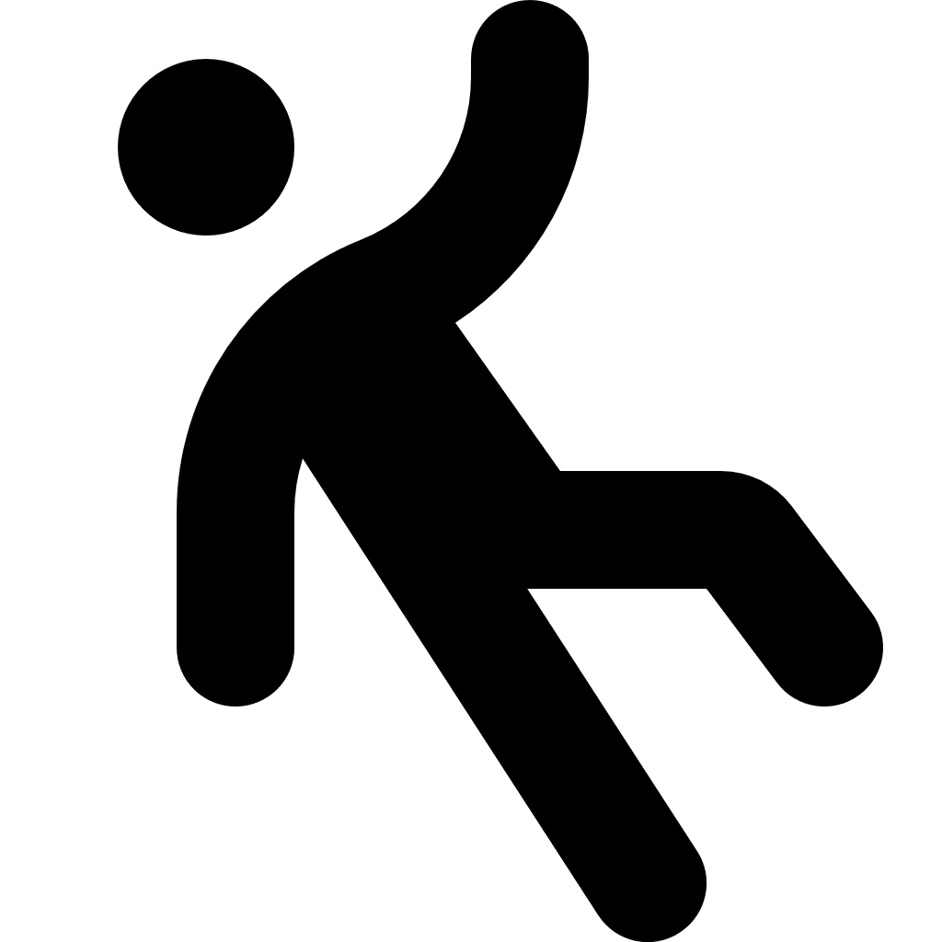
Reports from workers and others who notice slippery areas can help identify where risk assessment might be needed. Noticing that a surface is slippery is subjective. Using instruments to test and measure slipperiness is objective. If a formal assessment needs to be done, for example if someone has suffered a serious injury, the assessment needs to be objective. Further information on objectively measuring slipperiness is at AS/NZ 4663:2013: Slip resistance measurement of existing pedestrian surfaces.
Choosing floor coverings
When selecting floor coverings for the workplace, consider:
- Foot traffic: How much foot traffic will the surface experience?
- Slip resistance: Does the flooring provide sufficient grip when dry?
- Performance when wet: Does the surface remain safe when walked on in wet conditions?
- Work activities: Do the tasks carried out require a surface with appropriate friction (e.g. carpet may be unsuitable where workers push heavy trolleys or equipment)?
- Cleaning requirements: How will the surface be cleaned and how often?
Slip resistance should be maintained using appropriate cleaning methods. Some methods may unintentionally increase slip risks (e.g. detergent residue build-up may unintentionally reduce grip).
Common causes of existing flooring providing inadequate grip include:
- wear and tear, damage or contamination, particularly in high-traffic areas
- flooring no longer being used for its intended purpose, and
- inadequate or poor cleaning, including failure to perform periodic deep cleaning to restore grip.
Treatments to improve grip or slip resistance
Localised areas of flooring may lose their grip faster than the surrounding floor. These changes may be hard to see and unexpected, which may cause slips. When using slip-resistant treatments, you should aim for the localised area to be the same as the surrounding floor, so that there will be a consistent level of grip when walking over the whole surface.
Treatment options for improving the grip of existing flooring depend on:
- the expected use of the area
- the size of the area, and
- the type of flooring.
Surface treatments can have different cleaning requirements from the original flooring, which makes regular monitoring more important if you have only treated a localised area. Some treatments wear down and may need to be reapplied periodically. Treatments may also affect how long the flooring lasts or how well it meets other safety requirements (e.g. for food safety or infection control).
Case study
A community support worker visits a client recovering from hip surgery at their home. While walking down the hallway, the worker trips on the raised edge of some carpet but manages to regain her balance. As she moves between the rooms, she notices the floor has loose rugs and long cords from heaters, which she did not see at first due to poor lighting. In the kitchen, a small water spill from the sink has made the tiles slippery.
Slips often occur on wet floors or flooring that moves in an unpredictable way, and trips commonly result from unseen obstacles. The support worker recognises that the raised edge of the carpet, loose rugs, and spill from the sink are slip, trip and fall hazards that could cause serious injury to her or the client.
The support worker consults with the client about what they can change in their home to introduce suitable control measures. She removes the loose rugs so that anti-slip pads with high grip surfaces can be fixed to the bottom, repositions the electrical cords away from walking paths, and wipes up the spill in the kitchen. She also opens curtains near the entrance to let in more light so that it is easier to see her surroundings.
At the end of the visit, the worker reports the hazards to her employer. The employer reviews its hazard and incident reports and identifies a pattern where hazards emerge between visits.
The employer introduces a detailed home safety checklist for support workers to use at the start of every visit. It focuses on identifying and controlling slip, trip and fall hazards, since their clients are often people who need a community support worker because they have limited mobility. Copies are also given to the clients for them to use if they wish.
By proactively identifying risks and applying practical control measures, the employer reduces the likelihood of serious injury and creates safer environments for workers and clients.

      - Outdoor and extreme environments
Some workplaces are more likely to have higher risk for slips, trips and falls.
For example, if a workplace is outdoors or has extreme environmental conditions, or both (e.g. icy outdoor footpaths).
Outdoor areas
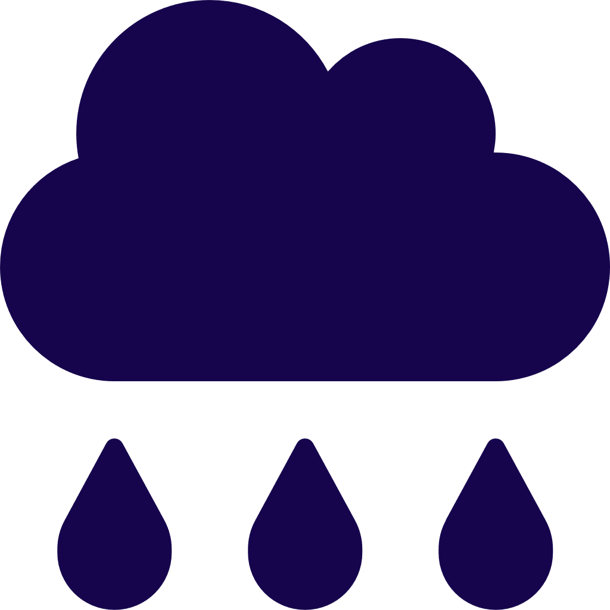
Outdoor areas can be affected by rain, mud, wind, vegetation, drainage, watering systems and vehicles. There may also be lower light levels than indoors, which can further increase the risk of slips, trips and falls.
Control measures for slip, trip and fall risks in outdoor areas include:
- providing and maintaining designated outdoor paths for commonly used access routes
- improving drainage in areas where water pools
- using non-slip surface treatments on slippery walking surfaces
- installing suitable lighting for areas accessed outside daylight hours
- selecting plants and trees that do not drop hazards such as seeds or sap on to pathways
- regularly trimming trees, hedges and other vegetation to maintain a clear path, reduce debris, and prevent overhanging branches from obscuring visibility or causing distraction
- planning for extra spot checks for fallen branches, seeds or sap if your local weather is often windy or rainy
- implementing a cleaning program to ensure outdoor areas are cleaned regularly, and
- scheduling watering systems to operate outside periods of high foot traffic.
If these are not possible to implement, block access and provide an alternative safe walking route.
Extreme environmental conditions
Workplaces with extreme environmental conditions have a higher risk for slips, trips and falls, for example:
- freezers and cold rooms
- areas with ice, water or condensation, and
- high-humidity environments such as kitchens, laundries or indoor pools.
Ways to control risk in these locations include:
- designing work areas with higher risk in mind, for example by including handrails even on flat ground if it is often slippery
- preventing or reducing humidity where possible
- maintaining plant and equipment to prevent leaks (e.g. checking seals), and
- removing ice or water build-up promptly.

      - Ramps and stairs
There is a higher risk of slips, trips and falls when using stairs or ramps because a person will usually need more concentration and physical energy to use them safely, compared to flat surfaces. The advice in section 3.1: ‘Floors and surfaces’ should be considered together with the advice on stairs and ramps below.
When designing ramps or stairs, you must consult the National Construction Code and relevant Australian Standards to ensure you meet the requirements that apply to your workplace. See the Further resources section for more information.
Ramps
Control measures for ramps include:
- An appropriate slope for the work (e.g. shallow enough to safely transport loads) which meets the relevant standards, such as Australian Standard AS 1428.1:2009: Design for access and mobility
- slope which is consistent for the whole length of the ramp as much as possible, to minimise sudden changes, especially at the entry and exit
- wide enough for the workplace requirements (e.g. if workers frequently use large trolleys)
- any corners are not too sharp, so that a person has enough room to turn safely into the entry, out of the exit, and around any other corners without getting stuck (e.g. when using long trolleys or mobility devices)
- advance warning of any changes in how steep or wide the ramp is
- contrasting colours and/or textures at the entry and exit
- enough lighting to see edges, especially on any open sides
- appropriate level and type of lighting if the area needs to be dim (e.g. cinemas, and some health care settings where patients are sleeping)
- handrails on at least one side
- upper and lower handrails on any open side (i.e. where there is a drop from the side of the ramp to the ground)
- extending handrails past the exit of the ramp onto flat ground
- floor surface with good grip.
Case study
A restaurant has a ramp connecting the outdoor courtyard to the indoor dining area. The ramp is frequently used by both staff and customers.
During a rainy day, the ramp became slippery. A staff member who was pushing a cart of food up the ramp briefly lost traction. The ramp had appropriate handrails and although the staff member felt at risk of losing control, no injury occurred.
The staff member immediately reported the hazard to their supervisor, and it was recorded in the restaurant’s incident and hazard reporting system.
The rain continued, so a cordon was put up to prevent any staff or customers from using the ramp and ‘wet floor’ signs were also put at the entry and exit.
After the rain cleared, as soon as it was reasonably practicable, a slip-resistant coating was applied to the ramp’s surface. The restaurant’s manager also organised an assessment of the gutters and grates to make sure there was enough drainage to prevent the outside floor surfaces from collecting too much water when it rained in future.
The ramp surface and surrounding drainage are checked whenever rain is forecast, as well as being added to the checklist that restaurant staff use when conducting regular safety inspections. In addition, staff make sure to pay attention to anywhere the slip-resistant coating may have started to wear away, as this could create a new hazard.
Stairs
Many control measures for ramps can be applied to stairs, along with the extra measures specific to stairs. This guide describes stairs in terms of multiple “steps”. The parts of a staircase are illustrated below.
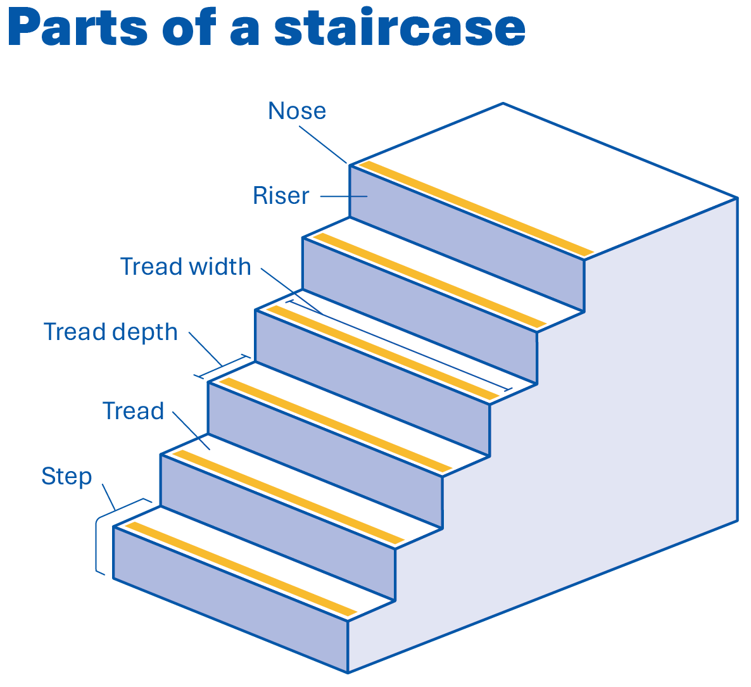
Control measures for stairs include:
- tread is deep enough, and the same depth from one step to the next
- risers are high enough, and a consistent height from one step to the next
- contrasting colours for the edges of steps (e.g. the walking surface of the tread contrasts with the step nose) and entry and exit of the staircase
- staircase slope is at a degree appropriate for the work (e.g. stairs are shallow enough to see the whole staircase, including when required to carry a load)
- slope is consistent for the whole length of the stairs, as much as possible, to minimise sudden changes, especially at the entry and exit
- wide enough for the workplace (e.g. if workers carry wide trays of food)
- any corners are not too sharp, to make sure a person has enough room to turn safely into the entry, out of the exit, and around any other corners with sufficient visibility (e.g. if workers will pass each other carrying wide loads which prevent them from being able to see the whole staircase)
- advance warning of any changes in how steep or how wide the stairs are
- enough lighting to see edges, especially on any open sides
- appropriate level and type of lighting if the area needs to be dim (e.g. cinemas, some health care settings)
- handrail on at least one side and any open sides
- upper and lower handrails on any open side (i.e. where there is a drop from the side of the staircase to the ground)
- extra handrails in the centre if the staircase is very wide
- handrails that extend past the exit of the staircase onto the flat ground
- floor surface with good grip.
      - Lighting
Slip, trip and fall risks are greater when they are unexpected and cannot be easily seen (e.g. it is too dark) or blend into the surroundings (e.g. holes concealed by shadows, or surfaces that look continuous but are not). Lighting for work areas should provide sufficient visibility to avoid hazards and reduce slip, trip and fall risks. In most cases, this will mean ensuring the workplace is well-lit. All areas of the workplace (including private homes if that is where the work occurs) should be appropriately lit.
In locations where lower lighting levels are required (e.g. to reduce stimulus that may cause agitation, or where patients or clients are sleeping), lighting must still be adequate to protect against risks such as trips or collisions.
Adequate lighting must be provided to enable people to work safely, move safely, and safely evacuate in an emergency.

Common visibility issues contributing to increased slip, trip and fall risks include:
- low or excessive light levels
- dark shadows
- changes in lighting (e.g. moving from bright outdoor light to a dark stairwell)
- substantial dust or particles in the air, and
- glare or reflections.
Lighting levels
Suitable lighting provides an even distribution of adequate light within and between areas with minimal glare, shadows or reflections.
Ways to control lighting risks by providing and maintaining suitable light levels include:
- providing at least 100 lux (so far as reasonably practicable) in areas such as corridors, walkways, staircases and lifts
- providing even lighting levels that are appropriate for the work area and activities being performed
- providing appropriate outdoor lighting so workers to move safely on outdoor paths, around outdoor work areas, and in car parks when light levels are low
- adjusting the operating hours of outdoor lighting to reflect seasonal changes and daylight savings
- ensuring emergency lighting is provided to enable the safe evacuation of people during an emergency
- providing additional lighting at locations with increased risk, such as crossing points on traffic routes
- adjusting lighting in transition areas (e.g. when moving from a bright outside area to a darker stairwell) by providing higher lighting levels in the stairwell to minimise contrast
- replacing bulbs as soon as they dim or flicker, or implementing a replacement program so bulbs are renewed before expected failure, and
- regularly cleaning light fixtures to minimise dust and dirt buildup.


Extra lighting
Ways to provide extra lighting include:
- adding or repositioning light fixtures
- painting walls and ceilings in white or other light colours to improve reflectance
- installations that bring natural light into the space, such as skylights or windows
- using lights with movement sensors if people will only be in the area some of the time or when there is low light
- using wireless, solar or battery powered lighting for areas where installing electrical lighting is difficult, and
- ensuring internal and external stairways are well lit.
Glare and reflection
Ways of controlling lighting risks associated with glare and reflection include:
- using window coverings to reduce incoming light and minimise outdoor glare
- replacing large, high-intensity light fixtures with multiple low-intensity fixtures
- installing diffuse light fittings that spread light evenly across wider areas
- using suitable coverings for bare bulbs to soften and control light, and
- minimising reflective surfaces by using matte paint or installing floor mats.
Visual contrast
Visual contrast helps workers identify safe stepping points and detect changes in the path of travel. It allows people to recognise hazards early and respond appropriately.
Visual contrast is the difference in lightness or darkness (also known as luminance) rather than colour, that makes objects distinguishable from their backgrounds.
Common examples of where visual contrast may be needed include:
- step nosing (front edge of steps)
- start and end of ramps
- handrails
- edges of loading docks, dock plate and platforms
- transition areas between different walking surfaces, and
- trip hazards such as raised door frames, covers on electrical cords, protruding objects or cracks in walkways.

Ways to provide effective visual contrast include:
- using markings with strong luminance contrast to highlight changes in walking surface (e.g. on step edges and potential trip hazards)
- increasing ambient lighting, especially around entry points
- enhancing the visibility of fluid spills by cordoning off or marking the edges of wet areas, and
- selecting flooring that provides high contrast when wet or when contaminated (e.g. porous flooring which darkens with moisture).
For more information on lighting in the workplace, see the model Code of Practice: Managing the work environment and facilities.
Case study
During a regular WHS inspection, one of the organisation’s Health and Safety Representatives (HSR) consulted workers about any incidents or near misses in the office that may not have been reported.
Workers said that sometimes people nearly collide with each other or trip over low pot plants when entering the meeting room during presentations.
The meeting room needs to be darker during presentations to avoid reflections and glare off the screen, so the PCBU and the WHS team, including the HSR, agreed that it was not reasonably practicable to raise the level of lighting but there must still be enough lighting to enable workers and visitors to move around safely and avoid collisions.
The PCBU introduced several control measures to the meeting room. Extra lighting was added to the edges of the meeting room to help reduce the contrast between the dark meeting room and the brighter areas in the rest of the office, using lamps that could be turned on if there was a presentation. This helped workers’ eyes adjust when entering the meeting room during a presentation. In addition, the low pot plants were replaced with tall pot plants which are easier to see in dim lighting.
When the WHS team followed up to monitor and review the control measures, workers said there were much fewer collisions, trips and near misses.

      - Furniture
Slips, trips and falls can occur when a person moves to avoid furniture, or if the furniture moves in an unexpected way.
Control measures for furniture include:
- ensuring furniture is in stable and good condition (e.g. chairs do not have wobbly legs)
- using anti-slip pads for the feet of furniture on a hard floor (e.g. a stool in a tiled reception area)
- castors with brakes or castor cups on wheeled chairs if used on a hard floor (e.g. office chair on a wooden floor)
- ensure drawers are kept closed when not in use
- provide enough lighting so furniture is clearly visible, especially low furniture (e.g. coffee tables and ottomans)
- ensure furniture does not block walkways and are placed away from emergency exits, swinging doors and blind corners, and
- provide enough room to move between furniture.
Falls can also occur when a person uses furniture to help them reach something instead of using a step stool or ladder.
      - Ladders
Falls from ladders in the workplace often result in serious injuries that may be fatal, even when working at relatively low heights. PCBUs must ensure workers are provided with information and training on how to use ladders safely. Workers should only use a ladder if they have been trained in how to inspect, set up and use ladders correctly. This guide does not cover situations where there is a risk of a person falling more than 2 meters, please see the Further resources section for more information.
Ladders should be:
- suitable for the work to be carried out, including consideration of the duration, physical surroundings and weather conditions
- used in accordance with the manufacturer’s instructions
- set up on a solid and stable surface and prevented from slipping
- regularly inspected by a competent person in accordance with manufacturer instructions
- inspected for visible damage or faults before setting up each time, and
- removed from service if faulty or damaged.
Ladders should have a load rating of at least 120 kg and meet the relevant standards, such as AS 1892.1-2018: Portable ladders.

When using a ladder, workers should:
- always maintain 3 points of contact with the ladder (2 feet and 1 hand, or 2 hands and 1 foot)
- use a tool belt or side pouch instead of carrying materials while climbing
- ensure only light-duty work is carried out from a ladder, where tools can be safely operated with one hand
- ensure only one person is on the ladder at a time
- wear slip-resistant footwear, and
- never straddle the ladder, i.e. sitting or standing in such a way that a person has one leg on either side of the ladder.
It is not safe to use a ladder without additional fall protection equipment if working:
- near the edge of an open floor or beside a railing
- where the worker must overreach
- when using 2 handed tools, especially where high leverage is required.
Additional safety precautions may be required when using a ladder:
- in access areas or doorways (e.g. put up a barrier or lock the door)
- in very wet or windy conditions
- next to traffic areas, unless the working area has barriers around it.
Further information on the safe use of ladders is provided in the model Code of Practice: Managing the risk of falls at workplaces.
      - High job demands and psychosocial hazards
When job demands are very high, long term, or frequent, they may be considered psychosocial hazards. Psychosocial hazards are aspects of work that have the potential to cause physical or psychological harm. They may interact or combine with other hazards to change, increase, or create new risks. For example, time pressure can cause fatigue.
Time pressure is a high job demand which can be linked with an increased risk of slips, trips and falls. Many control measures for time pressure and fatigue are made during the work planning phase and overlap with control measures for other potential hazards (e.g. suitable lighting).
For more information on psychosocial hazards, see the model Code of Practice: Managing psychosocial hazards at work.
Time pressure
Time pressure is more than being ‘fast paced’, it is when there is not enough time to complete the work that needs to be done. Time pressure can lead to a worker feeling rushed and pressured to ‘cut corners’, which can increase the risk of slips, trips and falls. Time pressure can also increase the risk of fatigue.

Some control measures for time pressure include:
- setting realistic deadlines or quotas
- having appropriate staff levels for the workload, taking into account skill and experience as well as number of staff
- assessing workload correctly
- incorporating enough time to support high emotional job demands, if appropriate (e.g. for paramedics, firefighters, police)
- automating some processes
- providing sufficient breaks between and during shifts, and
- assigning work with a mixture of fast and slow pace, and high and low levels of concentration.
Effectively controlling time pressure is not just about having enough time to complete the work, it is having enough time to complete the work safely.
Fatigue
In a work context, fatigue is more than feeling sleepy, tired or drowsy. It is a state of impairment which can be physical, mental, emotional, or a combination.
Fatigue can increase the risk of slips, trips and falls by reducing a person’s ability to:
- identify and react to potential hazards in time
- remember or judge the correct amount of force or distance,
- maintain their balance (e.g. walking on uneven paths or stepping up a kerb), and
- hold or use equipment correctly because of reduced strength or coordination.
Work which is psychologically demanding also increases the risk of fatigue. For example, jobs requiring intense concentration or high mental effort can create a risk of fatigue, even when a worker has slept well and has not worked a long shift.
Some control measures for fatigue include:
- minimising long or irregular hours
- minimising night shifts where reasonably practicable (or other times when workers would normally sleep)
- providing sufficient breaks (between and during shifts)
- providing equipment to help with tasks (e.g. a trolley for handling loads)
- making the environment a comfortable temperature for the work being done
- monitoring for signs of fatigue
- assigning work with a mixture of fast and slow pace, and high and low levels of concentration, and
- using automated systems to prevent fatigue‑related errors.
More information can be found at Managing the risks of fatigue at work.
    - Combining control measures
The table below lists some of the practical control measures for slips, trips and falls that have been covered in the previous chapter. Combining appropriate control measures in the context of work design and planning can reduce the hazards and risks associated with slips, trips and falls.
Control area | Practical control measure
Access and movement | - install level, unobstructed, slip‑resistant surfaces  - ensure ramps and stairs meet relevant standards  - ensure appropriate lighting and avoid abrupt lighting changes  - communicate temporary hazards clearly
Workplace layout | - reduce double handling and unnecessary movement  - separate pedestrian and vehicle routes  - provide clear signage for accessways and storage
Weather and environmental | - use canopies and drainage to reduce contamination risk  - plan for storms, rain, condensation and debris  - provide temporary safe pathways during adverse conditions  - coordinate weather‑affected work with other duty holders
Distraction management | - reduce noise and visual distractions (e.g. flickering lights)  - design workflows that prevent congestion in high‑risk areas  - manage fatigue and time pressures by reviewing schedules and workload
Work demands | - provide adequate time for tasks  - avoid incentives that promote rushing  - engage workers in assessing workload suitability
Maintenance and cleaning | - ensure repairs to flooring, leaks and lighting are prompt  - schedule cleaning during low‑traffic times  - provide spill kits, appropriate cleaning products and clear procedures  - keep walkways and storage areas uncluttered  - conduct regular inspections and encourage hazard reporting
Load handling | - use mechanical aids to reduce physical strain and manual handling  - ensure mechanical aids are appropriate for surface conditions  - avoid workers moving loads over uneven, wet or sloped surfaces
Scheduling | - review work schedules for conflicts to avoid rushing  - coordinate deliveries and operational tasks to avoid congestion  - provide alternate safe routes during temporary obstructions  - prepare contingency plans for delays and weather impacts
The illustration on the next page shows how different control measures can be combined to support good work design and reduce the risk or slips, trips and falls in the workplace.

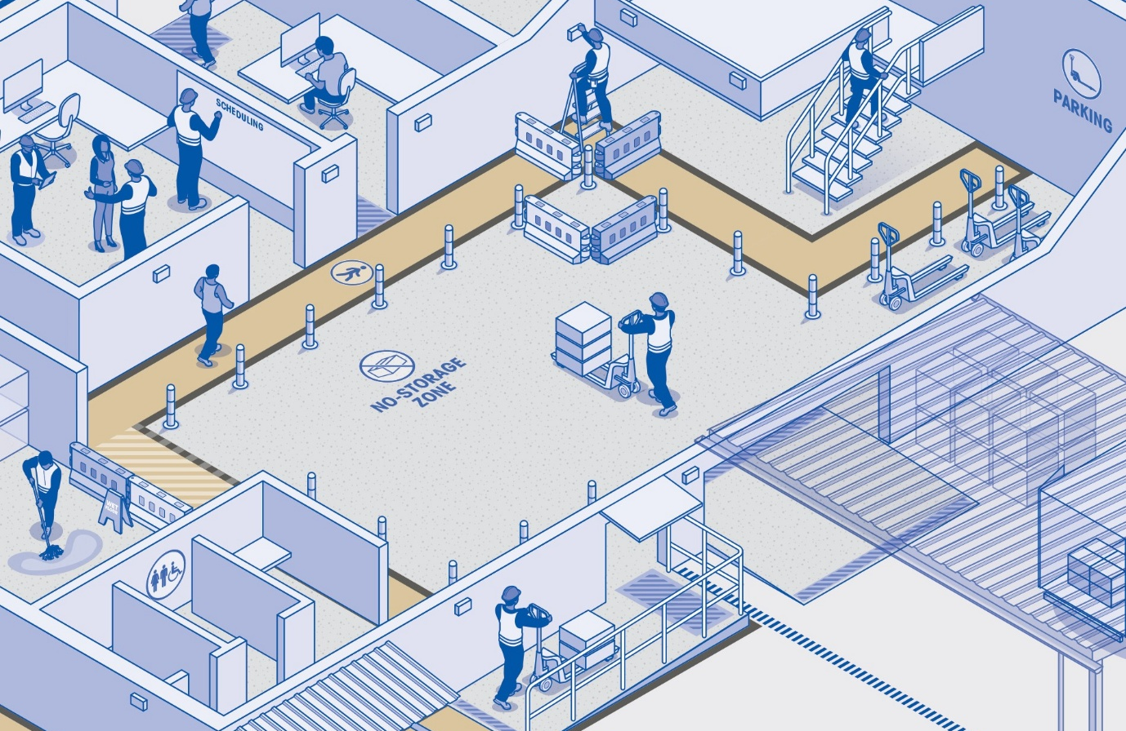
    - Reporting, notifying and reviewing
Reporting
Encouraging prompt reporting, especially preventative reporting, is important because it means action can be taken before a hazard can produce a high risk of slips, trips and falls. For example, reporting a leaky tap before a pool of water has had time to form might help avoid a person slipping on a wet floor.
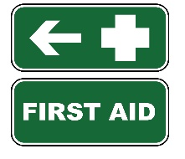
It must be clear who a person should contact if they need to report a risk of slips, trips and falls, or an incident. In a work context, this might be done by providing workers with the name and contact details of a PCBU’s WHS officer, or a shopping centre posting a phone number where a worker or customer can report if there is a spill that needs to be cleaned up.
Notifiable incidents and near misses must be reported to the PCBU and the WHS regulator.
Notifying the WHS regulator
The PCBU must notify the local WHS regulator if certain very serious things happen, which are divided into certain categories. Information about what is in these categories and what makes them ‘notifiable’ is in Safe Work Australia’s Handbook: Notifiable incidents, extended absences and suicides. Three of the most relevant examples for this guide are serious falls, serious injuries and extended absences (see the Glossary for definitions).
Reviewing control measures
Control measures should be monitored and reviewed regularly to make sure they are working as planned and remain effective. This means you should review control measures:
- regularly (e.g. during regular scheduled inspections)
- more often in areas where the risk is higher
- after an incident or near miss
- after a similar incident or near miss happens again, especially if there is a pattern
- when someone reports a hazard
- when furniture, flooring, layout or equipment changes
- when work tasks or work areas change
- after extreme weather
- when workers say the control measures do not seem to be working, or
- when a Health and Safety Representative requests it.

Check that the control measures:
- remove or reduce exposure to the hazard
- minimise risk
- are easy for workers and others to follow
- are used every day, not just during inspections
- do not create a new hazard
- are suitable for your particular workplace, and
- are put in place properly and consistently.
You should make sure that reviewing the control measures is done with your own workplace in mind, as different workplaces have different conditions, hazards and risks. Using a checklist is a good way to capture the information that helps measure how well a control measure is working over time.
You can adapt and add to the checklist below so that it suits your workplace.
There are several other checklists provided by WHS regulators, which are linked in the Further resources section.


    - Checklist: Identify slip, trip and fall hazards in the workplace
About this checklist
This checklist can assist with identifying slip, trip and fall hazards in the workplace. It covers some of the most common things you should check for. It is not intended to be a complete list, and you may modify or add additional items to suit your workplace needs.
Industry standards, legislative requirements and guidelines may apply. More information for what is relevant in your jurisdiction is available from your WHS regulator.
How to use this checklist
If you answer ‘No’ to any of the questions, refer to the corresponding section in the ‘Hazards and risks’ chapter of this guide for ideas about what control measures may be suitable for your workplace. Some ways you can determine the answers to the questions include:
- inspecting the physical workplace in person, both indoors and outdoors
- observing workers to understand how work is carried out
- consulting workers, including a competent person and a Health and Safety Representative
- checking industry guidance and standards to see if there is an objective measurement for “effective” or “adequate” in your industry, where relevant
- referring to manufacturer’s instructions or consulting manufacturers, or
- checking reports of incidents and near misses.
You should keep a copy of the completed checklist to refer to later. This will make it easier to keep track of how often control measures are being reviewed and whether they are working as expected.
Workplace:
Address:
Person completing checklist:
(name and role)
Date checklist completed:
Date of next review:

1. Internal Floors
Check Item | Yes | No
Floors are in good condition, level, and free from damage. | ☐ | ☐
Floor surfaces provide adequate grip for expected conditions. | ☐ | ☐
Changes in floor levels or surfaces are clearly visible. | ☐ | ☐
No leaks, pooled liquids, tracked-in water, or contamination. | ☐ | ☐
Walkways are free from objects, cables, equipment or stored items. | ☐ | ☐
2. External Areas
Check Item | Yes | No
Pathways are stable, level, and well maintained. | ☐ | ☐
External surfaces remain slip-resistant when wet. | ☐ | ☐
Drainage prevents pooling of water or mud. | ☐ | ☐
Grates, covers and outdoor surfaces are in good condition. | ☐ | ☐
Vegetation is controlled so debris does not create hazards. | ☐ | ☐
3. Cleaning & Maintenance
Check Item | Yes | No
Cleaning methods suit the flooring material. | ☐ | ☐
Spills are cleaned promptly using effective procedures. | ☐ | ☐
Wet-floor warning signs, barriers or exclusion zones are used correctly. | ☐ | ☐
Maintenance issues (e.g. lighting, leaks, flooring damage) are identified and actioned quickly. | ☐ | ☐
Drainage is adequate where liquids are used or stored. | ☐ | ☐
4. Housekeeping
Check Item | Yes | No
Accessways are clear, tidy, and free from clutter. | ☐ | ☐
Adequate storage is located close to points of use. | ☐ | ☐
Power outlets are positioned to avoid trailing cords. | ☐ | ☐
Contractors follow the site’s housekeeping and cleaning expectations. | ☐ | ☐

5. Lighting
Check Item | Yes | No
Lighting is sufficient to identify slip, trip and fall hazards. | ☐ | ☐
Step edges, ramps and transitions are clearly visible. | ☐ | ☐
Glare, reflections and deep shadows are minimised. | ☐ | ☐
Outdoor paths and carparks have adequate lighting during low light conditions. | ☐ | ☐
6. Stairs & Ramps
Check Item | Yes | No
Stairs and ramps meet design standards and are well maintained. | ☐ | ☐
Step edges and ramp transitions are clearly marked. | ☐ | ☐
Handrails are present, secure, continuous and easy to grip. | ☐ | ☐
Surfaces provide suitable traction under expected conditions. | ☐ | ☐
7. Work Tasks
Check Item | Yes | No
Tasks allow workers to maintain balance and visibility of the path of travel. | ☐ | ☐
Loads carried do not obstruct vision, especially on stairs or ramps. | ☐ | ☐
Mechanical aids (trolleys, etc.) are appropriate for the surface and task. | ☐ | ☐
Distractions (e.g. noise, lighting issues, multitasking) are minimised. | ☐ | ☐
8. Footwear
Check Item | Yes | No
Footwear is suitable, in good condition, and provides adequate grip. | ☐ | ☐
Workers understand and follow the workplace footwear requirements. | ☐ | ☐
9. Training, Reporting and Supervision
Check Item | Yes | No
Workers are trained in slip, trip and fall risks, spill response and hazard reporting. | ☐ | ☐
Training records are kept and reviewed when processes or equipment change. | ☐ | ☐
Workers know how to report hazards, near misses and faulty equipment. | ☐ | ☐
Supervision is appropriate for task risk level and worker experience. | ☐ | ☐

10. Psychosocial hazards
Check Item | Yes | No
Deadlines and quotas are realistic, with enough time to meet them safely. | ☐ | ☐
Work assigned is a mix of fast / slow paced, and high / low concentration. | ☐ | ☐
Rosters take into account total hours worked, shift length and timing (e.g. night or irregular hours). | ☐ | ☐
Monitor for signs of fatigue. | ☐ | ☐
Enough breaks for the type of work and the worker’s needs. | ☐ | ☐

Summary
Questions answered ‘No’
Control measures needed
Next steps: who, what, when

    - Further resources
A range of other helpful resources for managing the risks of slips, trips and falls are provided below. While WHS laws are different between jurisdictions, many of the resources from other jurisdictions may be useful no matter where you are.
If you need help understanding the requirements that apply to your workplace, please contact your local WHS regulator.
Resources
Author | - Resource
Safe Work Australia | - Slips, trips and falls - Safety by topic  - Model Code of Practice - How to manage work health and safety risks  - Model Code of Practice - Managing the risk of falls at workplaces  - Model Code of Practice - Managing the work environment and facilities  - Model Code of Practice - Managing psychosocial hazards at work  - Notifiable incidents, extended absences and suicides handbook  - Model Code of Practice - Hazardous manual tasks  - Model Code of Practice - Managing the risk of fatigue at work
SafeWork  SA | - Guide to slips, trips and falls at work  - Code of practice: Managing the risk of falls at workplaces  - Slips, trips and falls at level  - Retail work hazards under the microscope
SafeWork NSW | - Code of Practice - Managing the work environment and facilities  - Code of practice - How to manage work health and safety risks  - Slips, trips and falls on the same level - Hazards by topic  - Guide to preventing slips, trips and falls at work  - Slips, trips and falls on the same level systems self-assessment tool
WorkSafe NT | - Managing the risk of falls at workplaces
WorkSafe ACT | - Checklist - Slips, trips and falls
WorkSafe QLD | - Guide to preventing slips, trips and falls at work  - Slips, trips and falls at level incident worksheet  - Information portal - Slips, trips and falls
WorkSafe TAS | - Code of Practice - Managing the risks of falls at workplaces  - Code of Practice - Managing the work environment and facilities  - Slips, trips and falls  - Checklist - Slips, trips and falls
WorkSafe VIC | - Fall prevention  - Slips, trips and falls  - Preventing slips, trips and falls under 2 metres  - Injury hotspots - Slips, trips, and falls
WorkSafe WA | - Checklist - Slips, trips and falls on the same level  - Investigation report template - Slips, trips and falls  - Slips, trips and falls on the same level - Hazards and solutions by topic  - Slips, trips and falls cafe and restaurant industry
Australian Building Codes Board | - National Construction Code
Standards Australia | Some Australian Standards most relevant to slips, trips and falls are:  - AS 4586:2013: Slip resistance classification of new pedestrian surface materials  - AS 4663:2013: Slip resistance measurement of existing pedestrian surfaces  - AS 1657:2018: Fixed platforms, walkways, stairways and ladders – Design, construction and installation  - AS 1428.1:2009: Design for access and mobility  - AS 2210.1: Occupational protective footwear, Part 1: Guide to selection, care and use  - AS/NZS 1680.1 to 1680.5 series: Interior and workplace lighting  - HB 197:1999: Introductory guide to the slip resistance of pedestrian surfaces (only available in hard copy)  - HB 198:2014: Guide to the specification and testing of slip resistance of pedestrian surfaces (only available in hard copy)

    - Glossary
Term | Definition
competent person | a person who has acquired through training, qualification or experience the knowledge and skills to carry out the task.
duty holder | any person who owes a WHS duty under the WHS Act or Regulations including a PCBU, a designer, manufacturer, importer, supplier, installer of products or plant used at work (upstream duty holder), officer or a worker.
hazard | a thing or situation that could harm a person.
Health and Safety Representative (HSR) | a worker who is elected to represent the health and safety interests of workers in their work group. HSRs’ functions include representing the workers in relation to WHS matters and monitoring the PCBU’s compliance with the WHS Act, among others. Further information is available at Health and safety representatives and work groups.
must | indicates a legal requirement exists that must be complied with. Please see ‘should’ in this glossary.
notifiable extended absence | the absence of a worker of 15 or more consecutive calendar days due to a work-related injury or illness. Please note this has not been implemented in every jurisdiction yet, please contact your WHS regulator to confirm.
notifiable incident | a death, serious injury or illness, dangerous incident or violent incident arising from the conduct of a business or undertaking. For more information see Notifiable incidents, extended absences and suicides handbook. Please note this has not been implemented in every jurisdiction, please contact your WHS regulator to confirm.
person conducting a business or undertaking (PCBU) | a broad concept that extends beyond the traditional employer/employee relationship to include all types of modern working arrangements. A PCBU includes a:  - company  - partnership  - unincorporated body or association, and  - sole trader or self-employed person.
plant | any machinery, equipment, appliance, container, implement and tool; and any components of or anything fitted or connected to those things. Plant includes items as diverse as rope access systems, lifts, cranes, computers, machinery, conveyors, forklifts, vehicles, power tools, quad bikes, mobile plant and amusement devices.
reasonably practicable | involves considering:  - the likelihood of the hazard or risk occurring  - the degree of harm that may result from the hazard or risk  - what is known about the hazard or risk and control measures  - availability and suitability of control measures, and  - cost (only after assessing the above factors).  This process helps duty holders meet their obligations under WHS laws. Further guidance is available in the Interpretive guideline - the meaning of reasonably practicable.
regulator | the agency or department in each jurisdiction who monitors and enforces compliance with WHS laws. The regulators also:  - give advice and information on WHS duties  - collect, analyse and publish statistics  - promote and support education and training  - help duty holders, workers and representatives consult and coordinate on WHS matters  - promote and share information, tools and initiatives, including with other regulators.
risk | In a WHS context risk is the possibility that a person could be harmed because of a hazard. Assessing risk means considering what could happen, how serious it would be and how likely it is to happen.
serious fall | is when a person falls and it meets 1 or more of these categories:  - from 1 level to another level  - into a hole, trench, pit or void  - into a body of water  - onto a dangerous surface or object (e.g. near moving machinery).  There is no height threshold applied to a serious fall, it can be from any height.
serious injury | an injury or illness of a person that would:  - ordinarily require the person to have immediate treatment as an in-patient of a hospital, whether or not treatment is available or sought on that occasion  - result in a serious brain injury resulting from a significant blow, knock or other shock to the person’s head (either once off or from happening repeatedly)  - other conditions described in Safe Work Australia’s Notifiable incidents, extended absences and suicides handbook. The 2 points above are the most relevant to slips, trips and falls.
should | indicates a recommended course of action. Please see ‘must’ in this glossary.
worker | any person who carries out work for a PCBU, including work as an employee, contractor or subcontractor (or their employee), self-employed person, outworker, apprentice or trainee, work experience student, employee of a labour hire company placed with a 'host employer' or a volunteer.
workplace | any place where work is carried out for a business or undertaking and includes any place where a worker goes, or is likely to be, while at work. This may include offices, factories, shops, construction sites, vehicles, ships, aircraft or other mobile structures on land or water.

