Air monitoring and the workplace exposure limits for airborne contaminants
Technical Guide

July 2026

Disclaimer
Safe Work Australia is an Australian Government statutory agency established in 2009. Safe Work Australia includes Members from the Commonwealth, and each state and territory, Members representing the interests of workers and Members representing the interests of employers.
Safe Work Australia works with the Commonwealth, state and territory governments to improve work health and safety and workers’ compensation arrangements. Safe Work Australia is a national policy body, not a regulator of work health and safety. The Commonwealth, states and territories have responsibility for regulating and enforcing work health and safety laws in their jurisdiction.
Creative Commons
With the exception of the Safe Work Australia logo, this copyright work is licensed under a Creative Commons Attribution 4.0 International licence. To view a copy of this licence, visit creativecommons.org/licenses In essence, you are free to copy, communicate and adapt the work, even commercially, as long as you attribute the work to Safe Work Australia and abide by the other licence terms.
Contact information
Safe Work Australia | mailto:info@swa.gov.au | www.swa.gov.au

Contents
1. Introduction 9
1.1 Purpose of this guide 9
1.2 Regulatory requirements for air monitoring 9
1.3 Workplace exposure limits 10
1.4 Transition to workplace exposure limits 10
1.4.1 Key changes and implications 10
1.5 How to use this guide 12
2. Exposure to airborne contaminants 13
2.1 Inhalation exposure 13
2.2 Dermal exposure 16
2.3 Ingestion exposure 17
3. Workplace exposure limits for airborne contaminants 18
3.1 8-hr time-weighted average 19
3.2 Short-term exposure limit 20
3.3 Peak limitation 20
3.4 Units for workplace exposure limits 20
4. Air monitoring and risk assessment for airborne contaminants 22
4.1 Regulatory framework for air monitoring 22
4.2 Who can undertake air monitoring 24
4.3 Risk management for airborne contaminants 24
4.3.1 Determining if air monitoring is required 26
4.3.2 Gather and review information 26
4.3.3 Determine air monitoring strategy 27
4.3.4 Exposure assessment 27
4.3.5 Interpretation of results and risk characterisation 27
4.3.6 Management and control 27
4.3.7 Review and re-assess 28
5. Undertaking air monitoring 29
5.1 Developing a strategy and plan for air monitoring 29
5.2 Determining sample population 30
5.2.1 Selection of similar exposure groups 31
5.2.2 Determining sample numbers 32
5.3 Types of monitoring 32
5.3.1 Personal monitoring 34
5.3.2 Static sampling 34
5.4 Sampling methods 35
5.5 Sampling equipment 36
5.5.1 Active sampling 36
5.5.2 Passive sampling 37
5.5.3 Real-time monitoring 37
5.5.4 Calibration 40
5.6 Sampling media and analysis 40
5.7 How to sample for 8-hr TWA 42
5.8 How to sample for STEL 42
5.9 How to sample for peak limitation 43
5.10 How to sample task-based exposures 43
5.11 Quality control in air monitoring 44
5.12 Limitations of air monitoring 44
5.13 Alternatives to air monitoring 45
5.13.1 Biological monitoring 45
5.13.2 Modelling and use of existing data 45
5.13.3 Qualitative methods of assessment 46
5.13.4 Control banding 46
6. Adjustment of exposure limits 47
6.1 Adjusting time-weighted average exposure limits for extended work shifts 47
6.1.1 Quebec model 47
6.1.2 Brief and Scala model 48
6.2 Peak limitations or short-term exposure limit values 48
7. Data analysis 49
7.1 Statistical foundations for assessing exposure data 49
7.1.1 Distribution of exposure data 49
7.1.2 Occupational hygiene data and statistics 49
7.2 Sources of error and uncertainty 52
7.2.1 Sources of error 52
7.2.2 Sources of uncertainty 53
7.2.3 Accuracy and precision 54
7.2.4 Worked example 54
7.3 Analysis of variance (ANOVA) 55
7.4 Censored data 56
7.5 Outliers 56
7.6 Void samples 56
7.7 Quality assurance and control 57
8. Result interpretation 58
8.1 Statutory compliance 58
8.2 Action levels 58
8.3 Reporting results 59
8.4 Proposing controls 60
8.4.1 Reasonably practicable 60
8.4.2 Respiratory protective equipment: protection factors 61
8.5 Health monitoring 62
9. Other factors affecting exposure 63
9.1 Workload considerations 63
9.2 Exposure to mixtures of contaminants 63
9.3 Drugs and prescription medicines 65
9.4 Odour thresholds 65
9.5 Indoor air quality 66
10. Contaminant-specific guidance: assessment and control 67
10.1 Carcinogens 67
10.1.1 Regulatory context 67
10.1.2 Latency and risk 68
10.1.3 Globally harmonised system of classification and labelling of chemicals classifications 68
10.1.4 Non-threshold genotoxic carcinogens 69
10.2 Respiratory and dermal sensitisers 69
10.2.1 Respiratory sensitisers 69
10.2.2 Dermal sensitisers 70
10.3 Systemic and target organ toxins 70
10.3.1 Neurotoxins 70
10.3.2 Ototoxic substances 70
10.3.3 Ocular effects 71
10.4 Irritants and corrosives 71
10.5 Dusts not otherwise classified (NOC) 71
10.6 Nanoparticles 72
10.7 Asphyxiants 72
10.7.1 Simple asphyxiants 72
10.7.2 Chemical asphyxiants 72
10.8 Other substances without exposure limits 73
11. References 74
Appendix A: Key terms and abbreviations 77
Appendix B: ISO 7708 sampling curves for airborne particulates 83
Appendix C: Duties of a Person Conducting a Business or Undertaking 84
Appendix D: Essential information to capture in an assessment 85
Appendix E: Considerations for use of real-time monitors 87
Instrument response 87
Sensor resolution and accuracy 87
Detection limits 87
Chemical specificity and cross-sensitivities 87
Particulate size fraction 88
Baseline drift 88
Setting alarms 88
Appendix F: Examples of sampling methods, media and analysis 89
Appendix G: Minimum sampling times 90
Appendix H: Case study of adjusting exposure limits for extended shift rosters 93
Example H.1 AIOH Modified Quebec example 93
Example H.2 Brief and Scala method example 94
Appendix I: Example of statistical analyses 97
Appendix I1:IHSTAT® 97
Appendix I1.1 Lognormally and normally distributed exposure data 97
Appendix I1.2 Lognormally distributed exposure data only 100
Appendix I1.3 Normally distributed exposure data only 103
Appendix I1.4 Neither lognormally nor normally distributed exposure data 105
Appendix I2: Expostats (tool 1) 107
Appendix I2.1 Statistical inference of results 107
Appendix J: Examples of using excel for an ANOVA calculation 110
Establishing group compliance 110
Step 1: Using the Excel math function 110
Step 2: Group compliance calculation 111
Calculating individual compliance 113
Step 1: Calculating ANOVA: Single factor 113
Step 2: Determine individual variance 115
Appendix K: Examples of calculating compliance for mixtures 118
Example K1: Additive mixture formula calculation for dusts 118
Example K2: Exposure index calculation for volatile organic compounds 119

Figures
Figure 1: Aerodynamic equivalent diameters of common airborne contaminants and comparison materials 14
Figure 2: Dust particle size versus respirability curve 16
Figure 3: Approaches to air monitoring in occupational hygiene 23
Figure 4: The risk management process for airborne contaminants 25
Figure 5: Sampling strategy and type of workplace exposure patterns 33
Figure 6: Breathing zone of a worker 34
Figure 7: Sources of uncertainty and error when measuring airborne contaminants 52
Figure 8: Illustration of accuracy versus precision 54
Figure 9: Hierarchy of control measures 60
Figure 10: IHSTAT® output for lognormally and normally distributed data 97
Figure 11: IHSTAT® rules of thumb interpretation of lognormally and normally distributed data results 98
Figure 12: IHSTAT® Bayes output for lognormally and normally distributed data 99
Figure 13: IHSTAT® output for lognormally distributed data 100
Figure 14: IHSTAT® rules of thumb interpretation of lognormally distributed data results 101
Figure 15: IHSTAT® Bayes output for lognormally distributed data 102
Figure 16: IHSTAT® output for normally distributed data 103
Figure 17: IHSTAT® rules of thumb interpretation of results for normally distributed data 104
Figure 18: IHSTAT® output for neither lognormally nor normally distributed data 105
Figure 19: IHSTAT® rules of thumb interpretation of results for normally distributed data 106
Figure 20: Box and Whiskers plot of data being analysed 108
Figure 21: Results of naturally logging the monitoring results 111
Figure 22: Calculation of geometric mean and geometric standard deviation 111
Figure 23: Calculation of the unbiased uncertainty parameter (U) 112
Figure 24: Step one to calculating ANOVA: single factor 113
Figure 25: ANOVA: Single-tail output 114
Figure 26: Calculation of between-worker variance & standard deviation in cells Q6 & Q7 116
Figure 27: Final calculation individual compliance test 117

Tables
Table 1: WEL and WES list comparison 11
Table 2: Comparison of the benefits and limitations of air monitoring methods 39
Table 3: Examples of sampling methods, media and analysis 40
Table 4: Limitations associated with air monitoring 44
Table 5: Comparison of different statistical packages commonly used in Australia 50
Table 6: GHS carcinogenicity classifications 68
Table 7: Sampling curves for airborne particulates, adapted from ISO7708 Table B.2 [3] 83
Table 8: Duties of a PCBU 84
Table 9: Examples of sampling methods, media and analysis 89
Table 10: Examples of minimum sampling times as a function of flow rate and LoQ 92
Table 11: Application of the AIOH Quebec model to extended work rosters 94
Table 12: Application of the Brief and Scala model to extend work rosters 95
Table 13: Expostats lognormally and normally distributed data, statistical inference – percentiles 107
Table 14: Estimates of the data based on statistical analysis 108
Table 15: Expostats statistical inference: risk assessment 109
Table 16: Results of inhalable dust monitoring over a period of one week 110
Table 17: Limiting values of U 112
Table 18: Exposures to a mixture of dusts at a waste transfer station 118
Table 19: Exposures to a mixture of VOCs 119

- Introduction
  - Purpose of this guide
This technical guide on Air monitoring and the workplace exposure limits for airborne contaminants provides best practice guidance on the technical aspects of conducting air monitoring for airborne contaminants and assessing exposure consistent with the workplace exposure limits. This guide is intended for use within the Australian context by suitably qualified and experienced professionals such as occupational hygienists.
A separate Guide for PCBUs: Air monitoring and the workplace exposure limits for airborne contaminants provides guidance on the application of exposure limits for airborne contaminants in the workplace specifically for Persons Conducting a Business or Undertaking (PCBUs). The guide for PCBUs outlines the process that a PCBU must follow to comply with duties relating to the exposure limits under the Work Health and Safety (WHS) Regulations.
When discussing legal requirements, this document is referring to the model WHS laws. The laws and requirements in your jurisdiction may be different so you should check with your regulator.
In this guide, the word ‘must’ indicates a legal requirement that must be complied with. The word ‘should’ indicates a recommended course of action.
  - Regulatory requirements for air monitoring
The WHS Act places a primary duty on PCBUs to ensure, so far as is reasonably practicable, the health and safety of workers at work, and that others are not put at risk from work carried out as part of the conduct of the business or undertaking (Section 19).
As part of that duty a PCBU must ensure, so far as is reasonably practicable, that the health of workers and the conditions at the workplace are monitored for the purpose of preventing illness or injury of workers arising from the conduct of the business or undertaking. This may include monitoring for airborne contaminants.
Where an airborne contaminant has an exposure limit, PCBUs have an additional duty in the WHS Regulations to ensure that no person at the workplace is exposed to a substance or mixture in an airborne concentration that exceeds the exposure limit for the substance or mixture (Regulation 49).
Under Regulation 50(1) PCBU must ensure that air monitoring is carried out to determine the airborne concentration of a substance or mixture at the workplace to which an exposure limit applies if:
- the person is not certain on reasonable grounds whether or not the airborne concentration of the substance or mixture at the workplace exceeds the relevant exposure limit, or
- monitoring is necessary to determine whether there is a risk to health.
  - Workplace exposure limits
Safe Work Australia’s Workplace Exposure Limits for Airborne Contaminants (WEL list) contains a list of mandatory exposure limits under the WHS Regulations. These exposure limits are also listed in the Hazardous Chemicals Information System (HCIS) online database.
  - Transition to workplace exposure limits
From 1 December 2026, worker exposure to airborne contaminants must not exceed the exposure limits published by Safe Work Australia. In 2024, WHS ministers agreed to the exposure limits following a comprehensive review of the workplace exposure standards to ensure exposure values are based on contemporary health evidence and provide the highest level of protection for workers. The terminology was updated from Workplace Exposure Standards, to Workplace Exposure Limits, to clearly communicate that the exposure limits are limits that are not to be exceeded.
    - Key changes and implications
It is essential to check the WEL list for the specific limits for the airborne contaminants being monitored. Changes include:
- a decreased or increased exposure limit value
- an addition or removal of a type of exposure limit
- merging or splitting of groups of airborne contaminants
- addition or removal of an airborne contaminant listing
The WEL list also introduces updated notations and notes to assist users with managing risks and understanding the regulatory requirements.
For non-threshold genotoxic carcinogens (NTGCs) exposure limits will no longer apply. Unlike other airborne contaminants, a practical, protective exposure level cannot be assigned for NTGCs. For these substances, PCBUs must eliminate them from the workplace, replace them with a safer alternative if possible, or reduce the risk as far as reasonably practicable (see Section 10.1.4 for further information on NTGCs). Table 1 summarises the key differences between WES and WEL lists relevant to this guide.

Table 1: WEL and WES list comparison
Description | WES list  (pre-01 December 2026) | WEL list  (post 01 December 2026) | Why it matters
Name change | Workplace Exposure Standard (WES) | Workplace Exposure Limit (WEL) | Emphasises that these are mandatory limits not to be exceeded, aligns with international language
Legal requirements | Until 1 December 2026, PCBUs must ensure no person is exposed above the WES values (under WHS Regulations) | From 1 December 2026, PCBUs must ensure no person is exposed above the WEL values (under WHS Regulations) | From 1 December 2026, new or changed limits will apply
Specific changes
Numeric values | As given in WES list | Limits adjusted higher or lower based on updated health evidence, health-based limits added for some new chemicals, or a change to type of exposure listing | Existing control measures may no longer suffice; updated risk assessments are needed
Addition/ removal of chemicals | As per WES list | - Some new airborne contaminants have been added to, and some have been removed from, the WEL list  - 33 chemicals identified as non-threshold genotoxic carcinogens (NTGCs) no longer have an exposure limit | - PCBUs still have duties to eliminate or minimise the risk from substances without a WEL.  - For NTGCs, numeric limits will no longer apply, but duties to eliminate or minimise risk still remain.
Advisory notations/ hazard annotations | Included SEN (sensitiser), Sk (skin absorption) and carcinogenicity notations | - SEN is divided into RSEN (respiratory sensitiser) and DSEN (dermal sensitiser)  - New notation OTO (ototoxicity) introduced  - CARC notation removed from WEL  - Sk unchanged | - Updated notations provide additional information on risk of exposure.  - Removal of CARC notation as it is a hazard annotation, not providing additional risk information. Other GHS classifications are not included in the WEL list. Carcinogenicity information can be found in HCIS
Notes | Notes did not include additional regulatory requirements of Schedules 10 and 14 | Change to notes e and f:  - Note e: Health monitoring  - Note f: Chemicals subject to restriction or prohibition | Easier to identify chemicals with additional regulatory requirements
Type of exposure limits | 8-hr TWA, STEL, Peak | 8-hr TWA, STEL, Peak | No change
Control implications | Existing controls are designed to meet WES values | - Many workplaces will need to retest, review controls to meet changed/new limits  - For NTGCs, risks must be managed in accordance with the hierarchy of control measures | To ensure exposure is below the WEL, additional controls (in accordance with the hierarchy of control measures) may be required
  - How to use this guide
This guide provides information on the technical aspects of conducting air monitoring for airborne contaminants and assessing the level of exposure in relation to the workplace exposure limits.
You may be engaged by a PCBU to:
- undertake a risk assessment to determine whether air monitoring is required,
- review and provide advice on a risk assessment undertaken by a PCBU to determine whether air monitoring is required
- gather information via a walkthrough or survey of the workplace, asking questions about workplace processes, reviewing safety data sheets (SDS) for materials that release airborne contaminants
- review control measures such as ventilation, personal hygiene facilities and respiratory protective equipment (RPE)
- measure concentrations of airborne contaminants to verify controls are working or investigate reported health concerns, or
- measure concentrations of airborne contaminants and assess in relation to the exposure limit.
Chapters 2 – 4 outline the properties of airborne contaminants, the types of exposure limits and the process of undertaking risk assessment to inform air monitoring.
Chapters 5 – 8 provide detailed guidance on undertaking air monitoring, adjustment to exposure limits as required for assessing compliance, analysis of data and interpretation of results and statutory compliance.
Chapters 9 – 10 outline other factors affecting exposure and contaminant specific guidance.
Key Terms are defined in Appendix A.
- Exposure to airborne contaminants
The nature of many workplace activities leads to the generation of airborne contaminants such as a fume, mist, gas, vapour, fibre or dust. Airborne contaminants can be:
- directly used in a process
- produced as part of a process, or
- arise as by-products of a process.
Exposure to airborne contaminants may place workers at risk of acute and/or chronic adverse health effects.
Exposure limits have been established to provide protection to workers from the risk of adverse health effects in many parts of the world. In Australia, these exposure limits are known as Workplace Exposure Limits (WELs), while in other parts of the world, they are often referred to as Occupational Exposure Limits (OELs).
The exposure limit represents the airborne concentration of a particular substance or mixture above which a worker must not be exposed. Exposure limits are generally established to protect workers from resultant adverse health effects following inhalation. Exposure (and subsequent health effects) to substances in the workplace can also occur through skin absorption or ingestion.
  - Inhalation exposure
Inhalation is the principal route of entry of airborne contaminants in most workplaces. The risk to health from inhaled airborne contaminants on the body is determined by:
- the amount of the contaminant inhaled by the worker (the dose), based on:
  - the airborne concentration
  - the exposure time
  - their physical state, i.e., dust (where particle size is important), fume, fibre, mist, vapour or gas
  - the protection provided by any RPE worn
- the action in the body, including:
  - route/s of transportation
  - the target organ that is adversely impacted
  - the metabolites formed, if any, once the contaminant has been absorbed into the body organs,
  - the mechanism of adverse health impact, and
  - the length of time the contaminant or its metabolites remain in the body before clearance or excretion.

When considering exposure to airborne particulates the size of the particle is important; this is known as the aerodynamic equivalent diameter (AED). This measurement considers both the shape, physical size and the density of the particle. Examples of common airborne contaminant that occupational hygienists may encounter are shown in Figure 1 [1], [2].
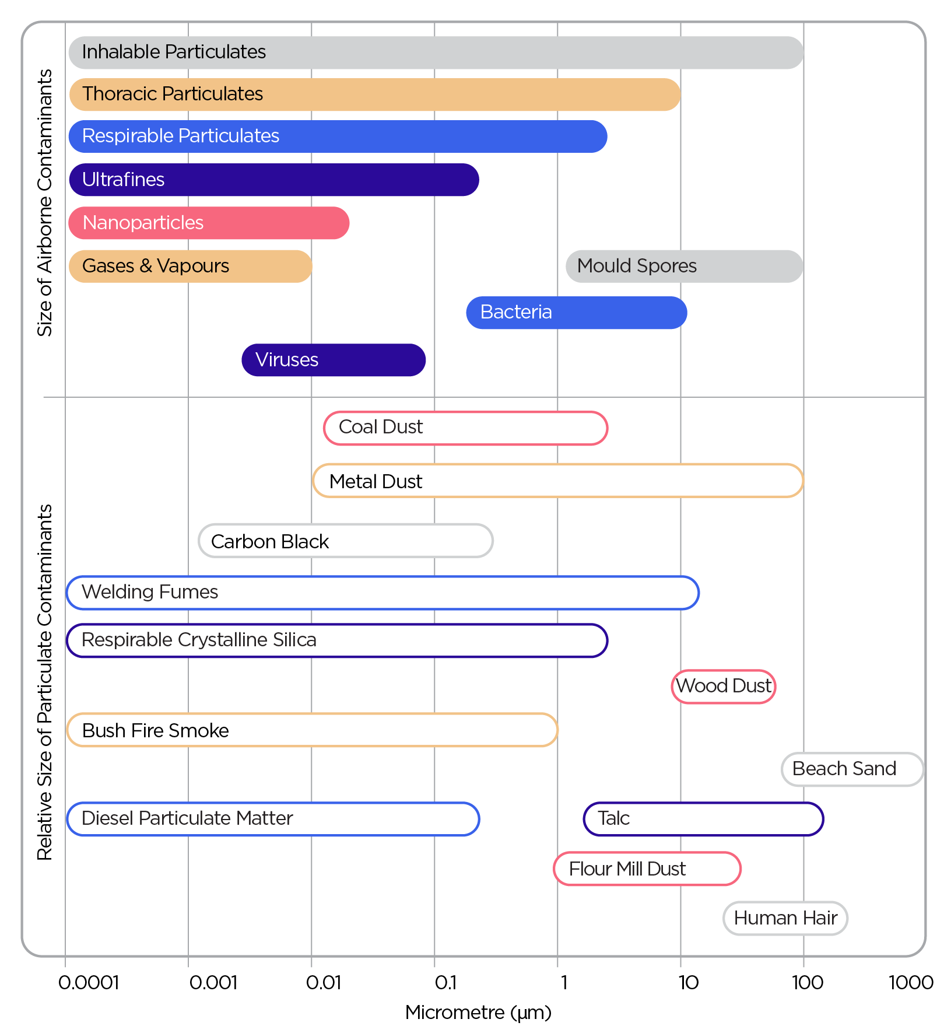
Figure 1: Aerodynamic equivalent diameters of common airborne contaminants and comparison materials

In the WEL list, dusts generated in the workplace are categorised primarily in two size fractions: inhalable and respirable. This classification reflects how efficiently, and where, particles of different AEDs enter and deposit within the respiratory system. This concept forms the basis for air monitoring for an occupational exposure assessment.
Each size fraction is defined by a percentage cut-off, representing the AED at which a sampling device (e.g. a cyclone) collects 50% of the particles within that size range. This means that particles smaller than the cut-off diameter are collected with greater efficiency, while larger particles are progressively excluded. This is the 50% collection efficiency point of the sampling device [3]. Not all particles within a size range are collected by any of the sampling devices, so reported quantities are therefore estimates of potential inhalation.
Inhalable fraction: Dust particles with an AED 50% cut-off of 100 µm can be inhaled through the nose and mouth [3]. These particles are typically deposited in the upper respiratory tract (nose and bronchi). These particles are then removed by the mucociliary escalator (lung clearance) mechanism and then swallowed (ingested). Examples include contaminants such as metal dusts, which can have adverse health effects on other organs of the body once absorbed.
Thoracic fraction: Dust particles with an AED 50% cut-off of 10 µm can be inhaled and penetrate beyond the larynx [3]. These particles are deposited in the tracheobronchial and alveolar (pulmonary) regions of the respiratory system. The thoracic fraction may be used in monitoring for cotton dust as noted (Note c) in the WEL list
Respirable fraction: Dust particles with an AED 50% cut-off of 4 µm can be inhaled and penetrate to the unciliated airways [3]. This means they are deposited deep into the respiratory tract, including the alveolar region of the lungs. Following deposition, particles may be retained in the alveoli and cleared by physiological mechanisms, and soluble components may be absorbed in the bloodstream, potentially affecting specific target organs. Examples of contaminants in the respirable range include respirable crystalline silica (RCS), coal dust, diesel particulate matter (DPM), graphite, manganese and vanadium. All respirable particles (AED 50% @ <4 µm) fall within the inhalable size fraction (AED <100 µm).
For substances with an exposure limit, the limit listed in the Workplace Exposure Limits for Airborne Contaminants is for the inhalable fraction unless noted otherwise.
Figure 2 summarises the size fraction cutoffs for inhalable, respirable and thoracic particulates [3]. Sampling curves are provided in Appendix B.
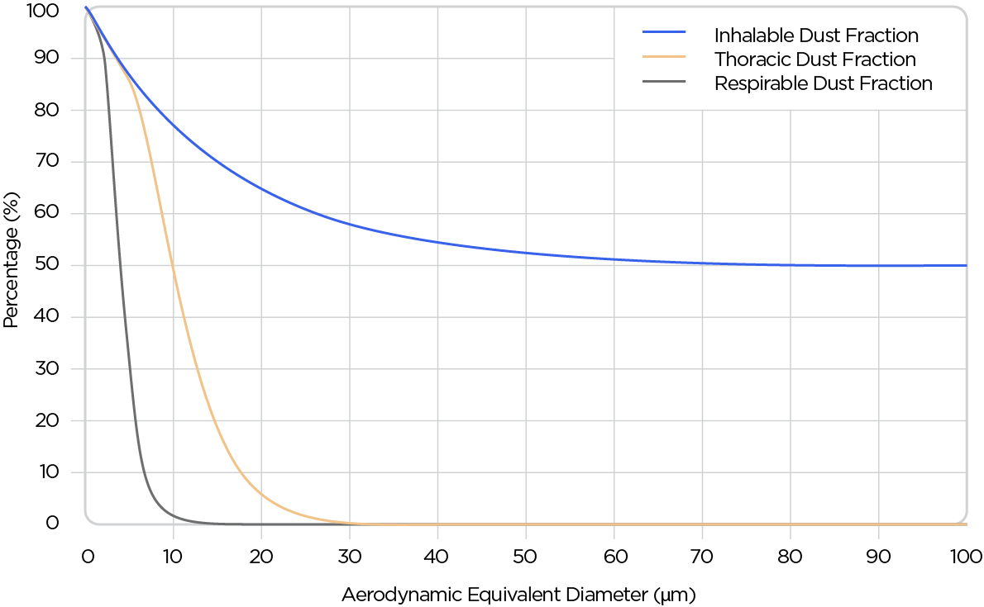
Figure 2: Dust particle size versus respirability curve
In certain settings, additional size fractions for specific contaminants and the characteristics of the exposed workforce are used. These size fractions are often included when real-time particulate samplers are used but are not appropriate for the purpose of establishing compliance against an exposure limit. These include:
- high-risk respirable fraction: A 50% cut-off of 2.5 µm (PM_{2.5}) [3], often used in general indoor air quality assessments where susceptible individuals may be exposed to fine particulate matter, for example from smoke infiltration during bushfires or other fire events, and
- nanoparticles (AED <0.1 µm): very small particles found within both respirable and inhalable fractions (See Section 10.6).
  - Dermal exposure
Exposure limits are generally established to protect workers from adverse health effects arising from inhalation exposure. However, for some airborne contaminants, dermal absorption can also contribute significantly to the overall dose and associated health risks. In these cases, a skin notation (Sk) is assigned in the WEL list to the exposure limit to indicate that meaningful uptake may occur through the skin in addition to the lungs.
Where both inhalation and dermal exposure are possible, the combined dose increases the risk of developing adverse health impacts. This additional risk should be considered during the risk assessment process, and further controls may be required to minimise exposure through skin contact with the contaminant. The PCBU may need to consider including complimentary exposure assessment methods in the exposure assessment program, such as biological monitoring (Section 5.13.1) or, where an appropriate analytical method exists, surface or dermal contamination sampling.
  - Ingestion exposure
Ingestion is not usually considered a major route of exposure to airborne contaminants in the workplace. This route of exposure should be taken into account where:
- there is a risk of absorption through the gastrointestinal system following inhalation,
- a risk of hand-to-mouth contact, particularly following contact with contaminated surfaces, or
- substances or processes where inadvertent ingestion may create a significant risk.
This route of exposure is particularly relevant to consider where good personal hygiene practices are not followed.

- Workplace exposure limits for airborne contaminants
The exposure limits given in the WEL list have been established using the methodology specified in the workplace exposure standards review. The evaluation process considered all available health evidence reports published by the agreed sources for recommending exposure limits and applied expert judgement, using a weight of evidence approach, in recommending an exposure limit.
Exposure limits are intended for use in occupational settings only and should not be applied to public health assessments or pollution limits. Environmental exposures are regulated under other legislation. Indoor air quality is addressed in Section 9.5.
Exposure limits apply to all people in the workplace, including those not actively engaged in the work activity generating the airborne contaminant, such as other workers, customers, visitors or members of the public.
As noted in the WEL list, exposure limits are not necessarily protective of all people in the workplace, and PCBUs must reduce exposure for each worker as much as reasonably practicable, which may be different for workers in different roles depending on which controls can be applied.
Exposure limits do not identify the dividing line between an exposure that will or won’t result in adverse health effects. Some people may have health effects at concentrations below the exposure limit, either due to individual differences or due to existing health conditions (such as pregnancy, cancer treatment, recovery from an illness, heart or lung disease).
In Australia, the three types of exposure limits used are:
- 8-hour time-weighted average (8-hr TWA) (see Section 3.1)
- Short-term exposure limit (STEL) (see Section 3.2), and
- Peak limitation (see Section 3.3).
Some airborne contaminants are assigned more than one type of exposure limit, for example, both an 8-hr TWA and a STEL or both an 8-hr TWA and a peak limitation. In such cases, all relevant exposure limits apply concurrently. Some contaminants may also have a requirement for health monitoring which is discussed in Section 8.5.
Consistent with the WHS Act, the key principle in assessing exposures to airborne contaminants is that risk to health from exposure concentrations should always be as low as reasonably practicable and under the WHS Regulations must be maintained below the relevant exposure limit.
Deciding what is ‘reasonably practicable’ to eliminate or minimise risks to health and safety requires considering and weighing up the exposure risk, the availability and suitability of controls, and the cost associated with managing the risk and whether this is grossly disproportionate to the risk. Further information on determining what is reasonably practicable is given in Section 8.4.1.

There are approximately 700 substances with an established workplace exposure limit, however, not all substances used or generated in workplaces have an exposure limit. Just because a substance doesn’t have an exposure limit doesn’t mean it is safe.
If there is a way to measure an airborne contaminant without an exposure limit, you may still conduct air monitoring to demonstrate exposure is minimised as far is reasonably practicable.
In considering the exposure risk to airborne contaminants without an exposure limit, you may take into account other reference values such as:
- No Observed Adverse Effect Level (NOAEL)
- Benchmark Dose
- Lowest Observed Adverse Effect Level (LOAEL), or
- OELs from other sources such as GESTIS-ILV, UK Health and Safety Executive (HSE) Workplace Exposure Limits, American Conference of Government Industrial Hygienists (ACGIH) Threshold Limit Values (TLV)®.
Alternatively, you may seek the advice of a toxicologist.
  - 8-hr time-weighted average
An 8-hr TWA exposure limit is the maximum permitted concentration of an airborne contaminant calculated as a time weighted average for an 8-hour working day, based on a 5-day working week (40 hours). An individual must not be exposed to concentrations that, when averaged over 8-hours, exceed the 8-hr TWA exposure limit. Monitoring for 8-hr TWA exposure periods is covered in Section 5.7.
The 8-hr TWA exposure limit is intended to protect most workers from the long-term adverse health effects of exposure to airborne contaminants. These are based on three key factors:
- the level (dose or concentration) of exposure,
- the adverse health effect and estimated dose-response based on experimental, observational or epidemiological data, and
- the time it takes for elimination of the contaminants and/or their metabolites from the body.
Short-term fluctuations above the 8-hr TWA exposure limit may occur during normal work activities. These are permissible provided the overall exposure averaged over the 8-hour working day remains lower than the 8-hr TWA exposure limit. However, exposure must never exceed any short-term exposure limit (STEL) or peak limitation for that specific airborne contaminant, even if the worker’s 8-hr average exposure would otherwise remain below the 8-hr TWA exposure limit.
A process is not considered to be reasonably controlled if short term exposures exceed 3 times the 8-hr TWA exposure limit for more than a total of 30 minutes per 8-hour working day, or if a single short-term value exceeds 5 times the 8-hr TWA exposure limit.

Where workers have extended work hours (a working day longer than 8 hours, more than 40 hours a week or have less than a 16-hour break between shifts), the 8-hr TWA exposure limit may need to be adjusted. These are known as shift-adjustments, and methods for calculating these are outlined in Section 6. This ensures adequate protection for workers who are working longer hours and/or have a reduced recovery time between shifts.
For shift-adjustments, the following principles apply:
- the 8-hr TWA cannot be adjusted upwards for shorter work shifts
- it is only appropriate to adjust the 8-hr TWA for longer shifts, and
- it is never appropriate to adjust any measured exposure data.
  - Short-term exposure limit
A short-term exposure limit (STEL) is the maximum permitted concentration of an airborne contaminant calculated as a time-weighted average over a 15-minute period. It is intended to protect most workers from the acute health effects following exposure to a hazardous airborne contaminant. Monitoring for short-term exposure periods is covered in Section 5.8.
For contaminants with an assigned STEL, this limit cannot be exceeded at any time, even if a worker’s overall exposure during the workday remains below the 8-hr TWA exposure limit. Exposures at the STEL are permissible only if the exposure:
- lasts less than 15 minutes
- occurs no more than 4 times per day, and
- is separated from another exposure at the STEL by at least 60 minutes.
A STEL cannot be adjusted for longer or shorter working days.
  - Peak limitation
A peak limitation refers to the highest concentration of an airborne contaminant that an individual may be exposed to, measured over the shortest possible time period, and not exceeding 15 minutes. Excursions above this level are not permitted, regardless of duration. Monitoring for peak exposures is covered in Section 5.9.
A peak limitation cannot be adjusted for longer or shorter working days.
  - Units for workplace exposure limits
The units for exposure limits are commonly expressed as milligrams per cubic metre (mg/m³), parts per million (ppm), or fibres per millilitre (f/mL), depending on the physical state of the substance.
- Dusts and particulates (e.g. respirable crystalline silica (RCS), wood dust, welding fumes) are expressed in mg/m³.
- Gases and vapours are molecules that are easily distributed in the air and usually expressed as ppm but can also be expressed as mg/m³. The conversion between units (for gases and vapours only) is calculated as:
$$Concentration \left(ppm\right)=\frac{concentration \left(mg/m^{3}\right) X 24.45}{molecular weight}$$
- Occasionally, a gas or vapour exposure may be reported as a percentage (%) concentration. The conversion is:
0.0001 % = 1 ppm = 1000 ppb
0.001 % = 10 ppm = 10 000 ppb
0.01 % = 100 ppm = 100 000 ppb
- Fibres: When an exposure limit applies to airborne fibre contaminants, such as asbestos or man-made vitreous fibres, exposures are normally expressed as fibres per millilitre of air (f/mL) except for those fibres that are classified as inhalable dust or have low biopersistence.
- Air monitoring and risk assessment for airborne contaminants
  - Regulatory framework for air monitoring
Where an airborne contaminant has an exposure limit, PCBUs have a duty in the WHS Regulations to ensure that no person at the workplace is exposed to a substance or mixture in an airborne concentration that exceeds the exposure limit for the substance or mixture (Regulation 49).
Under Regulation 50(1), a PCBU must ensure that air monitoring is carried out to determine the airborne concentration of a substance or mixture at the workplace to which an exposure limit applies if:
- the person is not certain on reasonable grounds whether or not the airborne concentration of the substance or mixture at the workplace exceeds the relevant exposure limit, or
- monitoring is necessary to determine whether there is a risk to health.
The WHS Regulations impose further specific requirements for air monitoring for asbestos and crystalline silica. Further information about the key duties of a PCBU under the WHS Regulations are given in Appendix C.
Air monitoring may also be done for other purposes, such as to evaluate the effectiveness of the controls in place to manage risks. Figure 3 shows different approaches to air monitoring in occupational hygiene depending on the objective of the monitoring.
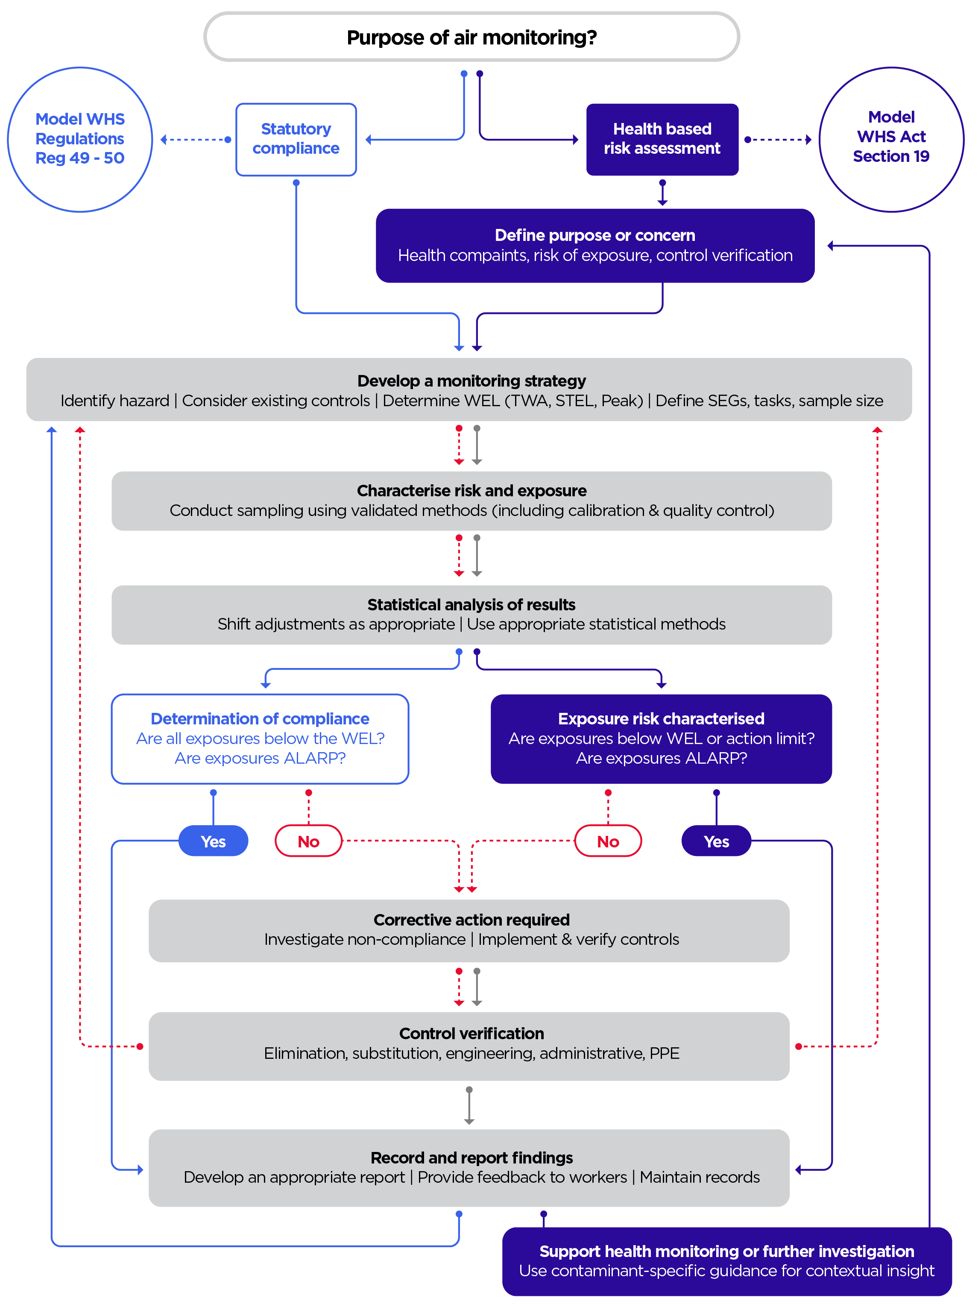
Figure 3: Approaches to air monitoring in occupational hygiene
  - Who can undertake air monitoring
Sampling for airborne contaminants is a complex activity that requires specialist knowledge, practical experience, and an in-depth understanding of workplace processes and conditions. Effective exposure assessment goes beyond the collection of samples; it relies on professional judgement and the interpretation of monitoring data within the context of the work environment to accurately evaluate health risk and inform appropriate control measures.
Those undertaking air monitoring should understand the behaviour and properties of contaminants, potential interferences, sampling and analytical limitations, and the statistical principles underpinning representative measurement and interpretation. This level of expertise is typically achieved through formal training and practical field experience.
Given the complexity of exposure assessments, air monitoring programs intended to determine compliance with the exposure limit should only be designed and conducted by a trained professional, such as a suitably qualified and experienced occupational hygienist.
Interpreting the results without sufficient expertise may lead to incorrect conclusions about worker exposure and control effectiveness. Interpretation of results should always be performed, or verified, in consultation with a suitably qualified and experienced occupational hygienist.
If specialised monitoring advice is required that is beyond your own skill set or expertise, the Australian Institute of Occupational Hygienists (AIOH) directory can be used to identify an occupational hygienist with the appropriate expertise.
  - Risk management for airborne contaminants
The risk assessment for airborne contaminants can be viewed as a cycle of continuous improvement. Figure 4 illustrates this process.

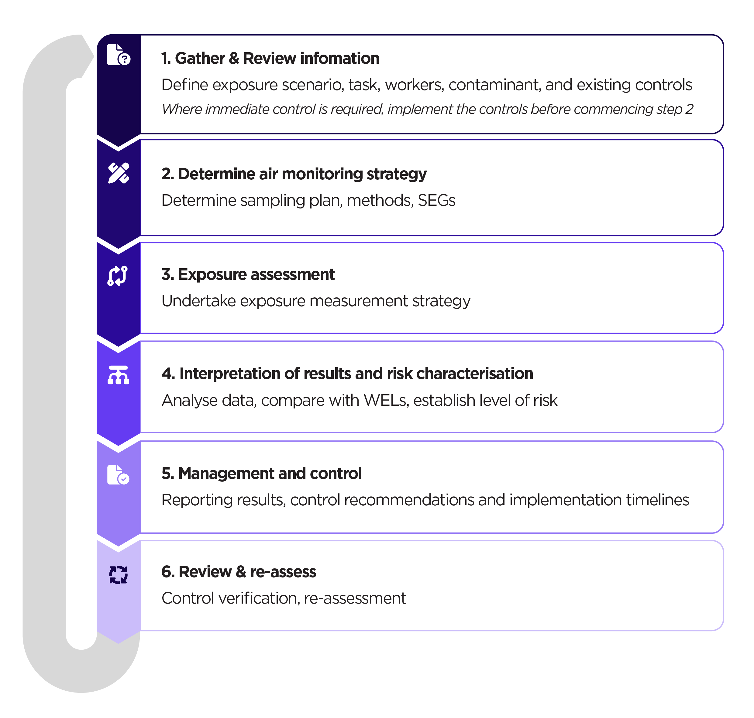

Figure 4: The risk management process for airborne contaminants

    - Determining if air monitoring is required
It is the duty of the PCBU under the WHS Regulations to determine whether air monitoring is required.
Occupational hygienists may be engaged by a PCBU to undertake a risk assessment, or to review and provide advice on a risk assessment undertaken by the PCBU. The risk assessment should include an assessment of the effectiveness of any implemented control measures and determine whether air monitoring is required.
Risk assessment to determine if air monitoring is required will generally be qualitative or semi-quantitative in nature [4], using assessment of the likelihood and consequence of exposure to determine a risk rating. The use of exposure modelling data to estimate airborne contaminant concentrations may be used to inform a risk assessment.
Further information about qualitative and semi-quantitative risk assessment can be found in the AIOH Guidebook Simplified Occupational Hygiene Risk Management Strategies.
Where a risk assessment for airborne contaminants indicates that there is a risk of exceeding the exposure limit or workers developing adverse health effects under current exposure conditions, controls should immediately be implemented and subsequent air monitoring carried out to measure the concentration of airborne contaminants and verify the efficacy of controls.
    - Gather and review information
Prior to sampling, you will need to identify the risks associated with the airborne contaminants in use or produced through a process in the workplace and the associated adverse health effects.
This is normally established by using prior knowledge and available background information [4], including reviewing applicable legislation and guidance (e.g. Safe Work Australia Codes of Practice).
This information regarding hazards and risks will then determine the extent and type of sampling to be conducted. If there is no applicable Australian legislation or guidance, information from other sources may be used as a guide to assist in minimising risk to health from exposure to airborne contaminants to as far as reasonably practicable (e.g. ACGIH, HSE, Agency for Toxic Substances and Disease Registry (ATSDR), National Institute for Occupational Safety and Health (NIOSH), and peer-reviewed publications).
A walkthrough inspection or survey of the workplace should be undertaken to identify any contaminants that may pose a risk to worker health. You should also:
- Engage with workers who may be exposed to airborne contaminants to understand the systems of work/activities they undertake to determine the extent and frequency of potential exposure.
- Review the hazardous chemicals register and safety data sheets available in the workplace. Obtain and review the results of calculations, analysis or testing provided by the manufacturer/supplier for articles that may not be accompanied by SDS.
  - Identify airborne contaminants in use (fume, mist, gas, vapour, fibre or dust).
  - Identify airborne contaminants that may be generated (fume, mist, gas, vapour, fibre or dust).
  - Consider routes of entry (inhalation, ingestion, absorption).
  - Understand health effects (acute vs chronic, ototoxicity, etc).
  - Assess the toxicity of the contaminant and its metabolites.
  - Assess ingredients listed in the composition in the SDS for potential toxicity.
- Research the industry and processes used.
- Gather and evaluate any existing data on previous air monitoring and relevant workplace control measures.
    - Determine air monitoring strategy
Where air monitoring is required, a strategy for sampling and assessment (including both quantitative and qualitative aspects), and interpreting worker exposure results should be established. Before an air sampling strategy is designed, the objectives of the air sampling should be understood and documented, with a clear plan for how the data collected will be used.
You should design a sampling strategy in such a way that it allows for representative sampling and for statistical analysis of air monitoring data which allows you to determine if exposures put the health of workers at risk.
Factors which should be considered and documented in developing the air monitoring strategy and planning the sampling are given in Section 5.1.
    - Exposure assessment
The intent of air monitoring is to collect representative worker exposure data. To measure workers’ exposure to airborne contaminants a well-designed sampling strategy, good sampling techniques and accurate, precise and sensitive analysis methods that provide an acceptable degree of certainty are required.
Section 5 provides guidance on the elements of air monitoring which should be considered when planning and conducting air monitoring.
    - Interpretation of results and risk characterisation
Risk characterisation involves analysing the results, comparing the exposure data to the exposure limits and considering the nature, frequency and duration of exposure to assess the risk to workers of developing adverse health effects.
Interpretation of sampling results should also account for uncertainties, potential confounding factors and variability in workplace conditions to ensure conclusions are both accurate and defensible. Further information is provided in Sections 6, 7 and 8.
    - Management and control
Occupational hygienists play a key role in developing practical and effective control strategies based on the exposure assessment outcomes. This includes recommending and prioritising control measures in accordance with the hierarchy of control measures.

Consideration should be given to elimination, substitution, isolation, engineering and administrative controls, and the appropriate use of personal protective equipment (PPE). Recommendations should be clearly documented and presented to the PCBU in a manner that is practical, transparent and actionable.
Where an exposure risk is identified, control measures should be implemented as a priority, followed by exposure monitoring to verify the effectiveness of those controls. Occupational hygienists should support the PCBU through consultation, implementation and verification to ensure sustainable reduction of risk to workers’ health, but it is the responsibility of the PCBU to implement controls and ensure the risk from exposure is as low as reasonably practicable.
    - Review and re-assess
Control verification and reassessment should be undertaken regularly and be overseen by a suitably qualified and experienced occupational hygienist. Verification activities, such as follow-up sampling, inspection and consultation, should be undertaken to determine whether the residual risk is as low as reasonably practicable. Reassessment of exposures should occur whenever processes, materials or work practices change, or when new information about the hazard becomes available.
- Undertaking air monitoring
  - Developing a strategy and plan for air monitoring
When developing a strategy and plan for air monitoring, the following elements should be considered and documented [5]:
- What is the objective of the air monitoring? E.g.:
  - compliance monitoring
  - development of exposure profile
  - health risk assessment
  - control verification
- Is there an exposure limit?
  - What type of limit? (See Section 3)
  - If not, is there another way to assess the risk from exposure? (See Sections 5.13 and 10.8)
- What type of air monitoring is required? (See Section 5.3)
  - Do you need to do full shift monitoring or short-term monitoring?
    - 8-hr TWA (See Section 5.7)
    - STEL (See Section 5.8)
  - Is continuous monitoring with recording and/or alarm required?
    - Peak limitation (See Section 5.9)
  - Do specific tasks need to be assessed? (See Section 5.10)
- What airborne contaminants are being sampled?
  - Consider:
    - Contaminant state (fume, mist, gas, vapour, fibre or dust).
    - Routes of entry (inhalation, skin absorption, ingestion) (See Section 2)
    - the toxicity and health effects (acute vs chronic, ototoxicity, etc) of the contaminants
    - Do any contaminants have any specific health effects not covered by the exposure limit? (See Section 10)
    - Could contaminants have additive effects, or other interactions? (See Section 9.2)
  - If routes of entry other than inhalation exist, do these need to be assessed as well? (See Section 5.13.1)
  - Are other contaminants present which could interfere with the sampling or analytic procedure?
- What are the expected concentrations?
  - Do you need to collect a large sample to detect low concentrations?
  - Do you need to consider the risk of breakthrough or overloading of samples for high concentrations? (Consider consecutive samples if required)
- Who is the sample population? (See Section 5.2)
- How many samples need to be collected? (See Section 5.2.2)
  - When should monitoring be conducted?
  - What is the normal work or shift pattern?
  - Are there times when the exposure is worse?
  - What are the production times?
  - What is the frequency and length of relevant tasks?
  - Are there one-off tasks like cleaning or maintenance which need to be considered?
  - Does an 8-hr TWA need to be adjusted for longer work shifts? (See Section 6)
- Could environmental conditions affect monitoring? e.g. ambient and seasonal conditions, indoor air movement, weather, worker workload and breathing rates that may be influenced by seasonal demands (See Section 9.1)
- How should air monitoring be conducted?
  - Is there a validated method? (e.g. an Australian Standard) (See Section 5.4)
  - What equipment is required? (See Section 5.5)
  - What air flow rate and sample volume is required?
  - What sample media is required? (See Section 5.6)
  - Is laboratory analysis required and available? (See Section 5.6)
  - Is the detection limit for the analysis sensitive enough to be readily compared to the exposure limit? (See Section 5.6)
  - Is statistical analysis required? (See Section 7)
- What other assessments or observations need to be made onsite? (See Appendix D)
  - What controls need to be assessed?
  - Is RPE in use? What information needs to be collected to allow for assessment of this control? (See Section 8.4.2)
- If air monitoring is not possible, what alternative methods of assessment exist? (See Section 5.135.13)
Further information about designing an air monitoring strategy can be found in the AIOH Guidebook Occupational Hygiene Monitoring and Compliance Strategies.
  - Determining sample population
When determining an appropriate sampling population, it is important to recognise that multiple valid sampling strategies exist, each with its own purpose, constraints and underlying assumptions.
Randomised selection of workers involves a representative group of workers being randomly selected from a larger group. This is generally preferred, as it reduces bias and increase confidence that results are representative; however, this is not always practicable.

Workplace realities such as small numbers of workers performing a specific role, production schedules, task variability, breakdowns or limited access to certain work groups may limit the ability to fully randomise the sampling population.
Regardless of the sampling strategy adopted, the process should remain systematic. This is achieved through the development of Similar Exposure Groups (SEGs), which provide a structured framework for identifying job and task similarities and for prioritising workers for monitoring.
Random sampling should be applied within SEGs where conditions allow. However, alternative approaches, such as worst-case or peak-exposure sampling, may be more appropriate depending on the exposure profile, the nature of the contaminants, or the need to assess compliance with peak or STEL limits. If you are unable to randomise the sample population, or if your sample population is small, it may be best to conduct worst-case monitoring.
    - Selection of similar exposure groups
Allocating SEGs in a workplace is an effective strategy that allows you to manage the sampling burden whilst maintaining statistical validity and meet the requirements for demonstrating compliance [5]. A SEG is a grouping method that allows occupational hygienists to select workers anticipated to be exposed to similar levels of workplace contaminants. The use of SEGs for designing monitoring programs are intended to eliminate the need to monitor every workers’ exposure to airborne contaminants every day. Well-defined SEGs are a central part of most sampling programs.
Where previous exposure monitoring data are available, this information should be used to inform SEG development, while recognising that historical data may not always be suitable as the primary basis for SEG development. Ultimately, the objective is to collect a sufficient number of samples that are as representative as reasonably practicable, taking into account both the specific objectives of the monitoring program and the practical limitations of the workplace.
In workplaces with little or no previous sampling data, several methods are available for determining SEGs. The SEGs could be based on one or more of the following factors:
- according to processes and hazards
- by processes, jobs and hazards
- by processes, jobs, tasks and hazards
- by processes, tasks and hazards
- by work teams
- by grouping non-repetitive work and tasks not performed on a daily or hourly basis.
It should not be assumed that SEG are simply groups of workers with the same job title as workers may not all do the same tasks.

    - Determining sample numbers
There are multiple published methodologies [5], [6], [7], [8] that can assist you in determining sample sizes when undertaking exposure assessments. The appropriate number of samples is contingent upon the specific objectives guiding the exposure assessment. Where the purpose is compliance monitoring, the following should be considered:
- Historical monitoring data for a SEG can be used if exposure conditions remain unchanged.
- Maximum at-risk workers [7].
- Number of samples required based on the number of workers in each SEG.
- Application of the rule of thumb: Sample 1 in 10 workers [5].
- Collect an agreed number of samples for the results to be appropriately compared with the exposure limit. For example, at least 6 samples per SEG per contaminant, to determine average exposure concentrations [6].
- Preliminary testing [6] that requires 3 to 5 samples per SEG (depending on how results compare to the exposure limit). Your preliminary test may show you do not need to do further monitoring, if all the results are below:
- 10% of exposure limit for 3 measurements.
- 15% of exposure limit for 4 measurements.
- 20% of exposure limit for 5 measurements.
If any exposure results exceed the exposure limit then non-compliance with the exposure limit is assumed.
If all the exposure results are below the exposure limit, but above 20% of exposure limit, and 5 measurements have been collected, the results are not robust enough to assess compliance without further measurements being collected [6].
  - Types of monitoring
A key part of the sampling strategy is to select the appropriate type of air monitoring method. This depends on the contaminant, the exposure limit, the sampling objective, and workplace conditions.
Before confirming the appropriate sampling method, an understanding of the type of exposure pattern during a work shift is needed (Figure 5). This will help to define the type of sampling to be selected.
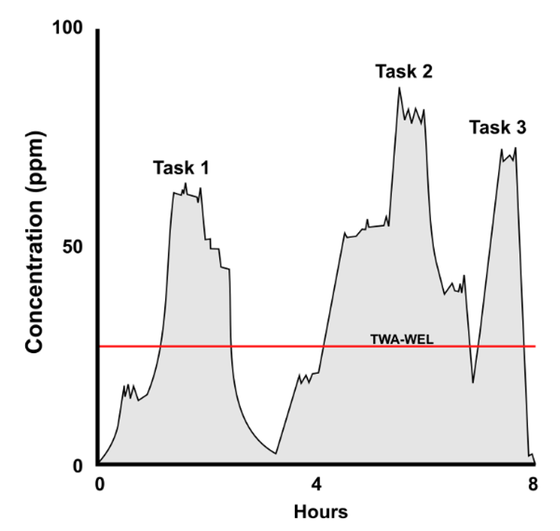 | 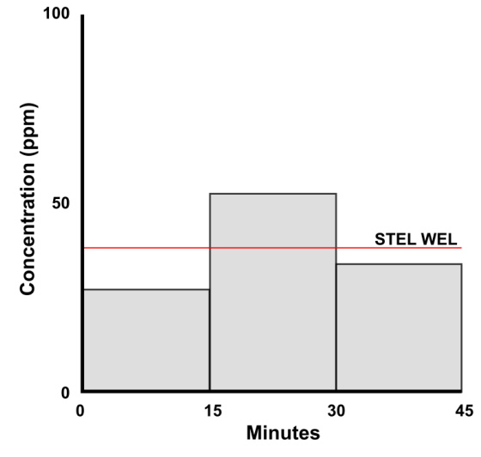
A. Typical exposure over a working shift compared to an 8-hr TWA exposure limit | B. Short-term exposure (15 minutes) compared to a STEL exposure limit
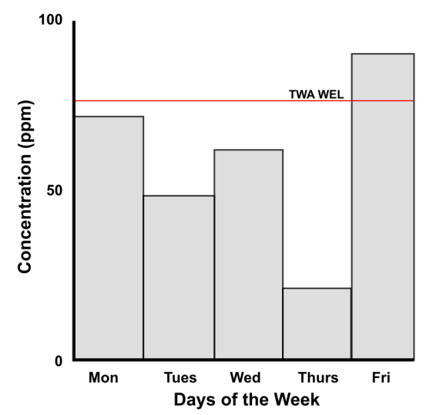 | 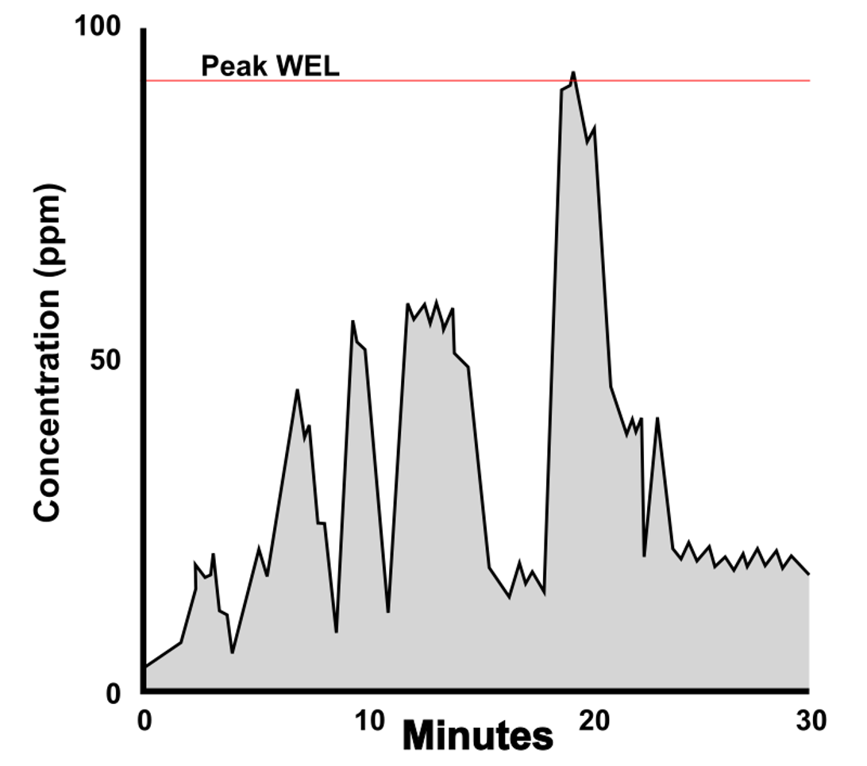
C. Daily variations in shift averages (8-hr TWA) | D. Real-time monitoring data logged across a range of activities during the shift
Figure 5: Sampling strategy and type of workplace exposure patterns

    - Personal monitoring
Samples used to assess workers’ exposure to airborne contaminants for comparison to the exposure limit can only be collected through personal monitoring conducted within the workers’ breathing zone. The breathing zone is defined as the hemisphere in front of the face, within a 30 cm radius of the nose, illustrated in Figure 6.
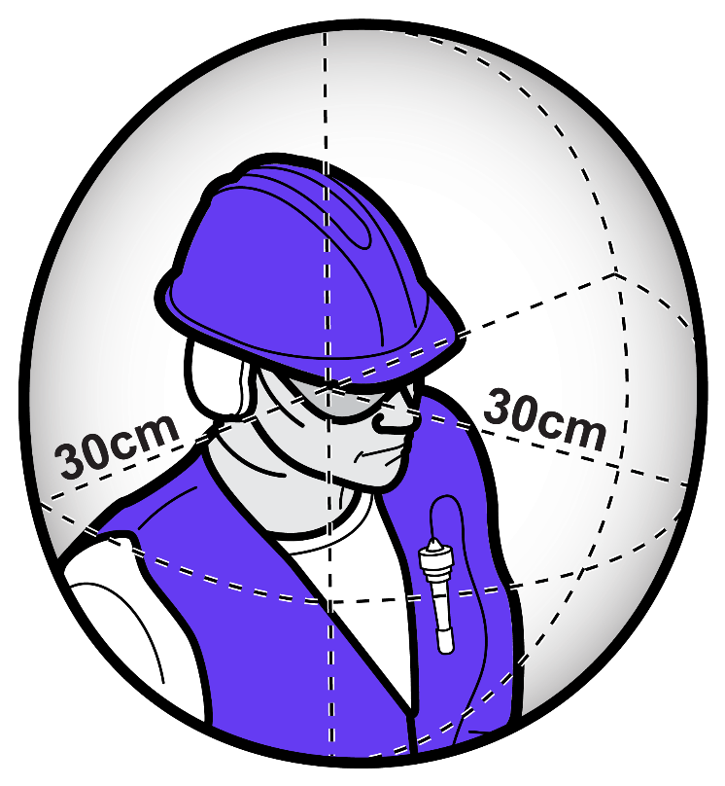
Figure 6: Breathing zone of a worker
Air monitoring is generally conducted outside any RPE or other PPE worn by the worker, to:
- measure the contaminant concentration in the worker’s breathing zone
- determine compliance with the exposure limit, and
- assess the effectiveness of controls.
An exception applies to welding fume assessments, where the sampling head may be positioned inside the welding helmet (where practicable) to better represent the air inhaled by the worker. However, this only applies when the welding helmet is not integrated with powered air-purifying respiratory (PAPR) protection. Where PAPR is used, it is recommended that sampling be undertaken outside the respirator.
    - Static sampling
Static or area monitoring involves positioning a sampling device at a fixed location within the workplace. The objective of static sampling is to assess the airborne contaminant concentrations in a defined area. This approach is commonly used to quantify background concentrations of contaminants, identify sources of emission or for control verification.
Static sampling results cannot be used to determine compliance with an exposure limit, and do not represent individual worker exposure. Instead, they may provide indicative information about potential exposure conditions within the monitored area.
  - Sampling methods
Measuring the exposure of workers to compare to exposure limits depends on good sampling techniques and accurate, precise and sensitive analysis methods that provide an acceptable degree of certainty.
The selection of an appropriate sampling method for sampling of airborne contaminants should be guided by the type of exposure limit being assessed:
- When assessing compliance with an exposure limit, the method needs to be capable of measuring exposure of a period of time that aligns with the applicable exposure limit (i.e., 8-hr TWA, STEL or Peak).
- For health-based risk assessment monitoring, you may need to consider whether the contaminant presents either acute or chronic effects.
  - For acute health effects: Use a method capable of identifying short-term or peak exposures. Real-time monitoring may be preferred.
  - For chronic health effects: Use full-shift sampling to determine the 8-hr TWA exposure.
- To evaluate control effectiveness, a method which demonstrates variability in air concentrations (e.g. a real-time monitor) may be more appropriate.
Select the appropriate type of sampling required for the situation (Section5.5), such as:
- active sampling using a pump to draw air through a sampling medium
- passive sampling using a diffusive sampling method, or
- real-time monitoring using an instrument which displays or logs data.
Grab samples may be used to identify contaminants of interest but cannot be compared with an 8-hr TWA, STEL or peak limitation.
Only validated methods, such as the Australian Standards, should be used. In the absence of an Australian Standard, other validated standards may be adopted, including:
- those recommended in AIOH Technical Papers,
- those published by the:
  - International Organization for Standardization (ISO),
  - US National Institute for Occupational Safety and Health (NIOSH) in the Manual of Analytical Methods,
  - US Occupational Safety and Health Administration (OSHA),
  - UK HSE in the Methods for the Determination of Hazardous Substances (MDHS), or
- those found on GESTIS AMCAW.
Guidance for sampling may also be obtained from the laboratory undertaking the analysis to determine which methods to use [9].

When selecting a sampling method, you should be familiar with relevant analytical methods and their sensitivity to determine the level of confidence associated with the measurement for determining compliance with the exposure limit. The selected method should provide results which provide sufficient confidence to be used for their intended purpose.
Where possible, the sampling method in conjunction with the analysis method should have a limit of detection (LoD) which is less than 10% of the exposure limit [10]. Guidance on the interpretation and management of sampling results is provided in Section 8.
The occupational hygienist should verify that the chosen sampling and analytical method is sufficiently sensitive to achieve an acceptable LoD/limit of quantification (LoQ). If this is not the case, you may need to identify a different laboratory or consider alternative sampling or analysis methods which may require a larger air sample being collected.
For some contaminants, it may not be possible to collect sufficient air sample for a worker’s personal exposure to be quantified, and therefore alternative methods of exposure assessment should be considered (see Section 5.13 Alternatives to air monitoring).
  - Sampling equipment
    - Active sampling
Active sampling involves drawing air through a sampling device using a mechanical pump operating at a pre-determined, controlled and calibrated flow rate, over a known period of time. This method allows the collection of airborne contaminants onto a collection medium (filters, sorbent media etc.) which are subsequently analysed to quantify the amount of contaminant present in the air.
When selecting equipment for the collection of airborne samples, it is essential to consider [11], [12]:
- Flow rate capabilities: The pump should have the capability to draw the required volume of air continuously over the period of monitoring, without the flow rate varying by more than the amount listed in the relevant method. This ensures that the sample collected meets the required sampling curve [3] for particles collected by the specific device.
- Flow stability: Pumps should be fitted with pulsation dampeners to smooth fluctuations [13] in the flow rate.
- Back pressure tolerance: The pump should have the capability to overcome resistance created by the sampling media and increasing pressure drop during sampling contaminants such as dusts.
- Size and weight: The equipment should be as light, small, non-intrusive and quiet as possible to minimise discomfort to the wearer.
For particulate sampling the sampling device you select should be validated for the relevant particulate size fraction.

    - Passive sampling
Passive sampling (also known as diffusive sampling) relies on natural diffusion or permeation of airborne contaminants onto a sorbent medium, without the use of a mechanical pump. The principle of operation is that the contaminant molecules diffuse from the air onto the sorbent due to a concentration gradient until equilibrium is reached.
Light-weight passive samplers (also referred to as monitors or badges) can be comfortably worn by workers for the duration of their shift. However, they have limitations in terms of the contaminants that can be measured. There are various types of passive samplers that are typically suited to vapour-phase contaminants known as volatile organic compounds (VOCs), such as benzene, toluene or formaldehyde, and mercury or gas phase contaminants such as ammonia, nitrogen dioxide, sulfur dioxide.
These samplers can only be worn by workers and are not suitable for static (area) sampling, because they rely on a minimum airflow across the monitor surface, usually generated naturally by worker movement, to facilitate adsorption of contaminants. If used as a static monitoring device, passive samplers may produce false negative results.
    - Real-time monitoring
Real-time monitoring refers to the continuous measurement of airborne contaminants using direct-reading instruments that measure and display (or log) data as exposure occurs. Unlike traditional sampling methods, which require sample collection followed by laboratory analysis, real-time monitoring provides near-instantaneous feedback on workplace conditions and the effectiveness of control measures.
Real-time monitoring devices were originally developed primarily as static or area instruments to evaluate the effectiveness of workplace controls. More recently, personal real-time monitors have become valuable tools for occupational hygienists, allowing:
- Identification of when exposures occur during a work shift,
- Association of exposure peaks with specific tasks or activities, or
- Collection of large datasets to characterise day-to-day exposure variability [14].
For some contaminants, laboratory-based sampling is impractical or inappropriate, for example, short sample hold times, absence of validated laboratory methods or contaminants subject to STEL or peak exposure limits. In such cases, real-time monitoring positioned within the worker’s breathing zone may provide effective means of assessing exposure consistent with STELs or peak limitations.
Using personal real-time monitoring to assess exposure against exposure limits should be discussed with your regulator to determine if it can be used to assess compliance. When assessing exposure using personal real-time monitoring, the quality control measures described throughout this document and the same threshold for best practice as described for active and passive sampling methods, should be met.

      - Key considerations for real-time monitoring
As with active or passive sampling, validated methods should be followed when using real-time monitors to assess workers exposures to contaminants (e.g. NIOSH Method 6604 [15]). With the growing use of real-time instruments, specific guidance has been developed to assist occupational hygienists in their application, including limitations and good practice considerations such as measurement periods and intervals [16], [17].
When selecting and using real-time monitors to assess worker exposures, a range of factors affecting the results should be considered:
- Instrument response and placement
- Suitability of real-time monitoring versus laboratory sampling
- Detection limits
- Sensor resolution and accuracy
- Chemical specificity and cross-sensitivities
- Particulate size fraction
- Alarm levels
- Baseline drift, and
- Understanding of how the monitor calculates the results.
These factors are explained in more detail in Appendix E.
      - Real-time particulate monitoring
In most cases, real-time particulate monitors are limited to measuring respirable dust and typically rely on using specialised sampling head which is designed to measure a specific particle size fraction [16], [17], [18]. Few instruments can measure the full range of inhalable dust, as most have an upper particulate sampling size limit well below 100 µm (AED 50% cutoff for inhalable dusts).
When using a real-time monitor to assess concentrations of respirable dust it is important that the sampling head used samples size fractions according to the appropriate sample curve (ISO 7708), and other device factors (e.g. factory calibration) are suitable for the intended sampling.
Calibration techniques and correction models can reduce bias and error. You should also consider environmental sensitivities, variability between devices, and dependence on reference instruments for recalibration when selecting a real time monitor.
The AIOH Technical Paper Minimising uncertainties when using direct reading dust monitoring instruments provides more information about use of real-time particulate monitors.
      - Real-time gas and vapour monitoring
Many gases and vapours are assigned a combination of an 8-hr TWA, STEL and/or peak exposure limit. Personal real-time gas/vapour monitoring can be used for measuring all exposure limits but are particularly useful for measuring STEL and peak concentrations because of their short response time. Real-time gas/vapour monitors can also measure against immediately dangerous to life and health (IDLH) values, which can be found in HCIS.
      - Comparison of real-time monitoring, active and passive monitoring
Table 2 outlines the advantages and disadvantages associated with the use of different sampling devices for personal and static monitoring approaches.
Table 2: Comparison of the benefits and limitations of air monitoring methods
Parameter | Personal monitoring |  |  |  | Static/area monitoring
Type of sampling | Active | Passive |  | Real-time | Active | Real-time
Purpose | Quantify worker exposure to airborne contaminants |  |  |  | Assess the effectiveness of workplace control  Establish baseline workplace conditions | Assess the effectiveness of workplace control  Determine sources of contaminants  Establish baseline workplace conditions
Location | Worn by an individual worker |  |  |  | Fixed in one position
Contaminants measured | Dusts & fumes (inc. chemical characterisa-tion), fibres, gases & vapours | Gases & vapours |  | Dusts, vapours & gases | Dusts & fumes (inc. chemical characterisation), fibres, gases & vapours | Dusts, vapours & gases
Particle size range/ capacity limitations | May become overloaded at high airborne concentrations, affecting data quality |  | Most instruments cannot capture the full inhalable fraction, as many are less than 30 µm |  | May become overloaded at high airborne concentrations, affecting data quality | Most instruments cannot capture the full inhalable fraction, as many are less than 30 µm
Uses | Evaluating worker exposure  Measuring compliance  Evaluating control effectiveness  Baseline workplace conditions |  |  |  | Evaluating control effectiveness  Baseline workplace conditions
Uses | Speciation of chemicals |  | Instantaneous results available |  | Speciation of chemicals | Instantaneous results available
Limitations | Requires workers to wear sampling equipment during work activities  May be subject to tampering  Worker may adjust work activities leading to results that are not representative of exposure |  |  |  | Cannot be used to assess compliance  Does not reflect individual exposure patterns, information gathering
Limitations | Wait times for results |  | Can’t do speciation unless monitor has additional capabilities |  | Wait times for results | Can’t do speciation unless monitor has additional capabilities
    - Calibration
All equipment used for sampling, such as sampling pumps and flow meters, needs to be calibrated against a metrologically traceable standard according to the manufacturer’s guidelines and/or appropriate standards [12], [19]. Flow rates should be measured using a flow meter or rotameter (a secondary standard) that has been calibrated against a primary standard (e.g. a film flowmeter/soap bubble meter) or using the primary standard directly This step is not required for passive monitors.
There are two forms of calibration:
- Flowrate verification, also known as a flow check, or in-field calibration
All airborne contaminant sampling that uses active sampling pumps, including real-time monitors, requires the flow rate to be set to the designated flow rate at the start of the sampling period. At the end of the sampling period, the flow rate needs to be checked again (verified), to ensure the flow rate has not deviated beyond the method-specific set tolerance.
- Periodic calibration, often undertaken as part of a maintenance and servicing program
Equipment, including pumps and secondary standards, should also be calibrated periodically (e.g. 6 monthly or annually). Ideally, the calibration of the sampling equipment is undertaken by a facility accredited by National Association of Testing Authorities (NATA) for the specific calibrations required.
Some real-time monitors require that you establish a calibration profile for a specific substance prior to sampling. Refer to the manufacturers’ guidelines for more information.
All sampling equipment should be part of a regular maintenance and servicing program.
  - Sampling media and analysis
When designing any airborne exposure sampling program, it is essential to ensure that the correct collection media is selected for the sampling method. It should also be compatible with the analytical technique to be used.
Examples of typical sampling media used during air monitoring and analysis are summarised in Table 3 and Appendix F.
Table 3: Examples of sampling methods, media and analysis
Contaminant | Sampling method | Sample media | Analysis
Elemental metal analysis (e.g. lead) | AS 3640 and analysed using HSE MDHS 91 | Polyvinyl Chloride (PVC) membrane filter | X-ray fluorescence (XRF) spectrometry
Inhalable dust | AS 3640 | PVC membrane filter | Gravimetric, pre- and post-weighing of filters
Respirable dust | AS 2985 | PVC membrane filter | Gravimetric, pre- and post-weighing of filters
RCS | AS 2985 | PVC membrane filter | Fourier-Transform Infrared Spectroscopy (FTIR) and/or X-ray diffraction (XRD)
VOCs | AS 2986.1  AS 2986.2 | Activated charcoal tube or suitable passive sampler | Gas Chromatography/Mass Spectrometer (GCMS)
Where possible, a laboratory with NATA accreditation for the specific analysis methodology required should be used. The laboratory should also participate in a Proficiency Testing program relevant to the analysis being conducted, such as for gravimetric, lead and asbestos (see Section 7.7).
A proper chain of custody (CoC) must be maintained throughout the sampling and analysis process. The CoC documentation should, at a minimum, include the dates of sample collection, the type of analysis required (including a copy of the request for analysis sent to the laboratory), confirmation of sample delivery to the laboratory, and any relevant transportation details.
Certain contaminants may also require special handling during transport, and these requirements should be established prior to sample collection. For example, VOC samples should be transported to the laboratory in a cooler with ice bricks, while formaldehyde samples should be wrapped in foil to prevent light exposure after sampling. You should also consider possible delays in transporting samples to the laboratory and any effect that may have on the sample.
Not all laboratories will report analytical results in the same way. There are several terms related to the smallest detectable concentration of an analyte which may be used:
- Limit of Detection (LoD): The lowest concentration that can be reliably detected and quantified.
  - For a laboratory this is the lowest analyte concentration reliably distinguished from the blank.
  - For air samples this is the lowest detectable concentration for the collected sample size.
- Limit of Quantification (LoQ): The lowest concentration the laboratory can measure with acceptable accuracy and precision. This level is often an order of magnitude higher than the LoD for the analytical method.
- Sometimes laboratories will provide a Limit of Reporting (LoR) instead, which is the lowest concentration of a substance that a specific analytical method can reliably report.
The LoD and LoQ levels may vary, depending on the analytical techniques used by the laboratory.

  - How to sample for 8-hr TWA
Sampling to determine the 8-hr TWA should be carried out over a full work shift, or as close to it as possible. Sampling should follow a recognised, validated method, and any deviations from that method be clearly noted and justified in the report. If full-shift sampling is not possible, you should refer to the relevant Australian Standard or equivalent to determine the minimum length of sampling.
The sampling duration should:
- allow collection of a sufficient volume of air so the presence of airborne contaminants above the LoD can be measured for the specific contaminant assessed, and
- be long enough to be representative of a workers’ exposure over a full shift.
Information on calculating minimum sampling times is available in Table 10 in Appendix G.
For compliance monitoring, sampling should be randomised and representative of the SEG to support unbiased comparison with exposure limits. Where representative sampling is not practicable, targeted sampling of worst-case exposure scenarios may be undertaken to support conservative assessment of compliance.
For exposure assessment and risk characterisation (e.g. health risk assessment), sampling should aim to be randomised and representative to describe typical exposure profiles and variability with the SEG. This may not always be achievable due to operational constraints, safety considerations or access limitations; however, efforts should be made to minimise bias in sample selection.
The timing of a sampling program should be determined in consultation with the PCBU and, ideally, conducted during periods when all relevant processes are operating. Sampling data only represent conditions on the day of testing. For this reason, it is important that the person undertaking the monitoring be present for the entire sampling period to record observations on the workplace conditions and the activities performed by the worker.
Where direct observation is not possible, for example where multiple samples are collected in different work locations, workers' field sheets should be completed and verified. In these cases, workers should also be interviewed following the sampling where possible. Appendix D gives an example of the type of information which should be collected.
  - How to sample for STEL
When measuring for a STEL, samples should be collected over 15-minutes, in accordance with a validated methodology. Sampling should be representative of the workers’ highest exposure tasks during the shift, which may require multiple samples to be collected, as shown in Figure 5(B), due to short-term variations in exposure levels. In some cases, you may need to consider a sampling method that allows high flow rates to be drawn through the sampling media supported by equipment that can maintain those flow rates reliably.
It is essential to ensure the specified flow rate through the sampling train is maintained, that sampling is conducted in accordance with the validated methodology and that the sample analysis is conducted in accordance with the method for the analyte of concern.
If a real-time monitor is validated for the contaminant of interest, it may be used to measure airborne concentrations over shorter periods (e.g. specific tasks) and peak exposures. These instruments may help to identify when high concentration exposures may occur.
  - How to sample for peak limitation
Peak exposures are measured to ensure that very high, short-duration exposures of workers are not above the peak limitation exposure limit for a specific contaminant. A peak limitation is a maximum or peak airborne concentration of a particular substance determined over the shortest analytically valid time period, not exceeding (i.e. not longer than) 15 minutes.
Similar to STEL sampling, sampling for peak exposures has the same challenges of predicting when high exposures may occur. To capture a peak exposure, you need to use methods that can respond quickly, such as real-time monitors (that are validated for the contaminant of interest). These monitors allow you to track fluctuations in airborne concentrations and identify when the highest concentrations occur, which can then be used to determine whether the peak limitation is exceeded.
Grab samples are not appropriate when comparing results to the peak limitation, as they are often unreliable. Where peak limits are specified, you should ensure your sampling strategy is sensitive and responsive enough to detect these very short-term excursions, not just the 15-minute average represented by STELs.
  - How to sample task-based exposures
Task-based exposures are measured to understand the exposure that occurs during specific tasks, particularly those that vary on a weekly, daily or even hourly basis. In contrast to 8-hr TWA exposure limit sampling, which provides an average exposure across the shift, task-based sampling focuses on short periods of activity that may present higher risks. This approach is useful when workers carry out short, high-risk tasks that may contribute disproportionately to their overall exposure, such as:
- welding activities,
- batching processes, or
- carrying out intermittent tasks at construction sites.
To measure task-based exposures, you should start sampling just before the task begins and stop once it is complete. Make sure the equipment and sampling methods you use are appropriate for the contaminant of interest and capable of collecting a sufficient sample for analysis. Appendix G shows how to determine minimum sampling times based on the sampling technique and the laboratory LoQ for the specific contaminant/s for task-based activities. If the length of the task is too short, you may not be able to obtain a representative sample, and the sampling would be considered invalid.
Real-time monitors are useful in these scenarios, as they log how exposure levels change during the task, helping to identify which part of the activity poses the highest risk. Task-based monitoring is not designed to demonstrate compliance with exposure limit on its own, but it can provide valuable information for developing control strategies and managing the highest-risk parts of the job.
Passive monitors are not suitable for task-based or short-duration exposure assessments because the sampling period is usually required to cover the full shift to compensate for the low sampling flow rate.
  - Quality control in air monitoring
Air monitoring conducted for comparison with exposure limits should be carried out by qualified professionals, as outlined in Section 4.2, using validated methods such as Australian Standards, International Standards or methods such as those published by the NIOSH, OSHA or the UK HSE. Quality control procedures within methods, such as the use of blanks and adherence to sample hold times should be followed, and any deviations from these methods should be noted within reports, along with their justification.
Equipment used for air monitoring should be subject to an auditable, documented maintenance program and calibrated in accordance with relevant standards and NATA requirements [12],, [13]. This includes the use of flow calibrators, pumps and other verification devices.
  - Limitations of air monitoring
Air monitoring is an important tool for assessing workplace exposures, but it does have limitations. When interpreting results, they should always be considered in conjunction with observations of the work environment, tasks performed and worker behaviours during the sampling period. Without this context, there is a significant risk of misinterpreting the data or overlooking important factors that influence exposure. Table 4 summarises key limitations associated with air monitoring.
Table 4: Limitations associated with air monitoring
Limitation | Description
Snapshot in time | Sampling results only reflect exposures on the day, and during the period of sampling; they may not capture variability across different days, shifts, or tasks
Limits of detection | All sampling methods have minimum limits of detection; which depend on the volume of air that is sampled and the lowest concentration of a substance that a specific analytical method can detect and reliably report
Short-term/peak events | Peaks are difficult to predict and may be missed if monitoring does not coincide with the event, or is averaged over a longer sampling period
Equipment and method constraints | Incorrect flow rates, unsuitable media, or environmental factors (temperature, humidity, cross-contaminants) can affect accuracy
Passive monitors | Require long sampling times, making them unsuitable for task-based or short-term exposures
Cost and resources | Monitoring can be expensive and time-consuming, limiting the number of samples that can be collected
Worker variability | Exposures differ between workers due to differences in tasks, behaviours, and location in the workplace
Need for good/ direct observations | Monitoring data should be supported with detailed observation of work practices, conditions and controls in place to make informed conclusions
  - Alternatives to air monitoring
Air monitoring may sometimes be impractical due to constraints such as timing, lack of validated sampling methods, limitations in analytical techniques, or access to appropriate equipment or suitably trained professionals to undertake the monitoring.
Accurately measuring the exposure of workers to compare to exposure limits depends on good sampling techniques and accurate, precise and sensitive analysis methods that provide an acceptable degree of certainty. For some airborne contaminants the availability of methods for measurement at the exposure limit with an acceptable degree of certainty is a challenge. If the LoD is high relative to the exposure limit or close to the exposure limit, confidence in the measurement is reduced.
In such cases, alternatives to air monitoring should be considered. These methods may also enable you to assess exposure via routes other than inhalation.
These methods cannot be used to assess compliance with the exposure limit in the place of air monitoring, but they can provide evidence to demonstrate that the PCBU can be reasonably certain workers are not being exposed above the exposure limit in accordance with Regulation 50, such that air monitoring is not required.
    - Biological monitoring
Biological monitoring, such as urine or blood testing, may be used to assess exposure by measuring the biological load of a contaminant or its metabolites, thereby accounting for all routes of exposure. This approach is particularly useful where inhalation is not the primary route of exposure.
Biological monitoring may be carried out as part of health monitoring required under the WHS Regulations or can be used independent of health monitoring to assess workers’ exposure to a contaminant.
    - Modelling and use of existing data
In some circumstances, exposure modelling data can be used to estimate airborne contaminant concentrations to characterise inhalation exposure profiles and may be used to assess health risk from exposure to airborne contaminants.
It may also be possible to use existing air monitoring data to assess workers’ exposure to an airborne contaminant. The Code of Practice: Managing risks of respirable crystalline silica in the workplace allows for the use of statistically valid exposure data to assess whether a PCBU can, with reasonable certainty, determine whether or not the airborne concentration of RCS at the workplace exceeds the exposure limit, provided the data are relevant to the work involving RCS at the workplace.
When considering modelling with the use of existing data, a workplace inspection should be conducted to ensure the model reflects the work being done and the potential airborne exposures.

    - Qualitative methods of assessment
Qualitative methods provide useful insight into whether an exposure risk exists or not. Examples of qualitative methods and observations include:
- Housekeeping: Is visible dust or chemical contamination present in the workplace? Remember that many contaminants of concern are not detectable by the human eye.
- Odours: Can you detect any unusual smells? (see Section 9.4 for limitations of odour thresholds). Noting that many workers who spend extended periods in a specific workplace may become desensitised to its odours and odour thresholds cannot be used as part of an assessment of risk.
- Health reports: Are workers reporting symptoms of ill health either while at work or after work?
    - Control banding
Control banding was developed as a practical tool to manage the risk resulting from exposure to substances in the absence of toxicological and exposure information.
It involves grouping workplace risks into control categories or “bands”, based on simple hazard and exposure information. Broad controls (e.g. containment) are applied to all substances within that band. Because there are a limited number of approaches to hazard control, a detailed assessment of the exposure risk is not required. Application of controls targeted at the expected exposure levels and exposure routes will be adequately protective for a range of hazards.
Control banding was developed in the late 1980s, primarily for use by small and medium-sized businesses, in response to limited knowledge about the potential health impacts of chemical-based products, particularly in manufacturing industries. Today, control banding is widely used, as it provides a practical approach where the cost of employing suitably qualified and experienced occupational hygienists may be prohibitive.
Control banding is not intended to replace air monitoring, but it can be valuable during the risk assessment process to help prioritise which exposures need to be controlled and determine when monitoring may be required [21].
- Adjustment of exposure limits
  - Adjusting time-weighted average exposure limits for extended work shifts
Exposure limits have been established on the assumption that workers are exposed to a contaminant for no more than 8 hours a day, 5 days a week (a typical 40-hour work week). This is because when workers are not at work, their exposure to the contaminant stops, giving their bodies time to recover and remove the substance and/or its metabolites before the next shift starts. When work shifts extend beyond 8 hours a day or differ from the usual work pattern (5 work days followed by 2 non-working days), the balance between exposure and recovery is disrupted.
Many contemporary workplaces do not operate on the traditional 8-hour, 5-day work pattern. Some industries implement extended shift rosters, with shift durations typically ranging from 10 – 12 hours over several days, followed by a period of rest. Depending on the shift pattern (longer daily hours, consecutive long shifts, or compressed weeks), workers might have less time to recover between exposures, potentially increasing cumulative exposure. In such cases, the exposure limit may need to be adjusted to reflect these differences and provide adequate protection.
Several models have been developed to adjust exposure limits for extended work shifts. Most Australian regulators and workplaces have adopted the AIOH shift adjustment tool, which is based on the Quebec model, and has been specifically adapted for Australian use [22]. The AIOH shift adjustment tool includes a decision pathway that will guide the user to select the appropriate shift adjustment approach based on the contaminant and work patterns. In some cases, the tool recommends applying the Brief and Scala Model, rather than the Quebec model. The Brief and Scala model is a relatively simple mathematical model based on the number of hours worked per day, week or month.
Other shift adjustment methods include the OSHA model and Pharmacokinetic-based models [23]. When calculating using any shift adjustment methods it is only the exposure limit which is adjusted and never the exposure data obtained from the air monitoring.
Where a shift adjustment reduces the exposure limit below the quantifiable range for field sampling analysis, rather than applying an adjustment that exceeds the analytical capability, the occupational hygienist should use professional judgement, prioritise control verification, and document the rationale for the decision in your report.
    - Quebec model
The Quebec model considers the length of exposure, the toxicity of the substance and the number of days worked in a month. In Australia, this is most commonly done using the Excel-based WEL Shift Adjustment Tool. This tool has been developed using health-based data from the same evidence sources used in the setting of the exposure limit [24].
Before using this tool, you should have a clear understanding of the work shift patterns. For example, do workers follow a standard roster of 8 hours per day 5 days a week, with 2 days off, or do they work extended rosters such as 12-hour shifts for 8 days consecutively, followed by 6 days off. Examples of how to use the AIOH WEL Shift Adjustment Tool are shown in Appendix H.
    - Brief and Scala model
The Brief and Scala model [25] is a conservative approach based solely on the exposure time. It mathematically produces a value known as the reduction factor (RF), which is then applied to the exposure limit, to adjust for extended shifts. A separate RF calculation is required for each type of shift roster, for which data was collected and reported.
Traditionally, this method has been the primary tool for modifying exposure limits for workers on extended shifts. Due to a focus on exposure duration and recovery time alone, the method produces conservative, “worst-case scenario” results, which do not consider the specific toxicological properties of the airborne contaminant.
For example, when transitioning from an 8-hour shift to a 12-hour shift, the exposure limit is reduced by half to reflect the increased exposure duration and decreased recovery period for all airborne contaminants, regardless of their specific toxicology.
The calculation of the 8-hr TWA reduction factor to be used based on the Brief and Scala model is:
Daily exposure [24]:
$$RF= \frac{8}{h}×\frac{24-h}{16}$$
Where:
RF = reduction factor
h= hours worked per shift
Note that 24-h represents the exposure free hours per day
If you are adjusting the exposure limit for a work pattern that is 7 days or more in a row, you should use the following formula:
Weekly exposure [24]:
$$RF= \frac{40}{h}×\frac{168-h}{128}$$
Where:
RF = reduction factor
h= average hours worked per week per roster cycle
Note that 168-h represents the exposure free hours per week
Worked examples of the Brief and Scala model are provided in Appendix H.
  - Peak limitations or short-term exposure limit values
Contaminants associated with acute health impacts are usually assigned a STEL or peak limitation. Shift-adjustments do not apply to STELs or peak limitations, as these limits are specifically designed to protect workers from defined acute health impacts and should therefore not be altered.
- Data analysis
Once air monitoring is complete, the samples should be analysed and the exposure results interpreted. The purpose of data analysis is to understand the variability of exposure, determine whether risks are controlled, and support decisions on compliance and worker protection. Statistical analysis allows you to move beyond individual sample results and make informed judgements about SEGs, tasks and/or workplaces, and to demonstrate with an acceptable degree of certainty that workers’ exposures are not expected to exceed the exposure limit at any time, not just at the time sampling was conducted.
The following section outlines considerations for analysing exposure data, including managing uncertainty, understanding variability between and within workers’ results, applying statistical tests such as analysis of variance (ANOVA), and dealing with censored data and outliers. Quality assurance measures are also described to ensure results are reliable and defensible. The first step in any statistical analysis is to assess the uncertainty of the measurements, as this forms the basis for interpreting all subsequent results.
  - Statistical foundations for assessing exposure data
Traditional (frequentist) statistical analysis can be applied to data that are either normally or log-normally distributed. Bayesian methods, commonly used in exposure assessment, are well suited for log-normally distributed data [26], which combines monitoring results with prior knowledge and professional judgement, making it particularly useful when sample sizes are small or when predictive modelling is required. Both approaches aim to increase confidence in the conclusions drawn from limited and variable exposure data.
To conduct such an analysis effectively, you require a basic understanding of the underlying statistical principles [26] and the properties of the exposure results. Without this foundation, valid conclusions cannot be drawn about exposure levels, compliance, or risk management.
    - Distribution of exposure data
In occupational hygiene, exposure results are usually log-normally distributed rather than normally distributed. This means that:
- most results are below the arithmetic mean (average)
- a few results may be very high, and
- the distribution of results is skewed rather than symmetric.
You should therefore generally apply statistical methods that are appropriate for log-normal data as using methods designed for normally distributed data will give misleading results. Where statistical analysis produces both normal and log-normal summary statistics, the log-normal statistical parameters should be used.
    - Occupational hygiene data and statistics
Occupational hygiene data should be statistically analysed and interpreted by a suitably qualified and experienced person, or under the supervision of one. To assist in doing statistical analyses, software packages/macros have been developed, such as IHSTAT®, Expostats [27], Hyginist and IHDataAnalyst. In Australia, the most commonly used packages are IHSTAT® and Expostats, which handle censored data differently (see Section 7.4). Table 5 compares these statistical packages.
Table 5: Comparison of different statistical packages commonly used in Australia
 | IHSTAT® |  | Expostats
 | IHSTAT® (v2.0) | IHSTAT® Bayes | Tool 1  Data interpretation for 1 SEG | Tool 2  Data interpretation accounting for between-worker variations | Tool 3  Determinants of exposure
Type of Analysis | Frequentist | Bayesian | Bayesian
Data Distribution Types
Test for distribution fit
Normal
Lognormal
Calculation Parameters
Percent censored (%<LOD/LOQ)
Maximum (max)
Minimum (min)
Median
Percent above OEL (%>OEL)
Arithmetic mean (AM)
Arithmetic standard deviation (SD)
Geometric mean (GM)
Geometric standard deviation (GSD)
Inference statistics population parameters
Percent above OEL (%>OEL)
Estimated arithmetic mean (MVUE)/inferred population mean
25th Percentile
75th Percentile
95th Percentile
UTL_{95%,70%}
UTL_{95%,95%}
UCL_{70%}
UCL_{95%}
An important factor to be considered when choosing a software package is how it applies to small number of samples, censored data, and results below the LoD. For most statistical analyses, a minimum number of samples is needed, which is normally 6 samples [6]. Where the number of samples to be collected in a SEG is above 20, and the range of results in the SEG is small, increasing the number of samples will not improve the precision nor reduce errors.
Statistical packages provide a range of information [20], [26] on the exposure, such as:
- Arithmetic mean (AM): an estimate of health risk to determine the risk of long-term chronic disease. It is used to calculate an estimate of the population mean for normal distributed data sets.
- Estimated arithmetic mean (MVUE)/ Inferred population mean: a preferred estimate of health risk to determine the risk of long-term chronic disease. It is used to calculate an estimate of the population mean for lognormal distributed data sets.
- Geometric mean (GM): which represents the central tendency of lognormally distributed data.
- Geometric standard deviation (GSD): a dimensionless value that shows the variability in exposure data. The higher the GSD, the greater the variability and it indicates whether the SEGs have been correctly designed, or that there is high variability within the tasks undertaken within the SEG. The smaller the GSD (close to but above 1), the better the similarities in exposure profiles, but if the GSD is high (>3), then the SEG may need to be reclassified.
- 95% upper confidence limit (UCL): the value where 95% of all possible estimates of the actual arithmetic mean of the SEG lies below. This means that if the 95% UCL is below the exposure limit, then there is a high likelihood that the average exposure of the SEG is below the exposure limit. If only a small number of samples are used the estimate of 95% UCL will be large in relation to the arithmetic mean.
- Exceedance fraction or predicted precent above exposure limit: (%>exposure limit): calculates the percentage of all population exposures that may exceed the selected exposure limit.
- 95th percentile: the value at which 95% of all possible exposures in the SEG are expected be below.
- 95%, 95% upper tolerance limit (UTL95%,95%): the value at which 95% of all possible estimates of the 95th percentile level lies below. This measure is extremely sensitive to exposure variability and may be used to look at contaminants that have acute toxic effects.
Appendix I1 shows examples of the outputs of statistical analysis using IHSTAT® (v2) and IHSTAT® Bayes and Appendix I2 shows a statistical analysis output using Expostats.

  - Sources of error and uncertainty
When analysing exposure data, it is essential to recognise that every measurement contains both error and uncertainty. Workers, work shifts, tasks, equipment and operating conditions all introduce variability that influences the measured concentration.
Errors relate to the factors that influence the measurement itself, whereas uncertainty reflects the range within which the true value is expected to lie, based on the sampling and analytical methods used. Transparent reporting of uncertainty increases confidence in the results, because it makes the limits of precision explicit rather than keeping it hidden. Common sources of uncertainty and error are shown in Figure 7.
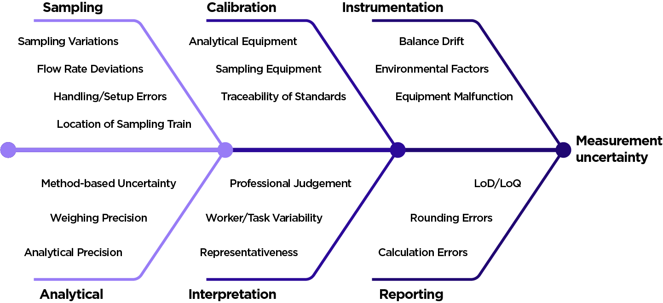
Figure 7: Sources of uncertainty and error when measuring airborne contaminants
    - Sources of error
Measurement data can be affected by two types of error:
- Systematic errors
When the results are consistently reported as higher or lower than the true value. An example is when a flow calibrator/meter incorrectly indicates the flow rate as 2.5 L/m when the actual flow rate is 2.1 L/m [28].
- Random errors
When small, unpredictable factors lead to inconsistent results each time. An example could be variability in flow rate.
      - Sampling Errors
A major contributor to measurement error comes from the sampling process. The placement of the sampling train, the representativeness of the location within the breathing zone, and the extent of particle losses through surface deposition all influence how accurately airborne contaminants are captured.
Flowrate is also a critical component of sampling, but it is important to distinguish how flowrate variability is treated. Acceptable limits for flowrate variability are specified in the relevant methods, such as Australian Standards (e.g. AS 3640 or AS 2985).
If the sampling pump operates within the applicable limit for flowrate variation, the measured flowrate variation is directly incorporated into the air volume calculation used to determine concentration. Because of this, flow variation is already accounted for in the calculation of the concentration and should not be reported again as a separate percentage error. Flowrate variability should be noted in the report methods section as being within the required limit as specified by the method.
      - Calibration Errors
Calibration is another source of potential error. Volumetric errors can arise if pre- and post-sampling calibrations are not conducted correctly, or if the calibrator itself has unaccounted error. The traceability and accuracy of the reference standard, leakage checks, and pump performance all contribute to how well the sampled air volume is known.
Similarly, the weighing of filters before and after sampling introduces error, particularly when dealing with very small changes in mass, or if using different balances for the gravimetric weighing. Laboratory balances, environmental conditions, and weighing protocols are all part of this calibration-related error. These factors do not need to be individually listed in a report, but you should be clear about whether sampling and calibration were performed in accordance with relevant standards using traceable equipment.
      - Instrumental variation
Instrumental variation relates largely to the analytical process. Accredited laboratories quantify the error associated with analytical precision, weighing repeatability, and any instrumental drift that may occur during analysis.
It is recommended that the analytical error should be reported with the final concentration in an occupational hygiene assessment (result ± error). Reporting this value does not reduce confidence; rather, it increases the reliability of the data by providing the reader with clear information about the measurement’s precision.
    - Sources of uncertainty
In contrast to errors, uncertainty indicates the range within which the true measurement result may lie, and this is dependent on the sampling and analytical techniques used.
Reporting uncertainty improves the confidence in the results and uncertainty should be included in reports [9], [29], [28], [30]. Accredited laboratories will always report this in their results.
Data should be presented correctly and not reported to more precision than the method allows. For example, if the method states that results when using a 6-place microbalance should be reported to 2 significant figures, results could look like:
- 0.012mg/m³
- 1.2mg/m³, or
- 12mg/m³.
Active sampling trains for particulates are normally reported to 2 decimal places, e.g., 1.23 mg/m³, whereas for gases and vapours above 1 ppm are normally rounded to the whole number.
Results from real time monitors should only be reported to the number of decimal places measured by the instrument, e.g. an instrument that only measure to one decimal place can only be reported to 1 decimal place, e.g., 12.3 ppm.
You should always report your results in accordance with the requirements of the relevant Australian Standard or other method.
    - Accuracy and precision
Figure 8 illustrates the distinction between accuracy and precision. Accuracy refers to how close a measured result is to the true value, whereas precision refers to the consistency of repeated measurements with each other, regardless of whether they are close to the true value. Measurements may therefore be precise while also being inaccurate.
In occupational exposure monitoring, these concepts can be difficult to evaluate because the true exposure level is generally unknown. Sampling is undertaken to estimate exposure rather than measure it directly, meaning accuracy cannot be assessed in the same way as under laboratory conditions or instrument calibration. In addition, other factors, such as inter-worker variability, can also influence the observed results.
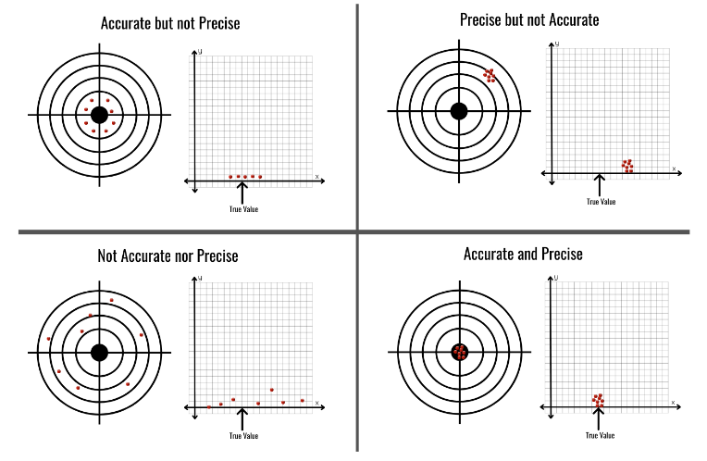
Figure 8: Illustration of accuracy versus precision
    - Worked example
A laboratory reports a result of 1.46 mg/filter for softwood dust with an analytical uncertainty of ±0.02 mg. The limit of quantitation for this method is 0.01 mg/filter. If 0.80 m³ of air was sampled (based on the logged flow within the acceptable range of variability), the concentration is calculated as:
C = $\frac{1.46mg}{0.8 m^{3}}$
C = 1.83 mg/m³
The analytical uncertainty for this volume of sample is calculated as:
C = $\frac{0.02mg}{0.8 m^{3}}$
C = 0.025 mg/m³
Rounded appropriately, the result is: 1.83 ± 0.03 mg/m³
The LoD for this volume of air is 0.0125 mg/m³. This means that results greater than this value can be reported with confidence, and results below this value cannot be quantified with accuracy. This result is below the inhalable softwood exposure limit of 2 mg/m³.
Because the uncertainty range (approximately 1.80–1.86 mg/m³) does not overlap the exposure limit, the measurement supports a conclusion that the sampled exposure was below the limit. However, as the value approaches 90% of the limit, it is appropriate to caution that future exposures under different conditions could exceed the limit and that controls should be reviewed.
In this example, flowrate variation is not reported as a separate uncertainty because it is already incorporated into the sample volume used in the calculation. Reporting it again would incorrectly inflate the total uncertainty.
  - Analysis of variance (ANOVA)
ANOVA is a statistical method used to separate and quantify the different sources of variability in exposure data. It helps you determine whether most of the variation in exposure comes from differences between workers, or from differences within the same worker across day and task.
Total exposure variation within a SEG includes both:
- Within-worker variation: differences in a single worker’s exposure over time, and
- Between-worker variation: differences in the average exposures of different workers.
This distinction is critical: where between-worker variation is high, workers within the same SEG experience very different levels of exposure, and individual assessment may be required. If within-worker variation dominates and group-level (SEG) analysis may be sufficient. The relative contribution of between- and within-worker variance is determined using ANOVA. This procedure compares between-worker variance with total variance and is described in standard occupational hygiene statistics references [8].
The calculation can be performed in Excel, and an example is provided in Appendix J. A meaningful ANOVA requires a substantial number of samples and a clear statistical definition of compliance. These conditions are not always met during air monitoring, particularly in workplaces where only a small number of samples have been collected.
  - Censored data
There are different methods [20] for dealing with analytical results that are below the LoD/LoQ. These results are commonly called “left-censored data”. Historically the most common method of handling this data was to divide the LoD by 2 (LoD/2) or divide the LoD by the square route of 2 (LoD/√2). With the availability of several statistical packages in occupational hygiene, better methods are now readily available. Packages that use the β-substitution method are considered to handle this type of data best [31], [32], [33] but can be computationally difficult.
One program that is available is NDExpo which was developed specifically to treat of censored data (non-detects) in occupational hygiene sample results. Software packages such as IHSTAT® (v2), IHSTAT® Bayes (v2) and Expostats include this in the statistical analysis of the exposure data (see Section 7.1.2).
For assessment against the exposure limit, samples should only be collected if the subsequent analysis technique is sensitive enough to provide a result at a LoD/LoQ which is commensurate with the relevant exposure limit. In such cases, you may need to identify a different laboratory, consider alternative sampling or analysis methods, or whether a larger air sample can be collected. For some contaminants, it may not be possible to collect air samples which allow worker exposures to be quantified, and alternative methods of exposure assessment should be considered.
  - Outliers
Outliers are results that differ significantly (high or low) from the rest of the data obtained for a SEG. You should investigate and document the reason for the difference, such as:
- High results may arise from equipment or control failures, non-routine events such as chemical spills or emergencies, or unusual work activities such as major process clean-up or overhaul.
- Low results may occur if the process is not working for part of a shift or if the workers spent significant time away from the exposure source (e.g. in their office). The work activities conducted on a sampling day should be indicative of a regular workday.
The potential causes for high or low results should be identified through the occupational hygienist’s recorded observations on a task record and supported by documentation of the worker’s activities during the sampling period (for example, through an exposure diary or record of post-shift discussion with the worker). Unless there is a valid and documented reason to exclude the result, it should be in the exposure data for the SEG.
  - Void samples
Void samples are those that have been compromised during collection, transport, or analysis, rendering the results invalid and unsuitable for inclusion in the dataset. Common causes include:
- Sampling media issues:
- Filters damaged before or during loading or filters that were loaded incorrectly.
- Overloaded samples, where the captured contaminant (such as dust), falls off the filter, or the backup section of a sampling tube exceeds the maximum amount relative to the sample amount.
- Presence of oversize particles on filters outside the size range of a specific size selective sampling head e.g., visible particles on the filter.
- Water-damaged filters.
- Filters damaged by heat, such as during sampling of welding.
- Equipment issues:
- Pump failures, such as stopping due to low battery or excessive back pressure.
- Sampling train disturbances, including pumps or tubing that became dislodged, disconnected or moved during sampling.
- Pump and sampling train not worn by worker (e.g. left in the crib room).
- Flow rates outside of accepted variations.
- Interrupted sampling periods or sampling durations shorter than the minimum required time.
Normally, these samples are not sent for laboratory analysis nor included in any statistical analysis of exposure data. These samples should be reported as void (invalid) samples.
Where laboratory analysis indicates that a sample is overloaded, the reported value should not be used for statistical analysis. The result may instead be reported descriptively as greater than the concentration reported by the laboratory. For example, if the laboratory report indicates that the sample is overloaded above 5 mg/m³, the result may be reported as “overloaded” or “>5 mg/m³” in the report.
  - Quality assurance and control
Quality control in the competence of people performing air monitoring and equipment/methods used in air monitoring are vital to collecting appropriate samples to quantify airborne contaminants. Air monitoring should be conducted by a trained professional, such as a suitably qualified and experienced occupational hygienist. See Section 4.2 for more information. There is NATA accreditation for the measurement of air volumes and field sampling methods.
Quality control in laboratory settings consists of two components:
- The first is internal quality control, where the laboratory ensures correct handling, preparation and analysis of all samples through validated procedures.
- The second is via proficiency testing through an external provider for specific analytes (e.g. asbestos, metals and respirable crystalline silica).
Both types of quality assurance are required to be undertaken by facilities accredited by NATA for compliance against ISO 17025.
You should ensure that any laboratory used to analyse occupational hygiene samples has appropriate quality control programs in place. This is essential to ensure the results are valid, defensible and meet regulatory and professional standards.
- Result interpretation
  - Statutory compliance
Regulation 49 of the WHS Regulations requires a PCBU to ensure that “no person at the workplace is exposed to a substance or mixture in an airborne concentration that exceeds the exposure limit for that specific substance or mixture”.
To meet this requirement, air monitoring results need to show that a person’s exposures are not expected to exceed the exposure limit at any time, not just that the exposure limit was not exceeded at the time the air monitoring was conducted. To demonstrate this with an acceptable degree of certainty, it may be necessary to consider the results of statistical analysis of the air monitoring data.
Exposure limits are not a target or safe level – a PCBU must keep exposure as low as reasonably practicable, not just below the limit. Compliance with the WHS legislation will require PCBUs to be able to show all reasonably practicable control measures are in place (and working) to minimise risks to health from exposure, as well as ensuring exposure is not above the relevant exposure limit.
To show compliance with Regulation 49 will require determination of a person’s exposure, which can take into account the protection provided by RPE, provided certain conditions are met. This includes that RPE can only be used to minimise risks after all other reasonably practicable higher order controls in the hierarchy of control measures have been implemented. This is discussed in more depth in Section 8.4.2.
The results of air monitoring should not be altered or adjusted based on extended work shifts (which may be used to adjust the exposure limit itself) or the protection factor of worn RPE. When considering the effect of RPE on compliance, the measured exposure concentration should still be reported, but can be accompanied with a statement that this is not considered an exceedance due to the use of RPE.
  - Action levels
Action levels (also referred to as action limits or trigger levels) are a risk-management tool adopted to prompt early intervention before contaminant exposures reach the assigned exposure limits.
Action levels are not mandated under the WHS Regulations, but rather can be used as a practical trigger point for control verification, to determine air monitoring frequency and to assist in determining whether health monitoring is required.
In some cases, a pragmatic approach is to define the action level as either a proportion of the exposure limit (e.g. 50%) or the lowest reliably measurable concentration above the analytical LoQ.
Action levels may still have benefit where the exposure limits are very low, or close to the LoQ, but they should be set realistically in the context of measurement capability. Recent research [34], indicates that the appropriate level of an action level depends on the variability of the exposure data. For highly variable data (Geometric Standard Deviation (GSD) > 3), an action level as low as one third of the exposure limit may be warranted, whereas for more uniform data (GSD < 1.3), the level may be set closer to two thirds of the exposure limit. When statistical analysis is applied, exceedance of an action level should be interpreted as a trigger to review existing controls, not as an indicator of compliance with an exposure limit.
  - Reporting results
Air monitoring results should be presented clearly, accurately, and in a format that is transparent, traceable, and reproducible. Reports should be written in plain, professional language, drawing on current best practice, and referencing any specific jurisdictional requirements.
Workers who have worn personal sampling devices should receive a written copy of their individual results. This should include an explanation that helps them understand the context and meaning of their results and indicates where they can obtain further information or assistance if required. Members of the same SEG should have access to de-identified group results, presented alongside a comparison to the applicable exposure limit or shift-adjusted exposure limit, as appropriate.
Where results indicate elevated exposures, the report should include recommendations for control review or improvement, ensuring that findings are actionable and aligned with the hierarchy of control measures.
A typical occupational hygiene report has the following components:
- Title page
- Executive summary – which should summarise what was done and when, major results and conclusions along with major recommendations. Normally not more than a page.
- Table of contents (except small reports e.g. less than 5 pages)
- List of tables and/or figures (except small reports e.g. less than 5 pages)
- List of terms and abbreviations
- Introduction
- Relevant legislation and workplace exposure limits
- Workplace and work activity description
- Methods
- Results (including uncertainty) and findings
- Limitations
- Discussion
- Conclusions and recommendations
- References
- Appendices
Some sections may be divided into subsections, especially if multiple hazards have been monitored.
Further guidance on the content and structure of occupational hygiene reports, including air monitoring results for comparison to exposure limits, is provided in the AIOH Guidelines for Writing Occupational Hygiene Reports.
  - Proposing controls
Exposure monitoring programs and results are intended to inform appropriate control strategies. When exposure assessment results indicate a risk to worker health verification of existing controls and identification of further improvements are required.
Eliminating the risk is the best control. If a PCBU can’t eliminate a hazard, they must minimise the risk so far as is reasonably practicable. The hierarchy of control measures (Figure 9) is used to select the highest control measures to effectively manage risk, and should be followed when recommending controls.
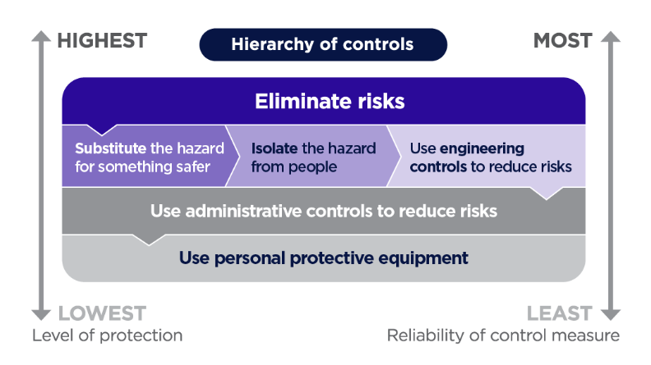
Figure 9: Hierarchy of control measures
    - Reasonably practicable
Section 19 of the WHS Act places a primary duty on PCBUs to ensure, so far as is reasonably practicable, the health and safety of workers at work and that others are not put at risk from work carried out as part of the conduct of the business or undertaking. Section 18 of the WHS Act sets out what is reasonably practicable to protect people from harm.
Deciding what is ‘reasonably practicable’ to protect people from harm requires considering and weighing up all relevant matters, including:
- the likelihood of the hazard or risk occurring
- the degree of harm that might result from the hazard or risk
- knowledge about the hazard or risk, and ways of eliminating or minimising the risk
- the availability and suitability of ways to eliminate or minimise the risk, and
- after assessing the extent of the risk and the available ways of eliminating or minimising the risk, the cost associated and whether this is grossly disproportionate to the risk.
What is reasonably practicable depends on a range of factors and may be different for different workers or work roles within the same workplace. The process for managing risks can help you decide what is reasonably practicable for a PCBU to meet their duties under WHS laws. Further information on determining what is reasonably practicable is given in the Interpretive guideline.
    - Respiratory protective equipment: protection factors
Before considering implementing the use of RPE, a PCBU must implement and document the use of higher levels of control following the hierarchy of control measures where reasonably practicable. If RPE is used to control exposure, it must be used in accordance with Regulation 44 of the WHS Regulations and the selection and use of the specific types should be documented.
During air monitoring, recording the type of RPE in use, including elements such as whether the worker was wearing it correctly, clean-shaven and fit tested for the specific respirator make and model is required. This assists when interpreting the exposure monitoring results and determining compliance with the exposure limit.
The use of RPE should only be considered in assessment of compliance with the exposure limit if a series of important factors have been applied and documented evidence of this information is available, which include:
- Implementation of all reasonably practicable higher-order control measures.
- A documented respiratory protection program is in place, including:
- Respirator fit testing has been performed before work commences for the specific make and model of the RPE worn.
- Where tight fitting RPE is used, that workers were consistently clean shaven.
- That RPE was worn over the entire period of anticipated exposure.
- The RPE had the correct filter.
- That the assigned protection factor was sufficient to provide protection to a level below the exposure limit.
All RPE used in the workplace should comply with the relevant Australian Standards. If there is no documented evidence that RPE was worn correctly during the monitoring, the minimum protection factor (MPF) cannot be applied in assessing compliance with the exposure limit.
Fit testing should be conducted by an appropriately trained person for all tight-fitting RPE. Fit testing is not required for loose-fitting PAPR.
If recommending new control measures such as specific RPE in a report, you should also consider if this introduces any new or different risks (e.g. heat stress) that also need to be controlled, and communicate these risks to the PCBU.
Further resources on RPE can be obtained from the RESP-FIT website.

  - Health monitoring
Health monitoring must be provided to a worker if they are carrying out work for the business or undertaking that is ongoing work at a workplace using, handling, generating or storing hazardous chemicals and there is a significant risk to the worker’s health because of exposure to a hazardous chemical referred to in Schedule 14 to the WHS Regulations (table 14.1, column 2).
A significant risk arises when workers face likely exposure to hazardous chemicals that could harm their health. Risk assessment to determine if health monitoring is required should consider the hazards of the chemicals and the frequency, duration and amount of exposure to rate the significance of the risk to worker’s health (e,g, using a risk matrix).
Additionally, health monitoring is required for chemicals not included in Schedule 14 if there is a:
- significant risk that the worker will be exposed, and
- a valid technique is available to detect the effect on workers’ health, or
- a valid way of determining biological exposure to the hazardous chemical is available and it is uncertain, on reasonable grounds, whether the exposure to the hazardous chemical has resulted in the biological exposure standard being exceeded.
Chemicals that have specific health monitoring requirements specified in Schedule 14 to the WHS Regulations include:

- 4,4'-Methylene bis (2-chloroaniline) (MOCA)
- Acrylonitrile
- Arsenic (inorganic)
- Benzene
- Cadmium
- Chromium (inorganic)
- Creosote
- Crystalline silica
- Isocyanates
- Lead (inorganic)
- Mercury (inorganic)
- Organophosphate pesticides
- Pentachlorophenol (PCP)
- Polycyclic aromatic hydrocarbons (PAH)
- Thallium
- Vinyl chloride

There are also requirements in Part 8A.1 and Part 8.5 of the WHS Regulations for health monitoring for respirable crystalline silica and asbestos respectively.
If health monitoring is required, it is the duty of the PCBU to ensure it is carried out by or under the supervision of a registered medical practitioner with experience in health monitoring.
Health monitoring is not itself a control, but a method to determine if controls are working effectively.
Safe Work Australia has developed health monitoring guides for a number of hazardous chemicals, including those listed in Schedule 14 to the WHS Regulations.
- Other factors affecting exposure
  - Workload considerations
When undertaking the risk assessment, the work rate (e.g., light, moderate, heavy, very heavy) should be considered when assessing worker exposure and recommending controls, as physical activity may influence breathing rate, contaminant uptake and body clearance mechanisms. Considerations include:
- Inhalation rate: The harder a person works, the faster and deeper they breathe. This increases the volume of air (and contaminants) inhaled per minute.
- Duration of exposure: High workloads often reduce opportunities for rest or task rotation, leading to longer exposure times.
- Metabolic uptake: Increased circulation and oxygen demand during heavy work can result in faster distribution of contaminants within the body.
- Protective equipment effectiveness: Respirators may become less effective during heavy workloads if fit is compromised by sweating, movement, or fatigue.
Where workload factors are likely to affect worker exposures, consideration may need to be given to the use of action levels (See Section 8.2) or recommending implementation of additional controls to reduce exposure to the hazard.
  - Exposure to mixtures of contaminants
It is rare for workers to only be exposed to a single airborne contaminant at a time. Most workplaces involve exposures to a mixture of contaminants. This requires an understanding of toxicological pathways, absorption into the body, and the pharmacokinetics following absorption.
There are three recognised types of actions following combined chemical exposure. These actions are [35]:
- Independent: Substances which act by different modes or on different target organs, and therefore the additive (dose) formula should not be used. Treat effects as independent or assess each substance against its individual exposure limit.
- Additive or Similar: Substances act by a similar mode of action, or on the same target organ or system and are based on the routes of exposure, organs of impact and pharmacokinetic action on the body. This is where the additivity formula should be applied.
- Interaction: Synergistic, antagonistic or potentiation interactions. You should not use the additive formula to demonstrate compliance where credible evidence of synergy or antagonism exists. Treat synergistic combinations conservatively; do not assume antagonism without strong scientific evidence. In this case, advice may need to be sought from a toxicologist on how to handle the specific combination of exposures.
In the absence of robust information on the combined effects of contaminants, you may assume additivity and apply the additive formula to assess the risk of exposure to multiple airborne contaminants [35]. The formula is not intended to be applied to complex mixtures such as petrol fumes or diesel engine exhaust.
The additive mixture formula should be used where there are potential exposures to multiple substances in a workplace, and where exposures:
- occur simultaneously,
- follow the same route of entry into the body, e.g. inhalation,
- have the same adverse health impact on the same target organ via the same mechanism, and
- are assessed with comparable exposure metrics.
To determine if substances cause similar adverse health impacts via similar routes of entry, the following references may be consulted for substances of concern:
- HCIS
- WES Review evaluation reports (available in HCIS)
- GESTIS Substance Database
- ACGIH TLV® documentation
- ATSDR
- Relevant SDS
To assess compliance for additive mixtures, calculate the Additive Mixture Formula by summing up each component’s exposure fraction. Examples of calculations of mixture calculations are included in Appendix K.
Compliance is demonstrated when Additive Mixture Formula is used and the total from the calculation <1. The formula [23], [36] for calculating this is:
$$Additive Mixture Formula= \frac{C_{1}}{{WEL}_{1}} +\frac{C_{2}}{{WEL}_{2}} +\frac{C_{3}}{{WEL}_{3}} +… +\frac{C_{n}}{{WEL}_{n}}$$
Where:
C₁ = measured airborne concentration of substance 1.
C₂ = measured airborne concentration of substance 2.
C₃ = measured airborne concentration of substance 3.
C_{n} = measured airborne concentration of substance n.
WEL₁ = published WEL for substance 1.
WEL₂ = published WEL for substance 2.
WEL₃ = published WEL for substance 3.
WEL_{n} = published WEL for substance n.
Where you have measured both a total non-speciated dust (respirable or inhalable) concentration or total VOC concentration and have also had chemical speciation undertaken, you cannot subtract the concentrations of the individual components from the total concentration. For example, you can’t subtract the measured concentration of zinc oxide from a welding fume (not otherwise classified) concentration.

  - Drugs and prescription medicines
Alcohol, recreational drugs, and certain prescription medicines can interact with airborne contaminants once they have entered the body, compounding adverse health effects. Some medicines can modify how contaminants are absorbed, distributed, metabolised, or excreted in the body. Others may impair alertness, coordination, or judgement, which can increase the risk of exposure. It is the role of a qualified medical professional to manage these health effects.
For example, corticosteroids (e.g., prednisone), often prescribed for asthma or inflammatory conditions, can suppress the immune system and reduce the body’s ability to fight infections. When combined with exposure to airborne contaminants, this may increase the likelihood of adverse health outcomes.
If the airborne contaminants present in the workplace could have altered exposure risks due to the use of drugs and prescription medicines, you should identify them and provide guidance on required actions to the PCBU.
  - Odour thresholds
An odour threshold is defined as the lowest concentration of a substance that approximately 50% of people with normal olfactory (smell) function can detect or identify. An odour threshold should never be used as an indicator of exposure, nor compliance with the exposure limit, because:
- Reported odour thresholds vary widely between studies and individuals. For example [37]:
  - Acetone has an odour threshold range is between 0.40–11 745 ppm, while the 8-hr TWA is 250 ppm, and the STEL is 500 ppm.
  - Carbon disulfide (CS2) has an odour threshold of 0.016–32 ppm, with an 8-hr TWA exposure limit of 1 ppm.
  - Carbon tetrachloride has an odour threshold of 1.68 – 720 ppm but the 8-hr TWA exposure limit is 0.1 ppm, which is well below what can be detected by smell.
  - Cyclohexene has an odour threshold of 0.18 ppm and an 8-hr TWA exposure limit of 300 ppm, showing strong odour at concentrations far below health-based exposure limits.
- Slow accumulation and odour fatigue may mean low concentrations may not be detected by smell alone.
- Odours that are pleasant or familiar (e.g. food and perfumes), can mask other smells and thus increase risk.
- Background odours can easily overwhelm or disguise contaminants, and individual variability and olfactory fatigue or adaptation reduce the reliability of odour thresholds over time.
The absence of an odour does not indicate a safe environment, in the same way that the presence of an odour does not confirm a hazard to health. Always confirm risk with a quantitative exposure assessment. Odour alone cannot be used as a warning sign, particularly when other odours are present.
  - Indoor air quality
You should not apply an exposure limit to general indoor environments such as in office and retail environments. Use of exposure limits is not appropriate for these environments since people are not pre-selected for industrial exposures (e.g. via pre-employment health screening), have limited awareness of control measures and may be more susceptible to health impacts due to pre-existing health conditions which otherwise do not limit their capacity for productive work.
Additionally, an exposure limit can only be compared to personal exposure samples, not to samples collected as static or environmental air samples.
At present, there are no regulated exposure criteria for indoor air quality, but guidance is available from the National Construction Code Indoor Air Quality Verification Methods Handbook. Creation of IAQ criteria/standards by modifying or scaling exposure limits is not appropriate as there is currently no strong, peer-reviewed evidence supporting the translation (population, exposure duration, health effects).

- Contaminant-specific guidance: assessment and control
This section provides guidance to support your assessment and control decisions for specific classifications of contaminants. These contaminant categories are practical groupings; they are not mutually exclusive.
All factors which can affect the level of workers’ exposure or the overall health effect that occurs because of exposure need to be considered in assessing workers’ health risk. If any of these factors apply, the exposure limit may not be protective of all workers and additionally assessment and/or controls may be required.
Some substances have secondary health effects which their assigned workplace exposure limits cannot protect against, because of the nature of these effects and the variability between individual people. Ensuring exposure is below the exposure limit may not protect against all health effects for these substances.
How to use this section:
- Identify the adverse health effects from relevant sources, such as:
  - Notations in the WEL list
  - HCIS
  - WES Review evaluation reports (available in HCIS)
  - GESTIS Substance Database
  - ACGIH TLV® documentation
  - ATSDR
  - Relevant SDS
- Review specific guidance for identified health effects.
- Confirm the appropriate exposure metric and sampling method before monitoring.
- Verify the appropriate exposure limits and any health-monitoring requirements before reporting.
- Consult the exposure to mixtures of contaminants section (Section 9.2) when combined exposures are likely.
- Identify any health hazards not covered by an exposure limit and determine if additional control measures are required.
  - Carcinogens
    - Regulatory context
For some substances, including some carcinogens, there are specific prohibitions and restrictions on use (see Schedule 10 to the WHS Regulations):
- Prohibited: these must not be used, handled or stored other than for genuine research or analysis. Authorisation from the WHS regulator is required for research or analysis.
- Restricted: usage, storage or handling is only permitted under regulatory authorisation and specified conditions. Restrictions may apply to all uses or for specified uses.
    - Latency and risk
A diagnosis of cancer may not be made until long after exposure to a carcinogen ends. The incidence of cancer is usually dose related ─ the greater the exposure to the carcinogen, the higher the risk of developing cancer. However, due to the limitations of epidemiological and animal studies at low dosages, a “no effect” level of exposure often cannot be positively identified for some carcinogens.
The severity of the hazard arising from exposure to a carcinogen needs to be considered when deciding what is reasonably practicable in protecting people from harm. Further information on determining what is reasonably practicable is given in Section 8.4.1.
    - Globally harmonised system of classification and labelling of chemicals classifications
Under the Globally Harmonised System of Classification and Labelling of Chemicals (GHS), substances may be allocated to a category of carcinogenicity based on the strength and weight of evidence. The GHS carcinogenicity classifications detailed in Table 6.
Table 6: GHS carcinogenicity classifications
Category | Classification | Evidence and requirements for control
Category 1A | Known human carcinogens | Sufficient evidence in humans.  Must be eliminated or substituted if reasonably practicable. If not, apply the hierarchy of control measures. Implement effective engineering controls and safe systems of work; use RPE only as supplementary protection. Verify with routine exposure monitoring; implement health monitoring where required.
Category 1B | Presumed to have carcinogenic potential for humans | Sufficient evidence from animal studies with limited human evidence or other peer-reviewed data.  Treat as carcinogenic to humans and minimise exposure to the lowest practicable level using the hierarchy of control measures and confirm effectiveness by monitoring; apply health monitoring if indicated by risk or regulation.
Category 2 | Suspected human carcinogens | Limited evidence of carcinogenicity; use with caution.  Start with elimination; if not reasonably practicable, ensure exposures do not exceed the exposure limit and continue to reduce to as far as is reasonably practicable. Reassess controls as new evidence emerges.
Information about the carcinogenicity classification of airborne contaminants can be found in HCIS.

    - Non-threshold genotoxic carcinogens
During the development of the exposure limits, some airborne contaminants were identified as non-threshold genotoxic carcinogens (NTGCs). Exposure to these substances can cause genetic damage and may lead to cancer. Unlike other airborne contaminants, a practical, protective exposure level cannot be assigned for NTGCs due to limited data and the nature of their effects, as no ‘safe’ level of exposure can be guaranteed. Therefore, exposure limits have not been specified for substances identified as NTGCs, however the list of NTGCs is available in Appendix B of the WEL List.
These substances pose a significant risk to workers and PCBUs have a duty to eliminate risks from NTGCs so far as is reasonably practicable. If elimination is not reasonably practicable, the risk of exposure must be minimised as far as reasonably practicable.
If there is a way to measure an airborne contaminant without an exposure limit, i.e. there is a sampling and analysis method, you may still conduct air monitoring to demonstrate exposure is minimised as far is reasonably practicable.
  - Respiratory and dermal sensitisers
Certain contaminants cause dermal and/or respiratory sensitisation in some workers. Over time, sensitisation can occur to even low concentrations of a substance over an extended period of time, but for some substances a single high-level exposure can trigger sensitisation.
Because workers could become sensitised to the substance at any level of exposure, the exposure limit cannot be set at a level that protects for this outcome. As exposures at the level of the exposure limit may not stop sensitisation from happening, additional controls may be needed to keep exposure to sensitisers as low as possible.
Once a person becomes sensitised, subsequent exposure to the contaminant, sometimes even at very low levels, can trigger an immunological response. Therefore, once sensitisation has occurred, exposure to that substance should be avoided.
    - Respiratory sensitisers
A respiratory sensitiser is a substance or mixture that induces hypersensitivity of the airways following inhalation of the substance or mixture. Contaminants considered respiratory sensitisers are listed in the WEL list with the advisory notation of RSEN.
Examples include:
- Beryllium and compounds
- Isocyanates
- Nickel soluble compounds
- Wood dusts (both soft and hardwood)

    - Dermal sensitisers
Dermal sensitisers are listed in the WEL list with the advisory notation, DSEN. Some hazardous chemicals that are known to be dermal sensitisers include:

- Aniline and homologues
- Beryllium and compounds *
- Cobalt*
- Dichloropropene
- Diquat
- Ethyl acrylate
- Ethylenediamine*
- Formaldehyde
- Glutaraldehyde*
- Isocyanates*
- Malathion
- Methyl methacrylate
- n-Butyl acrylate
- Nickel*
- Wood dusts*

* Both a respiratory and a dermal sensitiser
  - Systemic and target organ toxins
Many airborne contaminants can cause acute and/or chronic systemic effects once absorbed into the bloodstream. This can occur via inhalation, dermal absorption or ingestion. A single substance may cause multiple adverse health effects. The contaminants may cause multiple health effects on different body systems. For example:
- Xylene can cause an acute eye and skin irritation, central nervous system (CNS) depression and/or exert effects on the renal system, and
- Ethyl alcohol causes acute CNS depression (intoxication), and chronic effects from long-term exposure may lead to cirrhosis of the liver.
    - Neurotoxins
Neurotoxins are contaminants that can affect the CNS or peripheral nervous system by disrupting the function and structure of neurons and supporting tissues and cells (e.g., myelin, dendrites, axons, neuropils and synapses).
Neurotoxins can cause either acute or chronic effects. High, short-term exposure typically causes reversible CNS depression such as dizziness or narcosis. Repeated or prolonged exposures at lower concentrations can lead to persistent or irreversible changes, including peripheral neuropathy or Parkinson’s disease, reflecting the deterioration of structural components of the nervous system.
Examples of contaminants that have been identified as neurotoxins are benzene, lead, manganese, mercury, and toluene. Typical symptoms include dizziness, euphoria, impaired coordination, sleep disorders, manganism and dementia.
    - Ototoxic substances
An ototoxic effect is where the contaminant is proven to adversely impact a person's hearing, often, but not always, in combination with high noise levels greater than 80 dB(A). Airborne contaminants that have ototoxic properties are notated in the WEL list with ‘OTO’.
Some medications are also known ototoxins, for example, aspirin. For more information on ototoxic substances, refer to the Code of Practice: Managing noise and preventing hearing loss at work.
    - Ocular effects
Many contaminants have been identified as having the potential to harm the eye. These effects may be acute or chronic and include eye irritation, visual disturbances and permanent eye damage. Contaminants that can cause damage to the eyes include acids, alkalis, organic solvents, detergents and some metallic salts. In addition, some acids and alkali (caustic) contaminants can cause burns and cause permanent damage to the eye.
  - Irritants and corrosives
Contaminants that are classified as irritant or corrosive can affect one or more body organ or system, such as the eyes, mucous membranes, respiratory system or skin. For example, sodium hydroxide is irritating to the eyes, mucous membranes, respiratory system and skin. Where an exposure limit has been established based on irritant effects, a peak limitation exposure limit usually applies. Common irritants with a peak limitation include:
- Chlorine
- Chloroacetone
- Glutaraldehyde
- Hydrogen bromide
- Hydrogen chloride
- Methyl ethyl ketone peroxide
- Ozone
- Petrol (gasoline)
  - Dusts not otherwise classified (NOC)
Dusts not otherwise classified (NOC), often known as inert or nuisance dusts, due to their solubility and lack of toxicological data, do not have an exposure limit. Nevertheless, exposures to all dusts should be controlled to minimise the effect of dust deposition in the upper respiratory tract, ears and eyes.
Airborne dust can be measured as an indicator of the effectiveness of control measures, but measurements of total non-speciated dust cannot be used as a substitute for demonstrating compliance for substances with exposure limits. You should always attempt to identify the dusts present before monitoring.
Where no specific exposure limit exists, exposure to dusts NOC should be kept as low as reasonably practicable. Some jurisdictions may have established legislated limits or published guidance values for particles in the inhalable and/or respirable size fractions, and professional bodies have also developed guidance materials on this topic such as the AIOH Dusts Not Otherwise Specified (Dust NOS) & Occupational Health Issues Position Paper.

  - Nanoparticles
Nanoparticles can come from natural or artificial sources, and new technologies such as 3D printing can generate large numbers of nanoparticles. Nanoparticles are particles that are typically <100 nm (less than 0.1 µm) in at least one dimension.
Nanoparticles can present a greater risk to health than larger particles because they have a greater surface area, relative to their mass, and can penetrate further into the body. When assessing risk, you should review the toxicity of the non-nanoscale substance and then apply the appropriate exposure limit as a guidance value. However, you should not assume that the exposure limit for the primary material is protective for the nanoparticulate size fraction, so additional risk assessment and controls may be required.
  - Asphyxiants
    - Simple asphyxiants
Simple asphyxiants are defined as gases and vapours that are low or non-toxic but, if present in an environment at high concentrations, they may cause a reduction in the concentration of oxygen by displacement or dilution. Atmospheres low in oxygen do not provide adequate sensory warning of danger, as most simple asphyxiants are odourless.
Where an exposure limit has been set for a substance which is a simple asphyxiant, the exposure limit is not based on the hazard of simple asphyxiation. It is essential that the concentration of oxygen is maintained.
The minimum oxygen content in air to sustain life is between 19.5 and 23.5% by volume under normal temperature and pressure. At pressures significantly higher or lower than the normal pressure, specialist advice should be sought. If an environment is deficient in oxygen (less than 16%), dizziness, unconsciousness and death can rapidly follow.
Part 4.3 of the WHS Regulations and the Code of Practice: Managing risks of hazardous chemicals in the workplace provide information on controls for this hazard. The Code of Practice: Confined spaces provide information on controls for managing simple asphyxiants in confined spaces.
Simple asphyxiants may also have other associated risks, such as flammability and explosivity, which need to be considered when controlling the concentration of the asphyxiant. Examples of asphyxiants that may also present an explosion hazard include acetylene, ethane, ethylene, hydrogen, methane, propane, and propylene. Other simple asphyxiants that are not flammable and do not present an explosion hazard include argon, helium, neon, and nitrogen.
    - Chemical asphyxiants
Chemical asphyxiants are toxic gases or vapours that prevent the delivery or absorption of oxygen within the body.
The most common chemical asphyxiant in the workplace is carbon monoxide (CO). This substance binds strongly to the haemoglobin molecules in red blood cells, the same sites that normally carry oxygen around the body. This prevents oxygen from being transported to vital organs and tissues, leading to tissue hypoxia and impaired organ function. Other chemical asphyxiants include cyanide, hydrogen sulfide, phosgene, and carbon dioxide.
  - Other substances without exposure limits
There are approximately 700 substances with an established workplace exposure limit, however, not all substances used in workplaces have an exposure limit. Just because a substance doesn’t have an exposure limit doesn’t mean it is safe.
Under the WHS Act, a PCBU has the primary duty to ensure, so far as is reasonably practicable, that the health and safety of workers and other persons are not put at risk from work carried out as part of the conduct of the business or undertaking. This applies both to airborne contaminants with exposure limits and airborne contaminants without exposure limits.
If there is a way to measure an airborne contaminant without an exposure limit, you may still conduct air monitoring to demonstrate exposure is minimised as far is reasonably practicable. More guidance on considering the exposure risk to airborne contaminants without an exposure limit is given in Section 3.
- References

[1] | C. Huggins and G. Meyers, “Particle size distribution of quartz and other respirable dust particles collected at metal mines, nonmetal mines and processing plants,” US Department of the Interior, 1986.
[2] | B. Daly, “Chapter 5: Pollution Control,” in Woods Practical Guide to Fan Engineering, Woods of Colchester, 1978.
[3] | ISO 7708:1995, Air quality - Particle size fraction definitions for health-related sampling, International Organization for Standardization, 1995.
[4] | I. Firth, R. Golec, R. Di Corleto, K. Ng and J. Wilson, Simplified Occupational Hygiene Risk Management Strategies, AIOH, 2020.
[5] | D. Grantham and I. Firth, Occupational hygiene monitoring and compliance strategies, AIOH, 2019.
[6] | BS EN 689:2018, Workplace exposure - Measurement of exposure by inhalation to chemical agents - Strategy for testing compliance with occupational exposure limit values, British Standards Institute, 2018.
[7] | N. Leidel, K. Busch and J. Lynch, “Occupational Exposure Sampling Strategy Manual,” NIOSH, 1977.
[8] | T. Ogden, H. Kromhout, A. Hirst, K. Honnes, J. Ingle, J. can Rooij, A. Kennedy, T. Scheffers, M. van Tongeren and E. Tielemans, Testing Compliance with Occupational Exposure Limits for Airborne Contaminants (2nd ed.), BOHS & NNvA, 2022.
[9] | TestSafe Australia, Chemical analysis branch handbook (9th ed), NSW WorkCover.
[10] | Directorate-General for Employment, Social Affairs and Inclusion, “Methodology for derivation of occupational exposure limits of chemical agents : the General Decision-Making Framework of the Scientific Committee on Occupational Exposure Limits (SCOEL) 2017,” European Commission, 2018.
[11] | AIOH, “Technical Paper: Size Selective Samplers for Respirable Dust Sampling,” 2024. [Online]. Available: www.aioh.org.au/product/aioh-technical-paper-size-selective-samplers-for-respirable-dust-sampling-2024/.
[12] | AIOH, “Technical Paper: Air Sampling Pumps: Equipment Calibration Requirements,” 2018. [Online]. Available: www.aioh.org.au/product/air-sample-pumps/.
[13] | ISO 13137:2022, Workplace atmospheres - Pumps for personal sampling of chemical and biological agents - Requirements and test methods, International Organization for Standardization, 2022.
[14] | P. Smith, “Intra-workday fluctuations of airborne contaminant concentration and the time-weighted average,” Journal of Occupational and Environmental Hygiene, vol. 19, no. 12, p. 742–758, 2022.
[15] | NIOSH, “NIOSH Manual of Analytical Methods (5th ed),” [Online]. Available: www.cdc.gov/niosh/nmam/default.html.
[16] | E. Cauda, “Chapter AM: Measuring respirable aerosol with real-time optical monitors,” in NIOSH Manual of Analytical Methods (5th ed), 2021.
[17] | AIHA, Fact Sheet: Reporting Specifications for Electronic Real Time Gas and Vapor Detection Equipment, AIHA, 2022.
[18] | A. Thorpe and P. Walsh, “Comparison of portable, real-time dust monitors sampling actively, with size-selective adaptors, and passively,” Annals of Occupational Hygiene, vol. 51, no. 8, pp. 679-691., 2007.
[19] | AIOH, “Technical Paper: Flow Measuring Equipment: Calibration Requirements,” 2018. [Online]. Available: www.aioh.org.au/product/flow-measuring/.
[20] | S. Jahn, W. Bullock and J. Ignacio, A strategy for assessing and managing occupational exposures (4th ed), AIHA Press, 2015.
[21] | D. Zalk, Control Banding: A Simplified, Qualitative Strategy for the Assessment of Occupational Risks and Selection of Solutions, US Department of Energy, 2010.
[22] | I. Firth and D. Drolet, “Development of a Tool for the Adjustment of Workplace Exposure Standards for Atmospheric Contaminants Due to Extended Work Shifts’,” Health & Safety Research, & Practice, vol. 6, no. 2, pp. 6-10, 2014.
[23] | D. Paustenbach and W. Cyrs, “‘The History and Biological Basis of Occupational Exposure Limits for Chemical Agents’,” in Patty's Industrial Hygiene, Volume 1: Hazard Recognition, John Wiley & Sons., 2021.
[24] | AIOH, “Position Paper: Adjustment of Workplace Exposure Standards for Extended Work Shifts,” 2016. [Online]. Available: www.aioh.org.au/product/wes/.
[25] | R. Brief and R. Scala, “Occupational Exposure Limits For Novel Work,” American Industrial Hygiene Association Journal, vol. 36, no. 6, pp. 467-469, 1975.
[26] | P. Knott and D. Lowry, “Occupational Hygiene Statistics,” in Principles of Occupational Health and Hygiene: An Introduction, CRC Press, 2024.
[27] | J. Lavoué, L. Joseph, P. Knott, H. Davies, F. Labrèche, F. Clerc, G. Mater and T. Kirkham, “Expostats: A Bayesian Toolkit to Aid the Interpretation of Occupational Exposure Measurements,” Annals of Work Exposures and Health, vol. 63, no. 3, p. 267–279, 2019.
[28] | NOHSC:3003(2005), Guidance Note On The Membrane Filter Method For Estimating Airborne Asbestos Fibres (2nd ed), National Occupational Health And Safety Commission (NOHSC), 2005.
[29] | P. Johnson, “Monitoring, sampling and analysis of airborne dangerous substances,” 2024. [Online]. Available: https://oshwiki.osha.europa.eu/en/themes/monitoring-sampling-and-analysis-airborne-dangerous-substances.
[30] | AIOH, “Technical Paper: Minimising Uncertainties When Sampling and Analysing Respirable Crystalline Silica (RCS),” 2024. [Online]. Available: www.aioh.org.au/product/the-aioh-technical-paper-minimising-uncertainties-when-sampling-and-analysing-rcs/.
[31] | D. Helsel, Statistics for censored environmental data using Minitab and R (2nd ed), Wiley, 2012.
[32] | T. Huynh, G. Ramachandran, S. Banerjee, J. Monteiro, M. Stenzel, D. Sandler, L. Engel, R. Kwok, A. Blair and P. Stewart, “Comparison of methods for analyzing left-censored occupational exposure data,” Annals Occupational Hygiene, vol. 58, no. 9, pp. 1126-1142, 2014.
[33] | G. Ganser and P. Hewett, “An Accurate Substitution Method for Analyzing Censored Data,” Journal of Occupational and Environmental Hygiene, vol. 7, no. 4, pp. 233-244, 2010.
[34] | I. Firth, “Action Limits and Additive Effects – Impact on Compliance,” in AIOH 2025 Conference Proceedings, Sydney, 2025.
[35] | Directorate-General for Health and Consumers, “Toxicity and Assessment of Chemical Mixtures,” European Commission, 2012.
[36] | ACGIH, 2025 TLVs® and BEI®, ACGIH, 2025.
[37] | A. Lehocky, P. Owens, C. Marcham and D. Krause, Odor thresholds for chemicals (4th ed), AIHA Press, 2024.
[38] | A. Todorovic and M. Logan, “Gases and Vapours,” in Principles of Occupational Health and Hygiene: An Introduction, CRC Press, 2024.

Appendix A: Key terms and abbreviations
The following abbreviations and definitions are used in this guidance.
Term | Definition
% | Percentage
µg | Microgram, one thousandth of a milligram = 1/1000 mg
µg/m³ | Microgram per cubic metre
µm | Micrometre, one thousandth of a millimetre = 1/1000 mm
3D | Three dimensional
8-hr time weighted average (TWA) | The maximum permitted concentration of an airborne contaminant calculated as a time weighted average for an 8-hour working day, based on a 5-day working week (40 hours)
AED | Aerodynamic Equivalent Diameter, the equivalent diameter of particles based on their terminal velocity, which is a relationship between the physical diameter of the particle and its density
AIOH | Australian Institute of Occupational Hygienists
Airborne contaminant | A fume, mist, gas, vapour, fibre or dust suspended in the air that can be harmful to health when breathed in. They may not be visible to the naked eye or detected by odour
ANOVA | Analysis of Variance
AS | Australian Standard
Breathing zone | A hemisphere of 300 mm radius extending in front of a person’s face and measured from the midpoint of an imaginary line joining the ears
Carcinogen | A substance or a mixture which causes cancer
CNS | Central nervous system
CoC | Chain of custody
COH® | Certified Occupational Hygienist. Equivalent certifications include Certified Industrial Hygienist (CIH) and Registered Occupational Hygienist (ROH)
DPM | Diesel Particulate Matter
DSEN | Notation assigned to a substance or mixture that will induce an allergic response following skin contact
Dusts | Solid particles dispersed into the air by, activities such as handling, crushing and grinding of organic or inorganic materials, including rock, ore, metal, coal, wood and grain
Excursion | A short, temporary airborne concentration above the level of the exposure limit  Limited, controlled excursions above the exposure limit may be permitted, provided they meet the requirements specified in section 3.1 of the Workplace exposure limits for airborne contaminants
Exposure limit | An exposure limit in the Workplace exposure limits for airborne contaminants. It represents the airborne concentration of a particular substance or mixture that must not be exceeded
f/mL | Fibre per millilitre of air
Fumes | Extremely fine particles usually less than 1.0 µm in diameter. Fumes are formed when the material from a volatilised solid condenses in cool air. In most cases, the hot emissions react with the air to form an oxide.  Fumes are often associated with molten metals, especially in processes like welding. At high fume concentrations, agglomeration of particles may result in particles with much larger dimensions
Gases | A state of matter with neither fixed volume nor shape. Gases are formless and particles move freely, expanding or compressing to occupy the space in which they are confined
GCMS | Gas Chromatography/Mass Spectrometer
GESTIS | International Occupational Exposure limit values for chemical agents published in Germany by IFA
GHS | The Globally Harmonised System of Classification and Labelling of Chemicals, 7th Revised Edition, published by the United Nations as modified by Schedule 6 to the WHS Regulations
GSD | Geometric Standard Deviation, a dimensionless value that shows the variability in exposure data.  The higher the GSD, the greater the variability and it indicates whether the SEGs have been correctly designed, or that there is high variability within the tasks undertaken within the SEG. The smaller the GSD (close to but above 1), the better the similarities in exposure profiles, but if the GSD is high (>3), then the SEG may need to be reclassified
Hazard | A situation or thing that has the potential to harm a person
Hazardous chemical | Any substance, mixture or article that satisfies the criteria for any one or  more hazard classes in the GHS (including a classification referred to in  Schedule 6 of the WHS Regulations), unless the only hazard class or  classes for which the substance, mixture or article satisfies the criteria are  any one or more of the following:  - acute toxicity—oral—category 5  - acute toxicity—dermal—category 5  - acute toxicity—inhalation—category 5  - skin corrosion/irritation—category 3  - aspiration hazard—category 2  - flammable gas—category 2  - acute hazard to the aquatic environment—category 1, 2 or 3  - chronic hazard to the aquatic environment—category 1, 2, 3 or 4  - hazardous to the ozone layer.  Note: The Schedule 6 tables replace some tables in the GHS
HCIS | Hazardous Chemicals Information System
High-risk respirable fraction | Particles that penetrate into the alveoli regions of the respiratory system and have a dust fraction with an AED 50% cut-off of 2.5 µm. This is commonly called PM_{2.5} and is used in relation to the general public to protect people who may have underlying health issues
HSE | Health and Safety Executive (UK)
IFA | Institut für Arbeitsschutz, part of the German DGUV (Deutsche Gesetzliche Unfallversicherung)
IHSTAT® | Excel application that calculates various exposure statistics
Inhalable dust | Dust particles that are typically deposited in the upper respiratory tract (nose, bronchi), with a size fraction of 100 µm, AED 50% cut-off [3]
ISO | International Standards Organisation
L/min | Litres per minute
LOAEL | Lowest Observed Adverse Effect Level
LoD | Limit of Detection, the smallest concentration that can be differentiated from background using a specific measurement method
LoQ | Limit of Quantification, the lowest concentration of a substance that a laboratory test can reliably measure with acceptable accuracy and precision
LoR | Limit of Reporting, used by laboratories in reports as the lowest concentration of an analytical parameter that can be detected by a particular method that has acceptable precision and accuracy
May | ‘May’ indicates an optional course of action
mg | Milligram, one thousandth of a gram = 1/1000 g
mg/m³ | Milligrams per cubic metre
Mists | Suspended liquid droplets, generated by condensation of vapour back to the liquid state or by breaking up as a liquid into a dispersed state, such as by splashing or atomising. Mist is the term applied to a finely divided liquid suspended in the atmosphere.  Examples are an oil mist produced during cutting and grinding operations, acid mists from electroplating, acid or alkali mists from pickling operations, and the condensation of water vapour to form a fog
Mixture | A combination of, or a solution composed of, 2 or more substances that do not react with each other.  For readability the term ‘substance’ has been used to refer to both ‘substances’ and ‘mixtures’ throughout this document
MPF | Minimum protection factor, the level of respiratory protection that an item of properly functioning RPE would be expected to provide to properly fitted and trained users in the workplace when used according to the manufacturer’s information and instruction. The MPF considers all expected sources of facepiece penetration (e.g. face seal protection, valve leakage)
Mucociliary Escalator | A mechanism in the body that moves trapped substances from the major airways of the lung to the pharynx to be swallowed or coughed out
Must | ‘Must’ indicates a legal requirement exists that must be complied with
MVUE | Minimum-Variance Unbiased Estimator used in occupational hygiene statistics to estimate the arithmetic mean
NATA accredited | A testing facility accredited by the National Association of Testing Authorities (NATA) for a specific test procedure
NIOSH | National Institute of Occupational Safety and Health (USA)
nm | Nanometre, one thousandth of a micrometre = 1/1000 µm
NOAEL | No Observed Adverse Effect Level
NOC | Not Otherwise Classified
Non-speciated dust | Dust reported as a total mass without distinguishing the morphology or chemical composition
OEL | Occupational Exposure Limit
OSHA | Occupational Safety and Health Administration (USA)
OTO | Ototoxic notation assigned to substances that can increase the risk of hearing loss, especially in the presence of noise levels above 80 dB(A). These substances are known as ototoxins
PAPR | Powered air-purifying respirator
PCBU | A PCBU is an umbrella concept which intends to capture all types of working arrangements or relationships.  A PCBU includes a:  - company,  - unincorporated body or association, or  - sole trader or self-employed person.  Individuals who are in a partnership that is conducting a business will individually and collectively be a PCBU.  A volunteer association (defined under the WHS Act) or elected members of a local authority will not be a PCBU
Peak limitation | The maximum concentration of an airborne contaminant measured over the shortest time possible, and not exceeding 15 minutes. A peak limitation must not be exceeded at any time
Personal monitoring | Air monitoring samples collected over the duration of a working shift, within the breathing zone of the worker. This method of sampling is intended to capture a representative sample of the air a worker breathes in during their working shift, or whilst performing specific tasks
PPE | Personal protective equipment
ppm | Parts per million
Respirable dust particle | Particles that are deposited in the lower respiratory tract (alveoli), with a size fraction of 4 µm, AED 50% cut-off [3]
RF | Reduction factor
Risk | Risk is the possibility that harm (death, injury or illness) might occur when exposed to a hazard
RPE | Respiratory protective equipment
RSEN | Notation given to a substance or mixture that induces hypersensitivity of the airways following inhalation of the substance or mixture
SDS | Safety Data Sheet/s
SEG | Similar Exposure Group
Short-term exposure limit (STEL) | The airborne concentration of a particular substance calculated as a time-weighted average over 15 minutes, that may not be reached more than 4 times over the duration of a shift, with a 60-minute break between exposures
Should | ‘Should’ indicates a recommended course of action
Sk | Notation assigned to contaminants that can be absorbed through the skin
Smoke | Carbon or soot particles or tarry droplets less than 0.1 µm in size, and suspended in air, which results from the incomplete combustion of carbonaceous materials like coal or oil
Static monitoring | For the purpose of this Guide, static monitoring means samples of air collected at fixed locations, commonly between 1 and 2 metres above floor level
Substance | A chemical element or compound in its natural state or obtained or generated by a process:  - including any additive necessary to preserve the stability of the element or compound and any impurities deriving from the process; but  - excluding any solvent which may be separated without affecting the stability of the element or compound or changing its composition  For readability the term ‘substance’ has been used to refer to both ‘substances’ and ‘mixtures’ throughout this document
SWA | Safe Work Australia
Thoracic fraction | Particles that are typically deposited in the tracheobronchial regions of the lungs, which have a size fraction of 10 µm, AED 50% cut-off [3]. Commonly referred to as PM₁₀
Time weighted average (TWA) | The average airborne concentration of a particular substance when calculated over a set period of time
TLV® | Threshold Limit Value published by the ACGIH
UCL | Upper Confidence Limit, a statistical measure to compare grouped results against the occupational exposure limit
UTL | Upper Tolerance Limit, a statistical measure of an upper confidence limit for an upper percentile
Vapour | The gaseous form of a substance that is normally in the solid or liquid state at room temperature and pressure
VOC | Volatile Organic Compounds
WEL | Workplace Exposure Limit
WES | Workplace Exposure Standard
WHS | Workplace Health and Safety
Worker | Any person who carries out work for a person conducting a business or undertaking, including work as an employee, contractor, subcontractor, self-employed person, outworker, apprentice or trainee, work experience student, employee of a labour hire company placed with a 'host employer' and volunteers
Workplace | Any place where work is carried out for a business or undertaking and includes any place where a worker goes, or is likely to be, while at work. This may include offices, factories, shops, construction sites, vehicles, ships, aircraft or other mobile structures on land or water

Appendix B: ISO 7708 sampling curves for airborne particulates
Table 7: Sampling curves for airborne particulates, adapted from ISO7708 Table B.2 [3]
Equivalent aerodynamic diameter (AED)  (µm) | Inhalable dust fraction | Thoracic (PM₁₀) dust fraction | Respirable dust fraction | High risk respirable dust fraction (PM_{2.5})
0 | 100.0 | 100.0 | 100.0 | 100.0
1 | 97.1 | 97.1 | 97.1 | 95.9
2 | 94.3 | 94.3 | 91.4 | 66.9
3 | 91.7 | 91.7 | 73.9 | 30.0
4 | 89.3 | 89.0 | 50.0 | 11.0
5 | 87.0 | 85.4 | 30.0 | 3.8
6 | 84.9 | 80.5 | 16.8 | 1.3
7 | 82.9 | 74.2 | 9.0 | 0.5
8 | 80.9 | 66.6 | 4.8 | 0.2
9 | 79.1 | 58.3 | 2.5 | 0.1
10 | 77.4 | 50.0 | 1.3 | 0.0
11 | 75.8 | 42.1 | 0.7 | 0.0
12 | 74.3 | 34.9 | 0.4 | 0.0
13 | 72.9 | 28.6 | 0.2 | 0.0
14 | 71.6 | 23.2 | 0.2 | 0.0
15 | 70.3 | 18.7 | 0.1 | 0.0
16 | 69.1 | 15.0 | 0.0 | 0.0
18 | 67.0 | 9.5 | 0.0 | 0.0
20 | 65.1 | 5.9 | 0.0 | 0.0
25 | 61.2 | 1.8 | 0.0 | 0.0
30 | 58.3 | 0.6 | 0.0 | 0.0
35 | 56.1 | 0.2 | 0.0 | 0.0
40 | 54.5 | 0.1 | 0.0 | 0.0
50 | 52.5 | 0.0 | 0.0 | 0.0
60 | 51.4 | 0.0 | 0.0 | 0.0
80 | 50.4 | 0.0 | 0.0 | 0.0
100 | 50.1 | 0.0 | 0.0 | 0.0

Appendix C: Duties of a Person Conducting a Business or Undertaking
A PCBU has both general and specific duties under the WHS legislation in relation to airborne contaminants. Some of these duties are outlined in Table 8 below, in order of the WHS Act and WHS Regulations.
Table 8: Duties of a PCBU
Duties | Provisions
- ensure, so far as is reasonably practicable, workers and other people are not exposed to health and safety risks arising from the business or undertaking.  - eliminate health and safety risks so far as is reasonably practicable, and if this is not possible, minimise those risks so far as is reasonably practicable. | WHS Act  section 19(2) and WHS Act  section 17
- identify and manage risks to health and safety from exposure to hazardous chemicals, including using the hierarchy of control measures to minimise risk. | WHS Regulations  Part 3.1
- ensure that no person at the workplace is exposed to a substance or mixture in an airborne concentration that exceeds the exposure limit for the substance or mixture. | WHS Regulations  regulation 49
- ensure that air monitoring is carried out to determine the airborne concentration of a substance or mixture at the workplace to which an exposure limit applies if:  - the person is not certain on reasonable grounds whether or not the airborne concentration of the substance or mixture at the workplace exceeds the relevant exposure limit, or  - monitoring is necessary to determine whether there is a risk to health.  - ensure that the results of air monitoring carried out above are:  - recorded, and kept for 30 years after the date the record is made, and  - readily accessible to persons at the workplace who may be exposed to the substance or mixture. | WHS Regulations  regulation 50
In addition to these duties, there are other specific requirements in the WHS Regulations for hazardous chemicals (Chapter 7 Part 1), lead (Chapter 7 Part 2), asbestos (Chapter 8) and silica (Chapter 8 A).
Certain substances in the WEL list are also listed in Schedule 10 (prohibited or restricted carcinogens, restricted hazardous chemicals) or Schedule 14 (health monitoring) to the WHS Regulations. Additional duties apply to the use, storage and handling of these substances, due to their higher health risks.

Appendix D: Essential information to capture in an assessment
1. Site and worker identification
- Site/location details
- Date of assessment
- Name of worker being monitored
- Job title/role
- Roster pattern (e.g. Mon–Fri, shift pattern)
- Shift length (hours) and whether overtime occurred
- Primary work area and primary task
2. Exposure context
- Sources of exposure (process, material, or equipment)
- Description of tasks undertaken, including materials handled
- Tools/machines used during tasks
- Work locations during tasks
- Time periods for each task (start – finish)
- Use of respiratory protection (type used per task, also include whether worker was clean shaven, or had any factors that may influence the fit of the RPE)
3. Existing controls
- Engineering controls (e.g. local exhaust ventilation, type and use)
- Administrative controls (e.g. task rotation, procedures)
- RPE types
- Activities/tasks during which RPE was used
- RPE fit testing status
- RPE cleaning and maintenance arrangements
4. Sampling information
- Name of occupational hygienist collecting samples
- Sample identification
- Sample type (e.g. personal, static, area)
- Contaminants sampled
- Pump ID/number
- Sampling equipment IDs
- Flow calibrator make, model, and serial number
- Initial and final flow rates
- Average flow rate
- Start and finish times for each sample
- Total sample volume (litres)
- Calculated percentage change in flow rate

Appendix E: Considerations for use of
real-time monitors

Instrument response
- Real-time monitors may have delayed response times depending on sensor type.
- Depending on the sensor technology used, several minutes may be required for the instrument to respond fully to changes in concentration.

Sensor resolution and accuracy
Sensor resolution (the smallest reportable increment) and sensor accuracy can significantly affect the interpretation of exposure data, particularly for contaminants with low exposure limits. Your real-time monitor should have appropriate sensitivity (see Section 5.5.3).
In practice:
- If the 8-hr TWA exposure limit is 1 ppm and sensor resolution is 0.1 ppm, concentrations around the limit can be reasonably distinguished.
- If the 8-hr TWA exposure limit is 0.25 ppm and the instrument resolves only 0.1 ppm increments, display and averaging become coarse relative to the limit, and the calculated 8-hr TWA may be disproportionately influenced by rounding effects and instrument noise.
- A reading of 1 ppm with ±20% accuracy may represent an actual concentration between 0.8 and 1.2 ppm, which is critical when the STEL exposure limit is 1 ppm.

Detection limits
- All real-time instruments have minimum and maximum detection limits.
- Results reported as “zero” do not necessarily indicate the absence of a contaminant, only that concentrations are below the instrument’s detection capability.
- Both minimum and maximum detection limits should be considered when interpreting data.
- Detection limits should be stated in the instrument’s specifications; if not, they should be obtained from the manufacturer or supplier.
- The resolution of a monitor should not be assumed to be its minimum detection limit.

Chemical specificity and cross-sensitivities
- Real-time monitors cannot identify or chemically characterise contaminants unless specifically designed for a particular gas or vapour.
- Potential cross-sensitivities, where sensors react to other airborne substances (positive, negative and inhibitory), need to be considered during instrument selection.
- Cross-sensitivity is a sensor's unwanted reaction to gases other than its intended target, causing false or inaccurate readings (e.g., an H₂S sensor detecting H₂ gas), which can be positive (overestimation), negative (underestimation/masking), or inhibitory (suppress a sensor's response).
- Sensor performance may also be influenced by:
  - Sensor age, condition and calibration
  - Temperature and humidity (particularly for electrochemical sensors), and
  - Overall instrument calibration and condition.

Particulate size fraction
Real-time particulate monitors typically rely on using a specialised sampling head to collect a specific particle size fraction. Before using a real-time particulate monitor you should identify the size fraction collected by the device you are using and ensure it is suitable for your purpose, e.g. aligns with the appropriate sample curve from ISO 7708 [3].

Baseline drift
Base line drift refers to the phenomenon where a sensor's output deviates from the true value over time, even when the input remains constant. For gases and vapours with low exposure limits, baseline drift over relatively short periods can affect measurement reliability. Users should consult the instrument supplier or manufacturer for guidance on baseline stability and correction procedures.

Setting alarms
Real-time gas/vapour monitors measure instantaneous concentrations (e.g. every second or every few seconds), and some can calculate 8-hr TWA and STEL values internally from these raw readings.
These monitors usually have alarms that can be set at any level. These alarms are generally considered controls (e.g. for immediate evacuation etc.), warning the wearer that the exposure has exceeded the specified limit [38].
Real-time gas/vapour monitors may have two types of alarms; instantaneous alarms or time-weighted average alarms based on the detector’s internal averaging logic over time.
The device alarming is not an indication of exceedance of the exposure limit, if:
- an instantaneous alarm is set at the level of a time-weighted average exposure limit, or
- you have not configured the time-weighted average alarms to match the appropriate level.
Frequent alarms exposure limit can cause alarm fatigue, leading workers and supervisors to normalise to alarms and potentially ignoring them, reducing the system's effectiveness as a life-safety control.

Appendix F: Examples of sampling methods, media and analysis
Table 9: Examples of sampling methods, media and analysis
Contaminant | Sampling method | Sample media | Analysis using
Alkaline dust | NIOSH 7401 | 1 µm PTFE membrane filter | Acid-base titration
Amines in air | NIOSH 2010 | Silica gel tube | Gas Chromatography-Mass Spectrometry (GC/MS)
Ammonia | NIOSH 6016 | Silica gel tube | High-performance liquid chromatography (HPLC) with conductivity detection
Diesel particulate matter (as respirable elemental carbon) | NIOSH 5040 | Quartz fibre filter | Thermal-optical analysis; flame ionisation detector (FID)
Elemental metal analysis | NIOSH 7302 | Mixed cellulose ester membrane (MCE) | Inductively Coupled Plasma Atomic Emission Spectroscopy (ICP-AES)
Elemental metal analysis | AS3640 and analysed using HSE MDHS 91 | PVC filter | Gravimetric (pre- and post-weighing of filters) and X-ray fluorescence (XRF)
Formaldehyde | NIOSH 2016 | Cartridge containing silica gel coated with 2,4-dinitrophenylhydrazine | HPLC, UV (ultraviolet radiation) detection
Inhalable Dust | AS 3640 | PVC filter | Gravimetric
Mercury | NIOSH 6009 | Solid sorbent tube | Atomic Absorption
Oil mist | NIOSH 5026 | Membrane filters | Gravimetric and Fourier-Transform Infrared Spectroscopy (FTIR)
Pesticides | HSE MDHS 94/2 | Glass fibre filters | GC/MS
Polycyclic aromatic hydrocarbons (PAHs) | NIOSH 5515 | PTFE filter and XAD-2 tube | GC/MS
Respirable dust | AS 2985 | PVC filter | Gravimetric
Respirable crystalline silica (quartz and/or cristobalite) | AS 2985 | PVC filter | FTIR and/or XRD
VOCs | AS 2986.1  AS 2986.2 | Activated charcoal tube or suitable passive sampler | GC/MS

Appendix G: Minimum sampling times
To determine compliance with an 8-hr TWA workplace exposure, air monitoring should be conducted over a full shift, or at a minimum 75% of the shift. In contrast, assessing compliance with a STEL exposure limit requires a much shorter time (15 minutes).
Most traditional sampling methods are designed for 8-hr TWA exposure limit assessments rather than for shorter assessment periods. However, for assessment of STEL or peak exposure limits, or where task-based exposure monitoring is necessary, shorter sampling times are required. In these cases, it is important to understand, and meet, minimum sampling times for a method.
When collecting a representative sample (whether for an 8-hr TWA, STEL or task-based assessment), it is important to ensure that a sufficient air volume is collected to enable analytical detection. This requirement is based on the relationship between the limit of quantification (LoQ) of the laboratory method for the airborne contaminant and the minimum sample volume needed to detect a defined concentration. The formula to calculate the minimum sample duration is:
$$Minimum Sample Duration \left(T, minutes\right)= {\left(\frac{LoQ (mg)}{Flow rate ({m^{3}}/{min})}\right)}/{Estimated Concentration \left(mg/m^{3}\right)}$$
Before using this formula, all mass measurements need to be converted to “mg”, and all flow rates into “m³/min”. The conversion factors are:
Mass: 1 µg = 10⁻³ mg = 0.001 mg
Volume: 1 L = 10⁻³ m³ = 0.001 m³
Flow Rate: 1 L/min = 10⁻³ m³/min = 0.001 m³/min
or 1 mL/min = 10⁻⁶ m³/min = 0.000001 m³/min
Example:
You have been asked to undertake task sampling for respirable manganese dust and compounds (as Mn) (CAS: 7439-96-5), to determine risk of exposure compared to the exposure limit, when workers are undertaking a specific task. The exposure limit for Mn is 0.02 mg/m³.
You are using a SKC cyclone, at a flow rate of 3 L/min (0.003 m³/min) to collect the samples. The NATA-accredited laboratory you are using specifies a LoQ of 1 µg/filter (0.001 mg/filter) to analyse manganese on the PVC filter.
Assuming the estimated airborne concentration of manganese is 25% of the exposure limit (0.02 mg/m³), i.e. 0.005 mg/m³, the minimum sampling duration can be calculated as follows:
$$Minimum Sample Time \left(T, minutes\right) = {\left(\frac{0.001}{0.003}\right)}/{0.005}$$
$$=66.7 minutes$$
$$=1.11 hours$$
In this example, a minimum sampling duration of 1.11 hours is required to achieve a sufficient sample volume for valid laboratory analysis.
Should exposure estimates be at the level of the exposure limit (0.02 mg/m³) during the task being assessed, the minimum sample time would be 16.7 minutes (0.28 hours).
$Minimum Sample Time \left(T, minutes\right) = {\left(\frac{0.001}{0.003}\right)}/{0.02}$
$=16.7 minutes$
$=0.28 hours$
Task-based exposure monitoring may require alternative sampling methods capable of collecting the sample at higher flow rates. Examples of corresponding minimum sampling durations derived based on the sampling flow rate, analytical LoQ, and the exposure limit, are given in Table 10.
Table 10: Examples of minimum sampling times as a function of flow rate and LoQ
Type of contaminant | Flow rate | LoQ | Minimum sampling time in minutes and (hours) required
Type of contaminant | Flow rate | LoQ | @ 100% exposure limit | @ 50% exposure limit | @ 20% exposure limit | @ 10% exposure limit
Diesel Particulate Matter  (exposure limit: 0.01 mg/m³) | 1.7 L/min | 0.3 µg/ filter  (0.0003  mg/filter) | 17.6  (0.29 hr) | 35.3  (0.59 hr) | 88.3  (1.47 hr) | 176.5  (2.94 hr)
Diesel Particulate Matter  (exposure limit: 0.01 mg/m³) | 2 L/min | 0.3 µg/ filter  (0.0003  mg/filter) | 15  (0.25 hr) | 30  (0.50 hr) | 75  (1.25 hr) | 150  (2.50 hr)
Particulates  e.g. Lead, inorganic dusts and fumes (as Pb), Nicotine, Phorate (exposure limit: 0.5 mg/m³) | 2.0 L/min | 0.01 mg/ filter | 10  (0.17 hrs) | 20  (0.33 hrs) | 50  (0.85 hrs) | 100  (1.67 hrs)
 | 2.2 L/min | 0.01 mg/ filter | 9.1  (0.13 hrs) | 18.2  (0.30 hrs) | 45.5  (0.76 hrs) | 90.9  (1.52 hrs)
 | 2.5 L/min | 0.01 mg/ filter | 8  (0.13 hrs) | 16  (0.26 hrs) | 40  (0.66 hrs) | 80  (1.33 hrs)
 | 2.75 L/min | 0.01 mg/ filter | 7.3  (0.12 hrs) | 14.5  (0.24 hrs) | 36.4  (0.61 hrs) | 72.7  (1.21 hrs)
 | 3.0 L/min | 0.01 mg/ filter | 6.7  (0.11 hrs) | 13.3  (0.22 hrs) | 33.3  (0.56 hrs) | 66.7  (1.1 hrs)
 | 4.0 L/min | 0.01 mg/ filter | 5  (0.08 hrs) | 10  (0.17 hrs) | 25  (0.42 hrs) | 50  (0.83 hrs)
 | 8.0 L/min | 0.01 mg/ filter | 2.5  (0.04 hrs) | 5  (0.08 hrs) | 12.5  (0.21 hrs) | 25  0.42 hrs)
 | 10.0 L/min | 0.01 mg/ filter | 2  (0.03 hrs) | 4  (0.07 hrs) | 10  (0.17) | 20  (0.33 hrs)
 | 11.2 L/min | 0.01 mg/ filter | 1.8  (0.03 hrs) | 3.6  (0.06 hrs) | 8.9  (0.15 hrs) | 17.9  (0.30 hrs)
VOC  e.g. Toluene (exposure limit: 20 ppm or 75 mg/m³) | 9.5 mL/min | 1 µg/ sample  (0.001  mg/ sample) | 1.4  (0.023 hrs) | 2.8  (0.046 hrs) | 7  (0.115 hrs) | 14  (0.23 hrs)
VOC  e.g. Toluene (exposure limit: 20 ppm or 75 mg/m³) | 14.5 mL/min | 1 µg/ sample  (0.001  mg/ sample) | 0.9  (0.015 hrs) | 1.8  (0.030 hrs) | 4.6  (0.075 hrs) | 9.2  (0.15 hrs)
VOC  e.g. Toluene (exposure limit: 20 ppm or 75 mg/m³) | 50 mL/min | 1 µg/ sample  (0.001  mg/ sample) | 0.3  (0.004 hrs) | 0.5  (0.009 hrs) | 1.3  (0.02 hrs) | 2.7  (0.04 hrs)
VOC  e.g. Toluene (exposure limit: 20 ppm or 75 mg/m³) | 100 mL/min | 1 µg/ sample  (0.001  mg/ sample) | 0.1  (0.002 hrs) | 0.3  (0.004 hrs) | 0.7  (0.01 hrs) | 1.3  (0.02 hrs)
VOC  e.g Chloroform/ Trichloromethane (exposure limit: 0.5 ppm or 2.5 mg/m³) | 9.5 mL/min | 5 µg/ sample  (0.005  mg/ sample) | 210.5  (3.51 hrs) | 421.1  (7.02 hrs) | 1052.6  (17.54 hrs) | 2105.3  (35.06 hrs)
 | 14.5 mL/min | 5 µg/ sample  (0.005  mg/ sample) | 137.9  (2.30 hrs) | 275.9  (4.60 hrs) | 689.7  (11.49 hrs) | 1379.3  (22.99 hrs)
 | 50 mL/min | 5 µg/ sample  (0.005  mg/ sample) | 40.00  (0.67 hrs) | 80.00  (1.33 hrs) | 200.00  (3.33 hrs) | 400.00  (6.67 hrs)
 | 100 mL/min | 5 µg/ sample  (0.005  mg/ sample) | 20.00  (0.33 hrs) | 40.00  (0.67 hrs) | 100.00  (1.67 hrs) | 200.00  (3.33 hrs)
Formaldehyde  (exposure limit: 1 ppm or 1.2 mg/m³) | 16.2 mL/min | 0.2 µg/ sample  (0.0002  mg/ sample) | 10.3  (0.17 hr) | 20.6  (0.34 hr) | 51.4  (0.86 hr) | 102.9  (1.7147 hr)
Formaldehyde  (exposure limit: 1 ppm or 1.2 mg/m³) | 28.6 mL/min | 0.2 µg/ sample  (0.0002  mg/ sample) | 5.8  (0.1 hr) | 11.7  (0.19 hr) | 29.1  (0.49 hr) | 58.3  (0.97 hr)
Formaldehyde  (exposure limit: 1 ppm or 1.2 mg/m³) | 500 mL/min | 0.2 µg/ sample  (0.0002  mg/ sample) | 0.3  (0.006 hr) | 0.7  (0.01 hr) | 1.7  (0.03 hr) | 3.3  (0.06 hr)

Appendix H: Case study of adjusting exposure limits for extended shift rosters
A site is considering changing their shift roster from 8-hr to 12-hour shift lengths and wants to understand the implications of this on workers’ exposure risk and the PCBUs’ ability to demonstrate compliance with exposure limits.
To determine this, the two models are commonly used in Australia to adjust exposure limits for extended work shifts can be used:
- the AIOH Quebec model (modified), and
- the Brief and Scala model.
Both models consider the duration of each shift as well as the overall shift roster pattern. Currently, the site operates a roster of 5 days on and 2 days off, but management is also considering an alternative schedule, 8 days on and 6 days off.
The 8-hr TWA exposure limit for each of the relevant airborne contaminants at the site are:
- Arsenic: 0.01 mg/m³
- Acrolein: 0.05 mg/m³
- Carbon disulfide: 3.13 mg/m³
- Lead, inorganic dust and fumes (as Pb): 0.05 mg/m³
- Nickel (soluble compounds (as Ni)): 0.1 mg/m³
- Quartz (respirable dust): 0.05 mg/m³
- Zinc oxide (dust & fume): 2 mg/m³
For these examples the impact of three different changes to the work pattern have been calculated:
- a change in shift length from 8 hours to 12 hours a day (60 hours/week)
- a change in work roster from 5 days on, 2 days off to 8 days on, 6 days off (an average of 32 hours/week), and
- a change in shift length from 8 hours to 12 hours a day and a change in work roster from 5 days on, 2 days off to 8 days on, 6 days off (an average of 48 hours/week).

Example H.1 AIOH Modified Quebec example
When using the AIOH Modified Quebec model in the Excel WEL Shift Adjustment Tool, the reduction factor should be calculated for each contaminant [24]. This model requires consideration for the individual toxicity of each contaminant.
The impact of the three different changes to the work pattern have been calculated, as shown in Table 11. You can see that for some airborne contaminants, such as acrolein, there is no reduction due to the change in work hours or shift rosters, because of the short acting toxicity and half-life in the body. For the change to the modified shift pattern of 8 days on, 6 days off, the exposure limit is not adjusted, because this is a reduction in average weekly work hours.
Table 11: Application of the AIOH Quebec model to extended work rosters
Contaminant | 8-hr TWA WEL  (mg/m³) | Adjustment code | Reduction factor for an increase to a  12-hr shift,  5 days a week |  | Reduction factor for a modified shift pattern 8-hr shift, 8 days on, 6 days off |  | Reduction factor for a 12-hr shift and a modified shift pattern 8 days on,  6 days off
Contaminant | 8-hr TWA WEL  (mg/m³) | Adjustment code | Reduction factor | Adjusted WEL  (mg/m³) | Reduction factor | Adjusted WEL  (mg/m³) | Reduction factor | Adjusted WEL  (mg/m³)
Arsenic | 0.01 | 3 | 0.67 | 0.0067 | 1 | 0.01 | 0.83 | 0.0083
Acrolein | 0.05 | 1B | none | 0.05 | none | 0.05 | none | 0.05
Carbon disulfide | 3.13 | 4 | 0.67 | 2.09 | 1 | 3.13 | 0.67 | 2.09
Lead, inorganic dust and fumes (as Pb) | 0.05 | 3 | 0.67 | 0.033 | 1 | 0.05 | 0.83 | 0.042
Nickle (soluble compounds (as Ni)) | 0.1 | 3 | 0.67 | 0.067 | 1 | 0.1 | 0.83 | 0.083
Quartz (respirable dust) | 0.05 | 3 | 0.67 | 0.033 | 1 | 0.05 | 0.83 | 0.042
Zinc oxide (dust & fume) | 2 | 2 | 0.67 | 1.33 | 1 | 2 | 0.67 | 1.33

Example H.2 Brief and Scala method example
When using the Brief and Scala method, the reduction factor calculated applies to all contaminants and does not consider the pharmacokinetics of the individual contaminants. Based on the mathematical formulae using the changed work hours you can calculate the reduction factor (RF) as below.
The RF calculation used when only the daily shift length is modified is [24]:
$RF = \frac{8}{h}×\frac{24-h}{16}$
$$= \frac{8}{12}×\frac{24-12}{16}$$
$$=0.5$$
Where:
RF = reduction factor
h= hours worked per shift
Note that (24-h) represents the exposure free hours per day
For example, if the shift roster changes to 8 days on and 6 days off, the resulting change in average hours worked across a 7-day week would be reduced to 32 hours, which means you would not adjust the associated exposure limit.
However, should the daily shift length change to 12 hours a day, and the shift roster to 8 days on and 6 days off, the average hours worked per week would increase to 48 hours, and a RF calculation required as follow [24]:
$$RF = \frac{40}{h}×\frac{168-h}{128}$$
$$= \frac{40}{48}×\frac{168-48}{128}$$
$$=0.8333×0.9375$$
$$=0.78$$
Where:
RF = reduction factor
H = average hours worked per week per roster cycle
Note: (168-h) represents the exposure free hours per week
The impact of the three different changes to the work pattern have been calculated, as shown in Table 12.
Table 12: Application of the Brief and Scala model to extend work rosters
Contaminant | 8-hr TWA WEL  (mg/m³) | Reduction factor for an increase to a 12-hour shift, 5 days a week |  | Reduction factor for a modified shift pattern 8 days on, 6 days off |  | Reduction factor for a 12-hour shift and a modified shift pattern 8 days on, 6 days off
Contaminant | 8-hr TWA WEL  (mg/m³) | Reduction factor | Adjusted WEL  (mg/m³) | Reduction factor | Adjusted WEL  (mg/m³) | Reduction factor | Adjusted WEL  (mg/m³)
Arsenic | 0.01 | 0.5 | 0.005 | 1 | 0.01 | 0.78 | 0.0078
Acrolein | 0.05 | 0.5 | 0.025 | 1 | 0.05 | 0.78 | 0.039
Carbon disulfide | 3.13 | 0.5 | 1.57 | 1 | 3.13 | 0.78 | 2.44
Lead, inorganic dust and fumes (as Pb) | 0.05 | 0.5 | 0.025 | 1 | 0.05 | 0.78 | 0.039
Nickel (soluble compounds (as Ni)) | 0.1 | 0.5 | 0.05 | 1 | 0.1 | 0.0.78 | 0.078
Quartz (respirable dust) | 0.05 | 0.5 | 0.025 | 1 | 0.05 | 0.78 | 0.039
Zinc oxide (dust & fume) | 2 | 0.5 | 1 | 1 | 2 | 0.78 | 1.56

The calculations done under both the AIOH Modified Quebec model and the Brief and Scala model show that the increase in shift length produces the greatest adjustment to the exposure limit, because it increases the average weekly work hours the most. The combined change in shift length and work roster also reduces the exposure limit, but not as much, because the average weekly work hours are lower.
The change in work roster from 5 days on, 2 days off to 8 days on, 6 days off has no effect on the exposure limit because there is an overall reduction in average weekly work hours to be below 40 hours/week, which is the basis of the exposure limits, and exposure limits cannot be increased for shorter exposure periods.
Comparing the calculations done under the two models shows that the exposure limits adjusted using the Brief and Scala model are mostly lower than those calculated under the AIOH Modified Quebec model, because the Brief and Scala model does not consider the specific pharmacokinetics of the individual contaminant.
Your risk assessment for the impact of changing shift length on the PCBUs’ ability to demonstrate compliance with the exposure limit shows that increasing the shift length decreases the exposure limits (regardless of the model used), which may make compliance with the exposure limit more difficult. If average weekly work hours were reduced this would mitigate some (or all) of this risk.
Additionally, a reduction in the exposure limit may result in the adjusted exposure limit being close to or below the LoD, which may limit measurability.

Appendix I: Example of statistical analyses
IHSTAT® v2 and Expostats use ‘OEL’ instead of ‘WEL’, in the Australian context this means the exposure limits published in the WEL list.

Appendix I1:IHSTAT®
Figure 10 to Figure 19 illustrate the output of IHSTAT® v2 when the data has different types of statistical distribution.

Appendix I1.1 Lognormally and normally distributed exposure data
The 10 data points presented in Figure 10 are 62, 17, 16, 39, <5, 37, 28, 8, 59 and 26 ppm, with an exposure limit (OEL) of 100 ppm. Figure 11 shows the rules of thumb interpretation of results and Figure 12 shows the Bayes output.
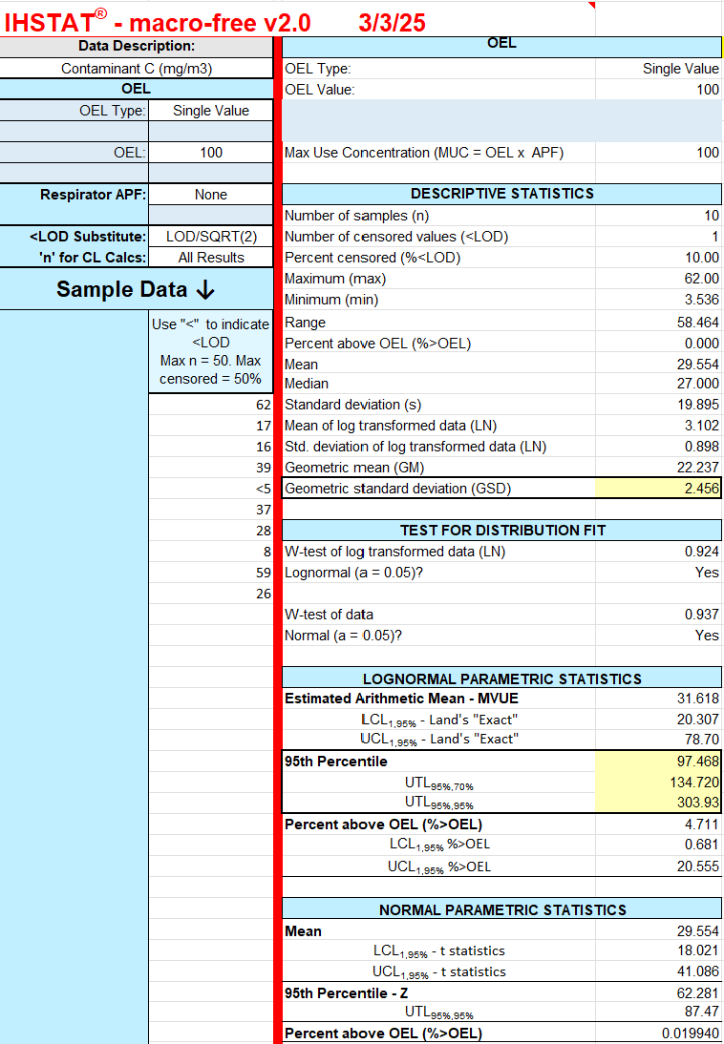
Figure 10: IHSTAT® output for lognormally and normally distributed data
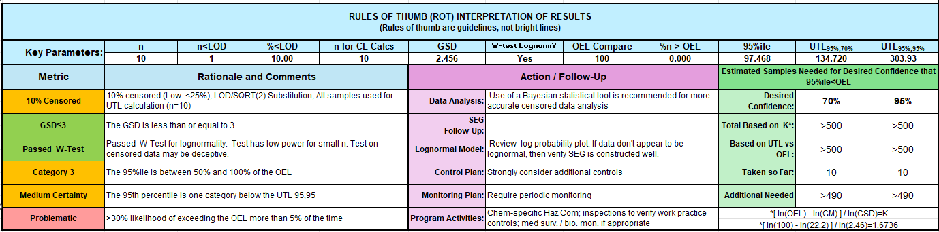
Figure 11: IHSTAT® rules of thumb interpretation of lognormally and normally distributed data results
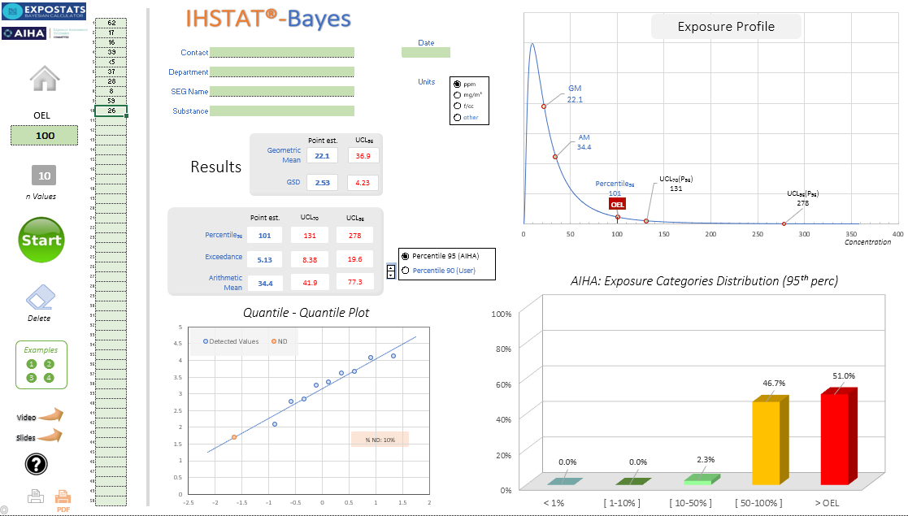
Figure 12: IHSTAT® Bayes output for lognormally and normally distributed data

Appendix I1.2 Lognormally distributed exposure data only
The 6 data points presented in Figure 13 are 1.24, 1.87, 1.82, 5.94, 0.69, <1 ppm, with an exposure limit (OEL) of 10 ppm. Figure 14 shows the rules of thumb interpretation of results and Figure 15 shows the Bayes output.
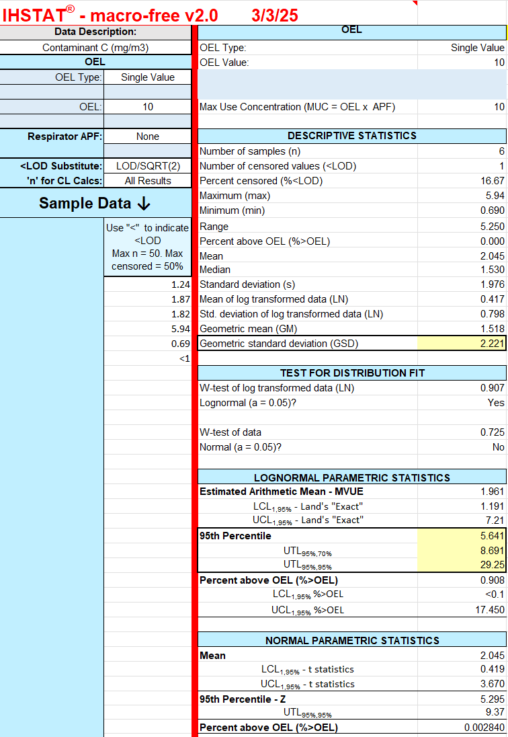
Figure 13: IHSTAT® output for lognormally distributed data
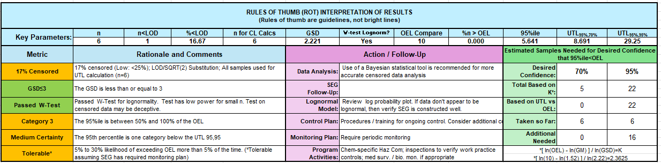
Figure 14: IHSTAT® rules of thumb interpretation of lognormally distributed data results
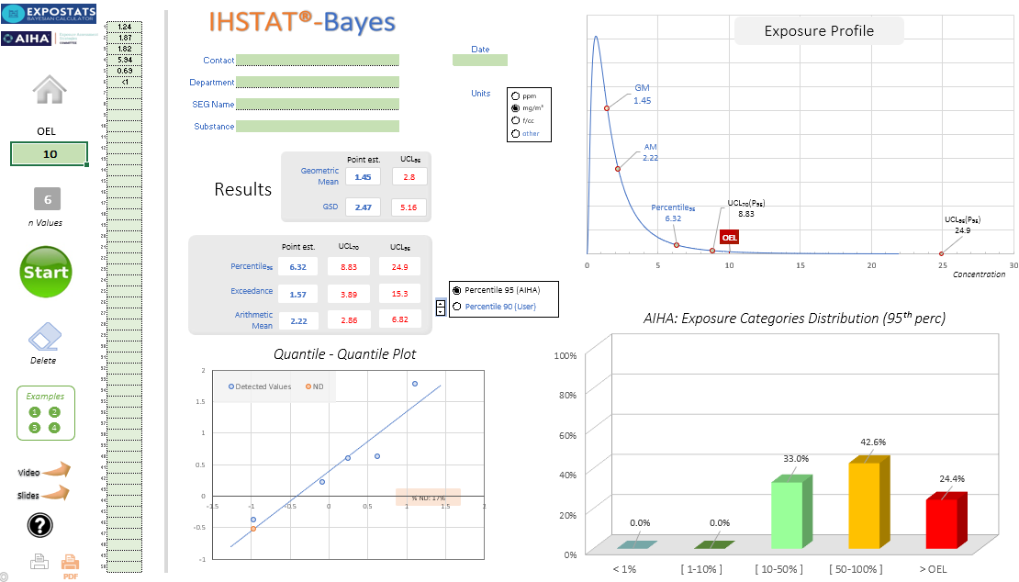
Figure 15: IHSTAT® Bayes output for lognormally distributed data

Appendix I1.3 Normally distributed exposure data only
The 12 data points presented in Figure 16 are 0.24, 0.87, 0.82, 0.94, 0.69, <0.1, 0.91, 0.28, 0.81, 0.33, 0.7, <0.1 ppm, with an exposure limit (OEL) of 2 mg/m³. Figure 17 shows the rules of thumb interpretation of results.
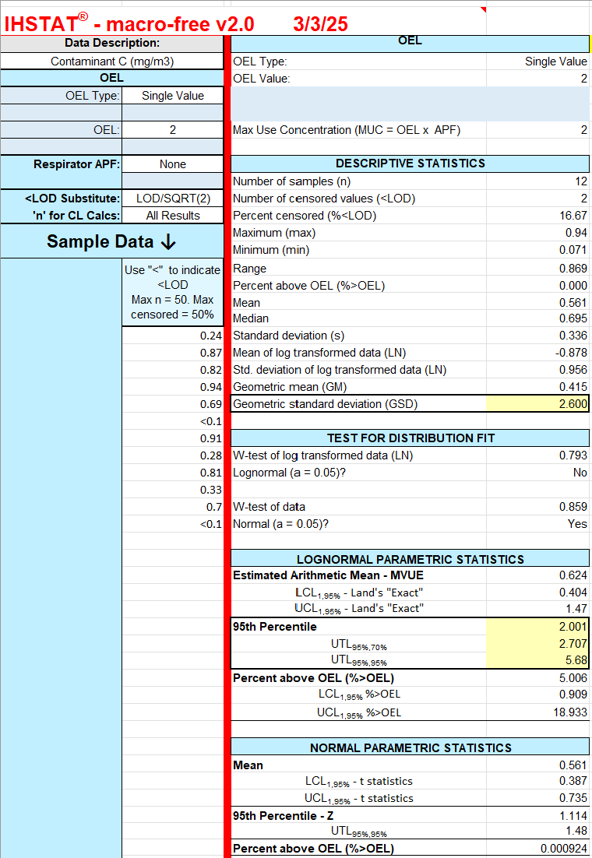
Figure 16: IHSTAT® output for normally distributed data
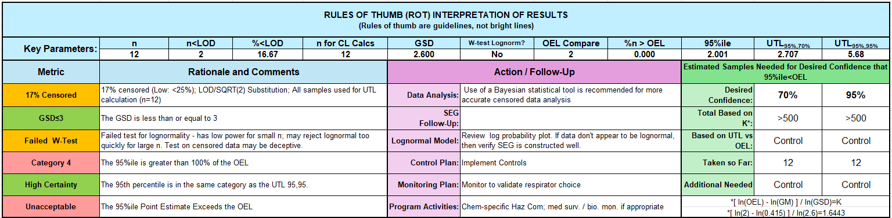
Figure 17: IHSTAT® rules of thumb interpretation of results for normally distributed data
No analysis was completed using IHSTAT® Bayes as the data are normally distributed only.

Appendix I1.4 Neither lognormally nor normally distributed exposure data
The 6 data points presented in Figure 18 are 0.24, 0.87, 0.82, 0.94, 0.69, 0.90 ppm, with an exposure limit (OEL) of 2 mg/m³. Figure 19 shows the rules of thumb interpretation of results.
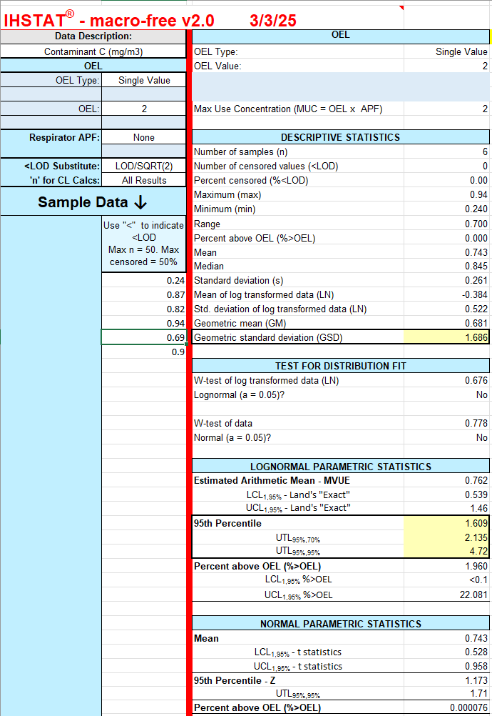
Figure 18: IHSTAT® output for neither lognormally nor normally distributed data
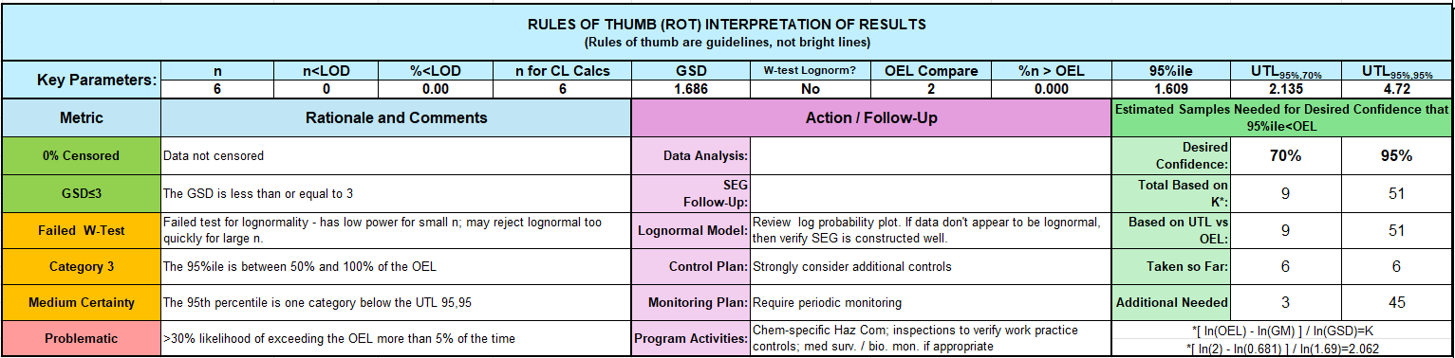
Figure 19: IHSTAT® rules of thumb interpretation of results for normally distributed data
No analysis was completed using IHSTAT® Bayes as the data are not lognormally distributed.

Appendix I2: Expostats (tool 1)
The statistical output of using Expostats to analyse the same data as in Appendix I1.1 (10 data points of 62, 17, 16, 39, <5, 37, 28, 8, 59 and 26 ppm, with an exposure limit (OEL) of 100 ppm) is shown in Table 13 – Table 15 and Figure 20.

Appendix I2.1 Statistical inference of results
Before using this tool, you need to decide which statistical parameter will be used to determine compliance, such as:
- Proportion greater than OEL (WEL),
- 95% upper confidence limit, or
- Arithmetic mean/geometric mean.
Table 13: Expostats lognormally and normally distributed data, statistical inference – percentiles
Sample Statistic | Value
Number of observations | 10
Proportion censored | 10%
Minimum | < 5
25th percentile | 16.2
Median | 27
75th percentile | 38.5
Maximum | 62
Proportion greater than OEL | 0%
Arithmetic mean | 29.7
Arithmetic standard deviation | 19.6
Coefficient of variation | 66%
Geometric mean | 23.2
Geometric standard deviation | 2.24
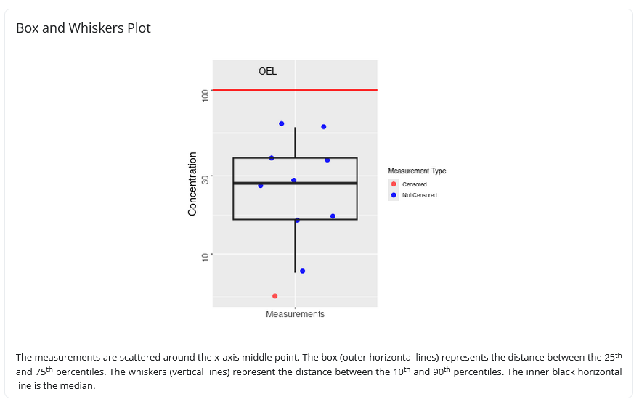
Figure 20: Box and Whiskers plot of data being analysed
Table 14: Estimates of the data based on statistical analysis
 | Distribution parameters | Exceedance fraction | Critical percentile | Arithmetic mean
The point estimate of the geometric mean is equal to: | 22 [13 - 36.9]
The point estimate of the geometric standard deviation is equal to: | 2.55 [1.93 - 4.22].
The point estimate of the: |  | Exceedance fraction is equal to 5.23% [0.708% - 19.5%]. | 95th percentile is equal to 102 [55.7 - 281]. | arithmetic mean is equal to 34.6 [21 - 77.6].
The 70% upper confidence limit is equal to: |  | 8.5% | 133 | 42.3
The 95% upper confidence limit is equal to: |  | 19.5% | 281 | 77.6
Table 15: Expostats statistical inference: risk assessment
 | Exceedance fraction | Percentiles |  | Arithmetic mean
Overexposure is defined as the: | exceedance fraction being greater than or equal to 5%. |  | 95th percentile being greater than or equal to the OEL. |  | arithmetic mean being greater than or equal to the OEL.
The probability that this criterion is met is equal to: | 51.8% |  | 51.8% |  | 2.44%
The probability that this criterion is met should be lower than: | 30% |  | 30% |  | 30%
The current situation is: | problematic |  | problematic |  | acceptable
Risk Meter | 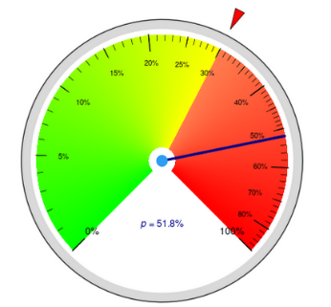 |  | 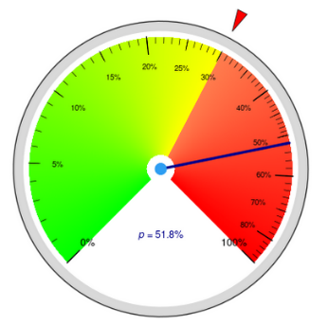 |  | 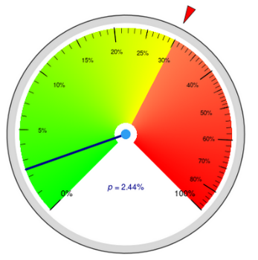
Density Plot | 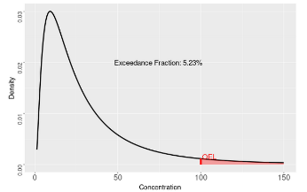 |  | 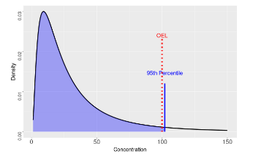 |  | 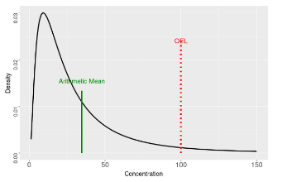

Appendix J: Examples of using excel for an ANOVA calculation
This Appendix provides an example of the Analysis of Variance (ANOVA) method for determining group and individual compliance, as described in Section 7.3. Multiple tools to perform this analysis have been developed by various organisations around the world; one developed to be used by occupational hygienists has been published by the Belgian Society for Occupational Hygiene called BWStat v3.1.0 tool.
For this example, we will demonstrate how to use Excel to calculate group and individual compliance using the Excel ANOVA tool. The scenario used is a fictional exposure scenario. You have been monitoring three workers in a small workplace for a week. The results of the monitoring for an inhalable dust, with an exposure limit of 10 mg/m³, are given in Table 16.
Table 16: Results of inhalable dust monitoring over a period of one week
Day monitored | Dust exposures mg/m³
Day monitored | Worker A | Worker B | Worker C
Monday | 5.22 | 3.58 | 3.30
Tuesday | 5.23 | 3.53 | 5.08
Wednesday | 4.87 | 4.80 | 4.63
Thursday | 4.68 | 3.50 | 3.14
Friday | 4.90 | 4.74 | –
Two of the workers were measured on all five days, but Worker C does not work on a Friday, so there are only four measurements for them. The measurements represent the exposures for normal activities undertaken during the workweek and are considered representative of the worker's usual exposure. Data for each worker is lognormally distributed.

Establishing group compliance

Step 1: Using the Excel math function
Import the measured exposure date (Figure 21) to Excel. From here, the log-transformed calculations will be undertaken using the Math-functions in Excel.
The first function to be used is the natural log (LN) function, which is used throughout this example. Type “=LN(B4)” in cell G4. This generates in G4 the natural log of the value in cell B4. Repeat this instruction for all, by updating the cell value for all cells from G4 to I8, for the representative LN value to be calculated for each measured value. The complete table is shown in Figure 21.
Tip: A shortcut is to select G4 and hover the cursor on the cell until it changes to a thin black cross. Hold down the left button of the mouse and drag the cross over to the bottom right-hand corner of cell I4 (representing Worker C on Monday) and then down to the bottom right-hand corner of cell I8 (Worker C on Friday). This should fill cells G4 to I8 with the natural logarithms of the original dust exposures in cells B4 to D8, without you having to manually type it in. It will be necessary to delete data in I8, which will show an “error” sign. This is because the log of zero cannot be calculated.
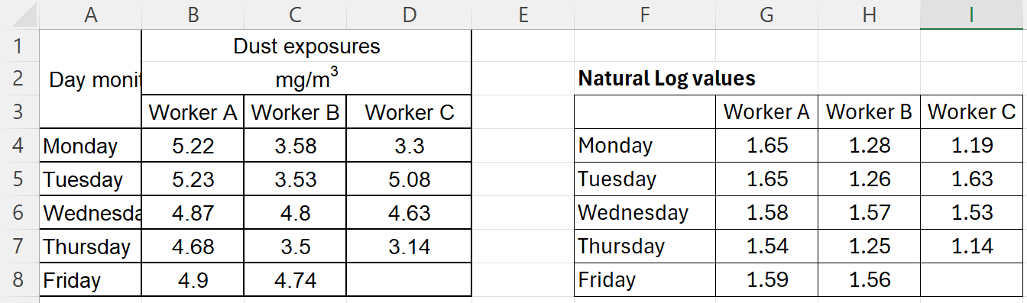
Figure 21: Results of naturally logging the monitoring results
Tip: To ensure consistency, keep the number of decimal places displayed in each cell to 2. However, Excel stores and uses all the numbers (including all decimal places), regardless of the visibility setting of the cell. This means that if you try to reproduce this example, some of the calculations may produce different numbers in the third or later decimal places, compared to those in the figures in this Appendix. This does not affect the outcome, but it may cause confusion.

Step 2: Group compliance calculation
Next, you will use the logged values to determine SEG compliance, as detailed in Section 7.3.
You will need to calculate the log-values of the geometric mean (GM), and the geometric standard deviation (GSD). There are two separate functions built into Excel that you can use (see Figure 22).
  - Geometric mean: Calculate GM by typing “Log GM” (as a label or descriptor of the data), into cell F10 and by typing “=AVERAGE(G4:I8)” in cell I10.
  - Geometric standard deviation is calculated by typing “Log GSD” (as label a descriptor of the data). into cell F11 and by typing “=STDEV(G4:I8)” in cell I11.
The outcome should be similar to that displayed in Figure 22.
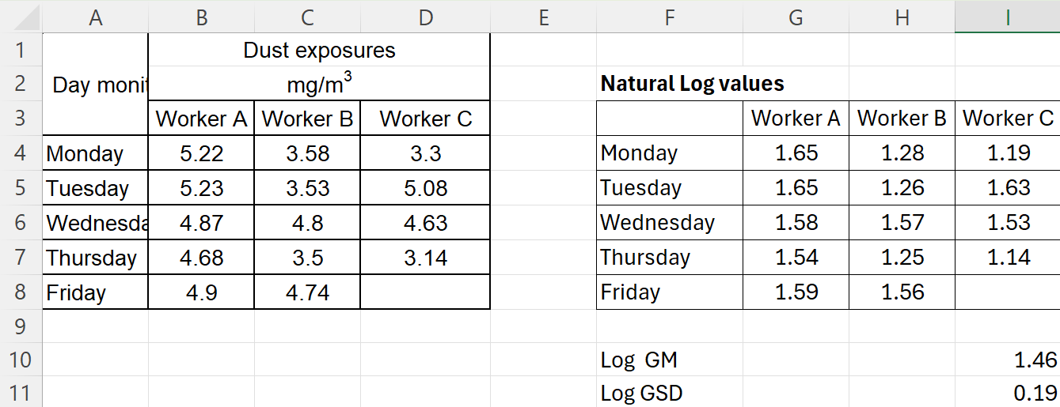
Figure 22: Calculation of geometric mean and geometric standard deviation
You are now ready to test group compliance. For this example, an exposure limit of 10 mg/m³ is applied, which you can type in cell L10. It is always advised to label your calculated values; thus, type “exposure limit” in K10.
Next, you need to calculate the unbiased estimator of variance (U) parameter by typing the label “U” into cell H12 and then calculating the U-value by typing “=(LN(I10)-L10)/I11” in I12 (see Figure 23).
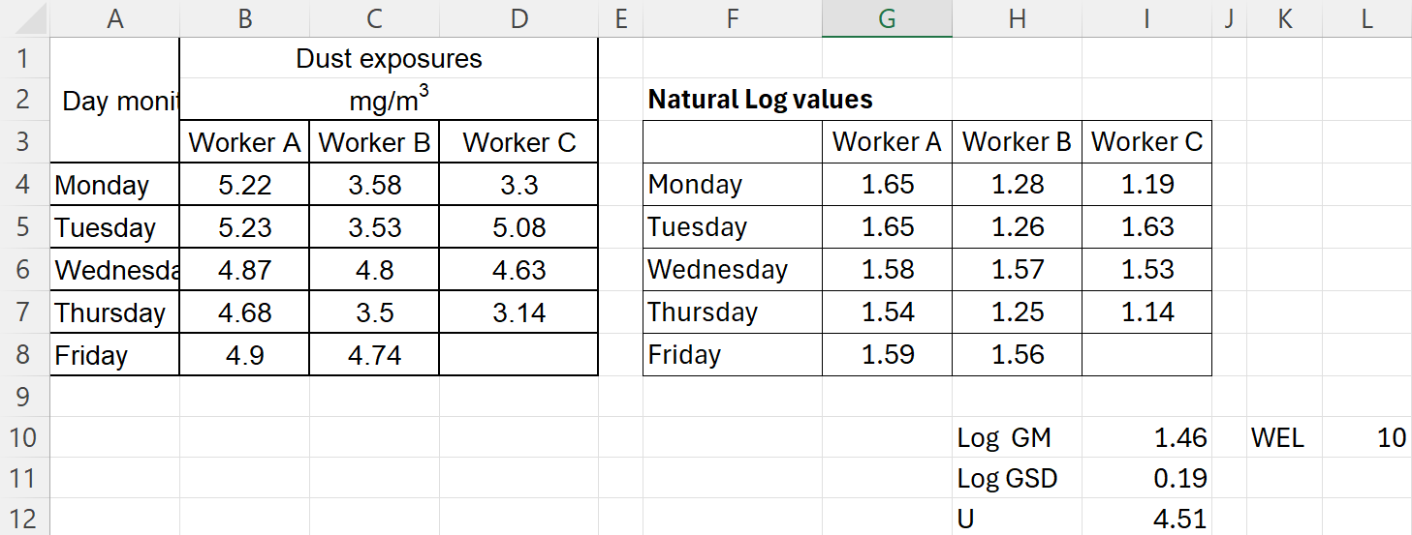
Figure 23: Calculation of the unbiased uncertainty parameter (U)
Compare the calculated “U” with the limiting value for U [8], based on the number of total measurements taken, shown in Table 17.
Table 17: Limiting values of U
Number of exposure measurements | Limiting value of U
9 | 2.035
10 | 2.005
11 | 1.981
12 | 1.961
13 | 1.944
14 | 1.929
15 | 1.917
If the calculated U, (cell I12), is greater than the limiting U (Table 17), the group data are in-compliance with the exposure limit. Conversely, where the calculated U is less than the limiting value provided in Table 17, the SEG is non-compliant with the exposure limit.
For this example, the calculated U is 4.51 for 14 exposure measurements. This is greater than the limiting U of 1.929, thus compliance is clearly demonstrated in this example.
When comparing the exposure limit of 10 mg/m³ with the raw, measured exposure values in Figure 21, this result is not surprising.

Calculating individual compliance
Next, you now need to perform a similar analysis of variance on individual compliance.
To execute the ANOVA test in Excel, you should have the “Analysis ToolPak” added to your Excel file. In Excel 365, you get it by going to “File> Options>Add-ins>”. Verify that the suite is listed in your Active Application Add-ins before commencing. If not, select to add-in and install.

Step 1: Calculating ANOVA: Single factor
In Excel, you can now select Data Analysis. In the Analysis Tools select “ANOVA: Single Factor”. A new small pop-up screen will appear (see Figure 24).
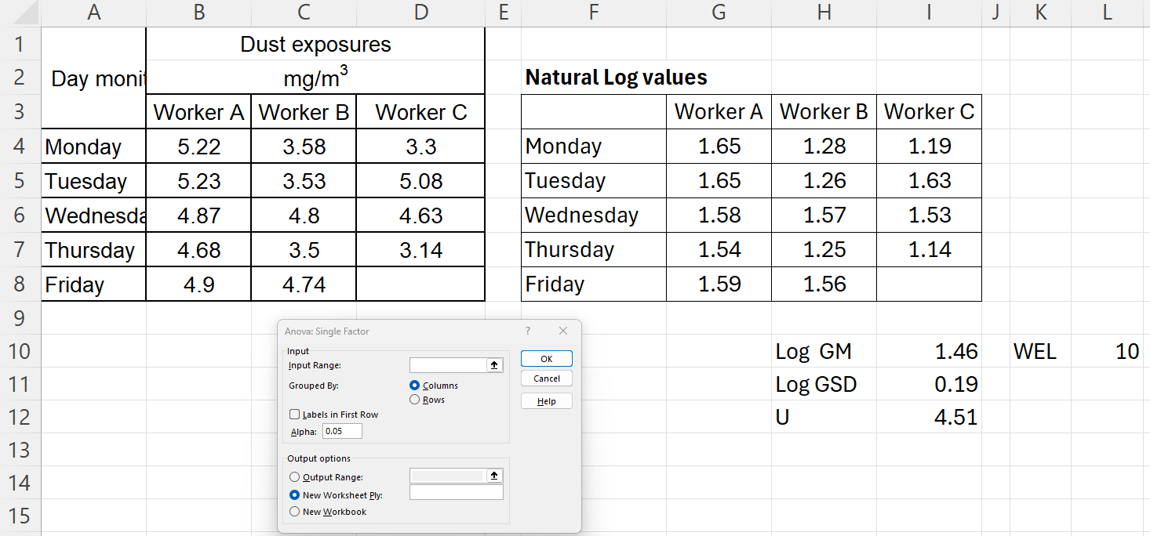
Figure 24: Step one to calculating ANOVA: single factor
Select the input data by highlighting the Natural log values in cells G4 to I8 ($G$4:$I$8). You then click to check the button against Output Range. In the Output Range slot, you select the location where you would like the results to be displayed, in this example, cell A13 was selected. Click OK, and the results of the Analysis of Variance will be displayed in the Output Range cell you selected (Figure 25).
Note: For this analysis, you only require some details from the ANOVA table, however for a complete explanation of its interpretation, you should consult a statistics textbook.
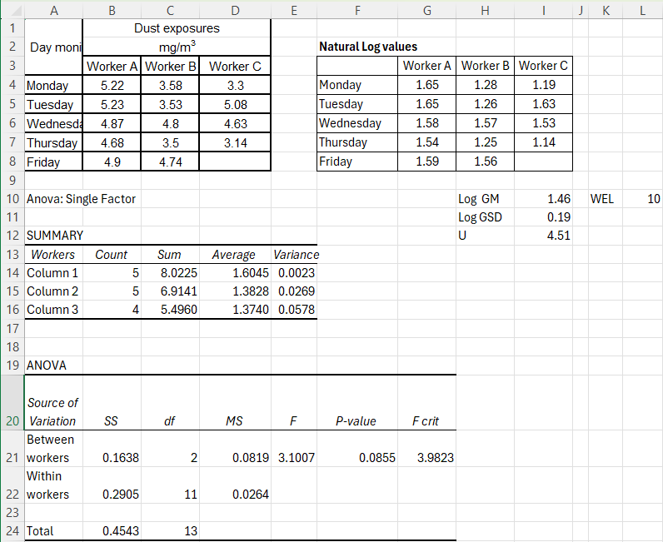
Figure 25: ANOVA: Single-tail output

Step 2: Determine individual variance
2.1 Within-worker variance
The within-worker variance is estimated by using the mean square (MS) value in the “Within workers” row of the ANOVA table, i.e. cell D22 of Figure 25, where we can see the calculated variance is 0.0264. For convenience, we will type this value in cell Q3, by typing =P25 in Q3 and typing the label “within-worker variance” in P3.
2.2 Between-worker variance
To calculate the between-worker statistics, we first need the between-worker mean square (MSB). This value has already been calculated by the ANOVA single factor calculation, 0.0819, reported as the “Between Workers MS” in the ANOVA table (D21, Figure 25).
The within-worker and between-worker standard deviations are both normally designated ‘sw’ and ‘sb’ respectively, and the corresponding variances are the squares of these.
If we had taken the same number of exposure measurements n₀, which had been collected from each person in the SEG, then MSB would be given by:
$$MSB= S_{w}^{2}+ {(n}_{o}×S_{b}^{2})$$
Which makes:
$$s_{b}^{2}= \frac{(MSB-s_{w}^{2})}{n_{o}}$$
But when you have an uneven number of samples per person, it becomes more complicated.
$$n_{o}= \frac{\{N- \frac{(\sum_{i=1}^{k}{n_{i}^{2} }}{N}\}}{(k-1)}$$
n_{o} is calculated based on using n_{i}, which is the number of exposure measurements made of the i^{th} person, N is the total number of measurements, and k is the number of people sampled. For our example, N = 14, and k = 3.
$$n_{o} = \frac{\left\{14- \frac{\left(5^{2}+5^{2} {+ 4}^{2}\right)}{14}\right\}}{\left(3-1\right)}$$
$$= \frac{\left\{14- \frac{\left(66\right)}{14}\right\}}{2}$$
$$= \frac{14- 4.71}{2}$$
$$=4.64$$
Now we can calculate the between-person variance s_{b}, remembering that the between-worker mean square MSB is in the ANOVA table, and using the value of n₀ that we have just calculated. You do this by inserting the calculation “=(D21-Q3)/Q5” (Figure 26) in cell Q6.
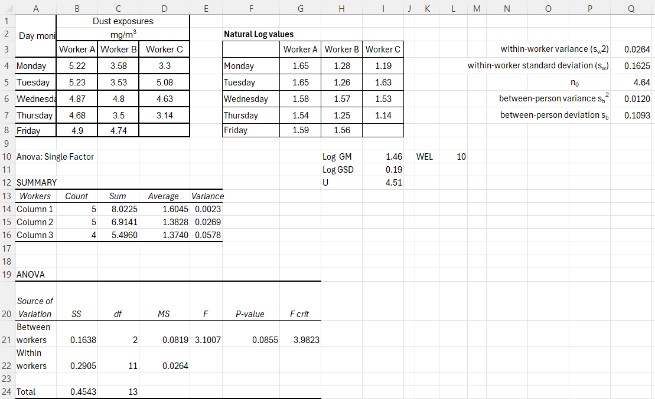
Figure 26: Calculation of between-worker variance & standard deviation in cells Q6 & Q7
Is the individual compliance test needed in this case?
You should only test if the between-worker variance is more than 20% of the total variance (s_{b}² > 0.2 x s²). In this case, s_{b}² is 0.0120 and s² is 0.0384. which shows us that there is significant variation between workers, as shown in cell Q9 in Figure 27. This means the SEG needs to be revisited to ensure that workers’ exposures are not exceeding the exposure limit.
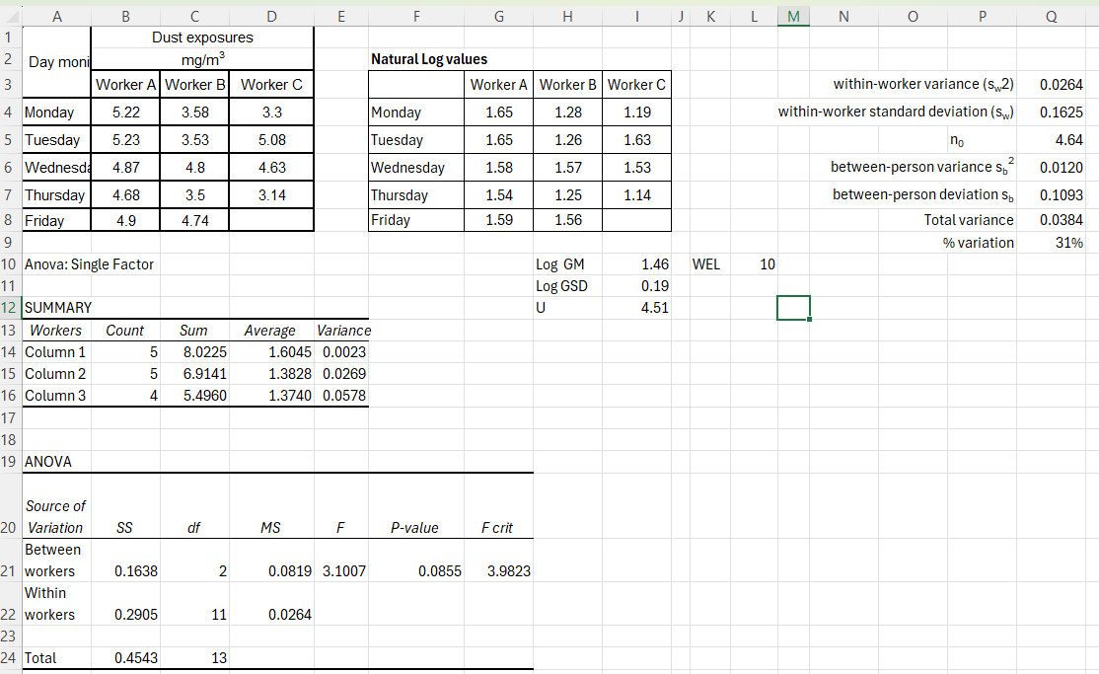
Figure 27: Final calculation individual compliance test

Appendix K: Examples of calculating compliance for mixtures
The following examples demonstrate how the additive mixture formula could be applied in practice.

Example K1: Additive mixture formula calculation for dusts
Airborne samples for inhalable dusts have been collected at a waste transfer station. In addition to providing details on the inhalable dust concentration, samples also underwent chemical speciation to determine if there were any components of concern.
The components that the laboratory has reported on is detailed in Table 18, along with the associated exposure limit and the concentrations measured. The information on the potential health impacts was obtained from the WES Review evaluation reports from HCIS.
Table 18: Exposures to a mixture of dusts at a waste transfer station
Contaminant identified | CAS No | 8-hr TWA WEL  (mg/m³) | Measured concentration  (mg/m³) | Potential health impact
Inhalable dust | No CAS Number | None | 4.08 | May affect the upper respiratory system (the nose, mouth, throat or upper respiratory tract)
Aluminium | 7429-90-5 | 10 | 2.34 | Adverse effects on the lungs, and central nervous system (CNS)
Barium (based on barium sulfate (inhalable)) | 7727-43-7 | 4 | 0.09 | Pneumoconiosis (baritosis)
Chromium (III) | 7440-47-3 | 0.5 | 0.1 | Irritation and other lung effects.
Iron salts, soluble (as Fe) | 7439-89-6 | 1 | 0.59 | Lung inflammation and pulmonary siderosis (occupational pneumoconiosis)
Manganese fume, dust and compounds (as Mn) (inhalable) | 7439-96-5 | 0.1 | 0.06 | Adverse neuro-physiological and neuro-psychological effects
Nickel, metal and insoluble compounds (as Ni) | 7440-02-0 | 0.1 | 0.02 | Inflammation of the airways and potential lung and nasal cancer
Tin (organic compounds) | No CAS Number | 0.1 | 0.81 | Central nervous system (CNS) and other systemic effects
Zinc oxide | 1314-13-2 | 2 | 0.1 | Metal fume fever
Zirconium compounds | 7440-67-7 | 5 | 0.15 | Impaired lung function and radiographic changes in the lungs
Since many of the components of the collected dust sample (aluminium, chromium (III), iron, nickel and zirconium) have similar health impacts on the same target organ (lungs) via the same route of entry (inhalation), the mixture calculation rules will apply.
Compliance is demonstrated when the Additive Mixture Formula is used and the total from the calculation <1, as follows:
Additive Mixture Formula $= \frac{C_{1}}{{WEL}_{1}} +\frac{C_{2}}{{WEL}_{2}} +\frac{C_{3}}{{WEL}_{3}} +\frac{C_{4}}{{WEL}_{4}} +\frac{5}{{WEL}_{5}}$
$$= \frac{2.34}{10} +\frac{0.1}{0.5} +\frac{0.59}{1.0}+\frac{0.02}{0.1}+\frac{0.15}{5}$$
$$=0.234+0.2+0.59+0.2+0.03$$
$$=1.254$$
This shows that even though no singular component of the dust measured exceeded its respective exposure limit, when the additive mixtures rules were applied then the total exposures were non-compliant (calculated result >1).
An investigation needs to be undertaken to identify the sources of the components contributing most significantly to exposure (iron – 59% and aluminium – 23%), for appropriate control/s to be identified and implemented to reduce the total exposures to acceptable risk levels.

Example K2: Exposure index calculation for volatile organic compounds
Monitoring for VOCs have been conducted using a passive VOC badge to assess exposures in a printing facility. The laboratory reported the results as a chemical speciation, providing individual concentrations for each VOC detected, each with its own assigned exposure limit. The VOCs that have similar health impacts are list in Table 19.
Table 19: Exposures to a mixture of VOCs
Contaminant identified | CAS | 8-hr TWA WEL  (ppm) | Measured concentration  (ppm) | Potential health impact
Cyclohexane | 110-82-7 | 100 | 18 | Impaired nervous system (CNS)
Ethyl acetate | 141-78-6 | 200 | 14 | Irritation of the eyes, nose & upper airways
Ethylbenzene | 100-41-4 | 20 | 2 | Irritation of the eyes, nose and upper respiratory tract, kidney damage and potential hearing loss
Methyl Ethyl Ketone | 78-93-3 | 200 | 59 | CNS
Tetrahydrofuran | 109-99-9 | 50 | 13 | CNS
Toluene | 108-88-3 | 20 | 5 | CNS
Xylene (mixed isomers | 1330-20-7 | 80 | 15 | CNS
The components (Cyclohexane, Methyl Ethyl Ketone, Tetrahydrofuran, Toluene and Xylene) that have similar health impacts, on the same organ, CNS, via the same route of entry, inhalation, will be used for inclusion in the mixture calculation as follows:
Additive Mixture Formula $= \frac{C_{1}}{{WEL}_{1}}+\frac{C_{2}}{{WEL}_{2}}+\frac{C_{3}}{{WEL}_{3}} +\frac{C_{4}}{{WEL}_{4}} +\frac{C_{5}}{{WEL}_{5}}$
$$=\frac{18}{100} +\frac{59}{200}+\frac{13}{50}+\frac{5}{20} +\frac{15}{80}$$
$=$ $0.18+0.295+0.26+0.25+0.1875$
$$=1.17$$
The results indicate that the exposure to each individual component is below 30% of the respective exposure limit. However, when the additive mixture calculation is applied, the combined exposure index exceeds the compliance threshold for the Additive Mixture Formula of 1. The primary contributors based on the percentage against their individual exposure limit is Methyl Ethylene Ketone (29.5%) followed by Tetrahydrofuran (26%) and Toluene (25%). The source of each of these exposures needs to be investigated to identify contributing tasks or processes and to determine where additional controls may be required.
In this case, the observational data should be reviewed to verify which control measures were in place and whether appropriate RPE was correctly fitted and worn throughout the entire shift. In some cases, workers may also need to undergo health monitoring, as required by the WHS Regulations.
The components (Ethyl acetate and Ethylbenzene) that have similar health impacts, on the same organ, URT, via the same route of entry, inhalation, will be used for inclusion in the mixture calculation as follows:
Additive Mixture Formula $= \frac{C_{1}}{{WEL}_{1}}+\frac{C_{2}}{{WEL}_{2}}$
$$=\frac{14}{200} +\frac{2}{20}$$
$=$ $0.07+0.1$
$$=0.17$$
In this case, exposure to ethylbenzene and ethyl acetate are compliant (<1).

Best practice is to engage a certified occupational hygienist (COH) or equivalent (CIH, ROH). Where a COH is not available, assessments may be undertaken by a person with relevant qualifications and experience in occupational hygiene, or a person working under the direct supervision of a COH.

