Managing the risks of exposure to diesel engine emissions in the workplace
Guide

JUNE 2026

Disclaimer
Safe Work Australia is an Australian Government statutory agency established in 2009. Safe Work Australia includes Members from the Commonwealth, and each state and territory, Members representing the interests of workers and Members representing the interests of employers.
Safe Work Australia works with the Commonwealth, state and territory governments to improve work health and safety and workers’ compensation arrangements. Safe Work Australia is a national policy body, not a regulator of work health and safety. The Commonwealth, states and territories have responsibility for regulating and enforcing work health and safety laws in their jurisdiction.
Creative Commons
With the exception of the Safe Work Australia logo, this copyright work is licensed under a Creative Commons Attribution 4.0 International licence. To view a copy of this licence, visit creativecommons.org/licenses In essence, you are free to copy, communicate and adapt the work, even commercially, as long as you attribute the work to Safe Work Australia and abide by the other licence terms.
Contact information
Safe Work Australia | mailto:info@swa.gov.au | www.swa.gov.au

Contents
1. Introduction 4
1.1 What are diesel engine emissions? 4
1.2 Workplace exposure to diesel engine emissions 5
1.3 Incidental exposure to diesel engine emissions 6
1.4 What are the health effects of exposure to diesel engine emissions? 6
2. Health and safety duties 7
3. The risk management process 8
3.1 Identify the hazards 8
3.2 Assess the risks 9
3.3 What is reasonably practicable? 11
3.4 Control the risks 11
3.5 Review hazards and control measures 20
4. Assessing exposures to diesel engine emissions 21
4.1 Air monitoring 21
4.2 Health monitoring 22
5. Further resources 23

    - Introduction
This guide provides information for a person conducting a business or undertaking (PCBU) on how to manage risks associated with exposure to diesel engine emissions (DEE) in the workplace.
      - What are diesel engine emissions?
Diesel engine emissions (DEE), also known as diesel exhaust, comes from engines powered by diesel fuel. It is a complex mixture of gases, vapours, liquid aerosols and particulates produced through combustion.
The composition of DEE varies depending on:
- the type of engine,
- its age and condition,
- operating conditions (e.g., temperature, pressure, engine speed),
- emission control systems, and
- the composition of the fuel, lubricating oils and additives used.
The main chemical components of DEE are gases and vapours commonly found in air, like nitrogen, oxygen, carbon dioxide and water vapour (Figure 1). A small percentage of DEE is made up of hazardous chemicals like carbon monoxide, nitrous oxide, nitrogen dioxide, sulfur oxides and fine particles known as diesel particulate matter (DPM).
Traces of other airborne contaminants may be present in DEE, including hydrocarbons like acrolein, formaldehyde, acetaldehyde, benzene, 1,3-butadiene, chlorobenzene, ethyl benzene, phenol, styrene, toluene, xylenes, and polycyclic aromatic hydrocarbons (PAHs).
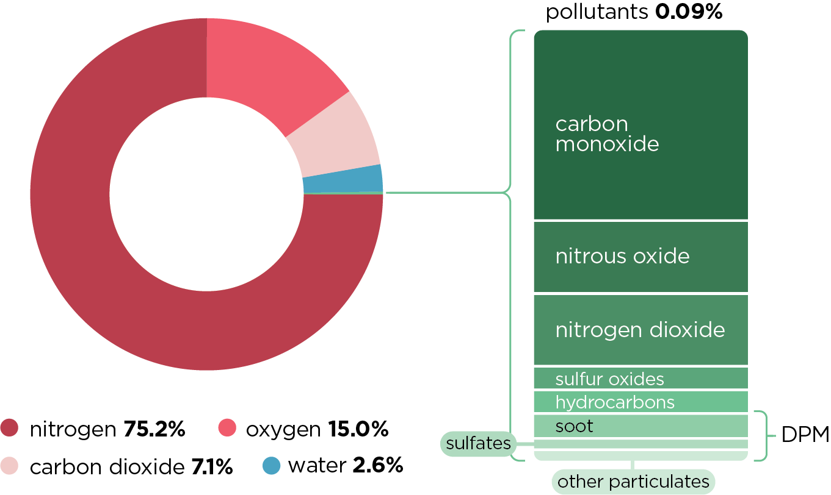
Figure 1: Composition of diesel engine emissions
Diesel Particulate Matter
DPM makes up only a small fraction of the total DEE. DPM is made up mostly of soot (elemental carbon), along with ultra-fine droplets of unburned hydrocarbons (from the lubricating oil or fuel additives), water mists, sulfates and trace concentrations of other particulate airborne contaminants from oil or fuel additives, some of which are hazardous.
These trace contaminants can include metals or metal compounds like arsenic, beryllium, cadmium, cobalt, inorganic lead, manganese, mercury, chromium or nickel.
More than 90% of DPM are smaller than 1 micrometre (μm). These small particles can adsorb hazardous gases and vapours from the DEE onto their surfaces. Because of its small size, DPM can stay airborne for long periods of time and can penetrate deep into the lungs, carrying other hazardous chemical components of the DEE.
      - Workplace exposure to diesel engine emissions
Exposure to DEE is a possible hazard for anyone working with or around diesel-powered engines, especially in enclosed, poorly ventilated spaces.
The most common source of workplace exposure to DEE is from heavy vehicles that use diesel fuel, like trucks, buses, trains, tractors, ships, loaders, forklifts, bulldozers and other mining and construction equipment. DEE may also be generated from stationary power sources like generators and winch motors, including those mounted to vehicles.
Workers in the following industries are most likely to be exposed:
- mining and quarrying,
- oil and gas,
- tunnelling,
- construction,
- agriculture,
- transport and logistics, and
- vehicle maintenance.
Levels of exposure to DEE can be higher in enclosed, poorly ventilated areas where the concentration of exhaust can build up, like in vehicle repair workshops, car parks, tunnels, mines, partially covered roadways and in vehicle holds in ships and trains.
Research has estimated 1.2 million Australian workers were exposed to DEE in the workplace in 2011, and almost 2% of these workers experienced high levels of exposures in their job.
      - Incidental exposure to diesel engine emissions
Incidental exposure refers to situations where DEE are present in the workplace, but the source is not under the direct control of the workplace. Regardless of the source, exposure to workers and others at the workplace still needs to be minimised.
Workers at risk of incidental exposure may include those who spend a significant amount of time around trucks that are unloading and loading and diesel-powered plant and machinery. Other workers at risk of incidental exposure include those who carry out work near busy railway lines and roadways, workers in drive-through takeaway outlets, traffic controllers and material handling operators.
      - What are the health effects of exposure to diesel engine emissions?
Inhalation is the most significant route of workplace exposure to DEE. Exposure to DEE can cause both short-term (acute) and long-term (chronic) health effects.
Short-term effects
Short-term exposure to high concentrations of DEE can have health effects ranging from irritation of the eyes, nose, throat and lungs, light-headedness, nausea, coughing and other respiratory symptoms to asphyxiation from carbon monoxide poisoning.
Long-term effects
DEE are carcinogenic, which means exposure can cause lung cancer and present an increased risk of bladder cancer. In addition to all DEE being considered carcinogenic, PAHs, a trace contaminant in DEE, have also been determined to be carcinogenic. Each year, around 130 Australians are diagnosed with lung cancer caused by work-related exposure to DEE.
Long-term exposure can also worsen asthma and allergies and increase the risk of heart and lung disease, such as chronic obstructive pulmonary disease.
    - Health and safety duties
PCBUs have a primary duty to ensure the health and safety of workers while they are at work in the business or undertaking, and others who may be affected by the work, such as visitors. This includes ensuring, so far as is reasonably practicable, that they:
- provide and maintain a safe work environment
- provide and maintain safe plant and structures
- provide and maintain safe systems of work
- ensure plant is safely used, handled and stored
- provide accessible and adequate facilities (for example access to washrooms, lockers, and dining areas)
- provide sufficient instruction, training, information, and supervision
- monitor workers’ health and conditions at the workplace, and
- maintain any accommodation to ensure the health and safety of workers.
Workers must take reasonable care for their own health and safety, comply with reasonable instructions, and not adversely affect the health and safety of other people.
The risks from hazardous substances generated in the workplace, such as DEE, must be managed by PCBUs in accordance with Parts 7.1 (Hazardous Chemicals) and 3.1 (Managing Risks to Health and Safety) of the WHS Regulations. The use of diesel-powered plant in the workplace is therefore subject to these requirements.
Section 3 of this guidance provides information on managing the risks to health and safety resulting from the generation of DEE in the workplace and includes consideration of identifying hazards, assessing and controlling risks and reviewing hazards and control measures.

    - The risk management process
As a PCBU you must manage the health and safety risks associated with DEE.
Risk management requires you to think about what could go wrong at your workplace and what the consequences could be. Then you must do everything that is reasonably practicable to eliminate or minimise those risks. This process will be implemented in different ways depending on the size and nature of your business or undertaking.
Risk management involves four steps. Following this step-by-step process can help you decide what is reasonably practicable, so that you can meet your WHS duties.
- Identify hazards—find out what could cause harm.
- Assess risks—understand the nature of the harm that could be caused by the hazard, how serious the harm could be and the likelihood of it happening.
- Control risks—implement the most effective control measures that are reasonably practicable in the circumstances and ensure they remain effective over time.
- Review hazards and control measures to ensure they are working as planned.
Further information on the risk management process is in the Code of Practice: How to manage work health and safety risks. Information from mining regulators on DEE exposure in the mining sector is available in specific guidance^{,,,,9}.
Due to the complex nature of DEE, managing risks may require the advice of a competent person, for example, an occupational hygienist.
      - Identify the hazards
Identifying hazards associated with DEE involves finding what could potentially cause harm to people. You should first identify and document all sources of DEE affecting the workplace. Sections 1.2 and 1.3 detail sources of DEE to which workers may be exposed.

The following considerations can help identify potential hazards:
- Observe the workplace and work tasks to identify where workers may be exposed to DEE and how workers interact with the diesel-powered plant.
- Consider other work activities at or near the workplace which could contribute to exposure of workers, or which may allow for other people to be exposed to DEE from sources under your control.
- Visually inspect the plant to determine faults or damage and during operation to see if blue, black or white smoke is being emitted:
  - Blue smoke (mainly oil and unburnt fuel) is caused by partly burnt fuel from badly worn engines which are poorly serviced or tuned.
  - Black smoke (soot, oil and unburnt fuel) is produced if there is a mechanical fault with the engine or if the engine is working near its maximum speed.
  - White smoke (water droplets and unburnt fuel) is produced when the engine is started from cold and disappears as the engine warms up.
- You are required to consult with workers and health and safety representatives when identifying hazards and assessing risks.
  - Ask whether they have identified any problems or potential problems.
  - Ask about any issues they may have with DEE exposure including during operation, inspection, maintenance, repair and transport.
  - Further information on consultation requirements is in the Code of Practice: Work health and safety consultation, co-operation and co-ordination.
- Refer to relevant industry guidance, or other documentation that could assist in identifying DEE hazards, such as the manufacturer’s specifications for plant.
- Talk to manufacturers, industry associations, suppliers, health and safety specialists or any other competent person about the risks associated with the work.
- Review your incident and injury records looking for any symptoms, for example, whether they experience irritation of the eyes, nose, throat and lungs, light-headedness or nausea.
      - Assess the risks
Once you have identified the hazards at your workplace, you may need to assess the risks—the likelihood of somebody being harmed by the hazard and how serious the harm could be.
A risk assessment can help you work out what action should be taken to control the risk and how urgently the action needs to be taken. An occupational hygienist or other competent person can assist in making this assessment.
The level of risk depends on the duration and frequency of exposure. Think about how exposures could happen and who might be harmed. Guidance on how to do a risk assessment is available in the Code of Practice How to manage work health and safety risks.

The Code of Practice Managing risks of hazardous chemicals in the workplace includes information on who should conduct a risk assessment, the types of risk assessment, how to structure a risk assessment and things to consider in the risk assessment.
The following questions may help you work out whether DEE emissions may pose a risk to workers:
- What are the sources of DEE?
- If sources are within the control of the workplace:
  - Is it necessary to use diesel engines, or can alternative power sources be used?
  - How many engines are running at any one time? Are they all necessary? Can operating times be reduced?
  - Are engines being operated at full speed or left idling? Can this be avoided?
  - Are the engines well maintained? What is the frequency of maintenance? Are emissions measured and engine efficiency improved using this information? Is there a plan to replace older engines?
  - Is the fuel used good quality and clean?
  - Is exhaust directed away from people?
  - Is the workplace ventilated? Do emissions enter directly into the workplace, or are there systems in place to ensure they are removed and don’t enter the workplace? Are the emissions processed through a treatment system? Is the treatment system maintained? Can emissions accumulate?
- If sources are incidental to the workplace:
  - Do emissions enter directly into the workplace, or are they processed through a treatment system?
  - Are emissions continuous or only at peak periods? How long are workers exposed?
  - Is the workplace ventilated? Are there processes or systems to prevent accumulation of emissions?
- Is there visible evidence of contamination?
  - Is there visible smoke near the exhaust point? What is the type of smoke, for example is it white, black or blue? How could it be avoided?
  - Is there a visible haze in the workplace? Can it be avoided and how?
  - Are there soot deposits in the workplace; how significant are they? What can be done to avoid them? What methods are in place for regularly cleaning the workplace?
- Have there been any health issues reported from potentially exposed groups? If yes, how have these been addressed, have the measures reduced exposure and/or reporting of health issues?
- Are there controls in place to minimise exposure? Are they effective? Do they protect against exposure to gases and vapours in the DEE as well as particulates?
Where the hazards and associated risks are well-known and have established and accepted control measures, you may not need to undertake a risk assessment. If, after identifying a hazard, you already know the risk and how to control it effectively, you may simply implement the controls, in accordance with the hierarchy of control measures (see Section 3.4).
      - What is reasonably practicable?
Deciding what is ‘reasonably practicable’ to protect people from harm requires considering and weighing up all relevant matters, including:
- the likelihood of the hazard or risk occurring
- the degree of harm that might result from the hazard or risk
- knowledge about the hazard or risk, and ways of eliminating or minimising the risk
- the availability and suitability of ways to eliminate or minimise the risk, and
- after assessing the extent of the risk and the available ways of eliminating or minimising the risk, the cost associated and whether this is grossly disproportionate to the risk.
The process for managing risks will help you decide what is reasonably practicable, so that you can meet your duties under WHS laws. Further information on determining what is reasonably practicable is in the Interpretive guideline.
      - Control the risks
You must eliminate risks to health and safety so far as is reasonably practicable. If it is not reasonably practicable to eliminate the risks, you must minimise the risks so far as is reasonably practicable. You will most likely need to use a combination of control measures to protect your workers from the risks associated with DEE.
No workplace is the same, therefore the way risks are controlled will be different at every workplace. You should consider the specific requirements of each workplace when managing risks. The hierarchy of control measures (Figure 2) ranks ways of controlling risks from the highest level of protection and reliability to the lowest.
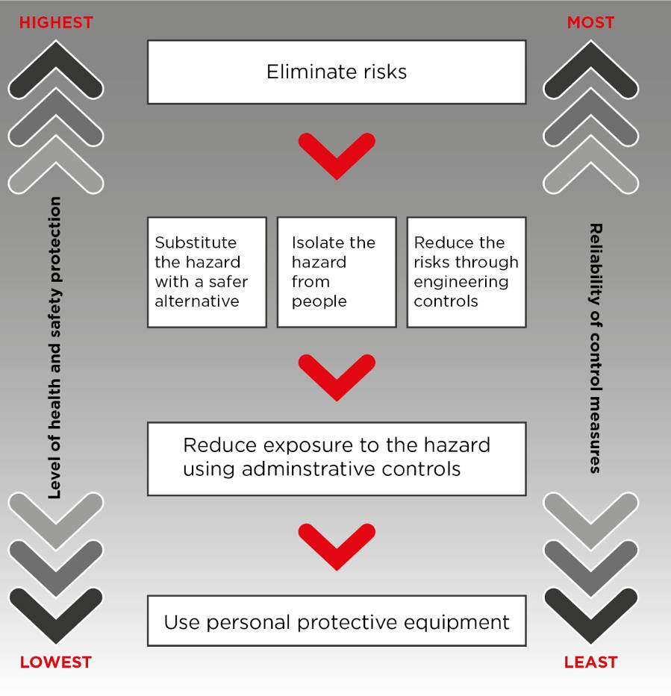
Figure 2: The hierarchy of control measures
You must work through this hierarchy and implement control measures which are reasonably practicable to manage health and safety risks associated with DEE.
You should consider if you need to protect against exposure to gases and vapours in the DEE, in addition to particulates (DPM). You should seek advice from an occupational hygienist or other competent person and refer to relevant industry guidance to ensure you use the most effective control measures available for your workplace.
Eliminating sources of DEE is the best option to reduce workers’ exposures. If elimination is not possible, reducing DEE at the source should be the primary consideration. Strategies typically focus on the fuel, the combustion efficiency of the engine and reducing or removing harmful emissions. You must minimise the risks as much as is reasonably practicable. This may involve using more than one control.
Elimination
Consider if risks from DEE can be eliminated by using alternative power sources, for example by replacing diesel-powered plant with electric, propane, compressed natural gas- or petrol-powered plant.
Replacing diesel engines will not be practicable in all circumstances and care must be taken that replacements do not introduce similar or other risks into the workplace. You must consider and manage any risks introduced by the use of alternative power sources.

Substitution
If replacing diesel-powered plant is not reasonably practicable, use ultra-low sulphur and other low-emission diesel fuels, fuel additives and low sulphur lubricants where possible. Avoid contaminating diesel fuel and lubricating oils, and ensure engines are well maintained to minimise emissions.
Isolating the hazard
Isolation involves physically separating the diesel-powered plant from people by distance or barriers. If it is not possible to eliminate the risks from DEE or minimise them through substitution (e.g. with alternate fuels or fuel additives), consider how you could separate the workers from the DEE. For example:
- where applicable, close down walkways or minimise access to prevent exposure to areas where DEE may be present during plant operation
- enclosing the worker in a sealed and/or pressurised, air-conditioned cabin with a high-efficiency particulate air (HEPA) filtered air supply (additional controls may be needed if carbon monoxide or other gases are a possible hazard)
- providing positive pressure ventilation for indoor areas to prevent infiltration of DEE, or
- modifying the layout of the workplace by separating the area of the workshop in which diesel engines are operating from the rest of the workshop.
Engineering controls
An engineering control is a control measure that is physical in nature, such as using a mechanical device or process. For example:
- using ventilation systems, or
- fitting emission after-treatment and capture systems to engines, such as:
  - diesel particulate filtration, which captures particulates onto a filter. Filters can be disposable or reusable.
  - exhaust gas recirculation to reduce nitrogen oxides emissions
  - selective catalytic reduction to reduce nitrogen oxides emissions, or
  - diesel oxidation catalysation to reduce residual hydrocarbons and carbon monoxide.
These systems are often integrated into modern engines, and you should consult with your equipment supplier for more information about what systems may already be in place, or which can be retrofitted.

Ventilation systems
DEE concentrations in enclosed areas including areas where engines are idling or in maintenance can be reduced using local exhaust ventilation or general ventilation.
Care in the selection, design, installation, operation and training in the use of ventilation systems is essential to ensure these systems minimise DEE levels in the workplace. The design of effective ventilation systems is a highly skilled area of expertise and should only be performed by competent persons.
Where possible, controls should operate at all times DEE emissions are produced and should not be able to be turned off by workers. Where possible, ventilation should be linked to operation of the diesel-powered plant. Regular planned preventative maintenance of ventilation systems is essential.
More information about design considerations for ventilation systems can be found in the Code of Practice Managing risks of hazardous chemicals in the workplace.
Local exhaust ventilation
Local exhaust ventilation (LEV) systems capture DEE as close to the source of release as possible, removing DEE before it gets into the air workers breathe. For example, tailpipe (see Figure 3) or stack exhaust hoses can be attached to a stationary vehicle running indoors and exhausted to outside with an exhaust extraction system where it will not re-enter the workplace or contaminate other areas. A partial enclosure can be used with LEV as shown in Figure 4.

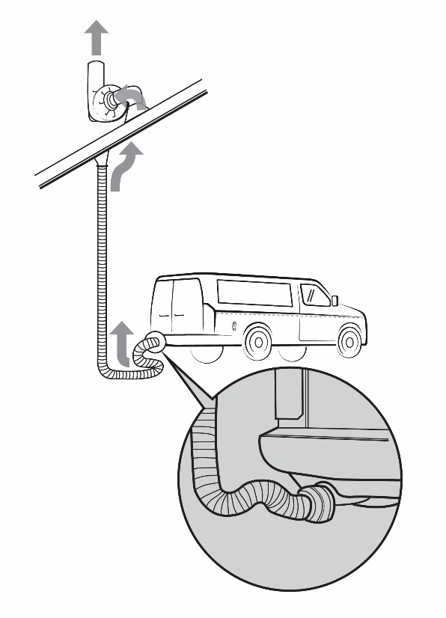
Figure 3: Fixed length flexible hose with tailpipe exhaust extraction system
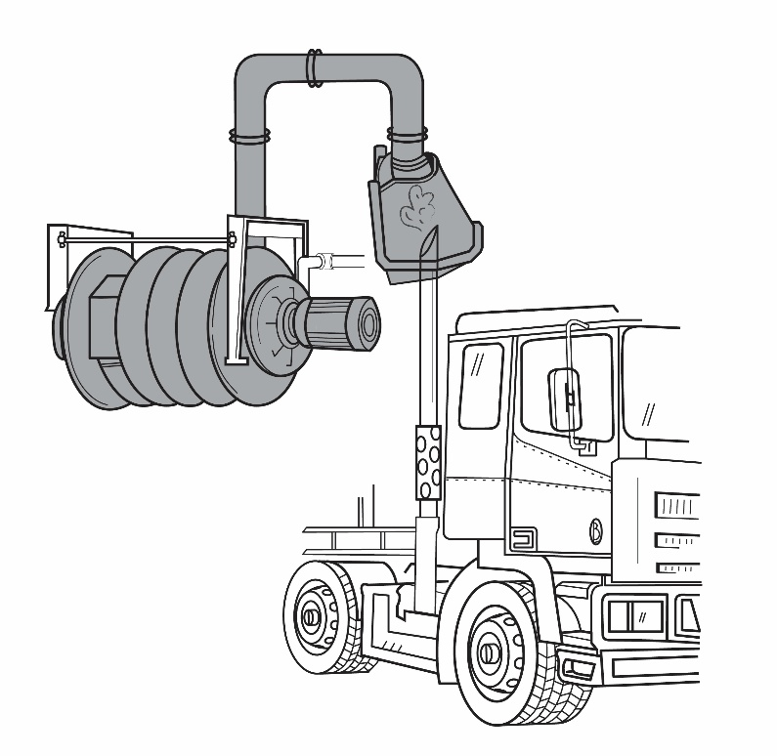
Figure 4: Fixed hose and funnel-type local exhaust extraction system

General ventilation
General ventilation can be natural or mechanical ventilation and is not as effective as LEV because it does not control the hazard at the source. Natural ventilation uses natural forces (e.g. wind and air density differences) to move outdoor air through opening in buildings like vents, windows and doors, as shown in Figure 5. Mechanical ventilation uses mechanical fans to move air in and/or out of a building. Mechanical ventilation includes HVAC systems.
General ventilation can reduce concentrations of airborne contaminants by diluting them (dilution ventilation), or by replacing contaminated air with fresh air (displacement ventilation). Because general ventilation is not as effective as LEV it is only suitable for areas with limited diesel-powered plant, such as a small workshop with one or two vehicles.
A combination of LEV and general ventilation can be used, such as tailpipe exhausts with open doors or roof extraction. You can also use portable extraction units to move DEE away from workers in areas like tunnels or covered roadways/walkways.
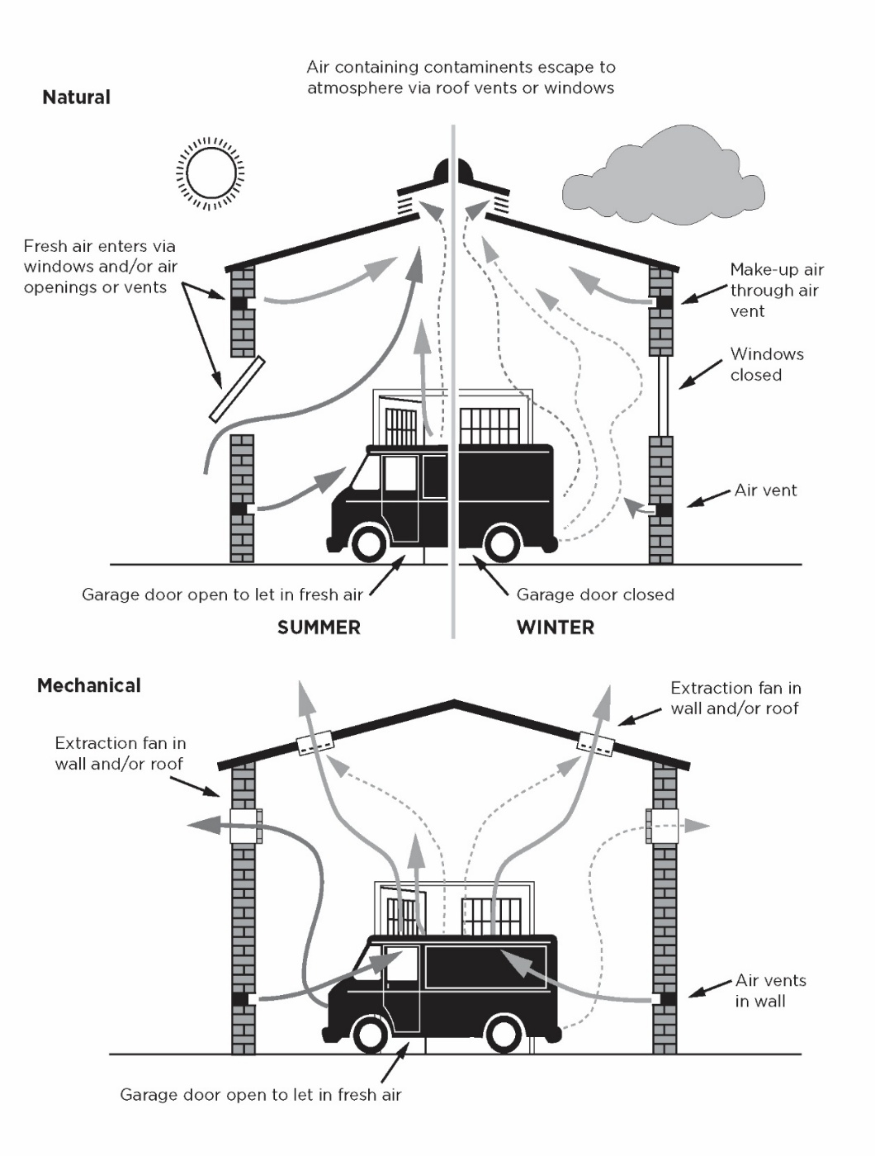
Figure 5: Examples of what general ventilation in a workshop could consist of i.e. natural and mechanical methods

Ventilation for incidental exposures
If work areas adjacent to sources of DEE (such as drive-through food outlets) have good natural ventilation, the frequency of emission ingress is low, and high concentrations of fumes do not accumulate, mechanical ventilation may not be required.
Where the concentration of DEE is high or natural ventilation is ineffective, engineering controls can be effective at minimising worker exposure in these locations. For example, in locations where concentrations of DEE are high, indoor work areas may need to be kept under positive pressure and provided with sufficient fresh air supplied from an uncontaminated source.
Other controls which could reduce exposure to DEE include:
- keeping openings like serving windows as small as practical, to limit entry of contaminated air, and
- use automatic windows and doors to reduce the time DEE can enter the work area.
Administrative controls
Administrative controls do not control the hazard at the source and instead, rely on human behaviour and supervision. Administrative controls used in addition to substitution, isolation and engineering controls can be effective and may be suitable as a short-term measure where no other reasonably practicable control measures are available. For example, using signs or no-go areas or lock-out tags on diesel-powered plant.
Some administrative controls are necessary to ensure higher level controls work as intended, such as:
- maintenance of ventilation systems and diesel-powered plant, and
- providing information, training and instruction needed to ensure workers can work safely.
If risks still remain after you have applied all reasonably practicable substitution, isolation and engineering control measures, you need to implement further administrative control measures to further reduce risks from DEE, such as:
- warnings, like signs, barriers and alarms
- changes to processes and systems of work, or
- reducing periods of exposure by rotating jobs and varying tasks.
Warnings
Signs, barriers and alarms may be designed, erected or installed to provide warnings, such as to:
- alert workers and other people that diesel-powered plant is currently operating
- warn workers and other people of areas where DEE may accumulate, or
- alert workers to other controls which should be used, particularly where they may have to take an action to ensure controls are effective (e.g. closing doors, turning on ventilation).
Processes and systems of work
You may be able to reduce workers’ exposure to DEE by using processes or systems of work which will help you to reduce the generation of DEE, for example by:
- operating engines to optimise combustion (e.g., driving to conditions, limiting idling and over-revving)
- reducing the number of diesel-powered plant
- reducing the number of workers in the exposure area, and
- switching off engines whenever possible, rather than leaving them idling.
Reducing periods of exposure
Work planning and scheduling is a method of reducing plant and worker interaction. Where reasonably practicable, reducing the number of workers directly exposed and their period of exposure, for example:
- scheduling work to minimise the number of workers near the diesel-powered plant while it is operating
- job rotation, and
- planning work to minimise the amount of diesel-powered plant operating at any one time.
Plant and ventilation testing and maintenance
You should have a maintenance schedule for all diesel engines and emission control equipment. All diesel engines should:
- have regular and routine testing of emissions, and
- have regular maintenance and the exhaust system checked for leaks.
You should use raw exhaust tests to measure how well exhaust treatments are working, and test in all normal working conditions (e.g., engines under load, in low gear with hot engine and hydraulics, engine revving at 70-80%).
Ventilation systems and other controls should also be maintained to ensure they are effective. This may include:
- regular visual checks
- regular monitoring and testing of ventilation flow rates
- leak testing vehicle cabs and other enclosures
- inspection, testing and maintenance of seals, filters and ducting
- regular servicing and maintenance according to the manufacturer’s specifications
- procedures for reporting and repairing faulty equipment, and
- records of servicing, maintenance, repair and testing of plant and equipment.

Information, training, instruction and supervision
Information, training, instruction and supervision must be given to workers on the health hazards associated with exposure to DEE emissions and on the proper use of control measures.
The information, training and instruction should enable workers to recognise where risks may not be effectively managed, such as obvious deterioration in the controls used (like poor maintenance of engines, damage to extraction equipment or ineffective general ventilation), so they can report to the people who would then take the necessary action to rectify the situation.
Information, training and instruction should include the following:
- the hazards and risks to the worker
- the control measures implemented and how to use and maintain them correctly, for example, how to use a ventilation system
- arrangements for reporting any changes in engine emissions or visible changes in the workplace
- the arrangements in place to deal with emergencies, and
- the selection, use, maintenance and storage of any respiratory protection equipment (RPE) required to control risks and the limitations of the RPE.
Information, training and instruction must be provided in a way that it is easily understood. The amount of detail and extent of training will depend on the nature of the hazards and the complexity of the work procedures and control measures required to minimise the risks. Records of training provided to workers should be kept.
Supervision should be provided to ensure safety procedures are being followed, particularly where administrative control measures are used to minimise risks.
Using respiratory protective equipment
RPE, in isolation, is the least effective method for controlling exposure risks as it does not control the hazard at the source and relies on correct fit and use by the worker. It must only be used to minimise risks after all other reasonably practicable higher-order controls have been implemented.
In many cases it will not be appropriate to provide respirators to workers who are exposed to DEE, such as at drive-through food outlets.
Selecting suitable RPE
RPE should comply with:
- AS/NZS 1715:2009: Selection, use and maintenance of respiratory protective equipment, and
- AS/NZS 1716:2012: Respiratory protective devices.
For RPE to be compliant with AS/NZS 1715:2009, the worker, task, and work environment must be considered as part of the RPE selection process.

Not all RPE will protect against exposure to all components of the DEE. In selecting RPE, you should consider if you need to protect against exposure to gases and vapours, in addition to particulates (DPM).
Detailed information about the requirements for selection and use of RPE is available in Appendix K of the Code of Practice Managing risks of hazardous chemicals in the workplace.
P2 disposable respirators, which only filter particulates, may be suitable if the concentration of gases and vapours in the DEE is low. If concentrations of gases and vapours in the DEE are high, a half- or full-face respirator with a filter cartridge that protects against gases and vapours, as well as particulates, may be required.
Using RPE as a control
As a PCBU, you must make sure the RPE you provide is appropriate and fits the worker who will be wearing it. If you are using RPE as a control measure, a RPE program should be put in place to ensure RPE remains effective in minimising exposure to DEE.
Information about fit testing, fit checking, training, maintenance, inspection, and record keeping for a RPE program are provided in Appendix K of the model Code of Practice Managing risks of hazardous chemicals in the workplace and AS/NZS 1715:2009 for further information.
Combine control measures
If a single substitution, isolation or engineering control measure is not sufficient to minimise the risk so far as is reasonably practicable, a combination of control measures must be used. In most cases, a combination of control measures will provide the best solution to minimise the risk to the lowest level that is reasonably practicable.
Ensure control measures do not create new risks
You should consider the control measures you select to make sure new risks are not introduced. If any new hazards are created from implementing a control measure, you must review and, as necessary, revise the control measure, consult with workers and their health and safety representatives, and ensure the risks are effectively controlled.

      - Review hazards and control measures
Review your control measures regularly to ensure their effectiveness at managing risks.
Control measures must be reviewed and if necessary revised:
- when the control measure is not effective in controlling risk. For example, if:
- it is obvious due to visible airborne contamination in the workplace
- it is identified that workers are not complying with administrative or RPE requirements
- workers report health effects, or
- air monitoring shows DPM is approaching the workplace exposure limit e.g. above half of the workplace exposure limit (see Section 4)
- before a change at the workplace that is likely to give rise to a new or different health and safety risk
- if a new hazard is identified
- if the results of consultation indicate a review is necessary
- if a health and safety representative or worker requests a review, or
- at least once every 5 years.
To review control measures, use the same process as when identifying a hazard (Section 3.1) and assessing the risk (Section 3.2).
    - Assessing exposures to diesel engine emissions
      - Air monitoring
Air monitoring is the measurement of airborne contaminants in the air. Air monitoring may assist in identifying risks to workers’ health from airborne contaminants and the effectiveness of the controls in place to manage those risks.
Air monitoring must not be used as an alternative to controlling exposure by putting in place control measures. Air monitoring is best done after the risk assessment and after control measures have been put in place.
Not all work involving airborne contaminants will require air monitoring, and you should conduct a risk assessment to determine if air monitoring is required. If you can be reasonably certain that exposure to an airborne contaminant will not exceed the workplace exposure limit, you do not need to conduct air monitoring.
Air monitoring must occur if:
- you are not certain whether or not an exposure limit is likely to be exceeded, or
- monitoring is necessary to determine if there is a risk to health.
You may need to engage a suitably qualified person, like an occupational hygienist, to help you determine if air monitoring is required, and if so, design and undertake monitoring to assess workers’ exposure.
Air monitoring may also be used to:
- determine if there is a failure or deterioration of the control measures
- determine when there is potential for DEE to build up in the workplace, and
- check the effectiveness of control measures.
Workplace exposure limits
Safe Work Australia’s Workplace Exposure Limits for Airborne Contaminants contains a list of mandatory exposure limits under the WHS Regulations.
There is no single workplace exposure limit (WEL) for DEE as a whole because the composition of DEE (and how much of each component is present) varies depending on factors such as engine type, fuel type and operating conditions.
There is a health-based 8-hour time-weighted average (TWA) WEL for diesel particulate matter (DPM), as an indicator for DEE, of 0.01 mg/m³ (measured as respirable elemental carbon)

Because DEE are a complex mixture, you may also need to measure airborne concentrations of other hazardous chemicals in DEE, such as:
- nitrogen dioxide
- carbon monoxide, and
- aldehydes such as formaldehyde,
to ensure exposure is below the applicable WEL and the risk of all health effects from exposure to DEE are adequately controlled.
Determining which airborne contaminants need to be measured will depend on the level of risk and the controls in place. This should be considered as a part of the risk assessment process. Further information on the workplace exposure limits can be found in the:
- Workplace exposure limits for airborne contaminants,
- A guide for PCBUs: Air monitoring and workplace exposure limits for airborne contaminants, and
- A technical guide: Air monitoring and workplace exposure limits for airborne contaminants.
      - Health monitoring
Health monitoring is the monitoring of a worker to identify changes in their health status because of exposure to certain substances. It involves a doctor examining and monitoring the health of workers to see if the exposure to hazardous chemicals at work is affecting their health.
Health monitoring is not a control and cannot be used in place of implementing the hierarchy of controls for DEE.
A PCBU must provide health monitoring to workers if there is a significant risk to worker’s health because of exposure to PAHs present in the DEE. Guidance on determining if exposure risk is significant can be found in the Health monitoring for persons conducting a business or undertaking guide and Schedule 14 to the WHS Regulations, which specifies the monitoring methods for PAHs. Further information can be found in the Health monitoring Guide for polycyclic aromatic hydrocarbons (PAHs).
A PCBU must also provide health monitoring to workers if there is a significant risk of exposure to another hazardous chemical in DEE and there are valid testing methods available.
    - Further resources
- Australian Institute of Occupational Hygienists (AIOH), 2017, Diesel Particulate Matter and Occupational Health Position Paper, AIOH
- Cancer Council, Diesel, Cancer Council, Australia

Mollenhauer, K. and Tschöke, H. eds., 2010. Handbook of diesel engines (Vol. 1). Springer, Berlin.
Peters, S, Carey RN, Driscoll TR, Glass DC, Benke G, Reid A, Fritschi L, The Australian Work Exposures Study: Prevalence of Occupational Exposure to Diesel Engine Exhaust, Ann. Occup. Hyg., Vol 59 (5) June 2015, pp. 600-600, Oxford University Press.
IARC Working Group on the Evaluation of Carcinogenic Risks to Humans, 2014. Diesel and gasoline engine exhausts and some nitroarenes. IARC monographs on the evaluation of carcinogenic risks to humans. IARC monographs on the evaluation of carcinogenic risks to humans, 105, p.9.
IARC Working Group on the Evaluation of Carcinogenic Risks to Humans, 2010. Some non-heterocyclic polycyclic aromatic hydrocarbons and some related exposures. IARC Monographs on the evaluation of carcinogenic risks to humans, 92, p.1.
Cancer Council, N.D. Diesel, Cancer Council, Australia
For example: Mine Safety Operations Division, 2008, Mining design guideline 29: Guideline for the management of diesel engine pollutants in underground environments, Department of Primary Industries, State of NSW ⁶ Department of Natural Resources, Mines and Energy, 2019, Diesel Emissions Management in Underground Coal Mines Best Practices and Recommendations, Department of Natural Resources, Mines and Energy, State
⁷ Environment Protection Authority, 2015, NSW Coal Mining Benchmarking Study Best Practice Measures for Reducing Non-Road Diesel Exhaust Emissions, Environment Protection Authority, State of NSW of Queensland ⁸ Department of Natural Resources and Mines, 2014. QGN 21 Guidance note for management of diesel engine exhaust in metalliferous mines, Department of Natural Resources, Mines and Energy, State of Queensland
9 Department of Mines and Petroleum, 2013, Management of diesel emissions in Western Australian mining operations — guideline: Resources Safety, Department of Mines and Petroleum, Western Australia

