Elevating work platforms
Code of Practice

DECEMBER 2025

Disclaimer
Safe Work Australia is a national policy body representing the interests of the Commonwealth, states and territories, as well as workers and employers to improve work health and safety and workers’ compensation arrangements. Safe Work Australia does not regulate WHS laws or administer workers' compensation arrangements.
Safe Work Australia is providing this information to achieve the standards of health and safety required under the model WHS Act and Regulations in relation to elevating work platforms.
The information in this model Code of Practice provided as general information only. It does not constitute and should not be relied on as legal, business, health, or financial advice. You should obtain independent professional advice relevant to your circumstances.
Safe Work Australia has used its best endeavours to ensure the quality of the information in this document but cannot guarantee its accuracy or completeness.
Neither Safe Work Australia, nor the Commonwealth of Australia will accept liability for any direct, incidental, or consequential loss or damage resulting from this model Code of Practice, or the information provided through this model Code of Practice: Elevating Work Platforms.
Creative Commons
With the exception of the Safe Work Australia logo, this copyright work is licensed under a Creative Commons Attribution 4.0 International licence. To view a copy of this licence, visit creativecommons.org/licenses In essence, you are free to copy, communicate and adapt the work, even commercially, as long as you attribute the work to Safe Work Australia and abide by the other licence terms.
Contact information
Safe Work Australia | mailto:info@swa.gov.au | www.swa.gov.au

Contents
Foreword 5
1. Introduction 6
1.1 What is an elevating work platform? 6
1.2 Who has work health and safety duties for EWPs? 11
1.3 WHS laws in your state or territory 16
1.4 What is involved in managing risks associated with EWPs? 17
2. The risk management process 20
2.1 Consultation 20
2.2 Identifying the hazards 21
2.3 Assessing the risks 24
2.4 Controlling the risks 25
2.5 Maintaining and reviewing control measures 27
2.6 Information, training, instruction and supervision 28
3. Hazards, risks and controls associated with EWPs 34
3.1 Operational risks 34
3.2 Ground condition risks 37
3.3 Fall risks 39
3.4 Electrical risks 41
3.5 Falling object risks 48
3.6 Noise risks 48
3.7 Hazardous chemical risks 49
3.8 Psychosocial risks 50
4. Before using an EWP 52
4.1 Planning and preparation 52
4.2 Selecting the right EWP 52
4.3 Registering an EWP 54
4.4 Pre-use safety checks 55
5. Using an EWP 57
5.1 Proper use 57
5.2 Communication 57
5.3 EWP ground level and platform controls 58
5.4 EWP operating procedures 58
5.5 EWP exclusion zones 60
5.6 EWPs not in use 61
5.7 Telehandlers used as an EWP 62
6. Inspecting and maintaining EWPs 63
6.1 Inspections 63
6.2 Inspection types 66
6.3 Monitoring and testing 68
6.4 Recordkeeping and reporting 69
Appendix A – Glossary 71
Appendix B – Pre-operational checklist 74
Appendix C – Routine inspections 76
Appendix D – Periodic inspections 77
Appendix E – Example report of a periodic inspection 80

Foreword
This Code of Practice on elevating work platforms (EWPs) is an approved code of practice under section 274 of the Work Health and Safety Act (the WHS Act).
An approved code of practice provides practical guidance on how to achieve the standards of work health and safety required under the WHS Act and the Work Health and Safety Regulations (the WHS Regulations) and effective ways to identify and manage risks.
A code of practice can assist anyone who has a duty of care in the circumstances described in the code of practice. Following an approved code of practice will assist the duty holder to achieve compliance with the health and safety duties in the WHS Act and WHS Regulations, in relation to the subject matter of the code of practice. Like regulations, codes of practice deal with particular issues and may not cover all relevant hazards or risks. The health and safety duties require duty holders to consider all risks associated with work, not only those for which regulations and codes of practice exist.
Codes of practice are admissible in court proceedings under the WHS Act and WHS Regulations. Courts may regard a code of practice as evidence of what is known about a hazard, risk, risk assessment or risk control and may rely on the code in determining what is reasonably practicable in the circumstances to which the code of practice relates. For further information, see the Interpretive Guideline: The meaning of ‘reasonably practicable’.
Compliance with the WHS Act and WHS Regulations may be achieved by following another method if it provides an equivalent or higher standard of work health and safety than the code.
An inspector may refer to an approved code of practice when issuing an improvement or prohibition notice.
Scope and application
This Code is intended to be read by a person conducting a business or undertaking (PCBU). It provides practical guidance to PCBUs on managing health and safety risks of working with EWPs.
This Code may be a useful reference for other persons interested in the duties under the WHS Act and WHS Regulations.
This Code applies to all workplaces covered by the WHS Act and WHS Regulations where an EWP is operated and where EWP equipment is used or stored.
How to use this Code of Practice
This Code includes references to the legal requirements under the WHS Act and WHS Regulations. These are included for convenience only and should not be relied on in place of the full text of the WHS Act or WHS Regulations. The words ‘must’, ‘requires’ or ‘mandatory’ indicate a legal requirement exists that must be complied with.
The word ‘should’ is used in this Code to indicate a recommended course of action, while ‘may’ is used to indicate an optional course of action.

- Introduction

1.1 What is an elevating work platform?
Elevating work platforms (EWPs), also called mobile elevating work platforms, are powered mobile plant designed to lift or lower people and equipment by a telescopic, hinged or articulated device, or any combination of these, from a base support. EWPs can move over a supporting surface without the need for fixed runways.
There are various types of EWPs, including but not limited to:
Knuckle boom
Knuckle boom lifts are self-propelled and can be used on flat slabs or firm unsealed surfaces. The work platform is elevated by a boom which has at least two main sections, with a knuckle between them, and is mounted on a turret which allows slewing. This arrangement permits the boom to reach up and over obstacles. Both sections of the boom may incorporate a telescoping extension. There are controls at ground level and on the platform.
Figure 1 Knuckle boom
A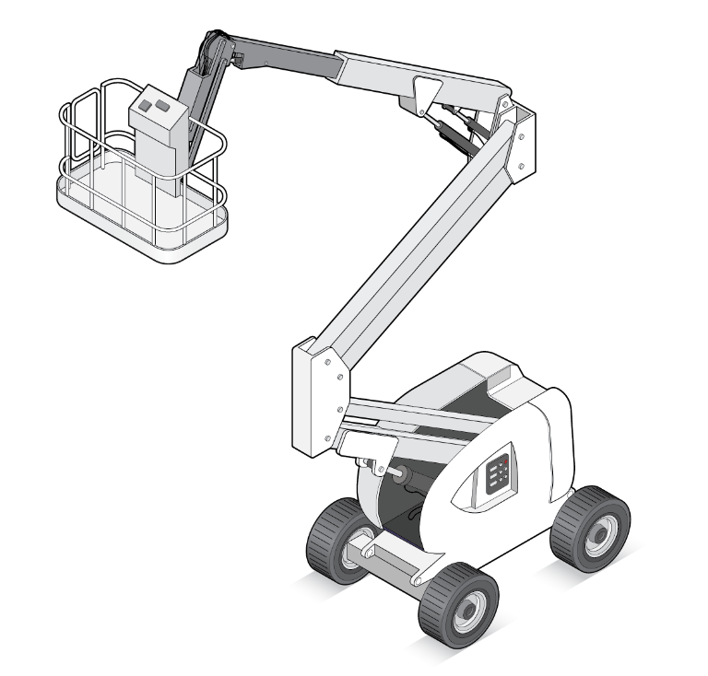
Scissor lift
Scissor lifts are self-propelled and are able to lift the work platform in an up and down motion. The lift mechanism is designed with a criss-cross section to allow for the folding and extending movement. Scissor lifts can also be fitted with extendable decks that extend beyond the footprint of the chassis.
Figure 2 Scissor lift
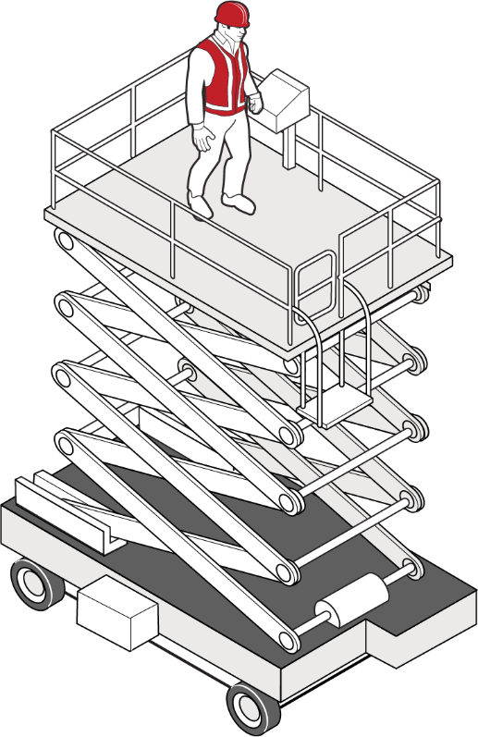
Self-propelled boom lift
A self-propelled boom lift can be used on sealed flat surfaces or unsealed, firm ground. The boom can either be straight or articulating. It can have a telescopic section and may also have a smaller jib boom. The boom allows the work platform to reach up and over objects and is also able to slew.
Figure 3 Self-propelled boom lift

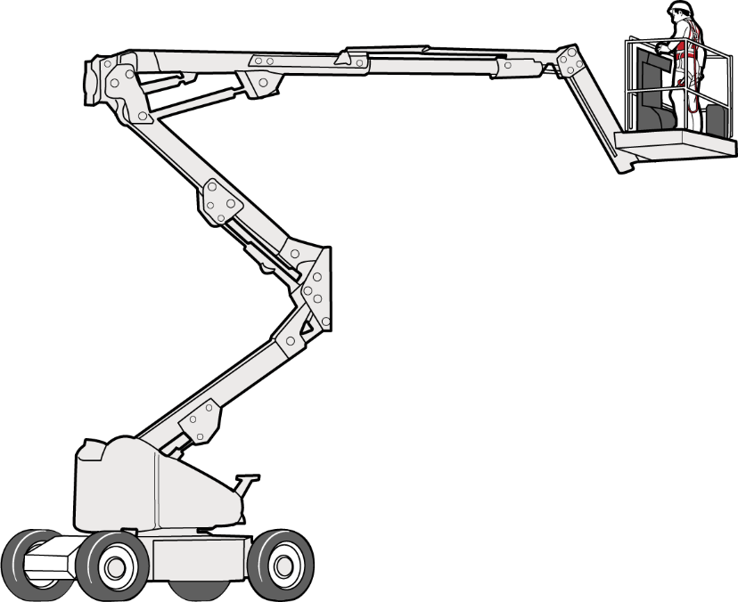

Telescoping boom
A self-propelled unit for use on flat surfaces or firm unsealed areas. The work platform is elevated using a straight extension (telescoping) boom. There are controls at ground level and on the platform.
Figure 4 Telescoping boom
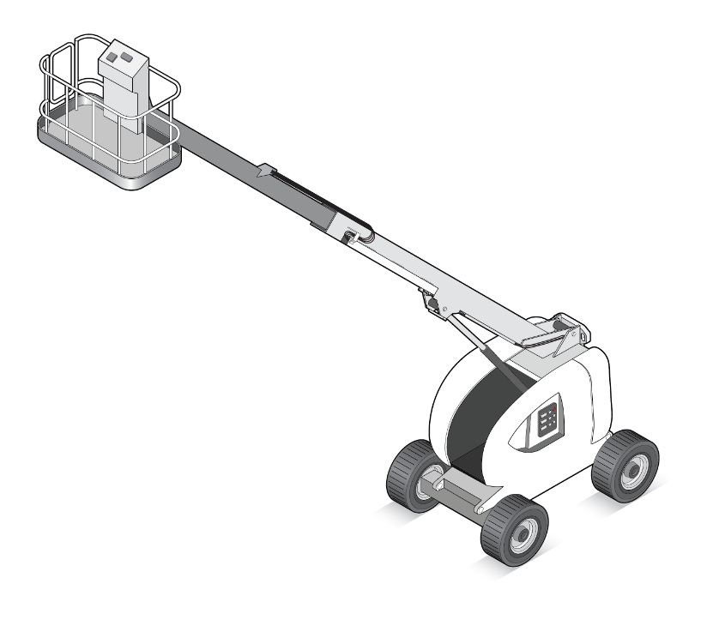
Trailer lift
A trailer mounted EWP that can be towed by most vehicles, and its stabilisers are mainly adjustable.

Figure 5 Trailer lift

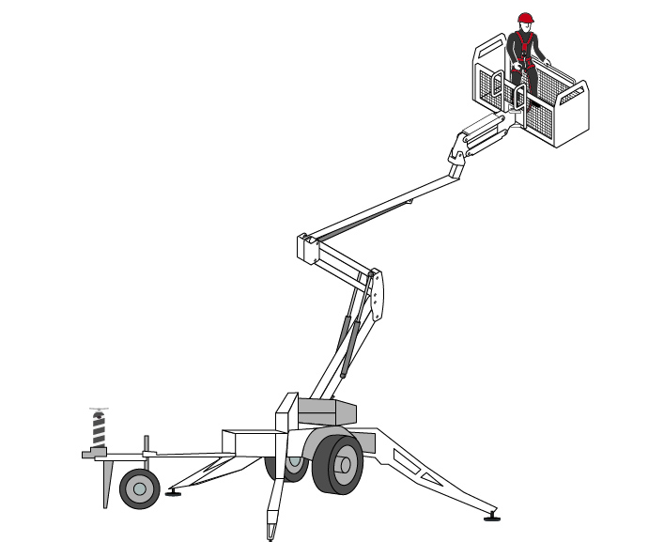
Truck or vehicle mounted lift
A boom lift that is mounted on the truck, or vehicle, chassis.

Figure 6 Truck or vehicle mounted lift
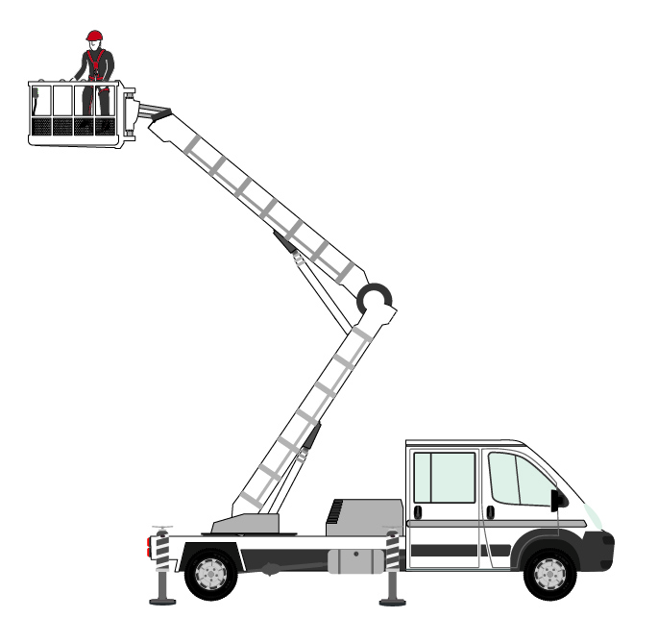
Telehandler
A telehandler is a versatile piece of equipment that has attachments allowing it to be used for different purposes. While they are most commonly fitted with fork arms or jib attachments, they can also be configured and fitted to be used as an EWP, including having basket controls for operation and ground controls (for rescue). A telehandler is not considered an EWP when fitted with other attachments.
Figure 7 Telehandler
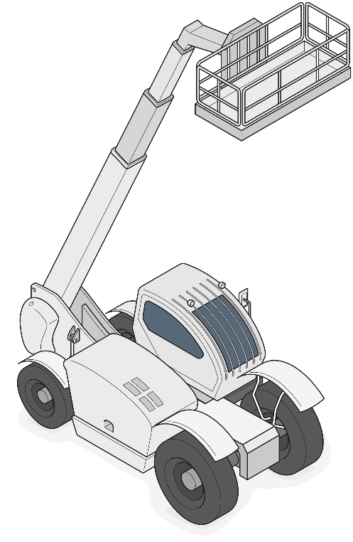
Vertical mast lift
Vertical masts are self-propelled with a telescoping mast to lift the work platform. Some can slew and have an additional tool tray for stock picking applications. They are typically used on flat, level, sealed surfaces such as in warehouses.
Figure 8 Vertical mast lift
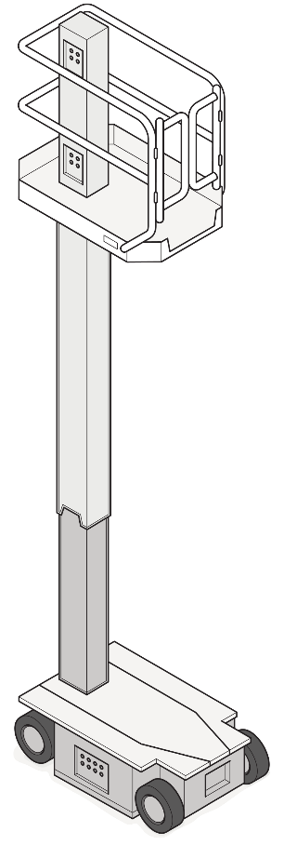
Other plant
Other plant with lifting mechanisms, such as Integrated Tool Carriers (ITC), are considered EWPs when they are configured and fitted as an EWP, including having basket controls for operation and ground controls (for rescue). An ITC is not considered an EWP when fitted with other attachments.
What is not an EWP?
Generally, plant fitted with a manufacturer approved, model specific work platform designed for personnel lift is considered an EWP. However, EWPs do not include a forklift fitted with a work platform (which should not be used in place of an EWP), or a crane suspending a workbox. EWPs are specifically designed with integrated safety features to provide a stable platform for people working at height, whereas forklifts and cranes are primarily intended for lifting loads, not people.
As stated above, telehandlers and ITCs are not considered an EWP when fitted with other attachments.

1.2 Who has work health and safety duties for EWPs?
A number of duty holders have a role in managing the risks of EWPs in the workplace, including:
- persons conducting a business or undertaking (PCBUs)
- PCBUs involving the management or control of fixtures, fittings or plant
- designers, manufacturers, importers, suppliers and installers of plant, substances or structures, and
- officers.
Workers and other persons at the workplace also have duties under the WHS Act, such as the duty to take reasonable care for their own health and safety at the workplace.
Different people could be involved with an EWP during its lifecycle from design through to its use and eventual disposal. Throughout this lifecycle, a person can have more than one duty, and more than one person can have the same duty at the same time.
For example, if you own and operate an EWP in your workplace and you decide to modify it yourself, or engage someone else to make the modifications, you will have the duties of a designer and manufacturer, as well as a person with management or control of plant at the workplace.
Further information is available in Guidance material for the safe design, manufacture, import and supply of plant.
Person conducting a business or undertaking (PCBU)
WHS Act section 19
Primary duty of care
A PCBU must eliminate risks arising from plant in the workplace, or if that is not reasonably practicable, minimise the risks so far as is reasonably practicable.
A PCBU can be a:
- company
- unincorporated body or association
- sole trader, or
- self-employed person.
The WHS Regulations include more specific requirements for PCBUs to manage the risks of plant (e.g. EWPs), as well as other hazards associated with the workplace.
This duty includes ensuring, so far as is reasonably practicable, the:
- provision and maintenance of safe plant, and
- safe use, handling, storage and transport of plant.
PCBUs have a duty to consult workers about work health and safety, including duties to consult, cooperate and coordinate with other duty holders. Further information on Duties of a PCBU is available in Duties of a PCBU.
For example, early consultation with relevant people, hazard identification and risk assessment (if required) can help identify suitable control measures to eliminate or minimise risks when working with EWPs. Risk management can also help workplaces to improve productivity and reduce any associated costs.
Officers
WHS Act section 27
Duty of officers
Officers, for example company directors, have a duty to exercise due diligence to ensure the PCBU complies with the WHS Act and Regulations. This includes taking reasonable steps to ensure the business or undertaking has and uses appropriate resources and processes to eliminate or minimise risks related to EWPs. Further information on who is an officer and their duties is available in the Interpretive Guideline: The health and safety duty of an officer under section 27.
Persons who conduct a business or undertaking involving the management or control of fixtures, fittings or plant
WHS Regulation 203
Management of risks to health and safety
WHS Regulation 204
Control of risks arising from installation or commissioning
WHS Regulation 205
Preventing unauthorised alterations to or interference with plant
WHS Regulation 206
Proper use of plant and controls
WHS Regulation 207
Plant not in use
WHS Regulation 208
Guarding
WHS Regulation 209
Guarding and insulation from heat and cold
WHS Regulation 210
Operational controls
WHS Regulation 211
Emergency stops
WHS Regulation 212
Warning devices
WHS Regulation 213
Maintenance and inspection of plant
WHS Regulation 214
Powered mobile plant-general control of risk
WHS Regulation 215
Powered mobile plant-specific controls measures
The WHS Regulations include specific duties for PCBUs involving the management or control of plant, including requirements to:
- manage the health and safety risks (physical and psychosocial) associated with plant
- prevent unauthorised alterations to or interference with plant, and
- use plant only for the purpose for which it was designed unless the proposed use does not increase the risk to health or safety.
The person with management or control of an EWP is often the plant owner but may also be the principal contractor of a construction project or another PCBU.
If you hire or lease an EWP, you have management or control of that EWP for the period you have hired it. Both you and the person you have hired or leased it from will have duties to eliminate or minimise the risks associated with the EWP, so far as is reasonably practicable. For short and long term hire these duties include who inspects the EWP, who keeps the logs, who verifies the high risk work licence (where required), and who controls modifications.
A person with management or control of plant at a workplace must:
- take all reasonable steps to ensure the plant is only used for the purpose for which it is designed, unless the person has assessed that the proposed use does not increase the risk to health and safety
- in determining whether or not the proposed use of plant increases the risk to health and safety, ensure that the risk associated with the proposed use is assessed by a competent person, and
- take all reasonable steps to ensure that all safety features, warning devices, guarding, operational controls, emergency stops are used in accordance with instructions and information provided by the person.
Work cannot be carried out safely unless the plant being used is appropriate for the work and maintained in good condition.
A person with management or control of plant at a workplace must ensure:
- plant is used and operated by a competent person − guards and operator protective devices are fitted and used
- the rated capacity is displayed and load measurement devices are operating correctly − the ground is prepared to place plant, especially if the terrain is uneven or uncertain, and
- the maintenance is carried out in accordance with the manufacturer’s recommendations or, in the absence of those, the recommendations of a competent person.
Further general guidance on plant can be found in the Model Code of Practice: Managing risks of plant in the workplace. A list of relevant Australian Standards can be found in the Glossary.
Designers, manufacturers, importers and suppliers of plant or structures
WHS Act section 22
Duties of persons conducting businesses or undertakings that design plant, substances or structures
WHS Act section 23
Duties of persons conducting business or undertakings that manufacture plant, substances or structures
WHS Act section 24
Duties of persons conducting businesses or undertakings that import plant, substances or structures
WHS Act section 25
Duties of persons conducting businesses or undertakings that supply plant, substances or structures
WHS Act section 26
Duties of persons conducting businesses or undertakings that install, construct or commission plant
WHS Regulation 295
Designer must give safety report to person who commissions design
Designers, manufacturers, importers and suppliers of EWPs must ensure, so far as is reasonably practicable, the EWPs they design, manufacture, import or supply are without risks to health and safety. This duty includes carrying out calculations, analysis, testing or examination as well as providing specific information and safety reports about the plant.
To assist in meeting these duties, the WHS Regulations require:
- manufacturers to consult with designers of the plant, and
- importers and suppliers to consult with designers and manufacturers of plant.
Further information is available in the Guide to manufacturing safe plant.
Installers, constructors, and commissioners of plant, substances or structures
The WHS Regulations include specific duties for PCBUs that install, construct, or commission plant or a structure that is to be used, or could reasonably be expected to be used, as, or at, a workplace. This includes ensuring, so far as is reasonably practicable, that the way in which the plant or structure is installed, constructed, or commissioned ensures that the plant or structure is without risks to the health and safety of persons:
- who install or construct the plant or structure at a workplace, or
- who use the plant or structure at a workplace for a purpose for which it was installed, constructed or commissioned, or
- who carry out any reasonably foreseeable activity at a workplace in relation to the proper use, decommissioning or dismantling of the plant or demolition or disposal of the structure, or
- who are at or in the vicinity of a workplace and whose health or safety may be affected by any such work.
Workers
WHS Act section 7
Meaning of worker
WHS Act section 28
Duties of workers
WHS Regulation 46
Duties of workers
Workers have a duty to take reasonable care for their own health and safety and to not adversely affect the health and safety of other persons. Workers must comply with reasonable instructions, as far as they are reasonably able, and cooperate with reasonable health and safety policies or procedures that have been notified to workers.
Workers include an employee, a trainee, apprentice or work experience student, a volunteer, an outworker, a contractor or sub contractor, an employee or a contractor or sub contractor, an employee of a labour hire company.
If personal protective equipment (PPE) is provided by the business or undertaking, the worker must, so far as they are reasonably able, use or wear it in accordance with the information, instruction and training provided.
Other persons in the workplace
WHS Act section 29
Duties of other persons at the workplace
Other persons at the workplace, such as delivery workers, customers, workers’ families and other visitors must take reasonable care for their own health and safety and must take care not to adversely affect other people’s health and safety. They must comply, so far as they are reasonably able, with reasonable instructions given by the PCBU to allow that person to comply with the WHS Act. Reasonable instructions include following all safety directions, not crossing barriers or barricades, and complying with directions during provision of a service or activity.

1.3 WHS laws in your state or territory
The Commonwealth, state and territory WHS regulators are responsible for implementing and enforcing their WHS laws. They make decisions about whether you comply with the requirements.
WHS laws are not the same across Australia. If you need help understanding your WHS requirements, please contact your WHS regulators.

1.4 What is involved in managing risks associated with EWPs?
WHS Regulations Chapter 3 Part 1 Regulations 32–38
Managing risks to health and safety
WHS Regulation 34
Duty to identify hazards
WHS Regulation 35
Managing risks to health and safety
WHS Regulation 36
Hierarchy of control measures
WHS Regulation 37
Maintenance of control measures
WHS Regulation 38
Review of control measures
WHS Regulation 203
Management of risks to health and safety
(PCBU involving the management or control of plant)
EWP operations can be dangerous and may cause death or injury to persons from:
- structural or mechanical failure, overturning and collapse
- contact or collision with other plant, structures, or people
- fire and related damage or collapse
- arcing or flashover from an energised overhead or underground electric line
- being hit by falling objects
- a fall from height
- extreme weather and related damage or collapse
- hearing loss
- fatigue
- psychosocial hazards (e.g. high job demands, remote or isolated work, or poor physical environments).
PCBUs must manage risks associated with EWPs by following a systematic process:
- Identify hazards—find out what could cause harm.
- Assess risks, if necessary—understand the nature of the harm that could be caused by the hazard, how serious the harm could be and the likelihood of it happening. This step may not be necessary if you are dealing with a known risk with known controls.
- Eliminate risks, so far as is reasonably practicable.
- Control risks—if it is not reasonably practicable to eliminate the risk, implement the most effective control measures that are reasonably practicable in the circumstances by following the hierarchy of control measures.
- Monitor and review the effectiveness of the measures—control measures need to be regularly reviewed to make sure they remain effective, taking into consideration changes, the nature and duration of work and that the system is working as planned.
Chapter 2 of this Code provides guidance on how to manage the risks associated with EWPs in the workplace by following the hierarchy of control measures while Chapter 3 addresses EWP hazards, risks and controls.
Further guidance on the risk management process is in the Model Code of Practice: How to manage work health and safety risks.
What is reasonably practicable?
Deciding what is ‘reasonably practicable’ to protect people from harm requires considering and weighing up all relevant matters, including:
- the likelihood of the hazard or risk occurring
- the degree of harm that might result from the hazard or risk
- knowledge about the hazard or risk, and ways of eliminating or minimising the risk
- the availability and suitability of ways to eliminate or minimise the risk.
Where the cost of implementing control measures is grossly disproportionate to the risks, it may be that implementing them is not reasonably practicable. This does not mean that you are excused from doing anything to minimise the risks. A less expensive way of minimising the risks must instead be used. If two control measures provide the same level of protection and are equally reliable, you can implement the less expensive option.
The question of what is reasonably practicable is determined objectively, not by reference to your particular business or undertaking’s capacity to pay, or other individual circumstances.
You cannot provide workers with a lower level of protection simply because you are in a lesser financial position than another PCBU facing the same hazards or risks in similar circumstances.
Your goal to produce a product or provide a service at a particular price cannot override your duty to ensure, so far as is reasonably practicable, the health and safety of your workers and others.
Further information on determining what is reasonably practicable is in the Interpretive guideline – Model Work Health and Safety Act - the meaning of reasonably practicable.
Safe design and good work design
The design phase provides the best way to eliminate hazards and minimise risks. For an EWP, this means thinking about its manufacture, storage, transportation, installation, access, use, inspection, testing, maintenance and repair.
EWP designers include professionals like engineers, industrial designers and designers of plant systems, such as, software and electrical systems. However, anyone who modifies plant can be a designer if the modification has not been designed by someone else. For more information, see the Guide for safe design of plant.
Effective design of ‘good work’ considers the work tasks, work systems, the physical working environment, and the workers and others in the workplace. For more information on good work design principles, see Principles of good work design: A work health and safety handbook.
Barriers that may put some workers at higher risk
Some workers may be at greater risk from hazards due to barriers to understanding or participating in safety processes. For example, workers with:
- limited experience in the workplace (e.g. young workers)
- barriers to understanding safety information (e.g. workers from culturally and linguistically diverse backgrounds
- perceived barriers to raising safety issues (e.g. power imbalance or stigma)
- previous exposure to a hazard resulting in injury, such as hearing loss or musculoskeletal injuries.
For example, inexperienced workers may not identify harmful behaviours or have the confidence to report them. You could address this by providing more detailed induction training, greater support and supervision until they gain experience and understanding.
Consulting your workers will assist you to identify who are at greater risk, and whether additional reasonably practicable controls are required to manage the risks for these workers. Further guidance is available in the Model Code of Practice: Managing psychosocial hazards at work and the Model Code of Practice: Work health and safety consultation, cooperation and coordination.

2. The risk management process

2.1 Consultation
WHS Act section 47
Duty to consult workers
WHS Act section 48
Nature of consultation
WHS Act section 49
When consultation is required
As a PCBU, you must consult, so far as is reasonably practicable, with workers who carry out work for the business or undertaking and who are (or are likely to be) directly affected by a health and safety matter.
This duty to consult is based on the recognition that worker input and participation improves decision-making about health and safety matters and assists in reducing work-related injuries, diseases and illnesses.
The broad definition of a ‘worker’ under the WHS Act means a PCBU must consult, so far as is reasonably practicable, with contractors and subcontractors and their employees, on-hire workers, outworkers, apprentices, trainees, work experience students, volunteers and other people who are working for the PCBU and who are, or are likely to be, directly affected by a health and safety matter.
Workers are entitled to take part in consultations and to be represented in consultations by a health and safety representative (HSR) who has been elected to represent their work group.
Workers usually know the physical and psychosocial hazards and risks associated with the EWP they use. By drawing on the experience, knowledge and ideas of workers it is more likely hazards will be identified so that effective control measures can be implemented.
Workers should be encouraged to report hazards and health and safety problems immediately so the risks can be managed before an incident occurs.
PCBUs must consult with workers when (but not limited to):
- identifying hazards and assessing risks to health and safety arising from the work carried out or to be carried out
- making decisions about ways to eliminate or minimise those risks, and
- making decisions about procedures for consulting with workers; resolving health or safety issues at the workplace; monitoring health of your workers; monitoring the conditions at the workplace under your management or control and providing information and training for your workers.
Regular consultation is better than consulting only as issues arise on a case-by-case basis, or as a reaction to a particular event, because it allows you to identify and fix potential problems early. Further guidance is available in the Model Code of Practice: Work health and safety consultation, cooperation and coordination.
Consulting, cooperating and coordinating activities with other duty holders
WHS Act section 46
Duty to consult with other duty holders
PCBUs must consult, cooperate and coordinate activities with all other persons who have a work health or safety duty in relation to the same matter, so far as is reasonably practicable.
There is often more than one business or undertaking involved in managing risks of plant in the workplace. Each may have responsibility for the same health and safety matters, either because they are involved in the same activities or share the same workplace.
In these situations, each duty holder should exchange information to find out who is doing what and work together in a cooperative and coordinated way so risks are eliminated or minimised, so far as is reasonably practicable.
For example: If using an EWP at a workplace shared with other businesses, the plant owner or manager should talk to those businesses about the risks the plant could cause them and work together in a cooperative and coordinated way to manage the risks.
Further guidance on consultation requirements is available in the Model Code of Practice: Work health and safety consultation, cooperation and coordination.

2.2 Identifying the hazards
WHS Regulation 34
Duty to identify hazards
Incidents involving EWPs have resulted in fatalities and serious injuries.
The first step in the risk management process is to identify all hazards associated with an EWP in the workplace in consultation with workers and others. This involves finding things and situations that could potentially cause harm to people.
Known hazards associated with using an EWP include:
- selecting an EWP which is not suitable for the task which may result in overturning or collapse
- mechanical hazards, unstable loads or poor maintenance which may result in structural failure, overturning, or contact or collision of the EWP with people or other plant
- ground hazards, including uneven, unstable or unknown ground conditions which may result in structural failure, overturning, or collapse
- collision or crush injuries and entrapment
- traffic hazards, including the boom extending into oncoming traffic resulting in collisions and injuries.
- overhead hazards, including overhead power lines, structures or trees resulting in electrocution or crush injuries
- environmental hazards, including inadequate ventilation, poor weather, hot/cold temperatures, fumes, wind or excessive noise in the area the EWP is used
- psychosocial hazards, including restricted working spaces, poor support, low job control, violence and aggression, lack of role clarity and job demands
- falling objects
- working at heights, including access and egress at height
- working over water, stockpiles or other hazardous materials or ground conditions
- working below the level of the base support, and other conditions, where the self recovery functions do not work, and
- working in congested areas with hazardous services.
The following can help to identify hazards related to the use of EWPs:
- observe the workplace and consider where the EWP will operate and how it could interact with other plant, people and structures, including overhead electric lines. Think about the layout and placement of overhead structures in your workplace where the EWP may be used, including doorways, scaffolding or other framework that the EWP may have to pass through.
- review inspection, testing and maintenance records, such as manufacturer’s instructions, safety alerts, bulletins, notices published by suppliers or WHS regulators, logbooks, and incident and injury records, including near misses, and
- consult with the EWP operator, workers, spotters, safety observers and others about problems they encounter or can reasonably foresee. This could include problems with operation, inspection, maintenance, repair, transport and storage of the EWP.
Inspecting the workplace
To identify hazards, think about all the activities that may be carried out during the life of the EWP operation at your workplace. For example, during transport, storage, installation, operation, inspection, testing, maintenance and repair, consider whether the EWP could:
- cause injury due to entanglement, collision, falling, crushing, trapping, cutting, puncturing, shearing, abrasion or tearing
- create hazardous conditions due to harmful emissions, fluids or gas under pressure, electricity, noise, radiation, friction, vibration, fire, explosion, moisture, dust, ice, hot or cold parts, cleaning, and exposing undisclosed asbestos-containing materials, or
- cause injury when an operator responds to common failure modes – for example, if operator controls are difficult to reach or require high force to operate.
Workplace conditions should also be considered as it can create risks. For example:
- local weather conditions such as high winds can be dangerous and cause uncontrolled movement or overturning of an EWP
- uneven or unstable terrain and operating surface can cause the EWP to overturn
- trenches or holes that have been recently filled, may affect stability. Ensure the ground can bear the weight of the machine and any loads it is required to carry. See Chapter 3 for more information on assessing ground conditions
- proximity to other structures can pose a risk of being crushed or trapped against the structure. This can occur when moving the EWP or positioning the work platform.
Inspecting the EWP
A person with management or control of plant at a workplace must review the relevant safety information and ensure each EWP is inspected:
- in accordance with the manufacturer’s recommendations, or.
- if there are no manufacturer’s recommendations, in accordance with the recommendations of a competent person.
Adequate supervision should also be in place in the workplace to ensure safe work practices are being followed. Talk to your workers and their HSR to find out what their experience is with the EWP supplier’s instructions for safe set-up and use of the EWP.
If you have hired or leased an EWP, you should also consult the person who owns the EWP about potential hazards, because you both have responsibility for ensuring, so far as is reasonably practicable, the EWP is safe and without risk to health and safety.
Factors to consider include:
- the condition of the EWP, for example, its age, maintenance history and how frequently the EWP is intended to be used.
- the suitability of the EWP, for example: Is it suitable for the intended use? Will it need to be modified for its intended use? Will the modification be carried out by a competent person? Is it suitable for the job requirements or is there another type of plant that is specifically designed for the task that is required?
- the location of the EWP, for example: What is its impact on the design and layout of the workplace and are workers able to access the EWP without risk of slips, trips or falls?
- abnormal situations, for example: What abnormal situations, reasonably foreseeable misuse or fluctuation in operating conditions can you foresee?
Chapter 6 provides more information about inspecting and testing EWPs.
Review safety information
Information about hazards, risks and control measures relating to EWPs in your workplace can be obtained from:
- manufacturers, importers or suppliers of the EWP
- maintenance technicians or specialists, for example engineers
- your workers
- regulators, unions and other organisations/associations
- businesses or undertakings similar to your own, and
- Australian, International or other technical standards.
Review incident records and other data
Check your records of workplace injuries and illness, inspection reports, maintenance logs, incident and investigation reports.
You should also check plant safety logbooks, manufacturer’s manual/instructions or safety alerts which are supplied with the majority of EWPs and capture important data.
EWP owners should have systems in place to review similar and reoccurring faults, misuse, or incidents to identify root causes.
This analysis should include considering industry trends, known incidents, service bulletins, alerts issued by manufacturers and other information sources to identify factors that may influence the service life of components.

2.3 Assessing the risks
A risk assessment considers what could happen if someone is exposed to a hazard and the likelihood of it happening. A risk assessment can help you determine:
- how severe a risk is
- whether existing control measures are effective
- what action you should take to control the risk, and
- how urgently the action needs to be taken.
Hazards have the potential to cause different types (e.g. physical or psychological) and severities of harm, ranging from minor discomfort to a serious injury or death.
Many hazards and their associated risks are well known and have well established and accepted control measures. In these situations, the second step to formally assess the risk is not required. If after identifying a hazard you already know the risk and how to control it effectively, you may simply implement the controls.
To assess the risk associated with EWP hazards you have identified, you should consider the following:
What is the potential impact of the hazard?
- How severe an injury or illness could be? For example, a serious or fatal crush injury, fall from height, injuries from collisions, lacerations, amputation, electrocution or loss of hearing.
- What is the worst possible harm the EWP hazard could cause? For example, an EWP could collapse or overturn causing harm to the operator, workers and others.
How likely is the hazard to cause harm?
- How frequently and how long are workers exposed to the hazard?
- What conditions is the EWP used in? For example, in a windy, muddy, dusty or corrosive environment or on uneven or unstable ground conditions?
- What is the condition of the EWP? For example, is it old and missing safety features found on new EWPs? Is it reliable? Does it often need repairs following a breakdown?
- If there are other people or items of plant in the vicinity, what effect do they have on the likelihood of the harm occurring?
- How could the hazards interact and combine to create new or higher risks? For example, psychosocial risks may increase if workers are exposed to high job demands or harassment, as well as remote or isolated work.
- Where and when is access required during the installation, operation or maintenance of an EWP and in an emergency?
- What work practices and procedures exist for EWP safety? For example, is de-energising and testing required to carry out maintenance?
- What kinds of information, training, instruction and supervision are provided to workers and other persons who may be near or around the EWP?
- How is work organised? For example, consider:
  - pedestrian and vehicular traffic around the EWP
  - exclusion or restricted zones, traffic management plans, hard or soft barriers
  - time spent on repetitive tasks
  - shift-work arrangements, and
  - production incentives that may affect health and safety.

2.4 Controlling the risks
WHS Regulation 36
Hierarchy of control measures
The WHS Regulations require duty holders to work through a hierarchy of control measures when managing risks to health and safety associated with an EWP.
Specific controls required under the WHS Regulations are discussed in the following chapters.
Hierarchy of control measures
The hierarchy of control measures can be applied to most risks. The hierarchy ranks control measures from the highest level of protection and reliability to the lowest as shown in Figure 8.
Figure 8 The hierarchy of control measures
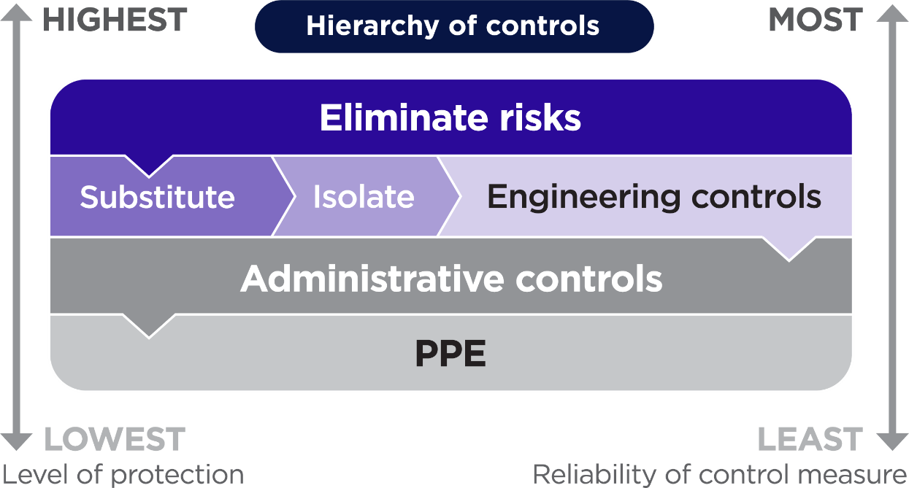
Further guidance on the risk management process and the hierarchy of control measures is in the Model Code of Practice: How to manage work health and safety risks.
Eliminating the risk
You must always aim to eliminate the risk. Eliminating risks related to using EWPs will generally mean not using an EWP or similar plant. For example, it may be possible to plan painting work so there is no need to use an EWP by painting beams on the ground prior to installation.
If it is not reasonably practicable to eliminate the risk, then risks must be minimised, so far as is reasonably practicable.
Minimising the risk
If eliminating the hazards and associated risks is not reasonably practicable, you must minimise the risk by one or more of the following:
- Substitution—minimise the risk by substituting or replacing a hazard or hazardous work practice with something that gives rise to a lesser risk. For example, depending on work requirements, the EWP may be substituted for other types of plant or structures, such as fixed scaffolding.
- Isolation—minimise the risk by isolating or separating the hazard or hazardous work practice from any person exposed to it. For example, exclusion zones should be used to separate the EWP from surrounding plant and structures. Ensure other plant or vehicles are not travelling near the EWP while operating.
- Engineering controls—engineering controls are physical control measures to minimise risk. For example:
- using proximity sensors that automatically stop the EWP from colliding with fixed objects such as girders, beams, powerlines, tree branches, other plant, or persons
- installing guards and secondary guards on EWP platforms to protect operators from coming into contact with overhead or adjacent structures
  - installing automatic levelling systems to stabilise EWPs on uneven terrain, reducing the risk of tipping over
  - installing computer aided stability systems to stabilise EWPs, especially in windy conditions, and
  - using advanced control systems to allow for precise EWP positioning and navigation, especially in tight spaces or awkward angles
- If risk remains, it must be minimised by implementing administrative controls, so far as is reasonably practicable.
- Administrative control measures include work methods or procedures that are designed to minimise exposure to a hazard, such as the use of spotters or safety observers, communication devices (e.g. two-way radios), advanced weather monitoring, remote monitoring, AI-powered predictive maintenance, virtual training tools. as well as the information, training and instruction needed to ensure workers can work safely. The use of signs to warn others that the EWP is operating is another administrative control measure.

- Any remaining risk must be minimised with suitable PPE.
PPE that may be used when working with an EWP includes:
  - safety harnesses, including relevant lanyard and personal energy absorber
  - a safety helmet/hard hat
  - steel capped, rubber soled shoes
  - a high visibility safety vest
  - goggles
  - sunscreen, and
  - gloves.
Administrative control measures and PPE do not control the hazard at the source. They rely on human behaviour and supervision and, used on their own, tend to be the least effective in minimising risks.
The control measures you apply may change the way work is carried out. In these situations, you must consult your workers and develop safe work procedures, and provide your workers with any information, training, instruction, or supervision they need on the changes.
Combining control measures
In most cases, a combination of control measures will be needed to minimise the risk so far as is reasonably practicable. For example, protecting workers from falling objects when using an EWP may involve using restraining systems and tethers to prevent or arrest the fall of components and tools, installing a platform to catch falling objects, and erecting barriers to keep workers away from the area near the base of the EWP.
You should check whether your chosen control measures introduce new hazards. For example, using an EWP to control hazards associated with falls may introduce risks involving moving plant that also need to be controlled.

2.5 Maintaining and reviewing control measures
WHS Regulation 37
Maintenance of control measures
WHS Regulation 38
Review of control measures
Once control measures are implemented, they should be monitored and reviewed to make sure they remain effective. Encourage workers to provide feedback on their effectiveness and communicate any changes to the workplace or processes that may pose a safety risk.

Reviewing control measures should be done regularly and is required:
- when the control measure is not eliminating or minimising the risks so far as is reasonably practicable
- before a change at the workplace that is likely to have new or different risks that the control measure may not effectively control
- if a new hazard or risk is identified or after a serious weather event.
- if the results of consultation indicate a review is necessary, or
- if a HSR requests a review because they reasonably believe one of the above has occurred and it has not been adequately reviewed already.
Common review methods include workplace inspection, consultation, testing and analysing records and data.
You can use the same methods as in the initial hazard identification step to check control measures. You must also consult your workers and their HSRs.
If problems are found, or your chosen control measures introduce new hazards, go back through the risk management steps, review your information and make further decisions about control measures.

2.6 Information, training, instruction and supervision
WHS Act section 19
Primary duty of care
WHS Regulation 39
Provision of information, training and instruction
WHS Regulation 317
Duty to ensure worker has been trained
As a PCBU, you must ensure, so far as reasonably practicable, the provision of any information, training, instruction or supervision that is necessary to protect all persons from risks to their health and safety arising from work carried out as part of the conduct of the business or undertaking. This includes refresher training.
Training should be provided by a competent person.
You must ensure that information, training or instruction provided to a worker are suitable and adequate having regard to:
- the nature of the work carried out by the worker
- the nature of the risks associated with the work at the time the information, training and instruction is provided, and
- the control measures implemented.

Information, training and instruction provided to workers should include (but not limited to):
- familiarisation with new or unfamiliar plant and work environments
- establishing communication procedures between the EWP operators, ground support workers, spotters, safety observers, other machine or vehicle operators and any other relevant workers
- relevant information for operators, including how to operate the plant controls, use the machine safely, perform pre-start inspections and keep the log book up-to-date to ensure safe use of the machine
- the proper use, wearing, storage and maintenance of PPE
- the hazards and risks associated with the work performed
- how to follow the health and safety procedures associated with the work, including the contents of any safe work method statements (SWMS) for high risk construction work
- the reasons for any fall protection measures (e.g. harness systems) in place
- emergency and rescue procedures, including positioning the EWP to ensure access to the emergency controls is not obstructed
- procedures for reporting hazards and incidents
- how to assess the workplace conditions, such as slope and ground conditions
- the correct selection, fitting, use, care, inspection, maintenance and storage of fall arrest and restraint equipment, if this equipment is to be used
- when changes are made to the operator of the EWP, and
- control measures for other potential hazards, such as crush or electrical hazards.
The PCBU must ensure, so far as is reasonably practicable, that the information, training and instruction are provided in a way that is readily understandable for the person to whom it is provided.
As a person with management or control of plant, you must also provide the necessary safety information to persons who are involved in setting up, operating, testing, maintaining or repairing plant. This should include information on the types of hazards and risks the plant may pose to the person when they are carrying out these activities.
Emergency instructions relating to an item of plant should be clearly displayed on or near it.
Operator training
It is important that workers are trained on operating the different types of machines that they will be using on site. If there are multiple types of EWPs on site, the workers should be trained for all the EWP types or only be directed to use the type that they are trained for.
The different types and brands can have significantly different controls. Incorrect use of the controls can lead to a serious incident and injury.
Workers, including spotters, safety observers and ground workers involved with the EWP, should be trained so that they are competent in operating the emergency controls to ensure that they are able to lower the platform if needed. Both the PCBU and the worker should keep a copy of the worker’s training records.
Supervision requirements
A PCBU must provide suitable and adequate supervision to protect all persons from health and safety risks arising from work by having regard to:
- the nature of the risks associated with the work, and
- the experience of the workers involved.
Lack of adequate supervision is a known risk that frequently contributes to WHS incidents when working with EWPs.
High levels of supervision are necessary where workers are carrying out new procedures or difficult and critical tasks.
Supervisors of EWP work must have the necessary knowledge, skills, qualifications and experience to competently supervise workers. This includes competency in preparing work plans, inspecting, verifying the equipment has been maintained, and monitoring and reviewing the effectiveness of control measures.
Licensing requirements
WHS Act section 43
Requirements for the authorisation of work
WHS Regulation 81
Licence required to carry out high risk work
WHS Regulation 82
Exceptions
WHS Regulation 85
Evidence of licence—duty of PCBU
Schedule 3 to the WHS Regulations
High risk work licence and classes of high risk work
For a boom-type EWP, where the boom length is 11 metres or more, the operator must hold the appropriate high risk work licence and this must be sighted and should be recorded at induction.
The boom length is the greater of:
- the vertical distance from the surface supporting the boom-type EWP to the floor of the platform, with the platform extended to its maximum height, or
- the horizontal distance from the centre point of the boom’s rotation to the outer edge of the platform, with the platform extended to its maximum reach.
The boom length is to be taken from the original design. If post-manufacture alterations reduce the boom length to less than 11 metres, the EWP remains subject to high risk work licensing requirements (based on the original design), regardless of whether verification of the alteration to the design has occurred.
High risk work licences are issued by WHS regulators, and require the relevant qualification issued by a registered training organisation (RTO).
As a PCBU, you must not direct or allow a worker to carry out high risk work that requires a high risk work licence, unless you see written evidence that they hold the relevant high risk work licence.
You must see their licence (or written evidence) before you allow them to work.
A person who operates a boom-type EWP with a boom length of 11 metres or more is not required to be licensed if they are undertaking nationally recognised training with an RTO to obtain their high risk work licence and supervised by a person holding the relevant licence. A licence is also not required if the work carried out is:
- solely for manufacturing, testing, trialling, installing, commissioning, maintaining, servicing, repairing, altering or disposing of the EWP
- solely for moving the EWP in the workplace where the EWP is operated or used without a load except when standard weights with predetermined fixing points are used for calibration and other testing, or
- limited to loading or unloading the EWP from a vehicle or equipment used to move the EWP.
Although a high risk work licence is not required in these situations or for some other EWPs, including a boom-type with a boom length of less than 11 metres, you still have a duty of care to ensure that the workers operating the EWPs are adequately trained to operate the EWP safely.
High risk construction work and safe work method statements
WHS Regulation 299
Safe work method statement required for high risk construction work
When using an EWP to perform high risk construction work, including where there is a risk of a person falling more than 2 metres, a SWMS is required.
A SWMS is a written document that must identify the high risk construction work activities to be carried out at a workplace, the hazards and risks to health and safety arising from these activities, the measures to be implemented to control the risks and how the control measures are to be implemented, monitored and reviewed.
The interactive safe work method statement (SWMS) tool provides information on preparing, using and reviewing SWMS for high risk construction work.
Who is responsible for preparing a SWMS?
A PCBU must prepare a SWMS or ensure a site-specific SWMS has been prepared for where the EWP will be used—before high risk construction work starts.
The person responsible for carrying out the high risk construction work is best placed to prepare the SWMS in consultation with workers who will be directly engaged in the high risk construction work.
If more than one PCBU has the duty to ensure a SWMS is or has been prepared, they must consult and cooperate with each other to coordinate who will be responsible for preparing it.
SWMS consultation
Workers and their HSRs, if any, must be consulted when preparing a SWMS. If there are no workers engaged at the planning stage, consultation must occur with workers when the SWMS is first made available to workers, for example, during workplace-specific training or a toolbox talk. Workers and their HSRs, if any, must also be consulted when a SWMS is reviewed.
For further information on SWMS see the Model Code of Practice: Construction work and the information sheet: Safe work method statement for high risk construction work.
Emergency plans
WHS Regulation 43
Duty to prepare, maintain and implement emergency plan
As a PCBU, you must prepare and maintain an effective emergency plan for the workplace. This is a written set of instructions specifically developed for the particular workplace and its specific hazards and covers a range of potential incidents.
An emergency plan must provide for the following:
- emergency procedures, including:
- an effective response to an emergency
- evacuation procedures
- notifying emergency service organisations at the earliest opportunity
- medical treatment and assistance, and
- an effective means of communication between the person authorised to coordinate the emergency response and all people at the workplace
- testing of the emergency procedures—including the frequency of testing, and
- information, training and instruction to relevant workers in relation to competency expectations for implementing the emergency procedures
The emergency plan may include:
- contact details for key people – e.g., fire wardens and first aid officers
- contact details for local emergency services
- how to alert people at the workplace to an emergency or potential emergency – for example, using a siren or bell alarm
- help for people who have hearing, vision, or mobility impairments
- a map of the workplace showing where to find fire protection equipment, first aid, emergency exits and assembly points,
- expected time for rescue drills for base/emergency lowering controls specific to each model on site, and
- the post-incident follow-up process – for example, notifying the WHS regulator, organising trauma counselling or medical treatment.
Rescue equipment should be available and easily accessible, or in certain higher risk activities on standby. There should be processes in place so that injured workers, including the EWP operator, can be rescued, particularly if they are being suspended by their harness.
If an emergency occurs where the platform needs to be lowered down, follow the operating manual for the machine as the procedures can significantly vary between different brands and types of machines. Workers should be trained in the use of emergency controls on the base of the machine. All emergency lowering procedures should ensure that there is no risk of crush injuries and that the lowering pathway is clear of obstructions.
For more information on emergency plans, please view Safe Work Australia’s Emergency plans fact sheet. You can also use this template to help you prepare an emergency plan.
Shared workplaces
In shared workplaces PCBUs must consult, cooperate and coordinate activities with all other persons who have a work health or safety duty in relation to the same matter, so far as is reasonably practicable.
In shared workplaces where there are multiple PCBUs, a master emergency plan could be prepared that all relevant duty holders use. Examples of shared workplaces include shopping centres, construction sites or office buildings.
Further guidance on emergency plans and procedures is available in the Emergency plans fact sheet and AS 3745–2010: Planning for emergencies in facilities.
- Hazards, risks and controls associated with EWPs

The following section sets out some of the most frequent risks associated with using EWPs and examples of risk controls are provided.
Hazards and risks vary from workplace to workplace. It is important that a PCBU completes an individual risk assessment and considers suitable control measures for each worksite.
The WHS Regulations require duty holders to work through a hierarchy of control measures when managing risks to health and safety associated with an EWP. Figure 8 of section 2.4 shows how control measures are ranked from the highest level of protection and reliability to the lowest.

3.1 Operational risks
Operational hazards such as incorrect EWP selection, unstable loads or lack of, or poor inspection and maintenance practices can create risks causing the EWP to become unstable, overturn, collide or move unexpectedly resulting in workers or objects falling, colliding or being crushed.
Preventing collisions or crush injuries
When planning work involving EWPs, you should consider how and where the EWP will need to be moved throughout the workplace. You must eliminate or minimise the risk of an EWP colliding with any person, object such as a tree branch, plant or structure. Consider where the EWP will need to operate, including congested areas with hazardous services, any potential work that will be undertaken below or near overhead objects and adjacent structures, or in tight spaces with entrapment risks.
Controls to reduce the risk of collisions and crush injuries include:
- physical barriers, such as a protective structure that is attached to the platform guardrail and provides overhead protection of the operator and minimises the risk of crush injuries
- presence sensing devices, such as proximity sensors, that stop the movement of the EWP if it detects the platform is or is about to collide with something near an object
- the use of one or more spotters, persons specifically assigned the duty of observing and warning against impending hazards relating to the movement and operation of an EWP
- control-orientation checks where remote/portable controls are used.
When operating a boom type EWP near busy traffic corridors, you must consider the pivot point of the EWP to ensure the boom does not extend into the path of oncoming traffic. This risk can be minimised by preparing a traffic management plan and establishing exclusion zones by using physical barriers such as barricades. Additionally, work carried out on, in or adjacent to a road or other traffic corridor that is in use by traffic other than pedestrians is also considered high risk construction work and requires the preparation of a SWMS prior to work commencing.
Further information on SWMS is available under High risk construction work and safe work method statements.
Inadvertent activation of the machine can occur when people or objects accidently collide or make contact with the controls, leading to a crush injury. The risk of inadvertent operation of the controls can be minimised with the use of mechanical guards to protect the joystick from being pushed or pulled or the use of presence or ‘deadman’ switches/sensors. Additionally, some EWPs can be fitted with joysticks that require centralisation, or a trigger or foot pedal to be pressed before it will allow movement. Some machines also have a timeout process, where operation of the machine times out after activating the trigger for a pre-set amount of time.
In most cases, a combination of controls will provide the best solution to minimise the risk to a reasonably practicable level.
You must maintain control measures to ensure they are effective. You must also review and revise them as necessary to maintain, so far as is reasonably practicable, a work environment that is without risks to health or safety.
Entering and exiting an elevated platform
EWPs should only be used as working platform and not as a lift to enter and exit a workplace unless the conditions outlined in AS2550.10 Cranes, hoists and winches – Safe use – Mobile elevating work platforms are met, including the development of a safe work method statement, and ensuring a risk assessment is conducted by a competent person.
Workers should only enter or exit the platform when it is lowered. Workers should only enter or exit an elevated platform in an emergency or where the EWP is specifically designed for such use and allowed by the manufacturer’s instructions.
Operating on sloping ground
Working on a slope has the effect of either increasing or decreasing the working radius of the EWP, which may in turn affect its stability and cause the EWP to tilt forwards, backwards or sideways. You must operate within the maximum slope limit identified in the original equipment manufacturer plate.
AS 2550.10: Cranes, hoists and winches – Mobile elevating work platforms, specifies that the gradient on which the EWP travels, including loading ramps, shall not be greater than the maximum gradient specified by the manufacturer.
AS/NZS 1418.10: Cranes, hoists and winches, Part 10: Mobile elevating work platforms requires the maximum allowable chassis inclination and gradeability to be stamped on the manufacturer’s plate.
Where the centre of gravity of the EWP is high above the ground, a minimal ground slope can be a major factor in causing it to overturn. This particularly applies when the boom is telescoped out. A side slope of only two or three degrees can have a drastic effect on stability. Soft ground, pneumatic tyres and suspension movement will also tend to increase the side angle of the EWP and increase the risk of overturning.
This is particularly the case at a site where construction work is being performed where the ground condition and slope may be constantly changing. A pothole in the ground will have the same effect as a gradient if the EWP’s wheel enters the hole. Where possible, avoid working or travelling on sloping ground.
Controls to reduce the risk on sloping ground include:
- be careful when reaching out from the platform, going too far can affect stability, especially when working on slopes
- when using outriggers, if fitted, observe the manufacturer’s instructions to set the outriggers before raising the platform
- when setting up an EWP on-ramps or slopes using outriggers, extreme caution is required to prevent slipping down the ramp. Do not set up the outriggers' footplates on a slope, and
- to avoid the EWP sliding when setting up, place the braked wheels up the incline.
Preventing EWP roll-aways
You must always aim to eliminate the risk of vehicle roll-away. For example, organise the work so that the EWP is not required in the workplace. If it is not reasonably practicable to eliminate the risk of vehicle roll-away, you must minimise the risk by implementing one or more of the following controls:
- Substitute or replace a hazard or hazardous work practice with something that gives rise to a lesser risk. For example, where possible, park off street on a level, flat surface instead of on the street or a slope.
- Isolate or separate the hazard from any person exposed to it. For example, use barriers or overhead walkways to separate mobile plant from workers, or establish a clearly marked exclusion zone around the EWP where necessary, for example immediately downhill from a truck or trailer being unloaded.
- Consider using engineering controls such as wheel chocks. A wheel chock is a wedge-shaped object with a non-slip bottom surface that can be placed behind or in front of a wheel to prevent it from rolling away. Chocking on level ground may not generally be required but should be considered when a vehicle is immobilised for maintenance purposes. Care should be taken when installing and removing wheel chocks as this can place workers in the direct line of the wheel if a roll-away was to occur.
- If you have applied all possible substitution, isolation and engineering controls, and risk still remains, you must use administrative controls or personal protective equipment to further minimise risks, so far as is reasonably practicable.
Administrative controls are work methods or procedures that are designed to minimise exposure to a hazard. The following are examples of administrative controls:
- provide workers with training on how to safely immobilise a vehicle
- conduct regular toolbox talks to remind workers of the control measures available to prevent vehicle roll-aways, and
- park on level, flat ground where possible.

3.2 Ground condition risks
Ground conditions can vary dramatically from one workplace to another, and even within the one workplace. The ground can appear to be solid, but underneath there may be hazards such as soft or waterlogged soils, voids, or underground services not visible from the surface.
Failure to address poor ground conditions to ensure EWP stability may result in the EWP tipping over, causing fatalities or serious injury to the operator and/or other people in the work site. As a PCBU, you must manage risks to health and safety associated with unstable ground if it is reasonably likely to injure the person. If it is not reasonably practicable to eliminate this risk, you must provide and maintain a safe system of work to minimise it.
Ground factors
At any site where mobile plant is being used, the operator as a duty holder, must ensure that the ground can safely support the plant.
While the only way to be sure that the ground conditions are completely safe is to call in a qualified expert or a competent person, understanding hazards and risks associated with plant types, site conditions and soil types are key elements when assessing ground conditions.
When assessing ground conditions, the PCBU and EWP operator must consider various factors that will affect the ability of the ground to provide adequate support, including:
- the presence of water, including when it is mixed with the soil as mud, and where it is present under the surface (e.g. underground springs or streams)
- the type of ground (e.g. clay, sand, rock or a mixture of these)
- backfilled ground that was previously an excavation or trench
- cavities or penetrations in the ground that have been covered but still exist
- the type of plant (e.g. selecting plant suitable for the ground conditions)
- continued operation of the EWP in one location (e.g. the outrigger pads may sink).
When an EWP is being set up, the operator can only make a decision based on the surface of the ground if other information, such as a geotechnical report, is not available. Generally, rock provides the most stable supporting surface for an EWP. However, although rock may be present on the surface, it may not extend far below the surface. One way to establish how far rock may extend below the surface is to examine nearby excavations or trenches at the workplace. Rock that extends far below the surface provides a good indication of the ground’s integrity. However, this will only provide a reasonable indication of the ground’s strength when the excavation is not too far from the EWP. Additional risks must be managed when outriggers are positioned too close to an excavation.
Care also needs to be taken with ground that has a ‘crust’ on its surface. The surface of this type of ground is usually firmer than the ground underneath. The firm surface may give the perception that the ground is more stable than it actually is. If the ground is punctured by an outrigger, or the end of a crawler track, the softer ground will be exposed, which may cause the EWP to overturn.

Where an EWP is continuously operated in one location, the ground underneath the supporting surface may become compacted. Additional care needs to be taken to ensure that the EWP has not compacted the ground to the extent that the EWP is more likely to overturn.
Geotechnical report as part of the construction activity
Where a geotechnical report is prepared by a geotechnical engineer on behalf of a principal contractor or PCBU as part of the building activity (e.g. for building foundations), the geotechnical report should be provided to the supplier of the EWP to assist the operator with the assessment of the ground conditions where the EWP will operate.
The geotechnical report should only be relied upon if it applies to the area where the EWP is to be set up or the area where the EWP will be used.
The principal contractor or PCBU in control of the site is responsible for engaging the geotechnical engineer.
Note: Where it has rained or the ground has been disturbed (e.g. by trenching operations), the geotechnical report may need to be updated.
Other considerations when managing risks:
- Plant: manufacturer’s specifications:
- operating manuals
- risk assessments
- training/instruction, and
- any matters or conditions identified by the manufacturer or designer to enable safe use of the plant.
- Sites:
- Inspection of the site to ensure the EWP selected is suitable for the job
- discussions with the owner/developer/client or PCBU regarding known site conditions and the use of mobile plant
- discussions with mobile plant operators about the operating limitations of their plant on the site
- desk study of available reports, site history, geotechnical assessments of the area and any previous stability issues with mobile plant on the site, and
- contact Before You Dig Australia (BYDA) and use the Look Up and Live Tool to check for existing services, such as water and underground electricity.
- Site inspection:
- should be undertaken before commencing any work. Inspection should include both the route the plant will travel through the worksite, and the ground that the plant will operate on, and
- PCBU or operator must prepare a SWMS for high risk construction work activities.

Control measures to manage risks
You must always aim to eliminate the risk, which is the most effective control. If this is not reasonably practicable, you must minimise the risk by working through the other alternatives.
Obtaining a geotechnical report will ensure there are no hidden hazards on the site.
Examples of control measures include:
- Elimination – Avoiding any areas where ground may be hazardous, including the travel path of the plant to its destination. For example, tyres can sink into soft edges near excavations or the edges of the travel path and cause the EWP to tip.
- Substitution – Swapping EWP types that reduce the effects of the ground hazard e.g. tracked plant with lower contact pressure rather than rubber-tyred plant or outriggers with high point loads.
- Isolation – Isolate or restrict access to areas on work site where hazardous ground conditions have been identified. For example, if the EWP is to be located close to an open trench, ensure the plant is a safe distance from the edge of the trench. Use physical barriers, such as secure fencing to ensure the machine cannot access the edge of the trench or any surrounding unstable ground.
- Engineering – Irrespective of the ground conditions, spreader plates, pads, timbers, mats or other means of distributing the load should be placed under the outriggers according to the manufacturer’s operating instructions for the specific type of EWP. Secondary guarding devices can also be used to minimise the risk of the work platform. A risk assessment must be conducted to determine any impacts on design registration, potential safety hazards, or changes to EWP operation.
- Administrative – Development and use of SWMS for any high risk construction work, warning signs, and providing appropriate information, instruction, training and supervision.
- PPE – Using safety harnesses, worn and correctly attached in boom type EWPs. Even when used correctly, the fall arrest harness does not guarantee that an injury will not occur, however it can reduce the likelihood of injury.

3.3 Fall risks
WHS Regulation 78
Management of risk of fall
WHS Regulation 79
Specific requirements to minimise risk of fall
WHS Regulation 80
Emergency and rescue procedures
Falls from a height are a major risk when using an EWP. As a PCBU at a workplace, if it is not reasonably practicable to eliminate the risk of a fall by working on the ground or on a solid construction, you must provide and maintain a safe system of work to minimise the risk so far as is reasonably practicable.
Where possible, work should be organised so that people are not working above or below each other. A SWMS is required if the EWP is used in a construction activity where a person could fall more than two metres.
To minimise the risk of workers falling from a height, control measures may include:
- substitute the new or introduced hazard for something safer, e.g. replace the EWP with safer plant such as scaffolding
- isolate the new or introduced hazard from people, e.g. use a physical barrier to prevent people from entering an area
- use engineering controls, e.g. workers on a boom-type EWP platform should use a full safety harness secured to the anchor point.
If risks remain, you must minimise them, so far as is reasonably practicable, by implementing administrative controls, e.g. supervise access to an exclusion zone, use warning signs, plan so work is not carried out for an extended time at height, ensure your workers wear appropriate PPE.
You may need a combination of controls to sufficiently minimise the risk of a fall.
You must ensure that workers have access to first aiders and first aid equipment in the event of a fall. For further information, see the Code of Practice: Managing the risks of falls at workplaces.
Fall prevention
A fall prevention device is material or equipment—or a combination of both—designed to prevent a fall for temporary work at heights, which does not require any ongoing adjustment, alteration or operation by any person to ensure its integrity after initial installation. This includes secure fencing, edge protection, scaffolding, or working platforms. EWPs should have guard rails that are securely attached to the platform and are in good condition. Ensure the gates are latched when not in use. Workers should only enter and exit the EWP using the gate. Workers should not use ladders or climb on railings to gain additional height.
Fall arrest
Fall arrest systems, including individual fall arrest systems (with anchorage lines or rails) are intended to safely stop a worker falling an uncontrolled distance and reduce the impact of the fall.
The system should be designed and installed so that the person travels the shortest possible distance before their fall is stopped. The equipment and anchorages should be designed, manufactured and installed to be capable of withstanding the force applied to them as a result of a person’s fall. If equipment has been used to arrest a fall, it should not be used again until it has been inspected and certified by a competent person as safe.
Full safety harnesses, secured to the anchor point, are to be worn by people on the platform of a boom-type EWP due to the increased risk of a free fall. A fall-arrest harness designed for attachment to a lanyard, including a personal energy absorber, should be worn by the people on the EWP. The lanyard should be as short as possible and should only be attached to the designated anchor point.
If a risk assessment determines it is needed, you should ensure workers wear harnesses on other EWP types.
Workers should be aware of the hazards associated with working at heights and trained in the safe operating procedures that are in place to prevent falls. Workers should be able to conduct a visual inspection of the handrails, gate/entry bar and other protective barriers on the EWP to ensure they are in good condition and operating correctly. Harnesses should be worn, correctly fitted, maintained and anchored.
You must establish emergency procedures, including rescue procedures, if a fall arrest system is used and ensure that the emergency procedures are tested so they are effective. All relevant works must be provided with information, training and instruction in relation to the emergency procedures.
Working over water
Where the work in an EWP is required to be on or over water. You must undertake a risk assessment to determine whether workers should wear a safety harness or personal flotation device.
The risk assessment should consider:
- the risk of falling into the water
- the risk of the EWP overturning and the risk of drowning
- alternative controls, such as securing the EWP to a barge to minimise the risk of overturning, and
- the type of EWP being used.

3.4 Electrical risks
Overhead and underground electric lines
Electric lines pose significant risks, including electrocution, arcing, explosion, fire causing burns, unpredictable cable whiplash and electrifying other objects including signs, poles, trees or branches. Whether carrying voltage of 400,000V or 230V, contact with energised electric lines can be fatal.
Touching an electric line is not the only way to be electrocuted. A ‘flashover’ or ‘arc’ can electrocute a person close to a line conductor.
WHS Regulation 147
Risk management
WHS Regulation 166
Overhead and underground electric lines
As a PCBU at a workplace, you must ensure, so far as is reasonably practicable, that no person, plant or thing at the workplace comes within an unsafe distance of an overhead or underground electric line.

Before you start work
Before directing or allowing work to start, a person with management or control of the workplace must take all reasonable steps to get current information about any underground or overhead electrical services in the areas at the workplace where the work involving the EWP is to be carried out.
If working in a public place the PCBU must take all reasonable steps to identify all services present. Information should be obtained by contacting:
- Before You Dig Australia – a free enquiry service for information on underground assets anywhere in Australia. This organisation will tell you if electrical cables owned by one or more of its contributory members are located in the vicinity of your site. Definite cable locations can be determined by special arrangement with the organisations. Before You Dig Australia can be contacted by submitting an online enquiry form on the Before You Dig Australia website www.byda.com.au.
- Relevant authorities about all electrical cables they may have placed in the vicinity of the work.
- Look up and live – provides an interactive map to identify the powerlines, their voltages and who owns them. With most of Australia’s above ground electricity network now active on the map, the tool is free and available on web, android and apple phone apps. It also includes information on powerline safety guidelines and de-energisation of powerlines.
The available information about existing electrical services may not be accurate. Therefore, it is important to also conduct an initial examination of the work site.
On private property, contact the owner or occupier of the site about buried cables before starting work.
Underground and overhead electrical services information obtained must be:
- made available to any worker, principal contractor and subcontractors
- readily available for inspection, as required under the WHS Act, and
- retained until the work is completed or, if there is a notifiable incident relating to the work, two years after the incident occurs.
Further guidance on electrical services and how to locate them is available in the Model Code of Practice: Construction work and General guide for working in the vicinity of overhead and underground electric lines.
Assessing the risk of electrical lines
The following should be considered when assessing the risk:
- Are workers or plant likely to go near electric lines? If so, how high are the electric lines and the plant and what voltage are the lines?
- Are overhead electric lines hard to see in the sky or are they hidden by trees?
- Have underground electric lines been accurately located?
- Has the relevant state or territory electricity supply authority been contacted for information about specific requirements when working near electric lines, including the qualifications required for those people working near electric lines?
- Have emergency rescue procedures been established, including calling the electricity supply authority to isolate the electricity supply before trying to rescue a person receiving an electric shock?
You should consider the distance required to avoid electrical flashover, allow for the inadvertent movement of a person or plant, and allow for the sag and sway of conductors.
If it is not reasonably practicable to ensure a safe distance, you must ensure that a risk assessment is conducted for the proposed work and control measures implemented are consistent with the risk assessment and the requirements of an electricity supply authority where it is responsible for the electric line.
Where overhead electrical lines are present and there is any risk of entering the exclusion zone, the principal contractor should ensure documented consultation occurs with the relevant Electrical Supply entity (in addition to other consultation outlined in Chapter 1), and all recommendations from the Electrical Supply entity are followed.
Further information can be found in the General guide for working in the vicinity of overhead and underground electric lines.
A SWMS must be prepared for managing the risks associated with high risk work on or near energised electrical installations or services, both underground and overhead.
Approach distances
Approach distances and work zones in each state and territory vary for people and plant depending on the voltage of the overhead electric line, whether the electric lines are insulated or bare, and in some states with or without consultation with the person in control of the energised overhead electric line or exposed part.
Most risks can be controlled by observing safe working distances for people and EWPs working near electric lines. Safe working distances will depend on the type of work and the voltage of the electric lines. Use the Look Up and Live Tool and contact the relevant electricity supply authority to determine the type of control measures required. This may include isolating the electric line for the duration of the work.
Contact with energised overhead electric lines may have an impact on parts of the EWP, for example, tyres, hydraulic and electrical systems. If contact occurs, the EWP should be immediately placed out-of-service until it has been inspected by a competent person and proven to be safe to use. If the EWP has inflatable tyres and there is a risk of tyre explosion, the machine should be placed in an appropriate exclusion zone for at least 24 hours after the incident.
It can be difficult for EWP operators to see overhead electric lines or judge their height. Prior to starting work, you should determine what approach distances and work zones (see Figure 7) are required for the safe operation of EWPs and the safety of EWP operators and other workers.

As the risk increases a greater approach distance is required. There are three work zones:
- Zone C is a No Go Zone closest to and surrounding the electric line where electricity supply authority approval is required. A ‘permit to work’ may be issued with specific conditions that must be met.
- Zone B surrounds the electric line and is further away than Zone C. It is for authorised persons only who must be trained in overhead electric line hazards. Documented consultation with the Electricity Supply Authority is required before working in Zone B. A safe system of work based on a risk assessment and any requirements of the electricity supply authority is required. A safety observer should also be used.
- Zone A is furthest away from the electric line and is for Instructed persons who do not have sufficient training or experience to enable them to avoid the dangers from overhead electric lines and associated equipment.
Figure 7 Work zones for EWPs near overhead electric lines
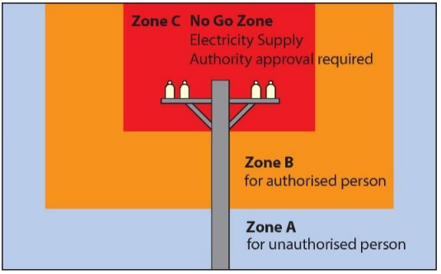
Figure 8 Operations near overhead electric lines
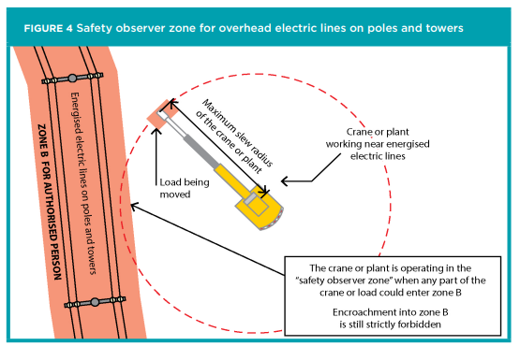

Controlling overhead electric line risks
Where it is reasonably practicable, the hazard must be eliminated, for example by removing energised electric lines from work areas. Consider:
- de-energising the electric line, or
- isolating and earthing the line for the duration of the work, or
- re-routing the electric line away from the work area.
Where elimination is not reasonably practicable, the risks must be minimised so far as is reasonably practicable. Consider substituting the hazard or work practice with something safer, for example by:
- using alternative plant that can operate without entering the unsafe zone
- using non-conductive tools, or
- using ultrasonic measuring devices to measure the height of overhead lines prior to the EWP entering an area near overhead electric lines.
Consider isolating the hazard from people by erecting a physical barrier to prevent any part of the EWP, equipment, person, or anything held or attached to a person, entering Zone B (see figure 7).
Consider using engineering controls like:
- limiting movement of plant with mechanical stops
- fitting proximity sensors that prevent the EWP from getting closer to the hazard
- fitting plant with programmable zone limiting devices, and
- Using an insulated EWP by an authorised person
If a risk still remains, you must use administrative controls like:
- fitting proximity sensors and a warning device to the EWP to alert operators when they are about to enter Zone B.
- making hazards more visible e.g. use warning signs
- managing and supervising the work
- defining areas where plant should not enter e.g. rigid tape barriers or high visibility bunting, and
- avoid working in wet conditions, if possible.
If any risks remain, suitable personal protective equipment must be used, including:
- electrically tested insulating gloves, rubber soled boots and safety helmets
- rubber insulating mat or on an equipotential conductive mat to stand on, and
- dry clothes especially in wet or humid conditions.
A combination of the above controls may be used if a single control is not enough to minimise the risks.

Approach distances for vehicles
Specific approach distances apply to vehicles and mobile plant stowed for transit and driven under overhead electric lines. Consider the voltage of the electric line and:
- the design and transit envelope
- the work activities e.g. person working from the top of the vehicle
- where the distance between the overhead electric line and ground may decrease, and
- the risk assessment factors for operating the vehicle.
Approach distances and work zones in each state and territory vary for people, plant and vehicles depending on the voltage of the overhead electric line, whether the electric lines are insulated or bare, and in some states with or without consultation with the person in control of the energised overhead electric line or exposed part.
For more information contact your state or territory electricity supply authority or electricity regulator.
Safety observers (electrical spotters)
A safety observer (also called an electrical spotter) is a person trained and competent to observe and advise the EWP operator near overhead and underground electric lines. All workers on a worksite should be able to clearly identify persons carrying out duties as a safety observer. This ensures that workers do not distract safety observers while they are carrying out electrical spotting duties.
An EWP is in a safety observer zone when it is possible that a part of the EWP, a person using an EWP or any equipment or tools being used or held by the person using the EWP could enter Zone B (on Figure 7) operations.
To carry out EWP operations in Zone B, the operator of the EWP and the safety observer require authorisation from the relevant electricity supply authority.
The safety observer should:
- mark the border of Zone B with suitable markers, for example red warning tape easily seen by the EWP operator
- stop unauthorised people entering Zone B
- not be required to observe more than one operating EWP at a time
- be able to communicate effectively with the EWP operator at all times and warn them if a part of the EWP or the load it is lifting is about to enter Zone B
- be provided with specialist communication equipment where there is a barrier to communication
- be trained to perform the role, and
- have the authority to stop the work at any time.

An EWP may not need a safety observer when:
- the electric lines have been de-energised and steps taken to ensure they cannot be inadvertently re-energised. High voltage electric lines should also be earthed.
- limiting devices have been installed to prevent any part of the EWP, plant or load being moved from entering the Zone B, or
- any part of the EWP or its load is prevented from entering the Zone B by physical barriers.
For more information, contact your state or territory Electricity Supply Authority.
Safety observer training and competence
Authorised people who work closer than Zone B and safety observers who observe the work should successfully complete a relevant training course provided by an RTO. They should be assessed as competent to carry out their work tasks in the vicinity of energised electric lines and exposed parts, and written certification should be verified.
Safety observers must be competent to implement control measures in an emergency and to rescue and resuscitate a worker if necessary. Authorised people and safety observers must be reassessed annually to ensure their ongoing competency to rescue and resuscitate and should also be reassessed to ensure their competency to work in the vicinity of overhead electric lines.
Contact with power lines
If contact with power lines is made:
- stay calm
- do not attempt to climb out of or touch the EWP until a competent person says it is safe to do in case the EWP is ‘live’
- if you must leave the EWP, for example, in the event of an imminent hazard such as fire, lower it as much as possible before exiting and ensure there is no contact with the EWP and the ground at the same time
- if exiting jump clear to the ground. Do not remain in contact with the EWP when you land on the ground. Shuffle or jump with both feet together away from the EWP as the ground may be charged
- keep the area clear of people, including workers and pedestrians
- notify the site manager/supervisor and call the relevant authorities immediately
- if possible, follow a competent person’s advice and attempt to break contact with the powerline
- if a competent person says it is safe to do so, exit the EWP. The EWP should be checked for arcing and other damage. Inform the local power authority so they can check and repair the power lines, and
- keep a safe distance from the EWP and the power lines until help arrives.

3.5 Falling object risks
WHS Regulation 54
Management of risk of falling objects
WHS Regulation 55
Minimising risk associated with falling objects
As a PCBU at a workplace, you must manage risks to health and safety associated with an object falling on a person if it is reasonably likely to injure the person. Falling objects include part or all of an EWP, or equipment and tools being used or carried while on the EWP.
If it is not reasonably practicable to eliminate the risk of falling objects, you must minimise the risk, so far as is reasonably practicable, using substitution, isolation, or engineering controls. For example, when planning where to site an EWP, consider:
- redesigning the work process to minimise the number of objects at height
- isolating the EWP away from people, plant and structures, including work areas and public access areas like buildings, footpaths, roads, unstable ground, railways, and waterways. This includes sufficient space to protect persons if the EWP collapses or tips over. The size of an exclusion zone should be based on a risk assessment, and
- erecting a physical barrier to separate workers and other mobile plant from the EWP’s operating radius.
If it is not reasonably practicable to eliminate the risk of falling objects, you must provide and maintain a safe system of work to minimise this risk. This safe system of work must provide adequate protection against the risk of falling objects, including by:
- preventing an object from falling freely, so far as is reasonably practicable; or
- if this is not reasonably practicable, by providing a system to arrest the fall of a falling object, so far as is reasonably practicable using tool lanyards to secure tools to an anchor point.
You must minimise any remaining risks by providing suitable PPE, such as hardhats.

3.6 Noise risks
WHS Regulations, Chapter 4, Part 1 Regulations 56–58
Noise
WHS Regulation 44
Provision to workers and use of personal protective equipment
WHS Regulation 46
Duties of a worker
As PCBU, you must reduce your workers’ exposure to hazardous noise so far as is reasonably practicable.

Noise can damage your hearing if it is too loud. Both sudden, loud noises, like an explosion, and constant, loud noise, like working near industrial machinery, can damage hearing.
Hearing damage includes permanent or temporary hearing loss and tinnitus (ringing in the ears).
Controlling noise risks
Where it is reasonably practicable, noise risks should be eliminated completely.
Where this is not practicable you should consider:
- substituting equipment by using electric EWPs indoors to eliminate/reduce the noise or change work practices to reduce the noise level at the source
- isolating the noise using barriers
- engineering controls that modify plant and processes to reduce the noise
- administrative controls that limit the time a worker spends near a noise source, or signage on hearing protection trigger levels, and
- PPE such as earmuffs or earplugs.
Workers must wear the PPE, such as ear protection, in accordance with any information, training and instruction provided to them by the PCBU at the workplace.
Further information is available in the Model Code of Practice: Managing noise and preventing hearing loss at work.

3.7 Hazardous chemical risks
WHS Regulations, Chapter 3, Part 2: Division 8
Hazardous atmospheres
WHS Regulation 46
Duties of a worker
WHS Regulation 344
Person conducting business or undertaking to obtain and give access to safety data sheets

If the EWP is being used for work involving the use of hazardous chemicals, the following should be considered:
- avoid having different (or incompatible) classes of hazardous chemicals on the platform at the same time
- review the material safety data sheets (SDS) to determine the safety measures and other information about the chemicals
- apply appropriate PPE - the SDS will identify which PPE is required
- ensure that the vapours, mists, fumes from solvents or chemicals do not enter any windows or air-conditioning intake registers, consider extraction ventilation to reduce vapour emissions, and
- where chemicals require mixing, do it on the ground and only take the required amount in a sealed container.
Workers must wear the PPE, such as masks and gloves, in accordance with any information, training and instruction provided to them by the PCBU at the workplace and in accordance with the SDS.
A PCBU must ensure that a register and a manifest of hazardous chemicals at the workplace is prepared and kept up to date. The register and SDS must be readily accessible to workers involved in using, handling or storing hazardous chemicals and to anyone else who is likely to be affected by a hazardous chemical at the workplace.
Further information is available in the Model Code of Practice: Managing risks of hazardous chemicals in the workplace.

3.8 Psychosocial risks
WHS Act section 19
Primary duty of care
WHS Regulations, Chapter 3, Part 2, Division 11
Psychosocial risks
Psychosocial hazards cause risks to worker’s mental health. To assess the risk, consider the duration, frequency and severity of exposure to psychosocial hazards. Psychological harm may include anxiety, depression, post-traumatic stress disorder and sleep disorders.
Common psychosocial hazards include:
- job demands. For example, a spotter or safety observer should not be assigned additional duties while spotting or observing as this may cause distraction and further risk.
- low job control, for example, workers having little say over break times
- poor support, for example inadequate training
- remote or isolated work
- poor physical environment, for example when working long hours in hot conditions
- violence and aggression
- bullying
- harassment, including sexual harassment, and
- conflict or poor workplace relationships and interactions.
PCBUs must eliminate, or if not possible, minimise, psychosocial risks so far as is reasonably practicable.
Controls to reduce psychosocial risks may include:
- providing regular breaks
- providing the appropriate level of supervision based on the level of risk and the worker’s experience
- staying in regular contact with workers in remote or isolated locations
- giving workers the equipment and training needed to do the work safely
- clearly describing key tasks, responsibilities and expectations
- regularly consulting to keep workers informed
- controlling physical WHS risks
- being active to promote cooperative work cultures, prevent workplace violence and aggression, bullying and harassment, and controlling harmful behaviours, and
- engaging third parties such as owners, tenants or neighbours so that they understand what is required of them to ensure a safe workplace.
In determining control measures to implement, PCBUs must consider things like:
- the duration, frequency and severity of the exposure to psychosocial hazards
- how psychosocial hazards may interact or combine
- the design of work including job demands and tasks
- the systems of work including how work is managed, organised and supported
- the design and layout, and environmental conditions, of the workplace (including safe entries and exits, and facilities for workers’ welfare)
- the design and layout, and environmental conditions, of workers’ accommodation (if any)
- the plant, substances and structures at the workplace
- workplace interactions or behaviours, and
- information, training, instruction and supervision provided to workers.
Further guidance on managing the risks of psychosocial hazards is in the Model Code of Practice: Managing psychosocial hazards at work.

4. Before using an EWP

4.1 Planning and preparation
Planning is the first step in ensuring an EWP is used safely. Planning includes:
- developing a scope of work
- selecting a suitable EWP, and
- providing a safe system of work.
Planning for EWP operations should start as early as possible and should involve consultation with all persons engaged in the work. This may include the principal contractor, EWP owner, manufacturer or supplier, electricity supply authority, designer, project manager, EWP operators and crew, and other workers.
Effective planning will help identify ways to protect persons who are:
- operating, maintaining, repairing and transporting an EWP
- performing other work activities at the workplace, and
- in an area adjacent to an EWP, including a public area or private property.
The construction project schedule should include dedicated dates and times for inspection and maintenance activities that align with the EWP manufacturer’s recommendations.

4.2 Selecting the right EWP
Many injuries and illnesses occur due to a failure to select the right equipment for the job. Before purchasing, hiring, or leasing an EWP, check it is suitable for the intended use, including the environment it will be used in and the work to be undertaken. Discuss your needs with your EWP supplier.
In some cases, an EWP may not be the right tool for the job.
Information must, so far as is reasonably practicable, be passed on from the designer through the manufacturer and supplier to the end user. This information includes:
- the purpose for which plant was designed or manufactured
- the results of calculations, analysis, testing or examination, and
- conditions necessary for the safe use of the plant, including ground conditions evaluations.
The decision to use a specific EWP should not be based on the availability of a particular EWP already at a workplace. You should select whatever best suits your workplace and the work. This includes considering:
The workplace
- layout, including site access, loading areas, distance from other buildings and structures, and plant in or near the workplace
- ground conditions, including stability, slope, and adequacy to support the weight of the EWP and loads. You can find this and other relevant information on the EWP’s specification plate and in the EWP’s manual
- operations of other plant, including other EWPs, concrete placing booms, and telehandlers, industrial trucks, mobile cranes
- traffic, including trucks and other vehicles, workers, and public access
- conditions if working inside, such as the location of beams that could be a crush hazard. If working indoors, an electric EWP should be considered as emissions from non-electric EWPs can be hazardous
- weather conditions, including wind, rain, extreme heat or cold
- proximity of overhead electric lines and structures, and
- proximity of underground services.
The work
- weight and dimension of workers and tools to be lifted
- EWP has adequate working height and reach required for the task
- visibility of loads throughout lifts, and
- length of time the EWP will be used.
You should also consider the needs of the workers. Where possible, select EWPs that have the same controls. Ensure workers are trained, or appropriately licensed where required, for the EWP they are using. This is particularly important in workplaces where multiple EWPs are used as there may be differences in the controls on the EWPs.
Each type of EWP has advantages and disadvantages. The types of EWPs commonly used on construction sites in Australia are shown in the introduction in Chapter 1.
For further information on what to consider when selecting EWPs, see AS 2550.10: EWPs, hoists and winches – Safe use – Mobile elevating work platforms.
Second-hand EWPs
A supplier of second-hand plant must ensure, so far as is reasonably practicable, that any faults that may give rise to health and safety risks are identified. Before the plant is supplied, the supplier must provide information in writing about the condition of the plant and any identified faults and that the faults have been rectified or, if the plant is supplied only for spare parts or scrap, that it is not to be used as plant.
EWP owners should be aware of any safety alerts or product advisory bulletins applicable to their EWP. The inspection and maintenance history of a second-hand EWP should be requested prior to purchase, in addition to plant design and item registration details (where required). Where an EWP has been in service prior to purchase and information on its condition and safe use is not available, a competent person (for example, a qualified mechanical engineer) should be engaged by the supplier to assess the EWP and develop this information.
Where a second-hand EWP has been imported from overseas, and the EWP requires registration, the importer or supplier must obtain design registration prior to use.
Plant registration requirements may vary between states and territories. Users should refer to their WHS regulators for specific guidance.
Hiring an EWP
Any person hiring or leasing an EWP to others has duties both as a supplier and as a person with management or control of an EWP in the workplace. This means that the supplier must ensure, so far as is reasonably practicable, that it is safe to use and has been maintained in accordance with the manufacturer’s instructions
EWP hiring companies should be aware of any safety alerts or product advisory bulletins applicable to their EWP.
Before you hire an EWP, you should ensure it is suitable for the intended use. If you do not have the knowledge or expertise regarding EWP specifications, limitations and operational requirements, you should consult the supplier and provide the supplier with all relevant information regarding the nature of the work, the workplace and the type of work required to enable them to provide the appropriate EWP.
You should also check that the EWP has been inspected and maintained by the owner according to the manufacturer’s specifications. This may involve checking the logbook or maintenance manual. You should also ensure that the hirer provides you with the manufacturer’s information about the purpose of the EWP and its proper use, including any modifications.
In most cases the supplier is responsible for inspecting and maintaining the EWP. However, if is hired or leased for an extended period of time, the supplier may come to your workplace to maintain it, or you might maintain the EWP while it is at your workplace.
If you choose to maintain it yourself, you should provide all information and records about the maintenance to the supplier at the end of the lease. More information on inspection and maintenance can be found in Chapter 6.

4.3 Registering an EWP
Boom-type EWPs must be registered before they can be used in the workplace. Registrable EWP designs must be design registered before being supplied and before being commissioned for use. The EWP manufacturer or supplier must provide the design registration number with the EWP.
The EWP design registration certificate number must be readily accessible in the vicinity of the EWP at all times. If a person modifies an EWP, they then have the responsibilities of a manufacturer and are to ensure the modified EWP is safe and the new design is design registered.
As a person with management or control of plant in the workplace, you may only direct or allow a worker to use a boom-type EWP in the workplace if it is registered.
Design registration
WHS Regulation 243
Plant design to be registered
You must register certain types of plant design and items.
The original designer or a person with management or control of the item of plant may apply for design registration.
The purpose of registering the design of an item of plant is to ensure it has been designed and verified to appropriate technical standard(s) prior to being supplied.
While design registration may be required, EWPs do not require item registration.
Note: telehandlers fitted with work platforms may be considered ‘boom-type elevating work platforms’ in some jurisdictions.
Your local WHS regulator has information on registering plant design and items of plant in your jurisdiction – how to do it and who can perform inspections.
Altered design registration
WHS Regulation 244
Altered plant designs to be registered
WHS Regulation 245
Recognition of designs by corresponding regulator
If a registered plant design is altered and these alterations may affect health and safety, the altered design must be registered. This is because altering a plant design may require the introduction of new risk control measures. Alterations may include:
- changes in engines, drives, brake systems, control systems, boom sections and other components where the new component is not simply a like-for-like replacement
- the addition of signage with greater wind area or mass, or in a different location, than allowed for in the EWP design
- repairing or modifying work platforms
- fitting attachments/accessories that have not been included in the original design
- fitting proximity sensors which interrupt EWP functionality.
For more information on plant design and item registration, see the Model Code of Practice: Managing risks of plant in the workplace.

4.4 Pre-use safety checks
The person with management or control of the EWP in the workplace must ensure, so far as is reasonably practicable, that the EWP is specifically designed for the purpose for which it is being used.
The work being undertaken, who will be involved, and the conditions of the site should be planned and discussed prior to deciding what type of EWP will be used. The discussions should include EWP operators and, where relevant, suppliers, designers, local councils or government authorities, and other trades and site managers.

Other factors to consider include:
- the condition of the EWP, for example, its age and maintenance history
- the location of the EWP, for example, any impact on the design and layout of the workplace and the workers’ ability to access the EWP without risk of slips, trips or falls
- any abnormal situations, for example misuse or variation in operating conditions you can foresee, and
- the position of an EWP, particularly where there are overhead power lines or when outriggers or stabilisers, if fitted, are used.
Considerations for the stability of an EWP include surface slopes, ground cavities and the condition of the ground. The ground (including concrete, roadway, paving, earth or rubble) needs to have sufficient capacity for the weight of the EWP. The positioning should ensure that access to the emergency controls is maintained. Deciding where to site an EWP should occur during the planning phase after considering relevant factors, such as:
- the risk of the EWP overturning or collapsing due to the ground giving way, overloading the machine, heavy winds and uneven ground
- the risk of the EWP colliding with or being struck by other plant, structures or objects at the workplace
- the paths of the EWP when travelling, including the ground the machine will be travelling over, and
- the lift path of the work platform.
If there are any issues with the EWP that may affect health and safety, do not use it. Park the EWP in a safe area, lock it out and tag the equipment to ensure it is not used by others. For further information, see Appendix B: Pre-operational checklist.

5. Using an EWP

5.1 Proper use
WHS Regulation 206
Proper use of plant and controls
As a person with management or control of an EWP at a workplace, you must take all reasonable steps to ensure that the EWP is used only for the purpose for which it was designed, unless you have determined that the proposed use does not increase the risk to health or safety. To determine this, you must ensure the proposed use is assessed by a competent person.
You must take all reasonable steps to ensure that all health and safety features and warning devices (including guarding, operational controls, emergency stops and warning devices) are used in accordance with the instruction and information provided by that person under regulation 39.

5.2 Communication
WHS Regulation 48
Remote or isolated work
A worker using an EWP may be isolated from assistance, including rescue, medical assistance, or attendance by emergency service officers. Find information on emergency planning in Chapter 2.
As a PCBU, you must manage the risks to both the physical and psychological health and safety of a remote or isolated worker. If you cannot eliminate these risks, you must minimise them so far as is reasonably practicable by providing a safe system of work. This includes providing effective communication with the isolated worker.
The type of communication system will depend on the site-specific conditions, such as the size of the workplace, noise and weather conditions. Expert advice and local knowledge may be needed to assist with the selection of an effective communication system.
You must ensure workers are provided information, training, or instruction on how to use the communication systems provided.
Further information can be found in the Model Code of Practice: Managing the work environment and facilities. For information on managing the psychosocial risks, see the Model Code of Practice: Managing psychosocial hazards at work.

5.3 EWP ground level and platform controls
There must be systems in place to ensure safe operation of the EWP ground level and platform controls. The operating controls can vary for each type and brand of EWP so careful consideration should be taken to ensure the operator training and procedures are relevant to the specific type of EWP and controls being used. All operating controls on the EWP must be identified to indicate their nature, function and direction of operation. The controls should be clearly labelled, with durable text or images.
Incorrect use of the controls can occur when there is inadvertent activation of the controls, or operator error. If workers are unfamiliar with the controls, not adequately trained or there is incorrect orientation of the control box, it is more likely that mistakes will be made.
Take particular care if there are multiple types of EWPs with different controls in use across a workplace. Where possible, put control measures in place to prevent workers switching between EWPs with different controls. If this is not possible, ensure workers understand any differences in operation between models, makes or manufacturers prior to use. The manufacturer’s instructions must be accessible to operators to facilitate correct use of the EWP.
Portable controls are often used in EWPs to allow operators additional flexibility to move around the work platform. There may be a higher risk of incorrect use with portable or remote controls, often due to misorientation of the controls with the movement of the EWP. There should be processes in place that specify and check the orientation of the control box, which is particularly relevant for the use of remote controls. It is recommended that the controls are placed on the front of the EWP. The remote controls and the EWP should have clear visual prompts that identify the orientation of the controls so it is easy to identify which way the EWP will move when using the controls.
You must train operators and ensure they are familiar with operating the controls. Ensure the instructions for lowering the platform in an emergency are clear. When positioning the EWP, ensure the emergency controls remain accessible from the ground. Emergency lowering also requires pre-operational inspection and testing.
Further information on recommended inspections is available in Part 6.2 – Inspection types.

5.4 EWP operating procedures
Documented operating procedures can help define responsibilities and manage EWP activities in a logical and systematic way. In conjunction with manufacturer’s instructions, operating procedures ensure the EWP operation is more likely to be carried out safely. Procedures should be prepared to suit the EWP, the work and the working conditions.
Documented EWP procedures may include:
- hazards and risk controls to be applied
- the type of EWP to be used
- the positions of the EWP, a diagram showing a view of the site may be used
- driving guidelines if the EWP is to be driven
- the maximum wind speed the EWP can be used in (and how this will be monitored on site using an anemometer or manufacturer approved method and recording maximum gusts during operation) including any derating rules for mesh/signage loads and ‘sail area attachments’
- the radius range with confirmation that the platform will be moved within the EWP’s capacity at the maximum radius
- the height of the work
- site and environmental conditions, including weather and ground conditions, if outdoors (and how this will be monitored on site) and other work being undertaken in the area
- if lighting is required, such as work being carried out at night
- what approvals are required, if any
- if the site and task require the use of a spotter or safety observer, and
- the tasks required, who is responsible for performing them and what communication system is to be used.
Travelling with the EWP
Travelling with an EWP increases the risk of destabilising and overturning the EWP as well as risks of collisions with other plant, structures or people. Extra precautions should be used if travelling through smaller spaces or near any overhead structures, such as doorways, or over ground level objects, such as gutters or pit covers. Using a spotter and operating the EWP through the portable or remote controls can assist with improving visibility of surroundings and preventing collisions. EWPs should not be moved with the outriggers extended.
The following safety measures should be applied when travelling with an EWP:
- retract the boom and lower the platform, if possible
- consider the use of a spotter to alert the EWP operator of any possible collisions, especially when travelling on slopes or in congested areas
- workers on the platform wear a harness that is attached to the anchor point
- ensure no persons are on the platform while the EWP is travelling, except for short distances where the EWP is specifically designed, rated, and approved by the manufacturer.
- ensure the travel path is free of people, objects, plant and structures
- extra caution must be taken if travelling across a slope. If travelling on a slope, travel with the platform pointing up the hill and ensure the slope does not exceed the EWP’s slope capabilities
- if travelling up a slope ensure there is enough clearance space under any overhead structures
- if travelling over a longer distance, have the boom fully retracted and as close as possible to the ground, and
- drive slowly and steer as smoothly as possible.
If it is not possible to retract the platform and the EWP is to travel with an elevated platform:
- ensure the EWP is designed to do so
- ensure the rated capacity of the EWP is not exceeded, and keep any tools or equipment on the platform secured
- be aware of power lines, surrounding structures and other overhead obstructions
- travel slowly and with caution, using a spotter or safety observer if possible
- travel on flat, smooth surfaces and avoid slopes and soft, uneven or unstable ground, and
- if the EWP is truck mounted, ensure the tyres are inflated to the correct pressure.
EWP tilt
If the EWP starts to tilt to one side:
- Work should stop immediately and the platform should be lowered or retracted.
- If safe to do so, workers should get out of the platform and attempt to find the cause of the tilt, such as uneven, soft ground or an error with the tyres or EWP.
- If unable to determine the cause of the problem, or how to rectify it, advice should be sought from a competent person.
- Work should not be started again until the problem is fully resolved. The EWP may need to be re-located to more stable ground.
- For machine faults, the EWP should be locked and tagged out and assessed by a competent person before returning to service.

5.5 EWP exclusion zones
A PCBU with management or control of powered mobile plant at a workplace must ensure it does not collide with any person, including spotters or safety observers, or any thing. If there is a possibility of a collision, the plant must have a warning device such as audible alarms and flashing lights alerting persons, who may be at risk from its movement.
You should consider setting up exclusion zones when using an EWP in the workplace. Use physical barriers, such as barricades to ensure that people, including where possible spotters or safety observers, other workers and visitors are kept separate from the EWP. Where possible, limit the people in the vicinity of the EWPs to the operators and people directly involved with the work, including where possible spotters or safety observers. Signage, barriers and markings should be used to guide people and vehicles around the EWP work area where needed.
If there is a risk of people, spotters or safety observers being hit by falling objects exclusion zones should be used and barricades should be positioned to keep people plant and vehicles at a safe distance.
Caution must be taken when loading/unloading an EWP onto a transport vehicle. The transport driver must ensure that there is suitable isolation from passing traffic, and that the EWP and transport vehicle are visible.

Traffic management plans
A traffic management plan can help a PCBU, site designers and other authorised workers identify and control hazards and risks associated with all vehicles on the worksite, including EWPs. This may include details of:
- designated travel paths for vehicles including entry and exit points, haul routes for debris or plant and materials, or traffic crossing other streams of traffic
- pedestrian and traffic routes
- designated delivery and loading and unloading areas
- travel paths on routes remote from the workplace including places to turn around, dump material, access ramps and side roads
- how often and where vehicles and pedestrians interact
- traffic control measures for each expected interaction including drawings of the layout of barriers, walkways, signs and general arrangements to warn and guide traffic around, past or through the workplace or temporary hazard
- on a public road, detail of the layout of signs and devices including temporary speed zones and the location, spacing, length and location of tapers. Consider pedestrian and cyclist routes to ensure the protection of the public
- requirements for special vehicles like large vehicles and mobile cranes, and
- requirements for loading from the side of road onto the site.
Where possible, avoid the need for vehicles to reverse as this is a major cause of fatal incidents. One-way road systems and turning circles can minimise risks.
Further guidance is in the model Code of Practice: How to manage work health and safety risks; the model Code of Practice: Construction work and Workplace traffic management guidance material.

5.6 EWPs not in use
WHS Regulation 207
Plant not in use
As a person with management or control of plant at a workplace, you must ensure, so far as is reasonably practicable, when an EWP is not in use that it is left in a state that does not create a risk to the health or safety of any person.
An unattended EWP may be located where other mobile plant may collide with it, become unstable, or be used by a person not competent to operate it. Except in an emergency due to fire or other life threatening reasons, the EWP operator should never leave the EWP controls in a state where it can be operated by unauthorised workers.

If an EWP is to be left unattended, you should ensure:
- the manufacturer’s instructions are followed or, if not available, those of a competent person
- the power supply and controls are isolated and locked off, including remote control equipment
- the keys removed or the starting device locked out
- adequate systems are in place to prevent unauthorised access to the EWP or provide warning of unauthorised access, for example, a lockable hatch to restrict access to the EWP cabin, and fitting of movement detectors, security camera or intruder (back to base) alerts, and it is not left in a location which may cause other mobile plant to collide with it.

5.7 Telehandlers used as an EWP
Telehandlers, or multipurpose tool carriers are machines that have different attachments allowing it to be used for different purposes. While they are most commonly fitted with fork arms, they can be also used as an EWP if the telehandler is configured and fitted as an EWP, having basket controls for operation and ground controls (for rescue).
Telehandlers have similar risks to boom type EWPs, including risk of overturn, falls and colliding with other plant, people, objects or structures.
If using a telehandler configured and fitted as an EWP, you should use the same safety controls that apply when operating any other EWP. This includes maintaining safe distance from power lines, not overloading the telehandler, and ensuring operators are trained in the use of the telehandler, including emergency controls.
Workers must not be on the work platform when the telehandler is travelling as there is a risk the person may be ejected or strike an object, overhead structure or powerlines.
Note that a high risk work licence may be required to operate a telehandler fitted with a work platform where the boom length is greater than 11 metres.
High risk work licences are regulated by each state and territory. Check with your jurisdictional authority to see what regulations apply to you.
When using telehandlers, you should only use the work platform that have been approved for use by the manufacturer, or a competent person, and that is specific to the model of the telehandler. This includes using specific platform configurations and load charts approved by the manufacturer when operating the telehandler as an EWP. Fork mounted work platforms must not be used. Be aware of the rated capacity and wind speed capacity as well as any relevant ground conditions and slopes. Operating instructions should be updated to reflect the use of the machine fitted with a platform. You must only use the attachment that is suitable for the work being carried out.

6. Inspecting and maintaining EWPs

6.1 Inspections
WHS Regulation 204
Control of risk arising from installation or commissioning
WHS Regulation 213
Maintenance and inspection of plant
WHS Regulation 237
Record of plant
As a person with management or control of an EWP at a workplace you must ensure, so far as is reasonably practicable, that thorough inspections are carried out to ensure the parts of the EWP which are subjected to deterioration through wear, damage, corrosion and abrasion are repaired or replaced well before they fail. Regular inspections enable issues to be identified and rectified, so that you can be satisfied that an EWP is safe for your workers to use until the next inspection.
You must ensure the maintenance, inspection, and if necessary, testing of an EWP is carried out by a competent person.
Details of observations during an inspection, including the nature of potential failures, are essential for planning maintenance, repair work and finding the cause of atypical failures.
When to inspect
There are numerous inspection types which should be carried out at different intervals. At a minimum, the WHS Regulations require inspections of an EWP to be carried out:
- in accordance with the manufacturer’s recommendations, if any, or
- if there are no manufacturer’s recommendations, based on a competent person’s recommendations, or
- if it is not reasonably practicable to comply with above, annually.
Further information on other recommended inspections is available in Part 6.2 – Inspection types.
Under the WHS Regulations, a designer of an EWP must give the manufacturer information about testing or inspections to be carried out on the EWP, if applicable. A manufacturer must ensure that such information is provided to any person being supplied with the plant. For EWPs that are imported, the importer must take reasonable steps to obtain this information and provide it to any person to whom the importer supplies the EWP and ensure that it is inspected having regard to the information provided by the manufacturer.

If there are no manufacturer’s recommendations, you should obtain recommendations from a competent person. Recommendations from a competent person should be based on relevant published technical standards, such as AS2550.10, and take into account key causes of failure, such as the following:
- Components of equipment have a design life; that is, a period of time during which the item is expected, by its design, to work within its specified parameters. Life expectancy may not be directly related to calendar periods, but a combination of time, cycles, usage and environmental conditions that may have affected storage of the device. Inspection intervals for most components are based on hours in operation which relates to the number of stress cycles the components have gone through.
- Many failures of components can be attributed to corrosion, wear, overloading, fatigue, or combination of these. Loose or missing fasteners, poor adjustment or inadequate lubrication can also contribute to failures. Items such as seals may have a reduced life when used infrequently due to lack of lubrication.
- It is essential to only operate the EWP within its rated capacity. A single instance of overloading can damage the EWP or lead to premature failure as overloading can reduce fatigue life.
- Road conditions and the distance travelled by vehicle mounted EWPs, or those that are transported on road, contribute to accelerated wear and tear of components.
- Frequency of inspections may have to be increased when operating in harsh conditions, for example corrosive, dusty, hot or cold environments.
- Older EWPs and those that are used more intensively or subject to harsh operating environments should be inspected more frequently and some components may need replacing more frequently than recommended by the manufacturer.
If inspection requirements are not met, the EWP should not be used until the PCBU is satisfied that an inspection has been undertaken.
Although it may not be necessary to inspect EWPs that are not being used, measures should be undertaken to protect the EWP from the environment during long term storage. Before returning the EWP to use, all safety and operating systems should be inspected and tested.
You must ensure that any safety issues identified through an inspection are rectified and the EWP is safe for your workers to use before the EWP is used again.
What to inspect
Exactly what an inspection should include will depend on the type of inspection being undertaken. Inspections should cover critical components.
‘Critical components’ are the plant components whose failure or malfunction may affect the health and safety of persons using the EWP or who are in its vicinity.
Manufacturers normally provide recommendations for what an inspection should include, but if these are not available or are inadequate, recommendations should be developed by a competent person. A competent person may refer to a published technical standard, such as AS2550.10, for guidance.

Inspections may include:
- identifying any modifications to critical components or systems that deviate from the manufacturer’s specifications
- identifying worn parts
- identifying damage to items like tyres, structural components and hydraulic hoses
- identifying abnormalities or defects—oils leaks, discolouration, cracks, unusual noises and vibrations
- checking fluid levels and greasing
- whether items or systems function as designed
- making adjustments within the manufacturer’s specifications, as required
- replacing items or fluids as required manufacturers may recommend replacing some items after a certain time period or hours of use irrespective of the condition
- identifying loose or missing components including safety critical fasteners
- undertaking written assessment of continued safe use, taking account of past and possible future use
- checking for any insulation damage (insulated EWPs)
- whether any manufacturers’ recommended safety upgrades have been completed, and
- whether data plates, placards and warning labels are in place and legible.
You must ensure that any safety issues identified through an inspection are rectified and the EWP is safe for your workers to use, before the EWP is used again.
How to inspect
Inspections may include simple visual observations, functional testing, testing or measuring against acceptance criteria and identifying defects like damage or corrosion.
One method of inspection is no less important or effective than the other. For example, a visual pre-operation inspection could detect a crack on a structural member, or an oil leak, in advance of a more comprehensive routine inspection. This could prevent further structural damage or an adverse safety outcome in the meantime.
However, some items can only be inspected after dismantling, such as pins, bushes, wear pads inside telescoping booms, or internal areas subject to corrosion including joints between fibreglass and steel, gearboxes and brakes.
With any form of inspection there should be supporting documentation or information to guide the competent person on how to inspect the item and how to confirm that the component is in a safe condition.
Who should undertake inspections
You must ensure inspections are undertaken by a person who is competent to do so. A competent person is a person who has the necessary knowledge and skills to carry out the task, acquired through qualification, training or experience.

The competent person overseeing the inspection should:
- have sufficient knowledge to oversee, where necessary, other competent persons undertaking related specialist work, understand their reports including whether they contain necessary information
- have sufficient knowledge of the requirements for the model being inspected so that the inspection can be undertaken as required, and
- be aware of the relevant safety information including safety bulletins from the manufacturer and other safety publications. These should be incorporated into the inspection program and documented.
A competent person must be able to demonstrate that they possess these attributes.

6.2 Inspection types
Generally, the following types of inspections should be undertaken:
- pre-operational inspection
- routine inspection
- periodic inspection, and
- major inspection.
Pre-operational inspection
Pre-operational inspections are generally visual inspections and functional verification. These should be conducted at the beginning of each use for obvious faults (anomalies) and to confirm the EWP’s correct functioning of controls and travel limits. These inspections should also include detection of damage, tyre pressures, fluid levels and leaks.
Pre-operational inspections must be undertaken by a competent person familiar with the operation of the particular model of EWP, for instance the EWP’s operator.
A list of typical items to be inspected during pre-operational inspections is included in Appendix B This is not an exhaustive list. The items to be inspected should be based on manufacturer’s recommendations, where available.
You must ensure that any safety issues identified through an inspection are rectified and the EWP is safe for your workers to use, before the EWP is used again.
Routine inspection
Routine inspections are normally based on time or usage and must be undertaken in accordance with manufacturer’s recommendations, if any. Routine inspections should be carried out at least every three months unless the EWP is not in service.
Routine inspections generally involve:
- dismantling some components to enable proper inspections
- removing covers of certain items
- review of logbook entries, for example, quality of previous records, identification of issues relating to pre-operational inspections or reasons for abnormal repairs
- availability of operator’s manuals
- condition of signage and decals
- lubrication and necessary adjustments
- function testing, and
- torque checking (critical fasteners).
You should ensure the competent person provides a written inspection report.
A list of typical items to be inspected during routine inspections is included in Appendix C. This is not an exhaustive list. The items to be inspected should be based on manufacturer’s recommendations, where available.
You must ensure that any safety issues identified through an inspection are rectified and the EWP is safe for your workers to use, before the EWP is used again.
Periodic inspection
Periodic inspections are based on intervals of usage in hours subject to a maximum time period, typically one year. Periodic inspections must be undertaken at least annually, unless otherwise recommended by the manufacturer or competent person.
Components that are recommended to be inspected at intervals of more than 12 months, and which usually require a greater level of intervention, must be inspected at intervals recommended by the manufacturer, where available, or otherwise at intervals recommended by a competent person.
A list of typical items to be checked during periodic inspections is given in Appendix D. This is not an exhaustive list. The items to be inspected should be based on manufacturer’s recommendations, where available.
You must ensure that any safety issues identified through an inspection are rectified and the EWP is safe for your workers to use, before the EWP is used again.
Major inspections
EWPs should be subjected to a major inspection for continued safe use after 10 years of service, and every 5 years thereafter.
EWPs should also be subjected to a major inspection if:
- the manufacturer recommends that it is due for a major inspection at earlier intervals
- the EWP is to be recommissioned or imported, and the previous operating records are not available
- the EWP is to be recommissioned or imported, and is designed or built to an unknown technical standard—in which case a design review should also be undertaken to ascertain whether the design meets minimum legislative requirements
- modifications have been made to the EWP which could impact health and safety, and
- the EWP has suffered damage that could compromise critical components or functions, or
- a competent person recommends it due to issues identified during other inspections.
Major inspections are not a substitute for other types of inspections but should be additional. Components subjected to a large number of stress cycles, such as structural members, require shorter inspection intervals. These components should be inspected during pre-operational, routine and periodic inspections and not left until the major inspection.
The major inspection should involve:
- dismantling and examination of critical components (inspection of certain components may require a complete strip down and removal of grease and corrosion), and
- assessment and recording of the serviceability of each component or assembly.
A list of typical items to be checked is given in Appendix F. This is not an exhaustive list. The items to be inspected should be based on manufacturer’s recommendations, where available.
You must ensure that any safety issues identified through an inspection are rectified and the EWP is safe for your workers to use and before the EWP is used again.

6.3 Monitoring and testing
In addition to pre-operational, routine and periodic inspections, EWPs should be monitored closely and tested against the manufacturer’s specifications or any relevant technical standards.
You must ensure any monitoring and testing of the EWPs is carried out by a competent person.
Condition monitoring
Condition monitoring is the monitoring of a parameter, such as vibration or temperature. Changes to the magnitude of a parameter may indicate the condition of the item has worsened, while an analysis of data trends can assist in preventative maintenance scheduling.
Examples of condition monitoring include:
- Testing engine and gearbox oil or hydraulic oil for metal particles to determine the condition of the mating parts. This information can be used to help schedule maintenance before the component suffers a failure.
- Trends of vibration characteristics of bearings measured periodically to predict the remaining life of the item or if it is misaligned.
It may not be reasonably practicable to use condition monitoring in all situations.
Non-destructive testing
Non-destructive testing (NDT) is a method of testing that includes ultrasonics, magnetic particle testing, acoustic or radiography that can be used to supplement other inspection techniques, for example visual inspection. NDT is used when:
- detecting cracks in welds and parent metal of welded components
- detecting cracks in fibreglass (insulated) booms
- measuring the wall thickness of components subject to corrosion or wear, and
- detecting cracks in pins and shafts subject to fatigue—particularly where there is a change in the geometry of, for example, the pin or shaft that may result in stress concentrations.
Not all NDT techniques are suitable in every situation.
NDT does not replace other types of inspections, for example looking for cracks during pre-operational or routine inspections.
Before performing NDT, it is important to establish the purpose of the testing. A competent person should identify the critical components and areas, the appropriate technique for testing, any test restrictions (for example lack of access, surface discontinuity due to poor weld profile, cutting or grinding), and the criteria for accepting an item as ‘safe’.
Test restrictions should be remedied to allow for less restricted testing, if possible. The competent person who undertakes the NDT should record the results of every inspection performed.
NDT should also form part of the quality assurance process, which is commonly known as qualification of a repair, when appropriate.

6.4 Recordkeeping and reporting
Detailed records of inspection, testing and maintenance must be kept for the period that the EWP is used or until you relinquish control of the EWP. Records should:
- demonstrate the PCBU has complied with their duties, particularly if the EWP was involved in an incident
- demonstrate that the plant is design registered
- determine the trends and causes of premature or unusual failures
- determine the integrity of previous inspections, and, if necessary,
- schedule repairs and future inspections.
The records of premature or frequent failure of components may help identify the root cause of failures or whether the causes of premature failures have already been addressed. It is recommended, and good industry practice, to share this information with the manufacturer to determine the best course of action and if any design changes need to be made on subsequently manufactured EWPs. You may also be asked to share this information up to 2 years after disposal or 2 years after a notifiable incident to aid investigations.
Each competent person involved in the inspection should provide a written report on completion of the inspection. Reports should include sufficient information:
- for the reader to understand the scope of work, the state of items and action taken or recommended
- to identify the critical components that have been inspected and the result of the inspections
- to confirm the work has been undertaken as required
- that supports conclusions—how the item was declared fit for use
- includes photos or sketches where necessary
- to facilitate further analysis to plan future work, and
- relating to future scheduled inspections—more frequent inspections or inspecting a specific part or system.

A written report should include:
- the name and signature of the competent person
- qualifications and contact details of the competent person
- the date and location of inspection
- inspection type (pre-operational, routine, periodic, major)
- owner/controller details
- manufacturer
- model number
- serial number
- hour meter reading
- date of manufacture or commissioning, and
- rated capacity.
Where it is not reasonably practicable to include all details of work undertaken in the record, the record should have:
- a brief summary of the work undertaken
- the date the work was completed
- hour meter and odometer readings
- a reference to the detailed report
- date of the report, and
- name and the signature of the competent person.
Copies of all records should be provided to the new owner or controller when ownership or control of an EWP changes.
Logbooks or an electronic logging system can be used for recording information about an EWP. Electronic recording systems should have an effective backup system against data loss.
Records should be kept in a readily accessible location and electronic records should be made available as required for use or inspection by you, your workers and any competent person conducting an inspection.

Appendix A – Glossary
Term | Description
Australian and New Zealand Standards | Standards are designed to provide guidance to help ensure safety, performance and reliability through the specifications of goods, services and systems.  The following standards provide guidance on certain types of plant. However, a person conforming with a Standard does not automatically mean they have complied with the Model WHS laws. This list is not exhaustive.  - AS/NZS1418.10 Cranes, hoists and winches, Part 10: Mobile elevating work platforms  - AS2550.10 Cranes, hoists and winches Safe use, Part 10  - AS 5247 Mobile elevating work platforms.
Barrier | A physical structure which blocks or impedes something.
Boom | Part of the EWP structure that allows operators to be hydraulically raised and moved horizontally and/or vertically to reach areas not able or not easily accessible by ladder.
Boom-type elevating work platform | A telescoping device, hinged device, or articulated device, or any combination of these, used to support a platform on which personnel, equipment and materials may be elevated.
Competent person | A person who through training, qualification or experience, has the knowledge and skills to carry out the task.  Note: Different types of EWPs require different competencies, including appropriate training and/or qualifications.
EWP | Elevating work platforms (EWPs), also called MEWPs (mobile elevating work platforms), are platforms that lift or lower people and equipment from a base support.  Different types include scissor lifts, boom-type lifts (including cherry pickers), telehandlers and vehicle mounted lifts.
Excavation | A trench, tunnel or shaft, but does not include:  - a mine  - a bore to which a relevant water law applies, or  - a trench for use as a place of interment.
Duty holders | Any person who owes a work health and safety duty under the WHS Act including a person conducting a business or undertaking, a designer, manufacturer, importer, supplier, installer of products or plant used at work (upstream duty holder), officer or a worker.
Logbook | Logbooks contain records of EWP details, safety checks, maintenance, identified faults and rectification undertaken.  Records should be kept in a readily accessible location. Electronic records should be made available as required and backed up against data loss.
May | ‘May’ indicates an optional course of action.
Must | ‘Must’ indicates a legal requirement exists that must be complied with.
Officer | An officer under the WHS Act includes:  - an officer under section 9 of the Corporations Act 2001 (Cth)  - an officer of the Crown within the meaning of section 247 of the WHS Act, and  - an officer of a public authority within the meaning of section 252 of the WHS Act.  A partner in a partnership or an elected member of a local authority is not an officer while acting in that capacity.
Outriggers | Outriggers are devices at the base of the chassis that increase stability of the EWP and that are capable of lifting and levelling the chassis.
Person conducting a business or undertaking (PCBU) | A PCBU is an umbrella concept which intends to capture all types of working arrangements or relationships.  A PCBU includes a:  - company  - unincorporated body or association  - sole trader or self-employed person.  Individuals who are in a partnership that is conducting a business will individually and collectively be a PCBU.  A volunteer association (defined under the WHS Act, see below) or elected members of a local authority will not be a PCBU.
Person with management or control of plant at a workplace | A person conducting a business or undertaking to the extent that the business or undertaking involves the management or control of fixtures, fittings or plant, in whole or in part, at a workplace.
Rated capacity | The maximum gross load which may be applied to the EWP or lifting attachment while in a particular working configuration and under a particular condition of use.
Reasonably practicable | There are two elements to what is ‘reasonably practicable’. A duty holder must first consider what can be done – that is, what is possible in the circumstances for ensuring health and safety. They must then consider whether it is reasonable in the circumstances to do all that is possible.  All of the relevant matters must be taken into account and a balance achieved that will provide the highest level of protection that is both possible and reasonable in the circumstances.
Safety observer (or electrical spotter) | A competent person with a line of sight who must be present to direct the EWP operator to ensure the safe movement of mobile plant in relation to any electrical hazards in the workplace.  A safety observer must be competent:  - To implement control measures in an emergency; and  - To rescue and resuscitate the worker who is carrying out the work, if necessary; and  - The safety observer must have been assessed in the previous 12 months as competent to rescue and resuscitate a person.
Should | ‘Should’ indicates a recommended course of action.
Spotter | A person specifically assigned the duty of observing and warning against impending hazards relating to the movement and operation of an EWP and who can undertake emergency procedures such as emergency retrieval if necessary.  A spotter should not be assigned additional duties while spotting. For example, a spotter should not be required to observe more than one task at a time.
Spreader plates or pads | Material (steel, timber or other) that sits under outriggers that help distribute the weight of the EWP on softer ground.
Stabilisers | Stabilisers are structural members that, when deployed, increase the stability of the EWP but do not lift the vehicles wheels off the ground.
WHS | Work health and safety.
Worker | Any person who carries out work for a person conducting a business or undertaking, including work as an employee, contractor or subcontractor (or their employee), self-employed person, outworker, apprentice or trainee, work experience student, employee of a labour hire company placed with a ‘host employer’ or a volunteer.
Workplace | Any place where work is carried out for a business or undertaking and includes any place where a worker goes, or is likely to be, while at work. This may include offices, factories, shops, construction sites, vehicles, ships, aircraft or other mobile structures on land or water.

Appendix B – Pre-operational checklist
Before using the EWP, you should carry out visual inspections and function tests in accordance with the manufacturer’s instructions or those of a competent person to ensure it is safe. The inspection and testing should be relevant to your type of machine and workplace, which may include but is not limited to the list below.
Before operating, check: | Yes | No | Comments
- the travel warning devices and any other visual and audible alarms are operational

- the load bearing parts of the boom arm are not bent or damaged. If the boom is insulated, ensure it is not compromised by foreign matter

- the logbook is up to date and any service requirements have been met (if overdue for a service, do not use).

- the descent equipment, including emergency descent equipment, is operating correctly and the safety release clips are in place and can be removed by hand

- the ground-level operating controls are free of damage, the emergency lowering controls can be operated. Instruction decals for these controls can be easily read.

- platform controls are in good working order. The decals indicating the operation of the controls can be easily read.
- the hydraulic fluids are not leaking and are at an appropriate level. All hydraulic hoses and fittings are securely attached and free from leaks.
- the outriggers are in good working order, with no leaks or damage.

- the brakes are in good working order.
- the platform is clear and free of damage or obstructions, the platform mounting pins are secure and in good condition and the handrails are secure and not bent or damaged.

- the rated capacity plate and all safety signs and placards are clearly visible and legible.
- the platform gate or entry bar works correctly and it shuts and latches automatically.

- the manufacturers plate has the: manufacturer’s name, year of manufacture, model and serial number, rated capacity, maximum number of occupants, maximum allowable wind speed, supply voltage ratings, weight of EWP, allowable manual forces and cautions and restrictions.

- the knuckle joints for signs of wear or damage. Boom overloading can result in flaking paint or distortion of the knuckle, which can be a sign of damage.
- the tyres are in good condition, with correct pressure according to the manufacturer’s specifications. EWPs fitted with pneumatic tyres must only be able to elevate with activated stabilisers.
- the personal fall protective equipment required is available and in good condition. Designated anchor points are clearly labelled and in good condition. Workers are trained in using the equipment correctly.
- all workers involved with the work are trained to use emergency controls and how to lower the machine in an emergency.
- the operator is trained and competent in safely operating the machine, including how to use the controls and holds the relevant high risk work licences.
- the functionality of all safety switches, interlocks and speed limiting devices has been tested.
- the functionality of all drive and speed functions has been tested.

Appendix C – Routine inspections
This table provides useful information on items to be included in a routine EWP inspection and a subsequent written report by a competent person. This list is not exhaustive. You should consult the manufacturer’s or competent person’s recommendations for the EWP for the items to be checked.
Component | Visual inspection | Functional test
Operator manual | y
Logbook | y
Structural defects | y
Tyres and wheels | y
Placards, warnings and control markings | y
Air, hydraulic or fuel leaks | y
Cables and wiring (security and damage) | y
Loose or missing components | y
Controls – base and platform | y | y
Control descent devices (where fitted) | y | y
Alarms – visual and audible |  | y
Emergency controls and retrieval system |  | y
Brakes |  | y
Slew brake function |  | y
Outriggers and stabilisers |  | y
Guard rails and self-closing gates |  | y
Safety switches and interlocks |  | y
Operation of drive functions |  | y
Routine inspection reports should contain:
Components to be inspected, and function tested – indication that the components have been inspected or tested
Any defects identified and action undertaken
Date of inspection and the signature of the competent person

Appendix D – Periodic inspections
Example of items to be checked during, periodic inspections.
These tables provide useful information on items to be included in periodic EWP inspections and a subsequent written report by a competent person.
This list is not exhaustive and may include items that are not relevant or fitted to the EWP. You should consult the manufacturer’s or competent person’s recommendations for the EWP for the items to be checked.
Items to be checked
Operation and safety manuals
Decals and warnings are secure and legible
Modifications
Condition of structure and welds
Fasteners, pins shield and covers
Hoods and gas struts
Stub axle
Turret/slew turntable
Manufacturer’s safety upgrades
Structural members
Hydraulic components
Mechanical components
Safety devices and interlocks
Controls and emergency stops
Braking systems
Platform levelling systems
Platform, handrails and gate
Emergency retrieval system
Other components whose maintenance records indicate repeated failures
Function controls
Items to be checked
Platform controls
Ground controls
Function control detents
Guards for controls
Function enable control
Emergency stop switches (ground and platform)
Function limit, cut out switches, interlocks and other safety devices
Manual descent or auxiliary power
Foot switch (deadman)
Capacity limiter
Drive brakes
Slew brakes

Platform
Items to be checked
Guard rails
Gates – self closing
Floor
Anchors for lanyard
Rotator
Scissor mechanism
Items to be checked
Scissor arms
Arm safety stop
Cylinder pins, pivot pins and securing components
Arm pins, wear pads and securing components
Chassis assembly
Items to be checked
Side compartment door assembly
Static strap
Wheel and tyre assemblies
Drive motors
Pothole protection system
Platform ladder
Wheel bearings
Oscillating axle lockout cylinder system
Outrigger or stabilisers
Extendable axle system
Drive hubs
Pedestal
Boom assembly
Items to be checked
Boom welds
Hose and cable carrier installation
Sheaves and sheave pins
Bearings
Wear pads
Slew bearing or worm gear
Oil coupling
Slew drive system
Insulation inserts
Power system
Items to be checked
Batteries fluid
Battery charger
Hydraulic and electric systems
Items to be checked
Hydraulic lift/steer pump
Hydraulic cylinders (arms and steering)
Steer cylinder attachment pins and pin retainers
Hoses, lines and fittings
Hydraulic tank, cap and breather
Fluid
Oil filter
Electrical connections and wire looms
Instruments, gauges, switches and horn
Periodic and major inspection report should include the reports of those providing additional inspections or repair services, and documents reviewed.
Periodic and major inspection reports should contain:
Date of commencement of inspection
Date of completion of inspection
Components inspected
Inspection method for each component or assembly
Components not disassembled for inspection and why
Inspection criteria, result, status (acceptable/not acceptable) and comments (e.g. replace, repaired)
Details of repair, repair procedures, tests and replacements
Details of functional and other tests
Observations and recommendations relating to future maintenance and inspections
Contact details of the PCBU
Name of the competent person, their qualifications, contact details and signature.

An assessment of remaining operational life can be applied to a component, an assembly or the whole plant. Increasing frequency of inspections will not improve fatigue life. A competent person should consider remaining operational life when establishing whether the plant should remain in service.

Appendix E – Example report of a periodic inspection
This example report provides useful information on what to expect in a periodic or major inspection report from a competent person.
Note: Some items may have more than one observation, for example, slew bearings are typically checked at four positions and observation at all positions should be recorded.
Owner/Controller of the EWP:  Location of inspection (street address):  Manufacturer:  Model No.:  Serial No.: |  |  |  |  |  | Contact person: Joe Smith  Contact details. Joe@email.com/0499 999 000  Start date:  Date completed:  Hour meter/odometer readings:  Design Registration No.:
Details of additional service providers
Name |  |  |  | Company |  |  |  | Contact details
Hydro Jones |  |  |  | EP hydraulics |  |  |  | 0444 444 999
Mark Sparkes |  |  |  | Hello Electricals |  |  |  | 0494 949 494
Item | Description |  | Method of inspection, including any restrictions or limitations  Example only |  | Acceptance criterion  For illustration only |  | Observation |  |  | Status | Comments Photos taken (Y/N)
1 | Slew bearing |  | Using a dial gauge |  | 0.15 mm |  | 0.12 |  |  | Ok | N
2 | Outrigger jack – left front |  | Using dial gauge with rated load |  | Creep less than 0.4 mm/10 min |  | 0.2 mm/min |  |  | Ok | N
3 | Horizontal Outrigger member |  | In-situ Visual |  | Paint cracking |  | No cracks |  |  | Ok | Y
4 | Knuckle Pin |  | Visual and measuring |  | Smooth surface and wear less than 0.1 mm in diameter |  | Rough surface  Wear 0.2 mm |  |  | NG | Not lubricated
5 | Main lift cylinder |  | timer |  | From fully retracted to fully extended in 24 to 27 sec |  | 35 sec |  |  | Not serviceable | Too slow
6 | Item X
7 | Item Y
8 | Item Z
Comments (detailing the defect and how it was rectified):
1. Replaced the pin and the bush with new components
2. Tested the valve for the main lift cylinder before returning to service. Test result: 25 sec

Competent person |  | Phone number and email |  |  |  | Qualifications |  |  | Date of inspection
Signature: |  |  |  |  |  | Date:

