Managing risks of respirable crystalline silica in the workplace
Code of Practice

November 2025

Disclaimer
Safe Work Australia is a national policy body representing the interests of the Commonwealth, states and territories, as well as workers and employers to improve work health and safety and workers’ compensation arrangements. Safe Work Australia does not regulate WHS laws or administer workers' compensation arrangements.
Safe Work Australia is providing this model Code of Practice as a practical guide to achieve the standards of health and safety required under the model WHS Act and Regulations in relation to managing risks of respirable crystalline silica in the workplace.
This model Code of Practice does not constitute and should not be relied on as legal, business, health, or financial advice. You should obtain independent professional advice relevant to your circumstances. More information on model Codes of Practice, can be found on the Safe Work Australia website.
Safe Work Australia has used its best endeavours to ensure the quality of the information in this document but cannot guarantee its accuracy or completeness.
Neither Safe Work Australia, nor the Commonwealth of Australia will accept liability for any direct, incidental, or consequential loss or damage resulting from this Code of Practice, or the information provided through this Code of Practice.
Creative Commons
This copyright work is licensed under a Creative Commons Attribution-Noncommercial 4.0 International licence. To view a copy of this licence, visit creativecommons.org/licenses. In essence, you are free to copy, communicate and adapt the work for non-commercial purposes, as long as you attribute the work to Safe Work Australia and abide by the other licence terms.
Contact information
Safe Work Australia | info@swa.gov.au | www.swa.gov.au

Contents
Foreword 6
1. Work health and safety duties 8
1.1. General work health and safety duties for persons conducting a business or undertaking 8
1.1.1. Primary duty of care and management of risks 8
1.1.2. Consultation with workers and their health and safety representatives 9
1.1.3. Consulting, cooperating and coordinating activities with other duty holders 10
1.1.4. Providing information, training, instruction and supervision 10
1.2. Duty for persons conducting a business or undertaking to ensure the exposure standard for respirable crystalline silica is not exceeded 11
2. Identifying and managing risks from respirable crystalline silica 13
2.1. What is a crystalline silica substance? 15
2.2. What is processing of a crystalline silica substance? 16
2.3. Controlled processing of a crystalline silica substance 17
2.4. Applying the hierarchy of control measures to manage risks from respirable crystalline silica 18
2.4.1. Elimination 18
2.4.2. Substitution 19
2.4.3. Isolation 19
2.4.4. Engineering controls 21
2.4.5. Administrative controls 22
2.4.6. Personal protective equipment 23
2.5. Determining if the processing of a crystalline silica substance is high risk 25
2.5.1. Considering control measures when determining if processing of a crystalline silica substance is high risk 26
2.5.2. Details of the crystalline silica substance 27
2.5.3. Frequency and duration of processing of a crystalline silica substance 28
2.5.4. Previous air monitoring results 28
2.5.5. Airborne concentration of respirable crystalline silica 29
2.5.6. Previous health monitoring results 30
2.5.7. Previous incidents, illnesses or diseases associated with exposure to respirable crystalline silica 31
2.5.8. Outcome of assessment 31
3. Additional requirements when processing crystalline silica substance that is high risk 33
3.1. Silica risk control plan 33
3.1.1. Completing a Silica risk control plan 33
3.1.2. Use of Safe Work Method Statement as a Silica risk control plan 34
3.2. Training 35
3.3. Monitoring 35
3.3.1. Air Monitoring 36
3.3.2. Health Monitoring 39
4. Maintaining and reviewing control measures 42
5. How does this Code apply to engineered stone? 44
5.1. Scope of the prohibition 44
5.2. What work with engineered stone is permitted? 45
5.2.1. Permitted work for repair, removal, minor modification and disposal of legacy engineered stone 45
5.3. Notification of work with legacy engineered stone 46
5.3.1. Initial notification of work 46
5.3.2. Re-notification 48
5.3.3. Evidence of notification 48
Appendix A - Additional information on requirements for the use of engineering controls 49
General ventilation 49
Outdoor settings 49
Indoor settings 49
Local exhaust ventilation 50
On-tool dust extraction 52
Water suppression 52
Mist and fog systems 54
Combining water suppression with other engineering controls 54
Appendix B - Additional information on requirements for the use of administrative controls 55
Housekeeping 55
Management of wet slurry 56
Recycled water 56
Decontamination 57
Appendix C - Additional information on the selection and use of respiratory protective equipment 58
Selecting suitable respiratory protective equipment 58
Consideration of the worker 61
Consideration of the task 62
Consideration of the environment 62
Fit testing respiratory protective equipment 62
Fit checking respiratory protective equipment 64
Respiratory protective equipment training and maintenance 64
Inspection and maintenance of re-usable respiratory protective equipment 65
Record keeping for a respiratory protective equipment program 66
Appendix D – Work health and safety duties in relation to managing risks from respirable crystalline silica in the workplace 67
Persons conducting a business or undertaking 67
Officers 69
Principal contractors 69
Designers, manufacturers, importers, suppliers 70
Persons conducting a business or undertaking that install, construct or commission plant or structures 70
Workers 71
Other persons in the workplace 71
Appendix E – Glossary 72

Foreword
This Code of Practice on managing the risks of respirable crystalline silica (RCS) in the workplace (hereafter referred to as the Code) is an approved code of practice under section 274 of the Work Health and Safety Act (the WHS Act).
An approved code of practice provides practical guidance on how to achieve the standards of work health and safety required under the WHS Act and the Work Health and Safety Regulations (the WHS Regulations) and effective ways to identify and manage risks.
A code of practice can assist anyone who has a duty of care in the circumstances described in the code of practice. Following an approved code of practice will assist the duty holder to achieve compliance with the health and safety duties in the WHS Act and WHS Regulations, in relation to the subject matter of the code of practice. Like regulations, codes of practice deal with particular issues and may not cover all relevant hazards or risks. The health and safety duties require duty holders to consider all risks associated with work, not only those for which regulations and codes of practice exist.
Codes of practice are admissible in court proceedings under the WHS Act and WHS Regulations. Courts may regard a code of practice as evidence of what is known about a hazard, risk, risk assessment or risk control and may rely on the code in determining what is reasonably practicable in the circumstances to which the code of practice relates. For further information see the Interpretive Guideline: The meaning of ‘reasonably practicable’.
Compliance with the WHS Act and WHS Regulations may be achieved by following another method if it provides an equivalent or higher standard of work health and safety than the code of practice.
An inspector may refer to an approved code of practice when issuing an improvement or prohibition notice.
Scope and application
This Code is primarily intended to be used by persons conducting a business or undertaking (PCBUs). It provides practical guidance on how to comply with the WHS Act and WHS Regulations to effectively manage risks associated with working with RCS in the workplace.
The information in this Code may also assist other duty holders, such as officers, principal contractors, workers and their health and safety representatives (HSR), designers, manufacturers, importers and suppliers.
In addition to this Code, supplementary guidance materials that focus on particular industries or processing tasks are available on the Safe Work Australia website.

How to use this Code of Practice
This Code includes references to legal requirements under the WHS Act and WHS Regulations. A summary of these duties is included in Appendix D. This summary is included for convenience only and should not be relied upon in place of the full text of the WHS Act or WHS Regulations.
The words ‘must’, ‘requires’ or ‘mandatory’ indicate a legal requirement exists that must be complied with. The word ‘should’ indicates a recommended course of action, while ‘may’ is an optional course of action.
Note: These acronyms are regularly used in this Code:
- RCS (respirable crystalline silica) - very small crystalline silica dust that can be breathed deep into the lungs.
- CSS (crystalline silica substance) - a material that contains at least 1% crystalline silica.
- RPE (respiratory protective equipment) – a type of equipment designed to protect the wearer from breathing in airborne contaminants such as RCS

Work health and safety duties
This Code is primarily intended for persons conducting a business or undertaking (PCBUs) that carry out work involving risk of exposure of workers or others to RCS in the workplace.
Note: Crystalline silica is in most rocks, soil, sand and clay. It is used to manufacture products like bricks, concrete, engineered stone and tiles.
RCS is often generated when a CSS is processed (see Part 2.2). RCS is invisible to the naked eye under normal lighting conditions and stays airborne for a long time. Ongoing exposure can cause serious health problems, permanent disability and death from diseases such as silicosis and lung cancer. Symptoms may not appear for many years and may continue to progress even after stopping exposure to RCS.
All silica-related diseases are preventable by using controls that eliminate or minimise exposure to RCS at work.
A summary of the work health and safety duties that apply to PCBUs, officers; principal contractors; designers, manufacturers, importers and suppliers; workers and other persons in the workplace is in Appendix D.

General work health and safety duties for persons conducting a business or undertaking

Primary duty of care and management of risks
As a PCBU, you have a primary duty of care for the health and safety of your workers and other persons at the workplace. This requires you to ensure, so far as is reasonably practicable, that the health and safety of workers and other persons is not put at risk from the work carried out by your business or undertaking.
Note: A PCBU can be a company, unincorporated body or association, partnership or self-employed person. If a business or undertaking is being conducted by a partnership, each of the partners is individually a PCBU. There may be multiple PCBUs at a workplace.
For more information on ‘reasonably practicable’ see the Interpretive Guideline The meaning of ‘reasonably practicable’
To meet the primary duty, you must eliminate health and safety risks at work. If you are not reasonably able to eliminate risks, you must minimise these risks as much as you reasonably can.
This Code provides information to assist you to eliminate or minimise the risk of exposure to RCS when working with a CSS.
There may be other physical hazards associated with working with a CSS. For example, exposure to other hazardous chemicals, cuts or lacerations from power tools, or noise exposure from power tools.
Alongside physical hazards, there may also be psychosocial hazards associated with working with a CSS. These psychosocial hazards may include high job demands, poor support, poor physical environments, and remote or isolated work.
You must manage all risks in the workplace, not just those associated with exposure to RCS. You must also make sure that when you are managing the risk of exposure to RCS, you are not introducing other hazards to the workplace.
Further information on the risk management process and managing other relevant risks can be found in the following Codes of Practice and guidance:
- How to manage work health and safety risks
- Managing the work environment and facilities
- Construction work
- Hazardous manual tasks
- Guide to managing risks of exposure to hand arm vibration
- Managing noise and preventing hearing loss at work
- Managing electrical risks in the workplace
- Managing risks of hazardous chemicals in the workplace
- Managing psychosocial hazards at work
There are specific requirements for PCBUs in relation to managing the risks of exposure to RCS. These are outlined in Part 2 and Part 3 of this Code.

Consultation with workers and their health and safety representatives
You must consult, so far as is reasonably practicable, with relevant workers and their elected health and safety representatives (HSRs; if any) about health and safety matters.
These health and safety matters include (but are not limited to):
- identifying hazards and risks
- introducing or changing processes or procedures
- changes or additional control measures put in place to protect workers from the risks
- resolving health and safety issues
- health monitoring
- monitoring the conditions at the workplace, including air monitoring, and
- information-sharing and training of workers.
It is important that workers participate in discussions about health and safety. You must allow workers a reasonable opportunity to express views before you make a decision that may affect their health and safety. Joint involvement in identifying hazards and assessing and controlling workplace risks will help build a mutual commitment to this process and any changes that may result.
Further information on consultation requirements is in the model Code of Practice: Work health and safety consultation, cooperation and coordination.

Consulting, cooperating and coordinating activities with other duty holders
A person can have more than one duty, and more than one person can have the same WHS duty at the same time. WHS duties cannot be transferred and, if you are a duty holder in relation to the same health and safety matter as another PCBU, you cannot simply assume that another PCBU will take responsibility for the matter – even if you consider that the other PCBU is well placed to do so.
PCBUs must consult, cooperate and coordinate activities with all other persons who have a WHS duty in relation to the same matter, so far as is reasonably practicable. Where you share a duty, each duty holder must consult and exchange information to find out who is doing what task and to work together in a cooperative and coordinated way to manage the risks to health and safety.
Further information on consultation requirements is in the model Code of Practice: Work health and safety consultation, cooperation and coordination.

Providing information, training, instruction and supervision
As a PCBU, you must, so far as is reasonably practicable, provide any information, instruction, training or supervision necessary to protect all persons from health and safety risks that arise from the work carried out as part of your business or undertaking.
You must ensure that information, training or instruction provided to a worker is suitable and adequate for:
- the nature of the work carried out by the worker
- the nature of the risks associated with the work, and
- the control measures implemented.
You must also ensure, so far as is reasonably practicable, that the information, training, and instruction are provided in a way that is readily understandable by the person to whom it is provided. A PCBU should consider any special requirements of the workers, for example, information, training and instruction may need to be provided in a language other than English. Other considerations include the specific skills or experience, disability, literacy or age of the worker.

In the context of a PCBU that carries out processing of a CSS, training must be provided:
- as part of induction and refresher training
- to a worker who will be carrying out a particular task or activity where RCS is present or could be generated, and
- when significant changes are made at the workplace that change how workers might be exposed to RCS.
Training should provide workers with a good understanding of:
- what RCS is and its health effects
- what controls are in place to protect them and how they can be used correctly
- when they might be at risk of exposure to RCS, including
- from work practices that breach the PCBU’s instructions or policies
- how to determine when controls might not be working effectively, and
- what to do if they observe unsafe practices at the workplace.
- You should encourage workers to report hazards and health and safety problems immediately.
Note: PCBUs must provide additional training to workers involved in the processing of a CSS that is high risk and to workers at risk of exposure to RCS because of processing of a CSS that is high risk – see Part 3.2.

Duty for persons conducting a business or undertaking to ensure the exposure standard for respirable crystalline silica is not exceeded
As outlined in Part 1.1.1, as a PCBU, you must eliminate or minimise the risk of exposure to RCS, so far as is reasonably practicable. This means ensuring that the airborne concentration of RCS is kept as low as is reasonably practicable.
In addition, you must also ensure that workers and other persons at the workplace are not exposed to RCS at an airborne concentration that exceeds the workplace exposure standard (WES).
The WES for RCS is measured as the respirable fraction of each of the following forms of airborne crystalline silica: Cristobalite, Tridymite, Tripoli, and Quartz. You must ensure that exposure to RCS at the workplace does not exceed 0.05 mg/m³ as an 8-hour time weighted average (see Workplace exposure standards for airborne contaminants).
Note: From 1 December 2026, workplace exposure standards (WES) will be known as workplace exposure limits (WEL) and PCBUs will need to ensure that no person at the workplace is exposed to an airborne contaminant at a level above the exposure limit in the Workplace exposure limits for airborne contaminants.
You must also ensure that air monitoring is carried out at the workplace to determine the airborne concentration of RCS if:
- the PCBU is not certain on reasonable grounds if the airborne concentration of RCS at the workplace exceeds its WES, or
- monitoring is necessary to determine whether there is a risk to health.
Note: Where it has been determined that RPE must be worn to minimise the risk of exposure to RCS, the protection provided by the RPE can be taken into account when determining compliance with the WES, provided all other reasonably practicable higher order controls in the hierarchy of control measures have been implemented, and the RPE is worn correctly.
You can be certain on reasonable grounds whether or not the airborne concentration of RCS at the workplace exceeds the WES by referring to statistically valid exposure data (see Part 3.3.1.6), provided the data is relevant to the work involving RCS at your workplace. Additional guidance based on sources of statistically valid exposure data is available at the Safe Work Australia website.

Identifying and managing risks from respirable crystalline silica
In addition to the general WHS duties outlined in Part 1, PCBUs have specific duties in relation to the management of risks associated with the generation of RCS from processing a CSS. These are outlined in detail Part 2 and Part 3 of this Code.
Figure 1 below summarises the overall risk management process to assist PCBUs.
Note: PCBUs must not begin processing CSS (see Part 2.2) until they have completed an assessment to determine if that processing is high risk (see Part 2.5 and Part 3). The assessment should be completed after identifying all reasonably practicable controls that will be implemented (see Part 2.3 and Part 2.4).
All processing of CSS must be controlled (see Part 2.3).
PCBUs must ensure they comply with all WHS duties, not just those that relate to the management of risks from RCS in the workplace.

Figure 1: Summary of process for managing risks with RCS
YES
NO
Are you processing a CSS (see Part 2.1 and 2.2)
PCBUs and others have a general duty under the model WHS laws relating to worker health and safety (see Part 1 and SWA website for further details)
Implement hierarchy of controls to eliminate and minimise exposure to RCS (see Part 2.4)
Ensure the processing is controlled
(see Part 2.3)
Maintain and review control measures (see Part 4)
YES
NO
Is the processing high risk?
(see Part 2.5)
PCBU must:
- Develop a silica risk control plan (see Part 3.1)
- Provide crystalline silica training to any worker you reasonably believe may be involved in processing of a CSS that is high risk or be at risk of exposure to RCS because of this high risk processing (see Part 3.2)
- Undertake air monitoring for RCS in accordance with regulation 50 (see Part 3.3.1)
- Provide health monitoring for all workers carrying out the processing of a CSS that is high risk in accordance with Division 6 of Part 7.1 of the WHS Regulations (see Part 3.3.2)

What is a crystalline silica substance?
A CSS is a material containing at least 1% crystalline silica (weight/weight concentration). Different types of materials can contain different amounts of crystalline silica. The most common form of crystalline silica is quartz (CAS 14808-60-7), but other less common forms include cristobalite (CAS 14464-46-1), tridymite (CAS 15468-32-3), and Tripoli (CAS 1317-95-9). Non-crystalline (amorphous) silica is not covered by this Code.
Examples of CSS include, but are not limited to:
- natural stone products such as marble or granite benchtops
- engineered stone
- sintered stone
- porcelain and ceramic products
- sandstone
- asphalt
- cement products containing fly ash, mortar and grout
- bricks, blocks, pavers, tiles and mortar
- concrete and cement-based products, such as fibre-cement sheeting and autoclaved aerated concrete
- most rocks, sands, and clays, and
- composite dental fillings.
For manufactured products, PCBUs may confirm crystalline silica content in a product or substance by referring to the relevant safety data sheet or contacting the manufacturer. Where safety data sheets are not available, other information sources including product information or technical data sheets may be consulted.

What is processing of a crystalline silica substance?
Under the WHS Regulations, processing in relation to a CSS is:
- use of power tools or mechanical plant to carry out an activity involving the crushing, cutting, grinding, trimming, sanding, abrasive polishing or drilling of a CSS
- use of roadheaders to excavate material that is a CSS
- quarrying of a material that is a CSS
- mechanical screening involving a material that is a CSS
- tunnelling through a material that is a CSS, or
- a process that exposes, or is reasonably likely to expose, a person to RCS during the manufacture or handling of a CSS.
This definition is intended to capture activities with a CSS that have the potential to generate and expose workers or others at the workplace to RCS. This can occur across a broad range of workplaces and industries including manufacturing, stonemasonry, construction, tunnelling, demolition, mining and quarrying.
Examples of types of work that involve processing a CSS include, but are not limited to:
- excavation, earth moving and drilling plant operations
- clay, sand and stone processing machine operations
- cutting and laying pavers and surfacing
- mining, quarrying and mineral ore treating processes
- road construction and tunnelling
- construction, building and demolition involving a CSS
- brick, concrete or stone cutting
- abrasive blasting (blasting agent must not contain greater than 1 % crystalline silica)
- foundry casting
- angle grinding or jack hammering of concrete or masonry
- hydraulic fracturing of gas and oil wells
- pottery making
- crushing, loading, hauling and dumping of rock, or muck from tunnelling, and
- cleanup activities such as sweeping or vacuuming dust containing crystalline silica.
Note: Processing of a CSS relates primarily to the use of power tools and mechanical plant. However, if the use of manual tools exposes or is reasonably likely to expose a person to RCS, then you must comply with the requirements for processing of a CSS outlined in this Code.

Controlled processing of a crystalline silica substance
A PCBU must not carry out, or direct or allow a worker to carry out, processing of a CSS unless the processing is controlled.
Processing of a CSS is controlled if:
- control measures to eliminate or minimise risks arising from the processing are implemented so far as is reasonably practicable (see Part 2.4); and
- at least 1 of the following measures are used during the processing:
  - the isolation of a person from dust exposure;
  - a fully enclosed operator cabin fitted with a high efficiency air filtration system;
  - an effective wet dust suppression method;
  - an effective on-tool extraction system;
  - an effective local exhaust ventilation system; and
- a person still at risk of being exposed to RCS after 1 or more of the measures in paragraph (b) are used:
  - is provided with respiratory protective equipment (RPE); and
  - wears the RPE while the work is carried out.
If it is not reasonably practicable to implement at least one of controls in paragraph (b) above, the processing of a CSS will only be considered controlled if a person who is at risk of being exposed to RCS during processing of a CSS is:
- provided with appropriate RPE; and
- wears the RPE while the work is carried out.
Note: The use of RPE as the only control measure will only satisfy the requirements for controlled processing of a CSS where none of the control measures in paragraph (b) above are reasonably practicable. You should be able to demonstrate you have considered the controls in paragraph (b) and explain why implementation is not reasonably practicable in the circumstances.

See Part 2.4.6 for further information about personal protective equipment, including RPE.

Applying the hierarchy of control measures to manage risks from respirable crystalline silica
As outlined in Part 2.3, processing of a CSS is only controlled if control measures to eliminate or minimise risks are implemented so far as is reasonably practicable. This may mean that additional control measures are required to be implemented even after implementing the prescribed controls measures in paragraphs (b) and (c) of Part 2.3.
The WHS Regulations require you to use the hierarchy of control measures to eliminate or minimise risks for all hazardous chemicals, including RCS. Working through the hierarchy of control measures (Figure 2) will help you determine the most appropriate controls for your workplace to manage the risks.
The hierarchy of control measures ranks control measures from the highest level of protection and reliability to the lowest level. The different types of control measures are set out below in order from highest order (i.e., elimination) to lowest order (i.e., administrative controls and personal protective equipment).
Further information on applying the hierarchy of controls to the processing of CSS is detailed in Parts 2.4.1 – 2.4.6 below.
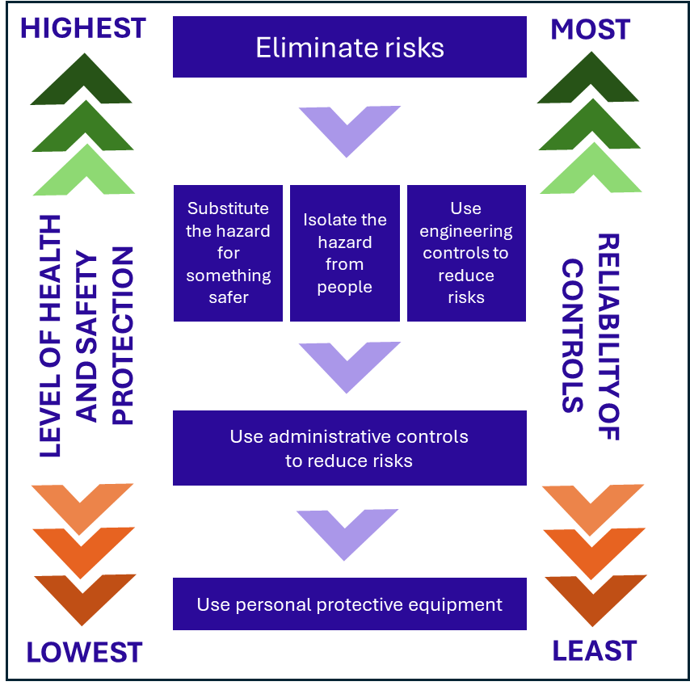
Figure 2: The hierarchy of control measures

Elimination
Elimination is the most effective control and must always be considered before all other control measures. If it is reasonably practicable, eliminate the CSS from the workplace. This will effectively remove the risk of workers being exposed to RCS when processing these products or materials.

In many cases, eliminating CSS may not be reasonably practicable. For example, if:
- a CSS is naturally occurring at your workplace
- you cannot make a required product without using a CSS, or
- you cannot deliver a required service without processing a CSS.
If it is not reasonably practicable to eliminate the risk, then risks must be minimised, so far as is reasonably practicable, using the hierarchy of controls.

Substitution
Substitution is where you replace a product or process with something that is less hazardous and therefore has a lower risk.
Substitution can be an effective way of reducing the risk of exposure to RCS. For example, you can:
- use products that have less crystalline silica in them
- use a CSS that does not need to be processed in any way
- use a hand saw to cut autoclaved aerated concrete products instead of a circular saw, or
- scoring and snapping tiles instead of cutting them with a power tool.
Effective substitution of CSS will depend on your workplace and the tasks your workers carry out. Substitution might not be practical where a CSS is naturally occurring or if it means you cannot make the required product or deliver a required service.

Isolation
Isolation involves physically separating the source of harm from people and is an effective way of protecting your workers from exposure to RCS. Isolation controls include:
- isolating high dust generation work processes within an enclosed room with restricted access
- providing physical barriers and exclusion zones between different workers and workstations to prevent dust or water mist from moving into other work areas or towards other workers
- distancing where processing of a CSS is carried out from other workers, and
- designating a room or area for other tasks such as changing or eating, away from the work area.
Due to the airborne nature of RCS, it is difficult to effectively isolate the processing of a CSS and your workers using distance. Removing the worker or others from exposure to RCS is the most effective form of isolation control.
This may involve placing barriers which prevent airflow between a hazard and your workers, ensuring that processing takes place within a fully contained system, using fully enclosed operator cabins fitted with a high efficiency air filtration system or positive pressure for enclosed cabins/rooms.
A fully enclosed operator cabin fitted with a high efficiency air filtration system is one that:
- is operated with the cab door and windows closed, and
- is maintained to ensure the cab, door, windows and rubber seals are free from damage which could allow ingress of dust, and
- maintains a positive internal cab pressure between 50 Pa and 200 Pa (as per ISO 10263-4:2009) when the machine is in use, and
- is fitted with a real-time monitor which displays the internal cabin pressure and alarms when the pressure drops below a pre-determined level, and
- uses high efficiency particulate air (HEPA) (H13 or H14) filtration on the cabin air intake, and
- incorporates a HEPA (H13 or H14) filter in the internal air-recirculation system (where possible).
For further guidance on enclosed operator cabins and air filtration systems, please refer to:
- AS/NZS ISO 23875 Mining — Air quality control systems for operator enclosures — Performance requirements and test methods
- ISO 10263 Operator enclosure environment (parts 1 – 5).
Where exclusion zones are set up, warning signs should be placed so that they are clearly visible before entering the area (Figure 3). The size of the exclusion zone should be determined by a competent person after assessing the risk to all unprotected people. The prevailing conditions should be taken into account, for example, the exclusion zone may need to be extended down-wind. Signs should warn that:
- there is a silica dust hazard present
- access to the area is restricted to authorised persons, and
- RPE (see Part 2.4.6.2) should be worn in the exclusion zone.
Where an exclusion zone interferes with other activities at the workplace, other workers should only work within the exclusion zone after being provided with RPE.

Figure 3: Examples of dust hazard signs
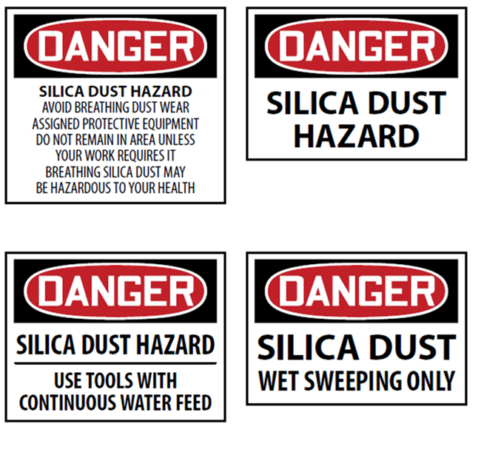
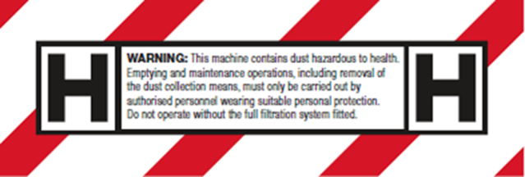

Engineering controls
Engineering controls use physical methods to change the characteristics of a task, including mechanical devices or processes that eliminate or minimise exposure of workers to RCS.
Engineering controls to control exposure to RCS can include:
- general ventilation
- local exhaust ventilation
- using wet processing methods
- drills, routers, saws and other equipment fitted with dust extractors and/or a water attachment to suppress dust, and cleaning up dust with an M- or H-class industrial vacuum cleaner (compliant with AS/NZS 60335.2.69:2017).
Note: Engineering controls alone are not sufficient to ensure the processing of CSS is controlled. You must ensure that all reasonably practicable controls measures are implemented to eliminate or minimise the risk of workers and others being exposed to RCS (see Part 2.3).
The selection of reasonably practicable engineering controls for your workplace will depend on the tasks your workers carry out. When considering and using engineering controls, be aware of other hazards that may be introduced. As many engineering controls are motorised, you must manage the risks to health and safety related to noise and vibration levels at your workplace. You must also manage electrical hazards that may arise combining electrical equipment with wet methods. See Part 1.1.1 for links to relevant model Codes of Practice and guidance to assist you in managing these risks.
General dust, including dust containing RCS is abrasive and can cause damage and wear to tools and equipment that are part of your engineering controls. It is important to have a maintenance and cleaning schedule in place to keep your equipment in good working order. You must regularly inspect your equipment for:
- wear and tear, corrosion or damaged parts
- air leaks in pneumatic tools
- kinks, holes or leaks in water suppression or dust extraction equipment, or
- damage to guards and flaps that contain water spray.
Maintenance and cleaning activities should be separately assessed to determine whether they involve processing of a CSS that is high risk, as they may pose a higher or lower risk than other processing of a CSS undertaken in the workplace.
Further information on the requirements for the use of engineering controls to minimise the risk of exposure to RCS is available in Appendix A.

Administrative controls
If risks remain after implementing higher order control measures, including those specified for controlled processing of a CSS (see Part 2.3), PCBUs must consider additional administrative controls to minimise risks.
Administrative controls must only be used after consideration of substitution and the implementation of isolation and engineering controls. They may be used to support other control measures (by implementing a preventative maintenance program) or used to provide additional protection (such as job rotation).
Administrative controls rely on worker behaviour to be effective, and it is very important to have the necessary administrative policies and worker training in place when crystalline silica is identified at your workplace. You also need to supervise your workers to make sure they understand and follow your administrative policies to help manage the risk of exposure.

Examples of administrative controls for RCS include:
- planning cutting tasks to make sure the minimum number of cuts are made
- written rules and policies for working with a CSS or cleaning CSS waste
- having a written clean-up procedure and log
- a maintenance schedule and log for equipment and personal protective equipment
- limiting the length of time a worker may be exposed to RCS
- restricted area policies so that only staff who are carrying out a task that generates RCS are allowed access to those areas, and
- signage at the workplace highlighting there is a silica dust hazard and any required use of RPE and other personal protective equipment (Figure 3).
Further information on the requirements for the use of administrative controls to minimise risk of exposure to RCS is available in Appendix B.

Personal protective equipment
- Sole reliance on personal protective equipment (PPE) as a control measure to protect workers from RCS is rarely appropriate because it does not prevent dust generation. It is the least effective form of controlling dust exposure and relies on correct fit and use by the worker, as well as adequate supervision.
However, it can be effective at minimising residual risk when used in conjunction with higher order controls, or if it is not reasonably practicable to implement higher order control measures. Figure 4 provides examples of PPE.
Figure 4 Examples of personal protective equipment
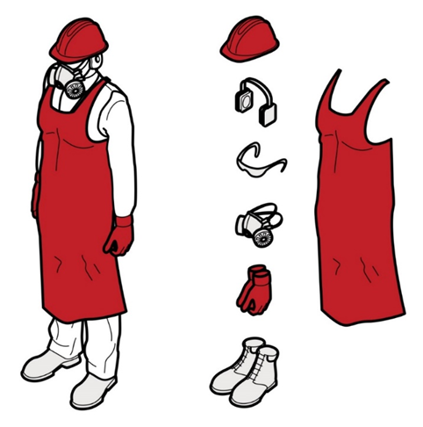
Note: Regulations 44, 45 and 46 relating to the duties of PCBUs, workers and persons other than a worker in relation to PPE also apply.
Before processing a CSS at the workplace, you must assess the conditions likely to affect the health and safety of workers and arrange for the provision and use of appropriate PPE, including any appropriate RPE.
You must make sure PPE is suitable, clean, hygienic and in good working order. This is to ensure it will not introduce other hazards to the worker and it will work as intended. Information about maintaining and cleaning PPE should be sourced from the manufacturer or supplier.
If you are directing the carrying out of the work, you must provide suitable PPE at no cost to the worker, unless the PPE has already been provided by another PCBU (e.g. a labour hire company). You must ensure workers are trained to use the PPE correctly. You must also provide ongoing training, information and instructions for your workers on how to use, wear, store, and maintain the PPE provided.
Workers must also take reasonable care for their own health and safety. They are required to follow reasonable instructions and cooperate with any workplace policies you have in place to protect them. Workers must use PPE as instructed by you. However, you must also supervise your workers to check they understand their training and are using PPE correctly.

2.4.6.1. Choosing the right personal protective equipment
There are requirements under the WHS laws for choosing and using PPE. You must make sure the PPE you provide is appropriate and fits the worker who will be wearing it. This will ensure the PPE is doing its job. Wrong or ill-fitting PPE means RCS can harm your workers because dust, including RCS, may be able to get into worker’s eyes or their breathing zone and into their lungs.
You should refer to your WHS regulator for further information about the correct use of PPE, including RPE.

2.4.6.2. Respiratory protective equipment
RPE is a type of PPE that is designed to protect the wearer from inhaling airborne contaminants, including RCS.
Where a worker is still at risk of exposure to RCS after the implementation of higher order control measures (including those higher order controls specified in Part 2.3 for controlled processing of a CSS), you must provide the worker with RPE. You must also ensure, so far as is reasonably practicable, that your workers wear the RPE they have been issued while the work is carried out.
There may be some cases where implementing higher order control measures is not reasonably practicable. Provided you are fulfilling your primary duty to minimise risks so far as is reasonably practicable, the use of RPE only, in the absence of higher order control measures, may be appropriate.
When determining suitability, the protection factor assigned to the RPE must be sufficient to provide protection. The RPE filter must also be suitable for RCS (i.e. a particulate filter is required).

RPE used to control the processing of a CSS must comply with the following Australian standards:
- AS/NZS 1716:2012 (Respiratory protective devices), and
- AS/NZS 1715:2009 (Selection, use and maintenance of respiratory protective equipment).
Further information on the requirements for selection and use of RPE to minimise the risk of exposure to RCS is available in Appendix C.

Determining if the processing of a crystalline silica substance is high risk
Under the WHS Regulations, if you have identified that processing of a CSS is carried out at your workplace, you must determine whether the processing is high risk or not. This assessment occurs after you have identified the process and determined all reasonably practicable control measures that will be implemented, but before work commences.
Note: High risk processing of a CSS means the processing is reasonably likely to result in a risk to the health of a person at the workplace.
If you are unable to determine if the processing is high risk, you must assume it is high risk, until such time as you are able to determine that the processing is not high risk through a subsequent assessment.
Note: You must document your assessment for each task (regarding the factors described below) and attach it to your Silica Risk Control Plan (see Part 3.1) even if you assume the processing is high risk.
There are additional requirements for PCBUs who are carrying out processing of a CSS that is high risk (see Part 3).
Note: You must still manage the risk of exposure to RCS even if you assess the processing as not high risk. See Part 2.3 and Part 2.4.

When determining whether the processing of a CSS is high risk, and therefore reasonably likely to result in a risk to the health of a person at the workplace, a PCBU must have regard to the following:
- the specific processing that will be undertaken
- the form(s) of crystalline silica present in the CSS (see Part 2.1)
- the proportion of crystalline silica contained in the CSS, determined as a weight/weight (w/w) concentration (see Part 2.5.2)
- the hazards associated with the work, including the likely frequency and duration that a person will be exposed to RCS
- whether the airborne concentration of RCS that is present at the workplace is reasonably likely to exceed half the workplace exposure standard (WES)
- any relevant air and health monitoring previously undertaken at the workplace, and
- any previous incidents, illnesses or diseases associated with exposure to RCS at the workplace.
An optional template and case studies are available in the supplementary toolkit to assist you in assessing whether processing of a CSS is high risk. However, this template is not mandatory, and you can use other forms to document the assessment, provided it demonstrates consideration of the matters a) to g) listed above.
Note: There is no one factor that can determine the outcome of your assessment. When assessing whether the processing of a CSS is high risk you must consider all the above factors. This is because there are instances where two identical CSS processes may produce different assessment outcomes. For example, processing of a CSS may be determined to be high risk if it is performed for longer durations on a frequent basis. Whereas, the same processing, using the same CSS, may be determined not high risk if it is performed for short durations and infrequently.
If you have more than one task involving processing of a CSS at your workplace occurring simultaneously, this may increase the likelihood that there will be a risk to the health of persons at the workplace. In this instance, the assessment may cover all CSS processing tasks, and you should consider in your assessment whether multiple CSS processing tasks will increase the risk to the health of persons at the workplace.

Considering control measures when determining if processing of a crystalline silica substance is high risk
When assessing whether the processing of a CSS is high risk, you:
- May take into account, but not solely rely on, any isolation or engineering controls implemented in accordance with the requirements for controlled processing of a CSS (Part 2.3).
- Must not take into consideration the effect of any PPE (including RPE, see Part 2.4.6) and administrative controls (see Part 2.4.5) used to control the risk of exposure to RCS. These control measures are excluded from the assessment because they do not control the RCS hazard at the source. These controls rely on human behaviour and are the least effective and reliable in minimising the risks of exposure to RCS.

When taking into account substitution, isolation or engineering controls, you should consider the relative effectiveness of implementing any of these types of controls and weigh this against how often and for how long the processing of a CSS is expected to be carried out at the workplace. Even with appropriate controls in place, your processing of a CSS may still be high risk if:
- it is carried out for long durations, multiple times a day or week
- multiple tasks involving processing of a CSS are being undertaken concurrently in the same work area, or
- the proportion of crystalline silica content of the CSS is high and processing results in the generation of significant amounts of RCS.
When considering the risk of exposure to RCS in the workplace, you should think about primary and secondary exposure:
- Primary exposure to RCS may occur to workers who are carrying out the task that is generating dust containing RCS or making it airborne.
- Secondary exposure to RCS may occur to workers doing other tasks in or near work areas where these processes are being undertaken or have recently been undertaken. This may include site supervisors, maintenance personnel, cleaners, housekeeping after processing of a CSS has been undertaken, general labouring, and associated trades.
Note: Regardless of whether you determine the processing of a CSS to be high risk or not, you must still ensure that the processing is controlled (see Part 2.3).
To assist you in assessing if the processing of a CSS is high risk, see further detail in Part 2.5.1 – 2.5.8 below.

Details of the crystalline silica substance
In your assessment to determine if the processing of a CSS is high risk, you should document the relevant details of the CSS, including the:
- source
- if applicable, document the product name and supplier, otherwise
- document the type of CSS (e.g. sandstone) and context (e.g. quarrying)
- form(s) of crystalline silica present, and
- silica content.
If you are processing a manufactured product (such as tiles, bricks, pavers or concrete) you may be able to determine how much and what forms of crystalline silica are in the CSS by referring to the label, safety data sheet or product information from the manufacturer or supplier. If these are not available or do not contain the information required, you should contact the manufacturer, importer or supplier to find out whether the product contains crystalline silica and, if so, what forms and levels of crystalline silica it contains.
If the processing involves a naturally occurring material (for example in mining, quarrying or tunnelling operations, and most civil construction sites), the best way to determine how much and what forms of crystalline silica are present is to undertake scientific testing of the material using a National Association of Testing Authorities (NATA) accredited (or equivalent) laboratory.
Relying on previously reported data or analysis (instead of undertaking testing) can give you an idea about whether a naturally occurring material is a CSS and the approximate amount of crystalline silica it may contain. However, it should be used with caution due to the variability of crystalline silica in natural substances.
If you have not performed scientific testing or are otherwise unable to determine the amount and form of crystalline silica in the CSS being processed, you will need to take this into account when assessing the risk (see Part 2.5) and assume the CSS contains a high amount of crystalline silica.
Note: PCBUs that design, manufacture, import or supply a CSS must, so far as reasonably practicable, give current information to downstream users of the CSS about the product. Generally, this would include giving information in relation to the intended use, any hazardous properties and any conditions for safe use of a CSS (see Appendix D for more information on upstream duties).

Frequency and duration of processing of a crystalline silica substance
In undertaking the assessment of any processing of a CSS carried out at your workplace, you must also consider the frequency and duration of the processing when determining if any processing of a CSS is high risk.
The more often processing of a CSS is carried out, the higher the risk of exposure to RCS is for workers and others at the workplace. The same applies to increasing the duration of the processing of a CSS carried out at the workplace.

Previous air monitoring results
In undertaking the assessment to determine whether the processing of a CSS is high risk, you must have regard to the results of any relevant air monitoring previously undertaken at the workplace. That is, you should ensure the data is relevant to the task, controls and conditions in your workplace. If it is not, then the data may not give an accurate indication of your workers’ likely exposure to RCS.
Examples of when previous air monitoring results may not be relevant include:
- the CSS has changed (new formulation of the substance)
- the processing of a CSS has changed
- the workplace has changed (e.g. a new location that is enclosed or has different dimensions)
- additional processing of one or more CSS is now undertaken in close proximity, or
- additional controls have been implemented.
In considering previous air monitoring results, you should determine if they indicate a risk to the health of workers because of the processing of a CSS at your workplace.
If you do not have any previous air monitoring results, this does not prevent you from determining whether the processing of a CSS is high risk, rather you must undertake your assessment considering all the other matters set out in Part 2.5.

Airborne concentration of respirable crystalline silica
In determining whether the processing of a CSS is high risk, you must have regard to the airborne concentration of RCS that is present at the workplace and whether it is reasonably likely to exceed half the WES for RCS.
Note: Reasonably likely in this context means the airborne concentration of RCS is more likely than not to exceed half the WES, when considered objectively and taking into account all relevant factors.
In determining whether your processing of CSS is high risk, you must not take into account any protection provided by administrative controls or RPE. Administrative controls and RPE can, however, be considered when determining whether a person is exposed to a level of RCS above the WES (regulation 50; Part 3.3.1).
Previous air monitoring results can be used to assess whether processing of CSS carried out at your workplace is likely to result in an airborne concentration of RCS that exceeds half the WES.
Note: Personal exposure data is generated by conducting air monitoring in the breathing zone of the worker. This is the most reliable form of data that can be used when conducting an assessment and it can be used to work out how effective control measures are. See Part 3.3.1 for further information on how air monitoring is conducted.

2.5.5.1. Where previous air monitoring is available
If you have previous monitoring for the specific processing of a CSS being assessed, that indicates the airborne concentration of RCS was above half the WES, then the processing of a CSS is more likely to be high risk.
However, air monitoring data that shows the airborne concentration of RCS exceeds half the WES may not automatically result in a determination that the processing of a CSS is high risk. Other factors must be considered (see Part 2.5) and may influence the assessment, such as the frequency and duration of the processing of a CSS.
For example, processing of a CSS that generates RCS at concentrations above half the WES and is performed once per year is not likely to be high risk.
In contrast, processing of a CSS that generates RCS at concentrations above half the WES, but below the WES, and is performed every working day of the year is likely to be high risk.

2.5.5.2. Where previous air monitoring is unavailable
If previous air monitoring results are not available, exposure data obtained from other sources can be used to assess the likely airborne concentration of RCS. This may include exposure data obtained from:
- the manufacturer of the control or tool used
- an industry association, or
- an occupational hygienist.

2.5.5.3. The relevance of previous air monitoring from other workplaces
If you are using exposure data from air monitoring that was not conducted in your workplace, you should ensure the data is relevant to the task, controls and conditions in your workplace. If it is not, then the data may not give an accurate indication of the airborne concentration of RCS.

2.5.5.4. Circumstances where previous air monitoring may not be required
While you must consider whether it is reasonably likely that the airborne concentration of RCS exceeds half the WES, there may be circumstances where exposure data is not required to reach an outcome. For example, where all other factors have been considered and provide sufficient information to determine whether the processing of a CSS is high risk or not.

Previous health monitoring results
When conducting your assessment to determine if the processing of a CSS is high risk, you must have regard to the results of any relevant health monitoring that has been previously conducted at the workplace. That is, you should ensure any health monitoring results are relevant to the task, controls and conditions in your workplace. If previous health monitoring relates to different tasks or controls, it should not be included for consideration.
Note: As silicosis and other silica-related diseases are long-latency diseases, an absence of illness or disease does not mean an absence of a risk.

Examples of when previous health monitoring results may not be relevant include:
- the CSS has changed
- the processing of a CSS has changed
- the workplace has changed (e.g. a new location that is enclosed or has different dimensions)
- additional tasks involving processing of a CSS are now undertaken in close proximity, or
- additional controls have been implemented.
Adverse health monitoring findings for workers who undertake specific processing of a CSS at your workplace may indicate a risk to health and should be considered when making an overall determination of whether the processing of a CSS is high risk.
Actual health monitoring records should not be included in the assessment. Please also refer to the confidentiality requirements related to health monitoring records provided in regulation 378 of the WHS Regulations.

Previous incidents, illnesses or diseases associated with exposure to respirable crystalline silica
In addition to considering the outcomes of health monitoring, you must also consider any reports of previous incidents, illnesses or diseases associated with RCS exposure at the workplace.
If you do not have any previous health monitoring results, it does not prevent you from determining whether the processing of a CSS is high risk or not, rather you must undertake your assessment considering all the other matters in Part 2.5.
As part of your assessment, you should consider whether there is a likelihood of these incidents, illnesses or diseases occurring in relation to the processing of a CSS being undertaken at your workplace.

Outcome of assessment
At the end of your assessment, you must record in writing:
- how the relevant factors in Part 2.5 have been taken into account, and
- whether or not the processing of a CSS is high risk.
In determining the outcome of the assessment, you must have regard to all of the required matters in Part 2.5. If you determine that processing of a CSS is not high risk, you must be able to explain why.
If after completing the assessment, you are unable to determine if your processing of a CSS is high risk, then you must assume that it is high risk. All requirements for processing of a CSS that is high risk apply, until you can determine the processing is not high risk (e.g. by implementing additional engineering controls, undertaking further testing or additional air monitoring and performing a new assessment).
You may seek professional advice to assist you in undertaking the assessment and determining whether the processing of a CSS is high risk or not. Advice should be sought from a person who has acquired the knowledge and skills to carry out the task, from training, qualification or experience, for example, an occupational hygienist or health and safety professional.

Your assessment will result in one of the three outcomes:
Outcome | Next steps
Unable to determine if the processing of CSS is high risk | You must assume that it is high risk, until you can determine the processing is not high risk (for example after implementing additional engineering controls and performing a new assessment).  All requirements for processing of a CSS that is high risk apply, and you must:  - ensure that processing is controlled as outlined in Part 2.3  - meet the additional requirements for processing of a CSS that is high risk outlined in Part 3, and  - meet all other duties and requirements under the WHS laws, including the general duties outlined in Part 1.
Processing of CSS determined as high risk | You must:  - ensure that processing is controlled as outlined in Part 2.3  - meet the additional requirements for processing of a CSS that is high risk outlined in Part 3, and  - meet all other duties and requirements under the WHS laws, including the general duties outlined in Part 1.
Processing of CSS determined as not high risk | You must:  - ensure all processing is controlled as outlined in Part 2.3, and  - meet all other duties and requirements under the WHS laws, including the general duties outlined in Part 1.

Additional requirements when processing crystalline silica substance that is high risk

Silica risk control plan
Under the WHS Regulations, a silica risk control plan is required for all processing of CSS that is high risk, before processing commences.
A silica risk control plan is a practical tool to document the specific tasks and control measures related to each processing of a CSS that is high risk carried out by the PCBU. It will be informed by the assessment of the processing of a CSS (see Part 2.5), that determined the processing is high risk.
You must make the silica risk control plan available to all workers generally and provide it to them before they commence the processing of a CSS. Once a silica risk control plan is in place, you must ensure any processing of CSS that is high risk is carried out in accordance with the plan.
You must ensure that the silica risk control plan is reviewed and revised to maintain, so far as reasonably practicable, a safe work environment. This includes reviewing and revising the control measures specified in the plan to minimise exposure to RCS whenever:
- they may no longer be effective
- they are impacted by a change at the workplace, or
- where a new hazard or risk is identified
Further information about reviewing control measures is included in Part 4.
The silica risk control plan must be developed in consultation with workers involved in carrying out processing of a CSS that is high risk and, if any, their HSR. It must also be set out and expressed in a way that is readily accessible and understandable by the persons who use it.
An optional silica risk control plan template is available along with instructions to help you complete it in the supplementary toolkit.
Note: If processing of a CSS that is high risk is part of construction work, you may use a Safe Work Method Statement (SWMS) in place of a silica risk control plan provided the SWMS covers all the required silica risk control plan content (see Part 3.1.2).

Completing a Silica risk control plan
The information in this Part is intended to assist you to complete the silica risk control plan template. If you are not using the template, you should ensure you document all the required information and that you do so in a way that is readily accessible and understandable to persons who use it.

3.1.1.1. Persons conducting a business or undertaking and process information
This section of the silica risk control plan template allows you to record essential details about your business, the number and type of tasks involving processing of a CSS that is high risk carried out at your workplace and the number of workers likely to carry out these processing tasks. This section also allows you to describe how you have met your duty to consult with workers and their HSRs (if any).
You need to include in the silica risk control plan a copy of the assessment for each task (or group of tasks) involving processing of a CSS that is high risk covered by the plan.

3.1.1.2. Control measures
A silica risk control plan must document which control measures you have chosen to implement to minimise the risks of RCS, including any administrative controls and personal protective equipment. To identify which controls will be the most appropriate, a PCBU must work through the hierarchy of controls and ensure that the processing is controlled (see Part 2.3 and Part 2.4).
You must outline the control measures chosen for each task involving processing of a CSS that is high risk. This includes details about how these control measures will be implemented and integrated into daily activities in the workplace, for example, toolbox talks, pre-start checks and daily cleaning of work areas.
You must also document how you will monitor and review the effectiveness of the control measures to be implemented (see Part 4), to ensure they are working effectively. This includes ensuring control measures are fit for purpose, suitable for the work, and installed, set up, and used correctly. You should also include the details of any reviews of control measures.

3.1.1.3. Training
As outlined in Part 3.2, you must provide crystalline silica training to any worker involved in processing of a CSS that is high risk or who is at risk of exposure to RCS because of the processing that is high risk. You are also required to keep a record of the training provided to workers. While not a mandatory requirement of a silica risk control plan, you may document in the plan where and how training records for crystalline silica are going to be kept.

Use of Safe Work Method Statement as a Silica risk control plan
‘Construction work’ is defined in the WHS Regulations as any work carried out in connection with the construction, alteration, conversion, fitting-out, commissioning, renovation, repair, maintenance, refurbishment, demolition, decommissioning or dismantling of a structure.
Regulation 291 of the WHS Regulations sets out a list of construction work that is high risk, and for which a Safe Work Method Statement (SWMS) is required. This includes work ‘carried out in an area that may have a contaminated or flammable atmosphere’.
Processing of a CSS may be considered high risk construction work if RCS may contaminate the work atmosphere. If a SWMS has been prepared for high risk construction work that involves processing of a CSS that is high risk, a silica risk control plan is not needed, provided the SWMS includes all the information required for a silica risk control plan.
Note: There may be situations where there are different types of high risk construction work occurring at the same time at a workplace and the PCBU may have elected to create separate SWMS for each type of high risk construction work. If separate SWMS are prepared, a silica risk control plan is still not needed, provided the collection of SWMS includes all the information required for a silica risk control plan.
More information about a SWMS for high risk construction work can be found in the model Code of Practice: Construction work and the Interactive SWMS guidance tool.

Training
In addition to the information, instruction, training or supervision you provide to your workers under your general duties (see Part 1.1.4), you must also provide crystalline silica training to any worker you reasonably believe may be involved in processing of a CSS that is high risk or be at risk of exposure to RCS because of processing of a CSS that is high risk at your workplace.
Crystalline silica training must be nationally accredited training, or another form of training approved by the WHS regulator, and must cover:
- the health risks associated with exposure to RCS, and
- the need for, and proper use of, any risk control measures required by WHS laws.
- You should contact the relevant WHS Regulator for further information about what crystalline silica training is required or acceptable in your jurisdiction.
You must keep a record of crystalline silica training undertaken by workers while the worker is carrying out the processing of a CSS that is high risk, and for 5 years after the day the worker ceases working for your business. This training record can be documented in the silica risk control plan.

Monitoring
For each processing of a CSS that is high risk at the workplace, a PCBU must:
- undertake air monitoring for RCS in accordance with regulation 50, and
- provide health monitoring for all workers carrying out the processing of a CSS that is high risk in accordance with Division 6 of Part 7.1 of the WHS Regulations.
In addition, you must provide air monitoring results to the regulator if the airborne concentration of RCS has exceeded the WES for RCS. You must report the result to the WHS regulator as soon as reasonably practicable and no more than 14 days from the date the result was reported to you.

Air Monitoring
As described in Part 1.2, under regulation 50 you must undertake air monitoring for RCS if:
- you are uncertain on reasonable grounds whether or not the airborne concentration of RCS at the workplace exceeds the WES for RCS, or
- monitoring is necessary to determine whether there is a risk to health from RCS at the workplace.
Note: While air monitoring may be undertaken as part of determining whether the processing of a CSS is high risk (see Part 2.5.4), additional air monitoring may be required to meet the obligations of regulation 50 (e.g. previous air monitoring results may no longer be relevant due to changes to control measures or work practices).

3.3.1.1. Reporting airborne concentration of respirable crystalline silica above the workplace exposure standard
If, as a PCBU, you have undertaken air monitoring for processing of a CSS that is high risk, and the results show the airborne concentration of RCS has exceeded the WES, you must report the results to the WHS regulator as soon as reasonably practicable, and no more than 14 days from the date that the air monitoring result was provided to you. The results must be reported even if workers are wearing appropriate and correctly fitted RPE, which provides protection from exposure to RCS.
The air monitoring results must be reported to the WHS regulator in a form approved by the WHS regulator. Please refer to your WHS regulator to identify the approved form in your jurisdiction and find out how to submit the form to the regulator.

3.3.1.2. Who can undertake air monitoring?
Conducting an effective air monitoring program requires training, specialist knowledge and a high level of competency and experience. Interpretation of the results of air monitoring and decisions about whether a workplace has an airborne concentration of contaminant above the exposure standards can be complex.
You should engage the services of an expert in air monitoring, for example an occupational hygienist, to design, undertake (or oversee) and interpret the results of a suitable air monitoring program, and to determine compliance with exposure standards. If a consultant is engaged to assess compliance with an exposure standard or the effectiveness of hazard controls, it is recommended that you ask to see evidence of their qualifications, experience and competence.

3.3.1.3. How is air monitoring conducted?
A good air monitoring program should be undertaken over time, and may require multiple days of sampling, to increase the likelihood that samples are representative of actual workplace exposures and take into account variability between workers and workplace conditions. Sampling should ideally be taken over the duration of the shift and not less than 4 hours or half of the shift duration. To get the most effective information, air monitoring should be arranged on days when normal CSS processing tasks are taking place.
Results from an air monitoring program should include statistical analysis of the data to provide a reliable estimate of the true range of RCS exposures. The length of an air monitoring program will depend on factors such as the variety of work processes that need examining, the extent of monitoring required, the nature of the processes and the type of laboratory analyses required.

3.3.1.4. What will a consultant do?
The consultant will use their expertise and judgement to work out an air monitoring strategy and advise how many workers, and in what areas, will be monitored and over what time period.
Exposure measurements should be made from unbiased and representative samples of actual worker exposure. The monitoring program should also address issues like the nature and duration of a process, sampling and analysis errors, statistical analysis for exposure data and the determination of the need for regular exposure measurement.

3.3.1.5. Determining compliance
Expert judgement and advice may be required to determine if compliance with the regulations for exposure standards is being achieved. Where air monitoring is required, it is often necessary to conduct several exposure measurements, often involving multiple workers. Compliance can be demonstrated only when the exposure of individual workers or groups of workers is known, with an accepted degree of certainty, to be below the exposure standard.
Where it has been determined that RPE must be worn to minimise the risk of exposure to airborne contaminants, the protection provided by the RPE can be taken into account when determining compliance with an exposure standard, provided all other reasonably practicable higher order controls in the hierarchy of control measures have been implemented, and the RPE is worn correctly.

3.3.1.6. Statistically valid exposure data – air monitoring
This section outlines how air monitoring should be conducted, with reference to sampling methods. Following these guidelines will ensure the exposure data is statistically valid.
Where monitoring of airborne contaminants is used to determine whether a worker’s exposure is below the exposure standard, the monitoring must be conducted in the breathing zone of the person, also known as ‘personal monitoring’. If RPE must be worn, air monitoring samples should be taken outside the RPE.
Since it is rarely practical to measure all individuals within an exposed workforce, occupational hygiene monitoring programs should carry out representative sampling of a Similar Exposure Group. The Similar Exposure Groups Baseline Strategy developed and implemented by the American Industrial Hygiene Association (AIHA) is regularly used in Australia. In this strategy a minimum of 6 to 10 samples are drawn from a Similar Exposure Group to obtain statistical significance.
An alternative and more recent approach to establish the initial risk is set out in CEN-EN 689:2018 Workplace exposure - Measurement of exposure by inhalation to chemical agents - Strategy for testing compliance with occupational exposure limit values. CEN-EN 689:2018 describes a two-step method that requires fewer sample numbers in the initial phase of sampling than recommended by the AIHA strategy, while still obtaining statistical significance.
The AIOH Occupational Hygiene and Monitoring & Compliance Strategies outline other valid methods for establishing Similar Exposure Groups and a personal exposure sampling plan that is representative of worker numbers, shifts worked, tasks performed and conditions at the workplace.
All personal sampling should be undertaken in accordance with AS2985:2009 Workplace atmospheres - Method for sampling and gravimetric determination of respirable dust, with samples analysed by a NATA-accredited (or equivalent) laboratory using validated analysis methods, such as ISO16258-1 (Direct-on-filter by XRD) or ISO19087 (Indirect method by FTIR).

3.3.1.7. Air monitoring records
The WHS Regulations require you to keep the results of air monitoring for 30 years. You must also make sure that the records are readily accessible to people at your workplace who may be exposed to RCS. Any previous air monitoring results in relation to processing of a CSS that is high risk must also be taken into consideration as part of your assessment to determine if the processing of a CSS is high risk, if the air monitoring was relevant and was conducted prior to undertaking the assessment.
An air monitoring report should include:
- the background and purpose of the air monitoring including the WES
- the task to be measured including work patterns and hazards involved with this task
- the control measures in place and their performance
- what sampling and measurements were taken (long and short-term) including information on the calibration of the sampling equipment
- specifics of how sampling was taken
- how and where the samples were analysed, including information on the calibration of the analysis equipment

- an interpretation of the results:
- exposure sources
- adequacy of current control measures
- assessment of risk including identification of tasks not measured that are likely to be an exposure source and any workers who could be exposed but were not measured, and
- compliance with WHS laws
- recommendations, for example:
- dust control action plan
- changing control measures and work practices
- worker training
- further air monitoring, and
- health monitoring.
Further information on air monitoring and complying with exposure standards is in the Workplace exposure standards for airborne contaminants and the guidance material Interpretation of Workplace exposure standards for airborne contaminants.

Health Monitoring
Division 6 of Part 7.1 of the WHS Regulations requires a PCBU to provide health monitoring to any worker carrying out ongoing work at a workplace using, handling, generating or storing hazardous chemicals if there is a significant risk to the worker's health because of exposure to a hazardous chemical.
This means that where there is significant risk to a worker's health arising from ongoing work involving exposure to RCS, including when undertaking processing of a CSS that is high risk, the worker must be provided with health monitoring.
Depending on the circumstances, health monitoring may not only be required for workers who regularly undertake processing of a CSS that is high risk but also for workers who may regularly be in the vicinity of RCS or in contact with RCS in other ways such as through cleaning work areas or equipment.
You should consider a health monitoring program for all workers undertaking ongoing tasks involving processing of a CSS at your workplace, especially if
- workers are undertaking these tasks frequently or for longer durations
- workers regularly need to use administrative controls or RPE to control risks, or
- statistically valid exposure data indicates the airborne concentration of RCS is greater than 50% of the WES.
If you are not sure whether health monitoring is required for your workers, you can seek specialist advice from an occupational hygienist, an occupational and environmental medicine physician, or a WHS regulator.
The below sections outline the requirements for health monitoring for workers who regularly undertake processing of a CSS that is high risk, and further information is available in the Health monitoring guide for PCBUs and Health monitoring guide for crystalline silica.

3.3.2.1. Conducting health monitoring

When to conduct health monitoring
Health monitoring should begin at the time a worker is first employed or before they first start work involving processing of a CSS that is high risk and there is a significant risk to their health because of exposure to RCS. This is so any changes to the worker’s health can be detected as early as possible. If your workers have been carrying out processing of a CSS that is high risk, and there is a significant risk to their health because of exposure to RCS, and you have not provided health monitoring, you must organise it as soon as possible.

Who should conduct health monitoring
Health monitoring must be carried out or supervised by a medical practitioner with experience in health monitoring. Health monitoring for RCS includes workers being screened with specialised equipment. Depending on the worker’s past exposures and medical history, some doctors may recommend carrying out further tests with a specialist to detect early-stage silicosis.

What to expect from health monitoring
Under WHS laws, the minimum requirements for health monitoring for crystalline silica through exposure to RCS are:
- collection of demographic, medical and occupational history
- records of personal exposure
- standardised respiratory questionnaire
- standardised respiratory function tests, for example, FEV1 (forced expiratory volume in one second), FVC (forced vital capacity) and FEV1/FVC, and
- chest X-ray full posterior-anterior (PA) view.
- All full-size PA chest X-rays should be taken in a specialist radiology practice or hospital department. The X-rays should be read by a radiologist who meets the reporting requirements and competencies of the Royal Australian and New Zealand College of Radiologists or is qualified as a ‘B reader’. A B reader is a radiologist who has undertaken specialised training to detect dust lung diseases such as silicosis, coal workers pneumoconiosis, mixed dust pneumoconiosis and progressive massive fibrosis (PMF).
- High-resolution computed tomography (HRCT) is more sensitive and effective than X-rays in the early detection of silicosis. A low dose HRCT scan of the chest (non-contrast) may be used by the registered medical practitioner supervising or carrying out the health monitoring, depending on the worker’s history and levels of silica exposure. Low dose HRCT may be used instead of, or as an adjunct to, X-ray. Alternative imaging methods are being developed and may also be considered.
Note: In Western Australia low dose HRCT must be undertaken for health monitoring required for RCS rather than chest X-ray.

3.3.2.2. Health monitoring records
The medical practitioner doing your workers’ health monitoring will provide you with a health monitoring report relating to each worker. Health monitoring reports must be kept by the PCBU for at least 30 years and the worker must receive a copy of the report.
You must provide the health monitoring report to your WHS regulator if the medical practitioner doing your monitoring:
- informs you that a worker may have contracted a disease, injury, or illness as a result of carrying out work using, handling, generating, or storing silica, or
- recommends that you take remedial measures (such as stopping a worker from continuing to perform particular work or implementing additional exposure controls).
- A PCBU must consider the results of any relevant health monitoring that has been previously conducted in the workplace (see Part 2.5.6) when assessing if the processing of a CSS is high risk.
In some jurisdictions, the doctor may notify a worker’s silicosis diagnosis to the Department of Health, Disability and Ageing. The National Occupational Respiratory Disease Registry (NORDR) stores data on occupational respiratory diseases in Australia. For all states and territories, it is mandatory for occupational and environmental medicine physicians and respiratory and sleep medicine physicians to report cases of silicosis to NORDR. Further information is available on the Department of Health, Disability and Ageing website.

Maintaining and reviewing control measures
Managing WHS risks is an ongoing process that needs attention over time and particularly when any changes affect the activities carried out at your workplace.
Control measures in place to manage risk of exposure to RCS should be reviewed regularly to ensure they are working effectively. Control measures for tasks involving processing of a CSS that is high risk should be reviewed more frequently. Do not wait until something goes wrong.
A review of your control measures is required:
- when the control measure is not effective in controlling the risk. For example, if:
- it is obvious due to general dust levels in the workplace
- it is identified that workers are not complying with administrative or personal protective equipment requirements
- air monitoring shows RCS is at or above half of the WES,
- a worker’s health monitoring report shows an injury, illness or disease, or
- the doctor supervising a worker’s health monitoring requests a review of your control measures,
- before something significant changes at the workplace. For example, if
- the safety data sheet for the CSS (where applicable),
- the workplace itself
- any aspect of the work environment, or
- any system of work, process or procedure,
- if a new hazard or risk is identified
- if raised by your workers or HSR during consultation
- if an HSR requests a review, and
- at least once every five years.
To review control measures, use the same process as when identifying a hazard. Consult with workers and any HSRs and consider the following questions:
- Are the control measures working effectively in both their design and operation?
- Have the control measures introduced new hazards?
- Have all hazards been identified?
- Have new work methods, new equipment or chemicals made the job safer?
- Are safety procedures being followed?
- Has the instruction and training provided to workers on how to work safely been successful?
- Are workers actively involved in identifying hazards and possible control measures? Are they openly raising health and safety concerns and reporting problems promptly?
- Are the frequency and severity of health and safety incidents reducing over time?
- If new information becomes available, does it show that current controls may no longer be the most effective?
- If existing control measures are not sufficient to eliminate or minimise the risk of exposure to RCS, you should review your risk assessment and determine if additional control measures are needed.

How does this Code apply to engineered stone?

Scope of the prohibition
For the purposes of the WHS Regulations, engineered stone is defined as an artificial product that:
- contains at least 1% crystalline silica as a weight/weight concentration, and
- is created by combining natural stone materials with other chemical constituents (such as water, resins, or pigments), and
- becomes hardened.
Note: Only products that satisfy all three of the above conditions fall under the definition of engineered stone.
Engineered stone does not include:
- concrete and cement products
- bricks, pavers, and other similar blocks
- ceramic wall and floor tiles
- grout, mortar, and render
- plasterboard
- porcelain products that do not contain resin
- sintered stone that does not contain resin, and
- roof tiles.
Note: A prohibition on the manufacture, supply, processing and installation of engineered stone benchtops, panels and slabs came into effect on 1 July 2024.
Engineered stone benchtops, panels and slabs which were installed prior to 1 July 2024, and uninstalled stock, are referred to as legacy engineered stone.
The engineered stone prohibition only applies to engineered stone benchtops, panels and slabs. Engineered stone products not in these forms are not prohibited, including finished products such as jewellery, garden ornaments, sculptures and kitchen sinks, which require no further processing to be used or installed.
The prohibition also does not apply to the manufacture, supply, installation or processing of:
- sintered stone or porcelain benchtops, panels or slabs, provided they do not contain resin, and
- natural stone (e.g. granite) benchtops, panels or slabs.
However, the duties outlined in Parts 1-3 of this Code still apply as these finished products, benchtops, slabs and panels are CSS.
Note: If your product does not meet the definition of engineered stone, or falls under one of the exclusions outlined above, then it is not prohibited.
However, if it is a CSS and you intend to process it, you must comply with all of the duties that apply to work involving the processing of a CSS, including the additional duties outlined in Part 2 and Part 3).

What work with engineered stone is permitted?
There are limited exceptions to the prohibition for which work with engineered stone benchtops, panels or slabs is permitted. These are:
- for research and analysis
- to sample and identify engineered stone
- for removal, repair and minor modification of legacy engineered stone, and
- disposal of engineered stone.
- See Part 5.1 for definitions of engineered stone and legacy engineered stone.
Any processing of engineered stone must be undertaken in accordance with Part 2 and Part 3 of this Code.

Permitted work for repair, removal, minor modification and disposal of legacy engineered stone
Engineered stone benchtops, panels and slabs are currently installed in many homes and other settings throughout Australia. There may also be stock of uninstalled engineered stone held by PCBUs (e.g. suppliers and distributors) after the commencement of the prohibition. These installed products and uninstalled stock are referred to as legacy engineered stone.
The WHS Regulations permit the controlled processing of legacy engineered stone benchtops, panels or slabs for the limited purposes of:
- removal, repair and minor modification to previously installed engineered stone, or
- disposal of engineered stone (i.e. after removal or disposal of uninstalled stock).
Note: Uninstalled stock may only be processed for the purposes of disposal. It is not permitted to process uninstalled stock for the purposes of, for example, repairing or making minor modifications to an installed benchtop. Additionally, once any legacy engineered stone is removed (uninstalled), it can only be further processed for the purpose of disposal and not for other purposes.
Exemptions to permit reinstallation in specific circumstances have been granted in most jurisdictions.
For information regarding the reinstallation of legacy engineered stone benchtops, panels or slabs, please refer to your WHS regulator. General information on reinstallation is also available on the Safe Work Australia website.
This means that PCBUs are permitted to carry out, or direct workers to carry out, the repair, minor modification, removal or disposal of legacy engineered stone involving processing provided:
- the regulations relating to the processing of a CSS are complied with, including that:
- the processing is controlled (see Part 2.3), and
- assessing whether the processing is high risk (see Part 2.5), and
- the WHS regulator is notified of the work (see Part 5.3).

5.2.1.1. Meaning of minor modification
Due to the diverse types of PCBUs expected to work with legacy engineered stone, including tradespersons such as builders, electricians, tilers and carpenters, the phrase minor modification is not defined and has its ordinary meaning.
Making a minor modification to an installed engineered stone product involves a change or alteration to the product that is limited in scope and where the relevant features and purpose of the product remain. For example, drilling a larger diameter hole in a kitchen benchtop to allow the installation of a new mixer tap would be a minor modification.

5.2.1.2. Disposal of legacy engineered stone
Processing of legacy engineered stone for disposal (for example, crushing engineered stone off-cuts) must be controlled and the disposal must comply with any applicable jurisdictional waste management requirements (such as quantity or dust level limits of the load or watering prior to tipping).
Note: The exception for disposal does not permit repurposing or reusing of processed legacy engineered stone, including crushed stone.
For specific details about the implementation of the engineered stone prohibition in your jurisdiction, refer to the WHS regulator for your jurisdiction.

Notification of work with legacy engineered stone

Initial notification of work
PCBUs must provide a written notice to the WHS regulator if they intend to carry out permitted work with legacy engineered stone – i.e. work that involves processing to:
- repair, make minor modification to, or remove an engineered stone benchtop, panel or slab that is already installed, or
- dispose of an engineered stone benchtop, panel or slab, whether it is installed or not.
You must notify the WHS regulator in each jurisdiction in which the work is carried out before any permitted work is carried out. However, if you carry out work that you did not know was permitted work with legacy engineered stone (e.g. due to misidentifying the engineered stone as another type of product), you must notify the WHS regulator as soon as practicable after becoming aware that the work involved processing of engineered stone.
Note: The notification:
- is current for a 12-month period, and
- is not required for every new job with legacy engineered stone.
You must describe the types of work likely to be carried out involving the processing of engineered stone during the 12-months from the date of notification.
You must use the form published by the WHS regulator in the jurisdiction where the work is to be carried out to provide notice. If you intend to carry out permitted work with legacy engineered stone in more than one jurisdiction, notification must be provided to the WHS regulator for each using the form approved by the relevant regulator. Refer to your WHS regulator for more information about this process.
Note: Victoria does not require PCBUs to submit a notification for permitted work with legacy engineered stone. If you are a PCBU who works in Victoria, please refer to WorkSafe Victoria.
WHS regulators will, at a minimum, require the following information:
- the type of work being carried out (i.e. repair, minor modification, removal or disposal),
- a description of the work (e.g. repairing kitchen benchtops), and
- the estimated frequency and duration of the work to be conducted (e.g. approximately one repair per week, and less than 30 minutes per repair).
Note: When multiple PCBUs have a duty to notify a WHS regulator about the same permitted work, section 46 of the model WHS Act requires the PCBUs to consult, co-operate and co-ordinate activities to ensure the WHS regulator is notified about that work (see Part 1.1.4).
Once you submit the notification to the WHS regulator, you do not have to wait for a receipt of notification from the WHS regulator to begin the permitted work.
The information provided to the WHS regulator in the notification will enable the regulator to have oversight of the PCBUs in their jurisdiction whose workers may be exposed to RCS while working with legacy engineered stone.
WHS regulators have powers to investigate and enforce WHS laws. The WHS regulator may rely on those powers to obtain further information from the PCBU about work with legacy engineered stone, and the PCBU’s compliance with relevant duties under the WHS laws.

Re-notification
You must re-notify the WHS regulator within 30 calendar days of the following occurring:
- You become aware of a change to the information provided in the previous notification. In this case, the re-notification must state and describe the information that has changed (e.g. an increase or decrease in the frequency and/or duration of the work or a change in the type of work with legacy engineered stone). A re-notification is not required if the PCBU ceases to carry out work with legacy engineered stone.
- The 12-month anniversary of the most recent notification made to the WHS regulator, unless you have ceased to carry out work with legacy engineered stone.
Once you submit the re-notification to the WHS regulator, you do not have to wait for a receipt of notification from the WHS regulator to continue the permitted work.

Evidence of notification
Each time you notify the WHS regulator, you must be given an acknowledgement from the WHS regulator. You must keep a copy of your notification form for a period of 5 years, and ensure it is readily accessible and allow a person to access a copy upon request.
For best practice, you should also keep their acknowledgment of notification from the WHS regulator as evidence of the date the notice was submitted.
A flowchart that summarises WHS duties in relation to notifying the WHS regulator of permitted work with legacy engineered stone is available on the Safe Work Australia website.

Appendix A - Additional information on requirements for the use of engineering controls

General ventilation
As a PCBU you have an obligation to ensure that the ventilation at your workplace enables workers to carry out work without risk to health and safety.
There are a range of different ventilation systems, and you need to use the ones that suit your workplace and the tasks your workers carry out.

Outdoor settings
Natural ventilation can help reduce the risk of exposure to RCS in outdoor settings and in big open buildings. Its effectiveness is dependent on the amount of RCS, weather and wind direction.
When working outside, you need to ensure that dust containing RCS does not travel in the direction of other workers or workplaces.
In most cases, natural ventilation is not effective on its own. Other controls must be used to manage the risk of RCS exposure.

Indoor settings
Improving the ventilation to a room or building may help reduce the concentration of RCS in the air. This can be achieved using fans or other mechanical ventilation systems. They should be arranged so that clean air (without RCS or dust) is directed towards the workers, and the contaminated air (with RCS or dust) is moved away from workers. You also should plan the extraction or movement of contaminated air to prevent it from causing an exposure hazard to other workers or workplaces.
You should also be careful to make sure fans do not dry any wet slurry before it can be cleaned up. This would increase the risk of dust containing RCS becoming airborne again.
Where it is not possible to use a fan or mechanical ventilation system, opening windows and doors may help improve indoor air quality. However, it may not provide much help where there are large amounts of RCS. As for mechanical systems, the air flow should draw contaminated air away from the workers.
Improving the general ventilation in an indoor setting may help reduce the amount of RCS in the air but cannot be solely relied upon to manage the risk to workers. Other controls must be used to manage the risk of RCS exposure.
Note: Ventilation systems require regular testing to ensure correct operation. Maintenance of local exhaust ventilation (LEV) equipment can also present a risk of exposure to RCS which must be managed by duty holders.

More information about ventilation at the workplace can be found in the Codes of Practice: Managing the work environment and facilities and Managing risks of hazardous chemicals in the workplace.

Local exhaust ventilation
Local exhaust ventilation (LEV) is designed to remove airborne contaminants from the air before they reach the breathing zone of workers. It is most effective as a control when it is applied close to the source of generation.
For drills, routers, saws and other equipment, an appropriately designed LEV should be fitted. The manufacturer of on-tool extraction and LEV equipment can provide information about how the equipment captures dust to determine its suitability for a particular workplace.
A simple LEV system most commonly comprises of:
- an extraction hood (fixed, portable, or flexible) to capture and remove contaminated air near the point of release
- ducting to connect to an air-cleaning system
- a fan to move the air through the system, and
- an exhaust stack outside the building to disperse the cleaned air.
While these controls may reduce background levels of RCS, they are not the most effective way of reducing exposure to RCS for workers processing a CSS as they do not capture dust at the source. Depending on the task and the amount of RCS generated, controls that suppress or capture dust at the source, such as integrated water suppression or dust extraction may be required to effectively reduce exposure to RCS. The processing of CSS must always be controlled (see Part 2.3).
If there is too much distance between an extraction unit and the dust generation point, the capture strength or velocity of extraction at the point of dust generation is too low to adequately capture the RCS generated. See the Capture Velocity section of the Controlling airborne contaminants at work: A guide to local exhaust ventilation (LEV) - HSG258 (hse.gov.uk) for further guidance
For LEV extraction to be effective, the cutting point needs to be close to the extraction hood (Figure 5, Figure 6). The nature of the work may not allow this, or it may require the worker to constantly reposition the work piece or hood. For example, a stonemason cutting a sink hole into a stone benchtop is regularly moving and turning the tool, which generates dust in a range of directions and angles.
Unless personal air monitoring shows that the RCS levels in the breathing zone of the worker are below the WES, RPE should always be used in combination with LEV.

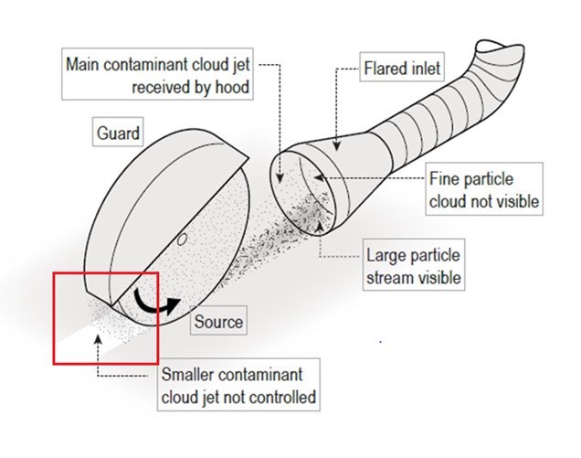
Figure 5: Operational view of local exhaust ventilation
Note: Ventilation systems require regular testing to ensure correct operation. Maintenance of LEV equipment can also present a risk of exposure to RCS which must be managed by duty holders.
Figure 6: Examples of using local exhaust ventilation
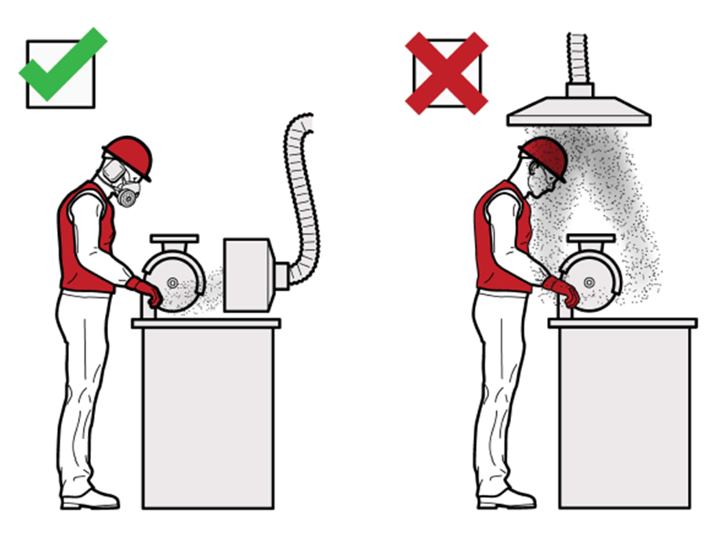

On-tool dust extraction
On-tool dust extraction systems can include a shroud, an on-tool hose attachment and a vacuum extraction system. The dust or mist is collected within the shroud and is then drawn into the hose attachment to the vacuum, where it is extracted, filtered and discharged. When correctly designed and used an on-tool extraction system can both capture and contain dust or mist generated from the processing of a CSS (Figure 7).
For all power tools, the dust extractor or vacuum should meet the M- or H- class requirements of AS/NZS 60335.2.69:2017. For power drills, the dust extractor should meet the requirements above or use a HEPA-filtered tool mounted dust collector.
Figure 7: A worker cutting/grinding with on-tool dust extraction
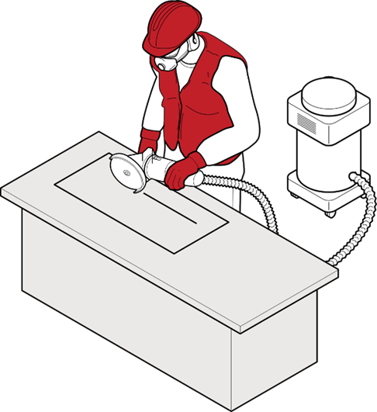

Water suppression
Water suppression uses water at the point of dust generation to dampen down or suppress dust before it is released into the air. To effectively control dust, water or fine mist suppression needs to be supplied at the right levels for the full duration of time that the work is being done.
Powered hand tools and equipment fitted with water feeds are available, including grinders and polishers, and large machinery including bridge saws, routers or polishing machines.

The equipment or machinery used for water suppression should:
- prevent workers from being able to turn water suppression systems down or off during operation
- have an appropriate ingress protection (IP) rating for use with water suppression to ensure it is sufficiently waterproof
- have the water feed attached and an adequate number of water feeds directed at the material and/or tool to prevent dust being released during the process
- have a consistent water flow and adequate water pressure during operation (usually at least 0.5 L/min)
- have a fit-for-purpose nozzle
- be fitted with guards, plastic flaps or brush guards designed to manage the water spray or mist containing RCS
- for underwater suppression cutting, the area around the task should be sectioned-off, and
- be maintained according to manufacturer’s instructions.

Note: Only tools and machinery that have been designed for use with water attachments should be used with water suppression. Handheld spray bottles, sponges or garden hoses are inadequate at suppressing RCS. They are also dangerous if used with power tools that are not designed for use with water.
Wet methods of fabrication can introduce other hazards to your workplace. When using wet methods consider:
- installing non-slip flooring
- filtering water that is recycled (see Appendix B)
- providing waterproof aprons, waterproof non-slip footwear and eye protection that does not fog up and obstruct worker’s vision
- ensuring run-off is effectively drained away from equipment and work areas
- implementing housekeeping policies so run-off does not dry to create a dust hazard, and
- if you are working outside with wet methods and it is very cold, check for ice hazards.
Water suppression can also be applied to RCS generated during earthworks, on stockpiles, and on roads. Rock drills, piling rigs, concrete pulverisers, crushing and screening plant and other similar heavy plant should have integrated water dust suppression systems.
Integrated water suppression is more effective than using hand-held hoses to reduce worker exposure to RCS. It is also important to remember that no method should be taken to be 100% effective on its own without the support of air monitoring data.

Mist and fog systems
Mist and fog systems may be used to control airborne dust where it is not possible or practicable to stop dust at the source.
Misting and Fogging systems can be (on a small scale) used in enclosed spaces or (large scale) used in open areas. They can be used with large amounts of mist to suppress large amounts of dust near the source or a fine fog to suppress general airborne dust.
When selecting or designing a water misting system, there are two important considerations:
- the water droplet size range needs to match the airborne dust particle size range (so that the dust particles collide with the water droplets, Figure 8), and
- water additives should be used to ensure hydrophobic (water repellent) dust is captured by the water.
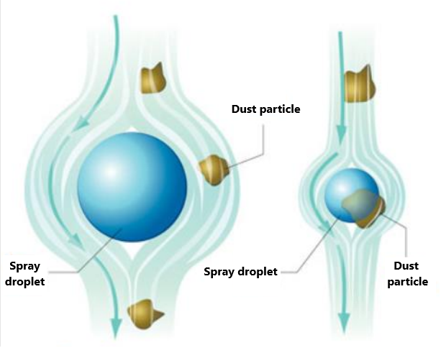
Figure 8: Matching water droplet size with dust particle size
If the drop diameter is larger than the dust particle diameter, the dust particle will follow the air stream around the drop (shown left).

If the diameters of the drop and the dust particle are comparable, the dust particle will follow the air stream and collide with the drop (shown right).

Combining water suppression with other engineering controls
Research has found that even when wet methods are used on products that contain high levels of crystalline silica, RCS may not be adequately controlled. Applying water to rotating tools can also generate RCS-contaminated mist that must also be controlled.
For this reason, properly designed water suppression and local exhaust ventilation may be required in combination to control all sources of RCS (e.g. dust and mist). It is important to only use tools and machinery that have been specifically designed to be used in this combination.

Appendix B - Additional information on requirements for the use of administrative controls

Housekeeping
When RCS is made or generated in the workplace, it can settle on floors, plant, equipment and workers’ clothing. From there, it can become airborne and inhaled. It is important to do a regular clean up (or housekeeping) to effectively manage the risk of exposure to RCS in the workplace.
Good housekeeping helps eliminate or reduce exposure to RCS. Developing written rules and policies for your workplace is a good way to implement housekeeping as an administrative control, and training people in appropriate cleaning methods.
Note: Housekeeping can itself be processing a CSS if it exposes, or is reasonably likely to expose, a person to RCS (see Part 2.2).
Table 1 Housekeeping best practice
Should: | Should not:
- conduct a cleaning schedule for work areas and a maintenance schedule for engineering controls  - for example, regularly cleaning dusty vehicle tracks or high use areas and keeping them wet during the day  - carry out daily cleaning procedures for slurry and settled dust  - for example, placing wet slurry inside a sealed container for disposal  - use a low-pressure water, wet sweeping or an M- or H- class rated vacuum cleaner to clean dusty floors, walls, other surfaces, and equipment  - always follow the vacuum manufacturer’s operator manuals and instructions for changing dust bags and filters  - clean personal protective equipment and equipment in designated areas  - if dusty PPE and equipment cannot be cleaned immediately after use it should be stored in sealed bags and cleaned prior to re-use. | - use compressed air, dry sweeping or general-purpose vacuum cleaners to clean surfaces or clothing

Management of wet slurry
Wet slurry is the resultant waste from water suppression. This slurry has the potential to build up from continuous processing using water suppression on equipment and machinery. The slurry is not hazardous while wet. However, if it dries, the dust can become airborne when disturbed and expose workers and others.
Wet slurry can be managed by:
- capturing or containing it through floor grading, grates, curbing and channelling
- keeping floors and surfaces wet, and
- regularly cleaning it up so that it is does not dry out.
Any wet slurry that is dehydrated so that it is still wet, but of cake-like consistency, should be disposed of in a way that minimises the risk of dust being redistributed over the workplace. This may include covering the slurry, keeping it wet or bagging it before disposal.

Recycled water
Water that is recycled on-site for use in water suppression, including recycled water used in brick or tile saws, should be effectively filtered to remove RCS and prevent contaminated water continually passing through the system. Without an appropriate filtration system there is a risk that continual recycling of water will increase the concentration of RCS in the water over time and subsequently the level of RCS in the mist arising from the water suppression activities.
Water recycling systems can filter slurry so that RCS and other dust particles are removed from the water before it is re-used. These systems can include:
- a pit that collects slurry from drains
- a slurry collection tank and filter press that compacts silica and other particles into a solid block for disposal,
- a slurry settlement tank and waste bag, where waste forms into a solid block, and
- a filtered water tank that recirculates clean water back into the water supply.
Some products, such as commercially available flocculants, promote the clumping of particles, and will consolidate RCS in recycled water more effectively. Water that is recycled needs to be visually assessed to ensure it is clear. If the water has a cloudy or milky appearance this means it is likely to contain a high concentration of RCS and may increase the risk that airborne particles or contaminated mist will be released in the workplace.
For further information on the management of recycled water, please refer to guidelines in your jurisdiction.

Decontamination
Dusty clothing and personal protective equipment can expose workers and others to RCS. Examples of how you can minimise exposure to dust carried on personal protective equipment and work clothes include:
- using an industrial M- or H- class vacuum cleaner to remove dust from clothes and uniforms:
- by positioning these units at the exits of dusty work areas, you can encourage workers to vacuum their clothes before leaving
- you should make sure that workers have access to an area to wash their arms, hands, faces and even their hair.
- providing a laundry service for dusty PPE and work wear supported by a policy, which includes:
- that dusty PPE and work wear are not to be taken home
- designated areas where dusty PPE and clothes must be changed
- when dusty PPE and clothes must be laundered
- if you use a commercial laundry, dampen the clothes and place them in a sealed, labelled plastic bag, and inform the laundry that the clothes are contaminated with RCS
- requiring workers to change dusty clothing after each shift, or if they have just finished a very dusty task to change at their next break, and
- providing workers with rubber boots and aprons.
Workers’ clothes and uniforms must be cleaned frequently to stop RCS from contaminating break rooms, other parts of the workplace and importantly, to stop workers from taking RCS home.
Note: Remember, RCS can be invisible to the naked eye and the absence of visible dust does not indicate an absence of RCS. The effective use of higher order control measures should limit the amount of RCS on clothing and in the workplace. You should regularly review the control measures in accordance with WHS Regulation 38, especially if a workers clothing is regularly covered in dust.

More information about facilities at your workplace can be found in the model Code of Practice: Managing the work environment and facilities.

Appendix C - Additional information on the selection and use of respiratory protective equipment

Selecting suitable respiratory protective equipment
For the purpose of controlling the processing of CSS, RPE must comply with:
- AS/NZS 1716:2012 (Respiratory protective devices), and
- AS/NZS 1715:2009 (Selection, use and maintenance of respiratory protective equipment).
AS/NZS 1716:2012 provides information to manufacturers, suppliers, PCBUs and users by setting out performance requirements for different types of RPE. To ensure compliance with this standard, you should buy RPE from a reputable supplier and ensure that it is certified to this standard. Compliant RPE will usually display the number for this standard on the respirator or its packaging.
Under AS/NZS 1715:2009:
- RPE must incorporate a particulate filter (P1, P2 or P3 - dependent on the type of RPE selected and the level of airborne contamination present).
- For particulate filters rated to overseas or international standards, seek advice from the manufacturer or a competent person on whether the RPE is also compliant with AS/NZS1715:2009.
- RPE must provide the required minimum protection factor (MPF). See Table 2 below from AS/NZS 1715:2009 for further information.
- Where tight-fitting RPE is used:
- the RPE must be successfully fit tested to the wearer
- a further fit test should be performed at least annually or whenever there is a change in the wearer’s facial characteristics or other features which may affect the facial seal of the RPE
- there can be no facial hair where the mask seals to the face (during fit testing or when wearing RPE).
- workers should undertake a fit check just before entering an area where RPE is required to reduce their exposure to RCS.
- Training, by a competent person, must be provided to workers in the correct use and limitations of the RPE.
- Training must be provided at the commencement of employment and at routine intervals thereafter (i.e. considered at least annually).
- You should consider RPE maintenance requirements, including cleaning and availability of appropriate equipment and spare parts.
- You must audit your RPE program at least annually and adjust it in accordance with the results of the audit.
Information about fit testing, fit checking, training, maintenance, inspection, and record keeping for a RPE program are provided below. Refer to AS/NZS 1715:2009 for further information.
For RPE to be compliant with AS/NZS 1715:2009, the worker, task, and work environment must be considered as part of the RPE selection process.
Figures 9 and 10 demonstrate common types of tight-fitting RPE and loose-fitting Powered Air Purifying Respirators (PAPR).
Figure 9 Examples of tight-fitting RPE
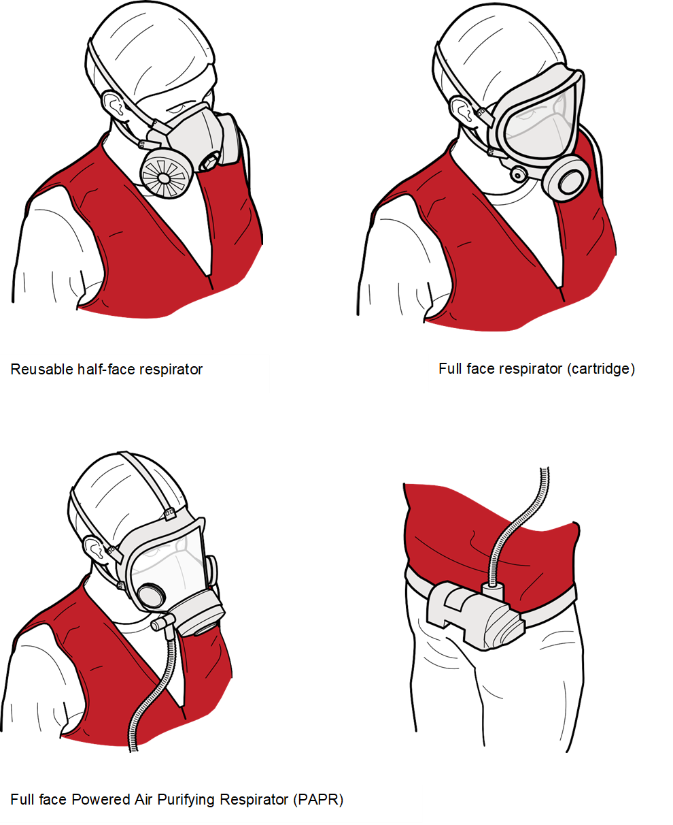
Figure 10 Examples of loose-fitting RPE
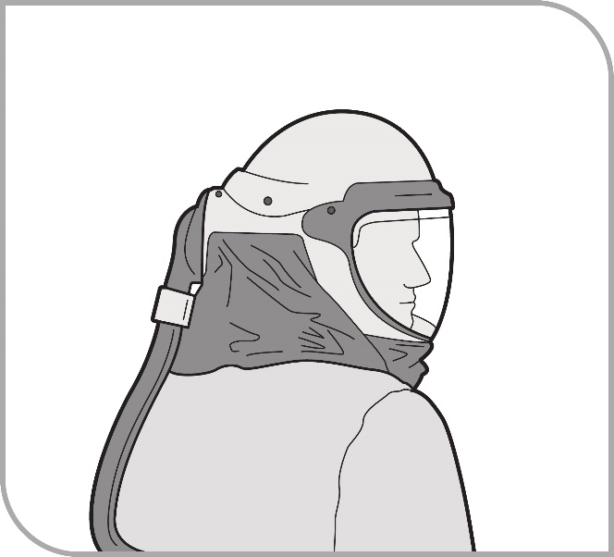
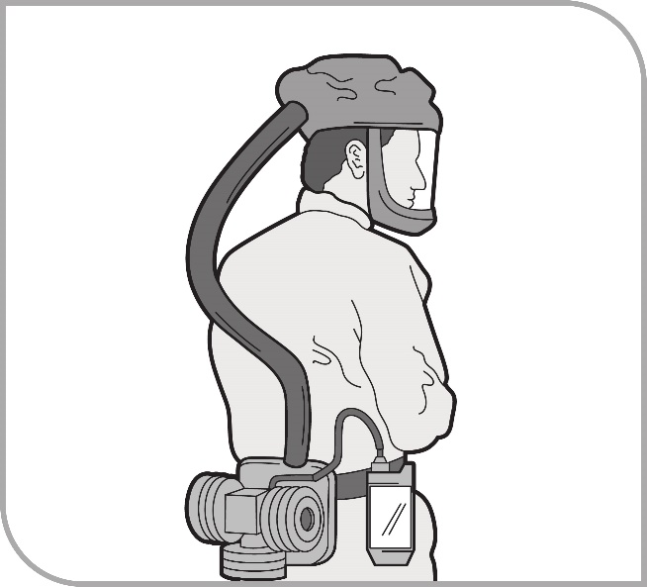
Table 2 Minimum protection factor afforded by different types of respiratory protective equipment (source: adapted from AS/NZS 1715:2009)
Loose-fitting PAPR with hood Loose-fitting PAPR with headcover
Required minimum protection factor | Suitable respiratory protective equipment
Up to 10 | - P1, P2 or P3 filter half facepiece—replaceable filter  - P1 or P2 disposable facepiece  - PAPR—P1 filter in PAPR with any head covering or facepiece
Up to 50 | - P2 filter in full facepiece  - PAPR-P2 filter in PAPR with any head covering or full facepiece  - PAPR-P3 filter in PAPR with any head covering  - Half facepiece with positive pressure demand or continuous flow air-line  - Half facepiece—air-hose RPE with electric blower
Up to 100 | - P3 filter in full facepiece  - Full facepiece air-hose (hose mask) natural breathing type
100+ | - PAPR-P3 filter in PAPR with full facepiece or head covering and blouse  - Head covering air-hose with electrical blower  - Head covering air-line respiratory—continuous flow  - Full facepiece air-line respiratory—positive pressure demand or continuous flow modes  - Full facepiece air-hose with electric blower

Consideration of the worker
For example, you must consider:
- Workers may have pre-existing medical conditions (e.g. chronic lung diseases such as asthma, or circulatory problems) that could restrict or prevent the wearing of certain types of respirators.
- e.g. non-powered air-purifying RPE imposes an extra burden on cardiac and respiratory systems.
- a person with a history of cardiac or respiratory disorders should be medically assessed by a medical practitioner or an occupational and environmental medicine physician, especially where heavy work or prolonged wearing of RPE is anticipated.
- Comfort; face shape and size will influence the size and model of respirator appropriate for each worker.
- helmet, hood and full-facepiece RPE, especially combined with full body protection, may give rise to feelings of claustrophobia, isolation and anxiety in some people.
- training programs are available to assist users in overcoming such feelings of anxiety.
- Facial hair (e.g. beards, moustaches, and stubble) can prevent tight-fitting respirators (i.e. half and full face RPE, both negative and positive pressure) from forming the effective face seal it requires to work properly.
- This means that workers need to be clean-shaven (i.e. male wearers should shave daily) or only have facial hair that does not interfere with the fitting surfaces or the respirator valve (e.g. sideburns generally will not interfere with half-facepiece respirators).
- Other factors may affect the facial fit of RPE, such as:
- long hair,
- jewellery, and
- make-up.
- Corrective lenses with temple bars or straps should not be worn if these will interfere with facial seal. Manufacturers of RPE can provide kits for installing eyeglasses in full facepieces.
- As everyone’s face is a different size and shape, there is no ‘one size fits all’ tight-fitting respirator. This means that you must also fit test each worker and their RPE before they undertake work.
- Tight-fitting RPE cannot be provided to workers who are, for valid reasons, unable to remain clean-shaven. In these circumstances, a powered air purifying respirator with a loose hood may be the only effective option.

Consideration of the task
For example, you must consider:
- How long the RPE needs to be worn and the physical demands of the task. For example, wearing unpowered RPE for more than an hour or during hard physical work may become uncomfortable and result in a person removing the respirator while still in a contaminated area.
- Battery or fan failure on loose-fitting PAPR creates an asphyxiation risk due to a build-up of carbon dioxide in the breathing zone.
- What other PPE will be worn. For example, some safety glasses may interfere with the fit of the respirator.
- Whether the task requires the worker to have unrestricted vision or be able to speak clearly.

Consideration of the environment
For example, you must consider:
- The temperature and humidity of the work environment.
- Powered respirators may be more appropriate where heat stress is a risk because they offer reduced inhalation resistance and create air flow over the face.
- In cold environments, coating the inner surface of the lens with an anti-fogging compound will reduce condensation of the water vapour in the exhaled breath.
- How windy the work environment is.
- The protection afforded by some loose-fitting PAPR devices can be seriously reduced by wind velocities over the body that exceed ~2 m/s and should not be used unless the manufacturer can guarantee their performance under the foreseeable wind conditions.

Fit testing respiratory protective equipment
In accordance with AS/NZS1715:2009, fit testing is required for all tight-fitting RPE. Loose fitting RPE does not require fit testing.
Fit testing measures the effectiveness of the seal between the respirator and the wearer’s face. If there is not a good seal, contaminated air potentially containing RCS could leak into the respirator and be breathed in by the worker.

Workers must pass a respirator fit test before they first start wearing a tight-fitting respirator including:
- half face disposable
- half face reusable
- full face reusable, and
- tight-fitting powered air purifying respirators (PAPR).
There are two types of fit testing methodologies:
- Qualitative fit test (also known as an aerosol taste test):
- a pass/fail test that relies on the wearer’s ability to taste or smell a test agent, and
- only used on half face respirators.
- Quantitative fit test:
- uses specialised equipment to measure how much air leaks into the respirator
- used on half face respirators, full face respirators and PAPR, and
- conducted using:
- artificial test atmospheres (e.g. a sodium chloride aerosol test), or
- natural atmospheric dusts.
Quantitative fit testing results are more objective than qualitative testing because some workers have difficulty with their ability to taste or smell. This can result in a ‘false pass’ and worker health not being adequately protected. Full face respirators and PAPR must be fit tested using the quantitative method.
In accordance with AS/NZS1715:2009, all fit testing must be carried out by a competent person, manufacturer, supplier or consultant before a worker wears a tight-fitting respirator for the first time.
An appropriately trained, qualified, and experienced person will have, at minimum, the following competencies:
- knowledge of the respirators used for the fit test
- knowledge of the fit test method
- the ability to set up all applicable equipment and monitor its function
- the ability to carry out the test and evaluate the results, and
- the ability to identify likely causes of fit test failure.
Fit testing can be carried out in a range of settings, including mobile testing units, specialist facilities or in-house using the appropriate equipment.

A further fit test should be performed:
- at least annually
- each time a new make or model of respirator is provided to a worker, and
- whenever there is a change in the wearer’s facial characteristics or features that may affect the seal (e.g. large weight loss or gain).
Note: it is unnecessary to undertake a fit test when you are simply replacing a respirator with the exact same make and model you have already been successfully fit tested to (whether disposable or reusable).
Most fit testing providers will provide a fit test card and/or certificate, which will help the PCBU to keep a record of all fit testing undertaken. Keep a written record of fit tests carried out for each worker and share the record with the worker after fit testing is complete. The record should include the:
- type of test performed
- make, model, style and size of respirator tested, and
- date and result of the test.

Fit checking respiratory protective equipment
Fit checking enables workers to take reasonable care of their own health and safety while working with CSS. A fit check is a quick check to ensure a fit tested RPE is properly positioned on the face and there is a good seal between the RPE and face. Fit checks do not replace the need for a fit test. Workers should follow the RPE manufacturer’s instructions on how to carry out a fit check.
Fit checking is the responsibility of the worker. Workers must be trained on how to carry out a fit check for their tight-fitting RPE. They should undertake a fit check every time they use a tight-fitting RPE (before entering a hazardous atmosphere) to ensure they are using and wearing it in a way that will protect their health and safety.
In accordance with the WHS Regulations, you must also ensure, so far as is reasonably practicable, that you workers wear the RPE they have been issued. It is important you supervise your workers to ensure fit checking is being conducted correctly. To help ensure workers are complying with their responsibilities to do fit checking, you may want to consider having them check their names off fit-checking lists and recording fit checking compliance during mandatory audits of your RPE programs.

Respiratory protective equipment training and maintenance
You must provide training for your workers who are provided with RPE. This is to make sure they correctly fit, use and maintain the RPE they are expected to use. Training must be provided by a competent person; this could be:
- a health and safety consultant
- a trained person in-house
- a representative from a RPE manufacturer or supplier
- an occupational hygienist, or
- the holder of recognised qualifications in WHS with expertise or experience in this area.
Where the training is being provided in-house, the in-house trainer should themselves have had training from a competent person.
Training for RPE should cover:
- why the RPE is required for their job
- when the worker must wear the RPE
- how the RPE works
- the limitations of the RPE
- how to correctly put on and take off the RPE
- how to fit check the RPE
- how to clean and maintain the RPE
- when and how to replace the filters and batteries (including rechargeable batteries), and
- how and where to store RPE when not in use.
You must keep records of any training.

Inspection and maintenance of re-usable respiratory protective equipment
Under the WHS Regulations, PCBUs must ensure that RPE is maintained, repaired, or replaced so that it continues to minimise the risk to the worker who uses it.
A maintenance program should enable time in the work schedule so that appropriate maintenance and cleaning can be undertaken within work hours and should include procedures for:
- cleaning RPE after each use by the worker (clean RPE should be easily identifiable as such)
- inspection of RPE by the worker for wear or damage before and after each use, as well as during cleaning
- appropriate storage (e.g. in a dry, clean and sealed container) - each worker should be provided with a dedicated container to store their RPE. Clean, dry RPE should be stored away from dust, oil, and out of direct sunlight, and face pieces should be stored so that they are not subject to distortion
- identification and repair or replacement of any worn or defective components of the equipment including filters (including availability of replacement parts)
- regular periodic inspection, maintenance and testing of RPE in accordance with the manufacturer’s instructions, and
- record keeping, including:
- details of any identified issues, including the date found/reported, and
- maintenance records including filter replacement and RPE maintenance schedules.

Record keeping for a respiratory protective equipment program
In accordance with AS/NZS1715:2009, record keeping for a RPE program must include:
- issue of RPE (non-disposable)
- date
- identifying mark (where issued for exclusive individual use)
- user records
- training
- fit test
- medical screening
- maintenance
- filter replacement schedule
- RPE maintenance schedule
- supplied air RPE maintenance records (if applicable).
- program records
- procedures (e.g. RPE selection, medical screening, training, fitting, maintenance, record keeping, auditing, etc.)
- audits/evaluations (at least annually)
- Review of risk assessment, along with air and health monitoring results (if applicable)
- air monitoring records (if applicable), and
- health monitoring (if applicable).
Records need not be kept for disposable RPE or for filters used in half or full facepiece RPE where these are changed regularly.

Appendix D – Work health and safety duties in relation to managing risks from respirable crystalline silica in the workplace

Persons conducting a business or undertaking
This Code provides information to assist PCBUs to comply with the WHS Act and WHS Regulations in relation to managing risks from RCS in the workplace. The following table summarises the relevant duties of a PCBU in this context.
Note: This table is not an exhaustive list of duties. You should refer to the relevant WHS laws in your jurisdiction.
Duty | Provision | Part of this Code
Make sure, so far as is reasonably practicable, that the health and safety of people at the workplace (including workers, volunteers and others) is not put at risk from the work carried out by the business or undertaking, so far as is reasonably practicable | WHS Act s 19 (Primary duty) | 1.1.1
To comply with a duty to ensure health and safety (e.g. the primary duty of PCBUs, or to manage risks associated with a hazardous chemical including RCS under reg 351), risks to health and safety must be eliminated, so far as is reasonably practicable. If it is not reasonably practicable to eliminate risks to health and safety, they must be reduced so far as is reasonably practicable. | WHS Act s 17  WHS Regulations reg 35 | 1.1.1
Must manage risks to health and safety associated with using, handling, generating or storing a hazardous chemical (such as RCS) at the workplace in accordance with Part 3.1 of the WHS Regulations, which sets out requirements in relation to the management of risks. | WHS Regulations reg 351 | 1.1.1  2.4  4
Must manage risks in accordance with the hierarchy of control measures | WHS Regulations reg 36 | 2.4
Eliminate health and safety risks, and if that is not reasonably practicable, minimise those risks using hierarchy of controls - so far as is reasonably practicable | WHS Regulations regs 35-36 | 2.4
Maintain, review and revise control measures used to make sure they remain effective and to maintain a work environment that is without risks to health and safety, so far as is reasonably practicable. | WHS Regulations regs 37 and 38 | 4
Provide workers with appropriate and readily understandable information, training, instruction or supervision. | WHS Regulations reg 39 | 1.1.4
Where RPE is required to minimise a risk to health and safety, make sure workers are provided with suitable RPE and that they wear, store and maintain it properly. | WHS Regulations reg 44 and 529 B | 2.4.6
Make sure consultation is undertaken with workers (and their HSRs, if any) on work health and safety matters that directly affect them. | WHS Act s.47 | 1.1.2-1.1.3
Make sure no person at the workplace is exposed to RCS in an airborne concentration above the workplace exposure standard for RCS. | WHS Regulations reg 49 | 1.2
Make sure air monitoring is carried out if: -  - you are not certain, on reasonable grounds, whether or not the airborne concentration of RCS exceeds the workplace exposure standard, or  - monitoring is needed to determine if there is a risk to health. | WHS Regulations reg 50 | 3.3.1
Make sure health monitoring is carried out if a worker is carrying out ongoing work at a workplace involving RCS and there is a significant risk to the worker’s health because of that exposure. | WHS Regulations reg 368 | 3.3.2
Provide health monitoring reports to regulator where there is evidence of disease, injury or illness or otherwise recommended. | WHS Regulations reg 376 | 3.3
Make sure processing of CSS is controlled | WHS Regulations regs 529C and (for the meaning of controlled processing) 529B, AS/NZS 1715:2009, AS/NZS 1716:2012. | 2.3
Must assess processing of CSS to determine if it is high risk | WHS Regulations reg 529CA | 2.5
If processing of a CSS is high risk - must develop and comply with a silica risk control plan for processing of CSS that is high risk | WHS Regulations reg 529CB and 529CC  WHS Regulations Part 6.3 Division 2  High risk construction work – safe work method statements | 3.1
Provide workers with additional training where workers are involved in the processing of a CSS that is high risk or workers are at risk of exposure to RCS because of the processing of a CSS that is high risk. | WHS Regulations reg 529CD | 3.2
Provide air monitoring results to the regulator if airborne concentration of RCS is above the WES for processing of CSS that is high risk | WHS Regulations reg 529CE | 3.3
Permitted exceptions to prohibition on work involving engineered stone. | WHS Regulations regs 529E and 529F | 4.2
Requirements for notification of permitted work with engineered stone | WHS Regulations regs 529G-J | 4.3.1-4.3.3

Officers
Under section 27 of the WHS Act, an officer (for example, a company director) must exercise due diligence to ensure the PCBU complies with the WHS Act and WHS Regulations. Exercising ‘due diligence’ includes taking reasonable steps to:
- acquire and keep up-to-date knowledge of work health and safety matters
- gain an understanding of the PCBU’s operations including the hazards and risks associated with those operations
- ensure the PCBU has available for use, and uses, appropriate resources and processes to eliminate or minimise risks to health and safety arising from the work
- ensure the PCBU has appropriate processes for receiving, considering and responding to information about hazards, risks and incidents
- ensure the PCBU has, and implements, processes for complying with its work health and safety duties or obligations, and
- verify these resources and processes are provided and used.

Principal contractors
WHS Regulations 308-315 specify additional duties for principal contractors
Each construction project (being a project involving construction where the cost is $250,000 or more) has a principal contractor. There can only be one principal contractor for a construction project at any one time.
The PCBU who commissions a construction project is the principal contractor for that project, unless they engage another PCBU to be the principal contractor for the project. The PCBU who commissions the construction project must authorise the nominated principal contractor to have management or control of the workplace and discharge the duties of the principal contractor.
A person with management or control of a workplace has additional duties in section 20 of the WHS Act.
In addition to the primary duties that a principal contractor has as a PCBU and a person with management or control of a workplace, the principal contractor has further duties relating to the construction work including preparing WHS management plans, ensuring general WHS compliance, and managing specific risks.

Designers, manufacturers, importers, suppliers
Under sections 22-25 of the WHS Act, a designer, manufacturer, importer or supplier of a CSS must ensure, so far as is reasonably practicable, that the CSS they design, manufacture, import or supply is without risk to health and safety.
These duties are often referred to as ‘upstream duties’ because they apply to PCBUs that, as designers, manufacturers, importers and suppliers, are higher up in the supply chain and can therefore potentially impact those who use the products they deal with ‘downstream’ in the supply chain or later in the lifecycle of the products.
Discharging upstream duties may require the designers, manufacturers, importers or suppliers of the CSS to carry out, or arrange for, calculations, analysis, testing or examination of the CSS to demonstrate it can be worked with without risks to health and safety.
Designers, manufacturers, importers or suppliers of a CSS must, so far as is reasonably practicable, give current relevant information to downstream users of the CSS about:
- the purpose for which the CSS was designed or manufactured,
- the results of any calculations, analysis, testing or examination in relation to the CSS, including any hazardous properties identified by testing, and
- any conditions necessary to ensure that the CSS is without risks to health and safety when used for a purpose for which it was designed or manufactured.
A designer, manufacturer, importer or supplier may provide the above information using a label, product information sheet or safety data sheet. In relation to CSS, information that upstream duty holders would generally be required to provide includes information about:
- the level of crystalline silica in the product,
- the hazardous properties of, and risks to health from, RCS, and
- the health and safety measures that must be taken when processing, installing, maintaining or removing CSS.

Persons conducting a business or undertaking that install, construct or commission plant or structures
Under section 26 of the WHS Act, a PCBU who installs, constructs or commissions a structure must also ensure, so far as is reasonably practicable, all workplace activity relating to the structure (including its decommissioning or dismantling) is without risks to health or safety.
A ‘structure’ is defined in the WHS Regulations as anything that is constructed, whether fixed or moveable, temporary or permanent, and includes buildings, masts, towers, framework, pipelines, transport infrastructure and underground works (shafts or tunnels).

Workers
Workers have a duty to take reasonable care for their own health and safety, and to take reasonable care to not adversely affect the health and safety of other persons (section 28 of the WHS Act).
Workers must:
- comply as far as they are reasonably able with any reasonable WHS instructions given by the PCBU, and
- co-operate with any reasonable policy or procedure relating to WHS at the workplace that has been notified to them.
If a worker refuses to participate in health monitoring or refuses to use personal protective equipment as they have been trained and instructed, a PCBU will need to take appropriate action to meet its duties under the WHS laws. This could include removing the worker from the source of exposure to RCS.

Other persons in the workplace
Other persons at the workplace include visitors or customers who attend a workplace. For example, if bricks are being cut by a PCBU during renovation at a customer’s home, that home becomes a workplace. The homeowner and other people who may enter the home while the work is being carried out are other persons for the purposes of the WHS Act.
Under section 29 of the WHS Act, other persons must take reasonable care for their own health and safety and must take care not to adversely affect other people’s health and safety. They must also comply, so far as they are reasonably able, with reasonable instructions given by the PCBU to allow the PCBU to comply with the WHS Act.

Appendix E – Glossary
Key terms | Meaning
Controlled processing | The processing of a CSS is controlled if:  (a) control measures to eliminate or minimise risks arising from the processing are implemented so far as is reasonably practicable; and  (b) at least 1 of the following measures are used during the processing:  (i) the isolation of a person from dust exposure;  (ii) a fully enclosed operator cabin fitted with a high efficiency air filtration system;  (iii) an effective wet dust suppression method;  (iv) an effective on-tool extraction system;  (v) an effective local exhaust ventilation system; and  (c) a person still at risk of being exposed to respirable crystalline silica after 1 or more of the measures in paragraph (b) are used:  (i) is provided with respiratory protective equipment; and  (ii) wears the respiratory protective equipment while the work is carried out.
Crystalline silica | The crystalline form of the abundant naturally occurring mineral silica or silicon dioxide (SiO₂). It includes cristobalite, quartz, tridymite and Tripoli and is present in almost all types of rocks, sand, clay, shale and gravel and in construction materials such as concrete, tiles and bricks.
Crystalline silica substance (CSS) | A material containing at least 1% crystalline silica, determined as a weight/weight (w/w) concentration.
Duty holder | Any person who owes a work health and safety duty under the WHS laws including a person conducting a business or undertaking, a designer, manufacturer, importer, supplier, installer of products or plant used at work (upstream duty holder), officer or a worker.
Engineered stone | Engineered stone:  - is an artificial product that:  - contains 1% or more crystalline silica determined as a weight/weight (w/w) concentration; and  - is created by combining natural stone materials with other chemical constituents such as water, resins or pigments; and  - becomes hardened; but  - does not include the following:  - concrete and cement products;  - bricks, pavers and other similar blocks;  - ceramic wall and floor tiles;  - grout, mortar and render;  - plasterboard.  - Porcelain products, where it does not contain resin;  - sintered stone, where it does not contain resin;  - roof tiles;
Hazard | A situation or thing that has the potential to harm a person. Hazards at work may include, noisy machinery, a moving forklift, chemicals (including RCS), electricity, working at heights, a repetitive job, bullying and violence at the workplace.
Health and safety representative (HSR) | A worker who has been elected by their work group under the WHS Act to represent them on health and safety matters.
Legacy engineered stone | Any previously installed engineered stone or stock of engineered stone that was not installed prior to the commencement of the engineered stone prohibition.
May | ‘May’ indicates an optional course of action.
Must | ‘Must’ indicates a legal requirement exists that must be complied with.
Officer | An officer under the WHS Act includes:  - an officer within the meaning of section 9 of the Corporations Act 2001 (Commonwealth)  - an officer of the Crown within the meaning of section 247 of the WHS Act, and  - an officer of a public authority within the meaning of section 252 of the WHS Act.  A partner in a partnership or an elected member of a local authority is not an officer while acting in that capacity.
Person Conducting a Business or Undertaking (PCBU) | A PCBU is an umbrella concept which intends to capture all types of working arrangements or relationships.  A PCBU includes a:  - company,  - unincorporated body or association, and  - sole trader or self-employed person.  Each individual who is in a partnership that is conducting a business or undertaking will individually be a PCBU.  A volunteer association or elected members of a local authority will not be a PCBU.
Personal protective equipment (PPE) | Anything used or worn by a person to minimise risk to the person’s health and safety.
Processing | Processing in relation to a CSS means:  (a) the use of power tools or mechanical plant to carry out an activity involving the crushing, cutting, grinding, trimming, sanding, abrasive polishing or drilling of a CSS; or  (b) the use of roadheaders to excavate material that is a CSS; or  (c) the quarrying of a material that is a CSS; or  (d) mechanical screening involving a material that is a CSS; or  (e) tunnelling through a material that is a CSS; or  (f) a process that exposes, or is reasonably likely to expose, a person to respirable crystalline silica during the manufacture or handling of a CSS.
Psychosocial hazards | A psychosocial hazard is a hazard that may cause psychological harm (whether or not it may also cause physical harm). They arise from or relate to the design or management or work, the work environment, plant at a workplace, or workplace interactions or behaviours.
Respiratory protective equipment (RPE) | For the purposes of controlling the processing of CSS, respiratory protective equipment means personal protective equipment that:  - is designed to prevent a person wearing the equipment from inhaling airborne contaminants; and  - complies with AS/NZS 1716:2012 (Respiratory protective devices) and with AS/NZS 1715:2009 (Selection, use and maintenance of respiratory protective equipment).
Risk | The possibility harm (death, injury or illness) might occur when exposed to a hazard.
Should | ‘Should’ indicates a recommended course of action.
Worker | Any person who carries out work for a person conducting a business or undertaking, including work as an employee, contractor or subcontractor (or their employee), self-employed person, outworker, apprentice or trainee, work experience student, employee of a labour hire company placed with a 'host employer' or a volunteer.
Workplace | Any place where work is carried out for a business or undertaking and includes any place where a worker goes, or is likely to be, while at work. This may include offices, factories, shops, construction sites, vehicles, ships, aircraft or other mobile structures on land or water.
Workplace exposure limit (WEL) | A workplace exposure limit published by Safe Work Australia in the Workplace Exposure Limits for Airborne Contaminants.  Note: From 1 December 2026 Australia will adopt the Workplace exposure limits for airborne contaminants (WEL list). Until 1 December 2026, PCBUs must still comply with the workplace exposure standard (WES list).
Workplace exposure standard (WES) | A workplace exposure standard published by Safe Work Australia in the Workplace Exposure Standards for Airborne Contaminants.  Note: From 1 December 2026 Australia will adopt the Workplace exposure limits for airborne contaminants (WEL list). Until 1 December 2026, PCBUs must still comply with the workplace exposure standard (WES list).

As defined in Division 11 of Part 3.2 of the WHS Regulations.
The WHS Regulations define high risk, in relation to the processing of a CSS, as the processing of a CSS that is reasonably likely to result in a risk to the health of a person at the workplace.
Regulation 529A(2) and (3) of the WHS Regulations defines CSS and crystalline silica.
Plant includes any machinery, equipment, appliance, container, implement or tool, and any component or anything fitted or connected to these things.
As per Regulation 382 and table 10.3 of Schedule 10 to the WHS Regulations, crystalline silica must not be used for abrasive blasting at a concentration of greater than 1%.
See Workplace exposure standards for airborne contaminants
Best practice is to use a certified occupational hygienist. Where a certified occupational hygienist is not available, a person with relevant qualifications and experience in occupational hygiene or a person under the supervision of a certified occupational hygienist is acceptable.
Best practice is to use a certified occupational hygienist. Where a certified occupational hygienist is not available, a person with relevant qualifications and experience in occupational hygiene or a person under the supervision of a certified occupational hygienist is acceptable.
See Workplace exposure standards for airborne contaminants.
Best practice is to use a certified occupational hygienist. Where a certified occupational hygienist is not available, a person with relevant qualifications and experience in occupational hygiene or a person under the supervision of a certified occupational hygienist is acceptable.
AIHA. (2015). A strategy for assessing and managing occupational exposures (B. W. Jahn S, Ignacio J, Ed. Fourth ed.). Virginia: American Industrial Hygiene Association.
Comite Europeen de Normalisation. (2018). CEN-EN 689: Workplace exposure - Measurement of exposure by inhalation to chemical agents - Strategy for testing compliance with occupational exposure limit values. In (pp. 58).
Best practice is to use a certified occupational hygienist. Where a certified occupational hygienist is not available, a person with relevant qualifications and experience in occupational hygiene or a person under the supervision of a certified occupational hygienist is acceptable.
Household and similar electrical appliances – Safety – Particular requirements for wet and dry vacuum cleaners, including power brush, for industrial and commercial use (IEC 60335.2.69 ED 5, MOD).
Protection Factor – A measure of the degree of protection afforded by the respirator, defined as the ratio of the concentration of contaminant outside the respirator to that inside the respirator. Minimum Protection Factor (MPF) - The level of respiratory protection that an item of properly functioning RPE would be expected to provide to properly fitted and trained users in the workplace when used according to the manufacturer’s information and instruction. The MPF considers all expected sources of facepiece penetration (e.g. face seal protection, valve leakage).
PAPR – Powered Air Purifying Respirator.
Best practice is to use a certified occupational hygienist. Where a certified occupational hygienist is not available, a person with relevant qualifications and experience in occupational hygiene or a person under the supervision of a certified occupational hygienist is acceptable.

