Engineered stone prohibition: exemptions

The engineered stone prohibition

**WHS Regulation 529D**   
Prohibition of work involving engineered stone benchtops, panels or slabs

A prohibition on the manufacture, supply, processing and installation of engineered stone benchtops, panels and slabs came into effect on 1 July 2024. It is an offence for a person conducting a business or undertaking (PCBU) to carry out work involving the manufacture, supply, processing or installation of engineered stone benchtops, panels or slabs. It is also an offence for a PCBU to direct or allow a worker to carry out this type of work.

**WHS Regulation 529A(4)**  
Meaning of engineered stone

For the purposes of the WHS Regulations, engineered stone is defined as an artificial product that:

1. contains at least 1% crystalline silica as a weight/weight concentration, and
2. is created by combining natural stone materials with other chemical constituents (such as water, resins, or pigments), and
3. becomes hardened.

|  |
| --- |
| **Note:** Only products that satisfy all three of the above conditions fall under the definition of engineered stone. |

Engineered stone does not include:

1. concrete and cement products
2. bricks, pavers, and other similar blocks
3. ceramic wall and floor tiles
4. sintered stone
5. porcelain products
6. roof tiles
7. grout, mortar, and render, and
8. plasterboard

There are limited [exceptions to the prohibition for which work with engineered stone benchtops, panels or slabs is permitted](https://www.safeworkaustralia.gov.au/doc/engineered-stone-ban-examples-permitted-work-legacy-engineered-stone). For further information, see Part 5.2 of the model Code of Practice: Managing risks of respirable crystalline silica in the workplace.

Under the WHS Regulations, a person may apply for an exemption from the engineered stone prohibition for a type of engineered stone product. A WHS regulator may grant an exemption if certain criteria are met. An exemption granted by a WHS regulator is recognised by all WHS regulators with a corresponding WHS law in relation to granting engineered stone prohibition exemptions.

Exemption from the engineered stone prohibition

**WHS Regulation 689A**  
Exemption from the engineered stone prohibition

The WHS Regulations allow a WHS regulator to exempt a type of engineered stone from the prohibition. If an exemption is granted, the engineered stone prohibition will not apply if a PCBU carries out work involving the type of engineered stone that has been exempted.

An exemption from the engineered stone prohibition may only be granted if the WHS regulator is satisfied that granting the exemption will result in a standard of health and safety that is at least equivalent to the standard that would have been achieved without that exemption.

An exemption granted by the WHS regulator of one jurisdiction will also apply in all jurisdictions except Victoria.[1]

|  |
| --- |
| Note: The exemption applies to a type of engineered stone. Once a type of engineered stone is exempted, any PCBU will be able to work with that type of engineered stone so long as they can satisfy any conditions imposed on the exemption. |

Application for an exemption

**WHS Regulations 689B and 690**   
Application for exemption

A person may apply to a WHS regulator to exempt a type of engineered stone from the prohibition.

Before applying for an exemption, the person must consult with the Safe Work Australia Members who represent the interests of employers and workers (social partners).

|  |
| --- |
| For further information about Safe Work Australia’s social partners, see Safe Work Australia’s [website](https://www.safeworkaustralia.gov.au/law-and-regulation/model-whs-laws/national-exemption-framework). |

The person must provide written notice to each social partner:

* stating that they intend to apply to a WHS regulator for an exemption
* inviting the social partner to make a submission for the regulator (within a reasonable period), and
* informing the social partner that the submission must be provided to the regulator as part of the application.

The person must also provide a copy of the proposed exemption application to each social partner together with the written notice.

When applying to the WHS regulator for an exemption, the applicant must provide the following:

* a written application in the manner and form required by the WHS regulator
* the written notice that was provided to each of the social partners, and
* any submissions made to the applicant by the social partners.

|  |
| --- |
| For further information on the application process, see the Guide for exemption applicants in the [National Exemption Framework](https://www.safeworkaustralia.gov.au/national-exemption-framework#:~:text=The%20framework%20guides%20the%20granting,work%20health%20and%20safety%20regulator.). |

How WHS regulators make decisions

**WHS Regulation 689C**   
Notifying persons of application for exemption

**WHS Regulation 698D**Regulator to be satisfied of certain matters

**WHS Regulation 689E**Safe Work Australia may issue and publish documents in relation to exemptions

Upon receiving an exemption application, a WHS regulator must provide the application documents to each corresponding WHS regulator.

Additionally, the WHS regulator may choose to provide the application documents to the following classes of persons, and invite them to make a submission in respect of the exemption application:

* employer organisations that include employers who engage in work involving engineered stone
* unions representing employees whose work includes work involving engineered stone, or
* persons who have qualifications, knowledge, skills and experience relating to engineered stone.

The WHS regulator must not grant an exemption unless it is satisfied that granting the exemption would result in a standard of health and safety that is at least equivalent to the standard that would have been achieved without that exemption.

When deciding this matter, the WHS regulator must have regard to:

* any submissions received by the WHS regulator from the above parties (i.e. corresponding WHS regulators, employee groups, employer groups and technical experts)
* any submission made by social partners and provided by the applicant with the application, and
* the Engineered Stone Prohibition exemption common decision-making criteria published on the Safe Work Australia website under the [National Exemption Framework](https://www.safeworkaustralia.gov.au/national-exemption-framework#:~:text=The%20framework%20guides%20the%20granting,work%20health%20and%20safety%20regulator.).

Outcome of an application

**WHS Regulation 676**  
Reviewable decisions

**WHS Regulation 694**Notice of decision in relation to exemption

**WHS Regulation 695**Publication of exemption

The WHS regulator will inform the applicant of the outcome of the exemption application.

If the exemption is granted, the WHS regulator must additionally:

* publish its reasons for granting the exemption within 14 days, and
* notify each corresponding regulator that the exemption is granted.

Once granted, exemptions will be recognised automatically in all jurisdictions with a corresponding WHS law for granting an exemption from the engineered stone prohibition; PCBUs should not apply for the same exemption in multiple jurisdictions.

|  |
| --- |
| Please note that Victoria’s Occupational Health and Safety laws do not provide for automatic mutual recognition of exemptions granted by other jurisdictions. If you are a PCBU who works in Victoria, please refer to [WorkSafe Victoria](https://www.worksafe.vic.gov.au/) for more information about the recognition of exemptions. |

If an application for an exemption is refused by the WHS regulator, the applicant may apply to the relevant external review body for review of the decision. Unless a longer period is allowed by the external review body, the application for external review must be made within 28 days after the day on which the decision to refuse the exemption first came to the applicant’s attention.

Duties for PCBUs working with exempt engineered stone

**WHS Regulation 691**  
Conditions of exemption

The WHS regulator may impose any condition it considers appropriate on an exemption from the engineered stone prohibition. This may include, for example, control measures for the manufacture, supply, processing or installation of an exempt engineered stone product, and/or requirements to undertake air monitoring, and monitor the health of persons at the workplace who may be exposed to respirable crystalline silica. A PCBU granted an exemption must comply with the conditions imposed on the exemption.

If an exemption is granted, PCBUs that are designers, manufacturers, importers or suppliers of an exempt type of engineered stone must still comply with the existing ‘upstream’ duties[2] in the WHS Act (sections 22-26) to ensure, so far as is reasonably practicable, that the design, manufacture, importation and supply of the exempt type of engineered stone is without risk to health and safety.

Discharging these upstream duties may require the designers, manufacturers, importers or suppliers of the exempt type of engineered stone to carry out, or arrange for, calculations, analysis, testing or examination of the product.

Designers, manufacturers, importers and suppliers must also, so far as reasonably practicable, give current relevant information to downstream users of the stone (including to PCBUs who will install the stone) about:

* the purpose for which the type of engineered stone was designed or manufactured
* the results of any calculations, analysis, testing or examination in relation to the type of engineered stone, including any hazardous properties identified by testing, and
* any conditions necessary to ensure that the type of engineered stone is without risk to health and safety when used for a purpose for which it was designed or manufactured, including any conditions placed on the use of the type of engineered stone as part of the exemption granted by the WHS regulator.

Exemption from the engineered stone ban

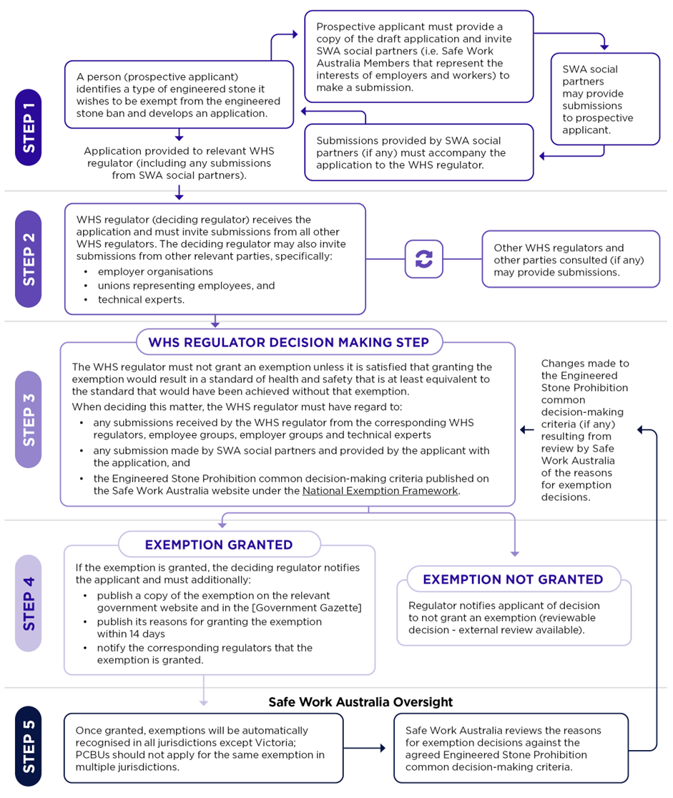

1. Victoria is the only jurisdiction that does not have a corresponding WHS law for the mutual recognition of an exemption from the prohibition granted by another WHS regulator with respect to a type of engineered stone. A person would need to separately apply for an exemption in Victoria.
2. These are referred to as ‘upstream’ duties because they apply to PCBUs who, as designers, manufacturers, importers and suppliers, are higher up in the supply chain and can therefore potentially impact those who use, in this case, engineered stone products ‘downstream’ in the supply chain or later in the lifecycle of the products.