WHS duties in a contractual chain

This fact sheet is for persons conducting a business or undertaking (PCBUs) who are working as part of a contractual chain.

It provides guidance on duties under the model work health and safety (WHS) laws and examples of how contractual relationships fit within the model WHS framework. This includes individual contractors and self-employed persons, who may be both a PCBU and a worker in a contractual chain.

Key points to remember are:

* WHS duties are not transferrable.
* WHS duties cannot be contracted out to another party, such as a subcontractor.
* A person can have more than one duty under the model WHS laws. For example, a self-employed person may be simultaneously a PCBU and a worker.
* Duties can be shared, so more than one person can have the same duty at the same time. For example:
  + A contractor and subcontractors, as PCBUs, will have the same duty to ensure access to first aid facilities at a workplace.
* You must consult, cooperate and coordinate on WHS matters with other duty holders when working as part of a contractual chain.

For clarity, a **worker** is anyone who carries out work in any capacity for your business or undertaking, including employees, contractors, subcontractors, apprentices and trainees.

A **workplace** means a place where work is carried out for your business or undertaking and includes any place where a worker goes, or is likely to be, while at work.

# What is a contractual chain?

**Contracting** is when a business engages another business to carry out work under contract.

A **contractual chain** refers to the situation where, in relation to the same project or work matter, there are multiple contractors and subcontractors. There can be several levels in a contractual chain. For example, a client may engage a head contractor to deliver a logistics project. The head contractor may engage contractors to undertake parts of the project, and these contractors may engage subcontractors to carry out particular activities that the contractor is to deliver.

Figure 1: Example of a contractual chain for a construction project

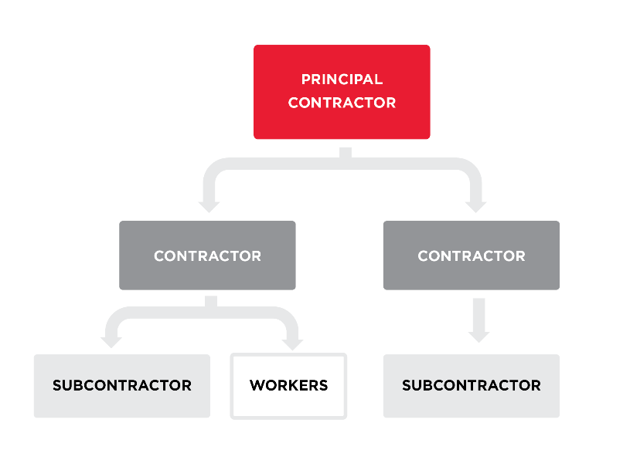

A contractual chain can form in any industry but is a common way of conducting business across the economy, for example in industries such as building and construction, road transport and events management.

It is good practice to understand if you are part of a contractual chain as it will help you understand who you may owe WHS duties to and who may owe you a duty of care and allow for necessary consultation about these duties.  
  
Duties under WHS laws

## Person conducting a business or undertaking

The primary duty holder under the model WHS laws is a PCBU. The term PCBU covers a broad range of modern work relationships and business structures. A PCBU can be an employer, a sole trader, self-employed person, company or corporation, association or government.

As a PCBU you have a duty under WHS laws to ensure the health and safety of workers and others who may be at risk from work carried out at the workplace. You must:

* eliminate risks so far as is reasonably practicable, or if this is not possible, minimise risks so far as is reasonably practicable
* provide and maintain a work environment that is without risk to the health and safety of workers
* provide adequate and accessible facilities for the welfare of workers to carry out their work, and
* give workers the necessary information, instruction, training or supervision to do their job safely and without risks to health.

PCBUs may also have other duties in addition to their primary duty of care. This includes duties relating to the management and control of workplaces, duties relating to the design, manufacture and import of plant and substances, duties to consult, and duties that apply to principal contractors on construction projects that involve construction work of $250,000 or more.

For more information about who may be a PCBUand their duties see: [*What is a person conducting a business or undertaking*](https://www.safeworkaustralia.gov.au/resources-and-publications/guidance-materials/what-person-conducting-business-or-undertaking) and [*Duties of a PCBU*.](https://www.safeworkaustralia.gov.au/law-and-regulation/duties-under-whs-laws/duties-pcbu)

### Reasonably practicable standard

As a PCBU, the standard you must meet to fulfil your WHS duties is to do what is ‘reasonably practicable’ to ensure the health and safety of workers and others. You must first try and eliminate risks to health and safety, so far as is reasonably practicable. If that is not possible, you must minimise the risks so far as is reasonably practicable.

What is reasonably practicable is an objective test. This means that you must meet the standard of behaviour expected of a reasonable person in your (the duty holder’s) position and who is required to comply with the same duty.

To identify what is (or was) reasonably practicable, all relevant matters must be taken into account and weighed up and a balance achieved that will provide the highest level of protection that is both possible and reasonable in the circumstances. The model WHS Act sets out the issues you must, at minimum, consider:

* the likelihood of the hazard or risk occurring
* the degree of harm from the hazard or risk
* knowledge about ways of eliminating or minimising the hazard or risk
* the availability and suitability of ways to eliminate or minimise the risk, and
* cost associated with available ways of eliminating or minimising the risk, including whether the cost is grossly disproportionate to the risk.

A risk management approach can help you determine what is reasonably practicable. You can find more information about this process in the [Code of Practice*: How to manage work health and safety risks*](https://www.safeworkaustralia.gov.au/resources-and-publications/model-codes-practice/model-code-practice-how-manage-work-health-and-safety-risks)*.*

You can find more information about what is reasonably practicable in [*How to determine what is reasonably practicable to meet a health and safety duty.*](https://www.safeworkaustralia.gov.au/resources-and-publications/guidance-materials/how-determine-what-reasonably-practicable-meet-health-and-safety-duty)

## Workers

Workers also have duties under WHS laws. Workers must take reasonable care of their own health and safety in the workplace and the health and safety of others who may be affected by what they do or do not do. Workers must also comply with any reasonable WHS instructions given by the PCBU and cooperate with the PCBU’s WHS policies and procedures that have been notified to workers.

# Who has PCBU duties in a contractual chain?

Depending on the situation, WHS duties may be owed by different PCBUs in a contractual chain including:

* a PCBU that engages a person or another PCBU to carry out work
* a PCBU that causes a worker to be engaged (e.g. through a subcontractor arrangement) or directs or influences their work
* a PCBU that manages or controls a workplace in which the work will take place
* a PCBU that is carrying out other work in the workplace that may affect the health and safety of those nearby.

Put simply, there does not need to be a direct contractual relationship between the PCBU and a worker lower down the chain in order for the PCBU to owe WHS duties to that worker.

WHS duties are not transferrable. Duties cannot be contracted out to another party in the contractual chain, such as a subcontractor.

You may also share the same WHS duties with another PCBU, such as a requirement to notify the WHS regulator of a notifiable incident (the death of a person, a serious injury or illness or a dangerous incident) where the incident arises out of the conduct of your business, even if it may also involve another business. You must notify the WHS regulator immediately after becoming aware the incident happened. You can find more information in the [*Incident notification information sheet*](https://www.safeworkaustralia.gov.au/resources-and-publications/guidance-materials/incident-notification-information-sheet)*.*

Figure 2: Example of who may owe duties as a PCBU in a contractual chain

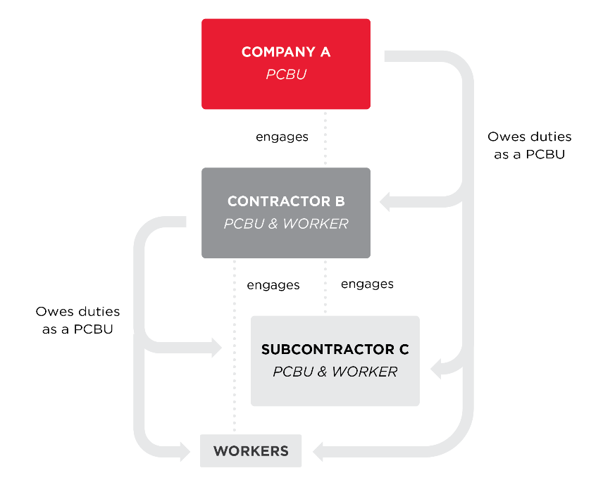

Individual contractor can be both a PCBU and a worker

In a contractual chain, an individual contractor (e.g. sole trader) will be both a PCBU and a worker. An individual contractor is a worker when engaged by a PCBU to perform work for it. For example, an owner truck driver contracted by a road logistics company to deliver goods from a retailer to customers.

PCBUs higher up the contractual chain will also owe a duty of care to the individual contractor as a worker if they caused the individual contractor to be engaged, or they influence or direct the individual contractor’s activities.

This means in a contractual chain an individual contractor may be a worker for multiple PCBUs. The individual contractor will owe a duty of care as a worker in relation to the work they carry out for PCBUs above them in the contractual chain.

At the same time, the individual contractor is a PCBU themselves as they are conducting a business as a sole trader (i.e. contracting their services to deliver the goods). As a PCBU they will have a duty to ensure, so far as is reasonably practicable, the health and safety of workers of any subcontractors they engage in the contractual chain (as well as any workers they engage). They also have a duty to ensure their own health and safety (while at work in their own business).

The key point to remember is that an individual contractor can be a worker and be owed a duty by all businesses further up the chain, and at the same time owe duties as a PCBU to themselves (while at work in their own business) and to other workers further down the chain.

### Self-employed persons

If you are self-employed you are a PCBU and have the primary duty of care for your own safety (while at work in your own business) and the safety of others. If a self-employed person is working for another PCBU (e.g. a self-employed welder who is contracted by a labour hire company), they are also a worker of that PCBU. For example, the self-employed welder must ensure, so far as is reasonably practicable, that the health and safety of workers and other people are not put at risk by their work. They also owe PCBU duties to any workers and subcontractors they hire. The self-employed welder must consult, cooperate and coordinate, so far as is reasonably practicable, with other contractors and the labour hire company to manage health and safety risks at the workplace.

**Case study – School refurbishment**

EM Construction has been engaged to undertake the refurbishment of a local school by the Department of Education. The project is valued at $500,000.

The Department of Education (as part of the State of NSW) is a PCBU and has obligations under the WHS Act to ensure the safety of its workers, including contractors it engages or whose work the Department influences or directs, so far as is reasonably practicable.

The Department has appointed EM Construction Pty Ltd as the Principal Contractor for the construction project. EM Construction is responsible for the management of day-to-day safety, including management of contractors, for the project. As the Principal Contractor, EM Construction must ensure that signs are installed outside the workplace which show their name and contract details and prepare and inform workers of the written WHS management plan for the workplace.

The Department tells EM Construction that it can make decisions on engaging contractors as needed and without consulting with the Department, since EM Construction will have day‑to‑day responsibility for the project. The Department establishes oversight arrangements which include regular project meetings and discussions on WHS issues.

EM Construction has duties as both a PCBU undertaking construction work and as the Principal Contractor managing the construction project.

**All independent contractors engaged by EM Construction are PCBUs** and their duties include:

* managing all WHS risks arising from their work so far as is reasonably practicable
* consulting, cooperating and coordinating with the Principal Contractor and other independent contractors about WHS matters
* being aware of the WHS management plan and complying with any site safety rules issued by the Principal Contractor.

**All independent contractors engaged or caused to be engaged, or whose work is influenced or directed by EM Construction, are workers of EM Construction (the Principal Contractor).**

**EM Construction and all independent contractors** owe obligations to each other and other people whose safety can be impacted by their work.

***Scenarios*** ***based on case study***

**Independent Contractor 1 – Archie’s Kitchens Pty Ltd**

EM Construction engages Archie’s Kitchens Pty Ltd to install a new kitchen in the school.

Archie’s Kitchens is a PCBU and has a primary duty to ensure the health and safety of its workers (including its subcontractors) and that others are not put at risk from its work so far as is reasonably practicable.

Archie’s Kitchens workers are also EM Construction workers. EM Construction owes duties to these workers as it caused the workers to be engaged when it contracted with Archie’s Kitchens to perform the kitchen work. EM Construction must ensure, so far as is reasonably practicable, the health and safety of Archie’s Kitchens workers and consult about WHS matters that affect them.

Archie’s Kitchens workers must take reasonable care for their own safety and take reasonable care that they do not put the health and safety of others at risk, such as keeping the work area free from trip and slip hazards.

**Independent Contractor 2 - SIM Plumbing and Electrical Pty Ltd**

Archie’s Kitchens consults with EM Construction about subcontracting some of the project to another business as it does not have the expertise to carry out plumbing and electrical work. EM Construction agrees. As a result, SIM Plumbing and Electrical Pty Ltd (SIM) is subcontracted by Archie’s Kitchens to do the plumbing and electrical work for the kitchen installation.

SIM is a PCBU and has a primary duty to ensure the health and safety of its workers (including any subcontractors) and that others are not put at risk from its work so far as is reasonably practicable.

SIM workers are also Archie’s Kitchens workers as they were caused to be engaged by Archie’s Kitchens to perform the plumbing and electrical work. Archie’s Kitchens must take all reasonably practicable steps to ensure the health and safety of SIM workers, for example managing the risk of exposure to dust during cabinet installation.

SIM workers are also EM Construction workers because they were caused to be engaged by EM Construction, who agreed that Archie’s Kitchens should engage SIM to perform part of the refurbishment work. EM Construction must ensure the health and safety of SIM workers and consult about WHS matters that affect them.

SIM workers must take reasonable care for their own safety and must take reasonable care that they do not put the health and safety of others at risk from their work.

**Sole trader – Star Tiling**

EM Construction engages Star Tiling to replace tiles in a bathroom at the school. Star Tiling is the registered business name of Joe Star, a sole trader.

Joe Star (trading as Star Tiling) is a PCBU and has a primary duty to ensure the health and safety of his workers (including any apprentices or contractors he engages) and that the health and safety of others is not put at risk by the work of his business so far as is reasonably practicable.

Joe Star is also carrying out work in his business. He must ensure his own health and safety while at work so far as is reasonably practicable.

Star Tiling workers are also EM Construction workers because they were caused to be engaged by EM Construction to perform the tiling work. EM Construction must ensure the health and safety of Star Tiling workers and consult about safety matters that impact on them.

Star Tiling workers are not Archie’s Kitchens workers as they are not engaged, or caused to be engaged, by Archie’s Kitchens and their work is not influenced or directed by them.

Star Tiling workers must take reasonable care for their own safety and must take reasonable care that they do not put the health and safety of others at risk from their work.

**Figure 3: Duties owed by EM Construction and contractors that sit beneath it in the contractual chain**(*This diagram follows on from the case study and scenarios on pages 5-6)

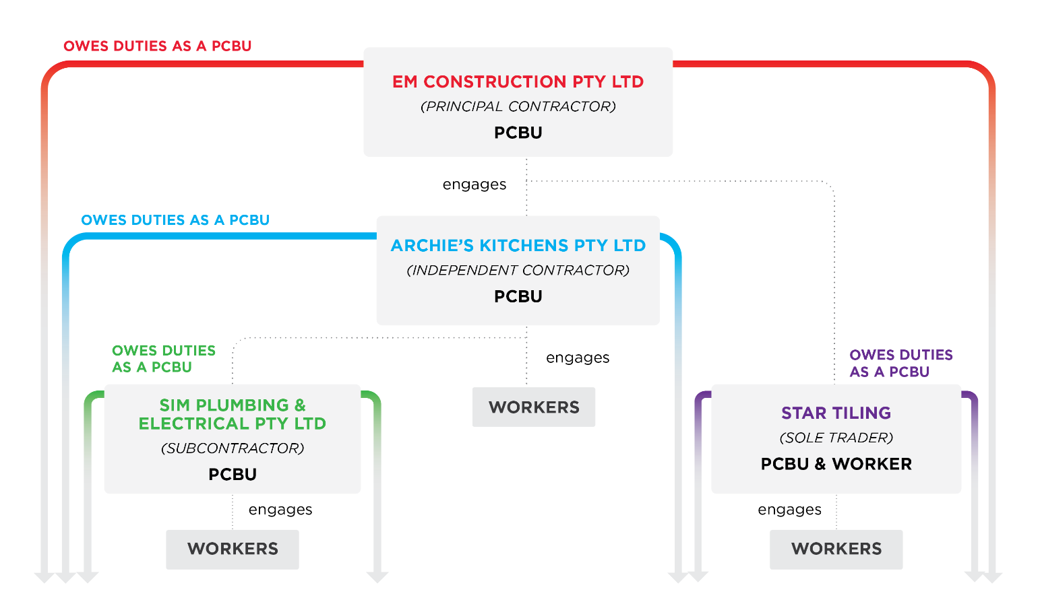

Working with other PCBUs and shared WHS duties  
  
In a contractual chain there will be multiple PCBUs who share the same WHS duties. PCBUs who share duties must each discharge their duty to the extent to which they have the capacity to influence and control the matter (whether that matter is a work activity, workers or the workplace).

The PCBU with the most influence and control over a matter will be in the best position to manage the associated risks. Determining which person or persons have the capacity to influence and control the work depends on the circumstances at the time. For example, at a housing construction site, subcontractors have some capacity to directly manage the risks associated with their own work and the activities of any worker they engage to carry out the work. The head contractor will also be able to influence and control the way work is carried out, and how risks are managed, by coordinating and monitoring the work and ensuring risk control measures are implemented.

PCBUs at the top of the contractual chain can build work health and safety into contractual management and take the lead in coordinating work health and safety practices down the chain. These PCBUs have important responsibilities in seeking assurance that systems to ensure worker safety are in place along the contractual chain and are functioning effectively. For example, although a head contractor may not be present on a housing construction site, they must still ensure the work is being carried out safely. The head contractor should check the subcontractor’s work procedures. The principal contractor (for construction projects over $250,000) must obtain any safe work method statements (for high-risk construction work) to ensure risks associated with the proposed work are addressed, and then visit the site as necessary to verify the work is being carried out safely.

PCBUs, regardless of their place in a contractual chain, have a duty to consult, cooperate and coordinate activities with all other PCBUs who they share a duty with, so far as is reasonably practicable. This helps avoid unnecessary duplication of activities, prevent gaps in managing health and safety risks and ensure that everyone’s WHS duties are met.

For example, a building manager and a business renting office space in the building, as PCBUs, will have the same duty to ensure toilet facilities are maintained at the workplace. It may not be practical or necessary for both PCBUs to maintain the toilet facilities, so they may arrange for only one of them to maintain the toilet facilities. In doing this and confirming the maintenance arrangements are in place and accessible to workers, each PCBU has ensured compliance with their duty.

PCBUs who share the same WHS duties must satisfy themselves there are safe systems of work in place that ensures worker safety and that these systems are functioning and are maintained. You should consider:

* planning ahead by thinking through every stage of the work
* thinking about how work carried out as part of the conduct of your business or undertaking could affect the work carried out by other PCBUs
* identifying risks at the workplace that need to be managed
* consulting with other PCBUs to agree on how risks will be managed and who is best placed to manage each risk, and
* clearly defining roles, responsibilities and actions.

PCBUs can enter into agreements with other PCBUs to make sure duties are met so long as it does not limit or modify their WHS obligations. It is good practice to make a record of any consultation or discussions you have and agreements you reach around how work will be carried out.

**Case study – Working with other PCBUs**

Springvale Management manages an office building. They contract out general office cleaning, including toilets and kitchen facilities to Shiny Bathrooms which is to be undertaken out of office hours on certain days. Springvale does not have direct control or influence over how Shiny will carry out the work, as they do not specify how cleaning is to be done and do not provide any equipment or chemicals to Shiny to use.

Springvale consults with Shiny to satisfy themselves that Shiny have adequate systems in place to ensure the health and safety of workers. Shiny cooperates with Springvale to verify that its workers have been trained in the use of the chemicals used for cleaning and are provided with personal protective equipment.

Workers of Shiny Bathrooms will work by themselves in the office building late at night. As Springvale has control and management of the office building, Shiny consults with Springvale to satisfy themselves of the security processes in place. Shiny cooperates with Springvale to make sure its workers are aware of and follow security processes – for example, to ensure that Shiny’s workers have access to the office carpark after hours which is secured with good lighting and easy access to the goods lift. They also coordinate to ensure workers are provided with security passes and are trained in security protocols and emergency procedures.

**Figure 4: Working with other PCBUs**

#### 

# Consultation with workers

PCBUs have a duty to consult with workers on WHS. Consultation is a two-way process between you and your workers to identify WHS issues, share views and information, participate in decision-making on health and safety matters and receive feedback on outcomes. If workers are represented by a health and safety representative, the consultation must involve that representative.

Each PCBU in the contractual chain must, so far as is reasonably practicable, consult with workers (and their representatives) who carry out work for them in the contractual chain. This includes giving workers a reasonable opportunity to express their views or raise issues about work health and safety at the workplace. Consultation should be done in a way that is accessible and can be understood by everyone, for example people who are culturally or linguistically diverse.

A PCBU must take into account the views of workers (and their representatives) and advise them of the outcome of the consultation.

For more information on consultation, cooperation and coordination see the [*Code of Practice: Work health and safety consultation cooperation and coordination*.](https://www.safeworkaustralia.gov.au/doc/model-code-practice-work-health-and-safety-consultation-cooperation-and-coordination)

**Figure 5: WHS consultation, cooperation and coordination**