Storage of flammable liquids

Guidance material

July 2020

**Disclaimer**

Safe Work Australia is an Australian Government statutory agency established in 2009. Safe Work Australia includes Members from the Commonwealth, and each state and territory, Members representing the interests of workers and Members representing the interests of employers.

Safe Work Australia works with the Commonwealth, state and territory governments to improve work health and safety and workers’ compensation arrangements. Safe Work Australia is a national policy body, not a regulator of work health and safety. The Commonwealth, states and territories have responsibility for regulating and enforcing work health and safety laws in their jurisdiction.

ISBN 978-1-76051-943-8 (Online PDF)

ISBN 978-1-76051-944-5 (Online DOCX)

**Creative Commons**

With the exception of the Safe Work Australia logo, this copyright work is licensed under a Creative Commons Attribution 4.0 International licence. To view a copy of this licence, visit creativecommons.org/licenses In essence, you are free to copy, communicate and adapt the work for non-commercial purposes, as long as you attribute the work to Safe Work Australia and abide by the other licence terms.

**Contact information**

Safe Work Australia | [info@swa.gov.au](mailto:info@swa.gov.au) | [www.swa.gov.au](http://swa.hosts.application.enet/business-support/Communication/Documents/www.swa.gov.au)

# Contents

Contents 3

Introduction 4

Who should use this guide? 4

What are flammable liquids? 4

Risk management 6

Identifying hazards 6

Assessing risks 9

Eliminating risks 9

Substitution 9

Isolation 10

Engineering controls 11

Administrative controls 12

Reviewing and maintaining controls 13

Example 14

Placards 15

# Introduction

## Who should use this guide?

If your business involves using, handling, generating or storing flammable liquids you must manage the [risks](https://www.safeworkaustralia.gov.au/glossary#risks) to health and safety associated with those liquids to protect both your workers and others at the workplace.

This guide provides practical advice for businesses that store small quantities of flammable liquids. You should seek specialist advice if you store large quantities of flammable liquids (i.e. [manifest quantities](https://www.safeworkaustralia.gov.au/safety-topic/hazards/chemicals/hazardous-chemical-records-and-signs-workplaces/placard-and-manifest-threshold-quantities)) or are unsure about how to manage risks at your workplace.

Be aware that you must ensure that flammable liquids are kept at the lowest practicable quantity for the workplace.

In this guide, the word ‘must’ indicates a legal requirement that must be complied with. The word ‘should’ indicates a recommended course of action.This guide is intended to supplement other information available from Safe Work Australia and should be read in conjunction with:

* the [model Code of Practice: How to manage work health and safety risks](https://www.safeworkaustralia.gov.au/resources-and-publications/model-codes-practice/model-code-practice-how-manage-work-health-and-safety-risks)
* the [model Code of Practice for Managing risks of hazardous chemicals in the workplace](https://www.safeworkaustralia.gov.au/resources-and-publications/model-codes-practice/model-code-practice-managing-risks-hazardous-chemicals-workplace), and
* the [Managing risks of storing hazardous chemicals in the workplace](https://www.safeworkaustralia.gov.au/resources-and-publications/guidance-materials/managing-risks-storing-chemicals-workplace) guide.

If you require assistance when designing and implementing the controls outlined in this guide, for example designing storage rooms, spill containment or ventilation systems, you should seek specialist advice.

This guide does not include information about requirements for containers in which flammable liquids are stored, or about requirements for labelling of containers. Further information about requirements for containers and labelling can be found in the [model Code of Practice for Labelling of Workplace Hazardous Chemicals](https://www.safeworkaustralia.gov.au/resources-and-publications/model-codes-practice/model-code-practice-labelling-workplace-hazardous-chemicals).

## What are flammable liquids?

Common examples of flammable liquids are fuels, solvents and thinners, alcohols, oil-based paints and resins.

Flammable liquids are classified according to the Globally Harmonized System of Classification and Labelling of Chemicals (GHS) when stored and used in workplaces, and the Australian Dangerous Goods code (ADG code) when transported. Classifying chemicals includes placing them into categories which reflect the severity of their hazard. You can often identify flammable liquids by the presence of warnings (as shown below) on their labels and in their safety data sheets.

The classification of a flammable liquid is determined by its flash point (the temperature at which it will will ignite) and its boiling point (because chemicals with lower boiling points tend to produce more vapour).

Table 1: GHS Category, ADG Class/packing group and associated label elements

|  |  |  |  |  |
| --- | --- | --- | --- | --- |
| Criteria | Flash point <230C, initial boiling point ≤350C | Flash point <230C, initial boiling point >350C | Flash point ≥230C and ≤600C | Flash point >600C and ≤930C |
| **GHS Category** | 1 | 2 | 3 | 4 |
| **GHS Pictogram** | The is the GHS flame pictogram - it depicts a fire. | The is the GHS flame pictogram - it depicts a fire. | The is the GHS flame pictogram - it depicts a fire. | No pictogram |
| **GHS Signal Word** | Danger | Danger | Warning | Warning |
| **GHS Hazard Statements** | Extremely flammable liquid and vapour | Highly flammable liquid and vapour | Flammable liquid and vapour | Combustible liquid |
| **ADG class and packing group (PG)** | Class 3: PG I | Class 3: PG II | Class 3: PG III | N/A |
| **ADG class label** | This is the dangerous goods class 3 label - it depicts a fire on a red background with the words 'FLAMMABLE LIQUID' | This is the dangerous goods class 3 label - it depicts a fire on a red background with the words 'FLAMMABLE LIQUID' | This is the dangerous goods class 3 label - it depicts a fire on a red background with the words 'FLAMMABLE LIQUID' | No class label as this is not a dangerous good. |

# Risk management

This section sets out a step-by-step process for identifying, assessing and controlling the risks associated with storing flammable liquids. It prioritises higher order controls, such as eliminating hazards. These controls are more reliable and must always be used where possible, over less effective controls such as signage and training.

Be aware that this guide provides only general advice about controlling the risks associated with small quantities of flammable liquids. Some specialised controls, such as using fully automated handling systems and inert atmospheres, are not discussed in this guide. If you identify other, more effective risk controls for your business you should use them where reasonably practicable.

More information about the risk management process, including how to identify hazards and assess risks can be found in the guide [Managing risks of storing chemicals in the workplace](https://www.safeworkaustralia.gov.au/resources-and-publications/guidance-materials/managing-risks-storing-chemicals-workplace), the [model Code of Practice: How to manage work health and safety risks](https://www.safeworkaustralia.gov.au/resources-and-publications/model-codes-practice/model-code-practice-how-manage-work-health-and-safety-risks) and [model Code of Practice: Managing risks of hazardous chemicals in the workplace](https://www.safeworkaustralia.gov.au/resources-and-publications/model-codes-practice/model-code-practice-managing-risks-hazardous-chemicals-workplace).

#### Consult your workers throughout the risk management process.

Having workers participate in discussions about health and safety is important. They are likely to know about the risks of their work and have an interest in keeping safe. You must consult with them to help you identify hazards and assess risks, and you should ask for their suggestions about managing those risks.

Getting workers involved will also help get staff on board with any changes that need to be made. It is best to keep staff involved throughout the process, let them know what’s changing and why.

More information on consulting with workers can be found in the [model Code of Practice: Work health and safety consultation, cooperation and coordination](https://www.safeworkaustralia.gov.au/resources-and-publications/model-codes-practice/model-code-practice-work-health-and-safety-consultation-cooperation-and-coordination).

## Identifying hazards

You must begin your risk management process by identifying hazards (that is, things and situations that could potentially cause harm to people).

Flammable liquids are a common source of fuel for fires and explosions, because they produce flammable vapour and ignite at low temperatures. Many fires start when flammable liquids are spilt or their containers are left open, and their vapours reach an ignition source such as an open flame.

Fire and explosion can result when the following three elements come together (commonly referred to as the fire triangle):

* a source of fuel (a flammable or combustible substance)
* a source of oxygen (usually in the air), and
* an ignition source (a source of energy sufficient to cause ignition).

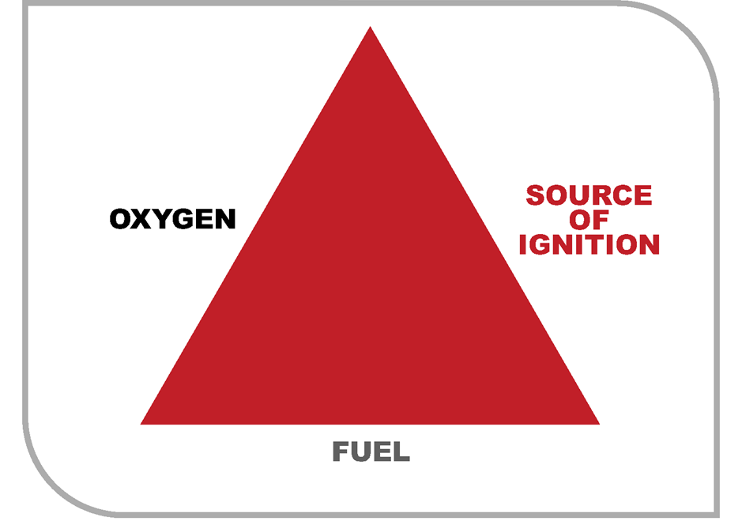

Figure 1: The fire triangle

* **Take stock of your flammable liquids**

The first step in managing risks associated with flammable liquids is to identify which types are stored at the workplace, and in what volumes. A list of hazardous chemicals used at your workplace and their current safety data sheets must be available in your workplace’s hazardous chemical register. However, it may also be useful to manually check your storage areas to see what they hold.

* **Identify other fire risk materials**

Flammable and combustible material should also be considered when managing the risks of a fire. These include items like wood or paper, which can easily ignite and increase the risk of a fire, and increase the fuel available in a fire.

If you have other fire risk materials, such as gas cylinders, aerosol spray cans and some fertilisers, you should also identify them in this step.

* **Identify ignition sources**

An ignition source can be any energy source that has the potential to ignite a fuel. You must identify any ignition source in your workplace that has the potential to ignite flammable or combustible material.

Examples of ignition sources are provided in the table below; you should refer to this list when assessing ignition sources at your workplace.

Table 2: Examples of possible ignition sources in the workplace

|  |  |
| --- | --- |
| Type of ignition source | Examples |
| Flame | Propane and oxy-acetylene torches, gas heaters, pilot lights, cigarette lighters. |
| Spark | Welding arcs, starters for fluorescent lighting, electric motors, electrical equipment like power points, switches and mobile phones. Static electricity, including from friction sources. Lightning, friction from drilling, grinding, scraping of metal on concrete. |
| Heat | Hot surfaces including light bulbs, ovens, radiators or heaters, flue pipes, vehicle engines and exhaust systems, pumps and generators. Exothermic chemical reactions (those which generate heat). |

* **Vapour clouds and hazardous areas**

Places where flammable gases, vapours, dusts, fumes and mists are likely to be present in the air in a flammable or explosive concentration are hazardous areas.

Flammable liquids can create clouds of flammable vapour when exposed to the air, either through open containers, pouring, mixing, or from a spill or leak. This vapour is invisible and can build up quickly. If an ignition source, such as a spark or open flame, is introduced into the area it may cause a fire or explosion. Even small quantities of flammable liquid can create a vapour cloud that can travel considerable distances and flashback to its point of generation if it meets a source of ignition. This is particularly the case when decanting or if the liquid is spilt.

You must identify any area where flammable vapours are likely to be present in your workplace. In general, where flammable liquids are stored in small quantities hazardous atmospheres should not result, provided that adequate ventilation is provided. In any case, you should ensure that ignition sources are not present in areas where flammable vapours may accumulate.

Chemicals in GHS Flammable Liquid Category 4, unlike other flammable liquids, do not ordinarily give rise to flammable vapours unless they are heated. This means they are less likely to ignite, but will provide fuel for a fire if one starts.

|  |  |
| --- | --- |
| This is an image of a question mark | EXPERT HELP  The assessment of hazardous areas is a complex process that needs specialist knowledge. If you believe a hazardous area is present at your workplace it is recommended that you engage a specialist to help you assess and manage the risks it poses. |

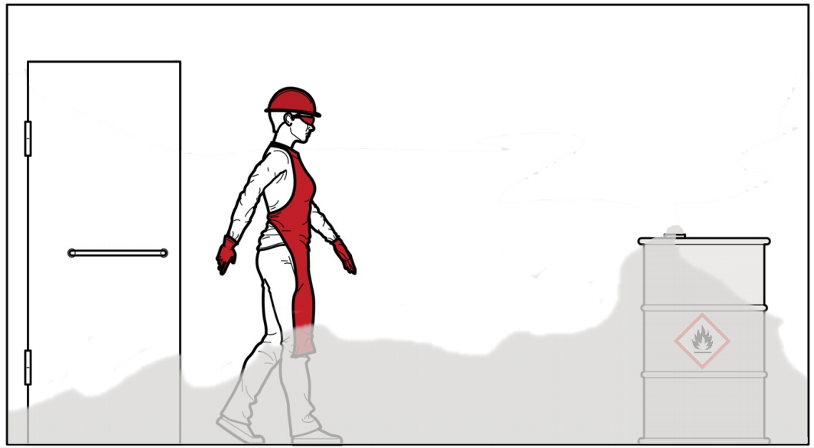

Figure 2: Stored flammable liquids may create hazardous vapours

## Assessing risks

Once you have identified hazards you need to consider the associated risks (that is, what could happen if someone is exposed to those hazards, and the likelihood of it happening). If you already know the risks, and how to control them effectively, you may simply implement the controls.

Controls that must be applied to manage the risks of flammable liquids are set out below.

## Eliminating risks

You must always begin by eliminating risks where it is reasonably practicable, as this is the most effective way to stop an incident from occurring.

* **Dispose of any unnecessary flammable liquids.** This includes flammable waste chemicals and chemicals which you no longer need. Ensure that flammable liquids are disposed of in accordance with local waste disposal requirements.
* **Dispose of combustible materials.** Excess combustible material, like wood or paper, can act as fuel for a fire.
* **Limit the amount of flammable liquids you store.** Limiting your hazardous chemicals to only those you require, and buying products only as you need them, helps eliminate the risks posed by flammable liquids.

## Substitution

If it is not possible to eliminate a flammable liquid from your workplace the risk must be minimised so far as is reasonably practicable. To minimise the risk, consider substituting it for a less hazardous alternative.

* **Substitute flammable liquids with non-flammable alternatives.** Such as by using nails instead of chemical adhesives.
* **Substitute highly flammable liquids for less flammable liquids.** Such as by using a water-based ink instead of a solvent-based ink.

When substituting chemicals it’s important to carefully consider whether new chemicals have other hazards that need to be managed in different ways.

## Isolation

Physically separate flammable liquids from people, ignition sources and other hazards to minimise the risks of a fire.

* **Store your chemicals away from workers and other hazards.** Chemicals are best stored away from normal work areas to reduce the risk of any accidental spills or damage of hazardous chemicals. For example, don’t store them:
  + where vehicles will be operating
  + in thoroughfares or near exits, or
  + in the same area as food or personal belongings.
* **Separate flammable chemicals from ignition sources.** If a flammable liquid or its vapour cloud comes into contact with an ignition source a fire will occur. The following steps should be taken to remove ignition sources:
  + choose a chemical storage location that is away from any ignition sources that cannot easily be removed (such as pilot lights)
  + eliminate any ignition sources near the chemical storage (for example, install non-sparking lights)
  + do not allow ignition sources to be introduced to the flammable liquid storage area
  + do not allow hot work (grinding, heating, welding etc.) near the flammable liquid storage areas, and
  + store flammable liquids in a flammable liquids cabinet where practicable.
* **Separate incompatible chemicals.** This can be done by separating chemicals within the same storage area (segregation) or by storing incompatible chemicals in separate storage areas.

More information about separating chemicals can be found in [Managing risks of storing chemicals in the workplace](https://www.safeworkaustralia.gov.au/resources-and-publications/guidance-materials/managing-risks-storing-chemicals-workplace) guide. As a general guide, the following separation distances are recommended between flammable liquids and other hazardous chemicals.

Table 3: Recommended separation distances between flammable liquids and other hazardous chemicals

|  |  |
| --- | --- |
| Types of Chemical | Separation distance |
| Other hazardous chemical such as gases under pressure and corrosive chemicals | Minimum three metres separation |
| Other fire risk chemicals such as flammable gases, pyrophoric chemicals, self-heating chemicals and oxidisers* | Minimum five metres separation |
| Highly reactive chemicals such as self-reactive chemicals, organic peroxides and explosives should be in completely separate storage areas | Isolate completely |

*flammable solids can typically be stored with three metres of separation

Separating incompatible chemicals can also include the use of barriers, such as flame-proof cabinets.

You should also refer to the safety data sheet for each hazardous chemical you store for more information about its storage requirements. Safety data sheets should be stored in your workplace hazardous chemical register and may be obtained from the manufacturer, importer or supplier of the chemical.

## Engineering controls

Consider which engineering controls, if any, could further control the risks. Note that not all of the controls described here will be suitable for every business.

Engineering controls are built into the design of plant, equipment or processes to minimise their hazards. Engineering controls are a very reliable way to control worker exposures as long as the controls are designed, used and maintained properly.

|  |  |
| --- | --- |
| This is an image of a question mark | EXPERT HELP  Engineering controls are a very reliable way to control the risks of hazardous chemicals as long as they are designed, used and maintained properly. If you are unsure about how to use engineering controls at your workplace, consider engaging a specialist to help you assess and manage the risks it poses. |

Key engineering controls that should be considered for the storage of flammable liquids are:

* **Bunding and drainage.** Bunding and spill trays should be in place (separation distances should be measured horizontally from the edge of any spill containment system). Incompatible chemicals should never share the same bunding or drainage systems, and liquids should not be stored above solids. Information about incompatabilities can be found on the safety data sheets for your chemicals.
* **Ventilation.** Design storage areas with sufficient natural ventilation so mechanical ventilation is not needed, or consider mechanical ventilation to extract flammable vapours that may accumulate. The design, installation and use of ventilation systems is discussed in depth in the [Managing risks of storing chemicals in the workplace](https://www.safeworkaustralia.gov.au/resources-and-publications/guidance-materials/managing-risks-storing-chemicals-workplace) guide.
* **Intrinsically safe electrical equipment.** Intrinsically safe electrical equipment means equipment which cannot produce a spark capable of starting a fire. If there is an area where a flammable vapour may be present, only intrinsically safe equipment should be used within it. This includes ensuring that any lighting or fittings is intrinsically safe. A hazardous area classification can help identify where this kind of equipement is required (see page 6).
* **Earthing and bonding to manage risk of static electricity**. Static electricity can be created from a range of activities including the transfer of flammable liquids. Accumulation of static electricity may lead to a spark igniting flammable vapours.
* **Enclosed transfer systems with vapour recovery connections.** Using enclosed transfer systems (rather than splash filling containers) can reduce the amount of flammable vapour produced when flammable liquids are transferred from one vessel to another.
* **Fire-fighting and fire protection systems.** If your workplace has a risk of fire, you must install fire-fighting equipment and fire protection systems. You must consider the types and quanties of chemicals used, handled and stored when deciding on the firefighting equipment and fire protection systems. These can include:
  + alarms and smoke detectors
  + fire extinguishers
  + fire doors and fire rated barriers, and
  + automated fire control systems such as sprinklers.

## Administrative controls

Administrative controls must be used to provide additional protection, if any risk remains after implementing substitution, isolation and engineering controls. Examples of administrative controls for flammable liquids include:

* **Written rules and procedures for using and storing flammable liquids.** For example:
  + keep lids open only for the period required for transfer
  + minimise exposed surface areas
  + avoid splash filling containers
  + minimise the temperature of liquids being transferred, and
  + clean up leaks and spills immediately using a spill kit.
* **Training.** For example:
  + how to safely use, store and handle flammable chemicals, and
  + how to respond to a fire (i.e. use a fire extinguisher, evacuate, contact emergency services).
* **Signage.** For example:
  + signs at the entrance to storage areas warning workers and others not to introduce ignition sources.

## Reviewing and maintaining controls

Risk controls are not ‘set and forget’ measures. Care must be taken to ensure they remain effective. Be prepared and organise:

* **A storeroom inspection schedule.** The [Managing risks of storing hazardous chemicals in the workplace](https://www.safeworkaustralia.gov.au/resources-and-publications/guidance-materials/managing-risks-storing-chemicals-workplace) guide has a checklist of what you should include.
* **Maintenance and testing schedule for engineering controls, including safety equipment.** Manufacturers should be able to provide information on recommended frequency of inspection, maintenance and testing. Maintenance is essential to ensure that engineering controls, such as mechanical ventilation and intrinsically safe electrical equipment, continue to operate effectively.
* **Regular staff training.** This should include inductions for new workers, and can include regular safety talks and refreshers for ongoing staff.

When reviewing controls, it is important to ask if anything has changed since the controls were put in place. For example, if you are now storing different chemicals they may need to be segregated differently, or the latest safety data sheet may contain new information. You should consult with your staff to help you identify any new or changed hazards, and any risk controls that are not operating effectively.

For more information on storing hazardous chemicals see the [Managing risks of storing hazardous chemicals in the workplace](https://www.safeworkaustralia.gov.au/resources-and-publications/guidance-materials/managing-risks-storing-chemicals-workplace) guide.

# Example

A spray-painting shop stores various paints and an organic solvent for equipment cleaning and paint thinning. The manager of the shop reviews the chemical’s safety data sheets, which are kept in the shop’s hazardous chemical register. He learns the following about the chemicals they store:

* The paints stored at the workplace can ignite, but do not sustain combustion. Despite this, they are still capable of creating a flammable vapour cloud if the containers are left open or a spill is not cleaned up.
* The solvent used is highly flammable. While only small quantities of the solvent are needed at any one time, larger quantities are often kept on site so that it does not need to be reordered regularly.

The spray-painting shop has a dedicated storage area where the paints and solvents are kept. A second, dedicated work area is used for thinning and mixing paints. No portable ignition sources (e.g. radio or fans) are allowed to be brought into the dedicated work area, or close to the dedicated work area. While there is fixed electrical equipment in the area (e.g. stirrer) it is rated as intrinsically safe in accordance with the relevant Australian Standard.

The storage area and work area have ventilation systems in place to remove any vapours that might accumulate if flammable liquids are spilt or their containers are left open.

Any flammable waste chemicals generated at the shop are stored overnight prior to disposal by a local waste company. There have been no reported spills in the past 12 months and no fires have occurred. Smoking is prohibited and that procedure is strictly adhered to.

**Result:** To supplement the existing controls, the manager decides to:

* Keep only small quantities of the solvent on site. The manager decides to buy smaller quantities more often, rather than buying and storing large quantities.
* Ensure the solvents and flammable liquid waste are stored in a lockable, flame-proof cabinet.
* Schedule another review in 12 months time.

# Placards

Placards are special signs required at some workplaces under work health and safety laws. You must display placards if you store hazardous chemicals above the placard quantities listed in the [Placard and manifest requirements under the model Work Health and Safety Regulations](https://www.safeworkaustralia.gov.au/safety-topic/hazards/chemicals/hazardous-chemical-records-and-signs-workplaces/placard-and-manifest-threshold-quantities), or if you store hazardous chemical in bulk (in containers that hold more than 500 litres or kilograms).

For flammable liquids, the placard quantites are:

* Category 1 flammable liquids – 50 litres
* Category 2 flammable liquids – 250 litres
* Category 3 flammable liquids – 1,000 litres
* Category 4 flammable liquids – 10,000 litres

Placards are also required if the combined quantitiy of category 1, 2 and 3 flammable liquids stored at the workplace exceeds 1,000 litres, even if the flammable liquids do not exceed their individual placard quantities.

Specific placard requirements are set out in Schedule 13 to the [model Work Health and Safety Regulations](https://www.safeworkaustralia.gov.au/doc/model-whs-regulations), but have been summarised below.

#### Outer warning placards

Outer warning placards are required if the quantity of hazardous chemicals at the workplace exceeds the placard quantity. An outer warning placards must be located at each entrance to the workplace that may be used by emergency services and must look like this:

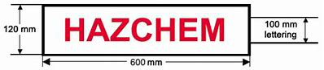

Figure 3: Outer warning placards dimensions

#### Placards for hazardous chemicals in packages or intermediate bulk containers (IBCs)

Placards for hazardous chemicals in packages or IBCs are required if the quantity of hazardous chemicals stored at the workplace exceeds the placard quantity.

If category 1, 2 or 3 flammable liquids are stored in packages (containers that hold 500 litres or less) or IBCs, placards must be displayed:

* at the entrance to any store room or storage area where the liquids are stored, and
* at the entrance to any building in which the liquids are stored.

Package and IBC storage placards for category 1, 2 or 3 flammable liquids look like this:

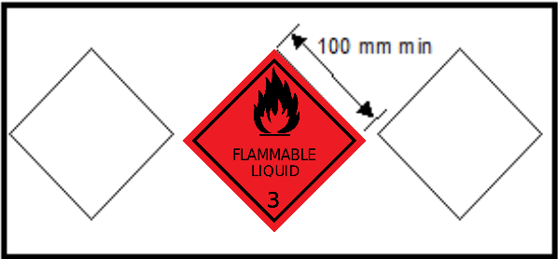

Figure 4: Package storage placard for Category 1, 2 or 3 flammable liquids

If you store only category 4 flammable liquids, the placard shown below is used instead:

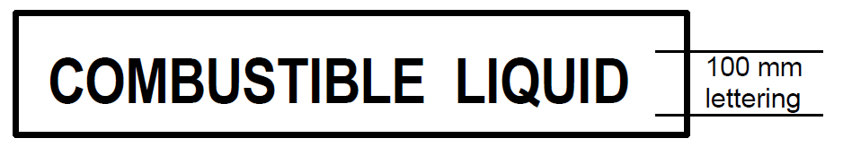

Figure 5: Package storage placards for Category 4 flammable liquids

Other package storage placards may also be required, depending on the other hazards of chemicals stored in the same building. The placards at the entry to the store will only include the class labels of the chemicals in that store that exceed the relevant placard quantity.

#### Placards for hazardous chemicals stored in bulk

If hazardous chemicals are stored in a bulk container (a container that holds more than 500 kilograms or litres, but not an IBC), placards must be placed on or adjacent to the container regardless of the total quantity of the hazardous chemical in the workplace. The placard for hazardous chemicals stored in bulk looks like this:

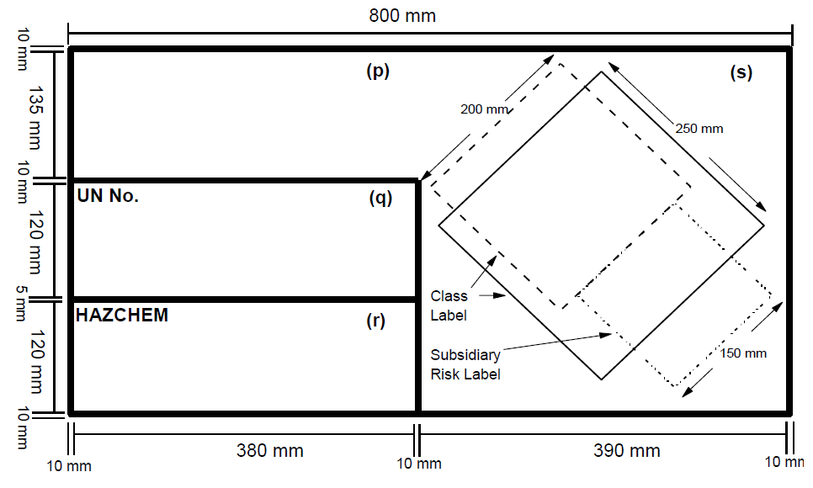

Figure 6: Bulk storage placards for hazardous chemicals

The placard must include the following information, as specified in the ADG code:

* in space (p)—the proper shipping name for the hazardous chemical
* in space (q)—the UN Number for the hazardous chemical
* in space (r)—the Hazchem Code for the hazardous chemical
* in space (s)—the class label and subsidiary risk label for the hazardous chemical

Note that if you are storing a category 4 flammable liquid in bulk, the combustible liquid placard (see Figure 5 above) must be placed on or adjacent to the container instead.