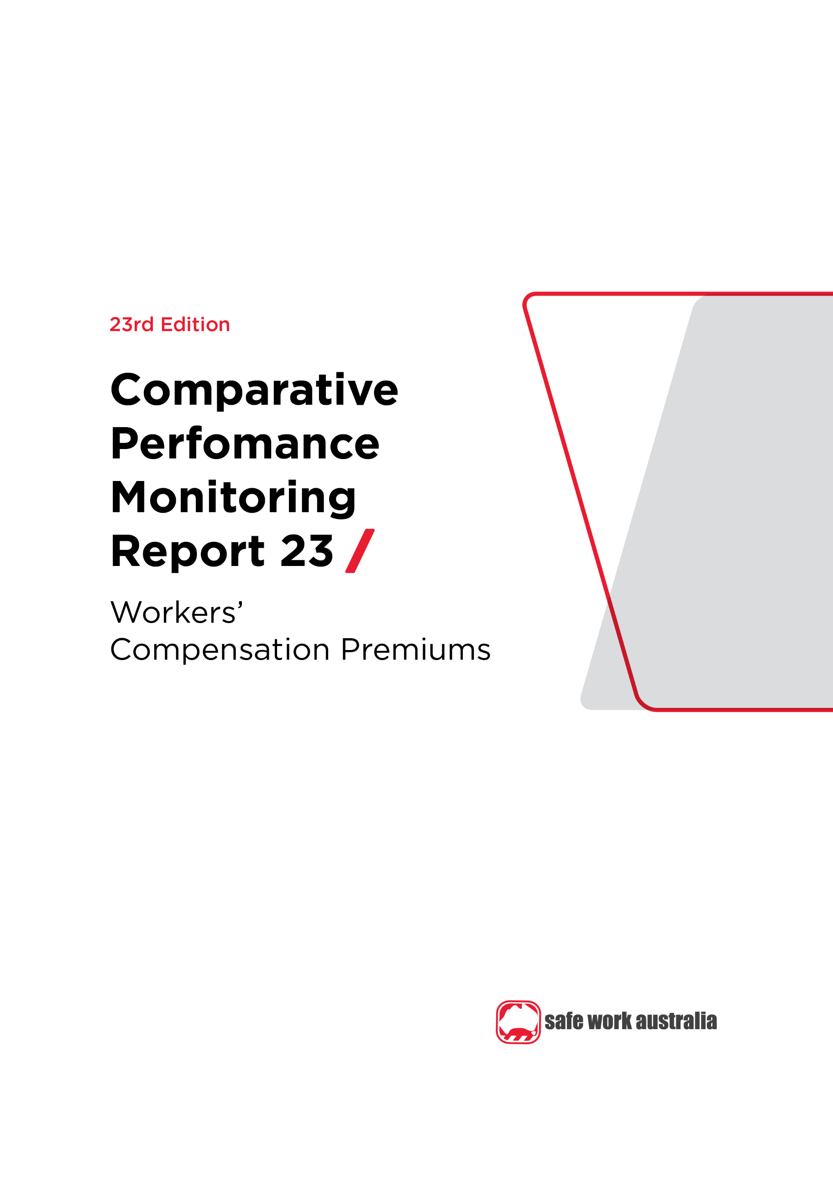

Disclaimer

Safe Work Australia is an Australian Government statutory agency established in 2009. Safe Work Australia includes Members from the Commonwealth, and each state and territory, Members representing the interests of workers and Members representing the interests of employers.

Safe Work Australia works with the Commonwealth, state and territory governments to improve work health and safety and workers’ compensation arrangements. Safe Work Australia is a national policy body, not a regulator of work health and safety. The Commonwealth, states and territories have responsibility for regulating and enforcing work health and safety laws in their jurisdiction.

**ISSN 2209-9158**

Creative Commons

With the exception of the Safe Work Australia logo, this copyright work is licensed under a Creative Commons Attribution 4.0 International licence. To view a copy of this licence, visit creativecommons.org/licenses. In essence, you are free to copy, communicate and adapt the work, even commercially, as long as you attribute the work to Safe Work Australia and abide by the other licence terms.

Contact information

Safe Work Australia | <mailto:info@swa.gov.au> | [www.swa.gov.au](http://www.swa.gov.au)

Contents

**Foreword 4**

**1. Workers’ compensation premiums 6**

**1.1 Standardised average premium rates by jurisdiction 6**

Indicator 13 – Standardised average premium rates (including insured and self-insured sectors) by jurisdiction 7

**1.2 Standardised average premium rates by industry 7**

Indicator 14 – Australian average premium rates by industry 8

Indicator 14a – Standardised premium rates for Agriculture, forestry and fishing by jurisdiction 9

Indicator 14b – Standardised premium rates for Mining by jurisdiction 10

Indicator 14c – Standardised premium rates for Manufacturing by jurisdiction 11

Indicator 14d – Standardised premium rates for Electricity, gas, water and waste services by jurisdiction 12

Indicator 14e – Standardised premium rates for Construction by jurisdiction 13

Indicator 14f – Standardised premium rates for Wholesale trade by jurisdiction 14

Indicator 14g – Standardised premium rates for Retail trade by jurisdiction 15

Indicator 14h – Standardised premium rates for Accommodation and food services by jurisdiction 16

Indicator 14i – Standardised premium rates for Transport, postal and warehousing by jurisdiction 17

Indicator 14j – Standardised premium rates for Information, media and telecommunications by jurisdiction 18

Indicator 14k – Standardised premium rates for Financial and insurance services by jurisdiction 19

Indicator 14l – Standardised premium rates for Rental, hiring and real estate services by jurisdiction 20

Indicator 14m – Standardised premium rates for Professional, scientific and technical services by jurisdiction 21

Indicator 14n – Standardised premium rates for Administrative and support services by jurisdiction 22

Indicator 14o – Standardised premium rates for Public administration and safety by jurisdiction 23

Indicator 14p – Standardised premium rates for Education and training by jurisdiction 24

Indicator 14q – Standardised premium rates for Healthcare and social assistance by jurisdiction 25

Indicator 14r – Standardised premium rates for Arts and recreation services by jurisdiction 26

Indicator 14s – Standardised premium rates for Other services by jurisdiction 27

Appendix 1 — Explanatory notes 28

Premium rates and entitlements 28

Appendix 2 – Jurisdictional contact information 31

Foreword

This is the 23rd edition of the Comparative Performance Monitoring (CPM) report which provides trend analyses about work health and safety and workers’ compensation schemes operating in Australia and New Zealand.

This report has been compiled and coordinated by Safe Work Australia with assistance from representatives of all work health and safety and workers’ compensation authorities in Australia and New Zealand. Through a partnership of governments, employers and employees, Safe Work Australia leads the development of national policy to improve WHS and workers’ compensation arrangements across Australia.

The report is presented in the following sections:

* *Work health and safety performance* – provides an overview of work health and safety performance across Australia and New Zealand through analysing trends in serious claim rates and work-related fatalities across jurisdictions.
* *Work health and safety compliance and enforcement activities* – includes a jurisdictional comparison of workplace interventions, inspectorate activity, safety notices, enforceable undertakings, legal proceedings and fines.
* *Workers’ compensation premiums* –includes a national and jurisdictional overview of the standardised average premium rates by industry in the past 5 years (this section).
* *Entitlements under workers’ compensation (scenarios)* – illustrates the differences in entitlement levels across jurisdictions under several scenarios.
* *Workers’ compensation funding – assets, liabilities and expenditure* – includes information about the different funding arrangements of the schemes and compares the differences in scheme funding arrangements and finances.
* *Workers’ compensation disputes* – includes information about disputes against an insurer’s decision or decisions relating to compensation.

Previous editions of the CPM report also included return to work rates as measured in the National Return to Work Survey. At the time of writing, the latest available survey results were from the 2018 Survey. For trend data on the return to work rates (from 2012 to 2018) please refer to the [*22nd edition of the CPM (Part 3)*](https://www.safeworkaustralia.gov.au/resources-and-publications/statistical-reports/comparative-performance-monitoring-report-22nd-edition-part-3). Results from the 2021 National Return to Work Survey will be published on the [Safe Work Australia](https://www.safeworkaustralia.gov.au/data-and-research/measuring-return-work-outcomes) website from late 2021.

Readers may find the [*Comparison of Workers’ Compensation Arrangements in Australia and New Zealand*](https://www.safeworkaustralia.gov.au/workers-compensation/comparing-workers-compensation-australia) useful as it discusses the way that each scheme deals with key aspects such as coverage, benefits, self-insurance, common law and disputes.

*About the data*

Data in this publication may differ from jurisdictional annual reports due to the use of different definitions and the application of adjustment factors to aid in the comparability of data.

These statistics should be considered in the broader context of the COVID-19 pandemic when comparing data over previous periods. The potential impact of the COVID-19 pandemic on this data are explored in the [*COVID-19 and Safe Work Australia data*](https://www.safeworkaustralia.gov.au/resources-and-publications/statistical-reports/covid-19-and-safe-work-australia-data) report.

The CPM does not currently include information or data from other industry-specific regulators that have responsibilities with respect to WHS and workers’ compensation. These include national industry-based regulators with compliance and enforcement roles such as the National Heavy Vehicle Regulator, the National Rail Safety Regulator and the National Offshore Petroleum Safety and Environmental Management Authority, and other agencies with responsibility for industry‑specific compensation claims. Further information on these regulators can be found on their respective websites.

In this report ‘Australian Government’ is used for indicators relating to WHS and workers’ compensation matters under the Australian Government jurisdiction, while ‘Comcare’ is used for the indicators relating to premium rates and entitlements.

This image contains the key findings for CPM 23 – Workers’ compensation premiums.
The key findings include that the standardised average Australian premium rate is 1.29% of payroll in 2019-20, a 3% increase since 2015-16. 

In 2019-20 the average premium rate in the Agriculture, forestry and fishing industry was the highest at 3.54% of payroll, and the lowest was in the Financial and Insurance industry at 0.23% of payroll. 

On average, the jurisdiction with the highest premium rate in 2019-20 was the Australian Capital Territory at 1.75% of payroll and the lowest was Comcare at 0.67% of payroll.

1. Workers’ compensation premiums

Workers’ compensation is a compulsory form of insurance for all employers in Australia. It provides protection to employees if they suffer a work-related injury or illness. Workers’ compensation premiums are paid by employers for this insurance, with the premium generally determined based on the amount of wages paid, as well as the industry and claim history of the employer.

The premium rates in this chapter are for policies that provided coverage during the financial years 2015‑16 to 2019-20. The premium rates reported are ‘earned premium’. Earned premium is defined as the amount allocated for cover in a financial year from premiums collected during the previous and current financial years, while written premium is defined as the amount of premium recorded for a policy at the time it is issued. The premiums reported are allocated for defined periods of risk, irrespective of when they were actually paid, enabling rates to be compared for each financial year. Goods and Services Tax charged on premiums is not included in the reported rates as most Australian employers recoup part or all this tax through input tax credits.

Standardised average premium rates by jurisdiction

*About average premium rates*

Premium rates published also vary to those published by the jurisdictions as adjustments are made to the data to enable jurisdictional comparisons. To increase comparability, adjustments have been applied to this indicator including:

* the use of Australian and New Zealand Standard Industrial Classification (ANZSIC) 2006 instead of ANZSIC 1993,
* the exclusion of provision for coverage of journey claims,
* the inclusion of self-insurers,
* the inclusion of superannuation as part of remuneration, and
* the standardisation of non-compensable excesses imposed by each scheme.

The effect of each of these adjustments is shown in *Appendix 1 – Table 2: Effect of adjustment factors on premium rates in 2019-20*, in the *Explanatory Notes*.

To be consistent with Australian jurisdictions, the New Zealand premium information includes the levy on employers to fund the workers’ compensation portion of the ‘Residual Claims Account’. This account relates to workers’ compensation claims incurred prior to 1 July 1999 but excludes the liability for pre-1992 non‑work injuries for earners.

Information about jurisdictional workers’ compensation arrangements is available from the [*Comparison of Workers’ Compensation Arrangements in Australia and New Zealand*](https://www.safeworkaustralia.gov.au/workers-compensation/comparing-workers-compensation-australia) publication that can be found on the [Safe Work Australia](https://www.safeworkaustralia.gov.au) website.

Standardised average premium rates

Indicator 13 shows that the standardised Australian average premium rate was 1.29% of payroll in 2019‑20, a **reduction of 3%** over the 5 year reporting period.

Indicator 13 – Standardised average premium rates (including insured and self-insured sectors) by jurisdiction

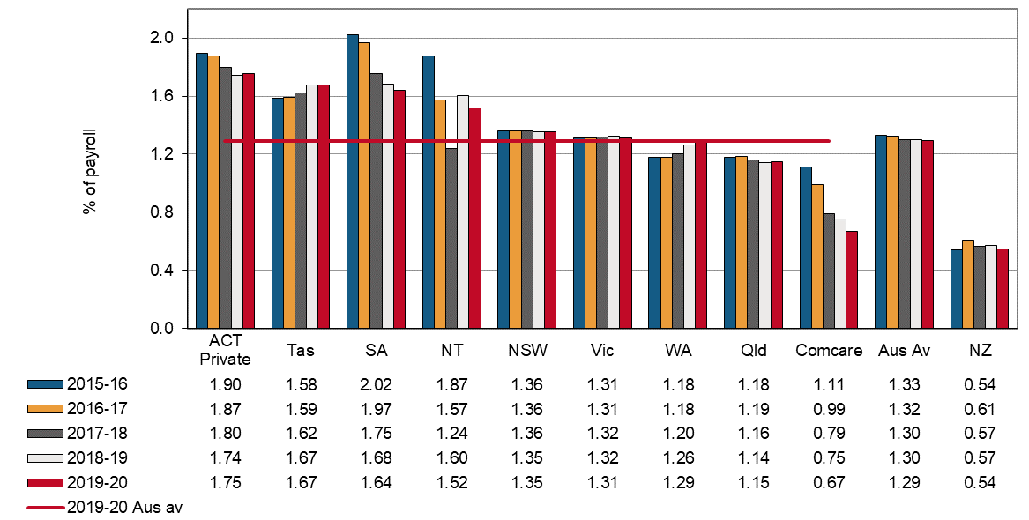

The Australian Capital Territory (Private) continued to record the highest average premium rate in the nation at 1.75% of payroll. This was followed by Tasmania (1.67% of payroll) and South Australia (1.64% of payroll). Conversely, Comcare recorded the lowest average premium rate among all Australian jurisdictions at 0.67% of payroll. This is a **reduction of 11%** from the previous year and a **reduction of 40%** from the 2015-16 financial year.

The New Zealand standardised average premium rate was 0.54% of payroll in 2019-20; substantially lower than the rate recorded for Australia. One reason for the lower rate in New Zealand is that the New Zealand scheme does not provide coverage for the same range of mental health conditions as the Australian schemes.

Standardised average premium rates by industry

The average premium rates by industry in Australia for the period from 2015-16 to 2019-20 are shown in Indicator 14 on the next page.

The Agriculture, forestry and fishing industry recorded the highest average premium rate at 3.54% of payroll in 2019–20. The lowest premium rate was recorded by the Financial and insurance services industry at 0.23%.

Premium rates for 7 out of the 19 industries have increased in the past 5 years, however significant decreases were seen in the Public administration and safety industry with average premium rates **reduced by 17%** since the 2015-16 financial year.

Indicator 14 – Australian average premium rates by industry

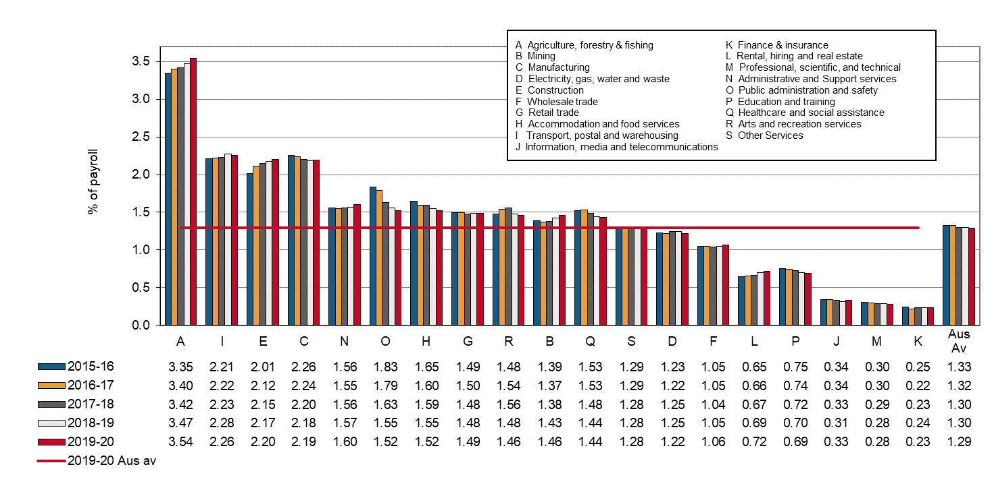

Standardised average premium rates by industry and jurisdiction

Presented below is a comparison of standardised average premium rates across the Australian jurisdictions for each of the 19 industry groups listed in Indicator 14. Not all jurisdictions are included under each industry, as some industries will not be relevant for certain jurisdictions, particularly Australian Government (Comcare).

# Agriculture, forestry and fishing

* The Australian average premium rate in the Agriculture, forestry and fishing industry increased slightly each year of the 5 year period to 3.54% of payroll in 2019-20. This was the highest average premium rate recorded across all industries.
* Western Australia and the Northern Territory experienced the largest **increases of 9% and 7%** respectively compared to the previous financial year, with the Northern Territory having the highest premium rate of the Australian jurisdictions at 6.61% of payroll.
* The New Zealand premium rate for this industry was 1.59% of payroll, a **decrease of 5%** from the previous financial year.

Indicator 14a – Standardised premium rates for Agriculture, forestry and fishing by jurisdiction

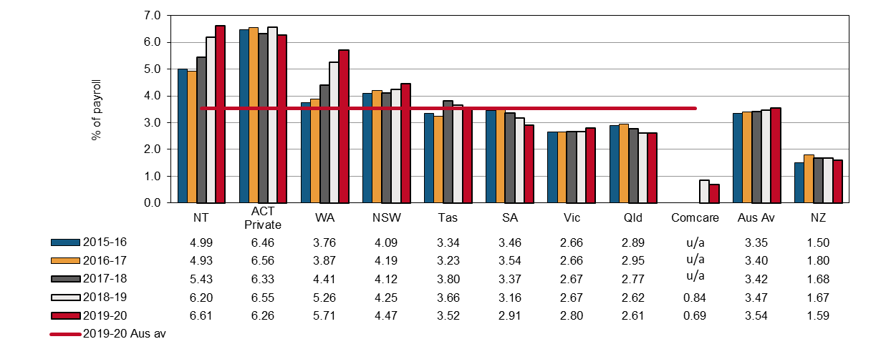

u/a – Data is unavailable or not collected

# Mining

* The Australian average premium rate in the Mining industry increased slightly to 1.46% of payroll for the 2019-20 financial year.
* Since 2018-19, the largest increase was observed in the Northern Territory (**h up 27%**), followed by Victoria (**h up 14%**).
* The Australian Capital Territory (Private) and Tasmania experienced the highest decreases in their premium rates (**i down 18% and 13%** respectively) since the previous financial year.
* Western Australia had the lowest premium rate (0.89% of payroll) for this industry in 2019‑20.
* The New Zealand premium rate for Mining **decreased by 17%** to a rate of 0.53% of payroll in 2019–20, substantially lower than the Australian average and any Australian jurisdiction.

Indicator 14b – Standardised premium rates for Mining by jurisdiction

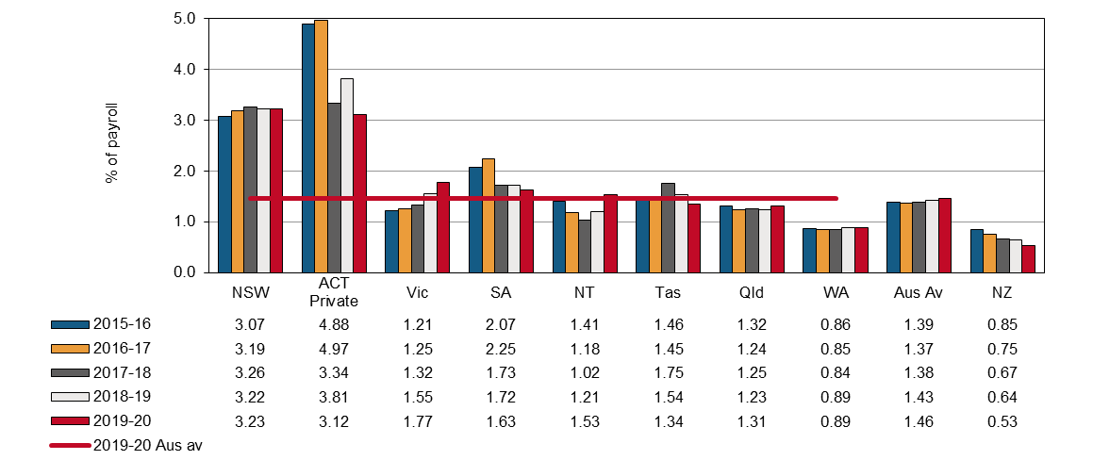

# Manufacturing

* The Australian average premium rate in the Manufacturing industry increased slightly since the previous year to 2.19% of payroll in 2019-20.
* Despite **increasing by over 50%** from the previous financial year, Comcare’s premium rates for this industry (0.21% of payroll) were significantly lower than those of the remaining Australian jurisdictions.
* Apart from a **29% decrease** in the average premium rate in South Australia (from 3.45% of payroll in 2015-16 to 2.45% of payroll in 2019-20), there were few notable changes in these rates in the 5 year reporting period.
* Excluding Comcare and South Australia, the premium rates of the Manufacturing industry in the remaining Australian jurisdictions vary less than 10% since 2015-16.
* New Zealand had a premium rate of 0.64% of payroll in 2019-20, a **decrease of 2%** from the previous financial year.

Indicator 14c – Standardised premium rates for Manufacturing by jurisdiction

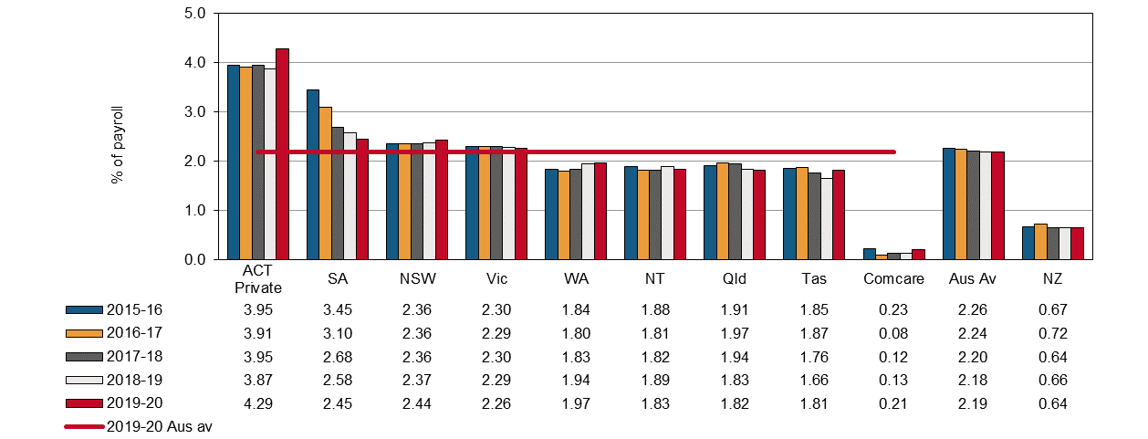

# Electricity, gas, water and waste services

* The Australian average premium rate in the Electricity, gas, water and waste services industry was 1.22% of payroll in the 2019-20 financial year, largely unchanging throughout the 5 year period.
* All but 3 jurisdictions recorded slight decreases in their average premium rates in 2019-20 compared to the previous financial year.
* The Australian Capital Territory (Private) and Comcare experienced large **increases of 20% and 11%** respectively, with the Australia Capital Territory recording the highest premium rate of the Australian jurisdictions of 2.62% of payroll.
* The Northern Territory had the lowest premium rate in this industry at 0.67% of payroll, followed closely by Western Australia at 0.80%.
* New Zealand had a premium rate of 0.62% of payroll in 2019-20, an **increase of 4%** from the previous financial year.

Indicator 14d – Standardised premium rates for Electricity, gas, water and waste services by jurisdiction

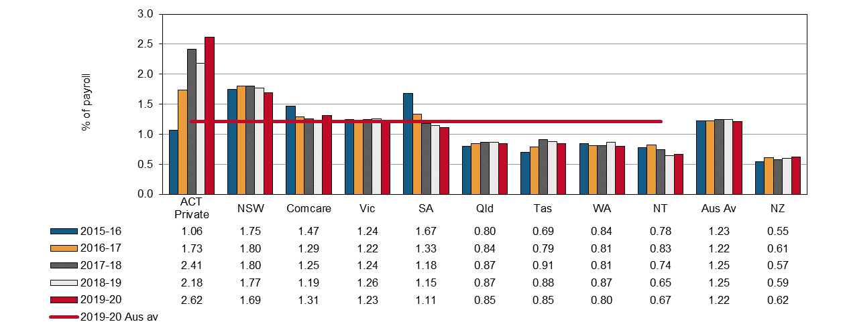

# Construction

* The Australian average premium rate in the Construction industry rose steadily over the previous 5 years to 2.20% of payroll in 2019-20.
* Comcare premium rates for this industry rose in 2019-20 to 0.24% of payroll, from a previous low of 0.05% in 2018-19.
* The average premium rate Northern Territory **increased by 11%** since 2018-19, to be 2.39% of payroll.
* The remainder of the Australian jurisdictions experienced minor changes of less than 5%.
* New Zealand recorded an average premium rate of 1.25% of payroll in 2019-20, a **reduction of 6%** from the previous financial year.

Indicator 14e – Standardised premium rates for Construction by jurisdiction

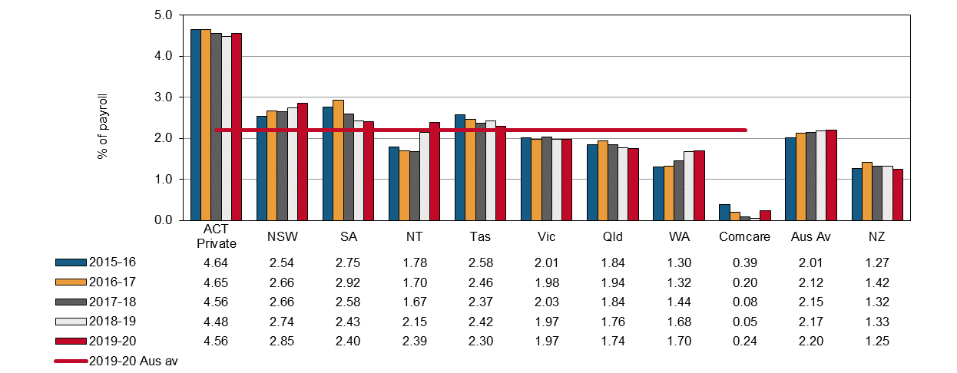

# Wholesale trade

* The Australian average premium rate in the Wholesale trade industry has remained relatively stable since 2015-16 at 1.06% of payroll.
* The Australian Capital Territory (Private) recorded increases each year of the 5 year period to a high of 2.56% of payroll, the highest of the Australian jurisdictions.
* The Northern Territory had the second highest rate of the jurisdictions with 1.84% of payroll, followed by Tasmania and Western Australia (1.37% and 1.32% respectfully).
* The New Zealand premium rate for this industry in 2019-20 reduced slightly compared to the previous financial year to be 0.39% of payroll.

Indicator 14f – Standardised premium rates for Wholesale trade by jurisdiction

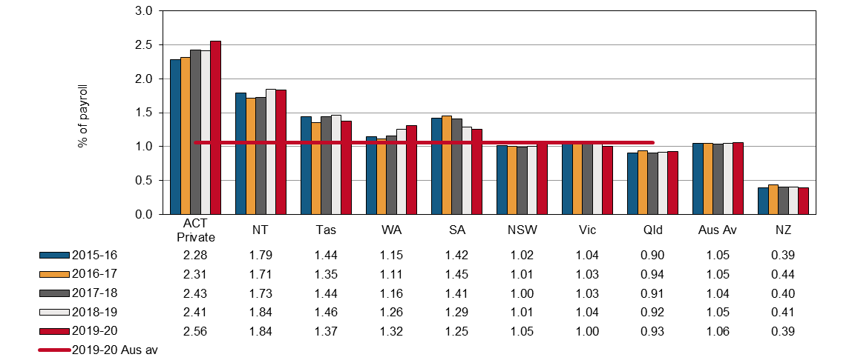

# Retail trade

* The Australian average premium rate in the Retail trade industry was steady at 1.49% of payroll in 2019-20, with almost no fluctuations in the past 5 year period.
* In 2019-20, the Australian Capital Territory (Private) had the highest premium rate of the Australian jurisdictions at 2.61% of payroll, followed by the Northern Territory (1.84%) and New South Wales (1.83%).
* Queensland recorded the lowest premium rate in this industry at 1.24% of payroll.
* Tasmania reported a **decrease of 8%** in average premium rates since the previous financial year. All other jurisdictions reported variations of 3% or less.
* The New Zealand premium rate for this industry in 2019-20 was 0.42% of payroll.

Indicator 14g – Standardised premium rates for Retail trade by jurisdiction

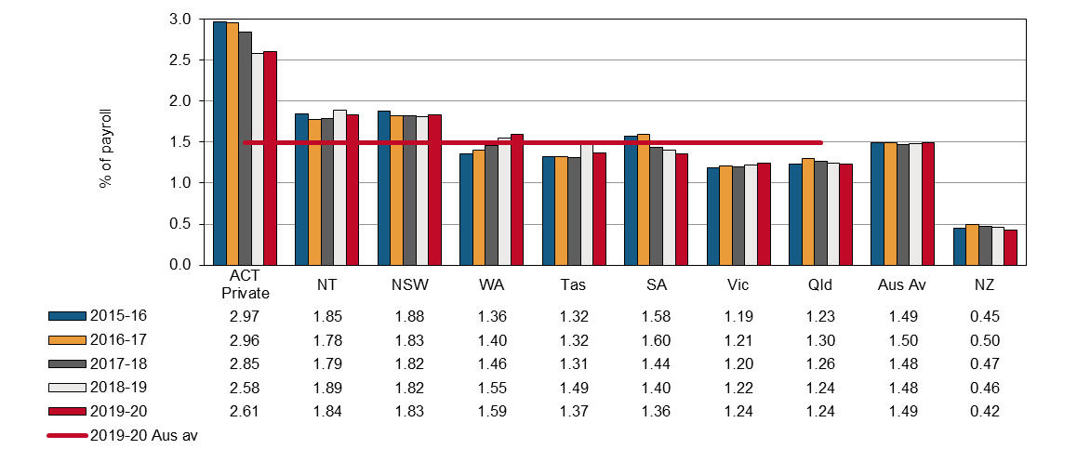

# Accommodation and food services

* The Australian average premium rate in the Accommodation and food services industry was 1.52% of payroll at 2019-20.
* Since 2016-17, Comcare recorded a large decrease in average premium rates from a high of 5.63% of payroll to 1.40% in 2019-20.
* All other jurisdictions reported variations of less than 6% since 2018-19.
* The Australian Capital Territory (Private) recorded the highest average premium rate of the jurisdictions at 2.16% of payroll and Victoria recorded the lowest rate at 1.21% of payroll in 2019‑20.
* The New Zealand premium rate for this industry in 2019-20 was 0.49% of payroll.

Indicator 14h – Standardised premium rates for Accommodation and food services by jurisdiction

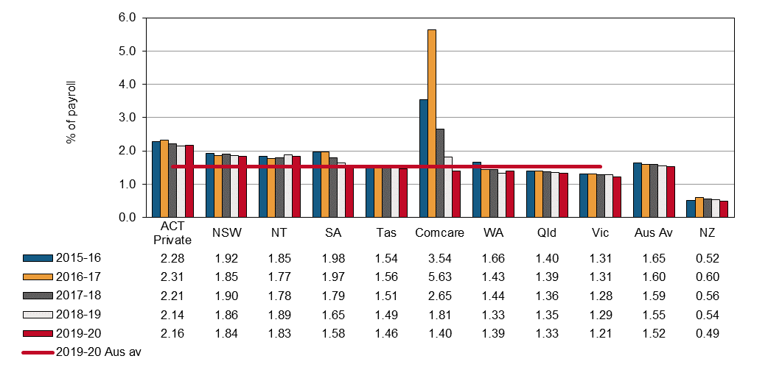

# Transport, postal and warehousing

* The Australian average premium rate in the Transport, postal and warehousing industry over the 5 year period **increased by 2%** from 2.21% in 2015-16 to 2.26% in 2019-20.
* The Australian Capital Territory (Private) had the highest rate of the jurisdictions at 4.85% of payroll in 2019‑20, followed by South Australia with 3.33%.
* Comcare and Tasmania saw premium rates **reduced by 9% and 8%** respectfully since the previous financial year. All other Australian jurisdictions reported variations of less than 2%.
* The New Zealand premium rate for this industry in 2019-20 was 1.03% of payroll.

Indicator 14i – Standardised premium rates for Transport, postal and warehousing by jurisdiction

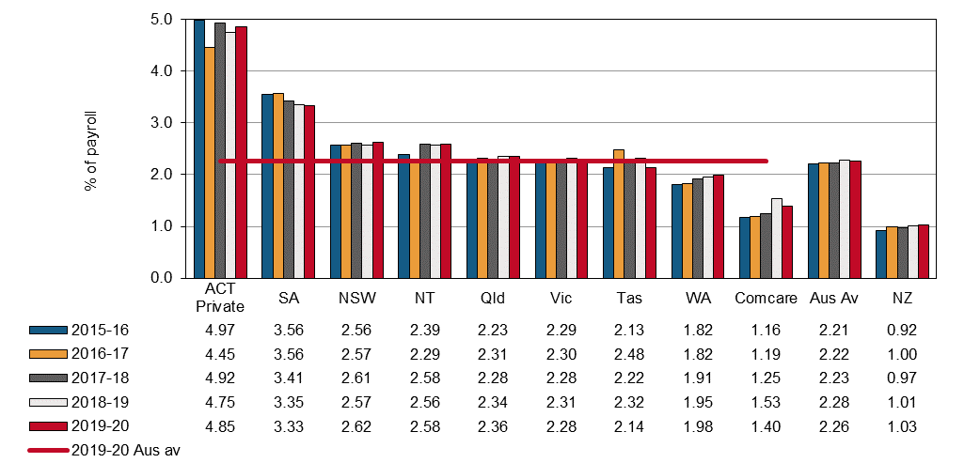

# Information, media and telecommunications

* The Australian average premium rate in the Information, media and telecommunications industry **decreased by 2%** over the 5 year period to 0.33% in 2019-20.
* The Northern Territory had the highest premium rate of the jurisdictions at 1.76% of payroll, more than **5 times the national average**.
* Tasmania recorded a **14% decrease** in average premium rates to a rate of 0.90% of payroll since the previous financial year.
* There were relatively high increases in Comcare, Queensland and the Australian Capital Territory (Private) (**h up 24%, 15% and 13%** respectively) since the previous financial year. However, the 2019-20 rates recorded Comcare and the Australian Capital Territory (Private) remained less than their average premium rates in 2015‑16.
* The New Zealand premium rate for this industry in 2019-20 was 0.16% of payroll.

Indicator 14j – Standardised premium rates for Information, media and telecommunications by jurisdiction

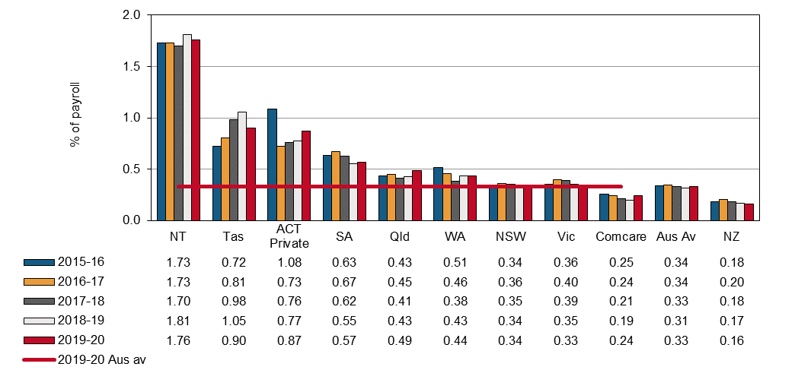

# Financial and insurance services

* The average adjusted Australian premium rate in the Financial and insurance services industry **decreased by 6%** over the 5 year period from 0.25% of payroll in 2015-16 to 0.23% in 2019-20.
* The Northern Territory recorded the highest premium rate at 0.95% of payroll, an **increase of 47%** from the previous financial year.
* The Australian Capital Territory (Private) recorded a **28% decrease** in premium rates to 0.67% of payroll; the lowest it has been in recent years.
* The lowest premium rate for this industry was that of Comcare at 0.17% of payroll, a **reduction of 13%** from the previous financial year.
* The New Zealand premium rate for this industry in 2019-20 was 0.11% of payroll.

Indicator 14k – Standardised premium rates for Financial and insurance services by jurisdiction

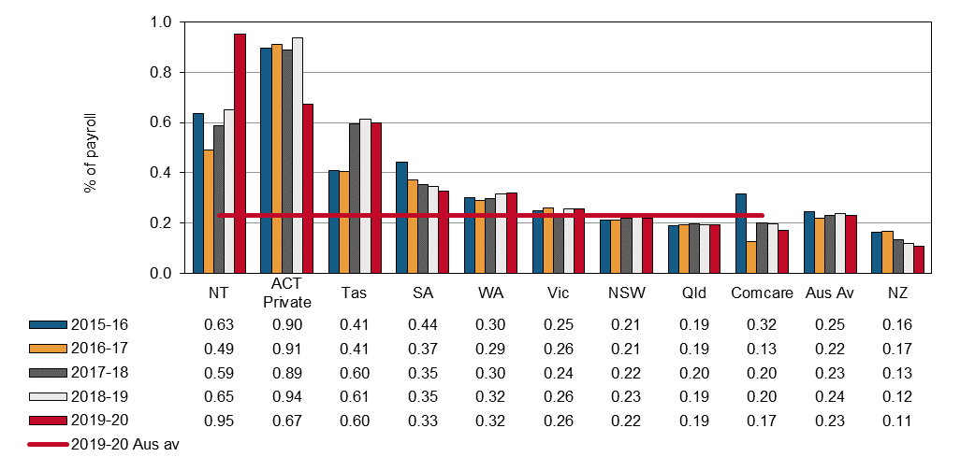

# Rental, hiring and real estate services

* The Australian average premium rate in the Rental, hiring and real estate services industry **increased by 4%** over the previous financial year, to 0.72% of payroll in 2019-20.
* The Australian Capital Territory (Private) recorded the highest rate at 1.08% of payroll in 2019‑20. The Northern Territory saw a sharp **increase of 29%** since the last financial year with rates at 1.05% of payroll.
* The premium rate for Comcare **decreased by 16%** from the previous financial year to 0.66% of payroll in 2019-20 (a rate below the Australian average).
* The New Zealand premium rate in 2019–20 **lowered by 7%** since the previous financial year, to 0.41% of payroll.

Indicator 14l – Standardised premium rates for Rental, hiring and real estate services by jurisdiction

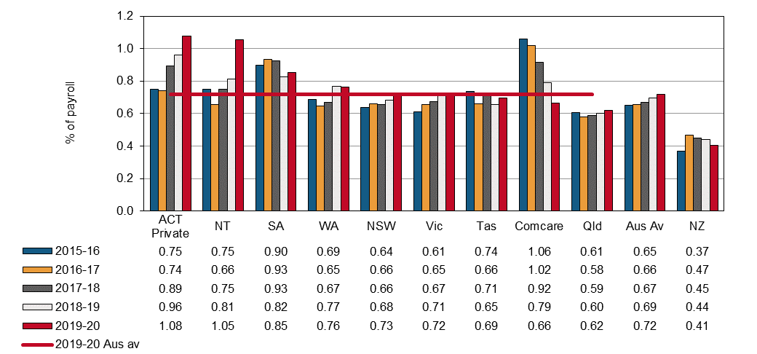

# Professional, scientific, and technical services

* The Australian average premium rate in the Professional, scientific, and technical services industry remained steady at 0.28% of payroll in 2019-20.
* Rates in the Northern Territory were significantly higher than that those of other Australian jurisdictions. The recorded rate of 1.51% of payroll was **540%** than that of the national average. Tasmania recorded the second highest premium rate of 0.63% of payroll.
* From a high of 0.91% in 2015-16, Comcare recorded reduced premium rates for this industry to 0.37% of payroll in 2019-20 (**i decrease of 60%**).
* The New Zealand average premium rate in this industry was 0.15% of payroll.

Indicator 14m – Standardised premium rates for Professional, scientific and technical services by jurisdiction

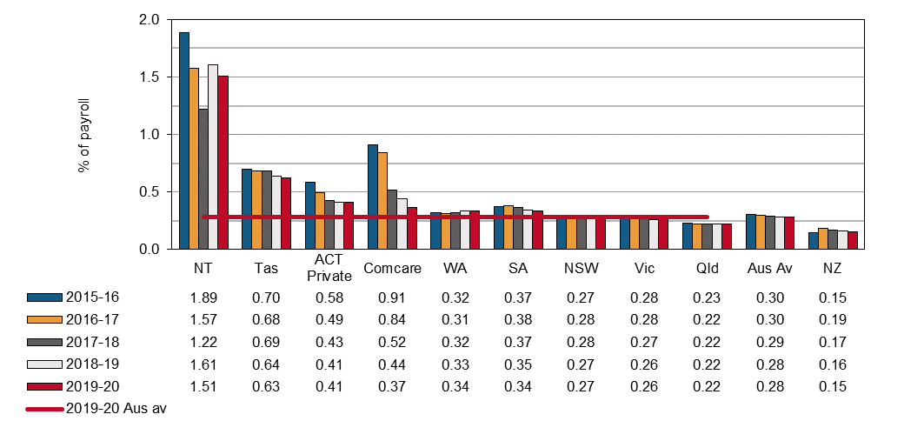

# Administrative and Support services

The Australian average premium rate for this industry increased slightly (**h up 3%**) in 2019-20 to 1.60% of payroll.

* Tasmania recorded the highest premium rates of the jurisdictions at 2.11% of payroll in 2019-20. This was a **decrease of 18%** from the previous financial year. Tasmania is followed by the Australian Capital Territory (Private) with rates of 2.04%.
* NSW rates increased to 1.71% of payroll (an **increase of 9%** since the previous financial year) in 2019-20.
* Comcare recorded a decrease in rates for the third consecutive year (**decreasing 23%** since the previous financial year), to a rate of 0.17% of payroll, **90% less** than the Australian average.
* The New Zealand average premium rate was 0.65% of payroll in 2019-20, a slight decrease (**i down 4%**) from the previous financial year.

Indicator 14n – Standardised premium rates for Administrative and support services by jurisdiction

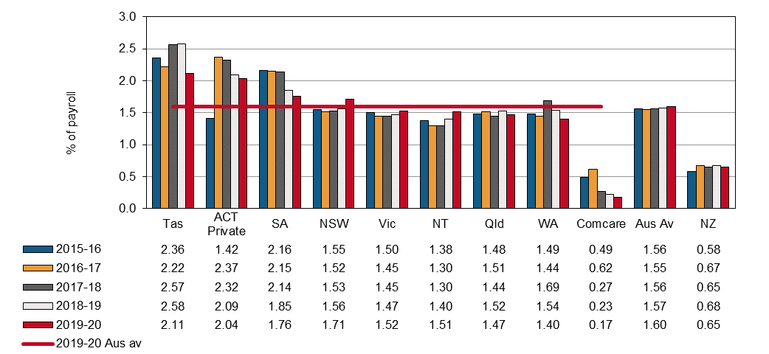

# Public administration and safety

* The Australian average premium rate for this industry decreased in 2019-20 to 1.52% of payroll.
* Notable increases were seen in Tasmania and Western Australia (both **h up 12%** from the previous year) and decreases for Comcare (**i down 19%**).
* The Australian Capital Territory (Private) had the highest premium rates for this industry at 2.95% of payroll, while Comcare had the lowest at 0.80%.
* The scheme covering the Australian Defence Force personnel is excluded from this industry division as they are covered by the *Military Rehabilitation and Compensation 2004 Act* administered by the Department of Veterans’ Affairs.
* New Zealand has shown a steady decrease over the recent 5 year period to a low of 0.17% of payroll in 2019-20.

Indicator 14o – Standardised premium rates for Public administration and safety by jurisdiction

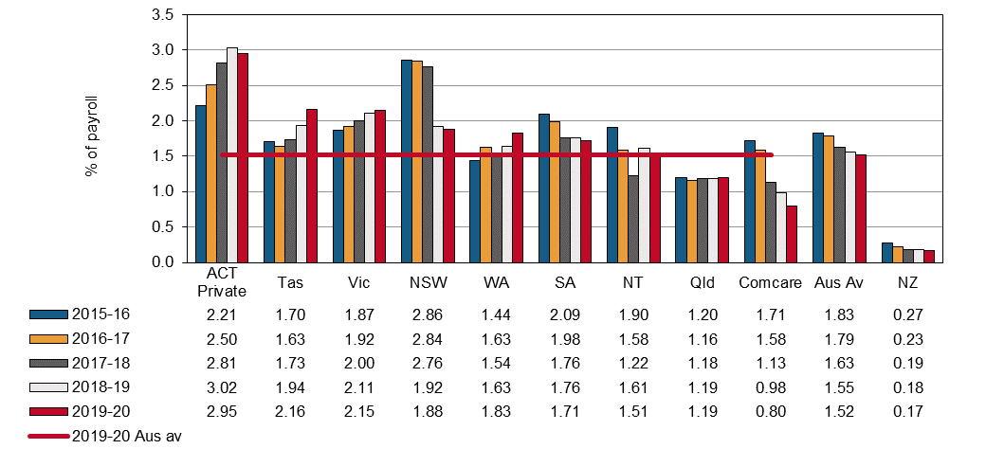

# Education and training

* The Australian average premium rate in the Education and training industry was steady at 0.69% of payroll, a **reduction of 8%** over the last 5 years.
* Comcare recorded decreases in rates for this industry from a high of 1.37% of payroll in the 2016‑17 to 0.08% in 2019-20, the lowest rate of the Australian jurisdictions and **88% lower** than the national average.
* The Australian Capital Territory (Private) recorded the highest premium rates of the jurisdictions at 1.47% of payroll.
* The New Zealand premium rate remained steady at 0.26% of payroll in 2019-20.

Indicator 14p – Standardised premium rates for Education and training by jurisdiction

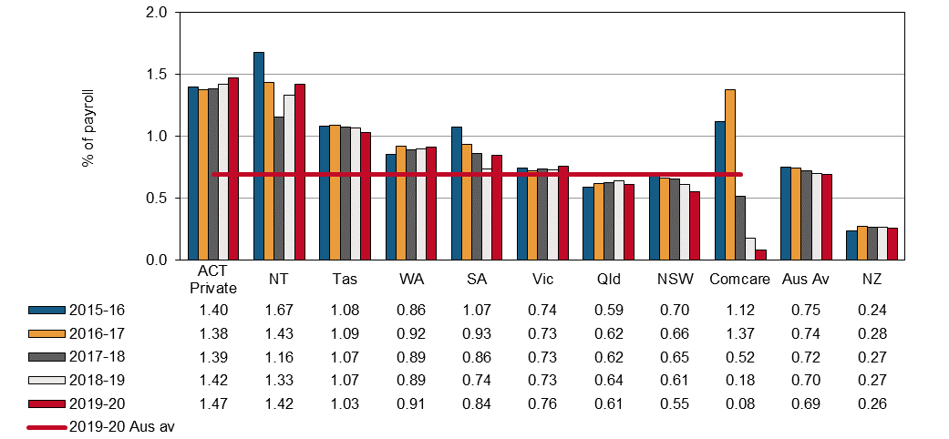

# Healthcare and social assistance

* The Australian average premium rate in the Healthcare and social assistance industry was steady at 1.44% of payroll in 2019-20.
* Comcare recorded decreases in rates for this industry from a high of 2.75% of payroll in the 2016‑17 financial year to 1.00%, the lowest rate of all the Australian jurisdictions in 2019-20.
* The Australian Capital Territory (Private) had the highest premium rates of the jurisdictions at 2.37% of payroll or **65% above** the Australian average.
* The Northern Territory premium rate had been reducing in recent years, however rates have sharply increased this financial year (**h up 24%**) compared to the previous financial year to 1.34% of payroll. This is the first time it has risen higher than the Australian average since 2015-16.
* New Zealand’s average premium rate for this industry has remained unchanged at 0.33% of payroll since the 2016-17 financial year.

Indicator 14q – Standardised premium rates for Healthcare and social assistance by jurisdiction

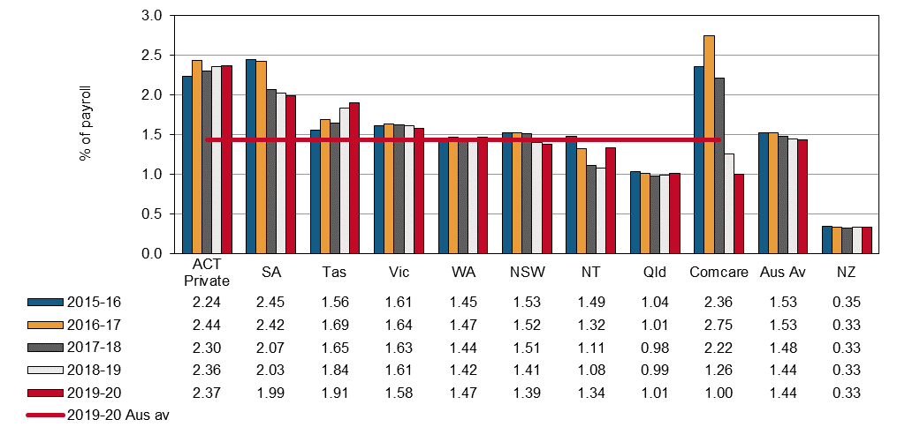

# Arts and recreation services

* The Australian average premium rate in the Arts and recreation services industry was 1.46% of payroll in the 2019-20 financial year.
* Comcare recorded decreased rates for this industry from a high of 1.93% of payroll in 2015‑16 to 0.83% in 2019-20, the lowest rate of the Australian jurisdictions at **43% less** than the Australian average.
* The Australian Capital Territory (Private) and South Australia have relatively higher premium rates for this industry, at 2.33% and 1.90% of payroll.
* Premium rates in Western Australia have risen to 1.53% of payroll, the first time it has exceeded the national average in 5 years.
* The New Zealand average premium rate for this industry was recorded at 0.73% of payroll in 2019‑20. It has fluctuated around the 0.75% level over the 5 year period.

Indicator 14r – Standardised premium rates for Arts and recreation services by jurisdiction

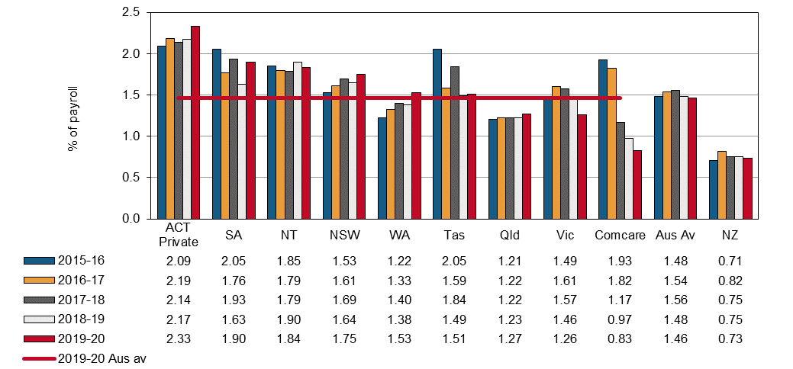

# Other services

* The Australian average premium rate in the Other services industry has been relatively steady at 1.28% of payroll in 2019-20.
* Queensland was the only jurisdiction to have rates lower than the national average at 0.96% of payroll or **25% less** than the Australian average.
* New Zealand recorded a premium rate of 0.50% of payroll in 2019-20.

Indicator 14s – Standardised premium rates for Other services by jurisdiction

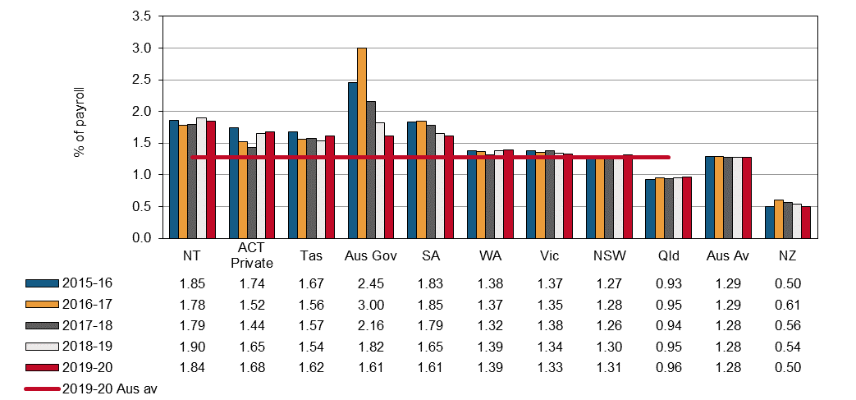

Appendix 1 — Explanatory notes

Premium rates and entitlements

Issues affecting the comparability of premium rates across the schemes include:

* differences in benefits and coverage for certain types of injuries, in particular the coverage of the journey to and from work
* differences in claims management arrangements
* variations in the funding arrangements for delivery of work health and safety services, with some jurisdictions providing degrees of cross-subsidisation
* differences in the definitions of wages for premium setting purposes, including whether superannuation contribution is part of wages
* different scheme excess deductibles (note that wage under-declaration has not been accounted for as it is considered to have a similar prevalence in each jurisdiction)
* different levels of self-insurance
* different industry mixes
* differences in premium calculation methodology, and
* different actuarial assumptions used in the calculation of premium rates.

## Premiums in the self-insured sector

Most jurisdictions allow large employers to self-insure their workers’ compensation if they prove that they can manage the associated financial and other risks. Jurisdictions with a large proportion of employees under self-insurance arrangements include New South Wales, South Australia, Tasmania and Comcare. Significantly fewer self-insurers operate in Victoria, Queensland, Western Australia and the Australian Capital Territory Private Scheme. A number of methodologies are employed in this report to obtain an estimate of the amount of premium that self-insurers would pay.

## Employer excess factors

Some schemes have non-compensable excesses where the employer pays the first five or 10 days compensation and/or meets medical expenses to a maximum amount. To improve comparability of premium rates a common deductible for the first five days of compensation with no medical costs has been applied. The factors applied to the insured sector data in each jurisdiction are shown in Appendix 1 – Table 1. Adjustment factors have also been applied to the self-insured sector to make the data consistent with the common deductible of the first five days compensation with no medical costs.

## Journey factors

All jurisdictions except Victoria, Western Australia, Tasmania, Comcare and New Zealand provide some level of coverage for journey claims. Hence, an estimated amount equal to the cost of providing this coverage has been removed from the premium rates of the jurisdictions that provide this type of coverage. The factors applied are shown in Appendix 1 – Table 1. In New Zealand, journey claims are covered by a different scheme.

Appendix 1 – Table 1: Premium rate adjustment factors (%)

| **Jurisdiction** | **Employer excess factors** | | | **Journey** |
| --- | --- | --- | --- | --- |
| **Insured sector** | | **Self-insured** |
| **Time lost excess** | **Medical expenses** | **Time lost excess** |
| New South Wales | -2.1 | n/a | -3.5 | n/a |
| Victoria | 2.0 | 0.8 | -2.5 | n/a |
| Queensland | n/a | n/a | n/a | -6.8 |
| Western Australia | -3.3 | n/a | n/a | n/a |
| South Australia | -2.5 | n/a | -3.8 | n/a |
| Tasmania | -2.8 | n/a | -2.5 | n/a |
| Northern Territory | -1.8 | n/a | n/a | n/a |
| Australian Capital Territory (Private) | -1.8 | n/a | n/a | -6.8 |
| Comcare | -2.0 | n/a | -4.5 | n/a |
| Seacare | Excess adjustment factors reviewed annually | | | -6.0 |
| New Zealand | n/a | n/a | n/a | -6.8 |

## Seacare scheme

Seacare scheme policies often include large excesses, ranging from $5,000 to $100,000, representing approximately three weeks to more than 12 months compensation, with the majority of policies containing excesses in the $5,000 to $25,000 range. An adjustment factor has been developed to take into account the large and variable deductible.

## Effect of adjustment factors on premium rates

Appendix 1 – Table 2 presents average premium rates with various adjustments to assist comparability. Each column in this table represents progressively adjusted premium rates as follows:

Column 1 – These data are average premium rates for insured employers only, calculated using the definition of remuneration as used by that jurisdiction, i.e. superannuation included where applicable. GST was excluded in all cases. Rates are applicable to the employer and medical excesses that apply in each jurisdiction and should not be compared.

Column 2 – These rates are average premium rates for the insured sector adjusted to include superannuation in the definition of remuneration. Estimates of superannuation were applied to Western Australia, Tasmania and the Northern Territory. All other jurisdictions were able to provide appropriate data. Data for New Zealand were also adjusted to include superannuation.

Column 3 – These rates are the average premium rates for each jurisdiction including both the insured and self-insured sectors before any adjustment factors are applied.

Column 4 – These rates adjust the rates in column 3 to account for the different employer excesses that apply in each jurisdiction. The adjustment made to the data from the self-insured sector may be different to the adjustment applied to the premium paying sector due to the assumption that a nil employer excess applies to the self-insured sector.

Column 5 – These rates further adjust the rates in column 4 to remove a component comparable to the cost of providing workers’ compensation coverage for journeys to and from work. These adjustments apply to all jurisdictions except Victoria, Western Australia, Tasmania and New Zealand where the coverage for these types of claims is outside the workers’ compensation system.

Appendix 1 – Table 2: Effect of adjustment factors on premium rates in 2019–20

| **Jurisdiction** | **Average premium rates for premium paying sector (%)** | | **Total(a) average premium rate**  **(%)** | **Total(a) average premium rate adjusted for employer excess (%)** | **Total(a) average premium rate adjusted for employer excess and journey claims**  **(%)** |
| --- | --- | --- | --- | --- | --- |
|  | **Unadjusted** | **Adjusted to include superannuation** |
|  | **1** | **2** | **3** | **4** | **5** |
| NSW(b) | 1.27 | 1.27 | 1.39 | 1.35 | 1.35 |
| Vic | 1.32 | 1.32 | 1.28 | 1.31 | 1.31 |
| Qld(c) | 1.17 | 1.17 | 1.23 | 1.23 | 1.15 |
| WA | 1.47 | 1.33 | 1.33 | 1.29 | 1.29 |
| SA | 1.67 | 1.67 | 1.68 | 1.64 | 1.64 |
| Tas | 1.85 | 1.68 | 1.72 | 1.67 | 1.67 |
| NT | 2.14 | 1.94 | 1.55 | 1.52 | 1.52 |
| ACT Private | 1.91 | 1.91 | 1.92 | 1.88 | 1.75 |
| Comcare | 0.73 | 0.73 | 0.69 | 0.67 | 0.67 |
| Seacare(d) | unavailable | unavailable | unavailable | unavailable | unavailable |
| **Australia** | **1.29** | **1.29** | **1.32** | **1.31** | **1.29** |
| NZ | 0.75 | 0.68 | 0.58 | 0.58 | 0.54 |

(a) Total of adjusted premium for insured sector plus calculated premium for self-insured sector.

(b) The NSW average premium rates also include the dust diseases levy which is not part of the New South Wales scheme but is payable by employers in that State.

(c) Queensland includes stamp duty levied at a rate of 5% of the premium including GST.

(d) Note that there are no self-insurers in the Seacare scheme.

Appendix 2 – Jurisdictional contact information

|  |  |  |
| --- | --- | --- |
| Jurisdiction | Organisation | Contact details |
| New South Wales | State Insurance Regulatory Authority  SafeWork NSW  NSW Personal Injury Commission  icare NSW | 13 10 50  [contact@sira.nsw.gov.au](mailto:contact@sira.nsw.gov.au)  [www.sira.nsw.gov.au](http://www.sira.nsw.gov.au/)  contact@safework.nsw.gov.au  [www.safework.nsw.gov.au](http://www.safework.nsw.gov.au/)  1800 742 679  [www.pi.nsw.gov.au](http://pi.nsw.gov.au/)  [www.icare.nsw.gov.au](http://www.icare.nsw.gov.au) |
| Victoria | WorkSafe Victoria | Advisory Service 1800 136 089  [info@worksafe.vic.gov.au](mailto:info@worksafe.vic.gov.au)  [www.worksafe.vic.gov.au](http://www.worksafe.vic.gov.au/) |
| Queensland | Office of Industrial Relations | Infoline 1300 362 128  [www.worksafe.qld.gov.au](https://www.worksafe.qld.gov.au/) |
| Western Australia | WorkCover WA  Department of Mines, Industry Regulation and Safety – WorkSafe | 1300 794 744  [www.workcover.wa.gov.au](http://www.workcover.wa.gov.au/)  1300 307 877  [www.dmirs.wa.gov.au](http://www.dmirs.wa.gov.au/) |
| South Australia | ReturnToWorkSA  SafeWork SA | 13 18 55  [www.rtwsa.com](http://www.rtwsa.com/)  1300 365 255  [www.safework.sa.gov.au](http://www.safework.sa.gov.au/) |
| Tasmania | WorkSafe Tasmania | 1300 366 322 (inside Tas)  (03) 6166 4600 (outside Tas)  [wstinfo@justice.tas.gov.au](mailto:wstinfo@justice.tas.gov.au)  [www.worksafe.tas.gov.au](http://www.worksafe.tas.gov.au/) |
| Northern Territory | NT WorkSafe | 1800 019 115  [ntworksafe@nt.gov.au](mailto:ntworksafe@nt.gov.au)  [www.worksafe.nt.gov.au](http://www.worksafe.nt.gov.au/Pages/default.aspx) |
| Australian Capital Territory | WorkSafe ACT | 13 22 81  [www.worksafe.act.gov.au](https://www.worksafe.act.gov.au/) |
| Seacare | Seacare Authority | (02) 6275 0070  [seacare@comcare.gov.au](mailto:seacare@comcare.gov.au)  [www.seacare.gov.au](http://www.seacare.gov.au/) |
| Australian Government | Comcare | 1300 366 979  [www.comcare.gov.au](http://www.comcare.gov.au/) |
| New Zealand | Accident Compensation Corporation  WorkSafe New Zealand | 64 7 848 7400  [www.acc.co.nz](http://www.acc.co.nz/)  0800 030 040  [www.worksafe.govt.nz](http://www.worksafe.govt.nz) |